COVID-19 outbreaks in Australian residential aged care facilities

# National snapshot

As at 8:00 am 17 August 2023 there are 617 active COVID-19 cases in 95 active outbreaks in residential aged care facilities across Australia. There have been 41 new outbreaks, 7 new resident deaths and 569 combined new resident and staff cases reported since 10 August 2023.

Table : Aged Care COVID-19 data as at 8.00am 17 August 2023[1]

| Category | Active*[2]* | Previous  7 days | Cumulative  Total | Previous 7 days |
| --- | --- | --- | --- | --- |
| Outbreaks[3] | 95 | -6 | 16,011 | 41 |
| Residential Aged Care Facilities affected | 95 | -6 | 2,835 | 0 |
| Resident Cases[4] | 455 | 42 | 156,759 | 422 |
| Resident Deaths | N/A | N/A | 5,850 | 7 |
| Staff Cases | 162 | 5 | 91,311 | 147 |

Residential aged care homes with active outbreaks are included in Appendix 1.

**Table 2: Overview of Active Outbreaks in Australia**

|  |  |  |  |  |  |  |  |  |  |
| --- | --- | --- | --- | --- | --- | --- | --- | --- | --- |
|  | ACT | NSW | NT | QLD | SA | TAS | VIC | WA | Total |
| Total Facilities with outbreaks | 0 | 27 | 0 | 26 | 5 | 5 | 23 | 9 | 95 |
| *Total number of active resident cases* | 0 | 137 | 0 | 144 | 26 | 6 | 113 | 29 | 455 |
| *Total number of active staff cases* | 0 | 37 | 0 | 48 | 16 | 4 | 43 | 14 | 162 |
| Total Outbreaks Opened in Previous 7 Days | 0 | 14 | 0 | 12 | 1 | 3 | 9 | 2 | 41 |
| Total Outbreaks Closed in Previous 7 Days | 0 | 16 | 0 | 15 | 1 | 1 | 7 | 7 | 47 |

**Figure 1: National Outbreak Trends in Aged Care**

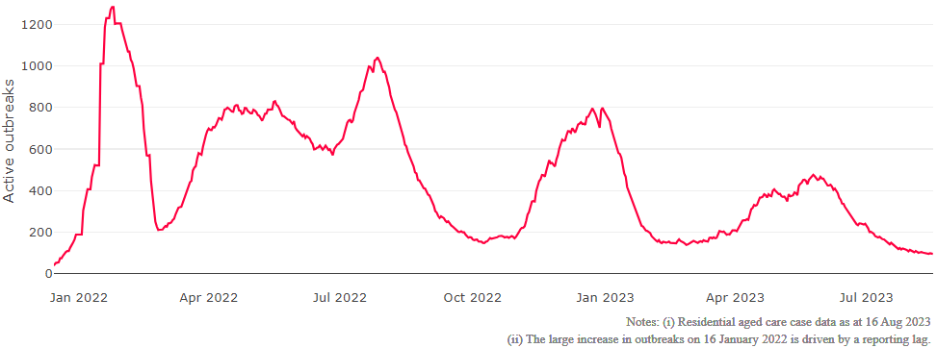

**Figure 2: Trends in Aged Care Cases – December 2021 to Present**

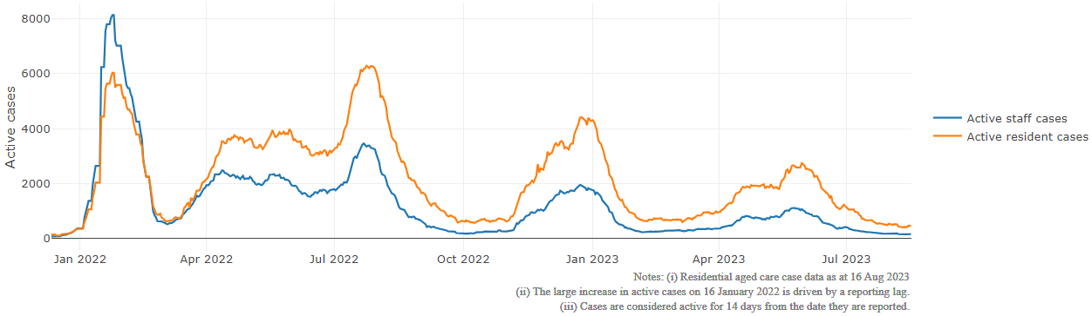

## Mortality

For the period of 1 January 2023 to 17 August 2023, COVID-19 is recorded as the cause of death in 3.1 percent of all deaths in permanent residents in aged care facilities.

Since the beginning of the Omicron outbreak in mid December[5] 2021, there have been 100,562 deaths in residential aged care from all causes (report period from 15 December 2021 to 10 August 2023)[6]. COVID-19 deaths account for 4.9 percent of this figure.

Over the course of the pandemic, all-cause excess mortality in Residential Aged Care was below expected numbers in 2020, and within expected range in 2021.

Figure 3: COVID-19 Deaths in Residential Aged Care Facilities overlaid with Community deaths

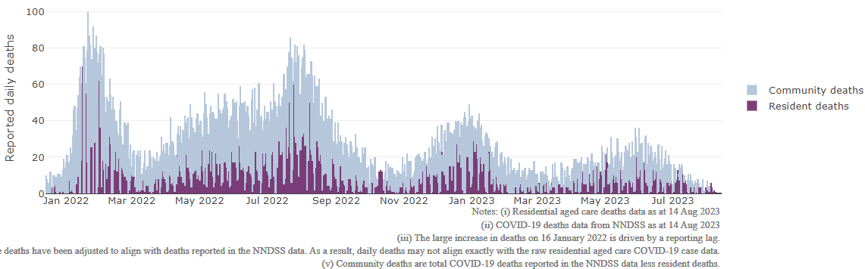

## Workforce in active residential aged care outbreaks

As at 18 August 2023, workforce surge staff have filled a total of 177,262 shifts in aged care services impacted by COVID-19, including 394 in the past 7 days. In the past 7 days (to 18 August) surge workforce providers have assisted 14 residential aged care homes. These shifts include roles for GPs, nurses, care workers, allied health workers, executive and ancillary staff. This includes:

Table 3: Workforce resources supplied to residential aged care facilities

| Workforce provider | Total Shifts | | Previous 7 days | |
| --- | --- | --- | --- | --- |
| Recruitment, Consulting and Staffing Association | 103,850 | 9 | |
| Healthcare Australia (Workforce Surge) | 14,856 | 22 | |
| Healthcare Australia (NACER) | 2,295 | N/A | |
| Mable | 2,711 | N/A | |
| Aspen Medical | 24,883 | 84 | |
| HealthX | 24,611 | 279 | |
| Torrens | 4,056 | N/A | |

The Australian Defence Force provided support to a total of 542 residential aged care homes between February and September 2022. The ADF deployment ceased on 30 September 2022.

## Oral antiviral treatments

Distribution of the oral anti-viral Lagevrio (Molnupiravir) commenced on 6 February 2022 to all RACFs with outbreak sites prioritised for delivery. The National Medical Stockpile has deployed 48,269 treatment courses of Lagevrio (Molnupiravir) to aged care facilities.

75,734 prescriptions for Lagevrio (Molnupiravir) have been issued to residents in residential aged care facilities, with a further 6,183 prescriptions for Paxlovid (nirmatrelvir + ritonavir) also issued since 28 February 2022 and up to 13 August 2023.

## Vaccination in Residential Aged Care Facilities

People living in residential aged care homes remain a high priority for the Government’s COVID-19 vaccination program. The Department is continuing to communicate with both the aged care and primary care sectors, reinforcing the importance of uptake and promoting the 2023 booster dose via regular newsletters, bulletins, social media videos and webinars.

All aged care residents who have not had a COVID-19 vaccination, or a COVID-19 infection within the last 6 months, continue to be offered a 2023 booster dose. The added protection from vaccination is especially important for aged care residents and will help reduce the risk of severe illness or hospitalisation.

The Department continues to work with Primary Health Networks to support residential aged care homes across Australia to arrange COVID-19 vaccination in-reach clinics with local primary care providers such as GPs, community pharmacists, and Aboriginal Community Controlled Health Services.

As at 16 August 2023:

* of those aged care residents who have been eligible for a booster dose since January 2023, 99,492 (66.4%)eligible residents have received a 2023 booster dose. This is an additional 1,314 residents since last week.
  + Eligibility for the vaccine under current settings is fluid, with people becoming eligible as they reach 6 months after a COVID-19 infection. This means that aged care residents who are now eligible may have only recently become eligible.
* 98% of residential aged care homes are recording residents vaccinated with the 2023 booster.
* 114,657 (62.1%) residents are estimated to have had a recent immunising event of a vaccine dose (including the 2023 booster), or COVID-19 infection in the last 6 months and are therefore not currently eligible for a 2023 booster dose.

The estimated eligible population is made up of residents who have completed their COVID-19 primary course and had their last COVID-19 vaccine dose or infection more than 6 months ago. As residential aged care populations are fluid, and case overlay is not exact, eligible populations for vaccination are an estimate only.

**Table 4: Aged Care COVID-19 2023 Booster Doses (data as at 16 August 2023)**

| Jurisdiction | % of estimated eligible residents vaccinated | Residents vaccinated |
| --- | --- | --- |
| National | **66.4%** | **99,492** |
| ACT | 75.5% | 1,493 |
| NSW | 66.5% | 31,796 |
| NT | 48.8% | <200 |
| QLD | 62.9% | 18,977 |
| SA | 66.6% | 8,726 |
| TAS | 76.3% | 2,792 |
| VIC | 69.8% | 27,549 |
| WA | 60.2% | 7,971 |

Source: Matched AIR data of residents in permanent residential aged care facilities.  
An updated data methodology was implemented on 26 July 2023 which may cause fluctuations to % of Estimated Eligible Residents Vaccinated and Resident Vaccinated figures

## Infection control and audit

People living in residential aged care homes remain a high priority for the Government’s COVID-19 vaccination program. The Department is continuing to communicate with both the aged care and primary care sectors, reinforcing the importance of uptake and promoting the 2023 booster dose via regular newsletters, bulletins, social media videos and webinars.

All aged care residents who have not had a COVID-19 vaccination, or a COVID-19 infection within the last 6 months, continue to be offered a 2023 booster dose. The added protection from vaccination is especially important for aged care residents and will help reduce the risk of severe illness or hospitalisation.

The Department continues to work with Primary Health Networks to support residential aged care homes across Australia to arrange COVID-19 vaccination in-reach clinics with local primary care providers such as GPs, pharmacists, and Aboriginal Community Controlled Health Services.

As at 17 August 2023, the Commission had conducted 5,255 ICM spot checks to observe infection control practices and PPE protocols in residential aged care facilities.

Table 5: Total Quality Assessment and Monitoring Activities with residential services (including IPC), by type and month 1 March 2020 to 17 August 2023

|  |  |  |  |  |  |  |
| --- | --- | --- | --- | --- | --- | --- |
| Regulatory Activities | 2019-20 (1 Mar - 30 Jun 2020) | 2020-21 | 2021-22 | 2022-23 | 2023-24  (to 17 Aug) | Total |
| ****Site visits**** | 318 | 3,452 | 1,732 | 3,687 | 428 | 9,617 |
| ****Non-site activities**** | 3,709 | 8,382 | 6,666 | 1,408 | 55 | 20,220 |
| Total activities | **4,027** | **11,834** | **8,398** | **5,095** | **483** | **29,837** |

# Appendix 1: National residential aged care services with Active outbreaks COVID-19

Please note, information reported in this table has been directly reported to the Department of Health and Aged Care by residential aged care facilities. Total cases refers to all staff and resident cases associated with the active outbreak and may not reflect the count of currently active cases. Where numbers have been incorrectly reported, facilities are able to correct these in the COVID-19 Support Portal through My Aged Care. Where a facility is reporting less than six resident or staff cases or less than six deaths, data has been suppressed to protect the privacy of affected individuals (note that “n/p” indicates data is not provided to protect privacy).

| Service Name | State | Resident Deaths | Resident Cases | Staff Cases | Total Incidents |
| --- | --- | --- | --- | --- | --- |
| Advantaged Care at Barden Lodge | New South Wales | 0 | <6 | 0 | <6 |
| Ainslie House | New South Wales | 0 | 8 | <6 | n/p |
| Anglican Care Bishop Tyrrell Place | New South Wales | 0 | <6 | 0 | <6 |
| Arcare Oatlands | New South Wales | 0 | <6 | <6 | <6 |
| Blue Hills Manor | New South Wales | 0 | 7 | <6 | n/p |
| Bupa Queens Park | New South Wales | 0 | 12 | <6 | n/p |
| Calvary Cessnock Retirement Community | New South Wales | 0 | <6 | 0 | <6 |
| Carino Care at Sylvania | New South Wales | 0 | <6 | <6 | 6 |
| Catholic Healthcare Maranatha Lodge | New South Wales | 0 | 27 | 11 | 38 |
| Estia Health Epping - The Poplars | New South Wales | <6 | 29 | <6 | n/p |
| Frederic House | New South Wales | 0 | <6 | 0 | <6 |
| Hawkesbury Living Pty Limited | New South Wales | 0 | <6 | 0 | <6 |
| Heritage Pennant Hills | New South Wales | 0 | 11 | <6 | n/p |
| Indochinese Aged Care Services | New South Wales | 0 | <6 | 0 | <6 |
| Meadowbank Grove Care Community | New South Wales | <6 | 16 | 0 | 16 |
| Murrayvale Aged Care | New South Wales | 0 | 9 | <6 | n/p |
| Randwick Montefiore Home | New South Wales | 0 | 0 | <6 | <6 |
| Ron Middleton VC Gardens | New South Wales | 0 | 11 | <6 | n/p |
| Scalabrini Village Chipping Norton | New South Wales | 0 | 11 | 6 | 17 |
| SummitCare St Marys | New South Wales | 0 | <6 | 0 | <6 |
| Tallwoods Corner Aged Care Service | New South Wales | 0 | 14 | 0 | 14 |
| Uniting Abrina Ashfield | New South Wales | 0 | <6 | 0 | <6 |
| Uniting Elanora Shellharbour | New South Wales | <6 | 24 | <6 | n/p |
| Uniting The Marion Leichhardt | New South Wales | 0 | 13 | <6 | n/p |
| Warrigal Care Mt Warrigal | New South Wales | 0 | <6 | 0 | <6 |
| Warrigal Care Shell Cove | New South Wales | 0 | 24 | <6 | n/p |
| Woodport Aged Care Plus Centre | New South Wales | 0 | 14 | 7 | 21 |
| Anam Cara | Queensland | 0 | <6 | 0 | <6 |
| Arcare North Lakes | Queensland | 0 | 15 | <6 | n/p |
| Arcare North Shore | Queensland | 0 | <6 | 0 | <6 |
| Ashmore Gardens Care Community | Queensland | 0 | 20 | <6 | n/p |
| Berrinba Greens Care Community | Queensland | 0 | <6 | <6 | 8 |
| Bethesda Caring Centre | Queensland | 0 | <6 | <6 | <6 |
| Blue Care Bundaberg Riverlea Aged Care Facility | Queensland | 0 | <6 | <6 | <6 |
| Blue Care Capricorn Aged Care Facility | Queensland | 0 | 22 | 12 | 34 |
| Bolton Clarke Talbarra | Queensland | 0 | 6 | <6 | n/p |
| Calvary Noosa | Queensland | 0 | 8 | 8 | 16 |
| Clifton Nursing Home | Queensland | 0 | 11 | 7 | 18 |
| Dovetree | Queensland | 0 | <6 | <6 | <6 |
| Estia Health Gold Coast | Queensland | 0 | 0 | <6 | <6 |
| Infinite Care Mount Lofty | Queensland | 0 | 13 | <6 | n/p |
| Keperra Sanctuary Hostel | Queensland | 0 | <6 | 0 | <6 |
| Lutheran Services - Trinder Park | Queensland | 0 | 6 | <6 | n/p |
| Nambour Gardens Care Community | Queensland | 0 | <6 | <6 | <6 |
| NewDirection Care at Bellmere | Queensland | <6 | 11 | <6 | n/p |
| Ozcare Noosa Heads | Queensland | 0 | 12 | <6 | n/p |
| PresCare - Alexandra Gardens | Queensland | 0 | 0 | <6 | <6 |
| Regis Lutwyche | Queensland | 0 | 28 | <6 | n/p |
| Springwood Terrace Care Community | Queensland | 0 | 6 | <6 | n/p |
| St Nicholas Aged Care | Queensland | 0 | 26 | 13 | 39 |
| St Vincent's Care Services Maroochydore | Queensland | 0 | <6 | 0 | <6 |
| Sunnymeade Park Aged Care Community | Queensland | 0 | 10 | <6 | n/p |
| Torbay | Queensland | 0 | 6 | <6 | n/p |
| Copperhouse Court Hostel | South Australia | 0 | 14 | 8 | 22 |
| Eldercare Sash Ferguson | South Australia | 0 | <6 | <6 | <6 |
| Eldercare The Village | South Australia | 0 | 12 | <6 | n/p |
| Estia Health Strathalbyn | South Australia | <6 | 26 | 6 | 32 |
| Matthew Flinders Home Inc | South Australia | 0 | 30 | 9 | 39 |
| Hawthorn Village | Tasmania | 0 | <6 | 0 | <6 |
| May Shaw Aminya | Tasmania | 0 | 9 | 6 | 15 |
| St Ann's | Tasmania | <6 | 24 | <6 | n/p |
| The Gardens | Tasmania | 0 | <6 | <6 | <6 |
| Uniting AgeWell Strathglen | Tasmania | 0 | 8 | <6 | n/p |
| AdventCare Yarra Ranges | Victoria | 0 | 25 | 15 | 40 |
| Aurrum Plenty | Victoria | 0 | <6 | 0 | <6 |
| Baptcare - Hedley Sutton Community | Victoria | <6 | 20 | 8 | 28 |
| Baptcare Wyndham Lodge Community | Victoria | 0 | <6 | <6 | 6 |
| Bupa Ballarat | Victoria | 0 | 11 | <6 | n/p |
| Bupa Wodonga | Victoria | <6 | 7 | 9 | 16 |
| Estia Health Bannockburn | Victoria | 0 | 8 | <6 | n/p |
| Estia Health Bentleigh | Victoria | 0 | 0 | <6 | <6 |
| Estia Health Knoxfield | Victoria | 0 | <6 | 0 | <6 |
| Estia Health Leopold | Victoria | 0 | <6 | 0 | <6 |
| Hope Aged Care Gladstone Park | Victoria | 0 | 6 | <6 | n/p |
| Killara Hostel | Victoria | 0 | <6 | 0 | <6 |
| Marina Residential Aged Care Service | Victoria | 0 | <6 | 0 | <6 |
| McKellar Centre | Victoria | 0 | 9 | <6 | n/p |
| Mercy Place Northcliffe | Victoria | 0 | <6 | <6 | <6 |
| Morrie Evans Wing Nursing Home | Victoria | 0 | <6 | 0 | <6 |
| Ocean Mist Aged Care | Victoria | 0 | <6 | <6 | <6 |
| Parkdale Aged Care | Victoria | 0 | <6 | <6 | <6 |
| Peninsula Grange Aged Care | Victoria | 0 | 10 | 6 | 16 |
| Sutton Park Assisted Aged Care | Victoria | 0 | 33 | <6 | n/p |
| Trevi Court | Victoria | 0 | 7 | <6 | n/p |
| Twin Parks Aged Care Centre | Victoria | 0 | 14 | <6 | n/p |
| Villa Maria Catholic Homes Providence Aged Care Residence | Victoria | 0 | 7 | 8 | 15 |
| Amaroo Village McMahon Caring Centre | Western Australia | 0 | <6 | <6 | <6 |
| Bethanie Subiaco | Western Australia | 0 | <6 | <6 | 8 |
| Gnowangerup MPS | Western Australia | 0 | 7 | <6 | n/p |
| Juniper Chrystal Halliday | Western Australia | 0 | <6 | 0 | <6 |
| Juniper Ella Williams | Western Australia | 0 | <6 | <6 | <6 |
| Quairading MPS | Western Australia | 0 | <6 | <6 | <6 |
| Regents Garden Four Seasons Booragoon | Western Australia | 0 | 7 | <6 | n/p |
| Regis Bunbury | Western Australia | 0 | 14 | <6 | n/p |
| Trinity Village | Western Australia | 0 | 16 | 12 | 28 |

1. Outbreak opening and closure includes changes in the status of exposure sites to outbreaks (and vice versa), which are applied retrospectively to facility records. New case information can also change the status of a recovered site back to an active outbreak site. As a result, changes in active outbreak status may not align with day on day variations to active totals. These adjustments will also affect the number of cases in staff and residents reported each week.
2. Active residents and staff cases are the total currently positive cases in active outbreaks
3. An outbreak is considered to be active pending advice from the relevant Public Health Unit. An outbreak is defined as at least 1 positive case in a resident or 2+ cases in staff.
4. Case numbers and numbers of deaths are dependent upon reporting from facilities and validation of deaths from state and territory governments. This is subject to change as further information is provided.
5. The Omicron outbreak start date has been redefined from late November 2021 to mid December 2021. Changes have been made to align reporting with the start date of Omicron published in the Department’s external facing Epidemiology report.
6. The Department is now accessing aged care deaths data from the SIEBEL dataset. Figures are live and subject to change. Source: Department of Health and Aged Care unpublished data / SIEBEL dataset.