Vaccination and Infection Control

*Disclaimer: This video is designed to be a conversation starter on the topic infection control practices in a remote aged care context. The facilitator should make use of other resources to ensure the learner continues to develop their understanding of their responsibilities in infection control practices.*

Infection control practices are an essential aspect of keeping people receiving care safe. In addition to Personal Protective Equipment, staff should understand infection control practices such as the correct way to wash hands and how vaccinations can help protect themselves and people receiving care from infectious diseases.

This video also explains toolbox talks and short education sessions that are used to inform and educate staff on a safety topic. The topic that the coordinator is covering is about controlling infection through vaccination.

## Infectious Diseases

Staff working with vulnerable people need to be aware of infectious diseases. These diseases can be passed from one person to another. Examples of these types of infectious diseases are:

* Influenza or the ‘flu’
* Colds
* Gastroenteritis or ‘Gastro’
* COVID-19

Older people are particularly vulnerable to getting sick from these diseases because their immune system is weaker. If they get an infectious disease, they can also end up with complications like pneumonia or become severely dehydrated.

This is why we put controls in place to protect the older people who receive aged care services.

* *Talk about these common infections and how they can impact the people your organisation supports. If you have some recent examples, use these to emphasise the problems for older people.*

## Infection Controls

Infection controls are actions put in place to help stop the spread of disease.

When we want to prevent infections we use a hierarchy of controls, which is simply a way of working out which action is going to give you the best results.

The hierarchy of control moves from the most effective to the least effective way of controlling a hazard. For example, it is much better to eliminate an infectious organism by washing hands thoroughly, than by simply putting on gloves to cover up the problem.

Think about these controls and where they fit within the hierarchy of controls:

* 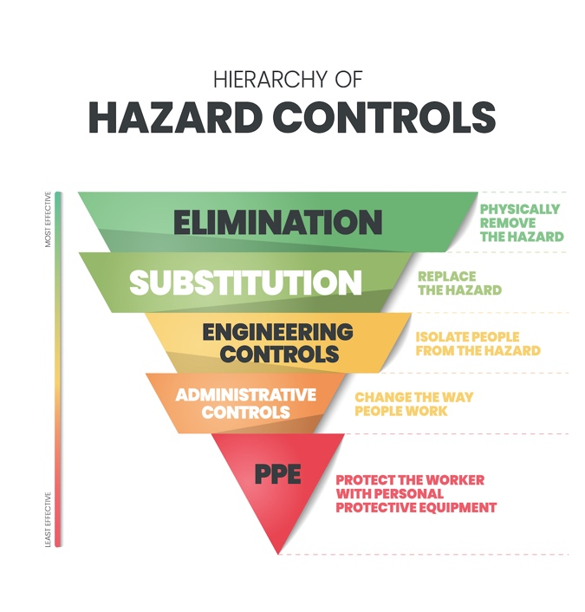Washing hands
* Using disposable food containers
* Physical distancing
* Holding activities outdoors
* Separating sick people from those who are well
* Restricting the movement of populations
* Providing training on infection prevention and control
* Having an outbreak management plan
* Encouraging vaccination
* Wearing masks
* Using personal protective equipment when working with others

Staff should always follow directives from government or management that help to stop the spread of infectious diseases.

* *Discuss infection controls your organisation uses to protect people receiving cares during an outbreak.*

## Vaccination

In the video, the team talk about vaccination and how it can help keep people receiving care and themselves safe. The team learn that vaccination is a safe, simple and effective way of protecting a person against harmful diseases if they come in contact with them.

Vaccination trains the body's natural immune system to fight a disease or variant that it hasn't met before and strengthens the person's immune system.

Once a person is vaccinated against a specific disease, they are less likely to experience severe illness or complications from the disease or pass the infection on to another person because their immune system quickly kills off the disease.

Staff working in aged care may need to be vaccinated against some diseases, like COVID depending on the setting they work in.

* *Discuss any vaccines that staff are recommended or required to have, including boosters, in your setting.*

It is a requirement in residential care and a recommendation in home care that aged care staff receive a Flu vaccine each year.

* *Discuss the benefits of vaccination with the learner/team.*

**Additional Resources**

Aged Care Quality and Safety Commission COVID-19 Storyboards: <https://www.agedcarequality.gov.au/resources/covid-19-staying-safe-storyboards-and-user-guides>

COVID-19 – staying safe storyboards and user guides – Aged Care Quality and Safety Commission: <https://www.agedcarequality.gov.au/resources/covid-19-staying-safe-storyboards-and-user-guides>

Hierarchy of Controls: <https://www.safetyandquality.gov.au/sites/default/files/2022-05/using_the_hierarchy_of_controls_in_conjunction_with_infection_prevention_and_-_fact_sheet.pdf>

Infection Control: The Basic Principles: <https://youtu.be/-PQ8em7Fi5U>

Infection prevention and control for aged care – Australian Commission on Safety and Quality in Health Care eLearning: <https://www.safetyandquality.gov.au/our-work/infection-prevention-and-control/hand-hygiene-and-infection-prevention-and-control-elearning-modules/infection-prevention-and-control-aged-care>

Influenza resources – Aged Care Quality & Safety Commission: <https://www.agedcarequality.gov.au/resources/influenza-resources>

Influenza (Flu) vaccine – Australian Government: <https://www.health.gov.au/topics/immunisation/vaccines/influenza-flu-vaccine>

The importance of vaccinations for influenza – WHO: <https://youtu.be/y-yjXAnd1C4>