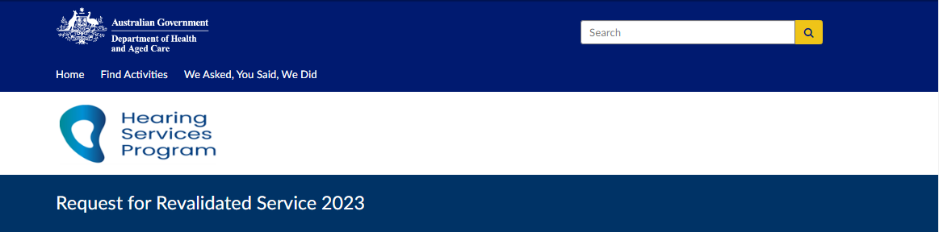1. Client details fields including date of birth and voucher number. (Required) 
Expiry date of current voucher. (Required) 

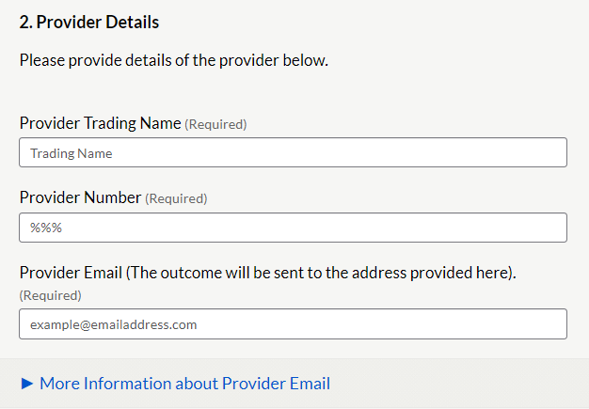

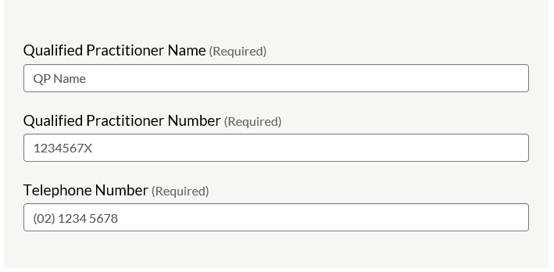

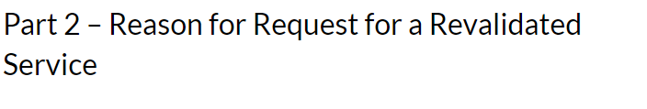Required Information for Reason A - Reassessment
Audiogram results, recent and previous
Tympanometry results if bone conduction was not completed. Required Information for Reason B - Refitting. 
Claim item number to be claimed
Supporting ECR 
Clinical Justification for the refit
Evidence to support the refit
Hyperlinks to Successful submission Examples

Please select the supporting Eligibility Criteria for Refitting  for requesting the Revalidated Service. 
List of radio buttons to select ECR 1-5
ECR 4 button selected. 
Drop down selection box. 
Select Claim item number. 

Please select the service item number to be claimed.
Drop down box. (select fitting item) 

Part 3 - Supporting Evidence for Reason B ECR 4 - Refitting
The current devices are unsuitable because the client requires a telecoil. Part 1. Audiogram 
Please provide 3 Frequency Average Hearing loss (3FAHL ) 
Field for left ear and right ear.2. Details of the client's needs.
Did the client opt out of a telecoil from the previous fitting?
Yes / No (yes selected).
Response field:
Describe change in client's needs since the last fitting, and why they require a telecoil. 
Tick box declaration (ticked): I declare the client is not being refitted with a FM system, streamer or equivalent under ECR4. (Required)  

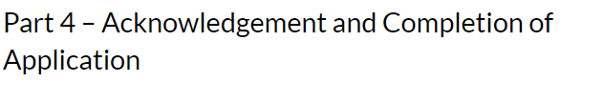Please tick the following declarations
regarding: 
Retaining a copy of request on the client file.
Client meets MHLT requirements.
Client's hearing and health needs have changed significantly and request is urgent.
The request been discussed with the client or their POA. Has their consent been obtained? 
This request and supporting evidence are subject to compliance monitoring, including audit.
 Request content - true and correct, not contain false information. Completion of Application information. 
Once submitted you will not be able to make changes.

Almost done  - click 'Submit response' button.
Provide an email address to receive a receipt and a link to a PDF copy of your request.  
Email address details
example@emailaddress.com

Your Response has been submitted. 
Response ID example ANON-numbers and letters.
Please have this ID available if you need to contact us. Thank you for your submission.
For enquiries regarding any application please contact the Program by email Hearing@Health.gov.au, include your response ID number, client name and voucher number. 