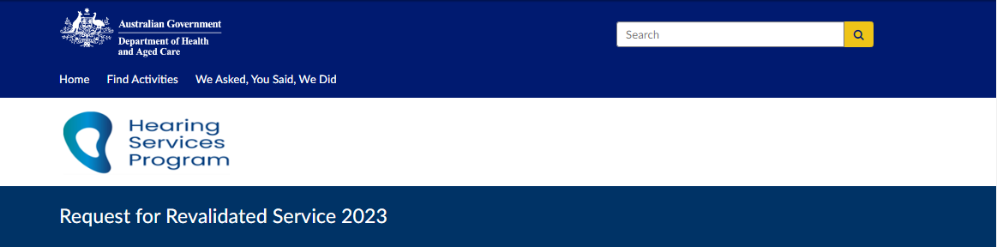1. Client details fields including date of birth and voucher number.  (Required) 
Expiry date of current voucher. (Required) 

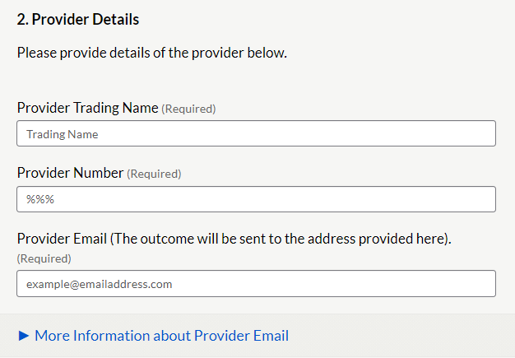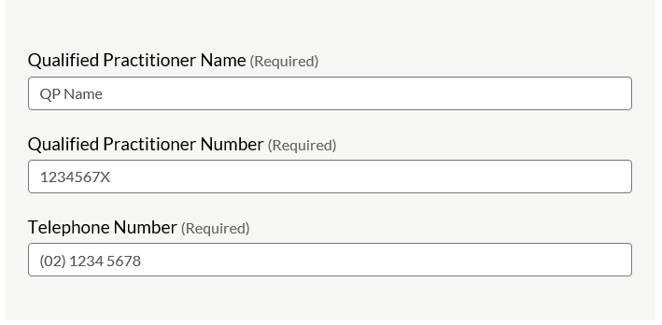

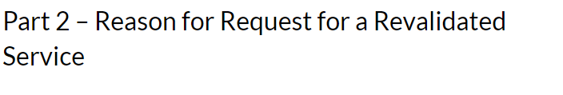Required Information for Reason A - Reassessment
Audiogram results, recent and previous
Tympanometry results if bone conduction was not completed. 

Required Information for Reason B - Refitting. 
Claim item number to be claimed
Supporting ECR 
Clinical Justification for the refit
Evidence to support the refit
Hyperlinks to Successful submission Examples

Please select the supporting Eligibility Criteria for Refitting  for requesting the Revalidated Service. 
List of radio buttons to select ECR 1-5
ECR 2 button selected. 
Drop down selection box. 
Select Claim item number. 


Part 3 - Supporting Evidence for Reason B ECR2 - Refitting - significant deterioration Health , dexterity or cognitive.
Hyperlinks to successful submission examples - ECR2  

Part 1. Audiogram 
Please provide 3 Frequency Average Hearing loss (3FAHL ) 
Field for left ear and right ear.2. Details of the deterioration  either: 
Health
Dexterity
Cognitive Ability 
or Speech discrimination
that has occurred since last fitting.Select tick box for supporting issue. 
Health (ticked)
Dexterity
Cognitive Ability (ticked) 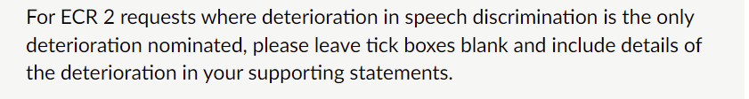

Date of last fitting details (required) 
DD/MM/YYYY
Date deterioration was reported
DD/MM/YYYY

Describe the deterioration in health, dexterity, cognitive ability or speech discrimination. (Required). 
Note: ECR do not support changes relating to glasses or becoming a carer. 

If Dexterity is the supporting reason include evidence as to why/why not a remote control has not been considered appropriate for current devices. 
Tick box (ticked)  - Declaration that the request is not due to client becoming a carer or use of spectacles. (required). 

3. Details of the current device(s) or fitting.  Why they are no longer suitable?
Field for response.
Has the fitting range been checked and devices optimised for current needs before the refitting is considered?

Regarding the current device(s) (at the follow-up appointment)
1. Was the fitting successful? 
Yes / No (Yes selected) 
2. Were the client's hearing goals met?
Yes / No (Yes selected) 

3. Was the client able to manage the device(s) independently? 
Yes / No (Yes selected) 
If answer is No, the program will investigate the original fitting to ensure program requirements were met. 

Did he client voice any concerns about the current devices and or fitting? 
Yes / No ( yes selected) 

4. Details of how the issues were addressed. 
Please provide detail of attempts to resolve issues with current device(s). 
Is there a family member or carer able to assist the client with their device management? 
Yes / No (No selected) (Required).  
Has remote control been considered to assist the client with their device management? 
Yes / No (No selected) (Required). 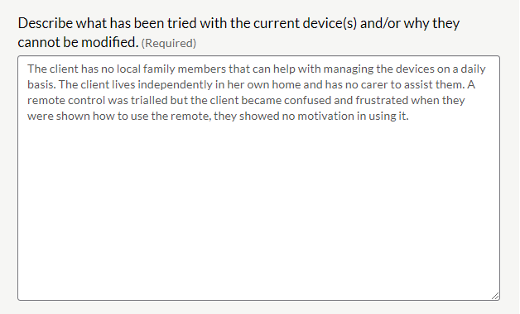

5. Details of Proposed solution.
 Hyperlink to current fully subsidised schedule.
Hyperlink to current partially subsidised schedule.
Enter proposed device codes for left and right ear.
If the client has a monaural fitting please enter N/A in the relevant fields below. 

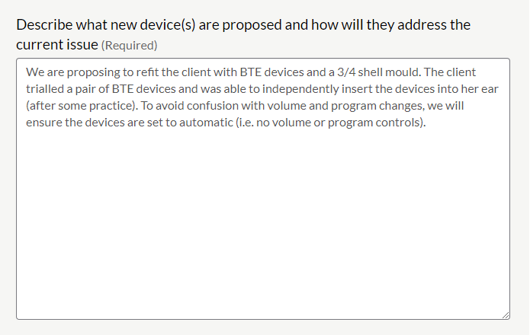

6. Doctor's Letter 
Not required to support requests where only Speech discrimination is nominated. 
Tick box (ticked) I declare a doctor's letter has been obtained and includes the change in the condition supporting this request. 
Name of Medical Practitioner -provide detail
Name of the Clinic or hospital -  -provide detail


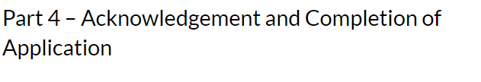Please tick the following declarations
regarding: 
Retaining a copy of request on the client file.
Client meets MHLT requirements.
Client's hearing and health needs have changed significantly and request is urgent.
The request been discussed with the client or their POA. Has their consent been obtained? 
This request and supporting evidence are subject to compliance monitoring, including audit.
 Request content - true and correct, not contain false information. Completion of Application information. 
Once submitted you will not be able to make changes.

Almost done  - click 'Submit response' button.
Provide an email address to receive a receipt and a link to a PDF copy of your request.  
Email address details
example@emailaddress.comYour Response has been submitted. 
Response ID example ANON-numbers and letters.
Please have this ID available if you need to contact us. Thank you for your submission.
Please allow 10 days for an outcome to your Request for Revalidated Service application. For enquiries regarding any application please contact the Program by email Hearing@Health.gov.au, include your response ID number, client name and voucher number. 