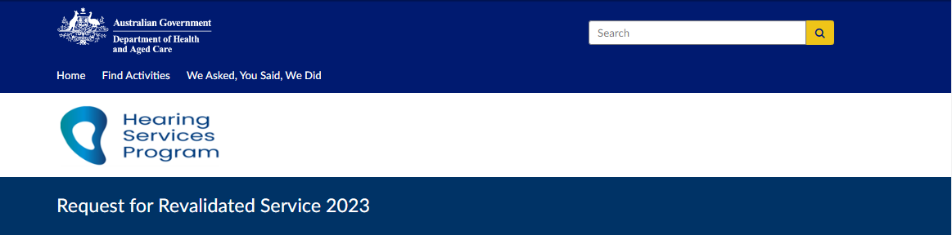Client details fields including date of birth and voucher. (Required) 
Expiry date of current voucher. (Required) 

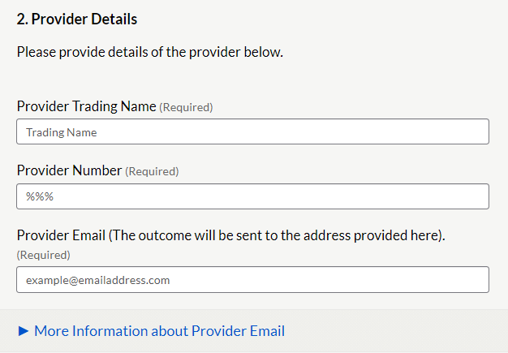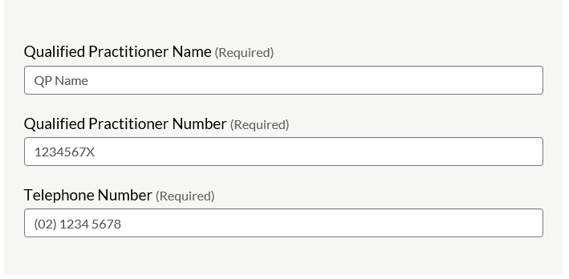

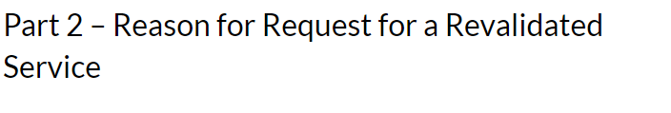Required Information for Reason A - Reassessment
Audiogram results, recent and previous
Tympanometry results if bone conduction was not completed. 
Required Information for Reason B - Refitting
Claim item number to be claimed
Supporting ECR 
Clinical Justification for the refit
Evidence to support the refit
Hyperinks to Successful submission Examples

Please select the supporting Eligibility Criteria for Refitting  for requesting the Revalidated Service. 
List of radio buttons to select ECR 1-5
Drop down selection box. 
ECR1 selected.
Select Claim item number. 


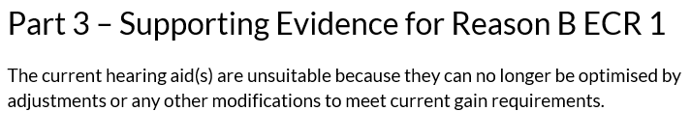1. Audiogram results 
Date of previous dd/mm/yyyy
Date of most recent dd/mm/yyyy
Indicate frequencies (tick boxes 0.5kHz to 4kHz) where deterioration ≥15dB has occurred. 

Please provide recent 3 Frequency Average Hearing loss (3FAHL ) 
Field for left ear and right ear.

2. Proposed Devices
The Hearing Threshold Levels from the most recent audiogram as above should be assessed against the fitting range of the client's current  devices.
Hyperlink to current fully subsidised schedule.
Hyperlink to current partially subsidised schedule.
Please enter the device code for the proposed devices.
If the client has a monaural fitting please enter N/A in the relevant fields below. 
Left Ear device code field (required)
Right Ear Device code field (required) 

Hyperlink to: More Information on Device Codes
Device code are specific to each device code registered on the program. 
Refer to Device schedules (hyperlinks above).

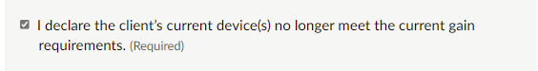

Part 4 - Acknowledgement and Completion of Application
Please tick the following declarations
regarding: 
Retaining a copy of request on the client file.
Client meets MHLT requirements.
Client's hearing and health needs have changed significantly and request is urgent.
The request been discussed with the client or their POA. Has their consent been obtained? 
This request and supporting evidence are subject to compliance monitoring, including audit.
 Request content - true and correct, not contain false information. 

All of the above are mandatory checks - requiring completion of the tickbox
Completion of Application information. 
Once submitted you will not be able to make changes.

Almost done  - click 'Submit response' button.
Provide an email address to receive a receipt and a link to a PDF copy of your request.  
Email address details
example@emailaddress.com


Your Response has been submitted. 
Response ID example ANON-numbers and letters.
Please have this ID available if you need to contact us. 
Thank you for your submission.

Please allow 10 days for an outcome to your Request for Revalidated Service application. For enquiries regarding any application please contact the Program by email Hearing@Health.gov.au, include your response ID number, client name and voucher number. 