Personal Protective Equipment

*Disclaimer: This video is designed to be a conversation starter on the topic of using personal protective equipment as one aspect of infection control in a remote aged care context. The facilitator should make use of other resources to ensure the learner continues to develop their understanding and competency of effective infection control practices.*

In aged care, Personal Protective Equipment (PPE) is anything workers wear or use to keep themselves or the people they care for safe.

In this video, Tamika learns about using PPE to keep herself and people receiving care safe by using PPE.

## Hierarchy of Controls

When we want to prevent infections we use a hierarchy of controls, which is simply a way of working out which action is going to give you the best results.

The hierarchy of control moves from the most effective to the least effective way of controlling a hazard. For example, it is much better to eliminate an infectious organism by washing hands thoroughly, than by simply putting on gloves to cover up the problem.

The following list demonstrates the hierarchy of controls when dealing with infectious diseases:

* 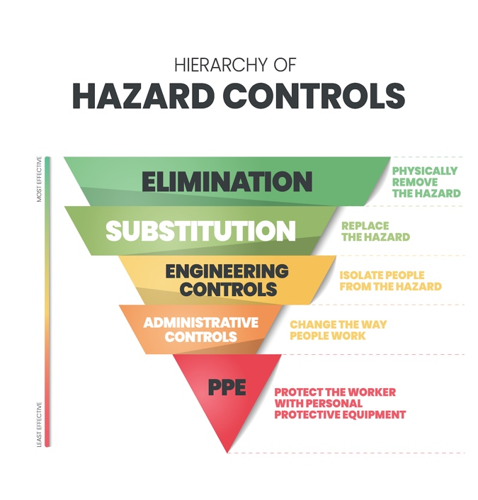Washing hands
* Using disposable food containers
* Physical distancing
* Holding activities outdoors
* Separating sick people from those who are well
* Restricting the movement of populations
* Providing training on infection prevention and control
* Having an outbreak management plan
* Encouraging vaccination
* Wearing masks
* Using personal protective equipment when working with infectious diseases or handling contaminated items.

Staff should always follow directives from government or management that help to stop the spread of infectious diseases.

## Personal Protective Equipment is part of infection control

As you can see from the above list, PPE is one part of the infection control practices used in aged care. Other aspects of infection control include washing hands regularly and separating clean items from contaminated items.

* *Talk about infection control practices in your workplace including handwashing and physical distancing.*
* *Make sure the learner knows how to wash their hands correctly and when to do so.*

Handwashing is an essential part of infection control, however, PPE is also used or worn whenever there is a chance that the worker will come in contact with an infectious organism or there is a chance, they may invertedly pass on an infection to another person.

PPE can also help the staff member in other ways. Wearing gloves, for example, can help stop a person's hands from drying out and cracking due to being in contact with water for long periods or stop chemicals being absorbed into the skin. Aprons may prevent the person's clothes from being splashed as they empty bedpans or buckets of water, or glasses, and goggles can stop foreign objects from flicking into their eyes.

## Types of PPE

Common PPE used in aged care includes:

* Disposable gloves
* Hairnets
* Goggles or glasses
* Aprons or gowns
* Disposable shoe covers

When working with a person with a known or suspected infection, the worker may need to wear additional PPE, including face shields or respirators.

* *Take a tour of your centre, facility or office and show the learner where PPE is located or stored.*
* *Talk about when PPE needs to be used in your setting.*

## Using PPE correctly

There are ways to safely put on and take off PPE and dispose of it correctly; this helps keep the worker and other people safe. There are posters and [videos](https://www.youtube.com/watch?v=yWWJMuLWD4k&list=PLKFDUMupjXqj9IXjb-CTx2g1Qzo3rxTgR&index=4) that show how to do this correctly.

PPE needs to be changed regularly for it to be effective. This means changing gloves and aprons between different care recipients.

* *Demonstrate or show a video on how to use and dispose of PPE correctly in your setting.*

Don’t forget to wash hands before putting gloves on and after taking them off!

## In the kitchen

PPE is also important in kitchens. While not every commercial kitchen requires staff to wear gloves and hair nets, these can help maintain food safety standards.

* *If the staff member is working in the kitchen or around food, discuss PPE requirements and show the learner where this PPE is located.*

## Links to additional videos and resources

Infection Control: The Basic Principles: <https://youtu.be/-PQ8em7Fi5U>

Infection prevention and control for aged care – Australian Commission on Safety and Quality in Health Care eLearning: <https://www.safetyandquality.gov.au/our-work/infection-prevention-and-control/hand-hygiene-and-infection-prevention-and-control-elearning-modules/infection-prevention-and-control-aged-care>

Wearing Personal Protective Equipment in aged care: <https://www.youtube.com/watch?v=yWWJMuLWD4k>

Aged Care Hygiene: Handwashing – OHS training video: <https://youtu.be/4s8EpsUGiyU>

Wash your Hands – It just makes sense: <https://youtu.be/M8AKTACyiB0>

WHO: How to handwash. With soap and water: <https://www.youtube.com/watch?v=3PmVJQUCm4E>