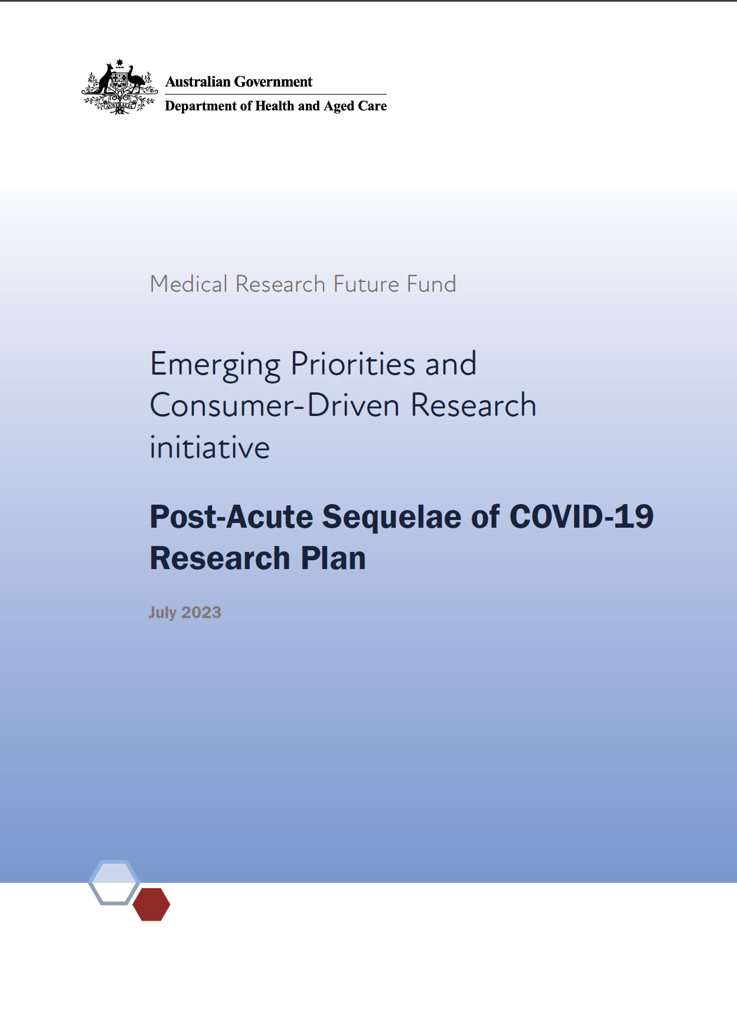

Background
Post-acute sequelae of COVID-19 (PASC), also known as long COVID, is the term given to prolonged symptoms experienced by some people following the acute phase of COVID-19 infection.
The House of Representatives Standing Committee on Health, Aged Care and Sport (the committee) launched an inquiry into Long COVID and Repeated COVID Infections following a referral from the Minister for Health and Aged Care, the Hon Mark Butler MP on 1 September 2022. The findings from this investigation were tabled on 19 April 2023 and published on 24 April 2023, in a report titled Sick and tired: Casting a long shadow. The committee recommended establishment of a longer-term nationally coordinated collaborative research program, with adequate representation from Aboriginal and Torres Strait Islander peoples, the culturally and linguistically diverse population, people with a disability, older people, people in rural and remote areas and other priority populations. They also recommended that research programs should span basic science, clinical trials, models of care, health promotion and implementation science. These recommendations highlight the need for broad research priorities to increase Australia’s knowledge of PASC and guide future policy and clinical care.
The Department of Health and Aged Care has been tasked with developing a national plan to respond to PASC, taking into consideration the House of Representatives Standing Committee findings. One component of the Department’s response is a $50 million MRFF investment for research into PASC, which is outlined in this Post-Acute Sequelae of COVID-19 Research Plan (the Research Plan).
Although international guidelines exist on the diagnosis and management of PASC,, Australia’s experience of PASC may be different to other countries. Factors including high rates of vaccination and high rates of COVID-19 infections with the Omicron variant are likely to have had an impact, although it is noted that representative data on the current incidence and prevalence of PASC in Australia are lacking.
Better evidence on many aspects of how to provide consumers with PASC with equitable access to high quality care, experiences that allow them to feel safe and confident in the care they receive, and benefit from improved health outcomes is urgently required. The focus of this Research Plan is on research into the effective management of PASC in the Australian community. Primary prevention of PASC is not included in this Research Plan.
As PASC is a new and emerging issue, a universally agreed nomenclature and case definition have not yet been established. A number of definitions have been proposed including those used by the World Health Organization (WHO) and the National Institute for Health and Care Excellence (NICE) in the UK. Noting the variance in terminologies, the parliamentary Long COVID inquiry preferenced the WHO definition of post COVID condition4 as the most useful clinical working definition in Australia at the current time.
Despite lack of universal consensus, and recognition of ongoing developments in this area, there is general agreement regarding the need for research to utilise validated questionnaires to characterise the key symptom domains where possible and appropriate. Additionally, the need for assessment of disability, and for protocolised clinical assessment and investigations to identify medical or mental health conditions which may explain some or all of the symptoms is recognised.
Researchers applying for grants under this Research Plan should abide by a standardised PASC definition and a systematic approach, while remaining cognizant of emerging definitions of PASC and related conditions.
This Research Plan has been developed by an independent Expert Advisory Panel to advise the Minister for Health and Aged Care on the strategic priorities for research investment.
$50 million dollars over four years from 2023–24 has been allocated for this Research Plan from the Medical Research Future Fund’s (MRFF’s) Emerging Priorities and Consumer-Driven Research (EPCDR) initiative. This initiative supports research on addressing emerging priority health needs and areas of unmet need. It will:
improve patient care
translate new discoveries into clinical practice
encourage researchers to work together with consumers
The objectives of the EPCDR initiative are to support research that improves patient care and translation of new discoveries, and encourage collaboration between consumers and researchers.
This Research Plan is intended to make the research purpose and direction transparent and provide certainty to stakeholders.

Objectives of the Research Plan
As requested by the Minister for Health and Aged Care, this Research Plan is to provide advice on research investments required to meet the following objectives:
generate evidence on the current and future impacts of PASC in the specific Australian context (including individual health and wellbeing, carers, communities, health system)
design and evaluate clinical pathways and models of care, co-led by general practitioners and primary care, for Australians with PASC, including to address inequities in access and outcomes
generate new diagnostic and therapeutic approaches to prevent the occurrence of PASC and/or improve health outcomes for individuals with PASC
This Research Plan must also align:
its priority areas with the objectives of the EPCDR initiative
with the recommendations from the Inquiry

Research activities
Priority areas for investment are allocated across short and medium-term timeframes. These priority areas will be used by Government in the design of competitive grant opportunities under this Research Plan.
Research activities will be, or contribute to, programs of work of national strategic importance that are informed by the key priority areas outlined in this Research Plan. Research activities will be both small and large scale, with the aim to concentrate research efforts into priority areas for investment and areas not already targeted through existing MRFF initiatives.
Noting the desire in the community for urgent action on PASC, including for research to better understand and address its impact on individuals and the community, the PASC Research Plan is being developed and implemented rapidly. This will allow research to commence as quickly as possible and has benefits for the broader PASC research landscape. Accelerated timeframes may impact researchers by requiring relatively quick application and assessment timeframes. These impacts will be monitored and evaluated to support future development of work programs.

Monitoring and evaluation
To support this plan, the MRFF Monitoring, Evaluation and Learning Strategy (the Strategy) provides an overarching framework for assessing the performance of the MRFF, focused on individual grants, grant opportunities, initiatives (eg the EPCDR) and the entire MRFF program.
The Strategy sets out the principles and approach used to monitor and evaluate the MRFF. It outlines the need for evaluations to be independent and impartial. The Strategy aims to be transparent in process and outcomes, and agile to the needs of the MRFF, its consumers and stakeholders (such as the health and medical research industry). This Research Plan and grants funded under it will be evaluated against the Strategy.

Our goal
To inform the Australian response to PASC so it is impactful, sustainable, and broadly inclusive of community, priority populations and the healthcare settings that service them.

Overview
The following aims and priority areas for research investment have been identified to achieve the objectives under this 4-year Research Plan.
Aim | Priority areas for investment
- Understand PASC to improve consumer, community and health system outcomes | 1.1 Knowledge of the short, medium and long-term effects and impacts of PASC on consumers, the community and/or the health system
- Improve care by building knowledge of the mechanisms and pathways that lead to PASC | 2.1 Understand the pathophysiology of PASC and how this varies across individuals
 | 2.2 Enhance knowledge of the key factors that impact PASC prognosis
- Identify the best therapies to improve outcomes for people with PASC | 3.1 Rapidly assess therapeutic interventions (including pharmacological and non-pharmacological) for PASC to improve care
- Ensure that health systems meet the needs of people living with PASC | 4.1 People living with PASC can access and receive high quality care
 | 4.2 Priority populations living with PASC have equitable access to high quality care and health outcomes

Aim 1: Understand PASC to improve consumer, community and health system outcomes

Priority area 1.1
Knowledge of the short, medium and long-term effects and impacts of PASC on consumers, the community and/or the health system
Research to begin in … | Priorities for investment (objective, outcome and funding)
2024 | Objective: (Targeted Call for Research) Conduct a large-scale multidisciplinary project in partnership with primary care researchers and consumers (including all age groups and priority populations), to identify how people experience PASC, including the impact on their physical and mental health and social and emotional wellbeing.  Outcome: Improving understanding of the impacts of PASC on individuals and the community to inform and improve clinical care and policy responses.  Funding: Up to $5 million per project. One project is anticipated to be funded.  Duration: Grant duration of up to 5 years.
2024 | Objective: (Targeted Call for Research) Conduct a large-scale multidisciplinary project in partnership with consumers, health service providers and policy makers using primary data collection and/or informatics approaches such as modelling and linkage to generate knowledge of population-wide and health system impacts of PASC.  Outcome: Improving understanding of the impacts of PASC on the Australian health system and society to inform policy and program responses.  Funding: Up to $5 million per project. One project is anticipated to be funded.  Duration: Grant duration of up to 5 years.

Aim 2: Improve care by building knowledge of the mechanisms and pathways that lead to PASC

Priority area 2.1
Understand the pathophysiology of PASC and how this varies across individuals

Priority area 2.2
Enhance knowledge of the key factors that impact PASC prognosis
Research to begin in … | Priorities for investment (objective, outcome and funding)
2024 and in 2025 | Objective: (Incubator) Small-scale developmental projects that:  - Topic A: investigate the molecular mechanisms, pathways or biomarkers that are central to the cause and progression of PASC  - Topic B: build knowledge of key factors that impact PASC prognosis, including but not limited to psychosocial, physical and behavioural contributors  Outcome: Generate knowledge to support the development of novel diagnostic or monitoring tools, or therapies for individuals living with PASC.  Funding: Up to $1 million per project. Seven projects are anticipated to be funded, with three to commence in 2024 and four to commence in 2025.  Duration: Grant duration of up to 2 years.  Notes:  2024. The highest ranked application in each of Topic A and B will be funded. The remaining applications across both Topics will then be pooled into a combined ranked merit list, with funding allocated until the total funding available for this objective is reached.  2025. The top 2 highest ranked application in each of Topic A and B will be funded. The remaining applications across both Topics will then be pooled into a combined ranked merit list, with funding allocated until the total funding available for this objective is reached.

Aim 3: Identify the best therapies to improve outcomes for people with PASC

Priority area 3.1
Rapidly assess therapeutic interventions (including pharmacological and non-pharmacological) for PASC to improve care
Research to begin in ... | Priorities for investment (objective, outcome and funding)
2024 | Objective: (Incubator and Targeted Call for Research)  Stage 1: Inception projects that build evidence and capability to demonstrate the feasibility of establishing a national adaptive platform trial that would allow for rapid assessment of pharmacological and non-pharmacological interventions for PASC.  The platform trial must include a range of settings, including but not limited to primary care and rural settings, and have clearly articulated strategies for including priority populations. Applicants should demonstrate that the  platform trial embeds consumer and health service involvement in all aspects of research design and implementation. Applicants should also have a clear process in place that promotes the platform’s ongoing use by, and encourages collaboration with, other researchers. In addition, applicants should include consideration of strategies for the ongoing viability of the proposed platform beyond the life of the grant.  Stage 1 projects are to be completed within 12 months of commencement of Stage 1. Only projects completing Stage 1 are eligible to apply for Stage 2 funding through a targeted competitive process to enable full implementation of the adaptive platform trial. Project teams can choose to collaborate with existing teams, and/or merge and pool resources with other teams during Stage 1, and then submit a joint application for Stage 2. Stage 1 projects are able to include additional collaborators and Chief Investigators in their Stage 2 applications.  Stage 2: Establish a multidisciplinary national adaptive platform trial that accelerates assessment and implementation of therapeutic interventions (pharmacological and non-pharmacological) for PASC.  Stage 2 projects are to be completed within 5 years of commencement of Stage 2.  Outcome: Accelerating the identification of optimal management approaches for people living with PASC.  Funding: Up to $9 million in total: $0.25 million per project for Stage 1 and $8 million per project for Stage 2. Four projects are anticipated to be funded in Stage 1 and one project is anticipated to be funded in Stage 2.  Duration: Grant duration of 1 year for Stage 1 and up to 5 years for Stage 2.  Additional eligibility requirements  The multidisciplinary CI team is required to include the following clinician researchers:  - primary care clinician researchers — at least 20% of the CI team  - clinician researchers who are primarily resident in a rural or remote area (MM 3–7 according to the 2019 Modified Monash Model) — at least 20% of the CI team  A clinician researcher is an individual who has a current professional registration with the Australian Health Practitioner Regulation Agency or the National Alliance of Self-Regulating Health Professions, or is an accredited art therapist or accredited sonographer.

Aim 4: Ensure health systems meet the needs of people living with PASC

Priority area 4.1
People living with PASC can access and receive high quality care

Priority area 4.2
Priority populations living with PASC have equitable access to high quality care and health outcomes
Research to begin in … | Priorities for investment (objective, outcome and funding)
2025 | Objective: Evaluate the effectiveness and feasibility of multidisciplinary, consumer-centred, scalable, cost-effective and sustainable models of care for people with PASC, through co-design with consumers, clinicians and health services (including primary care services).  - Topic A: the organisation that will undertake or oversee the majority of the proposed research must be located in, and the Chief Investigator A and 65% or more of all Chief Investigators must be primarily resident in, a metropolitan or regional area (MM 1 and 2 according to the 2019 Modified Monash Model)  - Topic B: the organisation that will undertake or oversee the majority of the proposed research must be located in, and the Chief Investigator A and 65% or more of all Chief Investigators must be primarily resident in, a rural or remote area (MM 3–7 according to the 2019 Modified Monash Model)  - Topic C: the proposed research focuses on First Nations health and includes demonstrated leadership by First Nations individuals and communities in the design and implementation of the research  - Topic D: the proposed research focuses on the health of people living with a disability and includes co-leadership by people living with a disability in the design and implementation of the research  - Topic E: the proposed research focuses on the health of people from culturally and linguistically diverse backgrounds and includes co-leadership by individuals from culturally and linguistically diverse backgrounds in the design and implementation of the research  - Topic F: the proposed research must have a focus on frail older people and includes co-leadership by older people in the design and implementation of the research  Outcome: Improve the quality of care received by people who have symptoms consistent with PASC and/or who are living with PASC, including priority populations.  Funding: Up to $24 million in total: $3 million per Topic. Eight projects are anticipated to be funded.  For Topics A and B, the two highest ranked applications in each topic will be funded.  For Topics C–F, the highest ranked application in each topic will be funded.  Duration: Grant duration of up to 5 years.  Notes:  For Topics A and B, it is expected that the study population included in the research proposed by applicants reflects the diversity of populations in the area outlined in the Topic.  For Topics C–F, applicants are encouraged to consider the diversity of experiences, views and needs present within the relevant communities.

The term PASC is preferentially used within this Research Plan although can be considered interchangeably within this document with the term long COVID.
National Institute for Health and Care Excellence (2021). COVID-19 rapid guideline: managing the long-term effects of COVID-19.
World Health Organization (2023). Clinical management of COVID-19: living guideline.
The WHO definition of long COVID is as follows: Post COVID-19 Condition, commonly known as long COVID is defined as the continuation or development of new symptoms 3 months after the initial SARS-CoV-2 infection, with these symptoms lasting for at least 2 months with no other explanation.
NICE define post-COVID-19 syndrome as signs and symptoms that develop during or after an infection consistent with COVID 19, continue for more than 12 weeks and are not explained by an alternative diagnosis. It usually presents with clusters of symptoms, often overlapping, which can fluctuate and change over time and can affect any system in the body. Post COVID 19 syndrome may be considered before 12 weeks while the possibility of an alternative underlying disease is also being assessed.
The funding is to be disbursed over a 4-year period, however the projects are expected to run over a longer time period (this will be specified in the grant agreements).
Consumers are people with lived experience as a patient, client, potential patient, user of health services and/or providing support as a carer, family or community member (Principles for Consumer Involvement in Research Funded by the Medical Research Future Fund).

