Medical Research Future Fund
Report on funding for rural, regional and remote health research
July 2023

Contents

Introduction 3

The Medical Research Future Fund investment in rural, regional and remote health research 3

Report overview 4

Approach 6

Research themes 6

Health categories 7

Alignment with MRFF measures of success 7

Limitations 7

Funding insights 8

MRFF investment in rural, regional and remote projects 8

Applications received and funded for MRFF grant opportunities 11

Impact of MRFF investment in rural, regional and remote research 16

Opportunities for learning and future funding 19

Conclusions 21

Appendices 22

# Introduction

The Australian Government is committed to health and medical research. It invests in Australian research and its translation into practice to ensure that Australia’s health system remains prepared for current and future health challenges.

The Australian Government provides more than $1.5 billion each year for health and medical research grants through the Medical Research Future Fund (MRFF) and the National Health and Medical Research Council (NHMRC) Medical Research Endowment Account. The MRFF funds priority-driven research with a focus on research translation and impact, whereas the NHMRC focuses on investigator-led research.

The MRFF was established under the *Medical Research Future Fund Act 2015* to provide financial grants to support Australian research and innovation to improve health outcomes, build the economy and contribute to health system sustainability.

## The Medical Research Future Fund investment in rural, regional and remote health research

One-third of Australians live in rural, regional and remote (RRR) areas. People in these communities have worse health outcomes and shorter life expectancies than those living in metropolitan areas.

The [Australian Medical Research and Innovation Strategy 2021–2026](https://www.health.gov.au/resources/publications/australian-medical-research-and-innovation-strategy-2021-2026?language=en) (the Strategy) states that:

Research funded through the MRFF will address existing areas of unmet health need, to address underinvestment and support capacity development with a focus on achieving equity in health outcomes, particularly for Aboriginal and Torres Strait Islander people and other priority populations.[1]

To contribute to the objectives outlined in the Strategy, one of the priority areas established subsequently in the [Australian Medical Research and Innovation Priorities 2022–2024](https://www.health.gov.au/resources/publications/australian-medical-research-and-innovation-priorities-2022-2024?language=en) (the Priorities) is to ‘ensure equitable health outcomes for all people living in Australia by targeting funding towards biomedical discovery and health service innovation to address specific and unique health challenges for priority populations’, which includes people in RRR communities. The Priorities state that ‘research to address differences in health and healthcare needs is important to reduce inequities in health outcomes’.

The Priorities also acknowledge barriers to research translation and innovation, and support development of capacity and capability, especially among clinical researchers and early- to mid-career researchers, and building research translation, innovation and commercialisation skills. For RRR areas, barriers include capacity and capability of the health workforce to engage in health research, education and training, and clinical care delivery to address specific and unique health challenges for priority populations.

To support RRR research and address the inequities and challenges faced by RRR researchers, an RRR focus has been embedded in several MRFF grant opportunities by promoting research that is:

conducted in an RRR location based on a Modified Monash (MM) classification of MM 3 or above (see Appendix A for more information on MM classifications)

conducted by a lead or administering organisation that is located in an RRR area based on a classification of MM 2 or above

conducted by a lead Chief Investigator and investigator team that are predominantly located in an RRR area

focused on priority populations such as Aboriginal and Torres Strait Islander communities and RRR communities

### MRFF funding of rural, regional and remote projects

Decisions regarding the expenditure of disbursements from the MRFF are guided by the Strategy and Priorities developed by the independent and expert Australian Medical Research Advisory Board following national public consultation. The Australian Government is required to consider the Priorities that are in force when making decisions on MRFF disbursements.

MRFF funding is primarily disbursed through contestable processes to ensure the integrity of the research design, quality and safety for patients, and best return on government investment. As such, the MRFF is committed to ongoing funding to support projects that address the specific health and healthcare needs that are a priority for people in RRR communities by offering dedicated funding through RRR-focused grant opportunities and/or dedicated streams of funding for RRR research.

Since its inception in 2015 until 30 April 2023, the MRFF has invested:

$297.4 million in 70 grants that focused on RRR health research or on research being conducted in RRR areas

$86.5 million in 42 grants that were awarded to organisations located in RRR areas (according to the MM model)[2]

This includes MRFF dedicated funding of RRR-focused research through RRR-focused grant opportunities and dedicated streams of funding. Between 2017 and 30 April 2023, there have been 15 rural-focused grant opportunities (including grant opportunities with dedicated streams) available through the MRFF (see Appendix B).

Available data for completed grant opportunities (noting that 4 grant opportunities out of 15 remain under assessment as of 30 April 2023) show that 27 grants, worth a total of $200.9 million, have been awarded through 11 RRR-focused grant opportunities.

## Report overview

This report shares how the MRFF has supported RRR communities by increasing investment into research that addresses the specific health and healthcare needs that are a priority for people in RRR communities, including consumers, patients, researchers and the health workforce. This includes supporting RRR research into specific health and healthcare needs to improve diagnosis, treatment and care to meet the needs of individuals and communities, to improve quality of life (as per the Priorities).

This report also raises awareness of research funding opportunities for health service staff and researchers in RRR areas. Moving forward, the MRFF will, where relevant, create streams of dedicated funding to support RRR research.

Finally, as part of the [MRFF Monitoring, Evaluation and Learning Strategy 2020–21 to 2023–24](https://www.health.gov.au/resources/publications/mrff-monitoring-evaluation-and-learning-strategy-2020-21-to-2023-24), this report includes the characteristics, funded rates and impact progress of grants related to RRR research.

# Approach

The MM model was used to define RRR locations. More information on this model is in Appendix A.

For the analysis of funding insights and funded rates, both successful and unsuccessful RRR projects up to 30 December 2022 were identified as any of the following:

research that focused on the health of people/communities located in a geographical area classified as MM 2 or above

research that was conducted by a lead or administering organisation located in a geographical area classified as MM 2 or above

research primarily conducted in RRR areas

research conducted by Chief Investigators primarily resident in RRR areas

research that focused on RRR health issues, found by searching the project summaries using the keywords ‘rural’, ‘remote’ and ‘regional’ and then manually validating for accuracy

The projects were then classified according to the MM model location — from MM 1 (metropolitan) to MM 7 (very remote communities) — and collated into 3 categories: ‘MM 1’, ‘MM 2’, and ‘MM 3–7’.

Summaries of the identified projects were analysed to classify areas of MRFF investment into specific research themes (including themes related to research areas, health services, and workforce capability, capacity and support) and health categories (diseases and health conditions), as well as to uncover areas for improvement. These research themes and health categories are outlined below.

## Research themes

Common research themes were identified based on the review of project summaries, noting that themes are not mutually exclusive and one project may relate to several themes. RRR projects were then classified under the most relevant theme, noting that priority populations, including Aboriginal and Torres Strait Islander health, were included under various themes. The common themes were:

clinical trials, including establishing infrastructure to promote access to clinical trials in RRR areas

evaluating RRR health generally, as well as models of care in practice, including access to care

health of RRR residents, main health issues (morbidity), end of life and causes of death

health statistics, health economics, cost-effectiveness analysis and cost–benefit analysis of health care

issues related to RRR health clinical staff and researchers, including resources, capability/capacity and support

mental health

RRR health services for RRR people as a group (population health) and individuals (eg primary health care)

## Health categories

Specific diseases and health conditions that RRR projects focused on were identified, and then projects were classified under the most relevant health category. The health categories were:

aged care (including wound care)

chronic illnesses

dental health

emergency and acute care

genomic medicine and/or genetic diseases

infectious diseases

mental health

obstetrics, contraception, gynaecology and perinatal care

prevention and behavioural intervention to promote health

## Alignment with MRFF measures of success

As part of evaluating progress towards impact for funded RRR projects (not including projects led by RRR lead or administering organisations that are not focused on RRR areas or communities), projects were mapped to the MRFF’s 8 measures of success as outlined in the [MRFF Monitoring, Evaluation and Learning Strategy 2020–21 to 2023–24](https://www.health.gov.au/resources/publications/mrff-monitoring-evaluation-and-learning-strategy-2020-21-to-2023-24).

Mapping was completed by reviewing project summaries and searching keywords. For example, project summaries were searched for both knowledge keywords (‘learn’, ‘evidence’, ‘knowledge’, ‘gap’, ‘study’, ‘evaluate’, ‘assess’, ‘data’, ‘advance understanding’) and consumer-led keywords (‘partner’, ‘partnering’, ‘collaborate’, ‘led’, ‘co-design’, ‘co-develop’), and then manually assessed for relevance. As part of this mapping, the MRFF definition of priority populations (as outlined in the [Australian Medical Research and Innovation Priorities 2022–2024](https://www.health.gov.au/resources/publications/australian-medical-research-and-innovation-priorities-2022-2024)) was used as a surrogate for traditionally under-represented groups.

## Limitations

RRR projects were analysed based on the project summary, not the full grant application. The most representative theme and category were selected based on the project summary.

Analysis of funded rates was conducted only on applications data for MRFF competitive grant opportunities for which complete address data for the lead or administering organisation were available, to enable categorisation into MM classifications. For all research, this was 3476 applications out of 3952, while for RRR-focused research, this was 283 applications out of 342. Due to data limitations, only the lead or administering organisations were considered when determining whether research was primarily conducted in an RRR area. For example, researchers from universities that have a campus located in an RRR area and the primary campus located in a metropolitan area usually list the primary campus address on the application. Therefore, the full extent of RRR-funded research may be underestimated.

Many RRR projects have yet to be completed, so evaluation of progress for these projects was based on potential, rather than realised, measures of success.

# Funding insights

## MRFF investment in rural, regional and remote projects

Since incorporating an RRR focus into MRFF grant opportunities in 2017, the yearly investment in RRR research projects — in both the number of projects funded and the amount of funding granted — has increased (Figure 1).

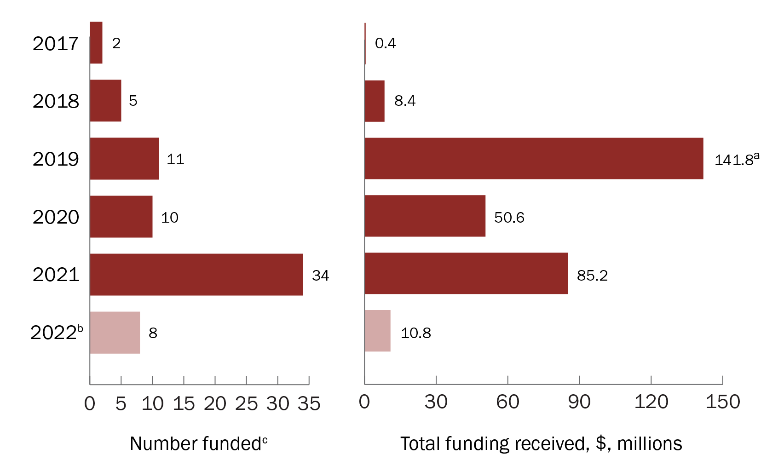

a The total for 2019 includes the 2019 Rural, Regional and Remote Clinical Trial Enabling Infrastructure grant opportunity, where $124.4 million was awarded to 3 programs to ensure that patients can access clinical trials wherever they live. Further details are provided in the highlight box ‘RRR-focused projects funded through the 2019 Rural, Regional and Remote Clinical Trial Enabling Infrastructure grant opportunity’.

b The dataset for 2022 is not yet complete and does not include data for grant opportunities that opened in 2022 and for which outcomes are not yet available or have not been announced.

c The number of projects funded includes grants with payments that commenced before or on 30 December 2022.

Figure 1 Number of projects funded and total funding received each year through MRFF RRR-focused grant opportunities

### MRFF investment by research theme

The theme with the most funded projects was ‘RRR health services for RRR people as a group and individuals’ (n = 22; 42.3% of all funded projects). However, projects within the theme ‘Clinical trials’ received the most funding ($144.9 million; 53.7% of the total funded amount). Three themes tied for the fewest funded projects (n = 2 for each), but the theme ‘Mental health’ received the least funding ($2.4 million; 0.9% of the total funded amount) (Figure 2).

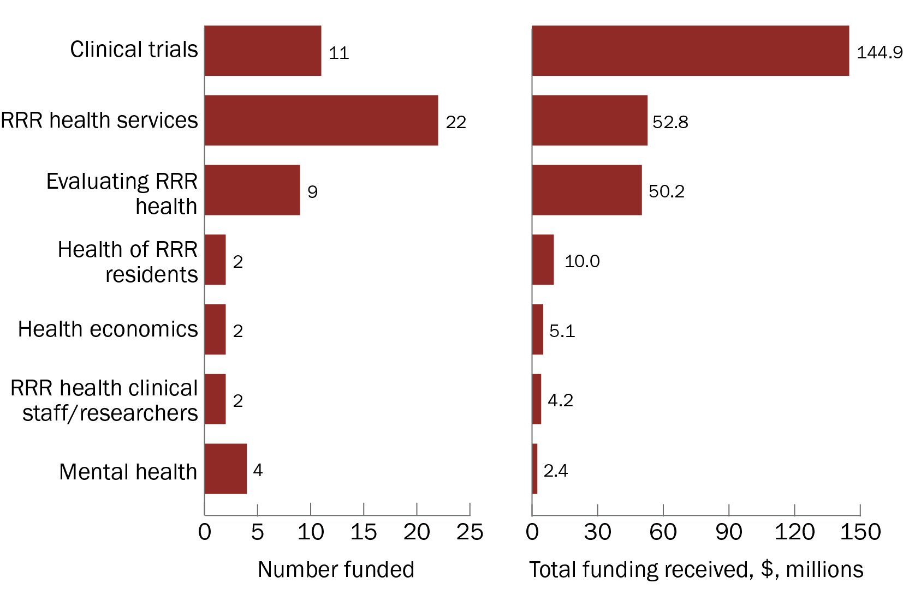

Note: The full names of the research themes can be found in the ‘Approach’ section of this report, under the heading ‘Research themes’. The dataset analysed covers grants with a focus on RRR health research or those conducted in an RRR location. This includes research focused on RRR health conducted by a lead or administering organisation that is located either in a metropolitan area or in an RRR area.

Figure 2 Number of projects funded and total funding received, by research theme

### MRFF investment by health category

The category with the most funded projects was ‘Chronic illnesses’ (n = 17; 32.7% of all funded projects), and this health category also received the most funding ($117.6 million; 43.6% of the total funded amount). The health categories ‘Genomic medicine and/or genetic diseases’ and ‘Dental health’ had the fewest funded projects (n = 1 for each), and ‘Genomic medicine and/or genetic diseases’ also received the least funding ($1.0 million; 0.4% of the total funded amount) (Figure 3).

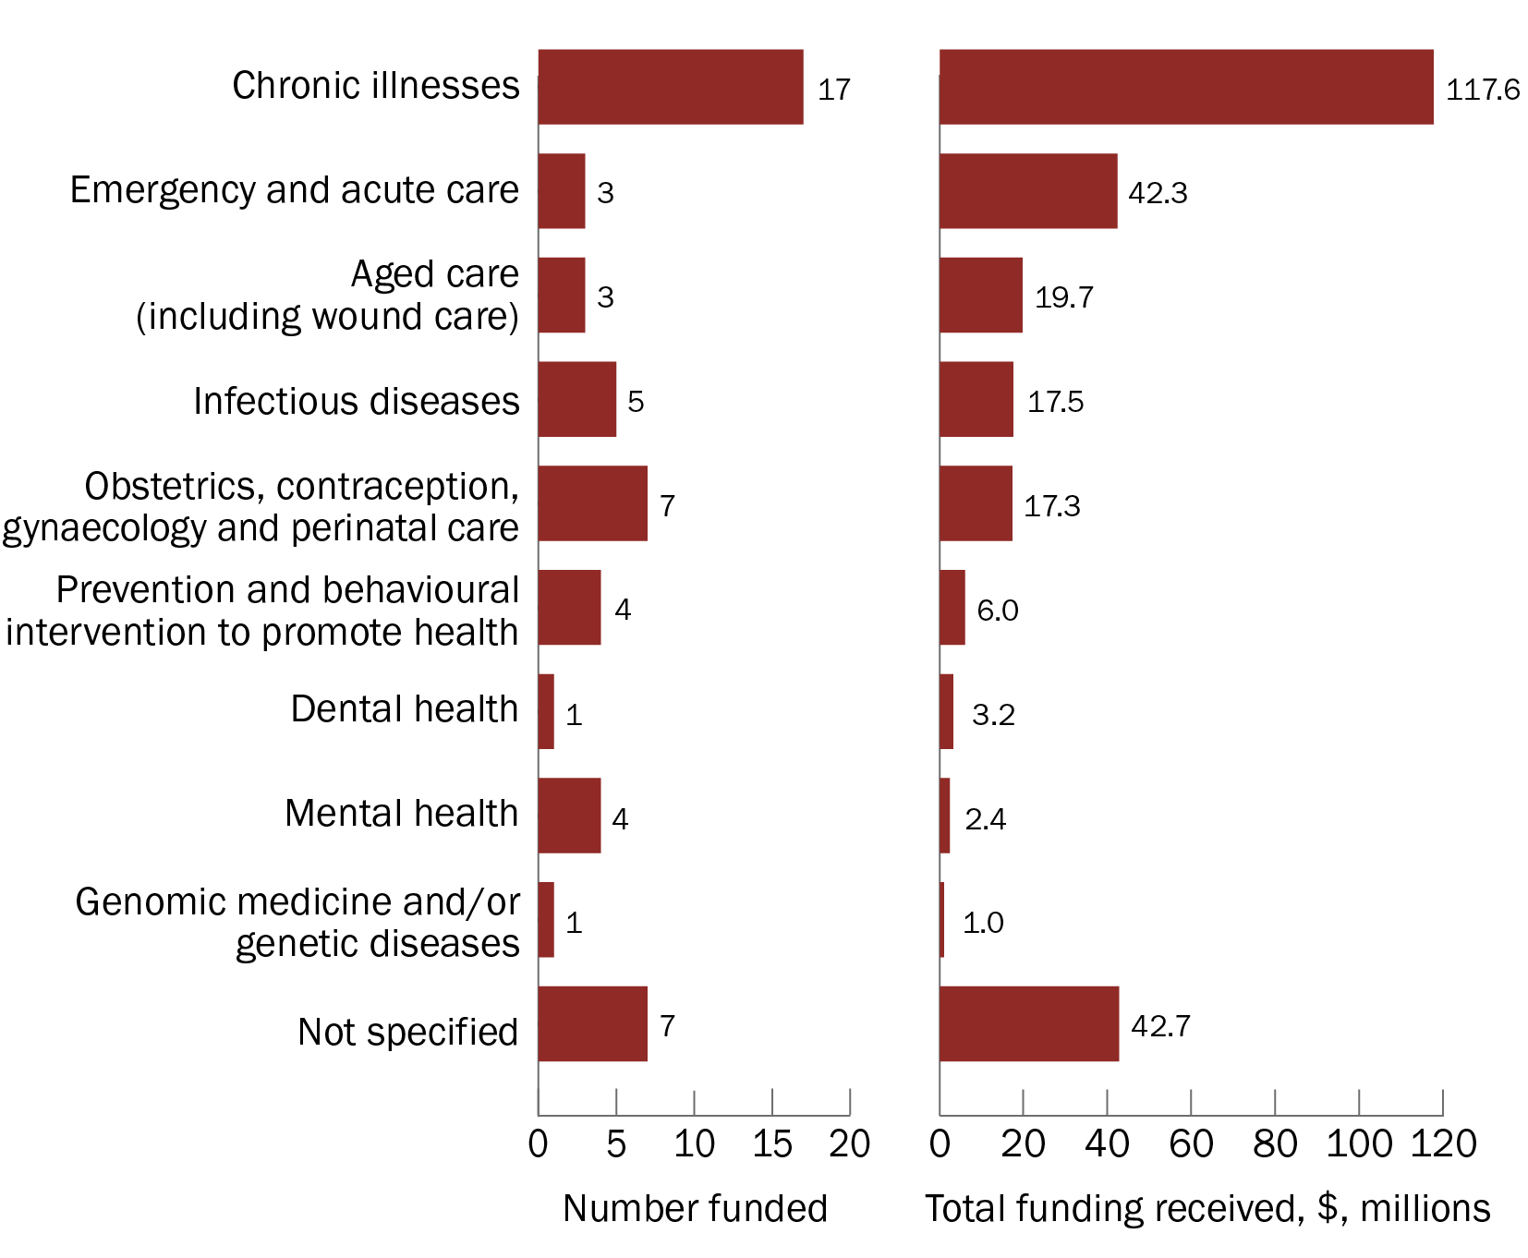

Note: The dataset analysed covers grants with a focus on RRR health research or those conducted in an RRR location. This includes research focused on RRR health conducted by a lead or administering organisation that is located either in a metropolitan area or in an RRR area.

Figure 3 Number of projects funded and total funding received, by health category

Highlight: RRR-focused projects funded through the 2019 Rural, Regional and Remote Clinical Trial Enabling Infrastructure grant opportunity

Australians in RRR areas face barriers to taking part in clinical trials, including distance, cultural differences, geographical isolation and workforce capacity. Because patients living in RRR areas have poorer health outcomes and often miss out on access to new products and treatments, it is important that access to clinical trials is supported in these areas.

To ensure patients can access clinicals trials regardless of where they live, the 2019 Rural, Regional and Remote Clinical Trial Enabling Infrastructure grant opportunity was announced under the MRFF’s [National Critical Research Infrastructure initiative](https://www.health.gov.au/our-work/national-critical-research-infrastructure-initiative). The intent of this grant opportunity was to remove barriers to participating in clinical trials by:

* improving facilities, equipment, services and systems in Australian RRR areas
* reducing the burden, costs and risk for patients and their families related to clinical trial participation
* increasing research capacity

Through the 2019 Rural, Regional and Remote Clinical Trial Enabling Infrastructure grant opportunity, 3 projects received funding totalling $124.4 million. These projects were:

* **ReViTALISE Project: Bridging the metro–regional trials gap by 2025.** This project was awarded $18.6 million and aims to
* increase trial participation in RRR areas by 2025, creating equitable access and outcomes
* improve models of care for Indigenous, palliative-care and supportive-care patients
* establish new research programs in older patients
* improve research literacy in the regional workforce with the establishment of a Regional Research Teaching Hub
* improve access to registry and immunotherapy trials
* **Australian Teletrial Program.** This program, which was awarded $75.2 million, brings clinical trials closer to the homes of RRR patients by implementing the Australasian Teletrial Model across Australia. The program creates Regional Clinical Trial Coordinating Centres to support clinical trials to adopt a scaled-up Australasian Teletrial Model
* **Rural, Regional and Remote Clinical Trial Enabling Program.** This proposal, led by NSW Health and ACT Health, was awarded $30.5 million and will address clinical trial inequality for 1.8 million people in RRR areas of New South Wales and the Australian Capital Territory. This will be achieved through partnerships and initiatives, including a new model of delivery — ‘virtual clinical trials’ — that enhances traditional approaches to trials, community engagement, providing RRR-based skilled staff to support trials delivery, and professional education

## Applications received and funded for MRFF grant opportunities

### Location of lead or administering organisation — all research

Fewer applications were received from lead or administering organisations located in RRR areas classified as MM 2 and above (a total of 130 applications; 3.7% of all applications with data available) than those in metropolitan areas (3346 applications; 96.3% of all applications with data available). This highlights the need to support the entire RRR ecosystem so that it has the capacity to develop and submit competitive research grant applications. It may also reflect that:

fewer lead or administering organisations are located in RRR areas

applications are preferentially submitted through metropolitan centres

some RRR organisations apply through metropolitan-based research administration offices

Because of the lower number of applications received, fewer projects were funded from organisations located in RRR areas than in metropolitan areas (*n* = 20 compared with *n* = 669) (Figure 4). This was also reflected in the total amount of funding received; organisations in RRR areas received $39.3 million, or 2.5% of the total funded amount (for applications with data available), while organisations in metropolitan areas received $1.5 billion. However, projects from organisations in the MM 2 classification had a similar funded rate to those in the MM 1 classification, while projects from organisations in the MM 3–7 classifications had the lowest funded rate (Figure 5).

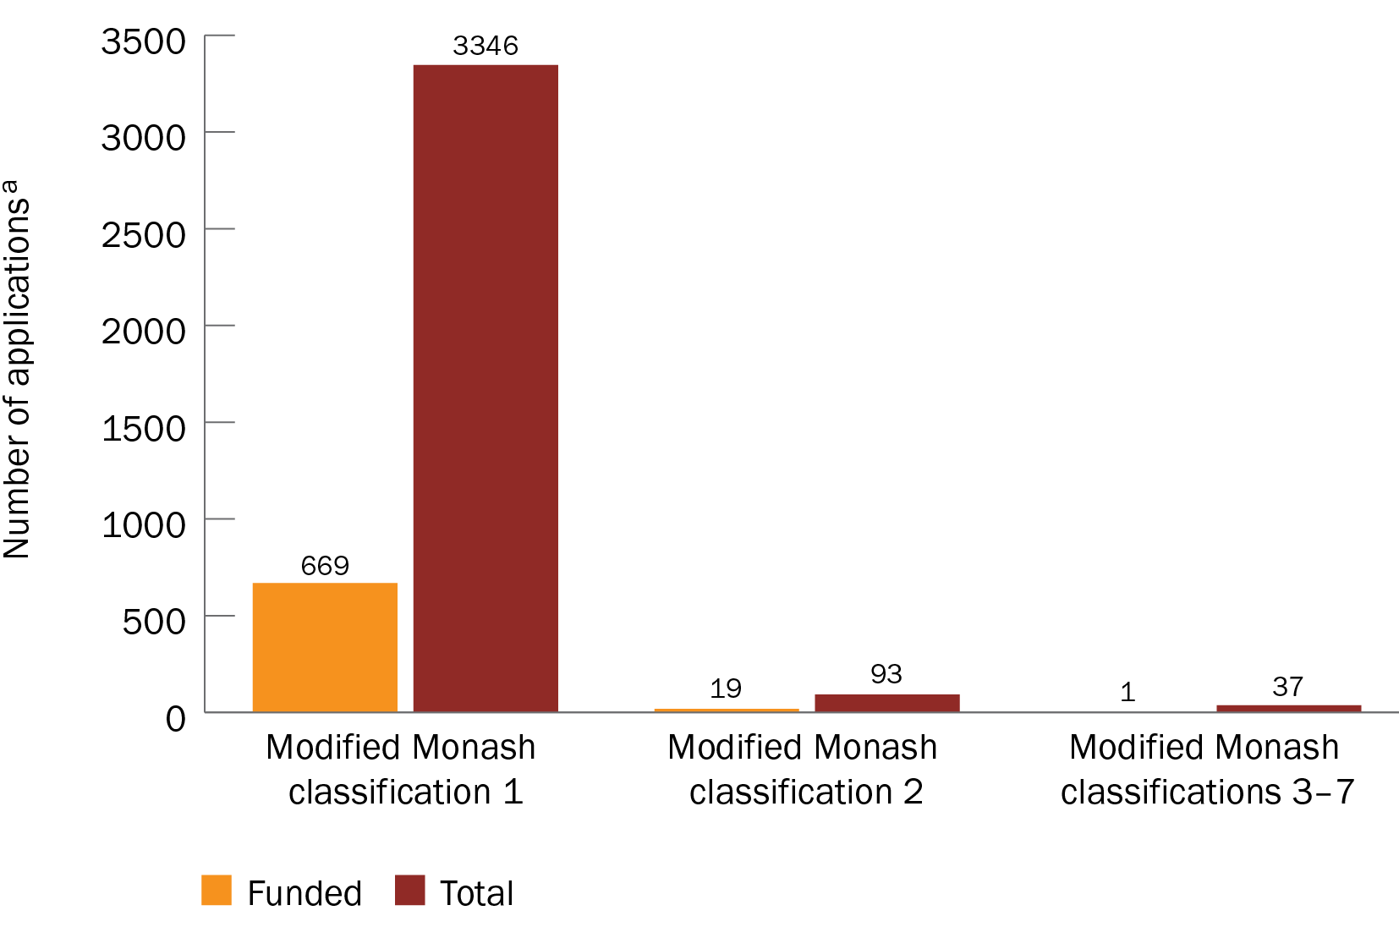

a A total of 3476 applications were analysed. See ‘Limitations’ for further details.

Figure 4 Number of applications received and funded for all research, by Modified Monash classification

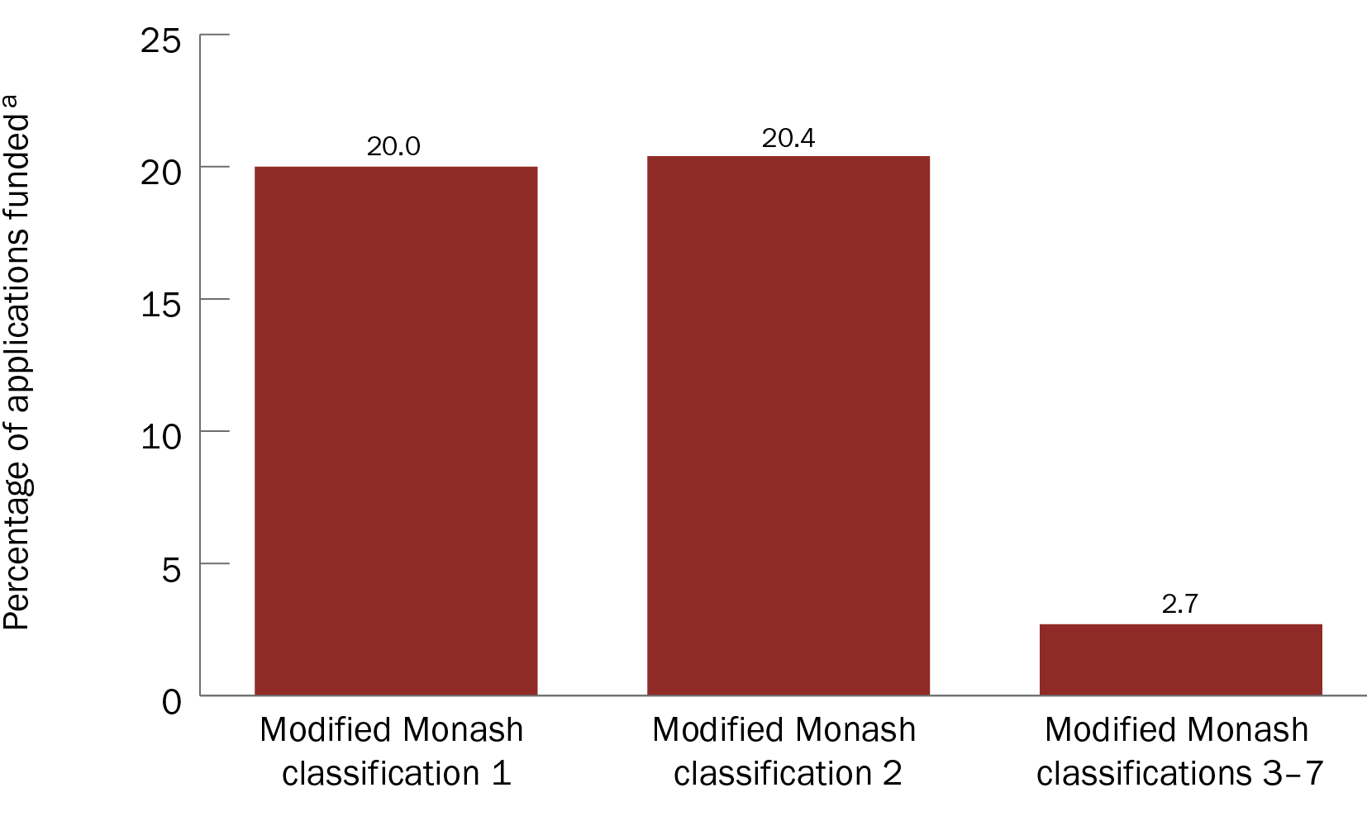

a A total of 3476 applications were analysed. See ‘Limitations’ for further details.

Figure 5 Funded rates for all research, by Modified Monash classification

### Location of lead or administering institution — RRR-focused research

For RRR-focused research projects, fewer applications were received from lead or administering organisations in RRR areas categorised as MM 2 and above (37 applications; 13.1% of all applications with data available) than those in metropolitan areas (246 applications; 86.9% of all applications with data available); the same caveats apply as for organisations performing all research. As a result, fewer RRR-focused projects were funded from organisations located in RRR areas than in metropolitan areas (*n* = 6 compared with *n* = 82) (Figure 6). This was also reflected in the total amount of funding received; organisations in RRR areas received $8.4 million, or 3.4% of the total funded amount (for applications with data available), while organisations in metropolitan areas received $241.5 million. RRR-focused projects from organisations in metropolitan areas also had higher funded rates than those in more RRR locations (MM 3–7) (Figure 7).

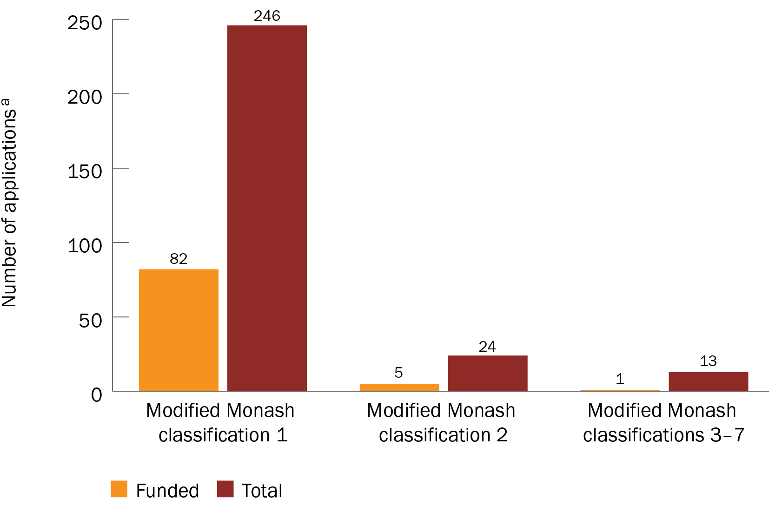

a A total of 283 RRR applications were analysed. See ‘Limitations’ for further details.

Figure 6 Number of applications received and funded for RRR-focused research, by Modified Monash classification

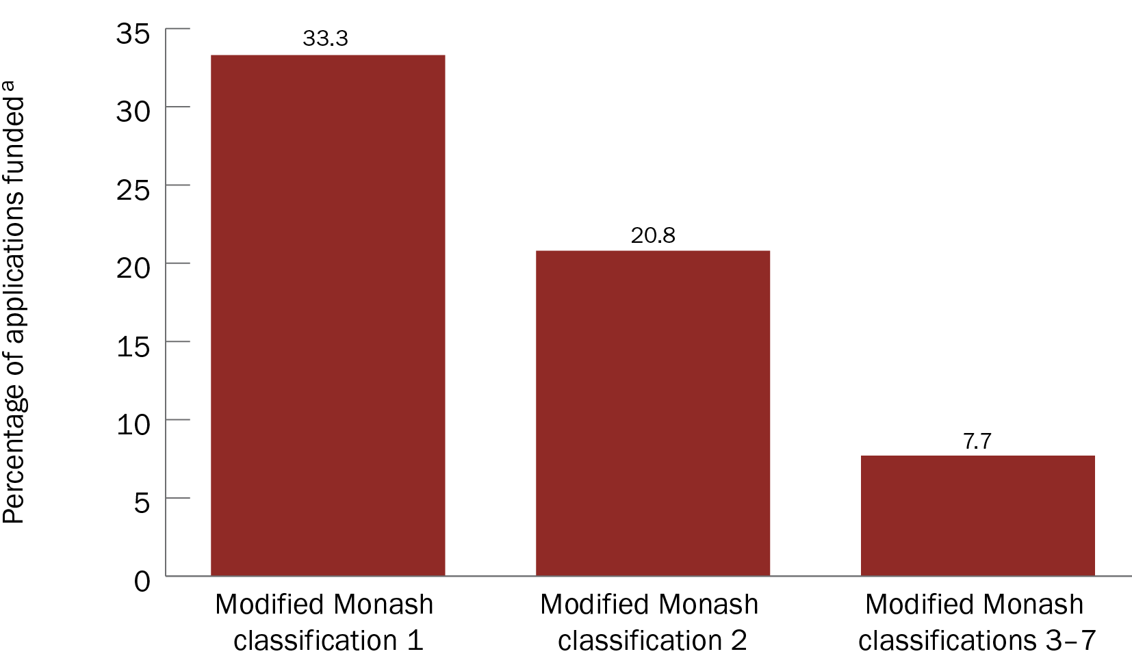

a A total of 283 RRR applications were analysed. See ‘Limitations’ for further details.

Figure 7 Funded rates for RRR-focused research, by Modified Monash classification

Highlight: RRR applicants funded through the 2021 Improving the Health and Wellbeing of Aboriginal and Torres Strait Islander Mothers and Babies grant opportunity

Organisations from RRR areas generally had a lower funded rate than metropolitan organisations. However, some grant opportunities that included an RRR-specific stream resulted in an increased funded rate for organisations located in RRR areas.

Under the MRFF’s [Emerging Priorities and Consumer-Driven Research initiative](https://www.health.gov.au/our-work/emerging-priorities-and-consumer-driven-research-initiative), the 2021 Improving the Health and Wellbeing of Aboriginal and Torres Strait Islander Mothers and Babies grant opportunity awarded $18.4 million to 5 projects. Applications were open from 12 August to 25 November 2021.

The objective of this grant opportunity was to support Indigenous-led Australian medical research projects that would improve access to culturally safe care during pregnancy, birthing and the post-natal period. Two separate streams of funding were available for this grant opportunity:

* Stream 1: The lead or administering organisation is based in any area according to the MM model locator (MM 1–7)
* Stream 2: The lead or administering organisation, Chief Investigator A and more than 50% of all Chief Investigators are primarily based in RRR areas according to the MM model locator (MM 3–7)

By making 2 streams of funding available that were based on the geographical location of the lead or administering organisation, applicants from all Australian locations — including those in RRR areas — were encouraged to apply.

The intended outcome of the research funded by this grant opportunity was to improve the health and wellbeing of Aboriginal and Torres Strait Islander families and communities through healthier mothers and babies. The objective and intended outcome of this grant opportunity are aligned with the following from the Australian Medical Research and Innovation Priorities 2020–2022:

* Aboriginal and Torres Strait Islander Health
* Primary Care Research
* Consumer-Driven Research
* Preventive and Public Health Research

The application and funding data for each stream are in Table 1.

Table 1 Application and funding data for the 2021 Improving the Health and Wellbeing of Aboriginal and Torres Strait Islander Mothers and Babies grant opportunity

| Stream | Number of applications received | Number of applications funded (funded rate) | Total funding applied for | Total amount funded |
| --- | --- | --- | --- | --- |
| 1 | 12 | 3 (25%) | $47,701,730 | $14,997,601 |
| 2 | 4 | 2 (50%) | $13,229,848 | $3,236,071 |

A total of 16 eligible applications were received for both streams by the closing date, and all the applications progressed to full assessment. Applications in stream 1 had a funded rate of 25% and received 31.4% of the total funding applied for, while applications in stream 2 had a funded rate of 50% and received 24.5% of the total funding applied for. For stream 1, one application was awarded almost $5.0 million, while for stream 2, 2 applications were awarded a total of $3.4 million.

There are proportionally fewer applications submitted from lead or administering organisations located in RRR areas than in metropolitan areas; the high funded rate for research located in MM 3–7 areas demonstrates how including RRR-specific streams in grant opportunities provides the opportunity for RRR researchers to engage in health research. Further efforts in this area should ensure that the health topics of significance to Australian RRR communities are addressed.

# Impact of MRFF investment in rural, regional and remote research

The MRFF’s measures of success are set out in the monitoring, evaluation and learning conceptual framework that is part of the MRFF Monitoring, Evaluation and Learning Strategy 2020–21 to 2023–24 (Figure 8). These measures support achieving MRFF outcomes and reflect MRFF’s vision, aims and objectives, which are articulated through 5 impact measures:

better health outcomes for patients

beneficial change to health practices

increased efficiency in the health system

increased job and export potential

economic growth from the commercialisation of health research outcomes

Embedding an RRR focus in several MRFF grant opportunities has increased the number and amount of awarded funds that support health and medical research projects undertaken in RRR areas, as well as projects that address health topics of significance to RRR communities in Australia. The success of this funding can be illustrated by mapping 52 projects identified as having an RRR health focus to MRFF’s measures of success (Table 2).

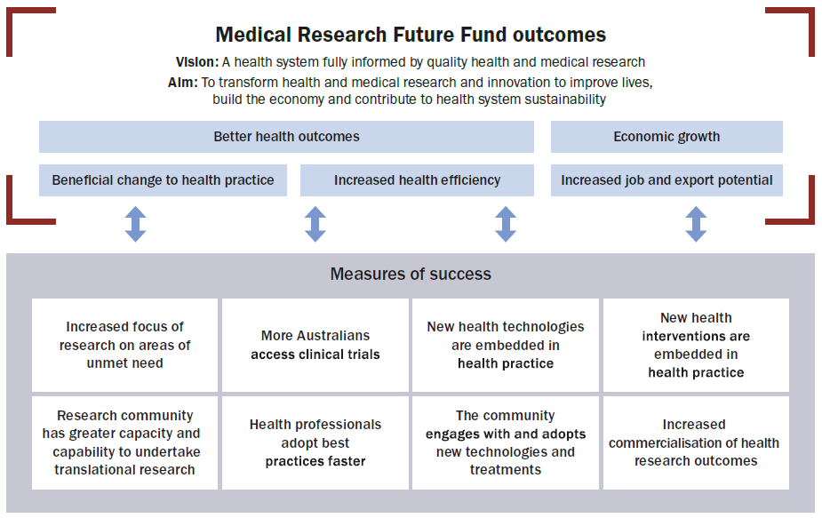

Figure 8 MRFF monitoring, evaluation and learning conceptual framework

Table 2 Mapping projects that focus on RRR health to MRFF’s measures of success

| Measure of success | Number of projects meeting the measure of successa |
| --- | --- |
| Increased focus on areas of unmet need | 22 projects (total funding $49,441,008) had a focus on Aboriginal and Torres Strait Islander health  40 projects (total funding $245,450,675) had a focus on rural and remote communities |
| More Australians have access to clinical trials | 11 projects (total funding $144,912,716) involved clinical trials and clinical trial-enabling infrastructure |
| New health technologies/interventions are embedded in health practice | 40 projects (total funding $245,450,675) deployed strategies to include traditionally under-represented groups, including strategies to support better access to health interventions or technologies |
| Research community has greater capacity and capability to undertake translational research | 6 projects (total funding $119,054,867) involved training in research translation and knowledge mobilisation |
| The community engages with and adopts new technologies and treatments | 15 projects (total funding $28,793,904) involved consumers in setting study priorities and co‑designing research |

a Figures do not sum to the total number of projects because one project can be mapped to several measures of success.

The main anticipated MRFF impact measures that may be achieved from RRR projects are:

better health outcomes

beneficial change to health practice

increased health efficiency

economic growth

As per the MRFF’s strategy, research funded through the MRFF will address ‘improvement in the efficiency and effectiveness of the health system, by promoting adoption of evidence-based practices, enabling equitable health outcomes, and focussing on the needs of patients, their families, and carers’.

Furthermore, 76.9% of RRR-focused research projects (40 projects with total funding of $245.5 million) set out strategies to support better access to health interventions or technologies. This will contribute to addressing the need to improve access to health care that meets the needs of RRR communities, and for RRR health research to be conducted by RRR health researchers in RRR areas. It also aligns with one of the priorities of the [Office of the National Rural Health Commissioner](https://www.health.gov.au/our-work/onrhc/about) to support the development, implementation and evaluation of innovative models of care in RRR Australia.

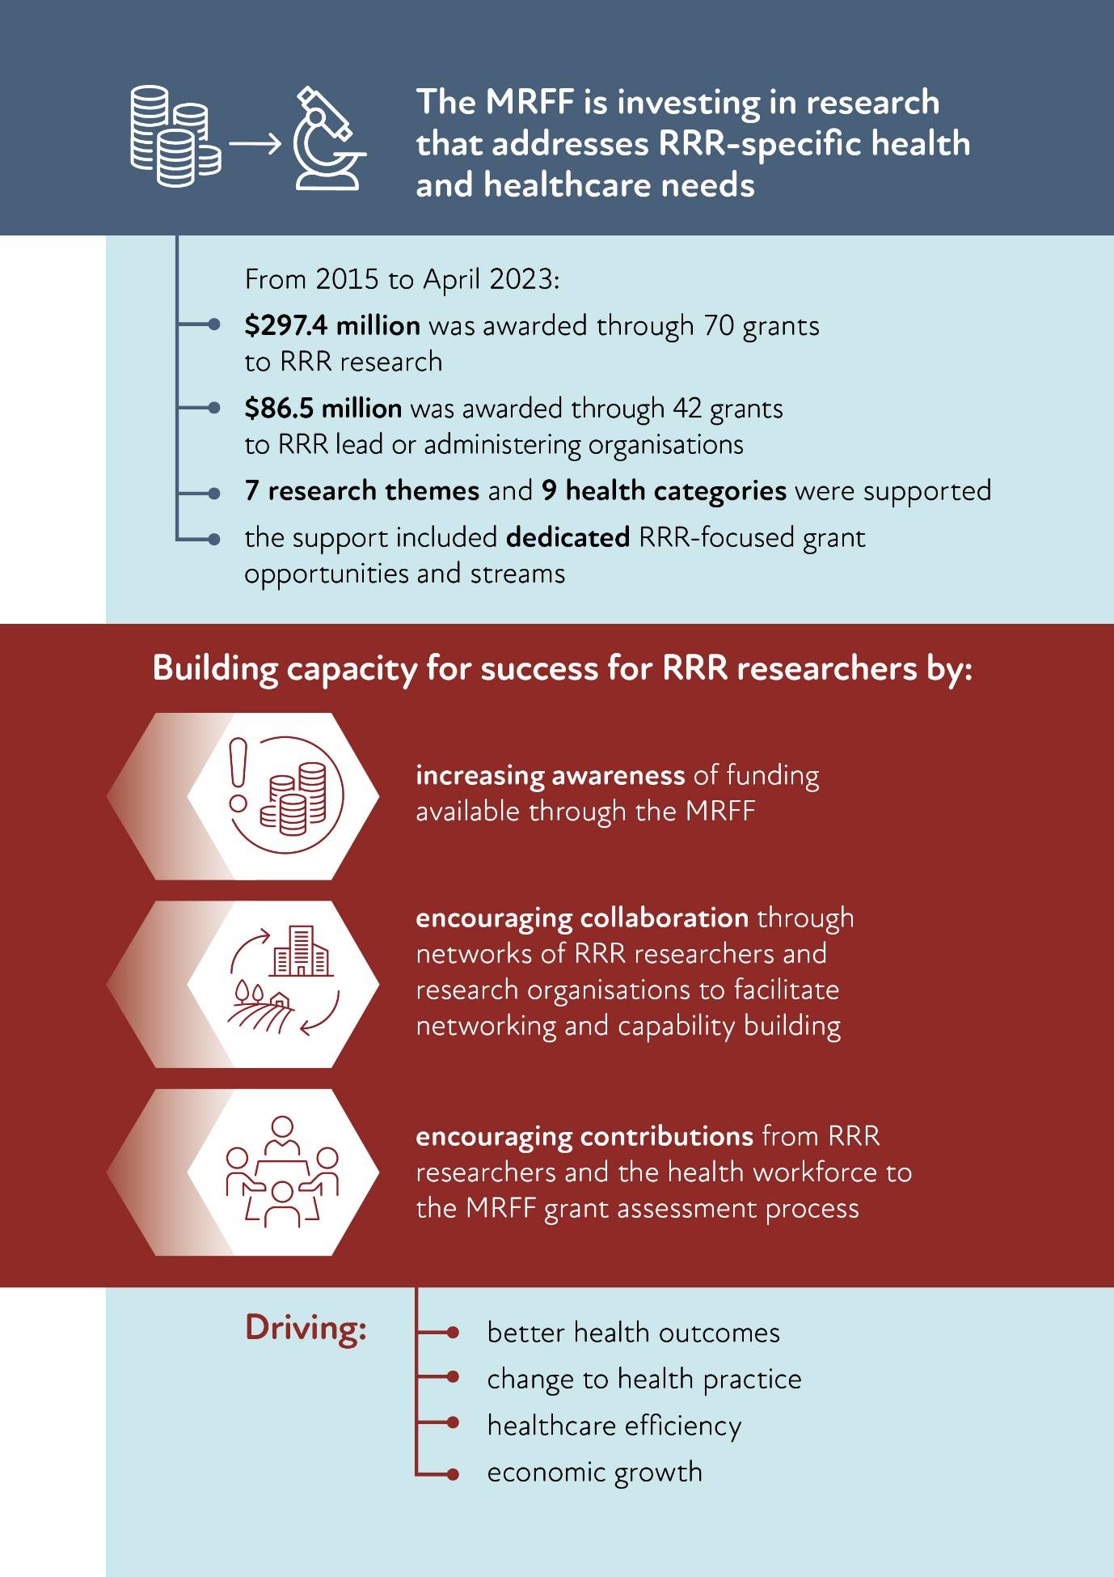

# Opportunities for learning and future funding

Although there has been an increased RRR focus embedded into several recent grant opportunities through dedicated RRR streams and/or priority populations, there are clear areas that receive limited MRFF funding. This has highlighted opportunities to further invest into areas that align with other national priorities, including:

* RRR mental health research, such as research focused on improving mental health services (including access) and RRR suicide prevention
* There is a large gap between the number of, and access to, mental health services in metropolitan areas and in RRR and Aboriginal and Torres Strait Islander communities, as outlined by the Productivity Commission’s [inquiry report into mental health](https://www.pc.gov.au/inquiries/completed/mental-health/report) (released November 2020)

Opportunities to support RRR mental health research would further complement the Australian Government’s [National Mental Health and Suicide Prevention Plan](https://www.health.gov.au/resources/publications/the-australian-governments-national-mental-health-and-suicide-prevention-plan?language=en), which sets out principles to support mental health and suicide prevention for all Australians

* research into prevention and behavioural intervention to promote health

As per the Priorities, the investments in preventive health research made through the MRFF are expected to contribute to policy objectives of the [National Preventive Health Strategy 2021–2030](https://www.health.gov.au/resources/publications/national-preventive-health-strategy-2021-2030?language=en)

* the promotion of capacity and capability in the RRR health and medical research workforce

The Commonwealth [Stronger Rural Health Strategy](https://www.health.gov.au/topics/rural-health-workforce/stronger-rural-health-strategy) is a 10-year strategy that started in 2018–19 and focuses on improving the health of people in Australia through the supply of a quality health workforce that is distributed across the country according to community need

RRR practitioners and researchers face barriers to leading or participating in research, including a lack of resources and training, and reduced workforce capacity. This may explain why relatively few MRFF applications were submitted or led by RRR organisations, and why funded rates were low for projects led by RRR organisations.

Building capacity for success may include:

increasing awareness of available MRFF funding by advertising through newsletters and peak bodies for RRR research, and by engaging and meeting with key stakeholders on the ground

* promoting collaboration through networks to leverage expertise and workforce to support the RRR health workforce and researchers in leading research projects
* MRFF applicants are encouraged to seek strategic partnerships with organisations whose decisions and actions affect Australians’ health, health policy and healthcare delivery

For grants focused on RRR research, collaborations are encouraged with partner organisations (such as healthcare providers) whose decisions and actions support the implementation of research that addresses the specific health and healthcare needs that are of priority for people in RRR communities

* increasing the engagement of RRR researchers and the healthcare workforce in the MRFF grant assessment process
* The MRFF’s grant assessment processes embrace diverse perspectives, including from alternative disciplines, industry, healthcare professionals and consumers

It is not essential to have a research qualification to be a part of [MRFF Grant Assessment Committees](https://www.health.gov.au/resources/publications/mrff-grant-assessment-committees) and contribute to MRFF grant assessment

The MRFF invites participation from a broad range of expertise areas, as well as the involvement of RRR consumers, to assess projects against technical and non-technical criteria, with a strong focus on impact and value

# Conclusions

Since its inception, the MRFF has increased investment into RRR research that has the potential to deliver better health outcomes, beneficial changes in health practice, increased health efficiency and economic growth. However, more needs to be done to support RRR organisations to apply for MRFF grant opportunities, and to bridge the funded-rate gap that especially exists for MM 3–7 areas.

The MRFF is committed to creating opportunities for RRR organisations by providing dedicated funding for RRR research through a range of approaches, and continuing to ensure eligibility criteria for RRR grants to maximise applications from RRR researchers. Approaches include separate streams of funding for research that is important to RRR communities and promoting RRR research led by organisations and researchers who reside in RRR areas.

By developing grant opportunities that are focused on RRR research, the MRFF aims to:

encourage RRR researchers and the healthcare workforce to apply to MRFF funding opportunities (researchers are invited to [subscribe to the MRFF newsletter](https://www.health.gov.au/using-our-websites/subscriptions/subscribe-to-mrff-newsletter) to be notified of new grant opportunities, and to note that information on all open MRFF grant opportunities is available on the Australian Government’s [GrantConnect website](https://help.grants.gov.au/))

encourage collaboration through networks of RRR researchers and research organisations (including through the RRR research translation centres) to facilitate networking and capability building, and to leverage expertise and workforce while the research is undertaken by RRR researchers and the RRR health workforce

increase research investment to empower RRR researchers to conduct research that addresses the specific health and healthcare needs that are of priority for people in RRR communities

This will ensure that the MRFF continues to support research that addresses specific health and healthcare needs that are of priority to people living away from metropolitan centres, and address the known health disparities that exist between metropolitan and RRR communities.

With poorer health outcomes, there are clearly important issues that are specific to RRR communities, and RRR-focused research is required to bridge the health gaps between metropolitan and RRR areas. For example, research into improving mental health services and outcomes in RRR settings should account for the unique characteristics of RRR communities, to establish prevention and behavioural interventions that are relevant to RRR settings. Providing funding opportunities for research conducted in RRR areas will also likely lead to sustainable development of research capacity in those areas.

# Appendices

Appendix A  Modified Monash Model

The [Modified Monash Model](https://www.health.gov.au/topics/rural-health-workforce/classifications/mmm) defines whether a location is a city, rural, remote or very remote. The model classifies geographical remoteness and population size on a 7-point scale (Table 3) that is based on the [Australian Statistical Geography Standard — Remoteness Area](https://www.health.gov.au/topics/rural-health-workforce/classifications/asgs-ra) framework.

People living in RRR areas find it harder to access medical services. To help address this, the Modified Monash Model was developed to better distribute the health workforce and attract health professionals to RRR areas. Some government programs also use the Modified Monash Model to define their eligibility requirements.

Table 3 Descriptions of Modified Monash Model classifications (last updated in 2019)

| Modified Monash classification | Description |
| --- | --- |
| 1 | Metropolitan areas — includes major cities |
| 2 | Regional centres — inner and outer regional areas that are in, or are less than 20 km by road from, a town with a population greater than 50,000 |
| 3 | Large rural towns — inner and outer regional areas that are not MM 2 and are in, or are less than 15 km by road from, a town with a population of 15,000–50,000 |
| 4 | Medium rural towns — inner and outer regional areas that are not MM 2 or MM 3 and are in, or are less than 10 km by road from, a town with a population of 5000–15,000 |
| 5 | Small rural towns — all remaining inner and outer regional areas and islands with a population more than 1000 |
| 6 | Remote communities — remote mainland areas and islands less than 5 km offshore with a population less than 1000 |
| 7 | Very remote communities — very remote areas and all other islands that are more than 5 km offshore |

Appendix B MRFF initiatives and grant opportunities with a rural, regional and remote focus

| Initiative | Grant opportunity |
| --- | --- |
| Clinical Trials Activity | 2022 Clinical Trials Activity |
| Dementia, Ageing and Aged Care Mission | 2022 Dementia, Ageing and Aged Care |
| Emerging Priorities and Consumer-Driven Research | 2021 Improving the Health and Wellbeing of Aboriginal and Torres Strait Islander Mothers and Babies |
| 2023 Models of Care for Sexuality and Gender Diverse People and People with Innate Variations of Sex Characteristics |
| National Critical Research Infrastructure | 2019 Rural, Regional and Remote Clinical Trial Enabling Infrastructure |
| Preventive and Public Health Research | 2018 Keeping Australians Out of Hospital — Preventative Health Research in Rural and Regional Communities (Tasmania) |
| 2019 Preventive and Public Health Research |
| 2020 Quality, Safety and Effectiveness of Medicine Use and Medicine Intervention by Pharmacists |
| Primary Health Care Research | 2019 Primary Health Care Research |
| 2021 Primary Health Care Research |
| 2021 Primary Health Care Digital Innovations |
| 2023 Primary Health Care Research |
| Rapid Applied Research Translation | 2020 Rapid Applied Research Translation |
| 2022 Rapid Applied Research Translation |
| Research Data Infrastructure | 2020 Primary Health Care Research Data Infrastructure |

1. As per the Priorities, ‘Priority populations’ is intended to be read broadly as including, without being limited to, Aboriginal and Torres Strait Islander people, older people experiencing diseases of ageing, people with rare or currently untreatable diseases and conditions, RRR communities, people with a disability, culturally and linguistically diverse communities. LGBTIQ+ communities and youth were added more recently as part of the [Principles for consumer involvement in research funded by the Medical Research Future Fund](https://www.health.gov.au/resources/publications/principles-for-consumer-involvement-in-research-funded-by-the-medical-research-future-fund?language=en).
2. The figures for funding and grants awarded are not mutually exclusive; ie an organisation that is in an RRR location (geographically) may also be conducting research that focuses on RRR health. Specifically, 20 grants, awarded a total of $50.6 million, appear in both categories.