Picture of Hearing Services Program Logo and Request Header. 
Client details questions including date of birth and voucher. (Required) 
Expiry date of current voucher. (Required) 


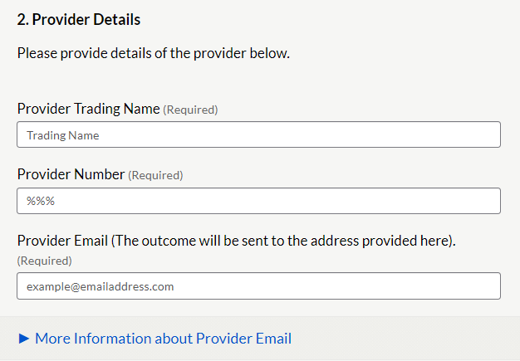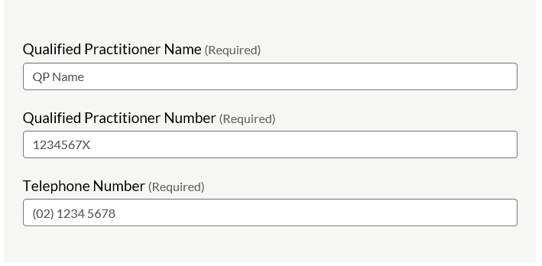

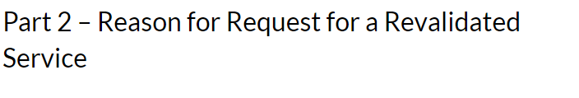Required Information for Reason A - Reassessment only.
Audiogram results, recent and previous.
Tympanometry results if bone conduction was not completed. Required Information for Reason B - Refitting
Must meet a supporting eligibility criteria. 
Claim item number to be claimed
Supporting ECR 
Clinical Justification for the refit
Evidence to support the refit
Hyperlinks to Successful submission Examples

Please select the Reason A-   Reassessment. 
List of ECR 1-5
Hyperlink to Eligibility Criteria for Refitting 
Please select Claim item number
Drop down selection box for Claim item number. (Required)
800/810 (reassessment)

Part 3 - Supporting Evidence for Reason A - Reassessment - Reassessment only. 
Link to Successful Submission example 
1. Audiogram results 
Date of previous dd/mm/yyyy
Date of most recent dd/mm/yyyy
Indicate frequencies (tick boxes 0.5kHz to 4kHz)  where deterioration ≥15dB has occurred. 
3FAHL for left and right ear.
Left ear and right ear

2. Tympanometry results if bone conduction was not completed. 
Select Tympanometry drop down. 


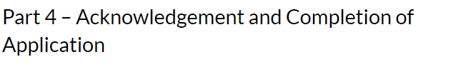Please tick the following declarations regarding: 
Retaining a copy of request on the client file.
Client meets program's MHLT requirements.
Client's hearing and health needs have changed significantly and request is urgent.
The request been discussed with the client or their POA. Has their consent been obtained? 
This request and supporting evidence are subject to compliance monitoring, including audit.
 Request content - true and correct, not contain false information. 
All of the above are mandatory checks - requiring completion of the tick boxes.

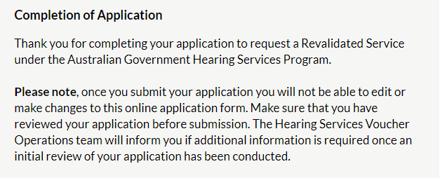

Almost done  - click 'Submit response' button.
Provide an email address to receive a receipt and a link to a PDF copy of your request.  
Email address details
example@emailaddress.com


Your Response has been submitted. 
Response ID example. ANON-numbers and letters, please have this ID available if you need to contact us. 
 
Thank you for your submission.

Please allow 10 days for an outcome to your Request for Revalidated Service application. For enquiries regarding any application please contact the Program by email Hearing@Health.gov.au, include your response ID number, client name and voucher number. 