Portal user guide – Upload a batch claims file

After you have provided a service for a client you can submit a claim for payment. A claim for payment form must be fully completed and kept on the client record. Claims can be submitted in a batch by uploading a .csv file in thecorrect format to the portal.

# Access

## What access do I need?

SP Claims

## What else do I need?

A .csv file with claims information in the correct format.

# Upload your e-claims batch file

## Step 1

Log in to the portal and open the Claimstab.

Click Batch Upload

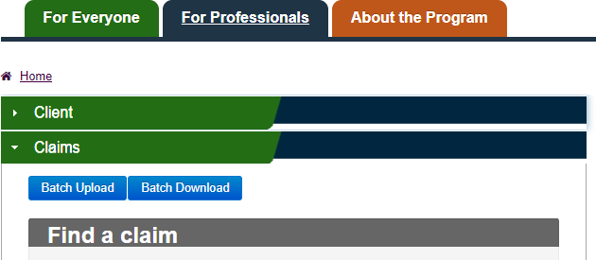

The File Uploadscreen will appear.

## Step 2

Click Choose Fileto open a File Selection dialog box, navigate to the location of your saved file, and select it. The text ‘No File chosen’ will be replaced by the title of your selected file.

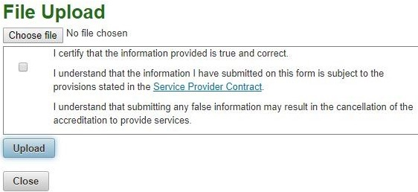

Read the certification information and check the box before clicking Upload.

When the File is successfully uploaded, a Successmessage will display on screen, inclusive of a Claims File Reference Number.

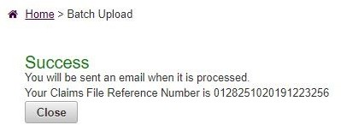

The reference numberwill also be sent as a confirmation email.

# CSV file uploaded by the provider to the portal

The file must:

* be a CSV file
* match CSV File Format
* be under 1 Megabyte

The file title must be **<96** characters (incl ‘**.csv**’).

When entering multiple claim items for a client into your e-Claim software (batch claim), please ensure they are listed in sequential order e.g. 600, 640, 777 or 710, 777 or 850, 555.

After it has been successfully uploaded, the file will be validated and processed by the system. If the uploaded file is not in the correct **CSV File Format** and does not meet the above requirements, the file, or individual claim items will be identified as invalid and rejected by the system.

Both approved and rejected claims will display in your [Batch Download](https://www.health.gov.au/resources/publications/hearing-services-program-portal-user-guide-download-a-batch-claim-response-file) file.

Below is the file format and rejection reasons for batch claims (e-Claims) in the Hearing Services Online (HSO) portal.

## CSV file format

Header record

|  |  |  |  |
| --- | --- | --- | --- |
| Field | Description | Type | Length |
| BATCH IDENTIFIER | Free text to link the upload file to the response file | Char | 20 |

Detail record

| Field | Description | Type | Length |
| --- | --- | --- | --- |
| VOUCHER NUMBER | The voucher number of the client | Char | 19 |
| SITE ID | The site the service was given at | Char | 6 |
| PRACTITIONER NUMBER | The practitioner that provided the service | Char | 8 |
| PROVIDER REFERENCE NUMBER | Provider free text to help them reconcile - not mandatory | Char | 15 |
| ITEM NUMBER | The item number of the service as per the schedule of service items | Numeric | 3 |
| DATE OF SERVICE | The date the service was given | Date | DDMMYYYY |
| 3FAHL LEFT | The 3FAHL measurement of the left ear | Numeric | 3 |
| 3FAHL RIGHT | The 3FAHL measurement of the right ear | Numeric | 3 |
| LEFT DEVICE CODE | The left device code - if applicable | Char | 7 |
| LEFT DATE OF FITTING | The date the left device was fitted | Date | DDMMYYYY |
| LEFT COST TO CLIENT | The client cost of left device | Numeric (7,2) | 10 |
| RIGHT DEVICE CODE | The right device code - if applicable | Char | 7 |
| RIGHT DATE OF FITTING | The date the right device was fitted | Date | DDMMYYYY |
| RIGHT COST TO CLIENT | The client cost of right device | Numeric (7,2) | 10 |
| MAINTENANCE COST TO CLIENT | The maintenance cost to client | Numeric (7,2) | 10 |
| TOTAL COST TO CLIENT | The total cost to client | Numeric (7,2) | 10 |

# e-Claims – reasons for rejection

If the portal rejects any claims, one of the following claim rejection reason messages will appear:

* Item claimed does not exists or was not valid at date of service
* Claim Error: Voucher does not exist
* Claim Error: Client does not exist
* Claim Error: Client has been cancelled
* Claim Error: Client/Voucher does not exist
* Site is not in the system or was not active at date of service
* QP number not linked at date of service
* Duplicate claim
* Date of Service cannot be in the future
* Date of Service: This date must be on or after the selected voucher issued date
* Maintenance amount paid by client required
* Cost to client required
* Batch claim not allowed for item number <Item number>
* Fitting date cannot be in the future
* Device not valid at date of fitting
* Device code not in the HSO system
* 3FAHLS Required
* Device details must be null for this item
* Device details required
* Device details for both sides required
* Device type must be ALD
* Hearing assessment was not claimed
* Hearing assessment was already claimed
* Is not DVA GOLD/WHITE
* Is DVA GOLD/WHITE
* Fitting was already claimed
* Previously fitted
* Not previously fitted
* Fitting configuration was not monaural
* Fitting configuration was not binaural
* Was not a new voucher
* Date of service was not on the last replacement date
* Date of service was not within 12 months prior to the maintenance expiry date
* Date of service was not after the maintenance expiry date
* Date of service was not more than 12 months after the last client review date
* Date of service was not more than 12 months after the last fitting date

Please contact the program at [hearing@health.gov.au](mailto:hearing@health.gov.au) if any further information is needed.