Portal user guide – Update your business details

Providers and device suppliers may need to update the details of their business from time to time. You can update contact details, address and trading names.

# Access

## What access do I need?

SP Admin or DM Admin

## What else do I need?

Any relevant business details which you are updating. Please ensure if you are updating the trading name that it has been registered.

# Business details page

## Step 1

Log into the portal and click Manage my Business Details.

Screenshot of the 'Manage MY Business Details' button on the Hearing Services Online portal.

## Service provider or device supplier details

These details are the details on your contract. Do not editthis information.

If this information needs to be updated, you will need to email [hearing@health.gov.au](mailto:hearing@health.gov.au)

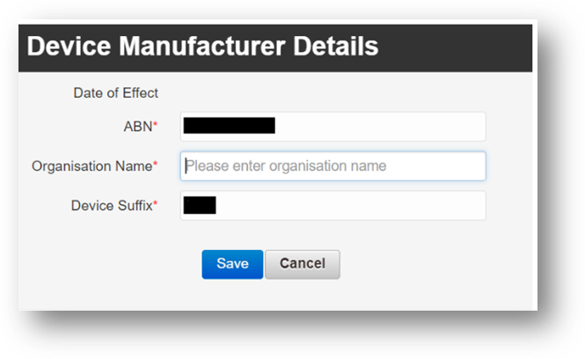

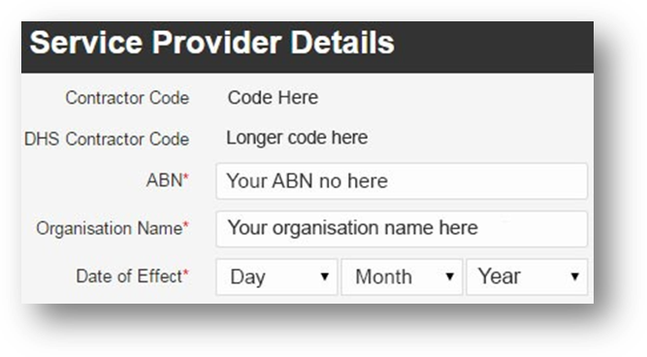

# Contact details

You can edit your contract holder details, as well as add a primary contact and, a secondary contact for your business.

## Step 2

Open the Contact Detailstab. Click Edit.

If required, update the contract holder’s details.

You can edit:

* Email address -The email address for the contract holder is the address that correspondence from the portal will be sent to. This includes emails such as notifications of client relocation.
* Nominating a different primary contact - If the contract holder is not your primary contact for the business, please untick the Primary contact is the contract holder box. Boxes will appear for you to enter the primary contact person’s details.
* Nominating a secondary contact - You can also add a secondary contact person. If you wish to do so, tick the Secondary contact details box. Boxes will appear for you to enter the secondary contact person’s details.

Click Save.

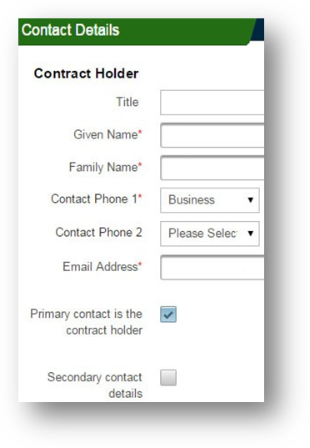

# Business and postal address

## Step 3

Open the Addresstab and click Edit.

Update the business address and click Check address. Choose whether to use the selected address, change the address or use the address as you entered it.

If your business has a different postal address, untick the Postal Address same as Business Address? Box, enter the address and Check address again.

Click Save.

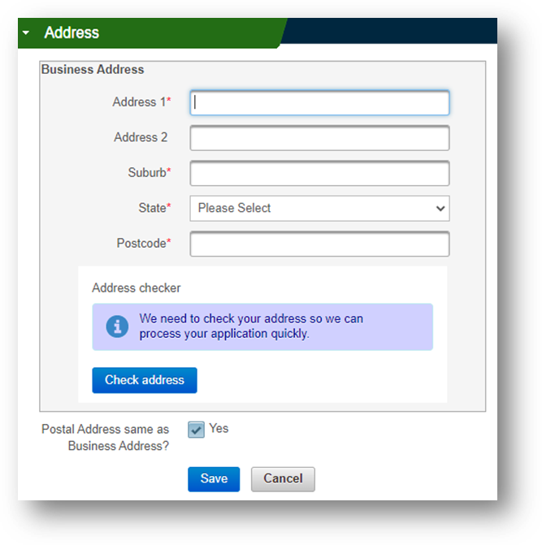

# Trading names

## Step 4

Under the Trading Names accordion, select Add new Trading Name.

Screenshot of the 'Add new Trading Name' button on the Hearing Services Online portal under the Trading Names accordion. 


## Step 5

Enter the trading name and select Save.

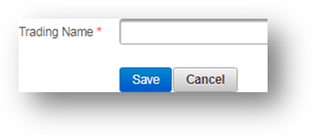

You will receive a message confirming that the new trading name has been added.

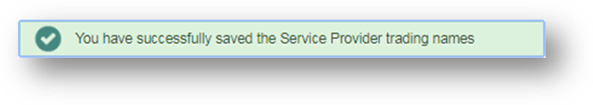

# How to make a trading name inactive

If you are selling or transferring your business, you will need to deactivate the trading name(s) that will no longer be used.

## Step 6

In the Manage My Business Details section under the Trading Names accordion, select the edit symbol next to the trading name you wish to deactivate.

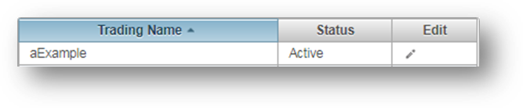

## Step 7

From the drop-down menu select deactivate. A warning message will appear to remind you to amend the site details that use the trading name.

Select Save.

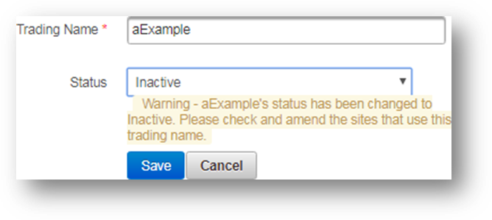

You will receive a message confirming the details have been updated.

