Portal user guide – Update client details

Clients’ details may be updated in the portal as required, this can include personal information, communication preferences and if they have passed away.

# Access

## What access do I need?

SP Site or SP Claims

## What else do I need?

You must be linked to the client in the portal.

# Client details

## Step 1

From the landing page of the portal, open the Client tab and search for the client.

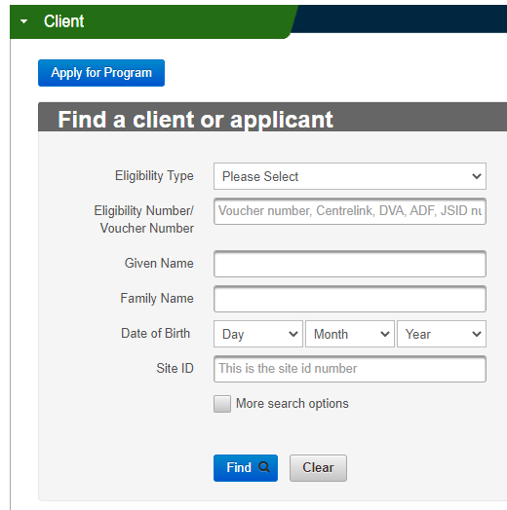

Opening the client’s page will bring up the client details screen.

## Step 2

The client’s current details are at the top of the screen. Click Editto update any of the following client’s details

* Name
* Date of birth
* Gender
* Title
* Contact number
* Address
* Specialist services (please see the ‘[update a client to specialist services](https://www.health.gov.au/resources/publications/hearing-services-program-portal-user-guide-update-a-specialist-services-client)‘ guide)

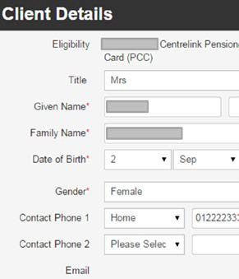

If you have updated the client’s address you will need to click Check addressand confirm the correct address.

Click Save.

# Updating communication preferences

## Step 1

Under the Client Communicationstab, Click Edit to update any of the following details:

* mark if the client lives in an aged care facility
* add an alternative contact
* update the client’s correspondence preferences
* add an email address

## Step 2

If your client would like to nominate an alternative contact, please check the box next to ‘Does the client have an alternative contact’. You will need to enter in the alternative contact’s details.

You can choose whether to send information to the client only, the alternate contact only, or to both.

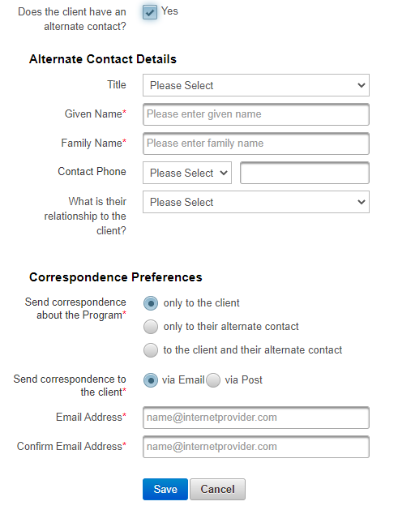

## Step 3

You can also add an email address for the client by selecting Send correspondence to the client to via Email.

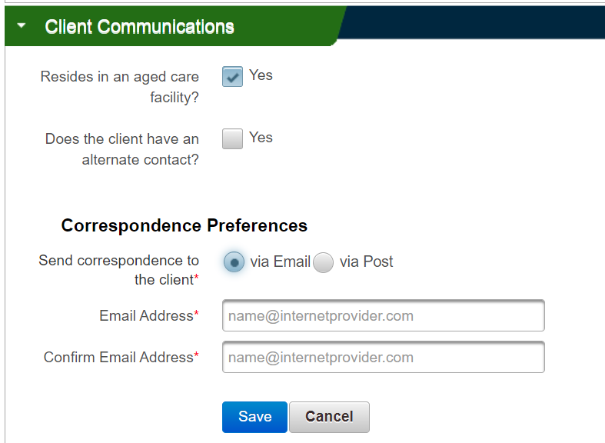

## Step 4

If the client prefers correspondence by post, you can also specify a different postal address for the client, if relevant. To do so, untick the Postal Address same as residential box and fill in the details. Click Check addressand confirm the correct address.

Click Save.

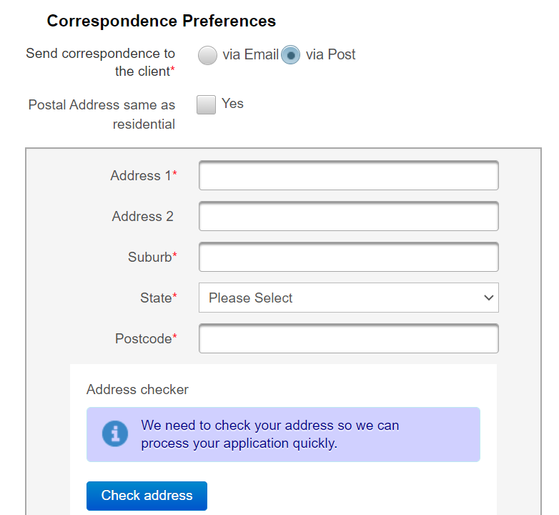

# Deceased clients

## Step 1

If your client has passed away, you need to update the portal.

Open the Change Client Status tab.

Click Edit, and in the drop down Action menu choose ‘Cancel– deceased’.

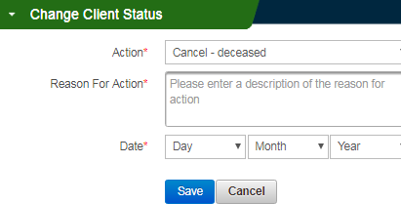

You will need to add a Reason For Action, such as “client’s family advised” and today’s date.

Click Save.