Portal user guide – Update a specialist services client

If a client becomes eligible for [specialist services](https://www.health.gov.au/our-work/hearing-services-program/accessing/cso-services), they must be informed of the services available to them, and their status must be updated in the portal.

# Access

## What access do I need?

SP Site

## What else do I need?

Notes on file to indicate why the client is eligible for specialist hearing services and their decision regarding which provider they wish to receive services from.

## Step 1

Login to the portal and open the Clienttab.

Find your client under Find a client or applicant.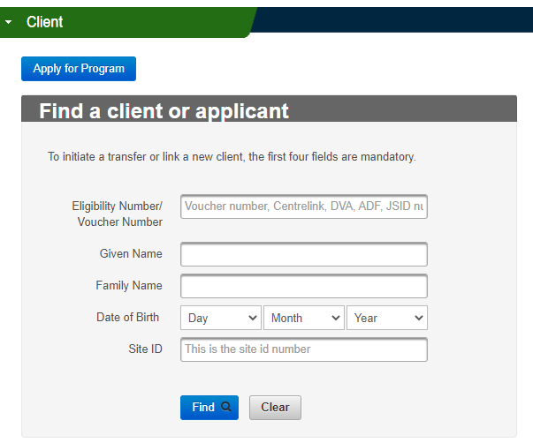

## Step 2

On the Client Details screen, click Edit.

Click the **Specialist Services** check box. The check box will be ticked and ‘Private’ (or ‘Australian Hearing’ if you work for Hearing Australia) will appear in a drop-down box.

Enter the date they were identified as a specialist services client and select the reason they are eligible for specialist services in the drop-down box.

Click **Save**.

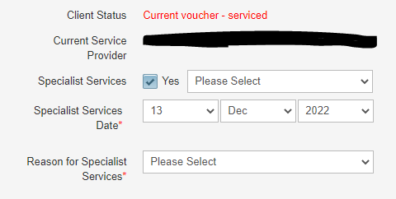

# Parallel services

If your client has an implantable device, such as a cochlear implant as well as a hearing aid, they may choose to receive their maintenance services for their implantable device from Hearing Australia but keep the services for their hearing device with a different provider. If this is the case, you will need to email [hearing@health.gov.au](mailto:hearing@health.gov.au) with “complex parallel” in the subject line to have their status updated.

# My client is no longer complex. How do I update it?

You will need to contact a user with SP Admin access within your organisation to update the status.

Simply untick the **specialist services** check box and click Save.