Portal user guide – Search, link and transfer clients

Clients should be linked to your business to make claims for services provided to them. You can link existing clients as well as transfer them to you from another provider, with their consent.

# Access

## What access do I need?

SP Admin, SP Site or SP Claims role

## What else do I need?

For a transfer, you will need a client consent form signed by the client or a power of attorney. Keep this on the client file.

# Getting to the search page

## Step 1

Log onto the portal and open the Client tab.

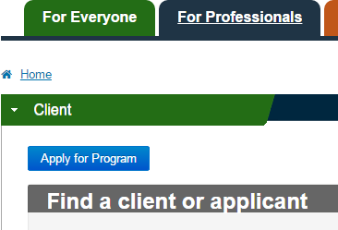

## Step 2

Search linked and unlinked clients or assist a client to apply for the program by entering at least one of the following points of identification:

* eligibility number/voucher number
* given name
* family name
* date of birth

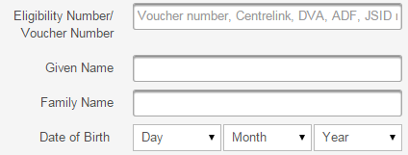

## Step 3

Click the Find button to search.

* If the criteria matches with one client, and they are not linked to you, you will be taken to the client consent screen.
* If the client is linked to you, you will be taken to the client details screen.
* If your search criteria matches with multiple clients, you will be taken to a list of records that match. Click on the surname to go to the client consent or client details screen.

# Is the client linked to you already?

* If you’re already linked, you only need one point of ID to locate the client.
* If the client is linked to another of your sites and you want them to be linked to your site you can transfer them to your site using the “Transfer To Site” button available under the Service Provider Relationship option.

Any correspondence regarding the client file will be sent to your site.

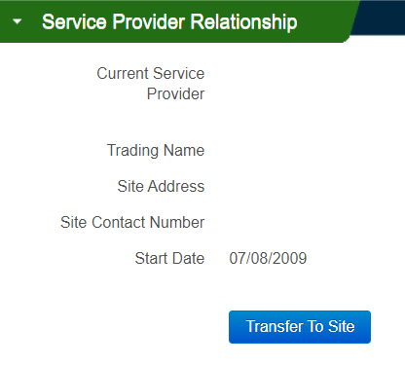

# Not linked to the client yet?

You’ll need to enter four points of ID for the client

* eligibility number or voucher number
* first name,
* last name, and
* date of birth.

These must all match the details in the portal exactlyto find the client

Note: If you’re using a voucher number to search for a client, make sure you include a hyphen ( - ) after the voucher number.

## Getting a “Can’t find a match” error?

* Reconfirm the details with the client – they must match Centrelink/DVA exactly
* If already linked, try searching using only a first or last name, or eligibility number
* Make sure they are in the correct fields and triple check for spelling errors!
* Try all four points of ID in case the client isn’t currently linked to you. If this is the case, you will need to confirm the client’s consent to transfer again and keep the written consent on file.