Portal user guide – Payments and reconciliation

You can view payment information in the HSO portal by downloading a Reconciliation Report. This report will show the claims that were included in your payment run as well as any recoveries that were deducted.

# Access

## What access do I need?

SP Claims

## What else do I need?

Payment run ID number

# Finding the payment run ID

When you receive your payment from the Reserve Bank, it will include a 16 digit “Payment Run ID” on your bank statement. It will start with your 4 digit contractor code (e.g. 012300000001001).

Alternatively, you can find the payment run ID displayed for each paid claim in the client profile claim information list.

## Step 1

Log in to the portal, open the client tab and search for a client.

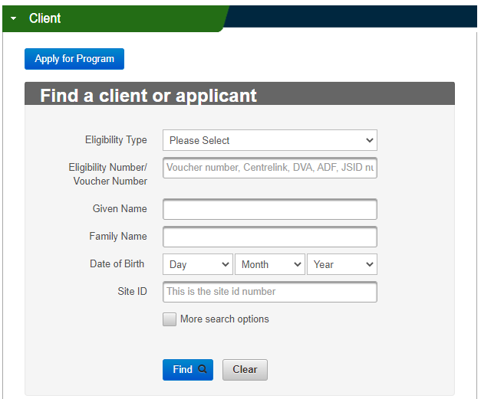

## Step 2

Click the View All at the bottom of the Claims History tab.

Screenshot of the View All, Manual Claim, Export buttons at the bottom of the Claims History accordion.

## Step 3

The payment run ID will display under the ‘Payment Run ID’ column.

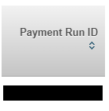

Note:A payment run ID is NOT the same number as the Claims File Reference Number that is issued when you upload your batch file.

Payments will include

* approved batch claims
* approved portal claims
* recoveries

Your payment will be the sum total of approved claims minus the sum total of recoveries.

Note: there may be more than one batch of claims included in each payment i.e. if you process two batches today, approved claims from both as well as any approved portal claims will be included in your next payment run.

Generally, payments will be made each business day. Payments are not processed on public holidays or during the end of year Government shutdown period between Christmas and New year.

# How to see what claims relate to your payment

## Step 1

Log in to the portal and open the Claims tab.

Enter your Payment Run ID (as described above) into the search field under ‘Claims’ in the portal and it will give you a list of all claims and recoveries attached to this payment.

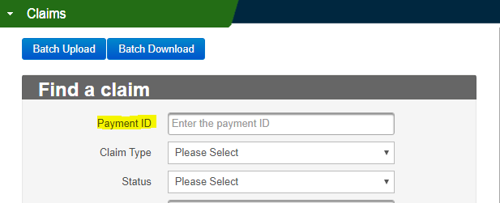

## Step 2

Click the Reconciliation button to download your reconciliation report.

Screenshot of the Export, Reconciliation and Cancel buttons on the HSO portal. 

## Step 3

Your Reconciliation Report will now download to your device.

Screenshot of an example downloaded Reconciliation Report in .xlsx format. 

Open the downloaded file to view your report. The report will display a list of approved and recovered claims included in your payment. It will also display summary information at the bottom of the document.