Portal user guide – Manage devices

Device suppliers may wish to add, view, edit or remove devices from the Schedule of Approved Devices under the program.

# Access

## What access to I need?

DM Admin

## What else do I need?

Information about the devices that you wish to update.

# Managing your devices in the portal

This user guide will assist you in:

* Adding a new device
* Viewing or amending existing devices
* Changing a partially subsidised device to the fully subsidised Schedule
* Removing devices

## Adding a new device

### Step 1

Login to the portal and navigate to the Devices tab, click the Register Device button.



### Step 2

Enter the required information for the device in the text boxes or using the drop down menus:

* Date of effect
* Trading name
* Model
* Category
* Type
* Schedule
* Compatible with app, remote control, remote programming
* Rechargeable batteries
* Fitting range

### Step 3

Certify the device meets the minimum specifications as outlined in Schedule 3 of the [Deed of Standing Offer](https://www.health.gov.au/resources/publications/hearing-services-program-deed-of-standing-offer-2020).

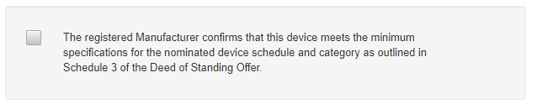

Click Submit Device if only adding one device.

### Step 4

If adding multiple device(s), click Submit Another. You will then need to enter details of additional device(s).

Repeat as required, when details of the final device are added click Submit Device.

An email confirming all devices added is sent.

## Viewing or amending existing devices

### Step 1

Login to the portal and navigate to the Devices tab and search for the device you wish to update by searching for the device (Search for the device / enter device code)

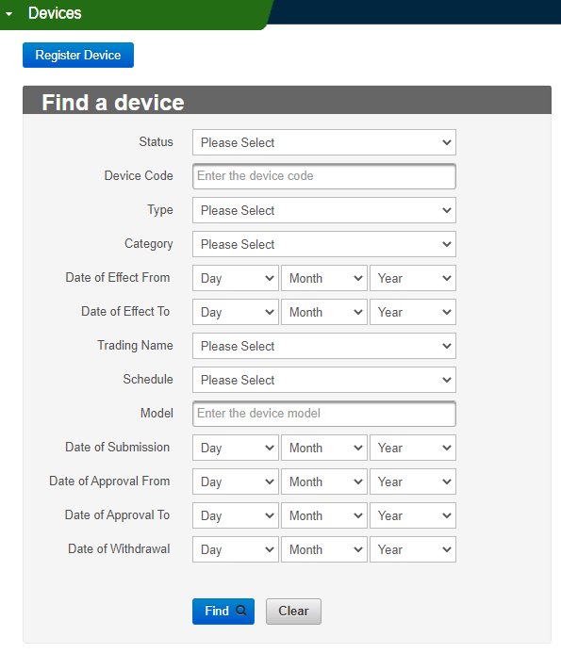

### Step 2

Click device code hyperlink to open the Device Details screen

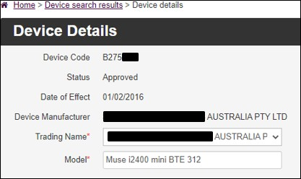

### Step 3

Click Edit button

You will be able to edit:

* the Model**\*** field (the title/identifier given to a device– each model name must be unique)
* Schedule (fully subsidised or partially subsidised)
* if it is compatible with app, remote control, remote programming
* if it uses rechargeable batteries
* the fitting range

Click Saveto confirm changes.

Details of edits made to a device display in the Device Historytab.

Note – Do notedit the Schedule* field from a partially subsidised to a fully subsidised device. See next step on how to do this.

## Changing a partially subsidised device to the fully subsidised Schedule

If you accidentally register a device on the Partially Subsidised device schedule instead of the Fully Subsidised device schedule, please email [hearing@health.gov.au](mailto:hearing@health.gov.au) with the device details and we can amend it to the correct Schedule on your behalf.

If the device has been available for some time, and has been fitted to clients, you can follow the below steps to withdraw the partially subsidised device and register a new device on the fully subsidised schedule.

### Step 1

Login to the portal, navigate to the Devices tab and search for the device you wish to change a partially subsidised to the fully subsidised Schedule, Click Find.

From the search results, click the device code hyperlink.

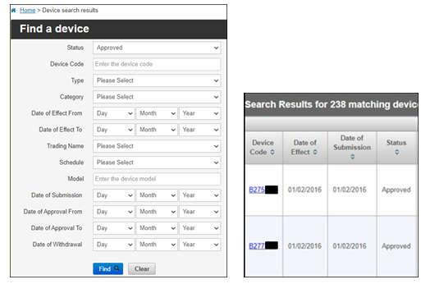

### Step 2

Click the Editbutton and tick the Withdraw Devicetick box

In the fields provided - select a Date of Withdrawal*, Withdrawn By* and Reason for Withdrawal* for the partially subsidised device and click Save.

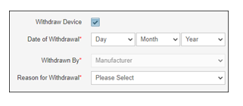

### Step 3

Open the Devicestab and click the Register Devicebutton.

Follow the steps outlined in procedure 1. Enter the details of the device, tick the statement of declaration box then click Submit Device. This will create a new device code, registering the device against the fully subsidised Schedule.

## Remove a device

### Step 1

Log into the portal, open the devices tab and navigate to the device you wish to withdraw by searching for the device (Search for the device / enter device code).

### Step 2

Click the Editbutton and tick the Withdraw Devicetick box

In the fields provided - select a Date of Withdrawal*, Withdrawn By* and Reason for Withdrawal* and click Save.

Note – date of withdrawal must be in the future

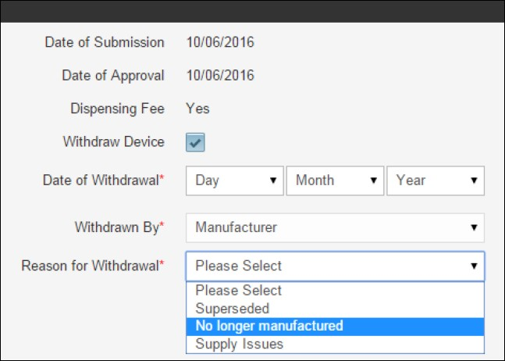

### Step 3

Click the Savebutton

You will receive a prompt advising the device has been updated.

Screenshot of the prompt indicating the device has been successfully updated. 

When the selected date has passed, the device status will automatically update to ‘Withdrawn’

### Adjustments

If you require an adjustment to the date of withdrawal, please email the program at [hearing@health.gov.au](mailto:hearing@health.gov.au)