Hearing Services Program

Portal user guide – For clients

# Introduction

This guide is intended for consumers of the Australian Government Hearing Services Program. This guide steps through how to:

* check your eligibility for the program
* apply for the program
* find a service provider
* check your voucher status and last known provider.

You will also find information on the outcomes of the eligibility checker:

* I am eligible
* I am not eligible
* I have an existing application
* I already have a voucher.

# Key terms for using the Hearing Services Program website

Below you will find some key information to help you use the website and online forms.

| What | Details |
| --- | --- |
| Service provider | This is a hearing services provider who can provide services to clients of the Australian Government Hearing Services Program (the program). |
| Alternate contact | This is a person you would like to include as an alternate contact. You can choose to have this contact person also receive copies of any correspondence you receive (for example a carer or family member). |
| Voucher | Previously, clients were sent a paper voucher to take to their preferred service provider. With the new website clients will no longer need to remember to take the voucher with them as service providers can now access an electronic voucher. |
| Local provider directory | This is an online searchable directory of all hearing services providers across Australia who can deliver services to clients of the program. |
| **Online form terms** |  |
| Online help | Throughout the website there is information included to help you complete your application or use the online forms. |
| Mandatory fields | Mandatory fields are marked with an asterisk (*). These fields need to be completed to progress to the next screen. |
| Date format | Dates are split into three separate fields for day; month; year for example 15 Sept 2013. |
| Error messages | Error messages will appear if information in a field is missing or incorrect. |

# Check your eligibility, voucher status, last known provider and apply for the program

If you haven’t accessed the program, you can check your eligibility online to determine if you are eligible for services through the program.

If you aren’t sure if you have accessed the program before, or if you have accessed the program but aren’t sure who your last provider is, you can check this online.

If you are found to be eligible, you can apply.

Follow the below steps.

## Step 1

Visit the website - [health.gov.au/our-work/hearing-services-program](https://health.gov.au/our-work/hearing-services-program)

Click the Check your eligibilitytile.

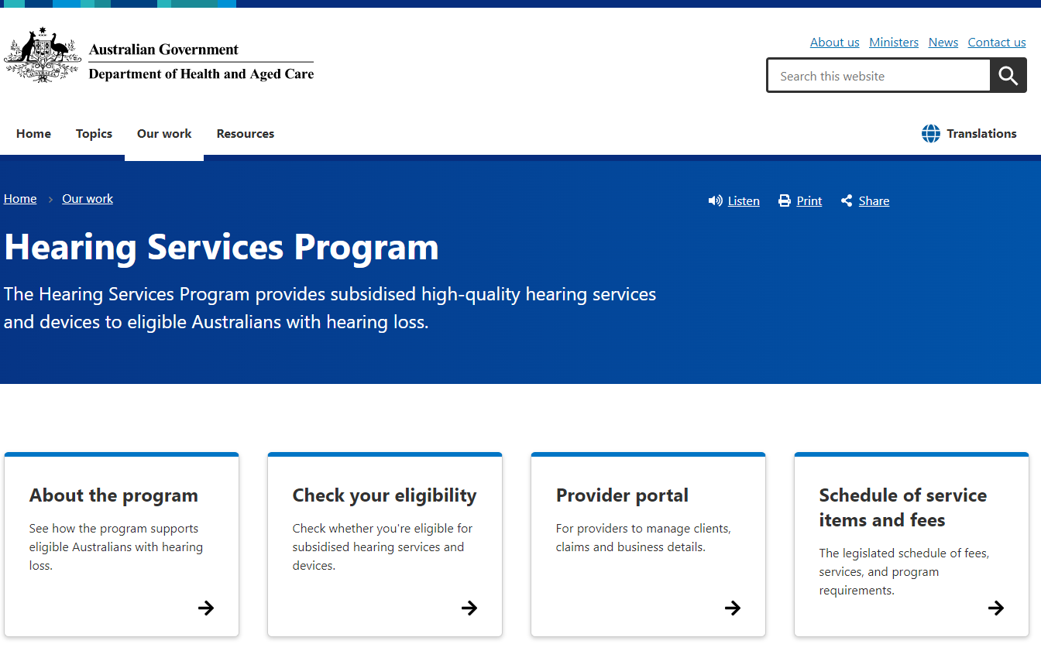

## Step 2

Scroll down and click on the ‘check your eligibility’ link.

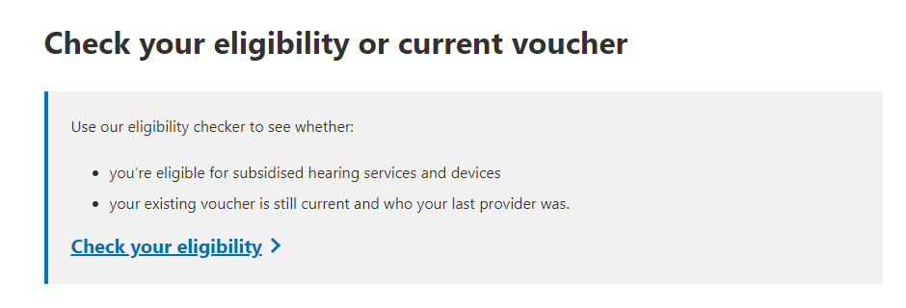

## Step 3

Click the Check now button.

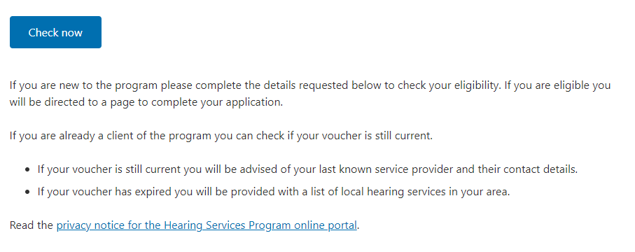

## Step 4

Enter the information required to check your eligibility for the program:

* Select your **Eligibility Type** from the drop-down menu. This is the concession or service entitlement you have.
* Enter your **Eligibility Number**. This is the reference number shown on your entitlement card.
* Select your **Title** from the drop-down box.
* Enter your **Given Name and Family Name**. This must be the same name and spelling as shown on your entitlement card.
* Enter your **Middle Name**. This is not a mandatory field, so you do not have to enter a middle name.
* Enter your **Date of Birth**.
* Select your **Gender** from the drop-down menu.

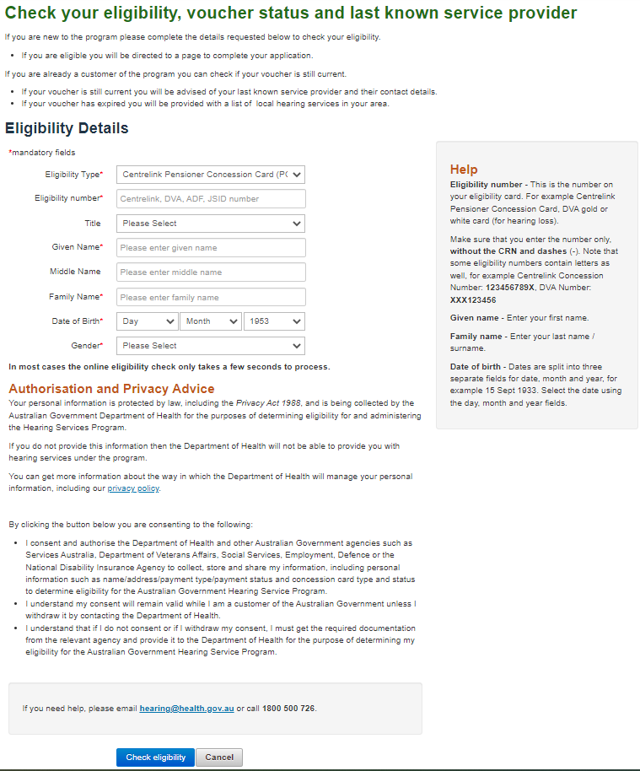

## Step 5

Read the Authorisation and Privacy Advice.

If you do not want to proceed, click the Cancel button. This will cancel your application and your details will not be saved. You will not be able to receive services through the program.

Click the Check eligibility button.

# Eligibility checker results

If you enter the information required to check your eligibility for the program, and click the Check eligibility button, you may be presented with one of the following messages:

* Eligible – you have been found eligible for the program
* Noteligible – you have been found not eligible for the program
* Existing application – you already have an existing application and should visit your chosen service provider to finalise your application
* Already vouchered – you already have a voucher for hearing services under the program.

## I am eligible

If you are presented with this screen, you are eligible for the program. You can provide contact information to continue applying for the program or click cancel if you do not wish to apply.

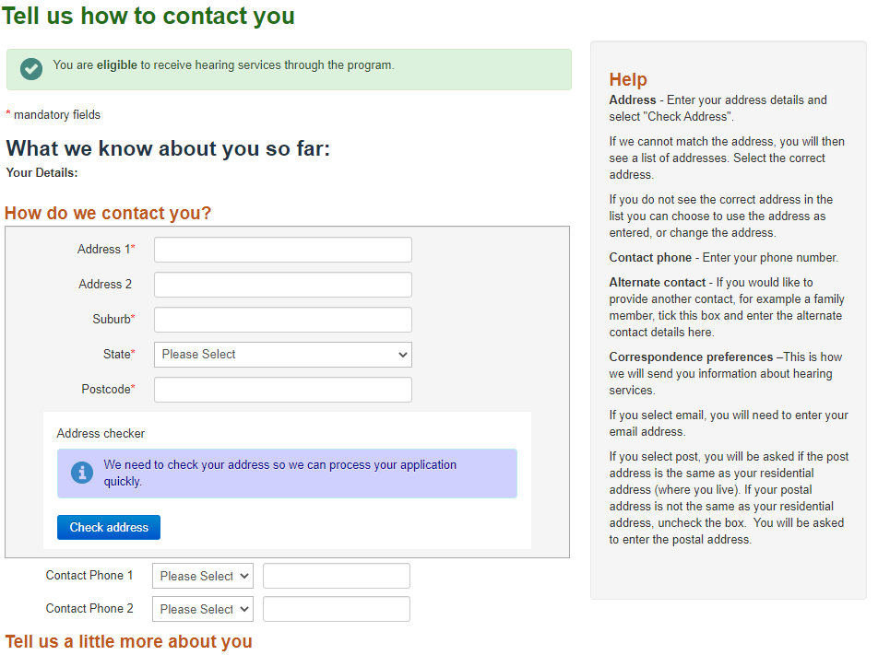

## Step 1

Enter your address and click the Check address button.

If we are unable to directly match the address, it will display a list of similar addresses in a new window.

You can use the address as you entered it, select an address from the new window or change the address. Please ensure that the address is correct so that you receive your client information.

## Step 2

Enter your **Contact Phone**, select the type of number from the drop-down list and then type the number into the space provided You can also add a second contact number.

## Step 3

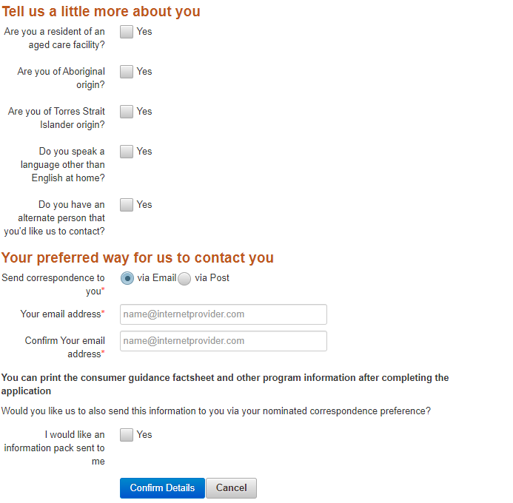

Tick the boxes if you

* are a resident of an **aged care facility**.
* identify as being of **Aboriginal origin**.
* identify as being of **Torres Strait Islander origin**.
* **speak a language other than English at home**. A drop-down list will appear. Select the language from the drop-down list. If more than one language is spoken at home, select the language used most.

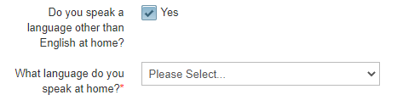

* would like to **add an alternate contact person**. Additional fields for the person’s name and details will appear. Please ensure you let the person know that you have added them as an alternate contact for the program and they may receive correspondence from us (e.g. a carer or family member).

## Step 4

If you have chosen to **add an alternate contact**, you will also be asked to tick a box for who should receive correspondence about the program. Tick the box to nominate how you would like **information sent.** Only one option can be selected.

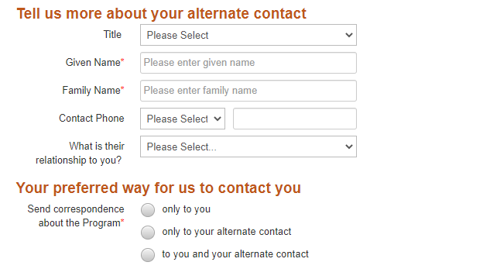

## Step 5

Select your preferred method to receive correspondence.

If it is email, you will need to add an email address and confirm the email address.

If it is via post, you will need to tick if the post address is the same as residential. If it isn’t, untick the box and enter the postal address and click the Check address button.

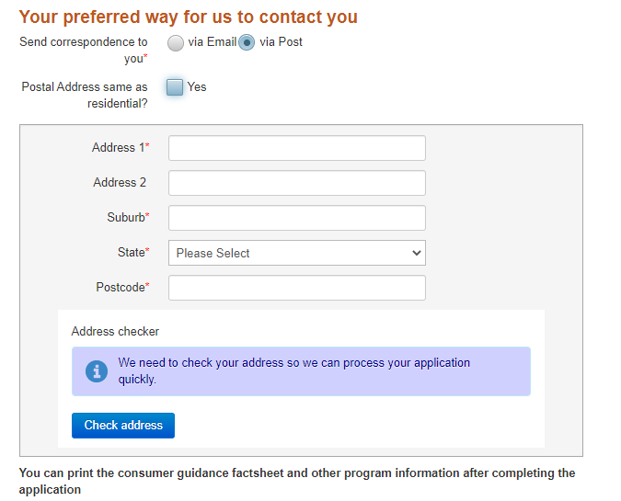

## Step 6

Select if you would like information to be sent about the program to your nominated method of correspondence.

Click the Confirm Details button to continue.

Click the Cancel button if you do not want to proceed. This will close your application and you will lose any entered information.

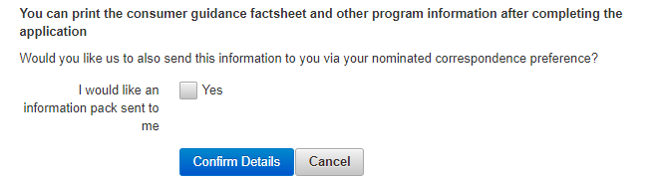

### Application results

Once you have completed the eligibility check and entered your contact details, there are two results.

#### Application saved (draft application)

Your eligibility has been confirmed, your contact details have been registered.

You will be sent an information pack, and a printout of the 20 closest service providers to the address listed in your application.

You can also use the [online provider directory](https://www.health.gov.au/resources/apps-and-tools/hearing-services-program-locate-a-provider) to find a service provider near you contact your chosen provider so that they can finalise the application process.

#### Application being processed (pending application)

Your eligibility has not been confirmed; however, your contact details have been saved. This may be due to:

* our systems are undergoing maintenance
* there are special circumstances meaning your eligibility cannot be checked at this time.

The Department will finalise the eligibility check and will let you know the outcome of your application through your preferred communication channels (email or post). We may need to confirm some of your contact details and if we are unable to do so, you may need to contact the organisation responsible for your eligibility, such as Services Australia.

Once completed contact your chosen provider

## I am not eligible

If you see this screen, it means that you have been found not eligible for hearing services through the program.

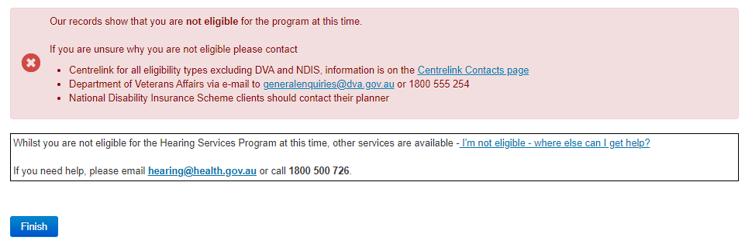

If you believe that you are eligible, you may wish to re-enter your information and re-check your eligibility. You can do this by clicking the Homelink at the top left of the screen and clicking the Apply nowbutton.

You may wish to contact the organisation responsible for your eligibility to determine why you are not eligible.

You can visit our [eligibility page](https://www.health.gov.au/our-work/hearing-services-program/accessing/eligibility) to learn about other hearing support options.

If your circumstances change you may become eligible and are welcome to re-apply for the program.

For more information check the eligibility information on the website. If you need assistance, please email [hearing@health.gov.au](mailto:hearing@health.gov.au) or call **1800 500 726.**

When you are ready click the Finish button.

## I have an existing application

If this screen appears, you have an existing application for hearing services.

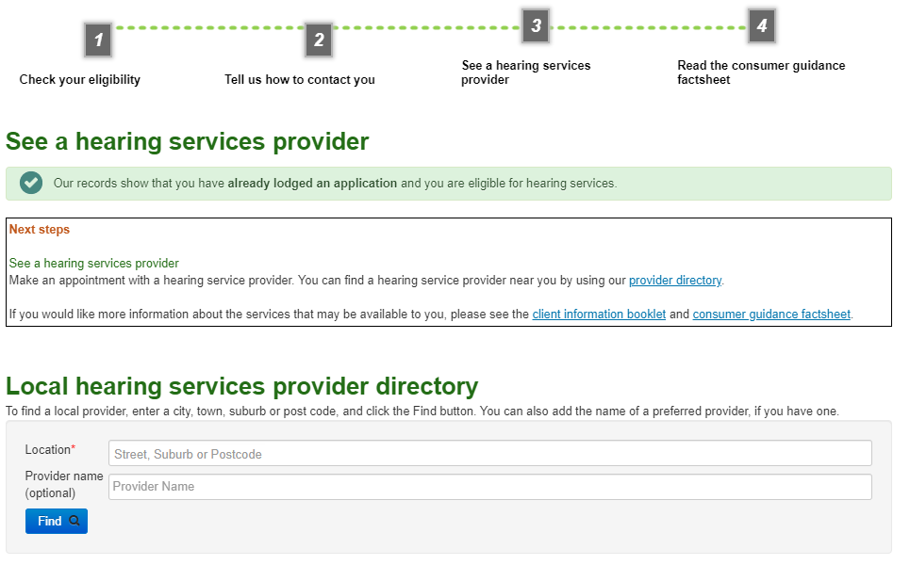

Contact a service provider to discuss your application.

If you do not already have a service provider, you can search the [online local provider directory](https://www.health.gov.au/resources/apps-and-tools/hearing-services-program-locate-a-provider). The directory will be available to you on this screen. You can search by location, and if you know the name of your preferred service provider you can include this in the search criteria.

When you have finished click the Finish button.

## I already have a voucher

If this screen appears, it means that you have already accessed services through the program.

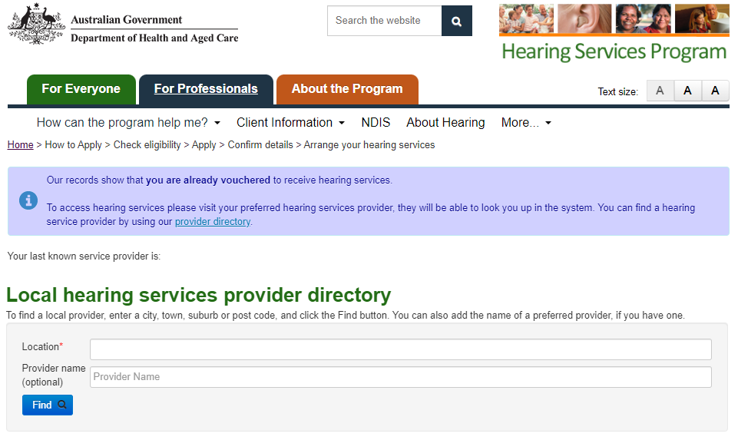

Contact a service provider to receive services.

If you already have a service provider, it will display on the screen. If you do not have a service provider, you can search the [online local provider directory](https://www.health.gov.au/resources/apps-and-tools/hearing-services-program-locate-a-provider) on the screen.

You can search by location, and if you know the name of your preferred service provider you can include this in the search criteria. To learn more about finding a service provider go to section two of this guide.

When you are ready click the Finish button.

# Find a service provider

You can search our [online local provider directory](https://www.health.gov.au/resources/apps-and-tools/hearing-services-program-locate-a-provider) to find a service provider who is able to provide services under the program.

A search will give you a list of providers nearest to your search location. The search will generally display between 3 and 20 results but is limited to searching in a 1000km radius. The list is also available in a printable format, with print options on screen.

You can also include the name of a specific service provider in your search criteria.

## Step 1

Visit the website - [health.gov.au/our-work/hearing-services-program](https://health.gov.au/our-work/hearing-services-program)

Click the Check your eligibilitytile.



## Step 2

Click on the find a provider link on the right side of the screen

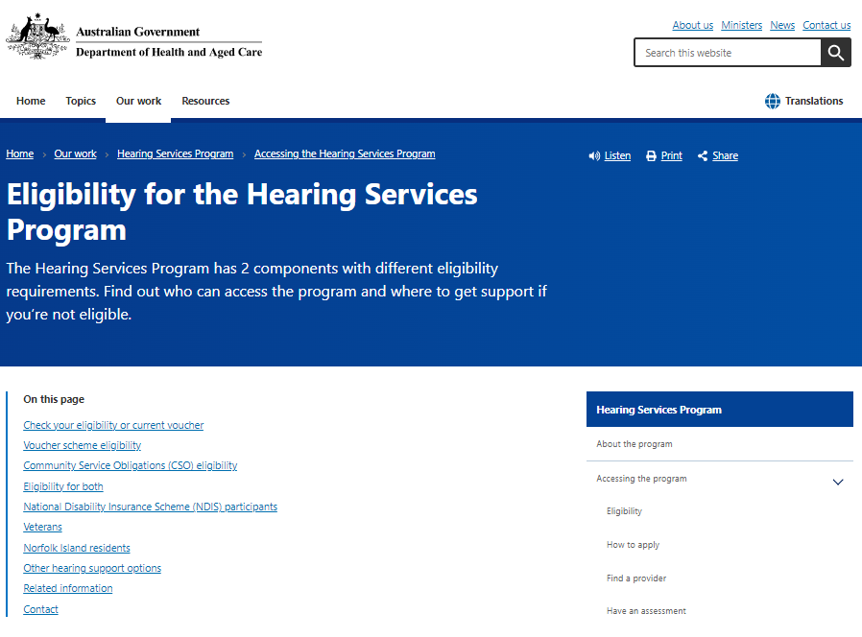

## Step 3

Click on the find your nearest provider link.

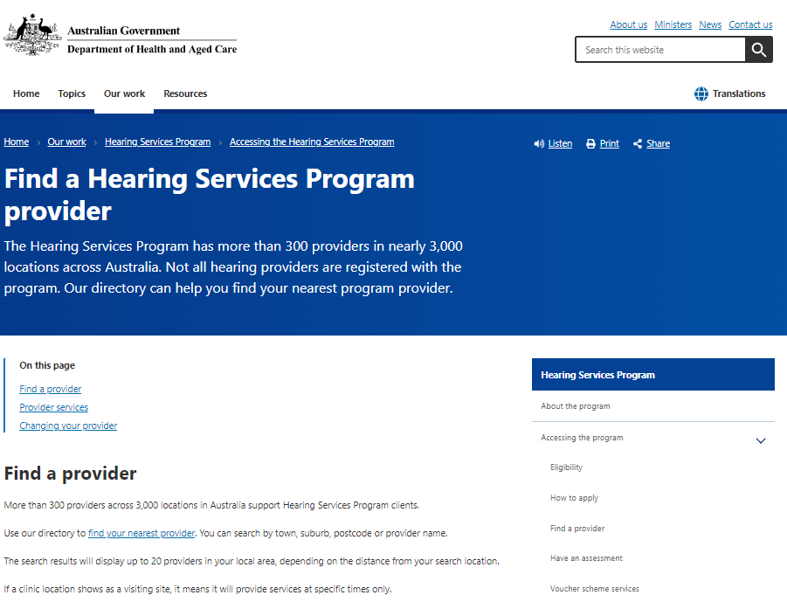

## Step 4

Click on the find a provider button.

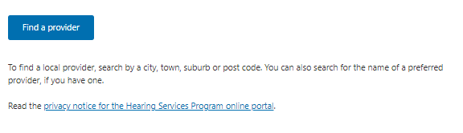

## Step 5

To find a service provider nearest to you or your preferred location, enter a **Location** (street, suburb or postcode). You can also search for a specific service provider by entering the **Provider Name**. This is optional.

As you type your location or service provider name, options that match what you are typing will appear in a drop-down list. Select the correct option from the drop-down list.

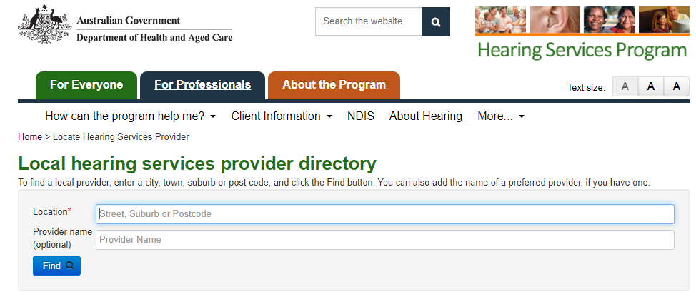

## Step 6

Click the Find button and your search results will appear.

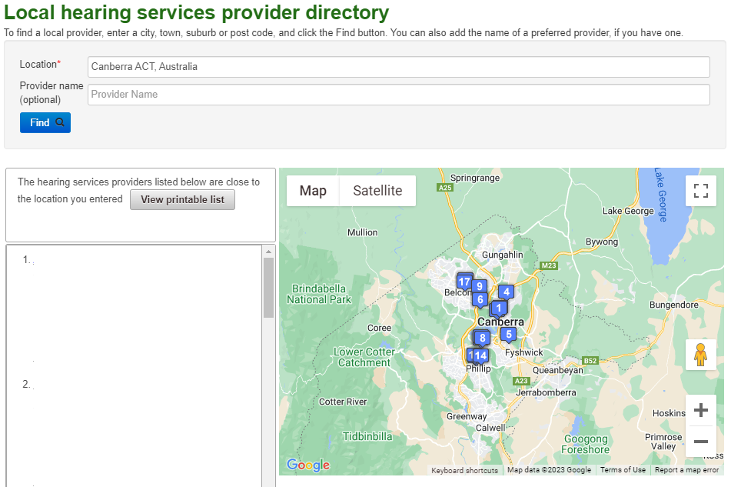

A list of service providers matching your search criteria will be listed. You can use the scroll bar on the right side of the list to view up to 20 service providers closest to the location you entered. A map of the location you entered is also displayed showing the exact location of the service providers. You can zoom in and out on the map using the plus (+) and minus (-) signs to the left of the map.

## Step 7

Click on any service provider name to view more details about that service provider. The details for the service provider you clicked will appear in the box under the map.

To match the service provider in the list to their location on the map, use the number displayed in front of their name.

You can print or save the list of providers if you need.

Click the View printable list button.

Health.gov.au/hear