Portal user guide – Finalise a draft voucher application

An application for a voucher may be in draft if it is submitted with incorrect client information and then saved for later. The draft application can be completed later when you have the client’s correct information.

# Access

## What access do I need?

SP Site

## What else do I need?

The clients consent to share their information.

# Finalising a draft application

Before finalising a draft application, a relationship with the client must be established by linking the client to your site.

## Step 1

To link a client to your site, click the Client tab, and enter the four points of identification – eligibility/voucher number, given name, family name and date of birth.

Click Find.

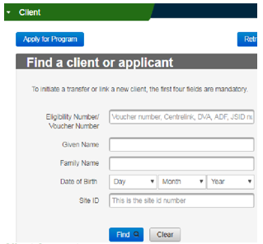

## Step 2

Select the Site ID you wish to transfer the client to and the Reason for Transfer from the dropdown.

Tick the box to confirm the client has provided consent and this has been documented on the client file.

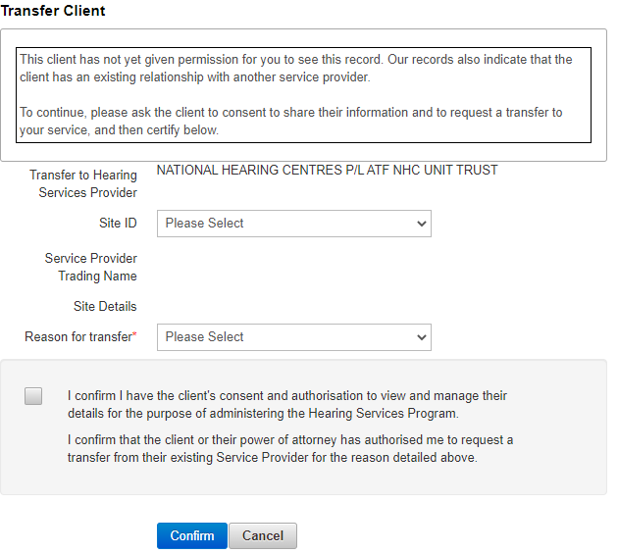

## Step 3

Click Confirm**,** the client is now linked to your business. You will receive a message confirming the client’s details have been changed. Select OK.

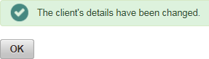

## Step 4

Open the client’s draft application by clicking on the Client tab and entering their four points of identification in the Find a client or application fields and click the Find button.

## Step 5

Review the statements and tick the box to indicate certification.

Screenshot of the tick box which certifies that the information has been entered as provided by the client. 

## Step 6

Click the Process Application button to finalise the application.

The client’s eligibility will be confirmed at this stage and if eligible, they will be issued with a voucher.

Screenshot of the Process Application, Cancel Application and Close buttons on the HSO portal. 

Click the Cancel Application button if you do not wish to proceed.