Portal user guide – Download a batch claim response file

After the portal has processed a batch claim file, you can view the results by downloading a batch response file. This file will display approved and rejected claims. Approved claims will show a claim amount. Rejected claims will show a rejection reason.

# Access

## What access do I need?

SP Claims

# Download your e-claims batch response file

## Step 1

Log in to the portal and open the Claims accordion.

Click Batch Download.

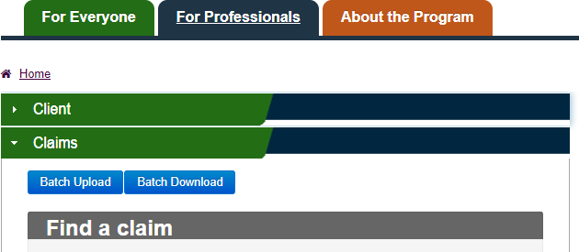

The Batch Downloadscreen will appear.

## Step 2

To access & download the batch file, enter the Claims File Reference Numberinto theLoad Numberfield.This is the number which appears on your Upload Success screen, and in the confirmation email sent to your nominated email account.

Alternatively, you can search by status, date range or Header ID.

Click Find.

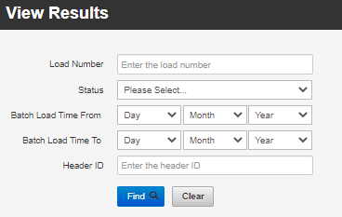

A list of batches that meet your search criteria will display.

## Step 3

Click the blue hyperlink in the load number column to download the batch response file.

Screenshot of the header bars of batch response files that meet your search criteria. Header bars (from left to right) are: Upload Log ID, Load Number, File Name, Header ID, Status, Load Time, File Rejection Reason.

Your designated Response File will now download to your device.

Screenshot of an example downloaded Response File in .csv format. 

Open the downloaded file to view the results of your batch claim. Note – A response file will only be available if the batch status is Processed. Rejected files will display a reason in the file rejection reason column. You must correct any formatting mistakes before attempting to upload the file again.

## Response file format

Header record

|  |  |  |  |
| --- | --- | --- | --- |
| Field | Description | Type | Length |
| BATCH IDENTIFIER | Free text to link the upload file to the response file | Character | 20 |

Detail record

| Field | Description | Type | Length |
| --- | --- | --- | --- |
| VOUCHER NUMBER | The voucher number of the client | Character | 19 |
| ITEM NUMBER | The item number of the service as per the schedule of service items | Numeric | 3 |
| DATE OF SERVICE | The date the service was given | Date | DDMMYYYY |
| PROVIDER REFERENCE NUMBER | Provider free text to help them reconcile - not mandatory | Character | 15 |
| RESULT | Approved / Rejected | Character | 10 |
| REJECTION REASON | Rejection reason description | Character | 250 |
| AMOUNT DUE | The total amount due to be paid | Numeric (7,2) | 10 |