Portal user guide – Confirm a return voucher

Eligible clients are issued with a 5-year voucher upon application. After this time, the voucher will expire and clients can be issued with a return voucher if they are still eligible.

# Access

## What access do I need?

SP Site

## What else do I need?

A client requiring ongoing hearing services who is linked to you in the portal. They must have an expired voucher and be eligible for a new voucher.

# Open the client details screen

## Step 1

Login to the portal, open the Client tab and search for the client using their details.

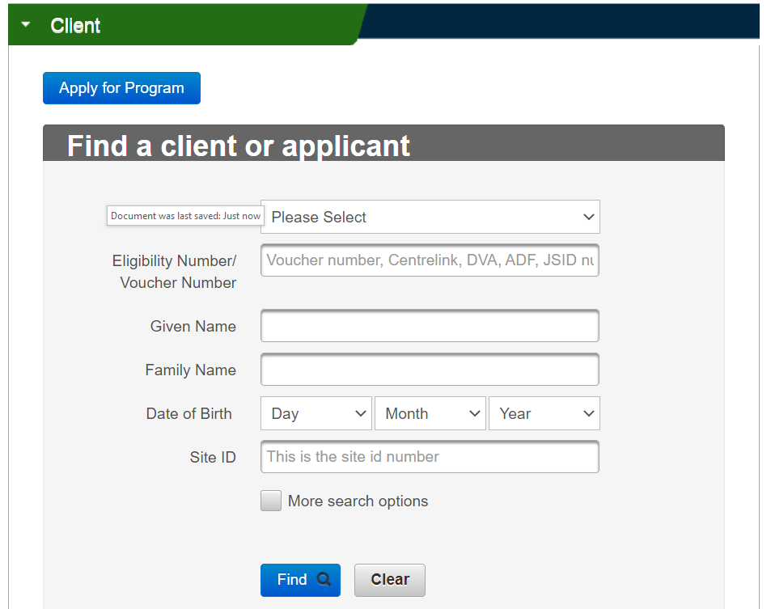

Open the client details screen.

Follow the directions in the ‘[search, link and transfer client guide](https://www.health.gov.au/resources/publications/hearing-services-program-portal-user-guide-search-link-and-transfer-clients)’ if required.

# Check current contact details

## Step 2

If the client has moved address or changed phone number, please update this information under the Client Details area.

If the client would prefer to receive correspondence via email, you can update this under the Client Communicationstab.

Follow the directions in the ‘[update client details guide](https://www.health.gov.au/resources/publications/hearing-services-program-portal-user-guide-update-client-details)’ if required

# Confirm client requires ongoing hearing services

## Step 3

Make sure you have contacted the client before you issue a new voucher.

On the Service History tab, click the Confirm Return Voucher button.

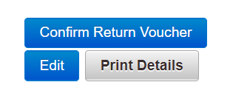

You will see a message pop up requiring you to confirm that the client requires ongoing hearing services. You must have contacted the client or their POA to confirm that this is the case prior to issuing a return voucher.

Screenshot of the confirmation message confirming that the client requires ongoing reading services. there is a confirm and a cancel button. 


If the client’s eligibility is confirmed, you will receive a confirmation message.

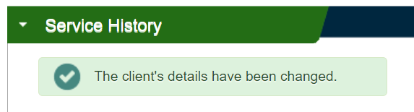

## Step 4

You can view the client’s new voucher details under the Service Historytab.

You can also use the Print Detailsbutton to create a printable PDF of this information for the client, if required.

# Client’s eligibility not confirmed

There are several reasons that the client’s eligibility may not be confirmed, and they are not issued with a return voucher.

* **Details could not be validated** – the client’s name or date of birth does not match Centrelink/DVA’s records for the eligibility number provided. Please contact the client or Centrelink/DVA to confirm the correct details. Update the details in the client details area before trying again.
* **Client no longer eligible** – a check with Centrelink/DVA has indicated this client is no longer eligible. If the client believes this is incorrect, they should contact Centrelink/DVA.
* **Confirm return voucher button unavailable** – confirm that the client’s voucher has expired at least the day before.

Note: Disability Employment Services clients must be referred by their DES planner and will therefore not have a confirm return voucher button available.