Portal user guide – Check client eligibility

Eligibility for the program is set out in legislation. The program has a tool on our website which allows clients to check their eligibility.

# Access

## What access do I need?

Access to <https://www.health.gov.au/our-work/hearing-services-program>

## What else do I need?

Client eligibility type and number, first and last name, date of birth, gender and consent.

# Check eligibility

If you are unsure if the client is eligible for the program, you can check and confirm their eligibility prior to submitting an application, and prior to providing services.

## Step 1

Visit the [program’s website](https://www.health.gov.au/our-work/hearing-services-program) and select “Check your eligibility”

## Step 2

Select the client’s Eligibility Type* from the drop down menu and enter:

* Eligibility Number
* Title (optional)
* Given Name
* Middle Name (optional)
* Family Name
* Date of Birth
* Gender

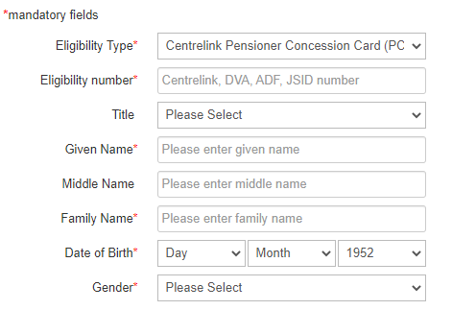

## Step 3

Read Authorisation and Privacy Advice aloud to the client.

If the client is happy to proceed, go to Step 4

If they are not happy to proceed, click Cancel. This will cancel the process and the details you have entered will not be saved.

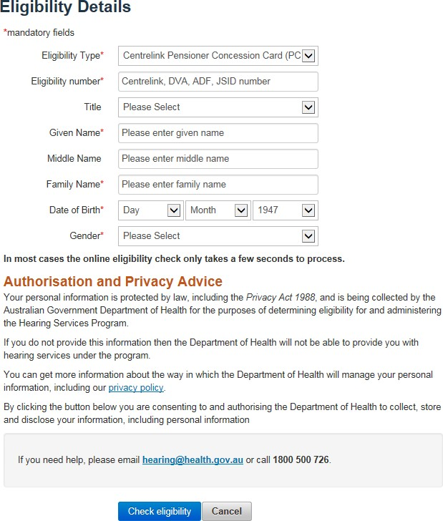

## Step 4

Click Check Eligibility.

The client’s eligibility is displayed at the top of the page. The most common include

* Eligible
* Existing draft application found
* Not eligible

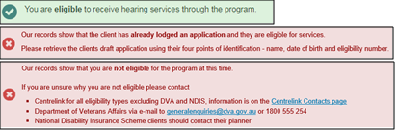

To learn how to finalise an existing draft application, please see [How to finalise a draft application](https://www.health.gov.au/resources/publications/hearing-services-program-portal-user-guide-finalise-a-draft-voucher-application)