Portal user guide – Apply for a new client voucher

Eligible program clients can only access services once they have an active voucher. If their voucher has expired, they will require a new voucher before they can receive further services.

# Access

## What access do I need?

SP Site or SP Claims

## What else do I need?

Consent from the client to apply to the Hearing Services Program on their behalf. You can obtain a signed program application form from the client or read the privacy and consent information contained on the portal application form to the client and affirm their verbal consent.

# Applying for a new client

Note - a voucher must be issued prior to any services being provided to the client.

## Step 1

Ensure that you have checked with the client to find out whether they have previously been issued with a voucher. Do not initiate a new application for the client until you have searched for them in the portal using any eligibility types relevant for the client.

Log into the portal and click Apply for program.

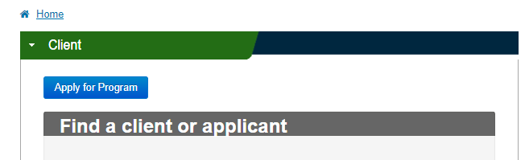

## Step 2

Select the client eligibility type and enter their eligibility number, first name, last name, date of birth and gender before clicking Check eligibility(At this point you will be told if the client is eligible for the program).

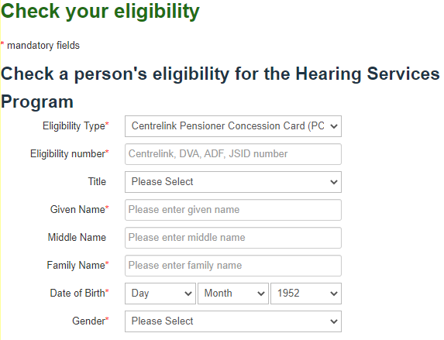

## Step 3

Enter the client’s address, contact number, tick the relevant boxes to the questions asked if applicable.

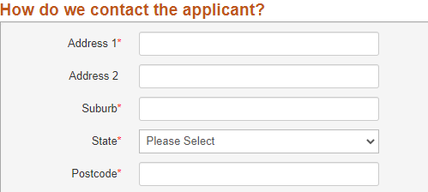

## Step 4

Tick the appropriate box for correspondence, ensuring you obtain the client’s email address if they would prefer to be contacted by email.

Ask the client if they would like to receive an information pack and click ‘Yes’ if applicable.

## Step 5

Before you submit the application, please review the details provided. If you need to amend anything, click Back and amend the details.

## Step 6

Check the certification box

Click Confirm Details.

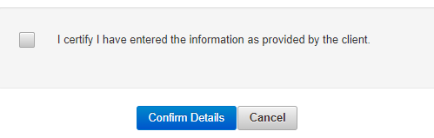

## Step 7

Review the client’s information. If all the details are correct click Process Application. If you need to amend anything, click Back on the page below, amend the details.

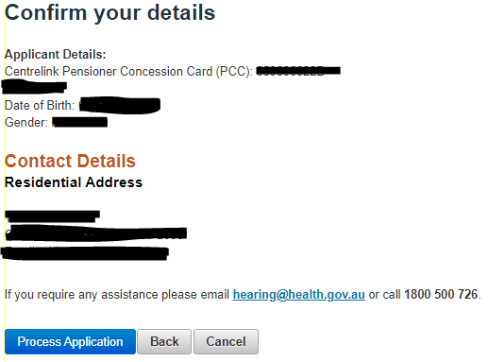

A message will appear at the top of the page advising you of one of the following

* The Application has been successful. A voucher will be generated
* Pending Application Saved. The system is unable to process it currently. When the system becomes available, we will process the application on your behalf.

## Step 8

Ensure the [client is linked to your site](https://www.health.gov.au/resources/publications/hearing-services-program-portal-user-guide-search-link-and-transfer-clients).