Portal user guide – Add and update a site

Services to program clients must be delivered at sites registered in the portal, unless the service is in a private home or aged care facility. Providers will need to register a site in the portal if they intend to provide services at a new location. Sites need to be kept up to date, including trading name, type of site and status.

# Access

## What access do I need?

SP Admin or SP Manager

## What else do I need?

The ambient noise levels at the site must be tested prior to providing services at the site. Please refer to the [provider handbook](https://www.health.gov.au/resources/publications/hearing-services-program-provider-handbook) for more information on ambient noise testing.

# Add a new site

## Step 1

From the landing page on the portal, open the Sites tab. Click the blue Add new Sitebutton

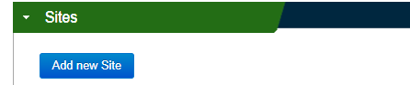

## Step 2

Your organisation name will be prefilled.

Select the trading name from the drop down menu.

Input the start date.

Indicate the type - whether your site is permanent or visiting.

Tick “Yes” if your site is in a remote location, either category 6 or 7 of the [Modified Monash Model](https://www.health.gov.au/topics/rural-health-workforce/classifications/mmm#how-to-find-current-areas-under-the-mmm).

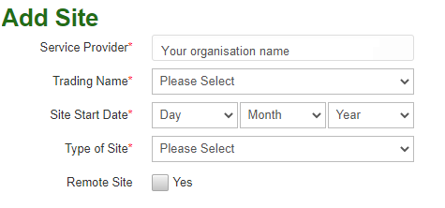

## Step 3

Enter the physical address of your site under Site Address.

Click Check addressto validate the location. This will ensure your site appears on the LPD correctly.

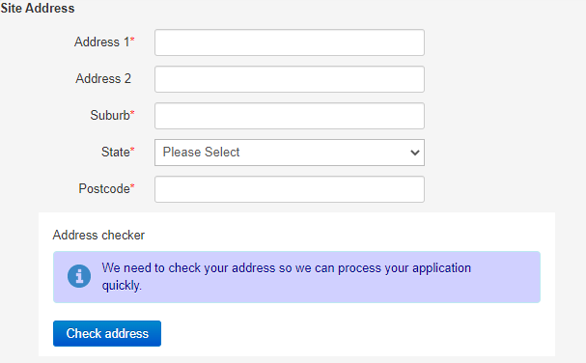

If your site has a postal address that is different to the physical address, untick the “Postal Address same as site address?” checkbox and add the postal address.

## Step 4

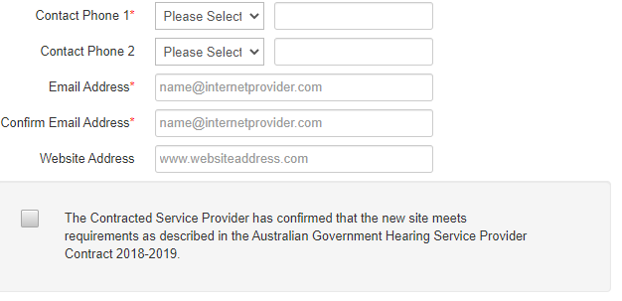

Add at least one phone number and email address for the site and confirm the email address again.

If your site has a website, you can add this here.

These details will appear on the LPD.

## Step 5

Certify that your site meets the requirements of the [Hearing Services Provider Contract](https://www.health.gov.au/resources/publications/hearing-services-program-service-provider-contract)

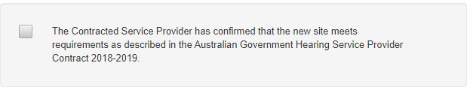

## Step 6

Click Add site to save the site details or Add another if you wish to save your site and add another site straight away.

Screenshot of the Add Site, Add another and Cancel buttons in the Add New Site function of the HSO portal. 

Note: If your site start date is in the future, the site will have a Pending status until this date and will not be listed in the Local Provider Directory (LPD). On the date you have entered, the site will automatically change to Active and be listed in the LPD.

# Update a site

## Step 1

Login to the portal and open the Sites tab.

Click on the suburb of the site you want to update. If you have many sites, you can enter the suburb or postcode in the search box and click Find.

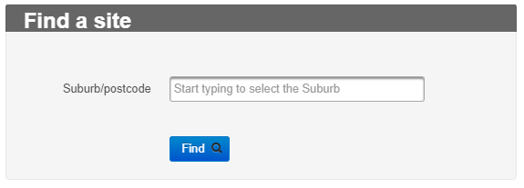

## Site Details

Under the Site Details tab you can edit the trading name, start date, type of site (visiting or permanent) and mark if it is a remote site.

Click Edit and update the details as needed.

Click Save to update any changes.

## Site Address

Under the Site Address tab you can amend the postal address of your site. If it is a change in physical address, you will be required to create a new site and follow the directions for ‘add a new site’ above.

Note: If you change the physical address for the site, please ensure you have a noise level certificate for the new location on file.

If you have a different postal address, uncheck “Postal Address same as site address?” and enter the postal address.

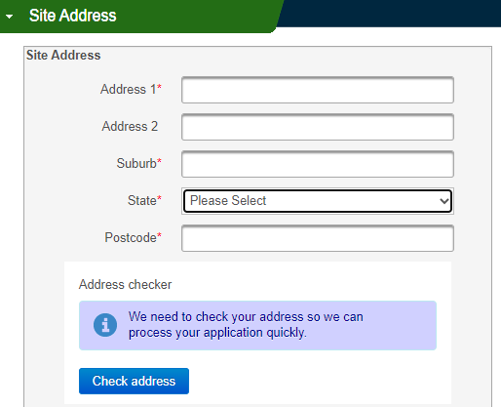

## Site Contacts

Under the Site Contacts tab, you can update the contact phone number, email address and website details.

These will update on the local provider directory, and the email address will change where site-related correspondence, such as relocation and claims emails, are sent.

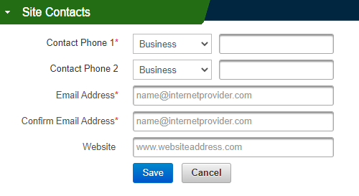

## Site status

If your site is temporarily inactive or closing permanently, you can update this in the portal. Open the Change Site Status accordion and click Edit.

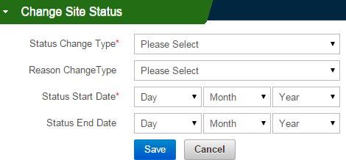

Select the status change type. If you choose permanent, please note that you will not be able to reopen the site later. You will need to add a new site or email [hearing@health.gov.au](mailto:hearing@health.gov.au). If your site will reopen in the future, you can choose temporary. You will also need to select a reason for the closure (ie. flooding).

For both change types, you will need to enter a start date when the status should take effect (the date the site will be closed from). If the closure is temporary, you can also add an end date (the last day the site will be closed). The site will then change to active the day after. If you aren’t sure when it will reopen, you can leave this field blank for now. When you know the date for reopening you can return to the same page and add an end date to reopen the site.

## Save updates

Click the Save button after each update. It is your responsibility to maintain all site information.

Updates such as site contact details will become effective within around 15 minutes and will be updated in the local provider directory. If you have changed the site status, this will update on the date you have entered for the status to take effect.