COVID-19 outbreaks in Australian residential aged care facilities

# National snapshot

As at 8:00 am 27 July 2023 there are 732 active COVID-19 cases in 131 active outbreaks in residential aged care facilities across Australia. There have been 53 new outbreaks, 13 new resident deaths and 660 combined new resident and staff cases reported since 20 July 2023.

Table : Aged Care COVID-19 data as at 8.00am 20 July 2023[1]

| Category | Active*[2]* | Previous  7 days | Cumulative  Total | Previous 7 days |
| --- | --- | --- | --- | --- |
| Outbreaks[3] | 131 | -10 | 15,867 | 53 |
| Residential Aged Care Facilities affected | 131 | -10 | 2,832 | 0 |
| Resident Cases[4] | 553 | -114 | 155,378 | 497 |
| Resident Deaths | N/A | N/A | 5,826 | 13 |
| Staff Cases | 179 | -29 | 90,861 | 163 |

Residential aged care homes with active outbreaks are included in Appendix 1.

**Table 2: Overview of Active Outbreaks in Australia**

|  |  |  |  |  |  |  |  |  |  |
| --- | --- | --- | --- | --- | --- | --- | --- | --- | --- |
|  | ACT | NSW | NT | QLD | SA | TAS | VIC | WA | Total |
| Total Facilities with outbreaks | 2 | 40 | 0 | 37 | 12 | 4 | 26 | 10 | 131 |
| *Total number of active resident cases* | 14 | 152 | 0 | 137 | 28 | 27 | 133 | 62 | 553 |
| *Total number of active staff cases* | 4 | 35 | 0 | 71 | 12 | 7 | 27 | 23 | 179 |
| Total Outbreaks Opened in Previous 7 Days | 0 | 18 | 0 | 17 | 6 | 1 | 8 | 3 | 53 |
| Total Outbreaks Closed in Previous 7 Days | 0 | 20 | 0 | 19 | 13 | 0 | 7 | 4 | 63 |

**Figure 1: National Outbreak Trends in Aged Care**

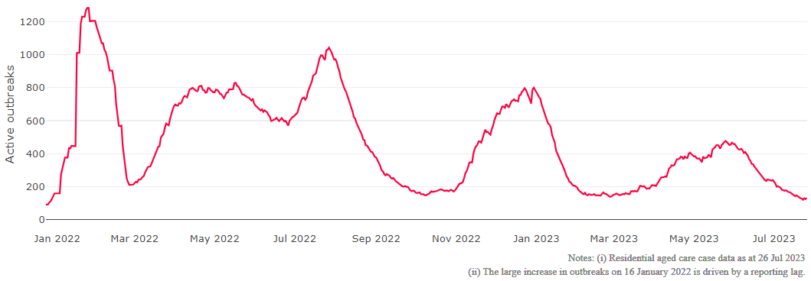

**Figure 2: Trends in Aged Care Cases – December 2021 to Present**

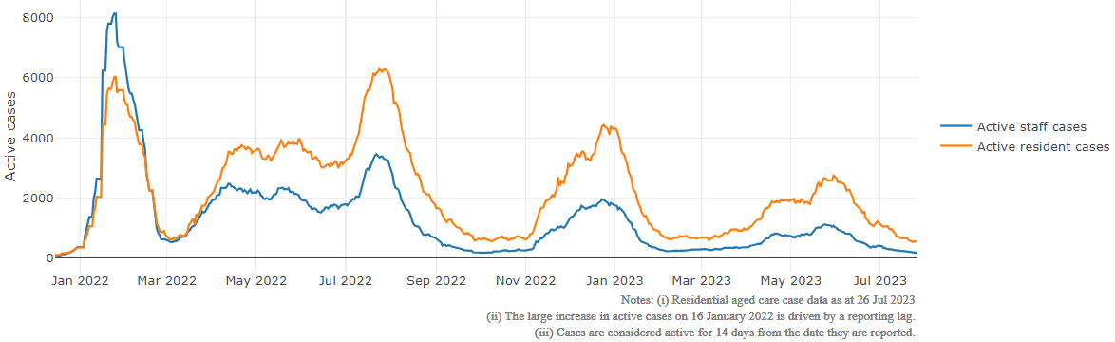

## Mortality

For the period of 1 January 2023 to 26 July 2023, COVID-19 is recorded as the cause of death in 3.6 percent of all deaths in permanent residents in aged care facilities.

Since the beginning of the Omicron outbreak in mid December[5] 2021, there have been 96,251 deaths in residential aged care from all causes (report period from 15 December 2021 to 26 July 2023)[6]. COVID-19 deaths account for 5.1 percent of this figure.

Over the course of the pandemic, all-cause excess mortality in Residential Aged Care was below expected numbers in 2020, and within expected range in 2021.

Figure 3: COVID-19 Deaths in Residential Aged Care Facilities overlaid with Community deaths

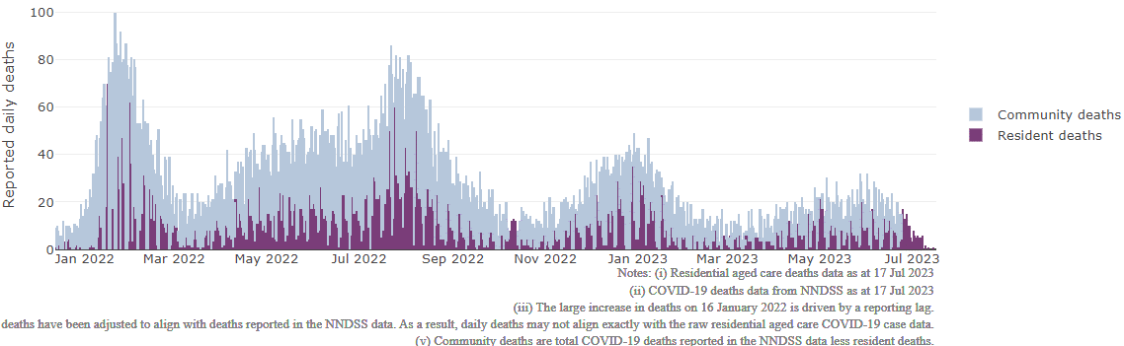

## Workforce in active residential aged care outbreaks

As at 28 July 2023, workforce surge staff have filled a total of 176,318 shifts in aged care services impacted by COVID-19, including 513 in the past 7 days. In the past 7 days (to 28 July) surge workforce providers have assisted 16 residential aged care homes. These shifts include roles for GPs, nurses, care workers, allied health workers, executive and ancillary staff. This includes:

Table 3: Workforce resources supplied to residential aged care facilities

| Workforce provider | Total Shifts | | Previous 7 days | |
| --- | --- | --- | --- | --- |
| Recruitment, Consulting and Staffing Association | 103,841 | 0 | |
| Healthcare Australia (Workforce Surge) | 14,831 | 36 | |
| Healthcare Australia (NACER) | 2,295 | N/A | |
| Mable | 2,711 | N/A | |
| Aspen Medical | 24,540 | 267 | |
| HealthX | 24,044 | 210 | |
| Torrens | 4,056 | N/A | |

The Australian Defence Force provided support to a total of 542 residential aged care homes between February and September 2022. The ADF deployment ceased on 30 September 2022.

## Oral antiviral treatments

Distribution of the oral anti-viral Lagevrio (Molnupiravir) commenced on 6 February 2022 to all RACFs with outbreak sites prioritised for delivery. The National Medical Stockpile has deployed 48,269 treatment courses of Lagevrio (Molnupiravir) to aged care facilities.

74,658 prescriptions for Lagevrio (Molnupiravir) have been issued to residents in residential aged care facilities, with a further 6,041 prescriptions for Paxlovid (nirmatrelvir + ritonavir) also issued since 28 February 2022 and up to 23 July 2023.

## Vaccination in Residential Aged Care Facilities

People living in residential aged care homes remain a high priority for the Government’s COVID-19 vaccination program. The Department is continuing to communicate with both the aged care and primary care sectors, reinforcing the importance of uptake and promoting the 2023 booster dose via regular newsletters, bulletins, social media videos and webinars.

All aged care residents who have not had a COVID-19 vaccination, or a COVID-19 infection within the last 6 months, continue to be offered a 2023 booster dose. The added protection from vaccination is especially important for aged care residents and will help reduce the risk of severe illness or hospitalisation.

The Department continues to work with Primary Health Networks to support residential aged care homes across Australia to arrange COVID-19 vaccination in-reach clinics with local primary care providers such as GPs, pharmacists, and Aboriginal Community Controlled Health Services.

As at 26 July 2023:

* of those aged care residents who have been eligible for a booster dose since January 2023, 94,324 (63.5%)eligible residents have received a 2023 booster dose. This is an additional 2,078 residents since last week.
* 110,996 (60.1%) residents are estimated to have had a recent immunising event of a vaccine dose (including the 2023 booster), or COVID-19 infection in the last 6 months and are therefore not currently eligible for a 2023 booster dose.

The estimated eligible population is made up of residents who have completed their COVID-19 primary course and had their last COVID-19 vaccine dose or infection more than 6 months ago. As residential aged care populations are fluid, and case overlay is not exact, eligible populations for vaccination are an estimate only.

**Table 4: Aged Care COVID-19 2023 Booster Doses (data as at 26 July 2023)**

| Jurisdiction | % of estimated eligible residents vaccinated | Residents vaccinated |
| --- | --- | --- |
| National | **63.5%** | **94,324** |
| ACT | 72.2% | 1,424 |
| NSW | 63.9% | 30,279 |
| NT | 45.4% | <200 |
| QLD | 59.5% | 17,801 |
| SA | 62.8% | 8,121 |
| TAS | 74.3% | 2,712 |
| VIC | 67.4% | 26,490 |
| WA | 55.8% | 7,338 |

Source: Matched AIR data of residents in permanent residential aged care facilities.

## Infection control and audit

People living in residential aged care homes remain a high priority for the Government’s COVID-19 vaccination program. The Department is continuing to communicate with both the aged care and primary care sectors, reinforcing the importance of uptake and promoting the 2023 booster dose via regular newsletters, bulletins, social media videos and webinars.

All aged care residents who have not had a COVID-19 vaccination, or a COVID-19 infection within the last 6 months, continue to be offered a 2023 booster dose. The added protection from vaccination is especially important for aged care residents and will help reduce the risk of severe illness or hospitalisation.

The Department continues to work with Primary Health Networks to support residential aged care homes across Australia to arrange COVID-19 vaccination in-reach clinics with local primary care providers such as GPs, pharmacists, and Aboriginal Community Controlled Health Services.

As at 27 July 2023, the Commission had conducted 5,212 ICM spot checks to observe infection control practices and PPE protocols in residential aged care facilities.

Table 5: Total Quality Assessment and Monitoring Activities with residential services (including IPC), by type and month 1 March 2020 to 27 July 2023

|  |  |  |  |  |  |  |
| --- | --- | --- | --- | --- | --- | --- |
| Regulatory Activities | 2019-20 (1 Mar - 30 Jun 2020) | 2020-21 | 2021-22 | 2022-23 | 2023-24  (to 27 Jul) | Total |
| ****Site visits**** | 318 | 3,452 | 1,732 | 3,687 | 239 | 9,428 |
| ****Non-site activities**** | 3,709 | 8,382 | 6,666 | 1,396 | 31 | 20,184 |
| Total activities | **4,027** | **11,834** | **8,398** | **5,083** | **270** | **29,612** |

# Appendix 1: National residential aged care services with Active outbreaks COVID-19

Please note, information reported in this table has been directly reported to the Department of Health and Aged Care by residential aged care facilities. Total cases refers to all staff and resident cases associated with the active outbreak and may not reflect the count of currently active cases. Where numbers have been incorrectly reported, facilities are able to correct these in the COVID-19 Support Portal through My Aged Care. Where a facility is reporting less than six resident or staff cases or less than six deaths, data has been suppressed to protect the privacy of affected individuals (note that “n/p” indicates data is not provided to protect privacy).

| Service Name | State | Resident Deaths | Resident Cases | Staff Cases | Total Incidents |
| --- | --- | --- | --- | --- | --- |
| Bill McKenzie Gardens | Australian Capital Territory | 0 | 18 | <6 | n/p |
| Mona Tait Gardens | Australian Capital Territory | 0 | 7 | <6 | n/p |
| Anglican Care Jesmond Grove | New South Wales | 0 | 11 | <6 | n/p |
| Anglican Care Storm Village | New South Wales | 0 | <6 | 0 | <6 |
| Aurrum Erina | New South Wales | 0 | <6 | <6 | <6 |
| Bangalor Retreat | New South Wales | 0 | 41 | 10 | 51 |
| Blayney Multi-Purpose Service | New South Wales | 0 | <6 | 0 | <6 |
| Bundaleer Gardens Hostel | New South Wales | 0 | <6 | <6 | <6 |
| Canterbury Place Care Community | New South Wales | 0 | <6 | 0 | <6 |
| Cardinal Stepinac Village | New South Wales | 0 | <6 | 0 | <6 |
| Elizabeth Jenkins Place Aged Care Plus Centre | New South Wales | <6 | 30 | <6 | n/p |
| Estia Health Bankstown | New South Wales | 0 | <6 | 0 | <6 |
| Estia Health Epping - The Poplars | New South Wales | 0 | 21 | <6 | n/p |
| Estia Health Merrylands | New South Wales | 0 | <6 | 0 | <6 |
| Greenwood Aged Care | New South Wales | 0 | <6 | <6 | <6 |
| HammondCare Mason | New South Wales | 0 | <6 | 0 | <6 |
| Heritage Botany | New South Wales | 0 | <6 | 0 | <6 |
| Holbrook Hostel | New South Wales | <6 | 12 | 9 | 21 |
| Inasmuch Community Hostel | New South Wales | 0 | <6 | <6 | <6 |
| Indochinese Aged Care Services | New South Wales | 0 | <6 | 0 | <6 |
| IRT Culburra Beach | New South Wales | 0 | 16 | <6 | n/p |
| IRT Sarah Claydon | New South Wales | 0 | 18 | 7 | 25 |
| Killara Gardens Aged Care | New South Wales | 0 | <6 | 0 | <6 |
| Lachlan Lodge | New South Wales | 0 | 0 | <6 | <6 |
| Marco Polo Woonona Care Services | New South Wales | 0 | <6 | 0 | <6 |
| Meadowbank Grove Care Community | New South Wales | 0 | 7 | 0 | 7 |
| Narraweena Grove Care Community | New South Wales | 0 | 8 | 0 | 8 |
| Pathways Cronulla Pines | New South Wales | 0 | <6 | <6 | 7 |
| Peakhurst Nursing Home | New South Wales | 0 | 10 | 0 | 10 |
| Peter Cosgrove House | New South Wales | <6 | 7 | 0 | 7 |
| Presbyterian Aged Care - Thornleigh | New South Wales | 0 | <6 | <6 | <6 |
| Randwick Montefiore Home | New South Wales | 0 | 0 | <6 | <6 |
| St Ezekiel Moreno Nursing Home | New South Wales | 0 | 28 | <6 | n/p |
| SummitCare Smithfield | New South Wales | 0 | <6 | 0 | <6 |
| The Orchards Aged Care | New South Wales | 0 | <6 | <6 | 7 |
| The Whiddon Group - Glenfield | New South Wales | 0 | <6 | 0 | <6 |
| The Whiddon Group - Glenfield - Arthur Webb | New South Wales | 0 | 22 | <6 | n/p |
| Tingira Hills Care Community | New South Wales | 0 | 11 | <6 | n/p |
| Toongabbie Terrace Care Community | New South Wales | 0 | <6 | 0 | <6 |
| Warrigal Care Shell Cove | New South Wales | 0 | 20 | <6 | n/p |
| Warrina Village Hostel | New South Wales | <6 | 45 | <6 | n/p |
| Yallambee Village | New South Wales | 0 | 11 | 0 | 11 |
| Adventist Retirement Village - Victoria Pt | Queensland | 0 | <6 | 0 | <6 |
| Arcare Hope Island | Queensland | 0 | 9 | 6 | 15 |
| Arcare Pimpama | Queensland | 0 | <6 | <6 | 6 |
| Ashmore Retreat | Queensland | 0 | 0 | <6 | <6 |
| Berlasco Court Caring Centre | Queensland | <6 | 25 | 9 | 34 |
| Blue Care Gracemere Aged Care Facility | Queensland | 0 | <6 | <6 | 6 |
| Bolton Clarke Fernhill | Queensland | 0 | 0 | <6 | <6 |
| Bolton Clarke Talbarra | Queensland | 0 | <6 | <6 | <6 |
| Buderim Views Assisted Aged Care | Queensland | 0 | <6 | <6 | <6 |
| Bupa Runaway Bay | Queensland | <6 | 12 | <6 | n/p |
| Calvary Noosa | Queensland | 0 | <6 | <6 | <6 |
| Carinity Clifford House | Queensland | 0 | 7 | 0 | 7 |
| Carinity Kepnock Grove | Queensland | 0 | <6 | 0 | <6 |
| Churches of Christ Buckingham Gardens Aged Care Service | Queensland | 0 | <6 | <6 | n/p |
| Estia Health Nambour | Queensland | 0 | <6 | 0 | <6 |
| Estia Health Southport | Queensland | 0 | 6 | <6 | n/p |
| Estia Health Twin Waters | Queensland | 0 | <6 | <6 | <6 |
| Lutheran Services - Northridge Salem | Queensland | 0 | 12 | 6 | 18 |
| Lutheran Services - Salem | Queensland | 0 | <6 | 0 | <6 |
| Magnolia Aged Care Coomera | Queensland | 0 | 9 | 10 | 19 |
| Maranatha Aged Care | Queensland | 0 | 15 | <6 | n/p |
| Morayfield Grove Care Community | Queensland | 0 | 15 | <6 | n/p |
| Mt Lofty Nursing Home | Queensland | 0 | 15 | 13 | 28 |
| NewDirection Care at Bellmere | Queensland | 0 | 6 | <6 | n/p |
| Parkview | Queensland | 0 | <6 | 0 | <6 |
| Regis Caboolture | Queensland | <6 | 36 | 10 | 46 |
| Regis Home Hill | Queensland | 0 | <6 | 0 | <6 |
| Regis Sandgate - Griffith | Queensland | 0 | <6 | 0 | <6 |
| Regis Sandgate - Musgrave | Queensland | 0 | 7 | <6 | n/p |
| Sinnamon Village - Nash Court | Queensland | 0 | <6 | 0 | <6 |
| Southern Cross Care Murgon - Castra | Queensland | 0 | <6 | <6 | <6 |
| St Paul de Chartres Residential Aged Care | Queensland | <6 | 11 | 15 | 26 |
| St Vincent's Care Services Mitchelton | Queensland | 0 | <6 | <6 | 6 |
| The Good Shepherd Nursing Home | Queensland | 0 | <6 | <6 | <6 |
| TriCare Kawana Waters Aged Care Residence | Queensland | 0 | 15 | <6 | n/p |
| Villa Maria Centre | Queensland | 0 | <6 | 0 | <6 |
| Wheller Gardens - Cooper House | Queensland | 0 | <6 | 0 | <6 |
| Aldinga Beach Court | South Australia | 0 | <6 | 6 | n/p |
| Ananda Aged Care Findon | South Australia | 0 | 28 | 11 | 39 |
| AnglicareSA Brompton | South Australia | 0 | 0 | <6 | <6 |
| Estia Health Flagstaff Hill | South Australia | 0 | <6 | 0 | <6 |
| Matthew Flinders Home Inc | South Australia | 0 | <6 | <6 | <6 |
| Oakfield Lodge Residential Care | South Australia | 0 | <6 | 0 | <6 |
| Resthaven Craigmore | South Australia | <6 | 6 | <6 | n/p |
| Resthaven Murray Bridge | South Australia | 0 | <6 | <6 | 6 |
| Resthaven Paradise | South Australia | 0 | 8 | <6 | n/p |
| Resthaven Westbourne Park | South Australia | 0 | 6 | <6 | n/p |
| Warrina Park Residential Aged Care Service | South Australia | 0 | <6 | <6 | <6 |
| Wesley House | South Australia | 0 | <6 | <6 | 6 |
| Barrington Lodge | Tasmania | 0 | <6 | 0 | <6 |
| May Shaw Aminya | Tasmania | 0 | 8 | <6 | n/p |
| Sandown Apartments | Tasmania | 0 | 9 | <6 | n/p |
| St Ann's | Tasmania | 0 | 11 | <6 | n/p |
| AdventCare Whitehorse | Victoria | 0 | 21 | <6 | n/p |
| Alcheringa | Victoria | <6 | 43 | <6 | n/p |
| BlueCross Hansworth | Victoria | 0 | 8 | 0 | 8 |
| BlueCross Ivanhoe | Victoria | 0 | 8 | 0 | 8 |
| Calvary Kirralee | Victoria | 0 | 7 | <6 | n/p |
| Calvary Millward | Victoria | 0 | 12 | <6 | n/p |
| Calvary Narracan Gardens | Victoria | 0 | 27 | 6 | 33 |
| Clovelly Cottage | Victoria | 0 | 38 | 12 | 50 |
| Coates | Victoria | 0 | 8 | <6 | n/p |
| Costa House | Victoria | 0 | <6 | 0 | <6 |
| Doutta Galla Woornack Aged Care Facility | Victoria | 0 | 9 | 0 | 9 |
| Estia Health Dandenong | Victoria | 0 | <6 | 0 | <6 |
| Homewood Residential Aged Care | Victoria | 0 | 10 | 0 | 10 |
| Little Sisters of the Poor St Joseph's Home | Victoria | 0 | <6 | 0 | <6 |
| MiCare Avondrust Lodge | Victoria | 0 | <6 | 0 | <6 |
| MiCare Margriet Manor | Victoria | 0 | <6 | 0 | <6 |
| Moyola Lodge Hostel | Victoria | 0 | <6 | <6 | 9 |
| Regis Frankston | Victoria | 0 | 6 | <6 | n/p |
| Regis Sandringham | Victoria | 0 | 26 | 6 | 32 |
| St Basil's Homes for the Aged in Victoria | Victoria | 0 | <6 | <6 | <6 |
| Sunnyside Lutheran Retirement Village | Victoria | <6 | 6 | 12 | 18 |
| The Belmont Residential Aged Care | Victoria | 0 | 20 | 0 | 20 |
| Twin Parks Aged Care Centre | Victoria | 0 | <6 | 0 | <6 |
| Villa Maria Catholic Homes Justin Villa Aged Care Residence | Victoria | 0 | <6 | 0 | <6 |
| Westmont Homestead | Victoria | 0 | 10 | <6 | n/p |
| Willowbrae - Melton | Victoria | 0 | 17 | <6 | n/p |
| Aegis Sandstrom | Western Australia | 0 | 19 | 7 | 26 |
| Aegis Shoalwater | Western Australia | 0 | 28 | 9 | 37 |
| Alice Ross-King Care Centre | Western Australia | 0 | <6 | <6 | 6 |
| Bethanie Kingsley | Western Australia | 0 | <6 | 0 | <6 |
| Brightwater Madeley | Western Australia | 0 | <6 | <6 | <6 |
| Guildford Village | Western Australia | 0 | <6 | <6 | 7 |
| Michael Lee Centre | Western Australia | <6 | 27 | 11 | 38 |
| Murdoch Gardens Care Community | Western Australia | <6 | 20 | <6 | n/p |
| Singleton Community Aged Care | Western Australia | <6 | 25 | 7 | 32 |
| Southern Plus East Fremantle | Western Australia | 0 | <6 | 0 | <6 |

1. Outbreak opening and closure includes changes in the status of exposure sites to outbreaks (and vice versa), which are applied retrospectively to facility records. New case information can also change the status of a recovered site back to an active outbreak site. As a result, changes in active outbreak status may not align with day on day variations to active totals. These adjustments will also affect the number of cases in staff and residents reported each week.
2. Active residents and staff cases are the total currently positive cases in active outbreaks
3. An outbreak is considered to be active pending advice from the relevant Public Health Unit. An outbreak is defined as at least 1 positive case in a resident or 2+ cases in staff.
4. Case numbers and numbers of deaths are dependent upon reporting from facilities and validation of deaths from state and territory governments. This is subject to change as further information is provided.
5. The Omicron outbreak start date has been redefined from late November 2021 to mid December 2021. Changes have been made to align reporting with the start date of Omicron published in the Department’s external facing Epidemiology report.
6. The Department is now accessing aged care deaths data from the SIEBEL dataset. Figures are live and subject to change. Source: Department of Health and Aged Care unpublished data / SIEBEL dataset.