COVID-19 outbreaks in Australian residential aged care facilities

# National snapshot

As at 8:00 am 20 July 2023 there are 947 active COVID-19 cases in 158 active outbreaks in residential aged care facilities across Australia. There have been 53 new outbreaks, 16 new resident deaths and 675 combined new resident and staff cases reported since 13 July 2023.

Table 1: Aged Care COVID-19 data as at 8.00am 20 July 2023[1]

| Category | Active*[2]* | Previous  7 days | Cumulative  Total | Previous 7 days |
| --- | --- | --- | --- | --- |
| Outbreaks[3] | 158 | -12 | 15,815 | 53 |
| Residential Aged Care Facilities affected | 158 | -12 | 2,832 | 0 |
| Resident Cases[4] | 723 | -3 | 154,902 | 519 |
| Resident Deaths | N/A | N/A | 5,820 | 16 |
| Staff Cases | 224 | -33 | 90,699 | 156 |

Residential aged care homes with active outbreaks are included in Appendix 1.

**Table 2: Overview of Active Outbreaks in Australia**

|  |  |  |  |  |  |  |  |  |  |
| --- | --- | --- | --- | --- | --- | --- | --- | --- | --- |
|  | ACT | NSW | NT | QLD | SA | TAS | VIC | WA | Total |
| Total Facilities with outbreaks | 2 | 48 | 0 | 42 | 21 | 3 | 30 | 12 | 158 |
| *Total number of active resident cases* | 16 | 209 | 0 | 159 | 66 | 12 | 194 | 67 | 723 |
| *Total number of active staff cases* | 2 | 62 | 0 | 73 | 29 | 1 | 42 | 15 | 224 |
| Total Outbreaks Opened in Previous 7 Days | 1 | 12 | 0 | 12 | 7 | 3 | 13 | 5 | 53 |
| Total Outbreaks Closed in Previous 7 Days | 1 | 23 | 0 | 14 | 4 | 2 | 12 | 9 | 65 |

**Figure 1: National Outbreak Trends in Aged Care**

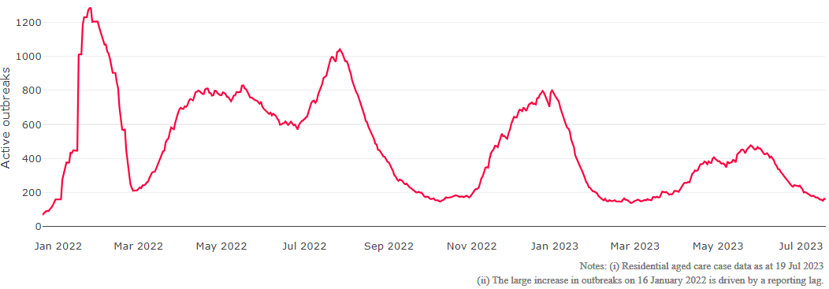

**Figure 2: Trends in Aged Care Cases – December 2021 to Present**

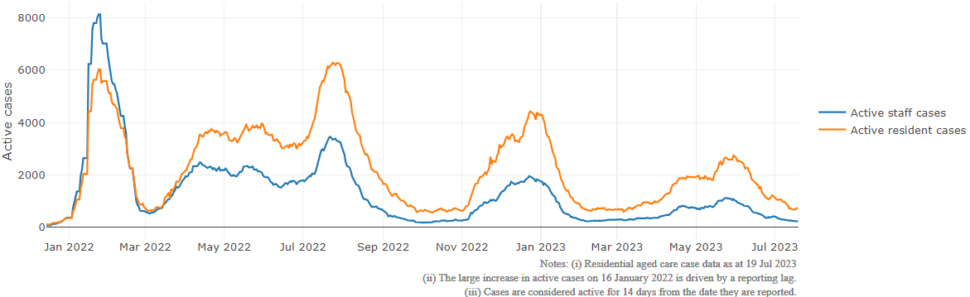

## Mortality

For the period of 1 January 2023 to 17 July 2023, COVID-19 is recorded as the cause of death in 3.6 percent of all deaths in permanent residents in aged care facilities.

Since the beginning of the Omicron outbreak in mid December[5] 2021, there have been 96,222 deaths in residential aged care from all causes (report period from 15 December 2021 to 17 July 2023)[6]. COVID-19 deaths account for 5.1 percent of this figure.

Over the course of the pandemic, all-cause excess mortality in Residential Aged Care was below expected numbers in 2020, and within expected range in 2021.

Figure 3: COVID-19 Deaths in Residential Aged Care Facilities overlaid with Community deaths

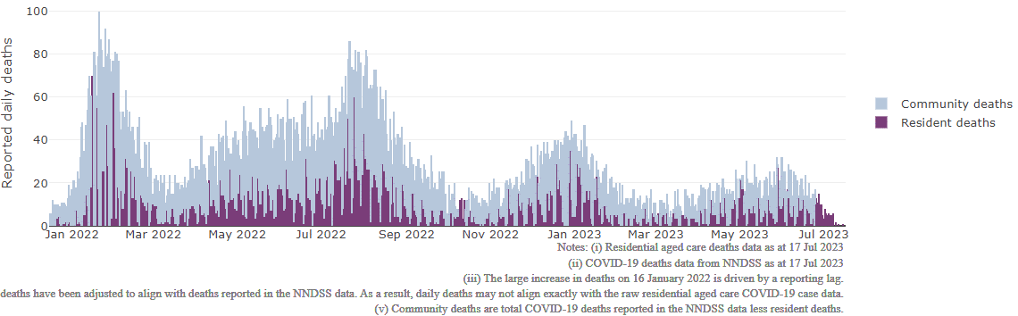

## Workforce in active residential aged care outbreaks

As at 21 July 2023, workforce surge staff have filled a total of 175,805 shifts in aged care services impacted by COVID-19, including 273 in the past 7 days. In the past 7 days (to 21 July) surge workforce providers have assisted 27 residential aged care homes. These shifts include roles for GPs, nurses, care workers, allied health workers, executive and ancillary staff. This includes:

Table 3: Workforce resources supplied to residential aged care facilities

| Workforce provider | Total Shifts | | Previous 7 days | |
| --- | --- | --- | --- | --- |
| Recruitment, Consulting and Staffing Association | 103,841 | 0 | |
| Healthcare Australia (Workforce Surge) | 14,795 | 29 | |
| Healthcare Australia (NACER) | 2,295 | N/A | |
| Mable | 2,711 | N/A | |
| Aspen Medical | 24,273 | 37 | |
| HealthX | 23,834 | 244 | |
| Torrens | 4,056 | N/A | |

The Australian Defence Force provided support to a total of 542 residential aged care homes between February and September 2022. The ADF deployment ceased on 30 September 2022.

## Oral antiviral treatments

Distribution of the oral anti-viral Lagevrio (Molnupiravir) commenced on 6 February 2022 to all RACFs with outbreak sites prioritised for delivery. The National Medical Stockpile has deployed 48,269 treatment courses of Lagevrio (Molnupiravir) to aged care facilities.

74,233 prescriptions for Lagevrio (Molnupiravir) have been issued to residents in residential aged care facilities, with a further 5,960 prescriptions for Paxlovid (nirmatrelvir + ritonavir) also issued since 28 February 2022 and up to 16 July 2023.

## Vaccination in Residential Aged Care Facilities

People living in residential aged care homes remain a high priority for the Government’s COVID-19 vaccination program. The Department is continuing to communicate with both the aged care and primary care sectors, reinforcing the importance of uptake and promoting the 2023 booster dose via regular newsletters, bulletins, social media videos and webinars.

All aged care residents who have not had a COVID-19 vaccination, or a COVID-19 infection within the last 6 months, continue to be offered a 2023 booster dose. The added protection from vaccination is especially important for aged care residents and will help reduce the risk of severe illness or hospitalisation.

The Department continues to work with Primary Health Networks to support residential aged care homes across Australia to arrange COVID-19 vaccination in-reach clinics with local primary care providers such as GPs, pharmacists, and Aboriginal Community Controlled Health Services.

As at 19 July 2023:

* of those aged care residents who have been eligible for a booster dose since January 2023, 92,246 (59.2%)eligible residents have received a 2023 booster dose. This is an additional 3,366 residents since last week..
* 109,277 (59.2%) residents are estimated to have had a recent immunising event of a vaccine dose (including the 2023 booster), or COVID-19 infection in the last 6 months and are therefore not currently eligible for a 2023 booster dose.

The estimated eligible population is made up of residents who have completed their COVID-19 primary course and had their last COVID-19 vaccine dose or infection more than 6 months ago. As residential aged care populations are fluid, and case overlay is not exact, eligible populations for vaccination are an estimate only.

**Table 4: Aged Care COVID-19 2023 Booster Doses (data as at 19 July 2023)**

| Jurisdiction | % of estimated eligible residents vaccinated | Residents vaccinated |
| --- | --- | --- |
| National | **59.2%** | **92,246** |
| ACT | 69.5% | 1,434 |
| NSW | 59.2% | 29,459 |
| NT | 41.8% | <200 |
| QLD | 55.8% | 17,556 |
| SA | 58.7% | 7,927 |
| TAS | 70.6% | 2,732 |
| VIC | 63.4% | 25,912 |
| WA | 50.8% | 7,076 |

Source: Matched AIR data of residents in permanent residential aged care facilities.

## Infection control and audit

The Aged Care Quality and Safety Commission (Commission) conducts a range of site and non-site activities to monitor and assess residential aged care services, including site audits and assessment contacts (site and non-site) (see Table 5 below). In August 2020, the Commission commenced an infection control monitoring (ICM) spot check program in all Australian jurisdictions.

The ICM spot check program involves on-site visits to residential aged care services, without an outbreak, to check compliance with personal protective equipment (PPE) and infection control arrangements. The purpose of the ICM spot check is to observe infection control practices, to ensure that staff, management and visitors were adhering to safe personal protective equipment protocols and to safe infection control arrangements as required under the quality standards.

As at 20 July 2023, the Commission had conducted 5,202 ICM spot checks to observe infection control practices and PPE protocols in residential aged care facilities.

Table 5: Total Quality Assessment and Monitoring Activities with residential services (including IPC), by type and month 1 March 2020 to 20 July 2023

|  |  |  |  |  |  |  |
| --- | --- | --- | --- | --- | --- | --- |
| Regulatory Activities | 2019-20 (1 Mar - 30 Jun 2020) | 2020-21 | 2021-22 | 2022-23 | 2023-24  (to 20 Jul) | Total |
| ****Site visits**** | 318 | 3,452 | 1,732 | 3,687 | 180 | 9,369 |
| ****Non-site activities**** | 3,709 | 8,382 | 6,666 | 1,390 | 19 | 20,166 |
| Total activities | **4,027** | **11,834** | **8,398** | **5,077** | 199 | **29,535** |

# Appendix 1: National residential aged care services with Active outbreaks COVID-19

Please note, information reported in this table has been directly reported to the Department of Health and Aged Care by residential aged care facilities. Total cases refers to all staff and resident cases associated with the active outbreak and may not reflect the count of currently active cases. Where numbers have been incorrectly reported, facilities are able to correct these in the COVID-19 Support Portal through My Aged Care. Where a facility is reporting less than six resident or staff cases or less than six deaths, data has been suppressed to protect the privacy of affected individuals (note that “n/p” indicates data is not provided to protect privacy).

| Service Name | State | Resident Deaths | Resident Cases | Staff Cases | Total Incidents |
| --- | --- | --- | --- | --- | --- |
| Bill McKenzie Gardens | Australian Capital Territory | 0 | 17 | <6 | n/p |
| Mona Tait Gardens | Australian Capital Territory | 0 | <6 | <6 | 7 |
| Alexander Campbell House | New South Wales | <6 | 10 | <6 | n/p |
| Anglican Care Jesmond Grove | New South Wales | 0 | 11 | <6 | n/p |
| Anglican Care Kilpatrick Court | New South Wales | 0 | <6 | 0 | <6 |
| Anthem | New South Wales | 0 | <6 | 0 | <6 |
| Arcare Glenhaven | New South Wales | 0 | <6 | 0 | <6 |
| Bangalor Retreat | New South Wales | 0 | <6 | 0 | <6 |
| BaptistCare Caloola Centre | New South Wales | 0 | 9 | <6 | n/p |
| BaptistCare Warabrook Centre | New South Wales | 0 | 25 | 7 | 32 |
| Bilyara Hostel | New South Wales | <6 | 28 | 19 | 47 |
| Bundaleer Gardens Hostel | New South Wales | 0 | <6 | <6 | <6 |
| Bupa Bateau Bay | New South Wales | 0 | 6 | <6 | n/p |
| Catholic Healthcare Villa Maria Centre | New South Wales | 0 | 10 | <6 | n/p |
| Chamberlain Gardens Aged Care | New South Wales | <6 | 34 | <6 | n/p |
| Coastal Waters Aged Care | New South Wales | 0 | 13 | 8 | 21 |
| Elizabeth Jenkins Place Aged Care Plus Centre | New South Wales | <6 | 26 | <6 | n/p |
| Estia Health Bankstown | New South Wales | 0 | <6 | 0 | <6 |
| Estia Health Epping - The Poplars | New South Wales | 0 | 6 | <6 | n/p |
| Greenwood Aged Care | New South Wales | 0 | <6 | 0 | <6 |
| Harden Grange | New South Wales | 0 | 8 | <6 | n/p |
| Holbrook Hostel | New South Wales | 0 | 11 | 9 | 20 |
| Inasmuch Community Hostel | New South Wales | 0 | <6 | <6 | <6 |
| IRT Culburra Beach | New South Wales | 0 | 7 | 0 | 7 |
| IRT Sarah Claydon | New South Wales | 0 | 15 | <6 | n/p |
| Kurrajong & District Community Nursing Home | New South Wales | 0 | <6 | <6 | 9 |
| Kyogle Multi-Purpose Service | New South Wales | <6 | 18 | 11 | 29 |
| Marco Polo Woonona Care Services | New South Wales | 0 | <6 | 0 | <6 |
| Meadowbank Grove Care Community | New South Wales | 0 | <6 | 0 | <6 |
| Narraweena Grove Care Community | New South Wales | 0 | <6 | 0 | <6 |
| Pathways Cronulla Pines | New South Wales | 0 | <6 | <6 | 7 |
| Peakhurst Nursing Home | New South Wales | 0 | 10 | 0 | 10 |
| Pembroke Lodge | New South Wales | <6 | <6 | 0 | <6 |
| RFBI Benhome Masonic Village | New South Wales | 0 | 10 | <6 | n/p |
| S Antonio Da Padova Nursing Home | New South Wales | 0 | <6 | 0 | <6 |
| Southern Cross Care Greystanes Residential Aged Care | New South Wales | 0 | 11 | <6 | n/p |
| St Hedwig Village | New South Wales | 0 | <6 | <6 | <6 |
| St Vincent's Care Services Auburn | New South Wales | 0 | 0 | <6 | <6 |
| St Vincent's Care Services Yennora | New South Wales | 0 | 22 | <6 | n/p |
| SummitCare Smithfield | New South Wales | 0 | <6 | 0 | <6 |
| The Orchards Aged Care | New South Wales | 0 | <6 | <6 | 6 |
| The Whiddon Group - Glenfield - Arthur Webb | New South Wales | 0 | 22 | <6 | n/p |
| Tingira Hills Care Community | New South Wales | 0 | 6 | <6 | n/p |
| Uniting Aldersgate Lilyfield | New South Wales | <6 | 31 | <6 | n/p |
| Uniting Arrunga Ermington | New South Wales | 0 | <6 | 0 | <6 |
| Uniting Edinglassie Emu Plains | New South Wales | 0 | <6 | <6 | <6 |
| Warrigal Care Shell Cove | New South Wales | 0 | 18 | <6 | n/p |
| Warrina Village Hostel | New South Wales | <6 | 45 | <6 | n/p |
| William Cape Gardens | New South Wales | 0 | 47 | 11 | 58 |
| Yallambee Village | New South Wales | 0 | 10 | 0 | 10 |
| Algester Lodge | Queensland | 0 | <6 | 0 | <6 |
| Anam Cara | Queensland | <6 | <6 | <6 | 6 |
| Anglicare SQ Symes Grove Home for the Aged | Queensland | 0 | <6 | 0 | <6 |
| Arcare Pimpama | Queensland | 0 | <6 | <6 | <6 |
| Augathella Multipurpose Health Service | Queensland | 0 | <6 | <6 | <6 |
| Berlasco Court Caring Centre | Queensland | 0 | 20 | <6 | n/p |
| Blue Care Gracemere Aged Care Facility | Queensland | 0 | <6 | <6 | 6 |
| Blue Care Kingaroy Canowindra Aged Care Facility | Queensland | 0 | <6 | 0 | <6 |
| Blue Care Wynnum Aged Care Facility | Queensland | <6 | 17 | <6 | n/p |
| Bolton Clarke Inverpine | Queensland | 0 | 0 | <6 | <6 |
| Calvary Noosa | Queensland | 0 | <6 | <6 | <6 |
| Carinity Clifford House | Queensland | 0 | 7 | 0 | 7 |
| Carinity Kepnock Grove | Queensland | 0 | <6 | 0 | <6 |
| Churches of Christ Buckingham Gardens Aged Care Service | Queensland | 0 | <6 | 0 | <6 |
| Churches of Christ Fair Haven Aged Care Service Hervey Bay | Queensland | 0 | <6 | <6 | 9 |
| Estia Health Nambour | Queensland | 0 | 19 | <6 | n/p |
| Estia Health Southport | Queensland | 0 | <6 | <6 | <6 |
| Estia Health Twin Waters | Queensland | 0 | <6 | <6 | <6 |
| Good Shepherd Lodge | Queensland | 0 | 12 | 6 | 18 |
| Infinite Care Ipswich | Queensland | 0 | <6 | 0 | <6 |
| Lutheran Services - Immanuel Gardens | Queensland | 0 | <6 | 0 | <6 |
| Lutheran Services - Northridge Salem | Queensland | 0 | 12 | 6 | 18 |
| Lutheran Services - Salem | Queensland | 0 | <6 | 0 | <6 |
| Lutheran Services - Tabeel | Queensland | 0 | <6 | <6 | <6 |
| Maranatha Aged Care | Queensland | 0 | 7 | 0 | 7 |
| MiCare Prins Willem Alexander Lodge | Queensland | 0 | <6 | <6 | <6 |
| Morayfield Grove Care Community | Queensland | 0 | 15 | <6 | n/p |
| Mt Lofty Nursing Home | Queensland | 0 | 15 | 13 | 28 |
| Oxley Grove Care Community | Queensland | 0 | 8 | <6 | n/p |
| Ozcare Malanda | Queensland | 0 | 0 | <6 | <6 |
| Ozcare Villa Vincent | Queensland | 0 | 0 | <6 | <6 |
| Portofino Hamilton | Queensland | 0 | 7 | <6 | n/p |
| Pyramid Residential Care Centre | Queensland | 0 | <6 | <6 | <6 |
| Regis Ayr South | Queensland | 0 | 0 | <6 | <6 |
| Regis Bulimba | Queensland | 0 | 6 | <6 | n/p |
| Regis Caboolture | Queensland | <6 | 12 | 6 | 18 |
| Regis Sandgate - Musgrave | Queensland | 0 | <6 | <6 | <6 |
| St Paul de Chartres Residential Aged Care | Queensland | <6 | 7 | 15 | 22 |
| St Vincent's Care Services Mitchelton | Queensland | 0 | <6 | <6 | <6 |
| The Good Shepherd Nursing Home | Queensland | <6 | <6 | <6 | 7 |
| TriCare Kawana Waters Aged Care Residence | Queensland | 0 | 6 | 0 | 6 |
| TriCare Stafford Lakes Aged Care Residence | Queensland | 0 | <6 | <6 | 6 |
| ACH Group Residential Care - Kapara | South Australia | 0 | 7 | <6 | n/p |
| ACH Group Residential Care - Perry Park (high care) | South Australia | 0 | 0 | <6 | <6 |
| Aldinga Beach Court | South Australia | 0 | <6 | <6 | 8 |
| Ananda Aged Care Findon | South Australia | 0 | 28 | 11 | 39 |
| AnglicareSA Brompton | South Australia | 0 | 0 | <6 | <6 |
| AnglicareSA Westbourne Park | South Australia | 0 | 6 | <6 | n/p |
| Bucklands Residential Care | South Australia | <6 | 13 | <6 | n/p |
| Calvary The Homestead | South Australia | 0 | 0 | <6 | <6 |
| Eldercare Acacia Court | South Australia | 0 | 11 | <6 | n/p |
| LHI Glynde | South Australia | 0 | 11 | <6 | n/p |
| Linsell Lodge Aged Care Facility | South Australia | 0 | 37 | 6 | 43 |
| Naracoorte Health Service | South Australia | <6 | 14 | 12 | 26 |
| Oakfield Lodge Residential Care | South Australia | 0 | <6 | 0 | <6 |
| Oaklands Park Lodge Residential Care | South Australia | 0 | 11 | <6 | n/p |
| Resthaven Aberfoyle Park | South Australia | 0 | <6 | 0 | <6 |
| Resthaven Craigmore | South Australia | 0 | <6 | <6 | 6 |
| Resthaven Murray Bridge | South Australia | 0 | <6 | <6 | 6 |
| Resthaven Paradise | South Australia | 0 | 8 | <6 | n/p |
| Resthaven Port Elliot | South Australia | 0 | 15 | 12 | 27 |
| Resthaven Westbourne Park | South Australia | 0 | <6 | 0 | <6 |
| Wesley House | South Australia | 0 | <6 | <6 | <6 |
| Barrington Lodge | Tasmania | 0 | <6 | 0 | <6 |
| Sandown Apartments | Tasmania | 0 | 9 | <6 | n/p |
| St Ann's | Tasmania | 0 | <6 | 0 | <6 |
| Alcheringa | Victoria | <6 | 40 | <6 | n/p |
| BlueCross Hansworth | Victoria | 0 | 8 | 0 | 8 |
| BlueCross Ivanhoe | Victoria | 0 | <6 | 0 | <6 |
| BlueCross Karinya Grove | Victoria | <6 | 10 | <6 | n/p |
| Calvary Elanora | Victoria | 0 | 14 | <6 | n/p |
| Calvary Kirralee | Victoria | 0 | 7 | <6 | n/p |
| Calvary Millward | Victoria | 0 | 12 | <6 | n/p |
| Calvary Narracan Gardens | Victoria | 0 | 22 | <6 | n/p |
| Clovelly Cottage | Victoria | 0 | 28 | 12 | 40 |
| Coates | Victoria | 0 | <6 | 0 | <6 |
| Doutta Galla Woornack Aged Care Facility | Victoria | 0 | 9 | 0 | 9 |
| Highwood Court | Victoria | <6 | 24 | 6 | 30 |
| Homewood Residential Aged Care | Victoria | 0 | 6 | 0 | 6 |
| MiCare Avondrust Lodge | Victoria | 0 | <6 | 0 | <6 |
| MiCare Margriet Manor | Victoria | 0 | <6 | 0 | <6 |
| Mooroopna Place Residential Aged Care Service | Victoria | 0 | 12 | <6 | n/p |
| Moyola Lodge Hostel | Victoria | 0 | <6 | <6 | <6 |
| Myrtleford Lodge Aged Care | Victoria | 0 | 25 | 11 | 36 |
| Olivet Aged Persons Home | Victoria | <6 | 16 | 6 | 22 |
| Rathdowne Place | Victoria | 0 | <6 | 0 | <6 |
| Regis Cranbourne | Victoria | 0 | 8 | 0 | 8 |
| Regis Inala Lodge | Victoria | 0 | <6 | <6 | <6 |
| Regis Sandringham | Victoria | 0 | 16 | <6 | n/p |
| St Basil's Homes for the Aged in Victoria | Victoria | 0 | <6 | <6 | <6 |
| Sunnyside Lutheran Retirement Village | Victoria | 0 | <6 | 6 | n/p |
| The Belmont Residential Aged Care | Victoria | 0 | 10 | 0 | 10 |
| Villa Maria Catholic Homes Bundoora Aged Care Residence | Victoria | 0 | <6 | 0 | <6 |
| Villa Maria Catholic Homes Justin Villa Aged Care Residence | Victoria | 0 | <6 | <6 | <6 |
| Westmont Homestead | Victoria | 0 | <6 | 0 | <6 |
| Willowbrae - Melton | Victoria | 0 | <6 | <6 | <6 |
| Aegis Sandstrom | Western Australia | 0 | 9 | <6 | n/p |
| Aegis Shoalwater | Western Australia | 0 | 7 | <6 | n/p |
| Aegis Shoreline | Western Australia | 0 | <6 | <6 | <6 |
| Bethanie Kingsley | Western Australia | 0 | <6 | 0 | <6 |
| Brightwater Inglewood | Western Australia | 0 | <6 | <6 | <6 |
| Brightwater Madeley | Western Australia | 0 | <6 | <6 | <6 |
| Craigcare Albany | Western Australia | 0 | 7 | <6 | n/p |
| MercyCare Joondalup | Western Australia | 0 | 9 | <6 | n/p |
| Michael Lee Centre | Western Australia | <6 | 27 | 11 | 38 |
| Murdoch Gardens Care Community | Western Australia | 0 | 20 | <6 | n/p |
| Regents Garden Scarborough Condocare | Western Australia | 0 | <6 | 0 | <6 |
| Singleton Community Aged Care | Western Australia | <6 | 13 | 0 | 13 |

1. Outbreak opening and closure includes changes in the status of exposure sites to outbreaks (and vice versa), which are applied retrospectively to facility records. New case information can also change the status of a recovered site back to an active outbreak site. As a result, changes in active outbreak status may not align with day on day variations to active totals. These adjustments will also affect the number of cases in staff and residents reported each week.
2. Active residents and staff cases are the total currently positive cases in active outbreaks
3. An outbreak is considered to be active pending advice from the relevant Public Health Unit. An outbreak is defined as at least 1 positive case in a resident or 2+ cases in staff.
4. Case numbers and numbers of deaths are dependent upon reporting from facilities and validation of deaths from state and territory governments. This is subject to change as further information is provided.
5. The Omicron outbreak start date has been redefined from late November 2021 to mid December 2021. Changes have been made to align reporting with the start date of Omicron published in the Department’s external facing Epidemiology report.
6. The Department is now accessing aged care deaths data from the SIEBEL dataset. Figures are live and subject to change. Source: Department of Health and Aged Care unpublished data / SIEBEL dataset.