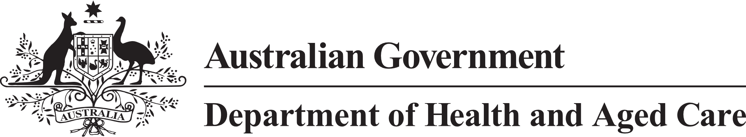

**Council of Elders**

# Communique – 21 & 22 June 2023

**Dementia deep dive** – the Council of Elders and National Advisory Council for Aged Care extensively discussed the National Dementia Action Plan and its significance in reforming aged care. This was the first time that both councils looked at an issue in depth together. Both councils recognised that dementia affects individuals differently, and personalised care can enhance their quality of life. To enhance supports, services, and the well-being of people with dementia, the Councils identified reducing stigma and normalising the experience of dementia, culturally appropriate dementia care, establishing a human-rights based model of care, suitable respite for carers and enhancing the safety of individuals living with dementia are areas of priority consideration.

**Community engagement -** the Council talked about practical ways to improve their reach and speak to more people about its work. Opportunities identified include attending local events and creating content to use in local newsletters to get the message out about the Council to as many older people in Australia as possible.

**Reform roadmap –** theCouncil welcomed the public release of the reform roadmap and the progress made on implementing the Royal Commission recommendations. They acknowledged the scale and speed of the aged care reform work completed so far. The roadmap will be an important resource for the Council when engaging with local communities.

**New Aged Care Act - rights and regulatory model -** the Council discussed the proposed approach to defining rights and enforcing them in the New Aged Care Act, as well as the approach to regulation, complaints, and feedback. The Council is concerned that achieving the necessary cultural change in aged care requires a balanced approach between regulations, teaching and helping care providers improve their skills, and giving older people the power to have their concerns taken seriously and addressed.

The Council talked about how rights should be defined and enforced in the new aged care act including the approach to regulation, complaints and feedback. The regulatory model should be able to address breaches of rights that are not severe but still greatly affect the quality of life for older people. The Council shared ideas about how this could be done.

**Aged Care Taskforce -** the Council discussed how it can support the Aged Care Taskforce by assisting its Council members, Tom Calma AO, Margaret Walsh OAM and John McCallum. Council will discuss matters under review by the Taskforce and offer advice as appropriate.

**Home care support and disability -** the Council reviewed detailed information from the department about the supports provided through aged care for individuals living with disabilities, particularly aids and equipment. The Council is concerned about the inequitable support currently offered to older people in Australia with disability-related needs under the National Disability Insurance Scheme relative to the aged care system. The Council urges the government to guarantee that adequate supports are provided for disability related needs in aged care.

**Regional stewardship for aged care** – the Council discussed for regional stewardship means finding ways for local staff to engage with the community and discuss important reforms in aged care. The Council is improving its connection with state and territory offices of the Department of Health and Aged Care. This will increase awareness of concerns raised by older people in the local community and bring clarity to the roles and responsibilities with the department and the government as a whole. The Council is delighted about the opportunity to share our networks and build connections to improve our relationships.

The next meeting of the Council of Elders will be held on 2 August 2023.