# Format

* Background and context
* Purpose
* Potential models
* What we have heard so far
* Next steps
* Questions

# Introductions

# Introductions

Images of:
Professor Anne Kelso AO, Chief Executive Officer, National Health and Medical Research Council
Dr Phillip Gould, First Assistant Secretary, Department of Health and Aged Care
Dr Masha Somi, Chief Executive Officer, Health and Medical Research Office, Department of Health and Aged Care



# Background and context

* Over **$1.5 billion** is provided each year for health and medical research grants through the MRFF and MREA.
* Intent is to improve cohesiveness of system and improve the effectiveness of the MRFF and MREA.
* We are seeking input from a broad range of stakeholders on how to do this.
* This is an important first step towards broader reforms to Australia’s health and medical research system.

# MREA and MRFF

**Medical Research Endowment Account (MREA)**

* Special account that supports NHMRC grants (~$900 million p.a.)
* Supports investigator-initiated grants in all fields of health and medical research from discovery to clinical, public health and health services research
* Administered by NHMRC, an independent agency in the Health portfolio

**Medical Research Future Fund (MRFF)**

* $20 billion sovereign fund that supports MRFF grants ($650 million p.a.)
* Supports grants in priority areas of medical research and innovation determined by government on advice of AMRAB following public consultation
* Administered by Health and Medical Research Office (HMRO) in Department of Health and Aged Care

# Purpose – What problems are to be addressed?

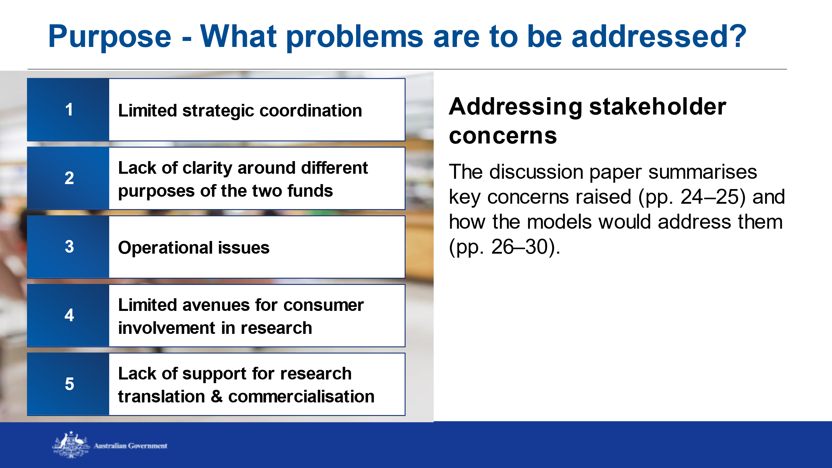

# Purpose – what is the goal of reform?

A health and medical research funding system that:

* regards all Australians as stakeholders
* values and seeks advice from stakeholders
* provides certainty for stakeholders, with well-understood frameworks, streamlined administration and coordinated grant opportunities
* harnesses foundational capability, knowledge and innovation generated by investigator-led research
* values priority-driven research to strengthen Australia’s health and economic sustainability

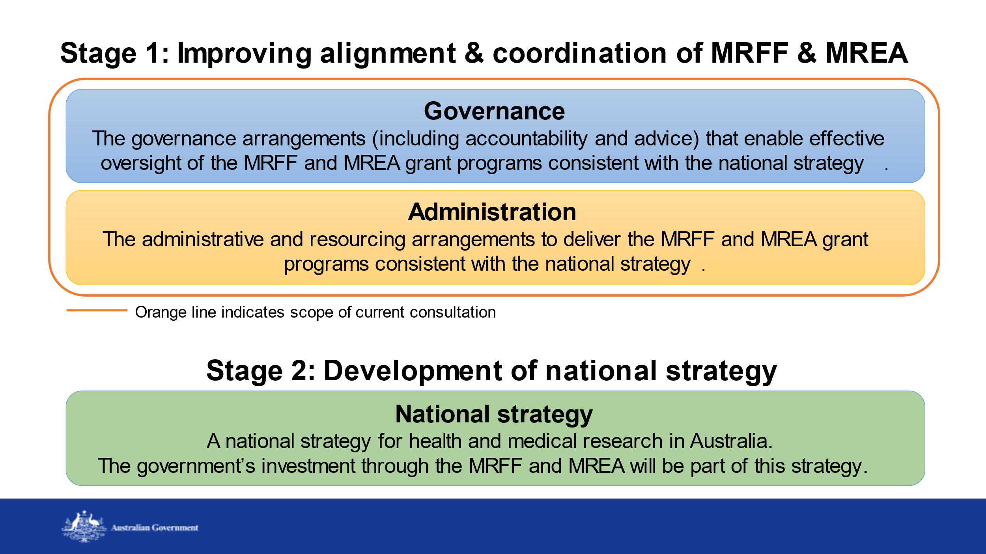

# Potential models

Three potential models for the governance and administration of the MRFF and MREA are presented for discussion:

* Model 1: Better alignment through coordination
* Model 2: Management of both funds by NHMRC
* Model 3: Merging of the two funds with new governance arrangements

# Model 1 – Better alignment through coordination

The MRFF and MREA continue to be separately managed, with a new coordination mechanism established to ensure collaboration and alignment between the funds:

* Promotes greater collaboration between HMRO CEO and NHMRC CEO, and between AMRAB and NHMRC Council
* Retains current governance and administrative arrangements (including consumer representation on advisory and grant assessment committees)
* Low implementation complexity

# Model 2 – Management of both funds by NHMRC

NHMRC leads and manages the MRFF and MREA, which continue as separate funding streams with distinct focuses:

* AMRAB ceases operations and NHMRC develops new investment plans for both funds
* New or revised advisory structures are implemented to support NHMRC Council and the NHMRC CEO – this would consider how to involve consumers
* Medium implementation complexity

# Model 3 – Merging of the two funds with new governance arrangements

Funds are merged and disbursed as a single grant program managed by NHMRC:

* New governance arrangements to support a single Commonwealth funding source for health and medical research – this would consider how to involve consumers
* Single cohesive investment strategy
* High implementation complexity

# Consultation questions

1. What benefits should be achieved through improving the alignment and coordination of the MRFF and MREA?
2. Which feature/s of the models will deliver these benefits?
3. Which aspects of the current arrangements could be changed to deliver the most appropriate and effective change, and why?
4. Which feature/s of the models will help deliver this change?

# What we have heard so far

* Diverse (and passionate) views from a broad range of research stakeholders
* Researchers (universities, MRIs), health providers and services,  
  businesses, consumers, priority populations - First Nations, rural/ regional/ remote, rare diseases
* Value of having both investigator-led and priority-driven approaches are well recognised
* Reform should promote and build on what works well in both funds
* End users of research (esp consumers) want to be involved and have an active role

# What we have heard so far

*‘Seamless but not homogenous’*

* Coordination and administrative issues could be addressed without any reform – Health and NHMRC could consider doing that work now
* This is opportunity to simplify, reduce waste, harmonise policies, reduce researcher burn-out
* Focus should be on making the most out of the investment (ie health outcomes and care), not making things ‘the same

# What we have heard so far

*‘Merged, not absorbed’*

* The two funds provide different opportunities for research – it is important that their unique elements and contributions are maintained
* Don’t lose what we have learnt through MRFF – commercialisation; priority populations focus; commissioning approach
* Don’t lose investigator-initiated research for discovery, innovation, translation and impact
* The voices of consumers are embedded in current governance arrangements – let’s build on what is working well

# What we have heard so far

*‘Consider a staged model’*

* Consider transitional or incremental reform, to keep the sector (consumers, industry, researchers) with us, ‘gateway’ changes, and avoid accidentally losing benefits
* Any reform will require significant change and therefore change management; Models 2 and 3 will require changes in NHMRC

*‘Consider other models’*

* In the UK, the two funds focus on different parts of the research pipeline

# What we have heard so far

*‘There is a place for us’*

* NHMRC has built research capacity and capability, and supported Australia to be a global leader in research
* Consumers esp priority populations (First Nations, rural/ regional/ remote, and rare disease) value the MRFF’s focus on unmet needs
* MRFF’s additional focus on impact and diverse research teams is bringing new researchers into the system

# What we have heard so far

*‘Attracted to a national strategy’*

* It’s hard to separate governance/administration from strategy
* Need to think of the pipeline as a whole (including workforce) and how the Australian Govt can work together and with other funders
* End users (esp consumers) want a strategy focused on their needs

# Next steps

* Written submissions due via the **Consultation Hub** by 11:59pm on Friday 14 July 2023
* Following consultation period, a summary report will be publicly available
* Contact: [HMRconsultations@health.gov.au](mailto:HMRconsultation@health.gov.au)

# Discussion

* How can MRFF and MREA governance structures enable consumer involvement in research governance?
* What elements of governance are working well for consumers and should be preserved?
* What could be improved?
* Are there administrative changes that could be made to enable more effective consumer involvement in research governance?

# Speaker

# Image of Dr Shyamsundar Muthuramalingam, Consumer & Community Engagement Practitioner Speaker

# Image of Dr Anthony Brown, Executive Director, Health Consumers NSW



Please submit your questions via Slido.

Join at

**slido.com**

**#3826731**



**Questions?**

**Thank you for attending**

