# Title slide: Consultation: Improving alignment and coordination between the Medical Research Future Fund & Medical Research Endowment Account Webinar 2 3 July 2023Introductions

Images of:
Dr Masha Somi, Chief Executive Officer, Health and Medical Research Office Department of Health and Aged Care
Mr Blair Exell, Deputy Secretary, Department of Health and Aged Care
Professor Anne Kelso AO, Chief Executive Officer, National Health and Medical Research Council

# Format

**Part 1**

* Webinar 1 (6 June 2023)
* Purpose of the reform and consultation
* What we have heard so far
* Next steps

**Part 2**

* Questions
* Submit via Slido

# Webinar 1

* Held 6 June 2023
* Recording available on the [department’s website](https://www.health.gov.au/resources/videos/consultation-improving-alignment-and-coordination-between-the-mrff-and-the-mrea-webinar-6-june-2023?language=en)

# Background and context

* Over **$1.5 billion** is provided each year for health and medical research grants through the MRFF and MREA.
* Intent is to improve cohesiveness of system and improve the effectiveness of the MRFF and MREA.
* We are seeking input from a broad range of stakeholders on how to do this.
* This is an important first step towards broader reforms to Australia’s health and medical research system.

# MREA and MRFF

**Medical Research Endowment Account (MREA)**

* Special account that supports NHMRC grants (~$900 million p.a.)
* Supports investigator-initiated grants in all fields of health and medical research from discovery to clinical, public health and health services research
* Administered by NHMRC, an independent agency in the Health portfolio

**Medical Research Future Fund (MRFF)**

* $20 billion sovereign fund that supports MRFF grants ($650 million p.a.)
* Supports grants in priority areas of medical research and innovation determined by government on advice of AMRAB following public consultation
* Administered by Health and Medical Research Office (HMRO) in Department of Health and Aged Care

# Purpose – What problems are to be addressed?

1. Limited strategic coordination
2. Lack of clarity around different purposes of the 2 funds
3. Operational issues
4. Limited avenues for consumer involvement in research
5. Lack of support for research translation & commercialisation

Addressing stakeholder concerns
The discussion paper summarises key concerns raised (pp. 24–25) and how the models would address them (pp. 26–30).

# Purpose – what is the goal of reform?

A health and medical research funding system that:

* regards all Australians as stakeholders
* values and seeks advice from stakeholders
* provides certainty for stakeholders, with well-understood frameworks, streamlined administration and coordinated grant opportunities
* harnesses foundational capability, knowledge and innovation generated by investigator-led research
* values priority-driven research to strengthen Australia’s health and economic sustainability

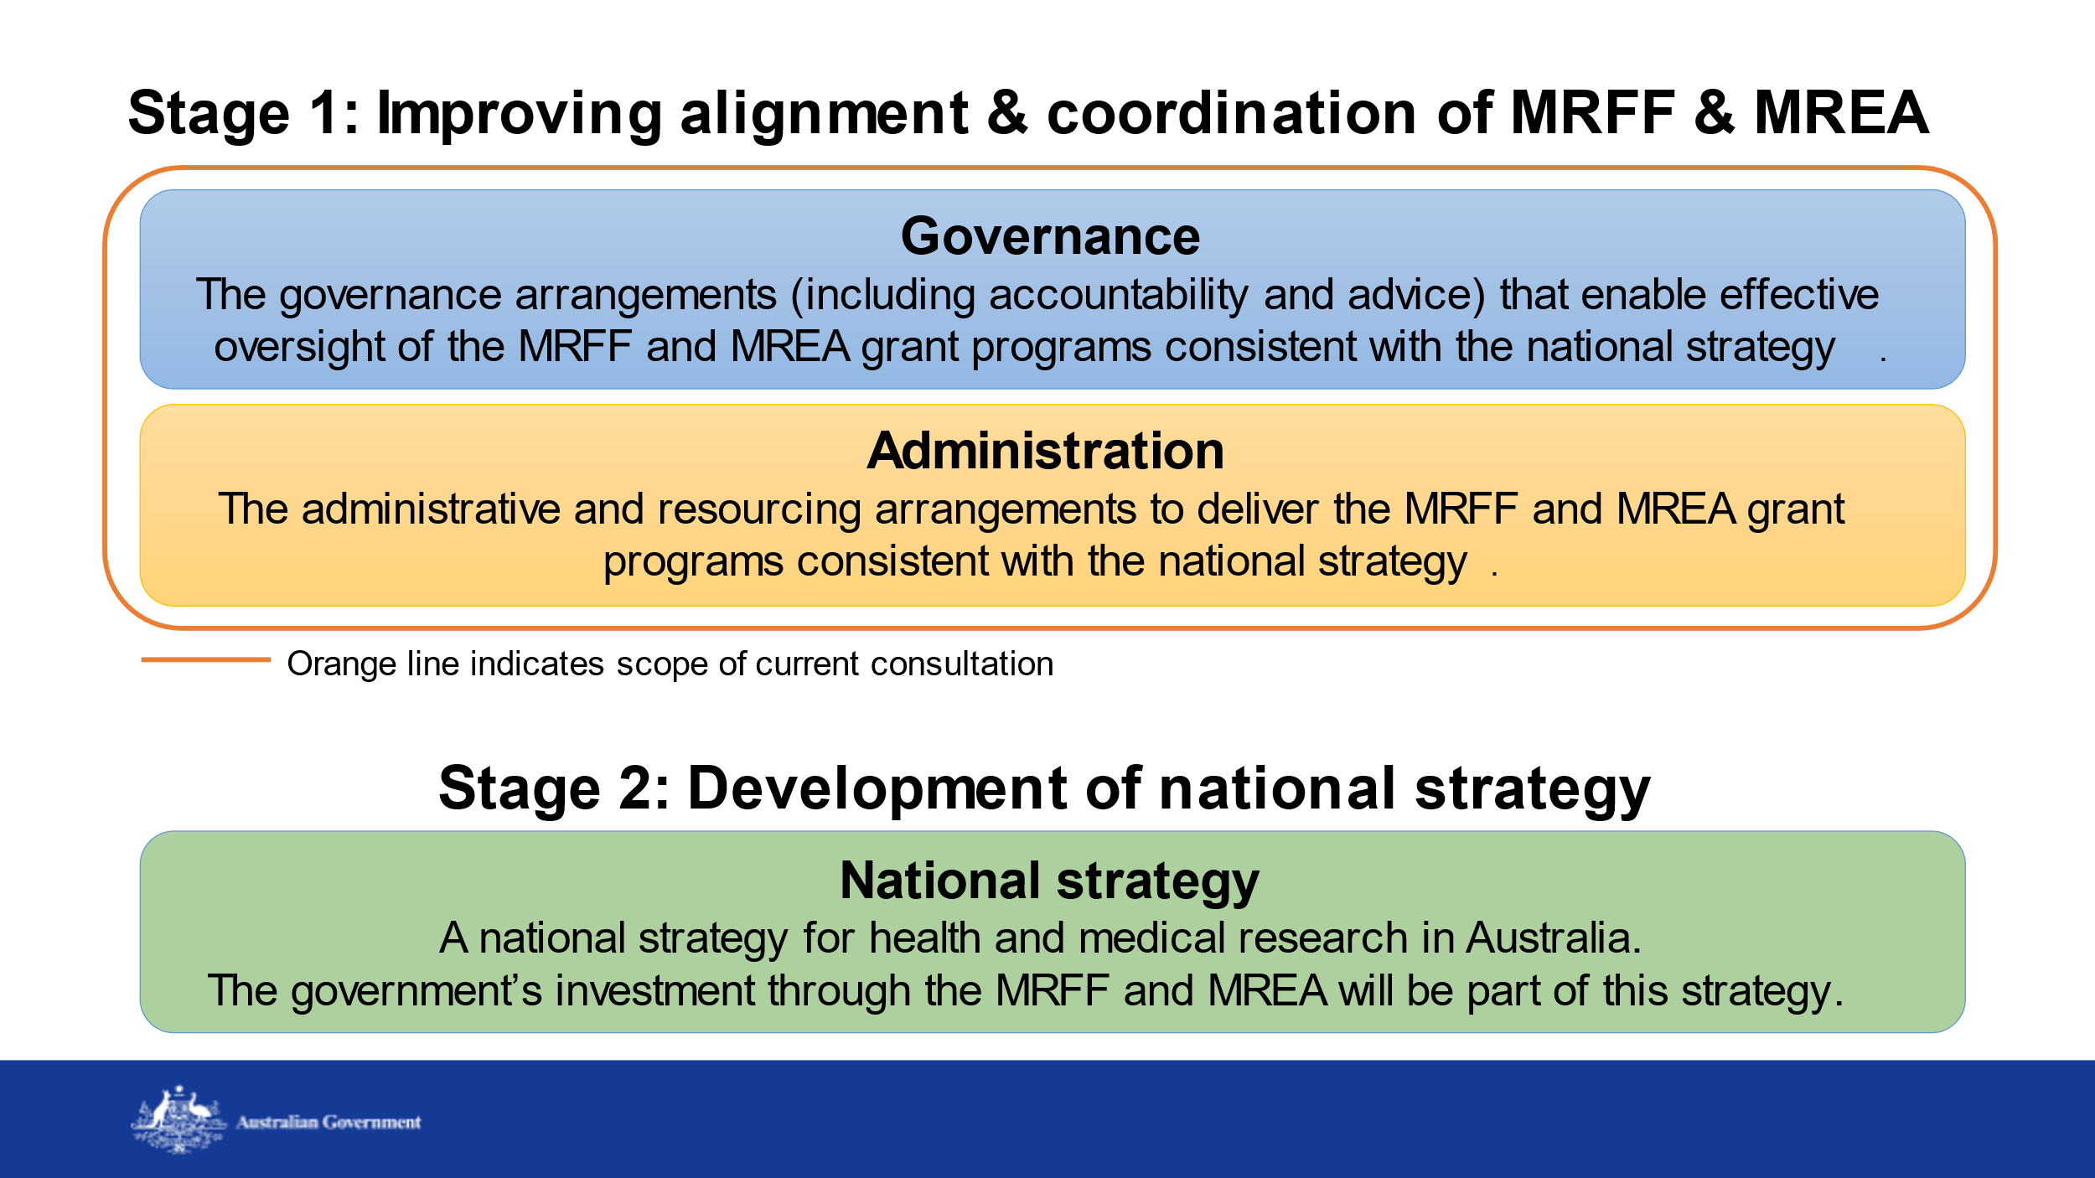

# Potential models

Three potential models for the governance and administration of the MRFF and MREA are presented for discussion:

* Model 1: Better alignment through coordination
* Model 2: Management of both funds by NHMRC
* Model 3: Merging of the two funds with new governance arrangements

# What we have heard so far

* Diverse (and passionate) views from a broad range of research stakeholders
* Researchers (universities, MRIs), health providers and services,  
  businesses, consumers, priority populations - First Nations, rural/ regional/ remote, rare diseases
* Value of having both investigator-led and priority-driven approaches are well recognised
* Reform should promote and build on what works well in both funds

# What we have heard so far

*‘Seamless but not homogenous’*

* Coordination and administrative issues could be addressed without any reform – Health and NHMRC could consider doing that work now
* This is opportunity to simplify, reduce waste, harmonise policies, reduce researcher burn-out
* Focus should be on making the most out of the investment (ie health outcomes and care), not making things ‘the same

# What we have heard so far

*‘Merged, not absorbed’*

* The two funds provide different opportunities for research – it is important that their unique elements and contributions are maintained
* Don’t lose what we have learnt through MRFF – commercialisation; priority populations focus; commissioning approach
* Don’t lose investigator-initiated research for discovery, innovation, translation and impact

# What we have heard so far

*‘Consider a staged model’*

* Consider transitional or incremental reform, to keep the sector (consumers, industry, researchers) with us, ‘gateway’ changes, and avoid accidentally losing benefits
* Any reform will require significant change and therefore change management; Models 2 and 3 will require changes in NHMRC

*‘Consider other models’*

* In the UK, the two funds focus on different parts of the research pipeline

# What we have heard so far

*‘There is a place for us’*

* NHMRC has built research capacity and capability, and supported Australia to be a global leader in research
* Consumers esp priority populations (First Nations, rural/ regional/ remote, and rare disease) value the MRFF’s focus on unmet needs
* MRFF’s additional focus on impact and diverse research teams is bringing new researchers into the system

# What we have heard so far

*‘Attracted to a national strategy’*

* It’s hard to separate governance/administration from strategy
* Need to think of the pipeline as a whole (including workforce) and how the Australian Govt can work together and with other funders
* Need to connect better to health system and delivery of health care

# Thank you

* Our thanks to those who have already contributed - the consultation activities have been productive and the feedback received is valuable!
* Please continue to share your ideas and views, including by submitting a written submission

# Next steps

* Written submissions due via the **Consultation Hub** by 11:59pm on Friday 14 July 2023
* Following consultation period, a summary report will be publicly available
* Contact: [HMRconsultations@health.gov.au](mailto:HMRconsultation@health.gov.au)



**Questions?**



Please submit your questions via Slido.

Join at  
**slido.com**

**#3927 435**

**Thank you for attending**

