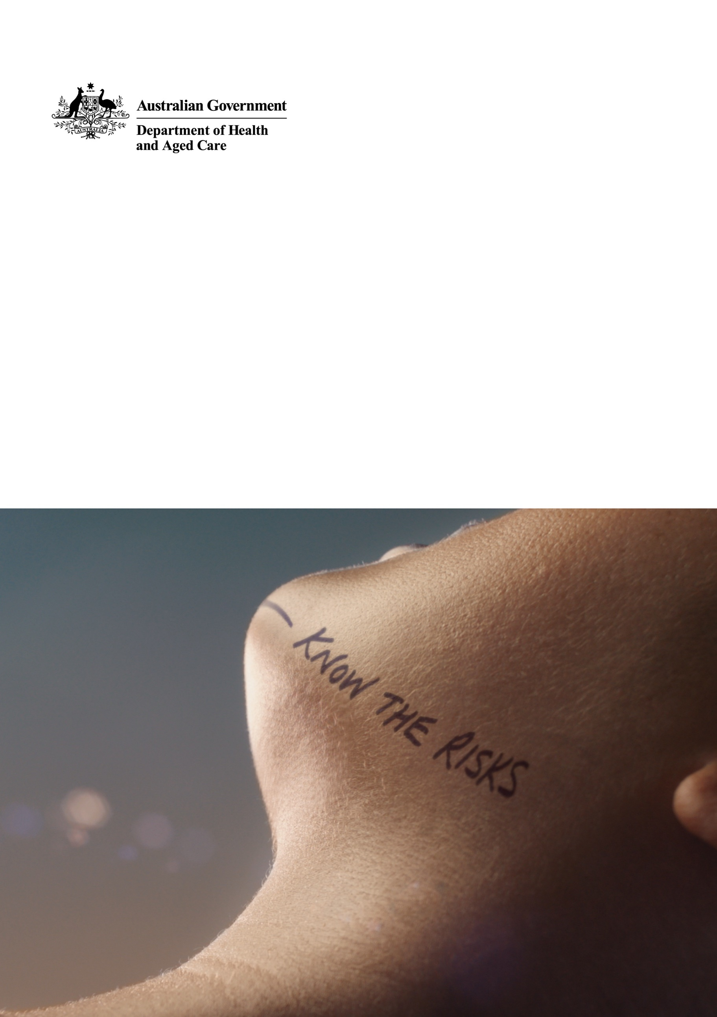

Campaign Communication Kit for Workplaces

Hearing Health Awareness and Prevention Campaign

July 2023



# Campaign communication kit

This kit has been developed to help build understanding of the importance of maintaining hearing health at all stages of life and the long-term benefits of routine preventative care.

People who work in loud environments are at a higher risk of hearing loss. This includes musicians and sound technicians, farmers, miners, military personnel, hospitality and construction workers.

As an organisation within these industries, this campaign will be relevant to your staff, members and networks and this kit will help you share important information.

This kit includes:

* Background information
* Target audiences (who this information is relevant for)
* Key messages
* Materials and resources
* Social media content
* Website/newsletter content

## Further information

Information about hearing health and the campaign can be found at [health.gov.au/hearing](https://www.health.gov.au/hearing-health)

## Contact

Communication Campaigns Section  
Department of Health and Aged Care  
[campaigns@health.gov.au](mailto:campaigns@health.gov.au)

# Background

An estimated 3.6 million Australians currently experience some form of hearing impairment. As Australia’s population ages, this is estimated to double to 7.8 million people in 2060[1].

Untreated hearing loss can have a significant impact on everyday life.

Prolonged exposure to loud noise at work, or sudden exposure to an intensely loud sound, can cause hearing loss. Many types of hearing loss can be prevented by limiting exposure to loud noise and using hearing protection.

Many Australians with hearing loss do not seek treatment. This is due to stigma, or lack of understanding about the long-term consequences of delaying treatment. Early awareness and intervention can help prevent further hearing loss. It is important that people who work in noisy environments have their hearing checked regularly.

This information aims to increase awareness of why Australians should look after their hearing health, and what they can do to check their hearing and prevent or reduce hearing loss.

# Target audiences

This kit has information for people who are exposed to occupational / workplace noise. This includes:

* farmers
* construction workers
* hospitality industry employees
* musicians and sound technicians
* miners
* military personnel.

# Key messages

Primary key messages:

* Being around loud noise at work is a major cause of preventable hearing loss.
* Long exposure to loud noise can damage your hearing.
* Protect your hearing by:
  + limiting the time you spend around loud noise
  + wearing personal protective equipment such as earplugs or earmuffs.
* Employers are required to assess noise levels in the workplace, monitor the hearing health of exposed workers and provide personal protective equipment.
* Having a hearing test helps to detect the early signs of hearing loss, so we can keep our hearing healthy for longer.
* Book a hearing check, talk to a health professional, or visit **health.gov.au/hearing** for more information.

**Use Safe Work Australia’s Model Code of Practice,**[**Managing Noise and Preventing Hearing Loss at Work**](https://www.safeworkaustralia.gov.au/sites/default/files/2020-07/model_code_of_practice_managing_noise_and_preventing_hearing_loss_at_work.pdf) **to protect workers from the effects of noise at work.**

# Materials and resources

Campaign materials can be downloaded from the ‘Resources’ page at [health.gov.au/hearing](https://www.health.gov.au/hearing-health/resources).

| Resource title | Suggested use | Variations available on request | Preview |
| --- | --- | --- | --- |
| **Protecting your hearing information sheet** | Promote through your channels/ networks | English and translated into seven languages* |  |
| **Protecting your hearing at work information sheet** | Promote through your channels/ networks | English and translated into seven languages* |  |
| **Protecting your hearing at work – guide for employers** | Promote through your channels/ networks |  |  |
| **Protecting hearing animation** | Embed on your website and share on social media |  |  |
| **15 second video – cafe** | Embed on your website and share on social media | With and without captions  and translated into seven languages* |  |
| **Social media infographics** | Share on your social media | English and translated into seven languages* |  |
| * Resource is translated into Arabic, Cantonese, Korean, Mandarin, Punjabi, Vietnamese and Spanish. | | | |

# Social media content

The content below can be used alongside the campaign assets and published on your social channels.

| Channel | Copy |
| --- | --- |
| **Workplace noise - Post 1**  Facebook & Instagram | Being around loud noise in the workplace is a major cause of preventable hearing loss.  It could be a short intense noise, such as a jet taking off (130 decibels) or being near a loud noise for long periods, such as a jack hammer (120 decibels) or a tractor (100 decibels).  Long exposure to sounds over 85 decibels at work can permanently damage your hearing.  But you can protect your hearing by:  🕞 Limiting how much time you spend around loud noise and taking listening breaks.  🎧 Wearing earplugs and earmuffs.  👂Having your hearing checked regularly by an audiologist or audiometrist.  Talk to a GP or book an appointment directly with a hearing clinic – you don’t need a referral.  For more information visit health.gov.au/hearing  #HearingHealth #HearingLoss #HearingTest |
| Twitter | Loud noise at work is a major cause of preventable #HearingLoss. Protect your #HearingHealth by reducing exposure to loud noise, wearing protective equipment and having your hearing checked regularly.  For more hearing health tips, visit health.gov.au/hearing |
| LinkedIn | Preventing #HearingLoss in the workplace is a joint effort.  Employers are required to assess noise levels in the workplace, monitor the hearing health of exposed workers, and provide personal protective equipment.  Employees should try to avoid long periods around loud noise, take scheduled listening breaks when loud noise is unavoidable, and wear protective equipment.  Regular hearing checks with an audiologist or audiometrist can help maintain healthy hearing for longer.  For more hearing health tips, visit health.gov.au/hearing |
| **Workplace noise - Post 2**  Facebook & Instagram | Music, agriculture, mining, defence, manufacturing, air and rail transport, hospitality and construction.  If you work in any of these industries you could be at a higher risk of #HearingLoss from being around loud noise.  But there are simple things you can do to protect your #HearingHealth at work:  🕞 Limit how much time you spend around loud noise and take listening breaks.  🎧 Wear earplugs and earmuffs.  👂Have your hearing checked regularly by an audiologist or audiometrist.  Talk to a GP or book an appointment directly with a hearing clinic – you don’t need a referral. For more information visit health.gov.au/hearing |
| Twitter | Music, agriculture, mining, defence, manufacturing, air and rail transport, hospitality and construction.  If you work in any of these industries you're at risk of #HearingLoss from loud noise.  Find out how to protect your #HearingHealth, visit health.gov.au/hearing |
| LinkedIn | Music, agriculture, mining, defence, manufacturing, air and rail transport, hospitality and construction – these are some of the world's NOISIEST JOBS.  If you work in any of these industries you could be at a higher risk of #HearingLoss from being around loud noise.  A good first step is to assess your risk using the noise risk calculator on the National Acoustic Laboratories website: knowyournoise.nal.gov.au.  For information and advice for preventing hearing loss in the workplace, visit health.gov.au/hearing |

The following hashtags are associated with this content:

* #hearing
* #HearingHealth
* #HearingTest

# Website/newsletter content

*Below is a sample article that can be placed on a website or in a newsletter. You may want to tailor this specifically for your industry.*

**Did you hear that? Protect** **your hearing at work to prevent hearing loss**

Being around loud noise in the workplace is a major cause of preventable hearing loss. It can be short intense noise or being exposed to loud noise for a long period.

Long exposure to sounds over 85 decibels at work can permanently damage your hearing.

In the workplace, preventing hearing loss is a joint effort between employers and employees.

As an employer you are required to assess noise levels, monitor the hearing health of exposed workers, and provide personal protective equipment.

Employees should avoid long periods around loud noise, take scheduled listening breaks, and wear protective equipment when loud noise is unavoidable.

Regular hearing checks with an audiologist or audiometrist should also be part of the routine for workers exposed to workplace noise.

For more information about hearing health, visit health.gov.au/hearing

1. *Roadmap for Hearing Health Hearing Health Sector Committee Supporting all Australians who are deaf or hard of hearing to live well in the community Report*