Australian Influenza Surveillance Report

Communicable Disease Epidemiology and Surveillance Section (CDESS)

Report no. 08, 2023

**Reporting fortnight:** Monday 10 July 2023 to Sunday 23 July 2023.

**Reporting weeks:** 28 and 29, of 2023.

The Department of Health and Aged Care acknowledges the providers of the many sources of data used in this report and greatly appreciates their contribution.

## Key Messages

It is important to note that due to the COVID-19 epidemic in Australia, data reported from the various influenza surveillance systems may not represent an accurate reflection of influenza activity. Results should be interpreted with caution, especially where comparisons are made to previous influenza seasons. Interpretation of influenza data from April 2020 onwards should take into account, but are not limited to, the impact of social distancing measures, likely changes in health seeking behaviour of the community including access to alternative streams of acute respiratory infection specific health services, and focussed testing for COVID-19 response activities. For information on COVID-19 incidence, severity, and distribution in Australia, please refer to the [COVID-19 epidemiology reports](https://www1.health.gov.au/internet/main/publishing.nsf/Content/novel_coronavirus_2019_ncov_weekly_epidemiology_reports_australia_2020.htm).

Note: This fortnightly report does not contain data from the HealthDirect surveillance system due to data transmission issues. Data will be included in future reports once available.

Activity:

* Influenza-like-illness (ILI) activity in the community reported to FluTracking has decreased in the last fortnight, while ILI presentations to ASPREN sentinel general practitioners (GPs) have been stable.
* In the year-to-date (1 January to 23 July 2023), there have been 174,898 notifications reported to the National Notifiable Diseases Surveillance System (NNDSS) in Australia, of which 22,436 notifications had a diagnosis date this fortnight.

Severity:

* There is currently not enough information to comprehensively assess the potential severity of the 2023 influenza season at this time.
* In the year-to-date, of the 174,898 notifications of laboratory-confirmed influenza, 162 influenza-associated deaths have been notified to the NNDSS.
* Since seasonal surveillance commenced in April 2023, there have been 1,991 sentinel hospital admissions, of which 137 (6.88%) were admitted directly to ICU.

Impact:

* This fortnight, community ILI activity has decreased or stabilised, notifications of laboratory-confirmed influenza to the NNDSS have decreased, and admissions to sentinel hospitals with influenza appear to be decreasing.
* It is likely that the impact on society due to the 2023 influenza season this fortnight has decreased.

At-risk populations:

* In the year-to-date, notification rates have been highest in people aged 05–09 years, followed by those aged 0–04 years, and 10–14 years.

Virology:

* In the year-to-date, 62.64% of notifications of laboratory-confirmed influenza reported to the NNDSS were influenza A, of which 95.08% were influenza A(unsubtyped); 4.40% were influenza A(H1N1); and 0.52% were influenza A(H3N2). Influenza B accounted for 35.19% of notifications; influenza A&B accounted for 0.27% of notifications; and 1.91% of influenza notifications were untyped.

Vaccine match and effectiveness:

* Of the 2,296 samples referred to the WHOCC in the year-to-date, 97.52% of influenza A(H1N1) isolates, 81.23% of influenza A(H3N2) isolates and 99.19% of influenza B/Victoria isolates characterised were antigenically similar to the corresponding vaccine components.
* It is too early to assess vaccine effectiveness for this season.

*The years 2020 and 2021 have been excluded when comparing the current season to historical periods (including the 5-year average) when influenza virus has circulated without public health restrictions. Please refer to Data considerations for interpretation of the five-year average.

## 1. Introduction

Each year, the influenza virus changes and different strains can circulate in the population. Particular subtypes of influenza can affect different groups of the population more than others. Depending on the susceptibility of the population, the subtypes that are circulating and the changes to the virus itself, the influenza season can be very different year to year. Our surveillance systems help us to understand influenza activity, severity of the infection in individuals and impact of the illness on society in Australia. We are also able to monitor which influenza viruses are circulating, which populations might be more affected, the effectiveness of the vaccine, and any resistance to antiviral drugs that has developed.

### 1.1. National Influenza Surveillance System

This report presents an overview of influenza activity based on a number of complimentary systems. No one single system, including notification data, provides the full picture on influenza, because influenza is a common disease and its presenting symptoms are non-specific. The epidemiology of influenza is informed by a number of different systems based in the community, laboratories, primary care and hospitals, as well as notifiable diseases data, which includes officially reported deaths. The information in this report is reliant on the surveillance sources available to the Department of Health and Aged Care at the time of production.

* The **National Notifiable Diseases Surveillance System (NNDSS)** coordinates the national surveillance of more than 60 communicable diseases or disease groups. Notifications of laboratory-confirmed influenza are made to state or territory health authorities and supplied daily to the Australian Government Department of Health and Aged Care via the NNDSS for collation, analysis, and to assist in the coordination of public health responses.
* **Healthdirect** provides free health triage advice and information services by telephone and online, and can assist in identifying symptoms including those that may be classified as an ILI syndrome. Community level ILI syndromic trends are monitored using Healthdirect data.
* **FluTracking** is an online syndromic surveillance system which monitors ILI in the community.
* The **Australian Sentinel Practices Research Network (ASPREN)** is a year-round sentinel general practice (GP) surveillance system in which general and nurse practitioners report de-identified information on the number of ILI patient presentations seen in participating practices each week. It should be noted that in addition to the overarching impacts of COVID-19 on influenza surveillance systems, interpretation of ASPREN’s data from 2020 onwards should consider the following COVID-19 impacts:
  + Changes in the health seeking behaviour at ASPREN sentinel sites due to the availability of telehealth and respiratory clinics may result in fewer presentations to General Practice (GP); and
  + Changes to GPs swabbing at ASPREN sentinel sites, due to the availability of telehealth and respiratory clinics, may result in a lower number of swabs being undertaken by ASPREN reporters.
* The **Influenza Complications Alert Network (FluCAN)** conducts surveillance of severe influenza at sentinel hospitals across the country during the influenza season. The Paediatric Active Enhanced Disease Surveillance (PAEDS) network also contributes data on influenza via FluCAN.
* The **World Health Organization Collaborating Centre (WHOCC) for Reference and Research on Influenza** analyses influenza viruses currently circulating in the human population in Australia and other countries, to inform which strains should be included in annual seasonal influenza vaccines for the Northern and Southern Hemispheres.
* **Sentinel laboratory surveillance** systems provide fortnightly reporting of influenza testing. This includes the number of tests undertaken, the number of positive results, and the detected viruses. Sentinel laboratory site testing data are influenced by jurisdictional and laboratory testing practices, and should be interpreted with caution. Please note that tests conducted at sentinel laboratory sites may include samples taken from people in home or hotel quarantine for COVID-19, and may not reflect respiratory viruses circulating in the community alone.

### 1.2. Data considerations

* NNDSS laboratory-confirmed influenza surveillance case definition
  + From 1 January 2022, the [NNDSS surveillance case definition for laboratory-confirmed influenza](https://www.health.gov.au/resources/publications/influenza-laboratory-confirmed-surveillance-case-definition) was updated to remove Point 5: ‘Single high titre by complement fixation test (CFT) or haemagglutination inhibition (HAI) to influenza virus’ from the list of laboratory definitive evidence.
  + This change has minimal impact on the interpretation of influenza notification trends, with the change ensuring consistency with the influenza laboratory case definition. For further information, please refer to the [NNDSS laboratory-confirmed influenza case definition Technical Supplement](https://www.health.gov.au/resources/publications/influenza-laboratory-confirmed-surveillance-case-definition).
* Data in this summary is reported by International Organization for Standardization (ISO) 8601 weeks, with the week ending on Sunday. Throughout the summary, where the year-to-date is presented, this includes data from 1 January to 23 July. NNDSS data are analysed and reported based on diagnosis date, which is the true onset date of a case if known, otherwise it is the earliest of the specimen date, the notification date, or the notification received date. NNDSS data were extracted on Thursday 27 July 2023.
* In interpreting these data, it is important to note that changes in notifications over time may not solely reflect changes in disease prevalence or incidence. Depending on the disease, the number of notifications may be influenced by changes in testing policies; changes in case definitions; changes in testing practices and screening programs; the use of less invasive and more sensitive diagnostic tests; and periodic awareness campaigns.
* In particular, analyses including data from 2020 and 2021 should be interpreted with caution. Influenza activity in 2020 and 2021 was unusual due to the suppression of influenza virus circulation because of COVID-19 mitigation measures. Data from these years may reduce five-year averages and affect analyses of usual seasonal trends. Therefore the years 2020 and 2021 are excluded in this report when comparing the current season to historical periods when influenza virus has circulated without public health restrictions. Where referenced, the five-year average in this report refers to the average of data from the years 2016, 2017, 2018, 2019, and 2022.
* Due to the dynamic nature of the NNDSS and other surveillance systems, data in this report are subject to retrospective revision and may vary from data reported in other national reports and reports by states and territories. Detailed notes on interpreting the data presented in this report are available at the Department of Health and Aged Care’s [Australian Influenza Surveillance Report website](https://www.health.gov.au/resources/collections/aisr?utm_source=health.gov.au&utm_medium=redirect&utm_campaign=digital_transformation&utm_content=flureport). While every care has been taken in preparing this report, the Commonwealth does not accept liability for any injury or loss or damage arising from the use of, or reliance upon, the content of the report. Delays in the reporting of data may cause data to change retrospectively. For further details about information contained in this report please contact the Influenza Surveillance Team ([flu@health.gov.au](mailto:flu@health.gov.au)).

## 2. Analysis

### 2.1. Activity

Activity measures the capacity of the circulating influenza viruses to spread person to person and may be measured indirectly through systems that monitor influenza-like illness and more directly through systems that monitor laboratory-confirmed influenza.

#### 2.1.1. Influenza-like illness (ILI)

**FluTracking**

* This fortnight (10 July to 23 July 2023), the average proportion of FluTracking participants reporting ILI (fever and cough) was 0.94%, compared to 1.2% in the previous fortnight (Figure 1).
* The average proportion of FluTracking survey respondents reporting ILI has decreased this fortnight.

**Sentinel General Practitioners (ASPREN)**

* This fortnight (10 July to 23 July 2023), an average of 7.82 per 1,000 consultations due to ILI were reported by sentinel ASPREN GPs, compared to 9.13 per 1,000 consultations in the previous fortnight.
* In the year-to-date, sentinel ASPREN GPs have reported between 0.5 to 10 consultations due to ILI per 1,000 consultations per week. The highest ILI rate to date this year was observed in week 26 (10 per 1,000 consultations) (Figure 2).
* In the year-to-date, 763 people presenting to a sentinel ASPREN GP with ILI were tested for respiratory viruses, of which 181 (23.72%) samples were positive for influenza.
* In the year-to-date, of those presenting to sentinel ASPREN GPs with ILI who were tested for respiratory viruses, 64.74% (494/763) tested positive for a respiratory virus. Among those positive for a respiratory virus, the most common virus reported was influenza (36.64%, 181/494). Other viruses detected included rhinovirus (29.35%), SARS-CoV-2 (13.36%), respiratory syncytial virus (RSV) (9.51%), adenovirus (3.44%), and parainfluenza virus type-3 (2.83%).

**Sentinel laboratories**

* This fortnight (10 July to 23 July 2023) the most commonly detected respiratory viruses* by sentinel laboratory site and week were as follows:
  + New South Wales: Influenza A (both weeks);
  + South Australia: Rhinovirus (both weeks);
  + Tasmania: Influenza B (week 28), and RSV (week 29);
  + Victoria: Influenza B and RSV (week 28), and Picornavirus (week 29);
  + Western Australia: RSV (both weeks).

*Excludes SARS-CoV-2 for laboratory data reported by WA.

**Figure 1:** Proportion of fever and cough among FluTracking participants, Australia, 2016 to 2023, by year and week of report*^

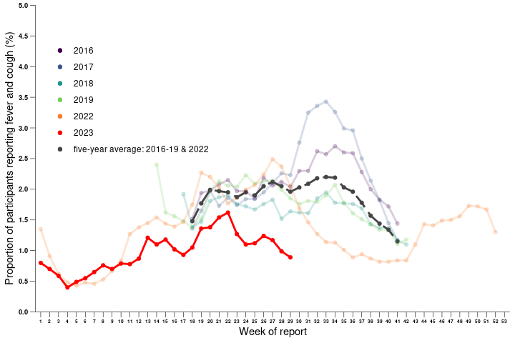

**Source:** FluTracking

*All data are preliminary and subject to change as updates are received, with most recent weeks considered particularly subject to revisions.

^FluTracking have expanded their reporting period from 2020 onwards due to COVID-19. As such, five-year historical comparisons are not available for data reported before May and after October for any year before 2020. The years 2020 and 2021 are excluded when comparing the current season to historical periods when influenza virus has circulated without public health restrictions. Please refer to Data considerations for interpretation of the five-year average.

**Figure 2:** Unweighted rate of ILI reported from ASPREN sentinel GP surveillance systems, Australia, 1 January 2016 to 23 July 2023, by year and week*^

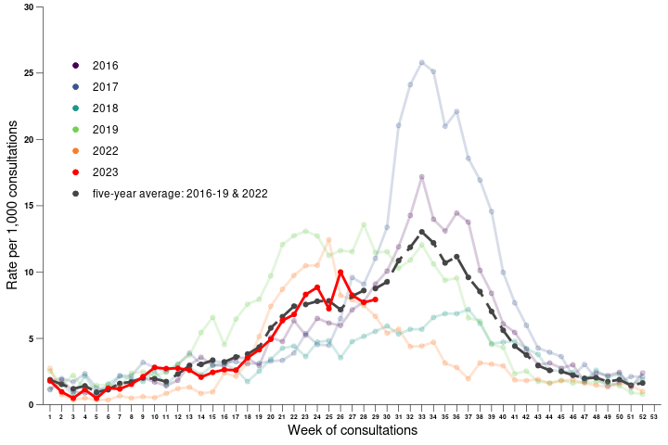

**Source:** ASPREN

*All data are preliminary and subject to change as updates are received, with most recent weeks considered particularly subject to revisions. The years 2020 and 2021 are excluded when comparing the current season to historical periods when influenza virus has circulated without public health restrictions. Please refer to Data considerations for interpretation of the five-year average.

^Please refer to surveillance system description for notes on impact of COVID-19 on ASPREN data.

#### 2.1.2. Laboratory-confirmed influenza

**National notification data (NNDSS):**

* There were 22,436 laboratory-confirmed influenza notifications with a diagnosis date this fortnight (10 July to 23 July 2023), a decrease compared to 33,828 notifications in the previous fortnight (Figure 3).
* In the year-to-date, there have been 174,898 notifications of laboratory-confirmed influenza to the NNDSS. This is a national notification rate of 673 cases per 100,000 population.

**ASPREN**

* In the year-to-date, there have been 181 (23.72%) influenza detections among the 763 ILI cases presenting to sentinel GPs who were tested for respiratory viruses.

**Sentinel laboratories**

* This fortnight (10 July to 23 July 2023), of the 21,369 samples tested across sentinel laboratories, 9.70% (n=2,072) have been positive for influenza, compared to 13% in the previous fortnight (Figure 4).
* Of the 258,501 samples tested across sentinel laboratories in the year-to-date, 6.02% (15,567/258,501) have been positive for influenza.

**Figure 3:** Notifications of laboratory-confirmed influenza, Australia, 1 January 2016 to 23 July 2023, by year and week of diagnosis*

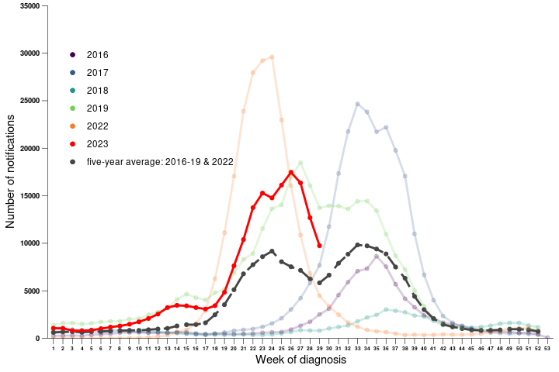

**Source:** NNDSS

*NNDSS notification data provided for the current and most recent weeks may be incomplete. All data are preliminary and subject to change as updates are received, with most recent weeks considered particularly subject to revisions. The years 2020 and 2021 are excluded when comparing the current season to historical periods when influenza virus has circulated without public health restrictions. Please refer to Data considerations for interpretation of the five-year average.

**Figure 4:** Proportion of sentinel laboratory tests positive for influenza and total number of specimens tested, 1 January to 23 July 2023, by subtype, year and week*

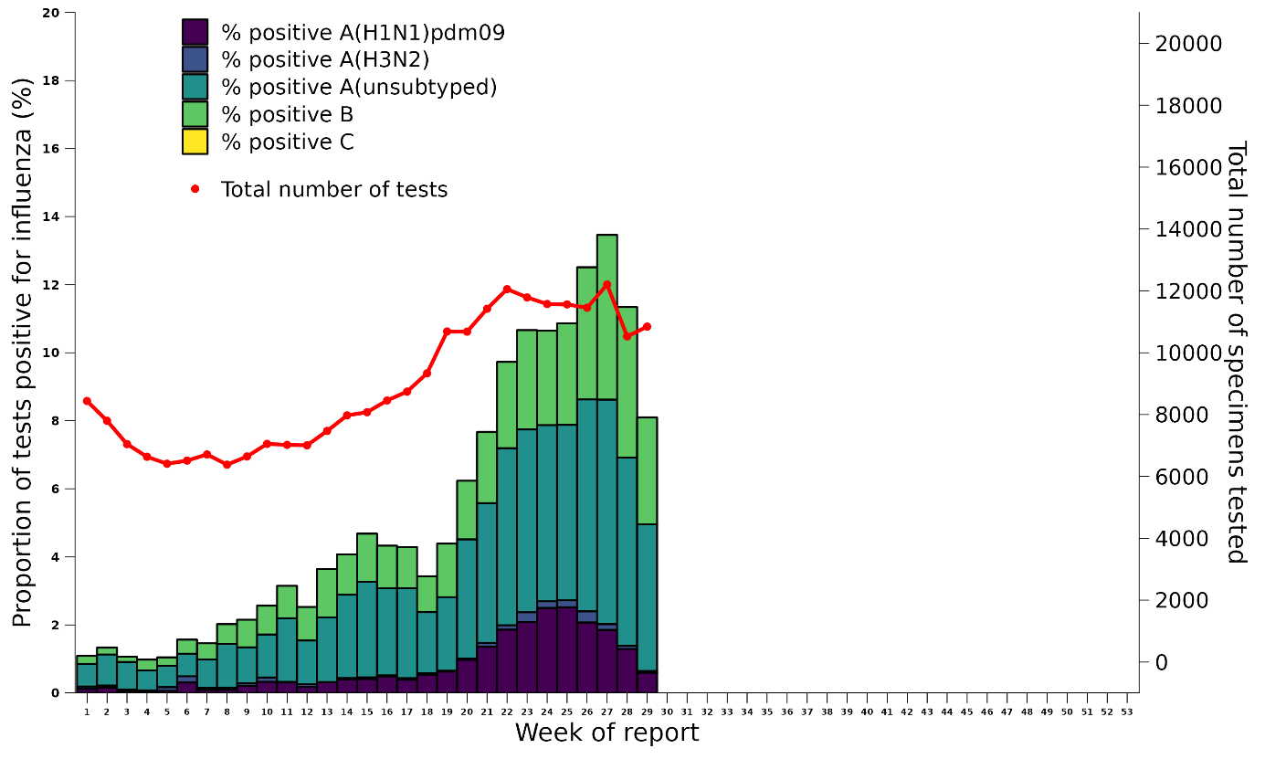

**Source:** Sentinel laboratories

*Total number of tests include all specimens that were tested for influenza, including multiplex panels used to test for SARS-CoV-2. Testing methodologies vary across jurisdictions and laboratories. All data are preliminary and subject to change as updates are received, with most recent weeks considered particularly subject to revisions.

#### 2.1.3. Geographical distribution of influenza activity

**National notification data (NNDSS):**

* In the year-to-date, influenza notification rates have been highest in Queensland (1,013 notifications per 100,000 population) followed by New South Wales (766 notifications per 100,000 population) (Table 1).
* This fortnight (10 July to 23 July 2023), influenza activity has decreased or stabilised across all jurisdictions (Figure 5).

**Table 1:** Laboratory-confirmed influenza notifications to the NNDSS and notification rate per 100,000 population, 1 January to 23 July 2023

| **Jurisdiction** | **ACT** | **NSW** | **NT** | **QLD** | **SA** | **TAS** | **VIC** | **WA** | **Total** |
| --- | --- | --- | --- | --- | --- | --- | --- | --- | --- |
| Number of notifications | 1,958 | 62,485 | 1,786 | 53,911 | 10,584 | 2,289 | 26,687 | 15,198 | **174,898** |
| Notification rate per 100,000 population | 429 | 766 | 713 | 1,013 | 581 | 401 | 404 | 546 | **673** |

**Figure 5:** Notifications of laboratory-confirmed influenza*, 1 January to 23 July 2023, by state or territory and week of diagnosis

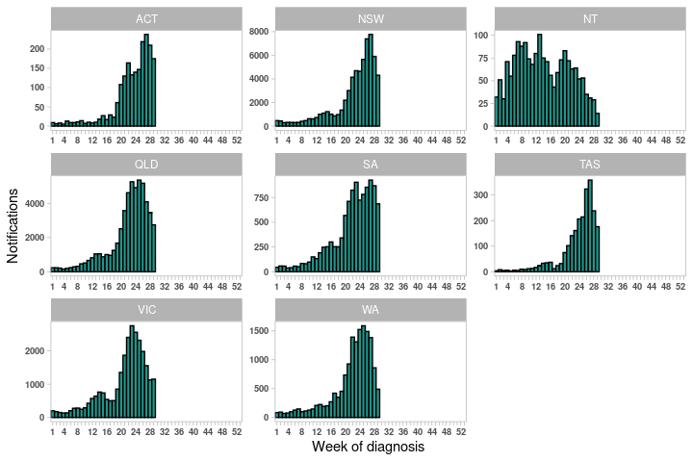

**Source:** NNDSS

*NNDSS notification data provided for the current and most recent weeks may be incomplete. All data are preliminary and subject to change as updates are received, with most recent weeks considered particularly subject to revisions.

For further information regarding influenza activity at the jurisdictional level, please refer to the following State and Territory health surveillance reports:

* ACT: [ACT Influenza Report](https://www.covid19.act.gov.au/updates/act-covid-19-statistics)
* NSW: [Respiratory surveillance reports](https://www.health.nsw.gov.au/Infectious/covid-19/Pages/weekly-reports.aspx)
* NT: [The Northern Territory Disease Control Bulletin 1991 - current](https://digitallibrary.health.nt.gov.au/prodjspui/handle/10137/506) (Influenza section)
* QLD: [Statewide Weekly Influenza Surveillance Report](https://www.health.qld.gov.au/clinical-practice/guidelines-procedures/diseases-infection/surveillance/reports/flu)
* SA: [Weekly Epidemiological Summary](http://www.sahealth.sa.gov.au/wps/wcm/connect/public+content/sa+health+internet/about+us/health+statistics/surveillance+of+notifiable+conditions) (Influenza section)
* TAS: [fluTAS Reports](https://www.health.tas.gov.au/publications/respiratory-surveillance-report)
* VIC: [Influenza Surveillance Reports](https://www2.health.vic.gov.au/public-health/infectious-diseases/infectious-diseases-surveillance/seasonal-influenza-reports)
* WA: [Virus WAtch](http://ww2.health.wa.gov.au/Articles/F_I/Infectious-disease-data/Virus-WAtch)

### 2.2. Severity

Severity is a measure of adverse outcomes or complications as a result of ILI such as hospital referrals, admissions, need for intensive care, and deaths. Measuring and understanding the severity of circulating influenza is difficult to establish at the beginning, or during a low, influenza season. The proportion of confirmed influenza cases with serious outcomes might be skewed initially because there are only a small number of people notified. This means that the measure of severity will vary substantially fortnight to fortnight until numbers are sufficiently high and there is enough data for measurements to stabilise. An assessment of severity can be provided once the signals become clearer.

**FluCAN:**

* This fortnight (10 July to 23 July 2023), there have been 166 hospitalisations due to influenza across FluCAN sentinel hospital sites, of which 15 (9.04%) cases were admitted to ICU (Figure 6).
* Since seasonal surveillance commenced in April 2023, there have been 1,991 sentinel hospital admissions due to confirmed influenza, of which 137 (6.88%) were admitted directly to ICU.

**National notification data (NNDSS):**

* In the year-to-date, of the 174,898 notifications of laboratory-confirmed influenza, there have been 162 influenza-associated deaths notified to the NNDSS.
* 78% of influenza-associated deaths were attributed to influenza A(unsubtyped), 11% to influenza B, 8% to influenza A(H1N1), and 1% to influenza A(H3N2). 1% of influenza-associated deaths were due to influenza untyped.
* The median age of deaths notified was 75.5 years.

Note: the number of influenza-associated deaths reported to the NNDSS does not represent the true mortality associated with this disease. The number of deaths is reliant on the follow up of cases to determine the outcome of their infection. The follow up of cases is not a requirement of notification and are only inclusive of laboratory-confirmed cases of influenza. Due to retrospective revision, the variation across jurisdictions in methodology, representativeness, and timeliness of death data, and reporting of an outcome of infection not being a requirement of notification, year on year comparisons of deaths in notified cases of influenza may not be reliable.

**Figure 6:** Number of influenza hospitalisations at sentinel hospitals, from April to October, 2016 to 2023 by year and week of diagnosis*

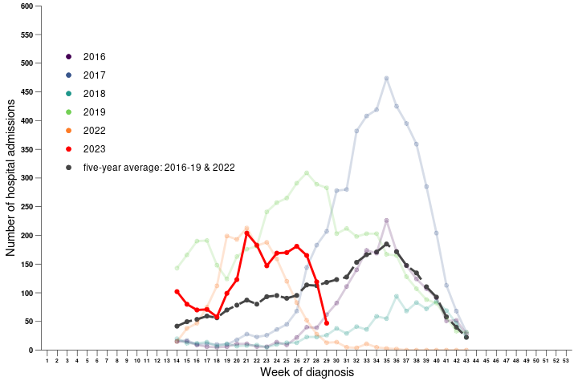

**Source:** FluCAN

*All data are preliminary and subject to change as updates are received, with most recent weeks considered particularly subject to revisions. The years 2020 and 2021 are excluded when comparing the current season to historical periods when influenza virus has circulated without public health restrictions. Please refer to Data considerations for interpretation of the five-year average.

### 2.3. Impact

Impact measures how influenza affects society, including stress on health-care resources and societal and economic consequences.

**FluTracking**

* This fortnight (10 July to 23 July 2023), the average proportion of FluTracking participants reporting ILI and taking time off regular work duties while unwell was 0.64%, compared to 0.87% in the previous fortnight.
* The proportion of FluTracking survey respondents reporting having ILI and taking time off regular duties while unwell has decreased this fortnight.

**FluCAN:**

* Since seasonal surveillance commenced in April 2023, there have been 1,991 sentinel hospital admissions, of which 137 (6.88%) were admitted directly to ICU.

### 2.4. At-risk populations

At-risk populations are people who may be more susceptible to infection with the influenza virus and/or who may be more likely to experience severe outcomes from their infection.

**National notification data (NNDSS):**

* In the year-to-date, notification rates have been highest in people aged 05–09 years (2,136 notifications per 100,000 population), followed by those aged 0–04 years (1,478 notifications per 100,000 population), and those aged 10–14 years (1,257 notifications per 100,000 population).
* In the year-to-date, influenza A accounted for the highest rate of notifications across all age groups (Figure 7).

**FluCAN:**

* Since seasonal surveillance commenced in April 2023, 71% of people admitted with confirmed influenza across sentinel hospital sites were children aged younger than 16 years*, 16% were adults aged 16 to 64 years, and 12% were adults aged 65 years or older.
* Of children aged younger than 16 years admitted with confirmed influenza to date, 5.65% (80/1,417) were admitted directly to ICU, compared to 13.46% (44/327) of adults aged 16 to 64 years, and 5.28% (13/246) of adults aged 65 years or older.

*Hospital admissions in children under 16 years of age are over-represented in the FluCAN data in order to provide increased information on this at-risk population. The age distribution of hospital admissions in the FluCAN sentinel surveillance system may not reflect the age distribution of all influenza admissions nationally.

**Figure 7:** Rate of notifications of laboratory-confirmed influenza, Australia, 1 January to 23 July 2023, by age group and subtype*

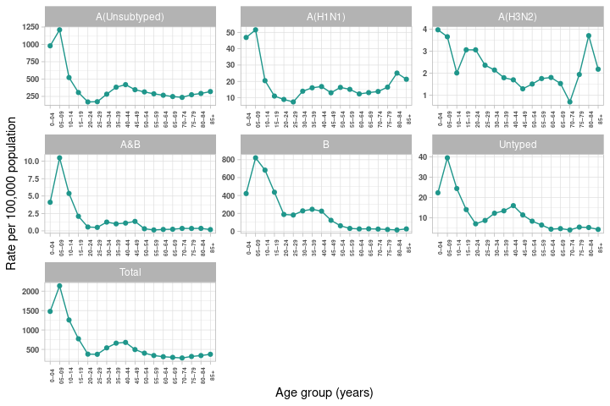

**Source:** NNDSS

*All data are preliminary and subject to change as updates are received.

### 2.5. Virology

**National notification data (NNDSS):**

* Of the 22,436 notifications of laboratory-confirmed influenza reported to the NNDSS this fortnight (10 July to 23 July 2023), 51.68% (11,596/22,436) were influenza B; 43.71% (9,807/22,436) were influenza A(unsubtyped); 1.30% (291/22,436) were influenza A(H1N1); 0.12% (27/22,436) were influenza A(H3N2); and 0.06% were influenza A&B (14/22,436). 3.12% (701/22,436) were influenza untyped (Figure 8).
* In the year-to-date, 62.64% of notifications of laboratory-confirmed influenza reported to the NNDSS were influenza A (109,548/174,898), of which 95.08% were influenza A (unsubtyped); 4.40% were influenza A(H1N1); and 0.52% were influenza A(H3N2). Influenza B accounted for 35.19% of notifications (61,542/174,898); influenza A&B accounted for 0.27% of notifications (476/174,898); and 1.91% of notifications were untyped (3,332/174,898).
* In the year-to-date, influenza A has accounted for the majority of influenza notifications in most jurisdictions. In the Northern Territory however, influenza B still accounts for the highest proportion of notifications, and the proportion of influenza B notifications is increasing in other jurisdictions, such as New South Wales and Queensland (Figure 9).

**ASPREN**

* In the year-to-date, there have been 181 influenza-positive samples detected through ASPREN GPs. Of these, 65.19% (118/181) were influenza A, of which 84.75% (100/118) were influenza A(H1N1); 8.47% (10/118) were influenza A(H3N2); and 6.78% (8/118) were influenza A(unsubtyped). 34.81% (63/181) were influenza B, of which 15.87% (10/63) were B/Victoria, and 84.13% (53/63) were B/untyped.

**FluCAN**

* Since seasonal surveillance commenced in April 2023, of the 1,991 hospital admissions across sentinel hospitals, 67.96% (1,353/1991) were due to influenza A, 31.59% (629/1991) were due to influenza B, and 0.45% (9/1991) were due to influenza A&B. Of the hospital admissions due to influenza A, 74.50% (1,008/1,353) were A(unsubtyped), 23.95% (324/1,353) were A(H1N1), and 1.55% (21/1,353) were A(H3N2).
* Of the patients admitted directly to ICU, 67.15% (92/137) were due to influenza A, and 32.85% (45/137) were due to influenza B. Of the ICU admissions due to influenza A, 81 were A(unsubtyped), 10 were A(H1N1), and 1 was A(H3N2).

**Sentinel laboratories**

* Of the 15,567 influenza positive samples in the year-to-date, 69.12% (10,762/15,567) were influenza A, of which 75.24% (8,099/10,762) were influenza A(unsubtyped); 22.19% (2,389/10,762) were A(H1N1); and 2.55% (274/10,762) were A(H3N2). Influenza B accounted for 30.86% (4,805/15,567).

**WHOCC**

* From 1 January to 23 July 2023, the WHOCC characterised 2,296 influenza viruses, of which 51% (1,170/2,296) were influenza A(H1N1), 11.4% (261/2,296) were influenza A(H3N2), and 37.7% (865/2,296) were influenza B/Victoria (Table 2).
* Of the influenza A(H1N1) samples tested for neuraminidase inhibitor resistance, 0.26% (n=2) demonstrated reduced inhibition to Oseltamivir. None of the influenza A(H3N2) or influenza B/Victoria samples tested for neuraminidase inhibitor resistance demonstrated reduced inhibition to Oseltamivir or Zanamivir.

**Figure 8:** Percent of notifications of laboratory-confirmed influenza, Australia, 1 January to 23 July 2023, by subtype and week of diagnosis*

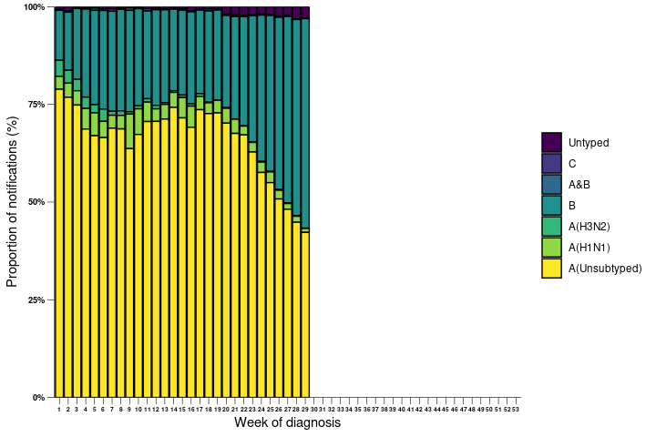

**Source:** NNDSS

*NNDSS notification data provided for the current and most recent weeks may be incomplete. All data are preliminary and subject to change as updates are received.

**Figure 9:** Percent of notifications of laboratory-confirmed influenza, Australia, 1 January to 23 July 2023, by subtype and state or territory*

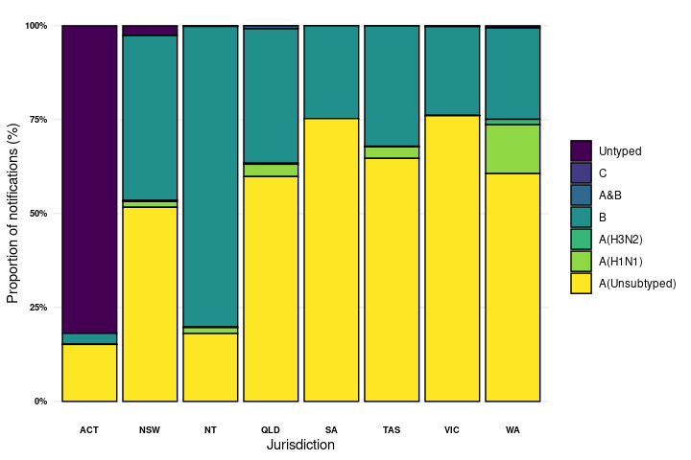

**Source:** NNDSS

*NNDSS notification data provided for the current and most recent weeks may be incomplete. All data are preliminary and subject to change as updates are received. As of 22 May 2023, subtyping data are not available for the ACT, until further notice.

**Table 2:** Australian influenza viruses typed by haemagglutination inhibition (HI) assay from the WHOCC, 1 January to 23 July 2023*

| **Strain** | **ACT** | **NSW** | **NT** | **QLD** | **SA** | **TAS** | **VIC** | **WA** | **Total** |
| --- | --- | --- | --- | --- | --- | --- | --- | --- | --- |
| A(H1N1) pdm09 | 74 | 153 | 62 | 65 | 46 | 64 | 644 | 62 | **1,170** |
| A(H3N2) | 13 | 60 | 4 | 80 | 27 | 4 | 60 | 13 | **261** |
| B/Victoria lineage | 11 | 138 | 382 | 26 | 17 | 14 | 215 | 62 | **865** |
| B/Yamagata lineage | 0 | 0 | 0 | 0 | 0 | 0 | 0 | 0 | **0** |
| **Total** | **98** | **351** | **448** | **171** | **90** | **82** | **919** | **137** | **2,296** |

**Source:** WHOCC

*Viruses tested by the WHOCC are not necessarily a random sample of all those in the community. State indicates the residential location for the individual tested, not the submitting laboratory. There may be up to a month delay on reporting of samples.

### 2.6. Vaccine match and effectiveness

**WHOCC**

* Of the 2,296 samples referred to the WHOCC in the year-to-date, 97.52% (1,141/1,170) of influenza A(H1N1) isolates, 81.23% (212/261) of influenza A(H3N2) isolates and 99.19% (858/865) of influenza B/Victoria isolates have been antigenically similar to the corresponding vaccine components.

**Australian Influenza Vaccines Composition 2023**

* All 2023 southern hemisphere [seasonal influenza vaccinations](https://www.health.gov.au/sites/default/files/2023-06/atagi-advice-on-seasonal-influenza-vaccines-in-2023_0.pdf) registered for use in Australia are quadrivalent influenza vaccines (QIVs).
* The influenza virus strains included in egg-based QIVs in Australia in 2023 are:
  + A/Sydney/5/2021 (H1N1) pdm09-like virus;
  + A/Darwin/9/2021 (H3N2)-like virus;
  + B/Austria/1359417/2021 (B/Victoria lineage)-like virus; and
  + B/Phuket/3073/2013 (B/Yamagata lineage)-like virus.
* The influenza virus strains included in cell-based QIVs in Australia in 2023 are:
  + A/Sydney/5/2021 (H1N1) pdm09-like virus;
  + A/Darwin/6/2021 (H3N2)-like virus;
  + B/Austria/1359417/2021 (B/Victoria lineage)-like virus; and
  + B/Phuket/3073/2013 (B/Yamagata lineage)-like virus.

**Vaccine effectiveness**

The best way to determine how well the vaccine protects against circulating viruses during the season is by determining the vaccine effectiveness. Vaccine effectiveness is usually estimated from observational studies and is calculated after the end of the influenza season, though interim analyses are sometimes available where there is sufficient data.

It is too early to assess vaccine effectiveness for this season.