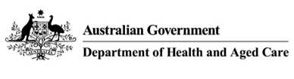

after hours other medical practitioners program guidelines

1 July 2023

After hours other medical practitioners program

## 

## Important Notice:

The AHOMPs Program ceased on 30 June 2023. Medical practitioners who were participating on the AHOMPs Program at that date were automatically placed in the Other Medical Practitioners Extension Program (OMPEP). and can continue to access A1 Medicare rebates until 30 June 2025

These Guidelines have effect from 1 July 2023

## Introduction

The intent of the AHOMPs program is to recognise the value of after-hours services provided by non-vocationally recognised general practitioners. The AHOMPs Program provides access to higher A1 Medicare rebates for non-vocationally recognised medical practitioners to provide quality after-hours general practice services through an accredited general practice or an accredited Medical Deputising Service (MDS).

The AHOMPs Program is administered by Services Australia through Medicare on behalf of the Department of Health and Aged Care, in accordance with these Guidelines. All decisions under the Program are made by senior and executive officers in the Department of Health and Aged Care who are authorised by the Minister (Authorised Persons).

## Eligibility

To be eligible for this Program persons must:

* be a participant in an Other Medical Practitioners (OMPs) program on 30 June 2023;
* be registered as a medical practitioner with the Medical Board of Australia;
* be a non-vocationally recognised medical practitioner and not hold fellowship of a general practice college;
* be eligible to claim Medicare benefits;
* provide after-hours general practice services through an accredited general practice or an accredited medical deputising service;
* commit to achieving fellowship of either the RACGP or ACRRM within 6 years of commencing the AHOMPs Program.

## Eligible Locations

To be an eligible location for the AHOMPs Program, a location must be either a general practice or a Medical Deputising Service (MDS) that holds accreditation from one of the Australian Government nominated accreditation bodies.

The Australian Government nominated accreditation bodies are Australian General Practice Accreditation Limited (AGPAL) and Quality Practice Accreditation Pty Ltd (QPA). These bodies accredit service providers against the Royal Australian College of General Practitioner (RACGP) standards for general practice.

A general practice must have a full certificate of accreditation from either AGPAL or QPA before it can be considered an eligible location for the AHOMPs Program.

A MDS must have a full certificate of accreditation from either AGPAL or QPA before being considered for the AHOMPs Program. As part of the accreditation process, a MDS will be required to demonstrate that it:

* provides after-hours deputised services to patients (i.e. at the request of the patient’s normal general practitioner);
  + operates for the entirety of the after-hours period, defined below; and
  + meets minimum standards for providing clinical supervision and support to non-vocationally recognised medical practitioners, including prospective AHOMPs Program participants.

## Definition of After-Hours

For the purposes of the AHOMPs Program, after-hours are defined as between 6pm and 8am on weekdays, before 8am and from 12pm on Saturday, all day Sunday and public holidays. Participants cannot claim GP after-hours MBS items for consultations or attendances they perform outside of these specified hours.

1. **Claimable item numbers**

This section identifies the MBS items under which a medical practitioner can claim for Medicare-eligible services as a general practitioner during the defined after-hours period.

Program participants should note that items for non-urgent after-hours consultations provided in consulting rooms may only be claimed from 8pm on weekdays, from 1pm on Saturdays and all day on Sundays and public holidays.

Participants should also note that urgent item 588 may only be claimed if they are employed by an accredited general practice or MDS that is located in an eligible regional or remote area.

Eligible areas in relation to claiming item 588 have been determined using the Modified Monash Model (MMM). The MMM is a classification system that categorises metropolitan, regional, rural and remote areas on the basis of both geographical remoteness and town size.

Areas that have a Modified Monash classification of 3 to 7 are considered to be eligible for claiming item 588. The Modified Monash classification of each Australian street address is provided on the [DoctorConnect website.](http://www.doctorconnect.gov.au)

**Table 1 - After hours MBS items, relevant period and eligible claimant**

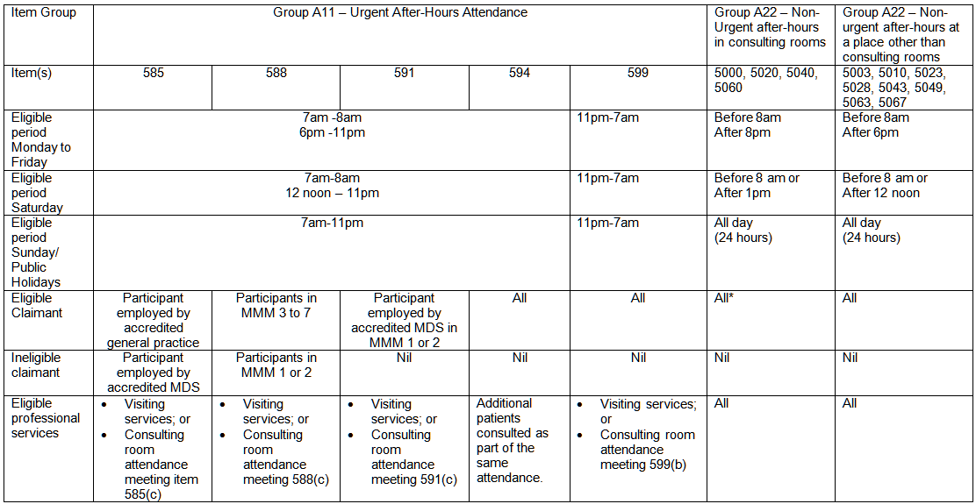

* AMDS Program participants are restricted from claiming MBS items for in clinic attendances performed at service locations that have not been approved by Health under the AMDS Program Deed of Agreement process. The AHOMPs Program MBS benefits for eligible in-clinic services do not remove AMDS Program restrictions on performing services at unapproved general practices. Further information can be obtained by emailing: [AMDS@health.gov.au](mailto:AMDS@health.gov.au).

## Pathway to Fellowship of RACGP or ACRRM

It is a requirement that all participants on the AHOMPs Program must obtain FRACGP or FACRRM within six years of registration under this Program. If a participant has not achieved fellowship in this timeframe, eligibility for the AHOMPs Program will cease.

If extenuating circumstances exist, the six year threshold may be extended annually up to a maximum of a further four years.

## Authorised Person’s Discretion

The Authorised Person for the AHOMPs Program will have full discretion to make decisions on all matters relating to the administration of the Program, including but not limited to approval of locations and medical practitioners.

## Change of Details

Participants must notify Services Australia if there are any changes to their details

Participants are required to notify Services Australia within 14 days if they no longer intend to provide after-hours services under the AHOMP Program.

## Termination of a Participant in Program

The Authorised Person may terminate the participation of a medical practitioner if they consider that a medical practitioner is not meeting the obligations of the Program. The Authorised Person will notify the participant regarding the termination and will provide the participant an opportunity to appeal this decision.

Participants may become ineligible for the Program for the following reasons:

* + achieving either the FRACGP or FACRRM qualification and thereby no longer meeting the definition of an eligible AHOMPs Program participant;
  + their practice location failing to remain accredited with one of the current Australian Government nominated accreditation bodies;
  + the Department of Health and Aged Care or Services Australia determines the participant is no longer on the pathway to achieving either FRACGP or FACRRM; and/or
  + the general practice or MDS ceases operation.

## 14. Program Contact Details

### **Department of Health and Aged Care**

To obtain further information regarding the program contact: [OMPs@health.gov.au](mailto:OMPs@health.gov.au)

**For further information regarding continuing professional development contact:**

### **The Royal Australian College of General Practitioners**

RACGP National Office  
100 Wellington Parade  
East Melbourne, VIC, 3002  
Ph: 1800 472 247

[The Royal Australian College of General Practitioners](http://www.racgp.org.au/) (www.racgp.org.au)

OR

### **The Australian College of Rural and Remote Medicine**

ACRRM  
GPO Box 2507  
Brisbane, QLD, 4000  
Ph: 1800 223 226

[Australian College of Rural and Remote Medicine](https://www.acrrm.org.au/) (www.acrrm.org.au)