What if my baby still has a fever? 
Some babies may still develop fever after vaccination, even after having three doses of paracetamol. As fever after vaccination is
common, it is okay to give paracetamol in line with dosage directions for up to 48 hours after the meningococcal B vaccine.
Keep your baby cool by making sure they don’t have too many layers of clothes or blankets, and give them lots of fluids. If your baby is breastfed, the best fluid to give is breast milk.
If your baby still has a fever more than 48 hours after vaccination or you are concerned about your baby’s health at any time, you should seek medical advice.
Your nurse, healthcare worker or doctor will give you more information about paracetamol at your vaccination appointment.
Vaccinate to protect your baby against meningococcal B
The meningococcal B vaccine is free for Aboriginal and Torres Strait Islander infants.

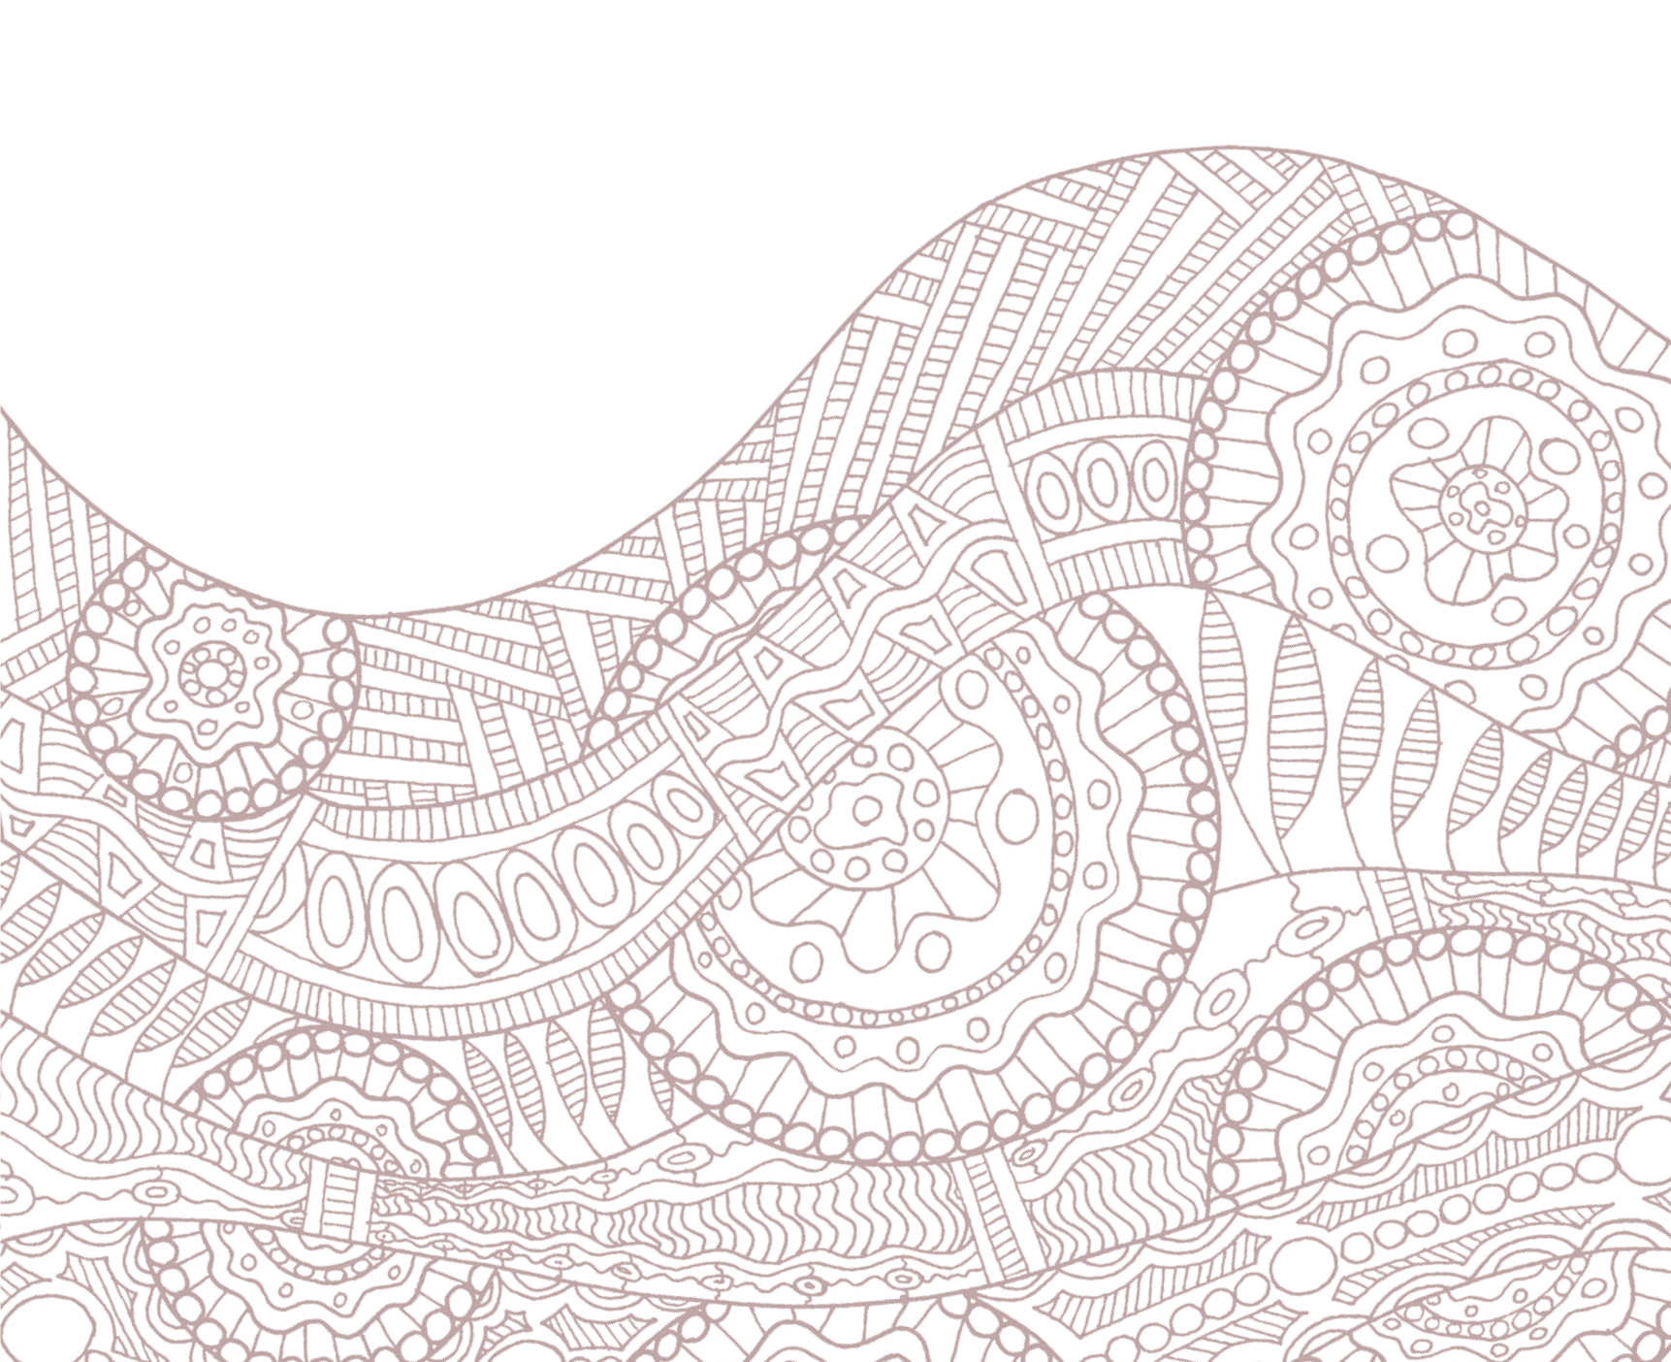
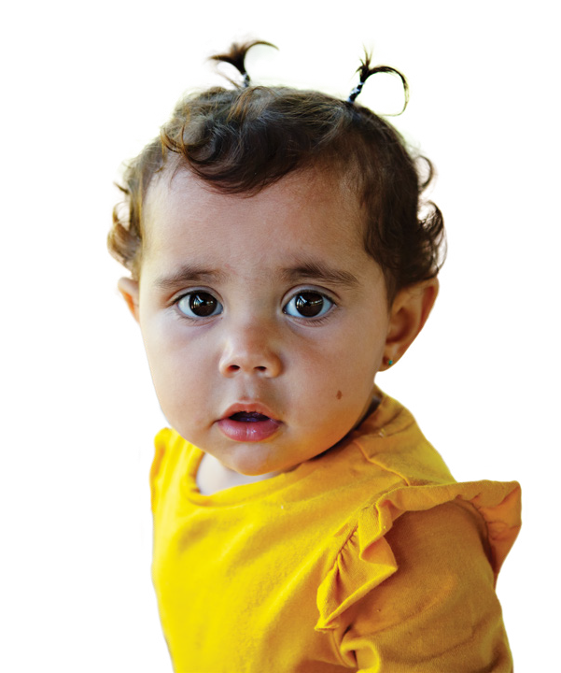
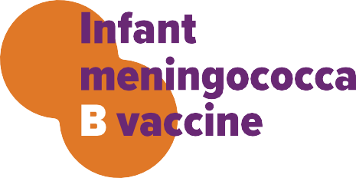
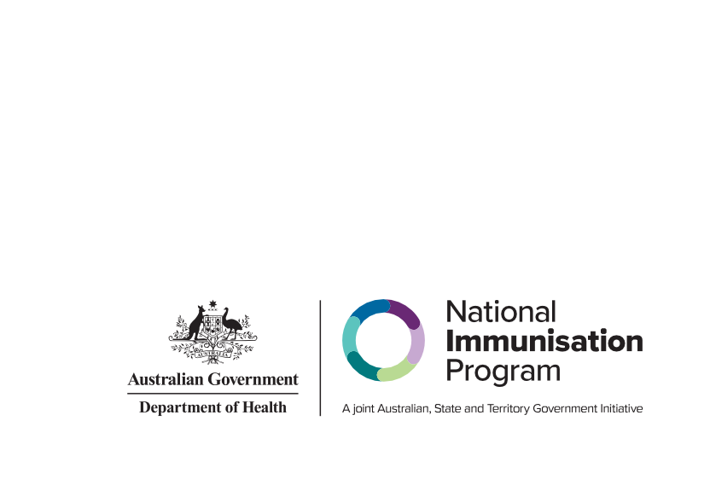
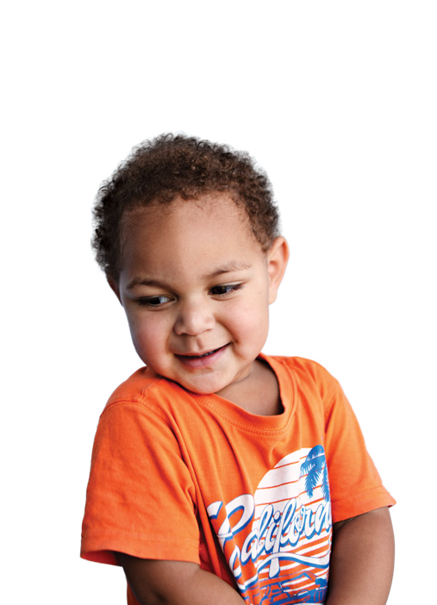

health.gov.au/immunisation

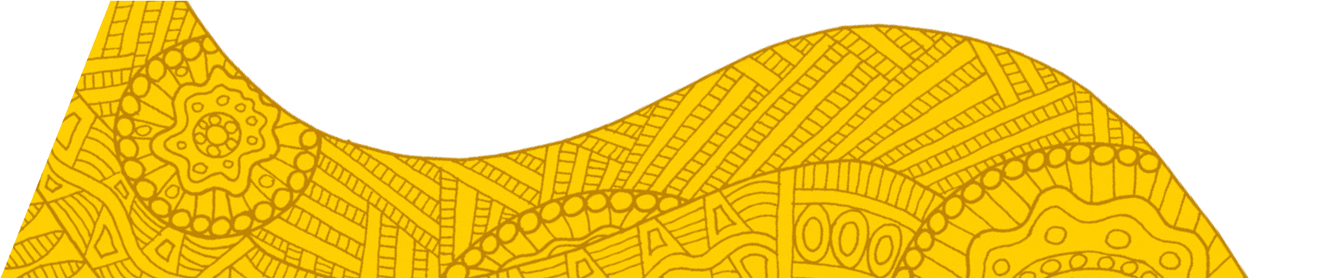
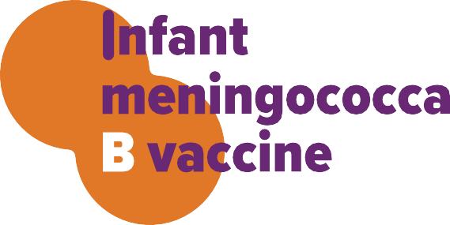

Who can get the meningococcal B vaccine?
The meningococcal B vaccine has been added to the National Immunisation Program schedule for Aboriginal and Torres Strait Islander infants.
The free meningococcal B vaccine protects your baby against infection from meningococcal B bacteria.
The meningococcal B vaccine is given at the same time as other routine baby vaccinations at 2*, 4 and 12 months. It is safe to give the meningococcal B vaccine with other childhood vaccines. It is also important that all doses are given to ensure the highest level of protection for your child.
An extra dose at 6 months is required for infants who have certain risk conditions. Your nurse, healthcare worker or doctor will advise if your child needs this extra dose.
Children who missed out can still get their meningococcal B vaccines free if they start doses before they turn 2 years of age.

What is meningococcal disease?
Meningococcal B disease is a serious illness caused by the ‘B’ strain of meningococcal bacteria. These bacteria are a major cause of meningitis (inflammation of the lining of the brain and spinal cord) and septicaemia (infection of the blood)
in young children. Aboriginal and Torres Strait Islander children under 2 years are at greater risk of the disease–about 4 times higher than in non-Indigenous children.

My baby has had the meningococcal B vaccine, what should I expect now?
The meningococcal B vaccine is safe and effective, although all medications and vaccines can have side effects.
Babies who get the meningococcal B vaccine are more likely to develop a high temperature (fever).
Other common side effects include irritability, pain, redness and swelling at the injection site.

How can I reduce the risk of fever?
It’s important to give your baby paracetamol to reduce the risk of fever.
It’s a good idea to have some paracetamol
at home before the 2-month* vaccination visit. You can buy it from your local pharmacy or talk to your nurse, health care worker or doctor prior to vaccination. Never give medicines that contain aspirin to a baby.

Paracetamol instructions
With each dose of the meningococcal B vaccine, it’s important to give three doses of paracetamol as follows:
- Dose 1 – 30 minutes before vaccination or as soon as possible afterwards
- Dose 2 – given 6 hours after the first paracetamol dose even if there is no fever
- Dose 3 – given 6 hours after the second paracetamol dose even if there is no fever
Make sure you follow the instructions that come with the medicine. If you’re unsure, ask a health professional for advice.

* Can be given from 6 weeks.

