Closing the Gap Social and Emotional Wellbeing Policy Partnership - Meeting 1 Communique, 30-31 March 2023
The first meeting of the Closing the Gap Social and Emotional Wellbeing Policy Partnership was held on 30-31 March 2023 on Kaurna country in Adelaide. The Partnership brings together First Nations and government members to accelerate action to improve social and emotional wellbeing (SEWB) and mental health outcomes and reduce suicide rates. The meeting was co-Chaired by Professor Pat Dudgeon, Gayaa Dhuwi (Proud Spirit) Australia and Tania Rishniw, Deputy Secretary, Department of Health and Aged Care.
The meeting was positive, open, and frank, with initial discussion focused on building strong foundations for culturally safe governance and ways of working for the Partnership, and the importance of defining SEWB for the purposes of the Partnership, to encompass mental health and suicide prevention. 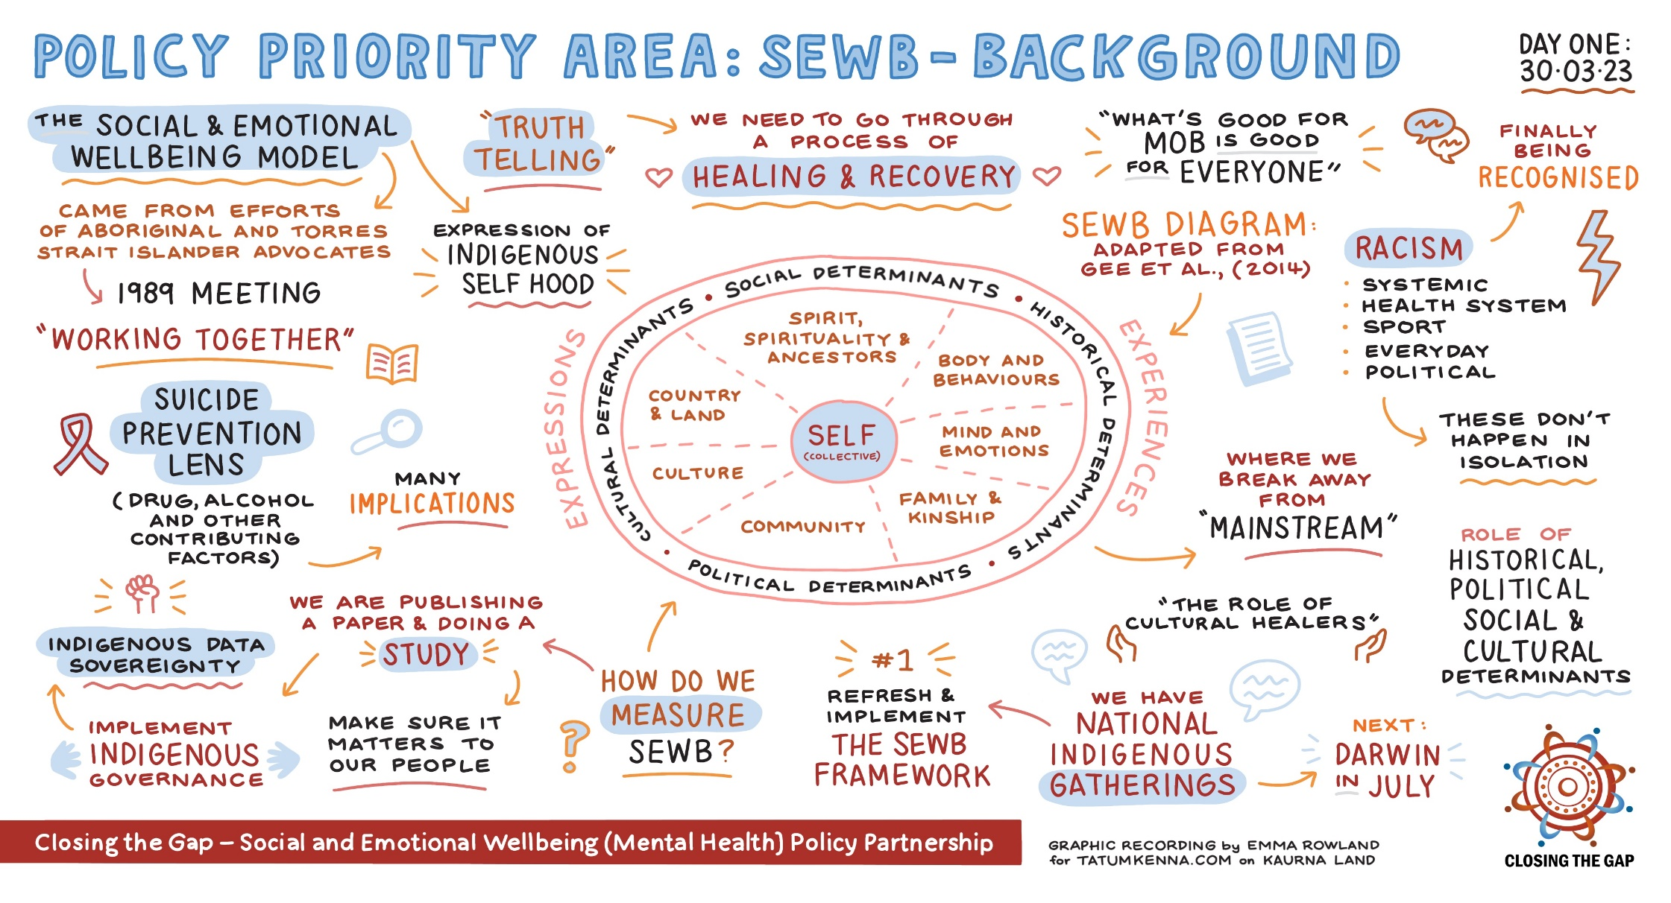
First Nations members brought forward priorities for consideration by the Partnership, including two key priorities for early action:
- a refresh of the National Strategic Framework for Aboriginal and Torres Strait Islander Peoples’ Mental Health and Social and Emotional Wellbeing 2017-23 (including an implementation plan), and
- the development of an Aboriginal and Torres Strait Islander-led commissioning framework.
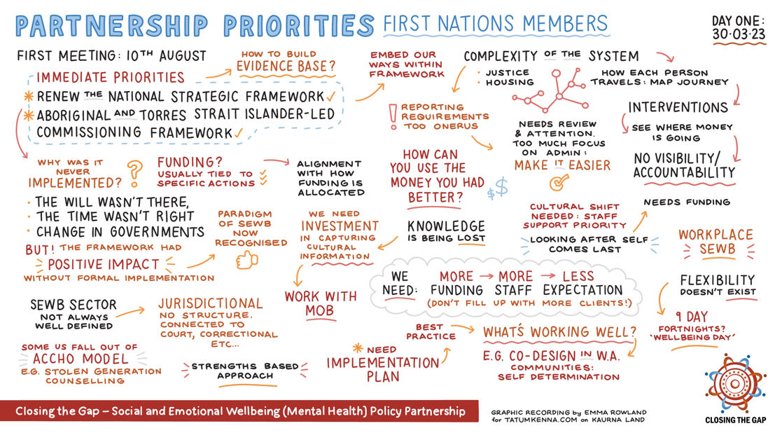
Government members shared information on key priorities and actions underway in each jurisdiction.
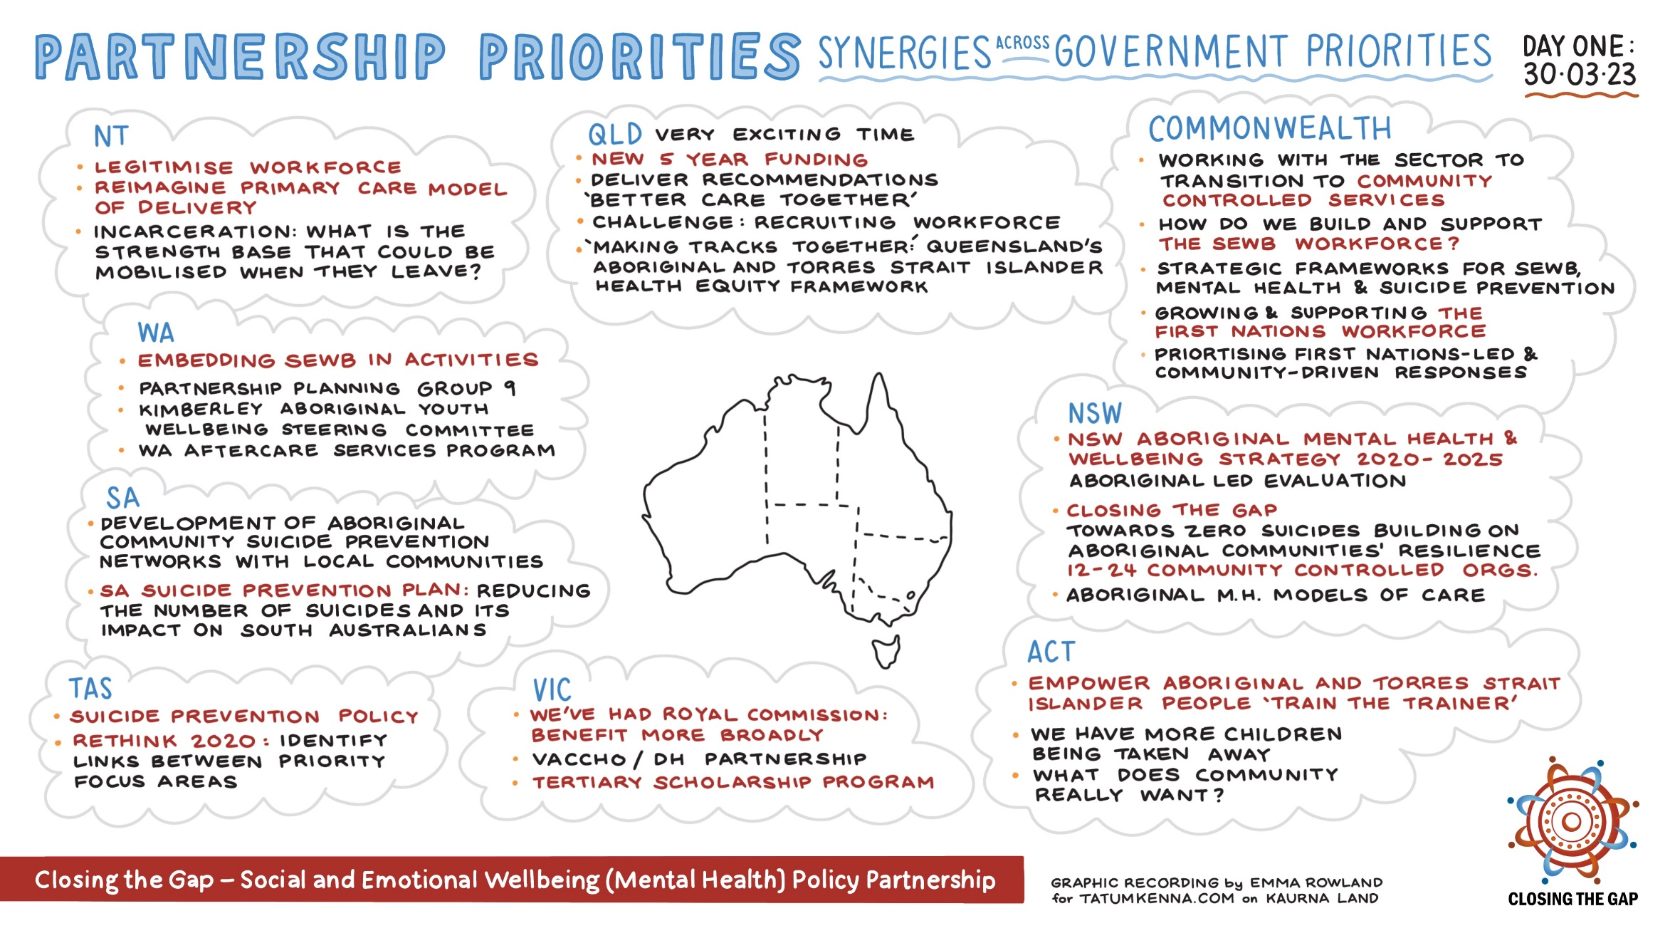

Key decisions by the Partnership:
- The refresh of the SEWB Framework is a critical priority for the Partnership. Planning for the refresh will be the focus of the second Partnership meeting to be held in Darwin in July, to coincide with the next quarterly SEWB Gathering.
- The ‘Agreement to Implement’ (the formal document that establishes the terms of reference for the Partnership) was agreed pending a number of revisions.
- Two First Nations SEWB PP members to be appointed the Mental Health and Suicide Prevention Senior Officials Group (MHSPSO) to provide policy advice and connection between and SEWB PP and MHSPSO and improve transparency and the embedding of the First Nations voice in mainstream services and systems.
- Two First Nations representatives with lived experience to be appointed to MHSPSO. This will not only provide lived experiences from different cultures, but also provide cultural safety for these representatives.
- The National Indigenous Australians Agency (NIAA) will join the Partnership as a non-voting member in recognition of the important role the agency plays in SEWB services and policy.
- The Partnership will be renamed the ‘Social and Emotional Wellbeing Policy Partnership’, rather than ‘Social and Emotional Wellbeing (Mental Health) Policy Partnership’ in recognition that for the purposes of the Partnership, SEWB encompasses mental health and suicide prevention.

