Case study – Jen

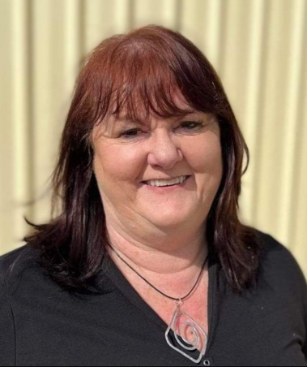Jen, 57, lives in Canberra and has two children and three grandchildren. She lives with Parkinson's disease and maintains a busy life, working full-time, and mentoring and advocating in her spare time.

Jen was diagnosed with Parkinson's disease at the age of 48 and had been experiencing symptoms for the previous four years.

Parkinson's disease is a disorder of the nervous system that progressively affects a person's control of their body movements.

Medication can help control the symptoms of Parkinson's. It is estimated that more than 200,000 Australians live with the disease, which after dementia, is the second most common neurological condition in Australia.

Jen says being able to access her five regular prescriptions at a lower cost through the Pharmaceutical Benefits Scheme (PBS) has been vital for staying active and enjoying life.

"I manage my Parkinson's with medication, exercise and staying positive and busy," Jen says.

"In my advocacy work for people with disability, my focus is on people having the best opportunities to work for as long as they can, without having to stop because of their illness."

On 1 January this year, the Australian Government reduced the general patient co-payment for medication listed on the PBS by almost a third – hoping to ease cost of living pressures by making medicines more affordable.

The cost reduction to many PBS medicines is providing savings to Medicare card holders who are not eligible for concession cards.

One of the newer medicines that Jen takes regularly is Opicapone (sold as Ongentys), which was added to the PBS in February 2023.

She pays $30 each month for this medicine, which would cost up to $1,800 a year without the PBS subsidy.

"When I go to the pharmacist, I get my medications at a reduced cost," Jen says.

"Being able to buy Ongentys for $30 each month has already saved me hundreds of dollars, and reduced the amount and the frequency of other medications I need to take.

"We're very lucky to have the PBS in Australia. Without it I wouldn't be able to afford half of my medications and wouldn't be able to work, and given that a lot of people who develop Parkinson’s are at pension age, the more expensive medicines would be out of reach for many."

Visit [**health.gov.au/pbs**](http://www.health.gov.au/pbs) for more information or talk to your pharmacist about how the PBS can help reduce the cost of your medication.