Case study – Caitlin

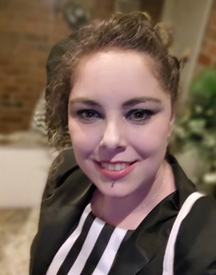Caitlin, 33, lives in Canberra and works as an online support provider for a large retailer. She lives with two types of asthma – eosinophilic, and allergic asthma.

Most people are familiar with allergic asthma, which is triggered by common allergens like pollen and dust, and thunderstorm asthma, where people develop asthma symptoms over a short period of time.

Less well known is eosinophilic asthma, a type of severe asthma caused by high levels of white blood cells in the airways of the lungs, which causes inflammation and swelling.

“My asthma was pretty well controlled until the Black Summer bushfires. Sustained smoke inhalation reset my immune system and permanently changed my symptoms from relatively mild to severe,” Caitlin says.

“When you can't breathe, you can't focus on anything else or move normally – it's very debilitating.”

According to data from the Australian Bureau of Statistics (ABS), asthma affects one in nine Australians – around 2.7 million people.[1]

Caitlin believes that as an incurable chronic health condition, asthma is not always taken as seriously as it should be.

“I depend on my medication to stay out of hospital. I am on the maximum amount of therapy possible, and I still don't have full control over my asthma.”

Caitlin buys between eight and ten scripts a month and most of these are listed on the Pharmaceutical Benefits Scheme (PBS). She also needs to attend multiple appointments with GPs and specialists to ensure continued access to her medication.

On 1 January 2023, the Australian Government reduced the general patient co-payment for medications listed on the PBS by almost a third to encourage people to not delay purchasing their PBS medicines.

“Last year, I was spending close to $500 a month. That's a lot of money to spend just trying to live like everyone else,” Caitlin says.

“Since the reduction in the PBS co-payment, I save around $100 a month on medicines, which is a great saving.

“One of the medicines I need to buy every month can only be dispensed from a hospital pharmacy. I pay $30 for it each time, but if it wasn't for the PBS, it would cost me $1,780 a month. I couldn't afford that medication without the PBS and I'm thankful for that.”

Once Caitlin has spent $1,563.50 on eligible PBS medicines, she will have reached the general patient [PBS Safety Net](https://www.pbs.gov.au/info/healthpro/explanatory-notes/section1/Section_1_5_Explanatory_Notes) threshold. Once the Safety Net threshold is reached Caitlin may apply for a Safety Net concession card and pay the concessional co-payment amount of $7.30 plus any applicable premium for pharmaceutical benefits for the rest of that calendar year.

Visit [**health.gov.au/pbs**](http://www.health.gov.au/pbs) for more information or talk to your pharmacist about how the PBS can help reduce the cost of your medication.

1. Refer ABS 2021-22 ‘Patient experiences in Australia’ survey, table 6.1.