Quarterly Financial Snapshot

Aged Care Sector

Quarter 2 2022-23

October to December 2022

# Introduction

In response to recommendations of the Royal Commission into Aged Care Quality and Safety (the Royal Commission), the Australian Government is committed to transparency in aged care through increased financial reporting on the sector.

As part of this commitment, the Department of Health and Aged Care publishes a Quarterly Financial Snapshot (QFS) of the Australian aged care sector. This is the second time the QFS has been published and it covers the period 1 October 2022 to 31 December 2022 (quarter 2 of the 2022-23 financial year).

The QFS:

* Provides timely information for aged care service providers to compare and benchmark their performance with sector-level results
* Supports the monitoring of key financial metrics for the aged care system
* Complements other existing publications such as the Financial Report on the Australian Aged Care Sector (FRAACS), Aged Care Star Ratings and the Food and Nutrition Report.

The QFS primarily draws on data collected from aged care service providers through the [Quarterly Financial Report](https://www.health.gov.au/topics/aged-care/providing-aged-care-services/responsibilities/quarterly-financial-report) (QFR). The QFR is a mandatory reporting requirement for all aged care providers and a key data source for the QFS. The QFR is completed based on Australian Accounting Standards wherever possible. The data is unaudited, but it is authorised by an aged care provider’s board.

As the department now has two quarters of QFR data available, this QFS introduces a comparison of sector-level results with the previous quarter in most charts and tables.

The department would like to thank all aged care service providers who completed the QFR and contributed to the development of this snapshot.

Acknowledging this is the second quarter of reporting under the new arrangements, QFR data quality is expected to improve over the next several quarters as familiarisation and maturity increases.

## Context

The Royal Commission acknowledged that Australia’s aged care sector is underfunded and has been for many years. Improving the financial sustainability of the sector remains a priority for the Australian Government.

The Australian Government is reforming the Australian aged care system through several key initiatives aimed at driving structural change, improving financial sustainability, and increasing transparency in aged care, including:

* Funding of $11.3 billion for the Australian Government’s commitment to deliver the Fair Work Commission’s interim decision for a 15 per cent pay increase, to build a valued aged care workforce
* The introduction of the [Australian National Aged Care Classification](https://www.health.gov.au/our-work/AN-ACC/about) (ANACC) funding model from 1 October 2022. The funding uplift will increase the average AN-ACC funding per resident per day by approximately 17% from $223 to $260. This is in addition to funding provided from 1 July 2023 through the 24/7 registered nurse supplement
* Annual funding increases for residential care delivery through the AN-ACC, informed by advice from the Independent Health and Aged Care Pricing Authority (IHACPA), which will ensure care funding moves in line with the costs of delivering care from 1 July 2023
* Supporting older Australians to remain in their own homes for longer and providing additional home care packages
* Delivering stronger regulations, reporting and improved data so that older Australians, their families and carers will have the right information to choose their provider and confidence in the aged care sector
* [Star Ratings](https://www.health.gov.au/our-work/star-ratings-for-residential-aged-care), introduced in December 2022, to increase transparency and choice for older Australians, and drive residential aged care provider compliance with financial reporting requirements
* Design of a new reformed and improved [in-home aged care program](https://www.health.gov.au/topics/aged-care/aged-care-reforms-and-reviews/reforming-in-home-aged-care).

Further information on aged care reform in the 2023-24 Budget can be found [here](https://www.health.gov.au/our-work/aged-care-reforms/what-were-doing).

In addition, while the full impact of structural reforms come into effect, the Australian Government has targeted programs in place to support providers through this period of reform and to ensure continuity of care for older Australians.

This QFS provides the first insight into financial performance of residential aged care providers and the delivery of care minutes under the new AN-ACC funding model which commenced on 1 October 2022. The December 2022 year-to-date results show an improvement in the overall financial performance of the residential aged care sector of $7.66 per resident per day on the September year-to-date position, as a result of the introduction of AN-ACC.

Fewer residential aged care providers reported negative earnings before interest, tax, depreciation and amortisation (EBITDA). The December 2022 year-to-date percentage of providers reporting negative EBITDA was 35 per cent, down from   
49 per cent at September 2022 year-to-date. An estimated 27 per cent of providers reported a negative EBITDA in quarter 2.

Quarter 2 also shows an increase in care minutes being delivered in the lead up to care minutes targets becoming mandatory from 1 October 2023. The department will continue to monitor both the impact of AN-ACC and sector progress towards care minutes targets closely.

The December 2022 year-to-date net profit before tax result decreased for home care providers. For-profit and not-for-profit home care providers returned a collective year-to-date net profit before tax of $138.5 million. This equates to a December 2022 year-to-date net profit before tax of $3.59 per care recipient per day, down $1.41 per care recipient per day on the September 2022 year-to-date result.

The percentage of profitable home care providers also decreased to 73.8 per cent, down from 78.4 per cent reported September 2022 year-to-date.

The department continues to acknowledge the impact of COVID-19 on the aged care sector, including on the potential financial position of aged care providers during this quarter. Operational costs, such as labour costs, typically increase when managing cases and outbreaks of COVID-19, particularly for providers of residential aged care. The correlating revenue through Australian Government grant support is unlikely to have been realised during the same quarter the increased expenses occurred.

For the period of October to December 2022, the department approved approximately $72 million in reimbursements to providers (an increase on approximately $58 million of reimbursements during the July to September 2022 period). For the period 4 June 2021 to 5 January 2023, the department has approved approximately $174.4 million in reimbursements to providers.

As a result of incoming [Aged Care Approvals Round](https://www.health.gov.au/topics/aged-care/providing-aged-care-services/funding-for-aged-care-service-providers/aged-care-approvals-round-acar) (ACAR) reforms, some providers may have amortised or impaired the value of bed licences over the quarter which will have impacted their balance sheet and overall financial result.

# Overview

The primary purpose of the QFS is to increase the transparency of the aged care system through the timely publication of financial performance data.

The QFS is a point-in-time snapshot of the financial performance of the Australian aged care system.

For-profit and not-for-profit residential and home care providers are the primary provider type included in the QFS. Local and state and territory (LST) government providers are included in labour cost and hours, home care account balance and unspent funds, and food and nutrition data only. They are not included in any other chart or table as this data is not collected in the QFR. In the context of this report, Home Care refers to the Home Care Packages Program.

## How to read the QFS

The QFS is split into 3 sections:



Benchmarking calculations: Throughout the document, this grey box is used to provide guidance on calculations throughout the document, to support aged care service providers to benchmark their performance against sector-level results.

### Quartile charts

Quartile charts have been used to assist with benchmarking by showing the median, and the upper quartile (50th to the 75th percentile) and lower quartile (25th to the 50th percentile). This highlights the spread of reported results.

### Comparison data

Comparison with the previous quarter’s result has been incorporated at the sector-level into charts, figures and tables to better understand changes or trends in financial performance.

Directional arrows have been incorporated in some tables and figures to indicate the change from the previous quarter (i.e. up arrows represent an increase and down arrows represent a decrease in value). Some figures have been rounded to   
2 decimal places (instead of one decimal place in the first QFS) to support more detailed comparison.

### Provider type definitions

The percentage of services is calculated using the proportion of claim days from a provider. The classification of regional and metropolitan services is based on the ABS Remoteness Name category, used to determine the location of services in the National Approved Provider System (NAPS).

| Provider type | Definition |
| --- | --- |
| Sector | Consolidated view of the provider types shown in the chart, figure or table. |
| For-profit metropolitan | Providers that deliver more than 70 per cent of their services in metropolitan areas and are either a Private Incorporated Body or a Publicly Listed Company. |
| For-profit regional | Providers that deliver more than 70 per cent of their services in regional areas and are either a Private Incorporated Body or a Publicly Listed Company. Regional covers inner regional, outer regional, remote and very remote as classified by the Australian Bureau of Statistics (ABS). |
| Not-for-profit metropolitan | Providers that deliver more than 70 per cent of their services in metropolitan areas and are either charitable, community based or religious organisations. |
| Not-for-profit regional | Providers that deliver more than 70 per cent of their services in regional areas and are either charitable, community based or religious organisations. Regional covers inner regional, outer regional, remote and very remote as classified by the ABS. |
| Providers across metropolitan and regional | Refers to non-government providers that deliver services more evenly across metropolitan and regional areas and, therefore, do not fall in the above categories. These providers deliver more than 30 per cent but less than 70 per cent of their services in metropolitan or regional areas. |
| LST government | Refers to providers owned by a local, state or territory government. This acronym is used in tables and charts. |

## Data sources and methodology

The QFS primarily draws on data collected through the QFR. Submission responses were high in the October to December 2022 QFR, where 99.9 per cent of residential aged care providers and 98.7 per cent of home care providers participated (including for-profit, not-for-profit and local, state or territory government providers).

The QFR collects some information as year-to-date results and some information for the isolated quarter. The year-to-date information collected in the QFR is primarily the profit and loss result. To ensure information is presented back to providers consistent with the way it has been collected, and consistently with standard accounting practices, the QFS presents the financial summary, wages to revenue percentage, EBITDA margin and percentage of profitable providers in year-to-date format.

In addition, an isolated quarter result has been provided for these charts to allow for specific quarterly comparison and to assist in understanding the impact of policy reforms or specific circumstances that may have impacted that quarter’s results.

The isolated quarter result for the profit and loss related charts has been derived by deducting year-to-date September 2022 results from year-to-date December 2022 results, and should be read as an estimate only. Quarter 2 figures derived using this calculation may include quarter 1 2022-23 adjustments, which may impact the actual results.

Other data such as care minutes, labour costs and food and nutrition are reported as quarter 2 results only and reflect how the information was collected in the QFR.

The QFS also draws upon data collected through [My Aged Care](https://www.myagedcare.gov.au/) and other internal department sources. Provider entry and exit data is extracted from NAPS and is correct at the date of extraction. Some providers may be counted amongst both residential and home care for entry and exit data. A provider exiting the sector may result in the services they delivered being transferred to another approved provider, closure of a service or a service being marked as inactive.

The QFR does not collect detailed information on hotel expenses, accommodation and administration, which provide additional insight into the underlying factors contributing towards overall profit and loss. This information is collected annually through the Aged Care Financial Report and reported publicly in FRAACS to allow monitoring of trends in this information over time.

## Previous snapshots and feedback

The [first QFS](https://www.health.gov.au/resources/publications/quarterly-financial-snapshot-of-the-aged-care-sector-quarter-1-2022-23-july-to-september-2022?language=en) (1 July 2022 to 30 September 2022) is available on the department’s website.

The QFS will evolve over time, and the department is committed to working with the sector to inform future publications. Feedback is welcome and should be directed to [agedcaremarket@health.gov.au](mailto:agedcaremarket@health.gov.au).

**Summary**

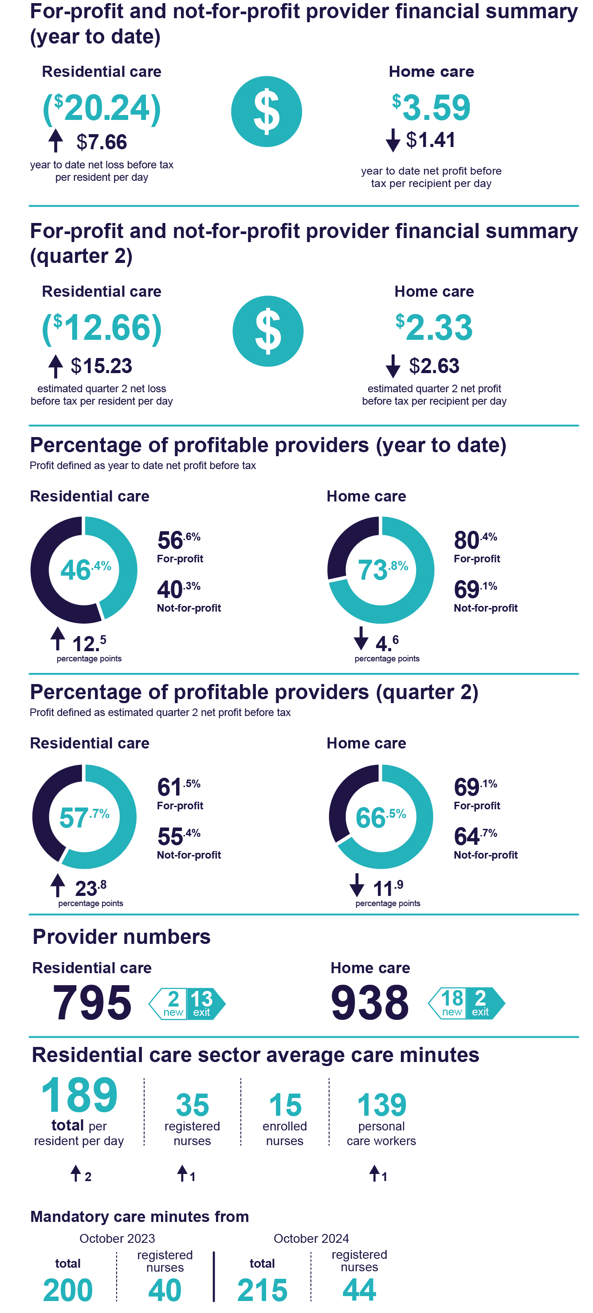

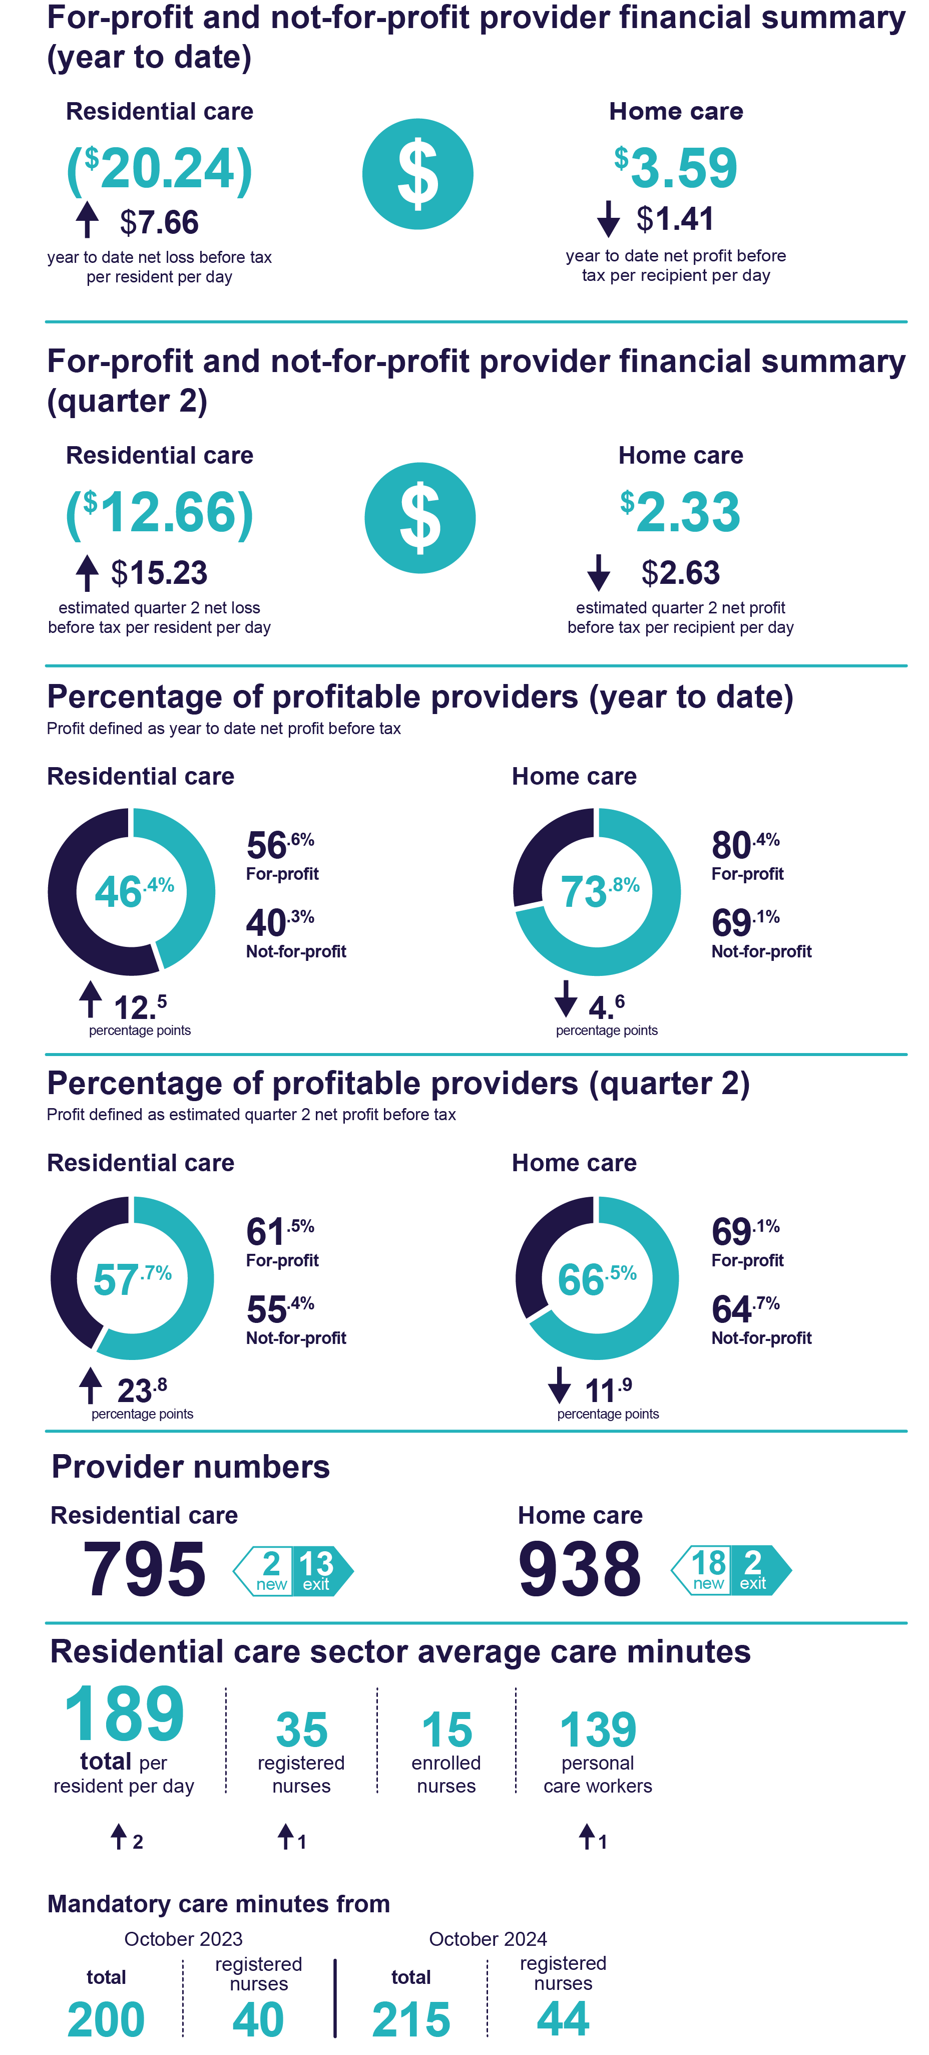

# Residential aged care

## Financial summary

Table 1 is a financial year-to-date summary of residential aged care service providers’ revenue and expenses to December 2022. For-profit and not-for-profit residential aged care providers returned a collective year-to-date net loss before tax of $678.3 million. This equates to a year-to-date net loss before tax of $20.24 per resident per day, an improvement of $7.66 per resident per day on the year-to-date September 2022 result.

As reported in the QFR, care funding allocated to providers per occupied bed days (OBD) was an average of $203.54 under the Aged Care Funding Instrument (ACFI) model for the July to September 2022 period. Care funding increased to an average of $225.11 per OBD (up $21.57) under the new AN-ACC model for the October to December 2022 quarter.

Table 1: Year-to-date summary of financial performance of residential aged care for-profit and not-for-profit providers

|  |  |  |  |
| --- | --- | --- | --- |
|  | Total | Per resident per day | Change from September 2022 year-to-date per resident per day |
| Revenue | $11,096.5m | $331.19 | ↑ $14.19 |
| Expenses | $11,774.8m | $351.43 | ↑ $6.53 |
| Net profit before tax | ($678.3m) | ($20.24) | ↑ $7.66 |
| Net profit before tax margin | (6.11%) | (6.11%) | ↑ 2.69 percentage points |
| EBITDA | $433.3m | $12.93 | ↑ $8.93 |

Table 2 is an estimated quarter 2 summary of residential aged care service providers’ revenue and expenses. For-profit and not-for-profit residential aged care providers returned a collective quarter 2 net loss before tax of $213.0 million. This equates to an isolated quarter 2 net loss before tax of $12.66 per resident per day, an improvement of $15.23 per resident per day on the quarter 1 result.

Table 2: Quarter 2 summary of financial performance of residential aged care for-profit and not-for-profit providers (estimate)

|  |  |  |  |
| --- | --- | --- | --- |
|  | Total | Per resident per day | Change from Q1 per resident per day |
| Revenue | $5,807.3m | $345.23 | ↑ $28.20 |
| Expenses | $6,020.2m | $357.89 | ↑ $12.97 |
| Net profit before tax | ($213.0m) | ($12.66) | ↑ $15.23 |
| Net profit before tax margin | (3.67%) | (3.67%) | ↑ 5.13 percentage points |
| EBITDA | $366.4m | $21.78 | ↑ $17.77 |

## Average care minutes

[Care minutes](https://www.health.gov.au/our-work/AN-ACC/providers/care-minutes) refers to the amount of time older Australians who live in Australian Government‑funded residential aged care services receive in care from registered nurses, enrolled nurses and personal care workers/assistants in nursing.

Average care minutes per resident per day for quarter 2 is shown in Table 3. The total average care minutes, per resident per day for the sector, was 189 minutes, which was an increase of 2 minutes on quarter 1.

Service-level targets are indicative of the minimum care minutes that should be delivered in a particular service. They are updated every three months, based on the resident case mix in the previous quarter. Meeting these targets will become a mandatory responsibility from 1 October 2023. The sector average target for care minutes is 200 minutes per resident per day, including 40 minutes of registered nurse time per day. This target will increase to 215 minutes as a sector average from October 2024, including 44 minutes of registered nurse time.

Table 3: Quarter 2 average care minutes per resident per day

|  | Sector | Change in average sector care minutes from Q1 | For-profit | Not-for-profit | LST government |
| --- | --- | --- | --- | --- | --- |
| Registered nurses | 35 | ↑ 1 | 35 | 33 | 63 |
| Enrolled nurses | 15 | - | 11 | 13 | 88 |
| Personal care workers/ Assistants in nursing | 139 | ↑ 1 | 136 | 145 | 89 |
| Total | 189 | ↑ 2 | 182 | 191 | 240 |

Chart 1 shows the change in care minutes from quarter 1 to quarter 2. Local, state or territory government providers recorded the highest average care minutes per resident per day (240 minutes, an increase of 11 minutes), followed by not-for-profit (191 minutes, an increase of 2 minutes) and for-profit providers (182 minutes, an increase of 3 minutes). Local, state or territory government providers are likely to have other non-Australian Government funding sources that contribute towards the delivery of care. Minutes have been rounded to whole numbers for care minutes.

Chart 1: Change in care minutes

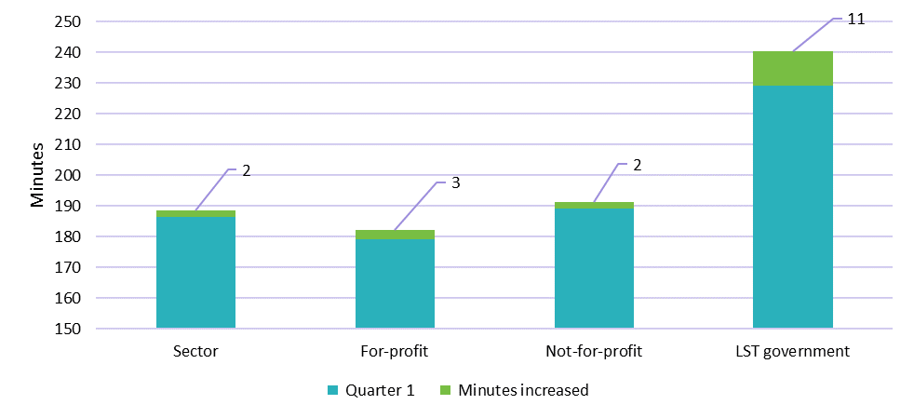

## Staff cost and time

Chart 2 below shows that the quarter 2 median staff cost and time per resident per day was $38.70 and 34.29 minutes for registered nurses, $11.15 and 12.85 minutes for enrolled nurses, and $98.98 and 138.44 minutes for personal care workers/assistants in nursing.

Allied health, diversional / lifestyle / recreation / activities officer and care management staff minutes do not contribute to the care minute targets but play an important part in the restorative care and other support for older Australians.

Local, state or territory government providers are included in this data.

**Chart 2: Quarter 2 median staff cost and time per resident per day**

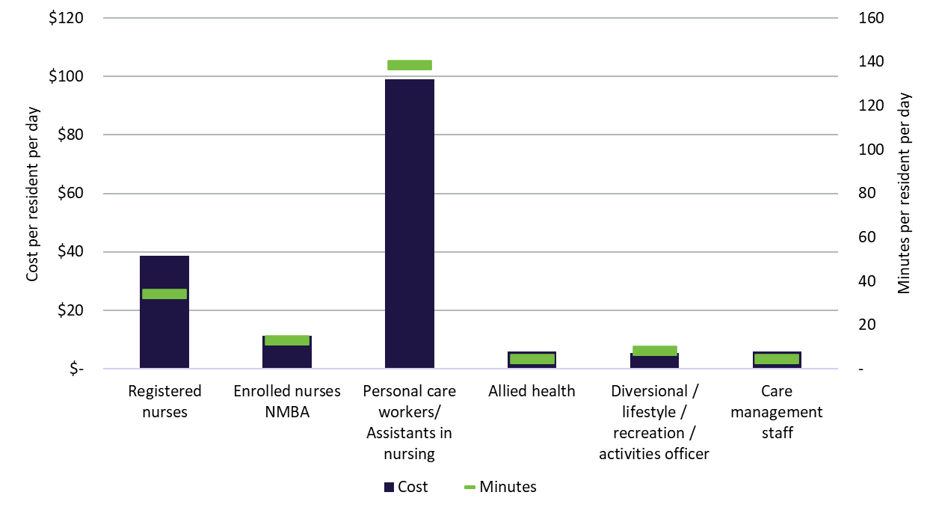

When comparing to quarter 1, the median cost per resident per day increased for registered nurses ($1.71), enrolled nurses ($0.30) and personal care workers/assistants in nursing ($2.87), but decreased for allied health ($1.25), diversional / lifestyle / recreation / activities officer ($0.72) and care management staff ($1.06). The median minutes per resident per day increased for registered nurses (0.97) and personal care workers/assistants in nursing (1.90) but decreased for all other categories.

From quarter 4 of the 2022-23 financial year (April to June 2023 reporting period), the department will collect additional information from providers on wages of direct aged care workers. This will allow for the monitoring of funding provided by the Australian Government for the purpose of increasing workers’ wages (as a result of the Fair Work Commission decision) and ensure that funding is being passed on.

Table 4: Quarter 2 median staff cost and time per resident per day

|  |  |  |  |  |
| --- | --- | --- | --- | --- |
|  | Cost  per resident per day | Change in cost from Q1 | Minutes  per resident per day | Change in minutes From Q1 |
| Registered nurses | $38.70 | ↑ $1.71 | 34.29 | ↑ 0.97 |
| Enrolled nurses | $11.15 | ↑ $0.30 | 12.85 | ↓ 0.30 |
| Personal care workers/ Assistants in nursing | $98.98 | ↑ $2.87 | 138.44 | ↑ 1.90 |
| Allied health | $5.80 | ↓ $1.25 | 4.60 | ↓ 1.00 |
| Diversional / lifestyle / recreation / activities officer | $5.48 | ↓ $0.72 | 8.36 | ↓ 1.20 |
| Care management staff | $5.94 | ↓ $1.06 | 4.29 | ↓ 0.70 |

## Allied health cost and time

There are a range of services aged care service providers are required to make available (or to assist with access) to all residents who need them. This includes access to allied health services as part of an individual therapy program aimed at maintaining or restoring a resident’s ability to perform daily tasks. [Allied health](https://www.health.gov.au/resources/publications/how-allied-health-care-is-supported-under-an-acc?language=en) minutes do not contribute to the mandatory care minute targets but play an important role in the care of older Australians. The quarter 2 median cost and time for allied health services per resident per day are shown in Table 5. Local, state or territory government providers are included in this data.

As shown in Table 4, the quarter 2 median total cost and time for allied health services per resident per day was $5.80 and 4.6 minutes. Median results are not reported for occupational therapists, allied health assistants and other allied health categories in Table 5 as more than 75 per cent of QFR respondents did not report any expenditure for these categories. The median cost per resident per day may also be higher than what is reported in Table 5 for speech pathologist, podiatrists and dietetic care as approximately 25 to 30 per cent of QFR respondents did not report any expenditure for these categories.

The QFR is a new reporting requirement for providers who were not previously required to report allied health care time and cost against specific allied health categories. Allied health professionals are often engaged through contracts which do not always include detailed reporting on cost and time by specific categories. Providers may still be adjusting their approach to record-keeping for allied health services to align with the new QFR requirements. As providers become more familiar with reporting this information, the department expects this data to improve over time. The department is actively engaging with the sector to understand and improve this reporting.

Table 5: Quarter 2 median allied health cost and time per resident per day

|  | Cost per resident per day | Change in cost from Q1 | Allied health minutes of care per resident per day | Change in minutes from Q1 |
| --- | --- | --- | --- | --- |
| Physiotherapist | $3.80 | ↓ $0.85 | 2.97 | ↓ 0.79 |
| Speech pathologist | $0.09 | - | 0.04 | ↓0.01 |
| Podiatrist | $0.24 | ↑$0.06 | 0.20 | ↑ 0.03 |
| Dietetic care | $0.18 | ↑$0.01 | 0.10 | - |

## Food and nutrition

Chart 3 shows the quarter 2 median total cost of food and ingredients for the sector was $13.17 per resident per day, an increase of $0.74 on quarter 1.

The median total cost of food and ingredients increased for all provider types.

Residential aged care providers spent an average of 80 per cent of the total food and ingredients costs on fresh food and ingredients, which was similar to the July to September 2022 quarter. Fresh food and ingredients are defined by the GST classification found on itemised purchase receipts.All foods that are GST-free are classified as “fresh”, whereas “other” foods have GST applied. A more detailed food and nutrition report for the 2021-22 financial year is available on the [department’s website](https://www.health.gov.au/resources/publications/food-and-nutrition-report-2021-2022?language=en). The split of fresh and other foods was not collected prior to the first QFR, but future QFS reporting will allow changes in spending on fresh food and ingredients to be tracked.

The amount spent on food and ingredients per resident per day is only one indicator of food quality. It should not be taken in isolation, as it does not consider factors such as residents’ satisfaction, cooking preparation method and overall nutritional status.

Chart 3 excludes aged care services that were unable to split out their contract catering costs into food and ingredients costs.

Chart 3: Quarter 2 median food and ingredients cost per resident per day by provider type

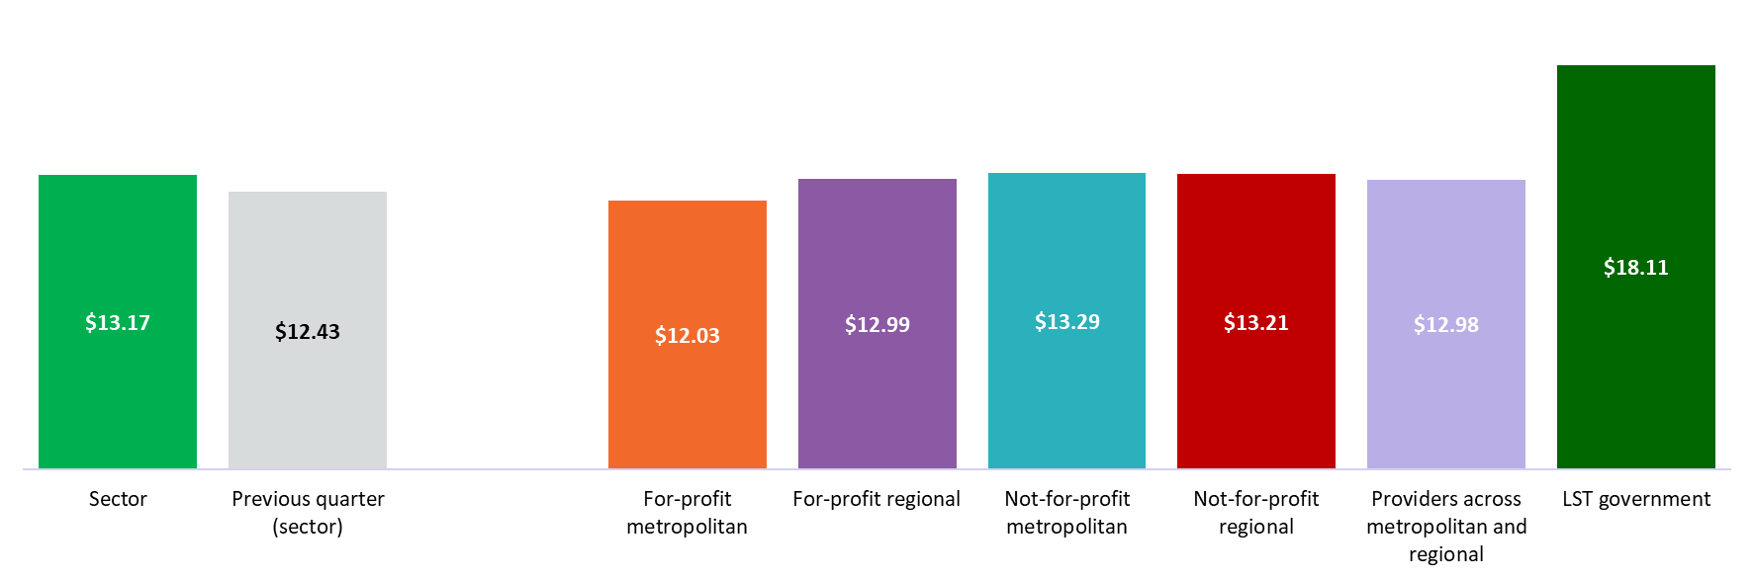

## Labour cost

The quarter 2 median total care labour cost reported by the sector was $173 per resident per day. The sector median was consistent with quarter 1, but the average care labour cost per resident per day has increased by approximately 2 per cent. The increase in average care labour cost may be due to the increased care labour spending by providers working towards their care minute targets in preparation for   
1 October 2023.

Total care labour costs include registered nurses, enrolled nurses, personal care workers/assistants in nursing, care management staff, allied health, diversional/ lifestyle/ recreation/ activities staff, and other non-care staff. The cost of labour includes salary and superannuation, bonuses and incentives, allowances, termination payments, value of fringe benefits, salary sacrifice and leave entitlements.

Local, state or territory government providers may have other non-Australian Government funding sources that contribute towards the delivery of care.

Agency staff cost represented 11.7 per cent of the total direct care labour cost to the sector in quarter 2, an increase of 0.3 percentage points on quarter 1.

Chart 4: Median and quartile total care labour cost per resident per day by residential aged care provider type

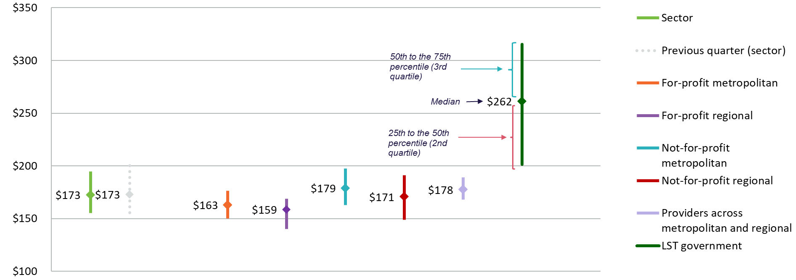

## Wages to revenue

Comparing wages to revenue is a financial viability indicator allowing aged care service providers to measure how much was spent on employees as a proportion of revenue. Chart 5 shows that the December 2022 year-to-date proportion of wages to revenue for the sector was a median of 72 per cent (down 2 percentage points on September 2022 year-to-date result). For-profit providers spent a smaller proportion of wages to revenue in comparison to not-for-profit providers and providers across metropolitan and regional. Wages are inclusive of all residential aged care service employees.

Chart 5: Year-to-date median and quartile wages to revenue percentage by residential aged care provider type

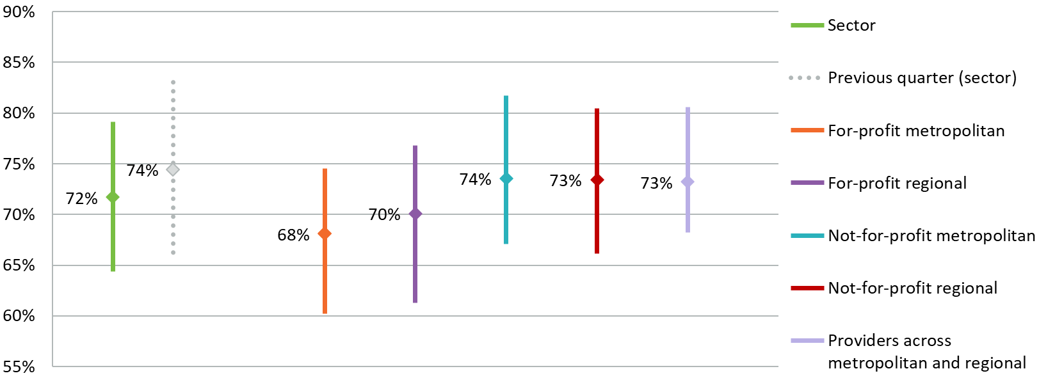

Chart 6 shows the estimated quarter 2 proportion of wages to revenue for the sector was a median of 69 per cent (down 5 percentage points on quarter 1 result). The proportion of wages to revenue decreased from quarter 1 to quarter 2 for all provider types. This was due to an increase in revenue while wages expenditure remained stable compared to quarter 1.

Chart 6: Quarter 2 median and quartile wages to revenue percentage by residential aged care provider type (estimate)

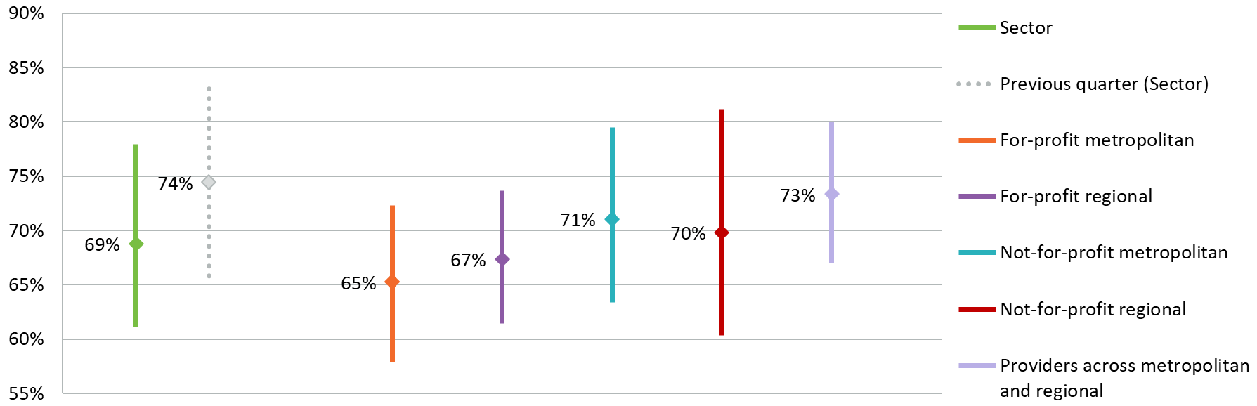

Wages to revenue percentage = (salaries and employee benefits + management fees) ÷ total revenue

## Hourly rate

The quarter 2 median hourly rate for registered nurses, enrolled nurses and personal care workers/assistants in nursing is shown by provider type in Chart 7. Residential aged care providers submitted the average hourly rate of direct care staff in the QFR. In quarter 2, the sector median of the average hourly rate was $45 for registered nurses, $33 for enrolled nurses and $27 for personal care workers/assistants in nursing, which were all the same as quarter 1.

Chart 7: Quarter 2 median hourly rate of direct care staff by residential aged care provider type

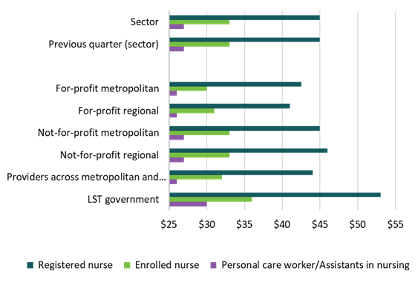

The average hourly rate is reported by providers by calculating the average hourly rate of direct care staff employed as per the employee award, agreement or contract. The average hourly rate does not include on-costs, penalty rates or casual loading.

Nil value responses have been excluded from the calculation of the median average hourly rate.

## EBITDA margin

EBITDA margin is used as an indicator of a provider’s financial performance and underlying profitability before accounting for depreciation assumptions, tax obligations or financing choices. EBITDA margins focus on a provider’s operating profitability and cash flow, where the higher the EBITDA margin is, the lower operating expenses are in relation to total revenue.

Chart 8 shows the December 2022 year-to-date median EBITDA margin for the sector was 4.52 per cent, which means an EBITDA return of $4.52 for every $100 of revenue earned. This was an increase of 4.33 percentage points (or an increased EBITDA return of $4.33 for every $100 of revenue earned) on the September 2022 year-to-date result.

All provider types reported a December 2022 year-to-date positive median EBITDA margin, compared to September 2022 year-to-date when only for-profit metropolitan and for-profit regional providers reported a positive median EBITDA margin. This shows an improved EBITDA margin at the end of December 2022 for all provider types.

The percentage of residential aged care providers reporting a negative EBITDA result decreased from 49 per cent (September 2022 year-to-date), to 35 per cent (December 2022 year-to-date).

Chart 8: Year-to-date median and quartile EBITDA margin by residential aged care provider type

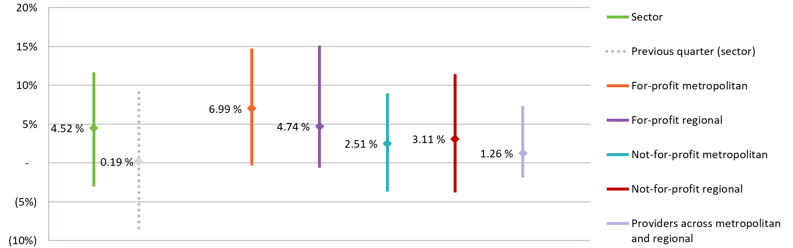

Chart 9 shows the estimated quarter 2 median EBITDA margin for the sector was 7.75 per cent, which means an EBITDA return of $7.75 for every $100 of revenue earned. This was an increase of 7.56 percentage points on the quarter 1 result.

The estimated percentage of residential aged care providers reporting a negative EBITDA result decreased from 49 per cent in quarter 1, to 27 per cent in quarter 2.

Chart 9: Quarter 2 median and quartile EBITDA margin by residential aged care provider type (estimate)

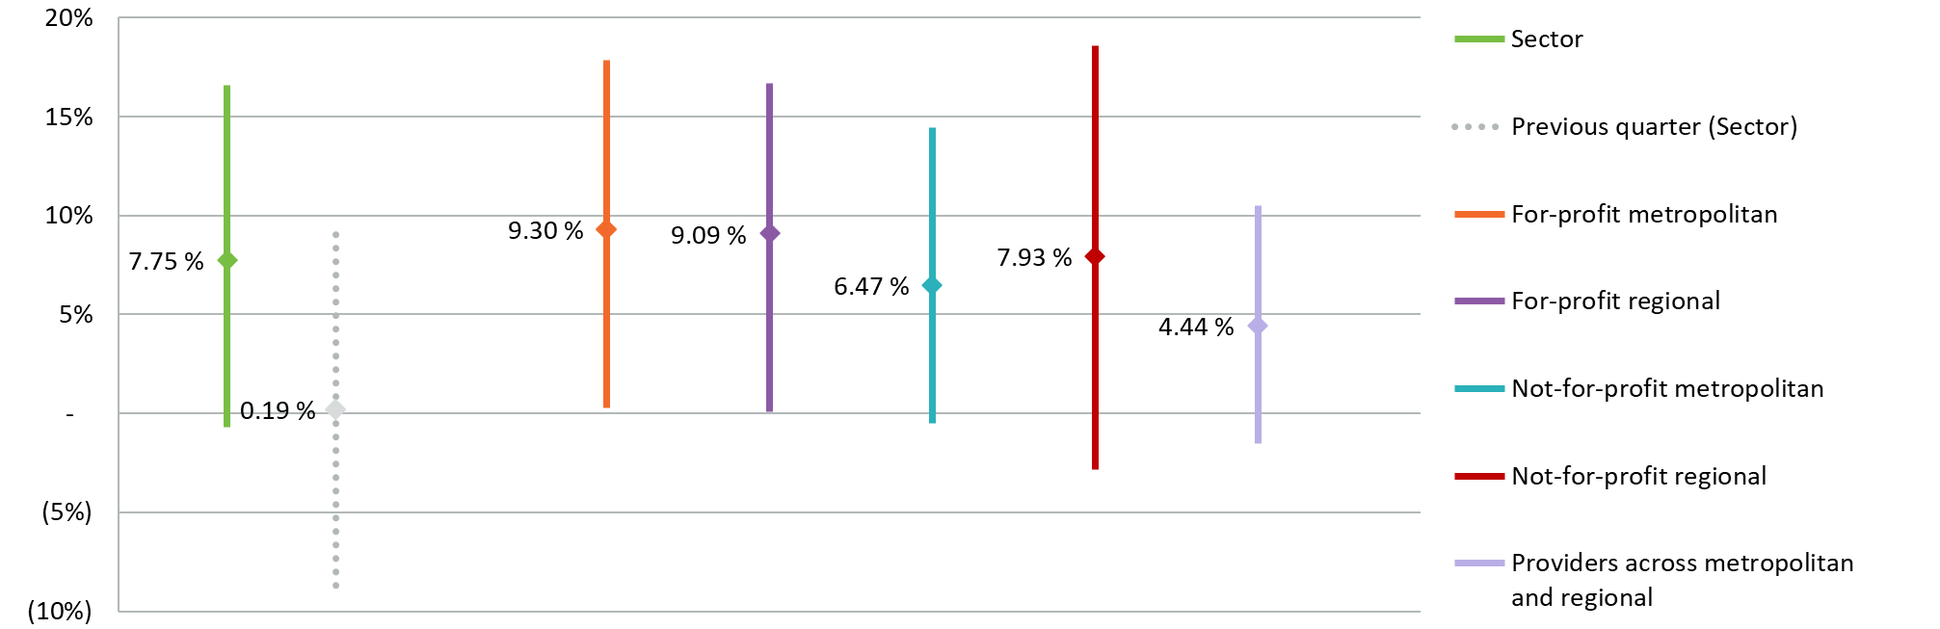

EBITDA margin = EBITDA ÷ total revenue

Depreciation on leased (right of use) assets and interest on lease liabilities are not added back as it represents the rent paid by providers that do not own their premises. As comparison, EBITDA does not add back rent for owner occupiers.

## Profitable residential aged care service providers

Measuring profitability can provide an incremental indication of the financial performance of the residential aged care service providers.

Figure 1 shows that 46.4 per cent of residential aged care providers reported a December 2022 year-to-date net profit before tax, compared to 33.9 per cent of providers at September 2022. Profitable providers at December 2022 year-to-date serviced 29.6 per cent of residents in aged care.

Figure 1: Year-to-date percentage of profitable residential aged care providers and percentage of residents serviced by profitable residential aged care providers

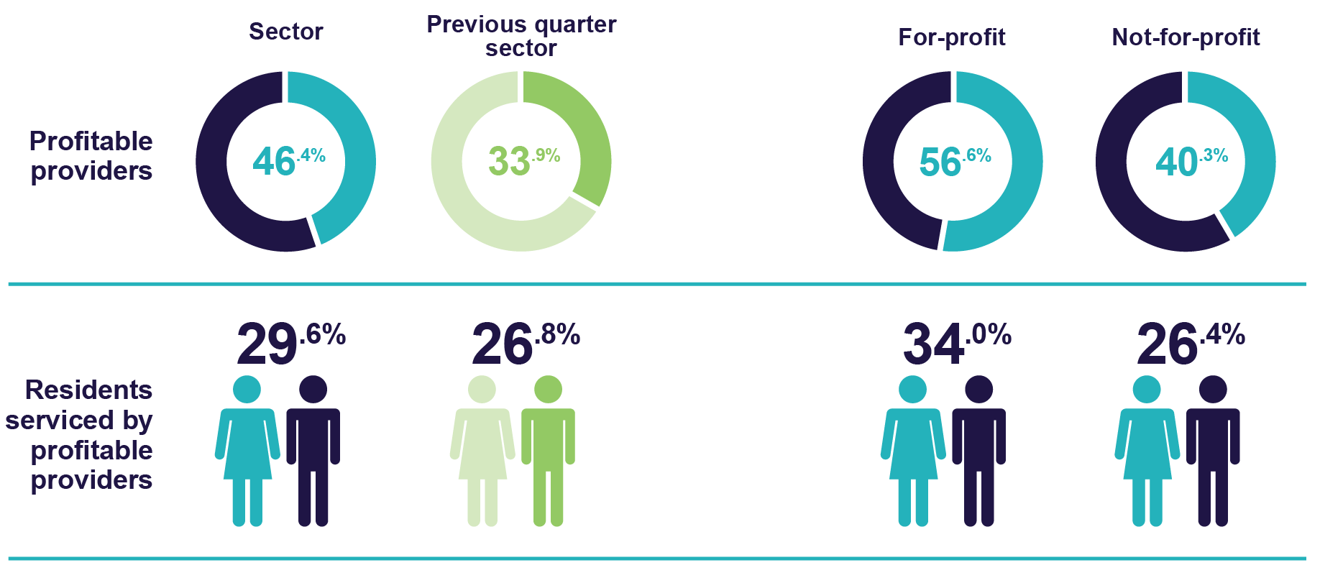

Figure 2 shows that an estimated 57.7 per cent of residential aged care providers reported a net profit before tax in quarter 2 (based on isolated quarter 2 results), compared to 33.9 per cent of providers in quarter 1. Profitable providers in quarter 2 serviced 39.1 per cent of residents in aged care.

**Figure 2: Quarter 2 percentage of profitable residential aged care providers and percentage of residents serviced by profitable residential aged care providers (estimated)**

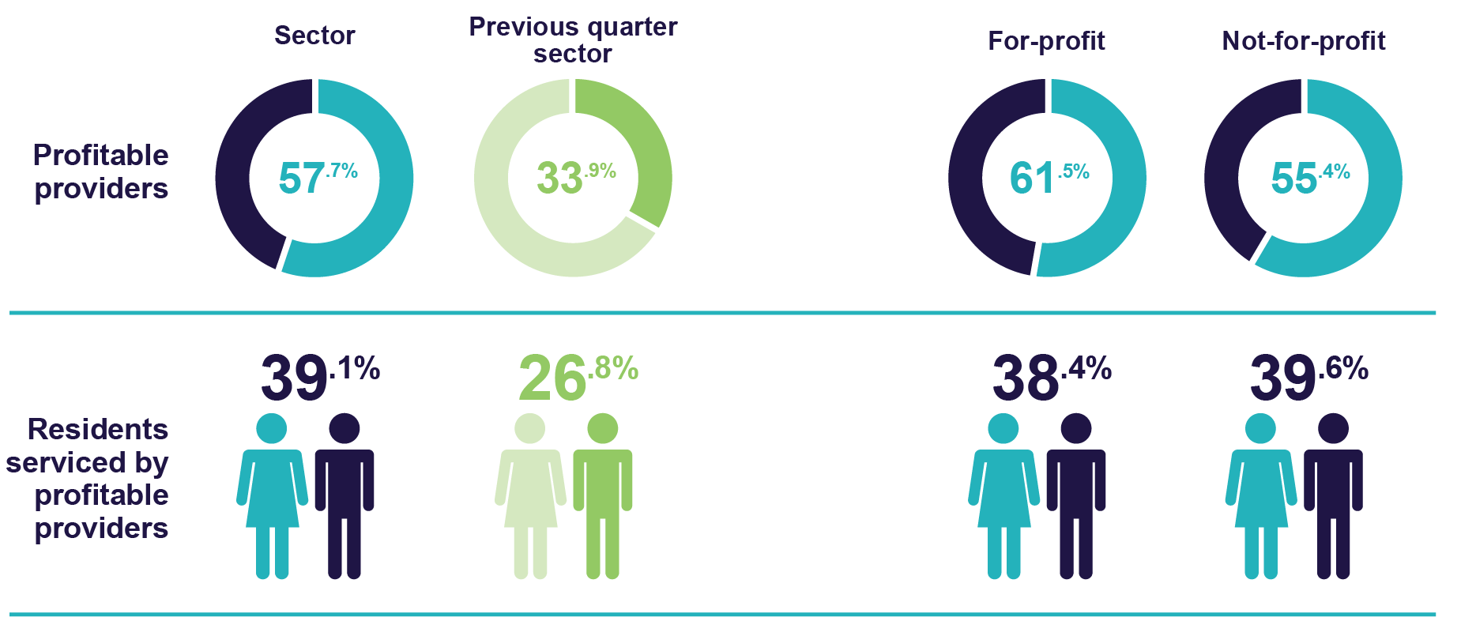

## Liquidity

Liquidity ratio measures the availability of cash and financial assets to cover providers' debt obligations (without raising external capital) if they were to become immediately due and payable.

If the ratio result is greater than 1.0, the provider has more cash and financial assets than their debt obligations. If the ratio result is less than 1.0, the provider’s debt obligations are greater than their cash and financial assets.

The December 2022 year-to-date, median liquidity ratio for the sector was 0.35, an increase of 0.02 on the September 2022 year-to-date position. This means that providers had approximately a third of cash and financial assets available when compared to their debt obligations.

The December 2022 year-to-date median liquidity ratio increased slightly on the September 2022 year-to-date result for all provider types.

The liquidity ratio for residential aged care providers shown in Chart 10 may be impacted by their financial performance or by their investment strategy.

Chart 10: Year-to-date median and quartile liquidity ratio of residential aged care providers by provider type

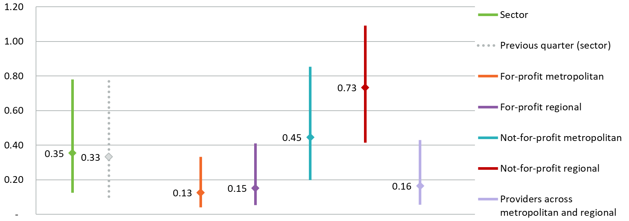

Liquidity ratio = (cash and cash equivalents + financial assets) ÷ (total liabilities - lease liabilities)

Calculations do not include undrawn credit facilities as liquid assets.

Total liabilities do not include refundable accommodation deposits that residents have agreed to pay, but the amount has not yet been received by the provider.

## Capital adequacy

The December 2022 year-to-date capital adequacy ratio shown in Chart 11 measures a provider's net asset position divided by total asset position (not including intangibles).

This ratio can be used as an indicator of a provider's ability to absorb any unexpected losses through their net asset position (also known as an asset buffer).

The median capital adequacy ratio for residential aged care providers was 0.28, meaning for every $100 of assets they owned, $28 was funded through equity and $72 was funded through debt or other liabilities. This was a decrease of 0.01 on the September 2022 year-to-date position.

If a provider has a stronger (higher) capital adequacy ratio, they will be able to fund and absorb the impacts of unforeseen circumstances (e.g. flood, unexpected losses) by using equity within the business. If a provider has a low or insufficient capital adequacy ratio, they may be forced to take on debt, or in extreme situations, go into administration when faced with unforeseen circumstances which have a financial impact.

Chart 11: Year-to-date median and quartile capital adequacy ratio of residential aged care providers by provider type

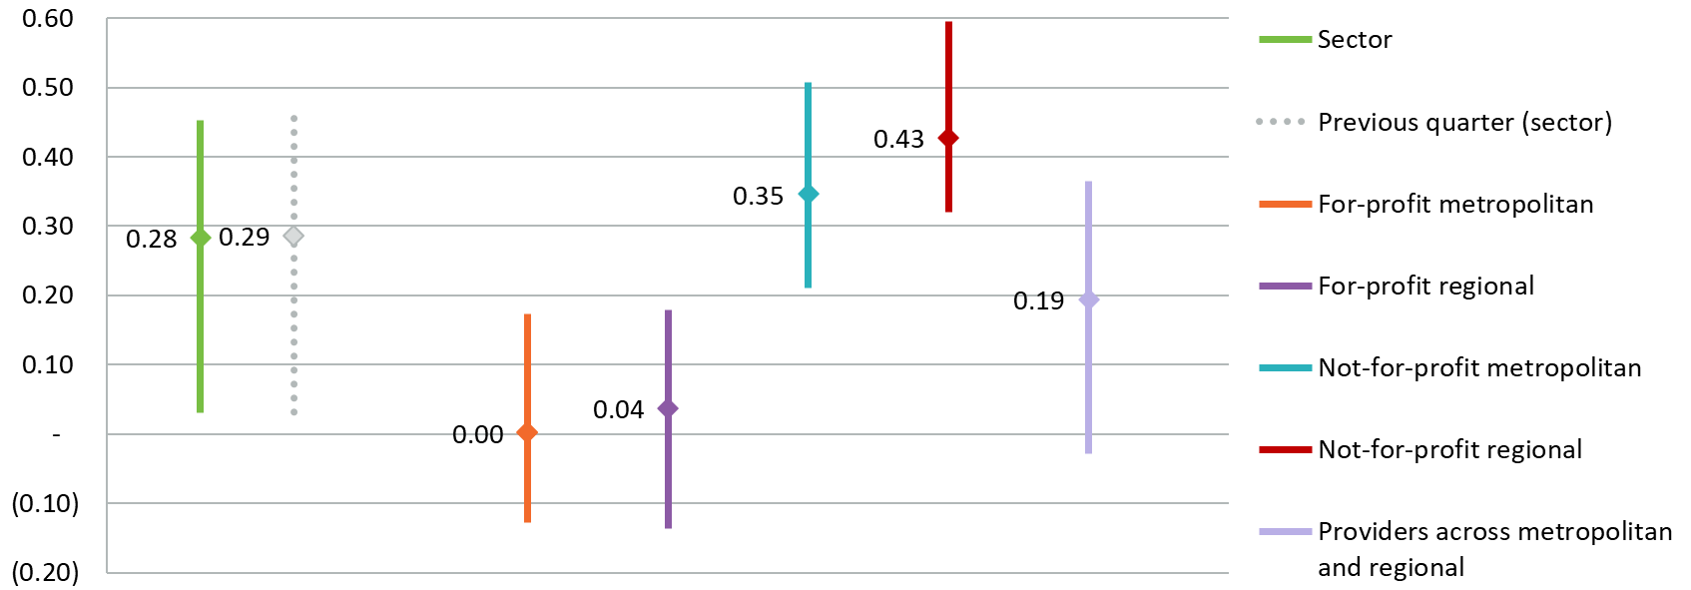

Capital adequacy ratio = (net assets - intangible assets) ÷ (total assets - intangible assets).

Intangible assets are removed as they are not considered to have value in the event of insolvency. This provides a more realistic reflection of the available capital to absorb unforeseen circumstances.

# Home care

## Financial summary

Table 6 is a December 2022 year-to-date summary of home care service providers’ revenue and expenses. For-profit and not-for-profit home care providers returned a collective year-to-date net profit before tax of $138.5 million. This equates to a December 2022 year-to-date net profit before tax of $3.59 per care recipient per day, down $1.41 per care recipient per day on the September 2022 year-to-date result.

The department will continue to monitor changes in profitability each quarter for home care providers and undertake further analysis as more data is collected.

Table 6: Year-to-date summary of financial performance of home care for-profit and not-for-profit providers

|  |  |  |  |
| --- | --- | --- | --- |
|  | Total | Per care recipient per day | Change from September 2022 year-to-date per care recipient per day |
| Revenue | $2,641.9m | $68.48 | ↓ $0.52 |
| Expenses | $2,503.4m | $64.90 | ↑ $0.80 |
| Net profit before tax | $138.5m | $3.59 | ↓ $1.41 |
| Net profit before tax margin | 5.24% | 5.24% | ↓ 1.96 percentage points |
| EBITDA | $158.8m | $4.12 | ↓ $1.48 |

Table 7 is an estimated quarter 2 summary of home care service providers’ revenue and expenses. For-profit and not-for-profit home care providers returned a collective quarter 2 net profit before tax of $46.1 million. This equates to a quarter 2 net profit before tax of $2.33 per care recipient per day, down $2.63 per care recipient per day on quarter 1.

Table 7: Quarter 2 summary of financial performance of home care for-profit and not-for-profit providers (estimate)

|  |  |  |  |
| --- | --- | --- | --- |
|  | Total | Per care recipient per day | Change from Q1 per care recipient per day |
| Revenue | $1,356.8m | $68.65 | ↓ $0.40 |
| Expenses | $1,310.7m | $66.32 | ↑ $2.24 |
| Net profit before tax | $46.1m | $2.33 | ↓ $2.63 |
| Net profit before tax margin | 3.39% | 3.39% | ↓ 3.80 percentage points |
| EBITDA | $55.1m | $2.79 | ↓ $2.78 |

## Staff cost and minutes

Chart 12 shows the quarter 2 median cost and time per home care recipient per day for registered nurses, personal care workers (including cleaning, gardening and domestic assistance), allied health, other direct care staff, care management, and administration and support. The median total staff minutes was 54.11 minutes per care recipient per day. Unlike residential aged care, there is no target or mandated [care minutes](https://www.health.gov.au/our-work/AN-ACC/providers/care-minutes) for home care service providers.

Data for enrolled nurses has not been included as more than 70 per cent of home care providers did not report any expenditure in this category. Local, state or territory government providers are included in this data.

Chart 12: Quarter 2 median staff labour cost and time per care recipient per day

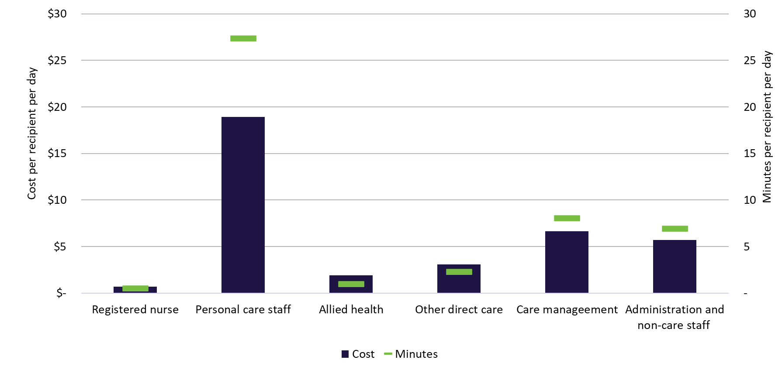

When comparing to quarter 1, the median cost per resident per day increased for all categories except for personal care workers. Time increased for all categories except for allied health which stayed the same as the quarter 1.

Table 8: Quarter 2 median staff cost and time per resident per day

|  |  |  |  |  |
| --- | --- | --- | --- | --- |
|  | Cost  per care recipient per day | Change in cost from Q1 | Minutes  per care recipient per day | Change in minutes from Q1 |
| Registered nurse | $0.69 | ↑ $0.06 | 0.49 | ↑ 0.06 |
| Personal care workers | $18.93 | ↓ $0.31 | 27.36 | ↑ 0.40 |
| Allied health | $1.93 | ↑ $0.03 | 0.96 | - |
| Other direct care | $3.08 | ↑ $0.73 | 2.28 | ↑ 0.30 |
| Care management | $6.66 | ↑ $0.07 | 8.04 | ↑ 0.10 |
| Administration and non-care staff | $5.73 | ↑ $0.19 | 6.92 | ↑ 0.10 |

## Staff cost

Chart 13 shows that the quarter 2 median total staff cost was $44 per care recipient per day for the sector, a decrease of $1 per care recipient per day on quarter 1.   
For-profit metropolitan providers reported the highest median total staff cost per care recipient per day ($48). The median total staff costs per care recipient per day decreased from $48 to $40 for for-profit regional providers.

Total staff includes registered nurses, enrolled nurses, personal care workers, allied health, other direct care, care management, and administration and non-care. The cost of labour includes salary and superannuation, bonuses and incentives, allowances, termination payments, value of fringe benefits, salary sacrifice and leave entitlements.

Chart 13: Quarter 2 median and quartile total staff cost per care recipient per day by home care provider type

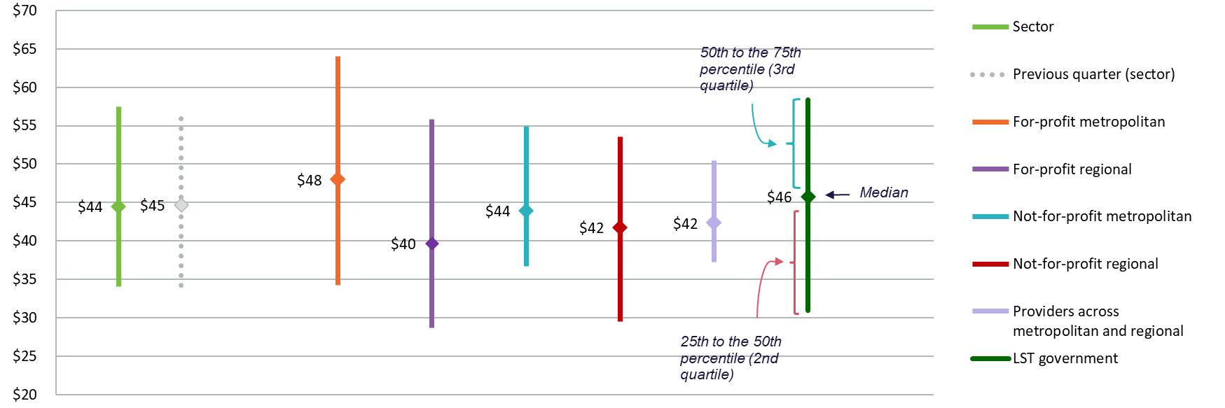

## Wages to revenue

Comparing wages to revenue is a financial viability indicator allowing home care service providers to measure how much is spent on employees as a proportion of revenue. Chart 14 shows the December 2022 year-to-date proportion of wages to revenue for the sector was a median of 61 per cent, which was the same result as the September 2022 year-to-date position.

The median proportion of wages to revenue was similar to the sector result for all provider types except for providers across metropolitan and regional which was lower (55 per cent). Wages are inclusive of all home care service employees.

Chart 14: Year-to-date median and quartile wages to revenue percentage by home care provider type

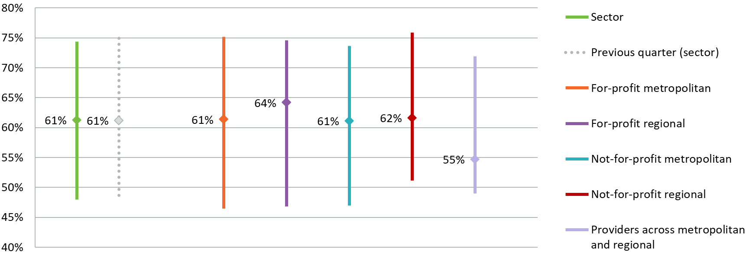

Chart 15 shows that the estimated quarter 2 proportion of wage to revenue for the sector was a median of 59 per cent (down 2 percentage points on the quarter 1 result).

Chart 15: Quarter 2 median and quartile wages to revenue percentage by home care provider type (estimate)

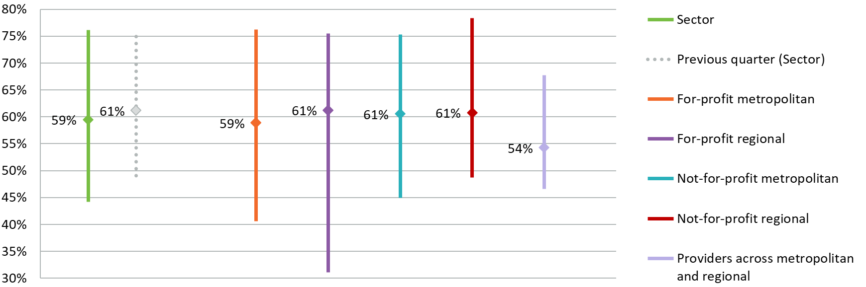

Wages to revenue percentage = (salaries and employee benefits + management fees) ÷ total revenue

## Hourly rate

The quarter 2 median hourly rate for registered nurses, enrolled nurses and personal care workers is shown by provider type in Chart 16. Home care service providers submitted the average hourly rate paid to direct care staff in the QFR. The home care sector median of the average hourly rate was $50 for registered nurses, $37 for enrolled nurses and $32 for personal care workers. This is consistent with quarter 1, except for registered nurses which increased by $1.

Chart 16: Quarter 2 median hourly rate paid to direct care staff by home care provider type

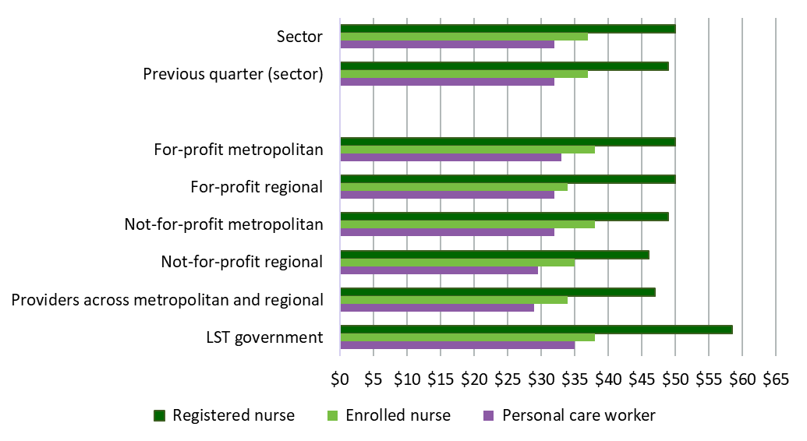

The average hourly rate is reported by providers by calculating the average hourly rate of direct care staff employed as per the employee award, agreement or contract. The average hourly rate does not include on-costs, penalty rates or casual loading.

Nil value responses have been excluded from the calculation of the median average hourly rate.

## Care and package management

Chart 17 shows the quarter 2 median percentage of the maximum Australian Government subsidy directed to care management and package management per home care package level, as reported on My Aged Care. There was minimal or no change in the percentage of care or package management from 30 September to   
31 December 2022, except for level 2 and 4 care management which increased by   
1 percentage point.

[Care management](https://www.health.gov.au/our-work/home-care-packages-program/managing/care-management#:~:text=Care%20management%20is%20a%20service,services%20align%20with%20other%20supports) ensures recipients receive the appropriate level of support in a way that meets current and future care needs. Care management is a function of providers and it should ensure there is no overlap, over-servicing, or mismanagement of services.

[Package management](https://www.health.gov.au/our-work/home-care-packages-program/managing/package-management) is the ongoing administration and organisational activities associated with ensuring the smooth delivery and management of a Home Care Package (HCP).

Chart 17: Quarter 2 median care and package management percentage per home care package level

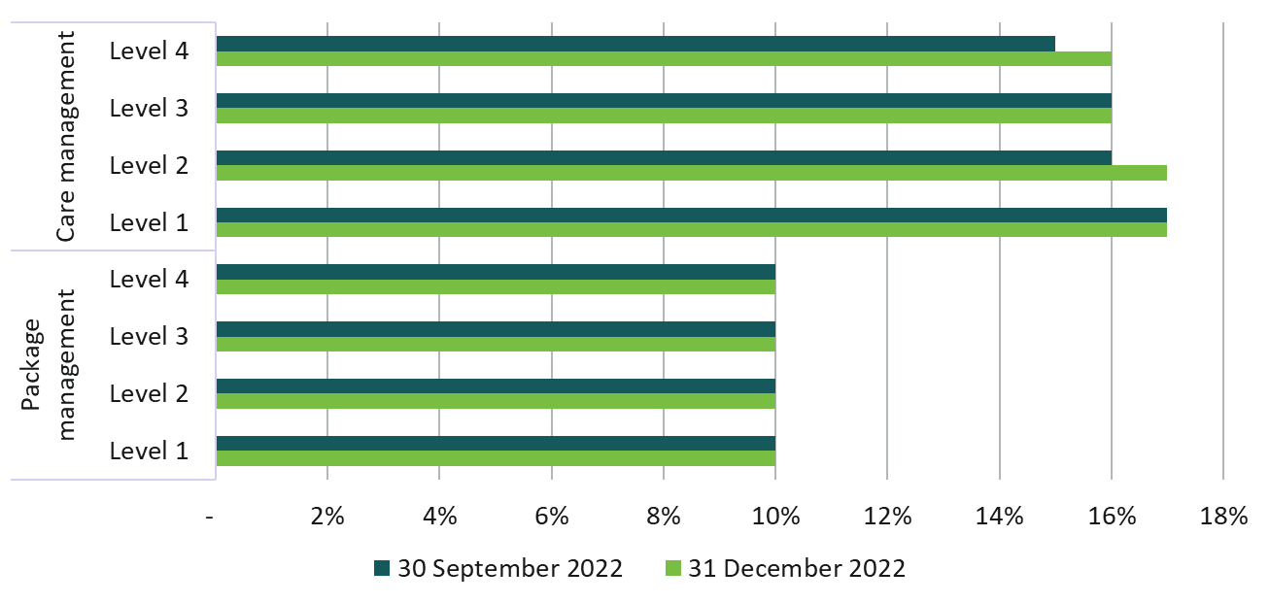

Care management = care management expenses ÷ total Australian Government subsidy

Package management = package management expenses ÷ total Australian Government subsidy

## EBITDA margin

EBITDA margin is used as an indicator of a provider’s financial performance and underlying profitability, before accounting for depreciation assumptions, tax obligations or financing choices. EBITDA margins focus on a provider’s operating profitability and cash flow, where the higher the EBITDA margin is, the lower operating expenses are in relation to total revenue.

Chart 18 shows the December 2022 year-to-date median EBITDA margin for the sector was 7.51 per cent, which means an EBITDA return of $7.51 for every $100 of revenue earned. This was a decrease of 1.35 percentage points on the September 2022 year-to-date result.

The percentage of residential aged care providers reporting a negative EBITDA result increased from 18 per cent (September 2022 year-to-date) to 25 per cent (December 2022 year-to-date).

Chart 18: Year-to-date median and quartile EBITDA margin by home care provider type

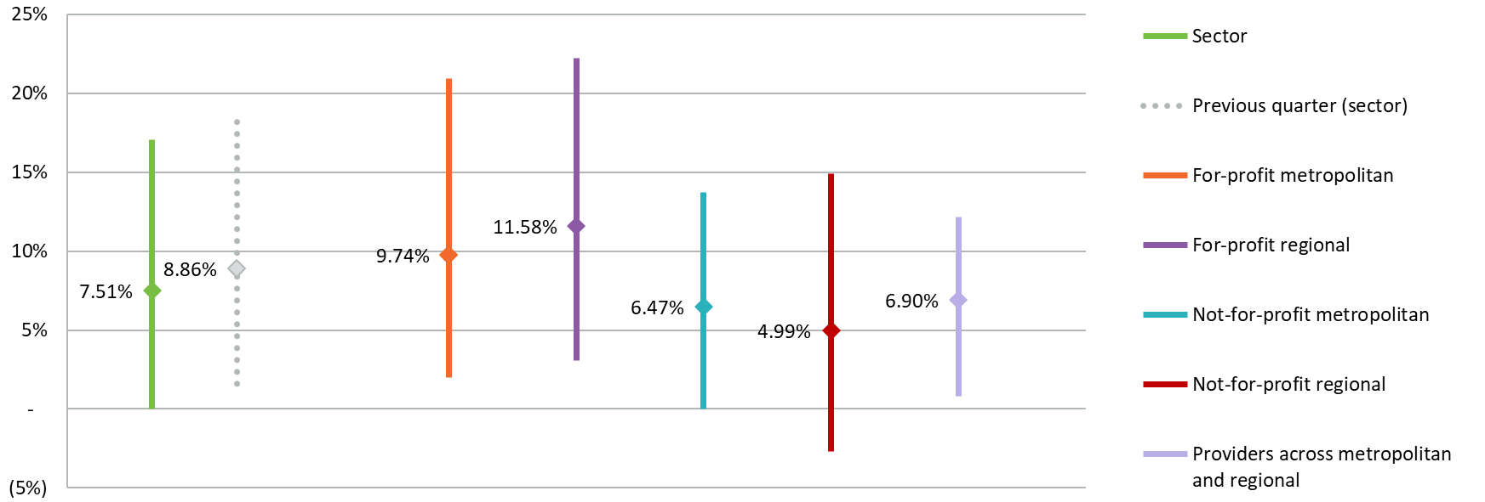

Chart 9 shows the estimated quarter 2 median EBITDA margin for the sector was 6.01 per cent, which means an EBITDA return of $6.01 for every $100 of revenue earned. This was a decrease of 2.85 percentage points on the quarter 1 result.

The estimated percentage of home care providers reporting a negative EBITDA result in quarter 2 increased to 33 per cent, up from 18 per cent in quarter 1.

Chart 19: Quarter 2 median and quartile EBITDA margin by home care provider type (estimate)

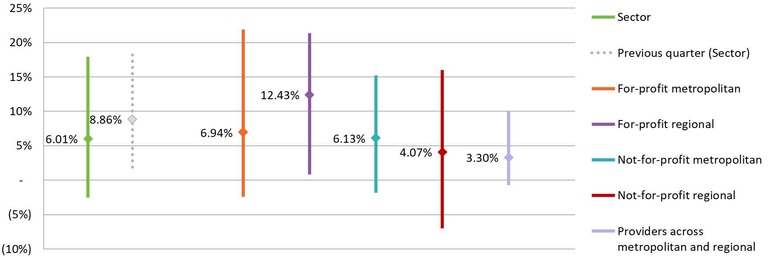

EBITDA margin = EBITDA ÷ total revenue

Depreciation on leased (right of use) assets and interest on lease liabilities are not added back as it represents the rent paid by providers that do not own their premises. As comparison, EBITDA does not add back rent for owner occupiers.

## Profitable home care service providers

Measuring profitability can provide an incremental indication of the financial performance of home care service providers.

Figure 3 shows that 73.8 per cent of home care service providers reported a net profit before tax December 2022 year-to-date, compared to 78.4 per cent of providers at the September 2022 year-to-date position. Profitable home care providers serviced 70.2 per cent of care recipients.

Figure 3: Year-to-date percentage of profitable home care providers and percentage of home care recipients serviced by profitable home care providers

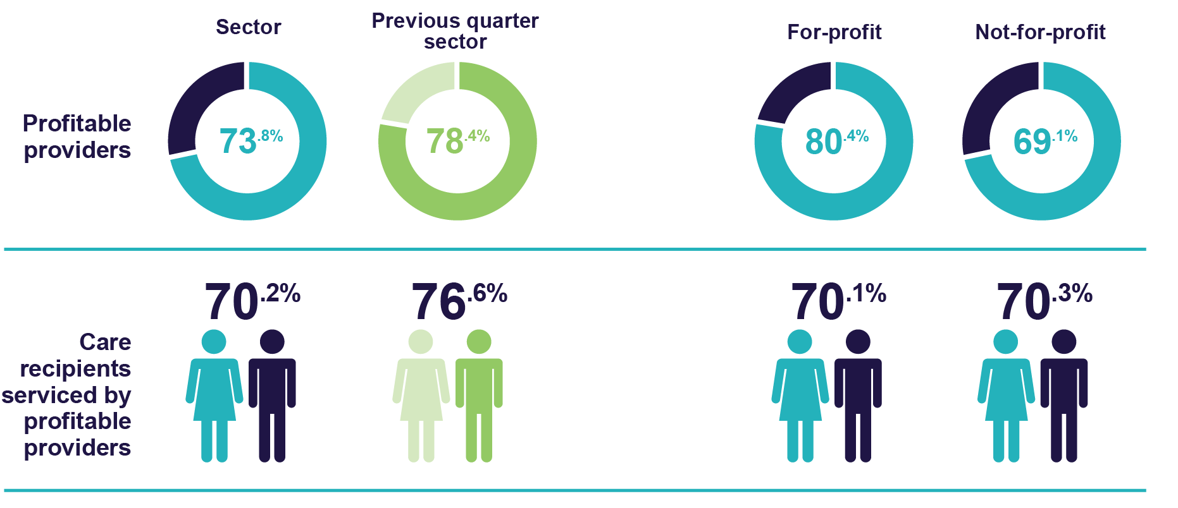

Figure 4 shows that an estimated 66.5 per cent of home care service providers reported a net profit before tax in quarter 2, compared to 78.4 per cent of providers in quarter 1. Profitable home care providers serviced 73 per cent of care recipients in quarter 2.

Figure 4: Quarter 2 percentage of profitable home care providers and percentage of home care recipients serviced by profitable home care providers (estimate)

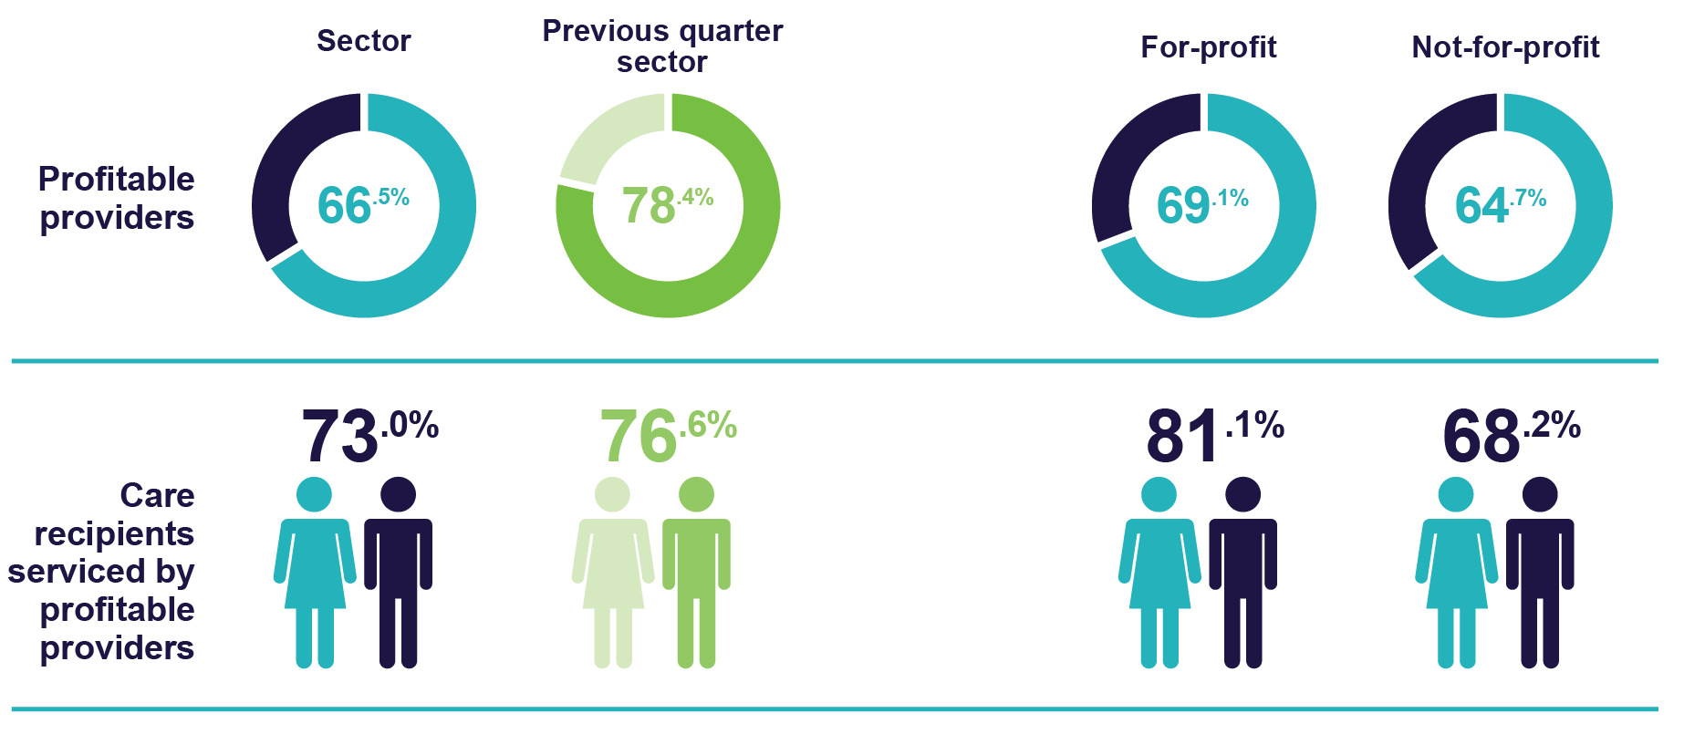

## Home care account balance and unspent funds

Since 1 September 2021, any unspent Government subsidy accrued is held in a HCP recipient’s Home Care Account Balance. These funds continue to be available to pay for care and services when needed by the HCP recipient. Some aged care service providers also have access to unspent funds accrued prior to 1 September 2021. These funds can be used to pay for a HCP recipient’s care and services. Unlike the Home Care Account Balance, the unspent funds’ balances for a HCP recipient cannot accumulate as all unspent amounts now go the recipient’s Home Care Account Balance.

The quarterly change in the home care account balance and the Australian Government portion of unspent funds is shown in Figure 5. Over time, it can be expected that the unspent funds balance will diminish, and the Home Care Account Balance will fluctuate according to market demand and supply.

Figure 5: Home care account balance and Australian Government portion of unspent funds

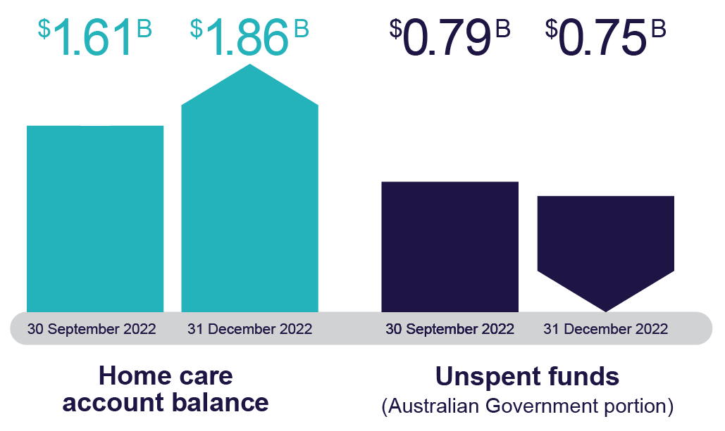

## Liquidity

Liquidity ratio measures the availability of cash and financial assets to cover providers' debt obligations (without raising external capital) if they were to become immediately due and payable.

If the ratio result is greater than 1.0, the provider has more cash and financial assets than their debt obligations. If the ratio result is less than 1.0, the provider’s debt obligations are greater than their cash and financial assets.

The December 2022 year-to-date median liquidity ratio for the sector was 0.78, a decrease of 0.04 on the September 2022 year-to-date position. This means for every $78 of cash and financial assets available, the provider had $100 of debt obligations.

For-profit regional providers experienced the greatest change in liquidity ratio results, dropping from 0.88 (September 2022 year-to-date) to 0.62 (December 2022 year-to-date).

The liquidity ratio for home care providers shown in Chart 20 may be impacted by their financial performance or by their investment strategy.

Chart 20: Year-to-date median and quartile liquidity ratio of home care providers by provider type

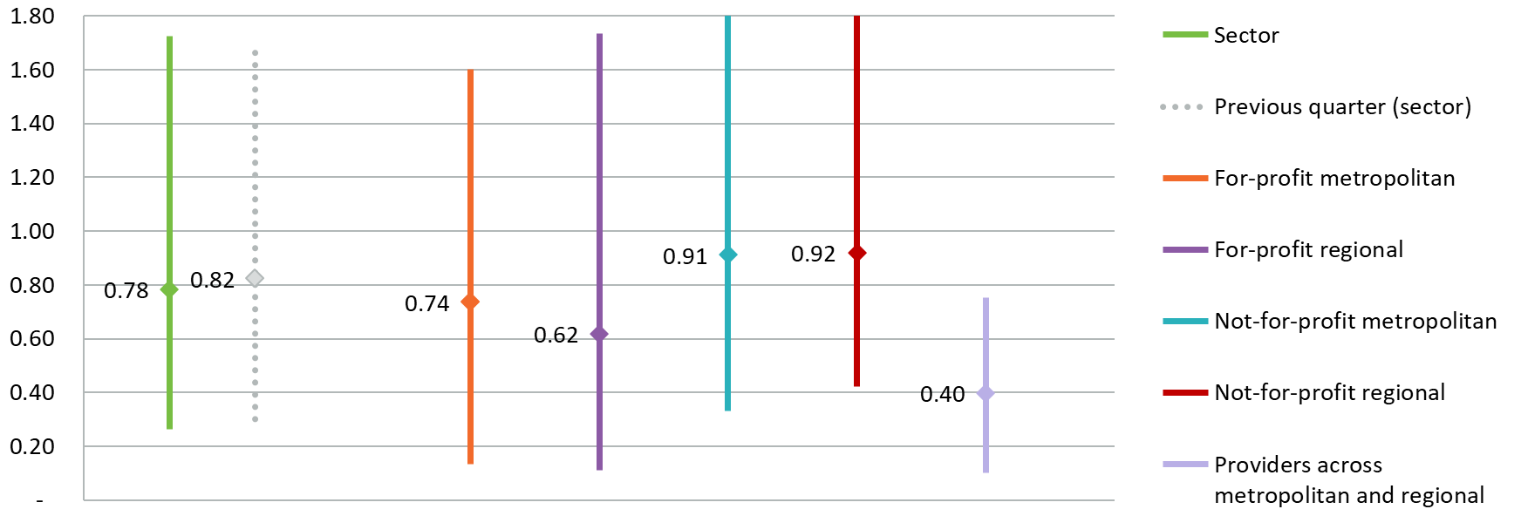

Liquidity ratio = (cash and cash equivalents + financial assets) ÷ (total liabilities - lease liabilities)

Calculations do not include undrawn credit facilities as liquid assets.

Total liabilities do not include refundable accommodation deposits that residents have agreed to pay, but the amount has not yet been received by the provider.

## Capital adequacy

Capital adequacy ratio shown in Chart 21 measures a provider's net asset position divided by total asset position (not including intangibles).

This ratio can be used as an indicator of a provider's ability to absorb any unexpected losses through their net asset position (also known as an asset buffer).

The median capital adequacy ratio for home care providers was 0.49, meaning for every $100 of assets they owned, $49 was funded through equity and $51 was funded through debt or other liabilities. This was an increase of 0.03 on the September 2022 year-to-date result.

The capital adequacy ratio was similar for all provider types when compared to the September 2022 year-to-date result, except for-profit regional providers which decreased from 0.51 to 0.42.

If a provider has a stronger (higher) capital adequacy ratio, they will be able to fund and absorb the impacts of unforeseen circumstances (e.g., flood, unexpected losses) by using equity within the business. If a provider has a low or insufficient capital adequacy ratio, they may be forced to take on debt, or in extreme situations, go into administration when faced with unforeseen circumstances which have a financial impact.

Chart 21: Median and quartile capital adequacy ratio of home care providers by provider type

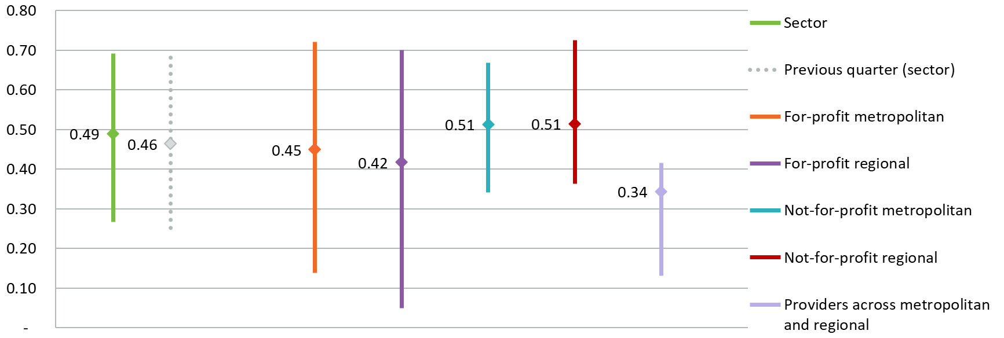

Capital adequacy ratio = (net assets - intangible assets) ÷ (total assets - intangible assets)

Intangible assets are removed as they are not considered to have value in the event of insolvency. This provides a more realistic reflection of the available capital to absorb unforeseen circumstances.

**Let’s change aged care together**

We invite Australians to continue to have their say about the aged care reforms.

Visit **agedcareengagement.health.gov.au**

Phone **1800 318 209** (Aged care reform free-call phone line)

For translating and interpreting services, call 131 450 and ask for 1800 318 209.

To use the National Relay Service, visit nrschat.nrscall.gov.au/nrs to choose your preferred access point on their website, or call the NRS Helpdesk on 1800 555 660.

