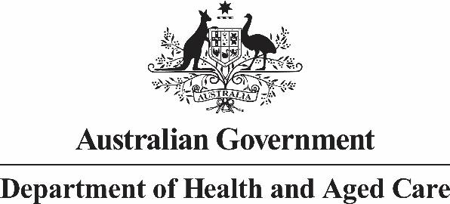 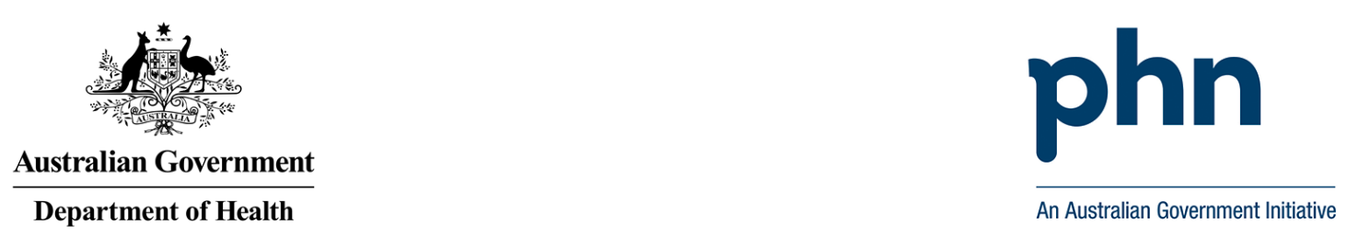

**Primary Health Network Program   
Annual Performance Report 2020-21**

Acknowledgement

This document was developed by the Australian Government Department of Health and Aged Care as part of the Primary Health Networks Program Performance and Quality Framework.

© Commonwealth of Australia 2023

This work is copyright. You may download, display, print and reproduce the whole or part of this work in unaltered form for your own personal use or, if you are part of an organisation, for internal use within your organisation, but only if you or your organisation do not use the reproduction for any commercial purpose and retain this copyright notice and all disclaimer notices as part of that reproduction. Apart from rights to use as permitted by the Copyright Act 1968 or allowed by this copyright notice, all other rights are reserved and you are not allowed to reproduce the whole or any part of this work in any way (electronic or otherwise) without first being given the specific written permission from the Commonwealth to do so. Requests and inquiries concerning reproduction and rights are to be sent to the Communication Branch, Department of Health and Aged Care, GPO Box 9848, Canberra ACT 2601, or via e-mail to [copyright@health.gov.au](mailto:copyright@health.gov.au).

Preferred citation: Australian Government Department of Health and Aged Care. (2023). *PHN Program Performance Report 2020-21.*

Disclaimer

Opinions expressed in PHN Program Performance Report 2020-21 are those of the authors and not necessarily those of the Australian Government Department of Health and Aged Care. Data may be subject to revision.

Contents

Acknowledgement 2

Disclaimer 2

Introduction 4

Emergency Department and Hospitalisations 4

Potentially Preventative Hospitalisations (PPH) 4

Lower Urgency Emergency Department Presentations 5

Program 5

Workforce 6

Alcohol and Other Drugs 7

General Practices 8

Accredited General Practices 8

Practice Incentive Program After Hours Payments 9

Digital Health 9

My Health Record (MHR) 11

Number of General Practices Uploading to MHR 11

Cross Views of MHR 12

First Nations Health 14

First Nations Health Assessments 16

Chronic Care 17

Aged Care 19

Mental Health 21

Population Health 23

Childhood Vaccination 23

Cancer Screening 23

Bowel Cancer Screening 23

Breast Cancer Screening 25

Cervical Cancer Screening 26

Organisational 27

Reference List 28

Appendix 1 29

Appendix 2 35

Acronyms and abbreviations 36

# Introduction

This is the third Primary Health Networks (PHN) Program-wide performance report conducted under the PHN Program Performance and Quality Framework (the Framework).

The Framework consists of a set of performance indicators which are used to measure individual PHNs’ progress towards outcomes. These indicators are considered program indicators and were selected as they reflected areas where PHNs could be expected to influence changes. In addition, several Program-wide performance indicators have been collected to assist in measuring how the PHN Program contributes to achieving a range of health outcomes. These are referred to as Contextual Indicators. All contextual indicator data has been compiled on a PHN level and relates to performance within and across PHNs, it does not represent national performance.

This performance report provides the overall analysis of the PHN program for the 2020-21 reporting period via the outcome themes as specified in the Framework. PHNs are assessed against all the organisational indicators and other performance indicators which reflect areas where PHNs can and should have influence. For some of these indicators PHNs may have limited input as the area may not be a priority for their region. This will not negatively affect their or program performance assessment.

During this reporting period, the impact of the COVID-19 pandemic continued to place a strain on the primary health care system across Australia. A series of lockdowns across jurisdictions also impacted on service delivery. In response to these events, PHNs have faced additional challenges in workforce demands, delivery of face-to-face commissioned services, and system pressure during the reporting period. PHNs have proven to be flexible and adaptable over this period in delivering the services required in their region and the Department would like to place on record its appreciation for their valuable contribution to the national response to the unprecedented challenges of that difficult period.

# Emergency Department and Hospitalisations

## Potentially Preventative Hospitalisations (PPH)

Potentially preventable hospitalisations (PPH) are currently a health system performance indicator of accessibility and effectiveness in the National Health Reform Agreement and an area of focus for PHNs. The indicator can be calculated using routinely collected hospital admission data and allows insight into the interface between primary and secondary health care. It can be disaggregated at various levels, by geographic regions, population subgroups and conditions to highlight priority areas for further investigation.

PPH are an admission to hospital for a condition *(Appendix 2)* which could have been prevented through an individualised health or disease management intervention in a primary care or community care setting (e.g.: by a general practitioner, dentist, or allied health professional). Age-standardised rates are used in PPH data as a method of controlling for varying age ranges across diverse populations.

Figure 1 shows that since 2017-18, PPH have been falling by an average of 5 per cent each year. In 2020-21, there was an average 6 per cent decrease nationwide in the rate of PPH per 100,000 population from 2019-20. PHNs recorded the lowest rate of PPH per 100,000 population since the PHN Program commenced in 2015-16, and this decrease occurred in vaccine preventable, chronic, and acute PPH. Additionally, decreases in PPH occurred in both metropolitan and regional areas, across all levels of socio-economic disadvantage, and in all state and territory jurisdictions.

*Figure 1: Potentially preventable hospitalisations by type, from 2015-16 to 2020-21*

*Bar chart of average potentially preventable hospitalisations per 100,000 population, for 2015-16 to 2020-21 reporting periods. The chart divides preventable hospitalisation types into vaccine, chronic and acute. 
*

*Source: AIHW Potentially Preventable Hospitalisations data*

## Lower Urgency Emergency Department Presentations

Data for the period covered by this report for this indicator is not yet available. The report will be revised as soon as the 2020-21 data is finalised and released for publication

# Program

All PHNs have met the three program indicators they were asked to report on from 2018-19 to 2020-21. This includes:

1. Delivering activities to address prioritised needs
2. Demonstrating health system improvement and innovation
3. Delivering support activities to general practices and other health care providers.

# Workforce

In the workforce priority area, PHNs are assessed against three indicators. Achievement against these indicators increased in 2020-21 compared to 2019-2020 (Figure 2):

1. 97 per cent of PHNs were supporting specialist drug and alcohol treatment service providers to have or work towards accreditation. This is an increase from 87 per cent in 2019-20.
2. 90 per cent of PHNs were supporting drug and alcohol commissioned health professionals in their region. This is an increase from 84 per cent in 2019-20.
3. All PHNs had a commissioning framework in 2020-21, as they did in the previous year. The commissioning framework assists them to fulfil their commissioning role in a strategic way.

Figure 2: Proportion of PHNs that met performance targets by Workforce indicator

Bar chart comparing the proportion of PHNs that met performance targets by workforce indicator in 2019-20 and 2020-21 reporting periods. These comparisons are shown across three categories, 1. Drug and alcohol service providers suitably accredited, 2. Support for drug and alcohol commissioned health professionals and 3. PHN commissioning framework. PHNs are performing better in the most recent reporting period for the first two categories, while both reporting periods show 100% of PHNs reached their targets in the third category.
  
Source: Performance reporting data provided by PHNs

The average number of workforce performance targets met by PHNs improved year-on-year in both regional and metropolitan areas compared to 2019-20 (Figure 3).

*Figure 3: Average number of Workforce performance targets met by remoteness*

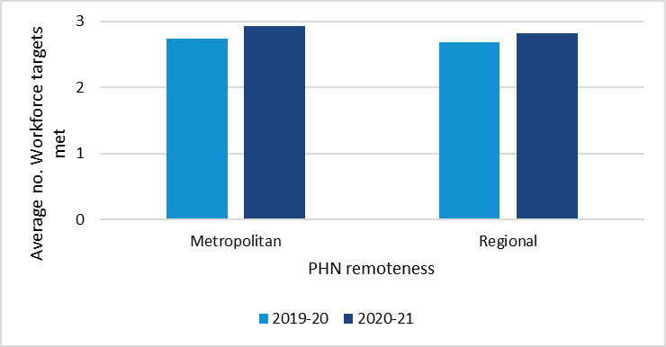   
Source: performance reporting data provided by PHNs. PHN remoteness classification is based on the Australian Statistical Geography Standard. PHN areas with at least 85 per cent of the population residing in Major cities are classified as metropolitan, as defined by the Australian Bureau of Statistics, using the population distribution as of 30 June 2016. All other PHN areas are classified as regional PHN areas.

# Alcohol and Other Drugs

PHNs are tasked with increasing service delivery capacity of the alcohol and other drug treatment sector through improved regional coordination and commissioning of treatment services. All PHNs remained consistent with the rate of drug and alcohol commissioned providers actively delivering services in their regions, whilst being flexible to COVID-19 restrictions. PHNs continued to nurture established partnerships with key local drug and alcohol treatment service stakeholders, and worked with their commissioned service providers to improve the rate of suitable accreditation supporting best practice. Professional development continued through the year and, despite restrictions placed on the Australian workforce due to COVID-19, there was an increase in professional development events, training and services compared to the previous year.

Through the substantial efforts of the whole alcohol and other drug sector this year, minimal disruptions to service provision were seen despite significant public health challenges experienced.

All PHNs have continued to meet the two indicators in 2020-21 (Figure 4). This includes:

1. The rate of drug and alcohol commissioned providers actively delivering services.
2. Partnerships established with local key stakeholders for drug and alcohol treatment services.

Figure 4: Proportion of PHNs that met performance targets by Alcohol and Other Drugs indicator

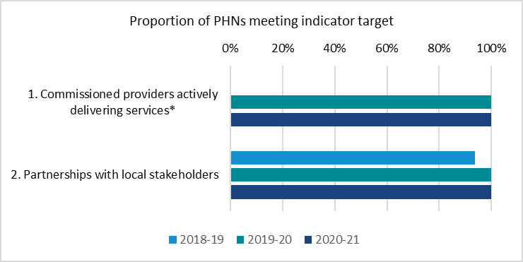  
Source: performance reporting data provided by PHNs   
*Only 2019-20 and 2020-21 data are displayed as this performance measure was taken as a baseline in 2018-19.

# General Practices

There has been an overall increase from 2019-20 to 2020-21 in the rate of general practices that are accredited, and those that are receiving Practice Incentive Program (PIP) after hours payments.

## Accredited General Practices

Accreditation is a voluntary process for general practices to demonstrate they are meeting Residential Aged Care General Practice (RACGP) safety and quality standards[1]. The PIP payments measured were the participation payment, sociable after hours cooperative and practice coverage payments, and complete after hours cooperative and practice coverage payments.

The average general practice accreditation rate in 2020-21 was 82 per cent (up from 77 per cent in 2019-20), and the average accreditation rate increased in 71 per cent of PHNs (Figure 5).

Figure 5: Average general practice accreditation rate

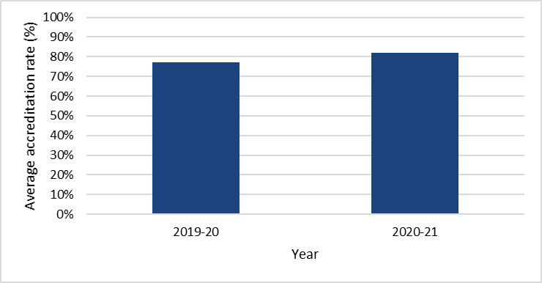  
Source: performance reporting data provided by PHNs

Accreditation rates increased in 2020-21 in both regional and metropolitan areas compared to 2019-20. Accreditation rates were also higher in regional areas (89 per cent) compared to metropolitan areas (78 per cent). This is consistent with findings from the previous year (83 per cent and 74 per cent respectively in 2019-20), (Figure 6).

Figure 6: Average general practice accreditation rate by remoteness

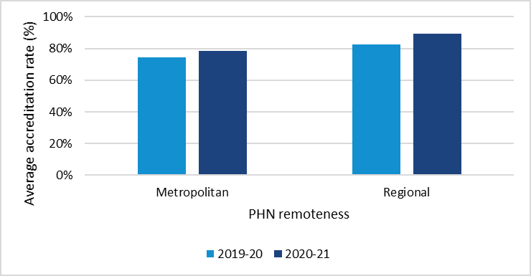  
Source: performance reporting data provided by PHNs

## Practice Incentive Program After Hours Payments

The average percentage of general practices receiving PIP after hours payments was 67 per cent (up from 60 per cent in 2019-20) and remains similar in both metropolitan and regional areas (Figure 7).

Figure 7: Percent of practices receiving PIP after hours payments by remoteness  
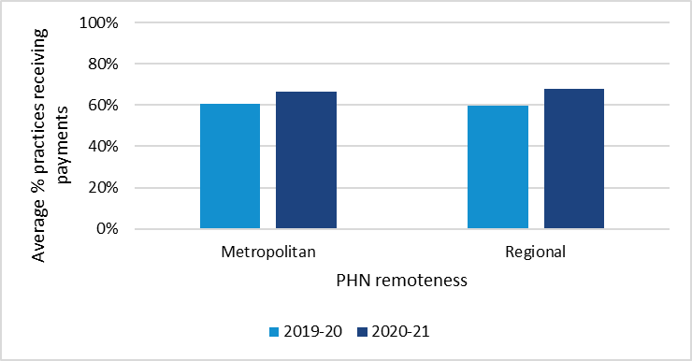  
Source: Department of Health and Aged Care and performance reporting data provided by PHNs. NTPHN not included.

# Digital Health

Digital health enables better coordinated care and better-informed treatment decisions. PHNs support health care providers to use digital health systems to improve patient care and communication.

There are three indicators of PHN performance in the digital health priority area. All three digital health indicators benchmarks were achieved in 71 per cent of PHN regions in 2020-21, the same result as last year (Figure 8). In addition, in 2020-21:

1. All PHNs have raised awareness of, and provided access to, My Health Record education to all general practices in their regions.
2. 97 per cent of PHNs have increased the rate of health care providers using smart forms, e-referrals and/or telehealth, up from 84 per cent of PHNs in 2019-20.
3. 74 per cent of PHNs have increased the rate of accredited general practices sharing data with the PHN, down from 84 per cent of PHNs in 2019-20.

*Figure 8: Proportion of PHNs that met performance targets by Digital Health indicator*

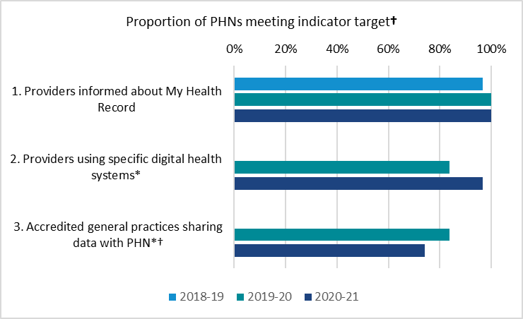  
Source: Performance reporting data provided by PHNs  
*Only 2019-20 and 2020-21 data are displayed as this performance measure was taken as a baseline in 2018-19.  
†Some 2019-2020 data for Accredited general practices sharing data with PHN has been revised.

Small increases were achieved across the Digital Health targets (comprising the three indicators above) in more socio-economically disadvantaged PHN regions, while a small decrease was observed in less disadvantaged regions (Figure 9).

Figure 9: Average number of Digital Health performance targets met by disadvantage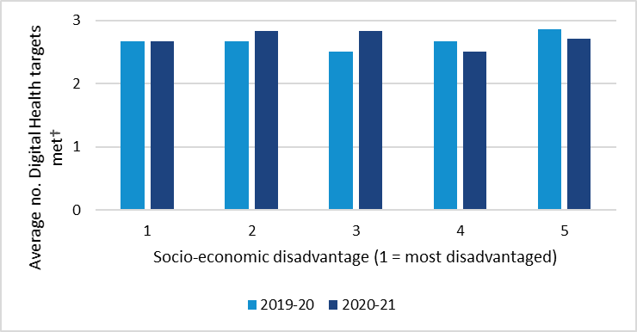  
Source: performance reporting data provided by PHNs  
†Some 2019-2020 data for Accredited general practices sharing data with PHN has been revised.

# My Health Record (MHR)

PHNs were funded by the Australian Digital Health Agency to support and encourage the use of MHR in general practices, pharmacies and among other health care providers, to enable better- coordinated care and better-informed treatment decisions for patients.

## Number of General Practices Uploading to MHR

The percentage of general practices uploading documents to MHR has increased, as has the regularity of their uploading. In 2020-21, the average percentage of general practices uploading documents to MHR at least once a week was 25 per cent, up from 18 per cent in 2019-20 (Figure 10).

Figure 10: Per cent of practices regularly uploading to MHR

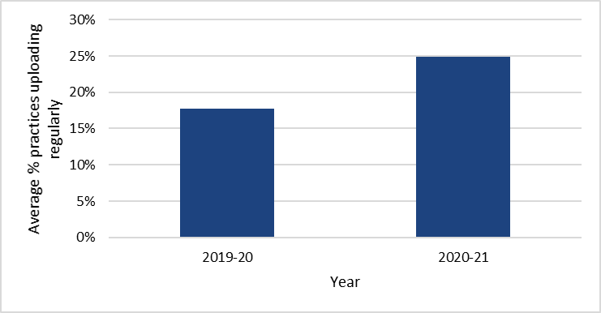  
Source: ADHA and performance reporting data provided by PHNs. NTPHN not included.

General practices uploading documents to MHR increased in both metropolitan and regional areas; 25 per cent and 24 per cent respectively, compared to 18 per cent in both in 2019-20 (Figure 11).

Figure 11: Per cent of practices regularly uploading to MHR by remoteness

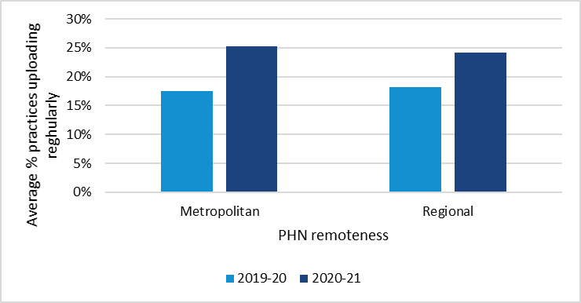  
Source: ADHA and performance reporting data provided by PHNs. NTPHN not included.

## Cross Views of MHR

Cross-views of MHR (the viewing of an MHR document authored in a different practice) increased in all PHNs by more than 12 per cent from 2019-20 in all general practices that were registered MHR providers. In pharmacy providers, cross-views of MHR increased in 97 per cent of PHNs.

The number of documents cross-viewed per general practice has continued to grow over the last three years (Figure 12). In 2020-21, general practices cross-viewed an average of 97 documents (up from 61 in 2019-20 and 19 in 2018-19). In pharmacies it was 16 documents in 2020-21 (up from nine in 2019-20 and five in 2018-19).

*Figure 12: Average count of MHR cross-views by general practices & pharmacies*

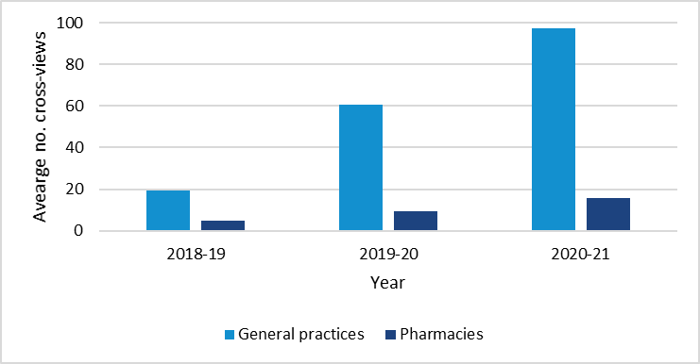  
Source: ADHA

Increases in cross-views of MHR for both general practices and pharmacies occurred across both metropolitan and regional areas. Regional areas had the greatest increase for both general practice (105 cross views in 2020-21 up from an average of 65 in 2019-20) and pharmacies (20 cross-views in 2020-21 up from an average of 11 in 2019-20) (Figures 13 and 14 respectively).

Figure 13: Average count of MHR cross-views per general practice by remoteness

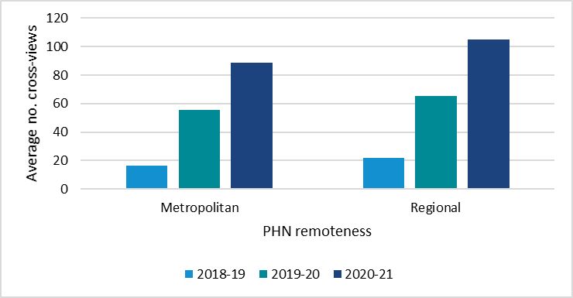

Source: ADHA

*Figure 14: Average count of MHR cross-views per pharmacy by remoteness*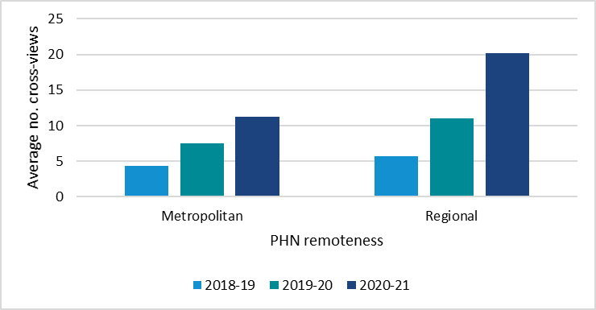

Source: ADHA

# First Nations Health

The PHNs are assessed for performance against seven indicators in the Aboriginal and Torres Strait Islander health priority area and the program performance is informed by a further one contextual indicator. In 2020-21, the proportion of PHNs delivering culturally appropriate Drug and Alcohol services improved to 100 per cent, and 100 per cent of PHNs continued to meet the indicators for delivering Integrated Team Care (ITC) services, culturally competent Mainstream Primary Health services, and supported access to coordinated care (Figure 15).

58 per cent of PHNs met the growth target for the proportion of PHN commissioned mental health services delivered to Aboriginal and Torres Strait Islander people that were culturally appropriate[2]. However, 74 per cent of PHNs improved on the proportion of services that were culturally appropriate compared to 2019-20. Of those PHNs who did not meet the growth target in 2020-21, 46 per cent had achieved over 90 per cent of their services for Aboriginal and Torres Strait Islander people being culturally appropriate.

Figure 15: Proportion of PHNs meeting First Nations indicator targets  
Bar chart comparing proportion of PHNs that met performance targets by First Nations health indicator over 2018-19, 2019-20, and 2020-21 reporting periods. The number of PHNs meeting targets for Culturally appropriate drug and alcohol services, Culturally competent mainstream primary health services, and Support for First Nations health workforce has increased over the reporting period. The number of PHNs meeting targets for Range of organisations delivering ITC services and Culturally appropriate mental health services decreased from 2019-20 to 2020-21.
  
Source: performance reporting data provided by PHNs  
*Only 2019-20 and 2020-21 data are displayed as this performance measure was taken as a baseline in 2018-19.  
†Some 2019-2020 data for Culturally appropriate mental health services has been revised.

There was an average 15 per cent increase in the number of First Nations health targets met in 2020-21 over the previous year. The greatest improvement was achieved in PHNs with higher levels of socio-economic disadvantage (Figure 16).

Figure 16: Average number of First Nations Health performance targets met by disadvantage

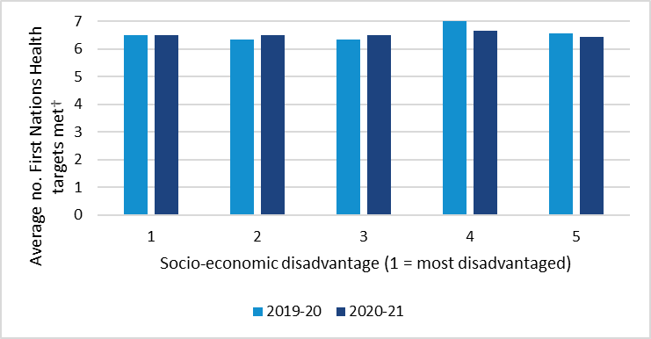  
Source: performance reporting data provided by PHNs  
†Some 2019-2020 data for Culturally appropriate mental health services has been revised.

PHNs in regional and remote areas reported an improvement in the number of First Nations Health targets being met, with the average number of First Nations targets increasing by four per cent year on year. There was a slight decrease in metropolitan areas (Figure 17).

Figure 17: Average number of First Nations Health performance targets met by remoteness

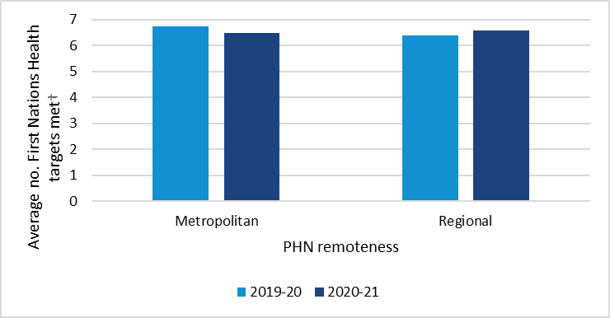

Source: performance reporting data provided by PHNs  
†Some 2019-2020 data for Culturally appropriate mental health services has been revised.

## First Nations Health Assessments

The number of First Nations people who had Health Assessments slightly decreased by one per cent in 2020-21 from 2019-20, and by one per cent in 2019-20 from 2018-19 (Figure 18).

Figure 18: Health Assessments for First Nations peoples

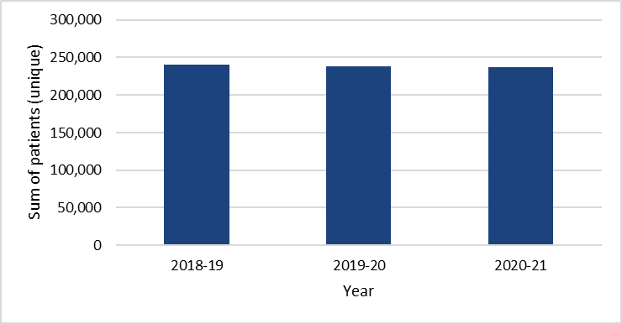

*Source: AIHW Indigenous health checks and follow-ups*

The number of Health Assessments provided to First Nations peoples in socio-economically disadvantaged areas has declined since 2018-19 (Figure 19).

*Figure 19: Health Assessments for First Nations peoples by disadvantage*

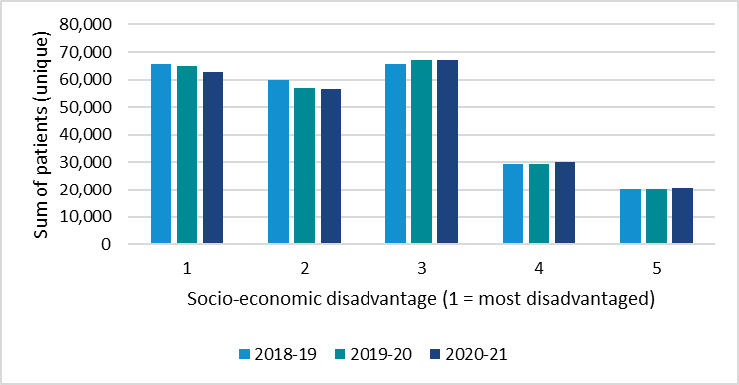

*Source: AIHW Indigenous health checks and follow-ups*

# Chronic Care

The number of Medicare Benefit Schedule (MBS) services provided for people with chronic health conditions has been increasing the past three reporting years. It increased five per cent in 2020-21 from 2019-20 (Figure 20).

Figure 20: Health Assessments, Chronic Disease Management Plans, and Multidisciplinary Case Conferences

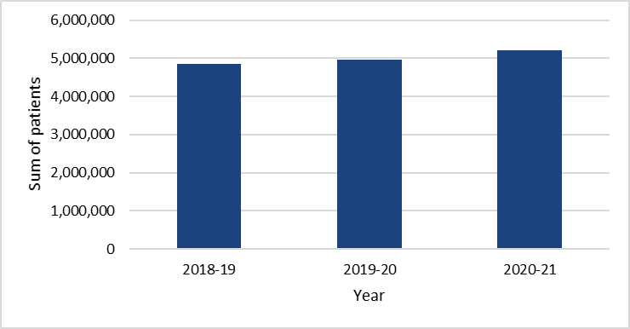  
Source: AIHW Medicare-subsidised general practices, allied health or specialist health care across local areas

The number of patients receiving health assessment and chronic condition management services from general practices increased across all levels of socio-economic disadvantage by four to six per cent since last year (Figure 21). The greatest increases in the number of patients receiving these services were in PHNs in metropolitan areas and areas of least socio-economic disadvantage (Figures 22 and 21 respectively).

Figure 21: Health Assessments, Chronic Disease Management Plans, and Multidisciplinary Case Conferences by socio-economic disadvantage

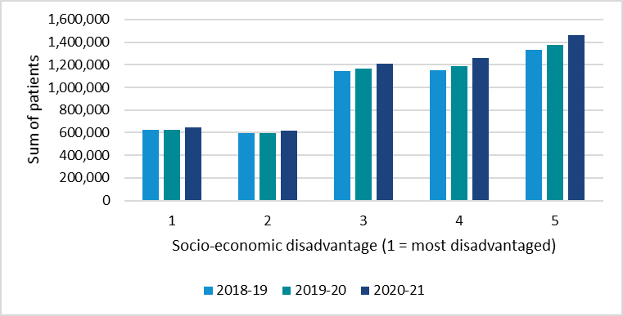

Source: AIHW Medicare-subsidised general practices, allied health or specialist health care across local areas

Figure 22: Health Assessments, Chronic Disease Management Plans, and Multidisciplinary Case Conferences by remoteness

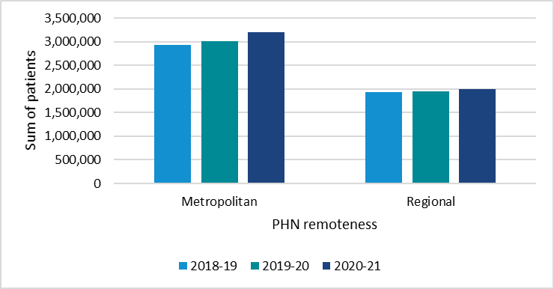

Source: AIHW Medicare-subsidised general practices, allied health or specialist health care across local area

# Aged Care

There are two broad indicators for aged care services and older Australians.

The first indicator is the average number of Medicare-subsidised general practice services provided per resident in residential aged care homes (RACHs). In 2020-21, this rate returned to the 2018-19 figure of 17.8 services per resident per year after reaching 18.3 in 2019-20 (Figure 23). This decline is not directly attributable to the impact of facility lockdowns and restrictions on visits during the COVID-19 pandemic because essential visits by medical staff continued during this period.

Figure 23: General Practice services provided per resident in Residential Ages Care Homes (RACHs)

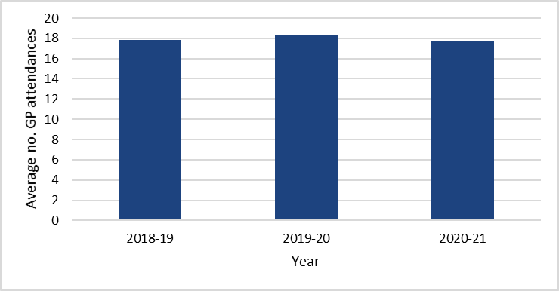

Source: AIHW Medicare-subsidised general practice, allied health or specialist health care across local areas

In 2020-21, Medicare-subsidised general practice RACH services were more utilised in facilities located in metropolitan areas (19.0 services per resident per year) than in regional areas (15.8 services per resident per year) (Figure 24).

Figure 24: General Practice services provided per resident in Residential Ages Care Homes (RACHs) by remoteness

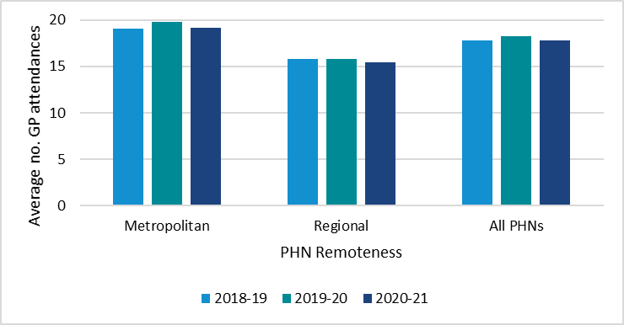

Source: AIHW Medicare-subsidised general practice, allied health or specialist health care across local areas

The second indicator is the proportion of the older population (people aged 65 years and over) who have a recorded Health Assessment from a Medicare-subsidised general practice, allied health or specialist health care service. This has slightly declined to 15.3 per cent in 2020-21 from 15.6 per cent in 2019-20 and 15.8 per cent in 2018-19. (Figure 25).

Figure 25: Proportion of people aged 65 years and over who have a recorded Health Assessment from a Medicare-subsidised general practice, allied health or specialist health care service

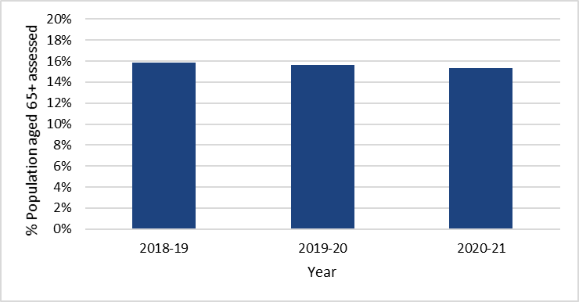

Source: AIHW Medicare-subsidised General Practice, allied health or specialist health care across local areas

Older populations in regional areas had proportionally more health assessments (16.8 per cent in 2020-21) than those in metropolitan areas (14.2 per cent in 2020-21) (Figure 26).

Figure 26: Proportion of people aged 65 years and over who have a recorded Health Assessment from a Medicare-subsidised general practice, allied health or specialist health care service by remoteness

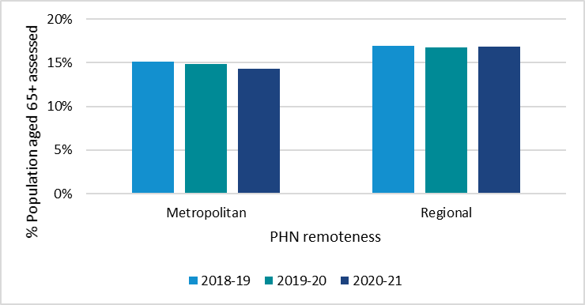

Source: AIHW Medicare-subsidised General Practice, allied health or specialist health care across local areas

# Mental Health

During 2020-21, PHNs were an essential component of the Australian Government’s emergency response capability, including being fast and adaptable in the delivery of services. PHNs were a valuable source of real-time, factual information about conditions on the ground during the COVID-19 pandemic, especially the impact on primary and mental health service delivery.

In 2020-21 no PHN met the criteria for all six mental health performance indicators in the Primary Health Network Performance and Quality Framework[3]. However, almost all PHNs had improved their performance in at least one indicator in comparison to last year (Figure 27). This average increase was reflected across metropolitan PHNs (Figure 28) and in all but the most socio-economically disadvantaged PHN regions.

* 55 per cent of PHNs met the growth target for an increase in the number of people accessing PHN-commissioned low intensity psychological interventions compared to 2019-20. Growth in this indicator may be affected by numerous factors not within the PHNs control, such as workforce and community demand.
* 55 per cent of PHNs met the growth target for an increase in the number of people accessing PHN-commissioned psychological therapies[4]. 65 per cent PHNs improved on rates of access to PHN-commissioned psychological therapies compared to 2019-20. Growth in this indicator may be affected by numerous factors not within the PHNs control, such as workforce and community demand.
* 48 per cent of PHNs met the growth target for an increase in the number of people accessing PHN commissioned clinical care coordination services for people with severe and complex mental illness compared to 2019-20. Growth in this indicator may be affected by numerous factors not within the PHNs control, such as workforce and community demand.
* 100 per cent of PHNs, in collaboration with their respective state and territory government-funded commissioning bodies, and other stakeholders delivered their joint foundational regional mental health and suicide prevention plans.
* No PHN met the target of 100 per cent follow up of clients at risk of suicide. However, 68 per cent improved on the number of clients followed up compared to 2019-20.
  + There are known methodological challenges with this indicator including clients with unique personal preferences, availability or complexities related to their presentation, workforce capacity challenges, inaccurate information at referral or data capture, and a challenging business context.
* 16 per cent of PHNs met the target rate of 70 per cent of complete episodes having a clinical outcome measure at the start and end of an episode of care. The national median proportion of episodes with outcomes collected was 42 per cent in 2020-21. Comparatively, during 2019–20, the National Outcome and Casemix Collection (NOCC) measures were collected for 43 per cent of people who received clinical care from public sector specialised mental health services.

The Department will continue to work with PHNs to refine the methodologies for the mental health performance indicators and improve the Primary Mental Health Care Minimum Data Set.

Figure 27: Proportion of PHNs meeting Mental Health indicator targets

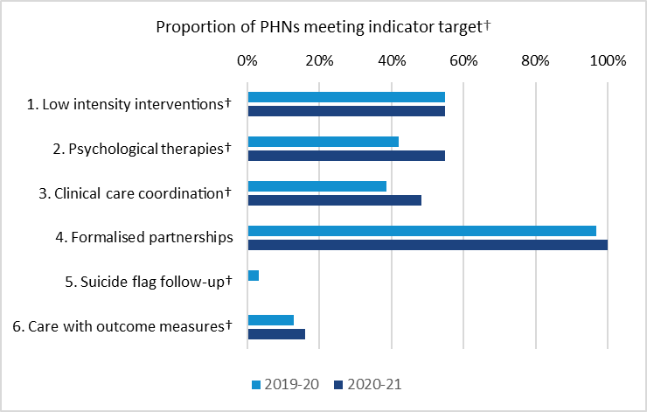

Source: performance reporting data provided by PHNs  
†Some 2019-2020 data for all indicators except Formalised partnerships has been revised.

Figure 28: Average number of Mental Health performance targets met by remoteness

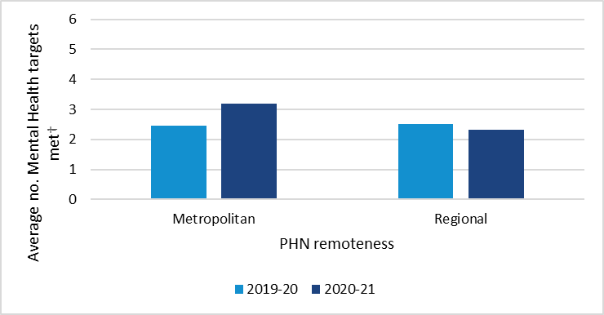

Source: performance reporting data provided by PHNs  
†Some 2019-2020 data for all indicators except Formalised partnerships has been revised.

The *Fifth National Mental Health and Suicide Prevention Plan 2017* directed PHNs and LHNs to develop joint regional mental health and suicide prevention plans, to help strengthen joint planning and commissioning across all regions. In 2020-21, all PHNs, in collaboration with their respective state and territory government-funded commissioning bodies and other stakeholders, finalised their foundational plans which documented how they will work together to achieve agreed priorities and support integrated mental health service delivery, while laying foundations for future action (Mental Health indicator four).

Several factors impacted performance including the impacts of the COVID-19 pandemic and/or natural disasters, as well as a combination of data quality and system issues, transition of commissioned service providers, and workforce availability and capability.

# Population Health

## Childhood Vaccination

Australia has generally high immunisation rates. In 2020-21, the average percentage of five-year-olds fully vaccinated increased to 95.28 per cent from 94.87 per cent in 2019-20 and 94.98 per cent in 2018-19 (Figure 29). All PHN areas achieved an immunisation rate of 90 per cent or more, ranging from a low of 91.5 per cent to a high of 97.5 per cent.

Figure 29: Average proportion across all PHNs of fully immunised five-year-olds

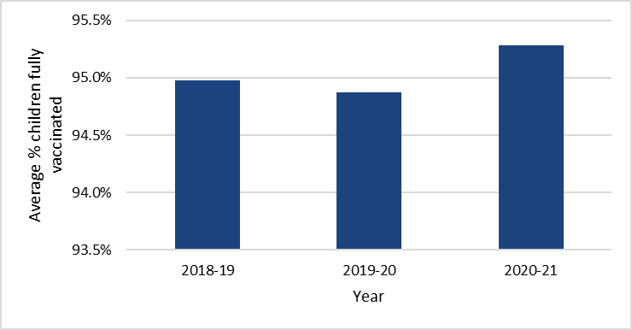

Source: Australian Immunisation Register, retrieved 08/11/2022 from <https://www.health.gov.au/resources/publications> for [2018](https://www.health.gov.au/resources/publications/2018-phn-childhood-immunisation-coverage-data?language=en), [2019](https://www.health.gov.au/resources/publications/2019-phn-childhood-immunisation-coverage-data), [2020](https://www.health.gov.au/resources/publications/2020-phn-childhood-immunisation-coverage-data?language=en), and [2021](https://www.health.gov.au/resources/publications/2021-phn-childhood-immunisation-coverage-data?language=en).

Notes and Caveats:

* All data is based on vaccinations reported to the Australian Immunisation Register (AIR) as at COB 08/11/2022
* In Australia, cohort immunisation status is assessed at 12 months of age (for vaccines due at six months), 24 months of age (for vaccines due at 12 and 18 months) and 60 months of age (for vaccines due at 48 months).
* The Coverage Assessment for 5-year-olds includes Dose 4 or 5 of DTP and Dose 4 of Polio.
* A minimum three-month lag period is allowed for late notification of vaccinations to the AIR, but only vaccines given on or before a child's first, second or fifth birthdays, respectively, are included in coverage calculations.

## Cancer Screening

Note on cancer data: the latest bowel and breast cancer screening data is from 2019-20 and is not yet available for the 2020-21 period.

### Bowel Cancer Screening

The number of patients receiving bowel cancer screening has been steadily increasing over the past five years (Figure 30). This increase has been consistent across all levels of socio-economic disadvantage and in both metropolitan and regional areas (Figure 31 and 32 respectively).

Figure 30: Average Bowel Cancer Screening rate (proportion of population invited to participate)

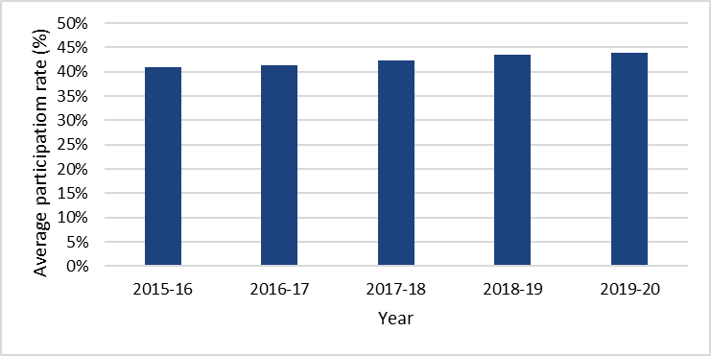

Source: AIHW Cancer screening programs: quarterly data

Figure 31: Average Bowel Cancer Screening rate by disadvantage (proportion of population invited to participate)

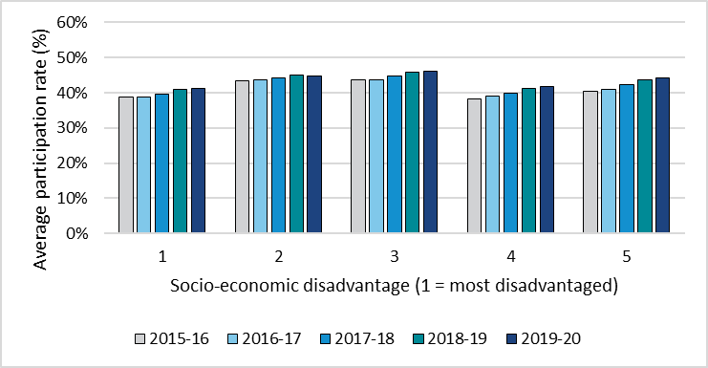

Source: AIHW Cancer screening programs: quarterly data

Figure 32: Average Bowel Cancer Screening rate by remoteness (proportion of population invited to participate)

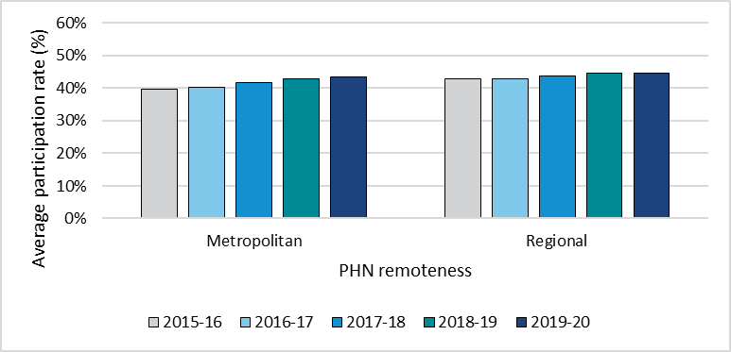

Source: AIHW Cancer screening programs: quarterly data

### Breast Cancer Screening

The number of patients receiving breast cancer screening decreased five per cent in 2019-20 (Figure 33). This decrease was reflected across all levels of socio-economic disadvantage and in both regional and metropolitan regions. (Figure 34 and 35 respectively).

Figure 33: Average Breast Cancer Screening rate (proportion of population eligible)

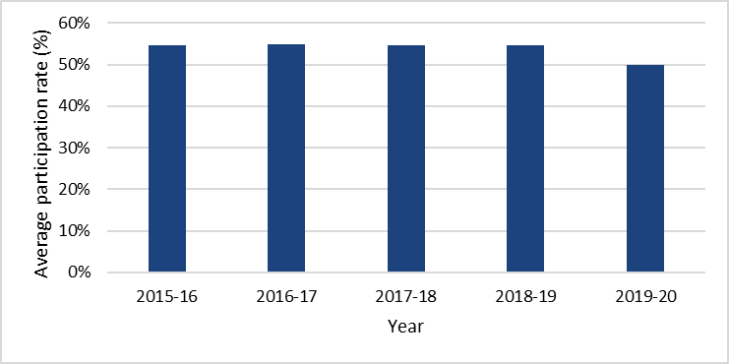

Source: AIHW Cancer screening programs: quarterly data; Note: population who was screened as a proportion of population eligible

Figure 34: Average Breast Cancer Screening rate by disadvantage (proportion of population eligible)

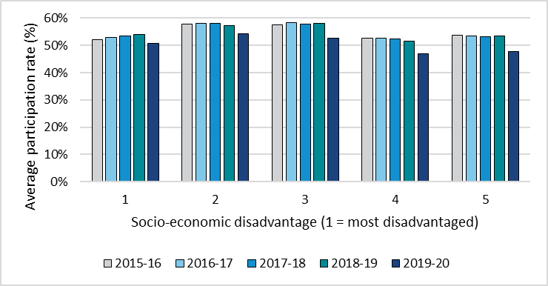

Source: AIHW Cancer screening programs: quarterly data; Note: population who was screened as a proportion of population eligible

Figure 35: Average Breast Cancer Screening rate by remoteness (proportion of population eligible)

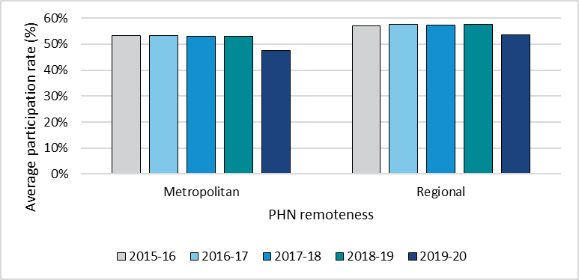

Source: AIHW Cancer screening programs: quarterly data; Note: population who was screened as a proportion of population eligible

### Cervical Cancer Screening

The latest cervical cancer screening data spanned two years, from 2018-20, and was not available for the two years prior (2016-18).

The number of patients receiving cervical cancer screenings in 2018-20 was the same as in 2015-16 (Figure 36). However, cervical cancer screenings decreased in the most socio-economically disadvantaged and regional areas and increased in the most socio-economically advantaged and metropolitan areas (Figure 37 and 38 respectively).

Figure 36: Average Cervical Cancer Screening rate (proportion of population eligible)

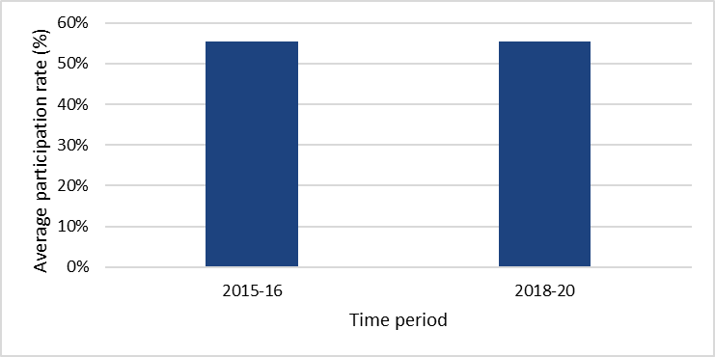

Source: AIHW Cancer screening programs: quarterly data; Note: population who was screened as a proportion of population eligible

Figure 37: Average Cervical Cancer Screening rate by disadvantage (proportion of population eligible)

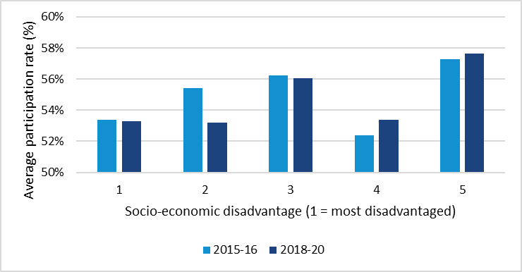

Source: AIHW Cancer screening programs: quarterly data; Note: population who was screened as a proportion of population eligible

Figure 38: Average Cervical Cancer Screening rate by remoteness proportion of population eligible)

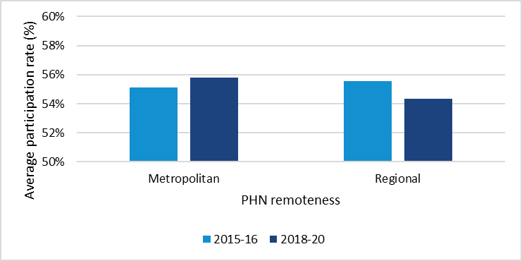

Source: AIHW Cancer screening programs: quarterly data; Note: population who was screened as a proportion of population eligible

# Organisational

Almost all PHNs met all 15 organisational indicators. Three PHNs are still to fully incorporate output and outcome performance indicators in their contracts for commissioned health services (Indicator 12). This is a significant improvement on 2019-20 when nine PHNs were yet to meet that standard.

In 2020-21, all PHNs completed variance report requirements (Indicator seven) which is an improvement on 2019-20 when two PHNs did not meet that standard.

# Reference List

AIHW [Indigenous health checks and follow-ups](https://www.aihw.gov.au/reports/indigenous-australians/indigenous-health-checks-follow-ups/data), published 19 August 2022

AIHW [Indigenous health checks and follow-ups](https://www.aihw.gov.au/reports/indigenous-australians/indigenous-health-checks-follow-ups/archived-content), published 2 July 2021

AIHW [Medicare-subsidised GP, allied health or specialist health care across local areas: 2019-20 to 2020-21](https://www.aihw.gov.au/reports/primary-health-care/medicare-subsidised-health-local-areas-2021-22/data), last updated 27 October 2021

AIHW [Medicare-subsidised GP, allied health or specialist health care across local areas: 2013-14 to 2018-19](https://www.aihw.gov.au/reports/primary-health-care/medicare-subsidised-health-local-areas-2019/data), last updated 01 Oct 2020

AIHW Potentially Preventable Hospitalisations data, received 3 May 2023

## Appendix 1

Assessment of each of the 42 Individual Performance Assessment performance indicators under the PHN Performance and Quality Framework for the 2020-21 reporting year.

Note: Data cleaning was undertaken on the 2019-20 data set and in some cases, indicators were recalculated for accuracy. The 2019-20 data presented below supersedes the corresponding data presented in the 2019-20 Annual Report.

*Addressing Needs*

**P1 (Program):** PHN activities address prioritised needs. 

1. All 31 PHNs have demonstrated that their activities address prioritised needs as set out in PHN Needs Assessment and/or national priorities. This is the same as the 2019-20 reporting period.

**P2 (Program):** Health system improvement and innovation.

1. All 31 PHNs have provided descriptions of a health system improvement, innovation, or commissioning best practice that has taken place in 2020-21. This is the same as the 2019-20 reporting period.

**IH1 (Indigenous Health):** Numbers of Integrated Team Care (ITC) services delivered by PHN.

1. All 31 PHNs have provided evidence of delivering services across the range allowed by Integrated Team Care guidelines, including care coordination, supplementary services, and clinical services. This is the same as the 2019-20 reporting period.

**IH2 (Indigenous Health):** Types of organisations delivering ITC services.

1. Thirty PHNs have shown engagement with an appropriate range of Integrated Team Care services including Aboriginal Medical Services, mainstream organisations, and services delivered by the PHN itself. This is one less than in the 2019-20 reporting period.

*Quality Care*

**P4 (Program):** Support provided to general practices and other health care providers.

1. All 31 PHNs have demonstrated they provide a range of support activities to general practices and other health care providers within their region. This is the same as the 2019-20 reporting period.

**MH6 (Mental Health):** Outcome readiness – completion rates for clinical outcome measures.

1. In 2020-21, five PHNs met the 70 per cent target rate of episodes of care that recorded outcome measures at episode start and episode completion. The national median proportion of episodes with outcomes collected was 42 per cent in 2020-21. Comparatively, during 2019–20, the National Outcome and Casemix Collection (NOCC) measures were collected for 43 per cent of people who received clinical care from public sector specialised mental health services.

**IH3 (Indigenous Health):** Evidence that all drug and alcohol commissioned services are culturally appropriate for Aboriginal and Torres Strait Islander people.

1. All 31 PHNs provided adequate evidence of the cultural appropriateness of these services, which is one more than in the 2019-20 reporting period. This is one more than in the 2019-20 reporting period.

**IH4 (Indigenous Health):** Proportion of PHN commissioned mental health services delivered to the regional Aboriginal and Torres Strait Islander population that were culturally appropriate.

1. Eighteen PHNs met the growth target (at least a 5 per cent increase) for the proportion of PHN commissioned mental health services delivered to Aboriginal and Torres Strait Islander people that were culturally appropriate in the 2020-21 reporting period. However, 23 PHNs improved on the proportion of services that were culturally appropriate compared to 2019-20.

**IH5 (Indigenous Health):** ITC improves the cultural competency of mainstream primary health care services.

1. All 31 PHNs have described sufficient activities undertaken to improve the cultural competency of mainstream primary health care services. This is the same as the 2019-20 reporting period.

**IH6 (Indigenous Health):** PHN provides support for Aboriginal and Torres Strait Islander identified health workforce.

1. 30 PHNs have supplied either or both descriptions of formal and informal support activities, and a workforce strategy addressing the capability, capacity, and proportion of the Aboriginal and Torres Strait Islander identified health workforce. This is the same as the 2019-20 reporting period.

**W1 (Workforce):** Rate of drug and alcohol treatment service providers with suitable accreditation.

1. Thirty PHNs report all specialist drug and alcohol treatment service providers have or are working toward accreditation. This is four more than in the 2019-20 reporting period.

**W2 (Workforce):** PHN support for drug and alcohol commissioned health professionals.

1. Twenty-eight PHNs supplied adequate evidence of support provided to drug and alcohol commissioned health professionals. This is two more than in the 2019-20 reporting period.

**W3 (Workforce):** PHN Commissioning Framework.

1. All 31 PHNs have Commissioning Frameworks including strategic planning, procuring services, and monitoring evaluation phases, with cultural appropriateness and stakeholder engagement considered throughout the process. This is the same as the 2019-20 reporting period.

**DH2 (Digital Health):** Rate of health care providers using specific digital health systems.

1. Thirty PHNs reported an increase in the rate of general practices, pharmacies, and allied health service practices using smart forms, e-referrals, and telehealth. This is three more than in the 2019-20 reporting period.

**DH3 (Digital Health):** Rate of accredited general practices sharing data with PHN.

1. Twenty-three PHNs reported at least a five per cent increase in the rate of accredited general practices sharing data with them (or where the baseline rate was over 60 per cent, maintenance of that rate). This is two less than in the 2019-20 reporting period.

*Improving Access*

**MH1 (Mental Health):** Rate of regional population receiving PHN commissioned low intensity psychological interventions.

1. Seventeen PHNs reported met the growth target (at least 5 per cent growth) for an increase in the number of people accessing PHN-commissioned low intensity psychological interventions in the 2020-21 reporting period compared to the 2019-20 reporting period.

**MH2 (Mental Health):** Rate of regional population receiving PHN commissioned psychological therapies delivered by mental health professionals.[5]

1. Seventeen PHNs met the growth target (at least 5 per cent growth) in the number of people accessing PHN-commissioned psychological therapies in the 2020-21 reporting period. 20 PHNs improved on rates of access to PHN-commissioned psychological therapies compared to 2019-20.

**AOD1 (Alcohol and Other Drugs):** Rate of drug and alcohol commissioned providers actively delivering services.

1. All 31 PHNs report that the rate of drug and alcohol commissioned providers actively delivering services has remained the same or increased in the 2020-21 reporting period. This is the same as the 2019-20 reporting period.

*Coordinated Care*

**MH3 (Mental Health):** Rate of regional population receiving PHN commissioned clinical care coordination services for people with severe and complex mental illness.

1. Fifteen PHNs met the growth target (at least five per cent growth) in the number of people accessing PHN-commissioned care coordination services in the 2020-21 reporting period compared to the 2019-20 reporting period.

**MH4 (Mental Health):** Formalised partnerships with other regional service providers to support integrated regional planning and service delivery.

1. All 31 PHNs, in collaboration with their respective state and territory government-funded commissioning bodies, and other stakeholders, delivered their joint foundational regional mental health and suicide prevention plans. This is one more than in the 2019-20 reporting period.

**MH5 (Mental Health):** Proportion of people referred to PHN commissioned services due to a recent suicide attempt or because they were at risk of suicide, followed up within seven days of referral.

1. No PHNs met the target indicator of 100 per cent follow up of clients at risk of suicide. However, 68 per cent improved on the number of clients followed up compared to 2019-20.
   1. There are known methodological challenges with this indicator including clients with unique personal preferences, availability or complexities related to their presentation, workforce capacity challenges, inaccurate information at referral or data capture, and a challenging business context.

**IH7 (Indigenous Health):** ITC processes support Aboriginal and Torres Strait Islander people enrolled in the program to access coordinated care.

1. All 31 PHNs provided satisfactory descriptions of the referral, intake, and discharge processes used in their ITC programs. This is the same as the 2019-20 reporting period.

**DH1 (Digital Health):** Rate of health care providers informed about My Health Record.

1. All 31 PHNs reported 100 per cent of general practices are aware of and provided access to My Health Record education. This is the same as the 2019-20 reporting period.

**AOD2 (Alcohol and Other Drugs):** Partnerships established with local key stakeholders for drug and alcohol treatment services.

1. All 31 PHNs have a satisfactory range of organisations involved in delivering drug and alcohol services. This is the same as the 2019-20 reporting period.

*Capable Organisations*

**P1 (Program):** PHN activities address prioritised needs.

1. All 31 PHNs have demonstrated their activities address prioritised needs as set out in PHN Needs Assessment and/or national priorities. This is the same as the 2019-20 reporting period.

**P4 (Program):** Support provided to general practices and other health care providers.

1. All 31 PHNs have demonstrated they provide a range of support activities to general practices and other health care providers within their region. This is the same as the 2019-20 reporting period.

**W3 (Workforce):** PHN Commissioning Framework.

1. All 31 PHNs have Commissioning Frameworks including strategic planning, procuring services, and monitoring evaluation phases, with cultural appropriateness and stakeholder engagement considered throughout the process. This is the same as the 2019-20 reporting period.

**O1 (Organisational):** PHN has an independent and diverse skills-based Board.

1. All 31 PHNs have appropriately independent and diverse skills-based Boards. This is the same as the 2019-20 reporting period.

**O2 (Organisational):** PHN Clinical Council and Community Advisory Committee Membership.

1. All 31 PHNs have at least one Clinical Council and Community Advisory Committee. This is the same as the 2019-20 reporting period.

**O3 (Organisational):** PHN Board considers input for committees.

1. All 31 PHNs provided satisfactory statements explaining how the Board considers input from committees. This is the same as the 2019-20 reporting period.

**O4 (Organisational):** Record of PHN Board member attendance at meetings.

1. All 31 PHNs’ Board members met or exceeded minimum attendance at meetings. This is the same as the 2019-20 reporting period.

**O5 (Organisational):** PHN Board has a regular review of its performance.

1. All 31 PHNs have Board performance reviews at least every 3 years. This is the same as the 2019-20 reporting period.

**O6 (Organisational):** PHN Board approves strategic plan.

1. All 31 PHNs’ Boards approved their PHN strategic plan. This is the same as the 2019-20 reporting period.

**O7 (Organisational):** Variance report of scheduled activities.

1. All 31 PHNs accounted for all variations. This is two more than in the 2019-20 reporting period.

**O8 (Organisational):** Quality management system.

1. All 31 PHNs have or are in the process of moving towards a fit for purpose quality management system. This is the same as the 2019-20 reporting period.

**O9 (Organisational):** Staff satisfaction.

1. All 31 PHNs have a fit for purpose process to measure staff satisfaction at least every two years. This is the same as the 2019-20 reporting period.

**O10 (Organisational):** Performance management process.

1. All 31 PHNs have a fit for purpose process to measure staff performance at least every two years. This is the same as the 2019-20 reporting period.

**O11 (Organisational):** Cultural awareness training.

1. All 31 PHNs conduct or offer cultural awareness training to staff at least every two years. This is the same as the 2019-20 reporting period.

**O12 (Organisational):** Rate of contracts for commissioned health services that include both output and outcome performance indicators.

1. Twenty-eight PHNs have increased the number of contracts containing both output and outcome measures or maintained a 100 per cent rate of contracts with such measures in the 2020-21 reporting period. This is four more than in the 2019-20 reporting period.

**O13 (Organisational):** Annual Report and audited financial statements.

1. All 31 PHNs’ annual reports meet requirements, and audited financial reports have unqualified auditor statements. This is the same as the 2019-20 reporting period.

**O14 (Organisational):** PHN stakeholder engagement.

1. All 31 PHNs have described satisfactory stakeholder engagement activities undertaken. This is the same as the 2019-20 reporting period.

**O15 (Organisational):** Engaging with complaints.

1. All 31 PHNs have attempted to address all complaints referred by the Department. This is the same as the 2019-20 reporting period.

## Appendix 2

Table 1: Breakdown of potentially preventable hospitalisation conditions

|  |
| --- |
| Acute PPH |
| Cellulitis |
| Convulsions and epilepsy |
| Dental conditions |
| Ear, nose and throat infections |
| Eclampsia |
| Gangrene |
| Pelvic inflammatory disease |
| Perforated/bleeding ulcer |
| Pneumonia (not vaccine-preventable) |
| Total acute |
| Urinary tract infections, including pyelonephritis |
| Chronic PPH |
| Angina |
| Asthma |
| Bronchiectasis |
| Congestive cardiac failure |
| COPD |
| Diabetes complications |
| Hypertension |
| Iron deficiency anaemia |
| Nutritional deficiencies |
| Rheumatic heart disease |
| Total chronic |
| Vaccine preventable PPH |
| Other vaccine-preventable conditions |
| Pneumonia and influenza (vaccine-preventable) |
| Total vaccine preventable |

# Acronyms and abbreviations

|  |  |
| --- | --- |
| AIHW | Australian Institute of Health and Welfare |
| COVID-19 | Coronavirus disease 2019 |
| GP | General Practice |
| GP | General Practice |
| IPA | Individual Performance Assessment |
| ITC | Integrated Team Care |
| KPI | Key Performance Indicator |
| LHNs | Local Health Networks |
| MBS | Medicare Benefit Schedule |
| MHR | My Health record |
| PHN | Primary Health Network |
| PIP | Practice Incentive Program |
| PPERS | PHN Program Electronic Reporting System |
| PPH | Potentially Preventable Hospitalisations |
| RACGP | Residential Aged Care General Practice |
| RACHs | Residential Aged Care Homes |
| SEIFA | Socio Economic Indexes for Areas |

1. Available at [www.racgp.org.au/running-a-practice/practice-standards/standards-5th-edition](http://www.racgp.org.au/running-a-practice/practice-standards/standards-5th-edition)
2. A culturally appropriate mental health service is defined as one that is delivered by a service provider who is: an Aboriginal and Torres Strait Islander person, or employed by an Aboriginal Community Controlled Health Service, or has indicated that they have completed a recognised training program in the delivery of culturally safe services to Aboriginal and Torres Strait Islander peoples.
3. MH1 Low intensity, MH2 Psychological Therapies, MH3 Clinical Care Coordination, MH4 Integrated Regional Planning, MH5 Suicide Risk, MH6 Outcome Readiness. The PHN Performance Quality framework can be found here: [Performance Quality Framework](https://www.health.gov.au/resources/publications/primary-health-networks-phn-performance-and-quality-framework).
4. In 2018-19, this indicator was measured as a baseline.
5. In 2018-19, this indicator was measured as a baseline.