National Mental Health Workforce Strategy 2022-2032 | Executive Summary
Mental ill-health is one of Australia’s most pressing issues. The challenge is complex and impacts all Australians—almost half of us will experience a mental health condition at some point in our lives. As the demand for mental health support and services increases, there is an urgent need to grow and create a well-rounded and responsive mental health system across Australia, that is supported by an appropriately skilled and contemporary workforce to meet the needs of all Australians.
The National Mental Health Workforce Strategy (Strategy) acknowledges the extraordinary efforts of the mental health workforce who work tirelessly to provide services and support to Australians.
The mental health workforce
This Strategy views mental health through a social and emotional wellbeing (SEWB) lens and conceptualises the mental health workforce accordingly, recognising the connection between people’s physical, psychological, social, emotional and cultural wellbeing.
The mental health workforce includes people who work exclusively in the mental health sector (for example, First Nations mental health workers, mental health nurses, psychologists and psychiatrists) and those that work in other health settings who frequently treat, interact with, care and support people experiencing suicidality, mental distress and/or ill-health (for example, allied health, general practitioners and nurses). In particular, general practice is central to the delivery of mental health care, especially for consumers living in regional, rural and remote areas, often acting as the first entry point to the mental health system.

The workforce also extends to people with lived or living experience of mental ill-health and/or suicide, and those working in other settings who are likely to have regular contact with people experiencing mental distress and/or ill-health and suicidality as part of their role (for example, aged care workers, educators, drug and alcohol workers, and housing and justice services workers). The Lived Experience (Peer) workforce is an integral part of the mental health workforce, with valuable skills and experiences that assist consumers of mental health services and their carers on their recovery journey.
There are several challenges associated with growing and sustaining the mental health workforce in Australia to meet the needs of all Australians. Key challenges include:
- Workforce shortages across occupations and disciplines
- Stigma and negative perceptions associated with working in mental health
- Unclear scopes of practice to establish who is able to perform what service and in which setting, particularly when working in multidisciplinary teams and in emerging workforces
- Limited connection and collaboration across mental health professions and disciplines
- Workforce maldistribution, particularly in regional, rural and remote areas
- Limited availability and use of high-quality data to inform workforce planning, and
- An overarching increasing demand for services.
Policy context and strategy development
The Strategy was developed at a time of considerable change in mental health policy in Australia with several critical reviews undertaken to guide reform, including the Productivity Commission Inquiry Report into Mental Health (2020) and the National Suicide Prevention Adviser’s Final Advice (2021). In response, governments are both individually and collectively embarking on activities to transform Australia’s mental health and suicide prevention system. The National Mental Health and Suicide Prevention Agreement, is a significant step towards system reform, committing governments to work in partnership to implement the Strategy, address critical workforce shortages and identify priority areas for action.
The Strategy acknowledges the broad scope of the mental health workforce and the potential to overlap with existing and planned national workforce strategies (for example, for the medical, alcohol and other drugs, suicide prevention and care workforces). To ensure efforts are complementary, implementation of the Strategy will be led by the Australian Government in close collaboration with state and territory governments and key stakeholders.
National Mental Health Workforce Strategy
The Strategy provides a high-level vision and roadmap to build a sustainable workforce that is skilled, well-distributed and supported to deliver mental health treatment, care and support that meets the current and future population needs.
This Strategy acknowledges that social and emotional wellbeing and mental health are closely related. The mental health workforce spans promotion, prevention, early intervention, treatment, and recovery across the life course to address the diverse needs of consumers and carers, and priority populations, including people with disability, First Nations peoples, people from culturally and linguistically diverse (CALD) communities, lesbian, gay, bisexual, trans and gender diverse, intersex, queer and questioning, Sistergirl and Brotherboy (LGBTIQA+SB) communities and people experiencing specific life circumstances. The mental health workforce is spread across health and social service domains in a range of roles, in paid and unpaid capacities, and is complemented by alternative therapies, friends, family and others.
Figure ES-1 presents the framework for the Strategy and outlines the key principles of mental health practice, five goals and four strategic pillars to achieve the Strategy’s overarching vision. The framework responds to the key themes emerging from public consultation, broader mental health and suicide prevention reform under way and the direction of other relevant workforce strategies.
The goals of the Strategy are to attract, train, maximise, support and retain an appropriately skilled, motivated and coordinated mental health workforce to meet the evolving needs of the mental health system into the future. These goals are designed to build on the strengths of the existing mental health workforce, integrating core principles of practice, while growing in size and capability over time.
The principles of practice describe a workforce that can meet the needs of people with a lived or living experience of mental ill-health and/or suicide, including families, carers and kin. While the Strategy focuses on actions to build and deliver the required workforce, it acknowledges the ultimate outcome is a workforce that benefits all Australians.
Four strategic pillars provide targeted objectives and prioritise key action areas to achieve the vision of the Strategy. The Strategy recognises that there are linkages between the actions across the strategic pillars, described further below.

Figure ES-1: The National Mental Health Workforce Strategy Framework
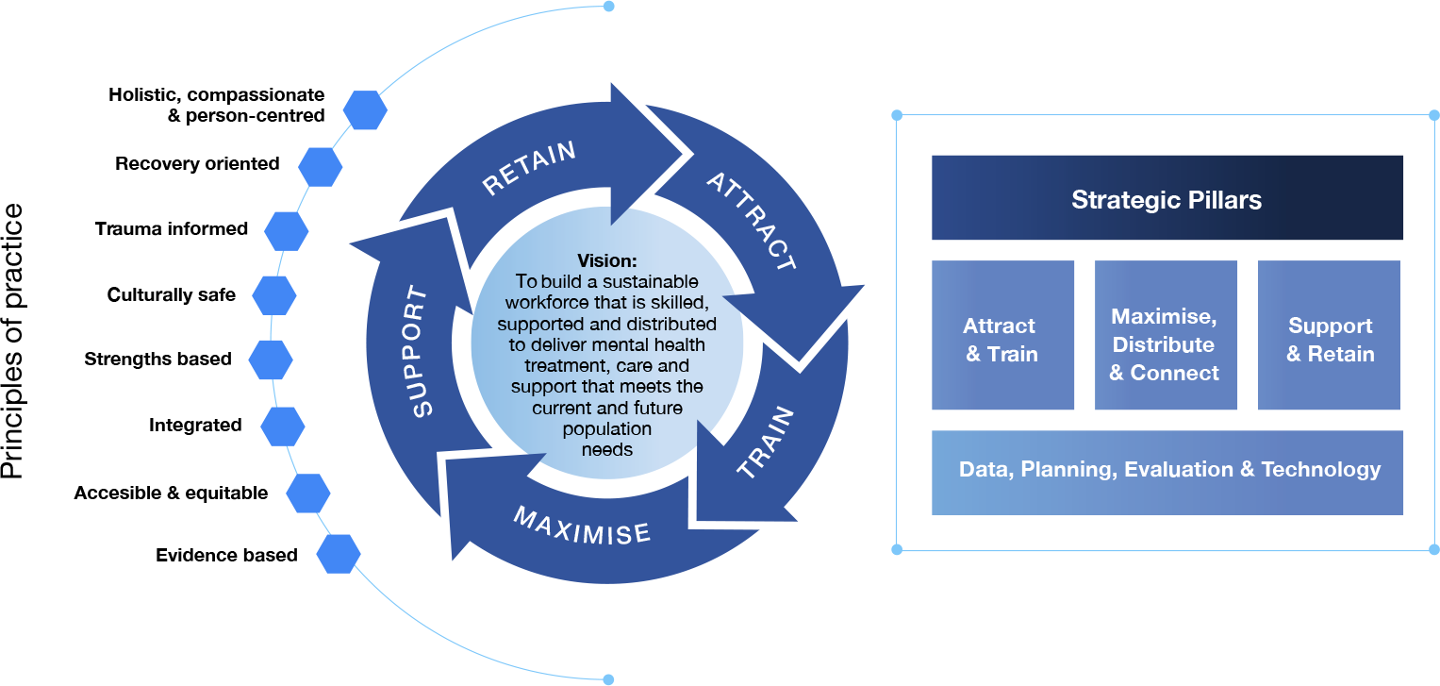
Strategic Pillar 1: Attract and Train
The mental health workforce will require growth in capability and capacity to meet future demand. Key considerations relate to the supply of a diverse and appropriately skilled contemporary workforce. Priority areas are to:
- Address critical shortages in the mental health workforce
- Mobilise the broader social and emotional wellbeing and health workforce
- Promote mental health careers as an attractive career choice
- Develop and deliver recruitment and career pathways to attract a suitably skilled and diverse workforce
- Enhance training pathways, access to supervision, and support skills transfer, and
- Strengthen the capability and core competencies of the workforce to recognise and respond to community need.
Strategic Pillar 2: Maximise, Distribute and Connect
The mental health workforce will require coordination to meet the needs of Australians at different stages across the life course and in a range of settings. Key considerations relate to the scope of practice, coordination of care, and distribution of the workforce, and opportunities to build a workforce that recognises and best utilises the skills and strengths of all workers. Priority areas are to:
- Enable the workforce to expand and work to the top of their scope and enhance regulatory arrangements to strengthen the safety and quality of care
- Strengthen coordinated care, collaboration and multidisciplinary ways of working within and between the mental health, wider health and social service workforces
- Provide evidence-based guidance to underpin workforce planning and the management of demand and surge capacity
- Address workforce supply in rural and remote areas, and
- Address workforce distribution across settings and between public, private and not-for-profit sectors.
Strategic Pillar 3: Support and Retain
There is a need to support the mental health workforce and systematically address key issues that impact workforce retention. The provision of supportive, safe and rewarding experiences responds to attraction and retention challenges. Priority areas are to:
- Support workplaces to create mentally healthy workplaces and adopt positive workplace cultures
- Implement evidence driven strategies to prevent and address worker stress and burnout
- Increase access to, and use of, continuing professional development across all career stages
- Increase supervision and mentoring across all career stages, including current and emerging leaders, and
- Adopt funding models and arrangements that drive quality of care and promote retention.
Strategic Pillar 4: Data, Planning, Evaluation and Technology
The mental health workforce will require a range of supporting structures to deliver services that meet the needs of the population across service settings. These include access to and use of high-quality data, workforce planning, monitoring and evaluation, and digital technology. Priority areas are to:
- Collaborate with consumers, carers and service providers in planning, monitoring and evaluation processes
- Use data to support workforce and service planning, including demand and surge management
- Improve data governance, quality, collection and utilisation, including addressing data gaps
- Evaluate workforce initiatives and monitor outcomes to drive continuous improvement, and
- Improve access to digital technology and support greater digital inclusion.
Implementation
Implementation of the Strategy will be shared. The Australian Government has established a national governance mechanism to oversee implementation of the Strategy and support collaboration between governments, regulators, peak bodies, professional colleges, training and education providers, and consumers and carers: the Mental Health Workforce Working Group (Working Group).
The Implementation Roadmap identifies short, medium and long-term priorities and actions to guide implementation activities. This will be supported by a series of Implementation Plans that outline targeted activities for priority professions, occupational groups and cross cutting issues facing the mental health workforce. These Implementation Plans will be progressively developed under the oversight of the national Working Group.

