

National Mental Health Workforce Strategy

The ten-year National Mental Health Workforce Strategy provides a high-level vision and roadmap to **build a sustainable workforce that is skilled, well-distributed and supported to deliver mental health treatment, care and support that meets the current and future population needs**.

This Strategy acknowledges that social and emotional wellbeing and mental health are closely related. The mental health workforce spans promotion, prevention, early intervention, treatment, and recovery across the life course to address the diverse needs of consumers and carers, and priority populations, including people with disability, First Nations peoples, people from culturally and linguistically diverse (CALD) communities, lesbian, gay, bisexual, trans and gender diverse, intersex, queer and questioning, Sistergirl and Brotherboy (LGBTIQA+SB) communities and people experiencing specific life circumstances. The mental health workforce is spread across health and social service domains in a range of roles, in paid and unpaid capacities, and is complemented by alternative therapies, friends, family and others.

Implementation will be shared by governments, regulators, professional colleges, education providers and peak bodies noting the shared responsibility in this space and will complement other workforce strategies.

# Intended goals of the Strategy

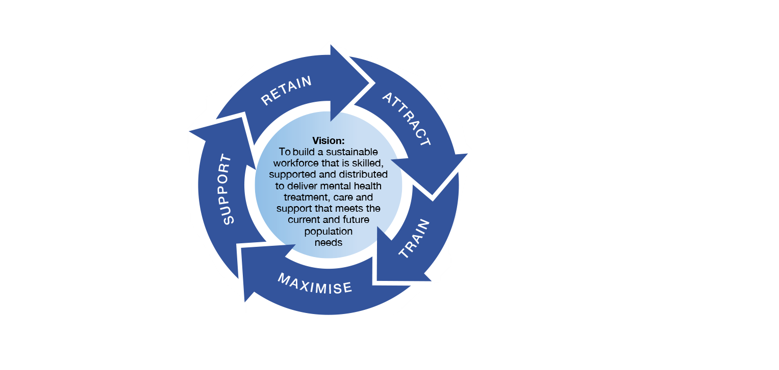

# Principles of practice

To meet current and future population needs, the Strategy supports the workforce (regardless of discipline, setting or role) to deliver mental health treatment, care and support in accordance with the following principles of practice:

**Holistic, compassionate & person-centred** – The needs and goals of consumers and carers are placed at the centre

**Recovery oriented** – Consumers and their carers and families are supported to actively lead their recovery journey

**Trauma informed** – Services are delivered in a way that is informed by the impact of trauma on the people seeking mental health care

**Culturally Safe** – Care is safe for all cultural, sexual and gender identities

**Strengths based** – People are supported to use and build on their unique strengths and resources

**Integrated** – Mental health services are connected across the wider health and social services sectors

**Accessible & equitable** – Services respond to the diversity of needs at different stages in the life course, minimising barriers for vulnerable communities

**Evidence based** – Data and evidence underpin service and workforce design, delivery and evaluation

# Strategic Pillars

The four strategic pillars provide targeted objectives and prioritise key action areas to achieve the vision of the Strategy. The Strategy recognises that there are linkages between the actions across the strategic pillars.

| Attract & Train | Maximise, Distribute & Connect | Support & Retain |
| --- | --- | --- |
| Address critical shortages in the mental health workforce | Enable the workforce to expand and work to the top of their scope and enhance regulatory arrangements to strengthen the safety and quality of care | Support workplaces to create mentally healthy workplaces and adopt positive workplace cultures |
| Mobilise the broader social and emotional wellbeing and health workforce | Strengthen coordinated care, collaboration and multidisciplinary ways of working within and between the mental health, wider health and social service workforces | Implement evidence driven strategies to prevent and address worker stress and burnout |
| Promote mental health careers as an attractive career choice | Provide evidence-based guidance to underpin workforce planning and the management of demand and surge capacity | Increase access to, and use of, continuing professional development across all career stages |
| Develop and deliver recruitment and career pathways to attract a suitably skilled and diverse workforce | Address workforce supply in rural and remote areas | Increase supervision and mentoring across all career stages, including current and emerging leaders |
| Enhance training pathways, access to supervision, and support skills transfer | Address workforce distribution across settings and between public, private and not-for-profit sectors | Adopt funding models and arrangements that drive quality of care and promote retention |
| Strengthen the capability and core competencies of the workforce to recognise and respond to community need |  |  |

|  |
| --- |
| Data, Planning, Evaluation & Technology |
| ­Collaborate with consumers, carers and service providers in planning, monitoring and evaluation processes |
| Use data to support workforce and service planning, including demand and surge management |
| Improve data governance, quality, collection and utilisation, including addressing data gaps |
| Evaluate workforce initiatives and monitor outcomes to drive continuous improvement |
| Improve access to digital technology and support greater digital inclusion |