**Australian Centre for Health Services Innovation**



Evaluation of the Program of Assistance for Survivors of Torture and Trauma

**Prepared for the**

**Department of Health and Aged Care**

Final Report June 2022

# Contents

**Glossary of terms 8**

**Executive summary 10**

Background 10

**Report structure 14**

**Chapter 1. Introduction 16**

* 1. The impact of torture and trauma on refugees 16
     1. Defining torture 16
  2. Programs for survivors of torture and trauma 17
     1. International snapshot of programs for survivors of torture and trauma 17
  3. Australian Commonwealth Government’s Humanitarian Support Program 19
  4. The Commonwealth Program of Assistance for Survivors of Torture and Trauma 19
     1. Aims and objectives of PASTT 19
     2. Activities and scope of PASTT 20
     3. PASTT delivery and governance 20
     4. PASTT logic model 22

**Chapter 2. Methodology** **24**

* 1. Aim of the evaluation 24
  2. Evaluation questions 24
     1. Key question 1: How appropriate is the PASTT model? 24
     2. Key question 2: How efficient has PASTT been? 25
     3. Key question 3: How effective has PASTT been? 25
     4. Key question 4: How can the program be developed or refined to best deliver on outcomes? 25
  3. Evaluation methods 26
  4. Ethics 27
  5. Data collection 27
     1. PASTT stakeholder consultation and interviews 29
     2. PASTT client interviews 31
     3. Engagement survey 31
     4. Review of literature 31
  6. Data analysis 32
  7. Data limitations 32

**Chapter 3. Appropriateness and Acceptability of PASTT** **34**

* 1. Appropriateness of PASTT service model 34
     1. A specialised refugee trauma informed service approach 36
     2. Connection to community 38
     3. Flexibility of approach 39
  2. Appropriateness of PASTT governance 42
     1. The Forum of Australian Services for Survivors of Torture and Trauma 42
  3. Challenges to appropriateness and sustainability 43
     1. Reporting requirements and outcome measures 43
     2. Balancing client-centred care philosophy with organisational constraints 44
     3. FASSTT collective decision making and sustainability 44
  4. Acceptability and client-centredness of PASTT 45
     1. STARTTS client satisfaction outcomes 45
     2. STTARS client satisfaction outcomes 46
     3. Satisfaction of interviewed clients 48
  5. Appropriateness and acceptability findings 49

**Chapter 4. Regional and rural implementation of PASTT 50**

* 1. Classification of regional and rural areas 50
  2. Implications of settlement in regional and rural areas 51
  3. Balancing service demand and capacity 53
     1. Capacity: staffing and staff management 54
     2. Capacity: local community characteristics 55
     3. Capacity: inadequate funding 57
  4. Metropolitan versus rural and regional: a false dichotomy 58
  5. Need for locally relevant models of service delivery 59
     1. Regional reach of FASSTT agencies 59
     2. Regional models of service delivery employed by FASSTT agencies 61
  6. Findings 63

**Chapter 5. Outcomes achieved 64**

* 1. Considerations and limitations in measuring outcomes 64
     1. Multilevel impact of PASTT 64
     2. Challenges evaluating social service programs 65
     3. Limitations of available program data 66
  2. Client outcomes 66
     1. Counselling, groupwork and complementary therapies 67
     2. Improvements in mental health and wellbeing 71
     3. Engaging in Australian society 80
  3. Health provider and service-level outcomes 84
     1. PASTT referral considerations 84
     2. Referrals into PASTT 85
     3. Referrals out of PASTT 87
     4. Capacity building of third-party providers and mainstream services 89
     5. Engagement and collaboration with third-party providers 92
  4. Community-level outcomes 97
     1. Essential role of community engagement 97
     2. Community programs, activities, and participants 98
     3. Advocacy and education activities 99
     4. Benefits and outcomes of community-level work 99
     5. Case studies of community-level activities and program impacts 100
  5. Findings 102

**Chapter 6. Economic analysis of PASTT 104**

* 1. Program funding 104
  2. Costs of service delivery 108
     1. Cost profiles 109
     2. Cost per client 112
  3. Key cost pressures 115
     1. Policy context and implications 117
     2. Humanitarian intake levels and rates of engagement with PASTT 117
     3. Settlement patterns 119
     4. Timing of engagement 120
     5. The impact of world events on diaspora communities 122
     6. Increasing cost of service delivery 122
  4. Evidence of unmet need 124
  5. Opportunity to improve funding model allocations 126

* 1. Findings 127

**Chapter 7. Alignment of PASTT with best international practice 128**

* 1. Global Standards on Rehabilitation of Torture Victims 128
     1. FASSTT agencies’ involvement with the IRCT and development and promotion of the standards 129
  2. PASTT alignment with global evidence-based standards 129
  3. Findings 137

**Chapter 8. Findings and conclusion 138**

* 1. Findings of the evaluation 138
     1. Implementation, appropriateness, and acceptability of the PASTT model 138
     2. Regional and rural delivery of PASTT 139
     3. Outcomes achieved by PASTT 139
     4. Economic analysis of PASTT 140
     5. Alignment of PASTT with international best practice 140
  2. Barriers and enablers to PASTT 141

**References 144**

**Appendix 1. Interview guide for PASTT stakeholder consultations 148**

**Appendix 2. Interview guide for PASTT client interviews 152**

**Appendix 3. PASTT client interviews: case studies 154**

Client Case Study: C2 154

Client Case Study: C3 155

Client Case Study: C4 156

Client Case Study: C5 156

Client Case Study: C6 156

Client Case Study: C7 157

**Appendix 4. FASSTT agency case studies 158**

Case study of “P” 158

Case study of “F” 159

Case study of “B” 160

Case study of collaborating with community leaders during the COVID-19 pandemic

(prepared by QPASTT) 161

**Appendix 5. Report on costs of rural and regional service provision 162**

**Appendix 6. Referrals into FASSTT agencies by sector 163**

**Appendix 7. Online engagement questionnaire 164**

Appendix 7.1 Content 164

Appendix 7.2 Supplementary data 166

Appendix 8. The Global Standards on Rehabilitation of Trauma Victims 168

Appendix 8.1 Alignment between the IRCT Standards and the NSMHS 172

Appendix 8.1.1 Accreditation feedback to support alignment with the IRCT Standards 172

**Appendix 9. Selected stakeholder quotes 174**

**Contact us 184**

# List of Figures

*Figure 1.* FASSTT member agencies in Australia 21

*Figure 2.*PASTT Logic Model 22

*Figure 3.* Overview of evaluation methods and data sources, aligned to evaluation questions 26

*Figure 4.* Visual representation of key features contributing to the appropriateness of PASTT for survivors of

torture and trauma 35

*Figure 5*. STARTTS client satisfaction questionnaire responses received between 2016-2021 (N=574) 46

*Figure 6*. STTARS client satisfaction interview responses received March 2022 (N=32) 47

*Figure 7*. The key balance of demand and capacity for regional and rural PASTT delivery 53

*Figure 8.* Key themes supporting locally relevant models of service delivery for regional PASTT implementation 59

*Figure 9*. Map of settlement locations supported by the Humanitarian Settlement Program (HSP). 60

*Figure 10*. Multi-level impact of PASTT activities 65

*Figure 11*. Trend in individual counselling clients (Australia wide) 2016-17 to 2020-21 67

*Figure 12.* Total individual counselling clients per year by FASSTT agency 68

*Figure 13*. Total number of PASTT groups (Australia-wide) per year 2016-17 to 2020-21 69

*Figure 14*. Total number of counselling groups per year for selected FASSTT agencies, 2016-17 to 2020-21 69

*Figure 15*. WHO-5 score improvements over time, stratified by number of surveys completed 77

*Figure 16.* WHO-5 scores assessed at baseline and closure timepoints 77

*Figure 17*. Goal achievement outcomes for STARTTS and QPASTT: 2016-17 to 2020-21 78

*Figure 18*. Goal achievement outcomes for VFST: 2017 to 2021 79

*Figure 19*. Referrals into PASTT (per FASSTT agency) per year, 2016-17 to 2020-21 85

*Figure 20.* Overall number of referrals into PASTT by sector from 2016-17 to 2020-21 86

*Figure 21*. Referrals out for selected agencies, 2016-17 to 2020-21 87

*Figure 22.* Statistics of FASSTT agency sector training (2016-2021) 90

*Figure 23.* Sectors provided with education and training (Australia-wide) 2016-17 to 2020-21 91

*Figure 24*. Roles of stakeholders completing partnership engagement questionnaire (n=85) 94

*Figure 25*. Satisfaction of third-party providers with FASSTT agency engagement and collaboration 94

*Figure 26*. Visual representation of stakeholder’s perceptions of PASTT’s impact on helping them to deliver

against the six objectives 96

*Figure 27*. Statistics of FASSTT agency community engagement (2016-2021) 98

*Figure 28*. Thematic findings from the Families in Cultural Transition and Older People in Cultural Transition (n=270) and Older People in Cultural Transition (OPICT) (n=96) Programs for financial year 2019-2020 101

*Figure 29.* FASSTT agency income ($ millions) allocated to PASTT service delivery by source: 2017-18 to 2020-21 106

*Figure 30.* Indirect costs as a proportion of total costs by agency: 2017-18 to 2021-22 111

*Figure 31*. Average cost per client by FASSTT agencies: 2017-18 to 2020-21 112

*Figure 32*. Proportion of total humanitarian entrants settling in rural and regional locations: 2016-17 to 2019-20 119

*Figure 33*. Client length of residence in Australia when engaging PASTT services: 2016-17 to 2020-21 120

*Figure 34*. Total number of hours of counselling support per client: 2016-17 to 2020-21 121

*Figure 35*. Length of time that clients remain active: 2016-17 to 2020-21 122

*Figure 36.* Whole of PASTT waiting list outcomes 2014-15 to 2020-21 124

*Figure 37*. Total number of clients on waiting list for counselling services, by FASSTT agency: 2017 to 2021 125

*Figure 38*. Number of clients waiting longer than 3 months for counselling services, by FASSTT agency:

2017 to 2021 125

*Figure A1*. Duration of respondent/external agency engagement with FASSTT agency (n=69) 166

*Figure A2*. Frequency of respondent/external agency contact with FASSTT agency (n=69) 166

# List of Tables

*Table 1.* Summary of programs for survivors of torture and trauma who resettle in Canada, the US and UK 18

*Table 2*. Alignment of key evaluation questions and report chapters 25

*Table 3*. Evaluation data sources and alignment with report chapters 28

*Table 4*. Characteristics of interviews and participants 30

*Table 5*. Growth in proportion of humanitarian entrants to Australia settling in regional and rural locations from

2016 to 2020 51

*Table 6*. Proportion of PASTT clients residing in regional and rural areas: 2017/18 to 2020/21* 52

Table 7. Advantages and limitations of models for regional and rural delivery of PASTT services 62

*Table 8*. Australia-wide individual counselling activities compared to target 68

*Table 9.* Australia-wide group counselling activities compared to target 70

*Table 10.* Referrals out to other providers by FASSTT agencies (%) and nationwide (number), 2016-17 to 2020-21 88

*Table 11*. PASTT base and supplementary funding: 2018-2023 105

*Table 12*.Total costs of service delivery (Actual) by agency: 2017-18 to 2021-22 108

*Table 13*. Salary expenses as a proportion of total agency expenses: 2017-18 to 2021-22 108

*Table 14*. Breakdown of agency costs per category for the 2020-21 financial year 109

*Table 15*. Average costs per client in 2018-19: non-capital city sites as compared with Sydney, NSW 113

*Table 16*. Derivation of 2020-21 average cost per client differentials across capital city sites versus

non-capital city sites 114

*Table 17*. Redundancies across FASSTT agencies occurring between 2017-18 and 2021-22 116

*Table 18*. Total humanitarian entrants to Australia since 2001-02 compared with number of unique individual counselling clients enrolled in PASTT over this period. 118

*Table 19*. Proportion of PASTT clients residing in regional and rural areas: 2017-18 to 2020-21* 120

*Table 20*. Wage related increases for selected agencies: 2017-18 to 2021-22 124

*Table 21. Cont.* Evidence to support alignment of PASTT and FASSTT with each IRCT standard 131

*Table 22*. Summary of enablers and challenges to PASTT 141

*Table A1.* Referrals from other providers into FASSTT agencies (%) and nationwide 163

*Table A2*. Alignment of the IRCT Standards and the NSMHS 172

*Table A3.* Selected stakeholder quotes to support findings 175

# List of Boxes

*Box 1*. Client case studies: Client 1 37

*Box 2*. Client case studies: Client 2 40

*Box 3*. Strategies used by QPASTT to increase regional and rural staff recruitment 54

*Box 4*. Client case studies: Client 3 72

*Box 5.* Client case studies: Client 4 74

*Box 6*. Client case studies: Client 5 75

*Box 7*. Client case studies: Client 6 81

*Box 8*. Client case studies: Client 7 81

*Box 9*. Client case studies: Client 8 83

*Box 10.* Client case studies: Client 9 93

*Box 11*. Client case studies: Client 10 93

**Glossary of terms**

|  |  |
| --- | --- |
| **Acronym or abbreviation** | **Full name** |
| ACT | Australian Capital Territory |
| ASeTTS | Association for Services to Torture and Trauma Survivors |
| AusHSI | Australian Centre for Health Services Innovation |
| CEO | Chief Executive Officer |
| EAP | Employee Assistance Program |
| FASSTT | Forum of Australian Services for Survivors of Torture and Trauma |
| FICT | Families In Cultural Transition program |
| HSP/HP | Humanitarian Support Program |
| IRCT | International Rehabilitation Council for Torture Victims |
| KPI | Key Performance Indicator |
| Melaleuca | Melaleuca Australia |
| MRC | Migrant Resource Centre |
| NSMHS | National Standards for Mental Health Services |
| NSW | New South Wales |
| NT | Northern Territory |
| OPICT | Older People In Cultural Transition program |
| PASTT | Program of Assistance for Survivors of Torture and Trauma |
| Phoenix | Phoenix Centre |
| PPE | Personal Protective Equipment |
| QIP | Quality Improvement Plan |
| QLD | Queensland |
| QPASTT | Queensland Program of Assistance to Survivors of Torture and Trauma |
| QUT | Queensland University of Technology |
| SA | South Australia |
| SCHADS | Social, Community, Home Care and Disability Services Industry Award |

|  |  |
| --- | --- |
| **Acronym or abbreviation** | **Full name** |
| SGA | Commonwealth Standard Grant Agreement |
| SHEV | Safe Haven Enterprise Visa |
| SIS | Specialised and Intensive Support Services |
| STARTTS | Service for the Treatment and Rehabilitation of Torture and Trauma Survivors |
| STTARS | Survivors of Torture and Trauma Assistance and Rehabilitation Service |
| TAS | Tasmania |
| TSV | Temporary Substantive Visa |
| UN | United Nations |
| US | United States |
| VFST | Victorian Foundation for Survivors of Torture (Foundation House) |
| VIC | Victoria |
| WA | Western Australia |
| WHO-5 | World Health Organisation-Five Well-being Index |

**Executive summary**

## Background

The Program of Assistance for Survivors of Torture and Trauma (PASTT) is a specialist service available to refugees who settle in Australia and are survivors of

pre-migration conflict and human rights abuses including physical and psychological harm. PASTT is funded by the Department of Health and Aged Care and has operated for over 27 years. It is currently administered by eight

not-for-profit state and territory-based agencies forming

the Forum of Australian Services for Survivors of Torture and Trauma (FASSTT). PASTT is provided Australia-wide including in many regional and rural areas.

The flexible nature of PASTT allows for services to be tailored to clients’ needs for short, medium, or long-term support. Services are offered at the individual, family, and community level and include counselling, community capacity development work, and advocacy. FASSTT agencies also engage in research activities and partner with mainstream services to provide care to clients. A key aim of PASTT-funded work is to improve the effectiveness of mainstream health and community organisations to support successful resettlement of refugees by delivering professional development and training activities to mainstream providers.

The Australian Centre for Health Services Innovation (AusHSI) was engaged by the Department of Health and Aged Care to independently evaluate the Program of Assistance for Survivors or Torture and Trauma (PASTT).

This evaluation examines the implementation (appropriateness, acceptability, challenges), outcomes (client, third-party provider, and community), and economic considerations related to PASTT service provision, including in regional and rural areas. The alignment of PASTT (and FASSTT activities) with international standards of evidence, is also considered.

The evaluation employed a mixed-methods approach. Data sources included:

− Quantitative activity data and other program data routinely collected by FASSTT agencies including service delivery activities (e.g., counselling sessions), program referrals, client outcomes and qualitative client feedback

− Quantitative financial data prepared by FASSTT agency staff for the purpose of this evaluation

− Individual and group qualitative interviews with FASSTT agency staff including upper management, clinical/counselling, community capacity building, and administration and corporate services

− Individual qualitative interviews with previous clients of PASTT

− Qualitative interviews with, and survey responses (quantitative and qualitative) from, external stakeholders who work with FASSTT agencies

It is noted that much of the data provided for this evaluation was self-reported by agencies or qualitative in nature, and so may be subject to recall bias, selection bias, or other limitations. To address this, data from multiple sources have been analysed and compared

(where appropriate) to inform findings. Relevant academic literature has also been drawn upon.

## Key findings

There are, in total, 36 key findings arising from the evaluation. Nine findings relate to implementation appropriateness; eight each to regional and rural service delivery, and outcomes achieved; nine to economic analysis; and two to alignment with best practice.

|  |  |
| --- | --- |
| **Appropriateness and acceptability of PASTT** | |
| Finding A1 | Culturally appropriate approaches (e.g., community healing) and needs-based support (e.g., helping with schooling, advocacy, settlement) are equally important for improving clients’ well-being as therapeutic approaches (e.g., counselling). Mainstream care was not perceived to be appropriate to meet the complex needs of many PASTT clients. |
| Finding A2 | PASTT demonstrates high levels of appropriateness in meeting client needs and improving access and outcomes for refugee communities. |
| Finding A3 | The three defining features of PASTT’s appropriateness are:   1. delivery of a specialised culturally responsive and trauma-informed service model; 2. establishment and maintenance of a connection to community; and 3. flexibility in approach regarding how, when, and which services are accessed and delivered.   Any future iteration of PASTT should seek to retain these three key features at its core. |
| Finding A4 | There is a continued need for PASTT to build the skills and capacity of mainstream services to respond to and care for refugee clients appropriately. |
| Finding A5 | Building and sustaining a long-term connection with communities is essential if PASTT is to reduce stigma and contribute to early intervention and prevention work. |
| Finding A6 | The Forum of Australian Services for Survivors of Torture and Trauma (FASSTT) is effectively facilitating the funding allocation and service delivery of PASTT. However, to support sustainability consideration should be given to leadership succession planning and maintaining a successful and timely democratic decision-making process. |
| Finding A7 | The flexibility provided in PASTT contracting agreements is a strength of current governance arrangements as it allows individual FASSTT agencies to maintain autonomy, be innovative, and respond to local needs. |
| Finding A8 | Consideration should be given to reviewing current reporting requirements, performance indicators, and evaluation criteria to align with PASTT’s underpinning philosophy and adequately capture the range and type of services which may be appropriate for clients’ needs. |
| Finding A9 | PASTT is client-centred and satisfactorily meeting the needs of its clients for service delivery within its scope. There may be an opportunity for FASSTT agencies to better communicate with clients regarding services that the agency can and cannot provide them at the outset of engagement. |

|  |  |
| --- | --- |
| **Regional and rural implementation of PASTT** | |
| Finding R1 | Overall, the findings support a need for PASTT delivery in regional and rural communities, however the service delivery models used in metropolitan areas have not been fully realised in regional settings. |
| Finding R2 | Balancing service demand and organisational capacity is a key challenge for regional and rural PASTT delivery. Capacity to respond is impacted by organisational factors (e.g., resourcing, staffing) and the region’s geographical context (e.g., higher cost of service delivery, limited workforce, and lack of third-party providers). |
| Finding R3 | Regional and rural communities are not homogenous so a single model to fund or deliver all regional PASTT services is not appropriate. Rather, it is important to support and encourage the development and delivery of locally relevant models of care. |
| Finding R4 | The non-directive, flexible and adaptable nature of the PASTT program and its funding facilitates each FASSTT agency to work effectively in regional and rural areas using models of care appropriate to the local and state-based context. |
| Finding R5 | The three major strategies used by FASSTT agencies to adapt PASTT delivery for regional and rural areas are:   1. establishing local offices to provide direct service delivery; 2. partnering with local third-party organisations to deliver PASTT services; and 3. using digital solutions. |
| Finding R6 | FASSTT agency staff in regional and rural areas are often required to work beyond the scope of practice required in metropolitan areas (e.g., assisting refugee clients with finding suitable housing or applying for work). |
| Finding R7 | There is a need to dedicate time and funding to training and capacity building of mainstream regional service providers and undertaking regional community development work to enable holistic delivery of PASTT in these communities. |
| Finding R8 | PASTT funding could be better allocated or increased to address some of the current challenges in regional service delivery. However, inherent systematic challenges associated with service delivery in regional and rural Australia are likely to remain. Consequently, it may be pertinent to discuss whether the PASTT model of care needs to be re-engineered for regional services. |

|  |  |
| --- | --- |
| **Outcomes achieved (effectiveness)** | |
| Finding O1 | PASTT is effective in achieving its aim of improving the psychosocial health and wellbeing of people who have experienced torture and trauma prior to their arrival in Australia. |
| Finding O2 | PASTT is effective in assisting refugees engage with Australian society including through employment, education, and social avenues. |
| Finding O3 | PASTT is mostly effective in its engagement with a range of third-party providers to enhance their capacity to support refugees who have experienced torture and trauma. However, to enable greater collaboration and sustainability, it will be important to address issues of trust with third-party providers; improve FASSTT involvement in system-level collaboration; and better communicate information about national and state PASTT funding, scope, and priorities to key external stakeholders. |
| Finding O4 | The ongoing demand for training of third-party providers, and high costs of developing and delivering these services, may warrant increased funding allocation for this service activity. |
| Finding O5 | The available evidence indicates that PASTT provides a safe, comfortable space for community healing and contributes to positive changes in refugee communities. Increased social cohesion, improved confidence and self-agency of groups and individuals, increased trust in the health system, and mental health stigma reduction have been reported. |
| Finding O6 | An important individual and system level outcome of PASTT is the employment of former clients within FASSTT agencies and the resulting ability to embed culturally appropriate lived experience in service delivery. |

|  |  |
| --- | --- |
| **Outcomes achieved (effectiveness)** | |
| Finding O7 | The broad scope of PASTT activities necessitates an evaluation of impact that encompasses measurement at the client, provider, service, community, and society level using both objective and subjective measures of impact. Given this may present challenges, there needs to be nuance into how the impact of PASTT is measured and acknowledged, particularly where it is linked to achieving ongoing funding. |
| Finding O8 | A more clearly defined national framework for classifying and reporting sector development and community engagement activities (including some pre-defined categories) would support ongoing quality improvement and evaluation activities of the PASTT program. |

|  |  |
| --- | --- |
| **Economic analysis (efficiency)** | |
| Finding E1 | Recent policy decisions, including reductions in the Humanitarian Program intake and cessation of the Social and Community Services Workers Wage Supplementation scheme, have resulted in significant disruption to core income streams across FASSTT agencies. |
| Finding E2 | The current PASTT funding model and base funding allocation is not fit for purpose due to:   1. a growing pool of humanitarian entrants accessing services over a relatively long period post settlement; 2. an increasing proportion of clients settling in regional and rural areas; 3. increasing costs of service delivery, especially wage-related costs; and 4. the impact of external stressors like international humanitarian crises and COVID-19. |
| Finding E3 | FASSTT agencies report a relatively low rate of indirect costs, reflecting the prioritisation of crisis-driven service delivery above long term planning and infrastructure investment. This may be indicative of financial vulnerability. Investment in national-level infrastructure for supporting services would likely provide a more efficient use of resources than agencies making investments in silos. |
| Finding E4 | Appropriately classifying and funding interpreter services at the national level should be a high priority in future funding allocations. |
| Finding E5 | At least 46% of humanitarian entrants have been enrolled in PASTT individual counselling services in the 10 to 20 years following their settlement. |
| Finding E6 | There is an increasing level of unmet need within the system as evidenced by growing waiting lists. |
| Finding E7 | There is a need for better resourcing of, and long-term investment in, community capacity building and engagement activities within the program, particularly for successful early intervention work. |
| Finding E8 | The categorisation and reporting of agency expenses as they relate to key activities and services is inconsistent across FASSTT agencies. A consistent national framework with clear definitions for reporting expenditure against pre-defined categories would support ongoing quality improvement and evaluation activities. |
| Finding E9 | Any new PASTT funding model should consider the cumulative eligible population, regional and rural service delivery, adequate and competitive staff salaries, longer funding durations, and balancing base and surge/ crisis funding. |

|  |  |
| --- | --- |
| **Alignment with best international practice** | |
| Finding IP1 | PASTT is clearly aligned with key international best practice standards as a specialist service that meets the recovery needs for refugee survivors of torture and trauma. |
| Finding IP2 | Additional opportunities to meet standards identified in international best practice relate to:   1. consistently implementing care for staff (particularly during surges in service demand); 2. better strategic and supported systems advocacy for PASTT services and rehabilitation funding; and 3. improving access to interpreters, particularly in regional and rural areas. |

**Suggested citation**: Abell B, Carter H, Davidson K, Rodwell D and Tyack Z. Evaluation of the Program of Assistance for Survi- vors of Torture and Trauma: Final Report. Australian Centre for Health Services Innovation; 2022.

**Report structure**

###### This evaluation report is structured as follows:

− ***Chapter 1: Introduction.***

− ***Chapter 2: Evaluation methodology****.* This chapter outlines the evaluation aim, key evaluation questions guiding the evaluation, evaluation methods, and considerations in evaluating PASTT.

− ***Chapter 3: Appropriateness and acceptability of PASTT***. This chapter analyses the implementation of PASTT including ‘what has’ and ‘what has not’ worked in terms of the delivery model and governance structures, along with its appropriateness and ability to effectively address client needs.

− ***Chapter 4: Regional and rural implementation of PASTT.***This chapter analyses the implementation of PASTT, including ‘what has’ and ‘what has not’ worked in terms of providing activities in regional and rural areas, along with how this impacts PASTT’s ability to effectively address client needs.

− ***Chapter 5: Outcomes achieved*.** This chapter examines the extent to which program outcomes are achieved at the client, service-provider, health system, and community levels.

− ***Chapter 6: Economic analysis*.** This chapter examines the funding arrangements, costs, and financial pressures of PASTT.

− ***Chapter 7: Alignment of PASTT with best international practice*.** This chapter considers the alignment of PASTT with international best practice for meeting the recovery needs of refugee survivors of torture and trauma.

− ***Chapter 8: Findings and conclusion*.** This chapter consolidates findings as discussed through the report, including an additional summary of barriers and enablers to PASTT’s effectiveness.

− ***Appendices*.** This includes data collection tools, relevant reports and literature, supplementary data, case studies, and additional quotes from stakeholder consultation.

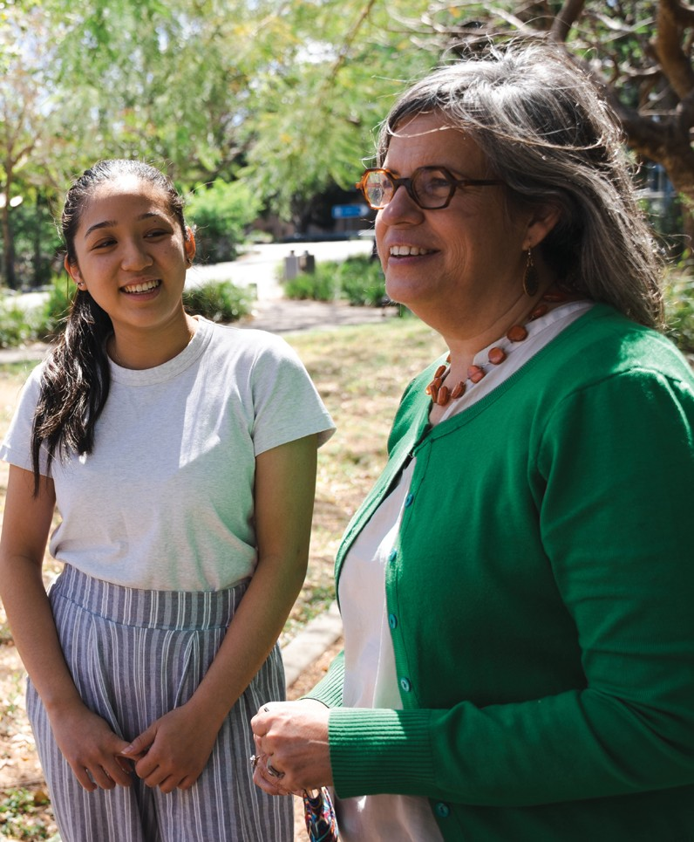

Australian Centre for Health Services Innovation QUT | 15

**Chapter 1. Introduction**

The Australian Centre for Health Services Innovation (AusHSI) was engaged by the Department of Health and Aged Care (DoHAC) to conduct an evaluation of the Program of Assistance for Survivors of Torture and Trauma (PASTT).

The purpose of this evaluation was to obtain an independent and evidence-based evaluation of PASTT in contributing to the successful resettlement of refugees in Australia. Specifically, the evaluation sought to assess the appropriateness, effectiveness, and efficiency of PASTT, aligned to key evaluation questions. The evaluation will be used to inform future PASTT planning and improvement.

## The impact of torture and trauma on refugees

Globally, by the end of 2020, more than 82 million people had been forcibly displaced because of persecution, conflict, violence, human rights violations, or events seriously disturbing public order1. Among them are over 26 million refugees, with half being under the age of 181. A total of 34,400 refugees were resettled worldwide in 2020 alone1. Australia has a long history of assisting displaced peoples, having resettled 920,000 refugees and others in need since the end of the Second World War2.

The effects of forced displacement are profound. Many refugees have experienced conflict, family separation, and significant torture and trauma prior to arrival in a settlement country3. Estimates suggest that as many as 35% of refugees have been physically tortured or psychologically violated worldwide4 . These experiences may have significant impacts on an individual’s immediate and long-term physical and psychological health5. For example, research indicates that torture and trauma survivors may suffer from traumatic brain injuries experience neurological symptoms (headaches, vertigo, loss of consciousness, dizziness)7, and psychological problems including anxiety, phobias, depression, and post- traumatic stress disorder4, 3, 8, 9. Moreover, torture and trauma can shatter survivors’ sense of security, their assumptions about their safety, the predictability of and trust in others,

and their sense of self-worth and control10. The physical and psychological consequences of torture and trauma can cause disability or restricted functioning, and have damaging effects on survivors’ social functioning, health, and well-being5. These impacts are often not only experienced by the individual survivors but also by their families and can lead to disruptions

in communities and broader society.

#### 1.1.1 Defining torture

Torture can take many forms. It can be physical or psychological and consist of beatings, electric shocks, sexual abuse, solitary detention, mock executions, sensory deprivations, being forced to witness others being torture or killed, and detention in harsh and inhumane conditions11. There are no boundaries to torture; children, women, and men, of any age, political, religious, cultural group, or societal class can be targeted.

In Article 1 of the Declaration on the Protection of All Persons from Being Subjected to Torture and Other Cruel, Inhuman or Degrading Treatment or

Punishment (1975), the United Nations Office of the High Commissioner for Human Rights12 defines torture as:

*“1. Any act by which severe pain or suffering, whether physical or mental, is intentionally inflicted by or at the instigation of a public official on a person for such purposes as obtaining from him or a third person information or confession, punishing him for an act he has committed or is suspected of having committed, or intimidating him or other persons. It does not include pain or suffering arising only from, inherent in or incidental to, lawful sanctions. 2. Torture constitutes an aggravated and deliberate form of cruel, inhuman, or degrading treatment or punishment.”*

## Programs for survivors of torture and trauma

Rehabilitation of torture and trauma survivors is complex.

It requires an in-depth understanding of torture and trauma and its effects, and expert skills in design and delivery of flexible, creative, adaptable, and responsive services to individuals, groups, and communities10. Several interventions focusing on improving the mental health of refugee survivors of torture and trauma have been reviewed in the literature.

For example, Shaw and Funk13 searched academic research databases and selected and analysed 68 social services programs developed for refugees. Programs were grouped into interventions focused on general adaptation, relationships, financial and employment support, or a specific area such as involvement in sport. Using Cochrane review methodology, Patel et al.5 identified nine Randomised Controlled Trials (RCT) of programs delivering interventions based on psychological treatments such as Narrative Exposure Therapy (NET) and Cognitive Behavioural Therapy (CBT). Murray, Davidson, and Schweitzer14 reviewed 22 intervention programs to improve refugee mental health after resettlement. These programs focused on interventions including CBT, school-based interventions, music therapy, drama therapy, creative expression workshops, coping skills, a sandplay program for school age children, and family group interventions.

Many programs have been evaluated and while some report positive changes or outcomes the findings are generally mixed13. There is also some suggestion in the literature that the findings to date may not be robust and should be treated with some caution. For example, in their review of RCTs, Patel et al.5, found that the quality of the methodology employed

in the studies was low and there was a high risk of bias in the results. In addition, the interventions that have been developed appear to be mostly short-term in nature, offering

individual or group treatment to a specific refugee population5, 13, 14. While potentially important for individual recovery, it

is unlikely that short-term and disconnected interventions provide an opportunity to comprehensively establish safety, trust, and facilitate service providers to build a strong connection with survivors, which are essential to both the commencement of healing and long-lasting rehabilitation13, 15. Hence, it is necessary that torture and trauma survivors have access to a range of services offered through a long-term, well-established, and evidence-based rehabilitation program.

#### 1.2.1 International snapshot of programs for survivors of torture and trauma

Programs for survivors of torture and trauma are offered in many countries. A list of over 160 centres from 76 countries is available on the International Rehabilitation Council for Torture Victims (IRCT) website16. As this list includes only the IRCT member centres it is possible that more programs are available.

This section in the report focuses on programs available in the countries that, according to the United Nations High Commissioner for Refugees (UNHCR), resettled the largest number of refugees in 2018 (latest official government statistics submitted to the UNHCR)1. This included Canada who admitted the largest number

of resettled refugees (27,100), followed by the United States of America (US) (22,900), Australia (12,700) and the United Kingdom (UK) (5,800). **Table 1**provides a summary of programs available to refugees resettled in Canada, the US, and the UK. In Section 1.4 the Australian Commonwealth Program of Assistance

for Survivors of Torture and Trauma (the focus of this evaluation) is introduced and described including a comparison of this program with those described in **Table 1**. It is noted the information provided below is not exhaustive and was sourced mainly from grey literature (non-academic/non-commercially published), when available, and a search of relevant websites.

Overall, each country provides a range of services to the survivors of torture and trauma. These include individual and group counselling, various therapies, advocacy, legal assistance, practical help such as language development, finding employment, housing or medical care, and training and education to external organisations17-22.

Community development and capacity building activities are largely missing from the portfolio of services available for torture and trauma survivors internationally.

The reach and funding arrangements of international services vary among the countries. For example, in the US, less than half of states (22 out of 50) offer specialised services for torture and trauma survivors that are funded by the U.S. Department of Health and Human Services 21, 23 and only 20 centres are listed as IRCT members16. Torture and trauma survivors who resettle in Canada can access individual and group therapeutic support delivered by three IRCT-member organisations based in Toronto 17, Montreal 19 and Vancouver 22. Services are free and funded under the government’s Interim Federal Health program that offers ‘limited, temporary coverage of health-care benefits’ 24 or via donations

from the public and other funders 17, 19, 22. In the UK, two IRCT-member charitable organisations offer services to torture and trauma survivors across several centres18, 20. These organisations are largely funded by grants, other charities, foundations and donations18, 20.

*Table 1.* Summary of programs for survivors of torture and trauma who resettle in Canada, the US and UK

|  |  |  |  |
| --- | --- | --- | --- |
| **Country** | **Reach** | **Centre and/or program and their activities** | **Funding** |
| Canada | 3 cities | The Canadian Centre for Victims of Torture (CCVT) in (Toronto) Vancouver Association for Survivors of Torture (VAST) Fund Rivo Resilience (Montreal)  Offer individual and group therapeutic support, counselling, art therapy, crisis intervention, access to professional services, legal aid, employment services, recreational activities, mentoring, peer support, community engagement, public education, language training | Government’s Interim Federal Health Program and via donations from public and other funders |
| US | 22/50  states | 43 Programs  100% offer social services (health service coordination)  93% offer psychological services (individual therapy, psychosocial support groups, wellness and art, alternative therapies, psychological evaluations)  73% offer medical services (physical therapy, occupational therapy, medical evaluations, medical forensic evaluations)  73% offer legal services  27% offer ‘other’ services (advocacy, employment services, micro- enterprise development, adult education, childcare) | U.S. Department of Health and Human Services, federal and state grants, the United Nations Voluntary Fund and funding from foundations, individuals, corporations |
| UK | 5 cities and presence in 2 counties | Freedom from Torture (London, Manchester, Newcastle, Glasgow, Birmingham, presence in Yorkshire and Humberside)  Room to heal (London)  Offer individual and group therapy and practical help (with accessing legal representation, medical care, housing, prepare for employment, education and training), medico-legal reports, training for organisations | Grants, other charities, foundations, and donations |

*All centres were contacted to seek further information about their programs, activities, reach, and funding to complement data found via their websites. Details about the US program were provided by HealTorture Logistics and Communication Coordinator via email. All other centres did not respond.

Sources: 17-23

## Australian Commonwealth Government’s Humanitarian Support Program

Australia has a well-established and internationally respected approach to refugee settlement25. The Commonwealth Government’s Humanitarian Support Program (HSP) assists humanitarian entrants and other eligible visa holders during their initial settlement in the country by offering support via an individualised case management approach2. This may include support

in terms of airport reception, general orientation, accommodation, referral to mainstream and specialised support services, connections to local community groups and activities, assistance to learn English and access education and training, and/or find employment2.

Specialised and intensive support services (SIS), which are a component of the Humanitarian Support Program, are provided to clients with complex needs such as disability, severe health needs, mental health issues, homelessness or housing instability, domestic or family violence, child and youth welfare concerns, family and/ or relationship breakdown, social isolation, financial hardship, and/or legal issues26. While most clients use services under the Humanitarian Support Program for six to eighteen months they can continue accessing HSP services for up to five years after their arrival to Australia2.

## The Commonwealth Program of Assistance for Survivors of Torture and Trauma

In addition to the Humanitarian Support Program, eligible clients who have pre-migration experiences of conflict and human rights abuses can also access PASTT-funded services. This includes Humanitarian Program (HP) entrants permanently resettled in Australia, and people on Temporary Substantive Visas (TSVs) and Safe Haven Enterprise Visas (SHEVs).

Established in 1995, PASTT is a specialist support service funded by the Department of Health and Aged Care (DoHAC) that has been offered to refugee survivors of torture and trauma who settle in Australia27. Under

the PASTT program, survivors can access specialised counselling and related support services with or without a diagnosed mental health illness. Interventions and support are offered at the individual, family, and community level. The flexible and adaptable nature of the PASTT program’s model allows for services to be tailored to the clients’ needs.

PASTT has been reported as a key complementary referral service for the Humanitarian Support Program to support the successful settlement of humanitarian entrants. Importantly, clients can engage, disengage,

and reengage with PASTT at any time after their arrival in Australia as program eligibility is not time dependent on the date of arrival.

Clients who access PASTT services can continue to do so after they exit the Humanitarian Support Program. This offers survivors of torture and trauma an opportunity to establish their lives in Australia and seek support from PASTT when they need it most.

#### Aims and objectives of PASTT

The overarching aim of PASTT is to contribute to the successful settlement of refugees in Australia in the short, medium, and long term27. Specific objectives are to:

− Provide survivors of torture and trauma with appropriate counselling and related support services

− Promote the physical health and psycho-social recovery of humanitarian entrants to Australia who have pre-migration experiences of conflict and human rights abuses, which make them vulnerable to developing mental health problems

− Provide services tailored to the needs of clients, whether this involves short, medium, or long-term support

#### 1.4.2 Activities and scope of PASTT

The scope of PASTT encompasses a wide range of activities and services including – but not limited to – psychological assessments, individual psycho- therapeutic interventions, group and family therapy,

specialist programs for particularly vulnerable cohorts, natural therapies, and community development. PASTT also provides support to the broader community and health services including professional development and capacity building for service providers (such as workers in the health, housing, education, and settlement fields), networking opportunities, research, volunteer programs, and case consultations.

Current Grant Operating Guidelines27 define the specific PASTT eligible activities which may be flexibly delivered to meet the needs of local clients and communities.

These include:

− Provision of direct counselling services to individuals, families, and groups

− Delivery of community development and capacity building activities

− Provision of education and training to health and other service providers

− Delivery of regional, rural, and remote outreach services

− Development of resources

− Advocacy and referrals to health and other services

− Delivery of community education and systemic advocacy

− Provision of activities that promote the psychological health and wellbeing of survivors of torture and trauma

#### 1.4.3 PASTT delivery and governance

PASTT is administered by eight state and territory-based member agencies forming the Forum of Australian Services for Survivors of Torture and Trauma (FASSTT; see **Figure 1**). All FASSTT members are individual specialist not-for-profit torture and trauma support agencies which are based in each of the capital cities across the country. These agencies are:

− Service for the Treatment and Rehabilitation of Torture and Trauma Survivors (STARTTS; NSW)

− Victorian Foundation for Survivors of Torture (VFST/ Foundation House; VIC)

− Queensland Programme of Assistance to Survivors of Torture and Trauma (QPASTT; QLD)

− Survivors of Torture and Trauma Assistance and Rehabilitation Service (STTARS; SA)

− Association for Services to Torture and Trauma Survivors (ASeTTS; WA)

− Phoenix Centre (TAS)

− Melaleuca Refugee Centre (Melaleuca; NT)

− Companion House (ACT)

PASTT funding is used by the FASSTT agencies to provide direct services to clients, and along with funding provided from a range of other sources, to engage

in complementary and supporting activities such as training of mainstream service providers, consultations, community development activities, and development of service infrastructure. However, it is important to note that each member agency of FASSTT operates, at base level, as an independent entity servicing the needs of client populations within the respective states and territories, with each having a separate PASTT Funding Agreement with the Department. However, FASSTT acts as a framework for the agencies to obtain and utilise funding to continue their work, to work collaboratively with each other, to share knowledge and resources, and develop, research, and innovate trauma-informed models of care appropriate and effective for use with refugee survivors of torture and trauma.

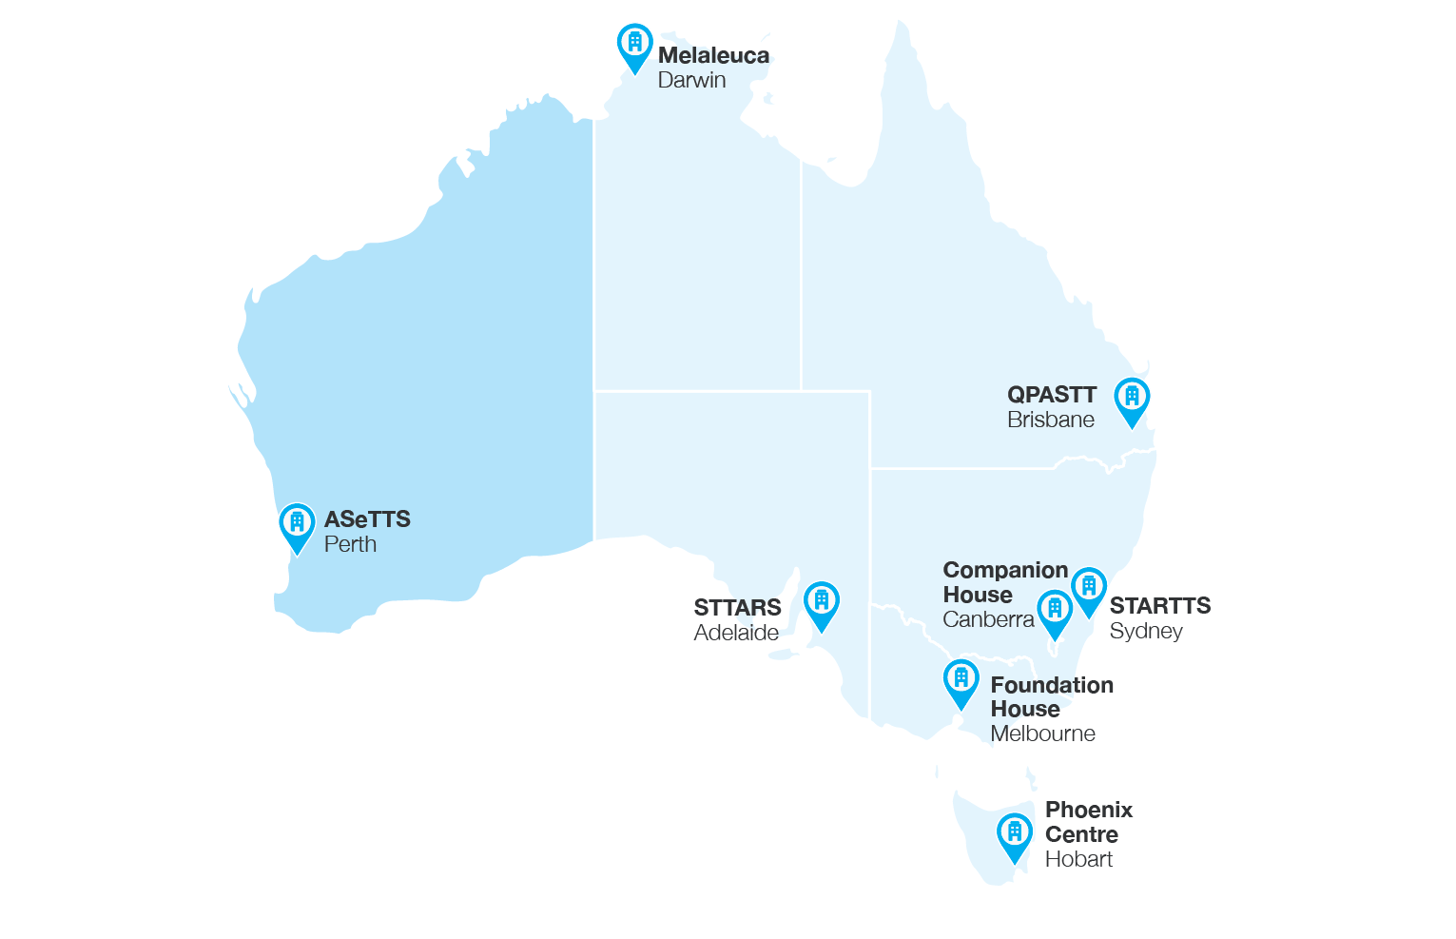

*Figure 1.* FASSTT member agencies in Australia

###### The Forum of Australian Services for Survivors of Torture and Trauma

FASSTT is a network of specialist agencies with the mission of providing short, medium, and long-term assistance to refugee survivors of torture and trauma, and to work to improve the capability of mainstream providers in working with clients with these special characteristics and needs28. It was established in 1992 and in 1995 was engaged by the Department of Health and Aged Care to establish PASTT to ensure there was nationwide access in Australia to longer-term counselling and interventions, and to improve refugee survivor access

to, and utilisation of, mainstream health services28. In 2011, a separate short-term torture and trauma program, originally developed as part of the Integrated Humanitarian Settlement Strategy funded by the Commonwealth Department of Immigration and Citizenship, was merged into PASTT28.

Since 2021, FASSTT has been registered as a not-for profit company limited by guarantee, reinvesting any surplus back into achieving the organisation’s purpose. This also gives FASSTT an enhanced capacity to operate as a single national legal entity where appropriate and facilitates the running of the FASSTT national office. FASSTT employs

a National Coordinator who plays an important role in facilitating engagement across the eight member agencies, including their collective collaboration with the Department of Health and Aged Care. Each FASSTT agency CEO

or Director is an equal voting member of the FASSTT Board. FASSTT also advises the Department of funding distribution across the member agencies.

There is a symbiotic relationship between PASTT and FASSTT28. Namely, FASSTT exists as an entity because of the existence of PASTT, while PASTT could not be delivered effectively without the existence of FASSTT28. Consequently, while this evaluation focusses on the implementation and impact of PASTT, in doing so it is important to recognise its interrelationship with the broader work of FASSTT member agencies.

#### 1.4.4 PASTT logic model

At the beginning of the evaluation AusHSI designed a logic model based on our understanding of PASTT from program documents. Throughout the evaluation we have added to and adapted the model based on our discussions with stakeholders and analysis of data. While each FASSTT agency adapts its PASTT-funded activities to suit their local context (see Chapter 3) a broad depiction of key inputs, processes, and outcomes consistent with PASTT logic is presented below in Figure 2.

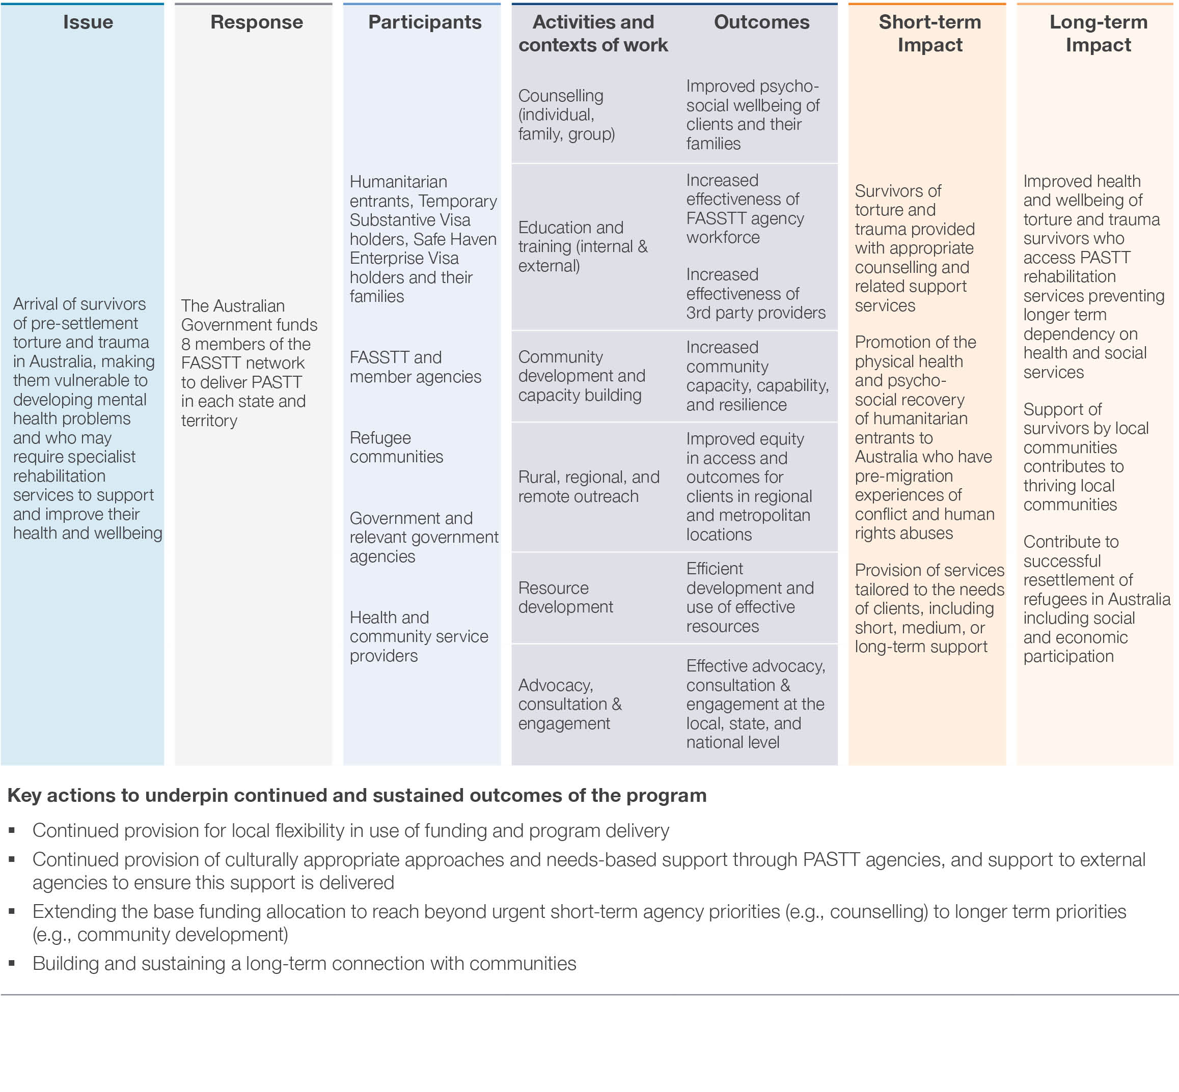

*Figure 2.* PASTT Logic Model



Australian Centre for Health Services Innovation QUT | 23

**Chapter 2. Methodology**

The evaluation aim, key evaluation questions guiding the evaluation, evaluation methods, and considerations in evaluating PASTT are discussed in the following chapter.

## 2.1 Aim of the evaluation

The purpose of the evaluation is to obtain an independent, evidence-based assessment of the appropriateness, effectiveness, and efficiency of PASTT in contributing to the successful resettlement of refugees in Australia. The evaluation also seeks to provide an assessment of what is working well with PASTT, and how the program could be improved in the future.

## 2.2 Evaluation questions

Key evaluation questions aligned with PASTT objectives were provided by the Department of Health and Aged Care and underpinned the conduct of the evaluation. These questions guided decisions on data collection and analysis.

Each of the four key questions and their sub-questions are presented below. **Table 2**outlines the corresponding report chapters for each key evaluation question.

#### 2.2.1 Key question 1: How appropriate is the

#### PASTT model?

1. Does PASTT align with key international best practice characteristics of a specialist service that meets the recovery needs for refugee survivors of torture and trauma?
2. What is the suitability of PASTT governance, funding arrangements, operation cost, and delivery model?
3. Extent to which services are consistent with, and tailored to, achieving the six specific program objectives:
   1. Improve the psychosocial health and wellbeing of people who have experienced torture and trauma prior to their arrival in Australia
   2. Increase the responsiveness of mainstream health and related services to the needs of people who have survived torture and trauma prior to arriving in Australia, through the provision of training and support services
   3. Build the confidence of refugee communities to access mainstream health and related services through capacity building activities
   4. Provide regional, rural, and remote outreach services to enable survivors of torture and trauma to access comparable services outside metropolitan areas
   5. Provision of resources to support and enhance the capacity of specialist counselling and related support services to deliver effective services to survivors of torture and to respond to emerging client needs
   6. Provide community education and advocacy to overcome any barriers to access and equity for the client group

#### 2.2.2 Key question 2: How efficient has PASTT been?

1. How efficiently have resources been used by PASTT providers? Can this be improved?
2. Has the program delivered value for money and cost- effectiveness?
3. To what extent has the program avoided duplicating internal or external functions and services?
4. To what extent has the program leveraged internal and external resources?

#### 2.2.3 Key question 3: How effective has PASTT been?

1. What is the effectiveness of PASTT and Forum of Australian Services for Survivors of Torture and Trauma (FASSTT) engagement with and of third-party organisations in delivering the six specific program objectives?
2. To what extent are services consistent with, and tailored to, achieving the six specific program objectives?
3. To what extent did the program facilitate early intervention?
4. To what extent are activities evidence-based?
5. What is the capability and effectiveness of PASTT services in addressing client needs?
6. What is the appropriateness of services provided (including but not limited to availability and duration)?
7. What are the changes in client-reported outcomes?

#### 2.2.4 Key question 4: How can the program be developed or refined to best deliver on outcomes?

1. What are the enablers and challenges to the program’s effectiveness?
2. What additional opportunities are identified in international best practice?
3. What are the recommendations for annual appropriation and funding mechanisms?

*Table 2*. Alignment of key evaluation questions and report chapters

|  |  |
| --- | --- |
| **Key evaluation question** | **Chapters** |
| Question 1. How appropriate is the PASTT model? | 3,4,6 |
| Question 2. How efficient has PASTT been? | 4,6 |
| Question 3. How effective has PASTT been? | 3,4,5 |
| Question 4. How can the program be developed or refined to best deliver on outcomes? | 6,7,8 |

## 2.3 Evaluation methods

The evaluation employed a mixed-methods approach using retrospectively and prospectively collected data. The initial stage of the evaluation involved informal discussions with key PASTT stakeholders from each of the eight FASSTT agencies to gain relevant information about the program and shape evaluation planning.

Following ethical approval, AusHSI then collected and analysed both quantitative and qualitative data across four parts of the evaluation: alignment with international practice; evaluation of client, service, and implementation

outcomes; cost-effectiveness and funding; and contextual and implementation factors. Data collection processes and data sources are depicted in **Figure 3**and outlined below in Section 2.5. This triangulation of data from multiple sources, collected by multiple evaluators, helps to mitigate some of the biases involved with single data sources, provides a more holistic perspective on the program, and allows for increased trustworthiness and validity of the findings29

*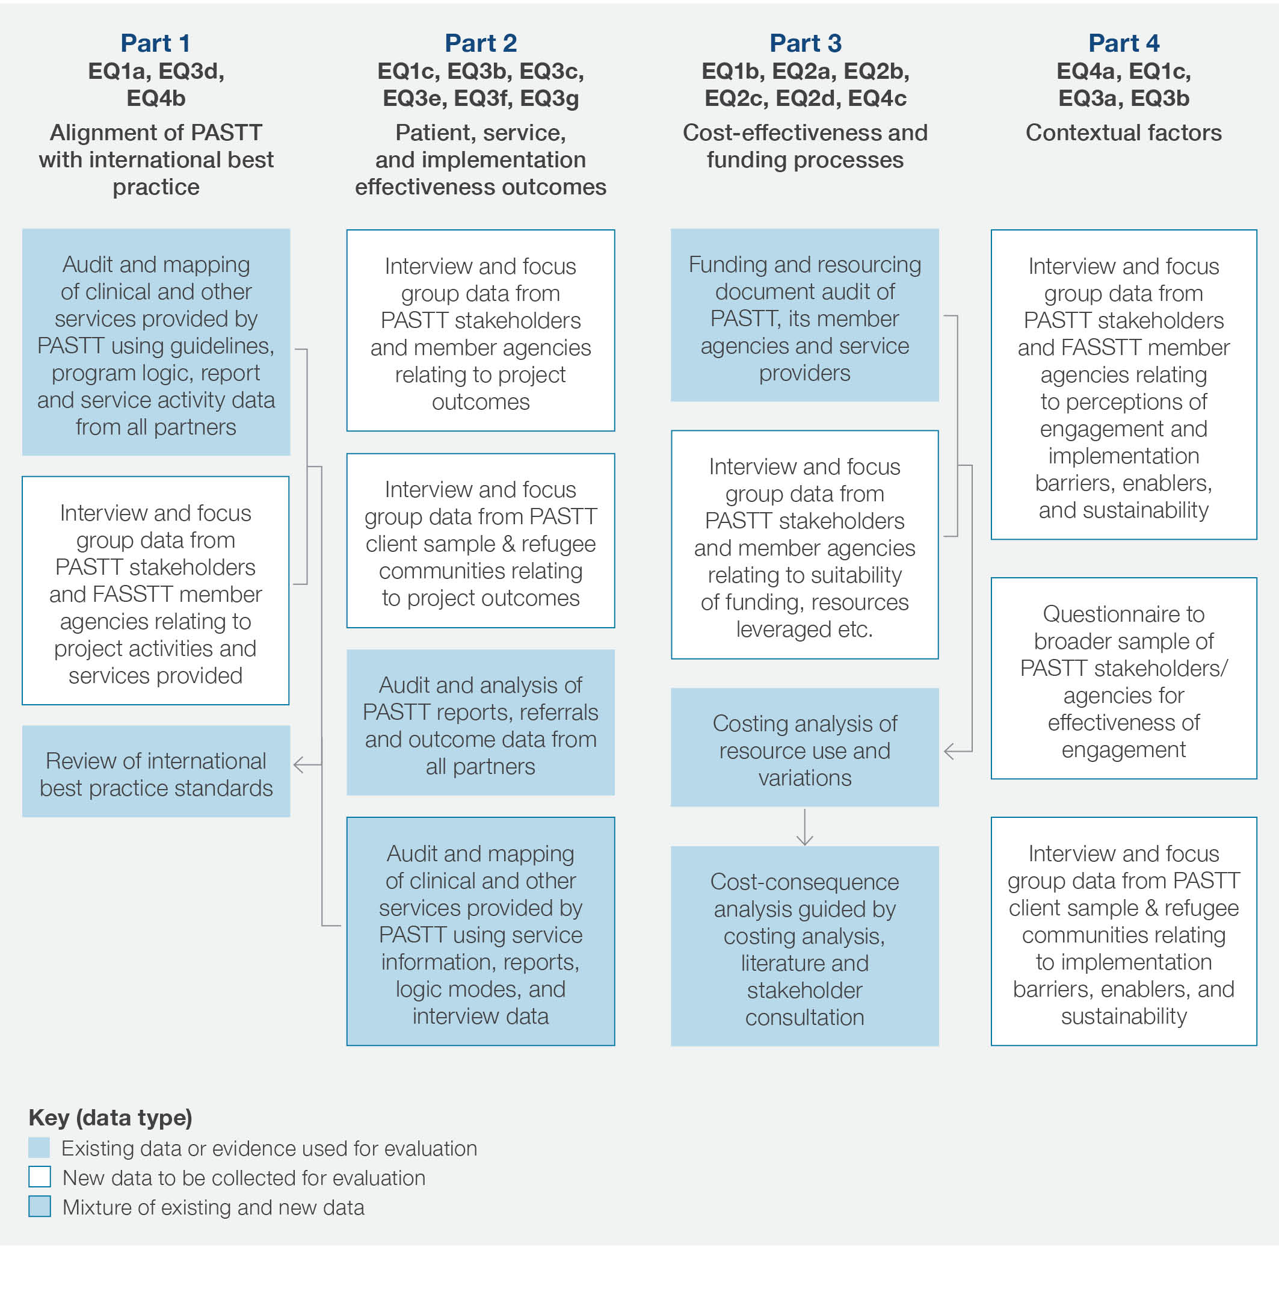  
Figure 3.* Overview of evaluation methods and data sources, aligned to evaluation questions

## 2.4 Ethics

Due to the vulnerable nature of PASTT clients and the nature of the activities conducted by FASSTT agencies it was deemed essential to obtain ethical review for the evaluation. To facilitate the efficient collection of data,

two separate ethics review submissions were made. The first, granted on 17th February 2022 from Queensland University of Technology Human Research Ethics Committee, allowed commencement of individual and group interviews with key organisational and partner stakeholders (e.g., FASSTT employees) and distribution of an online survey to key external stakeholders and service partners. This ethics application was categorised as Negligible/Low Risk.

The second ethics approval was granted on 3rd June 2022 from Bellberry Ethics Committee ([https://bellberry.](https://bellberry.com.au/) [com.au/](https://bellberry.com.au/)), which allowed commencement of interviews with PASTT clients and community stakeholders/ leaders. As expected, this application was categorised as ‘Greater than Low Risk’ due to the vulnerable nature and potential risks to participants in participating in research. This application was approved almost three months after the initial submission (on 11th March 2022) and involved three cycles of feedback during this time frame. Development of this second ethics application was complex and required consideration of potential harms and development of effective harm minimisation strategies. Through this process the AusHSI team developed a flexible plan for data collection from PASTT clients and others. The plan included partnering with individual agencies to ensure processes were acceptable to local stakeholders and likely to gain usable and informative data. The plan enabled data collection to

be via individual or group interviews that were facilitated either by an AusHSI team member or a trained local

bi-cultural worker/interpreter depending upon participant and organisational preferences and taking into account cultural factors.

## Data collection

Upon request, AusHSI received a number of key documents from each FASSTT agency, the FASSTT national coordinator, and the Department of Health and Aged Care. Data sources are listed in **Table 3**together with the report chapters they inform. AusHSI performed audit, review, and analysis of all key documents listed in **Table 3**. In addition, as outlined in Section 2.5.1, a key part of the evaluation consisted of qualitative interviews with key PASTT stakeholdersa.

a Interviews with PASTT clients were delayed due to the ethics review process.

*Table 3*. Evaluation data sources and alignment with report chapters

|  |  |
| --- | --- |
| **Data source** | **Chapters** |
| **Quantitative** | |
| FASSTT agencies’ Data Table Report including service activities and reach | 5,6,7 |
| Client WHO-5 wellbeing index scores | 5 |
| Client goal achievement data: QPASTT, STARTTS, VFST | 5 |
| Agency-completed evaluation data request comprising 2017-18 to 2021-22 data on: income, expenses, cost profiles, client numbers, waiting list numbers, staff redundancies, award wage rates | 6 |
| Previous AusHSI-led report (commissioned by FASSTT): “Cost of service provision for survivors of torture and trauma in rural and regional locations: an environmental scan and costing analysis for FASSTT” | 6 |
| National-level humanitarian entrants’ data30 | 6 |
| **Qualitative** | |
| FASSTT agencies’ Performance Reports | 3,4,5,7,8 |
| Qualitative interviews with stakeholders internal to FASSTT agencies | 3,4,5,6,7,8 |
| Qualitative interviews stakeholders external to FASSTT agencies | 3,4,5,7,8 |
| Qualitative interviews with former PASTT clients | 3,5,7,8 |
| Informal discussion with upper management personnel in FASSTT agencies | 3,4,6,7,8 |
| Case studies provided by FASSTT agencies (client and community level data) | 3,5,6,7,8 |
| Consultation with the Department of Health and Aged Care | 1,6 |
| Email communication (Department of Home Affairs, international centres for trauma and torture rehabilitation, FASSTT agencies) | 1,7,8 |
| **Qualitative + quantitative** | |
| Grey literature (government and non-government websites, reports, operating guidelines) | 1,6 |
| Peer-reviewed literature | 1,3,4,5,6,7,8 |
| Online questionnaire with external stakeholders | 5,8 |
| Client satisfaction survey data (STARTTS, STTARS) | 3 |

#### 2.5.1 PASTT stakeholder consultation and interviews

A semi-structured interview guide, designed to elicit responses to the evaluation questions, was used to direct conversation in all interviews (**Appendix 1**). In total, AusHSI conducted 26 (14 individual and 12 group) interviews with a total of 73 participantsb. Interview length ranged from 29min 39sec to 1hr 31min 26sec. A total duration of 26hrs 29min of interviews was collected. Almost all interviews were conducted virtually using Zoom or Microsoft Teams and ranged in size from 1-5 participants. There was

one large town-hall style interview with 22 participants conducted in-person by AusHSI evaluators.

Participants represented range of internal and external roles in relation to PASTT. Most participants were employees

of FASSTT organisations. Participants in some interviews were from homogenous teams or areas within FASSTT organisations (e.g., were all clinical/counselling team members) while other interviews included a range of people in different roles in the FASSTT agencies (or external).

Thirteen interviews included participants with upper managerial (e.g., CEO, CFO) or other managerial roles (e.g., team leaders). Nine interviews included FASSTT employees engaged in clinical or counselling roles.

One interview included only FASSTT employees who were engaged in community capacity building roles; and one interview included only FASSTT employees in corporate services or administrative roles. Most

interviews were conducted with stakeholders located in metropolitan areas of their state. There was one interview conducted solely with external participants (not FASSTT organisation employees) to gain additional perspectives about relationships and impact on mainstream services. A summary of the characteristics of those consulted throughout the interview process is provided in **Table 4**.

As part of our ethical commitment to protect the privacy of individual interview participants, interviewees are not named by agency, organisation, or specific role within the report.

This anonymity increased the likelihood that the participants could speak openly and honestly. This is important as there is a risk that interview participants may be identifiable to each other due to relationships within the FASSTT network and small size of some FASSTT agencies.

b This does not include additional informal conversations with FASSTT agency CEOs and the FASSTT network coordinator which totalled 8-10 hours.

*Table 4*. Characteristics of interviews and participants

|  |  |  |  |
| --- | --- | --- | --- |
| **Interview number** | **Interview and participant characteristics** | | |
|  | **Individual vs group** | **FASSTT vs**  **external** | **Role and level\*** |
| 1 | Individual | FASSTT | Upper management |
| 2 | Group (n=22) | FASSTT | Large multidisciplinary group including upper management |
| 3 | Individual | FASSTT | Upper management |
| 4 | Individual | FASSTT | Upper management |
| 5 | Group (n=3) | FASSTT | Upper management |
| 6 | Individual | FASSTT | Clinical/counselling services |
| 7 | Individual | FASSTT | Clinical/counselling services |
| 8 | Individual | FASSTT | Upper management |
| 9 | Group (n=5) | FASSTT | Clinical/counselling services |
| 10 | Group (n=4) | FASSTT | Community capacity building; Administration and corporate services |
| 11 | Group (n=4) | FASSTT | Upper management; Administration and corporate services |
| 12 | Individual | FASSTT | Upper management |
| 13 | Individual | FASSTT | Upper management |
| 14 | Group (n=3) | FASSTT | Clinical/counselling services |
| 15 | Individual | External | Upper management |
| 16 | Group (n=4) | FASSTT | Rural and regional services# |
| 17 | Individual | FASSTT | Upper management |
| 18 | Individual | FASSTT | Community capacity building |
| 19 | Group (n=2) | FASSTT | Administration and corporate services; community capacity building |
| 20 | Group (n=4) | FASSTT | Clinical/counselling services |
| 21 | Group (n=2) | FASSTT | Clinical/counselling services |
| 22 | Group (n=4) | FASSTT | Clinical/counselling services; Community capacity building |
| 23 | Group (n=2) | External | Upper management |
| 24 | Individual | FASSTT | Clinical/counselling services |
| 25 | Individual | FASSTT | Clinical/counselling services |
| 26 | Individual | FASSTT | Upper management |

*Upper management includes positions such as CEO and CFO; clinical/counselling services includes positions that provide direct mental health interventions to clients as well as team leaders and managers; community capacity building includes positions that engage in community development work including team leaders and managers; administration and corporate services includes positions that perform functions related to the operation of the organisations not captured in the other categories; rural and re- gional includes positions that work primarily in or with rural and regional locations including direct service providers, team leaders and managers; large multidisciplinary group consisted of positions working across the spectrum of the other categories.

#While only one group specifically comprised rural/regional participants, the topic of regional service delivery was raised in almost all interviews, and those working regionally were captured in other roles (e.g., counselling)

#### 2.5.2 PASTT client interviews

A semi-structured interview guide, designed to elicit responses to the evaluation questions, was used to direct conversation in all client interviews (**Appendix 2**). AusHSI conducted seven individual client interviews which ranged in length from 14 to 41 minutes. A total duration of approximately 2hours 40minutes of data was collectedc. Interviews were conducted via Zoom or phone, depending on the client’s preference. Six interviews were audio recorded and transcribed verbatim. One interview was conducted immediately upon first contact by AusHSI to schedule an interview, due to the client’s preference which resulted in it not being audio recorded. All clients were offered a trained interpreter or bicultural worker to join an interview and assist with communication, however none requested this service. Three participants requested for their family member to join the interview to assist with translation, four participants were fluent in English and did not require an interpreter.

The interviewed clients accessed two PASTT services from four different agencies. This included homework club and counselling. Six client interviews are presented as case studies in **Appendix 3** and referred to throughout this report.

#### 2.5.3 Engagement survey

A brief online questionnaire was developed by AusHSI to capture data from a larger and broader sample of PASTT stakeholders outside the interviews. Content comprised demographic questions, provider/partner satisfaction, and benefits of the partnership. The results were used to

triangulate the findings about implementation, engagement, and communication, reflect on satisfaction with partnerships established, and focus on ways to sustain collaboration

into the future. FASSTT agencies distributed a link to the online REDCap questionnaire to relevant partners, third- party providers, and community organisations identified as supporting or delivering PASTT services.

#### 2.5.4 Review of literature

Peer-reviewed and grey literature was sought, reviewed, and analysed to support the evaluation data and contextualise the findings. Grey literature included government and non-government reports (both published and unpublished), operating guidelines, and information available via several reputable websites. Published

peer-reviewed literature was purposefully sourced from reputable academic journals and databases. A full reference list is provided at the end of the report.

c One interview was not recorded thus an estimation of overall length of interviews is provided.

## Data analysis

Data analysis was conducted using de-identified aggregate and individual level outcome data. For quantitative data, descriptive statistics such as counts, costs, percentages, and means were used to calculate and present the relevant results of each outcome measure.

For all types of qualitative data (including that collected from interviews, written survey responses, discussion groups, and electronic platforms), data analysis adopted an inductive thematic approach. The raw data was used by individual researchers to group and categorise data, derive concepts, and develop preliminary themes which were later discussed in regular data analysis team meetings. During these meetings, higher level concepts

and themes were derived. No predetermined expectations or themes was applied. Methods used to maintain trustworthiness and rigour of the qualitative analysis included reflexive journaling through data collection and coding, and coding by AusHSI researchers experienced in qualitative research and implementation science.

## Data limitations

Overall, the AusHSI team assessed the data as being sufficient to inform a robust evaluation of PASTT. FASSTT agencies have generally been rigorous in their data collection. However, some limitations should be noted.

Quantitative data was provided by the agencies and not collected by the AusHSI team. The data that was provided included some missing data and there were occasionally discrepancies between data tables and workplans provided by the same agency, for the same reporting period. While similar types of quantitative data were provided by all FASSTT agencies, there were some inter-agency differences and inconsistencies in how the data was reported or how it was provided. In particular, reporting of community engagement work

varied markedly by agency making it challenging to count activities, classify organisations/groups, or report on more granular or subgroupings of data.

PASTT agencies nominated internal and external stakeholders, and past clients for AusHSI to approach for qualitative interviews and were responsible for distributing the online survey for external stakeholders. Hence, it is possible that the stakeholders who shared their opinions and experiences about PASTT differ from those who did not participate in this evaluation. Further, some interview participants, for a variety of reasons, may have shared information that they believed to be more socially acceptable than their true beliefs. AusHSI limited opportunity for these biases to affect data collection and analysis by devoting time to developing a good working relationship with each agency and engaging with all key stakeholders in regular communication. Further, when possible, AusHSI ensured a broad range of stakeholders from each agency was engaged as participants.

Also, as further described in **Chapter 5**, attribution of outcomes is often difficult in social service delivery.

However both quantitative and qualitative data have been used and triangulated where possible to increase confidence in findings while acknowledging limitations.

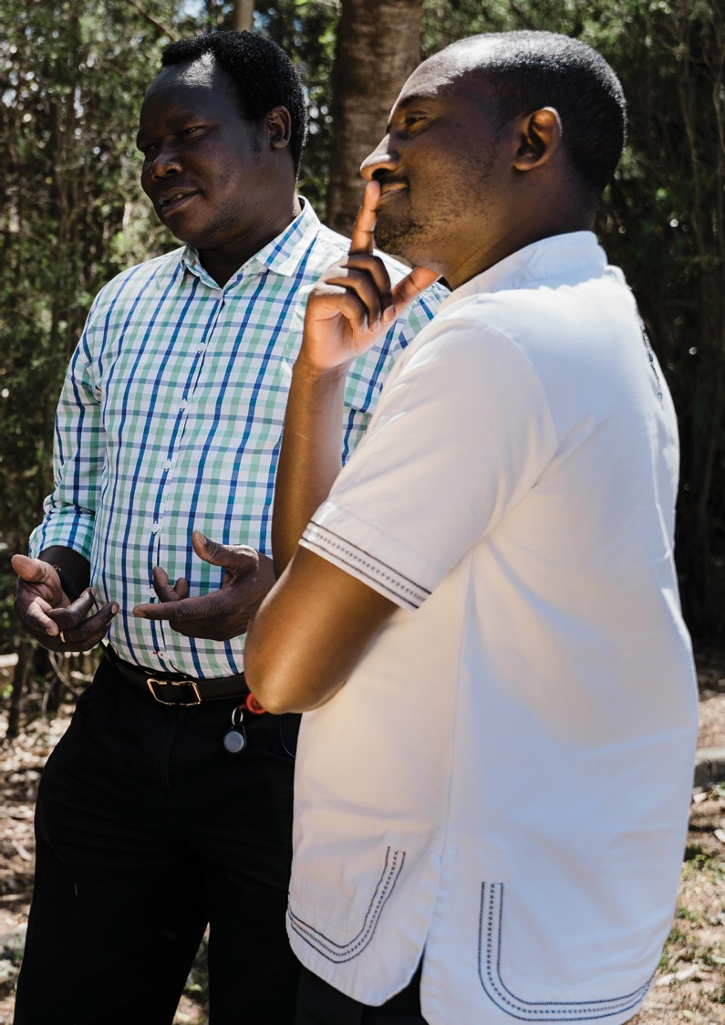

Australian Centre for Health Services Innovation QUT | 33

**Chapter 3. Appropriateness and Acceptability of PASTT**

This chapter considers PASTT appropriateness and acceptability using stakeholder consultation and existing client feedback. It also draws on published literature where appropriate. This chapter focusses on answering sub questions from key evaluation questions one and three as outlined below.

− Key evaluation question one: How appropriate is the PASTT model? (suitability of the delivery model and program governance)

− Key evaluation question three: How effective has the program been? (appropriateness of services provided, addressing client needs)

This analysis of the implementation of PASTT includes ‘what has’ and ‘what has not’ worked in terms of the delivery model along with its appropriateness and ability to effectively address client needs. The suitability of current program governance processes are also discussed. It draws largely on qualitative analysis which has occurred after extensive consultations with FASSTT

agency CEOs, staff members, former PASTT clients, and external stakeholders. Where relevant, illustrative quotes are provided to highlight points. Additional supporting quotes can be found in Appendix 9. Quantitative analysis has been undertaken based on a review of existing client feedback interviews and surveys conducted by STARTTS and STTARS.

The following sections summarise analysis completed relating to:

− Appropriateness of PASTT

− Acceptability and client-centredness of PASTT

## Appropriateness of PASTT service model

Appropriateness is the perceived fit or compatibility of a practice for a given consumer. This evaluation highlights three key features in relation to the appropriateness of PASTT in providing services to meet the needs of clients. These can be broadly described as:

1. The provision of a specialised refugee trauma informed service model
2. Flexibility in the approach to service delivery and client engagement
3. Building and maintaining connection to community

A visual representation of these three features is provided in **Figure 4**, along with an explanation of *why* these features are important for delivering appropriate services and *how* they help PASTT address client needs. These are explained in further detail in the subsequent sections. We suggest these three elements should be considered core features of PASTT as they are directly related to the philosophy that underpins the program and appear to be essential contributors to its effectiveness. These features also characterise PASTT’s unique contribution to the sector and are relevant to defining the program’s scope.

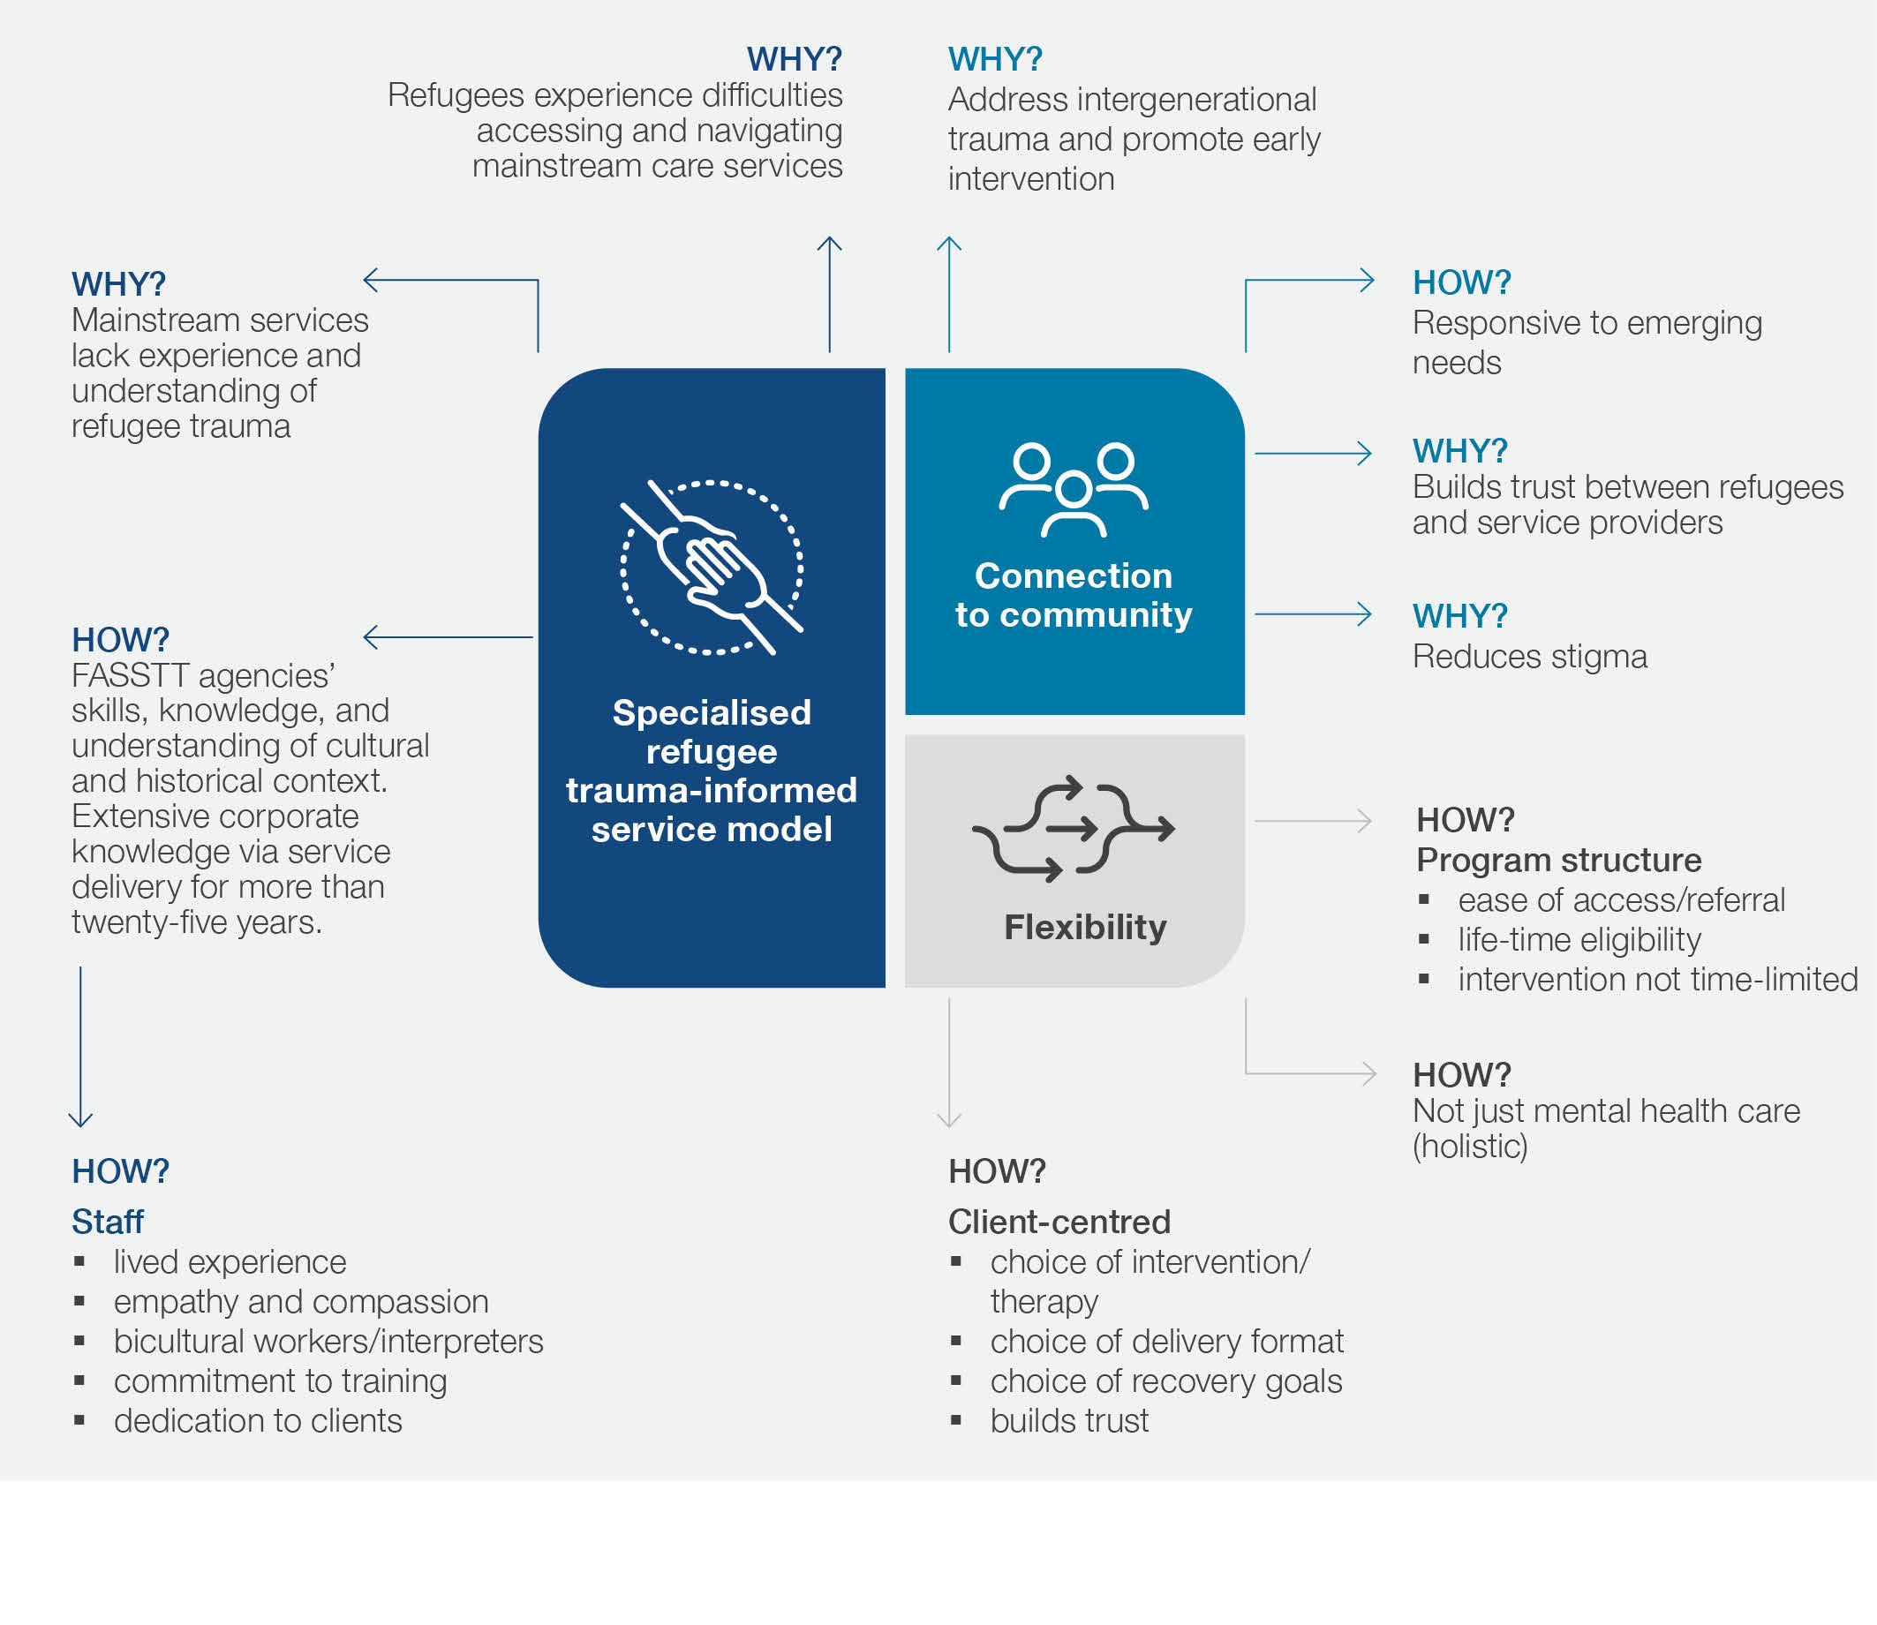

*Figure 4.* Visual representation of key features contributing to the appropriateness of PASTT for survivors of torture and trauma (including how and why each feature does so

#### 3.1.1. A specialised refugee trauma informed service approach

Research has demonstrated that refugees struggle to access and engage with mainstream healthcare

services both in Australia and internationally31, 32. Reasons include language barriers (perpetuated by a lack interpreter use), healthcare differences, cultural incompatibility

of services, cultural stigma, discrimination/racism, service provider knowledge, and the consumer’s lack of

knowledge about the systemd. These challenges were also raised in discussions with a range of PASTT stakeholders who additionally described the extra burden that accessing care via mainstream services disproportionally places

on refugee clients. These challenges appeared to be exacerbated in regional and rural areas where mainstream services are already constrained. One stakeholder in a clinical/counselling role noted:

*“In general, access to mental health services for our clients in [location] is really poor. It’s pretty much impossible for people to find a psychologist who speaks their language and psychologists are generally not funded to access interpreters. So other forms of mental health support that the broader community are able to access are really just not available to our clients”*

***Interview 25, Clinical/counselling services, FASSTT***

Additionally, both FASSTT agency staff and clients reported that the eligibility criteria, complex referral pathways, intake processes, cost, service environment, limited treatment flexibility, fragmented nature, and time-limited duration of mainstream care was not appropriate for many PASTT clients due to the complexity of their situations.

Many of the challenges for refugees engaging with mainstream services occur because such services are not fully equipped with the level of intercultural capacity required to meet the unique and diverse needs of refugees33, 34. While mainstream service providers are skilled in mental health treatment, they often lack the required understanding about torture and trauma, and its intersection with cultural and historical factorse. This is important as trauma exposure has been found to be the most important predictor of current mental illness in resettled refugees, even decades after settlement35. Consequently, guidelines recommend that services for refugees and their families should provide trauma-informed care as best practice36.

Trauma-informed care is defined as “an approach that recognizes the pervasive impact of trauma on development and health, applies this knowledge of trauma and its consequence into practice, and actively seeks to prevent re-traumatization”37. Principles include promoting safety, culturally competent trust-building, providing peer support, empowerment and collaboration, social connectedness and acknowledging cultural, historical and gender issues. Importantly, research evidence supports the effectiveness of such trauma focused therapy for treating post-traumatic stress disorder and depression in this population38.

However, evidence also suggests that many Australian service providers do not know how to use such methods to work with refugees who are experiencing psychological trauma32. This is evident in the high proportion of referrals PASTT receives from mainstream health services (**Figure****20****,** **Chapter 5**). Consequently, it is important that

PASTT continues to enhance the skills and experience of mainstream providers in working with this population.

Many FASSTT agency stakeholders see a valuable role for mainstream services in supporting clients with less complex presentations however, there remains a need for specialist care which enables greater choice and confidence in accessing support. This was highlighted in client interviews (Appendix 3) and reinforced by client feedback to FASSTT agencies which indicates that mainstream services are often not able to meet their needs, and in some cases make them feel uncomfortable. The client case study in Box 1 describes the problems experienced engaging with mainstream services, and how PASTT is able to provide more appropriate care for this client.

d “We are trying to use mainstream services to get people services as quickly as possible and sometimes that will work with, you know [English] speakers but often it won’t’ work with others” **Interview 12, Upper management, FASSTT**

e “I think if we didn’t exist, if PASTT didn’t exist –there would not be an avenue for trauma recovery, really, for people ... [the mental health system] really

doesn’t understand the nature of refugee trauma... It understands trauma, but not refugee trauma.” **Interview 1, Upper management, FASSTT**

*Box 1*. Client case studies: Client 1

## Case 1 – “H”

### Background

‘H’ is teenaged female who accesses ASeTTS services. She was originally from the South Asian region, arriving in Australia eight years ago as a refugee with her parents and siblings. H has directly experienced war trauma in her home country, and traumas during her journey to Australia. As a result of trauma H experiences intrusive thoughts, nightmares, and has limited capacity to concentrate. This has led to her becoming completely disengaged from school. H also experiences social anxiety and has difficulty interacting with people outside her home.

### Engagement with mainstream services

Initially she was referred to the Child and Adolescent Mental Health Service (CAMHS) for mental health support by a tertiary hospital. She attended only a few sessions before completely disengaging. She was also referred to

Headspace and again attended only a few sessions before disengaging. H has reported that it was difficult to get to appointments and that the use of public transport worsened her anxiety. It became difficult for her to get out of bed, leave the house, or to attend appointments. She also reported the clinical environment at CAMHS and Headspace felt cold, threatening, and unfriendly; like a hospital, and that the significant stigma in attending a mental health services within her community was a barrier to her continuing. H has reported that CAMHS and Headspace staff didn’t understand her, her culture or needs, or her experiences, and didn’t take the time to get to know her.

H was eventually referred to ASeTTs by CAMHS. ASeTTS has maintained constant involvement with H for over the subsequent three years. During this time other services have cycled in and out of her life; including Department of Communities: Child Protection. Services dipping in and out of young person’s life creates instability within family units. It becomes unclear who is involved and what they are assisting with, and makes it difficult to develop trusting relationships and maintain meaningful change.

### Engagement with PASTT services

H was allocated to ASeTTS Outreach Youth service. ASeTTS involvement at that time was as an adjunct to other tertiary hospital supports. The ASeTTS clinician allocated to support H delivered session at her home, and during walks around her neighbourhood. The clinician provided psychoeducation and practical supports to H, including explaining that trauma can have different impacts on young people and that there are different ways a person can be supported to explore those challenges and overcome them. H reported that she had benefitted from the flexible support model. Specifically, while other services are time limited and require the client and their family members to attend sessions at a designated office, ASeTTS approach to providing services through outreach and without time limits was considered responsive to H, and her family’s needs.

H has reported that she feels understood by, and finds it easy to talk to, ASeTTS staff. She has explained that unlike staff and clinicians from other organisations and agencies, ASeTTS staff are experienced in supporting refugees and addressing refugee trauma. With ASeTTS she does not need to moderate what she says, and is not concerned about ASeTTS staff becoming overwhelmed by her history and experiences. As a result of ASeTTS continued support and counselling, H recently advised she would like to get back to school and feel less anxious in public.

It is because **FASSTT agencies provide both culturally responsive and specialist trauma informed care** that PASTT demonstrates high levels of appropriateness in meeting client needs and improving access and outcomes for refugee communities. Knowledge, experience, and understanding has been built by each agency, and by FASSTT as a collective, over more than two decades. The program’s unique perspective normalising and linking the impact of culture, historical context, and past trauma with current mental health and wellbeing is lacking from most mainstream servicesf. This can have significant impacts on the care and outcomes these vulnerable clients receive. For example, PASTT providers were able to link a young woman’s eating disorder with her previous experience of trauma, despite this being missed multiple times as an inpatient in mainstream care. Another was diagnosed by mainstream providers as having paranoia and placed on multiple medications, however PASTT providers changed her declining trajectory when they were able to talk to her from a trauma-informed perspective, assess the scenario, and establish that the paranoid thoughts may have been founded in past events.

Information provided in a client case study from Companion House demonstrated the impact of normalising trauma for their client ‘N’, who presented with debilitating symptoms of posttraumatic grief and secondary depression. In counselling she was able to finally find a safe, non-judgemental place. She said this was the first time she had found such a space. Once her symptoms were reframed and normalised in the context of past childhood war related trauma, long experiences of refugee camps, forced separation, and death of

loved ones she began to realise that her current grief and depression were her body’s way of acknowledging all her history. N began to better relate to her children, move through her grief of loss of loved ones, establish professional relationships, gain part-time employment, and reported feeling fulfilled.

**FASSTT agency staff are also key** to its appropriateness and effectiveness. The high level of interpreter involvement in service delivery, engagement with community leaders, and employment of those with

lived experience and of similar refugee backgrounds (including bicultural workers) drive a considerable amount of PASTT’s appropriateness as a specialised service. Additionally, FASSTT agencies invest heavily in training, clinical supervision, mentoring, and professional

development for their staff to deliver high quality care (see Chapter 7, Alignment of PASTT with international best practice). This training also extends to that of mainstream service providers where PASTT aims to increase knowledge and change attitudes, enabling delivery of more appropriate care in that setting.

#### Connection to community

Another essential feature that sets PASTT apart and drives its success is an implicit understanding of the communities it supports and the long-term connections that agencies have built within these communitiesg.

Significant time, resources and effort are invested in this process through engagement and community development work. These connections allow FASSTT

agencies to take **an innovative and responsive service approach** based on an understanding of the needs of a dynamic and evolving population. For example, FASSTT agencies adopt a range of community advisory models including refugee reference groups and community consultations to respond to emerging needs and design appropriate solutions. Most recently this type of work has occurred to respond to the crisis affecting the Ukrainian community in New South Wales. Co-creation and co- design with communities was identified as a common thread across all agencies whether that be through leveraging internal or external connections, existing groups, or mainstream services. In 2021, one agency

co-designed and assisted in the successful delivery of a mental health and wellbeing psychoeducation

program for community leaders which aimed to build the community leaders’ capacity to support their community members during COVID-19-related distress.

f “We hold specialist knowledge in refugee trauma - it’s really important because that looks different from other kinds of trauma, it has a different nuance and complexity, and being able to be specialist and understand our communities and their type of trauma is really important as well”.

**Interview 2, Participant in large multidisciplinary group, FASSTT**

g “In our recovery context we also need to be working at those different levels [individuals, families, communities and societal] and I think that’s quite rare and where we are differentiated from mainstream services who don’t necessarily understand that we’re holding individual and collective recovery, not in competition, but alongside and, kind of, intertwined.” Interview 2, Participant in large multidisciplinary group, FASSTT

The community engagement work of PASTT also helps to **rebuild trust within these communities** so that they are better able to seek help, **breakdown cultural stigmas**, and open up about their experiencesh. This is crucial, as accessing and engaging with healthcare is intimately related to trust within refugee communities31.

For example, one agency has employed community connectors to go into newly arrived communities to build trust and connection and combat mental health stigma in the early stages of settlement. Another way this has been achieved is by employing staff with refugee backgrounds themselves and who can use their own lived experience within communities to foster trust and build relationships. Additionally, by having staff play the role of counsellor advocate (rather than counsellor) agencies can work on building trust by providing a soft entry into the service and meeting client needs for support outside of mental health. Once this trust has been built, it is easier for counsellor advocates to address mental health concerns. This is particularly important where communities may have reservations about seeking counselling due to stigma. Finally, **building and sustaining a long-term connection with communities was perceived to be essential if PASTT is to contribute to early intervention and prevention work including helping families to deal with the impacts of intergenerational trauma**, which is of growing concern to communities.

#### Flexibility of approach

Tailoring and adaption of service delivery to respond to and meet the needs of communities and individuals is a key element of PASTT’s work and contributes greatly to its effectiveness and appropriateness. The agencies place a high value on ensuring their clients’ specific needs are considered and that they receive support according to these needs, which was recognised and appreciated

by the interviewed clients (case studies C7, C2, C3, C4, C5, C6 in **Appendix 3**). Further, FASSTT agency staff

interviewed emphasised that being responsive and not prescriptive in their approach to trauma rehabilitation is a great strength of the PASTT program. For example, each agency **uses diverse forms of engagement and therapy** to foster recovery from an individual and societal perspective. This includes individual counselling, group work, complementary therapies, social support and advocacy, and community healing processes. Some

of these more culturally appropriate approaches (e.g., community healing) are not available to clients within mainstream health services. Additionally, PASTT provides both outreach to communities and in-reach to schools to better meet their clients where help is needed most.

Moreover, the agencies take a more **holistic approach to support** offering not only therapeutic services but also helping clients with multiple needs including schooling, advocacy, settlement, legal services, housing, health system navigation, and translation. Addressing these issues can ultimately be more important for improving clients’ well-being than providing counselling (see **Appendix 4**, case study “P”). Often this support can be provided ‘in-house’ due to the structure and services provided by FASSTT agencies, thereby reducing the need for clients to visit multiple organisations for assistance (see large number of internal referrals, **Figure 20**and **Table 10**, **Chapter 5****)**. Additionally, this holistic care usually occurs in a much more integrated approach with partner services than within mainstream care (for example, via case management or a liaison worker), reducing access barriers that might otherwise exist. The interviewed clients expressed their appreciation in being able to share and discuss all life aspects with PASTT counsellors (e.g., homework club example discussed in case study C2, **Appendix 3**). An example of PASTT’s flexibility in approach to service delivery and support for holistic care is also described in case study 2, Box 2.

h “It’s about our connection with refugee communities… at both an individual level but also at the community level. I think that is probably a huge thing that defines how we deliver PASTT, is that ability to focus on connection…re-establish a sense of safety and a sense of trust.” **Interview 1, Upper management, FASSTT**

*Box 2*. Client case studies: Client 2

## Case 2 – “M”

### Background

M is 19 years old. His family escaped the violence and trauma of war in their home country. His father was estranged from the family and M lives with his siblings and mother. M had stopped going to school and had withdrawn into

a very internal psychological space where he would play video games in his bedroom until the early hours of the morning and then sleep until late afternoon. He had lost contact with friends.

### Engagement with PASTT

A Companion House counsellor began home based visits to M in which they would sit outside in the backyard for sessions. M would not attend Companion House but did agree for these visits. The counsellor and M had a pre- existing relationship from an earlier period of counselling conducted at his school. A level of trust existed that enabled the initially reticent M to gradually open up about his feelings and internal state and for him to be receptive to some psycho-educational discussion around depression. Sessions in the back yard moved to neighbourhood walks. M expressed some satisfaction in a newfound awareness and language for what he was feeling. He began to talk with a greater future focus around the possibility of work and study.

The counsellor consulted with his mother around the possibility of her and M going to visit extended family overseas who M was very attached to. The counsellor supported this idea and a visit happened some months into the counselling intervention. On return, the counsellor continued working with M on neighbourhood walks. After a request from M the counsellor assisted him in applying for work and he was successful in gaining employment.

M eventually re-connected with his friends, applied for admission to university and was accepted. He also stopped taking the anti-depressant medication and was able to re-engage with the outer world and sustain a more functional daily pattern of sleep, diet, and relational connection.

Another key consideration associated with PASTT’s flexibility (compared to mainstream services) is that it can be **accessed by survivors of torture and trauma at any point in their Australian post-settlement journey**. This is important as resettled refugees may not experience mental health issues in the immediate settlement period (when their focus is on accessing basic needs) but may be triggered by local or international events many years later. This was the case for one of the interviewed clients (C3), who was trigged by an event twenty years after

settlement. This issue was also described by one FASSTT agency member as such:

*“Regardless of how long they’ve been here…trauma is not something that always has an immediate effect, many people can overcome the trauma, and do quite well, and then something happens, and changes in their lives that undermines their coping mechanisms*

*… that then can bring back the trauma to the full.”*

***Interview 8, Upper management, FASSTT***

**This lifespan approach, coupled with the ability to work with clients for as long as they need**, at a frequency that is comfortable for them, was perceived to be one of PASTT’s key strengths. It is also a defining characteristic in terms of appropriateness for this population (who often have long-term/recurring issues) compared to time-limited mainstream mental health services which have a greater focus on treating acute episodes. This was described by one counsellor advocate as such:

*“It’s not prescriptive, so while some clients might need 10 sessions for individual counselling, some might need 50, and so it’s really based on what the client needs rather than being prescriptive in terms of counselling or support, and that’s what we get complimented on for a lot of agencies and stakeholders that – that we actually don’t have that prescribed sessions”*

***Interview 2, Large multidisciplinary group, FASSTT***

Additional elements of service flexibility which are contributors to PASTT’s appropriateness are broad eligibility criteria, multiple avenues for referral (including self-referral, **Figure 20**, **Chapter 5)**, triaged intake processes, and the ability to re-engage with the service after discharge.

The combination of flexibility in service delivery and in client engagement creates a model of care in which refugees and their communities are placed at the forefront. This was evident in discussions with all PASTT stakeholders who unanimously acknowledged **the client-centeredness of PASTT**. Counselling, individual youth work, case work, community engagement, and most group work interventions are tailored to the goals and aspirations of clients and participants. Counselling sessions are client directed and conducted at a pace set by the client in order to build trusti. For example, creating a safe space for discussion is a key priority, with therapeutic counselling often delayed until this can occur. Counsellor advocates achieve this by intentionally conducting sessions that are intended to make clients feel respected, welcomed, and listened to. This was highlighted by one of the interviewed clients, C6, who felt that their counsellor advocate was able to “read the

room” and listened to what they wanted and needed from each session. The effectiveness of PASTT in delivering client-centered care was supported by feedback from former clients (see Sections 3.4.1 and 3.4.2) and in all PASTT client interviews.

i “Our role is not to say to the client ‘we need to do this’, it’s time to allow the client to say what they need… these clients are basically now with us having the opportunity to be the leader in the session, to be the one who is able to tell us what they need, and to voice their opinion. And that on its own is therapeutic.” **Interview 9, Clinical/counselling services, FASSTT**

## Appropriateness of PASTT governance

#### 3.2.1 The Forum of Australian Services for Survivors of Torture and Trauma

As described in Section 1.4.3, PASTT is administered by eight state and territory-based member agencies forming the Forum of Australian Services for Survivors of Torture and Trauma (FASSTT). Having FASSTT as the structure underpinning PASTT delivery was reported to be a key benefit by many agency stakeholders. FASSTT has built up decades of institutional knowledge and experience with refugee populations which can be directly applied

to PASTT service delivery. It was also perceived that FASSTT as a network has a greater impact than each of the eight agencies could have on their own when advocating for funding and providing input into national and state-based policy making.

Such a network also enables significant opportunities for knowledge sharing, resource development, mentoring, supervision, professional development, financial support, and collaboration. Sharing and leveraging such resources within the FASSTT network has been key to supporting the smaller agencies in the delivery of PASTT and ensuring long-term sustainability in times of vulnerability for individual agenciesj. This sharing overrides any potential competition between agencies and leads to increased opportunities for national collaboration and a broader perspective on the program, as described by one FASSTT agency stakeholder:

*“There’s strength in being able to collaborate with our organisations in other states and bring together resources, but also see patterns emerge as well, in terms of the work and developing things like a national minimum dataset, things like that which really show a national picture rather than just in particular states.”*

***Interview 2, Large multidisciplinary group, FASSTT***

One of the keys to successfully delivering PASTT within this multi-organisational network is that each agency can adapt service delivery models to their own setting and client needs and allocate overall budget accordingly. As is discussed in more detail in Chapter 6, FASSTT directors agree together the distribution of total PASTT funds across agencies using an established formula.

Each agency then has an individual funding agreement and activity workplan with the government. This is a clear strength of current funding and governance arrangements between the government and FASSTT agencies. Being able to develop their own activity workplans ensures the individuality of the agencies is maintained and allows them to be innovative in approach and better respond

to local client needs. FASSTT agency stakeholders commended the government for having such a non- prescriptive contracting model and for being open to dialog about adaptations and program deliverables. One FASSTT agency member described this as such:

*“I think another really important component of the PASTT contract is that we get to say what we want our work plan to be, there’s a lot of trust that we’ve got a really good knowledge about what’s presenting, we can articulate what the need is and how we might innovatively respond to it. I think that’s incredibly beneficial and quite rare- usually you get a prescriptive contract to complete. There’s also quite good consultation between the folk down in Commonwealth Health and us and our contract liaisons to be able to negotiate about what’s required to complete the work.”*

***Interview 2, Large multidisciplinary group, FASSTT***

j “Sustainability is proven, largely because of the relationship with the Department and the emphasis on collaboration across the country and the [FASSTT] network” **Interview 8, Upper management, FASSTT**

The unification of individual FASSTT agency contracts into a single funding agreement with the government has been proposed. If this was to occur, the ability of agencies to agree funding distributions and devise individual work plans would need to be maintained. Additionally, current governance structures are not appropriately resourced to support the additional work required of such a contracting model. There would need to be additional support for the current part-time FASSTT network coordinator to take on extra reporting responsibilities, administrative load, and contract management tasks if adopting such a model. Alternately, FASSTT may be better served as a peak agency providing services for survivors of torture and trauma which could be run by a secretariat and adequately resourced and funded.

## Challenges to appropriateness and sustainability

Several key challenges were highlighted by PASTT stakeholders in interviews which directly impact PASTT’s ability to maintain its appropriateness and sustainability. These are mostly related to FASSTT and organisational expectations, the difficulty many stakeholders reported in balancing a client-centred care philosophy with current funding levels, and service delivery constraints.

#### 3.3.1 Reporting requirements and outcome measures

As will be described in further detail in Chapter 5, there was a perception by FASSTT agency staff that reporting

requirements and performance indicators failed to adequately capture the broad scope and impact of their work. In particular, some felt that there was an over reliance on quantitative data (numbers of clients/activities), at the expense of being able to capture qualitative data, subjective measures, and narratives related to impacts. This was perceived important for capturing the impact of community work

and advocacy – key outcomes of PASTT. Indeed, previous research39 has reinforced the importance of subjective indicators to understand whether refugees are achieving outcomes that are personally meaningful. Additionally, key activities to support PASTT delivery, such as accreditation via the National Standards for Mental Health Services (NSMHS), could not be reported on under current arrangements.

On the whole, the agencies understood the need for a focus on targets to demonstrate effectiveness of service delivery and their ability to meet client demand. However, there is an imperative for consultation among the agencies, and with government, to revisit how these indicators are selected, defined, measured, and synthesised. Finally, individual agencies may capture and report data differently, and

have different levels of support and systems for doing so,

impacting both the quantity and quality of data available for benchmarking and evaluation. Ultimately a better balance is required in terms of data collection, targets, evaluation, and funding to more adequately capture the range of services which may be appropriate to meet clients’ needs (for example, support groups and community healing).

Several agency stakeholders also raised the need for better sensitivity in the wording of current contracts, particularly around the use the word ‘targets’ when defining and measuring performance. The reason for this is best described by one clinically focused FASSTT agency stakeholder as such:

*“The persons we work with are not targets, and targets are – is a really terrible word. Because target is used in war. And we are all – we’re survivors of torture and trauma, so that is a terrible – terrible word. But nevertheless, we use it. And I think it is wrong – from a philosophical perspective; it’s not okay.”*

***Interview 25, Clinical/counselling services, FASSTT***

#### 3.3.2 Balancing client-centred care philosophy with organisational constraints

Due to limitations in current funding levels, agencies are in a continuous balancing act between addressing service demand for individual services, responding to

crisis-driven client surges, and proactively engaging with communities on a larger scale. Stakeholders felt that their ability to deliver strategic and proactive community- level services was impacted, as decisions about which

services to prioritise and which refugee groups to support often had to be made in the context of extensive waitlists. This was described by one PASTT stakeholder as such:

*“So, we’re constantly feeling very reactive. So, we’re always responding to the next emergency, we’re responding to the increasing constant demand, but being able to do that preventative work is really difficult. And…within that community space, we’ve got such limited resources, we’ve got resources to connect and – and meet with communities and to have some ideas, but rarely do we have actually the resources to do that community healing that we actually really want to do”.*

***Interview 2, Large multidisciplinary group, FASSTT***

Additionally, some counsellor advocates perceived that FASSTT agreed organisational requirements (such as time-based assessments of mental health and Key Performance Indicators – see Client reported outcomes: WHO-5 section) place restrictive timeframes on counselling work, impacting their client’s ability to lead their own trauma-informed recovery.

#### 3.3.3 FASSTT collective decision making and sustainability

Key challenges of operating within the FASSTT network were also reported by several agency stakeholders in the interviews. The disparity in size and influence of members of FASSTT is something that is acknowledged by the agencies. Hence, in drafting the Constitution of FASSTT Ltd a decision-making process was agreed which is democratic and collaborative while embedding the best interests of clients. The FASSTT constitution (signed off by all agency boards) formalises cooperative arrangements to preserve a national program, gives direction to FASSTT leaders, and supports a consensus building culture based on the notion of a shared national responsibility for the healing of torture and trauma survivors. Despite this, multiple interview participants questioned whether the views of some agencies were adequately being heard in national discussions. The main issue of concern was maintaining a successful and timely democratic process for FASSTT decision making when the outcome impacts all agencies.

Finally, while FASSTT has seen significant stability over many years due to longevity of leadership, some concerns were raised by stakeholders about the long-term impacts on FASSTT and PASTT if these key agency stakeholders were to exit without sufficient succession planning. This potential circumstance poses a risk to the program and could create vulnerability within the network. Succession planning for FASSTT will therefore be key if the governance of PASTT is to be sustainable in the future.

## Acceptability and client-centredness of PASTT

Closely aligned to the concept of appropriateness is the concept of acceptability – the perception of clients that a program is satisfactory to meet their needs. In the case of this evaluation, client satisfaction was deemed to be a proxy measure for the client-centredness of PASTT. Quantitative data capturing client satisfaction was available from STARTTS and STTARS and has been included. Companion House provided summaries of client feedback surveys from 2017 and 2019, and Foundation House piloted use of a client satisfaction questionnaire in July 2021. However due to the low number of responses and/or brief summary of qualitative responses provided to AusHSI, those data have not been included here. Nevertheless, the trends in data from Foundation House and Companion House mirror those observed via STARTTS and STTARS.

#### 3.4.1 STARTTS client satisfaction outcomes

STARTTS clients typically complete a client satisfaction questionnaire (CSQ840) with their counsellor advocate at discharge. The CSQ8 Scale is a standardised, validated client satisfaction measure designed to enhance measurement of client satisfaction with the provision, quality, and outcome of services provided. The scales are widely used in health care, mental health programs, education, legal, social service, and other human services. The CSQ8 is considered to have excellent reliability and internal consistency, with high levels of client and staff acceptability when tested across diverse client samples and a range of health and human service programs. Interpreters are used to administer the

questionnaire, and translations of the CSQ8 can be found in Arabic, Dari, Persian/Farsi, Hazaragi, Karen (S’gaw), Swahili, and Tamil.

Initially, PASTT clients were reluctant to complete the questionnaire, leading to low response rates. This approach may also introduce bias due to the close relationship built between clients and the service provider.

STARTTS employed a separate team to conduct these questionnaires in 2015, with dramatic impacts in

completion rates, but financial constraints have prevented this from occurring since. However, the agency aims

to undertake an independent questionnaire collection process later in 2022.

**Figure 5**summarises the results from the client satisfaction surveys completed by 574 STARTTS clients between the 1st July 2016 to 30th June 2021. Clients were asked to rate each question between 1 (lowest) and 4 (highest). Responses were strongly positive for all 10 questions, with 3% or fewer selecting the least positive category in any question. Of note, 93% of clients ranked the quality of the service they received as being excellent or good, while 94% reported they were very satisfied or mostly satisfied with the overall service they received.

Eighty percent of clients reported that almost all or most of their needs had been met by the program. Lower ratings related to expectations that were not able to be met by the service and are beyond the scope of PASTT activities (for example, assistance with payment of an overseas debt, provision of social housing, or bringing family members to Australia).

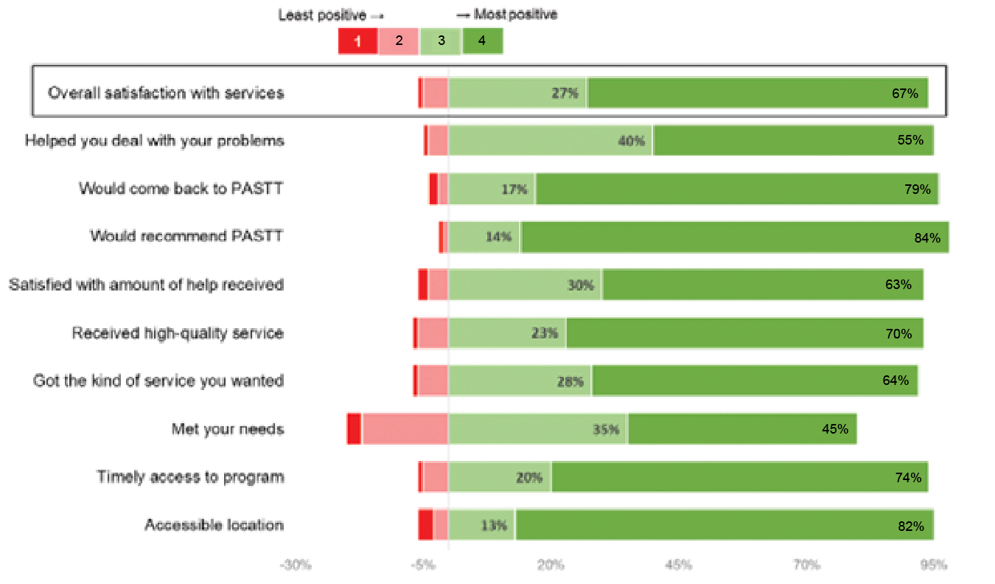

***Figure 5*. STARTTS client satisfaction questionnaire responses received between 2016-2021 (N=574)**

#### 3.4.2 STTARS client satisfaction outcomes

In March 2022, STTARS engaged an experienced torture and trauma counsellor to interview people who had previously received services from STTARS. A series of questions were asked about individuals’ experience of accessing STTARS services and the outcomes achieved. Interpreters were used in most interviews. Where possible participants were asked to verbally rate their experiences using a Likert scale from 1 (lowest) to 4 (highest) and to provide comments to add context where comfortable.

A total of 32 interviews were conducted. **Figure 6**summarises the quantitative outcomes from these interviews. Responses were strongly positive for all questions. Overall, 90% of respondents were satisfied or very satisfied with the services received at STTARS; 96% selected the most positive response (“very much”) when asked whether the service was delivered in a way that responded their culture and background; and 96% responded positively when asked whether they received a high-quality service. Qualitative comments from clients

about these ratings were also overwhelmingly positive. Low scores for ‘ability to complain about service’ were reported by clients as being related to personal beliefs, or their culture or religion, rather than a lack of agency processes to do so. Clients who reported lower levels of satisfaction with the agency (in the ‘overall satisfaction’ question) rarely explained this score with supporting information.

However, the few that did were again dissatisfied because they required assistance beyond the scope of the agency. For example, one client responded:

*“STTARS hasn’t done anything special for me. I had headaches…they helped me with my headaches. When I was in Malaysia and came here and I was in debt. I had taken lots of money from many people. I asked for help from STTARS but they didn’t help with the money and so I left STTARS.”*

Consequently, there may be an opportunity for FASSTT agencies to **better communicate with clients** regarding services that the agency can and cannot provide them at the outset of engagement.

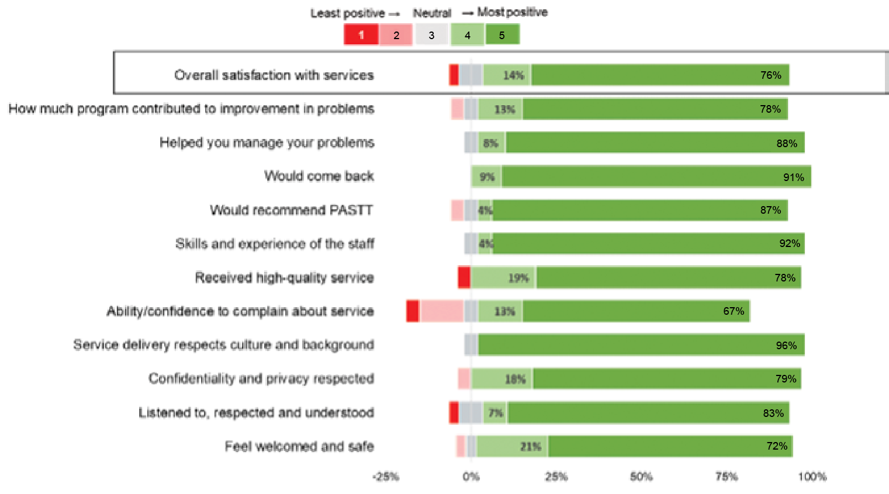

***Figure 6*. STTARS client satisfaction interview responses received March 2022 (N=32)**

###### Feedback supporting client-centredness and appropriateness

Additionally, qualitative client feedback recorded as part of this interview process which supports PASTT’s acceptability, client-centredness and appropriateness is presented below.

*“How I describe is they [STTARS] give service according to our needs, according to our problems… it’s what happened to me.”* ***Client 1***

*“I can say that the good thing is people are coming from different countries with languages. They try to solve different problem especially for people with language barriers. STTARS is a good place”* ***Client 2***

*“[My counsellor advocate] respects a lot my culture and religion. When there was a problem in Afghanistan, some people were killed, he called me and send messages saying I am there for you.”* ***Client 3***

*“When you found people who makes you feel comfortable [STTARS] you feel safe with them to say everything that’s bothering you… if you with someone who doesn’t make you feel comfortable you cannot say anything.”* ***Client 4***

*“We came from a war zone. STTARS would help in managing of getting what we went through during the war. We were depressed. We experienced horrific things, but you guys helped us without us noticing how to deal with it. I am very, very happy with STTARS. I don’t know what I would have done especially because of our background.”* ***Client 5***

*“I cannot say 5/5, I would say 10/5. They have provided very good service without them I would have been lost. I don’t know what I would have done without them”.* ***Client 6***

#### 3.4.3 Satisfaction of interviewed clients

The interviewed PASTT clients reported being very satisfied with the PASTT services they accessed and other services offered within the FASSTT agencies. Case studies C7

to C6 (**Appendix 3**) provide details about the clients’ experiences which were overwhelmingly positive. The clients appreciated the flexible, client-centered, tailored, and culturally sensitive approach. This assisted one client (C3) in feeling safe enough to open up and share very sensitive pre-arrival stories that had never been shared before, and made the client appreciate their own journey of survival. This client was very satisfied with the counselling service; the counsellor advocate created a welcoming and comfortable environment and established a good rapport with the client who was surprised to be able to share

very personal stories with a counsellor in the first session. Another client (C4) commented that the agency provided a safe and secure environment which allowed them to calm down and commence rehabilitation. The same client expressed strong feelings about the need to recognise the agency’s work because it allows refugee communities to heal and contribute to society. Yet another client (C6) praised the agency’s intake process system by which they were ‘matched’ with an understanding, responsive and respectful counsellor who adapted each session to what the client needed at the time. This client spoke very positively about counselling services which were very beneficial in their rehabilitation journey, allowed them to

overcome negative thoughts, and left them feeling “lighter”

after every appointment.

## Appropriateness and acceptability findings

**Finding A1.** Culturally appropriate approaches (e.g., community healing) and needs-based support (e.g., helping with schooling, advocacy, settlement) are equally important for improving clients’ well-being as therapeutic approaches (e.g., counselling). Mainstream care was not perceived to be appropriate to meet the complex needs of many PASTT clients.

**Finding A2**. PASTT demonstrates high levels of appropriateness in meeting client needs and improving access and outcomes for refugee communities.

**Finding A3**. The three defining features of PASTT’s appropriateness are: (1) delivery of a specialised culturally responsive and trauma-informed service model; (2) establishment and maintenance of a connection to community; and (3) flexibility in approach regarding how, when, and which services are accessed and delivered. Any future iteration

of PASTT should seek to retain these three key features at its core.

**Finding A4.** There is a continued need for PASTT to build the skills and capacity of mainstream services to respond to and care for refugee clients appropriately.

**Finding A5**. Building and sustaining a long-term connection with communities is essential if PASTT is to reduce stigma and contribute to early intervention and prevention work.

**Finding A6.** The Forum of Australian Services for Survivors of Torture and Trauma (FASSTT) is effectively facilitating the funding allocation and service delivery of PASTT. However, to support sustainability consideration should be given to

leadership succession planning and maintaining a successful and timely democratic decision-making process.

**Finding A7.** The flexibility provided in PASTT contracting agreements is a strength of current governance arrangements as it allows individual FASSTT agencies to maintain autonomy, be innovative, and respond to local needs.

**Finding A8.** Consideration should be given to reviewing current reporting requirements, performance indicators and evaluation criteria to align with PASTT’s underpinning philosophy and adequately capture the range and type of services which may be appropriate to meet clients’ needs.

**Finding A9.** PASTT is client-centred and satisfactorily meeting the needs of its clients for service delivery within its scope. There may be an opportunity for FASSTT agencies to better

communicate with clients regarding services that the agency can and cannot provide them at the outset of engagement.

**Chapter 4. Regional and rural implementation of PASTT**

This chapter considers the implementation of PASTT in regional and rural areas using stakeholder consultation and existing program data. It also draws on published literature where appropriate. This chapter focusses on answering sub questions from key evaluation questions one and three as outlined below.

− Key evaluation question one: How appropriate is the PASTT model? (suitability of the delivery model and funding arrangements in regional areas)

− Key evaluation question three: How effective has the program been? (achieving program objective of regional and rural service delivery)

This analysis of the implementation of PASTT includes ‘what has’ and ‘what has not’ worked in when providing activities in regional and rural areas, along with how

this impacts PASTT’s ability to effectively address client needs. This is important to consider in the context of this evaluation as the nature of regional and rural communities necessitate service delivery in different ways to that in urban locations41. It draws largely on qualitative analysis which has occurred after extensive consultations with FASSTT agency CEOs, staff members, and external stakeholders. This is supported by national settlement data and quantitative analysis from agency reports

where appropriate. Where relevant, illustrative quotes are

provided to highlight points. Additional supporting quotes can be found in **Appendix 9**.

## Classification of regional and rural areas

For migration purposes, Sydney, Melbourne, and Brisbane (including Logan) are categorised as metropolitan locations by the Department of Home Affairs - all other locations are categorised as regional42. For FASSTT agencies however, service delivery is best categorised as:

− Metropolitan: based within the capital city and surrounds of the FASSTT agency state/territory office (as depicted in Chapter 1, **Figure 1**. FASSTT Member Agencies in Australia).

− Regional and rural: any service delivery occurring beyond the limits of the capital city e.g., Launceston in Tasmania; Wagga Wagga in New South Wales; and Cairns in Queensland. This mostly (but not always) includes localities classified as rural or remote by the Modified Monash Model (MMM)43.

The FASSTT agency service delivery categorisations are adopted throughout this chapter and have also been used in economic analysis in **Chapter 6**

## Implications of settlement in regional and rural areas

Traditionally, locations outside of Australian capital cities have received only a small proportion of humanitarian entrants each year. However, more recently, settlement policy from both Commonwealth and state governments has encouraged regional settlement as a means of achieving mutual long-term benefits for communities, refugees, and Australia as a whole44. The Australian Government now has a target of 50 per cent of

humanitarian entrants to be settled in a regional location by 202242. The locations of such regional and rural settlement sites are decided by the Department of Home Affairs however some refugees may also choose to resettle more organically in non-metropolitan regions. As a result of these policies and practices, over one-quarter of all humanitarian entrants in 2019-2020 settled in regional or rural locations (**Table 5**).

*Table 5*. Growth in proportion of humanitarian entrants to Australia settling in regional and rural locations from 2016 to 2020 (source30)

|  |  |  |  |  |
| --- | --- | --- | --- | --- |
| **Proportion of all humanitarian entrants settled in regional or rural locations** | **2016/17** | **2017/18** | **2018/19** | **2019/20** |
| **Nationally** | **11%** | **21%** | **27%** | **27%** |
| Tasmania | 43% | 53% | 53% | 75% |
| Queensland | 22% | 42% | 46% | 56% |
| New South Wales | 9% | 19% | 27% | 27% |
| Victoria | 10% | 16% | 20% | 15% |
| South Australia | 5% | 7% | 11% | 8% |
| Western Australia | 3% | 2% | 2% | 3% |
| Australian Capital Territory | 0% | 0% | 0% | 0% |
| Northern Territory | 0% | 0% | 0% | 0% |

This has implications for programs such as PASTT, which aim to support the needs of all resettled refugees in Australia, regardless of geographical location. Consequently, despite FASSTT agencies being based in capital cities in each state, 16% of their clients nationally now reside in locations beyond these cities (in regional locations). This figure is

as high as 38% in Tasmania, 25% in Queensland, and 22% in New South Wales (**Table 6**). For some states, such as Queensland and New South Wales, this includes areas classified as rural or remote by the MMM (e.g., Toowoomba, Townsville, Cairns, Wagga Wagga, and Coffs Harbour).

*Table 6*. Proportion of PASTT clients residing in regional and rural areas: 2017/18 to 2020/21*

|  |  |  |  |  |
| --- | --- | --- | --- | --- |
| **Proportion of all PASTT clients residing in regional or rural locations** | **2017/18** | **2018/19** | **2019/20** | **2020/21** |
| **Nationally** | **11%** | **14%** | **15%** | **16%** |
| Tasmania (Phoenix) | 18% | 21% | 31% | 38% |
| Queensland (QPASTT) | 14% | 24% | 25% | 25% |
| New South Wales (STARTTS) | 20% | 21% | 23% | 22% |
| Victoria (VFST) | 0% | 4% | 6% | 8% |
| South Australia (STTARS) | 9% | 7% | 8% | 8% |
| Western Australia (ASeTTS) | 0% | 0% | 0% | 0% |
| Australian Capital Territory (CH) | 5% | 4% | 2% | 2% |

*Data not available for Northern Territory (Melaleuca). All Tasmania (Phoenix) regional and rural clients reside in Launceston.

The FASSTT agency stakeholders interviewed did not express criticism of government policies related to regional settlement, or of the resettlement of refugees in non-metropolitan areas: PASTT goals and processes put in place to deliver services to regional and rural communities were highly valued by organisational stakeholders. Rather, they were concerned by the challenges that existed in being able to provide services to clients, in an equitable manner compared to service provision in metropolitan areas. These challenges have persisted despite FASSTT quarantining

$2 million of its 2021 budget for regional and rural service delivery. The following sections summarise outcomes

of the analysis completed relating to the three main concerns for adequately meeting the objective of regional PASTT delivery:

− Balancing service demand and capacity

− Metropolitan versus regional and rural delivery: a false dichotomy

− Need for tailored state-based models of care

These points are discussed in further detail in the subsequent sections along with a description of factors that are contributing to these concerns. The

evaluators suggest these three elements should be given consideration in any future refinement of PASTT’s regional service delivery as they likely impact on its effectiveness in regional areas. This is important as clients in regional and rural areas have a broad a range of needs, issues, and experiences of trauma that are comparable to those of clients in metropolitan areas.

## Balancing service demand and capacity

One of the key challenges to PASTT regional delivery is balancing growing demand within existing organisational capacity. FASSTT agency stakeholders perceived demand to be largely driven by regional settlement policies, but this has been compounded by an increasing demand for PASTT services nationally due to a growing pool of eligible clients, life-time service eligibility, and re-traumatising world events (see Section 6.3 for more details). On the other hand, capacity to deliver these services is stretched regionally due to a range of factors including limited staffing, lack of resources, few or unskilled third-party providers, newly formed community relationships, and increased costs of service delivery (**Figure 7**). Such issues are not unique to PASTT, with similar barriers noted across Australia when providing services in regional and remote settings41. Nevertheless, the different internal (e.g., organisational) and external (e.g., socio-economic, demographic, geographic, legislative, and infrastructure) challenges faced by each agency in balancing service demand with service capacity in regional and rural areas may facilitate or constrain the work they can complete. This leads to increased complexity of providing PASTT effectively to vulnerable people in regional and rural Australia.

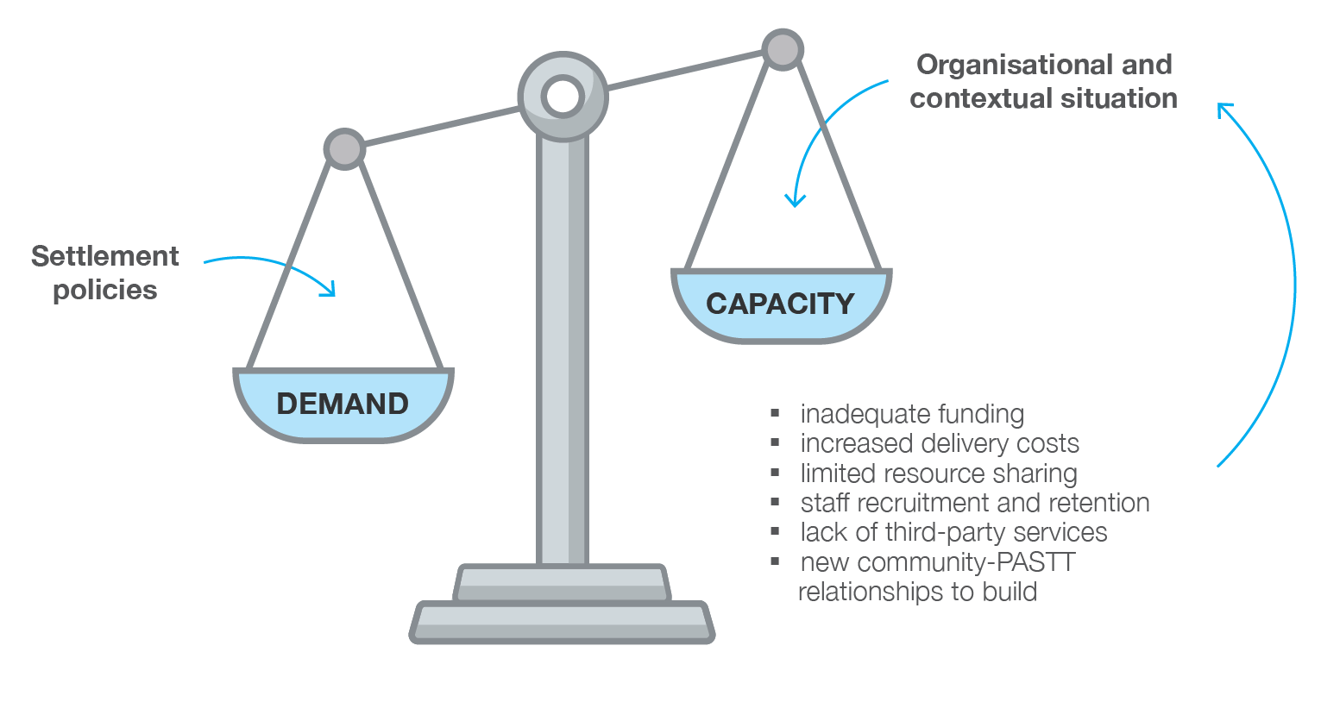

*Figure 7*. The key balance of demand and capacity for regional and rural PASTT delivery

#### Capacity: staffing and staff management

The ability to meet service demand in regional and rural areas is **highly impacted by staffing**. Interview participants reported that the FASSTT agencies had issues attracting and retaining enough regional and rural workers with adequate skills to deliver PASTTk. The number of suitable available staff in regional and rural areas was very small

due to prevailing workforce issues in country areas. This is confirmed by another data source which demonstrates the number of employed health professionals decreases with remoteness45. A poor distribution of psychologists,

psychiatrists, occupational therapists, and nurses in regional areas has also been found in previous analysis46. Additionally, it was suggested that there was little ability within existing PASTT funding to counteract this by providing incentives for people to relocate from metropolitan areas to work in regional and rural areas. Even where this had been done, for example in Queensland (**Box 3**), the FASSTT agencies were not able to offer employment conditions as competitive as other major employers (e.g., Queensland Health). These factors result in a very limited base from which to recruit employees in regional and rural areas and little likelihood of increasing the size of that base by sourcing employees from metropolitan areas.

Some interview participants associated the perceived under- staffing in regional and rural areas with the existence of long waiting lists for service in those areas. Staff turnover was also perceived as impacting on the agencies’ ability to connect and engage with communities.

*Box 3*. Strategies used by QPASTT to increase regional and rural staff recruitment

1. Immigration sponsorship of qualified counsellors (costing an additional $13,000 per staff member)
2. Higher wages incorporating a regional loading and relocation expenses
3. Provision of accommodation (additional $25,000 per region to costs)

**Difficulties in staff management and supervision in regional settings were also experienced by FASSTT agency staff.** In some cases, managers were located in metropolitan areas (because of costs in setting up rural and regional locations; see Section 4.3.3) and hence were disconnected in some ways from the staff in local areas.

Economies of scale, travel costs, and other issues (such as the lack of third-party provider services in regional areas; see Section 4.3.2) led to difficulties providing supervision, training, and professional development opportunities to staff in regional and rural locations. Difficulties in these areas had real impacts.

Without managerial oversight, staff supervision (clinical and non-clinical), training, and professional development, the quality of service provided may not be equivalent to metropolitan areas. Consequently, the risk of overwork,

burnout, stress, and vicarious trauma for employees is high. Addressing this challenge is also important as a strong professional environment including mentorship, support, and development for staff has been identified as a core component of staff retention in regional and rural areas47.

Organisational interview participants described how **FASSTT agency staff in regional and rural areas were often required to work beyond the scope of practice required in metropolitan areas**. For example, assisting refugee clients with activities such as finding suitable housing or applying for work in addition to activities more specifically related to torture and trauma recovery (e.g., counselling). This was because there was often no other local service equipped to help refugee populations meet these immediate and basic needs, particularly when clients become ineligible for settlement support after 5 years. Addressing these issues are considered fundamental to recovery, as trauma-informed interventions are unlikely to be successful unless basic needs are met first. Regionally-based staff members also often fulfil a range of roles including individual counselling, group work, community engagement, administration, and responding to client/ community needs and demands. The challenge of balancing these roles is not always acknowledged by the agencies in renumeration, resources, or supportl.

k “We’ve had a senior counsellor vacancy since September last year. We advertised that twice last year and did not get one application, and I’ve never heard of that in my life” **Interview 13, Upper management, FASSTT**

l “It’s actually quite a difficult balance to be a counsellor and also have some responsibility around community engagement and still hold that trust

and confidentiality. It’s not that our workers can’t do that, but it’s very difficult, but if there was additional resource to recognise that [role]…”

**Interview 2, Large multidisciplinary group, FASSTT**

In some smaller communities, **‘boundary issues’, confidentiality and other ethical considerations** were important concerns. For example, in metropolitan-based settings, counsellor and client interactions are usually confined to the time and place that counselling sessions are conducted. In regional and rural areas, interactions can extend beyond this as FASSTT employees are known in the community, have access to confidential information about other members of the community, and may interact with clients in non-professional capacities (e.g., during everyday

life). While in some ways this may be perceived as a positive for trust and relationship building in local communities, it can also present challenges for staff in balancing their personal and professional roles in the community. For example, one interviewee described how a FASSTT agency employee in a regional area was required to have two wedding receptions

- one in which close family and friends were in attendance, and another because the local refugee community became aware of their wedding and wanted to attend.

#### Capacity: local community characteristics

The characteristics (e.g., socio-economic, demographic, geographic) of the local area in which the FASSTT agency is required to work also present challenges to the provision of regional PASTT services. The interviewees reported

on issues they noted with general poverty among clients,

and challenges those clients had seeking and securing safe, affordable and suitable housing, gaining meaningful and appropriate employment, and accessing responsive, knowledgeable and experienced health services. These issues impacted the ability the FASSTT agencies had

to engage with clients and communities, and reduced opportunities to participate in rehabilitation. PASTT stakeholders were of the view that if clients’ basic health and safety needs were not fulfilled, then clients in need would not be likely to engage with FASSTT agencies and interventions, and services focused on trauma recovery were unlikely to be successful.

###### Third party providers

The availability and perceived competence of third- party providers in regional and rural areas was raised by the majority of interview participants who commented on regional and rural activities. **FASSTT agency representatives voiced that there were often fewer social, community, government, health, and specialist services available in these areas to collaborate with or refer clients to.**

*“The services to which you might want to refer our clients are not as prevalent in rural and regional areas, there might be ‘one of’ rather than ‘a number of’ providers”*

***Interview 11, Upper management; Administration and corporate services, FASSTT***

This is supported by data from the Australian Institute of Health and Welfare that shows there are less than half as many mental health specialists, nurses, and psychologists per 100 000 people in regional areas

compared to cities45. Services that were available were mostly inexperienced with refugee clients or had inadequate knowledge of trauma-informed carem.

Thus, the FASSTT agencies believed they were less able to refer clients out of PASTT and were not always confident that it would be beneficial for clients to do so.

Ultimately, this challenges the ability of PASTT to provide holistic care unless the agencies dedicate time to training and capacity building of these regional service providers.

As in previously reported research48 resource constraints also become more apparent in regional Australian settings and play a role in limiting service delivery. In metropolitan areas, FASSTT agencies were often able to share resources and work with other providers, but this was much harder in regional and rural locations where there were few services and a low number of clients who may utilise expensive resources if purchased.

m “Because in the regions, people have got to do it all themselves, schools are kind of clueless, health services are clueless, haven’t used an interpreter before, there’s nothing like a legal office that might help you, or a migration agent, nup, none of that.” **Interview 3, Upper management, FASSTT**

**A key issue identified was the difficulty in providing acceptable and cost-efficient in-person interpreter services in regional and rural areas.** Some interviewees highlighted that while this was already a challenge in some metropolitan centres, it was exacerbated in country areas, and particularly new settlement regions. Relying on phone interpreters as an alternative is both costly and impractical for therapy. One set of regional stakeholders described the positive impact that employing and training a local bicultural worker had on their ability to provide culturally and linguistically appropriate services for clients, as well as the considerable cost-saving of this in-house approach. Another agency reported working with the Translating and Interpreting Service to develop a glossary in Kurdish Kurmanji to assist their interpreters.

###### Local engagement and networks

Due to settlement policies and the establishment of new settlement locations, FASSTT agencies were sometimes required to begin **working in areas where they had no relationships with local providers and no local network of suppliers**. Additionally, resettling ‘new’ groups of refugees in existing regional locations could also present challenges. For example, a ‘new group’ of refugees might be settled in an area who had different characteristics, needs, and features to groups that had previously been settled. Time and effort are needed to locate, upskill, and establish links with local providers experienced in working with this new group. Interview participants described how establishing trust and credibility, and building capacity, in regional and rural communities, particularly with respect to local suppliers and other organisations, was paramount. It took time to do so, and therefore, the effectiveness of PASTT in regional and rural locations was related to how successfully links with local suppliers and stakeholders were established and maintained. This aligns with previously identified enablers of effective rural service delivery including reciprocity between providers within a community, links with service providers, shared infrastructure, and trust with communities41.

Community readiness, local knowledge, and investment in community development are key enablers to effective and sustainable regional service delivery41. Yet, many interviewees commented on the **difficulty in conducting community capacity building activities with regional and rural refugee communities**. Gaining community trust and establishing and maintaining interpersonal relationships with key figures in local refugee communities was of importance in conducting successful community development activities. It was highlighted in many interviews that having a stable and visible physical presence in local communities where refugees were settled in regional and rural areas was needed to do thisn. However, some interview participants described difficulties in locating suitable physical locations in regional and rural areas and obtaining necessary plant and equipment. Fly-in-fly out models of service delivery have been trialed before but are perceived to be ineffective, costly, unsustainable, and less preferable to clients.

n “People from those areas see that as an organisation we [PASTT] are validating the space by having a physical presence”. **Interview 16, Rural and regional services, FASSTT**

#### Capacity: inadequate funding

###### Increased costs of delivery

**Regional and rural delivery of services by FASSTT agencies is more expensive than in metropolitan areas.** AusHSI’s previous analysis of costs per client for STARTTS, QPASTT, Foundation House, and Phoenix (**Appendix 5**) demonstrated increased costs of service delivery in non-capital city locations. Similar increases in operational budgets for remote Queensland hub and spoke health services have also been reported in the literature49. This was also a critical issue for PASTT stakeholders with the majority of interviewees who were asked about regional and rural service delivery

commenting on costs. An exploration of drivers of capital city vs regional costs is presented in Section 6.3.3, however key pressures included:

− Renting or purchasing appropriate facilities in regional areas which was untenable for some agencies, particularly where there was a small or highly dispersed client population

− Overheads being generally more expensive in regional and rural areas. For example, telecommunications, petrol for vehicles, and the higher quality of technological devices required to effectively connect and operate in these areas

− Significant amounts of travel for frontline staff (who serviced large areas) and managers (to maintain appropriate oversight of frontline staff activities). Travel could be costly in time and money, and sometimes required hard decisions to be made between the costs and benefits of different travel modes (e.g., driving versus flying in a large state like Queensland).

###### Provision of a comprehensive service

Despite increasing regional settlement and higher client costs associated with PASTT delivery for these areas, the current funding distribution model agreed by FASSTT agencies does not apportion additional funding to those states with higher rates of regional settlement.

Consequently, while FASSTT agencies aim to provide the same level of care and comparable services in the regions, this is rarely the case. Many stakeholders expressed concern regarding inequity in the ability to provide, what they suggested were, more comprehensive and effective services beyond ‘base services’ they currently delivered in regional and rural areas. For example, counselling and client-level support could often be provided within the constraints of regional services, however capacity building of mainstream providers and communities, and advocacy work was often limited or slow to progress due to the reasons already highlighted in this chapter.

*“We actually need more than just a couple of counsellors on the ground in those regional areas. We do need a community development worker or a youth engagement worker. We do need someone who’s able to do some sector development, but again, our resources just don’t spread”*

***Interview 1, Upper management, FASSTT***

As a result of this insufficient resourcing, some metropolitan based programs or activities with evidence of benefit and efficacy for clients are not provided in regional areas. For example, STARTTS has a research-backed program based on neurofeedback as an intervention offered only to metropolitan clients. Several other FASSTT agencies have similar expanded programs, services, and interventions delivered only in metropolitan areas which are often not funded by PASTT but act in ways that are complementary to it. Most FASSTT agency representatives said that it was unlikely that their organisation would be able to provide additional services and activities in regional areas due to the financial cost of doing so, the lack of facilities or appropriately trained staff, or the lack of surrounding and supporting infrastructure.

While PASTT funding may be better allocated or increased to address some of these issues, inherent systematic challenges are likely to remain (e.g., workforce shortages). Consequently, it may be pertinent to discuss whether the PASTT model of care needs to be re-engineered for regional services. A key question will be what services should clients of different sized communities, in different geographical locations, be able to equitably access and how can that be achieved (e.g., telehealth, local partnerships)? This approach of locally adapted regional service delivery aligns with the National Strategic Framework for Rural and Remote Health50.

## Metropolitan versus rural and regional: a false dichotomy

Research highlights the variability and diversity of Australia’s regional and rural communities51, 52. Evidence gathered from consultations with PASTT stakeholders affirmed this perspective. Interviewees asserted that the tendency to assume that refugee communities can be homogenously grouped into ‘those who live in cities’ and ‘those that live

in regional areas’ represents a false dichotomyo. This is because the needs and challenges of one regional and rural refugee community may be very different from the needs and challenges of another regional and rural community (even in the same state). Consequently, recognition of the substantial variation that occurs between regional and rural refugee communities within and across FASSTT agency boundaries is necessary.

The impacts of these regional differences are interwoven into the way FASSTT agencies operate to effectively deliver PASTT in non-metropolitan areas. As a result, no ‘one

size fits all’ approach has been used in regional PASTT implementation (see Section 4.5 below). Rather, FASSTT agencies have developed locally relevant solutions, an approach which is encouraged in the National Strategic Framework for Rural and Remote Health50. This is also congruent with PASTT’s defining feature of flexibility and adaptability to meet client and community needs. While the overall funding amount may not be sufficient to deliver the scope of regional services required, the inherent ability to use available funding for a range of purposes (e.g., respond to emerging needs) was however highly regarded by regional PASTT stakeholders. One FASSTT agency member working in regional community capacity building described it as such:

*“...the differences in those needs between each regional area can be quite substantial, indeed, so too can the communities that each of those regions is working with, so in terms of having funding that is flexible and allows us to be specific to their needs is, you know, PASTT is brilliant for that”.*

Interview 10, Community capacity building participant, FASSTT

o “[each rural/regional service] carries its own set of circumstances. The reality is that rural and regional isn’t one big group, it’s a number of different areas that have their own aspects to work with and that we’ve needed to develop strategies to support people in those areas” **Interview 11, Upper management; administration and corporate services, FASSTT**

## Need for locally relevant models of service delivery

The need to deliver locally relevant models of regional and rural service delivery to meet the needs of diverse communities within the constraints of each agency’s existing capacity is further explored in this section. Key themes are highlighted in **Figure 8**.

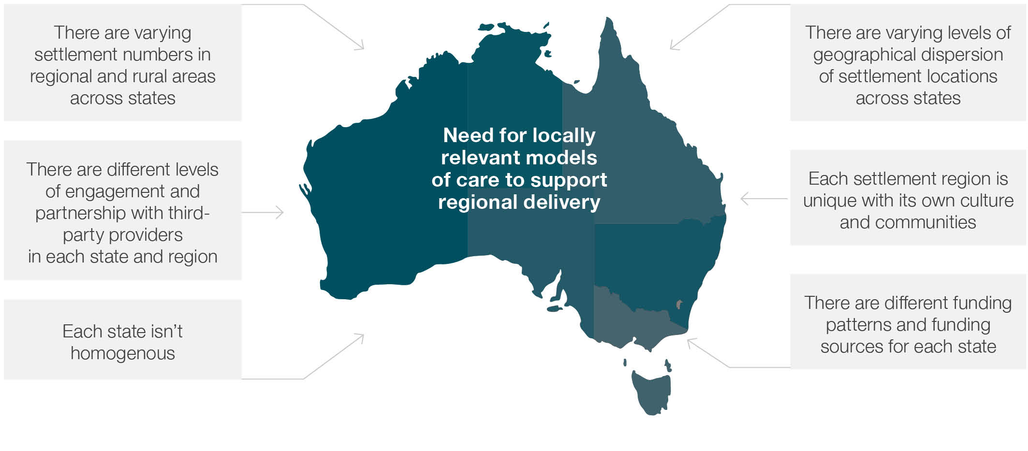

*Figure 8.* Key themes supporting locally relevant models of service delivery for regional PASTT implementation

#### Regional reach of FASSTT agencies

Given the close alignment of PASTT with the Humanitarian Support Program (HSP), it is unsurprising that the regional reach of PASTT mirrors the settlement locations supported by that program. To visualise this reach, **Figure 9**maps settlement locations in eleven different regions where HSP providers operate (red and green markers). Green stars highlight the location of FASSTT agency metropolitan offices.

As a result of these differences in national settlement patterns and HSP support across states and territories, the FASSTT agencies have different amounts and types of engagement in regional and rural locations. Some agencies have only minimal reach, engaging in a minority of locations with minimal staffing while others have large and comprehensive programs. For example,

− STARTTS (New South Wales) has locations and services in most areas except far western NSW

− QPASTT (Queensland) operates in several regional and rural locations, namely Toowoomba, Cairns, and Townsville

− Foundation House (Victoria) and STTARS (South Australia) have varying levels of engagement in regional and rural service provision.

− Phoenix (Tasmania) operates in Hobart and Launceston via offices of The Migrant Resource Centre Tasmania. Launceston is classified as regional service delivery by Phoenix.

− Companion House (Australia Capital Territory) does not engage in any significant regional and rural service delivery, and this will only change if there are new regional/rural settlement sites (e.g., Goulburn)

− Melaleuca (Northern Territory) does not provide services outside of Darwin

− ASeTTS (Western Australia) does not operate services outside of Metropolitan Pert

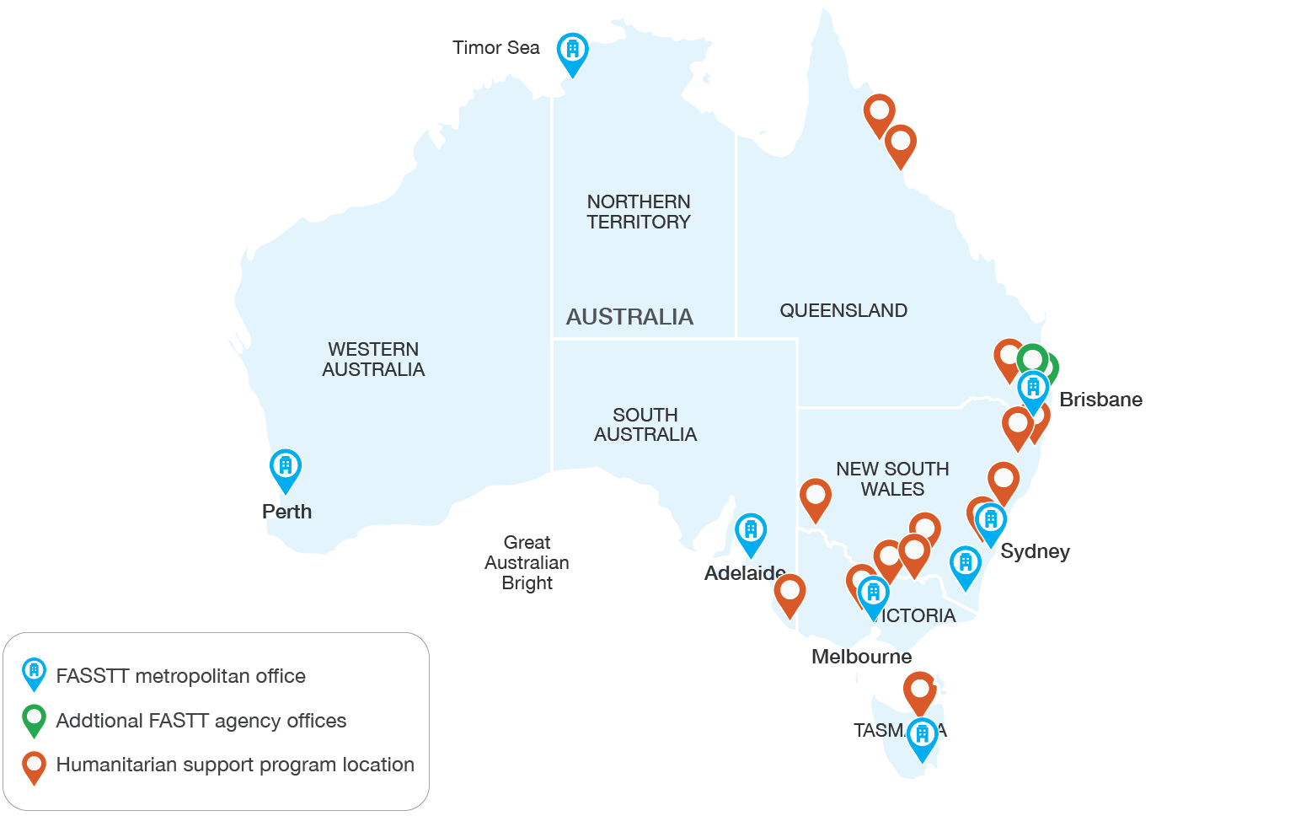

*Figure 9*. Map of settlement locations supported by the Humanitarian Settlement Program (HSP). Data taken from 53

Given this variation in reach, it is unsurprising that each FASSTT agency that conducts activities in regional and rural areas does so according to their own unique state-based model of care. **It is the non-directive, flexible and**

**adaptable nature of the PASTT program that facilitates each FASSTT agency to work in regional and rural areas using models of care appropriate to the local and state-based context.**

###### Determinants of reach and service delivery

Some interviewees suggested that the geographical size of the state or territory was connected to the ability of the FASSTT agency to provide PASTT in regional and rural areas. However, given the apparent success of STTARTS in NSW, **it is unlikely that geographical size is the single explanatory factor regarding the success of regional and rural service delivery**. Factors such as the total settlement intake, proportion of total clients in regional areas, and distance of regional settlement locations from capital cities may be more relevant. State-based funding sources or partnerships also facilitate regional service delivery in some instances.

QPASTT provides an interesting example to demonstrate the convergence of geographical size, number and dispersion

of clients, and other issues in impacting regional and rural service delivery. Firstly, the driving distance from Brisbane to two of QPASTT’s regional locations (Cairns, Townsville) is 15-20 hours, whereas all of the regional NSW localities are less than six hours drive from STTARTS’ base in Sydney.

Consequently, this has impacts on how these sites can be effectively and efficiently serviced. Additionally, while only 19% of the Queensland population live in MMM2 defined rural regions54, 50% of QPASTT’s eligible clients (resettled refugees) currently reside in these areas. Finally, Toowoomba is the only regional location nationwide to consistently rate in the top

10 settlement locations by number of arrivals annually30. This combination of factors, plus Queensland experiencing the highest cost of service delivery outside a capital city (**Table****15**, **Chapter 6**) is likely driving the challenges in regional service delivery QPASTT is currently experiencing.

#### Regional models of service delivery employed by FASSTT agencies

In discussions with key stakeholder participants, three major strategies that FASSTT agencies use to connect and provide services in regional and rural locations were identified. These were:

1. Establishment of local offices and staff, usually in shared facilities with other services (e.g., QPASTT)
2. Partnering with local third-party organisations (e.g., STARTTS)
3. Digital solutions (e.g., telehealth) (e.g., all agencies)

As summarised in **Table 7**there are advantages and disadvantages to each of the models. Importantly, there is limited published research evaluating the effectiveness of any of the models presented41. Some agencies engaged in a mix of these strategies as part of their overall model of care. For example, there was indication that most FASSTT agencies utilised digital solutions alongside

the other strategies, particularly during the COVID-19 lockdowns. QPASTT indicated that for some rural and regional areas they operated local offices in a shared arrangement with other services and that they had staff, particularly managers, operate in local areas in a part- time capacity (e.g., Fly In-Fly Out).

Ultimately, there is a need to understand that while the PASTT client base in regional and rural areas is

growing, service delivery models that are appropriate for

metropolitan communities do not always translate well into regional settings. There is a pressing need to design,

deliver, and support regional and rural health services using more flexible, innovative, and locally appropriate solutions, without compromising the quality and safety of care.

Table 7. Advantages and limitations of models for regional and rural delivery of PASTT services

|  |  |
| --- | --- |
| **Advantages** | **Disadvantages/Limitations** |
| **Local offices** | |
| * Physical presence to maintain local relationships with suppliers and refugee communities * Control over processes, activities, programs, and interventions * Direct management of staff | * Very costly to set up and maintain * Lacking economies of scale necessary to make this model viable over the long-term * Attempting to reduce costs by sharing facilities with other local services limits space available and impedes on client privacy |
| **Partnering/subcontracting with local providers** | |
| * Local knowledge and networks can be leveraged, leading to better care for PASTT clients * Long-term cost savings when compared to the cost of establishing their own presence in the location | * No physical presence or direct visibility of FASSTT agency in local community * Existing skilled third-party providers required in area of resettlement * Need to establish and maintain relationships with third- party providers ‘by distance’ * Ongoing time and cost in maintaining appropriate oversight of the local provider to ensure that they are working in accordance with the FASSTT agency goals and PASTT requirements and principles |
| **Digital solutions** | |
| * Counselling activities can be provided to geographically dispersed participants without the financial cost and difficulty of setting up a local office * Counselling activities can be provided directly without engaging a local partner, ensuring greater control over service delivery * Travel costs in terms of both money and time are eliminated | * Clients sometimes have limited access to devices or do not have access to a private or safe location to engage in digital or virtual counselling * Clients sometimes have limited experience using applications and programs (e.g., Zoom) * For some issues, digital solutions were not effective, adequate, or able to be employed * Reliability and/or comprehensiveness of telecommunications infrastructure is poor in some rural and regional communities * Other costs in providing staff with devices and software including, for example, licensing costs for software * For many clients, face-to-face therapy is still the preferable option |

## Findings

**Finding R1.** Overall, the findings support a need for PASTT delivery in regional and rural communities, however the service delivery models used in metropolitan areas have not been fully realised in regional settings.

**Finding R2.** Balancing service demand and organisational capacity is a key challenge for regional and rural PASTT delivery. Capacity to respond is impacted by organisational factors (e.g., resourcing, staffing) and the region’s geographical context (e.g., higher cost of service delivery, limited workforce, and lack of third-party providers).

**Finding R3.** Regional and rural communities are not homogenous so a single model to fund or deliver all regional PASTT services is not appropriate.

Rather, it is important to support and encourage the development and delivery of locally relevant models of care.

**Finding R4.** The non-directive, flexible and adaptable nature of the PASTT program and its funding facilitates each FASSTT agency to work effectively in regional and rural areas using models of care appropriate to the local and state-based context.

**Finding R5.** The three major strategies used by FASSTT agencies to adapt PASTT delivery for regional and rural areas are: (1) establishing local offices to provide direct service delivery;

(2) partnering with local third-party organisations to deliver PASTT services; and (3) using digital solutions.

**Finding R6.** FASSTT agency staff in regional and rural areas are often required to work beyond the scope of practice required in metropolitan areas (e.g., assisting refugee clients with finding suitable housing or applying for work).

**Finding R7.** There is a need to dedicate time and funding to training and capacity building of mainstream regional service providers and undertaking regional community development

work to enable holistic delivery of PASTT in these communities.

**Finding R8.** PASTT funding could be better allocated or increased to address some of the current challenges in regional service delivery. However, inherent systematic challenges associated with service delivery in regional and rural Australia are likely to remain. Consequently, it may be pertinent to discuss whether the PASTT model of care needs to be re-engineered for regional services.

**Chapter 5. Outcomes achieved**

This chapter examines the outcomes and impact of PASTT using existing administrative and program data, previous agency evaluations, a partnership/engagement survey, case studies, and stakeholder consultation. It also draws on published literature where appropriate. The focus of the chapter is key evaluation question three: *How effective has the program been?*

Quantitative analysis has been undertaken based on a review of existing organisational documents including annual PASTT reports and via specific requests for data on client numbers, service delivery and engagement activities, and client reported outcomes (goal setting, WHO-Five wellbeing index). Quantitative and qualitative data was

also analysed from an engagement questionnaire sent to a range of external PASTT stakeholders. Descriptive

analysis of data, including trends over the past five financial years where available, is presented. In addition, qualitative analysis has occurred after conducting interviews with PASTT clients, reviewing case studies and client feedback interviews conducted by FASSTT agencies, and extensive consultations with agency CEOs/directors and staff members. Where relevant, illustrative quotes are provided to highlight points. Additional supporting quotes can be found in **Appendix 9**and client interview case studies in **Appendix 3**.

The following sections summarise analysis completed relating to:

− Client-level outcomes

− Service provider and health system level outcomes

− Community-level outcomes

## Considerations and limitations in measuring outcomes

As with any health or social services evaluation assessing a broad range of activities and outcomes, limitations in the robustness of the data means that it is not possible to make causative attributions. To increase robustness, quantitative and qualitative data have been used to undertake the evaluation while acknowledging limitations. The considerations and limitations discussed below shaped data collection and analysis and ultimately informed the evaluation response.

#### 5.1.1 Multilevel impact of PASTT

Given that the activities of PASTT occur at the client, health service, and community level, outcomes should also reflect impact across this same range of settings (**Figure 10**). All stakeholders interviewed also reiterated the importance of considering PASTT’s impact across multiple layers of the system. Impacts at the client level and provider level were easier to document for agencies compared to community level impacts which often

take many years to eventuate. However, evaluation of such impacts is important as programs that support community and social healing processes can be powerful and cost-effective tools for enhancing the lives of many14.

Additionally, impacts on individual clients can have flow on effects to their families and communities which may be missed if focusing only on proximal impacts of counselling and recovery.

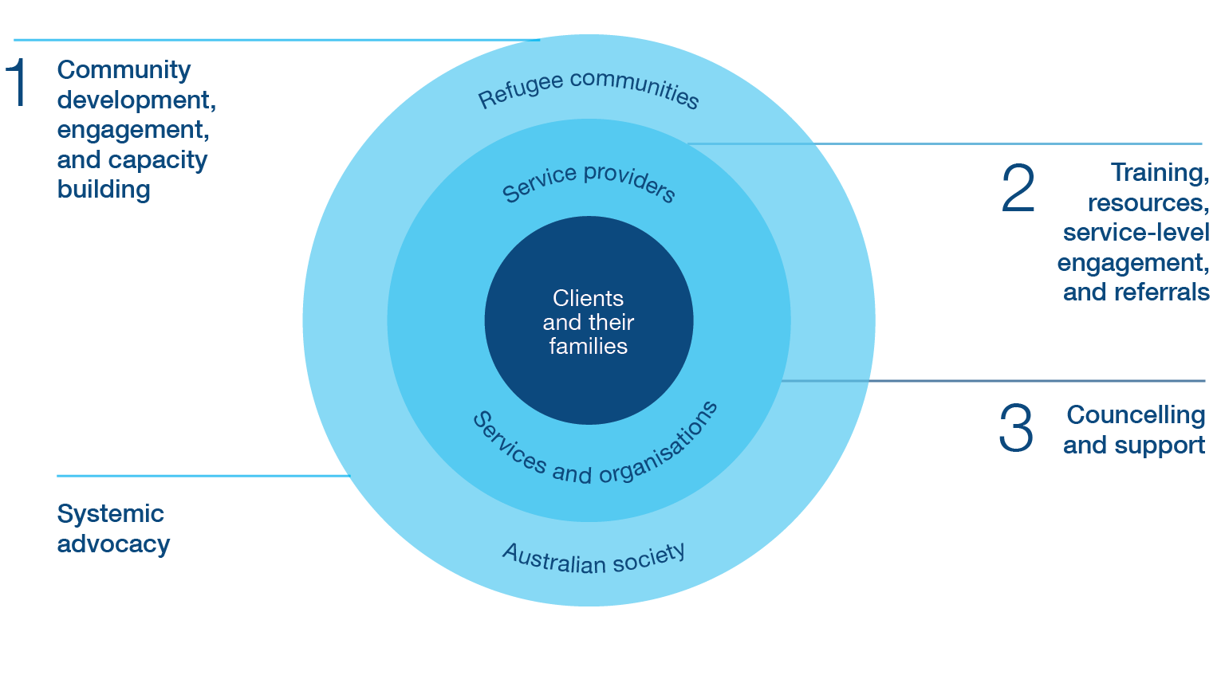

*Figure 10*. Multi-level impact of PASTT activities

#### 5.1.2 Challenges evaluating social service programs

One key challenge in PASTT evaluation is that FASSTT agencies undertake work that can be difficult to quantify and attribute in a meaningful way. In part this is because of their varying activities, wide reach, long or varying duration, individualised nature, and multitude of potential outcomes. Tracking and isolating long-term impact is also difficult in the dynamic environments where these agencies are providing a range of services in collaboration with other partners (for example, demonstrating PASTT’s contribution and impact to a policy change). This challenge is also reflected in the literature, with research evaluating the effectiveness of social service programs for refugee communities limited and lacking methodological rigour13.

Consequently, there needs to be nuance in how the impact of PASTT is understood, and acknowledgement that some forms of work (e.g., community development) face challenges in evaluation. For such programs, service effectiveness is often seen as success across a number of hard or measurable indicators, such as an individual’s employment, health, or English language proficiency.

However, previous research55 has reinforced the importance of subjective indicators to understand whether refugees are achieving outcomes that are personally meaningful. Therefore, to provide a full picture of the effectiveness of PASTT, a comprehensive approach should be taken to capture all the elements of the program, process, and context in which the program is delivered, using both objective and subjective measures of impact.

#### 5.1.3 Limitations of available program data

Current data for the program provides only a partial picture to assess whether PASTT meets its objectives and outcomes. The expert opinions of FASSTT agency staff, staff from other stakeholder organisations, and available administrative and program data (supported by relevant literature), are the principal sources for most of the key findings. Inconsistencies were sometimes found in the reporting of activities and participants between different

data sources from the same agency for the same reporting period (for example, activity work plans compared to data tables submitted to funders). Additionally, data for sector development/training and community engagement was not reported in consistent ways across agencies. For example, description was not provided of how agencies counted the number of organisations represented at

large multi-disciplinary training events. Finally, community engagement work would benefit from tighter definitions or categorisations of activity/engagement type that could be applied nationally, and clearer ways of highlighting events in partnership with, or part-funded by, external organisations/ groups. Sometimes it was not clear whether groups

such as parent’s or youth groups were counted in both counselling groups and community engagement activities.

## Client outcomes

The following section details findings related to PASTT outcomes at the level of the individual client. This section draws on qualitative and quantitative data, and case studies. Due to the lack of quantitative data to report measurable outcomes, the qualitative interviews with FASSTT agencies and their stakeholders were the primary data source. Analysis of qualitative data captured during client interviews provides further examination of client reported outcomes and experiences. Where relevant, illustrative quotes are provided to highlight points.

Interviewed client case studies are included in **Appendix**

**3**. Narrative case studies detail the experiences of individual clients and were developed and provided by the FASSTT agencies. Quantitative data provided by agencies supported analysis of client-reported outcomes. This includes data from 32 former STTARS clients who were interviewed about their experiences with the agency by two torture and trauma counsellors (one internal and one external to STTARS). Clients/caregivers interviewed ranged in age from 8 to 76 years and represented a range of cultures, ethnicities, and service engagement patterns.

Overall, PASTT clients experienced improved mental health and wellbeing, and increased engagement

in Australian society after engaging in the program, although challenges were experienced in achieving these improvements. Key findings related to client level

outcomes are summarised and presented in Section 5.5.

#### 5.2.1 Counselling, groupwork and complementary therapies

While PASTT has impacts on individual clients through its range of service delivery, advocacy, and capacity building activities, counselling services, groupwork, and complementary therapies are key drivers in delivering improved client level outcomes. Provision of counselling services and direct client services also takes up a

significant proportion of each agencies budget (**Table 14**). Broadly categorised, each FASSTT agency engages in individual counselling and group counselling/groupwork with PASTT clients. These services may be provided

to new clients or continuing clients. Foundation House also provides complementary therapies such as trauma informed yoga, naturopathy, massage, body work, and mindfulness to clients

###### Individual counselling

FASSTT agencies have demonstrated significant reach of counselling activities across the communities they support. On average, PASTT funding has supported FASSTT agencies to provide individual counselling services to 9,396 total clients across Australia each year between 2016 and 2021. **Figure 11**plots the Australia wide (i.e., FASSTT network) trend for individual new client counselling, individual continuing client counselling, and total individual counselling (new plus continuing) engaged in by the FASSTT agencies from 2016-17 until 2020-21. As can be seen, after a slight decline in 2017-18 the total number of clients receiving individual counselling via PASTT has remained relatively constant despite reductions in humanitarian intakes. The number of new clients decreased in 2017-18 (aligned to

a halving of intake numbers that year) while the number of continuing clients has increased. Continuing clients have comprised almost 50% of all counselling provided via PASTT since 2019.The number of new clients seen each year from 2016 to 2020 is equivalent to 30-40% of the humanitarian entrants to Australia in that same year. Although, for reasons which will be discussed in Chapter 6, this underestimates the true eligible client pool for PASTT services.

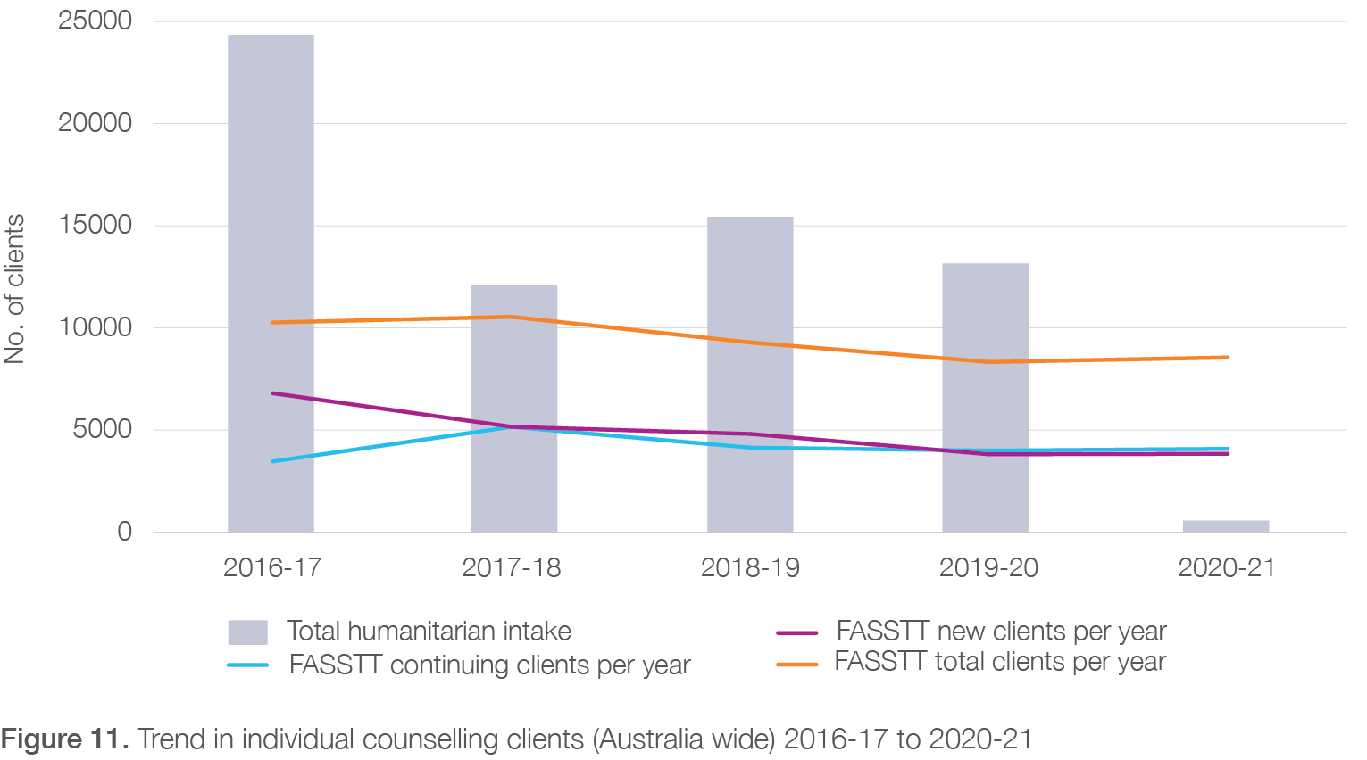

Annual targets for individual counselling are proposed by each agency in their Activity Work Plans. Analysis determined that these targets were generally met or exceeded, and sometimes by large amounts. However, it is noted that two organisations (ASeTTs and Melaleuca) had difficulties meeting individual counselling targets in 2020-21 due to lower than predicted arrivals via the Humanitarian Resettlement Program as a result of COVID-19. However, this was an anomaly and targets for following reporting periods have again been exceeded. The individual counselling activities and targets for each FASSTT agency (where data were provided) are consolidated in **Figure 12**and **Table 8**. In 2018-19, around 8% extra individual counselling activities above targets were completed while in 2019-20 about 2% extra were completed. In 2020-21 about 2% fewer than targeted individual counselling activities were completed, although the reason for this has been explained above.

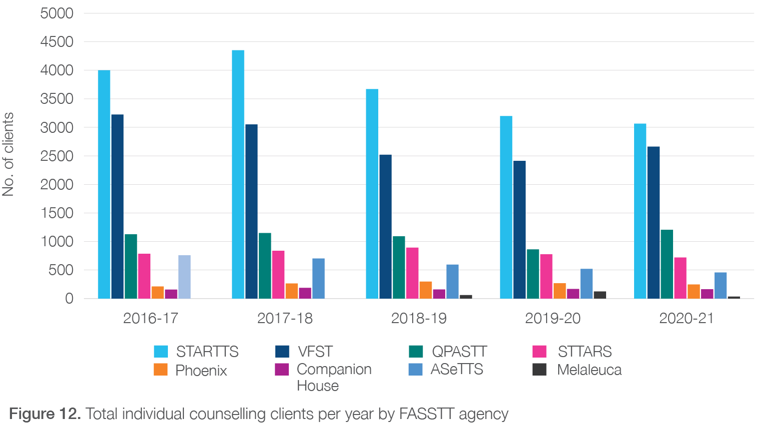

*Table 8*. Australia-wide individual counselling activities compared to target

|  |  |  |  |
| --- | --- | --- | --- |
| **Year** | **Total** | **Target** | **Discrepancy* (%)** |
| 2016-17 |  | | |
| 2017-18 |  | | |
| 2018-19 | 5024 | 4648 | 376 (8%) |
| 2019-20 | 7469 | 7340 | 129 (2%) |
| 2020-21 | 8307 | 8458 | -151 (-2%) |

* Discrepancy: positive number means that target was met or exceeded; negative number means that target was not met. Target vs total counselling activities not available for all agencies. No data provided for 2016-17 and 2017-18.

###### Group counselling and groupwork

This category of service delivery includes group counselling, psychoeducation, wellbeing and belonging group work (e.g. women’s groups, sport’s groups, parent’s groups), and youth group activities. While acknowledging some missing data exists, the total number of groups facilitated by PASTT, Australia-wide, for the past five years is displayed in **Figure 13**. On average, PASTT ran 205 groups each year over this period. The number of groups peaked in 2017-

18 declining for the following two years (impacts of reduced humanitarian intakes and COVID-19 restrictions) before increasing considerably in 2020-21. Each group held multiple sessions across these years, with the total group sessions for each agency ranging from 5 (Melaleuca) to 2,724 (STARTTS).

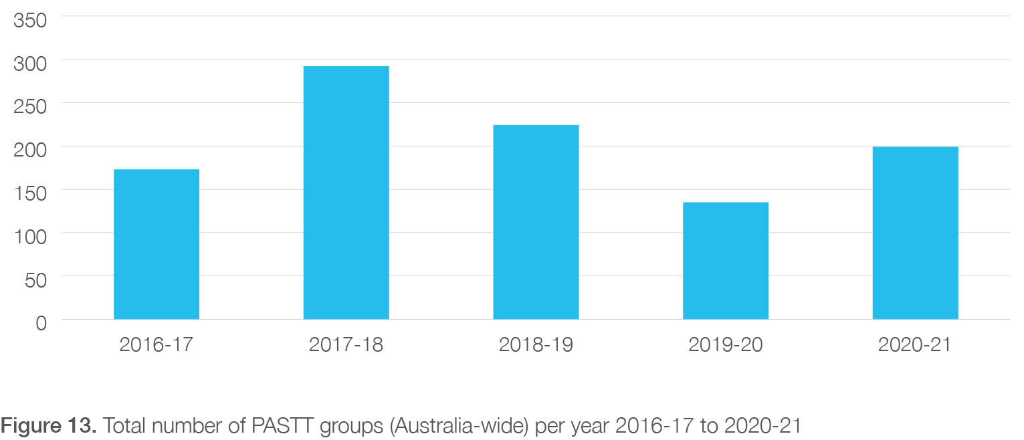

There was some variance in the number of groups conducted each year depending upon agency. In **Figure 14**, the number of groups for six agencies where full data sets were available, is plotted. The number of groups remained relatively constant for STTARS and Phoenix. There was a noticeable drop in the number of groups conducted by VFST and STARTTS in 2019-20 (due to COVID-19 restrictions/lockdowns), and a noticeable increase in the number of groups conducted by QPASTT and STARTTS in the following year (successful transition to remote working/therapy arrangements, easing of lockdowns).

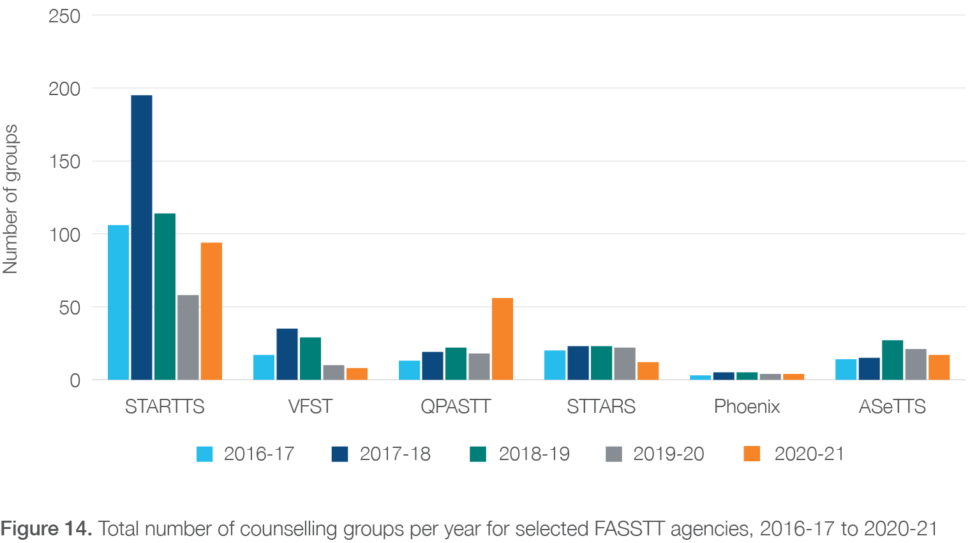

There was also more variation, compared to individual counselling activities, in meeting targets related to groupwork, however some of this is due to missing data about targets across agencies. Across the FASSTT network, about 78%, 11%, and 21% more group activities were conducted than predicted in 2018-19, 2019-20, and 2020-21 respectively (**Table 9**).

*Table 9.* Australia-wide group counselling activities compared to target

|  |  |  |  |
| --- | --- | --- | --- |
| **Year** | **Total** | **Target** | **Discrepancy* (%)** |
| 2016-17 |  | | |
| 2017-18 |  | | |
| 2018-19 | 82 | 46 | 36 (78%) |
| 2019-20 | 59 | 53 | 6 (11%) |
| 2020-21 | 139 | 115 | 24 (21%) |

* Discrepancy: positive number means that target was met or exceeded; negative number means that target was not met. Target vs total counselling activities not available for all agencies. No data provided for 2016-17 and 2017-18.

###### Complementary therapies

Foundation House (VFST) is the only FASSTT agency to offer a full range of complementary therapies (provided by specialised complementary therapy practitioners) as part of PASTT. Modalities include naturopathy, massage, yoga, and other body-based therapies. These therapies are provided alongside, or as an alternative to, counselling and biomedical treatment options. They are particularly useful for clients experiencing physical symptoms or somatic presentations. A recent evaluation of VFST’s complementary therapy program provided evidence

that it delivers positive outcomes for clients including relief from physical symptoms, and improvements in social, emotional, and mental wellbeingp. Moreover these therapies were perceived as accessible, culturally meaningful, and translatable to many clients. There

are almost no other free or low-cost complementary therapies available for refugees in Australia. Consequently, VFST provides a significant, beneficial service that is not otherwise available to this client group.

Current challenges to the implementation and sustainability of the complementary therapies program at VFST are resource related. These include long wait times, a capped number of sessions, and limited availability of staff. Additionally, the complementary therapies program at VFST was entirely funding by PASTT income for many years, but recent resourcing constraints have meant that 30-40% of the costs of this program now need to be cross subsidised from other funding streams.

#### 5.2.2 Improvements in mental health and

#### wellbeing

One of the key objectives of PASTT is to improve the psychosocial health and wellbeing of refugees who have experienced torture and trauma prior to their arrival in Australia. International research has shown that counselling, psychotherapy, advocacy, healing circles, and group support can have positive effects on mental health (including depression and distress) of refugee participants14, 15. In the qualitative interviews with FASSTT agency stakeholders, evidence for such improvements in client-level mental health and wellbeing outcomes was also found for the program, despite counsellor advocates reporting that it was often hard to see day-to-day improvement. The counsellor advocates interviewed provided several descriptions of the way that PASTT clients experienced reductions in depression, anxiety, and other psychosocial outcomes including reductions

in suicidality, and improvements in sleep and behaviourq.

This is exemplified in the client case study in **Box 4**

below. Concurrently, PASTT clients were described as demonstrating increases in self-confidence and self-esteem, resilience, self-directedness and autonomy, decision-making capability, and improvements in appearance, hygiene, and self-care practices. A key issue for survivors of torture and trauma relates to reduced ability to trust. Reports of clients experiencing increased trust in relationships, especially with counsellor advocates or therapists, were provided. This was further supported by comments provided by the interviewed clients (**Appendix 3**).

* + - 1. Foundation House complementary therapies services: final evaluation report. Emma Thomas and Jo Farmer. June 2022. *Shared with AusHSI by VFST*.
      2. *“We work at the extreme end of the trauma spectrum every single day…we don’t have easy cases, everyone has been tortured or deeply traumatised, yet in those circumstances we have very low suicide rates”* ***Interview 5, Upper management, FASSTT***

*Box 4*. Client case studies: Client 3

## Case 3 – “D”

### Background

“D” is a 57-year-old European man who arrived in Australia in 2000 with his wife and three children. While a soldier D directly witnessed and/or was confronted with war atrocities and experienced frequent and continued physical and psychological torture at the hands of prison guards and government administrators once captured by enemy forces.

D was referred to ASeTTS for counselling in 2005. Upon commencing engagement with ASeTTS D was experiencing significant psychological distress, difficulties sleeping, nightmares, severe anxiety, and depression. He presented with chronic suicidal thoughts and violent behaviours. Misuse of alcohol was affecting D’s mental and physical health and impacting D’s familial relationships. He appeared dysfunctional in all practical and personal areas of functioning.

### Engagement with PASTT

Individual torture and trauma counselling provided to D focused on his suicidal thoughts, feelings of guilt and shame. Self-esteem issues, and behavioural and relationship difficulties. ASeTTS Consultant Psychiatrist was also involved; assessing D’s psychiatric state and suicide risk, and co-managing D’s needs with the ASeTTS’ counsellor; this included implementing suicide risk protocols and regularly monitoring clinical progress. Alongside counselling and psychiatric support provide to D, D’s family was also provided counselling to develop understanding of trauma and trauma responses, and to support the family in stabilising their dynamics.

After 1-year D reported a reduction in his psychological pain and suicide risk, symptoms of anxiety and depression had reduced, family functioning was improved, and alcohol abuse had ceased.

D continued counselling for a number of years with sessions focused on addressing unresolved feelings of guilt, shame and anger in order to reduce hypervigilance, and hypersensitivity to repeated harm. Counselling also addressed ongoing issues of suicide risk, substance use, healthy relationships and family and domestic violence.

As evident is the above case study, PASTT clients represent a unique, complex, and challenging population to work with. During the interviews, the counsellor advocates and clinical stakeholders drew on their experiences with PASTT clients to provide other specific examples of mental health improvements in individuals. One interviewee described how a depressed and suicidal client, who had stopped bathing regularly,

was now practicing self-care and was an integral part of the counselling group. In another example, counselling group work with teenagers resulted in positive behavioural changes such as reductions in

aggressive physical behaviours and disengagement in gang-related behaviour. Interviewees described how their work assisted clients to get ‘better’ or to make as

much improvement as they could rather than on focusing on ‘curing’ people. Multiple interviewees highlighted

how their clients often became more engaged in the treatment or counselling process as the number of sessions increased. This engagement was viewed by the interviewees as demonstrating a form of success along the client’s journey to recovery.

For example, an interviewee discussed how a shy client with very low self-esteem, who rarely spoke in counselling sessions, had progressed to be engaged in the counselling process and to be actively using the training and other services provided by the FASSTT agency.

Clients’ autonomous decisions to reduce counselling frequency due to self-perceived improvement was also viewed similarly as a marker of success.

Similar examples of benefits to clients’ mental health and wellbeing were also reported by the interviewed clients (e.g. case study C3, C5, C6, C7 in **Appendix 3**) and observed in the STTARS client feedback interviews (described in Section 3.4.2). These examples included dealing with depression and emotions, improved relationships with family, better sleep, and initiation of medications. Direct quotes from clients obtained in the

STTARS feedback process best exemplify the importance of PASTT in improving mental health and wellbeing:

*“I remember I used to feel really, really down and they would talk to me, build my self-esteem and make me feel better. Yes, before I used to cry a lot, used to feel like someone was suffocating me and feel a lot of pressure. They used to talk to me. I still go through some of those moments. I remind myself what the counsellor used to say to me and that helps.”*

*“STTARS helped me a lot. I give high score for STTARS wherever I go. I wouldn’t be able to sleep otherwise. I had a lot of nightmares but now things are better, and I can sleep”*

*“Without STTARS I wouldn’t have been able to survive. At that time, it was very difficult, the doctors thought I wouldn’t come [good] by myself but STTARS supported me”*

*“It was really helpful when I compare from before and after of service there is a lot difference. Its good difference. I also had to take medication from STTARS help and the medications were good for me”*

It is important to note that a unique and important aspect of PASTT is its client-centredness which allows it to be flexible, adaptable, and for clients to re-engage if needed after initial treatment is completed or discontinued. The complexity of cases and the types of treatment and outcomes that are achieved, including the impact on families and the fact that many clients re-engage with PASTT, are vividly evident in the case studies provided in **Box 5**and **Box 6**(source for case studies – Foundation House). These cases also demonstrate the significant duration of engagement required by some clients, and the variety of external services engaged by PASTT via referral to improve outcomes.

*Box 5.* Client case studies: Client 4

## Case 4 – “C”

### Background

“C” is a man aged in his early 40s who is of South Asian ethnicity. He was referred by a concerned community member after receiving a drink driving charge resulting in the loss of his license. He presented with unexplained outbursts of anger, alcohol abuse, and sleeplessness. He had come to Australia on a refugee visa in 2016, accompanied by his wife and three children.

### Assessment

He was assessed to suffer from Post-Traumatic Stress Disorder (PTSD) and depression caused by (i) burning down of his village as a young man and the death of his father, (ii) dangerous transit to Malaysia, followed by 12 years of precarious living which included several detentions and police beatings, (iii) death of a child from Dengue Fever.

### PASST engagement outcomes

He attended 4 counselling sessions which included a referral to Complementary Therapies for naturopathic assistance for his insomnia. He gained full time employment which meant his capacity to attend appointments was difficult and contact continued for several months with phone ‘check-ins’. During Victoria’s lockdown due to COVID-19, in 2020 his referrer recontacted the counsellor to request his treatment be re-established, (which was possible with the assistance of telehealth) as his employment had ceased. Since then, he has primarily received fortnightly Cognitive Behaviour Therapy for 20 months. He also resumed a therapeutic connection with the

Complementary Therapist and found herbal treatment and massage beneficial. His PTSD symptoms had decreased, however, the recent genocide in Myanmar targeting Chin state, has re-triggered his nightmares and flashbacks.

In late 2020 his Counsellor/Advocate became aware that his wife was threating to leave, and the children had not been able to engage in on-line learning and this had caused additional stress and exacerbated his symptoms. A family assessment was completed, and his daughter aged 14 was linked to a Child and Youth Counsellor/Advocate as she was displaying behaviour of concern including self-harm. The family assessment has exposed a family under great pressure with financial strain, potential homelessness, disengagement with education for the children and significant conflict in the home. Both he and his daughter continue to engage in work with the FASSTT agency with regular reviews against goals set by them. Several referrals to external providers have been made including to school welfare staff (primary and secondary), emergency relief services, housing assistance organisations, community support program, and employment services provider.

*Box 6*. Client case studies: Client 5

## Case 5 – “E” (first referred 2014; re-engaged 2019)

### Background

“E” is a woman aged in her late 20s who is of South Asian ethnicity. She was initially referred by the refugee clinic at Monash Hospital because she expressed high levels of distress including suicidal ideation. Her husband had arrived via boat in 2000 and had eventually received a substantive visa. She and two of her children had arrived in Australia in 2013. She subsequently had two further children after her arrival in Australia.

### First Assessment (2014)

She was assessed to suffer from anxiety and depression. The risk assessment indicated she was of medium risk for suicide. The major protective factor was her Muslim faith and her love for her children.

### PASTT engagement and outcomes (first engagement)

E was seen by a counsellor/advocate for 14 months including 53 counselling sessions along with some advocacy and telephone ‘check ins’. Initially, weekly sessions were conducted due to the potential suicide risk, however this reduced to fortnightly and then monthly as time progressed. There was a clear plan to assist her to gain insight into her psychological presentation and provide strategies for coping with the pressures she was under. Her case was closed in mid-2015. Several referrals to external providers were made including to an ethnic Women’s Group, a GP who assisted with medication for anxiety and depression, migration legal assistance to investigate the possibility of sponsoring family to migrate to Australia, and massage therapy to assist with sleep/relaxation.

### Second Assessment (re-engagement 2019)

E self-referred with a similar presentation of anxiety and depression. She stated that the ‘bad thoughts’ were back and that she could not see a way out of her darkness. While still married, her family situation had deteriorated. There was ongoing concern about eviction from their rental property. Recent bombing targeted at Hazaras in Afghanistan had killed a relative, and her mother and sister called constantly begging to get them to safety. This led to resurgence of feelings of hopelessness. She said her days were spent alone in her house, crying, with no one to help. Her children and role as a mother were no longer as strong a protective factor.

### Treatment and outcomes (re-engagement 2019)

She resumed counselling due to the ongoing worries and preoccupation about what was happening in both Afghanistan and Pakistan. She has seen the counsellor advocate 23 times in 2019 and monthly (usually via tele- health due to COVID-19 restrictions) from 2020 onwards. There was a closure plan in place, however this was extended due to the ongoing trauma for her family overseas. At the time of writing the intention was to close this case in three more sessions. Several referrals to external providers were made including to a family violence service, a material aid provider and housing service, and Red Cross Tracing.

Improvements in mental health and wellbeing were also observed in the analysis of quantitative data made available to the evaluation by FASSTT agencies to examine client reported outcomes. This data is generated from the reflections of clients through therapy sessions and surveys conducted by PASTT program providers.

#### Client reported outcomes: WHO-5

The World **Health** Organisation-Five Well-Being Index (WHO-5) is a short self-reported measure of current psychosocial wellbeing. It has been validated for use in adults and children aged 9 and above, is available in over 30 languages and has been used with refugee populations in other settings. It has been found to have adequate validity in screening for depression and other mental health outcomes, with good construct validity as a unidimensional wellbeing scale, including in children and older people56.

The questionnaire consists of five statements in relation to respondents’ experiences over the past two weeks, with respondents rating each statement on a 0-5 Likert scale. The statements are positively worded rather than focusing on perceived hardships or negative experiences. An example item from the WHO-5 is ‘I have felt cheerful and in good

spirits’. A participant’s total raw score is multiplied by four to give a final score, with 0 representing the worst imaginable level of well-being and 100 representing the best imaginable well-being.

###### WHO-5 PASTT protocol

The following process for the collection of client WHO-5 data has been agreed by all FASSTT agencies. The protocol was officially implemented on 1st July 2020. Since this time, all agencies have implemented the protocol for all individual counselling clients and for all groups that are meeting over a period of at least three sessions. Compliance rates with the protocol are high for new clients enrolled since July 2020, however there were some difficulties experienced in bringing established clients on board in a consistent way.

For individual counselling clients, it is recommended that the questionnaire be introduced as early as appropriate in the session at the following time points:

− Initial WHO-5 administered at the earliest engagement with the client. This may be at intake or at the initial assessment

− Second WHO-5 administered at Session 5

− Third WHO-5 administered at Session 10

− Subsequent WHO-5 administered after every 10 sessions

− Final WHO-5 at closure/discharge

For group counselling that involves 3 or more sessions (including family groups), WHO-5 is administered to each group member:

− Before the intervention

− Post the intervention

− Every three months (for ongoing/long term interventions)

For pragmatic reasons, if it is not feasible for a WHO- 5 questionnaire to be administered in alignment with the agreed protocol, a flexibility of up to 2 sessions is considered acceptable. For example, if for any major

reason the WHO-5 cannot be implemented in session 10, then it should be implemented in session 11 or no later than session 12. If implemented in session 11 or 12, the next WHO-5 will be due in session 20 as per the protocol.

###### WHO-5 outcomes

Between June 2020 to December 2021, there were 1,702 WHO-5 questionnaires completed by 1,192 individual PASTT clients. Of these clients, 59% were female and the mean age was 37.0 (range 9 to 82). 70% of respondents had been born within the WHO Eastern Mediterranean Region and 69% required an interpreter. Approximately one third of respondents were engaged in other programs in addition to counselling.

Overall, 68% of completed questionnaires were the initial WHO-5 assessment. There were 366 individuals (31%) who had completed a second survey, 122 (10%) who had completed a third survey and 46 (4%) who had

completed four or more surveys. A total of 94 clients (8%) had reached closure status.

**Figure 15**highlights the improvements observed in WHO-5 scores over time. Outcomes have been

stratified according to the total number of questionnaires completed, to account for the likely bias in the complexity of clients who undertake counselling for a longer period of time. Clients that completed two questionnaires experienced a 23% average improvement in WHO-

5 score over time, while clients that completed three questionnaires experienced a 29% improvement and clients that completed four questionnaires experienced a 47% improvement.

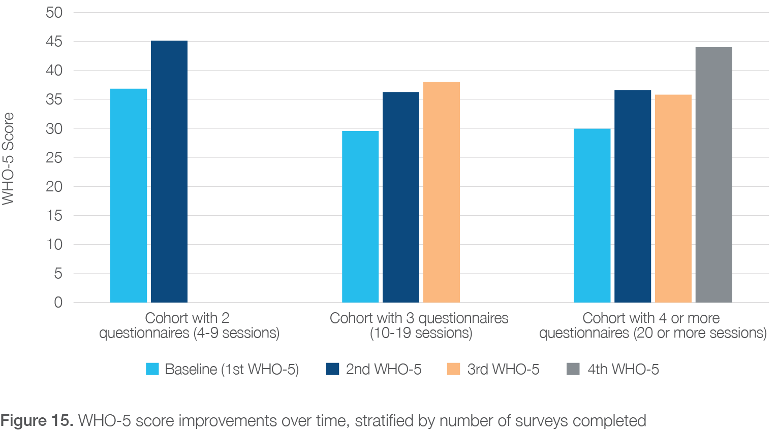

**Figure 16**highlights the improvement observed between baseline and closure assessments, for the 94 clients who had recorded a closure status. These clients reported an average 36% improvement in WHO-5 score over the duration of their enrolment in PASTT counselling services.

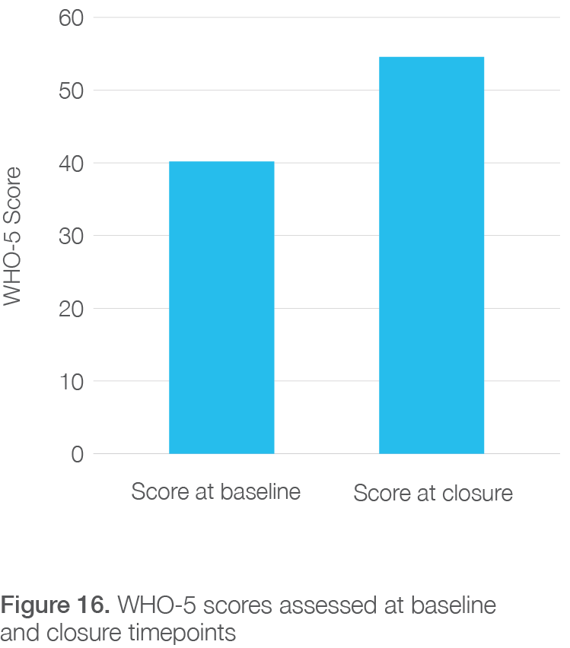

Figure 16. WHO-5 scores assessed at baseline and closure timepoints

#### Client reported outcomes: Goal achievement

For clients attending individual counselling, a goal setting process is embedded into the service. Goals are set by clients in partnership with their counsellor advocates at the beginning of their engagement with the service, as part of the assessment process. Progress towards goals is assessed at every ten sessions and at closure. For a variety of reasons, not all clients will remain engaged until there is a formal closure.

Data on client goal achievement was available from STARTTS, QPASTT and VFST. As data from STARTTS and QPASTT were reported using a consistent categorization and assessment framework, data from these agencies has been collated and summarised

in **Figure 17**. Of the 10,306 documented goals, the most reported related to the management of anxiety symptoms (13%) and management of traumatic stress

(12%). Overall, 80% of goals were assessed to have been achieved ‘somewhat’ to ‘very much’.

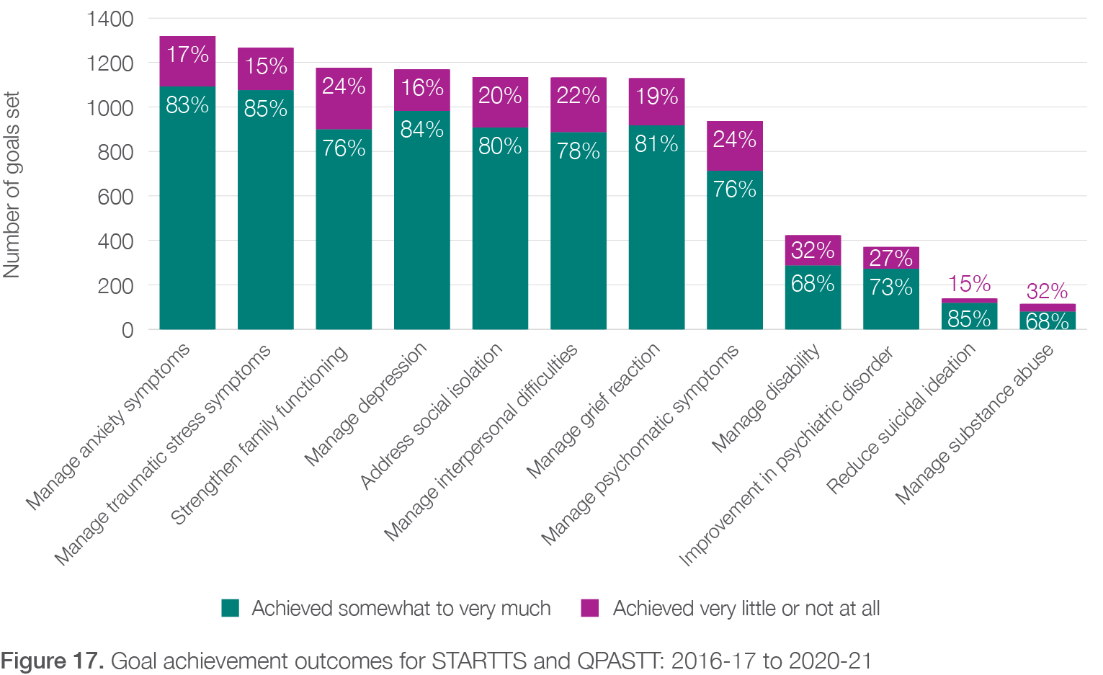

Within VFST, client goals are formulated and assessed using the “Goal Tree” framework. The Goal Tree applies to all VFST clients (adults, children, and adolescents) who have had a comprehensive psychosocial assessment and for whom subsequent interventions are planned. There are two levels adopted in conceptualizing goals. The first level captures the eleven domains of functioning that reflect core areas of desired improvement (summarised in **Figure 18**). The second level disaggregates each of these domains into several sub-goals that may be selected, as relevant to the individual client. Achievement ratings for each goal are completed by counsellor advocates at the point of closure.

**Figure 18** summarises VFST client goal achievement outcomes between 2017 to 2021 across each of the eleven domains of functioning. Of the 3,005 documented goals, the most common fell within the domains of: signs and symptoms of mental health (22%); interpersonal functioning (17%); and family functioning (14%). Overall, 87% of the goals were achieved ‘somewhat’ to ‘very much’.

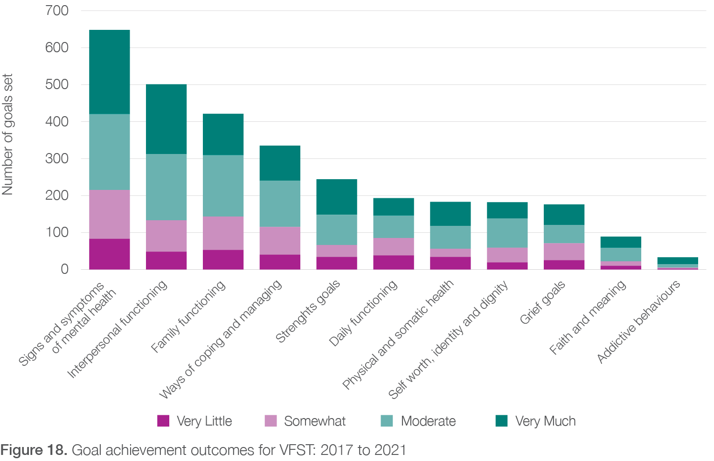

#### 5.2.3 Engaging in Australian society

One of the long-term goals of both PASTT and the Humanitarian Settlement Program, is to help new arrivals integrate into Australian life and become self-reliant members of the community. The client interviews provided evidence that PASTT contributed to assisting people from refugee background in advancing their education, realising their own potential, and improving their personal and professional life. The case studies, FASSTT agency qualitative interview data, and STARTTS client feedback also demonstrated that PASTT was successful in creating positive opportunities for clients to engage more fully in Australian society. This was demonstrated through clients’ improved ability to undertake activities of daily living; engage with education and training; and obtain meaningful employment.

###### Daily living and activities

FASSTT agency interviewees discussed how engagement in PASTT provided clients with greater confidence to undertake important aspects of daily living. PASTT

clients became more confident in using public transport and moving around, obtaining housing, using banking services, negotiating Centrelink, and demonstrated improvements in English language competency. Clients became confident in advocating for themselves and their communities. PASTT clients were able to move from trauma to success in education and training, and to obtain or re-engage in employment. Support and advocacy from PASTT enabled many children and youth to re-engage at school. Direct quotes from clients, obtained during the STARTTS feedback interviews, best

exemplify the importance of PASTT in assisting social and economic participation in society:

*“They are there all the time. I’m illiterate [the bicultural worker] used to help me read letters. I felt that I was drowning and there was a straw that was hung into save me and people at STTARS was the straw”.*

*“[My son] got much help, how to live in Australia, what will be the challenges of Australia, how he can defeat the challenges, many things.”*

*“STTARS did organise a home tutor for me through TAFE. A volunteer has been coming to my home*

*to help me”*

*“One of [my daughter]’s main problems was with her responsibility to studies and school. She had problem with these things. With homework, with school stuff, with teacher… STTARS helped a lot with all that”*

###### Engagement with education and training

Several examples were provided by FASSTT agency stakeholders related to positive client engagement with education and training. One agency described how a previous client had completed training and accreditation in childcare, receiving full marks. Another client had obtained a university degree since engaging with PASTT and was now resourceful and resilient.

Interviewed clients also provided examples of the positive impact of engagement with PASTT on their education and training. One client (C2) reflected on their experience accessing the QPASTT homework club to assist with high school education. The client struggled with learning, especially with speaking English, which he was often mocked about by school peers. Involvement with the homework club provided a safe space to openly speak and practice English without being humiliated

or embarrassed. This client recognised the need to change schools to improve future outcomes and, with the assistance of a PASTT counsellor who ran the homework club, received a scholarship to one of the top high schools within the state. The client successfully

completed high school and a university degree, and now is a successful professional who previously worked for the FASSTT agency. This client largely attributed this positive outcome to involvement with PASTT and its homework club and reflected that *“If I had not received assistance from [the agency] it would have been a very different story*”. Another client (C7) expressed that as

a result of being engaged in counselling sessions, they commenced studying early childhood education and completed work experience in this field. The counsellor also assisted the client in obtaining employment in an early childhood role.

In **Box 7**and **Box 8**, two case studies are provided further detailing the influence of PASTT on school engagement for refugee youth (source of case studies: QPASTT and STTARS).

*Box 7*. Client case studies: Client 6

**Case 6 – (school engagement)**

**Background**

A female student was referred to QPASTT because she was skipping school, distracted in class and on a pathway to expulsion for school.

**Treatment and outcomes**

Key school staff worked with QPASTT’s Youth Engagement and Advocacy officer. The school was made aware of the barriers facing the student, both at home and school, and the impact of her refugee experience. Additional supports were put in place for the student to complete schoolwork. The student’s teachers were supported to

improve communication with the student and provide appropriate classroom interventions. QPASTT organised case conferences between the student’s family and the school to improve family engagement and understanding of the child’s experience. As a result, the student’s engagement in school improved. The student joined the school rugby team and participated in excursions. Relationships between the school staff and the student improved significantly allowing the student to communicate her needs to teachers and wellbeing officers.

*Box 8*. Client case studies: Client 7

## Case 7 – “H” (school engagement)

### Background

When “H” was a young child his family fled Afghanistan, seeking safety in Pakistan. H experienced significant trauma when he witnessed a bomb blast where several of his friends were killed. He often missed school to look for work and ways to support his family. Seeking work required H to spend time with older males and he experienced severe abuse from them. Consequently, H and his father sought asylum in Australia. It was almost 10 years before the family was able to reunite in Australia.

H’s Australian school noticed that he was frequently hyper-vigilant and anxious and finding it hard to engage. H was also engaging in risk-taking behaviour including experimenting with smoking cigarettes and other substances. H found it hard to sit in class because learning was hard after having missed so much school and he described often feeling overwhelmed with bad memories. H’s situation was complicated due to needing to navigate changes in family dynamics and roles.

### Engagement with PASTT and outcomes

H’s school referred him to STTARS for support. H was uncertain about engaging in counselling as it wasn’t a familiar concept to him. However, after a few appointments he remarked ‘counselling feels like I can share my heart’. Initially H had weekly counselling appointments offered in a confidential space at his school where he felt safe. He was supported to build body awareness and ways to regulate his emotions. H was able to speak about things that had happened to him that he had never talked about before and to unpack his feelings of shame, fear and anger. His counsellor also supported him acknowledge and work through grief he felt about living in a new country and leaving behind peers that felt like family. As well as working individually with H his counsellor was able to provide consultancy support to the school about how to support H within the classroom setting.

As H felt more in control and engaged better at school his appointments were gradually moved to fortnightly then monthly. In addition to processing past traumas he was supported to explore themes of his identity and how he could stay close to his culture and also embracing life in Australia.

At the end of his counselling journey with STTARS, H transitioned from school into a training course to pursue his goal of working in the construction industry. He reflected - ‘*I am proud of myself and am more control of my emotions and behaviour than before’*.

###### Obtaining employment

FASSTT agency stakeholders also described the impact of PASTT on clients being able to seek and obtain employment. In one example, the agency interviewee described how a male client who held high status in his country of origin, and was a successful business owner and employer, was affected by loss of status, role change, and experience of unemployment in Australia. Involvement in PASTT had helped this man to recover such that he was actively searching for employment. In a second

example, the interviewee described how a long-term client, who had been involved with PASTT for 10-15 years and had experienced family violence, was finally able to gain employment and have some financial security.

In many cases, previous PASTT clients obtained employment within FASSTT agencies. This was seen as extremely beneficial because, along with providing the client employment and opportunities for growth, the organisation obtained bicultural workers. Bicultural

workers provided the FASSTT agencies with a wealth of lived experience and culturally appropriate understanding to draw upon, making the organisation more effective in meeting the goals of PASTT. Many of these employees also came with skills from their previous lives in their country of origin. In addition, employment of previous clients as bicultural workers increased the visibility of PASTT within the refugee community, providing additional pathways to conduct community capacity building work, and increased the overall cultural capital of the FASSTT agency and PASTT within the community. Importantly, this embedding of peer workers and lived experience into the development and delivery of PASTT aligns with key national, state, and territory strategic policy for improving and sustaining mental health service delivery57, 58.

A case study describing the impact of PASTT on a client who later obtained employment with STARTTS and the subsequent impacts on her family and the agency is presented in **Box 9****.** The client described the range of impacts as such:

*“The intervention of STARTTS started with me, but uplifted my whole family, and through a ripple effect helped me uplift my community and people from many different refugee communities. STARTTS’ impact has spread the benefits further that way. STARTTS gave me life which is a permanent feature in my mind and heart. Material things do not make me happy. Acceptance and recognition are the biggest things for me; and that is what I was given at STARTTS – as a client and as an employee. This acceptance is beautiful and life changing.”*

*Box 9*. Client case studies: Client 8

## Case 8 – “S”

### Background

S was born in South Asia. Her home was burnt down in 1983 and her family displaced. She worked as a research assistant/interpreter for a project related to the positive impact of the peace process in Sri Lanka. S also had to listen and provide counselling for torture survivors as part of her job as a field counselling officer. All the women she was supporting were sexually abused by soldiers. S was personally tortured by the Government to reveal information of these young women. S also provided counselling in schools and she was forced to share information she was given by students. She was eventually asked to leave the country with four days’ notice, due to the risk to her life.

### Engagement with PASTT

When S came to Australia, she didn’t know anyone. She was on a tourist visa and then sought asylum which was granted. She could not return home as it was too dangerous. A church service referred her to STARTTS. At that time, S felt she was going through an identity crisis. While life in Sri Lanka was dangerous, she had an identity that revolved around her work and her life had meaning. Losing that had a significant impact on her. She could not stop crying, was very depressed and refused to leave her house.

STARTTS’ counsellor conducted a home visit. The counsellor also helped with case management/practical assistance for the whole family. The counsellor understood the cultural transition process and she built a trusting relationship with the whole family, at the time when S did not trust anyone in Australia. S was refused assistance by other organisations and she felt humiliated after her interaction with them. STARTTS’ Counsellor was different. S felt she was finally able to trust someone, and she felt that her Counsellor also trusted her.

The counsellor organised a psychologist for S’s son. She connected S and her husband with TAFE. The Counsellor came to the hospital when S was delivering her daughter. The Counsellor provided support for 12 months. She also supported S to obtain her driver’s license. She helped S develop a life plan and a professional development plan. S felt able to follow this plan and feels she would not have been able to develop one for herself. STARTTS’ counselling assistance was crucial to this.

### Employment with PASTT

S completed her Diploma in Community Services at TAFE, a bachelor’s degree at university and Social Work master’s degree. S started work with a Settlement Agency as a case manager and then applied and was trained to become a program facilitator with STARTTS. S loved this as this helped her healing journey, and she trusted STARTTS implicitly because of her positive experience with the Counsellor. S felt that through facilitating these groups she formed and created a community. She felt she had recognition and respect and felt empowered. S felt that this expanded her horizons and gave her a rebirth in a new country. This work is what led to S engaging in further studies, and she felt that her new role was life changing for her. S became more confident and felt that STARTTS staff who managed her work listened and encouraged her, and valued her experience and the context she brought to STARTTS.

## Health provider and service-level outcomes

This section reports findings related to PASTT outcomes at the service provider level. This encompasses all health, social, education, and government and non-government organisations (and their staff) who contribute to, or are impacted by, PASTT implementation (hereafter termed third-party providers). It specifically seeks to examine the effectiveness of PASTT and FASSTT engagement with such third-party organisations and how well this helps them delivering against program objectives. The findings emerged from qualitative interviews with FASSTT agencies and stakeholders that PASTT interacts with, and case study data provided by the agencies. Quantitative and qualitative data was also analysed from agency reports, client feedback interviews conducted by STTARS, and an engagement questionnaire sent to a

range of PASTT partners and third-party service providers (see Section 2.5.3).

Overall, the FASSTT agencies worked with a large variety of service providers to achieve PASTT outcomes. The third-party organisations worked in many different contexts, were engaged by the FASSTT agencies for different reasons, and were utilised at varying levels of frequency. There were three overarching reasons for engaging with third-party providers. Firstly, **to receive referrals into PASTT and to refer clients out** to receive services that the FASSTT agency could not provide. Secondly, **to provide training and upskilling to third- party organisations** to better provide trauma-informed care to refugee survivors of torture and trauma. Finally, the FASSTT agencies interacted with third-party organisations in collaborative ways to **raise awareness of PASTT or the FASSTT agency’s profile** in that area, or to accomplish activities not directly related to service delivery but deemed important such as collective advocacy work on behalf of clientsr. Key findings related to provider and service-level outcomes are summarised and presented in Section 5.5.

#### 5.3.1 PASTT referral considerations

It was apparent in the interviews with FASSTT agency stakeholders that engagement with third-party providers was an important but complex part of PASTT delivery. One reason for this complexity was that each FASSTT agency operates with a different suite of PASTT and non-PASTT service provision activities. For example, some FASSTT agencies (such as QPASTT) are primarily

focused on delivery of PASTT, while other agencies (such as STTARS) have a broader incorporation of mental and physical health services, or other services within their organisational structure. Hence, some FASSTT agencies interact ‘outside’ with third-party providers to a large degree, while others have greater ability for ‘internal’ referrals. Agencies employing this later approach use staff and case managers working in other FASSTT service streams to identify clients who may benefit from referral to PASTT and provide conversations regarding mental health in a sensitive and informed way. Most agencies provide some services not directly within the scope of PASTT but stressed that they received additional funding from non-PASTT sources to engage in these other activities (**Chapter 6**). There was a strong belief by FASSTT agency stakeholders interviewed that the ability to internally refer to provide additional services ‘in-house’ was beneficial for PASTT clients.

There were mixed views about referring PASTT clients out to third-party providers/mainstream services. Some FASSTT agency staff were cautious or apprehensive about doing

so due to concerns about potential lack of skill, capacity, effectiveness, and appropriateness of the third-party providers to work in a trauma-informed way or with complex and vulnerable clients. This hesitancy was also felt on the side of some of the third-party providers interviewed as well, who experienced this distrust as a barrier to fully engaging with and referring to PASTT services. Some FASSTT interviewees also highlighted a duality of effects in relation to having strong connections with third-party providers outside of the agency. For example, seeking expertise and assistance outside of the FASSTT agency (i.e., ‘referring out’) was required to increase the health and wellbeing of clients. However, these linkages increased the visibility of PASTT within the sector which, in turn, often led to increases in referrals into PASTT and increased service demand without corresponding increases in organisational capacity to meet the demand.

1. *“it’s also building a bridge with other services so that they are better linked to the communities as well”* **Interview 4, Upper management, FASSTT**

#### 5.3.2 Referrals into PASTT

Over the five-year period from 2016-17 to 2020-21, a total of 45,111 referrals into the PASTT program were received by FASSTT agencies. The greatest number of referrals into PASTT occurred in 2016-17. This is likely due to the additional humanitarian intake of a Syrian/Iraqi cohort which occurred at this time. It is evident in **Figure 19**, that there was a decreasing trend in referrals into FASSTT agencies, overall, between 2017-18 and 2019-20 before leveling off to be more constant between 2019-20 and 2020-21. The overall decrease in referrals appears to be mainly attributable to decreases in referrals in to the two largest FASSTT agencies, STARTTS and VFST. The number of referrals into the other FASSTT agencies remained relatively constant or increased slightly during the same period.

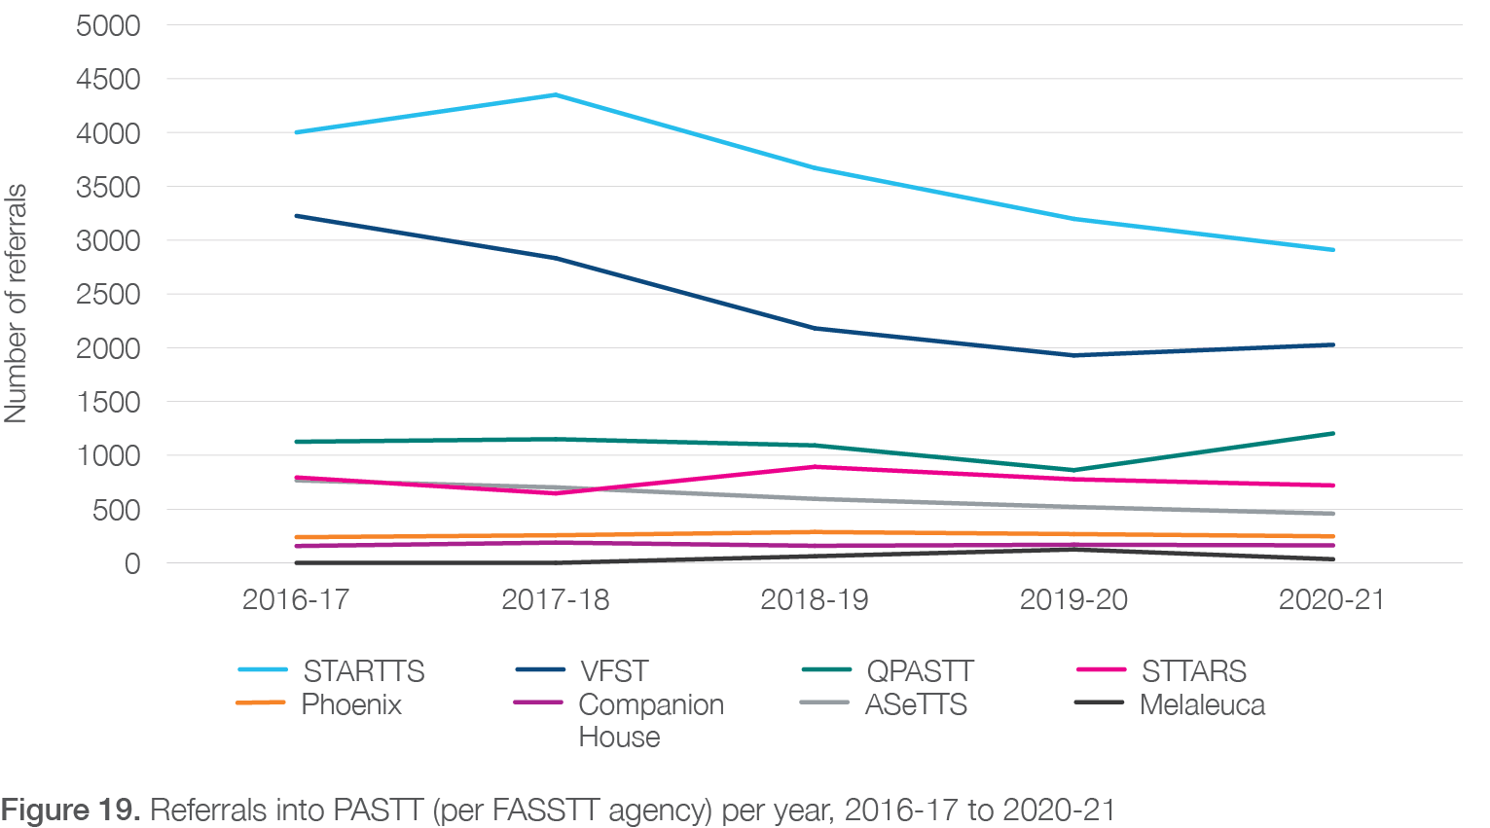

FASSTT agencies received referrals into PASTT from organisations in several different sectors. **Figure 20**indicates that client self-referral (22.2%) was by far the greatest source of referrals into the PASTT program followed by ‘internal’ referrals (14.3%) from within

the FASSTT agency itself. In this context, this means that many PASTT clients are identified and enrolled in PASTT after becoming involved with a non-PASTT

service provided by the same FASSTT agency. Primary and secondary schools (12.9%) and the Humanitarian Settlement Program (12.8%) were also the source of large numbers of referrals in. General medical services (11%) were more likely to refer into PASTT than mental health services (3.0%) or allied health services (1.3%).

Notably, a large number of referrals were designated to come in from ‘other services’. This category captures referrals from charity services, children’s/youth services, community services, correctional services/police, emergency services, interpreters/translators, parenting groups, Red Cross, religious organisations, and volunt

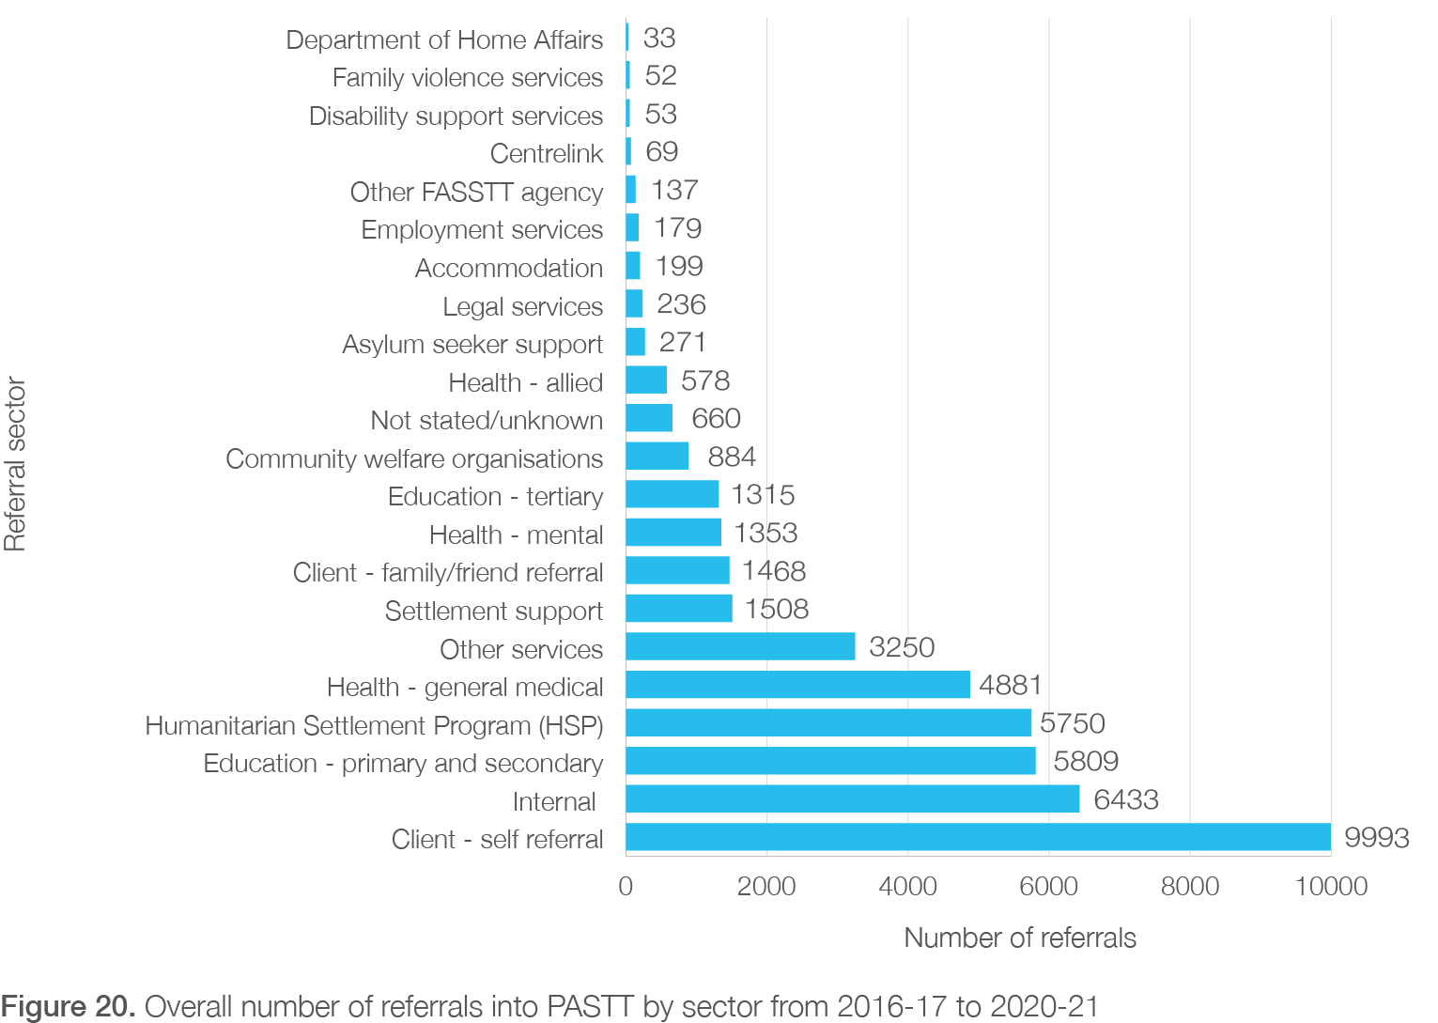

When reflecting on this data however it must be noted that FASSTT agencies have identified that improvements are required in accurately capturing and reporting referral data. For example, the high number of internal referrals may also be due to agency staff missing an initial referral from an external service provider into the FASSTT agency and then only capturing the subsequent referral into PASTT (rather than the original source). AusHSI has been advised that steps have been taken to improve referral reporting in recent years.

There were some notable similarities and differences in the source of referrals into PASTT for each FASSTT agency.

**Appendix 6**presents the proportion of referrals for the previous five years by source of referral for each FASSTT agency. As would be expected, the top five most important sources for referrals into PASTT tended to be the same for each state/territory and match those reflected in **Figure 20**: self-referral, internal referral, HSP, health (general medical), primary and secondary education.

However, while some states/territories had very high percentages of referrals from a single source (e.g., Melaleuca via the HSP), others had two or three sources which provided a similar percentages of their referrals (e.g., VFST via self-referral and education services). Internal referrals accounted for the greatest proportion of referrals for Companion House, STTARS, and ASeTTS. QPASTT, Phoenix, and especially Melaleuca, received most referrals from the Humanitarian Settlement Program. STTARS received most referrals from general medical practitioners.

#### 5.3.3. Referrals out of PASTT

Over the five-years from 2016-17 to 2020-21, FASSTT agencies made 15,255 ‘referrals out’ for non-PASTT-funded services. That includes internal referrals, made to another service within the same FASSTT agency, and external referrals, made to a third-party provider.

###### Total number of referrals out and trends

**Figure 21**graphs the trend in the total number of referrals out by selected agencies (where referral out data was available for each of the five years). The organisations included in this figure are VFST, QPASTT, STTARS, Phoenix, Companion House, and ASeTTS. There was some variability in the number of outward referrals made over the period examined. This appears to be mainly the product of variability in referring out in three organisations, STTARS, ASeTTS, and VFST. QPASST, Phoenix, and Companion House had relatively constant numbers of referrals over the five-year period. As noted, this analysis does not include referrals made by STARTTS and Melaleuca.

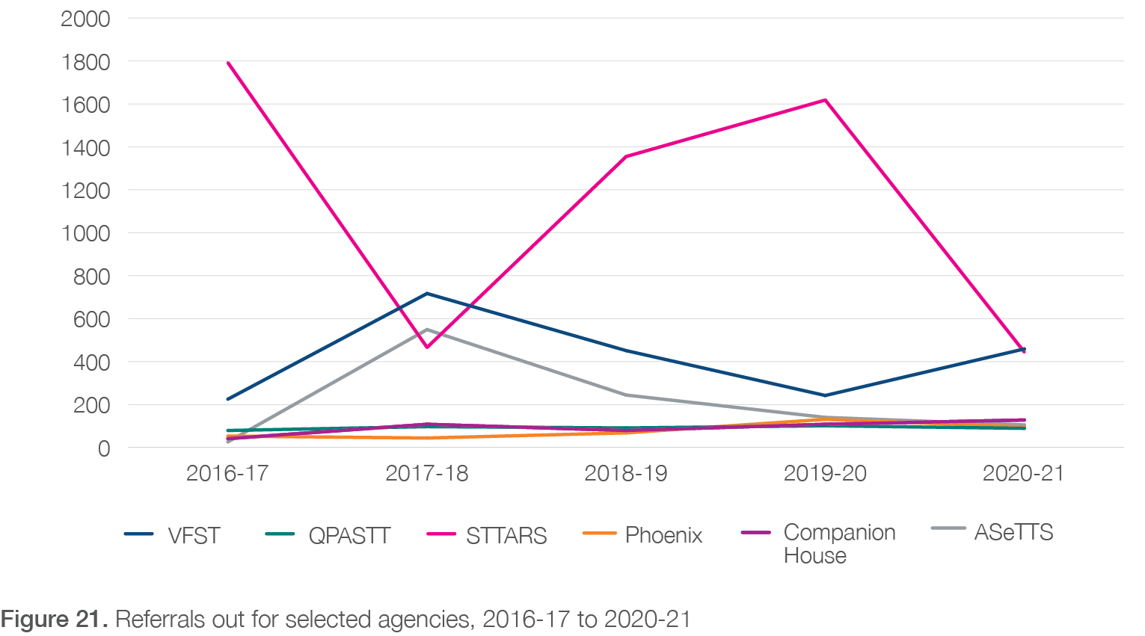

Most FASSTT agencies predominately made internal rather than external referrals. Internal referrals made up more than 50% of the overall referrals made during this period. For STARTTS, internal referrals made up over three-quarters of ‘referrals out’ (83%), about half for STTARS (51%) and ASeTTS (51%), and about a quarter for Companion House (22%). This high level of internal referral may be linked to the perception of many interviewees that third-party service providers were often not equipped to adequately care for PASTT clients. This may also be due to the issues with reporting of internal referrals as discussed above.

**Table 10** visualises the proportion of referrals out to third-party providers made by each FASSTT agency, expressed as a percentage of the total number of referrals for that specific agency in the previous five years. Comparatively large proportions of referrals out were made to community welfare organisations and “other services” (see above) for several FASSTT agencies, such as VFST, QPASTT, and Phoenix. Phoenix, QPASTT, and VFST also commonly referred out to mental health services. A larger proportion of referrals to general medical services were made by Melaleuca and VFST than most other FASSTT agencies. Allied health services generally received low proportions of referrals from each FASSTT agency. After internal referrals, community welfare organisations, other services, health (general), and health (mental) comprised the greatest proportion of onward referrals nationwide.

Clients also recognised this ability of PASTT to provide holistic support via onward referral, with one client reporting during the STTARS feedback interviews:

*“Beside counselling, STTARS is a place that can’t provide all the support but they do link out to other services with our problem. I think that it’s best thing to do if they can’t do it and they don’t provide support themselves. They do link you to get supports from other places that’s really good”*

*Table 10.* Referrals out to other providers by FASSTT agencies (%) and nationwide (number), 2016-17 to 2020-21

|  |  |  |  |  |  |  |  |  |  |
| --- | --- | --- | --- | --- | --- | --- | --- | --- | --- |
|  | STARTTS | VFST | QPASTT | STTARS | Phoenix | Companion House (CH) | ASeTTS | Melaleuca | Total number |
| Accommodation | 0.6 | 3.1 | 3.5 | 6.6 | 6.6 | 12.1 | 1.8 | 10.0 | 590 |
| Asylum Seeker Support Service | 1.2 | 0.2 | 0.4 | 0.3 | 1.3 | 0.4 | 2.0 | 0.0 | 109 |
| Centrelink | 0.2 | 3.7 | 1.3 | 4.5 | 2.3 | 12.3 | 1.2 | 6.0 | 432 |
| Client - self | 0.0 | 1.1 | 0.0 | 0.0 | 0.0 | 0.0 | 0.0 | 0.0 | 24 |
| Client - family/friend | 0.0 | 0.7 | 0.0 | 0.0 | 0.0 | 0.0 | 0.0 | 0.0 | 14 |
| Community Welfare organisations | 1.3 | 23.4 | 17.7 | 7.0 | 16.6 | 1.5 | 2.3 | 6.0 | 1135 |
| Department of Home Aﬀairs | 0.0 | 0.2 | 0.2 | 0.9 | 0.0 | 0.4 | 0.3 | 0.0 | 61 |
| Disability support service | 0.3 | 0.4 | 1.1 | 0.1 | 1.0 | 1.3 | 0.8 | 0.0 | 54 |
| Education – primary & secondary | 0.1 | 8.3 | 3.3 | 1.2 | 0.8 | 1.9 | 0.6 | 14.0 | 286 |
| Education – tertiary | 0.3 | 1.9 | 0.9 | 1.1 | 0.3 | 5.0 | 0.9 | 0.0 | 156 |
| Employment | 0.3 | 1.3 | 3.7 | 1.5 | 1.8 | 11.4 | 0.5 | 6.0 | 214 |
| Family Violence service | 0.1 | 1.3 | 2.2 | 0.1 | 3.1 | 1.9 | 0.1 | 6.0 | 72 |
| FASSTT Other | 0.2 | 0.2 | 3.1 | 0.3 | 3.8 | 1.1 | 0.3 | 0.0 | 69 |
| Health – allied | 1.2 | 5.9 | 4.4 | 2.5 | 3.6 | 4.1 | 0.0 | 4.0 | 385 |
| Health – general medical | 1.8 | 9.7 | 3.7 | 7.5 | 4.1 | 3.0 | 2.6 | 14.0 | 800 |
| Health – mental | 2.0 | 10.8 | 16.4 | 2.3 | 18.1 | 1.9 | 0.9 | 8.0 | 626 |
| HSP (previously HSS) | 0.4 | 1.4 | 0.2 | 0.6 | 1.3 | 0.4 | 0.0 | 0.0 | 92 |
| Internal | 83.9 | 1.7 | 1.8 | 47.6 | 9.2 | 22.2 | 54.6 | 8.0 | 7712 |
| Legal (migration related) | 1.5 | 2.3 | 13.3 | 2.3 | 4.1 | 8.0 | 3.4 | 0.0 | 405 |
| Legal (non-migration related) | 0.7 | 2.7 | 3.5 | 2.5 | 1.3 | 2.2 | 1.0 | 8.0 | 280 |
| Settlement Support | 0.6 | 4.6 | 2.8 | 2.9 | 8.2 | 2.8 | 0.4 | 8.0 | 357 |
| Not stated/unknown | 0.0 | 0.0 | 0.0 | 3.1 | 0.0 | 1.7 | 15.2 | 0.0 | 346 |
| Other services | 3.5 | 15.0 | 16.4 | 5.0 | 12.8 | 4.1 | 11.2 | 2.0 | 1035 |
| Organisation total | 100.0 | 100.0 | 100.0 | 100.0 | 100.0 | 100.0 | 100.0 | 100.0 | 15254 |

Note: cells are colour coded to represent the highest (green) to lowest (red) proportions of referrals from each agency, and overall.

#### 5.3.4 Capacity building of third-party providers and mainstream services

One of the key objectives of PASTT is to increase the responsiveness of mainstream health and related services to the needs of people who have survived torture and trauma prior to arriving in Australia, through the provision of training and support services. FASSTT agency stakeholders interviewed discussed the importance of providing training and development to third-party providers to allow them to work more effectively with PASTT clientss. ‘Sector development’ and the ongoing provision of effective capacity and capability building activities were an important goal referred to by many of the FASSTT agency representatives. There was a strongly perceived need to help mainstream health services and other providers work in culturally appropriate and trauma informed ways, thereby allowing management of less complex cases in the community. Interviewees discussed their belief that it was important to change the impetus of mainstream services from ‘getting things done’ to being more client centred.

Examples of such capacity building efforts and collaboration between PASTT and third-party providers were provided in four case studies from Phoenix (1-3) and VFST (4):

1. PASTT client “F” attempted suicide and his counsellor engaged in warm referral to the State Mental

Health Services (SMHS). The PASTT counsellor has continued to work collaboratively with the SMHS Psychiatrist and Case Managers to support F, and provided informal training on collaborating with interpreters and working with clients from a refugee background when new SMHS staff have supported F.

1. PASTT client “C” was accessing counselling with significant trauma stress and was experiencing issues with housing, education, and the impact of disability on her ability to pursue employment. The PASTT counsellor referred C to Catholic Care for English classes, Housing Connect for housing support, and to

Centrelink for support with a Disability Support Pension (DSP) application. The PASTT counsellor provided advocacy and liaised with services about support needs. Through these external services C has secured housing and is supported by a housing support worker with CatholicCare, is accessing transport support,

has been approved for DSP and is accessing English classes. This has enabled the PASTT counsellor support to focus on mental health recovery.

1. PASTT client “K” was accessing counselling and had multiple mental health and health issues and was taking prescription medication. K did not understand the health issues or what the medications were

for. The PASTT counsellor worked closely with K’s GP and supported the GP to organise a female interpreter for K. As a result, K and the GP were able to talk through the medical issues and the medications. The GP now has more knowledge of accessing interpreters when supporting people from refugee backgrounds.

1. PASTT client “V” was believed to be suffering from tuberculosis based on a preliminary medical

assessment. Making a conclusive diagnosis required an invasive medical procedure (bronchoscopy), which he refused to have. He had been tortured

and was overcome by fear at the prospect of having the procedure conducted. With V’s permission, his counsellor informed the specialist of the situation, and she accompanied him to the appointment. During the consultation, she reassured him that he was safe, all steps of the procedure were carefully explained, and he was given the option of terminating the procedure at any point. By maximising V’s control over the situation and providing comfort and reassurance, his anxiety was manageable, and the bronchoscopy was successfully completed.

FASSTT agency stakeholders also talked about the provision of direct training activities to government and non-government organisations including those located in regional and rural areas. Training was provided using a variety of formats including in-person as well as

via digital channels. Several organisations discussed the development and distribution of publicly available training resources. Some resources were developed with specific target audiences in mind. For example,

STTARTS has a resource kit for social workers and VFST has a range of publicly available resources for schools and teachers available for download on their websites.

Some organisations actively engaged with universities by assisting with curriculum development, presenting lectures or seminars to students, or by offering internal placements for students to gain work experience.

Engagement with universities in these ways was seen as beneficial for several reasons.

1. “Other services can work with survivors of torture and other traumatic events, so if you have workers in other services who are working from a trauma-informed approach it may be that they can provide the support to the individual which might free us [PASTT] up to work with a survivor who is more traumatised or who needs more of a specialist intervention”. **Interview 4, Upper management, FASSTT**

Firstly, universities represented a possible source of future staff for the FASSTT agencies. Secondly, interacting with students during their initial training and development was also a method to increase the knowledge and skills of mainstream services that employed the students when they entered the workforce.

Some interviewees discussed feedback and evaluation activities they conducted in relation to the training provided by the FASSTT agencies. These interviewees said that in most cases, the training was viewed very positively and that the third-party providers indicated that the training made them more effective, responsive, and well-equipped to work with PASTT clients when needed.

The main negative spoken about by the FASSTT agency interviewees related to the financial costs of capacity building activities. The proportion of PASTT expenses allocated to sector development and training is outlined in Section 6.2.1 and **Table 14**. The cost of developing and providing training sometimes exceeded what was allocated for it in the overall PASTT funding amount. Therefore, extra burden was placed on FASSTT agencies to obtain additional funding from non- PASTT sources or to reduce or reallocate other costs to ensure that this important work could continue.

Additionally, much smaller amounts are allocated per agency staff member to engage in their own professional development than are provided by other employers in the sector, making it much more difficult to upskill and retain staff. For example, QPASTT can allocate $600 per staff member per year for training whereas Queensland Health offers professional development to allied health practitioners of approximately $2500 per year plus three days professional development leave (source: data prepared by QPASTT).

Over the five-year period from 2016-17 to 2020-21, 1,456 organisations were provided training by FASSTT agencies, Australia-wide (average of 291 per year). This total includes 40 instances of ‘internal’ training. Overall, 1,524 training sessions were conducted and 35,810 individuals participated. In non-pandemic years FASSTT agencies consistently trained over 7,000 individuals annually (**Figure 22**). However, these figures are likely to be an underestimate as complete data from at least one agency was missing for every year except 2018-2019 and 2020-2021

*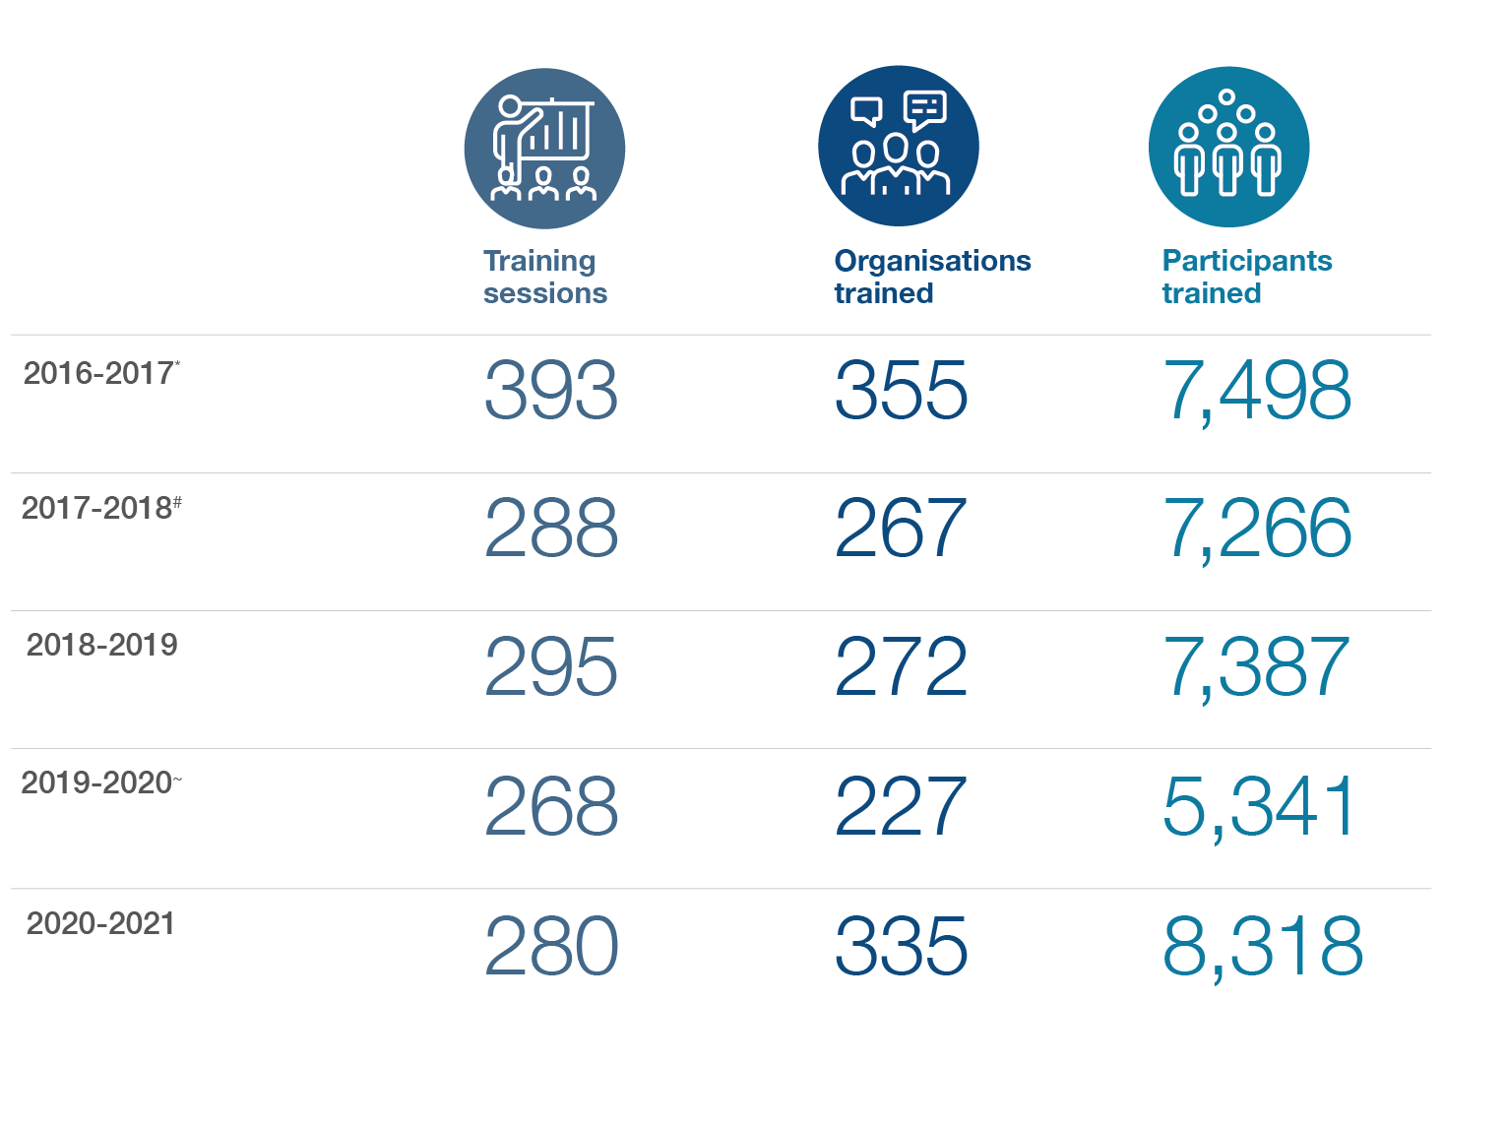  
Figure 22.* Statistics of FASSTT agency sector training (2016-2021). *: all data missing for Melaleuca, #: all data missing Melaleuca & total participants for ASeTTs, ~: data missing for total participants Phoenix

It was not appropriate to provide a breakdown of the number of sessions, participants, and agencies provided training by each FASSTT agency over this period due to inconsistent reporting practices and missing data across agencies. For example, how FASSTT agencies counted the number of external organisations attending training appeared to vary across agencies. Some agencies reported a multidisciplinary training session for a network as one organisation, while others captured representation for all organisations in attendance. Other agencies reported on the number of participants but not the total number of agencies represented each year.

With this caveat in mind, **Figure 23**displays a breakdown of the sectors that received training from the FASSTT agencies from 2016-17 to 2020-21. The greatest number of education and training activities were provided to the following sectors: settlement support, other services, mental health services, allied health services, general medical services, and primary and secondary schools. ‘Other services’ included aged care, multicultural groups, community organisations, and not-for profits.

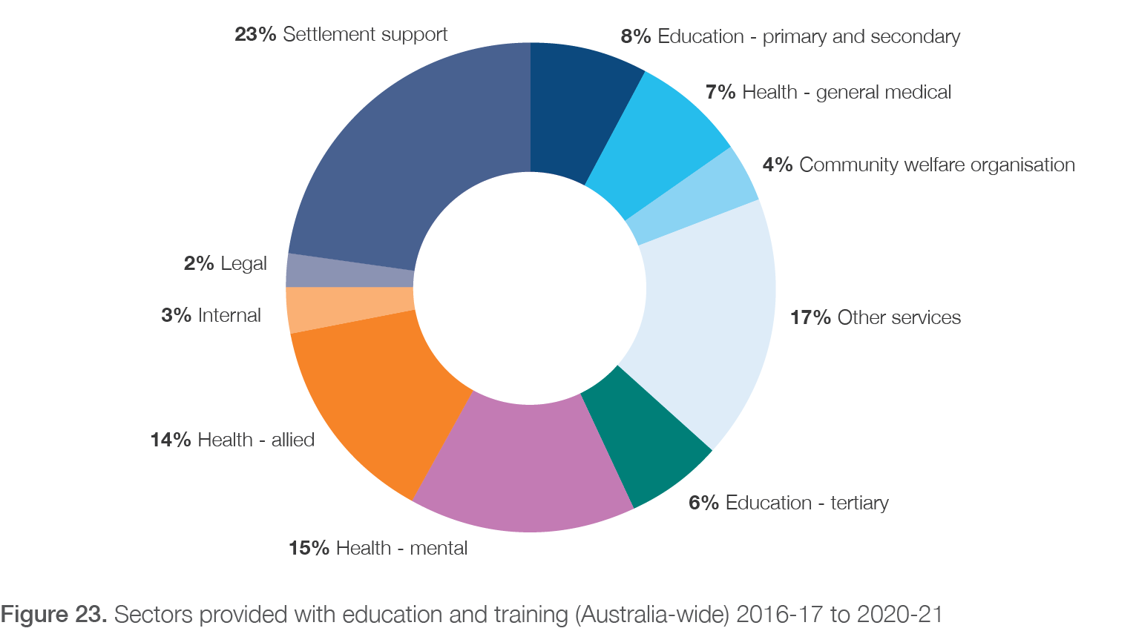

#### 5.3.5 Engagement and collaboration with third-party providers

The FASSTT agency interviewees often discussed interactions and engagement with third-party providers which were not specifically related to referral or training. Thus, these activities were not directly focused on service delivery but concentrated on networking, sharing of ideas and resources, and other activities. Examples of the types of organisations FASSTT agencies engaged with in this way included schools, state government departments and bodies, and other organisations that could or would encounter PASTT clients, such as settlement service providers, the Humanitarian Services Program, Centrelink,

General Practitioners, and English Language learning providers. Examples of activities that the FASSTT agencies collaborated with third-party providers on in this manner were advocacy (such as in preparing joint responses to parliamentary enquiries or submissions), or to highlight the existence of PASTT and the FASSTT agency in the sector through an ‘agency champions program’, a ‘portable panel’, and participation in a ‘transcultural mental health network’. One agency described how they took opportunities, particularly in rural areas, to be part of consortia of several types of agencies/organisations to seek funding to develop and administer additional programs and services to PASTT clients or their families and communities. The outcome of such an activity was the development and trial of a youth program, ‘All one under the sun’, which aimed to improve interactions and relationships between refugee youth and local indigenous youth in a major regional centre. Another stakeholder described a collaboration with a local TAFE to provide a structure for sharing and working through grief after a suicide occurred within their refugee student group. This type of intervention had considerable outcomes in terms of reducing stigma and preventing further significant mental health outcomes for these individuals.

###### Schools

Engaging with schools was also seen to be an important part of PASTT, particularly in regional and rural areas where other supports may often be lacking. One PASTT stakeholder discussed specific engagement activities

to develop relationships and connections with schools which were seen as both a source of referrals and a way to increase effectiveness of their services:

*“Schools are very important places, not just for the kids but for the parents as well. So, if you’ve got a school that’s supportive of the family and understands what a family of a refugee background has been through, then the school can also support.”*

***Interview 1, Upper management, FASSTT***

It was reported that most teachers are compassionate and empathetic to the refugee experience, however many lack the understanding of how refugee trauma poses barriers to learning and wellbeing. This constrains their ability to implement effective strategies in the classroom and with students. PASTT education and advocacy address this and helps achieve positive outcomes for clients. This is demonstrated in two case studies (**Box**

**10**and **Box 11**) about the impact of QPASTT’s Youth Engagement and Advocacy Officer.

*Box 10.* Client case studies: Client 9

**Case 9 (Youth Engagement and Advocacy Officer)**

**Issue, engagement and outcome**

During a QPASTT school outreach session, a student disclosed past experiences of sexual violence. As well as establishing emotional support plans for the student, QPASTT’s Youth Engagement and Advocacy Officer was able to liaise with the school to ensure the student could access culturally appropriate support through an external service during school hours. This was important because the student did not feel safe accessing support outside of school hours and did not want to engage with the school’s internal wellbeing team on this issue.

*Box 11*. Client case studies: Client 10

**Case 10 (Youth Engagement and Advocacy Officer)**

**Issue, engagement and outcome**

A student who was accessing QPASTT’s school outreach support and counselling became homeless due to family violence. QPASTT’s Youth Engagement and Advocacy Officer initiated a partnership with the school to ensure the student could access appropriate support from QPASTT counsellors, housing, and domestic violence services.

Collective advocacy from QPASTT and the school enabled the student to access urgent financial support through Centrelink and additional brokerage support through Brisbane Domestic Violence Service. QPASTT advocated for the student to leave class to respond to her housing circumstance and to be considered for additional support with schoolwork. QPASTT was also able to raise the school’s awareness of safety concerns with certain family members to ensure the student was protected.

Finally, STARTTS in Schools is an exemplar program providing an interface between schools and STARTTS’ programs and services and promoting systematic changes at the school level to improve the learning environment and healing outcomes for children and young people of refugee backgrounds. The evaluation of that program demonstrated important outcomes and can be found here ([STARTTS in Schools Evaluation Report](https://www.hintsforhealing.startts.org.au/hfh/media/Final-SIS-Evaluation-Report.pdf)).

###### Partnership Questionnaire

An online questionnaire (**Appendix 7.1**and **Section 2.5.3**) was designed to evaluate (a) the effectiveness of PASTT and FASSTT engagement with these third-party organisations; and (b) how this engagement helped external organisations to deliver against the PASTT program objectives. A survey link was distributed by each FASSTT agency to their partners and relevant third-party providers.

A total of 85 stakeholders responded and completed the questionnaire. These participants were largely from New South Wales (43%) and Victoria (39%) with smaller proportions responding from Queensland (7%), Western

Australia (5%), and the Australian Capital Territory (2%). The duration of their engagement with FASSTT agencies ranged from less than 5 years (38%), to more than 15 years (19%) (**Figure A1**, Appendix 7.2). Respondents also covered the spectrum of PASTT-related services and referral pathways (**Figure 24**) and interacted with FASSTT agencies in varying frequencies of engagement ranging from every day to once per year or less (**Figure A2**, Appendix 7.2).

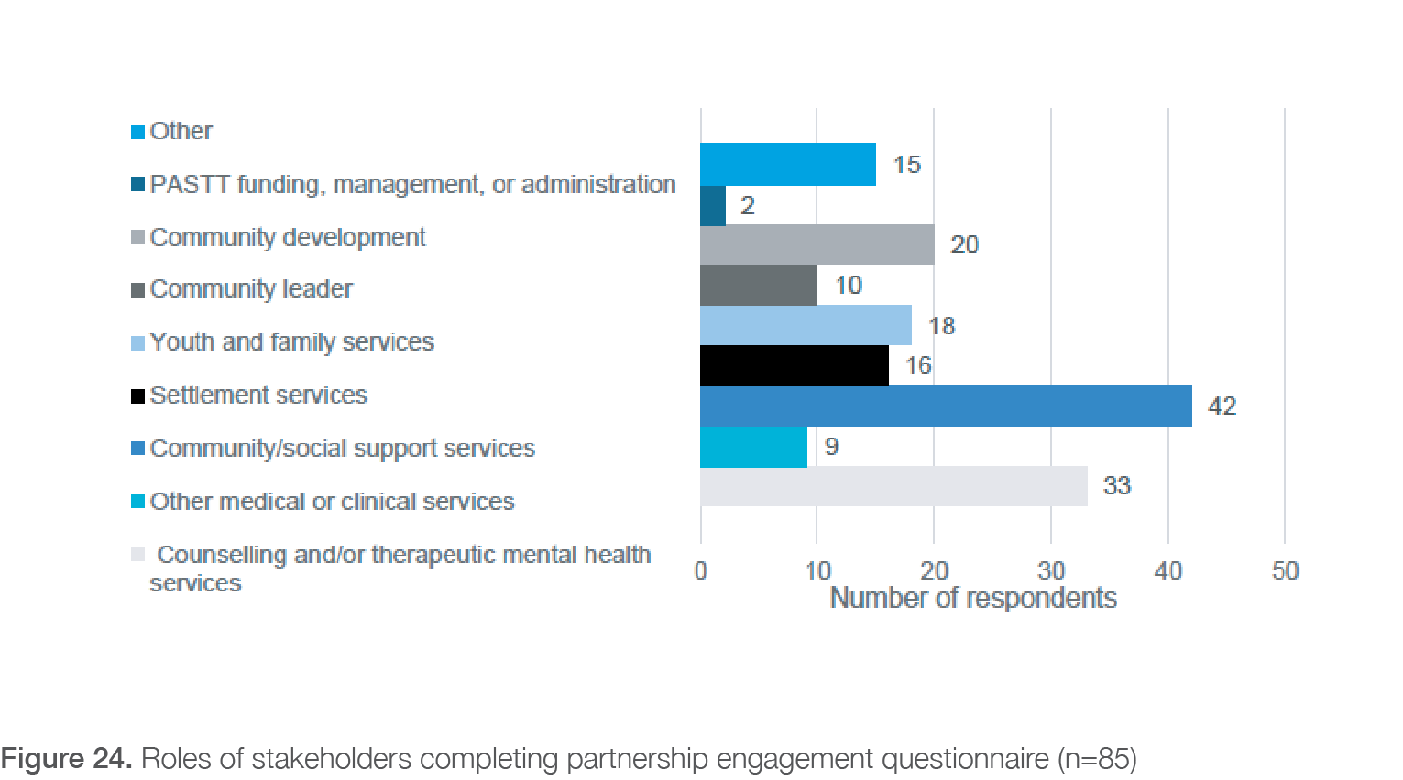

Stakeholders overwhelmingly reported satisfaction with their involvement with FASSTT agencies and PASTT activities, rating this 90 out of 100 (median score) on a sliding scale (from 0-100). **Figure 25**displays all satisfaction ratings.

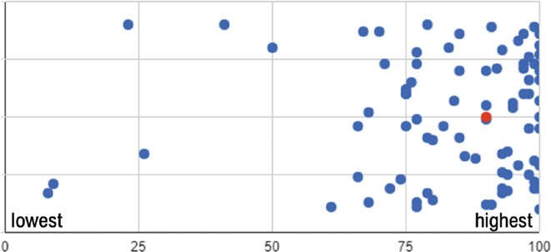

*Figure 25*. Satisfaction of third-party providers with FASSTT agency engagement and collaboration (0: not at all, 100: yes, most definitely, blue dots: individual responses, red dot: median score)

Third-party providers commented most positively on:

− The agency leaders, staff members, and counsellor advocates working within PASTT, and their knowledge, understanding and professionalism: *“they are absolute experts in their field, very knowledgeable about the sector, and are passionate about supporting the community”* – survey response 50, third-party provider

− The high quality of training and sector development received

− The approachable, responsive, and collaborative nature of agencies: *“individuals who are easy to approach and connect the sector with their appropriate staff*” - survey response 76, third-party provider

− The adaptability of services provided

− Shared values and goals between third-party providers and agencies

− Open and regular communication between third-party providers and agencies

However, despite many positive comments about engagement and collaboration, some stakeholders were considerably less satisfied with their involvement, reporting mixed quality of interactions with the agencies.

These negative comments mostly equated with the lower satisfaction scores observed in **Figure 25**and were not restricted to one FASSTT agency. Common reasons for the lower satisfaction scores given include:

− Extensive waitlists and wait times for PASTT services resulting in third-party stakeholders giving up on referring clients (most common frustration of

respondents): *“At times there are long waiting lists that means the people we refer are left for periods of time without much needed counselling support”* - survey response 70, third-party provider

− Perception by third-party providers that FASSTT distrusts non-refugee specific services; sense that the FASSTT agency sees itself as the only legitimate provider and only source of expertise regarding health issues in those of refugee background; perceived lack of real willingness to acknowledge the work of other services in the sector; unclear expectations of

partnerships: *“Overall there are many situations where that [FASSTT agency] operates very collaboratively with settlement services and other health services.*

*However historically there is a sense that that [FASSTT agency] and the public mental health services do not integrate as well as they could.”*- survey response 42, third-party provider

− Some instances of breakdowns in communication or feedback to referrers and third-party providers

about the care and outcomes of individual clients: *“staff have reported breakdowns in communications about mutual clients on occasion”-* survey response 78, third-party provider

− FASSTT having a monopoly on the sector and lacking transparency associated with this; sometimes FASSTT works in a silo, especially at a strategic or system level: *“Feedback I have received from stakeholders is that [FASSTT agency] individual staff, especially clinicians and other frontline staff, work very collaboratively and*

*closely on individual projects with partners. However, at a strategic level or in terms of collaborating with state health services overall, there is a sense that [FASSTT agency] does not engage as proactively as it could be expected to.”* - survey response 42, third-party provider

− A perception by third-party providers of FASSTT agencies sometimes working outside of their scope or not understanding the context e.g., in child development

While communication about individual clients, PASTT activities, and general service delivery was considered to be a strength of third-party provider engagement, several external stakeholders reported frustrations with

communication of PASTT priorities, processes, funding, and outcomes at the broader level. This encompassed a lack of knowledge about who was responsible for setting PASTT priorities nationally, how funding was allocated to agencies each year, what services were funded from the program

(as opposed to other sources), and how/if outcomes have been evaluated. While FASSTT agencies and the

government have processes in place to ensure transparency and accountability, these key messages are not being consistently communicated to key stakeholders (e.g. state health department). This was perceived as a barrier to

local level governments and organisations being able to strategically plan their activities to support FASSTT agencies in their respective states and territories, fill service gaps, and reduce potential duplication of services.

Finally, third-party stakeholders were asked to rate how much they felt their engagement with PASTT and FASSTT agencies enabled them to deliver on the program’s six key objectives (**Figure 26**). Responses were mixed, but generally positive impacts of engagement with PASTT were seen across all objectives. PASTT had the clearest impacts on external providers being able to (1) improve refugee psychosocial health and well-being; and (2) provide community education and advocacy. Delivery of regional and remote services was considered least impacted by PASTT engagement. This

is consistent with the findings observed for regional and

remote PASTT delivery in **Chapter 4**, and lack of third-party providers in these regions.

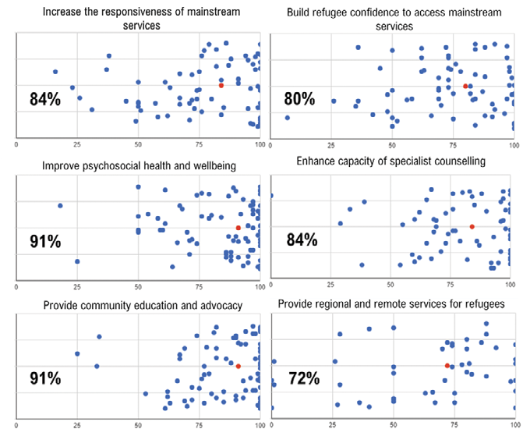

*Figure 26*. Visual representation of stakeholder’s perceptions of PASTT’s impact on helping them to deliver against the six objectives (0: not at all, 100: yes, most definitely, blue dots: individual responses, red dot/%: median score)

## Community-level outcomes

The following section details findings related to PASTT outcomes at the community level. These findings were derived from qualitative interviews, quantitative data reports, performance reports, existing evaluations, and community case studies provided by FASSTT agencies. The qualitative interviews with the PASTT stakeholders were the primary data source. The section is divided into four parts: (1) essential role of community engagement,

(2) community-capacity building programs, (3) education and advocacy activities, and (4) benefits of community engagement. Some illustrative quotes from the participant interviews are provided to explain important aspects

of community level outcomes, with additional quotes provided in **Appendix 9**. Narrative case studies detail the outcomes of programs and were developed and provided by the FASSTT agencies.

Overall, there was a strong perception that community capacity building programs lead to positive impacts on individual clients which then flow into the community. Key findings related to community-level outcomes are summarised and presented in Section 5.5 .

It should be noted that due to large heterogeneity of communities, agencies’ engagement approaches, and programs delivered across the country, the outcomes at this level were not well captured at a national level and may need to be considered at the agency level in future evaluations.

#### 5.4.1 Essential role of community engagement

Because of their potential for cost-effectiveness and working at scale, interventions that target whole refugee communities are crucial. While scarce, previous research has shown community-level interventions can reduce isolation, increase support networks, improve communities’ social capital, and positively impact psychosocial wellness and mental health39. Consequently, while individual therapy is an important element of PASTT, work that focuses on and with the community offers another powerful tool that can complement and enhance counselling. FASSTT agency stakeholders described it as such:

*“…as much healing can take place in those – some of those community sessions – for some people because they won’t access other therapeutic opportunities, but really powerful healing can take place in the community sessions.”*

***Interview 14, Clinical/counselling services, FASSTT***

*“It’s offering a space where they’re able to share on a deeper and vulnerable way and start to change maybe some of the cultural experiences of shame and hiding what’s going on.”*

***Interview 16, Rural and regional services, FASSTT***

In particular, community work contributes to rebuilding fractured and lost social relationships and structures. Close collaboration with communities was continuously emphasised as essential by FASSTT agencies. It was recognised as integral to trauma-informed care at the

individual, group, and community level. Having a strong and ongoing presence in the community allowed the agencies to increase the awareness of PASTT services. Building

trust was repeatedly highlighted as the fundamental pillar of commencing the rehabilitation journey. However, some

community members are reportedly not ready, comfortable, or familiar with engaging with counselling sessions. Thus, community-based programs offered an opportunity to expose and familiarise community members with the agencies, their staff, the services they offer, and provided an avenue for clients to engage with counselling services if needed. **It was the perception of FASSTT stakeholders that the demand for community development activities is greater than the demand for individual counselling but that the organisation is under resourced to complete these activities.**

#### 5.4.2 Community programs, activities, and participants

Two of the key objectives of PASTT are to (1) build the confidence of refugee communities to access mainstream health and related services through capacity building activities; and (2) provide community education and advocacy to overcome any barriers to access and equity for the client group. In terms of these objectives, FASSTT agencies have demonstrated significant reach, providing a wide range of community-based engagement activities and education to refugee communities.

Some indication of the reach of the community capacity building work engaged in by FASSTT agencies can be seen in the number of organisations that participated

in such programs, the number of activities conducted, and the number of participants that engaged in these between 2016 and 2021 (**Figure 27**).

Despite the impacts of COVID-19 restrictions on engagement in 2019-2020, FASSTT agencies were still able to perform over 5,200 activities with 584 agencies, groups, and organisations (reaching over 115,000 individuals) across Australia over the five-year period. The total participant numbers are made possible by working with a wide range of partners, chiefly refugee communities and relevant stakeholders e.g., assisting community groups in organising and delivering events. However, these figures are likely to be an underestimate as complete data from at least one agency was missing for every year except 2018-2019 and 2020-2021. Additionally, how activities, participants, and organisations were captured, categorised, and reported was not always transparent or consistent across agencies or reporting periods.

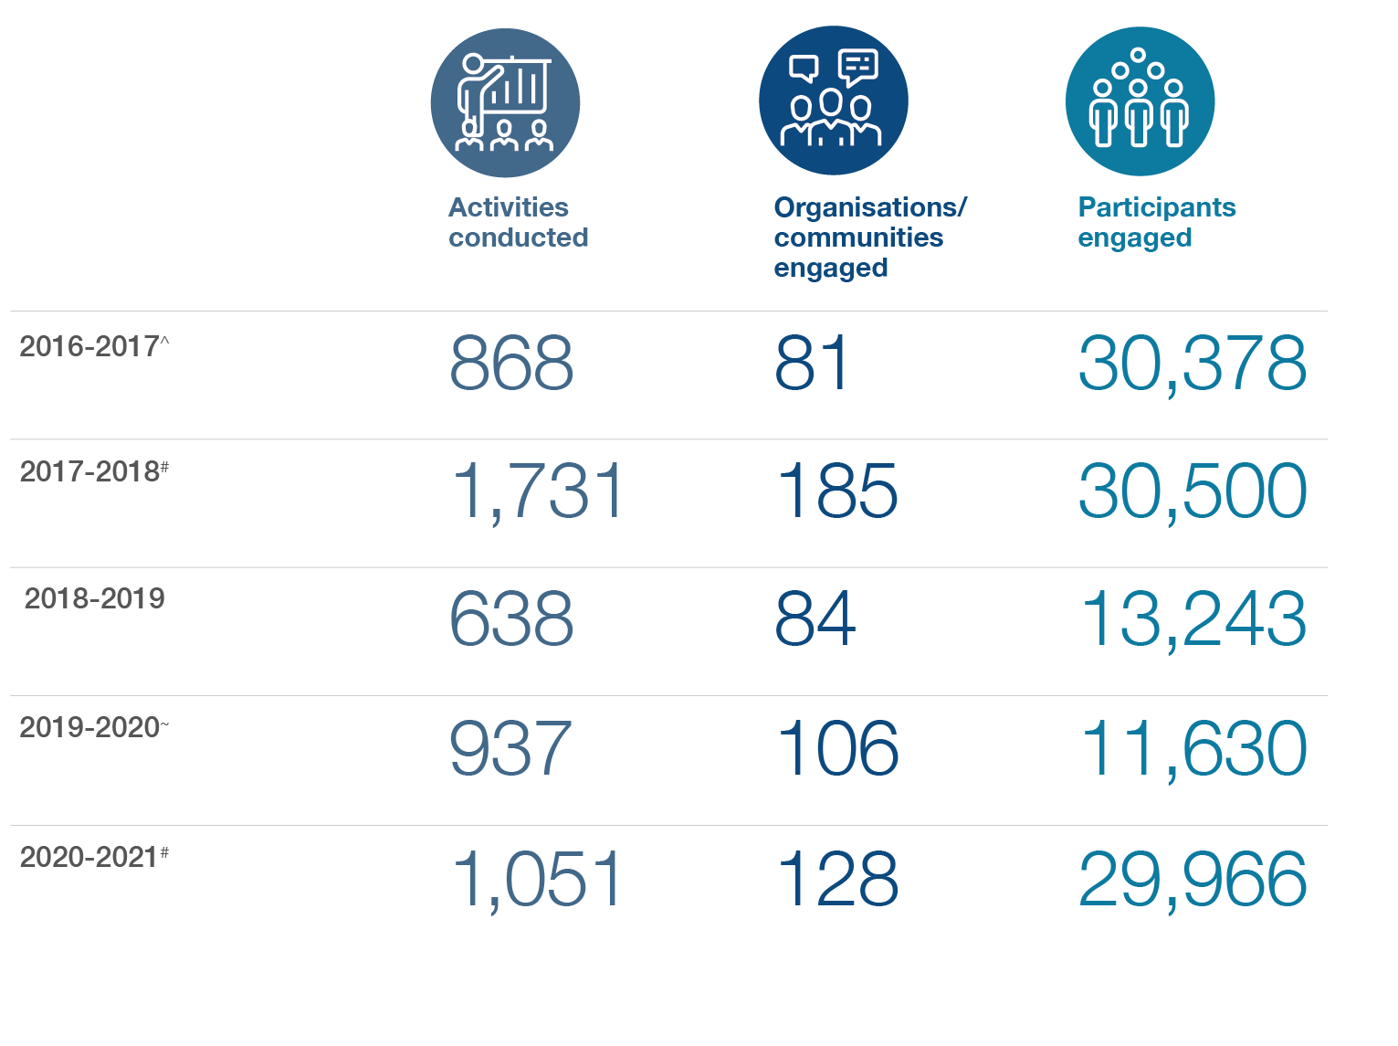

*Figure 27*. Statistics of FASSTT agency community engagement (2016-2021). ^: missing data one agency,#: missing data 2 agencies, ~: missing data 3 agencies

Some selected examples of PASTT-led community-based programs/activities include:

− A drop-in homework club for young people from a refugee background

− A yoga group for women

− Community leadership courses

− Family fun days

− Men’s, women’s, family, and youth groups

− A LGBTIQ + refugee support group

− COVID-19 support and awareness

− Mental health literacy projects

− Storytelling by elders

− Youth ambassadors

− Musical groups and exercise groups

#### 5.4.3 Advocacy and education activities

FASSTT stakeholders reported their agencies’ advocacy and education work as an important part of community- based activities. The agencies both advocated on behalf of

communities and empowered communities to self-advocate. Some examples of the agencies’ advocacy and education work included:

− Contributing to and making parliamentary submissions on behalf of communities and in consultation with community leaders (e.g., QPASTT made a submission to the Queensland Parliament Inquiry into serious vilification and hate crimes and as a result was requested to present to the Legal Affairs and Safety Committee at a public hearing)

− Advocacy to the Department of Education to provide more resources to students; school and community advocacy for better support by, and structures in, external services for multi-cultural communities (e.g., increasing availability and access to interpreters)

− Advocacy to the government to share more information about international crises in the areas of ongoing and intermittently escalating conflict, and to create more places in the humanitarian program

− Education with health services and government health officials to increase communities’ understanding of COVID-19, link people with COVID-19 testing, promote access to vaccines, and address misinformation

− Education with schools to assist in understanding the challenges faced by families and young people in home schooling

− Advocacy and assistance for individual clients to secure safe housing, access health services, legal services, and negotiate employment and income support

− Support and assistance with establishment of community advisory groups

#### 5.4.4 Benefits and outcomes of community- level work

Analysis of evaluation data and stakeholder interviews indicates that there are a range of benefits of PASTT’s community education, advocacy, and capacity building programs. Such programs develop communities’ resilience, decrease social isolation, build strength

and sense of belonging, provide a unique opportunity for developing and strengthening relationships, and expand community members social networks. This is important given that evidence suggests feeling socially

connected contributes to both integration and well-being for refugee communities59. Engagement in community- based activities and events empowers communities and their members to self-identify issues and seek solutions. Community members were able to develop and exercise leadership skills and take on leadership roles within the community and beyond. Clients develop confidence and courage, for example, work with youth results in them being able to speak in front of peers. Finally, PASTT’s community work has enabled refugee communities to be given a voice in service planning and delivery.

Community capacity building programs provide a safe, comfortable, and familiar space for community healing and addressing issues such as mental health stigma and intergenerational traumat. Such programs give clients

an opportunity to share knowledge, experiences, and traditions with the community and across generations via new, fun, and creative activities. These activities bring together young and elderly community members to

share the main issues they believe are affecting them and engage jointly in events. One interviewee expressed their belief about the benefits of community-based events in a very passionate way:

t “A decade ago, community leaders in [location] wouldn’t talk about mental health. They are actively talking, reaching out about mental health now. So, I think there have been absolutely achievements in terms of stigma reduction.” **Interview 1, Upper management, FASSTT**

*“[when running community capacity building activities] you see energy, you see resilience, you see laughter, you see tears. I mean we trip over tears daily in a way, but [in community capacity building activities] you trip over the laughter that’s got people through, and that’s what needs to be celebrated. It’s not always drowning in trauma, because all of these people are survivors who have come through incredible challenges.”*

***Interview 18, Community capacity building, FASSTT***

Community programs also provide a way to honour the wisdom, resilience, sacrifices, and strength of members which assists clients in their healing and rehabilitation. As one of the FASSTT participants working in community development said, “*being able to share and talk about and put into words those things has been a really important healing process for them, and a lot of them said they didn’t want to feel that their lives had been for nothing”* - **Interview 18, Community capacity building, FASSTT.**

#### 5.4.5 Case studies of community-level activities and program impacts

###### A drop-in homework club for young people from a refugee background

QPASTT established The Homework Club based on emerging community needs. It is coordinated by a young person from a refugee background, with a roster of 50 volunteer tutors. The Homework Club helps with: homework; mentoring; education and employment pathways; social opportunities; and access to QPASTT youth workers in an informal space. Benefits and healing observed include:

− Social opportunities with peers, including from different schools and different cultural backgrounds

− Connection with QPASTT staff in informal manner

− Links to other programs and activities for further social and wellbeing opportunities

− Connection with volunteers, including learning about education/work pathways, and work experience

− Study skills

− Confidence and self-agency

− Sense of community and communality - the challenges of learning in a different system and in a new culture are understood

One of the clients interviewed for this evaluation (C2) only connected to PASTT via homework club and school-based advocacy without engaging in any counselling or individual-level therapy. However, the impact of these activities on the student and his peers has been significant, including improved education and employment outcomes (see **Appendix 3**). C2 described the impact as such:

*‘There is so much potential in humans and you don’t realise that potential until you are afforded the opportunity, or you are told that you can, or you are encouraged that you have that potential. And I have seen from personal experience, people that I would go with [to the homework club], like peers and other people that would come at the time to receive support.*

*They would go to uni and were smashing it, getting jobs…that’s what we want to see, people to be educated, law obeying citizens, paying their taxes.’*

###### Mental Health Literacy and Suicide Prevention Projects

The projects delivered psychoeducation and training for members of particular cultural groups, as a result of concerns being raised by those communities to

STARTTS. The projects focused on increasing knowledge of basic mental health concepts and available support services and increasing confidence of community members to engage in mental health conversations in their communities to identify risk and signs of mental illness. In this way they could provide peer support

to people at risk of self-harm and to refer community members to appropriate support services. Benefits and healing observed include:

− Reduction of stigma

− Reduced social isolation

− Increased peer leader support to isolated community members at-risk

− Increased referrals to support services

− Increased ability to cope with stress

− Increased awareness of self-care

− Parents better able to support their children.

###### Families in Cultural Transition (FICT) Program

This program uses a model of peer-facilitated conversations on sensitive topics and is an effective way to improve social connectedness of newly arrived community members, address barriers faced by refugees as they resettle in Australia, and to have a positive impact on family relationships and environment. **Figure 28**(*from: Families in Cultural Transition Evaluation Report, STARTTS)* provides thematic findings from the FICT and an extension of this program, Older People in Cultural Transition (OPICT) Program, for 2020.

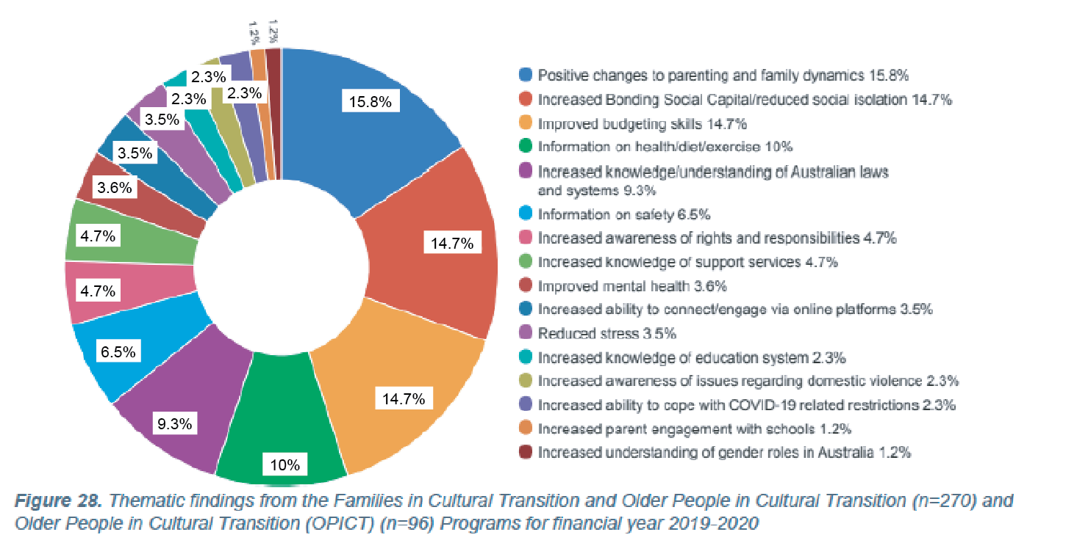

###### Community capacity building programs in rural Victoria

Bendigo Community Health Service and Barwon Child Youth and Family successfully engaged with refugee communities in their catchment area by developing community advisory groups to provide advice and input into the development of psychosocial and psychoeducation programs focusing on mental health and wellbeing.

Outcomes included development of a peer education mental health support program in Geelong and the development of a therapeutic group work program in Bendigo. Both initiatives led to increased community knowledge around mental health, facilitated access to mainstream services and lead to direct counselling referrals into the torture and trauma counselling programs.

###### Collaborating with community leaders during the COVID-19 pandemic

QPASTT provides a case study about their success in using pre-existing collaborations with Multicultural Australia, CALD faith leaders, and CALD community

leaders to assess and respond to needs of community members during the COVID-19 pandemic (**Appendix 4**) Multi-agency and community working groups supported:

− Development of in-language fact sheets

− Building community capacity for translation in many diverse languages

− Question and answer forums with the chief health officer, and government and health officials

− Family support for online schooling

− A grassroots mental health literacy project

The outcomes of this collaboration are further described in **Appendix 4**.

## Findings

**Finding O1.** The available evidence indicates that PASTT is effective in achieving its aim of improving the psychosocial health and wellbeing of people who have experienced torture and trauma prior to their arrival in Australia.

**Finding O2.** The available evidence indicates that PASTT is effective in assisting refugees engage with Australian society including through employment, education, and social avenues.

**Finding O3.** The available evidence indicates that PASTT is mostly effective in its engagement with a range of third-party providers to enhance their capacity to support refugees who have experienced torture and trauma. However, to enable greater collaboration and sustainability, it will be important to address issues of trust with third-party providers; improve FASSTT involvement in system-level collaboration; and

better communicate information about national and state PASTT funding, scope, and priorities to key external stakeholders.

**Finding O4.** The ongoing demand for training of third-party providers, and high costs of developing and delivering these services, may warrant increased funding allocation for this service activity.

**Finding O5.** The available evidence indicates that PASTT provides a safe, comfortable space for community healing and contributes to positive changes in refugee communities. Increased social cohesion, improved confidence and self-agency of groups and individuals, increased trust in the health system, and mental health stigma reduction have been reported.

**Finding O6.** An important individual and system level outcome of PASTT is the employment of former clients within FASSTT agencies and resulting ability to embed culturally appropriate and lived experience in service delivery.

**Finding O7.** The broad scope of PASTT activities necessitates an evaluation of impact that encompasses measurement at the client, provider, service, community, and society level using both objective and subjective measures of impact. Given this may present challenges, there needs to be nuance into how the impact of PASTT is measured and acknowledged, particularly where it is linked to achieving ongoing funding.

**Finding O8.** A more clearly defined national framework for classifying and reporting sector development and community engagement activities (including some pre-defined categories) would support ongoing quality improvement and evaluation activities of the PASTT program.

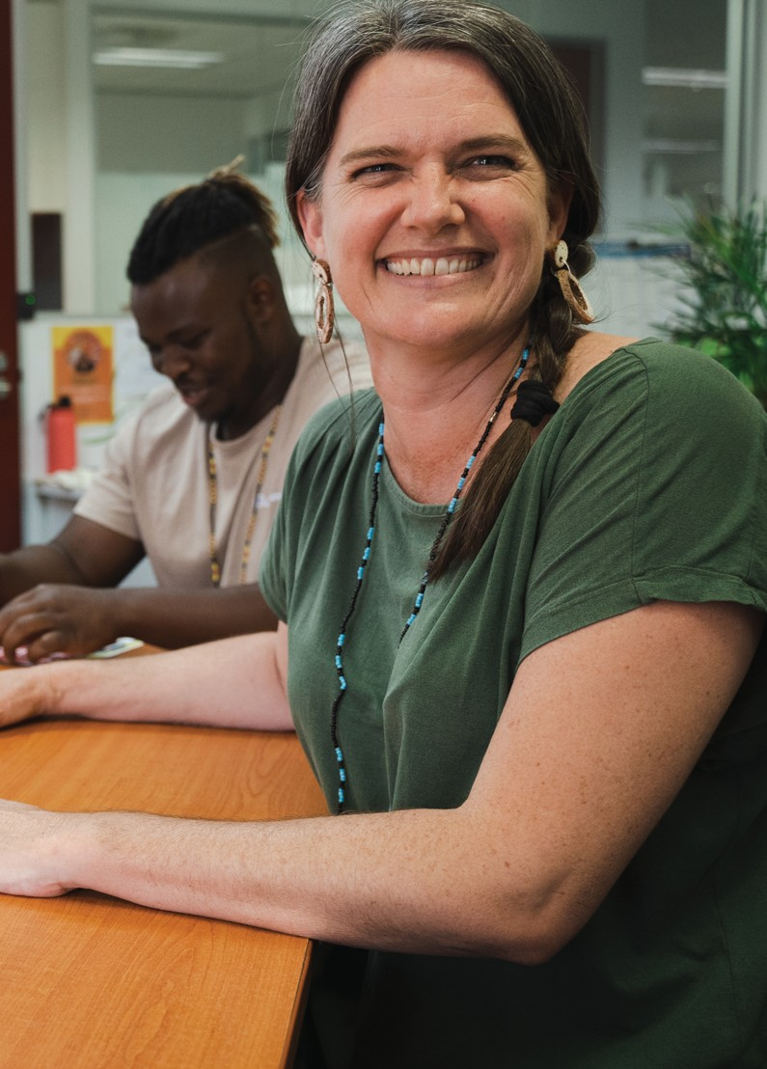

Australian Centre for Health Services Innovation QUT | 103

**Chapter 6. Economic analysis of PASTT**

This chapter examines the funding arrangements, costs, and financial pressures of PASTT using existing agency and program data, supported by stakeholder

consultation. It also draws on published literature where appropriate. The focus of the chapter is key evaluation question two: *How efficient has the program been?* It also provides insights to key evaluation question one, discussing the suitability of current funding arrangements and operational costs.

Quantitative analysis has been undertaken based on a review of existing organisational documents including annual PASTT reports, as well as via specific requests for data on budget outcomes, cost profiles, client numbers, and waiting list outcomes. Descriptive analysis of data, including trends over the past five financial years where available, is presented. In addition, qualitative analysis has occurred after extensive consultation with FASSTT agency leadership and staff and quotes are used to support findings where appropriate. Additional supporting quotes can be found in **Appendix 9**.

The following sections summarise analysis completed relating to:

## Program funding

The Australian Government has funded PASTT for over 27 years. The continuity of PASTT funding for more than two decades has been key in enabling agencies to plan and build capacity over time, develop collaborations between each other, and maintain long-term stakeholder relationships. This continuity provides confidence in the sustainability of ongoing service delivery for clients and heath service stakeholders.

The long-term investment by the government in PASTT has encouraged greater investment in refugee causes by state and philanthropic sources and drawn in other resources

for policy and program development. This has generated a

− Program funding

− Cost of service delivery

− Key cost pressures

− Evidence of unmet need

− Opportunities

larger ‘base platform’ of refugee knowledge and experience in Australia to respond quickly and efficiently to emerging crises. FASSTT agency stakeholders strongly endorsed the overall funding model with several citing it as an international exemplar for funding specialised refugee services.

Currently PASTT is funded through the Commonwealth Standard Grant Agreement. Each of the eight PASTT agencies is contracted by The Commonwealth, represented by the Department of Health and Aged Care, under separate Funding Agreements. During each contracting period all agencies receive a proportion of the

overall PASTT base funding budget via an agreed distribution model. This funding is released to each agency in progressive payments throughout the financial year.

Besides the agreed PASTT base funding, additional one-off supplementary funds may be provided by the government as block payments under special circumstances. For example, recent top-ups have been provided in response to humanitarian crises, natural disasters, to alleviate waitlists, and to counter increased service demands associated with COVID-19.

Amounts of base funding and supplementary top-ups since 2018 are presented in **Table 11**. Base funding amounts are largely dependent on Government policy decisions, primarily the humanitarian program intake numbers. In the 2020-21 Federal Budget, it was announced that the cap on the Humanitarian Program intake would reduce by 5,000 to 13,750 for the next 3 years. In the 2022-23 Budget it was further announced that this cap would be maintained over the forward estimates. This reduction triggered a lowering of

PASTT base funding. As a temporary measure, $10 million in top-up funding is being provided in both 2021-22 and 2022- 23 to maintain existing service levels and manage waitlists.

In addition to Commonwealth PASTT funding, some agencies produce self-generated income that is used to cross- subsidise PASTT activities where necessary. Self-generated income comes from sources including philanthropic and untied donations, interest on term deposits, and revenue from delivering other services or programs.

Agency budget deficits in recent years have also been supplemented with surplus income carried forward from previous years with approval from the respective agency boards.

***Table 11*. PASTT base and supplementary funding: 2018-2023**

|  |  |  |  |  |  |
| --- | --- | --- | --- | --- | --- |
| **PASTT Funding -GST exclusive ($mil)** | **2018-19** | **2019-20** | **2020-21** | **2021-22** | **2022-23** |
| Base funding | 28.4 | 29.9 | 28.3 | 23.4 | 23.8 |
| Top-up funding | - | - | - | 10 | 10 |
| Afghan funding | - | - | - | 5.2 | 2.7 |
| QPASTT – flood assistance | - | - | - | - | 0.2 |
| COVID-19 funding | - | 1.9 | - | - | - |
| Social and Community Services Workers Wage Supplementation (SACS)* | 2.7 | 3.1 | 3.4 | - | - |
| Total funding | 31.1 | 34.9 | 31.7 | 38.6 | 36.7 |

*SACS payments ceased in 2020-21, following the legislated cessation of the Social and Community Services Special Account.

**Figure 29** summarises the combined income profile across FASSTT agencies between 2017-18 to 2020-21. The ‘other income’ category includes any self-generated income as well as retained earnings that have been carried forward to meet budget deficits.

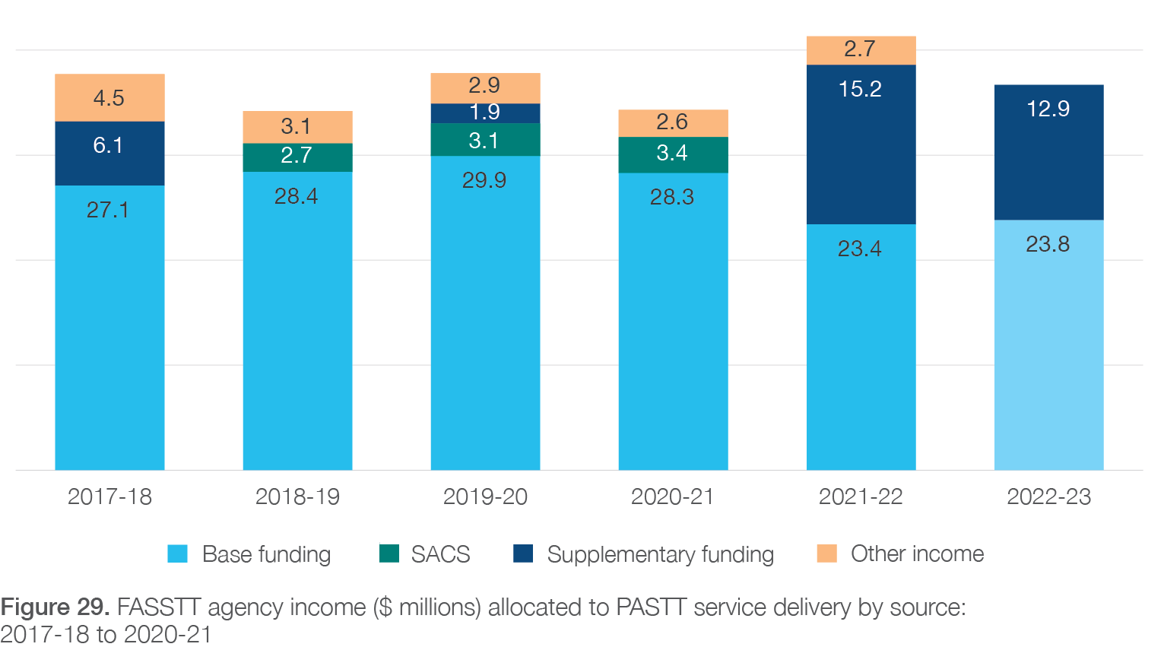

PASTT base funding is a critical income stream for all FASSTT agencies. In line with this funding imperative, consultations with agency stakeholders have confirmed that PASTT-funded activities sit at the centre of service delivery and are well aligned with broader organisational goals. As one FASSTT agency member described:

*“Without PASTT we wouldn’t be able to do any of the other things…our positions, that hold, the glue that holds the whole program together is PASTT funded”*

***Interview 22, Community capacity building, FASSTT***

Importantly, base funding acts as a consistent scaffold to build work around and leverage for further grants and tenders. In this way the PASTT investment by the Australian Government is used to leverage additional

activities and services to benefit clients and communities.

#### 6.1.1 Funding distribution across FASSTT

#### agencies

PASTT funding distribution arrangements consider the number of refugees entering each state and territory and the minimum viability needs of each agency. To ensure the viability of smaller agencies (e.g. Melaleuca and Companion House), minimum funding levels are agreed between FASSTT and the government. This amount

has been reviewed several times, most recently leading to a revision in minimum viability funding of $423,000 per annum. Consultation with FASSTT stakeholders demonstrated clear support for this practice in that it maintains equity and stability of service provision, while ameliorating issues with economies of scale often faced by these smaller agencies.

Since 2010, PASTT base funding has been allocated to each agency according to the proportion of refugee and humanitarian entrants into each state and territory

averaged over the previous five years (using Department

of Immigration and Citizenship settlement data). Originally, this funding allocation process occurred once across a contract lifecycle (every 3-5 years), however changes

in annual settlement patterns in recent years have necessitated a move to yearly re-assessments of funding distribution. With fluctuating yearly allocations from the base funding pool, agencies have cited a lack of certainty when making decisions around planning programs or retaining staff, with perceived impacts on organisational stability and service quality. This is compounded by the unpredictable nature of top-ups, which in recent financial years have been as high as 42% of the base funding.

Consideration should therefore be given for PASTT returning to longer, more predictable funding periods for base funding allocation.

## Costs of service delivery

Total costs of service delivery across PASTT decreased from $39.0 million in 2017-18 to $34.5 million in 2018-19. Despite lower arrival numbers in the subsequent two years due to the COVID-19 response (see **Table 12**below), total

costs increased to $35.7 million in 2019-20 and $37.4 million in 2020-21. Drivers of these increased costs are outlined

in Sections 6.2.2 (Cost per client), 6.3.2 (Humanitarian

intake levels and rates of engagement with PASTT), 6.3.3 (Settlement patterns), 6.3.4 (Timing of engagement), 6.3.5 (The impact of world events).

***Table 12*. Total costs of service delivery (Actual) by agency: 2017-18 to 2021-22**

Salary-related expenses have consistently accounted for a large proportion of total costs across FASSTT agencies, ranging from 72% to 80% within 2021-22 projections (**Table 13**). An increasing overall trend in salary expenses across FASSTT agencies has been recorded, from 71% in 2017-18 to 75% in 2021-22. Increasing salary costs have been driven in part by ongoing increases in award wage rates, as well as legislated increases to employer superannuation contributions. Additional detail on wage- related cost pressures is outlined in Section 6.3.6 .

Cessation of the Social and Community Services Workers Wage Supplementation (SACS) scheme has also impacted on agency salary budgets. Between 2018-19 and 2020- 21, PASTT received $8.7 million in SACS in addition to their base funding. These payments ceased in 2020-

|  |  |  |  |  |
| --- | --- | --- | --- | --- |
| **Actual expenses ($ millions)** | | | | |
| **Agency** | **2017-18** | **2018-19** | **2019-20** | **2020-21** |
| STARTTS | 15.0 | 13.2 | 13.2 | 13.8 |
| VFST | 11.6 | 10.3 | 10.4 | 11.2 |
| QPASTT | 4.7 | 4.5 | 5.3 | 5.3 |
| STTARS | 3.5 | 3.0 | 3.1 | 3.4 |
| ASeTTS | 2.5 | 1.8 | 1.9 | 2.0 |
| CH | 0.6 | 0.5 | 0.5 | 0.5 |
| Phoenix | 0.8 | 0.8 | 0.9 | 0.8 |
| Melaleuca | 0.4 | 0.4 | 0.4 | 0.4 |
| **Total** | **39.0** | **34.5** | **35.7** | **37.4** |

21, following the legislated cessation of the Social and

Community Services Special Account.

***Table 13*. Salary expenses as a proportion of total agency expenses: 2017-18 to 2021-22**

|  |  |  |  |  |  |
| --- | --- | --- | --- | --- | --- |
| **Agency** | **2017-**  **18** | **2018-**  **19** | **2019-**  **20** | **2020-**  **21** | **2021-**  **22** |
| Total FASSTT | 71% | 73% | 75% | 73% | 75% |
| STARTTS | 67% | 73% | 76% | 70% | 72% |
| VFST | 73% | 74% | 76% | 77% | 77% |
| QPASTT | 69% | 72% | 73% | 73% | 75% |
| STTARS | 73% | 74% | 76% | 80% | 80% |
| ASeTTS | 75% | 72% | 71% | 57% | 70% |
| CH | 80% | 77% | 80% | 76% | 80% |
| Phoenix | 71% | 71% | 70% | 68% | 72% |
| Melaleuca | 72% | 76% | 78% | 65% | 74% |

#### 6.2.1 Cost profiles

###### Activity-based cost breakdowns

**Table 14**outlines the proportion of agency budgets allocated to key cost categories in the 2020-21 financial year. Direct counselling and community service activities accounted for the largest proportion of costs within each agency ranging from 44% to 65% of total costs, translating to a combined total of $18.5 million across FASSTT, when applying proportions to the 2020-21 actual expenditures in **Table 12**. Community engagement and development activities were the next largest expense category, accounting for between 3% and 21% of agencies’ total costs and a combined FASSTT total of $5.4 million (29,966 participants engaged across 1,051 activities, **Figure 27**, **Chapter 5**). FASSTT agencies spent a combined total of $1.3 million on sector development and training in 2020-21 (8,318 participants trained across 335 sessions, **Figure 22**, **Chapter 5**). Interpreting services accounted for between 5% to 10% of total costs, and a combined total of $2.2 million across FASSTT.

***Table 14*. Breakdown of agency costs per category for the 2020-21 financial year**

|  |  |  |  |  |  |  |  |
| --- | --- | --- | --- | --- | --- | --- | --- |
| **Cost categories: FY 2020-21^** | **STTARTS** | **VFST** | **QPASTT** | **STTARS** | **ASeTTS** | **Phoenix** | **CH** |
| **Total direct costs** | **76%** | **85%** | **80%** | **80%** | **79%** | **87%** | **85%** |
| Intake and assessment | 3% | 6% | 7% | 3% | 6% | 5% |  |
| Counselling and community services | 44% | 57% | 45% | 65% | 49% | 61% | 63%* |
| Community engagement/ development | 19% | 12% | 21% | 4% | 8% | 8% | 3% |
| Sector development and training | 4% | 5% | 1% | 1% | 9% | 8% | 9% |
| Interpreting | 6% | 5% | 6% | 7% | 7% | 5% | 10% |
| **Total indirect costs** | **23%** | **15%** | **20%** | **20%** | **21%** | **13%** | **15%** |
|  |  | | | |  | | |
| Indirect cost rate (indirect costs as proportion of direct costs) | 32% | 18% | 25% | 25% | 27% | 15% | 18% |

^Cost category data was not available for Melaleuca; *Includes intake and assessment costs

Each financial year FASSTT agencies prepare their own Activity Work Plans (planned activities, outcomes, proposed budget) to outline how they will use the

provided PASTT funding to deliver activities to meet the needs of local clients and communities. This flexibility granted to each FASSTT agency in using their allocated PASTT budget is a clear strength of the overall funding model. The adaptability of PASTT funding at the state- level also received unanimous support from the FASSTT agency stakeholders consulted throughout evaluation.

Such a non-prescriptive approach allows agencies to allocate resources, hire staff, engage with communities, and deliver programs in the way most appropriate to their client base. It also fosters innovation and means PASTT can be highly responsive to the emerging needs of clients and communities. This ensures both early intervention and recovery focused issues can be appropriately facilitated.

Maintaining this agency-level funding flexibility should be a key priority in any revision to the overall PASTT funding model. Alongside this is the need to be open to two-way dialog about the impact of such variations in funding use and associated program deliverables.

###### Current budgets prioritise counselling services over sector development and community work

Many FASSTT agency stakeholders consulted described how the urgency of addressing the unmet need for individual counselling and direct service provision

meant that these areas were often prioritised when allocating resources in Activity Work Plans, despite the well understood importance of sector development and community capacity building activities in ensuring future sustainability. This is reflected in agency expenditures, with intake, assessment, and counselling services comprising between 47% to 66% of total costs (**Table****14**). While PASTT funding does support agencies to undertake community-based activities (and is often the only consistent source of funding available for this work), the challenges in adequately supporting communities

in a holistic way within current funding envelopes was a commonly cited concern, particularly by those

working in community capacity building roles. Individual counselling services are also an expensive form of service delivery, and other options may be more efficient and cost-effective. For example, group work is a culturally appropriate and effective treatment for many clients that

has resource efficiencies. Community healing is also perceived to be an underutilised resource which has potential to be both effective and efficient for community recovery and early intervention.

This broader focus aligns with research which suggests that there is a need to move away from medical models of individual stress-related trauma and focus more on positive psychosocial models of change14. For example, building community capacity, facilitating local healing, engaging community leaders, and working with health professionals in culturally appropriate ways is more likely to facilitate lasting change, decrease stigma, and increase mental health utilisation. This approach, however, requires a long-term investment in community work, something that agency stakeholders have described as challenging to achieve within current PASTT funding allocations.

Additionally, current funding has not allowed agencies to adequately adapt and respond to new communities over the long-term, or track performance data from community-led projects. Consequently, it would be

useful to consider ways in which this community focused work could be better resourced and evaluated within

the program to allow for long-term, ongoing community capacity building and impact.

###### Direct vs indirect costs

The proportion of agency budgets allocated to direct versus indirect costs is highlighted in **Table 14**. Direct costs are those directly attributed to service delivery, while indirect costs, often referred to as ‘overheads’, are those which support the organisation as a whole, without being attributable to a specific project or service. This includes costs of information technology, finance, administration, travel, and management/executive personnel.

Research from the US has demonstrated that insufficient funding for indirect costs is one of the main drivers of financial vulnerability among non-for-profit organisations60. The authors describe a “non-profit starvation cycle” whereby non-profits feel pressure to both underinvest

in their indirect costs and underreport their true costs to funders. Similar findings have been reported in the Australian not-for-profit setting, where ‘true’ indirect costs often substantially exceed the amount that is

allocated by funders61. Evidence suggests that insufficient investment in overheads can negatively impact the overall effectiveness of not-for-profits62.

A study of 130,000 charities in the US found that the minimum rate of indirect costs (as a proportion of direct costs) associated with financially healthy organisations was 29%63. This is comparable to a recent review of Australian

not-for-profits that reported an average indirect cost rate of 33%, with significant variation between 26% and 47%61. In comparison to these Australian and international benchmarks, FASSTT agency indirect cost rates are relatively low, with all agencies sitting below the Australian average in 2020-21 (**Table 14**). In addition, a trend of decreasing proportions of indirect costs has been observed across agencies between 2018-19 and 2021-22 (**Figure 30**).

Inconsistencies in how agencies collect and report on financial data, particularly within indirect cost categories, mean that direct comparisons are not able to be made. For example, indirect costs within QPASTT includes a regional and remote service delivery component that was not able to be separated out, resulting in slight over-estimation of indirect costs for that agency. Implementation of a consistent framework for financial reporting across FASSTT would help to support future quality improvement and evaluation activities.

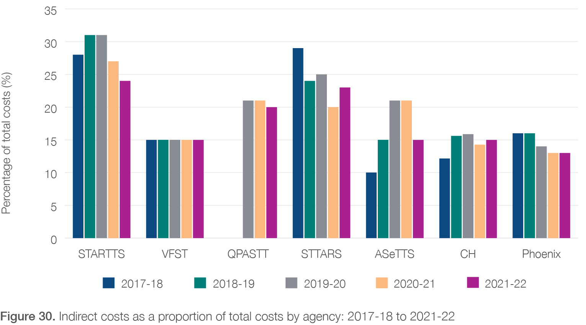

A common concern arising from consultations with FASSTT agency stakeholders was their limited ability to invest in indirect costs within current funding envelopes, and the impact this is having on service delivery and sustainability. Activities such as administration, IT, finance, communication, co-design, learning and development, accountability/ reporting, data measurement, and evaluation were perceived as crucial to support service delivery and sustainability. However, agencies only spend small proportions of their budget on these indirect activities as they perceive it to be necessary to prioritise frontline services to meet the immediate urgency of need in this area. In addition, some agency stakeholders believed that more data-driven, outcomes-focused contracting and reporting was overly burdensome and under resourced. Consideration should be given to increasing the base PASTT funding to allow for a higher proportion of spending on indirect costs, which would in turn promote longer term financial stability. Investment in national-level infrastructure across FASSTT to support and streamline activities such as communication, development, and data collection (e.g., a national reporting database) would likely provide greater efficiencies than individual agencies undertaking these in silo.

#### 6.2.2 Cost per client

###### Overall cost trends

An overall ‘cost per client’ estimate can be derived by dividing total agency expenses (**Table 12**) with total number of individual counselling clients in a given financial year. This estimate should therefore not be interpreted as indicative of the average costs to provide counselling services to one individual, as it encompasses the full range of agency services including group work, community engagement, sector development, and indirect costs. For example, within these expenses agencies provided sector development/training to an average of 7,162 participants each year and engaged with 23,143 individuals via community development work annually (**Figure 22**and **Figure 27**). Nonetheless, in the absence of complete and consistent data on the total number of clients being engaged across all activities of

the program each year, this estimate is useful as a means of analysing overall trends and observing differences in relative costs of service provision between metropolitan and non-metropolitan settings.

When estimated on a ‘per client’ basis, overall agency costs have been increasing over the past five years **Figure****31**highlights the trends in cost per client by agency between 2017-18 and 2020-21. At a national level, the average cost per client has increased from $3,660 in 2017- 18 to $4,344 in 2020-21. Increasing client complexity was flagged as one cause of this increased cost by PASTT stakeholders. Additional explanation around the potential cost pressures driving these costs per client increases is included in Section 6.3 below

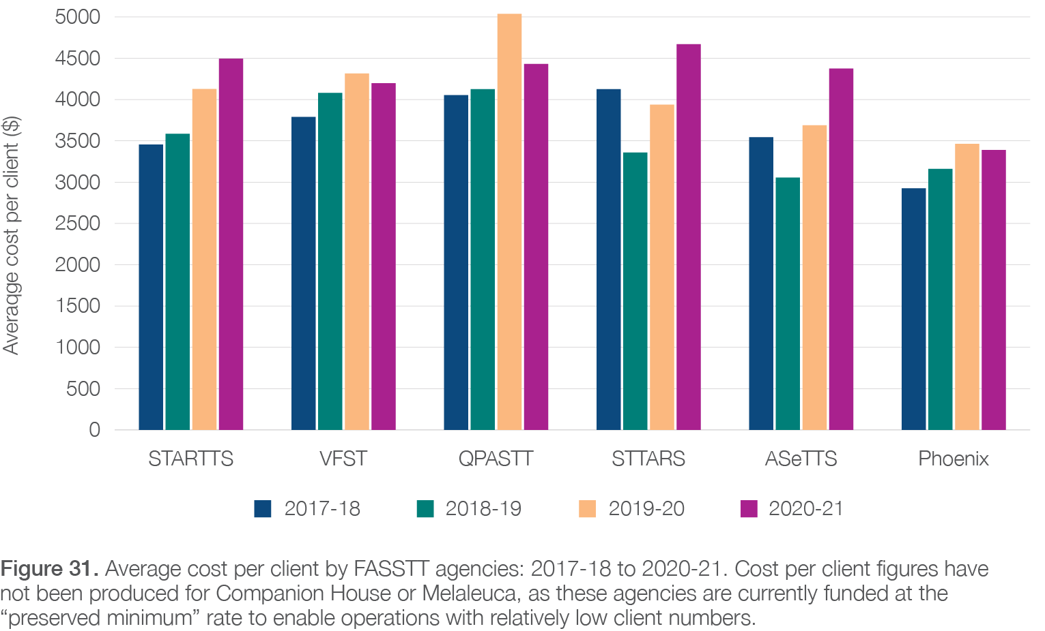

###### Capital city vs regional costs

In 2019, AusHSI conducted an environmental scan encompassing all FASSTT non-capital city services and sites within NSW, Queensland, Victoria, and Tasmania. The full report, including detailed methodology, is provided in **Appendix 5**. Findings from this work indicated that the location-based costs of service delivery were driven by four key factors:

− Distance of site from the nearest capital city

− Type of facility: local office versus outreach

− Level of host community capacity to provide services for survivors of torture and trauma

− Additional resources required in the first 12 months of a new site

Consultation with agency CEOs when preparing this evaluation confirmed that the relative cost loadings identified in this earlier report would be consistent with current cost profiles, once scaled to reflect overall costs per client in the most recently reported financial year.

For the purpose of this report, findings from the original environmental scan have been distilled to summarise differences in cost drivers between capital city versus non-capital city service delivery locations. This will allow for future funding models to approximate costs of service delivery for metropolitan versus regional and rural clients

at the state or national level, without requiring site-specific calculations to be performed. **Table 15**summarises costs per client within non-capital city locations across NSW, Queensland, Tasmania, and Victoria as estimated within the 2019 environmental scan, along with respective cost loading factors.

*Table 15*. Average costs per client in 2018-19: non-capital city sites as compared with Sydney, NSW

|  |  |  |
| --- | --- | --- |
| **Setting** | **Average cost per client ($2019)** | **Non-capital city cost loading factor** |
| **Base cost per client: Sydney** | **3,520** | **Reference** |
| **Average regional and rural cost per client** | | |
| New South Wales | 5,791 | 1.65 |
| Queensland | 6,350 | 1.80 |
| Tasmania | 5,347 | 1.52 |
| Victoria | 5,775 | 1.64 |
| Total | 5,700 | 1.62 |

**Table 16** takes the regional and rural loading factors estimated from the 2019 environmental scan (**Table 15**and **Appendix 5**) and applies these to the 2020-21 cost per client estimates at state and national levels. At the national level, the average cost per client within a capital city location is $3,952, compared to an average $6,400 for clients in non-capital city locations.

***Table 16*. Derivation of 2020-21 average cost per client differentials across capital city sites versus non-capital city sites**

|  |  |  |  |  |  |
| --- | --- | --- | --- | --- | --- |
| **Agency** | **Average cost per client ($2021)** | **Regional and rural loading** | **Proportion of regional clients** | **Average cost per capital city client ($2021)** | **Average cost per non- capital city client ($2021)** |
| STARTTS | 4,495 | 1.65 | 22% | 3,932 | 6,469 |
| VFST | 4,199 | 1.64 | 8% | 4,006 | 6,573 |
| QPASTT | 4,430 | 1.80 | 25% | 3,693 | 6,663 |
| STTARS | 4,670 | 1.62 | 8% | 4,449 | 7,204 |
| ASeTTS | 4,376 | 1.62 | 0% | 4,376 | 7,087 |
| Phoenix | 3,389 | 1.52 | 38% | 2,835 | 4,306 |
| **Total FASSTT** | **4,344** | **1.62** | **16%** | **3,952** | **6,400** |

* Cost per client figures have not been produced for Companion House or Melaleuca, as these agencies are currently funded at the “preserved minimum” rate to enable operations with relatively low client numbers.

The increased costs of regional service delivery were supported with specific examples in stakeholder consultationsu. For example, there is a need to provide specialised phone contracts and handsets that work in the regions. Due to the poor network coverage in regional areas, the phones/plans that must be obtained are generally more expensive. Additionally, specialty therapy resources cannot be shared between providers or organisations to split costs, as in metropolitan areas. Another cost that is increasing is the need to obtain accredited and skilled interpreters for the various languages spoken by the communities. Often phone interpreters have to be used, which is costly for service provision. Finally, having a physical presence in regional communities is key to relationship building with refugee communities and other service providers, but the costs of rent and travel in these areas can make this prohibitive.

The issues associated with implementation of PASTT in regional areas that also explain these higher costs, and state/ territory-based differences have been previously explored Chapter 4. Particular consideration for these additional expenses needs to be taken into account in future funding allocations for states/territories with large geographical areas and few established settlement communities.

u “[PASTT funding is flexible] but in the funding there’s no consideration of the cost that it takes to deliver these types of services in the regions” –

**Interview 16, rural and regional stakeholder, FASSTT**

## Key cost pressures

Analysis of quantitative financial data and stakeholder consultations demonstrated that the current levels of base funding for PASTT are inadequate to meet current service demands or promote sustainability. This is evidenced by the increasing service costs and need for top-ups and

self-generated income to maintain service delivery. Even with these additional sources, agencies are often forced to prioritise programs, services, or therapies due to limited resources. Alternatively, some agencies leverage off non-

PASTT funded activities to overcome this funding deficient. For example, in one agency PASTT counsellor advocates attended activities presented as part of a youth program (which was not PASTT funded) to make connections with families which facilitated relationship building and referral into the PASTT program. One FASSTT agency stakeholder voiced concerns as such:

*“I don’t think it [funding] is sustainable, and I certainly don’t think it’s sustainable as an expectation that we continue provide the level of services that we have provided, because we know that it’s actually costing us more to deliver what we are delivering, than what we get funded for, and yet we know that there’s so much more that can be done that we’re not able to do.”*

***Interview 26, Upper management, FASSTT***

While larger agencies with multiple funding streams have been able to absorb or offset some of the operating costs of their services to date, the financial viability of maintaining PASTT delivery is reaching a crisis point for other agencies.

For most, the sustainability of current service levels is unlikely, given increases in both costs and demand for services. These funding issues are having downstream impacts including burgeoning waitlists and employee distress because of the need to waitlist clients. Numerous processes have been put in place by the FASSTT agencies to increase efficiencies

and reduce costs (such as staffing freezes and resourcing reviews). The FASSTT agency stakeholders consulted reported any further cost reductions will likely have significant flow on effects to staff and communities.

Financial pressures are further evidenced by recent staff redundancies that have been implemented by some agencies, despite the ongoing, high demand for services. The Phoenix Centre stated that redundancies had been avoided thus far by not replacing outgoing

staff who have resigned or moved into other roles within the organisation. A summary of recent redundancies since 2017-2018 is provided in **Table 17**. In addition, multiple agencies also stated that some redundancies had been avoided by not replacing outgoing staff who have resigned or moved into other roles within the organisation. These reductions in staffing levels have led to periods of instability for some agencies, triggering

further staff turnover. This was described by one FASSTT agency member as such:

*“...the challenge is because of that funding cut [linked to fewer entrants] it was like, the organisation became unstable. So, everything happened, then it was harder to retain staff, experienced staff. Some were made redundant, but some decided to leave because of that uncertainty around it.”*

***Interview 20, counselling/clinical services, FASSTT***

Agency stakeholders have also described the impact these redundancies have at the client and organisational level:

− loss of counsellor advocates is problematic for clients who rely on continuity of care for therapy

− lost investment in the mentoring and capacity building of agency staff

− stress for counsellor advocates not sure if they will have employment to see clients to closure

− loss of specialised organisational knowledge and skill

− inability of agency to provide rural and regional service delivery

***Table 17*. Redundancies across FASSTT agencies occurring between 2017-18 and 2021-22**

|  |  |  |  |  |
| --- | --- | --- | --- | --- |
| **Agency** | **Year** | **FTE**  **positions** | **Role descriptions** | **Reason for redundancy** |
| STARTTS | 2017-18 | 21 | Counsellor/project officers (5), Group counsellor positions (5), Senior Group Counsellor (1), Family counsellors (4), Team Leader (1), ICT Support Worker (1), Project officers (3), Admin staff (1) | Reduction in funding following the end of the special provisions for the Syrian and Iraqi group |
| QPASTT | 2021-22 | 3 | Team Leaders, Counsellor Advocates, Community Worker, Youth Worker | insufficient salary funds due to impact of ongoing wage increases |
| VFST | 2017-18 | 7 | Direct services coordinator (1), Counsellor Advocates (6), Community Liaison Workers (2) | insufficient funds to keep up with increases in CPI and award wages. Program for refugees from Syria and Iraq involved in-depth trauma work and a sizeable number required complex and long-term interventions that meant specialist staff were needed for longer than the original funding anticipated. |
| STTARS | 2018-19 | 3.1 | Client service management, Finance officer, Counsellor, Executive Assistant | Agency restructure |
| Phoenix | 2021-22 | 1 | Not stated | Not stated |
| ASeTTS | 2017-18 | 1 | Complex case specialist | Restructure due to decreases in HSP and PASTT funding |
| 2018-19 | 5 | Counsellor Advocates, team leaders, administrative roles | Restructure due to decreases in PASTT funding |
| 2020-21 | 3.6 | Counsellor Advocates, team leaders/ managers | Voluntary redundancies following restructure to adjust to PASTT funding levels |
| CH | 2017-18 | 1 | Counsellor Advocate | Reduced PASTT funding as a result of Syrian/Iraqi funding injection having finished |

A further exploration of cost and service pressures is presented below and supported by quantitative and qualitative data where appropriate.

#### 6.3.1 Policy context and implications

FASSTT agencies rely on PASTT base funding as the core income stream to support service delivery. However, base funding allocations are largely driven by Government policy decisions and therefore subject to change year-

on-year. Recent policy decisions have caused substantial disruption to overall PASTT funding, most notably the 2020-21 Federal Budget announcement that the cap

on the Humanitarian Program intake would reduce by 5,000 to 13,750 for the next 3 years. In the 2022-23 Budget it was subsequently announced that this cap would be maintained over the forward estimates. This resulted in changes to PASTT base funding levels that placed agencies under extreme financial pressure. The Government subsequently agreed that $10 million in top-up funding be provided in both 2021-22 and 2022-

23 as a temporary measure to allow agencies to maintain existing service levels and manage waitlists.

In addition to changes in base funding allocations, the decision to cease the Social and Community Services Workers Wage Supplementation (SACS) scheme in 2020- 21 has also had a substantial impact on salary budgets for some agencies (**Table 11**and **Figure 29**).

#### 6.3.2 Humanitarian intake levels and rates of engagement with PASTT

All humanitarian entrants to Australia that are survivors of torture and trauma are eligible to receive PASTT services, regardless of their length of residence in Australia. As

a result, the total eligible pool of clients continues to grow year on year. **Table 18**summarises annual and cumulative numbers of humanitarian entrants to Australia over the 20-year period between 2001-02 and 2020-21, along with the total number of unique clients that have been enrolled in individual counselling services over set historical windows of time.

Of the 277,539 humanitarian entrants to Australia over the last 20 years, **at least 46% have been enrolled in individual counselling services via PASTT at some point since settlement (****Table 18****)**. This proportion has remained relatively consistent when considering rates of engagement over the past 15 years (46%) and past 10 years (45%). This can be considered a lower range estimate of engagement as in addition to individual counselling, client engagement with PASTT also occurs via groupwork, community engagement programs, and advocacy initiatives. However, as data is not consistently collected by all agencies on the numbers of clients engaged beyond individual counselling, this has been omitted from these estimates. Further detail about the levels of engagement across these additional activities can be found in Chapter 5 (**Figure 22**and **Figure 27**).

***Table 18*. Total humanitarian entrants to Australia since 2001-02 compared with number of unique individual counselling clients enrolled in PASTT over this period.**

|  |  |  |  |
| --- | --- | --- | --- |
| **Year** | **Total entrants** | **Cumulative total entrants** | **Individual clients accessing PASTT counselling services and relative proportion of cumulative entrant totals** |
| 2020-21 | 564 | **5-year total** | |
| 2019-20 | 13,159 |  | 40,886  62% of 5-year entrant total 28% of 10-year entrant total 19% of 15-year entrant total |
| 2018-19 | 15,438 | 65,621 |
| 2017-18 | 12,117 |
| 2016-17 | 24,343 |  |
| 2015-16 | 17,555 | **10-year total** | |
| 2014-15 | 13,756 |  | 64,746  45% of 10-year entrant total 31% of 15-year entrant total 23% of 20- year entrant total |
| 2013-14 | 13,759 | 144,434 |
| 2012-13 | 19,998 |
| 2011-12 | 13,745 |  |
| 2010-11 | 13,778 | **15-year total** | |
| 2009-10 | 13,770 |  |  |
| 2008-09 | 13,507 | 211,520 | 97,776  46% of 15-year entrant total 35% of 20-year entrant total |
| 2007-08 | 13,014 |
| 2006-07 | 13,017 |  |  |
| 2005-06 | 14,144 | **20-year total** | |
| 2004-05 | 13,178 |  |  |
| 2003-04 | 13,823 | 277,539 | 126,741  46% of 20-year entrant total |
| 2002-01 | 12,525 |
| 2001-02 | 12,349 |  |  |

This cumulative pool of eligible clients was a key theme in discussions with PASTT stakeholders about drivers of service demand, as demonstrated in quotes from two stakeholders.

*“...there’s a cumulative effect, so often we’re seeing more clients than are represented just in the more recent arrivals, and so if our funding is reduced based on numbers of arrivals, that doesn’t necessarily recognise that we have a lot of longer-term clients we are still supporting very actively.”*

***Interview 20, Clinical/counselling services, FASSTT***

*“…and while we’ve had a couple of years, you know, where the humanitarian program has been closed off, or pretty much, we’ve seen pretty consistent referrals”*

***Interview 11, Upper management;Administration and corporate services, FASSTT***

Because of this growing base of clients, there was a perception that the demand for services had increased despite low levels of humanitarian intake over the past two years (see **Figure 1****1**). Consequently, the number of referrals into the program is almost always beyond the capacity of current service delivery. This is evidenced by growing waiting lists (further detail in Section 6.4 below).

###### Impact on funding allocation

PASTT stakeholders believed that this cumulative client pool makes funding based on the previous 5-years of settlement numbers inadequate and unsustainable as these calculations do not reflect true service demands. The late engagement and long-term nature of service access adds pressure to agencies that is not captured in the funding formula. The recent arrival linked reductions in funding during the pandemic clearly demonstrate this

fact where financial viability was strained trying to keep up with unchanged service demand.

#### 6.3.3 Settlement patterns

As described in **Chapter 4**, an increasing proportion of humanitarian entrants have settled in regional and rural areas over the past decade, consistent with settlement and rural development policy across governments. **Figure 32**outlines the proportion of total humanitarian entrants settling in rural and regional locations within each state and territory between 2016-17 and 2019-20 (prior to the steep drop-off in entrants in 2020-21 due to the COVID-19 pandemic). At a national level, regional and rural settlement rates have more than doubled over this four-year period, from 10.8% in 2016-17 to 26.8% in 2019-20.

**Table 19**summarises the proportion of PASTT clients who reside in regional and rural locations. Consistent with the trends observed in total humanitarian entrants (**Figure 32**), there has been an increase in the overall proportion of regional and rural PASTT clients from 11% in 2017-18 to 16% in

2020-21. Phoenix reported the highest overall proportion of rural and regional clients in 2020-21 (38%), followed by QPASTT (25%) and STARTTS (22%). Key considerations around regional and rural PASTT delivery impacting costs have been explored in **Section 6.2.2**and **Chapter 4**.

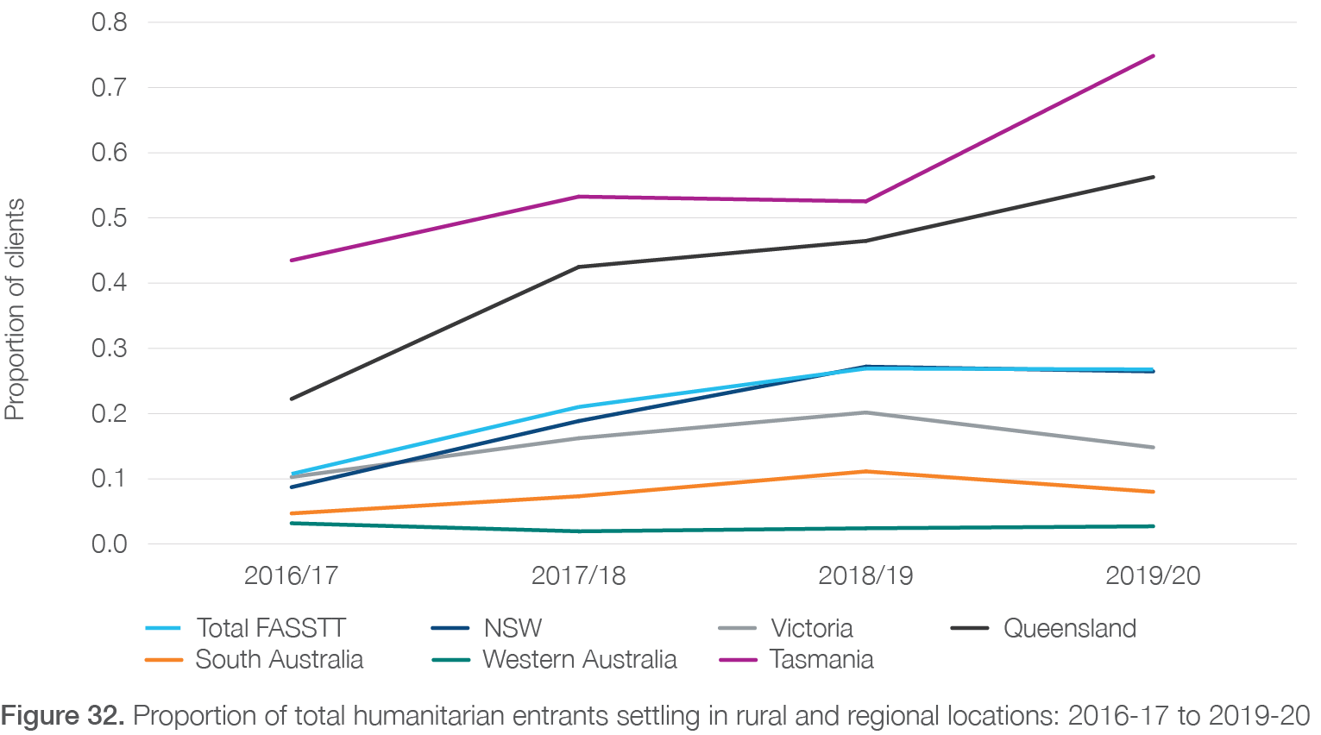

***Table 19*. Proportion of PASTT clients residing in regional and rural areas: 2017-18 to 2020-21\***

|  |  |  |  |  |
| --- | --- | --- | --- | --- |
| **Proportion of all PASTT clients residing in regional and rural locations** | **2016/17** | **2017/18** | **2018/19** | **2019/20** |
| **Nationally** | **11%** | **14%** | **15%** | **16%** |
| Tasmania (Phoenix) | 18% | 21% | 31% | 38% |
| Queensland (QPASTT) | 14% | 24% | 25% | 25% |
| New South Wales (STARTTS) | 20% | 21% | 23% | 22% |
| Victoria (VFST) | 0% | 4% | 6% | 8% |
| South Australia (STTARS) | 9% | 7% | 8% | 8% |
| Western Australia (ASeTTS) | 0% | 0% | 0% | 0% |
| Australian Capital Territory (CH) | 5% | 4% | 2% | 2% |

*Data not available for Northern Territory (Melaleuca). All Tasmania (Phoenix) regional and rural clients reside in Launceston.

#### 6.3.4 Timing of engagement

Over the past five years, there has been a trend towards clients engaging PASTT counselling services after a longer period of time post-settlement (**Figure 33**)v. While 48% of PASTT clients in 2016-17 had been in Australia for less than one year, only 33% fell into this category in 2019-20 (prior to major impacts of declining arrival numbers being felt).

Conversely, the proportion of clients who had been in Australia for 5 or more years increased from 22% in 2016-17 to 35% in 2019-20.

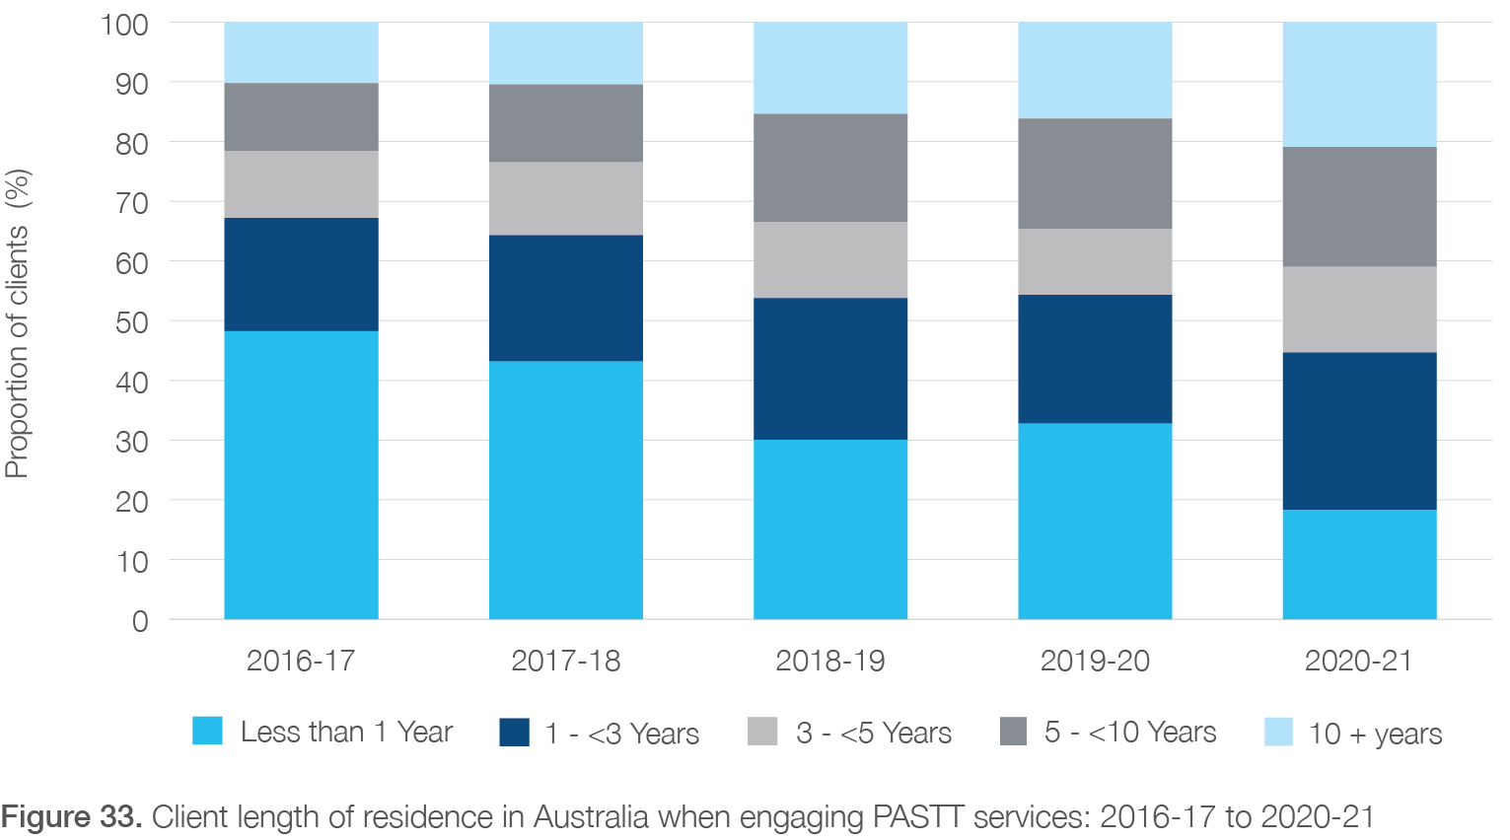

v “Our current funding formula’s based on annual arrival numbers but our work is across the lifespan” **Interview 5, Upper management, FASSTT**

Consultations with FASSTT agency stakeholders suggest this later engagement may be driven by a variety of factors occurring during this time including re-traumatisation from global conflicts, the COVID-19 pandemic, and increased financial insecurity. Additionally, the visibility and success of engagement work by the agencies in new communities continues to drive demand beyond settlement.

Trends in the total number of hours of counselling support per client have remained relatively stable over the past 5 years (**Figure 34**). There has been a slight decrease in the proportion of clients requiring 0 to 5 hours of support, from 44% in 2016-17 to 38% in 2020-21.

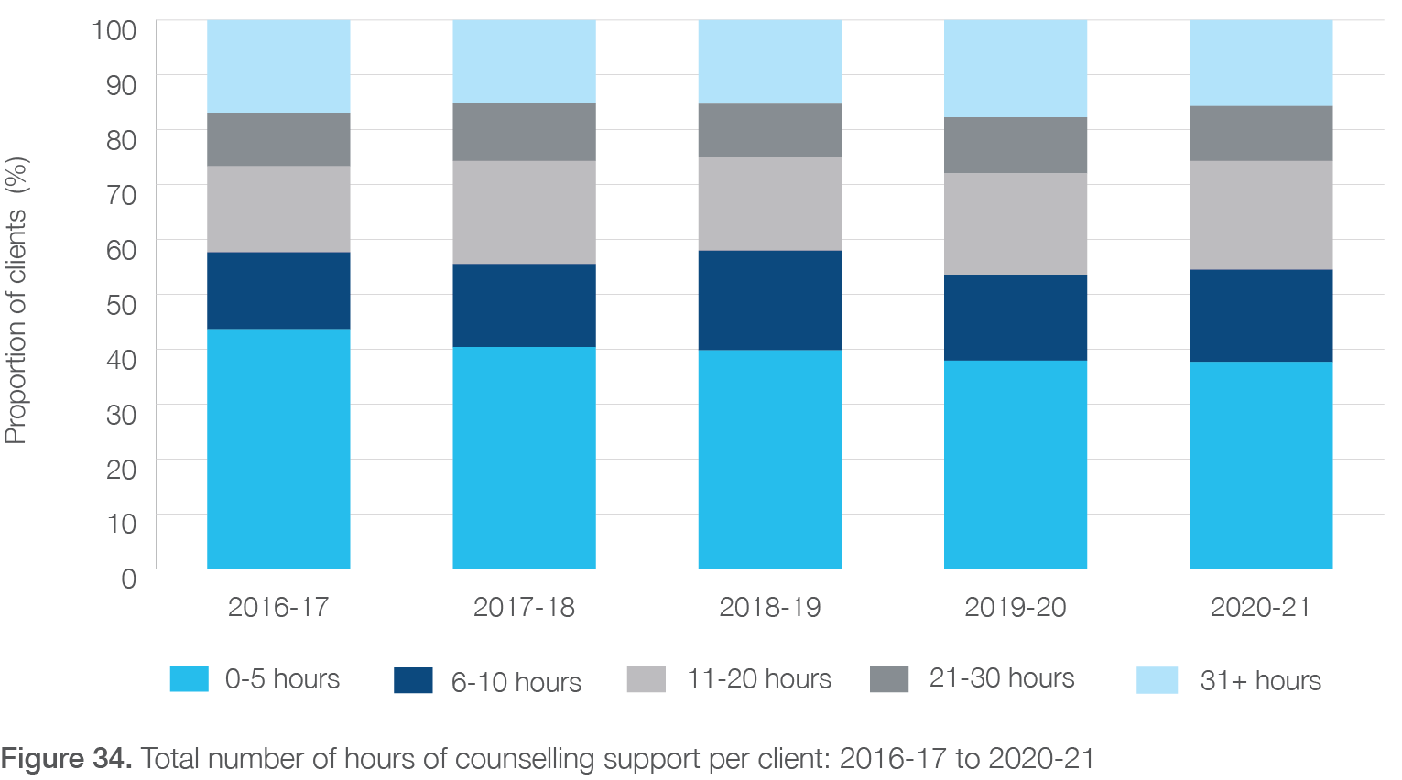

An upward trend in the length of time that counselling clients remain active has been observed over the last five years (**Figure****35**). The proportion of clients active for more than two years increased from 14% in 2016-17 to 24% in 2020-21. Conversely, the proportion of clients active for three months or less decreased from 35% to 25% over this same period.

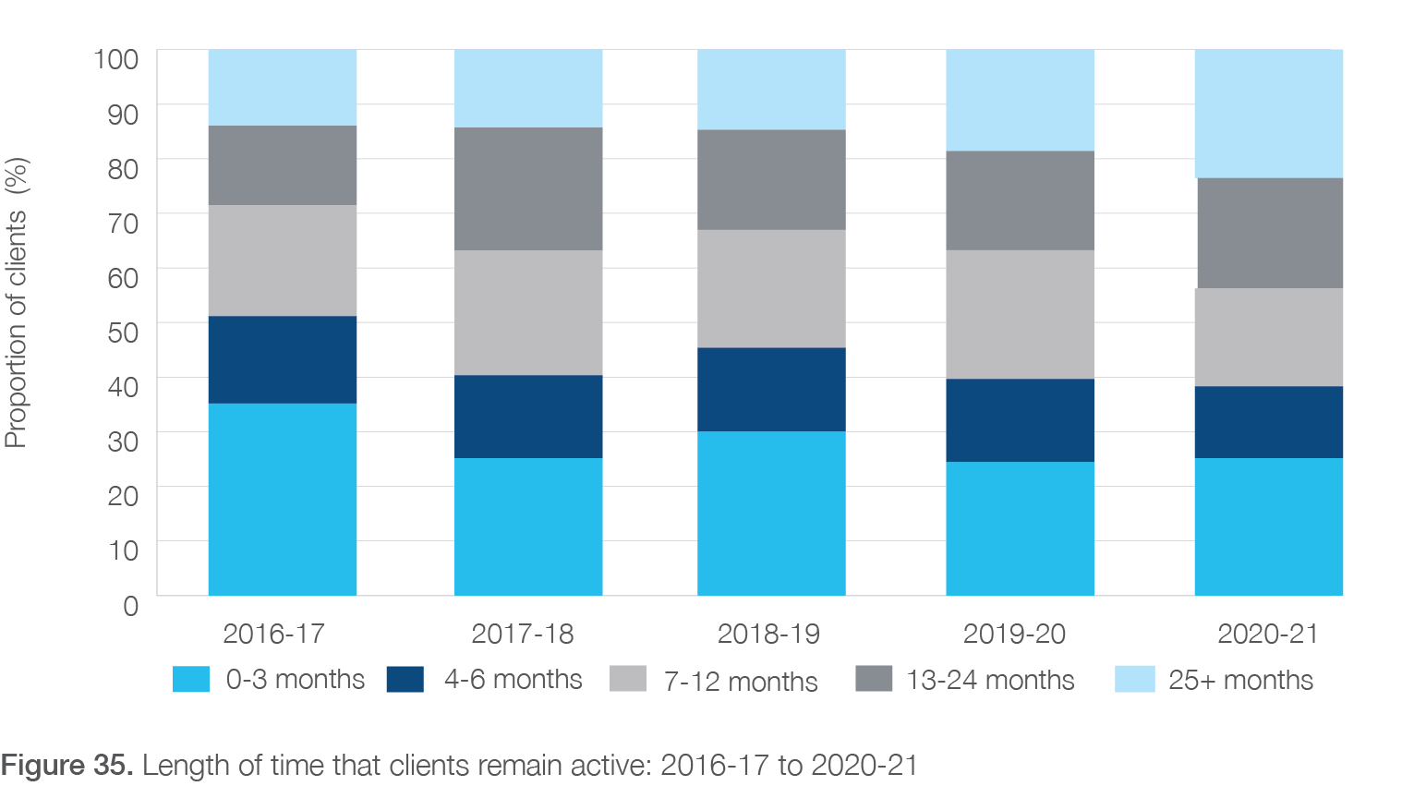

#### 6.3.5 The impact of world events on diaspora communities

Consultations with agency stakeholders clearly highlighted that external world events were a driver of demand that brought new clients into the service and re-traumatised existing clients or those who had exited the program.

For example, war, conflict, or other socio-political events often triggered a spate of referrals from existing refugee communities. Examples provided were the recent Afghan evacuation, Ukrainian conflict, and COVID-19. The retraumatising effect of such crises are forefront in case studies “F” and “B” supplied by FASSTT agencies

(**Appendix 4**). Sometimes the best way to address this need is by working with those effected at the community level.

However, funding such time-sensitive and unpredictable work is challenging. This is compounded by the fact that base funding is designed to respond to the needs of the existing client pool (current clients, waitlisted, already settled) and has no capacity to adjust to unforeseen/ unpredictable surges in demand (such as humanitarian crises) without restricting or pausing services for existing clientsw. Agencies often have to make difficult decisions to push waitlisted clients aside to deal with unfolding crises, which has ongoing ripple effects for the existing client base. Without having enough funding to plan, improve, and be proactive in their approach with communities, this demand will always be greater than supply.

#### 6.3.6 Increasing cost of service delivery

One of the main challenges is that PASTT is an expensive service to fund given its complex and specialist nature, culturally appropriate approaches, focus on staff capacity building, and need for long-term community engagement. These costs are only increasing over time, which is putting agencies under financial strain. For example, the need

to maintain IT infrastructure and security as well as client data management system costs is an increasing area of expenditure. Multiple agencies have needed to invest in major IT investment projects over the past three years. There have also been COVID-19 related costs which could be expected to continue, including provision of Personal Protective Equipment to conduct in person sessions, Rapid Antigen Tests, telehealth provision, and potential upgrades

two ventilation in physical premises. More generally, increasing rates of inflation have been observed over the 2020-21 and 2021-22 financial years and are forecast to continue into

the medium term. This will place further upward pressure on costs associated with wages as well as other essential goods and services including petrol, insurance, and travel.

Two key examples of cost increases that could be addressed in future budgets relate to interpreters and staff salaries, described in more detail below.

w “[recent arrivals evacuated from Afghanistan] in effect, they’re on top of our cumulative load because it brings more people out of the established diaspora into the service needing assistance, it elevates our need to become much more engaged at a community level through community engagement strategies which are not well-resourced through PASTT” **Interview 5, Upper management, FASSTT**

###### Interpreters

The use of interpreters has been crucial to PASTT’s appropriateness by making it easier for clients to communicate about trauma and supporting access to mainstream services. As such, interpreters are present at many service interactions. Yet, there is no longer specific PASTT budget support for providing interpreter services and agencies are required to fund these costly services out of their existing budget. This has become a major challenge under current funding levels (particularly for smaller agencies or those in rural locations) as interpreters account for 5-10% of each agency’s overall operating costs (**Table 14**). There are also discrepancies in the way these costs are reported, with some agencies classifying them as direct costs, and others as indirect costs. Interpreters, however, are an essential direct service delivery cost of PASTT and the lack of additional funding allocation for them is compromising service delivery, the number of clients seen, and the counselling sessions delivered. As a potential solution some agencies have created their own pool of ‘in-house’ interpreters who have been effective in reducing costs, but this is an unfeasible approach for all FASSTT agencies. Appropriately classifying and funding interpreter services at the national level should be a high priority in future funding allocations.

###### Salaries

Given that salary-related expenses account for a large proportion of total costs across agencies, the trend of salary increases observed (**Table 13**) presents a concern for PASTT’s financial sustainability. Increasing wage rates were cited as one reason for multiple redundancies across agencies in the last 5 years (**Table 17**). An indication of cost increases is that the difference is wage costs for QPASTT for an equal number of workers between 2020- 21 and 2021-22 is $286,000 per annum. Consequently, staff salaries were also one of the most pressing issues raised by FASSTT agency stakeholders interviewed during the consultation process.

While there have been incremental yearly increases built into PASTT base funding allowances for staff salaries,

in many cases this has not kept up with the amounts required by the respective state Social, Community, Home Care and Disability Services Industry Awards, as well as legislated annual increases to compulsory superannuation contributions by employersx. In addition, VFST and QPASTT are now required to pay 1.65% and 1.37% per annum, per employee (including casuals) respectively in a compulsory allocation to portable long service leave. A summary of changes to wage rates between 2017-18 and 2021-22 for selected agencies is included in **Table 20**.

In response to these increases, agencies have needed to absorb additional costs into their operations, detracting from funds available for service delivery. Furthermore, the salaries provided within PASTT funding are typically not competitive with other larger government or community service organisations which can pay above award salaries via enterprise bargaining arrangements. Similarly, there are no incentives for staff to work in regional areas, making these roles less attractive compared to other organisations. This presents further challenges in the recruitment and retainment of high-quality staff, which from consultations with stakeholders, was perceived to be one of the keys to the program’s success. As such, it is recommended that future PASTT budgets provide funding for salary equity with comparable organisations and with increments that are consistent with the upward pressures being experienced.

x “That’s a real critical issue for us that there’s never any indexation on any of these grants, that means that agencies are just forced to absorb wage increases, CPI increases, our insurances have gone up…” **Interview 1, Upper management, FASSTT**

***Table 20*. Wage related increases for selected agencies: 2017-18 to 2021-22**

|  |  |  |  |  |  |  |  |
| --- | --- | --- | --- | --- | --- | --- | --- |
| **Agency** | **Average award and rate** | **2017-**  **18** | **2018-**  **19** | **2019-**  **20** | **2020-**  **21** | **2021-**  **22** | **Average annual increase** |
| VFST | Level 6 of the Victorian SCHADS Award plus Equal remuneration order (ERO) | 5.8% | 5.1% | 5.7% | 4.5% | 2.5% | 4.7% |
| QPASTT | Level 5.3 Counsellor SCHADS Award plus |  |  | 3.6% | 1.5% | 4.2% | 3.1%  (projected to increase to 4.2%) |
| STARRS | Level 5 Counsellor SCHADS Award |  | 7% | 6% | 5% | 6% | 6.0% |
| CH | SCHADS Award (average increases across agency) |  | 7% | 6% | 5% | 5% | 5.7% |
| Phoenix | SCHADS Award (average increases across agency) | 26.37%  since 2017-18 |  |  |  |  | 5.3% |

## Evidence of unmet need

An analysis of trends in waiting list numbers and average waiting times was conducted as proxy indicators of demand. Across PASTT, total numbers of clients on a waiting list for individual counselling services increased from 497 in 2014- 15 to 613 in 2020-21 (**Figure 36**). The number of clients waiting for longer than 6 months increased from 65 (13% of total waiting list) in 2014-15 to 151 (25% of total waiting list) in 2020-21.

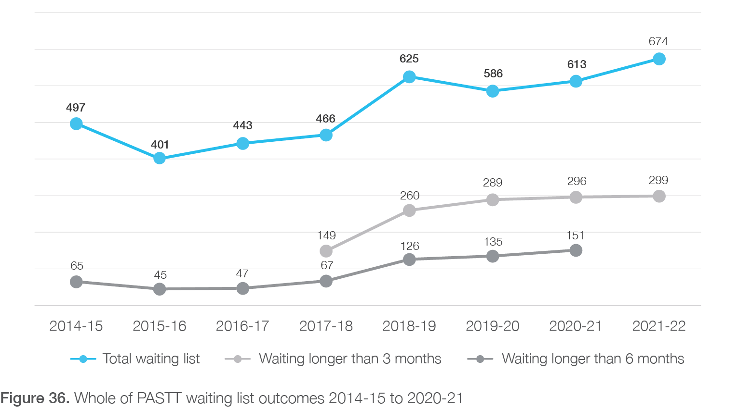

Trends in the total number of clients on a waiting list for counselling services by agency is presented in **Figure 37**.

Substantial recent increases were observed in VFST and QPASTT.

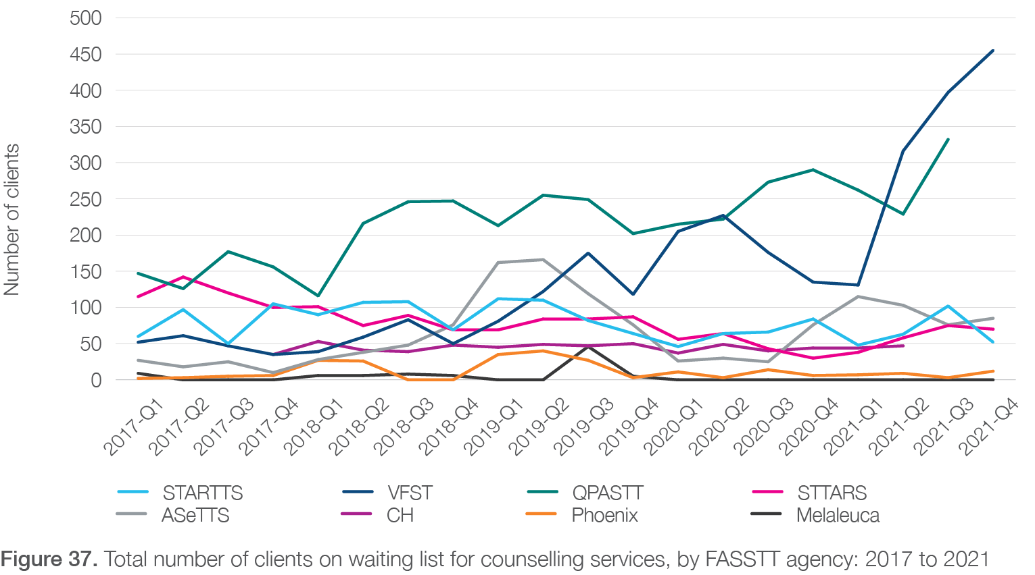

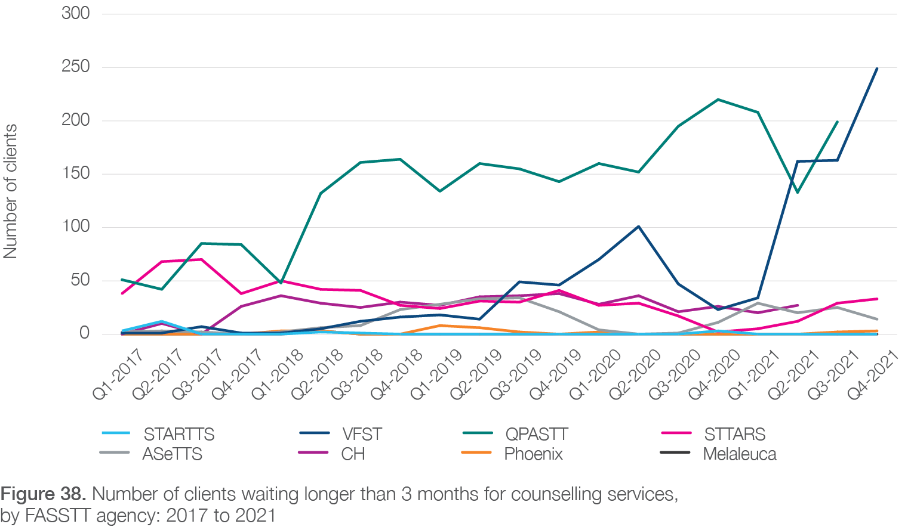

Trends in the number of clients waiting longer than 3 months for counselling services between 2017 and 2021 is presented in **Figure 38**. Consistent with trends in total waiting list numbers, sharp increases were observed by VFST (249 clients in Q4-2021) and QPASTT (199 clients in Q3-2021).

In addition to waiting lists, PASTT stakeholders also spoke about the “unseen and unknown needs” in new and existing communities. By performing community development work and engaging with communities FASSTT agencies uncover more potential refugees who could benefit from PASTT services. However, meeting this demand is always challenging. This is described as such by one stakeholder:

*“We have a waitlist of 50 [in that region] - we could have a waitlist of 200 if we went out more, so then you have to have the balance of losing the trust of a community who have to sit on a waitlist for 6, 12, 18 months”*

***Interview 2, Large multidisciplinary group including upper management, FASSTT***

## Opportunity to improve funding model allocations

The adequacy of the current PASTT funding formula/ allocation was seen as a point of contention amongst many FASSTT agencies, but they readily admitted that a viable alternative was yet to be presented. In our analysis of qualitative consultations the following suggestions were proposed which are supported by analysis of the quantitative data:

− remove links between funding and arrival numbers, rather focus on cumulative population

− set a guaranteed minimum amount of base funding for each agency each contracted year and then top this up when required to deal with surge in demand due to crises

− return to longer, more predictable funding periods

− better account for agencies with increased rural service provision

− better account for staff salaries in funding model

## Findings

**Finding E1.** Recent policy decisions, including reductions in the Humanitarian Program intake and cessation of the Social and Community Services Workers Wage Supplementation scheme, have resulted in significant disruption to core income streams across FASSTT agencies.

**Finding E2.** The current PASTT funding model and base funding allocation is not fit for purpose due to: (1) a growing pool of humanitarian entrants accessing services over a relatively long period post settlement; (2) an increasing proportion of clients settling in regional and rural areas; (3) increasing costs of service delivery, especially in relation to growing wage-related costs; and (4) the impact of external stressors including international humanitarian crises and COVID-19.

**Finding E3.** FASSTT agencies report a relatively low rate of indirect costs, reflecting the prioritisation

of crisis-driven service delivery above long term planning and infrastructure investment. This may be indicative of financial vulnerability. Investment in national-level infrastructure for supporting services would likely provide a more efficient use of resources than agencies making investments in silos.

**Finding E4.** Appropriately classifying and funding interpreter services at the national level should be a high priority in future funding allocations.

**Finding E5.** At least 46% of humanitarian entrants have been enrolled in PASTT individual counselling services in the 10 to 20 years following their settlement.

**Finding E6.** There is an increasing level of unmet need within the system as evidenced by growing waiting lists.

**Finding E7.** There is a need for better resourcing of, and long-term investment in, community capacity building and engagement activities within the program, particularly for successful early intervention work.

**Finding E8.** The categorisation and reporting of agency expenses as they relate to key activities and services is inconsistent across FASSTT

agencies. A consistent national framework with clear definitions for reporting expenditure against pre- defined categories would support ongoing quality improvement and evaluation activities.

**Finding E9.** Any new PASTT funding model should consider the cumulative eligible population, regional and rural service delivery, adequate and competitive staff salaries, longer funding durations, and balancing base and surge/crisis funding.

**Chapter 7. Alignment of PASTT with best international practice**

This chapter considers the alignment of PASTT with international best practice for meeting the recovery needs of refugee survivors of torture and trauma. It consolidates data from four sources (1) information compiled and provided by the FASSTT National Coordinator demonstrating how PASTT and FASSTT agencies align with The Global Standards on Rehabilitation of Torture Victims (‘the standards’, see Appendix 8) and the National Standards for Mental Health Services (NSMHS, see Appendix 8.1 ), (2) data and performance reports provided by the FASSTT agencies, (3) qualitative data from interviews with key stakeholders from each FASSTT agency, and (4) PASTT client interviews.

This chapter focusses on answering sub questions from key evaluation questions one, three, and four as outlined below.

− Key evaluation question one: How appropriate is the PASTT model? (alignment with international best practice)

− Key evaluation question three: How effective has the program been? (evidence-based activities)

− Key evaluation question four: How can the program be developed or refined? (opportunities as identified in international best practice)

## Global Standards on Rehabilitation of Torture Victims

The Global Standards on Rehabilitation of Torture Victims (‘the standards’, **Appendix 8**) were developed and adopted by the International Rehabilitation Council for Torture Victims (IRCT) in 2020. These 17 standards were developed based on a global survey of best practice, have undergone expert technical review and political adoption via the IRCT’s General Assembly, and have been shaped with regional consultation to address different local contexts. International best practice for supporting recovery and rehabilitation needs of survivors of torture and trauma is achieved when programs and their service delivery align with these standards.

FASSTT involvement in the IRCT and role in the development and promotion of the standards is discussed in the next section. A summary of evidence evaluating

the alignment of FASSTT and PASTT with each of the standards is provided, along with a brief discussion of gaps and opportunities for improvement that became evident in the evaluation.

#### 7.1.1 FASSTT agencies’ involvement with the IRCT and development and promotion of the standards

FASSTT is actively represented in the IRCT governance structure through the individual IRCT membership of FASSTT agencies. FASSTT agency representatives participate in the IRCT Council and its Executive Committee. FASSTT agency representatives have also been elected to the IRCT leadership as President (Jorge Aroche, STARTTS, 2016-2020) and Vice-President (Jorge Aroche, STARTTS, 2009-2012). Robyn Smythe (STTARS) is the current elected representative from Australia in the IRCT Executive Committee.

FASSTT agencies play a leading role as international experts in torture and trauma rehabilitation, and their work (largely delivered through PASTT) is well recognised internationally. The FASSTT agencies’ representatives were catalysts for the development and adoption of the standards. In the latest Annual Report (2021)64 the IRCT specifically refers to the leading role that ASeTTS played in guiding the IRCT in developing an E-learning training course consisting of modules focused on each of the 17 standards. STARTTS is also acknowledged in the same Annual Report (2021) for an extraordinary contribution to the Torture Journal.

Experts from Australia were invited to reflect on the consequences for torture survivors and the ongoing violence in Afghanistan following the Taliban’s return to power in a webinar attended by 200 people which was the most well attended IRCT webinar of 2021. Lastly, there are several publications authored by the FASSTT agencies’ staff in peer-reviewed international journals.

## PASTT alignment with global evidence-based standards

The evidence summarised in **Table 21**predominantly indicates clear alignment of PASTT (and overall FASSTT agency policies, procedures, and activities) with

evidence-based standards of care for the recovery needs of refugee survivors of torture and trauma. While in two areas, ‘Care for staff’ (standard 12) and ‘Advocate for rehabilitation funding’ (standard 14), PASTT is mostly aligned with the IRCT Standards, some qualitative interview and survey data suggests that additional actions are needed to realise these standards fully. First, policies, practices and activities addressing ‘Care for staff’ must be consistently implemented, especially during surges in service demand during which staff tended to compromise their own self-care time to dedicate it to front-line activities. Second, while each agency advocated for rehabilitation funding within their own capacity, it was apparent that large agencies, with dedicated staff member/s responsible for applying for additional funding, had greater capacity to seek and secure external funding.

In smaller agencies, one person often had multiple roles and responsibilities which included sourcing and

applying for external funding. Action is therefore needed to increase smaller agencies’ capacity to seek and secure additional funding. There was also perception by some external stakeholders that agencies sometimes work in

a silo, especially at a strategic or systems’ level. Other opportunities for improvement exist in relation to ‘Access to information’ (standard 7), where access to interpreters in some states/territories and in regional and rural areas was described as variable and could be improved.

**Table 21**categorises PASTT’s alignment with the standards on a spectrum from strong to unclear/ incomplete. Green boxes represent clear and strong alignment of PASTT with the described IRCT standard. Orange boxes represent standards which are clearly aligned but are less strongly being achieved. There were no areas in which there was unclear or complete lack of alignment with any of the IRCT Standards.

It is important to note that the standards are overarching and have been developed for rehabilitation service providers (agencies) in general, not for evaluation of one program they deliver. Hence, evidence provided in this section does not solely refer to the PASTT program but also to FASSTT agency-wide policies and structures.

Additionally, the number of examples provided for PASTT’s alignment with the standards does not reflect the strength of alignment.

| International rehabilitation standard | | Summary of evidence supporting PASTT alignment with the standards | | | |
| --- | --- | --- | --- | --- | --- |
| **1. Our commitment  to victims** | Standard description | Uphold the well-being and dignity of torture victims as well as professional ethical standards and principles regarding treatment and rehabilitation, including informed consent, confidentiality, do no harm, the best interests of victims, and their free choice about the services they receive, resist re-traumatisation, and apply global best practices, which are all pivotal to the work of rehabilitation centres that are independent and accountable to victims, in accordance with the principles of the UN Committee against Torture’s General Comment No. 3 on the right to redress and rehabilitation. | | | |
| Supporting evidence | PASTT has comprehensive agency-level policies and procedures in which all staff are trained. Areas covered include: client rights and responsibilities, privacy and consent, stages of service intervention, professional practice, client engagement, and consultation processes. | | | |
| **2. Independent services** | Standard description | Implement relevant structures and procedures so that rehabilitation can be provided independently, autonomously, in full compliance with applicable professional standards and ethics, and free from any external influence. In particular, rehabilitation centres should prioritise the development and implementation of structures, methodologies, and procedures that are victim-centred, evidence-based, participatory, empowering, holistic, accessible, equitable, respectful, gender sensitive, culturally appropriate, and accountable. Where funding is received from sources that could be perceived to place an external influence on the rehabilitation provider, it is essential to ensure that the organisation’s mandate and the principles of victim confidentiality, transparency, and independence of decision-making are prioritised and emphasise the victims’ best interests. Torture victims must be informed about measures taken to protect the rehabilitation process from external influence. | | | |
| Supporting evidence | Services provided by FASSTT agencies are explicitly non-denominational, politically neutral, and available for clients across the country. | Service provision that accommodates client rights was perceived by FASSTT agency staff to be of utmost importance. | Seven FASSTT agencies have received accreditation against the NSMHS; the eighth FASSTT agency (Melaleuca) is currently seeking accreditation. | FASSTT agencies offer individual counselling, group counselling, internal and external education and training, and community capacity building activities. |
| **3. Safety of victims** | Standard description | Ensure the implementation of every possible safety and safeguarding measure for victims receiving services, including all aspects of the relationship with victims, bearing in mind that the best interest of the torture victim is a key principle of rehabilitation services. Torture victims must be informed about and input to the determination of safeguarding and safety measures. | | | |
| Supporting evidence | The right to safety for clients is enshrined in the FASSTT agencies’ policies and procedures (e.g., Safe Guarding at QPASTT; VFST Trauma Recovery Framework). | Safety management processes are embedded into FASSTT agency services. For example, FASSTT agencies undertake suicide risk assessments at intake and in counselling sessions. STARTTS draft Clinical Governance Framework 2022 references client safety as the second Pillar (Pillar B) in the service delivery framework. Clients are, wherever possible, involved in safety planning by FASSTT agencies. | All workers across all jurisdictions are screened prior to beginning employment according to vulnerable persons checks. | One FASSTT agency reported conducting on-arrival COVID-19 screening procedures for all people entering the agency’s offices which included the clients. |
| **4. Support of families** | Standard description | Ensure that the specific rehabilitation needs of torture survivors’ families, in particular children and vulnerable populations, are considered an essential part of the rehabilitation process. Where resources allow, families should receive support in accordance with their needs. Where relevant, culturally appropriate community-based approaches should be employed during the rehabilitation process. Ensure that the specific rehabilitation needs of torture survivors’ families, in particular children and vulnerable populations, are considered an essential part of the rehabilitation process. Where resources allow, families should receive support in accordance with their needs. Where relevant, culturally appropriate community-based approaches should be employed during the rehabilitation process. | | | |
| Supporting evidence | All FASSTT agencies have specific policies, programs, and interventions for working with children and families and employ appropriately qualified staff (e.g., QPASTT Protection of Children and Young People Policy; STARTTS Families in Cultural Transition program). | FASSTT agencies provide ongoing training and supervision for staff working with children and families. | FASSTT agency staff report using a holistic approach to working with trauma with a broad focus on client-specific needs including needs of the family unit. For example, QPASTT ‘Community Connectors’ implement the agency-developed ‘Building Stronger Families’ group work program in regional communities, which combines trauma recovery, psychoeducation, and parenting to empower and enable improved acculturation and adaption of parenting in the Australian context. | FASSTT agencies have strong links with primary and secondary schools and youth groups. |
| **5. Access to Justice** | Standard description | Whenever possible, support victims’ access to justice and be advocates for the eradication of torture as a part of the rehabilitation process. This includes supporting victims to document their claims in accordance with the Istanbul Protocol and file complaints and advocating with national authorities to adopt and implement national anti-torture laws and National Preventive Mechanisms (NPMs). | | | |
| Supporting evidence | All FASSTT agencies are independent members of the IRCT. | FASSTT agencies support the advocacy work of national agencies such as the Refugee Council of Australia and Amnesty International. | FASSTT agencies engage in advocacy work of their own by preparing submissions to government at both state and Federal levels. For example, QPASTT made a submission to the Queensland Parliament Inquiry into serious vilification and hate crimes. | FASSTT agencies offer support to enable refugee communities to self-advocate for issues of concern. |
| **6. Intake processes** | Standard description | Establish intake processes where victims of torture can access rehabilitation services on the basis of self-referral or referral by a third party such as competent physical or mental health, social, or legal professionals, human rights defenders, faith-based, indigenous, ethnic and national minority communities, other torture victims or family members. These processes must ensure that, within available resources, torture victims have free, equal and non-discriminatory access to services, regardless of their ability to pay or legal status in the country concerned. To the extent possible, rehabilitation service providers should prioritise outreach, in particular for torture victims that are marginalised, detained, living in remote areas or lack funds for transport costs. | | | |
| Supporting evidence | Outreach services are provided. | FASSTT agencies have established referral pathways. Intake, assessment, and allocation processes are clear, transparent, and documented. | Transparency is prioritised, clients who are not accepted into PASTT are provided with clear reasoning for that decision and referred onto other relevant providers. | FASSTT agencies described how waitlists are managed considering the needs of clients. Individuals on waitlists are provided with at least some level of care while they wait. |
| **7. Access to information** | Standard description | Provide torture victims with all relevant information concerning the rehabilitation services offered. Rehabilitation centres must respect and promote torture victims’ agency over their own lives and the choice(s) regarding their rehabilitation. Where possible and appropriate to the service provided, reliable interpreters should be made available at no cost to the torture victim. Whenever possible, victims should be able to choose the gender of rehabilitation professionals, including interpreters. Informed consent must be obtained according to relevant professional and ethical standards before and during the process of rehabilitation. | | | |
| Supporting evidence | FASSTT agencies have detailed information available about services they provide, how to access their services, the scope of these services, and expectations of behaviour by both staff and client during interactions. | FASSTT agencies have written information available (online and paper-based) that is culturally appropriate, in languages spoken by clients. | FASSTT agencies utilise interpreters in providing information and during service provision. | FASSTT agencies respect and promote the clients’ agency by providing client-centred services and practicing soft- and non-prescriptive approach. |
| **8. Victim feedback** | Standard description | Establish procedures and mechanisms that enable torture victims to provide ongoing feedback, including upon leaving the service, in a language they speak about the rehabilitation services they receive, for example through the use of standing service user engagement mechanisms, victim satisfaction surveys, service evaluations, focus groups and other participatory mechanisms. This feedback should be reviewed periodically and form the basis for continuous improvements to the rehabilitation services offered. Satisfaction should be clearly defined, using consistently applied standards. In addition, mechanisms whereby victims can complain and receive a prompt and satisfactory response in relation to the rehabilitation services they receive should be established. Victims should be enabled to effectively engage through measures such as provision of information about complaint possibilities and the establishment of support functions that include other victims. | | | |
| Supporting evidence | FASSTT agencies have established feedback and complaints mechanisms. | There are formal and informal reporting requirements for feedback, including to management and FASSTT agency boards. | Feedback is gathered from clients in a variety of ways including through Client Satisfaction surveys. | Feedback is used to plan, deliver, evaluate, and improve services. |
| **9. Victims participation in rehabilitation** | Standard description | Promote the meaningful contribution of victims in service design and delivery, research, decision-making and governance processes of rehabilitation services through recognition of victims’ experience in service development and recruitment processes, open consultative and feedback processes and/or other participative methods that are context and situationally appropriate. | | | |
| Supporting evidence | Organisational philosophy of client-centredness means service provision is context, culturally, and situationally appropriate. | People with lived experience of torture and trauma are employed by FASSTT agencies and represented at the Board-level. | There are extensive community consultation processes and practices, community advisory groups, and community involvement in needs assessment, service design, delivery and evaluation. |  |
| **10. Organisational capacity** | Standard description | Prioritise continuous training and capacity enhancement for staff and volunteers, for example in specialised evidence-based treatment methods, trauma sensitive interview techniques, empathetic listening and anti-racism, cultural and gender awareness in accordance with relevant professional standards and ethics and international human rights standards. | | | |
| Supporting evidence | FASSTT agencies have processes and procedures in place to ensure staff are suitably skilled with a core focus on professional development and clinical supervision. This includes some FASSTT agencies providing clinical supervision for other FASSTT agencies and inter-agency sharing of resources.  Relevant, recognised accreditation has been obtained for many activities and professions within the FASSTT agencies. For example, seven of eight FASSTT agencies have received accreditation against the NSMHS. | | | |
| **11. Staff safety** | Standard description | Ensure that staff and volunteers are safe, secure and cared for and have the means to report incidents which could compromise their safety or the safety of others through reporting processes or other suitable means that ensure that these risks are documented and context appropriate measures taken to minimise them. In this regard, member centres are to ensure the adoption and implementation of appropriate policies to prevent and address discrimination, harassment and sexual and other forms of abuse. | | | |
| Supporting evidence | FASSTT agencies have polices to ensure staff safety with respect to occupational health and safety, risk management, and critical incidents. | FASSTT agencies have polices to ensure staff safety with respect to cultural safety, equal employment opportunity, discrimination, harassment, and abuse in the workplace. | Procedures regarding anti-discrimination and prevention of workplace bullying have been developed and staff are provided training regarding these procedures. | One FASSTT agency reported conducting on-arrival COVID-19 screening procedures for all people entering the agency’s offices. |
| **12. Care for staff** | Standard description | Address vicarious trauma and prevention of burnout as an organisational priority for all staff. To that end, provide a robust and supportive well-being infrastructure and working environment for staff through, for example, regular supervision, peer support mechanisms, staff mentoring, psychosocial support techniques, and access to occupational health services. | | | |
| Supporting evidence | FASSTT agencies are aware of the potential for vicarious trauma and staff burnout and have policies and procedures in place to address these issues.  FASSTT agencies ensure counselling staff receive regular clinical supervision from dedicated clinical supervisors.  FASSTT agencies provide formal and informal methods for staff debriefing and attempt to foster a culture of care and support. Training is provided to all staff to recognise stress and access support including Employee Assistance Programs and to promote engagement in self-care activities. | | | |
| **13. Share knowledge** | Standard description | Disseminate information about torture and its effects to professionals in healthcare and other relevant fields who may come into contact with torture victims. Information should include available and possible approaches to rehabilitation, the specific needs of torture victims (including early identification, assessment and timely referrals), trauma-informed care, documentation procedures according to the Istanbul Protocol and the value of providing rehabilitation to facilitate life after torture. Where security considerations allow, the dissemination of this information should be considered a critical moral and social responsibility for centres assisting victims of torture. | | | |
| Supporting evidence | FASSTT agencies share knowledge by participating in service delivery networks, being members of advisory committees and networks, and providing secondary and case consultation with other service providers. | FASSTT agencies develop strong, positive relationships with external services that support PASTT clients. FASSTT agencies work to upskill mainstream service providers to adopt a trauma- informed lens. | FASSTT agencies develop and disseminate resources, frameworks, training modules and research publications to support knowledge transfer in the field. | FASSTT agencies participate in conferences to share the impact of rehabilitation with national and international universities, academic institutions, and other international agencies. |
| **14. Advocate for rehabilitation funding** | Standard description | Attempt, where possible, to establish or strengthen dialogue with states and their relevant agencies to inform them about torture and its effects and the value of rehabilitation, and to request that they provide funding to support the rehabilitation of torture victims worldwide, preferably through: a) direct funding of rehabilitation centres assisting survivors of torture in their respective countries, b) contributing to the United Nations Voluntary Fund for Victims of Torture (UNVFVT), or c) funding the IRCT’s sub-granting program. | | | |
| Supporting evidence | The FASSTT agencies regularly make submissions to government enquiries, publish public statements regarding issues of concern, and advocate for adequate funding to continue their work. | FASSTT agencies work to build effective strategic relationships with government, non-government, and private sector organisations. | FASSTT agencies are members of advisory groups, networks, and peak bodies. | Several FASSTT agencies seek external non-PASTT funding to develop special programs or provide additional services and activities for clients. |
| **15. Definition of quality of life** | Standard description | Apply the following definition of quality of life: the subjective well-being of individuals and their communities within their specific social and cultural context in relation to factors such as physical and mental health, family, social and community relations, culture, education, employment, economic security, exposure to physical and psychological violence and freedom, good governance and basic human rights, spiritual life, gender equality and non-discrimination, religious beliefs, legal status and the natural and living environment. | | | |
| Supporting evidence | FASSTT agencies have explicitly or implicitly embedded the definition of quality of life into their service delivery.  Survivor recovery needs are viewed by FASSTT agencies through multiple conceptual lenses, including the individual’s history of torture and other traumatic events, risk and protective factors in the settlement/host country, and cross-cultural factors. | | | |
| **16. Evaluating improvements in quality of life** | Standard description | Apply evaluation tools appropriate to their specific context. This is done with the recognition that IRCT members provide services in very different contexts, including detention, political repression, uncertain legal status, discrimination and poverty, which may have a severe negative effect on victims’ quality of life. Furthermore, each member centre will determine what tools are best used to evaluate improvements in all indicators relevant to addressing the needs and improving the quality of life of the torture victims they support and communicate this to the IRCT membership. In documenting the results of their work, IRCT members are encouraged to take into account how the quality of life of torture victims is connected to the enjoyment of rights, including access to justice, international protection, redress and all five forms of reparation (restitution, compensation, rehabilitation, satisfaction and the right to truth, and guarantees of non-repetition). | | | |
| Supporting evidence | FASSTT agencies have a client-centred process of developing personal recovery goals with clients and tracking and reviewing progress.  FASSTT agencies use many methods to evaluate improvements, including use of the WHO-5. Agencies administer the WHO-5 in a standard way, at intake or early assessment, at or around session 5, at or around session 10, every 10 sessions thereafter, and at discharge/end of treatment.  Some FASSTT agencies have conducted research to develop more appropriate evaluation tools to use with the PASTT client population. Some FASSTT agencies have used innovations such as the use of computerised platforms that allow assessments to be conducted in the language of the client, minimising constraints regarding interpreter availability and cost. | | | |
| **17. Documenting our global impact** | Standard description | Share the results of their support to torture victims with the IRCT membership on an annual basis. This will become part of the IRCT’s annual Global Impact Report, which demonstrates to the world our collective impact in the lives of torture victims. | | | |
| Supporting evidence | Each FASSTT agency publishes a publicly available annual report for the IRCT. Each agency is involved with the IRCT through meetings and events. FASSTT agency representatives have stood for election to the IRCT EXCOM and Council. | | | |
| Note. Green: Clear and strong alignment with IRCT standards; Orange: Clear but less strong alignment with IRCT standards  Abbreviations. FASSTT: Forum of Australian Services for Survivors of Torture and Trauma; PASTT: Program of Assistance for Survivors of Torture and Trauma; NSMHS: National Standards for Mental Health Services; IRCT: International Rehabilitation Council Torture Victims; WHO-5: World Health Organisation-Five Well-being Index | | | | | |

* 1. **Findings**

***Finding IP1*. PASTT is clearly aligned with key international best practice standards as a specialist service that meets the recovery needs for refugee survivors of torture and trauma.**

***Finding IP2*. Additional opportunities to meet standards identified in international best practice relate to: (1) consistently implementing care for staff (particularly during surges in service demand); (2) better strategic and supported systems advocacy for PASTT services and rehabilitation funding; and (3) improving access to interpreters, particularly in regional and rural areas.**

**Chapter 8. Findings and conclusion**

The previous chapters have identified findings for the key evaluation questions. This includes nine findings for implementation, appropriateness and acceptability of PASTT; eight for regional and rural delivery; seven for outcomes achieved; nine for economic analysis; and two for alignment with best practice. This discussion and concluding chapter consolidates findings as discussed throughout the report, including an additional summary of barriers and enablers to PASTT’s effectiveness.

## Findings of the evaluation

#### 8.1.1 Implementation, appropriateness, and acceptability of the PASTT model

***Finding A1*.** Culturally appropriate approaches (e.g., community healing) and needs-based support (e.g., helping with schooling, advocacy, settlement) are equally important for improving clients’ well-being as therapeutic approaches (e.g., counselling). Mainstream care was not perceived to be appropriate to meet the complex needs of many PASTT clients.

***Finding A2*.** PASTT demonstrates high levels of appropriateness in meeting client needs and improving access and outcomes for refugee communities.

***Finding A3*.** The three defining features of PASTT’s appropriateness are: (1) delivery of a specialised culturally responsive and trauma-informed service model; (2) establishment and maintenance of a connection to community; and (3) flexibility in approach regarding how, when, and which services are accessed and delivered.

Any future iteration of PASTT should seek to retain these three key features at its core.

***Finding A4*.** There is a continued need for PASTT to build the skills and capacity of mainstream services to respond to and care for refugee clients appropriately.

***Finding A5*.** Building and sustaining a long-term connection with communities is essential if PASTT is to reduce stigma and contribute to early intervention and prevention work.

**Finding A6.** The Forum of Australian Services for Survivors of Torture and Trauma (FASSTT) is effectively facilitating the funding allocation and service delivery of PASTT. However, to support sustainability consideration should be given to leadership succession planning and maintaining a successful and timely democratic decision- making process.

***Finding A7*.** The flexibility provided in PASTT contracting agreements is a strength of current governance arrangements as it allows individual FASSTT agencies to maintain autonomy, be innovative, and respond to local needs.

***Finding A8*.** Consideration should be given to reviewing current reporting requirements, performance indicators and evaluation criteria to align with PASTT’s underpinning philosophy and adequately capture the range and type of services which may be appropriate to meet clients’ needs.

***Finding A9*.** PASTT is client-centred and satisfactorily meeting the needs of its clients for service delivery within its scope. There may be an opportunity for FASSTT agencies to better communicate with clients regarding services that the agency can and cannot provide them at the outset of engagement.

#### 8.1.2 Regional and rural delivery of PASTT

***Finding R1*.** Overall, the findings support a need for PASTT delivery in regional and rural communities, however the service delivery models used in metropolitan areas have not been fully realised in regional settings.

***Finding R2*.** Balancing service demand and organisational capacity is a key challenge for regional and rural PASTT delivery. Capacity to respond is impacted by organisational factors (e.g., resourcing, staffing) and the region’s geographical context (e.g. higher cost of service delivery, limited workforce, and lack of third-party providers).

***Finding R3*.** Regional and rural communities are not homogenous so a single model to fund or deliver all regional PASTT services is not appropriate. Rather, it is important

to support and encourage the development and delivery of locally relevant models of care.

***Finding R4*.** The non-directive, flexible and adaptable nature of the PASTT program and its funding facilitates each FASSTT agency to work effectively in regional and rural areas using models of care appropriate to the local and state-based context.

***Finding R5*.** The three major strategies used by FASSTT agencies to adapt PASTT delivery for regional and rural areas are: (1) establishing local offices to provide direct service delivery; (2) partnering with local third-party organisations to deliver PASTT services; and (3) using digital solutions.

***Finding R6*.** FASSTT agency staff in regional and rural areas are often required to work beyond the scope of practice required in metropolitan areas (e.g., assisting refugee clients with finding suitable housing or applying for work).

***Finding R7*.** There is a need to dedicate time and funding to training and capacity building of mainstream regional service providers and undertaking regional community development work to enable holistic delivery of PASTT in these communities.

***Finding R8*.** PASTT funding could be better allocated or increased to address some of the current challenges in regional service delivery. However, inherent systematic

challenges associated with service delivery in regional and rural Australia are likely to remain. Consequently, it may be pertinent to discuss whether the PASTT model of care needs to be re-engineered for regional services.

#### 8.1.3 Outcomes achieved by PASTT

***Finding O1*.** The available evidence indicates that PASTT is effective in achieving its aim of improving the psychosocial health and wellbeing of people who have experienced torture and trauma prior to their arrival in Australia.

***Finding O2*.** The available evidence indicates that PASTT is effective in assisting refugees engage with Australian society including through employment, education, and social avenues.

***Finding O3*.** The available evidence indicates that PASTT is mostly effective in its engagement with a range of third-party providers to enhance their capacity to support refugees who have experienced torture and trauma. However, to enable greater collaboration and sustainability, it will be important to address issues of trust with third-party providers; improve FASSTT involvement in system-level collaboration; and better communicate information about national and state PASTT funding, scope, and priorities to key external stakeholders.

***Finding O4*.** The ongoing demand for training of third-party providers, and high costs of developing and delivering these services, may warrant increased funding allocation for this service activity.

***Finding O5*.** The available evidence indicates that PASTT provides a safe, comfortable space for community healing and contributes to positive changes in refugee communities. Increased social cohesion, improved confidence and self- agency of groups and individuals, increased trust in the health system, and mental health stigma reduction have been reported.

***Finding O6*.** An important individual and system level outcome of PASTT is the employment of former clients within FASSTT agencies and resulting ability to embed culturally appropriate and lived experience in service delivery.

***Finding O7*.** The broad scope of PASTT activities necessitates an evaluation of impact that encompasses measurement at the client, provider, service, community, and society level using both objective and subjective measures of impact. Given this may present challenges, there needs to be nuance into how the impact of PASTT is measured and acknowledged, particularly where it is linked to achieving ongoing funding.

***Finding O8*.** A more clearly defined national framework for classifying and reporting sector development and community engagement activities (including some pre-defined categories) would support ongoing quality improvement and evaluation activities of the PASTT program.

#### 8.1.4 Economic analysis of PASTT

***Finding E1*.** Recent policy decisions, including reductions in the Humanitarian Program intake and cessation of

the Social and Community Services Workers Wage Supplementation scheme, have resulted in significant disruption to core income streams across FASSTT agencies.

***Finding E2*.** The current PASTT funding model and base funding allocation is not fit for purpose due to:

(1) a growing pool of humanitarian entrants accessing services over a relatively long period post settlement;

(2) an increasing proportion of clients settling in regional and rural areas; (3) increasing costs of service delivery, especially in relation to growing wage-related costs; and

(4) the impact of external stressors including international humanitarian crises and COVID-19.

***Finding E3*.** FASSTT agencies report a relatively low rate of indirect costs, reflecting the prioritisation of crisis-driven service delivery above long term planning and infrastructure investment. This may be indicative of financial vulnerability. Investment in national-level

infrastructure for supporting services would likely provide a more efficient use of resources than agencies making investments in silos.

***Finding E4*.** Appropriately classifying and funding interpreter services at the national level should be a high priority in future funding allocations.

***Finding E5*.** At least 46% of humanitarian entrants have been enrolled in PASTT individual counselling services in the 10 to 20 years following their settlement.

***Finding E6*.** There is an increasing level of unmet need within the system as evidenced by growing waiting lists. ***Finding E7*.** There is a need for better resourcing of, and

long-term investment in, community capacity building and

engagement activities within the program, particularly for successful early intervention work.

***Finding E8***. The categorisation and reporting of agency expenses as they relate to key activities and services is inconsistent across FASSTT agencies. A consistent national framework with clear definitions for reporting expenditure against pre-defined categories would support ongoing quality improvement and evaluation activities.

***Finding E9*.** Any new PASTT funding model should consider the cumulative eligible population, regional and rural service delivery, adequate and competitive staff salaries, longer funding durations, and balancing base and surge/crisis funding.

#### 8.1.5 Alignment of PASTT with international best practice

***Finding IP1*.** PASTT is clearly aligned with key international best practice standards as a specialist service that meets the recovery needs for refugee survivors of torture and trauma.

***Finding IP2*.** Additional opportunities to meet standards identified in international best practice relate to: (1) consistently implementing care for staff (particularly during surges in service demand); (2) better strategic and supported systems advocacy for PASTT services and rehabilitation funding; and (3) improving access to interpreters, particularly in regional and rural areas.

## Barriers and enablers to PASTT

**Table 22**presents a summary of the key enablers and challenges to PASTT’s implementation and effectiveness which have been identified throughout the evaluation.

***Table 22*. Summary of enablers and challenges to PASTT**

|  |  |
| --- | --- |
| **Enablers** | **Challenges** |
| **Client/community level** | |
| Long-standing, well-developed, proactive, and collaborative relationships   * Community liaison positions * Advisory boards/panels * Nourishing relationships * Resulting benefits include recruitment within agencies, self- directed referrals into the program * Leads to stigma reduction about mental health and addresses barriers to access | Complexity of work   * High risk clients with highly complex needs * Reoccurring trauma * Inability to fully meet the client/community needs (recognised need to expand services to those not fully or at all supported, and waitlists)   Clients’ experience of lost social and professional status in Australia  Time and effort to adapt procedures and programs to very diverse communities  Community engagement affected by issues with confidentiality in small, poorly resourced areas |
| **Staff level** | |
| Highly skilled, knowledgeable, experienced, well-trained, accredited, multi-disciplinary and long-term staff who have empathy, respect and dignity for clients  Employment of interpreters, bi-cultural workers, former clients with lived experience  Strong culture of continuous reflective practice Having systemic approach to care/treatment | Impacts on staff wellbeing (burnout, vicarious trauma)  Staff resourcing and retention issues (inability to attract and hire skilled staff; exacerbated in rural and regional areas; effects on sustainability)  Demands of continuing professional development  Demands of balancing competing tasks that align with core business and engaging with external stakeholders |
| **Organisational level** | |
| Development of efficient and effective triage and intake systems  Holistic approach to service delivery  Diversification - provision of a range of services in addition to PASTT  Strong organisational culture; pride in being a specialised agency  Comprehensive staff support and professional development systems to protect against vicarious trauma  PASTT being the core of the agencies work  High standards of accountability– focus on employing skilled staff and attaining/maintaining mental health accreditation  Data collection, analysis and reporting informs work, strategic plans, goals/targets  Managerial and leadership support Engagement in research activities | The effects of organisation size and structure   * Impact on task division and staff roles and responsibilities * Burden of reporting and administrative tasks * Physical space sharing with other organisations/providers, particularly in rural and regional areas   Capacity   * Inability to meet demand in a timely manner especially when there is a surge * Tension between striving to engage with communities and inability to meet the consequent demand * Not being able to adequately engage in research activities |

|  |  |
| --- | --- |
| **Enablers** | **Challenges** |
| **FASSTT** | |
| FASSTT being a reliable, responsive, and proactive support (for agency-wide issues), and an effective and an efficient channel for knowledge, information, and resource exchange  FASSTT as internationally and nationally recognised and highly regarded organisation  One national collective voice stronger than eight individual state voices  Cumulative experience and knowledge | Agency size perceived as determining the impact of its voice within the network  Perception of some agencies that FASSTT is not equally inclusive for all agencies  Sustainability   * Inadequate succession planning and its effect on sustainability (threat to the entity should long-standing CEOs leave their agencies at the same time) |
| **PASTT** | |
| PASTT’s adaptability and flexibility   * Australia-wide but state/territory-based and locally adapted * Individualised, tailored and client-centred approach * Flexible delivery location/format * Broad parameters for access to treatment (no time frames or limits for clients to engage) * Allows soft approach to engage clients (move from other service provision to PASTT when ready) * Allows innovation and creativity in service delivery and interventions provided (e.g., neurofeedback)   PASTT stability/longevity   * Assists in developing other non-PASTT funded services * Results in gaining external credibility and recognition * Allows engagement in long-term advocacy activities | |
| **Third party providers** | |
| Promotes coordination of care with other services  Builds and maintains strong relationships with external providers  Provides outreach locations and visibility in other multicultural services | Perceived lack of competency/experience of mainstream providers leads to apprehension to refer clients out  Perceived failure of third-party providers to recognise agencies’ speciality in torture and trauma rehabilitation   * Funds awarded to non-specialist organisations to service refugee clients rather than FASSTT agencies * Lack of interest of local health services and departments in engaging with FASSTT agencies   Coordination of care often perceived as difficult (communication issues about care management, acceptance of clients referred out by third party providers under the condition that the FASSTT agency will continue provision of care) |
| **COVID-19** | |
| A range of activities offered online  Due to individual client preferences, a small number of clients able to continue online sessions | Negative effects on clients (re-traumatisation, isolation, inability to meet face-to-face, lack of privacy for online sessions)  Surge in demand for training needs from external stakeholders |



Australian Centre for Health Services Innovation QUT | 143

**References**

1. United Nations High Commissioner for Refugees. Global Trends Forced Displacement in 2018. Copenhagen, Denmark: UNHCR Global Data Service, 2019.
2. Department of Home Affairs. About the program, [https://immi.homeaffairs.gov.au/what-we-do/refugee-](https://immi.homeaffairs.gov.au/what-we-do/refugee-and-humanitarian-program/about-the-program/about-the-program) [and-humanitarian-program/about-the-program/about-](https://immi.homeaffairs.gov.au/what-we-do/refugee-and-humanitarian-program/about-the-program/about-the-program) [the-program](https://immi.homeaffairs.gov.au/what-we-do/refugee-and-humanitarian-program/about-the-program/about-the-program) (2021, accessed 7th June 2022).
3. Uphoff E, Robertson L, Cabieses B, et al. An overview of systematic reviews on mental health promotion, prevention, and treatment of common mental disorders for refugees, asylum seekers, and internally displaced persons. *Cochrane Database of Systematic Reviews* 2020.
4. Basoglu Me. *Torture and mental health*. Cambridge: Cambridge University Press, 2001, p.35-62.
5. Patel N, Kellezi B and Williams A. Psychological, social and welfare interventions for psychological health and well‐being of torture survivors. *Cochrane Database of Systematic Reviews* 2014. DOI: 10.1002/14651858. CD009317.pub2.
6. Jacobs U and Iacopino V. Torture and its consequences: A challenge to clinical neuropsychology. *Professional Psychology*: Research and Practice 2001; 32: 458.
7. Moreno A and Grodin M. Torture and its neurological sequelae. *Spinal Cord* 2002; 40: 213-223.
8. Johnson H and Thompson A. The development and maintenance of post-traumatic stress disorder (PTSD) in civilian adult survivors of war trauma and torture: A review. *Clinical psychology review* 2008; 28: 36-47.
9. Weisleder P and Rublee C. The Neuropsychological Consequences of Armed Conflicts and Torture. *Current Neurology and Neuroscience Reports* 2018; 18: 9. DOI: 10.1007/s11910-018-0818-6.
10. Puvimanasinghe T, Denson LA, Augoustinos M, et al. Flexibility, creativity and responsiveness in trauma

counselling: Working with refugees and asylum-seekers.

*The Australian Community Psychologist* 2019; 30: 10-29.

1. The Forum of Australian Services for Survivors of Torture and Trauma. What is Torture, [https://www](http://www/). fasstt.org.au/torture-its-impact/#:~:text=What%20 is%20Torture,in%20harsh%20and%20inhumane%20 conditions (2022, accessed 7th June 2022).
2. Office of the United Nations High Commissioner for Human Rights. Declaration on the Protection of All Persons from Being Subjected to Torture and Other Crule, Inhuman or Degrading Treatment or Punishment, [https://www.ohchr.org/en/instruments-mechanisms/](https://www.ohchr.org/en/instruments-mechanisms/instruments/declaration-protection-all-persons-being-subjected-torture-and) [instruments/declaration-protection-all-persons-being-](https://www.ohchr.org/en/instruments-mechanisms/instruments/declaration-protection-all-persons-being-subjected-torture-and) [subjected-torture-and](https://www.ohchr.org/en/instruments-mechanisms/instruments/declaration-protection-all-persons-being-subjected-torture-and) (1975, accessed 7th June 2022).
3. Shaw SA and Funk M. A systematic review of social service programs serving refugees. *Research on Social Work Practice* 2019; 29: 847-862. DOI: 10.1177/1049731518824405.
4. Murray KE, Davidson GR and Schweitzer RD. Review of refugee mental health interventions following resettlement: best practices and recommendations. *American Journal of Orthopsychiatry* 2010; 80: 576.
5. Peterson C, Poudel-Tandukar K, Sanger K, et al. Improving mental health in refugee populations: A review of intervention studies conducted in the United States. *Issues in Mental Health Nursing* 2020; 41: 271-282. DOI: <https://doi.org/10.1080/01612840.2019.1669748>.
6. International Rehabilitation council for Torture Victims. Our members, [https://irct.org/who-we-are/our-](https://irct.org/who-we-are/our-members) [members](https://irct.org/who-we-are/our-members) (2022).
7. Canadian Centre for Victims of Torture. Canadian Centre for Victims of Torture, <https://ccvt.org/> (2022, accessed 26th May 2022).
8. Freedom From Torture. Freedom From Torture, [https://](https://www.freedomfromtorture.org/) [www.freedomfromtorture.org/](https://www.freedomfromtorture.org/) (2022, accessed 26th May 2022).
9. RIVO: Intervention network for persons affected by organized violence. RIVO: Intervention network for persons affected by organized violence, [https://rivo-](https://rivo-resilience.org/en/) [resilience.org/en/](https://rivo-resilience.org/en/) (2022, accessed 26th May 2022).
10. Room to Heal. Room to Heal, [https://www.roomtoheal.](https://www.roomtoheal.org/) [org/](https://www.roomtoheal.org/) (2022, accessed 26th May 2022).
11. U.S. Department of Health and Human Services. Services for Survivors of Torture, [https://www.acf.hhs.](https://www.acf.hhs.gov/orr/programs/refugees/services-survivors-torture) [gov/orr/programs/refugees/services-survivors-torture](https://www.acf.hhs.gov/orr/programs/refugees/services-survivors-torture) (2022, accessed 26th May 2022).
12. Vancouver Association for Survivors of Torture. Vancouver Association for Survivors of Torture (VAST), [https://www.](https://www.vastbc.ca/) [vastbc.ca/](https://www.vastbc.ca/) (2021, accessed 26th May 2022).
13. HealTorture.org. Helping Torture Survivors Heal, [https://](https://www.healtorture.org/) [www.healtorture.org/](https://www.healtorture.org/) (n.d., accessed 6th June 2022).
14. Government of Canada. Interim Federal Health Program, [https://www.canada.ca/en/immigration-](https://www.canada.ca/en/immigration-refugees-citizenship/services/refugees/help-within-canada/health-care/interim-federal-health-program.html) [refugees-citizenship/services/refugees/help-within-](https://www.canada.ca/en/immigration-refugees-citizenship/services/refugees/help-within-canada/health-care/interim-federal-health-program.html) [canada/health-care/interim-federal-health-program.html](https://www.canada.ca/en/immigration-refugees-citizenship/services/refugees/help-within-canada/health-care/interim-federal-health-program.html) (2022, accessed 26th May 2022).
15. Shergold P, Benson K and Piper K. Investing in Refugees, Investing in Australia: the findings of a Review into Integration, Employment and Settlement Outcomes for Refugees and Humanitarian Entrants in Australia, [https://www.homeaffairs.gov.au/reports-and-pubs/files/](https://www.homeaffairs.gov.au/reports-and-pubs/files/review-integration-employment-settlement-outcomes-refugees-humanitarian-entrants.pdf) [review-integration-employment-settlement-outcomes-](https://www.homeaffairs.gov.au/reports-and-pubs/files/review-integration-employment-settlement-outcomes-refugees-humanitarian-entrants.pdf) [refugees-humanitarian-entrants.pdf](https://www.homeaffairs.gov.au/reports-and-pubs/files/review-integration-employment-settlement-outcomes-refugees-humanitarian-entrants.pdf) (2019, accessed

8th June 2022).

1. Department of Home Affairs. Specialised and Intensive Services, [https://immi.homeaffairs.gov.au/settling-in-](https://immi.homeaffairs.gov.au/settling-in-australia/humanitarian-settlement-program/specialised-and-intensive-services) [australia/humanitarian-settlement-program/specialised-](https://immi.homeaffairs.gov.au/settling-in-australia/humanitarian-settlement-program/specialised-and-intensive-services) [and-intensive-services](https://immi.homeaffairs.gov.au/settling-in-australia/humanitarian-settlement-program/specialised-and-intensive-services) (2021, accessed 8th June 2022).
2. Australian Government. Grant Opportunity Documents - GO1890. Program of Assistance for Survivors of Torture and Trauma (PASTT), [https://www.grants.gov.au/Go/](https://www.grants.gov.au/Go/ViewDocuments?GoUuid=70e19677-d40b-99d1-835a-b3d45f7c2eb8) [ViewDocuments?GoUuid=70e19677-d40b-99d1-835a-](https://www.grants.gov.au/Go/ViewDocuments?GoUuid=70e19677-d40b-99d1-835a-b3d45f7c2eb8) [b3d45f7c2eb8](https://www.grants.gov.au/Go/ViewDocuments?GoUuid=70e19677-d40b-99d1-835a-b3d45f7c2eb8) (2019, accessed 8 June 2022).
3. Cole R. *Never Turning Away. Australia’s World-Leading Program of Assistance to Survivors of Torture and Trauma (PASTT).* 2018.
4. Noble H and Heale R. Triangulation in research, with examples. Royal College of Nursing, 2019, p. 67-68.
5. Department of Home Affairs. Settlement Reports, [https://www.data.gov.au/dataset/ds-dga-8d1b90a9-](https://www.data.gov.au/dataset/ds-dga-8d1b90a9-a4d7-4b10-ad6a-8273722c8628/details) [a4d7-4b10-ad6a-8273722c8628/details](https://www.data.gov.au/dataset/ds-dga-8d1b90a9-a4d7-4b10-ad6a-8273722c8628/details) (2022).
6. Au M, Anandakumar AD, Preston R, et al. A model explaining refugee experiences of the Australian healthcare system: a systematic review of refugee perceptions. *BMC International Health and Human Rights* 2019; 19: 22. DOI: 10.1186/s12914-019-0206-6.
7. Due C, Green E and Ziersch A. Psychological trauma and access to primary healthcare for people from refugee and asylum-seeker backgrounds: a mixed methods systematic review. *International Journal of Mental Health Systems* 2020; 14: 71. DOI: 10.1186/ s13033-020-00404-4.
8. Im H and Swan LET. Working towards culturally responsive trauma-informed care in the refugee resettlement process: qualitative inquiry with refugee- serving professionals in the United States. *Behavioral sciences* 2021; 11: 155. DOI: 10.3390/bs11110155.
9. Minnican C and O’Toole G. Exploring the incidence of culturally responsive communication in Australian

healthcare: the first rapid review on this concept. *BMC Health Services Research* 2020; 20: 20. DOI: 10.1186/ s12913-019-4859-6.

1. Steel Z, Silove D, Phan T, et al. Long-term effect of psychological trauma on the mental health

of Vietnamese refugees resettled in Australia: a

population-based study. *Lancet* 2002; 360: 1056-1062. 2002/10/18. DOI: 10.1016/s0140-6736(02)11142-1.

1. American Academy of Pediatrics. The medical home approach to identifying and responding to exposure to trauma. 2014.
2. Miller KK, Brown CR, Shramko M, et al. Applying trauma-informed practices to the care of refugee and immigrant youth: 10 Clinical Pearls. *Children* 2019; 6:

94. DOI: 10.3390/children6080094.

1. Lambert JE and Alhassoon OM. Trauma-focused therapy for refugees: meta-analytic findings. *Journal of Counseling Psychology* 2015; 62: 28-37. 2014/12/09. DOI: 10.1037/cou0000048.
2. Villalonga-Olives E, Wind T, Armand A, et al. Social capital based mental health interventions for refugees: A systematic review. *Social Science & Medicine* 2022: 114787. DOI: [https://doi.org/10.1016/j.](https://doi.org/10.1016/j.socscimed.2022.114787) [socscimed.2022.114787](https://doi.org/10.1016/j.socscimed.2022.114787).
3. Larsen DL, Attkisson CC, Hargreaves WA, et al. Assessment of client/patient satisfaction: Development of a general scale. *Evaluation and Program Planning* 1979; 2: 197-207. DOI: 10.1016/0149-7189(79)90094-6.
4. Roufeil L and Battye K. Effective regional, rural and remote family and relationships service delivery (Briefing Paper No. 10). *Australian Family Relationships Clearinghouse* 2008.
5. Department of Home Affairs. Discussion Paper: Australia’s Humanitarian Program 2021–22. In: Affairs DoH, (ed.). Canberra, Australia: Australian Government, 2021-2022.
6. Department of Health. Modified Monash Model, [https://](https://www.health.gov.au/health-topics/rural-health-workforce/classifications/mmm) [www.health.gov.au/health-topics/rural-health-workforce/](https://www.health.gov.au/health-topics/rural-health-workforce/classifications/mmm) [classifications/mmm](https://www.health.gov.au/health-topics/rural-health-workforce/classifications/mmm) (2021, 2022).
7. McDonald‐Wilmsen B, Gifford SM, Webster K, et

al. Resettling refugees in rural and regional Australia: Learning from recent policy and program initiatives. *Australian Journal of Public Administration* 2009; 68: 97-111. DOI: [https://doi.org/10.1111/j.1467-](https://doi.org/10.1111/j.1467-8500.2008.00611.x)

[8500.2008.00611.x](https://doi.org/10.1111/j.1467-8500.2008.00611.x).

1. Australian Institute of Health and Welfare. Rural and remote health, [https://www.aihw.gov.au/reports/](https://www.aihw.gov.au/reports/australias-health/rural-and-remote-health) [australias-health/rural-and-remote-health](https://www.aihw.gov.au/reports/australias-health/rural-and-remote-health) (2020, accessed 6th June 2022).
2. State of Victoria. *Royal Commission into Victoria’s Mental Health System, Final Report, Summary and Recommendations, Parly Paper No.202, Session 2018-*

*21*. 2021.

1. Buykx P, Humphreys J, Wakerman J, et al. Systematic review of effective retention incentives for health workers in rural and remote areas: towards evidence‐ based policy. *Australian Journal of Rural Health* 2010; 18: 102-109. DOI: [https://doi.org/10.1111/j.1440-](https://doi.org/10.1111/j.1440-1584.2010.01139.x)

[1584.2010.01139.x](https://doi.org/10.1111/j.1440-1584.2010.01139.x).

1. Kandasamy N and Soldatic K. Implications for practice: Exploring the impacts of government contracts on refugee settlement services in rural and urban Australia. *Australian Social Work* 2018; 71: 111-119. DOI: [https://](https://doi.org/10.1080/0312407X.2017.1357079) [doi.org/10.1080/0312407X.2017.1357079](https://doi.org/10.1080/0312407X.2017.1357079).
2. Battye K. Workforce shortages or dysfunctional service models. In: *Proceedings, 9th National Rural Health Conference* 2007, pp.7-10.
3. Department of Health. National Strategic *Framework for Rural and Remote Health.* Canberra: Australian Government, 2016.
4. Cheers B. *Welfare bushed: Social care in rural Australia*. Routledge, 2019.
5. Larson A. Rural health’s demographic destiny. *Rural and Remote Health* 2006; 6: 1-8.
6. Department of Home Affairs. Humanitarian Settlement Program (HSP): Service providers, [https://immi.](https://immi.homeaffairs.gov.au/settling-in-australia/humanitarian-settlement-program/service-providers) [homeaffairs.gov.au/settling-in-australia/humanitarian-](https://immi.homeaffairs.gov.au/settling-in-australia/humanitarian-settlement-program/service-providers) [settlement-program/service-providers](https://immi.homeaffairs.gov.au/settling-in-australia/humanitarian-settlement-program/service-providers) (2020, 2022).
7. Versace VL, Skinner TC, Bourke L, et al. National analysis of the Modified Monash Model, population distribution and a socio‐economic index to inform rural health workforce planning. *Australian Journal of Rural Health* 2021; 29: 801-810.
8. Williams KE, McMahon T, Grech K, et al. Resettlement factors associated with subjective well-being among refugees in Australia: findings from a service evaluation. *Journal of Immigrant & Refugee Studies* 2021: 1-16. DOI: 10.1080/15562948.2021.1996671.
9. Topp CW, Østergaard SD, Søndergaard S, et al. The WHO-5 Well-Being Index: a systematic review of the literature. *Psychotherapy and psychosomatics* 2015; 84: 167-176.
10. Productivity Commission. *Mental Health*, Report no. 95. June 2020. Canberra.
11. National Suicide Prevention Adviser. *Connected and Compassionate: Implementing a national whole of governments approach to suicide prevention (Final Advice)*. December 2020. Canberra.
12. Ziersch A, Miller E, Baak M, et al. Integration and social determinants of health and wellbeing for people from refugee backgrounds resettled in a rural town in South Australia: a qualitative study. *BMC Public Health* 2020; 20: 1700. DOI: 10.1186/s12889-020-09724-z.
13. Gregory AG and Howard D. The nonprofit starvation cycle. *Stanford Social Innovation Review* 2009; 7: 49-53.
14. Social Ventures Australia and the Centre for Social Impact. Paying what it takes. Funding indirect costs to create long-term impact, [https://apo.org.au/](https://apo.org.au/node/317081)

[node/317081](https://apo.org.au/node/317081) (2022).Rooney P and Fredrick H. *Paying for Overhead: A Study of the Impact of Foundations’ Overhead Payment Policies on Educational and Human Service Organizations, Working Paper.* 2007. Indiana University: The Center for Philanthropy.

1. Rooney P and Fredrick H. *Paying for Overhead: A Study of the Impact of Foundations’ Overhead Payment Policies on Educational and Human*

*Service Organizations, Working Paper.* 2007. Indiana University: The Center for Philanthropy.

1. MacArthur Foundation. Indirect Cost Policy, https:// [www.macfound.org/about/our-policies/indirect-cost-](http://www.macfound.org/about/our-policies/indirect-cost-) policy/#:~:text=The%20Foundation%20adopts%20 this%20Indirect,grant%2Dfunded%20projects%20 or%20activities. (2022, accessed 25 May 2022).
2. International Rehabilitation council for Torture Victims. IRCT Annual Report, [https://irct.org/uploads/media/](https://irct.org/uploads/media/Annual_Report_2021_Final_Small_Size.pdf) [Annual_Report_2021_Final_Small_Size.pdf](https://irct.org/uploads/media/Annual_Report_2021_Final_Small_Size.pdf) (2021).

**Appendix 1. Interview guide**

**for PASTT stakeholder consultations**

Introduction

Hi, my name is [ ]. I’m speaking with you today because we are interested in your thoughts about the Program for Survivors of Torture and Trauma (PASTT). The information you provide to us will be used to help evaluate PASTT and to improve how it is administered.

There are no right or wrong answers and any and all information you can provide will be helpful. We won’t criticise you or your opinions. Don’t worry if you feel you cannot respond to some questions. It is fine to let me know you are unsure or do not know.

We will record the conversation with you if that is OK and will only share your conversation with other members

of the research team or by making sure other people cannot identify your responses. We take your privacy and confidentiality seriously. I am/We are in a private room with the door closed and there are no other people present. We don’t need you to use any specific details like names in response to our questions. We want to let you know that we intend that the results of the interviews will be published but we will do so in a way that does not identify you, so for example if you do use names, we’ll remove those before any publications are made.

We really appreciate your time and willingness to speak with us. Do you have any questions before we get started?

Section 1: Understanding implementation, barriers, and facilitators (ask these questions to all stakeholders)

1. To start I was hoping you could tell me a bit about your role here at [ ] as it relates to PASTT?
2. Can you describe your experience implementing the PASTT activities/delivering services?
   1. What works well in current implementation/service delivery? (Probes: What do you mean by…? Can you tell me how…? Can you give me an example of…? How does this impact…?)
   2. What are the challenges to current implementation/ service delivery? (Probes: What do you mean by…? Can you tell me how…? Can you give me an example of…? How does this impact…?)
   3. What might be some suggestions for how to overcome these challenges?

Section 2: Implementation, context, and outcomes (ask questions which have not been addressed

***by answers in Section 1 – the key questions for all stakeholders are highlighted purple)***

PASTT Intervention – Organisational Perspective

*Ensure answer captures staff’s perspectives on the evidence base for the intervention, potential barriers to frontline staff and the usefulness/adaptability of PASTT to the local context*

1. Can you describe any ways you’ve had to adapt PASTT activities or processes to fit your local context? (Probes: what were the reasons for these adaptions? How easy was this adaptation?)
2. On a scale of 1-10 with 10 being the highest value, how adaptable is PASTT to local context?... Why did you give it that rating?

**PASTT Intervention – Client Perspective/Outcomes**

*Ensure answer captures staff perspectives on if PASTT addresses client barriers, is client-centred/offers choice, easy to access, minimal burden, easy transitions between services/elements. Stories of care transitions for clients that may be affected by PASTT*

1. Can you talk me through the process a client might go through to access and engage with PASTT? (prompts: so what happens next? what about any care transitions/referrals? exit out of service?)
2. Tell me about your most memorable client experience related to PASTT
3. How do you think PASST services address client barriers to care?
4. On a scale of 1-10 with 10 being the highest value, how would you rate the client-centredness of PASTT?... Why did you give it that rating?
5. In your opinion, what is the impact of PASTT on clients? (prompts: consider positive and negative impacts – early intervention, access to supports,

well-being). Follow-up question: Why is your service in particular important in achieving these outcomes?

1. In your opinion, what is the impact of PASTT on communities? (prompts: consider positive and negative impacts). Follow-up question: Why is PASTT in particular important in achieving these outcomes?

**PASTT Recipients – Organisational Characteristics**

*Ensure answer captures staff perspectives on organisational climate/culture, management/leadership/ clinical support, communication, goals/vison, data, staffing, support systems/training, sustainability planning*

1. In your experience, how does organisational culture and climate impact service delivery?
2. In your opinion, is PASTT an important priority for [your organisation]?... What makes you say that?
3. How does implementation of PASTT align with other organisational goals? What are the processes for monitoring achieving of these goals?
4. How much support do you think PASTT has from key managers, operational leaders, clinical and community partners?
5. What processes or procedures are in place related to the hiring, review, and retention of staff which impact service delivery?
6. Do you think [your organisation] expects PASTT to be sustainable? …Why do you say that?

**PASTT Recipients – Client Characteristics**

*Ensure answer captures client demographics, health, beliefs etc that may impact on care.*

1. Are their particular demographics or characteristics of clients and communities that influence the success of service delivery?
2. What strategies do you think worked best to recruit/ engage with clients?

**External context**

*Ensure answer captures current policy environment, competing services, community services/resources leveraged that can impact implementation and sustainability of PASTT*

1. What are the state and federal socio-political contexts that influence implementation and service delivery?
2. What do you believe are the key drivers of service demand?
3. How adequate is the current level of PASTT funding in meeting the needs of clients?
4. Can you describe your relationship with services partners and stakeholders beyond the core PASTT program? (prompts: communication, collaboration, resource sharing, rural locations)

Section 3: Resourcing context and sustainability (ask all questions)

**Implementation and sustainability infrastructure**

*Ensure answer captures current processes, resources, strategies and plans for implementation and sustainability of PASTT*

1. Can you identify any areas of duplication – either internal or external - in the types of services and functions provided by PASTT?
2. On a scale of 1-10 with 10 being the highest value, how efficiently do you believe resources have been used by PASTT providers? …Can you tell me a bit more about that? (Probe: *Have you leveraged existing resources? Where could you gain more efficiency?*)
3. What infrastructure and resources will be needed to sustain PASTT?
4. Do you believe that implementation and sustainability are well planned for by [your organisation]…at the national level?
5. Are there modifications or adaptations that will need to be made to sustain your services over time

(prompts: lower cost, different staff, reduced intensity, different settings)?

Closing questions

1. Can you suggest any ways in which the current governance or funding structure of PASTT could be improved?
2. Can you suggest any ways in which the overall PASTT service delivery model could be improved?
3. What could be the most valuable service PASST can provide in the future?
4. Do you have any questions for me? [end of interview]

**Appendix 2. Interview guide for PASTT client interviews**

**Introduction**

Hi, my name is [ ]. I’m speaking with you today because we are interested in your thoughts about the Program for Survivors of Torture and Trauma (PASTT). The information you provide to us will be used to help evaluate PASTT and to improve how it is administered.

There are no right or wrong answers and any and all information you can provide will be helpful. Don’t worry if you feel you cannot respond to some questions. It is fine to let me know you are unsure or do not know.

We will record the conversation with you if that is OK and will only share your conversation with other members

of the research team or by making sure other people cannot identify your responses. We take your privacy and confidentiality seriously. I am/We are in a private room with the door closed and there are no other people present. We don’t need you to use any specific details like names in response to our questions. We want to let you know that we intend that the results of the interviews will be published but we will do so in a way that does not identify you, so for example if you do use names, we’ll remove those before any publications are made. So, please remember to keep the discussions we have today private. Please do not share anything that is talked about today with anyone who is not present in the interview.

We really appreciate your time and willingness to speak with us. Do you have any questions before we get started? Finally, before we start I’d just like to reconfirm that you

consent to participate, and remind you that you can

choose to withdraw your participation at any time. Are you happy to begin the interview?

**PASST Client Perspective.**

*Ensure answer captures client perspectives on if PASTT addresses client barriers, is client-centred/offers choice, easy to access, minimal burden, easy transitions between services/elements.*

1. To start, could you tell me a little bit about how you became involved with the program/[insert local agency]? (prompts: how long ago, what types of services accessed, how hear about/referred? Was it hard to access?)
2. How did you feel about the support/care/services you received from the program/[insert local agency]? (prompts: satisfaction)
3. What did you like about the support/care/services you received through the program/[insert local agency]? (prompts: access, tailored to them, culturally appropriate, holistic, right time, cost etc)
4. What things didn’t you like about the program/ [insert local agency]? (prompts: access, cost, barriers etc)
5. What would you have done/what would have happened if the program/[insert local agency] wasn’t there?
6. Do you think the program/[insert local agency] is better at meeting your support needs than

other services available? Why/why not? (prompt: accessibility, availability, timeliness, appropriateness, and type of care/support delivered)

<Reconfirm that the participant is happy to continue participating>

**PASST Client Impact**.

Ensure answer captures client perspectives on PASST impact in terms of implementation, service, community, and client outcomes.

1. Tell me about the impact that the program/[insert local agency] has had on you personally *(prompts: health, quality of life, family, connections, work, social, referrals to other services)*

Think about your **access and use of all health and community services**3. For example, having access to services that meet your needs when you need them like housing, finance, family, legal and health services.

1. How has your access and use of these services changed since coming to the program/[agency]?
2. How much do you think the program/[agency] had an impact on that change? *(prompt: not at all, a little, a lot)*

Think about your **emotional health and well-being**3.

For example, getting mental health treatments, dealing with trauma and stress, engaging in recovery, developing communication, connection to culture and being satisfied with life overall.

1. How has your emotional health and well-being changed since coming to the program/[agency]?
2. How much do you think the program/[agency] had an impact on that change? (*prompt: not at all, a little, a lot*)
3. Can you think of anything in your community that has changed because of the program/[insert local agency]? *(prompts: social connections, participation in events, advocacy, voices heard, services, training, family connections3)*

**PASST Client Opportunities**.

1. Can you suggest any ways in which the program/ [local agency] could be improved? *(prompt: new models of care/services, access, funding, scope)*
2. Do you have any questions for me?

Thank you for participating in the interview today. Please feel free to get in contact with the research team if you have any questions.

**Appendix 3. PASTT client interviews: case studies**

A selection of PASTT client interviews

#### Client Case Study: C2

C2 arrived from Afghanistan in 2010 and commenced attending a local state high school. Studying in Australia was challenging, which was exacerbated by the combination of using a foreign language (which C2 was not proficient in at the time) and being surrounded by often unkind teenagers who mocked C2 for not being able to express himself very well. This was recognised by the C2’s family friend who recommended going to

a homework club run by one of the FASSTT agencies. Access was easy and the C2 found themselves spending most afternoons at the agency. The client recalled looking forward to the afternoons at the homework club because *“it was such a welcoming, lovely place, where you just felt like you belong, and that people respected you and you felt welcomed, and people always cared about you”*.

The client formed close relationships with peers and counsellors responsible for the homework club. Although this was the only PASTT service ever accessed, C2 recalled that each time a counsellor visited the school they would check in with him about all aspects of life, not just education. The same approach and care were provided at the homework club, where children were provided with assistance with their studies but also engaged in conversations about other life aspects.

C2 accessed the local state school’s services for children from non-English speaking backgrounds, but these

were recognised as insufficient in meeting C2’s needs. The client felt that the school staff were not sufficiently prepared to assist people from refugee backgrounds. They could not relate to the C2, did not understand the complexity of needs and circumstances he came from, and lacked empathy. This contrasted with how C2 felt about the support received from the agency, where he was always treated in a dignified manner, felt supported, heard, understood, safe, and welcomed. C2 stated: *“I’m just glad that I found [the agency]”*.

Attending the homework club provided C2 with an opportunity to communicate with peers and counsellors without being judged or bullied, and resulted in great improvements in English. Further, C2’s connection with the agency made him realise that to improve future life prospects he would need to change schools. This was discussed with the homework counsellor who advocated on the C2’s behalf and secured a scholarship to attend one of the top high schools in the state. This led to

the client being able to study at a university, and now

progress a professional career and enjoy a good standard of living. This successful outcome was largely attributed by the client to engagement with the agency: *“If I had not received assistance from [the agency] it would have been a very different story”*.

C2 also commented on the impact of the homework club on peers and overall agency work on people from refugee backgrounds. The assistance provided to children was seen as something that *“just gives them that extra edge*

*– with their self-confidence, with their ability, that they can pursue their studies”*. The client was very passionate

about the impacts on others who attended the homework club by saying: *“There is so much potential in humans and you don’t realise that potential until you are afforded the opportunity, or you are told that you can, or, you are encouraged that you have that potential. And I have seen from personal experience, people that I would go with*

*[to the homework club], like peers and other people that would come at the time to receive support. They would go to uni and were smashing it, getting jobs…that’s what we want to see, people to be educated, law obeying citizens, paying their taxes.”*

C2 had an overwhelming sense of appreciation for the agency and its work, and pride to be a part of it. The client has continued a close relationship with the agency. C2 is an active and passionate advocate who has been volunteering in delivering youth activities and worked for the agency. He feels closely connected to the agency and stated that *“[the agency] has been a major part of my life and will be for the rest of my life”*.

#### Client Case Study: C3

C3 arrived in Australia in early 2000s but did not feel the need to use the PASTT services until almost 20 years later. The client developed a professional career, and has worked in a range of organisations where they were

made aware of PASTT and the FASSTT agency delivering the program. As an active community leader, C3 supports community members and has referred some clients to PASTT. While at times C3 thought that may need some support, due to feeling burnt out from busy work and personal life, they did not think the program accepted people who arrived in Australia more than 5 years previously. There were also times when C3 wondered if they were perhaps suffering from depression, should be hospitalized, or start taking medication for mental health, but ultimately thought that *“As a [community] leader I thought I was so strong, that I wouldn’t need the support, I thought was I good”*.

An event at work triggered flashbacks related to pre- arrival experiences for C3 and a colleague convinced them to seek assistance from PASTT. C3 was hesitant but decided to try PASTT counselling services. The client said: *“At times I get emotional about things, you know, so I thought, it’s time for me to see what this is all about”*. An initial appointment was made by the client’s colleague however C3 did not feel comfortable with the first counsellor and asked to change, which happened promptly and with no difficulties. The second counsellor

was thought of as *“the best; it was more like informal, (…) without even much introduction I found that I was sharing a lot more information than I could! So, the experience was really good for me. I learnt a lot of things about myself I didn’t know”.*

During the counselling sessions, C3 was able to share all aspects of life pre- and post-arrival to Australia, gained

a deeper understanding of self, and managed to make changes in their personal and professional life to find a better balance and time for self-care which was largely missing before. The program’s features of being flexible, client-centred, tailored, and culturally appropriate were much appreciated by the client.

C3 was grateful for the approach applied by the PASTT counsellor who made them feel safe and provided

an opportunity to share sensitive information. When reflecting on how useful counselling was the C3 said *“It was helpful. I had no idea it would be helpful, and I think I as a little bit sarcastic about it, you know, because of myths and misinformation about it…counselling and many other things”*.

C3 listed a number of positive outcomes due to counselling, for example, *“it helped me with managing my anger, and building relationship with my boys, (…) setting boundaries, and communication with family, talking about feelings what we have never done before. (…) It really helped me with getting in-tune and in-touch, through*

*that I learnt a lot about myself (…). People used to tell me I was resilient and strong, things I didn’t understand, I didn’t get the meaning of those words until then, and now I think, actually I am. (…) It helped to be an effective leader, a good parent and someone for myself. (…) I am confident but the program helped me find my inner self”*. C3 felt that the timing of accessing PASTT counselling, prior to the start of COVID-19 pandemic, was very fitting. Counselling empowered the client not only to manage their own family’s feelings and response to the pandemic but also to effectively support their community.

C3 did not seek mental health services from the mainstream health providers but reflected on a friend’s experience and knowledge from being a community leader. The mainstream health services were thought as often inappropriate, due to lack of interpreters or asking inappropriate questions, and difficult to access at the time of need due to waitlists or having to make an appointment far in advance.

C3 did not offer any suggestions for how to improve individual counselling sessions however a recommendation was made to increase awareness about the PASTT program in diverse communities. The client felt that this was especially needed

in those who arrived when PASTT and the agency were not well-known in the community. A recommendation was also made to provide education and training for communities so that they can better support its members, especially those who may be reluctant to access counselling or unaware of this service and its benefits.

#### Client Case Study: C4

C4 arrived in Australia in 2018 and has been involved with the agency from the beginning. Pre-arrival experiences resulted in C4 feeling extremely stressed and having ongoing nightmares. This, together with the client’s high blood pressure, led to feeling as if they were going to

die. Through engagement with the agency C4 started to feel better – calmer and less homesick. C4 commented that the agency *“showed love and commitment” and “comforted and calmed”* them down. C4 appreciated that the agency “was not offended” by the way they was feeling or behaving. The support provided was

beyond helping them with deal with post-traumatic stress disorder, and included assistance with getting child support, food and *“everything”. If the agency had not helped at the time of need C4 “would have died”*.

Organising child support was very stressful for C4. Prior to arrival, C4 thought that they would be provided with child support as they had no family or other support in Australia. However, this proved to be difficult to organise. The first staff member (from the agency) who assisted with organising child support was thought to add to this stress by *“adding confusion to the family’”* hence the client’s case was later managed by another person. The second staff member was highly spoken of, and the client felt that their work *“helped family a lot”.*

C4 would like the agency’s work to be recognised by others because it *“makes refugee communities feel good. It makes a person come back from their stress and*

*anxiety to be great people and do great things in society”*. The client appreciated the agency’s work with them and within the community. Now, the client feels strong in

their family and community, and realises that they can do things for themself without relying on others. Most of all, C4 feels calm and supported by other community members who they are now supporting with what was taught by the agency.

#### Client Case Study: C5

C5 has been seeing a PASTT counsellor for many years.

Post-arrival, the agency ‘checked in’ with the family and referred the client for counselling. C5 recalled being told that they need help with their mental health due to

*“suffering”*. The agency provided interpreting services for each session which was appreciated by the client due to their inability to communicate in English. The services were thought of as very helpful. Prior to commencing counselling sessions, the client was frequently hitting their children, reported that they *“did not care what was*

*happening”* and thought of committing suicide. Now, it all has stopped and their mental health and wellbeing has improved so that they now *“feel really well”*.

The flexibility and easy access to counsellors was greatly appreciated by the client. C5 can call or text the counsellor at any time and receives a response. Recently, C5 lost

a family member which was greatly upsetting. They did not want to show emotions in front of their children and reached out to the counsellor for support. It was possible to see the counsellor the same day, which provided

an opportunity for the client to open up, cry and share personal feelings in a private situation away from the family. This made the client feel much better. C5 also reported being encouraged by the counsellor to start doing more things for themselves, for example, to start attending English classes, and to become more independent.

#### Client Case Study: C6

C6 started using counselling services about a year ago after hearing about the agency and their services from a community member in their church. At the time, the client was only able to engage in phone counselling due to COVID-19 lockdowns and restrictions. This made C6 feel very comfortable and, following one face-to-face session, they decided to continue with phone rather than in-person appointments. It was easy and convenient to access the agency’s services and the intake process, which the client thought was really useful. Specifically, the intake process led to C6 being matched with a great counsellor of the same gender, who was not a part of their community and, which the client felt was very appropriate and comfortable with. The client appreciated that the agency took the lead in organising the appointments, which were promptly and efficiently booked.

C6 enjoyed and appreciated how the counselling sessions were run. Often, the client just wanted to “rant”, to share their own feelings and experiences which was possible to do. C6 emphasised that the counsellor did not give out lots of information or offer unwanted advice but was able to *“read the room”* and instead listened to what they wanted and needed from each session. This was expressed by C6 as: *“sometimes I just wanted to be heard”*, which was what they got out of each session. C6 reported that counselling has been very beneficial and they are feeling *“lighter”* after each session. If counselling was not sought, C6 was certain there would be a feeling of being lost, not being in a good position and being caught in the same loop of thoughts.

The counsellor always encouraged C6 to call or text if they needed to talk. However, at times the client was unable to talk about the issue/s experienced straight away. C6 had to either wait a few days for an available appointment with the regular/ongoing counsellor, or speak to whichever counsellor was available at the time. While C6 understood that there are some limitations with accessing their regular counsellor (e.g., scheduled work hours, other appointments already booked) it was considered inconvenient to wait to discuss pressing issues or to have to *“re-tell”* their story to another counsellor. The client preferred to speak to the regular counsellor and waited for an available time. However, at

times, the burning issue that needed to be discussed had

sometimes “gone away” before the next session.

While C6 thought mainstream services could had been potentially used for counselling, at the time they needed counselling using the agency’s services was really convenient. At the time, C6 *“did not think clearly”* and thought that a lot of research would be needed on their part to access mainstream services. They expressed that being left to do their own research on counselling

services and then approaching them would have resulted in overthinking the entire process, which could have led to a lack of engagement.

C6 has not yet accessed other services offered by the agency due to *“still processing what has happened”* in the past. However, the agency assisted with a really

stressful situation on the client’s behalf which was greatly appreciated. C6 has recommended the agency’s services to friends within the community. While they have currently decreased the frequency of counselling sessions, C6 appreciated the ability to schedule more sessions if needed, and stated that *“it feels reassuring to know that even if I stuff up I still have someone there”.*

#### Client Case Study: C7

C7 has been involved with the agency for about 18 months. They were initially referred to the agency by a settlement service post-arrival and found communication with the agency positive, and that it was easy to access and navigate. Counselling was the main service used, but they also received assistance with a stomach problem.

C7 found the counselling very beneficial and developed a trusting relationship with their counsellor. In each counselling session, C7 feels there is an opportunity to open up and tell *“secrets”*. As a result of counselling, C7

increased their self-belief and became more positive, even though *“life is not easy”* and being *“alone is not easy”*.

The counsellor was reportedly very encouraging (e.g., to practice English), easy to talk to, and someone who provided great advice, resulting in the client feeling very satisfied with the counselling services. The counselling sessions were thought of as very comfortable with no judgement of the client and their personal experiences.

As a result of being engaged in counselling sessions, C7 commenced studying early childhood education and completed work experience in this field. The counsellor assisted the client in obtaining employment in early childhood which is due to begin in the upcoming months once the course is finished. C7 has not been involved in other services or activities offered by the agency as up until now they have been focused on studying. However, the client is aware of group programs and activities that are available.

**Appendix 4. FASSTT agency case studies**

*Just a small selection of available case studies have been used in this report. Many other case studies are available from AusHSI and the FASSTT agencies to support the findings of this evaluation.*

#### Case study of “P”

Penny* (named changed for confidentiality) arrived in Australia in mid-2021 due to persecution in her home country due to her gender identity. Penny had

experienced significant trauma including sexual violence

and the murder of a family member. Penny fled to a transition country where she faced harassment and had to live clandestinely to avoid danger.

Soon after her arrival in Australia Penny was referred to STTARS for counselling support due to wanting to

manage her trauma symptoms including hypervigilance, panic attacks and a low mood. Penny’s mental health declined further when she started to receive physical and verbal threats from a house mate in her share accommodation which re-triggered her past trauma and

led to Penny feeling so unsafe at home that she started to sleep on a local beach rather than return home at night.

###### The first goal in supporting Penny’s recovery was to respond to the immediate crisis and risk issues.

− Being a transgender woman made it very difficult for Penny to access the emergency accommodation shelters. STTARS accessed emergency relief funds to secure safe accommodation for one night for Penny while engaging in a significant amount of trauma informed advocacy with other services to enable Penny to access short term emergency accommodation where she could be reasonably safe.

− While in emergency accommodation Penny’s mental distress increased and she frequently spoke of strong thoughts to end her life. During this time, Penny frequently called or dropped into STTARS office in a high level of distress. Immediate support was provided to de-escalate distress, develop safety plans and create links with state based mental health crisis services.

###### Restoring Safety and Rebuilding Trust

− Initially, Penny met at least weekly with a regular counsellor who supported Penny to explore coping strategies she had used in the past and increase her emotional safety through developing new coping strategies. Despite the precariousness of Penny’s situation, a robust and trusting therapeutic relationship was established.

− In addition to counselling, a high level of advocacy was needed to ensure that Penny was provided with safe and appropriate accommodation which included case conferences with many other services, support letters, safety plans, multiple phone calls to stakeholders including housing providers and settlement agencies.

− Penny often required additional telephone support as she became overwhelmed at all the information

that was provided to her and needed a safe space to unpack information so she could understand it better. This was particularly an issue when other services did not use interpreters.

###### Enhancing Agency and Control

− After 3 months of advocacy Penny was able to source safe and stable housing. Having access to a safe

and predictable environment made a considerable difference in Penny’s ability to engage in her recovery processes and her counsellor noticed significant improvement in Penny’s mental health. Penny has commented that now she feels like ‘I can get on with my life’.

− Penny was able to look for employment and has attend a number of job interviews.

− Penny has also enrolled in a TAFE SA certificate to improve her employment opportunities and has taken steps to obtain her driving license.

###### Processing Trauma

− Now that Penny has achieved a ‘safe enough’ environment she is able to start to processes some of her historical trauma through fortnightly counselling

sessions. This allows her to tell her story, to remember,

to mourn and to rebuild her life.

Counselling currently includes:

− Acknowledgement of past traumatic events and daily stressors and how these may be linked

− Normalising and validating reactions to traumatic events

− Processing traumatic memories

− Reducing guilt and self-blame

− Building skills to increase Penny’s skills in tolerating distress and regulating her affect

− Restoring her sense of dignity and purpose, and

− Exploring options to extend Penny’s social networks

Penny has demonstrated a growth in confidence and self-agency and the level of support needed has decreased. Penny is a brave, strong, and insightful

survivor who gained deep insight during her therapeutic journey. A statement from February 2022 indicates Penny’s development of self-compassion and confidence:

*“I used to blame myself and put myself down, now I look at a situation and fight for myself’*

#### Case study of “F”

Fatima* (named changed for confidentiality) contacted Foundation House in the days after the Taliban takeover distressed and worried asking for help to get her husband out of Afghanistan. Due to her high level of psychological distress, she was engaged immediately. The initial assessment revealed Fatima fled from Afghanistan into Pakistan as a young person. Her family applied for humanitarian protection and was granted a visa to come to Australia in 2016, when Fatima was 17 years old.

Fatima married another Afghan refugee in 2019, and in early 2020 her husband returned to Afghanistan to attend support his terminally ill mother, then was unable to leave due to the Pandemic.

In her first session, Fatima talked about her worry for her husband’s safety as a member of the Hazara minority.

She also felt the pressure of trying to get other extended family members to Australia.

Fatima talked about how the images of Taliban overtaking Kabul triggered memories from her childhood in Afghanistan and experiences in Pakistan. Fatima disclosed that she witnessed public executions of women in Afghanistan when she was a child and remembered the fear she felt whenever she saw a member of the Taliban. The images of the bomb explosion at Kabul airport also brought back memories of an explosion at a bazaar in Pakistan that she witnessed, which injured her younger brother. Fatima stated that she was experiencing increased nightmares and flashbacks to those memories as well as heart racing, shortness of breath and dizzy spells whenever she thought about her husband’s situation. Fatima also reported that she felt isolated and overwhelmed by the demands of looking after her 18-month-old son who was born just before her husband left Australia.

Fatima was invited to a Foundation House crisis information session during which she received information about ways to help her husband access supports to leave Afghanistan. The counsellor also linked Fatima to Refugee Legal for legal advice and support with regards to visa applications for her extended family.

Her counsellor provided psychoeducation and taught Fatima emotional regulation strategies (such as breathing and mindfulness exercises) in their counselling sessions. Fatima learned how to manage her anxiety and the importance of limiting her exposure to news and distressing media content. The counsellor also provided

a space for Fatima to talk about and process some of the traumatic memories triggered by these events and linked Fatima to a community-based playgroup for parenting support and to break the social isolation.

Fatima’s mental health improved over the course of the counselling sessions. She was able to manage her anxiety which helped her to be more available to her son and support her husband while he was trying to

get out of Afghanistan. He eventually managed to cross the border into Iran from where he was able to board a flight to Australia. Fatima submitted visa applications for her extended family members. She made friendships and connections with other young mums through the playgroup. She reported feeling connected and not isolated any more. In her final session, Fatima stated that she felt more in control of her life again and had strategies and tools in place to better tolerate the traumatic memories from her past, manage family duties and parenting her young child. She also reported feeling energised by playgroup, her and her child enjoying being connected to other children and mums.

#### Case study of “B”

‘B’ is a 41-year-old man who is a survivor of torture and trauma. He is married with two children and arrived in Australia in 2006. His wife and children joined him a year later, after several years of separation.

B was transitioning well into life in Australia for a number of years. After watching a TV program about war in his country he experienced sudden re-traumatisation and extreme PTSD symptoms. He was referred to ASeTTS for torture and trauma counselling by his General Practitioner in 2007, shortly after being re-traumatised.

During intake and assessment B recalled his experiences of torture and trauma as a prisoner of war. B was tortured on a daily basis for a period of 6-months by prison guards and civil officers. He was continually interrogated, and forcibly coerced to provide the military with information and evidence. His physical torture included being severely beaten which resulted in serious injuries. B was also forced to strip naked, then beaten, urinated on or hosed down and left outside on winter nights were the temperature was as low as -15 degrees. In the morning after exposure to the cold he was again seriously beaten. B was during the 6-months frequently deprived of food and water, basic hygiene facilities, and medical treatment.

At the time of referral to ASeTTS B was experiencing disordered sleeping, nightmares, an array of psychosomatic complaints, anxiety, irritability, and anger and aggression which was manifesting as family and domestic violence. B had separated from his family as a result of his actions towards his wife and children.

Over the first 4-months of ASeTTS’ services a comprehensive torture and trauma counselling plan was developed; this included individual, couple and family counselling supports. This included services delivered from ASeTTS offices and outreach services. B also underwent Psychiatric assessment with ASeTTS’ Consultant Psychiatrist; who them provided regular psychiatric support and supervision.

After 2-years B’s psychological distress and PTSD symptoms significantly reduced, his physical health had improved, his family relationships were much improved, and family and domestic violence behaviours had ceased. B was still experiencing war and torture related nightmares; however, the severity and frequency had reduced.

While the frequency of B’s sessions with ASeTTS decreased over time, he accessed services for an extended period in order to reduce his sleep difficulties and continued to improve family functioning.

#### Case study of collaborating with community

#### leaders during the COVID-19 pandemic

#### (prepared by QPASTT)

Click to access online case study

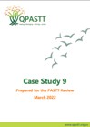

**Appendix 5. Report on costs**

**of rural and regional service provision**

The 2019 AusHSI report, “Cost of service provision for survivors of torture and trauma in rural and regional locations”, can be accessed via the link below. This report contains an environmental scan and costing analysis for the Forum of Australian Services for Survivors of Torture and Trauma (FASSTT).

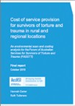

# Appendix 6. Referrals into FASSTT agencies by sector

*Table A1.* Referrals from other providers into FASSTT agencies (%) and nationwide (number)23

|  |  |  |  |  |  |  |  |  |  |
| --- | --- | --- | --- | --- | --- | --- | --- | --- | --- |
|  | STARTTS | VFST | QPASTT | STTARS | Phoenix | Companion House (CH) | ASeTTS | Melaleuca | Total number |
| Accommodation | 0.6 | 3.1 | 3.5 | 6.6 | 6.6 | 12.1 | 1.8 | 10.0 | 590 |
| Asylum Seeker Support Service | 1.2 | 0.2 | 0.4 | 0.3 | 1.3 | 0.4 | 2.0 | 0.0 | 109 |
| Centrelink | 0.2 | 3.7 | 1.3 | 4.5 | 2.3 | 12.3 | 1.2 | 6.0 | 432 |
| Client - self | 0.0 | 1.1 | 0.0 | 0.0 | 0.0 | 0.0 | 0.0 | 0.0 | 24 |
| Client - family/friend | 0.0 | 0.7 | 0.0 | 0.0 | 0.0 | 0.0 | 0.0 | 0.0 | 14 |
| Community Welfare organisations | 1.3 | 23.4 | 17.7 | 7.0 | 16.6 | 1.5 | 2.3 | 6.0 | 1135 |
| Department of Home Aﬀairs | 0.0 | 0.2 | 0.2 | 0.9 | 0.0 | 0.4 | 0.3 | 0.0 | 61 |
| Disability support service | 0.3 | 0.4 | 1.1 | 0.1 | 1.0 | 1.3 | 0.8 | 0.0 | 54 |
| Education – primary & secondary | 0.1 | 8.3 | 3.3 | 1.2 | 0.8 | 1.9 | 0.6 | 14.0 | 286 |
| Education – tertiary | 0.3 | 1.9 | 0.9 | 1.1 | 0.3 | 5.0 | 0.9 | 0.0 | 156 |
| Employment | 0.3 | 1.3 | 3.7 | 1.5 | 1.8 | 11.4 | 0.5 | 6.0 | 214 |
| Family Violence service | 0.1 | 1.3 | 2.2 | 0.1 | 3.1 | 1.9 | 0.1 | 6.0 | 72 |
| FASSTT Other | 0.2 | 0.2 | 3.1 | 0.3 | 3.8 | 1.1 | 0.3 | 0.0 | 69 |
| Health – allied | 1.2 | 5.9 | 4.4 | 2.5 | 3.6 | 4.1 | 0.0 | 4.0 | 385 |
| Health – general medical | 1.8 | 9.7 | 3.7 | 7.5 | 4.1 | 3.0 | 2.6 | 14.0 | 800 |
| Health – mental | 2.0 | 10.8 | 16.4 | 2.3 | 18.1 | 1.9 | 0.9 | 8.0 | 626 |
| HSP (previously HSS) | 0.4 | 1.4 | 0.2 | 0.6 | 1.3 | 0.4 | 0.0 | 0.0 | 92 |
| Internal | 83.9 | 1.7 | 1.8 | 47.6 | 9.2 | 22.2 | 54.6 | 8.0 | 7712 |
| Legal (migration related) | 1.5 | 2.3 | 13.3 | 2.3 | 4.1 | 8.0 | 3.4 | 0.0 | 405 |
| Legal (non-migration related) | 0.7 | 2.7 | 3.5 | 2.5 | 1.3 | 2.2 | 1.0 | 8.0 | 280 |
| Settlement Support | 0.6 | 4.6 | 2.8 | 2.9 | 8.2 | 2.8 | 0.4 | 8.0 | 357 |
| Not stated/unknown | 0.0 | 0.0 | 0.0 | 3.1 | 0.0 | 1.7 | 15.2 | 0.0 | 346 |
| Other services | 3.5 | 15.0 | 16.4 | 5.0 | 12.8 | 4.1 | 11.2 | 2.0 | 1035 |
| Organisation total | 100.0 | 100.0 | 100.0 | 100.0 | 100.0 | 100.0 | 100.0 | 100.0 | 15254 |

Note: cells are colour coded to represent the highest (green) to lowest (red) proportions of referrals to each agency, and overall

**Appendix 7. Online engagement questionnaire**

## Appendix 7.1 Content

Note about content: Survey items 1-4 are demographic questions to allow assessment of responses via location, service provider etc. Items 35-39 assess satisfaction and benefits of the partnership.

**Introduction**

The Program of Assistance for Survivors of Torture and Trauma (PASTT) has been funded by the Department of Health and Aged Care since 1995 to provide survivors of torture and trauma with appropriate counselling and related support services. PASTT aims to promote the physical health and psychosocial recovery of people living in Australia who have pre-migration experiences of conflict and human rights abuses, which make them vulnerable to developing mental health problems. The PASTT program model allows for providers to deliver services tailored to the needs of clients, whether this involves short, medium or long-term support.

PASTT is delivered by member agencies of the Forum of Australian Services for Survivors of Torture and Trauma (FASSTT), one in each state and territory including:

− NSW – Service for the Treatment and Rehabilitation of Torture and Trauma Survivors (STARTTS)

− VIC – Victorian Foundation for Survivors of Torture (VFST/Foundation House)

− QLD – Queensland Programme of Assistance to Survivors of Torture and Trauma (QPASTT)

− SA – Survivors of Torture and Trauma Assistance and Rehabilitation Service (STTARS)

− WA – Association for Services to Torture and Trauma Survivors (ASeTTS)

− TAS – Phoenix Centre

− NT – Melaleuca Refugee Centre

− ACT – Companion House

The Australian Centre for Health Services Innovation at the Queensland University of Technology has been contracted to provide an independent evaluation of

PASTT, including the success of stakeholder engagement and any partnerships formed.

You have been asked to complete this survey as you have been identified by one of the FASSTT member agencies as supporting or delivering PASTT services. The survey aims to reflect on the partnerships established, develop a clearer idea of the success of engagement, and focus on ways to sustain collaboration into the future.

Your answers to the questions are confidential and will not be shared in identifiable form with anyone in your organisation/group or elsewhere. We will, however, be reporting the results of all aggregated surveys. All the responses will be anonymised. If you agree to participate you do not have to complete any question(s) you are uncomfortable answering. If you do not wish to answer a question you can leave it blank and move to the next question. You can also withdraw from the research project at any time by closing your web browser.

Acknowledging that you have read and understood the participant information [link to PIS] and providing responses to survey items is accepted as an indication of your consent to participate in this research project. If

you would like more information about this survey, please contact Bridget Abell ([bridget.abell@qut.edu.au](mailto:bridget.abell@qut.edu.au)). If you do not wish to continue, please close your browser now.

1. In which state or territory are you/your organisation currently based?
   1. New South Wales
   2. Victoria
   3. Queensland
   4. South Australia
   5. Western Australia
   6. Tasmania
   7. Northern Territory
   8. Australian Capital Territory
2. Which of the following categories best describes how you engage in your role with PASTT and/or the FASSTT member agency? (select all that apply)
   1. Counselling and/or therapeutic mental health services
   2. Other medical or clinical services
   3. Community/social support services
   4. Settlement services
   5. Youth and family services
   6. Community leader
   7. Community development and capacity development
   8. PASTT funding, management, or administration
   9. Other [free-text]
3. How long have you been involved with PASTT/ delivery of PASTT services? [free text]
4. How frequently do you engage, communicate, or collaborate with PASTT and/or the FASSTT

member agency? (e.g. via meetings, email, phone,

videoconference, referral pathways, shared clients, or in training, or resource sharing?

* 1. Daily
  2. Several times a week
  3. Weekly
  4. Several times a month
  5. Monthly
  6. Several times a year
  7. Once a year or less

In this part of the survey, we will ask you some questions about your own experience and satisfaction in taking part in PASTT collaborations and activities.

Please feel free to write as much as you wish in your response to the following questions.

1. What have been some of the barriers/difficulties you have experienced while participating in partnership with PASTT? This could be at a personal or organisational level. [free text]
2. What factors have made participation in the PASTT partnership easier for you and/or your organisation? This could be at a personal or organisational level. [free text]
3. So far, how satisfied have you been with participating in the PASTT partnership? (Slider scale from drawbacks greatly exceed benefits to completely satisfied)
4. Think back to when you and/or your organisation became involved in PASTT and PASTT activities. Since joining PASTT or providing PASTT activities, it has enabled you/your organisation to: (sliding scale from not at all to most definitely)
   1. Improve the psychosocial health and wellbeing of clients and refugee communities
   2. Increase the responsiveness of mainstream health and related services to the needs of your clients and refugee communities
   3. Build the confidence of refugee communities to access mainstream health and related services
   4. Provide regional rural and remote outreach services for Survivors of Torture and Trauma and refugee communities
   5. Enhance the capacity of specialist counselling and related support services
   6. Provide community education and advocacy
5. Any further comments about your experience or satisfaction working with PASTT or your FASSTT member agency? [free text]

Thank you for participating in the survey. Please click submit to ensure your answers are provided. You can then shut your browser.

## Appendix 7.2 Supplementary data

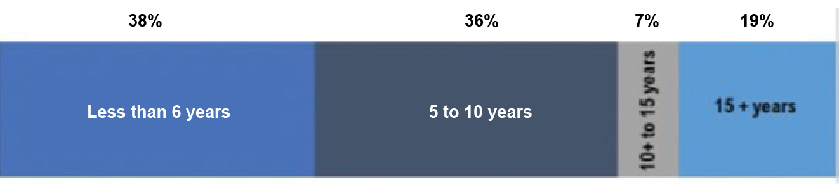

*Figure A1*. Duration of respondent/external agency engagement with FASSTT agency (n=69)

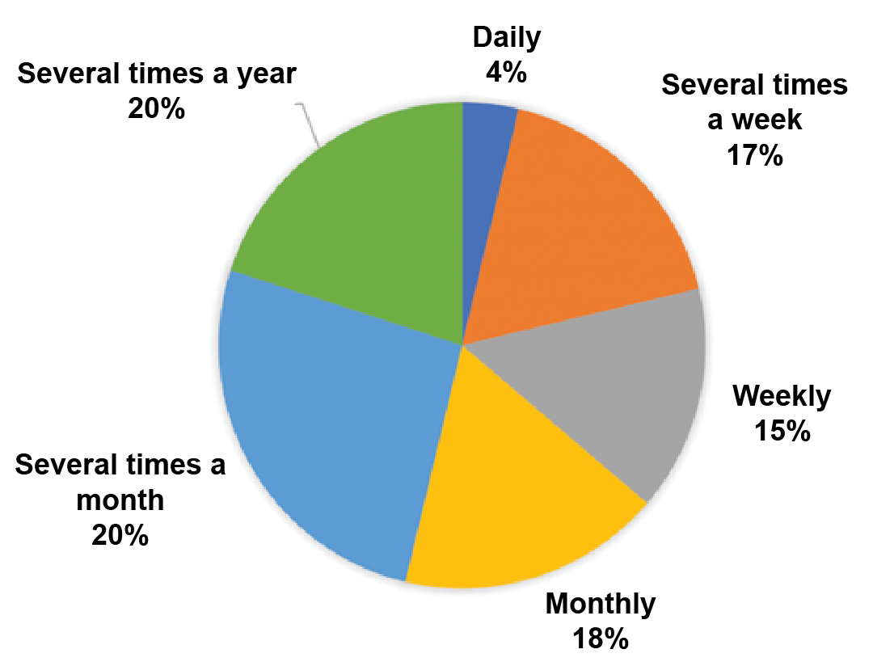

*Figure A2*. Frequency of respondent/external agency contact with FASSTT agency (n=69)

# Appendix 8. The Global Standards on Rehabilitation of Torture Victims

IRCT GENERAL ASSEMBLY RESOLUTION

**irct.org**

**Global Standards on Rehabilitation of Torture Victims**

20

20

RESOLUTION ADOPTED BY THE 6TH GENERAL ASSEMBLY OF

THE INTERNATIONAL REHABILITATION COUNCIL FOR TORTURE VICTIMS (IRCT) ON 6TH OCTOBER 2020.

*Recognising that there exists a continuum of standards in rehabilitation services and that they may change at any given time, depending on the context, political situation and the scale of human rights violations;*

*Building upon our efforts to prevent torture, fight impunity, and provide redress and holistic rehabilitation to victims;*

*The members of the International Rehabilitation Council for Torture Victims (IRCT), in our joint work towards the identification, establishment and promotion of minimum standards for holistic rehabilitation delivery, commit ourselves and urge all rehabilitation service providers to:*

##### Paragraph 1 – Our commitment to victims:

Uphold the well-being and dignity of torture1 victims2 as well as professional ethical standards and principles regarding treatment and rehabilitation, including informed consent, confidentiality, do no harm, the best interests of victims, and their free choice about the services they receive, resist re-traumatisation, and apply global best practices, which are all pivotal to the work of rehabilitation centres that are independent and accountable to victims, in accordance with the principles of the UN Committee against Torture’s General Comment No. 3 on the right to redress and rehabilitation.

##### Paragraph 2– Independent services:

Implement relevant structures and procedures so that rehabilitation can be provided independently, autonomously, in full compliance with applicable professional standards and ethics, and free from any external influence. In particular, rehabilitation centres should prioritise the development and implementation of

1. In this document, the term ”torture” covers all acts and omissions that may qualify as “torture” or “cruel, inhuman or degrading treatment or punishment” as defined by the UN Convention against Torture and further elaborated by the practice of the UN Committee against Torture.
2. The IRCT notes that some anti-torture actors prefer to use alternative terminology to “victim” such as “survivor” or “person subjected to torture”. For the purpose of clarity and consistency, this document will use the term “victim” to describe any person that has been subjected to torture or cruel, inhuman or degrading treatment or punishment.

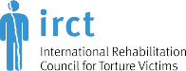

GLOBAL STANDARDS ON REHABILITATION OF TORTURE VICTIMS

structures, methodologies, and procedures that are victim-centred, evidence-based, participatory, empowering, holistic, accessible, equitable, respectful, gender sensitive, culturally appropriate, and accountable. Where funding is received from sources that could be perceived to place an external influence on the rehabilitation provider, it is essential to ensure that the organisation’s mandate and the principles of victim confidentiality, transparency, and independence of decision-making are prioritised and emphasise the victims’ best interests. Torture victims must be informed about measures taken to protect the rehabilitation process from external influence.

### Paragraph 3 – Safety of victims:

Ensure the implementation of every possible safety and safeguarding measure for victims receiving services including all aspects of the relationship with victims, bearing in mind that the best interest of torture victims is a key principle of rehabilitation services. Torture victims must be informed about and provide input into the determination of safeguarding and safety measures.

### Paragraph 4 – Support to families:

Ensure that the specific rehabilitation needs of torture survivors’ families, in particular children and vulnerable populations, are considered an essential part of the rehabilitation process. Where resources allow, families should receive support in accordance with their needs. Where relevant, culturally appropriate community-based approaches should be employed during the rehabilitation process.

### Paragraph 5 – Access to justice:

Whenever possible, support victims’ access to justice and be advocates for the eradication of torture as a part of the rehabilitation process. This includes supporting victims to document their claims in accordance with the Istanbul Protocol3 and to file complaints, and advocate for national authorities to adopt and implement national anti-torture laws and National Preventive Mechanisms (NPMs).

### Paragraph 6 – Intake Processes:

Establish intake processes through which victims of torture can access rehabilitation services on the basis of self-referral or referral by a third party, such as by competent physical or mental health, social, or legal professionals; human rights defenders; faith-based, indigenous, ethnic and national minority communities;

other torture victims or family members. These processes must ensure that, within available resources, torture victims have free, equal and non-discriminatory access to services, regardless of their ability to pay or legal status in the country concerned. To the extent possible, rehabilitation service providers should prioritise outreach, in particular for torture victims who are marginalised, detained, living in remote areas or lack funds for transport costs.

### Paragraph 7 – Access to information:

Provide torture victims with all relevant information concerning the rehabilitation services offered. Rehabilitation centres must respect and promote torture victims’ agency in their own lives and their choices regarding rehabilitation. Where possible and appropriate to the service provided, reliable interpreters should be made available at no cost to torture victims. Whenever possible, victims should be able to choose the gender of rehabilitation professionals, including interpreters. Informed consent must be obtained according to relevant professional and ethical standards before and during the process of rehabilitation.

1. Manual on the Effective Investigation and Documentation of Torture and Other Cruel, Inhuman or Degrading Treatment or Punishment

page 2

GLOBAL STANDARDS ON REHABILITATION OF TORTURE VICTIMS

##### Paragraph 8 – Victim feedback:

Establish procedures and mechanisms that enable torture victims to provide ongoing feedback, including upon leaving rehabilitation services, in a language they speak, about the services they receive; for example, through the use of standing service user engagement mechanisms, victim satisfaction surveys, service evaluations, focus groups, and other participatory mechanisms. This feedback should be reviewed periodically and form the basis for continuous improvements to the rehabilitation services offered. Satisfaction should be clearly defined and use consistently applied standards. In addition, mechanisms whereby victims can complain and receive a prompt and satisfactory response in relation to the rehabilitation services they receive should be established. Victims should be enabled to effectively engage through measures such as provision of information about complaint possibilities and the establishment of support functions that include other victims.

##### Paragraph 9 – Victims’ participation in rehabilitation:

Promote the meaningful contribution of victims in service design and delivery, research, decision-making, and governance processes of rehabilitation services through recognition of victims’ experience in service development and recruitment processes, open consultative and feedback processes, and other participatory methods that are contextually and situationally appropriate.

##### Paragraph 10 – Organisational capacity:

Prioritise continuous training and capacity enhancement for staff and volunteers, for example, in specialised evidence-based treatment methods; trauma sensitive interview techniques; empathetic listening and anti- racism; cultural and gender awareness in accordance with relevant professional standards; and ethics and international human rights standards.

##### Paragraph 11 – Staff safety:

Ensure that staff and volunteers are safe, secure and cared for and have the means to report incidents that could compromise their safety or the safety of others through reporting processes or other suitable means that ensure that these risks are documented and that context- appropriate measures are taken to minimise them. In this regard, rehabilitation centres should ensure the adoption and implementation of appropriate policies to prevent and address discrimination, harassment, and sexual and other forms of abuse.

##### Paragraph 12 – Care for staff:

Address vicarious trauma and prevention of burnout as an organisational priority for all staff. To that end, provide a robust and supportive well-being infrastructure and working environment for staff through, for example, regular supervision, peer support mechanisms, staff mentoring, psychosocial support techniques, and access to occupational health services.

##### Paragraph 13 – Share knowledge:

Disseminate information about torture and its effects to professionals in healthcare and other relevant fields who may come into contact with torture victims. Information should include available and possible approaches to rehabilitation, the specific needs of torture victims (including early identification, assessment, and timely referrals), trauma-informed care, documentation procedures according to the Istanbul Protocol, and regarding the value of providing rehabilitation to facilitate life after torture. Where security considerations allow, the dissemination of this information should be considered a critical moral and social responsibility for centres assisting victims of torture.

page 3

GLOBAL STANDARDS ON REHABILITATION OF TORTURE VICTIMS

### Paragraph 14 – Advocate for rehabilitation funding:

Where possible, attempt to establish or strengthen dialogue with states and their relevant agencies to inform them about torture and its effects and the value of rehabilitation, and to request that they provide funding to support the rehabilitation of torture victims worldwide, preferably through: a) direct funding of rehabilitation centres assisting survivors of torture in their respective countries, b) contributing to the United Nations Voluntary Fund for Victims of Torture (UNVFVT) or c) funding the IRCT’s sub-granting programme.

*RECOGNISING the importance of a holistic approach to the fight against torture, which encompasses prevention, justice and reparation for victims and that IRCT members contribute to all aspects of this effort to eradicate torture;*

*The IRCT membership expresses our joint ambition to document and demonstrate our collective global impact on the quality of life of the torture victims we support, and therefore commit to endeavour to:*

### Paragraph 15 – Definition of quality of life:

Apply the following definition of quality of life: The subjective well-being of individuals and their communities within their specific social and cultural context in relation to factors such as physical and mental health; family, social and community relations; culture; education; employment; economic security; exposure to physical and psychological violence and freedom; good governance and basic human rights; spiritual life; gender equality and non-discrimination; religious beliefs; legal status; and the natural and living environment.

### Paragraph 16 – Evaluating improvements in quality of life:

Apply evaluation tools that are appropriate to their specific context. This is done with the recognition that IRCT members provide services in very different contexts, including detention, political repression, victims with uncertain legal status, discrimination and poverty, which may have a severe negative effect on victims’ quality of life. Furthermore, each member centre will determine which tools are best used to evaluate improvements in all indicators relevant to addressing the needs and improving the quality of life of the torture victims they support, and communicate this to the IRCT membership. In documenting the results of their work, IRCT members are encouraged to take into account how the quality of life of torture victims is connected to the enjoyment of rights, including access to justice, international protection, redress and all five forms of reparation (restitution, compensation, rehabilitation, satisfaction and the right to truth, and guarantees of non-repetition).

### Paragraph 17 – Documenting our global impact:

Share the results of their support to torture victims with the IRCT membership on an annual basis. This will become part of the IRCT’s annual Global Impact Report, which demonstrates to the world our collective impact in the lives of torture victims.

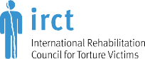For more information please visit: [**www.irct.org**](http://www.irct.org/)

Vesterbrogade 149, building 4, 3rd floor

1620 Copenhagen V

**Denmark**

2017 © International Rehabilitation Council for Torture Victims (IRCT) **All rights reserved**

## Appendix 8.1 Alignment between the IRCT Standards and the NSMHS

There is strong alignment between the IRCT standards and the NSMHS. Evidence for meeting the IRCT Standards was provided to the NSMHS accreditors and was formally and independently acknowledged. Below in Table A2, the IRCT Standards are presented against the NSMHS. Additionally, the below section includes NSMNS feedback to some of the FASSTT agencies’ services and policies to further support alignment with the IRCT Standards.

***Table A2*. Alignment of the IRCT Standards and the NSMHS**

|  |  |  |  |  |  |  |  |  |  |  |  |  |  |  |  |  |  |
| --- | --- | --- | --- | --- | --- | --- | --- | --- | --- | --- | --- | --- | --- | --- | --- | --- | --- |
| **IRCT Standards** | | | | | | | | | | | | | | | | | |
|  | 1 | 2 | 3 | 4 | 5 | 6 | 7 | 8 | 9 | 10 | 11 | 12 | 13 | 14 | 15 | 16 | 17 |
| NSMHS*  equivalent | 1  2  4  10.1 | 1  8 | 2 | 3  6  7 | NE | 10.2  10.3  10.4 | 6 | 3  6  10 | 3  6  10 | 2  8  9 | 2  8  9 | 2  8  9 | 5 | NE | 1 | 10.4 | NE |
|  | 10.5 |  |  |  |  |  |  |  |  |  |  |  |  |  |  |  |  |

*Standard 1: Rights and Responsibilities; Standard 2: Safety; Standard 3: Participation/Consumer and Carer Engagement; Standard 4: Diversity; Standard 5: Promotion and prevention; Standard 6: Consumers; Standard 7: Carers; Standard 8: Gov- ernance; Standard 9: Integration; Standard 10: Delivery of care; 10.1: Delivery of Care – Recovery; Standard 10.2: Delivery of Care – Access; Standard 10.3: Delivery of Care – Entry; Standard 10.4 Delivery of Care – Assessment; Standard 10.5: Delivery of Care – Support; NE: no equivalent

#### Appendix 8.1.1 Accreditation feedback to support alignment with the IRCT Standards

The accreditation review against NSMHS statements supporting alignment with the Mental Health Services accreditation standards and consequently the following IRCT Standards:

###### Statements against IRCT Standard 1:

*“Companion House is commended for its engagement with clients based on key principles of respecting human rights and the rights to safety and self-determination.*

*Staff readily referenced human rights as the basis for their work with refugees and asylum seekers. Clients and stakeholders reinforced this by providing numerous*

*examples of individual experience and of program design and initiatives undertaken by Companion House. Staffs ensure that clients are at the centre of all engagements and interventions, as evidenced by interviews client and program files, minutes of meetings and publications.*

*Clients expressed their strong view that staff at Companion House encourage individual decision making and real choices and that their rights are respected and promoted.” (QIP Report 2019)*

*“Importantly, there was a clear resonance through the Board and staff interviews of a shared focus on clients and the importance of dealing with clients respectfully as fellow human beings. The regular checking in with clients to ensure that they are still comfortable with a previous choice, such as a consent or other commitment, is seen by staff as one of the ways of confirming client rights.” (STTARS, QIP Report 2021)*

*“QPASTT is a dynamic and innovative organisation with a strong values driven approach to its work with clients and their communities. The Counsellor Advocate approach is innovative and recognises the importance of gaining trust in order to be able to work effectively with clients over*

*the longer term. QPASTT is highly regarded by the many cultural communities it has engaged, and is regarded as genuinely listening and committed to responding. Clients feel that QPASTT is a safe place, with staff that can be trusted.”* (QPASTT, QIP Report 2019)

###### Statements against IRCT Standard 2:

*“STTARS comply with all ethical and legal requirements for the protection of client privacy and confidentiality.*

*Applicable legislation includes: Commonwealth Privacy Act 1988 as amended; Commonwealth Notifiable Data Breaches scheme; State Privacy Acts and Health Records Acts (Other States); Information*

*Privacy Principals Instruction (SA); and The Freedom of Information Act 1991. Additionally, where legislation does not specifically apply, STTARS policies and procedures are consistent with the intent of the Australian Privacy Principles.”* (Australian Service Excellence Standards Accreditation Report 2021)

###### Statements against IRCT Standard 6:

*“At interview clients described Companion House intake process as detailed and client- centric - ‘like they wanted to really help me’. ……Intake documentation was overall consistent in format and content………Staff were clear about eligibility criteria, the management of waiting lists and referrals for those clients who required services*

*by another agency. Waiting lists for counselling are effectively managed and strategies are in place to risk- manage clients through telephone contact and through Companion House coordinating other resources as required.”* (QIP Report 2019).

###### Statements against IRCT Standard 8:

*“Review of the policy, procedures and records shows that there are multiple processes in place for consumers to express compliments, complaints, and grievances regarding their care and for these to be addressed by MRC Tas Phoenix Centre appropriately*

*Interviews with consumer representatives, facilitated by the interpreter, unanimously confirmed that there is awareness of how to give feedback and make a complaint and that they feel confident to do so.”*

###### Statements against IRCT Standard 10:

*“Staff receive a thorough induction and are well supported. Clinical supervision is in place and the well-being of staff is given priority. The organisation’s commitment to continuous quality improvement is*

*demonstrated by the review of the supervision system this year and the introduction of improved scheduling and other enhancements. Staff at interview displayed both passion for their work and competence.”* (STTARS, QIP report 2021)

*“There is a strong evidence base to the work as shown by the references in the comprehensive Clinical Services manual. There is a thorough and well-paced induction for new staff. There are well-developed systems for line supervision and clinical supervision. There is a schedule of Offline weeks (no client work) when regional staff attend head office for training and other developmental activities.”* (QPASTT, QIP Report 2019).

###### Statements against IRCT Standard 12:

*“STTARS has high staff retention as well as significant numbers of staff (and Board members) returning to the organisation after experiences elsewhere. This indicates a positive workplace culture, which was confirmed*

*in interviews. …There is a strong commitment to risk management which is appropriate given the history and vulnerability of the clients.”* (STTARS, QIP report 2021)

*“Another key factor in the organisation’s success is the flexibility and commitment of staff and strong collaborative and positive teamwork observed across all roles in the organisation. Staff are supported in through ongoing training, quality clinical and administrative supervision, access to EAP and communication systems are very effective with multiple formats used to ensure information flows and collaborative planning that enables continuity of care for clients.”* (STARTTS, 2022.)

# Appendix 9. Selected stakeholder quotes

The quotes provided in Table A3 below come from interviews, conducted by the AusHSI team, with a broad cross- section of key stakeholders from FASSTT agencies and external organisations, as described in Section 2.5.1. Those interviewed were engaged in a variety of roles and at several levels in the organisational hierarchies of the agencies. Specific attributions for quotes are not provided as they are intended to be understood as supplementary examples informing the key findings described in the above report.

| Chapter | Theme | Selected quotes |
| --- | --- | --- |
| **Appropriateness and acceptability of PASTT** | Appropriateness of PASTT | “The PASTT program gives us that flexibility to support people in a way that they need to be supported to feel safe.”  ‘It’s [session focus] completely up to the client.’  “Advocacy is a – a – way to sort of meet people where they’re at, (...) walking with them and (…) building a relationship, which is so important (…) in trauma recovery.”  “[Our specialisation] is to be able to rock’n’roll with the challenges of finding an interpreter, finding bicultural links and community leaders.”  “Our clients whose human rights have been deprived due to torture, trauma and human rights violation, these clients are basically now with us having the opportunity to be the leader in the session, to be the one who is able to tell us what they need, and to voice their opinion. And that on its own is therapeutic and gives them more strength and capacity to tell us where they want to go.”  “We had to adapt the way we worked when we started to see people from [location], we had to adapt again when we started to see people from [different location] and...so with every new wave, there will be challenges...but it would be overstating it if we said we’ve never seen anything like this before because in fact we have and we just have to develop the experience to adapt what we need to do and the model that we are using, so there will be challenges but I don’t think they are insurmountable challenges.”  “PASTT for me is more a structure to work within of the way of being and to kind of outline general goals and general stages and ways of assessing and engaging…”  “So, for example, Ukrainian crisis at the moment, we were referred yesterday I think an 86- or 96-year-old, so someone who came out to Australia at the end of World War 2, traumatised then, has been fine, lived a full life, seen what’s happening in Ukraine, been triggered...there’s not many programs that have that broad level of accessibility.”  “Authentically genuine co-design process.”  “We’ve got the flexibility to say, does this person need one to on or do they need more group. Or do they — really being based around what each person needs, is probably one of the big strengths of PASTT. And that’s focussing on — and everybody uses the words because they’re trendy, we’re person centred, we’re client centred. But this program allows us to really do that. So, every assessment is starting with the person and that really holistic view. We don’t see they’ve got this diagnosis or this illness, so what is the whole situation. What’s the background, what’s the supports around them, what are their goals and aspirations, what are they hoping to get out of the service and then to tailor it around that…Because I think it — it is that holistic and population-based approach that’s really important.” |
|  | Appropriateness of FASSTT | “I certainly really highly value the support we get from the other FASSTT agencies, I think as a smaller agency there’s no way we would be able to do this work without the support of the network, it’s just been incredibly valuable.”  “Collectively, we are much more convincing and much more powerful than we would be as eight individual organisations.”  “There is a lot of sharing of intellectual property and that is always been incredibly generous… overwhelmingly from the bigger states to the smaller states.”  “I think it’s probably because we are not competitors that we can very genuinely be very generous with each other.” |
|  | Challenges- reporting and outcomes and balancing demands | “We have significant quantitative aspects of the work that we do, that are not followed. (…) We have to, have the chance to – to – to be able to (...) present the qualitative aspects of our work. In a non-quantitative way. (…)”  “I hate it every time data time comes around. I love data, but... I’d love to see some enhancements in our data system. It’s probably not relevant for the Department, but I think what I talked about in terms of the continuous improvement and accreditation, I think that’s so critical and being able to demonstrate – I don’t know if you’ve had a look at the stuff we’ve put up – but in terms of client outcomes and things like that, we can only really give you qualitative data and I would love to develop some systems and things that not just demonstrate to us and the department, but also you can share that with people and with communities about the things that they’ve been able to contribute to and the outcomes for them. Yeah, I’d love to be able to. So, I just think there’s so much opportunity there to do some things but to do that now would mean that I would have to cut the counselling, and that is going to hurt people in the immediate term and won’t be effective. I think that probably sums it up.”  “I think some of the targets don’t really make sense in terms of breaking it down into actual money and they’re a little historical.”  “So, funding changes that have occurred with PASTT over the years haven’t necessarily been reflected in changes in our targets. So, we will be looking at trying to negotiate a lower target but then you’ve got the issue ‘well what happens to all those people in the community who need the service if we reduce the targets’ because the needs are still there.” |
| Acceptability | “[The client] said to me, ‘I can’t believe. This is the first time I feel,’ – even though before coming here she was in another – in a transitional country, which also offered some support for her, prior to, she had to escape her country. But she said, ‘This is the first time I feel someone has listened to me.’ - like, not me, I’m talking about the organisation.” |
| **Regional and Rural Implementation of PASTT** |  | “The cost for the number of clients that need servicing can sometimes be disproportionate compared to servicing clients in metropolitan [location].”  “...just don’t have the same economies of scale in rural and regional settings and that’s always a factor.”  “[Each rural/regional community] carries its own set of circumstances...the reality is that rural and regional isn’t one big group, it’s a number of different areas that have their own aspects to work with and that we’ve needed to develop strategies to support people in those areas.”  “For us to spend money establishing offices in rural locations would just take money away from service delivery.”  “[When the number of clients is] relatively small in multiple areas, then it pays to build capability of the local community health centre or whatever the case may be.”  “The time needed to do the sort of community development work, the connections with communities, it’s so much harder up there.”  “There’s so much work that needs to be done to upskill and really get [3rd party providers in rural and regional areas] to probably see how their service could be a bit more responsive to our families.”  “We deliver a number of different, I guess, services and programs, yet, you know, the needs of refugee communities in regional areas go beyond that scope and housing is an example, or employment might be an example, and they’re two areas that [the organisation] traditionally, you know, is not really involved in, particularly housing, yet the staff there will be called by the local community about, you know, ‘I’m stuck, I need housing’, so they get involved in all these areas mainly because they are trusted in that part of the world and I think that can be quite a challenge for them to juggle these many needs.”  “[Talking about PASTT service delivery in rural and regional areas] But we have a commitment to being flexible and providing an equity of access when that’s possible but that, again, that’s an additional cost, and additional resources are needed.”  “With the [rural and regional] service providers, it’s just unbelievable what you can achieve in those relationships when you are there.”  “When relationship building is based on being present and reliable and predictable, that gets really undermined with a fly-in, fly-out model, whether that’s with direct service delivery or management as well.”  “Because in the regions, [FASSTT agency staff] have got to do it all themselves, schools are kind of clueless, health services are clueless, haven’t used an interpreter before, there’s nothing like a, you know, legal office that might help you, or a migration agent, nup, none of that.”  “...we need to actually make a decision, um, do we provide an adequate service in the regions or do we provide as much as we provide in the metro areas, and I think that, I don’t think that we’re gonna be able to do the latter, but I don’t think we’ve reached the former either.” |
| **Outcomes achieved** | Client-level | “…even physically their presentation was very closed and extremely hyper-vigilant, extremely anxious, um, you know, a couple of, you know, like, quite fidgety, quite, you know, and just through the process of gradually providing support and stability, even just in their physical presentation you could see their recovery because they could actually engage, their body language was more open, they could make eye contact more, they could – so even just that initial, um, part of the journey where they learn to feel safe and trust and even physically sort of be able to open up and reduce anxiety enough to engage in that, you know, counselling experience, you know? I’ve had, you know, a few clients with that presentation, um, yeah, yep.”  “[the client] said that (...) if it was not for the counsellor in the time and the space that she built in – in counselling, where she felt safe and accepted and not judged and where the trauma, and the impacts of trauma and the mental health were normalised(...). She got a sense of this environment being somewhere where she could be free and safe and – and she wasn’t crazy. (...) she wanted to then offer that to others. She wanted to show others that she’d come from a place where she thought she was crazy and nuts. And she was labelled as that all along. She wanted to offer hope, that hope of not being damaged.”  “…many clients have that experience of that trust first time in many years, and safety at [FASSTT agency] and feeling, like, homely at [FASSTT agency]. Um, and coming to [FASSTT agency] for that one smile in their, like, face. So, like, those kind of comments and those kind of, yeah, positive feedback constantly comes to us.” |
| Health provider and service-level | “It’s been a push to get them [mainstream mental health services] to see our clients.”  “[Talking about 3rd Party providers] I’ve had a few very difficult and one very disastrous outcome with psychotic [client] who can’t manage has to be seen urgently, they were so slow to pick it up. Eventually engaged with him and he did suicide in their service, and I think it was that slowness, not understanding our level of trauma.”  “[Talking about conducting 3rd party provider training] We’re more confident about making referrals to those agencies.”  “If we can train more people, ah, mental health professionals, about how to work with refugees, then I think the community is actually trauma-informed community, trauma-informed society and I think that’s what we need.”  “[Talking about resource development for 3rd party providers] In a sense, they’re produced in a very cost-effective way, like, if the department was going to contract people to produce that, it would probably cost them much much more than having the expertise on tap that can be drawn in to produce those resources.”  “When I think about the training that we have done, we get incredible feedback from people about the impact that it’s made... We do a lot of advocacy... I talk to people from the fire department through to the police station, through to the local GP service. Things like that around trying to support them to be more culturally aware... through to systems things.”  “If there is one frustration at a strategic level, it is related to the relationship between [state] health and the Commonwealth. For example, there is no engagement between the responsible Commonwealth bodies and [state] health. We do not even know who [in the Department] is responsible for PASTT”  “[from the outside] there appears to be little accountability for which funding (i.e. state vs Commonwealth) is used for what services or programs. Thus, the agency could be being funded twice to provide the same service.” |
|  | Community-level | When speaking of community capacity building activities: “It [individual counselling] is a bit like a needle in a haystack.”  “And really what we want to be able to do is build capacity of communities to be able to support the members of their communities better themselves and be able to identify people who should be referred to our organisation early, rather than to that crisis point.”  “So, we think we do quite a lot around that and as an agency. For example, we just recently supported the Disability Royal Commission down here. I’m meeting with someone around mental health assessments this afternoon. It’s a whole range of those things, and I know they’re at a bigger level but that’s also about having a voice there that’s reminding people that you actually need to be mindful of multicultural communities in these processes, because at the end of the day if you put a system in place and it’s not had that cultural lens over it, it won’t work... I know that’s a really high-level kind of example but hopefully the long-term benefit of that is that the work’s been done right at the front end so that we’re not having to pick up the pieces, and hopefully that makes it more accessible for people.” |
| **Economic analysis** | Funding | “It’s really difficult not knowing how much funding we’re going to have year-to-year.”  “We don’t see it as, really, such a positive thing to be working with people forever and we want to find ways that will help them to meet goals that have been established as part of the counselling process.”  “If we took PASTT funding in isolation there is no way we could go anywhere near meeting the needs of clients.”  “So, for example, what’s happened is we’ve had an increase in the rate of referral. If your rate of referral increases but you don’t have a corresponding increase in funding levels, then what happens is you have a longer period of time before you’re able to comprehensively respond to referrals. You can respond around, you know, are they an appropriate referral to us, if not, refer them out. But if they are appropriate for us but you don’t have the resources to employ the staff in order to deliver that service then there becomes a wait.”  “There’s never been leftover capacity (...) we’re just delivering services as strategically and thoughtfully as we can.”  “(...) and I mean, I’m a realist, you’re never gonna get enough money, to be able to provide a perfect service, that’s fine, but I guess it’s about being able to have funding that is responsive to those sort of increasing requests for the service.”  “...through training we’re also hopefully building the capacity of other agencies to respond, um, perhaps in a more culturally competent or a culturally inclusive way to perhaps also increase that sustainability of – of PASTT funding because we can also have those partnerships.”  “I actually think the way that PASTT funding works, it’s — you know, I keep hearing it’s absolutely unique in terms of the department says, we’ve got this much money, how do we split it amongst you. But there’s huge commitment between the services with that principal, that the funding goes where it’s most needed and it’s based on client need. Um, and it actually works [laughs].”  “Things are stretched, you know, people are spread thinly, to some degree (…) and I think there’s definitely, a need for more [funding].”  “We always have fights, like you know, but, that we’ll have fights every year about funding and we kind of go back over old ground and, yeah, but we have a formula for how we recommend funding is distributed and there’s always people unhappy at the end of that but then there’s always a shrug of shoulders that basically says the formula is actually the best that we’ve got and it’s not perfect.”  “I’ve worked in related fields for a long time, and I think we go through lots of cycles of talking about how can we make contracts longer, funding more stable and so on. Ideally, I would love it if PASTT went, we recognise you need this level of base funding that’s got nothing to do with who’s coming, who is not coming, and you get top-ups on that. To have five-year contracts would be good and to know that you’ve at least got X, and then if you’ve got an increase in people newly arriving, that gets topped up. So, definitely not the, here you go, here you go, oh we haven’t had people arrive. Boom. We’ll actually reduce that. That doesn’t help with anything. So longer contracts, increased funding generally I would say, but yeah. Definitely having some stability and certainty... “  “The issue is that [state] health has no insight about the Commonwealth’s planning for PASTT…it seems that funding levels regularly change. The process is not transparent and therefore it is unclear what the Commonwealth’s priorities are, and what they are funding.” |
|  | Demand/waitlists | “We are also – like, you know, sometimes we have to work to create a demand, for example, ah, we are running, um, mental health promotion groups at the ground level, um, and also we are – we are doing community development capacity-building programs so that these communities actually understand that they need to seek, um, counselling support, you know.”  “The demand is constant, it just depends on what the urgency of different groups might be.”  “We’re not able to meet the demand on our services. (…) Um, I don’t know if it’s a particularly, um, [location deleted] thing, or COVID, or, or what, but we, you know, I – what keeps me awake at night is that we haven’t had arrivals for the past two years into [location] really, except for the recent Afghan evacuees. Um, our referrals actually went up, they didn’t go down.”  “I don’t know how, how we’re going to be able to cope once arrivals really start again. Um, so yeah. We, you know, I – I’d put our statistics in, in what I’d sent through, so they’re all there. But, um, yeah. We just, we’re just not able to meet demand. Like currently our waitlist is sitting at over [number] now. Um, it’s, it’s not ethical for us to have more people on a waitlist that we’re not going to get to for a very long time.” |
| PASTT being the core work | “The PASTT-funded activities are bread and butter to the organisation.”  “Without PASTT we wouldn’t be able to do any of the other things…our positions, again, that hold, the glue that hold the whole program together are PASTT funded.”  “[PASTT] is who we are.” |
| Cost pressures | “Because we do try and run it so leanly, I guess, to deliver great value to the Commonwealth, it has meant that we haven’t been able to invest as much in some of those back office supports that are really necessary for the ongoing stability, so data, finance systems, IT systems....”  “[Back office supports] has an impact, then, on the work, like it has an impact on the efficiency and effectiveness of the counsellors...”  “(…) the funding hasn’t increased to fully cover those increasing staffing and running costs, right, it costs more to put petrol in the car, it costs more to keep the lights on and all those sorts of things….”  “(…) there also needs to be a recognition in that funding that you need management structures, that you need staff support structures in place in order to ensure that the best quality service is being delivered. Even just, sort of, the accountability requirements, you’ve got to have a sophisticated database system now to be able to report all the time, you’ve got to have a well-functioning finance area to be able to stay on top of all the accounting requirements and financial requirements and somebodies got to pay for those....”  “The majority of your costing is your salary, that will be a big impact on the budget. (…) So that’s one of the biggest, and obviously now with the COVID, technology demands are really high up, so everyone needs a laptop, everyone needs a phone for work at home, and those things have really gone out the roof, so yeah.” |
| **Findings and discussion** | Summary of barriers | “We can sustain as an organisation but it’s not providing the level of care that we would see our clients needing or we wish to provide.”  “I think our dependence upon [PASTT funding] is perilous because it’s very much at the whim of whoever is in power at government.”  “I might be differing from the opinion of my colleagues in FASSTT…but I think there is significant risk in assuming [PASTT funding] will be there forever.”  “Because of the number of challenges we have, everything with the cohort, with interpreters, with the number of demands and KPIs and deliverables, and I think that retaining people is an issue that could affect sustainability.”  “...But if the three [CEOs and the National Coordinator] leave in the same year, for instance, I think it would fall apart, to be honest, it’s in danger of falling apart.”  “We are obviously competing against government services who are able to offer a lot more attractive salaries and probably a lot more attractive professional development ... (…) So, I think there’s a bit of competition with salaries. We pay under the SCHADS award, which is a level five. That’s not competitive with a lot of the other community service organisations either, because they’ve got their own infrastructure and size and so on, they’re able to have enterprise bargaining arrangements. They can pay above award salaries.”  “[we are] constantly shifting priorities and try and do everything (…) still we do achieve our KPIs, it’s probably not 100% in terms of quality, but we do meet the KPIs.”  “Hidden cost of inability to see referred clients - “internalised guilt and burnout”  “The waiting list…has its own weight and its own cost in management and the people feel about it which is an important part of service delivery.”  “The waiting list is a stressful thing full of people who want services that we don’t provide fully.”  “How do we triage and fix these problems so that we don’t’ have very distressed staff supporting very distressed people.”  “That has an emotional and psychological impact on people [staff] and I don’t think that there’s anything this evaluation can do to address that but for me it’s a day-to-day challenge for us to manage the distress associated with that and also have any kind of meaningful response.”  “There’s basically a whole field of vacancies out there where they could easily go to. So we’ve had a counsellor leave, but I’ve also got two other counsellors that are actively being approached by other agencies for work.”  “I know one of the big objectives of PASTT is to be able to support services so that people from background don’t have to stay in our service and can access all of those other services, but when you’ve got so much turnover in some of those services, the only capacity to give short bursts of training. You’re almost chasing your tail sometimes because by the time they start to build a bit of capacity, they lose it because of turnover or because of other priorities.”  “We might be supporting someone who could potentially be supported by another mental health service after a while, but as I said, there’s blockages there. So, people can’t move on… there’s certainly a lot of services that would say that they provide a trauma informed practice, but they’re not experienced and specialised in delivering trauma informed recovery practice with people from refugee backgrounds. They’ve fled wars and so on… I think there are services who are genuinely wanting to develop their practice to be able to better engage with communities… most of the feedback we get from people from communities, is that they struggle to engage with another service, and some of that is simple things. Like they don’t use interpreters…”  “One of the things that I have certainly seen increase, and that’s only in 18 months, but [agency] tells me that, yep, we’re definitely seeing an increase in, is obviously access to affordable housing. It’s an incredible issue. We’ve seen increases in family violence rates. Increase in engagement – engagement’s not the right word – but child safety services involvement. So, I think there’s a lot of complexity that’s happening for people, and some of that is very retriggering of trauma. So, it’s not as clean cut as being a, oh that’s a case management thing, and we don’t do case management kind of thing. So, I think there’s a lot more – and I know that we’ve talked about this in past agencies. The level of complexity of issue and need for people, we are seeing an increase in... if you live in [location deleted] and you’re looking for a rental property, you’re probably not going to get one. People have got that stress and on top of all the COVID and everything else. Yeah, so I think there are definitely some socio-economic factors there that are making it more difficult. Certainly, access to employment in [location] is a real issue.”  “…and finally got it [decision/action by FASSTT network] through, which wasn’t easy, it wasn’t easy at all, I mean, I sort of joke that herding cats doesn’t even begin to describe what the process was because there were eight organisations with eight boards not just the eight CEOs it was their boards that sat behind it and their boards would change we’d get to a point and we’d have another discussion and take it back and of course the board would be new and so you’d start the iteration all over again...” |
|  |  | “Sometimes I would like to be in one of those places [bigger agencies], so I could feel more – feel safer doing my work with support around me.”  “For a lot of people, it’s not an area that they want to venture into because it’s so…you know, with vicarious trauma and so on, it’s hard work…and in government or private practice people can earn a lot of money.”  “One of the things that I find a bit limiting is just not having the resources to really apply some of that continuous improvement activity, that I would love to see happening, and just as a little example of that – and I think I might have briefly mentioned this when we met on the previous meeting. Being such a small PASTT service, I wear so many hats and go to so many different PASTT meetings and get so envious of the fact that they’ve got, oh you’ve got a data person. You’ve got a this, you’ve got a that...So I really want to develop some really good tools and be able to embed them in our database system, and use some really interactive ways to get feedback about people’s experience of our service, and then be able to actually work through all of that and come up with some really good recommendations, and then test them with communities and look at different ways. So, I have big dreams, but I have little time to do some of that...you don’t wait until you’re closing someone’s file to ask them what it’s been like. You need to be checking that every time you’re interacting with someone. Is it still relevant for you? Is it still useful? So, I’m trying to build a culture around doing that in real time checking.”  “Some of them are highly vulnerable, some of them are suicidal, some of them just released, just discharged from hospital… we are trying to do with them is hold people, to help them become better, and then once they are ready to start opening their trauma and working on their traumatic material.”  “For a lot of people who come from a refugee background where they’ve held a qualification in their country of origin, and that’s not recognised here. It not only creates barriers for them, obviously in terms of their employment, but their identity and their self-esteem.”  “It is a challenge sometimes to bring people from multiple communities together around a topic, and there’s some obvious reasons for that, that apply across all circumstances, but the on-cost of it is – usually for every community we engage, we’ve also got to then engage the bicultural worker, for language support and cultural context. So that multiplies, and so that sometimes means that when we’re providing some groups, we’re limited to only targeting one or two communities, and I think while we try to spread that – again, I don’t know this to be an issue – but I’m conscious that for other communities, it could be a, oh how come you’re doing that with that group, and that with that group, but there’s nothing yet for our group?”  “And how do we manage that demand while still doing our everyday work with the clients that we know about? Um, there’s difficult decisions that we have to make on a daily basis. (…) There’s all these really ethically difficult decisions that we need to make. And that’s just the demand that we know about, there’s other demand that we don’t hear about and for me something I feel really passionately about is the zero to five age group, these are infants, children who can’t speak, who can’t express their vulnerability, but because we struggle to do the work that we know about it’s really hard to do that work that is preventative, that really deeply and truly addresses intergenerational trauma.”  “We’re always responding to the next emergency, we’re responding to the increasing constant demand, but being able to do that preventative work is really difficult.”  “We know the demand by far exceeds what we can ever possibly deliver and sometimes our staff – us, because they’re passionate, they will – they will do it anyway you know, they will find ways, particularly, um, ones who are working in the communities, people who come from the lived experience background, they just – they just do it as community members on their weekends you know, they find ways to continue to do this stuff. (…) We know that that happens and that people go, like, people in this organisation and I’m sure in all the FASSTT organisations, go above and beyond so it’s never a question of whether we’re delivering good work, it’s a question of how do we have that seen and acknowledged.”  “…even though PASTT doesn’t fund work with asylum seekers, as an organisation you’re working with a people on a continuum of visas…” |
|  | Summary of Enablers | “I love that [ability to stay engaged with clients] about this place that you get to stay with people as long as they need.”  “[Lived experience] is afforded the place it should have had.”  “The overarching, I suppose, feedback would be about the fact that the program’s been in existence for the time it has been has meant that there’s a great deal of expertise and capacity that’s been built up.”  “The team are passionately committed to PASTT services and delivery…and you’ve got a lot of people who have stayed for a long time to do that.”  “Flexibility to meet the needs of clients: each state can do things slightly differently.”  “I don’t think that any service in Australia can compare to our services in working with refugees and mental health and that’s just accumulated knowledge over more than 30 years of work.”  “We have really good links with all other institutions that are working in the field of [specialist intervention] in the world. And I believe we are one of the leaders in the world on using these techniques for working with trauma.”  “I’m really fortunate that the team that we’ve got are fantastic in the work that they do… but there’s a lot of experience in that team, but not easy to replace at all.”  “We employ people and support people to actually develop really specialist practice, and we’re known for that...”  “The work is great, it’s got it challenges, it is really worthwhile, and the staff…everyone who works here from that basis … it’s for the work and the clients that you work here.”  “You can always walk up [to a staff member] and debrief.”  “It [staff group support] is a lovely safety and I think it that is a joy in the work as well.”  “I really appreciate the effect that we can be flexible enough to accommodate whatever they – they bring to us, and how they bring it to us. I do think it’s variable, and that’s why I’m here, because given all the challenges what keeps me here is that possibility of that relationship with those clients and what it can do for them, but not because it’s easy.”  “Nobody is here for self-interest” |
|  | Contextual factors affecting rehabilitation | “They need to deal with, you know, good ol’ Maslow’s hierarchy, they gotta deal with their housing needs and all of that crap first before they get to their psychological needs.”  “Access to affordable housing. It’s an incredible issue.”  “Huge challenges with housing and access to GPs.”  “Housing, which I feel like is across Australia right now, but it’s, um, really difficult for families and also the vulnerability, if housing – there’s concerns, there’s not really many options for people to be able to move or they’re quite vulnerable and, you know, are living in really bad circumstances and what they’re being charged as well.”  “Um, in terms of how safe people feel in Australia, that impacts a lot on how they engage with trauma work. Um, and the federal policy can influence that.  Sometimes it’s the ability to be reunited with family members. So, if you’ve got family members who are still living in danger, that has an effect on it.  Um, at the state level, some of the things that really impact are the availability of social housing. Um, you know, safe accommodation is an absolute basic for feeling safe enough to start rebuilding and to unpack trauma or those kinds of things. That’s an ongoing challenge.”  “I think one of the (…) events that took place in [location] have had very little coverage in our media here, and they’ve also had very little action from our government here. (…) Everybody has family, both in [location] and on the border in camps, and so they are all very, very strongly impacted. All of the [community members] have family members, and all the community members here are supporting family members. And there’s horrendous violence, but it’s not well known or recognised within Australia. (…) We went into schools last year, and I can remember asking – we’re sitting with a large group of teachers talking about the large [community name] population within the school. And I just said, ‘How much do you observe kids being impacted by what’s going on in [location]?’ And there was this blank look from all these teachers, and they just were not aware of what was happening. And I think that’s happening within the general population, that news is not getting out and is not being picked up. And our government has, unlike the Ukraine where there’s daily horrendous images that are traumatising to the whole population to look at, this was hidden.”  “...we have to understand the entire sociocultural background but we also have understand in a way the systemic, ah, social economic system they are coming into, and we have to understand both systems and that a lot of our client’s needs are actually based on the gaps between the systems.” |



**Australian Centre for Health Services Innovation**

# Contact us

Australian Centre for Health Services Innovation

[www.aushsi.org.au](http://www.aushsi.org.au/) | [contact@aushsi.org.au](mailto:contact@aushsi.org.au) School of Public Health and Social Work

QUT Centre for Healthcare Transformation, Faculty of Health

60 Musk Ave, Kelvin Grove QLD 4059