Current vaping and current smoking in the Australian population aged 14+ years:

February 2018-September 2022

Prepared by:

Melanie Wakefield, Ashleigh Haynes, Michelle Scollo, Sarah Durkin

Centre for Behavioural Research in Cancer

Cancer Council Victoria

Prepared for:

Department of Health and Aged Care

January 2023

Table of contents

Summary 1

Introduction 2

Method 3

Results 5

Discussion 16

Acknowledgements 18

References 19

Appendix 20

## Summary

This study used data from the Roy Morgan Research company national “Single Source” monthly survey of Australians aged 14+ years to investigate the prevalence of current vaping and current smoking from January 2018 to September 2022.

We aggregated monthly prevalence estimates over each six-month period and then for each year to present stable prevalence estimates for the population overall, and for the age groups 14 to 17, 18 to 24, 25 to 34, 35 to 49 and 50+ years.

We found a marked increase in the six-monthly population prevalence of current vaping (vaped in the past month) that began in late 2020 and continued throughout 2022. This increase in current vaping was particularly apparent among those aged under 25.

Six-monthly population prevalence of current smoking appeared relatively stable over time for the overall Australian population aged 14+ years, although estimates for those aged 14 to 17 years throughout 2020, 2021, and 2022 were erratic and some were unexpectedly high. Smoking prevalence increased between 2020 and 2022 among respondents aged under 25.

In 2022, the Australian population aged 14+ years contained over 3.5 million smokers and/or vapers, with current smokers (11.8% of the population) outnumbering current vapers (7.3%).

However, there were more current vapers than current smokers among those aged 14 to 17 years and 18 to 24 years. Among older age groups, the prevalence of smoking was higher than vaping, especially for those aged 35 to 49 years and 50+ years.

Examining annual prevalence estimates further, while annual prevalence of overall smoking prevalence was relatively stable, the annual prevalence of exclusive smoking appeared to gradually trend downwards, while the prevalence of exclusive vaping and dual use of tobacco and e-cigarettes both trended upwards with large increases from 2020 to 2022. The increase in exclusive vaping and dual use from 2020 to 2022 was most observable among those aged under 25.

Finally, we investigated the age distributions of current vapers and current smokers in Australia (including dual users), finding that 39% of current vapers were aged under 25 years compared to just 16% of current smokers.

## Introduction

Over the recent period, reports of high levels of use of e-cigarettes among young people have emerged.[1, 2] These high rates of use are cause for concern given the strong evidence that vaping in young people increases the likelihood of smoking uptake.[3]

While some smokers may have used e-cigarettes to stop using tobacco, many continue to use both tobacco and e-cigarettes (called dual use) which does not appreciably reduce the serious harms of smoking since even low-rate smoking substantially increases risk.[4, 5] Further, use of e-cigarettes has the potential to introduce independent or additive health risks.[6]

It is important to examine national level data to understand patterns of use of both e-cigarettes and tobacco in Australia. Government-funded surveys provide very important intelligence on the prevalence of health behaviours to guide policy decisions, yet can be usefully complemented by other surveys undertaken by state governments, public health organisations or reputable commercial enterprises where data have been analysed in a transparent manner.

This report presents recent population survey data collected by a well-respected national survey fieldwork company on time trends in current vaping and current smoking for the population overall aged 14+ years and for five age groups.

We further present data on exclusive vaping, exclusive smoking and dual use of tobacco and e-cigarettes for the population overall and for five age groups.

## Method

Survey design and participants

The Roy Morgan Research company supplied data from their national “Single Source” omnibus survey of Australians aged 14+ years. Data were available from five of Australia’s major capital cities (Sydney, Melbourne, Brisbane, Perth and Adelaide), in which 64% of the national population resided in 2021.[7]

Up to and including March 2020, the survey used a multi-stage household sampling frame to split cities into areas of approximately equal population size and then divided areas into segments. Beginning from a randomly selected address, households within segments were systematically approached and data were collected on weekends. Interviewers were instructed to recruit one person per household, asking for the youngest male and, if unavailable, then for the youngest female.

Due to the start of the COVID-19 pandemic and associated lockdowns, from April 2020 the survey moved to using a telephone sampling frame and survey administration. The sample design was comprised of three elements within a dual frame system (75% mobile phone, 25% landline): 35% address-based stratified random probability sampling, 45% random digit dial, and 20% targeted sample to ‘boost’ for difficult to reach populations. Respondent selection for landline interviews were based on the youngest person in the household, with one person interviewed per household. For mobile phone interviews, the mobile phone owner was interviewed.

Survey questions

Two questions determined current smoking behaviour, namely ‘do you now smoke factory-made cigarettes’ and ‘in the last month, have you smoked any roll-your-own cigarettes of tobacco?’ Participants were defined as current smokers if they answered yes to at least one of these two questions.

The question on e-cigarette use asked all participants between February 2018 and July 2022: “Next about vaping devices and e-cigarettes. Which of these have you used in the last month?” Response options were (1) ‘device with fillable cartridge (mod system)’, (2) ‘device with pre-filled cartridge (pod system)’, (3) ‘disposable device’, (4) ‘others’, (5) ‘have used a vaping device in the last month but don’t know which device’, and (6) ‘none – have not used a vaping device or e-cigarette in the last month’. Current vaping was defined by those who endorsed any of the first five response options to this question. In September 2022 a new question was trialled to assess e-cigarette use. Half of participants were first asked “Have you used a vaping devices or e-cigarette in the last month?” and those who responded ‘yes’ were subsequently asked to indicate which type(s) they had used in the past month (using the response options listed above). The remaining half of participants were asked directly about their use of the types of devices they had used in the last month (as in February 2018 – July 2022). There were no significant differences in vaping prevalence by question asked.

Outcomes and analysis

While the two survey questions on current smoking have been included in the survey each month for decades in the Roy Morgan Research company survey, the single question on e-cigarette use has been in place since February 2018. Consequently, our study compared estimates of current smoking and vaping from February 2018 to September 2022.

Data were weighted by age, sex, and city to provide representative monthly estimates of smoking and vaping for all these cities combined. Population weights were constructed using population estimates from the Labour Force Survey (Australian Bureau of Statistics) which were re-calibrated each month. Rim-weighting was additionally applied to more accurately reflect the population of 27 smaller geographic areas in the 5 capital cities. From April 2020, rim-weighting was applied to control the sample interviewed using landline (versus mobile) telephone methods, due to the lockdown-associated methodology change. From May 2020, rim-weighting was applied to control the sample of those with low education and those who speak a language other than English, as they each have a lower interview rate.

As a preliminary investigation, we used monthly-level survey data on current smoking and current vaping to visualise the underlying data for the population overall and for key age groups. In particular, we explored whether prevalence estimates were associated with the method change in April 2020 and with periods of lockdown during the pandemic period. We used moving averages (averaging the estimates obtained for the current month, the previous month and the subsequent month) to smooth these monthly prevalence estimates.

Due to the wide variability in survey estimates per month—particularly for the younger age groups—we aggregated the data to the six-month level to provide a more stable picture of trends over time for the population overall and for age groups. We note that the first six-month period contained aggregated data from February to June 2018, as the e-cigarette question asked in January 2018 differed from that asked in all later periods. The final six-month period covered July to September 2022.

Next, we examined time trends in exclusive smoking, exclusive vaping and dual use of these products in the population overall and for age groups.

To do this, we aggregated data to the annual level for 2018 (February to December only), 2019, 2020, 2021, and 2022 (January to September only) to provide further stability in survey estimates for these more fine-grained categories of use, especially for the younger age groups.

## Results

Preliminary analysis

Inspection of the monthly prevalence estimates of current vaping and current smoking showed no association of the survey method change with notable changes in estimates. Periods of lockdown—particularly in 2021—appeared to be associated with a lower prevalence of current vaping (see Appendix).

The preliminary analysis using the monthly survey data also showed the wide variability in prevalence estimates due to small monthly sample sizes for some age groups. This provided a strong rationale for aggregating the data to the six-month level to provide more stability in estimates of current vaping and current smoking prevalence for age groups to better explore time trends.

Current vaping per six-month period

Figure 1 shows the prevalence of current (past month) vaping for the population aged 14+ years, along with 95% confidence intervals around the prevalence estimates.

The prevalence of current vaping increased markedly from the last six months of 2020 and continued to do so until the end of the available data series, with tight confidence intervals surrounding these prevalence estimates.

Figure 1: Six-monthly prevalence of current vaping for population aged 14+ years, 2018 to 2022 (weighted %).

Current vaping: used e-cigarettes in the past month. Error bars represent 95% confidence intervals around survey estimates. ^Data from the final series in 2022 covers three months only.

Figure 2 shows the six-monthly prevalence of current vaping for five age groups, along with 95% confidence intervals around the prevalence estimates.

Figure 2: Six-monthly prevalence of current vaping by age group, 2018 to 2022 (weighted %).

Current vaping: used e-cigarettes in the past month. Error bars represent 95% confidence intervals around survey estimates. ^Data from the final series in 2022 covers three months only.

Among those aged 14 to 17 years, there was a very large increase in the six-monthly prevalence of current vaping throughout 2021. Vaping prevalence among 14-17-year-olds decreased in the first half of 2022, before increasing to their highest levels in July-September 2022. This age group had the second highest prevalence of current vaping in July-September 2022, after those aged 18-24.

Among those aged 18 to 24 years, vaping prevalence showed an increase in late 2019 followed by somewhat of a plateau in early 2020. From late 2020, the prevalence of current vaping began to rise in this age group, followed by a very large acceleration in prevalence that continued until the end of the available data series. This age group had the highest prevalence of vaping throughout 2022.

Among those aged 25 to 34 years, the six-monthly prevalence of current vaping steadily increased from the last half of 2020, with a somewhat slowed rate of increase in late 2022.

Among those aged 35 to 49 years, the prevalence of current vaping increased from early 2020 and this rate of increase continued until the first half of 2022. In July-September 2022, vaping prevalence slightly decreased and this age group had the second lowest prevalence of current vaping throughout 2022.

The lowest six-monthly prevalence of current vaping was observed between 2020 and 2022 among those aged 50+ years, with no clearly observable increase in use over the entire period.

Current smoking per six-month period

Figure 3 shows current smoking prevalence for each six-month period for the population aged 14+ years.  
Smoking prevalence was fairly stable over time with the exception of the period covering the start of the pandemic which indicated lower smoking prevalence.

Figure 3: Six-monthly prevalence of current smoking for population aged 14+ years, 2018 to 2022 (weighted %).

Current smoking: smokes factory-made cigarettes or smoked roll-your-own cigarettes in the past month. Error bars represent 95% confidence intervals. ^Data from the final series in 2022 covers three months only. Figure 4 shows six-monthly prevalence of current smoking for five age groups over time.

Figure 4: Six-monthly prevalence of current smoking by age group, 2018 to 2022 (weighted %).

Current smoking: smokes factory-made cigarettes or smoked roll-your-own cigarettes in the past month. Error bars represent 95% confidence intervals. ^Data from the final series in 2022 covers three months only.

Among those aged 14 to 17 years, the prevalence of current smoking was consistently low and relatively stable early in the series. The variability of estimates increased in this age group from late 2020, although on average the smoking prevalence estimates over this more recent period tended to trend upwards.

Among those aged 18 to 24 years, smoking prevalence tended to slowly trend upwards to late 2019 and then downwards until early 2021 before rising again in late 2021 to a peak in early 2022.

Current smoking prevalence tended to be relatively flat and highest among those aged 25 to 34 years and this was more consistently observed from early 2020, although prevalence was slightly higher among 18-24 year olds throughout 2022.

Among those aged 35 to 49 years, the six-monthly prevalence of current smoking trended downwards to early 2020 and remained relatively flat thereafter.

Finally, among those aged 50+ years, the six-monthly prevalence of current smoking trended towards a marginal decline over time to early 2020, then increased very slightly and remained stable through to the end of the series.

Smoking, vaping, and exclusive and dual use

Table 1 shows the prevalence for each year of smoking (aggregating data shown in Figures 3-4 to yearly totals), exclusive smoking (i.e. current smokers who did not currently vape), vaping (aggregating data shown in Figures 1-2 to yearly totals), exclusive vaping (i.e. those who currently vaped but did not currently smoke), vaping and/or smoking (i.e. those who currently vaped and/or smoked), and dual product use (i.e. those who currently vaped and smoked).

For the population aged 14+ years, the annual prevalence of exclusive smoking gradually trended downwards, while the prevalence of exclusive vaping and dual use both trended upwards with large increases from 2020 to 2022. Vaping and/or smoking was relatively stable between 2018 and 2020, before large increases in 2021 and 2022.

Overall, the prevalence of exclusive smoking was much higher than the prevalence of exclusive vaping or the prevalence of dual use.

Considering the total population in 2022, there were many more current smokers (11.8% were exclusive smokers or dual users) than current vapers (7.3% were exclusive vapers or dual users). In 2022, 16.5% of the population aged 14+ vaped and/or smoked.

Table 1 also shows the prevalence of smoking and vaping for five age groups.

Exclusive vaping was most common in 2022 among the younger age groups and least common among those aged 50+ years.

Dual use was most common in 2022 among those aged 18 to 24 years and 25 to 34 years, and least common among those aged 50+ years.

Exclusive smoking was highest in 2022 among those aged 25 to 34 years and 35 to 49 years, followed by those aged 50+ years.

For those aged 14-17 years, there were more current vapers (11.3%) than current smokers (6.0%) in 2022. There were also more current vapers (21.7%) than smokers (15.4%) among those aged 18-24 years. However, for all older age groups, there were more current smokers than current vapers. Among those aged 25 to 34 years, 14.6% were current smokers and 13.7% were current vapers, while among those aged 35 to 49 years, 13.0% were current smokers and 4.9% were current vapers. Finally, among those aged 50+ years, 9.5% were current smokers and 1.4% were current vapers.

Table 1: Annual prevalence of smoking, vaping, vaping and/or smoking, exclusive and dual use of tobacco and e-cigarettes, 2018 to 2022* (weighted %).

|  | Feb – Dec 2018 % [95% CI] | 2019 % [95% CI] | 2020 % [95% CI] | 2021 % [95% CI] | Jan – Sep 2022 % [95% CI] |
| --- | --- | --- | --- | --- | --- |
| Total aged 14+ (n=63,374^) | | | | | |
| Smoking | 12.3 [11.8,12.9] | 11.9 [11.4,12.5] | 11.2 [10.8,11.6] | 11.6 [11.2,12.1] | 11.8 [11.4,12.3] |
| Exclusive smoking | 11.5 [10.9,12.0] | 10.7 [10.2,11.2] | 10.1 [9.7,10.5] | 9.6 [9.3,10.0] | 9.2 [8.9,9.6] |
| Vaping | 1.4 [1.2,1.6] | 1.8 [1.6,2.0] | 2.5 [2.2,2.7] | 5.5 [5.2,5.9] | 7.3 [6.9,7.7] |
| Exclusive vaping | 0.5 [0.4,0.6] | 0.5 [0.4,0.7] | 1.3 [1.2,1.5] | 3.5 [3.3,3.8] | 4.7 [4.4,5.1] |
| Vaping and/or smoking | 12.8 [12.3,13.4] | 12.5 [12.0,13.0] | 12.5 [12.1,13.0] | 15.2 [14.7,15.6] | 16.5 [16.0,17.1] |
| Dual use | 0.9 [0.7,1.1] | 1.2 [1.1,1.4] | 1.1 [1.0,1.3] | 2.0 [1.8,2.2] | 2.6 [2.3,2.8] |
| 14-17 years (n=3,431^) | | | | | |
| Smoking | 2.1 [1.3,3.5] | 1.9 [1.3,2.9] | 4.8 [3.7,6.3] | 6.2 [4.8,8.0] | 6.0 [4.8,7.6] |
| Exclusive smoking | 1.9 [1.1,3.2] | 1.6 [1.0,2.6] | 4.2 [3.2,5.6] | 3.4 [2.3,4.9] | 2.9 [2.1,4.1] |
| Vaping | 0.8 [0.4,1.5] | 0.8 [0.4,1.4] | 2.1 [1.2,3.5] | 9.8 [7.9,12.0] | 11.3 [9.5,13.4] |
| Exclusive vaping | 0.5 [0.2,1.3] | 0.5 [0.2,1.1] | 1.5 [0.8,2.9] | 6.9 [5.3,9.0] | 8.2 [6.7,10.1] |
| Vaping and/or smoking | 2.6 [1.7,4.0] | 2.4 [1.7, 3.5] | 6.3 [4.9,8.2] | 13.1 [11.0,15.6] | 14.2 [12.2,16.5] |
| Dual use | 0.3 [0.1,0.6] | 0.3 [0.1,0.6] | 0.6 [0.2,1.4] | 2.9 [2.0,4.0] | 3.1 [2.3,4.3] |
| 18-24 years (n=7,315^) | | | | | |
| Smoking | 12.9 [11.3,14.7] | 14.2 [12.5,16.2] | 11.5 [10.1,13.1] | 11.4 [10.1,12.8] | 15.4 [13.8,17.2] |
| Exclusive smoking | 11.7 [10.1,13.4] | 11.7 [10.0,13.5] | 8.4 [7.2,9.8] | 6.7 [5.7,7.9] | 7.6 [6.5,8.8] |
| Vaping | 2.0 [1.4,2.7] | 3.5 [2.7,4.6] | 5.6 [4.6,6.8] | 15.5 [14.0,17.1] | 21.7 [19.8,23.7] |
| Exclusive vaping | 0.8 [0.4,1.4] | 0.9 [0.6,1.4] | 2.5 [1.9,3.3] | 10.8 [9.5,12.2] | 13.8 [12.3,15.5] |
| Vaping and/or smoking | 13.6 [12.0,15.5] | 15.1 [13.3,17.2] | 14.0 [12.5,15.7] | 22.2 [20.4,24.0] | 29.3 [27.2,31.4] |
| Dual use | 1.2 [0.8,1.7] | 2.6 [1.9,3.6] | 3.1 [2.3,4.1] | 4.7 [3.9,5.6] | 7.9 [6.7,9.3] |
| 25-34 years (n=12,384^) | | | | | |
| Smoking | 15.3 [13.9,16.8] | 14.5 [13.2,15.9] | 14.3 [13.1,15.4] | 15.3 [14.2,16.5] | 14.6 [13.4,16.0] |
| Exclusive smoking | 13.7 [12.3,15.1] | 12.4 [11.2,13.8] | 12.4 [11.4,13.6] | 11.7 [10.7,12.8] | 10.0 [9.0,11.2] |
| Vaping | 2.3 [1.7,3.0] | 2.8 [2.2,3.5] | 3.9 [3.4,4.5] | 9.7 [8.7,10.7] | 13.7 [12.5,15.0] |
| Exclusive vaping | 0.6 [0.4,1.0] | 0.7 [0.5,1.0] | 2.1 [1.7,2.6] | 6.1 [5.3,6.9] | 9.1 [8.1,10.2] |
| Vaping and/or smoking | 15.9 [14.5,17.4] | 15.2 [13.9,16.7] | 16.4 [15.2,17.6] | 21.4 [20.1,22.7] | 23.7 [22.2,25.3] |
| Dual use | 1.6 [1.1,2.3] | 2.1 [1.6,2.7] | 1.8 [1.5,2.2] | 3.6 [3.0,4.3] | 4.6 [3.9,5.4] |
| 35-49 years (n=15,986^) | | | | | |
| Smoking | 15.1 [13.8,16.5] | 13.9 [12.7,15.1] | 13.0 [12.0,14.0] | 13.4 [12.5,14.3] | 13.0 [12.1,14.0] |
| Exclusive smoking | 14.2 [12.9,15.6] | 13.0 [11.9,14.2] | 12.1 [11.2,13.1] | 11.8 [11.0,12.7] | 11.3 [10.4,12.2] |
| Vaping | 1.4 [1.1,1.8] | 1.5 [1.1,1.8] | 2.3 [1.9,2.7] | 3.7 [3.2,4.2] | 4.9 [4.3,5.6] |
| Exclusive vaping | 0.5 [0.3,0.7] | 0.6 [0.4,0.9] | 1.4 [1.1,1.8] | 2.1 [1.8,2.6] | 3.2 [2.7,3.7] |
| Vaping and/or smoking | 15.6 [14.3,17.0] | 14.4 [13.3,15.7] | 14.4 [13.4,15.5] | 15.5 [14.6,16.5] | 16.2 [15.2,17.2] |
| Dual use | 0.9 [0.7,1.3] | 0.9 [0.7,1.2] | 0.9 [0.7,1.1] | 1.6 [1.3,1.9] | 1.7 [1.4,2.1] |
| 50+ years (n=24,259^) | | | | | |
| Smoking | 10.3 [9.7,10.9] | 10.1 [9.4,10.7] | 9.2 [8.7,9.8] | 9.5 [9.0,9.9] | 9.5 [8.9,10.1] |
| Exclusive smoking | 9.8 [9.2,10.4] | 9.3 [8.7,10.0] | 8.8 [8.3,9.4] | 8.9 [8.4,9.3] | 8.8 [8.3,9.4] |
| Vaping | 0.7 [0.6,0.9] | 1.0 [0.8,1.3] | 0.9 [0.7,1.0] | 1.3 [1.1,1.5] | 1.4 [1.2,1.7] |
| Exclusive vaping | 0.3 [0.2,0.4] | 0.3 [0.2,0.4] | 0.5 [0.4,0.6] | 0.7 [0.6,0.8] | 0.7 [0.6,0.9] |
| Vaping and/or smoking | 10.6 [10.0,11.2] | 10.4 [9.7,11.0] | 9.7 [9.2,10.3] | 10.2 [9.7,10.7] | 10.2 [9.7,10.8] |
| Dual use | 0.5 [0.4,0.6] | 0.7 [0.5,1.0] | 0.4 [0.3,0.5] | 0.6 [0.5,0.7] | 0.7 [0.5,0.9] |

Notes. *2018 includes February to December only, 2022 includes January to September only. Smoking: smokes factory-made cigarettes or smoked roll-your-own cigarettes in the past month, Vaping: used e-cigarettes in the past month, Exclusive smoking: current smoker but not current vaper, Exclusive vaping: current vaper but not current smoker, Vaping and/or smoking: current vaper and/or current smoker, Dual use: current smoker and current vaper. ^Weighted ns represent a per ’000 population estimate rounded to the nearest thousand.

Figure 5 shows that considering only those in the population who were current smokers and/or vapers in 2022 (January-September), 56% were exclusive smokers, 16% both smoked and vaped and 29% exclusively vaped.

Figure 5: Distribution of product use among all smokers and/or vapers aged 14+ years, 2022 (January – September, weighted %).

Notes. Estimated population size Australia wide. Exclusive smoking: current smoker but not current vaper. Exclusive vaping: current vaper but not current smoker. Dual use: current smoker and current vaper. Percentages may not add to 100 due to rounding.

Figure 6 (next page) shows that among all smokers and vapers within each age group, only among the two youngest age groups was exclusive vaping more common than exclusive smoking. Within the older age groups, smoking was more common than vaping.

Figure 6: Distribution of product use among all smokers and vapers for five age groups, 2022 (weighted %).

Notes. Estimated population size Australia wide. Exclusive smoking: current smoker but not current vaper. Exclusive vaping: current vaper but not current smoker. Dual use: current smoker and current vaper. Percentages may not add to 100 due to rounding.

Finally, we investigated the age distributions of current vapers and current smokers in Australia (including dual users).

Figure 7 shows that 39% of current vapers were aged under 25 years of age, compared to 16% of current smokers.

Figure 7: Distribution by age group for current vapers and current smokers in Australia, 2022 (January-September, weighted %).

Current vapers: used e-cigarettes in the past month. Current smokers: smokes factory-made cigarettes or smoked roll-your-own cigarettes in the past month.

## Discussion

This study found a large increase in the six-month population prevalence of current vaping from late 2020 and continuing throughout 2022. This increase was particularly apparent among those aged 14 to 17 years, 18 to 24 years, and 25-34 years. The annual prevalence of current vaping showed a consistent picture with large increases over time in the prevalence of exclusive vaping and dual product use between 2020 and 2022 in the overall population, but especially for the three youngest age groups.

While six-monthly population prevalence of current smoking appeared relatively stable over time, within this, the annual prevalence of exclusive smoking appeared to gradually trend downwards over time, while the prevalence of dual use of tobacco and e-cigarettes trended upwards with large increases between 2020 and 2022. There were also different patterns by age group: while overall smoking prevalence remained relatively stable for respondents aged 25 and older, there were increases in smoking between 2021 and 2022 in those aged 14-17 and 18-24.

In 2022, the Australian population aged 14+ years was estimated to contain over 3.5 million smokers and vapers, with current smokers (11.8% of the population) outnumbering current vapers (7.3%). However, among those aged 14 to 17 years and 18 to 24 years, there were more current vapers than current smokers. Among older participants, the prevalence of smoking was higher than vaping, especially for the two older age groups aged 35 to 49 years and 50+ years.

The Australian Bureau of Statistics has reported data from the National Health Survey and supplementary surveys conducted in late 2020 and early 2021 that approximately 2.2% (+/-0.4) of Australians 15 years and older were currently using e-cigarettes in that period.[8] This is similar to the 2.4% we found here for those 14+ years in 2020 and somewhat lower than the 5.5% we report for 2021. The ABS reported prevalence of 4.8% (+/-2.4%) in late 2020 and early 2021 among those aged 18 to 24 years, similar to the 5.6% we found here for 2020, but markedly lower than the 15.5% we report for 2021. These differences between surveys may be attributable to different time periods and definitions of current vaping[1] and the varying survey methods.

The Australian prevalence estimates reported here are lower than current vaping estimates for Victoria reported by our group using telephone surveys in November 2018+November 2019 (n=8,000) but higher than our estimate from a further very large survey over the first five months of 2022 (n=12,000).[9] These surveys found 3.0% of Victorians aged 18+ years were current vapers in 2018+2019 increasing to 6.1% in early 2022. Among those aged 18 to 24 years, the figures were 7.2% in 2018+2019 increasing to 17.6% in 2022. Again, variation in estimates between surveys may reflect varying survey periods, differing definitions of vaping[2], and jurisdictional differences.

Strengths of the Roy Morgan Research survey series are its use of consistent questions to measure smoking and vaping, its large sample size overall and for most age groups, and the surveying of the population each month which permits more flexible aggregation of data over particular time periods to ensure a greater sample size in subgroups for discerning longer-term trends.

Limitations of the survey include the smaller sample sizes in some months especially for the 14 to 17 age group in 2020-2022 that made prevalence estimates highly variable. For this reason, we aggregated monthly data to the six-month level to examine time trends within age groups in the binary outcomes of current smoking and current vaping. We further aggregated data to the year level to examine the overall picture across the years within age groups of exclusive smoking, exclusive vaping and dual use of products.

The change in sampling method from households to telephone could have affected prevalence estimates but estimates at and around the month of method change suggest no observable change in prevalence at this time (see Appendix). Rather, the changes in prevalence we observed tended to emerge later in 2020 and into 2021.

Lockdown periods may have influenced preparedness to participate in surveys, to accurately self-report one’s smoking and/or vaping, and also the likelihood of being a current smoker and/or current vaper. For this reason, we represented the most substantial periods of lockdown in our graphs and observed that such periods may have been associated with less likelihood of vaping among younger age groups. Lockdown periods provide more opportunity for parental scrutiny and under these circumstances, young people may be more likely to under-report some undesired behaviours.[10] There is also some evidence that young teenagers had less opportunity to engage in vaping behaviours during prolonged periods of lockdown.[1]

Finally, while our data series did not cover Australia as a whole, it was comprised of respondents in the largest Australian capital cities of Sydney, Melbourne, Brisbane, Perth and Adelaide which covers 64% of the population aged 14+ years.[7] However, smoking prevalence tends to be higher in rural than urban locations[11] so smoking prevalence for the nation may be slightly higher.

## Acknowledgements

We thank the Roy Morgan Research company for provision of the dataset used in this report.

## References

1. Watts C, Egger S, Dessaix A, et al. Vaping product access and use among 14–17-year-olds in New South Wales: a cross-sectional study. Australian and New Zealand Journal of Public Health. 2022.

2. Sreeramareddy CT, Acharya K, Manoharan A. Electronic cigarettes use and 'dual use' among the youth in 75 countries: estimates from Global Youth Tobacco Surveys (2014-2019). Sci Rep. 2022;12(1):20967.

3. Baenziger ON, Ford L, Yazidjoglou A, et al. E-cigarette use and combustible tobacco cigarette smoking uptake among non-smokers, including relapse in former smokers: umbrella review, systematic review and meta-analysis. BMJ Open. 2021;11(3):e045603.

4. Hackshaw A, Morris JK, Boniface S, et al. Low cigarette consumption and risk of coronary heart disease and stroke: meta-analysis of 141 cohort studies in 55 study reports. BMJ. 2018;360:j5855.

5. Freeman B, Owen K, Rickards S, et al. E-cigarette use by people who smoke or have recently quit, New South Wales, 2016-2020. Med J Aust. 2022.

6. Byrne S, Brindal E, Williams G, et al. E-cigarettes, smoking and health. A Literature Review Update. Australia: Commonwealth Scientific and Industrial Research Organisation, 2018.

7. Australian Bureau of Statistics. Census 2021. Canberra: Australian Bureau of Statistics; 2022 [cited 2022 12 October]; Available from: <https://www.abs.gov.au/census/find-census-data/search-by-area>.

8. Australian Bureau of Statistics. Smoking: 2020-21 financial year. 2022.

9. Bayly M, Mitsopoulos E, Durkin S, et al. E-cigarette use and purchasing behaviour among Victorian adults. Findings from the 2018-19 and 2022 Victorian Smoking and Health Surveys. Melbourne: Centre for Behavioural Research in Cancer, Cancer Council Victoria, 2022.

10. Barrett EM, Maddox R, Thandrayen J, et al. Clearing the air: underestimation of youth smoking prevalence associated with proxy-reporting compared to youth self-report. BMC Medical Research Methodology. 2022;22(1):108.

11. Australian Institute of Health & Welfare. Data Tables: National Drug Strategy Household Survey 2019 Tobacco Smoking Chapter (Supplementary Data Table 2.58). Canberra: Australian Institute of Health & Welfare; 2020.

## Appendix

Preliminary inspection of month-level estimates of current vaping and current smoking

Current vaping per month

Figure A1 shows the monthly prevalence of current vaping (vaped in the past month) for the population aged 14+ years from February 2018 to September 2022, plotted against shaded periods when at least one of the cities was locked down for >15 days of a month.

The change from household sampling to telephone sampling was not associated with any notable change in current vaping prevalence estimates.

Overall, the prevalence of current vaping increased markedly later in the series, mostly likely commencing from the last quarter of 2020. We observed a plateauing of that increase during the lockdown period of 2021 and a return to a stable escalation of vaping prevalence thereafter.

Figure A1: Monthly prevalence of current vaping for population aged 14+ years, February 2018 to September 2022 (weighted %).

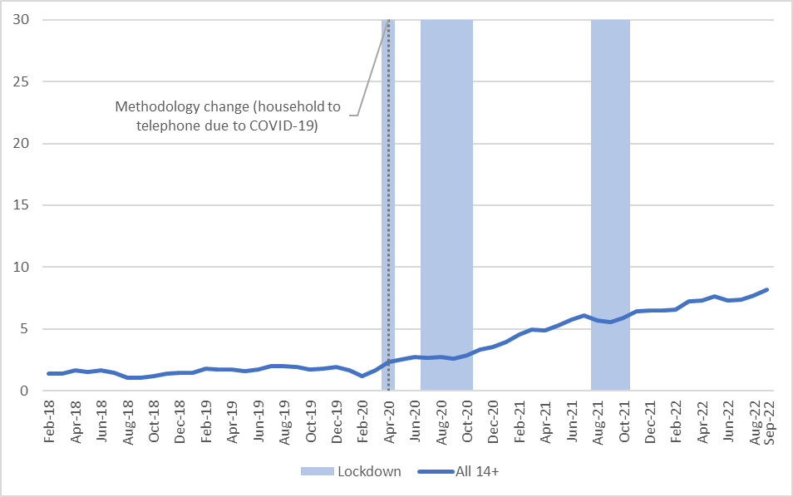

Shaded areas show >15 days of month in lockdown across at least one entire city (Sydney, Melbourne, Brisbane, Perth, Adelaide). Moving average applied (x, x-1, x+1) to smooth monthly trend lines. Current vaping: used e-cigarettes in the past month.

Figure A2 shows the monthly prevalence of current vaping for five age groups from February 2018 to September 2022.

Again, the change from household sampling to telephone sampling was not associated with any notable change in current vaping prevalence estimates within age groups.

Despite using monthly moving averages to smooth estimates, monthly prevalence estimates were highly variable for the two youngest age groups, particularly later in the series.

Current vaping prevalence markedly increased over time among those aged 14 to 17 years, 18 to 24 years and 25 to 34 years (although there was very high variability in estimates for 14-17 year olds). Towards the end of the series, vaping prevalence was highest in these age groups. Those aged 35 to 49 years showed a slower and smaller increase in prevalence of current vaping, and current vaping was consistently low among those aged 50+ years.

Vaping prevalence estimates appeared lower in the two younger age groups over the 2021 period of lockdown.

Figure A2: Monthly prevalence of current vaping by age group, February 2018 to September 2022 (weighted %).

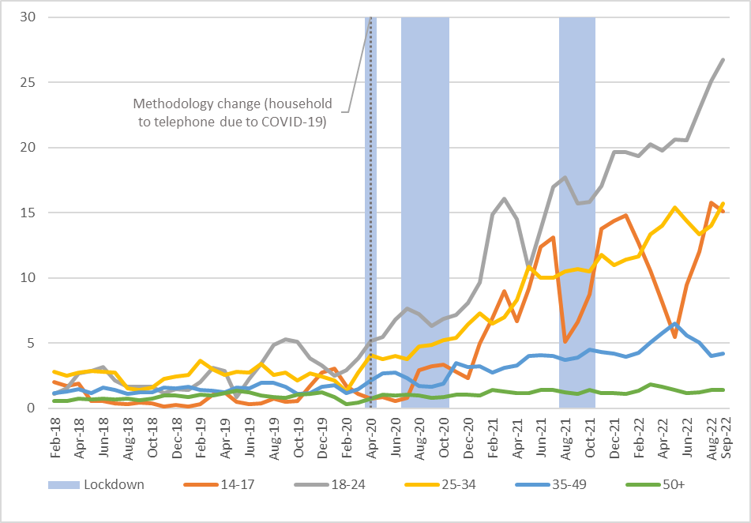

Shaded areas show lockdown >15 days of month in lockdown across at least one entire city (Sydney, Melbourne, Brisbane, Perth, Adelaide). Moving average applied (x, x-1, x+1) to smooth monthly trend lines. Current vaping: used e-cigarettes in the past month.

Current smoking per month

Figure A3 shows the prevalence of current smoking for the population aged 14+ years from February 2018 through September 2022.

The change in survey sampling in April 2020 was not associated with any notable change in the estimates.

Overall, prevalence appeared to be slowly declining until mid to late 2020, after which prevalence appeared to level off or marginally increase.

Figure A3: Monthly prevalence of current smoking for population aged 14+ years, February 2018 to September 2022 (weighted %).

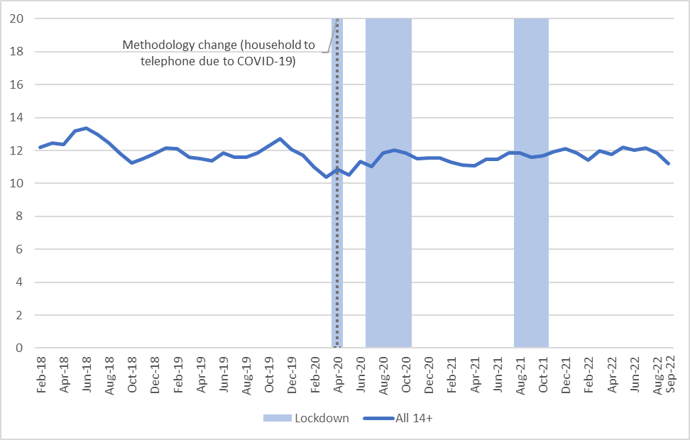

Shaded areas show lockdown >15 days of month in lockdown across at least one entire city (Sydney, Melbourne, Brisbane, Perth, Adelaide). Moving average applied (x, x-1, x+1) to smooth monthly trend lines. Current smoking: smokes factory-made cigarettes or smoked roll-your-own cigarettes in the past month.

Figure A4 shows prevalence of current smoking each month for five age groups from February 2018 to September 2022.

The change from household sampling to telephone sampling was not associated with any notable change in current smoking prevalence estimates within age groups.

Despite using monthly moving averages to smooth estimates, monthly smoking prevalence estimates became highly variable for the 14 to 17 year age group from late 2020 and in some months moved much closer to estimates of smoking prevalence in the adult age groups.

Monthly current smoking prevalence was generally highest throughout the data series among those aged 18 to 24 years, 25 to 34 years, and 35 to 49 years.

Figure A4: Monthly prevalence of current smoking by age group, February 2018 to September 2022 (weighted %).

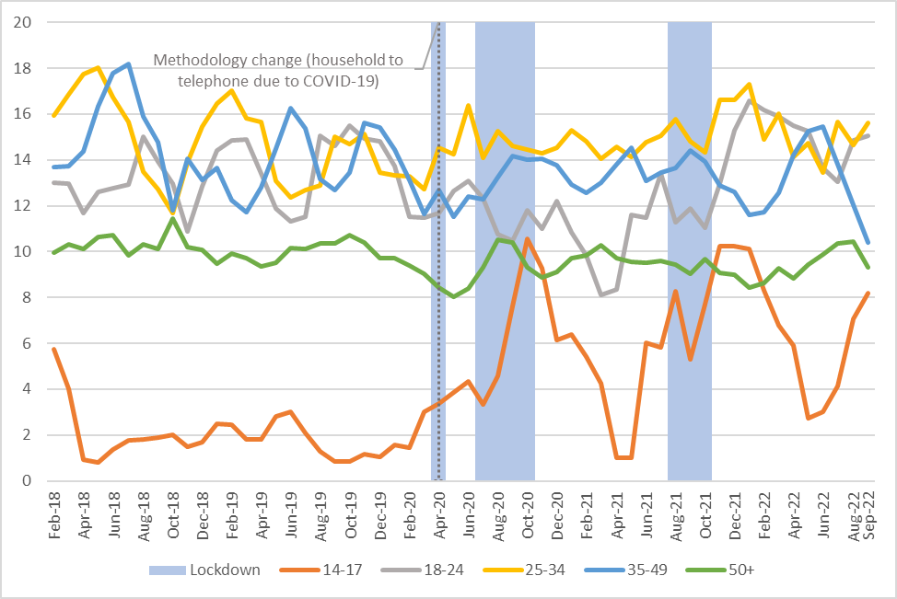

Shaded areas show lockdown >15 days of month in lockdown across at least one entire city (Sydney, Melbourne, Brisbane, Perth, Adelaide). Moving average applied (x, x-1, x+1) to smooth monthly trend lines. Current smoking: smokes factory-made cigarettes or smoked roll-your-own cigarettes in the past month.

1. The ABS define current vaping as ‘currently using e-cigarettes or vaping devices daily, weekly or less than weekly’, whereas the Roy Morgan survey question defined current vaping as ‘used an e-cigarette or vaping device in the past month’.
2. The Victorian Smoking and Health Survey defined current vaping as ‘currently vaping either daily, weekly, monthly but less than weekly, or less than monthly’.