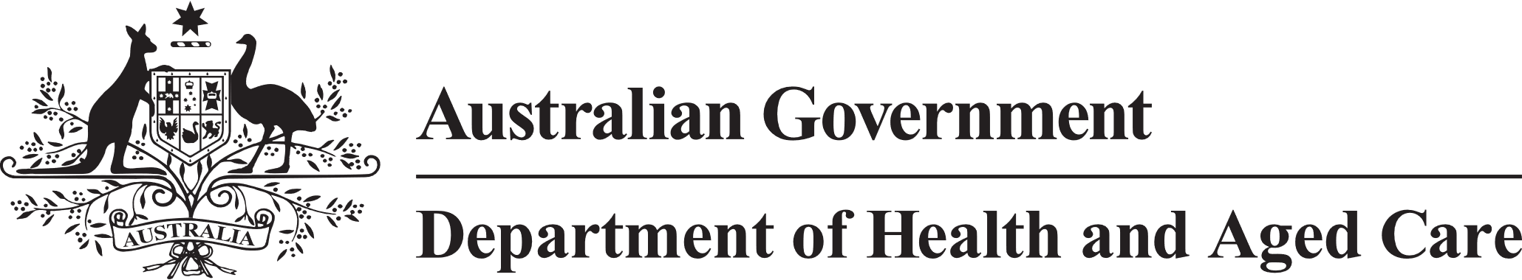Communique – 15 May 2023

**Council of Elders**

**We want to hear from you** - We have established a Council of Elders phone line to provide a non-digital way for the public to ask us questions. The Facebook page also went live in April.

We encourage you to go to our Facebook page and ask questions or leave us a message on our phone line, which is 02 6289 8769.

**2023-24 Budget** - Council welcomed the substantial increase in funding for aged care in the 2023-24 budget. It was good to see the extra money going into general practitioner bulk billing, payment of energy subsidies and rent relief, which for many older people will give some welcome relief to cost-of-living pressures. It will be important to track progress to see if these budget initiatives are making a real difference. The Fair Work Commission announced the largest ever wage increase for the aged care workforce. It was great to see valuable and caring services provided by dedicated staff both recognised and funded. It will be important for this money to be passed onto staff so they can focus on doing important and valued work.

Council noted that an Aged Care Taskforce will be set up. We will work with them to get the best outcomes for older people once it is established.

Council alerted the government to community confusion about the future of the Community Home Support Program (CHSP). Government confirmed that the program has been extended for 12-months.

**First Nations Aged Care Commissioner and Support at Home Reform** – Council were very pleased with the budget investment in First Nations Communities and programs. We talked about next steps for the establishment of a First Nations Aged Care Commissioner and about the challenges and opportunities for the Commissioner to gain insights of older First Nations people particularly in regional and remote communities across Australia. The Council is focused on how important it is to share information with the community and hear its experiences. Council also discussed the First Nations Home Care Reform. We noted that a substantial proportion of First Nations Elders access services from mainstream providers, making it important that all service providers offer Culturally sensitive and safe supports.

**Aged Care Act Information Management Framework** - Council welcomed the chance to provide input into the framework to find the right balance between protecting individual’s privacy and their information with the legislation. Noting the value that a broad range of perspectives when drafting legislation brings. Our feedback focussed on making sure data and information supports transparency, research and rights protection to allow older people to stay in control and remain safe.

**Communication** - Council talked about ways to reach more older people in the community to communicate about aged care reform. Ideas included talk-back radio and local community news outlets. We also noted the partnership between the department and the Australian Library and Information Association and Community Broadcast Association of Australia as other opportunities to connect with older people living across Australia.

The next meeting of the Council of Elders will be held on the 21st and 22nd June 2023.