**National evaluation of the Comprehensive Palliative Care in Aged Care Measure – Mid-point Report**

Australian Department of Health and Aged Care

13 September 2022

Disclaimer:

Nous Group (**Nous**) has prepared this report for the benefit of Australian Department of Health and Aged Care (the **Client**).

The report should not be used or relied upon for any purpose other than as an expression of the conclusions and recommendations of Nous to the Client as to the matters within the scope of the report. Nous and its officers and employees expressly disclaim any liability to any person other than the Client who relies or purports to rely on the report for any other purpose.

Nous has prepared the report with care and diligence. The conclusions and recommendations given by Nous in the report are given in good faith and in the reasonable belief that they are correct and not misleading. The report has been prepared by Nous based on information provided by the Client and by other persons. Nous has relied on that information and has not independently verified or audited that information.

© Nous Group

Contents

1 Executive summary 4

1.1 The Comprehensive Palliative Care in Aged Care Measure 4

1.2 Purpose and scope of this Mid-point Report 4

1.3 Mid-point evaluation findings 6

1.4 Activities being implemented under the Measure 7

1.5 Baseline assessment by which to assess future progress against the Measure’s aims 13

2 Introduction 16

2.1 Overview of the Measure 16

2.2 Purpose and scope of the national evaluation 16

2.3 Purpose of this report 17

3 Evaluation methodology 18

3.1 Evaluation approach 18

3.2 Methodology 19

4 Policy and operating context 21

5 Mid-point evaluation findings 24

5.1 Implementation progress and lessons to date 24

5.2 Appropriateness of the Measure 32

5.3 Baseline against national outcomes 36

5.4 Early success of models of care being implemented 68

5.5 Extent to which the Measure addresses interface issues 74

5.6 Effectiveness of joint funding and delivery arrangements 76

Glossary 83

Appendix A National palliative context and Measure activities 87

A.1 National palliative care context 87

A.2 Detail on jurisdictional approaches and activities 88

Appendix B Plan for national outcomes analysis in the Final Report in 2023 114

Appendix C Detailed methodology 119

C.1 Evaluation methodology 119

C.2 Program logic 120

C.3 Data collection plan 125

C.4 Data sources that informed this report 127

Appendix D National outcomes and indicators 132

Appendix E Assessment of delivery against Project Agreement responsibilities 140

Appendix F Detailed analysis of jurisdictional models of care 144

F.1 Models of care 144

# Executive summary

## The Comprehensive Palliative Care in Aged Care Measure

**The Measure aims to improve palliative care in residential aged care facilities (RACFs).**

The Comprehensive Palliative Care in Aged Care (CPCiAC) Measure (the Measure) aims to strengthen national efforts to improve access to quality palliative care as a key component of an integrated health-aged care system. The Measure provides $57.2 million in federal funding over six years from 2018-19 to 2023-24 through the Project Agreement for CPCiAC Measure (Project Agreement), with funding to states and territories commencing from 2019-20. The Measure is provided through a matched funding arrangement, meaning states and territories are required to match federal funding. States and territories implement initiatives suited to local needs.

Nous Group (Nous) has been engaged by the Australian Government Department of Health and Aged Care (the Department) to undertake a national evaluation of the Measure between July 2020 and October 2023.

## Purpose and scope of this Mid-point Report

**This report provides an interim assessment of progress towards the Measure’s aims.**

This report assesses the extent to which the Measure, at this stage, is achieving its aims. It covers the period from when funding to states and territories began in 2019-20 to June 2022. It outlines:

* Activities being implemented by states and territories, and provides an early assessment on the appropriateness and effectiveness of the models of care, and funding and delivery arrangements. Further detail on implementation progress is provided in section 5.1, and further detail on the appropriateness and effectiveness of the models of care is provided in sections 5.2, 5.4 and 5.5.
* The complete baseline assessment for the ten national outcomes, as described in Table 1. This report includes significantly more quantitative data that was not available at the time of the Baseline Report (2021). Where possible, it details early progress being made against outcomes. Further detail on the updated baseline and emerging findings against outcomes is provided in section 5.3.

Table 1 National outcomes for the CPCiAC measure

| Outcome number | Outcome theme | Outcome description |
| --- | --- | --- |
| 1 | Understanding | More discussions focused on end-of-life care decision making between residents, families, carers, General Practitioners (GPs) and specialist palliative care services including use of Advance Care Plans (ACPs). |
| 2 | Understanding | Improved access to information that informs end-of-life care decisions for residents and families. |
| 3 | Capability | A higher proportion of clinical and non-clinical staff in RACFs have skills and confidence appropriate to their roles to recognise and respond to the holistic palliative care needs of residents, in a culturally safe way. |
| 4 | Access and choice | Improved access to quality palliative care in RACFs including:   * increased use of assessments to establish residents’ palliative care needs * decreased health service use related to clinically futile or non-beneficial treatments and inpatient bed days * decreased healthcare expenditure arising from decreased service use. |
| 5 | Access and choice | Improved quality of palliative care provided in RACFs including:   * reduced symptom burden * improved quality of life for residents during the period they access palliative care * better experience of death and dying for residents, families/carers and staff, including meeting physical, psychosocial, cultural and spiritual needs. |
| 6 | Access and choice | Greater resident choice in palliative care including:   * more people dying where they want * increased person-centred care informed by an individual’s choice. |
| 7 | Collaboration | Improved care coordination with GPs/primary care, acute care services and specialist palliative care services. |
| 8 | Collaboration | Improved integration between the health and aged care systems. |
| 9 | Collaboration | More palliative care services and health planners are informed by performance information on appropriateness, effectiveness, efficiency and outcomes. |
| 10 | Data and evidence | Improved clinical governance to identify and implement quality improvement initiatives and evaluation of outcomes within RACFs. |

## Mid-point evaluation findings

**The Measure is showing early success at achieving its aims of improving access to, and coordination of, palliative care for residents in residential aged care.**

The Measure has directed significant joint investment into improving palliative care for those living in residential aged care across Australia. It is an innovative matched funding arrangement that aims to strengthen the shared responsibility for addressing an area of significant need. There are signs that states and territories are developing joined up approaches at the interface of health and aged care. While some states (such as Victoria and the Australian Capital Territory (ACT)) were providing specialist palliative care into RACFs prior to the Measure, it was not consistently the case across all jurisdictions. The joint funding is supporting the expansion of palliative care services in all states and territories; it is facilitating both the expansion of existing models of care and enabling new approaches to the way palliative care, including specialist palliative care services, is delivered outside of hospital settings and in RACFs.

The inability for the Australian Government to partner with states and territories to design the Measure, prior to being announced (due to budget confidentiality), created challenges and delayed implementation.It meant one jurisdiction did not match the available funding from the Australian Government. There were significant delays to implementation after funding was announced. It has been challenging for some states and territories to adopt a partnership approach (when they did not feel they were adequately consulted in the development and design of the Measure). Lastly, the time-limited, unweighted funding limited what some jurisdictions would invest in and the lack of specificity on required data collection and sharing from states makes understanding the national impact of the Measure more challenging. Section 5.6 explores the effectiveness of the joint funding and delivery arrangement in further detail.

At this stage, projects being implemented by states and territories are improving access to palliative care in RACFs and addressing interface issues. All states and territories are implementing models of care to improve palliative and end-of-life care coordination, thus strengthening national efforts to improve access as a key component of an integrated health-aged care system. In summary:

* The Measure has funded 46 collaborative, evidence-based projects that are expected to impact over 800 RACFs. Some of these demonstrate innovative approaches (such as modified needs rounds and incentivising GPs to provide palliative care in aged care). The Measure has increased capacity to provide palliative care in aged care, with the funding of at least 57 full time equivalent (FTE). These roles are a mix of clinical and administrative roles, with some roles dedicated to coordination at the health-aged care interface. The 57 full time equivalent (FTE) includes state or territory health department project teams, RACF personal care interns, nurse practitioners, clinical nurse consultants (CNCs) and nurse liaisons. These comprise of a mix of roles that are based in centralised teams or in aged care providers specifically.
* Projects directly respond to the literature on resident, family, carer and staff needs. This includes developing more systematic responses to identify and respond to palliative care needs (e.g., through projects that expand access to needs rounds and improve the capability of personal care workers). Many projects are improving collaboration between aged care (nurses and personal care workers) and health (GPs, specialist palliative care clinicians and hospitals) by focusing people on a shared goal.
* Emerging lessons on implementation include the how building on existing models of care can help to maximise impact, and how dedicated roles in state and territory health departments can help to support implementation on the ground. Barriers have included limited workforce capacity, difficulties engaging personal care workers due to high turnover and challenges engaging GPs. States and territories reported they would benefit from coming together through a community of practice to share learnings from implementation. One jurisdiction could take the lead on this. Section 5.1.2 explores emerging lessons in further detail.

The coronavirus disease (COVID-19) pandemic has disrupted and continues to disrupt health and aged care, and delayed the Measure’s implementation. Outbreaks of COVID-19 and associated lockdowns of facilities led to limited access of specialist palliative care clinicians to RACF residents and staff at times. Redeployment of health and aged care staff reduced the capacity to prioritise Measure activities. The impact of COVID-19 on the Measure is further explored in section 5.1.2.

Systemic factors limit the impact of specific funding arrangements such as the Measure.While efforts have focused on building a more integrated health-aged care system for nearly two decades, realising the goal nationally has been elusive.[1] This slow progress reflects systemic deficiencies in the structure of the health care and aged care systems – funding, governance, workforce shortages, GP and nurse remuneration, capability of personal care workers, a lack of integrated care pathways – that inevitably act as stumbling blocks. Hence, funding agreements for specific initiatives will be limited in their effectiveness by these structural factors, as this mid-point evaluation has found (see section 5.1.2).

All states and territories indicated that COVID-19 plus one or more of the systemic factors delayed implementation. Yet there are examples of projects starting to address systematic factors. One project is embedding processes to support personal care workers to identify palliative care needs, as opposed to stand-alone training given high turnover rates. Another recognises that GP remuneration is a key barrier, so is incentivising GP incentives to work in aged care with emerging success of improved GP engagement.

## Activities being implemented under the Measure

**The Measure has funded 46 projects and 57 FTE, and is expected to impact over 820 RACFs.**

Table 2 (overleaf) is a summary of the implementation progress (informed by 2022 consultations). Appendix A provides further detail. Tasmania, Western Australia (WA), South Australia (SA), Northern Territory (NT), the ACT and Victoria are using a centralised approach to implement, whereby it is coordinated by a team in the health department, with funding given to providers to deliver services. New South Wales (NSW) and Queensland have decentralised approaches, with Local Health Networks (LHNs) having responsibility for design and implementation.

Table 2 Projects planned and implementation progress by jurisdiction

|  |  |  |  |  |
| --- | --- | --- | --- | --- |
| State/territory | Total funding | Implementation progress | Early insights | Evaluation |
| Australian Capital Territory | * $2.2million * 28 RACFs * 4.3 FTE | ACT has expanded the Palliative Care Needs Rounds (PCNR) model by recruiting Nurse Practitioners to conduct rounds. 28 of 29 RACFs have at least one component of needs rounds in place. Recruitment of Nurse Practitioners has been challenging.  Implementation is on track. | The PCNR model is improving the ability of RACF staff ability to respond to resident needs. RACF staff and clinicians have reported better anticipatory prescribing and experiences of death and dying for the residents. | No. An evaluation has previously been completed. |
| New South Wales | * $20million * 13.6 FTE | NSW has a devolved approach, where each Local Health Districts (LHDs) have developed initiatives to reflect local needs. 9.5 FTE have been recruited. NSW opted to take a reduced proportion of Commonwealth funds. Implementation is on track. | LHDs have used funds to increase reach of existing models, trial new models of care (Pop Up, Needs Round, ELDAC) and/or implement targeted capacity building exercise to upskill RACFs staff. | Yes. This is not focused on the Measure. Annual reporting. |
| Northern Territory | * $1million * 10 RACFs * 0.2 FTE | NT is conducting in-reach Needs Rounds or screening rounds at RACFs and education and training through weekly visits and case debriefs, however COVID-19 put these projects on hold.  Top End: Implementation is ahead of schedule.  Central Australia: Implementation is delayed. | Top End: Reported reduced hospitalisations and emergency department transfers from RACFs, and improved awareness of palliative care teams in RACFs.  Central Australia: Education and training has improved RACF confidence and capability to respond to palliative care. | No. There is ongoing monitoring. |
| Queensland | * $18million * 419 RACFs | QLD has a devolved approach where each Hospital and Health Services (HHS) has a Specialist Palliative Care in Aged Care project team who developed appropriate service models. Recruitment delays in many HHSs are a barrier to implementation. | Specialist Palliative Care in Aged Care (SPACE) teams are connecting RACF staff with resources and building GP relationships. The SPACE team plays a linkage and leadership which helps mitigate high staff turnover. | Yes |
| South Australia | * $7.7million * 22 RACFs * 31.8 FTE | SA have developed three projects including Hospice in Aged Care, Hospice in the RACF and GP Shared Care in Aged Care. 22 RACFs are impacted, with regional areas a focus.  Implementation is on track, after delays to Hospice in RACF in 2021. | The traineeship program appears to show increased capacity and improved palliative care knowledge, and confidence among staff through triggering conversations of PC and embedding processes at an operational level. | Yes |
| Tasmania | * $2.3million * 28 RACFs * 3 FTE | TAS projects are in early implementation. Specialist Palliative Care in-reach into RACFs is progressing well, with delays to recruitment of GP registrars in palliative care; and RACF funding for allied health support.  Implementation is on track for all but the allied health project. | Tasmania DOH and RACFs have letters (similar to MOU) as a mechanism to support service delivery and collaboration. | Yes |
| Victoria | * $28.4million * 35 RACFs | VIC is experiencing implementation delays, with four out of five workstreams on hold. At this stage, the funding is expanding community-based specialist palliative care providers to support RACF residents.  Implementation is delayed. | It is too early to determine impact given delays. | Yes |
| Western Australia | * $11.4million * 285 RACFs * 4.5 FTE | WA has two projects implemented, with Metropolitan Palliative Care Consultancy Service (MPaCCS) progressing well. The 7 remaining projects are in procurement due to an overwhelming landscape and COVID-19 delays.  Implementation is on track for 2 projects and procurement is progressing for the 7 remaining projects. | The Metropolitan Palliative Care Consultancy Service expansion has improved collaboration between GPs and RACF staff (by providing more PC support and conducting in-reach education to RACFs). | Yes |

**At this stage, most models of care have demonstrated some early success; however, many are still in the early stages of implementation.**

The 46 projects being implemented by states and territories can be categorised into seven distinct models of care (see Table 2). This allows for assessment of the extent to which models of care align to the evidence base and for comparison of differential benefits achieved across a diverse set of activities nationally. All states and territories are implementing models of care that align to the evidence base. Section 5.4.3 provides an initial assessment of the success of the different models of care. The Final Report in 2023 will use national administrative data sets (where possible) and quantitative data from state/territory evaluations to better understand differential benefits and impacts of models of care. Regardless of the model of care, common factors have enabled their success to date including:

* the quality and capacity of the surrounding health system,
* open communication between families/carers and RACF staff,
* mechanisms and processes to support staff to triage and identify residents needing palliative care,
* working collaboratively with stakeholders, including RACF leadership.

Table 3 Models of care being implemented by states and territories

|  |  |
| --- | --- |
| Model of care | Description |
| Access to specialist palliative care support | Specialist palliative care services are available to residents, their families and carers, and staff through proactive in-reach into RACFs (e.g., SA, Tasmania), telehealth support (e.g., Queensland), or clear referral pathways to specialist palliative care services (e.g., WA).[2] |
| Needs rounds | Specialist palliative care practitioners collaborate with RACF staff and GPs to provide proactive assessment of residents’ palliative care needs and uplift staff capability through care planning discussions. In some models, practitioners work together to provide case management support. |
| Education and training | Specialist palliative care educators deliver formal education sessions to RACF staff and other practitioners involved in the delivery of palliative care in aged care (e.g., GPs). Case-based education through needs rounds and case conferencing models (e.g., NSW, NT) may also contribute to capability building. Embedded palliative care resources for RACF staff and GPs (e.g., End of Life Directions for Aged Care (ELDAC)) support ongoing capability development and compliance with policies and procedures related to palliative care. |
| Traineeships | Clinical and/or non-clinical staff complete an accreditation for advanced training in palliative medicine to expand the capacity and capability of both the health and aged care workforces in delivering quality palliative care (e.g., SA, TAS). |
| Incentivising shared care | Mechanisms that seek to remove barriers to participation in models of shared or integrated care for key practitioners, in particular GPs. For example, in SA’s Regional Hospice in RACFs model, GPs are remunerated to participate in needs rounds. |
| Access to multidisciplinary resources | Resources such as nurse liaisons, pharmacists and social workers, are recruited to meet the holistic palliative care needs of residents in a timely manner. Multidisciplinary teams (MDTs) may also participate in case conferences as part of ongoing case management. |
| Culturally safe and appropriate models of care | Focus on the delivery of holistic palliative care that addresses the needs of Aboriginal and Torres Strait Islander residents, their families and communities around death and dying. |

## Baseline assessment by which to assess future progress against the Measure’s aims

**The baseline assessment shows that a proportion of RACF residents receive palliative care, yet there remains a significant opportunity to increase access and improve the quality of care.**

The evaluation is using ten national outcomes to assess the extent to which the Measure is achieving its aims over time (see Appendix B). Section 5.3 provides a detailed baseline assessment. It is based on five national datasets, including National Integrated Health Services Information Analysis Asset (NIHSI-AA), a national survey of a sample of RACFs and qualitative input from state and territory health departments, RACFs, specialist palliative care clinicians, GPs, Primary Health Networks (PHNs) and the Palliative Care Australia (PCA) consumer representative group. The Final Report in 2023 will provide a comprehensive assessment of progress. In summary, the baseline assessment indicates that at the time the Measure was announced and implementation commenced:

* End-of-life decision making. The majority of RACFs report that most residents have ACPs in place.[3] However, plans may not be discussed or updated regularly. The majority of RACFs are compliant with Aged Care Standards related to ACPs and that require RACFs to involve residents in care planning and services.[4] (Outcome 1, Outcome 2)
* Capability. Training is often not mandatory in RACFs,[5] however demand for palliative care training and resource is increasing, particularly among nurses and personal care workers.[6] (Outcome 3)
* Access to palliative care. From 2014-19, there were 62,252 RACF residents who accessed palliative care medicines and services while living in a RACF – approximately seven per cent of total RACF residents.[7] A majority (55 per cent) of RACF residents who died in 2018-19 may have received palliative care related medicines in their RACF that year. [8] In a majority of Palliative Care Outcomes Collaboration (PCOC) care episodes in 2021, care was provided by the specialist palliative care in-reach service within two days of resident being ready.[9] (Outcome 4)
* Quality of palliative care. The quality of palliative care in RACFs is variable. RACFs are the most common referrer to specialist palliative care residential care in-reach services reporting to PCOC.[10] RACF residents most commonly attend the Emergency Department (ED) for reasons other than their primary illness.[11] (Outcome 5)
* Greater resident choice. The majority of RACF residents who died in 2018-19, died in a RACF,[12] however a substantial proportion of RACF residents in 2021 did not have their preferred place of death recorded by the RACFs.[13] (Outcome 6)
* Care coordination. Less than ten per cent of RACF residents attended a multidisciplinary case conference in 2018-19.[14] This suggests that GPs are involved in coordinating care in RACFs, but there is an opportunity for further improvement.(Outcome 7)
* Health and aged care interface. Approximately one third of RACF residents had a presentation to ED or one hospitalisation from 2018-19. Only three per cent of hospitalisations related to palliative care, however palliative care related hospitalisations were more likely to be overnight stays.[15] (Outcome 8)
* Performance information. There is mixed use and availability of performance information on the appropriateness, effectiveness, efficiency and outcomes of palliative care. PCOC provides performance information to palliative care services and health planners, however, its use is limited and it does not capture information about RACFs.[16] (Outcome 9)
* Clinical governance. Only one per cent of aged care complaints since 2018 related to palliative and end-of-life.[17] In 2021, 65 per cent of RACFs had recently implemented quality improvement initiatives.[18] Complaints and the Royal Commission into Aged Care Quality and Safety (the Royal Commission) may have prompted these initiatives.(Outcome 10)

# Introduction

|  |
| --- |
| This section describes the Measure and the national evaluation purpose and scope. |

## Overview of the Measure

**The Measure aims to improve palliative care in RACFs.**

The Measure provides $57.2 million in federal funding over six years from 2018-19 to 2023-24 through a Project Agreement, with funding to states and territories commencing from 2019-20. The Measure aims to help older Australians living in residential aged care who are nearing the end of their life. Its goals are to:

improve palliative and end-of-life care for older people living in residential aged care.

further enable people to die where they want, supported by increased aged care services.

The Measure is provided through a matched funding arrangement model, meaning states and territories are required to match Australian Government funding. States and territories implement initiatives suited to local needs, with the suggestion being that the initiatives focus on:

* in-reach models of care, that include assessments to establish residents’ palliative care needs.
* models that support end-of-life care decision making that aim to deliver quality, person-centred care to dying residents through the development of agreed goals of care.
* education and training initiatives, that aim to build the capacity of the RACF workforce and other clinicians involved in the delivery of care to residents of RACFs.[19]

## Purpose and scope of the national evaluation

**The national evaluation of the Measure is assessing whether its aims are achieved.**

Nous has been engaged by the Department to evaluate the Measure between July 2020 and October 2023. The evaluation objectives are to:

* assess implementation, appropriateness, effectiveness and cost-effectiveness of the Measure.
* measure and analyse the impact of state and territory activities in relation to the Measure’s objectives.
* identify the barriers and enablers to achieving the intended outcomes.
* assess the effectiveness of the governance model of the Measure.
* identify issues to inform future priorities, consider demographics, and health and aged care reforms.
* analyse the achievements of the program in relation to the National Palliative Care Strategy
* develop recommendations to inform palliative care policy development.

The national evaluation will not evaluate:

* Individual models implemented by the states and territories nor compare palliative care outcomes across states and territories. Some jurisdictions are undertaking local evaluations of their activities, which the national evaluation will draw on.
* Palliative care activities in residential aged care settings that are not funded under the Measure. For example, if an in-reach service is expanded under the Measure, then expansion activities only will be considered in this evaluation.

## Purpose of this report

This Mid-point Report provides an assessment of implementation and effectiveness of Measure to 30 June 2022. Nous delivered a Baseline Report in 2021 and will deliver a Final Report in 2023.

This report structures findings against the key evaluation questions (KEQs) (see Appendix C)). It provides:

* The impact of the policy and operating context on implementation of the Measure.
* Comprehensive mid-point evaluation findings on:
* activities being implemented in each state and territory as of June 2022
* whether the Measure is being implemented as planned and lessons from implementation to date
* the extent to which it is appropriate to meeting the needs of residents, families and carers
* the effectiveness of the joint funding and delivery arrangements
* alignment to the National Palliative Care Strategy
* the emerging success of models of care (based on available data at this stage).
* An updated baseline for the ten national outcomes, as additional quantitative data is now available (that was not available at the time the Baseline Report was delivered in 2021). The baseline primarily reports data from the years prior to and when the Measure funding began (2018 to 2021). The baseline helps to understand the trajectory of outcomes being achieved in the early stages of implementation of the Measure, by which future progress can be measured. See C.3, page 94, for a list of national outcomes and indicators.

# Evaluation methodology

|  |
| --- |
| This section describes the evaluation approach, methodology and key limitations. |

## Evaluation approach

**The national evaluation has process, outcome and economic components.**

An Evaluation Framework, agreed by the Department and states and territories in 2021, outlines the methodology. The evaluation has three components:

1. Process component. This examines the process of implementation and delivery of the Measure, including the effectiveness of joint funding and delivery arrangements between the Australian Government and states and territories. The mid-point assessment for this component is provided in section 5.
2. Outcome component. This examines the extent to which intended outcomes and goals were achieved. The Evaluation Framework identified ten national outcomes by which to assess progress towards goals. The baseline assessment against the national outcomes is provided in section 5.3.
3. Economic component. This examines the cost-effectiveness of the Measure. This will be provided in the Final Report in 2023.

Eight KEQs structure the evaluation (see the Data collection plan, page 124).

**The evaluation design responds to the operating context and known data limitations.**

The complexity of the palliative care landscape, data availability and having eight jurisdictions implementing different activities, results in some challenges for the evaluation. These challenges include:

* Pressures on the health and aged care systems impact implementation and evaluation of the Measure. There is substantial work underway to improve palliative care (see Appendix D). This reform context and complex drivers of improved palliative care in RACFs makes attribution of any improvement in palliative care outcomes to the Measure difficult.
* Implementation of the Measure varies across jurisdictions. Jurisdictions have different priorities and approaches to implementation of the Measure. Their maturity in the delivery of palliative care in RACFs also varies, including capability and capacity to build on existing initiatives. The evaluation will remain aware of jurisdictional variations; however, will bring a national perspective to the evaluation.
* There are significant limitations to the data available on palliative care in residential aged care. Jurisdictions collect different data, which in turn have different limitations. Qualitative data collection will be used to fill any gaps in quantitative data where possible.

## Methodology

**This Mid-point Report draws on a range of qualitative and quantitative data sources.**

This report builds on insights from the literature review and service mapping conducted in 2020. It draws on a range of data sources including:

* consultations in 2021 and 2022 with stakeholders implementing the Measure (see Figure 1)
* six-monthly implementation updates from state and territory health departments since April 2021
* a survey of a sample of RACFs, conducted in 2021 (to inform the evaluation baseline)
* existing national government datasets including NIHSI-AA[20] (covering 2014-15 to 2018-19) and data from the Aged Care Quality and Safety Commission (ACQSC) (covering January 2018 to March 2022)
* other data sets, including data provided by ELDAC (covering 2017 to 2021), PCOC (covering 2021) and the Australian Healthcare and Hospitals Associatio|n (AHHA) (covering 2018 to 2021).

Figure 1 | Stakeholders engaged during mid-point data collection

This diagram demonstrates the stakeholders that were involved in the 2021 and 2022 consultations. These are:
- residential aged care facilities
- specialist palliative care clinicians
- general practitioners
- Primary Health Networks
- Australian Government and state and territory health departments
- peak bodies and Palliative Care Australia's national consumer representative group


The evaluation seeks to assess the contribution of the Measure to change being observed in the data, yet it will not be possible to be definitive about causality. Other limitations to the data available to assess implementation and effectiveness of the Measure are detailed in Appendix C.4 and include:

* NIHSI-AA contains data on all states and territories only up until June 2019. The evaluation uses NIHSI-AA to examine RACF resident service use and movements between care settings. NIHSI-AA currently covers the period from July 2014 to June 2019 and as such, informs the baseline assessment. The Final Report in 2023 will assess progress against the baseline using updated NIHSI-AA data.
* The national evaluation uses secondary data to understand the input from families and carers. They are unlikely to be able to comment on changes in palliative care in RACFs over time nor be aware of which of their interactions with facilities were activities funded by the Measure. The evaluation will draw on local state/territory evaluations that may engage families/carers. It also involves engagement with clinicians, practitioners and the PCA consumer representative group who may be better placed to observe changes in palliative care due to the Measure over time.
* The evaluation incorporates the views of stakeholders from across Australia; however, engagement levels vary by state and territory. RACFs and non-specialist clinicians providing palliative care in NSW and Victoria and specialist clinicians in Victoria were not engaged in 2022 due to limited nominations from these states.
* Survey responses may not represent all RACFs and need to be validated with other evidence. Nous conducted a survey of RACFs in 2021, the results of which inform this Mid-point Report. Responses to the survey are biased towards facilities who are more mature in their delivery of palliative care.
* There is limited data available on training and education, due to the limited availability of palliative care focused courses. This Mid-point Report incorporates data from AHHA on participation in the Palliative Care Online Training Courses and ELDAC Residential Aged Care toolkit. These resources are not directly funded under the Measure and so the baseline assessment using this data provides an indication of training demand and use in the aged care workforce.
* The evaluation draws on information from states and territories but will not compare models of care. The report provides an overview of models of care being implemented across the states and territories, and some emerging successes of these models, but does not compare these models nor palliative care outcomes across states and territories (see section 5.4). Some jurisdictions are undertaking local evaluations of their activities, which the national evaluation will draw on.

# Policy and operating context

|  |
| --- |
| This section describes the context in which the Measure is being implemented. |

**Significant reform is underway for palliative care in aged care.**

The Measure was introduced amongst significant reforms within health and aged care. COVID-19 and the implementation of recommendations from the Royal Commission will continue to impact the health and aged care systems. The Measure activities are funded by a mix of funding from state and territory governments (for health systems) and federal governments (for aged care and primary care). The policy, stakeholder and operating contexts are shown in Table 4 and detailed below.

Table 4 Policy and operating context of the Measure June 2022

|  |  |
| --- | --- |
| Policy context | * Comprehensive Palliative Care in Aged Care Measure * National Palliative Care Strategy * End-of-Life Direction for Aged Care * Australian National Aged Care Classification (AN-ACC) * Aged Care Quality Standards * Jurisdictional strategies and policy frameworks * AHHA Palliative Care Online Training * Mandatory Quality Indicator Program * Program Of Experience in the Palliative Approach * National Safety and Quality Health Standards * Palliative Care Standards * Palliative Care Outcomes Collaboration |
| Stakeholder environment | * Australian Government * State and territory governments * Residential aged care facilities * Specialist and non-specialist palliative care providers * Aged care and palliative care peak bodies |
| Operating environment | * Royal Commission into Aged Care Quality and Safety * 2022-23 Budget * COVID-19 * Voluntary assisted dying legislation * High workforce mobility and turnover * Shifting community expectations for person-centred and holistic care * Trends in the health and aged care sector towards integrated care, values-based care and digital health |

**Palliative care in RACFs is at the interface of health and aged care, meaning collaboration is critical.**

There are overlapping responsibilities for palliative care across the Australian Government and state/territory systems[21]. Residents may receive palliative care from multiple providers, funded by different levels of government and involving specialist palliative care clinicians or GPs. Recognising this, the evaluation uses data from different sources including clinicians, RACFs and the Australian and state and territory governments to understand how the Measure addresses issues at the interface of these two systems.

The extent of control all levels of government have over delivery of services in RACFs is dependent on the RACFs itself. For-profit and not-for-profit RACFs, as opposed to government administered facilities, have relatively more control over the types and mode of service delivered within the facility.

**Palliative care is multifaceted and there is a need to improve its delivery in RACFs.**

Palliative care is multifaceted and complex. It addresses physical, spiritual and psychosocial needs, and can be non-specialist or specialist in nature. This means that palliative care in RACFs can be delivered in many ways – through non-specialist and specialist staff within the RACFs or through in-reach or out-reach services. In addition, palliative care in the residential aged care setting is increasingly a temporary and intermittent support for non-permanent residents, not just permanent residents.

RACFs are residents’ homes and in principle there should not be barriers to health service provision based on where someone resides. The Measure responds to these challenges and aims to strengthen national efforts to improve access to palliative care as a key component of an integrated health-aged care system.

**Ongoing reforms impact Measure implementation and the ability to attribute outcomes.**

Ongoing initiatives and reforms across health and aged care impact implementation of the Measure and the ability of the evaluation to contribute observed changes. Australian and state and territory governments have much work underway related to palliative care in RACFs (see Appendix A.1). Key reforms and initiatives include:

* The Measure responds to findings from the Royal Commission. It aims to strengthen national efforts to improve access to quality palliative care as a key component of an integrated health-aged care system.[22] The evaluation draws on evidence from the Royal Commission and recognises that recommendations will continue to impact implementation.
* An increased emphasis on ACPs has seen national efforts to increase the quality and accessibility of planning, which will continue in coming years.
* All states have passed voluntary assisted dying legislation.[23] Aged care providers will need to begin considering their legal responsibilities regarding voluntary assisted dying.
* COVID-19 had and may continue to have, an impact on RACFs. It resulted in a reduced capacity to implement activities or collect data relating to the Measure. COVID-19 impacted the ability of RACFs to respond to some palliative care needs (as reported in 2022 consultations with RACFs).
* Workforce shortages and diversion of resources due to COVID-19 outbreaks continue to put pressure on health and aged care systems to implement Measure activities. Shortages are particularly acute for roles that are key to palliative care, such as GPs, nurses and nurse practitioners, and in regional, rural and remote areas.[24] The impact on the Measure is further explored in section 5.1.2.

# Mid-point evaluation findings

|  |
| --- |
| This section provides mid-point evaluation findings on:   * Progress in implementing the Measure and lessons from implementation to date (section 5.1). * The appropriateness of the Measure in meeting the needs of residents, families, carers and staff (section 5.2). * The baseline assessment against national outcomes and, where possible, limited findings on the early progress against outcomes (section 5.3). The Final Report in 2023 will provide a detailed assessment of progress against national outcomes. * Models of care being implemented in states and territories (section 5.4). * The extent to which the Measure is addressing interface issues at this stage (section 5.5). * The effectiveness of the joint funding and delivery arrangements (section 5.6). |

## Implementation progress and lessons to date

### Key findings

* The Project Agreement outlined responsibilities for the Australian Government, states and territories.
* All jurisdictions have been delivering on the Project Agreement responsibilities to date.
* All jurisdictions signed up to the Measure, with some significantly delayed in doing so.
* All states and territories have commenced implementation; there have been significant delays.
* At this stage, the Measure has funded 46 projects and 57 FTE, and is expected to impact over 820 RACFs.
* Implementation has been supported by leveraging existing infrastructure and models of care, funded roles, RACFs leadership and clinical governance.
* COVID-19, aged and health care workforce challenges, and access to equipment and medication have delayed implementation.

### Delivery against Project Agreement responsibilities to date

**The Project Agreement outlined responsibilities for the Australian Government, states and territories.**

The Project Agreement outlined the Measure aims, financial arrangements and responsibilities of governments.[25] States and territories subsequently signed specific schedules that outlined their individual funding arrangements, planned projects, and outputs and reporting milestones. The Department, in initial discussions with Treasury in 2020/21, were advised to remain flexible in drafting state specific schedules, to avoid challenges regarding payment. States and territories were advised to remain flexible in their specific schedule language.

**All jurisdictions have been delivering on the Project Agreement responsibilities to date.**

The Australian Government and states and territories have been delivering on responsibilities in the Project Agreement (see Table 3 for a high-level assessment and Appendix E for detail). In consultations, all states and territories indicated delivery of some outputs has been delayed (see Appendix A.2).

Table 5 Mid-point assessment of delivery against responsibilities in the Project Agreement[26],[27]

|  |  |  |
| --- | --- | --- |
| Stakeholder | Responsibilities | Delivery on responsibilities |
| Australian Government | Monitoring and assessing achievement against milestones in the delivery of projects to ensure that outputs are delivered within the agreed timeframe.  Providing a consequent financial contribution to states.  Delivering a national evaluation by 2023-24. | The Australian Government continues to meet the responsibilities outlined in the Project Agreement and support the Measure’s implementation. The Department:   * has been monitoring achievement against jurisdictional milestones through assessing specific performance reports, received April each year * has provided funds to jurisdictions on sign-up to the Measure * has commissioned an independent national evaluation which started in 2020 * has conducted three Project Implementation Group meetings. |
| States and territories | Providing a matched financial contribution to support the implementation of the Project Agreement. | All states and territories are providing matched financial contributions to support implementation of the Project Agreement to date.  NSW reduced their initial contribution and elected to take $10 million from the $17 million offered by the Australian Government. Jurisdictions could elect to phase their funding contributions to suit their funding profile, as long as the total contribution from the state or territory matched the Commonwealth’s contribution. For example, NSW’s annual contribution increases over the five-year period to match the total Australian Government funding by the end of year five. |
| States and territories | Submitting project proposals and supporting evidence. | All states and territories submitted proposals and supporting evidence after signing up to the Measure. |
| States and territories | All aspects of delivering on the project outputs set out in the Project Agreement. | All states and territories are working towards delivering project outputs set out in the Project Agreement; however, all states and territories reported in jurisdictional consultations the impact of COVID-19 had delayed some activities. |
| States and territories | Reporting on the delivery of outputs as set out in each specific Project Agreement. | All states and territories have been reporting on the delivery of outputs set out their agreements. All states and territories provided annual milestone performance reports to the Department in 2021 and 2022. Payments were made to all jurisdictions in 2021-22, apart from Victoria. Victoria will be re-submitting their report in the coming months and payment will be made, dependant upon Victoria satisfactorily delivering their agreed milestones. The level of detail in each milestone performance report varies between states and territories. |
| States and territories | Evaluating their agreed projects, to contribute to the overarching evaluation of the Measure. | The national Project Agreement outlines a responsibility for states/territories to evaluate their projects. Six of the state/territory schedules referenced conducting an evaluation (including ACT, Queensland, SA, Tasmania, Victoria and WA). Five of these states have commenced planning or conducting of their evaluations (ACT decided not to undertake an evaluation given the model of care they are implementing has already been evaluated).  The remaining two states/territories, NSW and NT, have schedules that refer to local monitoring/evidence requirements. This limits the extent to which the national evaluation can understand the impact of models of care (see section 5.4).  To date, all states/territories have contributed to the national evaluation through input on the Evaluation Framework, completion of six-monthly data collection templates and participation in six-monthly consultations with evaluators. |

Some aspects of the Project Agreement’s design and level of specificity have created challenges for implementation of activities and the national evaluation. This is discussed in section 5.6.

All jurisdictions signed up to the Measure, with some significantly delayed in doing so.

All jurisdictions have signed up to the Measure, albeit at differing times (see Figure 3). Six jurisdictions signed up to the Measure in 2020 and two in 2021. Each state and territory then identified initiatives in response to jurisdictional policy objectives, local health system contexts and local needs.

Figure 2 Dates that states and territories signed up to the Measure

This is a timeline diagram of the dates that states and territories signed up to the Measure. 
December 2019: Australian Government announces the Measure.
March 2020: SA and NT sign up.
May 2020: WA and ACT sign up.
June 2020: NSW signs up. 
July 2020: QLD signs up.
May 2021: TAS signs up.
July 2021 VIC signs up. 
Late 2022: Midpoint report.

States and territories are using either a centralised or decentralised approach to design and implement the Measure, in part reflective of each health system structure. For example, Tasmania, WA, SA, the ACT, NT and Victoria’s implementation is coordinated by a team in the central health department, with funding given directly to providers to deliver services. NSW and Queensland have decentralised approaches, with LHNs having responsibility for the design and implementation of local projects.

All states and territories have commenced implementation; there have been significant delays

All states and territories have commenced implementation yet are at different stages given different sign-up dates and when funding was received. All jurisdictions reported some delays to implementation, typically attributed to:

* Initial delays to sign up to the Measure. Tasmania and Victoria signed up in 2021, so are less progressed in implementation.
* Time taken to engage to understand local needs or procure providers. SA and WA undertook extensive engagement processes to design their activities, which they indicated delayed implementation.
* The impact of COVID-19. All states and territories reported that the impact of COVID-19 resulted in facilities being in lockdown and health care resources (both within health departments and frontline clinical staff) being redeployed. This meant Measure activities were deprioritised and delayed.

**At this stage, the Measure has funded 46 projects and 57 FTE, and is expected to impact over 820 RACFs**

Some jurisdictions are yet to procure some Measure-funded positions and finalise projects so these figures may increase.

Section 5.4 provides analysis of the emerging success of models of care. In summary, the mid-point assessment of implementation progress demonstrates:

* Seven of the eight states and territories pooled the Australian Government and state/territory funds. NSW reported that they did not distribute joint funds (see section 5.6).
* Two states and territories have or are intending to modify their original plans. NT and WA indicated approaches were refined based on new information about what was needed or to adapt to COVID-19 delays. For example, WA has adapted the scope and approach of their education and training project. The project is looking at how to better suit RACFs needs, due to the COVID-19 challenges RACFs faced.
* Some states and territories have implemented activities in specific RACFs whereas others are running state-wide initiatives. NT, SA and Tasmania have identified specific RACFs or regions to implement projects. NSW has funded LHDs to implement projects. ACT, Queensland, Victoria and WA are implementing projects state-wide.
* All states/territories are implementing activities that align to Measure aims. All are doing some form of specialist in-reach, six of which have some form of needs rounds.
* The Measure has enabled states and territories to adopt innovative models of care or activities that they would not otherwise have undertaken. For example, SA has introduced an incentive to encourage GPs to attend Palliative Care Needs Rounds (PCNR) (see Case study 7, page 59*).* There are indications from NSW, NT, Queensland, SA and WA that the Measure is also enabling innovation that otherwise would not have been funded.
* Two jurisdictions are working towards delivering projects to improve care for Aboriginal and Torres Strait Islander people. Victoria is planning on partnering with Aboriginal and Torres Strait Islander organisations to develop models of care to support access to culturally safe palliative and end-of-life care. Queensland is expanding the Torres Strait and Cape Specialist Palliative Care in Aged Care (SPACE) project to liaise with local communities (seeCase study 8, page 59).
* Queensland, SA, Tasmania, Victoria and WA are planning a formal evaluation. NSW and NT are conducting some local-level monitoring of their specific projects, whilst ACT is not conducting any evaluation or monitoring. NSW indicated their evaluation is not specific to the Measure as there is no specific funding allocated for evaluation in the Project Agreement.

### Early lessons from implementation to date

**Implementation has been supported by leveraging existing infrastructure and models of care, funded roles, RACF leadership and clinical governance**

Stakeholders reported several factors that have enabled implementation (based on consultations with state and territory health departments, clinicians and RACFs). Commonly cited factors included:

* Measure activities that build on existing models of care, particularly needs rounds. Three jurisdictions (ACT, SA and WA) are expanding existing services, so are further progressed in implementation. This is largely because they build on existing structures (e.g., project model or design, project teams, clinical governance, partnerships with facilities) and workforces/relationships. Victoria is using matched funding to expand existing community-based specialist palliative care; however, implementation is delayed.
* Dedicated and funded roles within the state health department.Tasmania indicated they have established a dedicated ‘CPCiAC team’ role, which has led to improved collaboration with RACFs and PHNs, and progression of activities (see Case study 1, page 22).This also helps to ensure alignment with other related initiatives such as Greater Choice for At Home Palliative Care (GCfAHPC) program.
* Engaged and supportive leadership within the RACFs impacted by the Measure. RACF management being engaged in palliative care has flow-on effects to on-the-ground clinical knowledge and confidence of personal care workers (as reported in consultations in 2022).
* Establishment of clinical governance groups in Queensland, Tasmania and Western Australia. Each state reported that this helped to better coordinate palliative care discussions across health and aged care stakeholders, and increase awareness and understanding of activities across the state.
* Effectiveness and capacity of the acute health system surrounding participating RACFs.States and territories indicated that workforce capacity and strong existing infrastructure in primary care, hospitals and specialist palliative care services expedites implementation.Queensland and ACT activities built on existing processes and health-aged care relationships, and progressed with limited delay. Conversely, other stakeholders indicated implementation was challenged by the under resourced aged care system, inadequate GP remuneration and the capacity to respond to cultural needs of Aboriginal and Torres Strait Islander people. (See Case study 2on page 24.)

|  |
| --- |
| Case study 1: Funded CPCiAC team within the Tasmania health department enables better collaboration with PHNs.  The health department in Tasmania used some Measure funds to recruit a core CPCiAC team to coordinate with stakeholders implementing activities under the Measure. The PHN indicated that this has improved the capacity for collaboration and coordination in palliative care, and reduced the risk of duplication (such as between the Measure activities and GCfAHPC program initiatives). |

**COVID-19, aged and health care workforce challenges and access to equipment and medication have delayed implementation.**

To date, workforce challenges such as capacity, mobility and turnover, and GP attitudes and remuneration, have been the most significant reported barriers to implementation. Commonly cited barriers included:

* COVID-19 disrupted and continues to disrupt health and aged care systems. Lockdowns in RACFs, and aged care and clinical workforces being deployed or leaving RACFs delayed implementation.
* Limited clinical and aged care workforce capacity.One of the most consistently cited challenges was the limited number of Registered Nurses in RACFs and other medical palliative care specialists for in-reach/out-reach. This impacted the capacity for facilities to implement Measure activities or the ability for state health departments or providers to recruit to new positions funded by the Measure.
* Challenges engaging personal care workers due to high mobility and turnover. There is significant turnover and mobility in facility managers, personal care workers and other aged care staff, making sustainable upskilling challenging (as reported in consultations).[28],[29] RACFs and clinicians reported that turnover and redeployment due to COVID-19 delayed implementation.
* Challenges engaging GPs to deliver Measure activities. Timely access to GPs trained in palliative care allows for earlier identification of issues requiring intervention and avoidance of unnecessary hospitalisation.[30] There is variable engagement of GPs in Measure activities across jurisdictions. GP shortages (particularly in rural and regional areas), inadequate remuneration and GP attitudes to working in aged care reportedly impacted the ability to engage GPs in ACT, NT, Queensland, SA, Tasmania and WA. Many RACFs and clinicians reported that Medicare Benefits Schedule (MBS) items do not adequately cover the time and effort required of GPs to attend facilities, undertake assessments and provide care. Some stakeholders indicated there is resistance among some GPs to work in aged care (possibly for this reason). Lastly, a lack of interoperability of medical records and systems was reportedly a major barrier to GP involvement, as GPs must enter duplicate data entry. ELDAC recognised IT challenges when developing the palliative and end-of-life care dashboard.[31]
* Limited opportunities to share challenges and solutions. Almost all state and territory health departments reported they would benefit from coming together regularly (as the Project Implementation Group or community of practice). They indicated that the opportunity to share activities, challenges and solutions would have been beneficial. One jurisdiction could take the lead.
* Variable access to palliative care medication and medical equipment for some RACFs in regional areas. RACFs from regional areas were more likely to report more difficulty accessing medical supplies and equipment, which impacted the ability to implement some activities.
* Cultural views about death amongst some personal care workers from culturally and linguistically diverse (CALD) backgrounds. A high proportion of the personal care workforce are from CALD backgrounds. In 2020, 35 per cent of the total residential aged care direct care workforce identified as CALD.[32] Some RACFs indicated that sometimes different cultural views of dying and the health system meant they were more likely to want to transfer residents to hospitals rather than have them die in facilities – at times in opposition to the intent of Measure activities.
* RACFs in regional, rural and remote areas reported the above factors were more of a limiting factor in implementing palliative care activities in aged care than those in metropolitan areas.

|  |
| --- |
| Case study 2: NT reported that health and aged care infrastructure challenges implementation.  Stakeholders in the NT identified the significant structural challenges facing the health and aged care systems, particularly in Central Australia. Limited capacity in the health and aged care systems in the territory (as reported by the NT health department) means that capacity to focus on improvements to palliative care in the RACFs settings is limited. This has limited their ability to progress some of the planned Measure activities on schedule (as reported in consultations). |

## Appropriateness of the Measure

* Evidence identifies palliative care needs of residents, families, carers, staff and the system.
* Stakeholders reported that COVID-19 impacted the ability of Measure activities to meet needs at times.
* By design, the Measure is an effective mechanism to meet the needs of residents, families, carers, staff and the system.
* All states and territories have funded activities under the Measure that directly respond to identified needs.

Evidence identifies palliative care needs of residents, families, carers, staff and the system

Nous conducted a literature review as part of the early stages of this evaluation.[33] It identified eight common palliative care needs for RACF residents, as well as common needs of families, carers, staff and the broader system (summarised in Figure 5). ‘System needs’ refer to needs at the Australian Government (predominantly related to the aged care system and primary care system) and state and territory government level (predominantly related to health care systems).

Table 6 Summary of needs of residents, families, carers and staff[34]

|  |  |
| --- | --- |
| Resident needs | Across supports and services, evidence indicates that RACF residents need care that is culturally appropriate, coordinated and flexible to need their individual needs and preferences.   * Nursing and medical support. * Pain and symptom management. * Multidisciplinary and specialist medical support to manage complex medical needs. * Avoidance of unnecessary hospitalisations and procedures. * Involvement in decision-making including advance care planning. * Case conferencing and care coordination. * Counselling and psychosocial support. * Spiritual support. |
| Families/carer needs | * Education and access to information. * Emotional, spiritual and psychological support. * Respectful support and involvement including bereavement. |
| Staff needs | * Access to clinical staff when needed. * Training, support and supervision to identify palliative care needs. * Appropriate referral pathways. * Education in symptom management. * Time and resources to deliver care. * Training to engage with residents and families. |
| System needs | * Ability to communicate with patients, carers and families about palliative care needs, death and dying. * Appropriate facilities, workforce and funding to provide care. * Communication channels across the health system, including with other RACF staff and hospitals. * Appropriate education and training options underpinned by competency and capability frameworks. |

**Stakeholders reported that COVID-19 impacted the ability of Measure activities to meet needs at times**

In 2021 and 2022 consultations, many RACF staff and clinicians reported that COVID-19 impacted the ability of RACFs and clinicians to meet the needs of residents, carers and families at times. For example:

* Lockdowns limited the ability of families, carers to help to meet the end-of-life cultural, spiritual and emotional needs of some residents. Lockdowns limited family and carer visits to RACFs meaning some residents died without family/carer support. In NT, COVID-19 impacted residents’ ability to die on Country. One NT RACF is ‘bringing the Country’, to the resident in the RACF, by creating eucalyptus scents to replicate Country, offering campfires in the dry season and allowing family members to stay overnight or outside visitor hours.
* Redeployment of health system resources impacted the capacity for RACFs to provide the same standard of clinical palliative care in-reach in some instances*.* Outbreaks in facilities and consequent lockdowns increased pressure on some RACF staff to respond to palliative care needs of residents, as clinical staff were less available/more over resourced. In all states and territories, face-to-face needs rounds or case conferencing in RACFs were paused due to COVID-19.

**By design, the Measure is an effective mechanism to meet the needs of residents, families, carers, staff and the system**

There are three ways in which the design of the Measure (as defined in the Project Agreement) is appropriate to meet the needs of residents, families, carers and staff. This includes:

1. The Project Agreement defined aims that matched evidence on needs. The Project Agreement suggests initiatives focus on models of care that ‘include assessment to establish palliative care needs’, recognising that the first step in improving palliative care responses is needs identification.[35] It also suggests a focus on education and training for ‘the RACF workforce and other clinicians’. This reflects that availability of palliative care delivered by skilled staff with the RACF is a challenge.[36],[37],[38]
2. The funding mechanism facilitates greater collaboration at the health and aged care interface. System-level needs relate to the need for support to overcome funding, delivery and interface issues. A mechanism that provides joint Commonwealth-state funding, like the Measure, directly responds to this need. Section 5.6 explores the effectiveness of the joint funding and delivery mechanism.
3. The Measure allows for flexible approaches to meet local needs. The Measure allowed states and territories to choose activities that respond to local contexts, and all have taken different approaches to design and implementation of the Measure. Some states and territories are implementing new approaches to palliative care, whilst others are expanding existing models of care.

**All states and territories have funded activities under the Measure that respond to one or more identified needs; they are least likely to respond to psychosocial and cultural needs**

Shaped by the design of the Measure, states and territories have design and implemented activities that reflect needs (see section 5.2). While not all activities aim to address all needs, commonalities include:

**Resident needs:**

* All states and territories have funded activities focused on addressing residents’ clinical needs. This includes through improved nursing and medical support, case conferencing and care coordination, and specialist medical support to manage complex medical needs through Measure-funded activities.
* Two states have funded activities to meet cultural needs. Victoria is planning on partnering with Aboriginal and Torres Strait Islander organisations to develop models of care to support access to culturally safe palliative and end-of-life care. Queensland is expanding the palliative care focus of the Torres Strait and Cape SPACE project to liaise with local communities.
* Two states have funded specific roles to address medication management needs*.* SA has employed a project pharmacist to attend needs rounds to identify and reduce medication mismanagement. The project pharmacist has invited community pharmacists in local regional areas to attend needs rounds to discuss residents. Future work will engage community pharmacists to address medication challenges. ACT has nurse practitioners who attend needs rounds to prescribe appropriate medications pre-emptively to support after-hours access to medications.
* Activities are less likely to address the psychosocial and spiritual needs of residents. States and territories were less likely to indicate that activities provided counselling or psychosocial supports. Tasmania is planning an allied health project; implementation has not yet commenced. SA provided a grant to expand an existing spiritual care program that targets residents and families in RACFs.
* All states and territories have projects that seek to improve the quality of or discussions about ACPs. SA has ACP workshops, ACT conducts case conferences that target ACP completion and WA, under the nurse liaison role, aims to improve a resident’s access to ACPs once referred to the Metropolitan Palliative Care Consultancy Service (MPaCCS). Far West Local Health District (FWLHD) in NSW are uploading ACPs to electronic medical records (EMRs) to ensure they are available for RACF staff and hospital teams. See Case study 6, page 51.

|  |
| --- |
| “It is important to have discussions of ACPs to acknowledge the patient’s needs and wishes, not just to have an ACP in place.”  Specialist clinicians, April consultation round 2022 |

**Family and carer needs:**

* Two states have funded activities to meet the educational needs of families and carers.SA and WA are implementing education to staff, to target family and carer grief and bereavement. In other states, family and carer needs are indirectly focused on through Measure activities. For example, those implementing needs rounds build staff capacity to respond to family and carer needs through ACP review for residents.

**Staff needs:**

* All states and territories are seeking to meet the capability building needs of clinical and non-clinical staff.At least three jurisdictions (QLD, SA and WA) have funded either formal or one-off education and training or more informal ‘case-based’ education (e.g., NT) for clinical staff and personal care workers in RACFs. Six jurisdictions are conducting needs rounds, which incorporate an education component for personal care workers, nurses and clinical staff. SA is piloting a personal care worker trainee model to improve capacity of RACF staff. See Case study 3, page 27.

|  |
| --- |
| Case study 3: SA is piloting personal care traineeships with 27 new trainees commencing in 2022.  Eldercare are testing a traineeship model for 27 personal care attendants in RACFs. The model has a palliative care focus and includes a peer mentor program. Early benefits of the model include greater conversations around palliative care in the RACF setting and greater confidence of mentors to respond to palliative care through the teaching process. Eldercare have stated that the Measure has changed the way they intend to hire personal care workers in the future. |

## Baseline against national outcomes

### Key findings

In summary, the baseline assessment indicates that at the time the Measure was announced and implementation commenced:

* End-of-life decision making. The majority of RACFs report that most residents have ACPs in place.[39] However, plans may not be discussed or updated regularly. The majority of RACFs are compliant with Aged Care Standards related to ACPs and that require RACFs to involve residents in care planning and services.[40] (Outcome 1, Outcome 2)
* Capability. Training is often not mandatory in RACFs,[41] however demand for palliative care training and resource is increasing, particularly among nurses and personal care workers.[42] (Outcome 3)
* Access to palliative care. From 2014-19, there were 62,252 RACF residents who accessed palliative care medicines and services while living in a RACF – approximately seven per cent of total RACF residents.[43] A majority (55 per cent) of RACF residents who died in 2018-19 may have received palliative care related medicines in their RACF that year.[44] In a majority of PCOC care episodes in 2021, care was provided by the specialist palliative care in-reach service within two days of resident being ready.[45] (Outcome 4)
* Quality of palliative care. The quality of palliative care in RACFs is variable. RACFs are the most common referrer to specialist palliative care in-reach services to residential care reporting to PCOC.[46] RACF residents most commonly attend ED for reasons other than their primary illness.[47] (Outcome 5)
* Greater resident choice. The majority of RACF residents who died in 2018-19, died in a RACF,[48] however a substantial proportion of RACF residents in 2021 did not have their preferred place of death recorded by the RACFs.[49] (Outcome 6)
* Care coordination. Less than ten per cent of RACF residents attended a multidisciplinary case conference in 2018-19.[50] This suggests that GPs are involved in coordinating care in RACFs, but there is an opportunity for further improvement. (Outcome 7)
* Health and aged care interface. On average, one third of RACF residents had a presentation to ED or one hospitalisation from 2018-19. Only three per cent of hospitalisations related to palliative care, however palliative care related hospitalisations were more likely to be overnight stays.[51] (Outcome 8)
* Performance information. There is mixed use and availability of performance information on the appropriateness, effectiveness, efficiency and outcomes of palliative care. PCOC provides performance information to palliative care services and health planners, however, its use is limited, and it does not capture information about RACFs.[52] (Outcome 9)
* Clinical governance. Only one per cent of aged care complaints since 2018 related to palliative and end-of-life.[53] In 2021, 65 per cent of RACFs had recently implemented quality improvement initiatives.[54] Complaints and the Royal Commission into Aged Care Quality and Safety (the Royal Commission) may have prompted these initiatives. (Outcome 10)

### About the baseline

**This report provides an updated baseline assessment against the national outcomes**

The evaluation is using ten national outcomes to assess the extent to which the Measure is achieving its aims over time (see Appendix D). At the time of the Baseline Report in July 2021, several quantitative data sources were not available. For example, the NIHSI-AA dataset has a two-year time lag and was still being finalised, and PCOC was still in pilot stages, so data was not available for external analysis yet. The updated baseline assessment in this report now includes the following:

* quantitative analysis of NIHSI-AA data for 2014-19; this provides information on the provision of medical and palliative care related services to residents in RACFs and acute care settings
* participation of specialist in-reach palliative care services in PCOC from January to December 2021
* data from ELDAC from 2017 to 2021, which provides information on the ELDAC advisory service and resources to support aged care workers to support palliative care and planning
* data from AHHA from 2019 to 2021 on the use of the Online Palliative Care Training Portal
* data from ACQSC for 2018 to 2022 on compliance with the Aged Care standards and complaints.

**The Final Report in 2023 will assess progress against the national outcomes**

Given the early stage of implementation of the Measure, this Mid-point Report does not provide a detailed assessment of progress against national outcomes. Where possible, it identifies early insights on progress against outcomes. This relies on qualitative data, as it is not possible at this stage to determine whether fluctuations in quantitative data over one-two years are natural or the start of trends. The Final Report in 2023 will provide a comprehensive assessment of progress against the outcomes.

**There are some challenges to the assessment against national outcomes**

Challenges of specific data sets are provided in Appendix C, including that some data sources provide conflicting information. Key challenges to the assessment of national outcomes include:

* External factors will need to be considered when assessing change from the baseline. The Measure is being implemented alongside other initiatives (see Appendix A.1). These may change the nature of palliative care in RACFs, meaning findings may be in part attributable to other changes occurring in parallel. Nous will seek to identify initiatives outside the Measure associated with changes in outcomes (e.g., comparing jurisdictional approaches to identify potential differences in outcomes). The evaluation seeks to assess the contribution of the Measure to change being observed in the data, yet it will not be possible to be definitive about causality.
* Survey responses may not represent all RACFs and need to be validated with other evidence. Responses to the survey of RACFs are likely to be biased towards facilities who are more mature in their delivery of palliative care. Responses to some survey questions sit in contrast to other evidence collected as part of the evaluation. The baseline draws data from multiple sources to validate results.
* Resident and carer views have been captured indirectly. The baseline does not include information from direct consultation with residents or carers for the reasons detailed in section 5.2.

### Baseline assessment against national outcomes

The following pages provide the baseline assessment for each national outcome structured as follows:

* A baseline assessment for each outcome, drawing on data covering from 2014 to 2022.
* Supporting evidence for the indicators for each outcome. Some indicators are relevant to more than one outcome. To prevent duplication, they are referred to under one outcome and cross-referenced.
* Where possible, early insights on any progress being made against national outcomes.

Each outcome aligns to a component of the National Palliative Care Strategy, identified by the Strategy goals of: Understanding, Access and choice, Collaboration, and Data and evidence.

Appendix B provides more information about the assessment Nous anticipates undertaking for the Final Report in 2023.

|  |
| --- |
| Outcome 1: More discussions focused on end-of-life care decision making between residents, families, carers, GPs and specialist palliative care services including use of ACPs. |
| **Baseline assessment:** The majority of RACFs report that most residents have ACPs in place and the majority of RACFs are compliant with Aged Care Standards relating to ACPs. However, plans may not be regularly updated or used in RACFs. |

This outcome assessment is based on analysis of data from the NIHSI-AA, ACQSC and a survey of a sample of RACFs Nous conducted in 2021.*[55]*

#### Outcome 1: Baseline assessment

**The majority of RACFs reported that most residents have ACPs in place and these appear to be developed during the stay at a RACFs**

Based on a 2021 survey of RACFs, facilities overwhelmingly reported (98 per cent) using routine processes to discuss and record the end-of-life care wishes of each resident. On average, RACFs reported that 81 per cent of all current residents have ACPs in place and only 32 per cent of residents having ACPs when they enter the facility.[56] This aligns with anecdotal evidence from specialist palliative care services consulted in 2021, who reported that approximately 80 per cent of residents have ACPs in place.

**The majority of RACFs are compliant with Aged Care Standards for assessment and planning practices related to ACPs**

The majority of RACFs (80 per cent) assessed by the ACQSC from 2019 to 2022 had adequate assessment and planning practices in place to identify and address consumer current needs, goals and preferences, including ACPs (see Figure 6 on page 31).[57] The proportion of non-compliant facilities increased during 2020 to 2021, but in 2022 is at similar levels to 2019. This may be related to the impact of the COVID-19 pandemic on practices within RACF, given that the data fluctuates in line with COVID-19 outbreaks.

|  |
| --- |
| “One of the most common issues throughout our inquiry involved a failure by providers to implement palliative care plans for residents.”  Royal Commission into Aged Care Quality and Safety |

**While many RACFs have ACPs in place, plans may not be regularly updated or used in RACFs**

The Royal Commission noted that one of the most common issues throughout their inquiry involved a failure by providers to *implement* palliative care plans for residents.[58] Clinicians interviewed during baseline consultations also noted that some ACPs did not have sufficient detail or relevant information to be legally sound. All PCA consumer representatives in 2022 reported that, anecdotally, RACFs may require residents to have a plan, but plans are not regularly updated or used. In ELDAC’s Working Together program, only 46.4 per cent of RACFs and home services in the program reported updating ACPs every 12 months at the outset of the program – this improved to 82.6 per cent after the program.[59] ACPs are only effective if discussions are held with the resident and/or family about the plan and these plans are updated regularly. This evidence suggests that use of ACPs could be improved.

Figure 3 RACFs assessed for compliance with Aged Care Standards 2(3)(b), 2(3)(c) and 3(3)(c) from 2019 to 2022

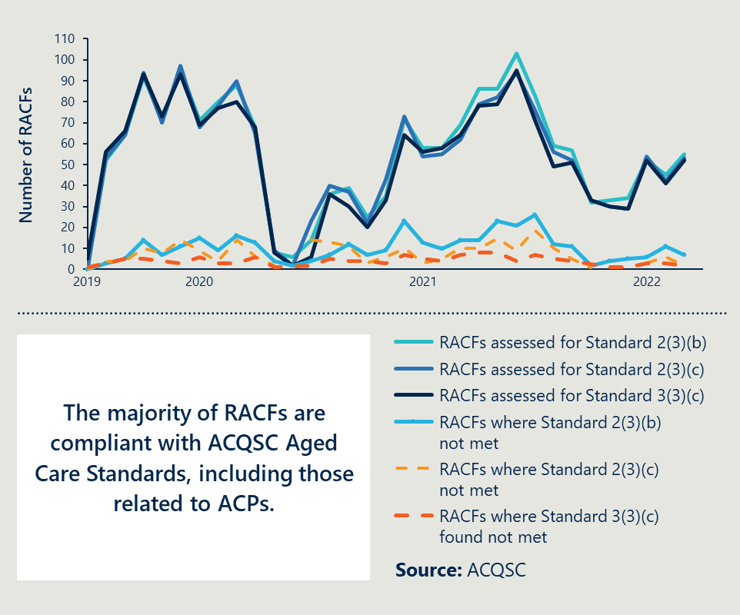

#### Outcome 1: Emerging mid-point findings

There is emerging evidence of more discussions being conducted that focus on end-of-life care decision making

Evidence of emerging progress against this outcome includes:

* Measure activities are helping to improve the effectiveness of ACPs and GPs involvement in discussions in ACT, SA and WA. In WA, specialist palliative care clinicians reported that the MPaCCS model is ensuring ACPs are completed when residents are discharged from hospital. They noted it is improving the quality of ACP discussions on resident preferences. In SA, clinicians reported that needs rounds are improving GP engagement and coordination with RACFs. See Case study 4, page 32.
* NT stakeholders reported that the use and effectiveness of ACPs may be impacted by cultural differences**.** NT RACFs reported some difficulties in completing ACPs with Aboriginal and Torres Strait Islander residents and their families due to differences in cultural views around death and dying, and difficulties in achieving family engagement. There is an opportunity for tailored conversations about death and dying, and to employ Aboriginal and Torres Strait Islander personal care workers and nurses.
* In Tasmania and NSW, it is too early to assess the extent to which Measure activities are impacting use of ACPs but there is need for more consistency. In Tasmania, implementation is in the early stages; however, as a baseline, the PHN reported significant variability in the use of ACPs and the degree to which GPs are involved. This was supported by RACFs in Tasmania, who reported that there is a need for more consistency and structure around ACPs. In NSW, LHDs reported using an adapted version of the ACT needs rounds tools including ACPs. It is too early to assess any effect on ACP use.
* All jurisdictions reported structural issues impede discussions occurring in RACFs. As noted in section 5.1.2, all stakeholders reported GP remuneration, staff shortages (exacerbated by COVID-19) and disparate systems across RACF, acute and GP care settings hinder coordination.

These emerging findings are evidence of the contribution of Measure-funded activities to the National Palliative Care Strategy Goal 4 (collaboration). They demonstrate early progress in strengthening the funding mechanisms that facilitate advance care planning.

|  |
| --- |
| Case study 4: Needs rounds are being implemented in the ACT, Queensland, SA, NSW and Tasmania. Across these states and territories, the needs round model is improving RACF staff access to resources, increasing specialist and GP input in RACFs, improving the use of ACPs and reducing ED transfers.  In the ACT, Measure funding has been used to expand the PCNR model. Needs rounds are being conducted by Nurse Practitioners in the specialist palliative aged care (PEACE) team to facilitate access to medications. ACT RACFs have reported that the PEACE team’s support is helping to prevent avoidable hospital transfers. One RACF in ACT has assigned a Registered Nurse to conduct the needs rounds for one dedicated day per month. The nurse completes case conference coordination and paperwork to support GP involvement. Specialist clinicians reported this approach has led to better coordination with the GP clinics, better anticipatory prescribing to residents and a better experience of death and dying for residents, because plans are in place and are being used effectively.  In Queensland, RACFs have been conducting needs rounds with support and input from Nurse Practitioners or Clinical Nurses, the SPACE team and GPs. So far, the SPACE team has engaged with more than 400 RACFs and the needs rounds are reported to support improved staff access to resources.  In SA, where the needs rounds model involves compensating GPs to attend rounds, the approach is reported to be improving GP engagement, confidence in palliative care and coordination with RACFs.  In NSW, FWLHD has adapted the ACT’s PCNR model to suit the area. Anecdotally, the CNC conducting the rounds reported a 200 per cent decrease in ED presentations for end-of-life care in the first six months of implementation.  In Tasmania, the Measure has funded specialist CNCs who have recently started attending RACFs and conducting needs rounds. Implementation is in the early stages, but they aim to enhance RACF staff skills in palliative care, support active preparation to respond to resident needs and reduce avoidable hospital transfers. They also aim to improve communication and documentation among staff and with GPs, and communication with families and residents. |

|  |
| --- |
| Outcome 2: Improved access to information that informs end-of-life care decisions for residents and families. |
| Baseline assessment: The majority of RACFs are compliant with Aged Care Standards that require them to involve residents in care planning and services. |

This outcome assessment is based on analysis of data from the NIHSI-AA and ACQSC.

#### Outcome 2: Baseline assessment

From 2019 to 2022, 85 per cent of RACFs assessed by the ACQSC had practices in place to involve residents as a partner in care planning and services.

As shown in Figure 6 (see page 31), the majority of RACFs have practices to ensure residents are a ‘partner’ in ongoing assessment and planning for care and services.[60] This involves ‘ongoing sharing of information, asking for consumer feedback and encouraging consumers to take part in planning their own care’.[61]

Evidence suggests that a case conferencing approach where a multidisciplinary team focuses on individual residents, including multidisciplinary meetings, can provide person-centred care and appropriate prescribing.[62] As noted in Outcome 7, there were 241,642 permanent residents of RACFs for all or part of the year in 2018-19 and 33,384 multidisciplinary case conferences conducts. Of the total residents, 20,645 residents (8.5 per cent) attended at least one multidisciplinary case conference that year involving a medical practitioner or GP (see Figure 15 on page 47).

#### Outcome 2: Emerging mid-point findings

There is emerging evidence of improved access to information to inform end-of-life decisions.

This includes:

* In WA, GPs reported that the MPaCCS model helps to provide support beyond what GPs could provide themselves. This aligns with the experience of WA specialist clinicians, who reported the MPaCCS model is increasing the availability of specialist clinicians to support RACF staff. This is reported to support staff to address resident needs and help improve the quality of ACP focused discussions.
* There is an opportunity for RACF staff to improve the way that information is provided to families about palliative care options. The PCA consumer representative group reported that some RACFs did not proactively provide information. While they reported that palliative care services were good, more information could have been provided about palliative care services and options to residents and their families. This may be driven by a lack of skills and inadequate training around palliative care.

These emerging findings are evidence of contribution of Measure-funded activities to the National Palliative Care Strategy Goal 1 (understanding). They demonstrate early progress in improving families/carers’ understanding of the benefits of palliative care and better involvement of them in decisions about the care of their family members.

|  |
| --- |
| Outcome 3: A higher proportion of clinical and non-clinical staff in RACFs have skills and confidence appropriate to their roles to recognise and respond to the holistic palliative care needs of residents, in a culturally safe way. |
| Baseline assessment: Palliative care training is often not mandatory in RACFs; however, nurses and care workers are the most common users of the Palliative Care Online Training portal run by the AHHA. |

This outcome assessment is based on analysis of data from the NIHSI-AA and AHHA.

#### Outcome 3: Baseline assessment

**Education and training resources are available; however, training is often not mandatory**

Based on a 2021 survey of RACFs, 37 per cent of RACFs indicated they did not have mandatory palliative care training for any staff group. RACFs overwhelmingly reported (97 per cent) that they have specific policies and procedures with clear steps to assist staff to recognise when a resident is close to end-of-life.[63] However, clinicians noted that these policies need to be accompanied by training for them to be effective. Registered Nurses were the only group where a majority of RACFs indicated mandatory training included palliative care.

**There is a demand for palliative and aged care training resources, particularly among nurses and care workers**

Analysis of ELDAC data found that from 2018-2019, the Residential Aged Care toolkit was ELDAC’s most visited webpage (142,838 total webpage views). The Residential Aged Care toolkit provides organisational resources for RACFs, including tools for After Death Audits. Active users of the Residential Aged Care toolkit have increased since 2018 (see Figure 7 on page 35).[64] Users of the AHHA Online Palliative Care Training portal are also increasing (see Figure 7 on page 35).

ELDAC estimates that the audience for the Residential Aged Care toolkit is nurses (45 per cent), care workers (20 per cent) and care managers (20 per cent).[65] Similarly, nurses and care workers make up most users of the AHHA Palliative Care Online Training portal, suggesting there is demand for resources in these cohorts. Most users in 2021 were Registered Nurses (20 per cent), care workers (18 per cent) or students (14 per cent).[66]

Comparison of users of the online resources against the 2020 Aged Care Workforce Census data suggests that in 2020, users of the AHHA portal may have accounted for almost 30 per cent of the estimated number of direct care workers in RACFs (see Figure 7 on page 35).

Figure 4 Total and new users of the AHHA Palliative Care Online Training portal and the ELDAC Residential Aged Care toolkit from 2018 to 2021[67]

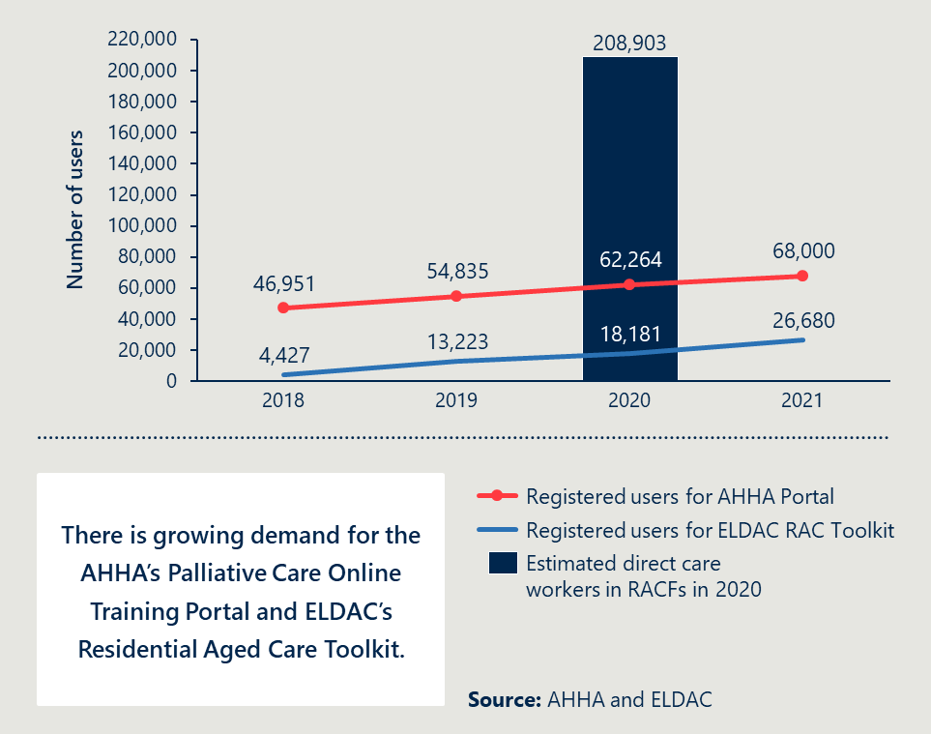

**RACFs and home care services enrolled in ELDAC’s Working Together program identified education for new staff as an unmet need**

ELDAC’s Working Together program enlisted 56 RACFs and 14 home care services in a program to improve planning and conduct audits within their organisation. Sites were surveyed before and after plan development and in-service education for new staff was identified as one of the key unmet needs among sites – only 11 per cent of sites reported this need being adequately met before the program (improving to 60 per cent after).[68]

**While there is a need for training, existing resources help to improve knowledge, skills and confidence**

From 2019 to 2021, there were approximately 13,000 new users of the Palliative Care Online Training portal. Of surveyed users,[69] an average of 82 per cent reported feeling ‘confident’ or ‘extremely confident’ in delivering best-practice palliative care services after undertaking the training, compared to 35 per cent before. In 2021, an average of 91 per cent of users identified as having improved their level of knowledge and/or skills in palliative care after undertaking the training.[70]

Nous also received NIHSI-AA data on the number of residents dispensed with subcutaneous medicine as an indicator for Outcome 3. Based on advice from Nous Expert Advisor, Dr David Currow, this data has not been included. There is significant variation across states and territories in the proportion of RACF residents receiving subcutaneous medicines associated with palliative care. However, Dr. Currow advised that palliative care management does not require subcutaneous medicines and this variation across jurisdictions is not likely to be driven by resident or RACF resource factors.

The proportion of RACF residents who are hospitalised and or present to ED, may also be related to the skills of clinical and non-clinical staff in RACFs (see Outcome 8 on page 48).

#### Outcome 3: Emerging mid-point findings

**There is early evidence that training embedded in work practices is an effective approach to improving the skills of RACF staff**

The PHNs in WA and ACT reported that there is a need to shift away from training individuals (which is impeded by staff turnover) to embedding processes within RACFs. In SA, there is early evidence that the traineeship program with Eldercare is helping to embed palliative care processes at the operational level. In the ACT, the Nurse Practitioner-led needs rounds have education and training embedded in the needs rounds for RACFs *(see Case study 5, page 36).*

**ACT and Tasmania have developed projects to upskill clinical staff**

In the ACT, there have been recruitment challenges in finding Nurse Practitioners to facilitate needs rounds. To address this and facilitate succession planning, two training nurses have been hired while they complete their Masters degree, who will later move into Nurse Practitioner positions. In Tasmania, GP Registrars are being hired under the Measure.

**In SA and WA, education and training has required significant effort and strong relationships between clinicians and RACFs**

In SA, specialist clinicians reported that varying engagement from RACFs when they are nominated for training by LHNs. Clinicians also reported that determining educational needs for RACFs requires substantial effort due to the variation in RACF size, skill mix and models of care.

In WA, the Residential Aged Care Excellence in Palliative Care (RACEPC) project on workforce capability, education and training is in the early days of implementation of a revised approach. The WA Department of Health reported it was delayed due to site access complications with COVID-19, in addition to RACFs reporting an overwhelmed landscape due to activities resulting from the Royal Commission and new funding initiatives.

**There is a need for improved training tailored to personal care workers**

Personal care workers make up the majority of the aged care workforce.[71] PCA consumer representatives reported that training may not adequately equip them for the complexity of their roles, particularly for discussions around ACPs. Stakeholders in Tasmania and ACT reported personal care worker training needs to be low burden given capacity constraints and accessible in many languages to reflect the diversity of the personal care workforce. In SA, there is emerging evidence that a traineeship model for personal care support workers (Certificate 3 facilitated by Eldercare) could be effective.

These emerging findings are evidence of contribution of Measure-funded activities to the National Palliative Care Strategy Goal 2 (capability). They demonstrate early progress in improving the capability of personal care workers, nurses and GPs working in aged care to identify and address resident’s needs.

|  |
| --- |
| Case study 5: In the ACT, needs rounds integrate case-based education for RACF staff.  The ACT has 29 RACFs. All but one facility has at least one of the PCNR model components in place, with most sites conducting needs rounds monthly. The PCNR is an integrated model involving collaboration from all members of the care team, including clinicians and RACF staff. Case‐based education is integrated into the PCNR model, with each resident’s bio‐psycho‐social status discussed to promote symptom management and identify opportunities to extend staff knowledge.  Support is also provided RACFs through the ACT Program of Experience in the Palliative Approach (PEPA). |

|  |
| --- |
| Outcome 4: Improved access to quality palliative care in RACFs including:  * increased use of assessments to establish residents’ palliative care needs * decreased health service use related to clinically futile or non-beneficial treatments and inpatient bed days * decreased healthcare expenditure arising from decreased service use. |
| Baseline assessment: Approximately only seven per cent of RACF residents accessed palliative care services from 2014-19. An average of 55 per cent of RACF residents who died in 2018-19 may have received medicines associated with palliative care, but access to palliative care can be improved. In a majority of PCOC care episodes in 2021, care was provided by the specialist palliative care in-reach service within two days of the resident being ready. |

This outcome assessment is based on analysis of data from the NIHSI-AA and PCOC. Analysis of healthcare expenditure is not included here and will be included in the Final Report in 2023.

#### Outcome 4: Baseline assessment

**Approximately seven per cent of RACF residents accessed palliative care specialist services from 2014-19**

Analysis of NIHSI-AA data indicates that, from 2014-19, there were 62,252 RACF residents who accessed palliative care medicines and services while living at a RACF (see Figure 5 on page 39). This represents an estimated seven per cent of the RACF resident population from 2014-19.[72] However, this only incorporates palliative care services and medicines billed to MBS and Pharmaceutical Benefits Scheme (PBS) by specialists, and palliative care related hospital admissions. The number and proportion of RACF residents who accessed all types of palliative care (such as GPs and community-based palliative care teams) is likely to be higher.[73],[74]

**In 2018-19, 12.9 per cent of residents received palliative care related medicines in 2018-19**

From 2018-19, an average of 12.9 per cent[75] of RACF residents received medicines related to palliative care (see Figure 6 on page 49).[76] This is based on the total residents of RACFs between July 2018 to June 2019 (241,642) however the Australian Institute of Health and Welfare (AIHW) reports suggest that the number of people in permanent residential aged care in 2018-2019 was closer to 180,000.[77]

A cross-sectional Australian study to assess unmet need for palliative and other end-of-life care among people who died in hospital, found that a range of 38 per cent and 74 per cent needed palliative care and approximately 13.3 per cent did not receive any end-of-life care despite its potential benefit.[78], [79] Need for palliative care was found to be higher in older residents, which suggests that the proportion of RACF residents who need palliative care services may be higher than this.

This aligns with indicative evidence from ELDAC’s Working Together program, described in Outcome 3 (see page 35). Among sites surveyed before and after the program on a total of 775 residents’ deaths, a majority of residents were not referred to an external specialist palliative care service in the three months before they died. Sites reported that 24.1 per cent of residents were referred to specialists pre implementation, improving by only 2.1 percentage points to 26.2 per cent post implementation.[80] This suggests there is need to improve referrals and access to palliative care services for RACF residents.

This combined evidence indicates that there is a significant proportion of RACF residents who may need, but not have access to, palliative care services and medicines. This aligns to the finding of the Royal Commission that “most residential aged care services do not have access to specialist palliative care teams”.[81]

Figure 5 RACF residents who accessed palliative care services while living at a RACF from 2014-19

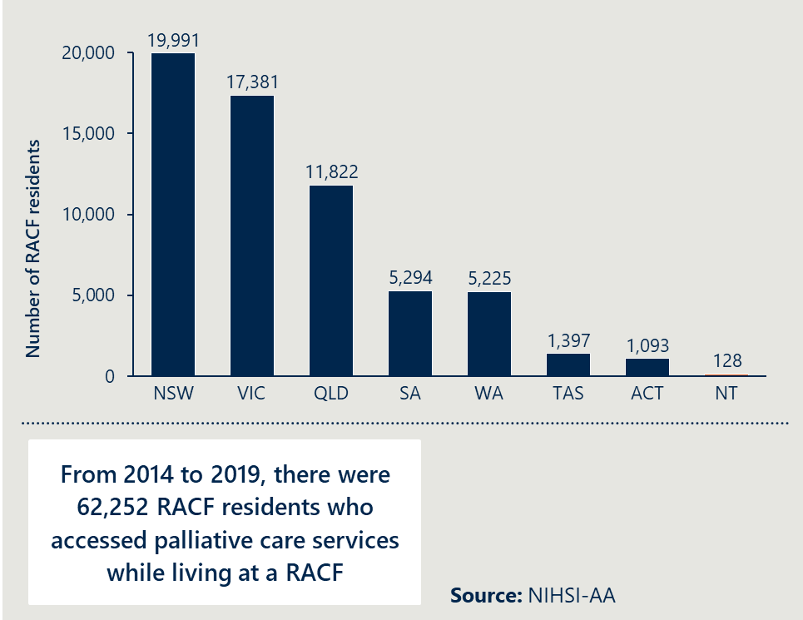

Figure 6 RACF residents in total and who received medicines related to palliative care in 2018-19

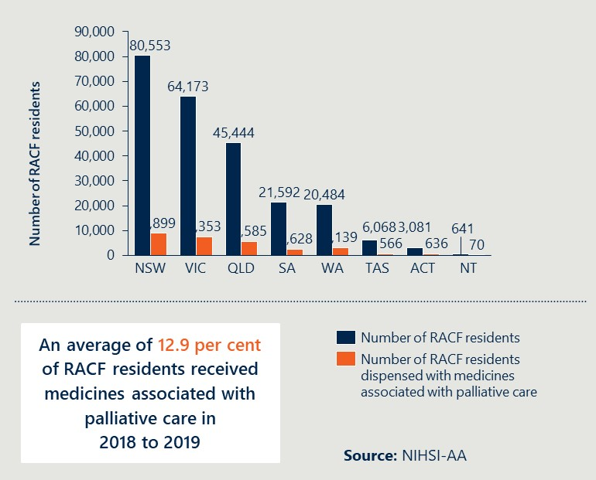

**Despite this, the majority of RACFs report that residents can access palliative care services**

In Nous’ 2021 survey of RACFs, an average of 96 per cent[82] of RACFs across Australia overwhelmingly reported being able to access specialist palliative care services and 88 per cent of RACFs reported that residents can access palliative care services from a GP. It is likely this sample is biased as those RACFs who are more engaged in palliative care would have been more likely to respond.

**An average of 55 per cent of RACFs residents who died in 2018-19 may have been dispensed with medicines associated with palliative care that year**

The proportion of residents dispensed with palliative care associated medicines ranged from 35 to 83.6 per cent of RACF residents who died, across states and territories (an average of 55 per cent of RACF residents who died in 2018-19) (see Figure 7 on page 50). This is much higher than the proportion of residents identified as ‘needing’ palliative care through an Aged Care Funding Instrument (ACFI) appraisal.[83]

In the ACT, there were 760 residents who died and 636 residents who were dispensed with palliative care medicines (83.6 per cent). This relatively high proportion of residents could be driven by the ACT’s early trials on the Integrating Specialist Palliative Care into Residential Care for older people (INSPIRED) needs rounds model.

Figure 7 RACF residents who died in 2018-19 and residents dispensed with palliative care associated medicines

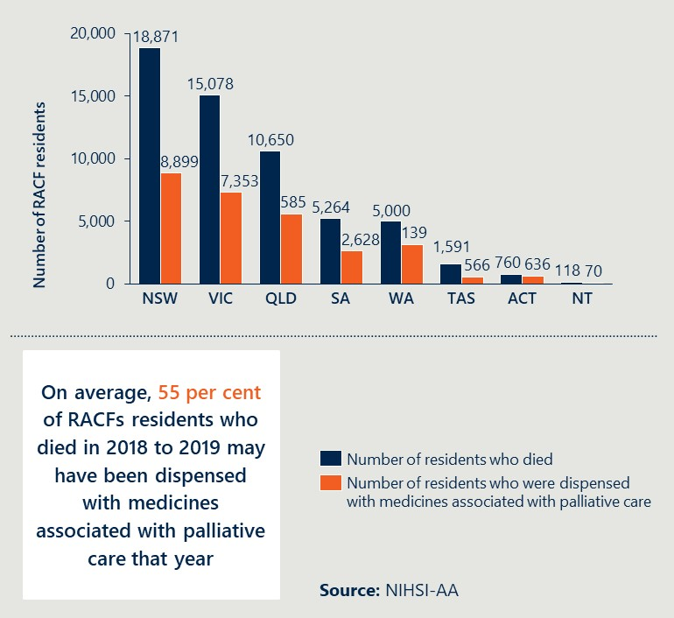

One third of RACF residents had at least one hospitalisation overall and/or at least one ED presentation in 2018-19, as outlined in Outcome 8. It is not clear what proportion of these admissions and presentations were clinically futile.

**In a majority of PCOC care episodes in 2021, care was provided by the specialist palliative care in-reach service within two days of the resident being ready**

PCOC supports services to provide quality palliative care in RACFs and supports clinicians to systematically assess individual resident experiences and routinely collect information relating to symptoms. As outlined in Outcome 5, in 2021, there were 57 specialist palliative care services conducting in-reach into RACFs reporting to PCOC (see Figure 8 on page 42) – 5,173 residents in RACFs were seen by these services. Of the 5,653 total episodes of care provided by these in-reach services, 5,183 episodes were assessed for the benchmark of whether the care commenced within two days of the resident being ready. Of those assessed, 91 per cent (4,719) of care episodes were found to meet this benchmark.[84] This indicates that these services reporting to PCOC are very responsive.

#### Outcome 4: Emerging mid-point findings

**There is emerging evidence that the Measure-funded activities are contributing to an increase in access and availability of palliative care**

Emerging evidence from states that are more progressed in implementation includes:

* Queensland Specialist Clinicians and the Queensland Department of Health reported an increase in referrals to the SPACE team.
* In WA, RACFs reported that MPaCCS involvement has contributed to increased confidence for staff and care partners to deliver palliative care.
* Specialist clinicians in SA reported that needs rounds are improving GP engagement, confidence and coordination with RACFs. In SA, the contracted evaluators reported that community pharmacists are helping to facilitate better access to palliative care related medicines.
* In ACT, RACFs reported that the PEACE team is very effective and helps to avoid clinically futile hospital transfers.

These emerging findings are evidence of contribution of Measure-funded activities to the National Palliative Care Strategy Goal 3 (access and choice). They demonstrate early progress in improving residents’ choice to receive palliative care in the place of their choosing, by providing more options to access palliative within RACFs.

|  |
| --- |
| Outcome5: Improved quality of palliative care provided in RACFs including:  * reduced symptom burden * improved quality of life for residents during the period they access palliative care * better experience of death and dying for residents, families/carers and staff, including meeting physical, psychosocial, cultural and spiritual needs. |
| Baseline assessment: RACFs are the most common referrer to specialist palliative care residential care in-reach services reporting to PCOC. RACF residents most commonly attend ED for reasons other than their primary illness. |

This outcome is assessed by analysis of data from the NIHSI-AA, ELDAC and PCOC.

#### Outcome 5: Baseline assessment

**RACFs were the most common referral pathway to specialist palliative care residential care in-reach services reporting to PCOC in 2021**

In 2021, there were 57 specialist palliative care services conducting in-reach into RACFs. These accounted for 5,653 episodes of care (see Figure 8 on page 42). Referrals from RACFs comprised 43.1 per cent of all referrals to PCOC-reporting specialist palliative care services conducting in-reach services to RACFs. Of the 5,553 episodes of care, other referral pathways were GPs (12.8 per cent), specialist practitioners (4.2 per cent) and palliative care units or teams at hospitals (nine per cent). A small proportion came from other hospital teams (15.5 per cent; see Figure 8 on page 42). GPs and RACFs, which are the care team directly involved in residents’ care, comprised a combined 55.8 per cent of all referrals to specialist palliative care residential care in-reach services reporting to PCOC.

Figure 8 Episodes of care and referral pathways to specialist palliative care services conducting in-reach to RACFs and reporting to PCOC, from January to December 2021

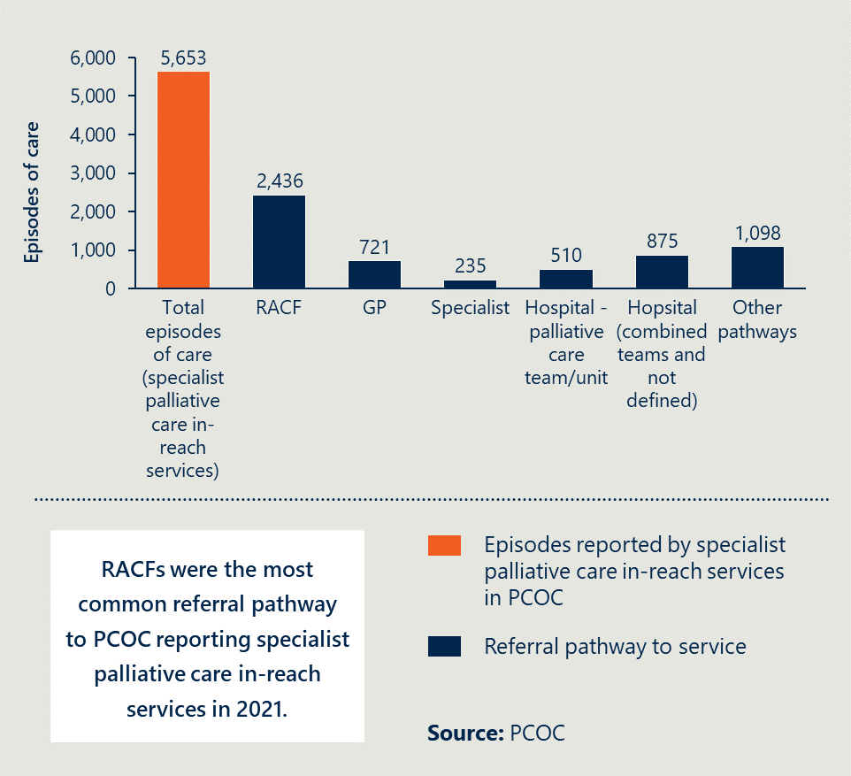

**Residents most commonly attend ED for injury, symptom management or rapid deterioration**

Analysis of NIHSI-AA data indicates that, among 81,733 RACF residents with at least one ED presentation in 2018-19, the most common reason for transfers to ED were ‘injury, poisoning and certain other consequences of external causes’ – 21.9 per cent of all ED presentations in 2018-19 (see Figure 9 on page 54).[85] As noted in Outcome 8 (see Figure 14 on page 61) only three per cent of hospitalisations of RACF residents in 2018-19 were related to palliative care.[86]

In an audit of 775 residents’ deaths, RACFs and home services participating in ELDAC’s Working Together program (see Outcome 3) reported that the most common principal life limiting illnesses among audited residents were dementia (39.4 per cent), cardiovascular disease (33.2 per cent) and cancer (22.1 per cent).[87] However, among the 81,733 RACF residents presenting to ED in 2018-19, mental and behavioural disorders (which includes dementia) was the seventh most common reason for residents to present to ED.

Surveyed ELDAC sites were also asked to report the principal reason for residents’ hospitalisation in their last week of life. The most common reason reported was sudden unexpected deterioration (48.9 per cent most common before the ELDAC program, improving to 63.1 per cent afterwards), followed by symptom management (39.3 per cent before, improving to 28.2 per cent after).[88]

**This combined NIHSI-AA and ELDAC evidence suggests that RACF residents are most commonly presenting to EDs for reasons other than their principal life-limiting illness**

The data indicates that RACF residents are most transferred to EDs for injury, symptom management or rapid deterioration. This may suggest that there is an opportunity to improve the quality of life and management of residents’ symptoms within RACFs, but it is unclear whether ED presentations caused by injury, poisoning and certain other consequences of external causes are clinically required or futile.

This aligns to the Royal Commission, which found that there was “lack of consistency results in a ‘postcode lottery’ of sorts for clients seeking palliative care support”. The Royal Commission report also identified experiences of residents and families and carers who had a poor experience of death and dying.[89]

Figure 9 Top ten reasons for ED presentations of RACF residents in 2018-19[90]

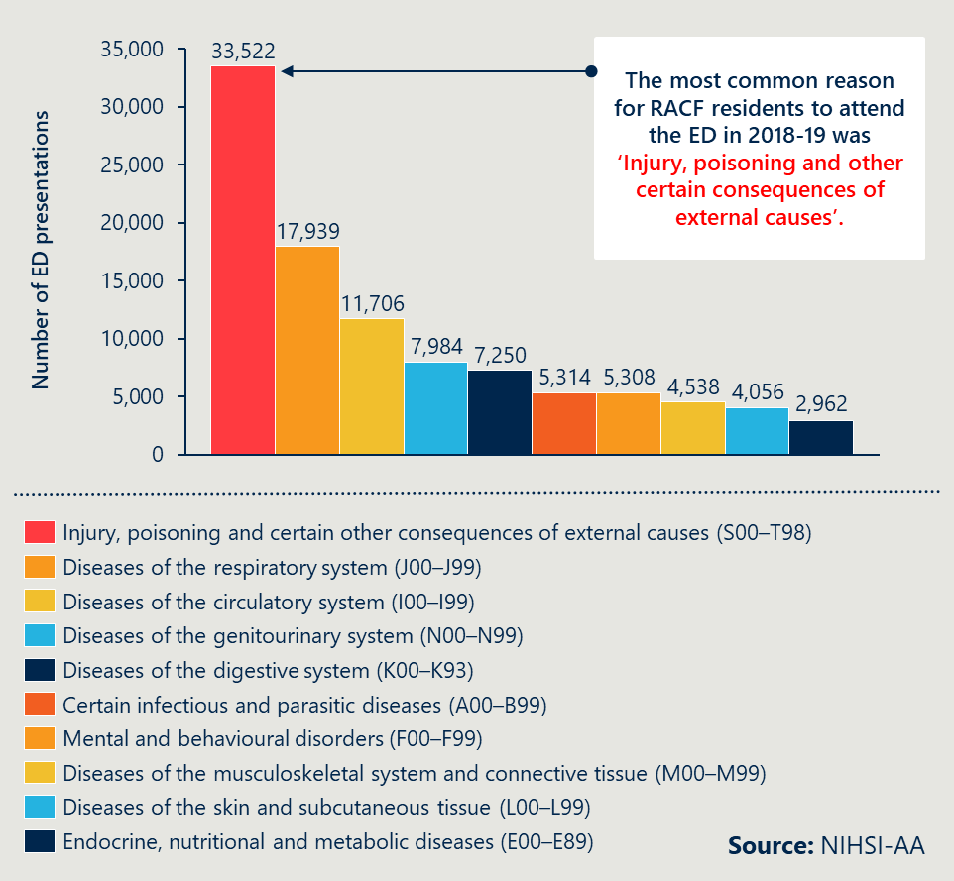  
Outcome 5: Emerging mid-point findings

**There is emerging evidence that Measure activities are improving the quality of palliative care in some RACFs, although there is significant variability**

There is early evidence that the MPaCCS model in WA and needs rounds models in ACT, SA and Queensland, are improving the quality of palliative care through increased involvement of specialist palliative care services in RACFs.

|  |
| --- |
| “People aren’t always afraid that they will die, but they are afraid of how they will die.”  Specialist clinician |

There are still challenges that inhibit the ability of RACFs to provide quality palliative care:

* There is a lack of allied health workers available to RACF staff who can provide non-medical aspects of palliative care. RACFs with a religious affiliation had chaplains and other supports in place.

There are also challenges related to the high proportion of CALD workers in the personal care workforce, regarding differing views of death and subsequent unease with certain palliative care related procedures and medications (as reported in consultations with RACFs in 2022).

|  |
| --- |
| Outcome 6: Greater resident choice in palliative care including:  * more people dying where they want * increased person-centred care informed by an individual’s choice. |
| Baseline assessment: The majority of RACF residents who died in 2018-19, died in a RACF; however, a substantial proportion of RACF residents in 2021 did not have their preferred place of death recorded by the RACFs. |

This outcome is assessed by analysis of data from NIHSI-AA and ACQSC.

#### Outcome 6: Baseline assessment

The majority of RACF residents who died in 2018-19, died in a RACF

Analysis of NIHSI-AA data indicates that 81.6 per cent of total RACF residents who died in Australia from 2018-19, died in a RACF,[91] compared to 16.1 per cent in hospital and 1.6 per cent in ED (see Figure 10 on page 45 for national deaths of RACF residents in 2018-19, and Figure 12 on page 56 for the proportion by each state and territory). These proportions increase slightly if WA and NT are removed, as data on RACF resident deaths in ED and Admitted Patient Care (APC) is not available for those jurisdictions, as described in Figure 12 on page 56.[92] Tasmania had a slightly higher proportion of RACF residents dying in ED; however, this was still only 2.57 per cent of all RACF resident deaths in 2018-19.

Studies of the general population show most Australians would prefer to die at home (60 to 70 per cent) rather than in a hospital or residential care.[93] However, when people enter residential aged care, this becomes their home and is assumed to be the preferred setting for most RACF residents compared to a hospital. Therefore, 81.6 per cent of deaths occurring in RACFs likely indicates that most residents are dying where they want, as the RACF is considered their home.

Figure 10 The majority of RACF residents who died in 2018-19, died in a RACF

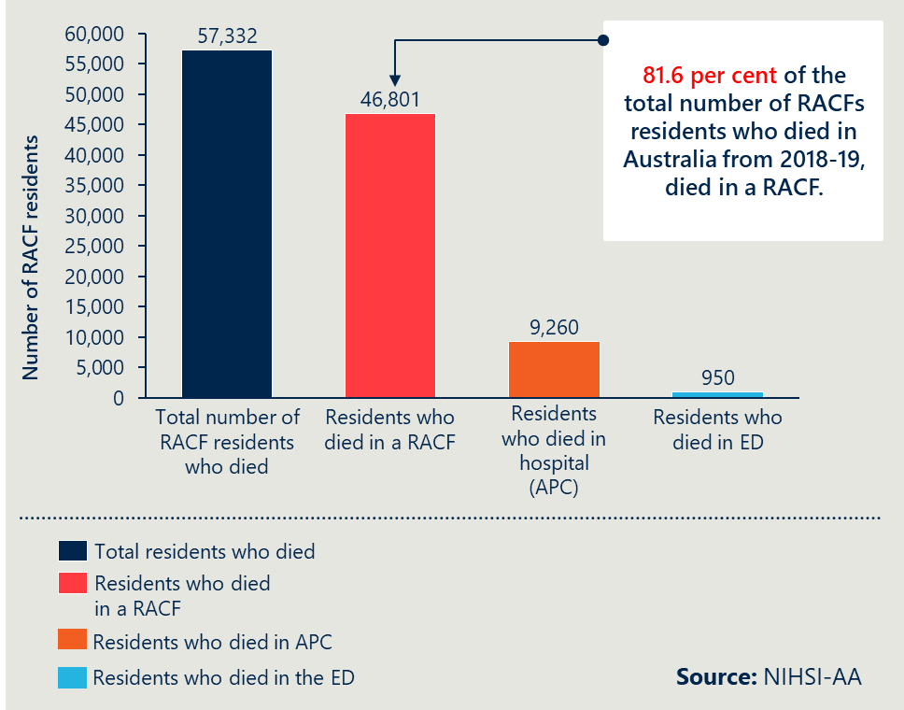

Figure 11 Residents who died in a RACF as a proportion of total deaths of RACF residents in 2018-19, by state and territory

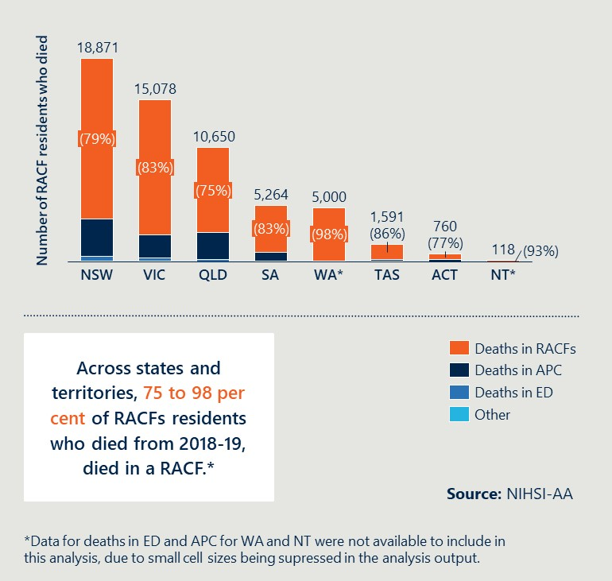  
  
**On average, a majority of RACFs are compliant with the Aged Care Standard on ensuring consumers nearing the end-of-life have their needs, goals and preferences addressed**

As shown in Outcome 1 (see Figure 3 on page 40), Standard 3(3)(c) had the highest average rate of compliance among RACFs assessed from 2019 to 2022. This requires that consumers feel confident that when they need end-of-life care, the facility will support them: to die in line with their social, cultural and religious and spiritual preferences.[94]

In 2021, a **substantial proportion of RACF residents do not have their preferred place of death recorded by the RACF**

Approximately 23 per cent of surveyed RACFs in 2021 reported that they have recorded a preferred place for less than half of all residents, including seven per cent that have preferred place of death recorded for no residents. In a Nous survey of RACFs around Australia in 2021, 81 per cent of RACFs reported that they had ACPs in place.

This aligns with analysis of ACQSC data described in Outcome 1 and 2 (see Figure 3 on page 40). It indicates that from 2019 to 2022, approximately 20 per cent of RACFs were assessed as not having practices in place that identify and address consumers current needs, goals and preferences, including through the use of ACPs. This suggests there are many RACF residents who do not have ACPs in place and do not have their preference for place of death recorded.

#### Outcome 6: Emerging mid-point findings

**At this stage, ACP use is still variable, however their effectiveness may be improving**

Mid-point consultations with RACFs suggest there is still variability in the use of ACPs. There is some anecdotal evidence of the Measure having impact in ACT and NT, however that is not the case across all jurisdictions. Stakeholders across all jurisdictions reported that having discussions associated with ACPs, in addition to having the ACPs in place, helps enable staff to be better prepared, pre-empt needs and medications and facilitate a better experience of dying for the resident and their family.

|  |
| --- |
| Outcome 7: Improved care coordination with GPs/primary care, acute care services and specialist palliative care services. |
| Baseline assessment: 8.5 per cent of RACF residents attended a multidisciplinary case conference in 2018-19. This suggests that GPs are involved in coordinating care in RACFs, but there is an opportunity for further improvement. This accounts for an estimated 50 per cent of the total estimated number of RACF residents who accessed palliative care or were dispensed with medicines related to palliative care. |

This outcome is assessed by analysis of data from NIHSI-AA.

#### Outcome 7: Baseline assessment

**Half of the RACF residents who accessed palliative care related medicine or services in 2018-19 may have attended a multidisciplinary case conference run or attended by a GP**

There were 241,642 permanent residents of RACFs for all or part of the year in 2018-19. Of these, 20,645 residents (8.5 per cent) attended a multidisciplinary case conference that year involving a medical practitioner or GP (see Figure 15 on page 47). Analysis suggests that this proportion may be higher than 8.5 per cent.[95] This aligns with findings of the survey of RACFs in 2021, which found that the majority of RACFs surveyed reported that residents can access palliative care from GPs.

These case conferences include:

* Multidisciplinary case conferences billed by a medical practitioner other than a specialist or consultant physician (MBS items 735, 739, 743, 747, 750 and 758). This involves a multidisciplinary case conference team discussing a resident’s history and multi-disciplinary care needs, and identifying and assessing progress towards outcomes related to care and service for the resident.
* Multidisciplinary case conferences attended by a GP, specialist, or consultant physician as a member of a case conference team, to lead and coordinate a multidisciplinary case conference on a resident with cancer to develop a multidisciplinary treatment plan. This includes a multidisciplinary team of medical practitioners and allied health providers (MBS items 871 and 872).

Of these residents who attended multidisciplinary meetings run by GPs, seven per cent then accessed palliative-care related medicines or subsidised palliative medicine specialist services within one month following the meeting (see Figure 15 on page 47).

Residents may or may not attend these multidisciplinary case conferences, depending on their individual condition and/or interest in attending, however, the significant number of meetings occurring each year suggests that GPs are involved in coordinating care in RACFs.

Figure 12 Multidisciplinary case conferences that involve GPs and medical practitioners, 2018-19

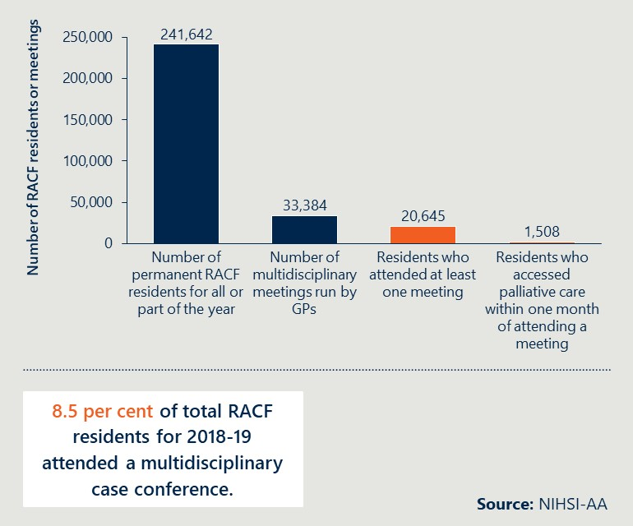

#### Outcome 7: Emerging mid-point findings

**All jurisdictions have reported greater involvement of specialist palliative care services; there is anecdotal evidence that care coordination has improved in some jurisdictions**

ACT have reported benefits because of increased clinical staff participation in case conferencing and needs rounds. In SA, GPs are being incentivised to improve engagement in needs rounds (see *Case study 7,* page 59). In WA, the MPaCCS expansion has increased palliative care medical consultancy support to GPs and the Liaison Nurse has increased engagement with hospital-based clinicians and GPs. Tasmania is using Measure funds to hire GP registrars but has not reported any findings at this stage. There is at least one example of the Measure working well in Queensland, such as in West Moreton Hospital and Health Service (HHS).

Across jurisdictions, new roles (i.e., additional FTE) have contributed to improved care coordination. Central Australia has seen increased staff confidence, because of education within the RACFs, to respond to palliative care needs and decision-making, rather than sending residents straight to hospital.

These emerging findings are evidence of contribution of Measure-funded activities to the National Palliative Care Strategy Goal 4 (collaboration). They demonstrate early progress in improving communication between and across national, state/territory and local palliative care networks and stakeholders.

**Several jurisdictions reported poor GP remuneration as a limiting factor to GP involvement**

Tasmania, NT, WA and ACT reported that poor GP remuneration, particularly through constraints on MBS items which can be billed, inhibit GP involvement in Measure activities.

All jurisdictions reported that high staff turnover in RACFs is a barrier in progressing Measure activities and inhibits the positive impact of newly developed relationships.

|  |
| --- |
| Outcome 8: Improved integration between the health and aged care systems. |
| Baseline assessment: Approximately one third of RACF residents had a presentation to ED or one hospitalisation from 2018-19. Only three per cent of hospitalisations related to palliative care and these were more likely to be overnight stays. Residents are more likely to receive palliative care medicines in the RACF, but some residents may not have access to the palliative care services they need. |

This outcome is assessed by analysis of data from NIHSI-AA.

#### Outcome 8: Baseline assessment

**Approximately one third of RACF residents had at least one hospitalisation or ED presentation in 2018-19**

NIHSI-AA data provides detailed information on the level of health service use related to acute care settings. From 2018-19, analysis of NIHSI-AA shows that 31 per cent of RACF residents had at least one hospitalisation in 2018-19 and 33.8 per cent of RACF residents had at least one ED presentation (see Figure 16 on page 48).

When only the states and territories with available ED data in NIHSI-AA are considered, 36.7 per cent of RACF residents in NSW, Victoria, Queensland, Tasmania, SA and ACT had at least one ED presentation. It is not possible to tell whether these ED presentations were related to palliative care, because of the way that data is captured in EDs,[96],[97] however the Royal Commission highlighted integration of care between RACF staff and other health practitioners as an issue in providing effective palliative care and this could contribute to additional ED presentations.[98]

Figure 13 Number of RACF residents with at least one hospitalisation or ED presentation in 2018-19

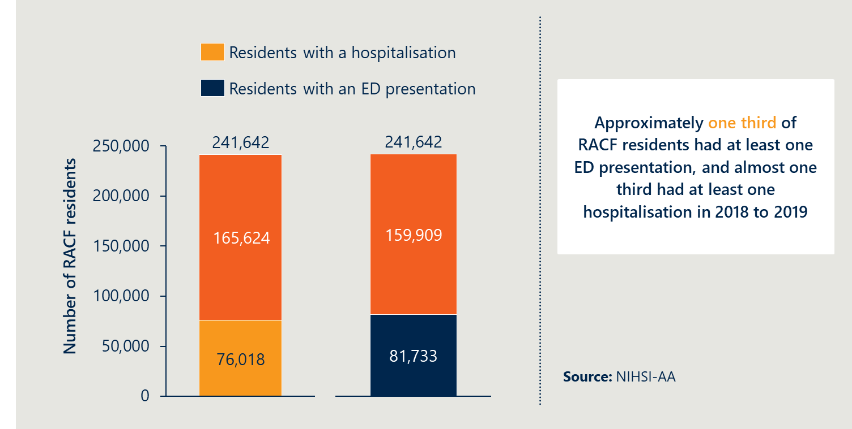

**Only three per cent of hospitalisations of RACF residents in 2018-19 were related to palliative care**

Nationally, 31.4 per cent of RACF residents had at least one hospital stay (see Figure 17 on page 49) but only three per cent of these hospital stays were related to palliative care. In 2018-19, 11.9 per cent of RACF residents received medicines associated with palliative care. Of the RACF residents who died in 2018-19, an estimated 55 per cent of RACF residents may have received medicines associated with palliative care (see Figure 10, page 40). It is unclear what proportion of RACF residents received specialist or non-specialist palliative care services in 2018-19 (in addition to medicines).[99]

Between 38 per cent and 74 per cent of people who die in hospital are estimated to need palliative care – this is likely to be higher in older residents[100],[101] (see Outcome 4, page 39). This suggests that the proportion of RACF residents who need palliative care services may be higher than 38 to 74 per cent. While RACF residents are more likely to receive palliative care medicines in the RACF, some residents may not have access to the palliative care services they need.

Figure 14 RACF residents with at least one hospitalisation in 2018-19

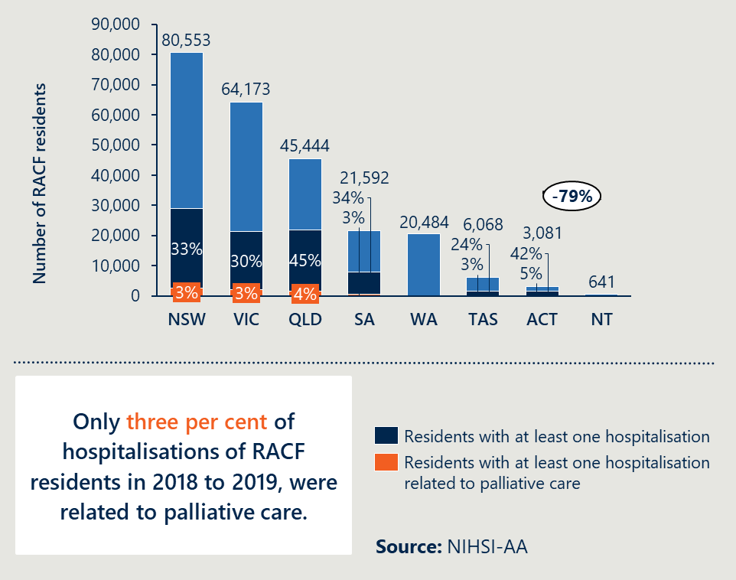

**Hospitalisations of RACF residents related to palliative care were more likely to be overnight stays in 2018-19**

For palliative care related hospitalisations for RACF residents, overnight stays comprised 98.6 per cent of total bed days, compared to 85.4 per cent of total bed days for all hospitalisations. Similarly, of residents with at least one hospital stay, 67.5 per cent of total residents hospitalised had an overnight stay, compared to 95 per cent of residents hospitalised for palliative care (see Figure 18 on page 50). In 2018-19, the average bed days for total and palliative care related overnight hospitalisations for RACF residents did not differ much – in general, overnight hospitalisations had an average of 5.7 bed days, compared to an average of 5.82 bed days for palliative care related hospitalisations.

The total number of bed days for RACF residents (675,526 bed days, see Figure 18 on page 50) may be driven by a small number of residents hospitalised for a very long time. However, same day hospitalisations do occur. Nous’ Expert Advisor Dr. David Currow advised that, in many cases, same day hospitalisations are the only appropriate way to provide care which is not able to be done in the RACFs (such as fluid drainage, catheter or stent changes).

Figure 15 Hospitalisations and bed days for RACF residents overall and for palliative care, from 2018-19

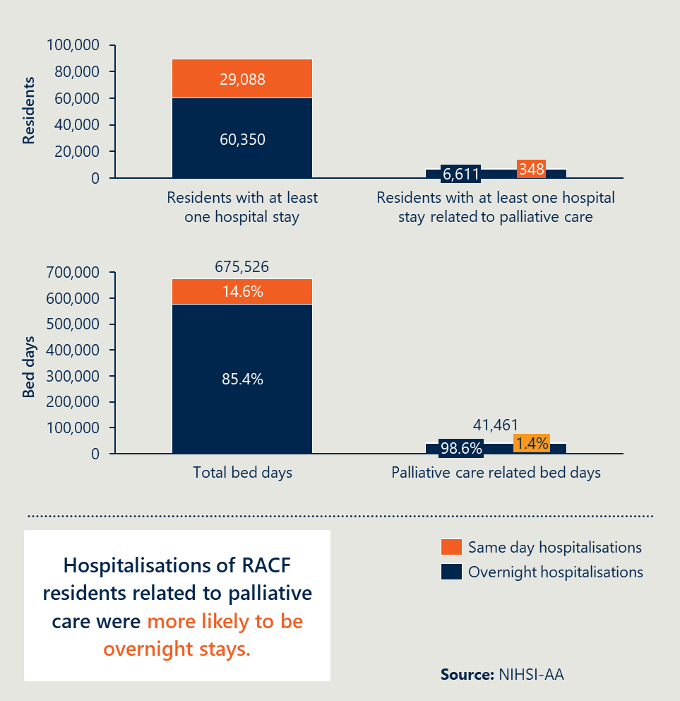

#### Outcome 8: Emerging mid-point findings

**In ACT and NT, COVID-19 restrictions impacted routine needs rounds and may have contributed to an increase in transfers to ED and more urgent referrals**

Specialist clinicians in the ACT reported that RACFs faced challenges during COVID-19 restrictions to continue needs rounds. Anecdotally, specialist clinicians reported referrals to the specialist palliative care team and nurse practitioner became more urgent and increasingly related to residents deteriorating or dying. Clinicians also reported that less needs rounds being conducted resulted in increased transfers to hospitals.

In NT, RACFs reported that ED transfers may be driven by other factors, such as to enable people to see families due to COVID-19 restrictions in RACFs. Transfers may also be driven by an inability to provide basic care in the RACF, if they do not have access with the existing palliative care or health services.

**In Queensland, there is early evidence of increased referrals to the SPACE team and anecdotal evidence that their support helps to reduce the need for hospital admissions**

In QLD, specialist clinicians reported an increase in referrals to the SPACE teams. Anecdotal evidence suggested that this may be related to increased awareness of death during the COVID-19 pandemic and the increased salience of vulnerability of aged care residents during this time. Clinicians reported that the involvement of the SPACE teams and GPs reduced the need to admit RACF residents to hospitals.

|  |
| --- |
| Case study 6: In NSW’s FWLHD, the Measure-funded CNC is uploading ACPs into EMR software to streamline ACPs across care settings  The Measure-funded CNC Palliative and End-of-Life care team in FWLHD has been providing an in-reach model of care to the residential aged care sector in the district over the past 12 months. They have adapted the Calvary Needs Round model to address underutilisation of existing resources and the need for a standard approach to end-of-life planning and care delivery.  In 2021, a total of 29 needs rounds occurred across five RACFs. During the first year of needs rounds in the FWLHD it was found that 17 of the 65 residents did not have ACPs in place and a further 15 had plans that had not been reviewed for over three years. All but two of these were updated because of the needs rounds. Since July 2021 and the EMR Advance Care build, up to date ACPs or Directives discussed at needs rounds have been uploaded in to EMR to ensure they are readily available even if the resident is transferred to hospital. This sharing of information enhances a streamlined approach to ACP use across care settings. |

|  |
| --- |
| Outcome 9: More palliative care services and health planners are informed by performance information on appropriateness, effectiveness, efficiency and outcomes. |
| Baseline assessment: There is mixed use and availability of performance information on the appropriateness, effectiveness, efficiency and outcomes of palliative care. PCOC provides performance information to palliative care services and health planners, however, its use is limited and it does not capture information about RACFs. |

This outcome is assessed by analysis of data from NIHSI-AA, PCOC and a survey of RACFs.

#### Outcome 9: Baseline assessment

**There is mixed use of performance information on the appropriateness, effectiveness, efficiency and outcomes of palliative care**

Approximately half of RACFs surveyed by Nous in 2021 reported that they always or usually used an audit process to look at end-of-life care (e.g., an after-death audit).[102] However, during consultations clinicians noted that there is limited use of audit processes beyond what is required for accreditation. Therefore, the true proportion of RACFs that use audit processes to look at end-of-life care is likely to be lower than reported by RACFs in the survey.

Only 17 per cent of RACFs reported using a digital dashboard or other tool to monitor palliative care suggesting limited access to performance information.[103] As noted in Outcome 3 (Figure 7 on page 35), there is increasing demand for resources including the AHHA’s Palliative Care Online Training Portal and ELDAC’s Residential Aged Care toolkit, but current users comprise a small proportion of the estimated total direct care workforce in RACFs.

**NIHSI-AA provides information on residents’ access to palliative care services, medicines and acute care services; however, data availability is delayed**

As noted throughout section 5.3, analysis of NIHSI-AA provides insight into RACF resident access to palliative care services, medicines and acute care services. From 2014-19, approximately seven per cent of RACF residents accessed palliative care services (see Figure 8). From 2018-19, approximately one third of RACF residents had at least one hospitalisation or ED presentation (see Figure 16) and approximately 12.9 per cent of residents received medicines associated with palliative care (see Figure 9). NIHSI-AA provides an accurate picture of RACF residents health service utilisation across care settings. However, the time required for data collation, processing and linkage means that the data availability is delayed by two years, which presents a challenge for health planners seeking to use NIHSI-AA to inform decisions.

**PCOC provides performance information to palliative care services and health planners; however, its use is limited and it does not capture information about RACFs**

PCOC collects information on palliative care outcomes alongside other information about the resident and support provided. The use of PCOC is voluntary but well established in palliative care services, some of which provide services to residents in RACFs. As noted in Outcome 5, there were 184 specialist palliative care services who participated in PCOC in 2021[104] and 57 specialist palliative care services conducting in-reach to residential care, and reporting to PCOC in 2021 (see Figure 11 on page 42).

PCOC has developed a new model that RACFs can implement to capture similar information. This was piloted in 2021 and is being rolled out further with additional funding in the 2021-22 Australian Government Budget; however, data is not available on this program yet.

#### Outcome 9: Emerging mid-point findings

**Early evidence in Tasmania suggests that dedicated Departmental resources help with information sharing between the PHN and the Tasmanian Department of Health**

In Tasmania, the PHN reported that the recruitment of the ‘CPCiAC team’ within the Tasmanian Department of Health has led to more and improved interaction with Primary Health Tasmania (PHT) and enabled PHT to share information with the Department.

While Measure implementation is in the early stages in Tasmania, PHT is conducting a baseline and follow up survey of all RACFs’ facility managers, clinical staff and personal care workers. The baseline survey asks about involvement in the Measure, confidence in providing palliative care, the need for more training and existing policies, procedures.

|  |
| --- |
| Outcome 10: Improved clinical governance to identify and implement quality improvement initiatives and evaluation of outcomes within RACFs. |
| Baseline assessment: Only one per cent of aged care complaints since 2018 related to palliative and end-of-life. In 2021, 65 per cent of RACFs had recently implemented quality improvement initiatives. Complaints and the Royal Commission may have prompted these initiatives. |

This outcome is assessed by analysis of data from NIHSI-AA, Nous’ RACF survey, ACQSC and PCOC data.

#### Outcome 10: Baseline assessment

**Only one per cent of aged care complaints since 2018 related to palliative and end-of-life care**

ACQSC data indicates that on average, only 1.04 per cent of complaints from 2018-19 were related to palliative and end-of-life care (see Figure 19 on page 53). Complaints increased in 2020. This was largely driven by increases in NSW and Victoria (see Figure 19), which suggests the increase may be related to COVID-19 restrictions in these states.

**Complaints** **and the Royal Commission may have prompted quality improvement initiatives**

In 2021, 65 per cent of RACFs had implemented quality improvement initiatives to improve palliative care outcomes over the previous 12 months.[105] Following an assessment of non-compliance, a RACF is expected to implement quality improvement activities to improve practices and demonstrate compliance going forward. Over 2021, there were an average of 789 complaints made each month, accounting for only ~30 per cent of RACFs. Many initiatives respond to the Royal Commission rather than complaints.[106]

Figure 16 Total and palliative care related complaints to the ACQSC, from January 2018 to March 2022

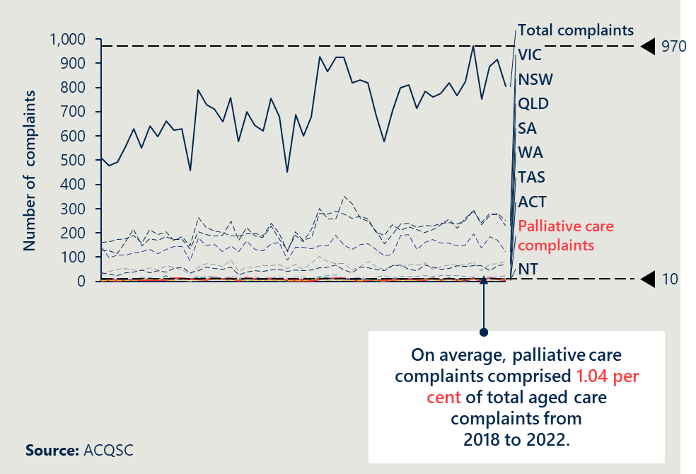

#### Outcome 10: Emerging mid-point findings

**There is some early evidence of Measure activities improving clinical governance**

Local evaluations being undertaken by three jurisdictions have focused on systematic information collection. SA, Tasmania and Queensland, through their evaluations which either solely or in part focus on CPCiAC activities, are systematically monitoring activities and outcomes within RACFs where the RACFs are implementing Measure activities. This monitoring and evaluation of activities implemented by RACFs would most likely not have occurred without the Measure.

Infrastructure such as Digital Health Record and My Health Record can enable better data collection and sharing. In ACT, the Health Directorate reported a focus in the coming months on improved data governance and collection to assist with evaluating Measure activities. Also in ACT, the PHN reported that improved systems, technology and infrastructure (as well as processes and individual capabilities) were needed to enable better communication and collection of data. This included rolling out Digital Health Record and promoting better use of My Health Record. The Tasmanian PHN also reported that implementing My Health Records could improve data sharing and care transitions.

|  |
| --- |
| Mid-point assessment of achievements of the Measure in relation to the National Palliative Care Strategy  One of the evaluation objectives is to assess the extent to which the Measure aligns and contributes to the priorities of the National Palliative Care Strategy 2018.[107]  At this stage, the evaluation has found that the Measure is aligned to priorities of the National Palliative Care Strategy. This is evidenced by:   * It aligns by design. The activities, outputs and intended outcomes of the Measure, outlined in the program logic in Appendix C, align to goals of the National Palliative Care Strategy 2018.[108] * There is emerging evidence of progress against outcomes that contribute to National Palliative Care Strategy priorities. As outlined throughout section 5.3, the early assessment of progress against national outcomes indicates progress is being made in areas that support the intent and goals of the National Palliative Care Strategy. As examples, this includes early indications that the funded Measure activities delivered by states and territories are: * improving families/carers’ ‘understanding’ (National Palliative Care Strategy Goal 1) of the benefits of palliative care and involving them in decisions about the care of their family members (see Outcomes 1 and 2, from page 30) * improving the ‘capability’ (National Palliative Care Strategy Goal 2) of personal care workers, nurses and GPs working in aged care to identify and address resident’s palliative care needs (see Outcome 3, page 33) * improving residents ‘access and choice’ (National Palliative Care Goal 3) to receive palliative care in the place of their choice, by providing more options to access palliative care within RACFs (see Outcomes 4, 5, 6, page 36) * improving ‘collaboration’ (National Palliative Care Goal 4) by strengthening the funding mechanisms that facilitate coordinating between the aged and health care sectors (see Outcomes 7 and 8, page 43) and communication between national, state and local palliative care stakeholders * improving ‘data and evidence’ (National Palliative Care Goal 6) through dedicated resources and evaluations that help with information sharing (see Outcomes 9 and 10, page 51).   There is no evidence at this stage that the Measure could be better aligned to the National Palliative Care Strategy. |

## Early success of models of care being implemented

### Key findings

* This evaluation will assess the extent to which models of care align to evidence and are achieving success.
* All states and territories are implementing models of care that align to the evidence base.
* States and territories are implementing seven different models of care.
* At this stage, most models of care have demonstrated some early success; however, many are still in the early stages of implementation.
* Regardless of the model of care, some common factors enable their success.

### Approach to assessing models of care

**This evaluation will assess the extent to which models of care align to evidence and are achieving success**

The evaluation is assessing the success of different models of care being implemented in states and territories in two ways:

1. The extent to which models of care being implemented by states and territories align to the evidence on good practice palliative care in RACFs.
2. The extent to which the models of care are achieving benefits or desired outcomes in line with the intended aims of the Measure, including what enables their success in different contexts. Given the early stage of implementation for many states and territories, this report provides an early assessment of success based on evidence available as of June 2022. The Final Report in 2023 will provide a more detailed assessment once more time has passed for benefits to be realised and measured (using jurisdictional evaluations of their models of care where available and NIHSI-AA data).

It is out-of-scope for the national evaluation to formally evaluate individual models of care or benchmark or compare palliative care outcomes across states and territories. The national evaluation will draw on jurisdictional-level evaluations of their own models of care (where available) to understand local successes, benefits and challenges.

### Alignment of models of care to the evidence base

**All states and territories are implementing models of care that align to the evidence base**

Evidence demonstrates that successful models of palliative care are often multi-component models that seek specialist input, care and/or training from specialist palliative care providers (e.g., palliative care nurses, geriatricians).[109]

The Nous literature review conducted in 2020 as part of this evaluation identified six frequently cited components of evidence-based palliative care models of care in RACFs. These were: case management, capability building, specialist in-reach and out-reach services, shared care and integrated care.

A comparison of these evidence-based components of palliative care models and the models of care being implemented by states and territories indicates alignment. All states and territories are implementing activities that incorporate one or more of these components (see Appendix F for further detail):

* Case management. A collaborative process of assessment, planning, facilitation and advocacy for options and services to meet a resident’s needs.
* Capability building. An approach to improving care provision that builds capabilities of residential aged care facility staff through education and professional development opportunities.
* Specialist in-reach or out-reach services. Care from specialist palliative care providers is provided either within or outside of the RACF.
* Shared care. Joint participation of GPs and specialists in the planned delivery of care for residents with palliative care needs, informed by an enhanced information exchange.
* Integrated care. Care that brings together inputs, delivery, management and organisation of services relating to diagnosis, treatment, care and health promotion.[110]

### Early assessment of the success of models of care

**States and territories are implementing seven different models of care**

The 46 projects being implemented by states and territories can be categorised into seven distinct models of care (see Table 4). This allows for comparison of differential benefits achieved across a diverse set of activities nationally.

Table 7 Models of care being implemented by states and territories

|  |  |  |
| --- | --- | --- |
| Model of care | Description | Implemented in |
| Access to specialist palliative care support | Specialist palliative care services are available to residents, their families and carers and staff through proactive in-reach into RACFs (e.g., SA, TAS), telehealth support (e.g., QLD), or clear referral pathways to specialist palliative care services (e.g., WA). [111] | SA, WA, TAS, QLD, NT |
| Needs rounds | Specialist palliative care practitioners collaborate with RACF staff and GPs to provide proactive assessment of residents’ palliative care needs and uplift staff capability through care planning discussions. In some models, practitioners may work together to provide case management support. | ACT, SA, QLD, TAS, NSW, NT Top End |
| Education and training | Specialist palliative care educators deliver formal education sessions to RACF staff and other practitioners involved in the delivery of palliative care in aged care (e.g., GPs). Case-based education through needs rounds and case conferencing models (e.g., NSW, NT) may also contribute to capability building. Embedded palliative care resources for RACF staff and GPs (e.g., ELDAC) support ongoing capability development and compliance with policies and procedures related to palliative care. | WA, SA, NT |
| Traineeships | Clinical and/or non-clinical staff complete an accreditation for advanced training in palliative medicine to expand the capacity and capability of both the health and aged care workforces in delivering quality palliative care (e.g., SA, TAS). | SA, TAS |
| Incentivising shared care | Mechanisms that seek to remove barriers to participation in models of shared or integrated care for key practitioners, in particular GPs. For example, in SA’s Regional Hospice in RACFs model, GPs are remunerated to participate in needs rounds. | SA |
| Access to multidisciplinary resources | Additional resources such as nurse liaisons, pharmacists and social workers, are recruited or engaged to meet the holistic palliative care needs of residents in a timely manner. MDTs may also participate in case conferences as part of ongoing case management. | NSW, SA, WA |
| Culturally safe and appropriate models of care | Focus on the delivery of holistic palliative care that addresses the specific needs and experiences of Aboriginal and Torres Strait Islander residents, their families and communities around death and dying. | VIC, NT |

**At this stage, most models of care have demonstrated some early success; however, many are still in the early stages of implementation**

This mid-point assessment of the success of models of care is primarily based on qualitative consultations and self-reported information from states and territories (see section 5.4.1). The Final Report in 2023 will use additional quantitative data from state/territory evaluations and NIHSI-AA to better understand differential benefits and impacts of models of care.

Table 5 on page 58, summarises the early reported successes of models of care (see Appendix F for further detail). In summary, it demonstrates:

* Across all models of care, an increased focus on holistic palliative care appears to support improved staff confidence and capability to identify and address residents’ palliative care needs, including ACPs (national Outcomes 1 and 3). Traineeships and funding for additional positions dedicated to palliative care have increased the capacity of RACFs to deliver quality palliative care earlier in some jurisdictions.
* Models of care that focus on shared care, integrated care and capability building (such as access to multidisciplinary supports and needs rounds) have supported improved care planning and more meaningful conversations with residents’ families and carers, and with other areas of the health and aged care system.
* Early evidence indicates that incentives for shared care, needs rounds and models that provide access to specialist palliative care support are improving issues at the interface of health and aged care through improved GP engagement, more timely access to GPs for residents and the promotion of shared care to deliver on residents’ ACPs.
* For some models of care, it is too early to identify emerging outcomes due to the jurisdiction in which it is being implemented being in the early stages of implementation. For others, it is difficult to identify where the Measure has directly contributed to the success of the model of care, or where other existing initiatives or contextual factors have contributed.

Table 8 Evidence of emerging success of models of care being implemented[112]

|  |  |
| --- | --- |
| Model of care | Evidence of emerging success |
| Needs rounds | In consultations, clinicians and RACF staff reported some emerging outcomes including:   * improved ability of RACF staff to identify and respond to residents’ palliative care needs and deterioration including earlier referrals to specialist palliative care services * increased awareness of residents’ ACPs and how to enact them, or where an ACP may be required * improved GP engagement, confidence and coordination within RACFs to deliver palliative care including anticipatory prescribing.   An evaluation of a pilot of the INSPIRED model in ACT indicated improved access to specialist palliative care for RACF residents, improved staff confidence and capability, and reduced hospitalisations. |
| Access to specialist palliative care support | In SA and WA, clinicians and RACF staff reported increased confidence among RACF staff to:   * identify the palliative care needs of residents and address deterioration earlier * deliver palliative care and to hold conversations with residents and their families * support access to psychosocial supports (e.g., social workers) to improve holistic palliative care, including to enable improved communications with families and carers.   In WA, clinicians also reported that the MPaCCS model had improved collaboration between GPs and RACF staff, including the ability of RACF staff to advocate to GPs and families on behalf of residents with complex needs. |
| Education and training | While some stakeholders reported that education and training they had received or available resources were useful, many commented on that staff capacity and turnover often undermined its ongoing success in building staff capability in the long-term. |
| Traineeships | RACF staff in SA reported some early benefits to traineeship model including:   * expanded workforce capacity (27 new trainees in total to date) * improved confidence among personal care workers through access to mentoring opportunities * improved palliative care specialist skillset across clinical and non-clinical staff and increased knowledge sharing * greater recognition and feeling valued among personal care attendants.   Tasmania has only recruited one GP Registrar position at this stage of implementation. |
| Incentivising shared care | Early anecdotal reports from clinicians and RACF staff from SA in consultations indicated that providing financial incentives to GPs may be associated with better GP participation in needs rounds. The evaluation will collect further data to assess the association with GP engagement. |
| Access to multidisciplinary resources | No evidence at this stage due to early stage of implementation of these models of care. |
| Culturally safe models of care | No evidence at this stage due to early stage of implementation of these models of care. |

**Regardless of the model of care, some common factors enable their success**

There are some commonalities in what supports models of care to be successful, regardless of which model is being implemented. These broadly align to the success factors identified in the literature review conducted as part of this evaluation in 2020. Common factors that supported early success included:

* The quality and capacity of the surrounding health system. In consultations, stakeholders emphasised the importance of effective primary and acute health system infrastructure in facilitating access to palliative care. For example, the effectiveness of needs rounds relies on the availability of nurse practitioners (or other specialist palliative care practitioners), local GPs and the capacity of RACF staff. In NT and rural areas of Queensland, there is a lack of GPs and allied health staff which inhibits the success of multidisciplinary models of care.
* **Open communication between families/carers and RACF staff.** Families and carers need communication to understand their family member is being cared for. COVID-19 heightened the need for clear continuity of care between acute and RACF settings because of RACF lockdowns and the inability of families/carers to visit RACFs.
* **Mechanisms and processes to support staff to triage and identify residents needing palliative care***.* High workforce turnover limits the effectiveness of one-off education and training for RACF staff. An emerging finding from the May 2022 stakeholder engagements is to embed education policies and procedures into RACF settings, to ensure a more sustainable investment of education and training initiatives. Stakeholders also consistently emphasised the importance of ACPs to support shared and integrated care for residents and their families and carers.
* **Working collaboratively with stakeholders, including RACF leadership.** Stakeholders reported that engagement with RACFs to ensure buy-in was essential to the implementation of new models of care. For example, clinicians in SA identified that where LHNs were responsible for nominating RACFs to participate in education and training, rather than self-nominated participation, staff were less engaged (due to capacity constraints) and it was challenging to identify educational needs.

|  |
| --- |
| Case study 7: SA is incentivising GPs to participate in needs rounds to respond to poor GP engagement in aged care.  SA is trialling an innovative model of incentivising GPs to participate in needs rounds, recognising the importance of having the primary provider of care attend needs rounds with a specialist. Given sector wide challenges to engage GPs in aged care and palliative care, particularly in rural settings, GPs were invited to participate in needs rounds through incentive. Flinders University will undertake an evaluation of the model, however emerging insights identified 19 GPs attended 59 needs rounds. Interestingly, GPs with trainees began to bring registrars and interns, suggesting the model is valuable from a model of care perspective and an education perspective. |

|  |
| --- |
| Case study 8: Queensland and Victoria are focusing on providing palliative care services for Aboriginal and Torres Strait Islander communities  In Queensland, the Torres Strait and Cape SPACE project utilised SPACE funding to expand their palliative care focus. They conduct a pop-up palliative care service focused on liaising with local communities to develop their approach to palliative care. In Victoria, Measure funds are being used to recruit a coordinator role for the Resident Elders program. The program is in the very early stages but is designed to promote culturally safe Aboriginal and Torres Strait Islander palliative and end-of-life care for elders. |

## Extent to which the Measure addresses interface issues

### Key findings

* Improving palliative care in RACFs requires addressing issues at the interface of the health and aged care systems.
* At this stage, the Measure is an effective mechanism to improve interface issues. It encourages collaboration, strong relationships and shared responsibility between key players.

**Improving palliative care in RACFs requires addressing issues at the interface of the health and aged care systems**

The term ‘health and aged care interface’ is used in this context to refer to the intersection between the health and aged care systems. It describes how people with palliative care needs living in RACFs access the health system while in the aged care system (the RACF), or as they transition between the primary or acute health system and the aged care system.

The literature review conducted as part of this evaluation in 2020 identified the key health interface issues that RACFs, primary care and acute care sectors are seeking to address.[113] These were:

* access to primary health care services[114]
* access to secondary and tertiary health care services, such as specialists or allied health professionals[115]
* avoiding unnecessary transfers to hospital EDs, which are often due to challenges accessing appropriate health services from within the RACFs[116]
* poor clinical handovers that occur when residents are required to transition between RACFs and the health system[117]
* coordination of the various health and aged care services that a person is accessing[118]
* continuity of care when transitioning into a RACF and communication between hospitals and RACF when transitioning between health and aged care services[119] which includes poor clinical handovers that occur when residents are required to transition between RACFs and the health system[120]
* a lack of support to navigate the complex health and aged care systems.[121]

**At this stage, the Measure is an effective mechanism to improve interface issues**

There is emerging evidence that the Measure is an effective mechanism to address health-aged care interface issues (recognising the early stage of implementation for many states and territories, meaning some benefits and outcomes are yet to be realised and/or measured).

Early progress against some national outcomes indicates improvements in coordination between clinicians, care settings and in the interface issues (see section 5.3). There is some very early evidence of improvements related to coordination between GPs/primary care, acute care services and specialist palliative care services.

|  |
| --- |
| “If we just had state funding, we’d only be talking about hospital avoidance, as from a health service provider perspective, we are funded for acute services. [The Measure] has provided leverage to focus on the whole spectrum of palliative care in aged care.”  State Health Department, April consultation round 2022 |

There are two ways in which the Measure has supported improvements to date:

* As a funding instrument, the Measure design encourages increased collaboration of health and aged care system stakeholders. A joint funding arrangement creates shared investment and accountability that supports improved collaboration across health and aged care stakeholders in states and territories (as reported by four state and territory health departments, and many RACF staff and clinicians in consultations in 2022). Section 5.6 details effectiveness of joint funding and delivery arrangements under the Measure to improve collaboration at the interface of health and aged care.
* The projects and models of care being implemented in states and territories respond to identified interface issues (see section 5.6). At least six states and territories have implemented needs rounds, incentives to deliver shared care and access to specialist palliative care that encourages collaboration and coordination between health and aged care stakeholders. For example, Queensland, SA and ACT have implemented models of care that include the education and engagement of GPs, such as financial incentives for GP participation in needs rounds, to improve timely access to GP supports for RACF residents. The models of care and their effect on interface issues are summarised in section 5.4.3 and in detailed in Appendix F.

|  |
| --- |
| Case study 9: The nurse liaison role in WA is improving the interface between health and aged care.  The role is improving the interface between hospitals and RACFs by smoothing the transitions of individual residents across these settings and minimising the use of acute hospital resources. The nurse liaison is a crucial resource for care coordination and collaboration, through facilitating appropriate handover from hospital discharge to RACFs. |

## Effectiveness of joint funding and delivery arrangements

### Key findings

* Joint funding aims to create a shared responsibility and investment in the outcomes of care.
* At this stage, the Measure has demonstrated success at improving collaboration at the health-aged care interface.
* Greater engagement between the Australian Government and states and territories in developing the Measure would have prevented some of the implementation delays.
* The time limited, unweighted funding limited what some states and territories would invest in.
* Lack of clear accountability and specificity for data collection and reporting makes it more challenging to understand the national impact of the Measure.

**Joint funding aims to create a shared responsibility and investment in the outcomes of care**

The Australian and state/territory governments have overlapping responsibility for delivering palliative care in aged care (see section 4). This means joint activity from both the Australian and jurisdictional governments is needed to achieve improvements in the delivery of palliative care in aged care.

Joint funding through a matched funding model in the form of a National Partnership Payment (Project Agreement), such as the Measure, is one mechanism to facilitate that cross-government activity.[122] It is a tangible commitment from both levels of government around a common goal and ensures dedicated funds to support achievement of an agreed goal (in this case, improving access to quality palliative care in RACFs and better integrating the health-aged care system).

Analysis by the Productivity Commission has identified challenges in the historical design and implementation of Project Agreements, in part due to intergovernmental dynamics.[123] Overlapping responsibilities have led to conflict over responsibilities and uncertainty about coordination of service provision. Funding arrangements vary across states and territories, leading to regional variation and a lack of national consistency in services delivered, which is further complicated at the interface of aged care and health systems.[124]

**At this stage, the Measure has demonstrated success at improving collaboration at the health-aged care interface**

The Measure is emerging as an effective mechanism to improve the interface of health-aged care in relation to palliative care. All states and territories, except for NSW, pooled their funds and dedicated them to joint activities aligned to the Measure’s aims. NSW are still delivering activities that align to the Measure’s aim, but rather than pool funds, they are distributing state and commonwealth funds in a different way. The Commonwealth contribution of funds was provided by NSW Health to each LHD in $150,000 payments. The NSW contribution for the Measure was sourced from an existing state commitment to fund nursing positions. While other states and territories’ annual contribution matches that of the Commonwealth’s, NSW opted to slowly increase the annual contributions over the life of the Measure. NSW also opted to only receive and match $10 million from the Commonwealth, rather than the originally proposed $17 million.

At this stage, the national evaluation has identified emerging benefits of the joint matched funding arrangement aligned to the aims of the Measure.

Figure 18 provides specific examples for each state and territory, with national insights summarised below:

* Joint funding has enabled greater scale and scope of jurisdictions to respond to palliative care in aged care that otherwise would not have occurred. Jurisdictions indicated this was for two reasons:
  1. Joint funding has been used to provide additional resources, which was reported as one of the key barriers to providing better access to palliative care in RACFs. For example, ACT, NSW, NT, SA, Tasmania and WA used the funds to increase FTE for over 40 roles such as CNCs, nurse practitioners, nurse liaisons and social workers.
  2. The joint funding enabled specialist palliative care services to focus on palliative care outside community and hospital settings. WA reported that the joint funds meant there was greater scope for projects to focus on expanding access to more holistic palliative care earlier in the stage of dying when people are still in RACFs. They indicated that state-only funding would likely have focused on end-of-life care provided in hospital settings.
* Joint funding has strengthened collaboration to improve palliative care between health and aged care stakeholders. Six states and territories reported that joint funding has helped address siloed ways of working and align staff around a common purpose. For example, Queensland and WA indicated it is easier for state-funded health services to engage with RACFs and to organise clinicians and aged care workers around a shared goal (as opposed to being distracted by revenue streams). Conversely, only one of the eight states did not report increased collaboration because of the Measure. Victoria reported that CPCiAC funds are not contributing to a particular model of care, due to the time limited nature of the funds. They reported the only progress made so far has been on expanding existing community-based palliative care services.
* Joint funding and delivery arrangements have enabled design of innovative models of care. States and territories reported many examples of innovative models of care being possible due to Measure funding. These include SA’s Eldercare traineeships (which funds 27 new trainees) and funding for community pharmacists. It also includes WA’s nurse liaison role which helps to expand use of ACPs and QLD’s multi-service Teams site that facilitates daily discussions and virtual handovers to support strong relationships across aged care, community and acute settings.

Figure 18 provides examples of the effectiveness of the joint funding and delivery arrangements (based on consultations with, state and territory health departments and RACFs and clinicians in 2022).

Table 9 Effectiveness of joint funding and delivery arrangements[125]

|  |  |
| --- | --- |
| Queensland | The joint funding has provided an opportunity for the specialist palliative care team to connect RACF staff with what is available in palliative care and has facilitated contacts. |
| NT | There are mixed views towards the effectiveness of joint funding and delivery in NT. Central Australia emphasised the inability of the funding to target the structural, system-level changes required in NT. Top End NT reported improved collaboration and relationships between RACFs and specialist palliative care teams which did not exist before. |
| Tasmania | The arrangement has brought together representation from the residential aged care sector, specialist palliative care sector, General Practice and Department of Health. |
| SA | The funding arrangement has enabled collaboration between aged care and health care, as services are recognising the benefit of leaning on each other (e.g., sharing nurse practitioners during staff shortages). Combined funding has enabled state government service providers to work in and with aged care facilities. |
| WA | The WA health department indicated that that if it were only state health funding being used, their projects would have focused on hospital avoidance, as a funder of state health services. However, given the joint funding and leverage provided by the Australian Government involvement, their projects focus more broadly on needs identification through to systemic responses and holistic palliative care. |
| ACT | The joint funding through the Measure allows residents to access palliative care through health system teams going into RACF settings. |
| Victoria | The joint Commonwealth-state funding has mostly contributed to continuing and expanding community-based specialist palliative care providers who can support RACF residents. |
| NSW | NSW reported that Commonwealth-state funding was not combined when distributed to LHDs; however, LHDs reported that funds have strengthened local relationships between primary care, LHDs and RACFs. |

**Greater engagement between the Australian Government and states and territories in developing the Measure would have prevented some of the implementation delays**

The matched funding used for this Measure is an innovative approach to the challenge of developing collaboration and shared responsibility at the interface of health and aged care. At the mid-point, there are emerging signs that collaboration and less siloed approaches are being developed.

However, a significant drawback in the approach is that due to budget confidentiality, there was no opportunity to partner with the jurisdictions in the development of the Measure. Based on consultations with the Australian Government and state and territory health departments, this meant that:

* Jurisdictions were not informed in advance about the joint funding requirements.
* Not all jurisdictions were able to find new funds to match the Australian Government funds (as they were not able to earmark jurisdictional budgets in advance).
* During subsequent negotiations, there was confusion among some states and territories as to whether matched funds equated to contributions in-kind, but this was never an option. The contributions were always required to be financial, and these differing views between the commonwealth and states and territories contributed to delays in states and territories signing up to the Measure. Nevertheless, at least one state did not match the available funding from the Australian Government.
* It has been challenging for some jurisdictions to adopt a partnership approach when they did not feel like partners in its design.
* There were significant delays to implementation after the funding was announced. While funding to jurisdictions commenced in 2019-20, four of the eight jurisdictions did not sign up until 2020 (and two of those were not until 2021). While this was partly attributable to COVID-19 issues, it also resulted from the need to find jurisdictional funding to match the Commonwealth budget funding.
* Implementation delays have flow on effects for understanding the impact of the Measure, given projects were significantly delayed or only partially and incompletely implemented, and thus measurement of benefits/outcomes is delayed.

**The time limited, unweighted funding limited what some states and territories would invest in**

States and territories indicated two aspects of the funding created challenges for some of them, as outlined below:

* Time limited nature of the funding limited what some states/territories were prepared to fund. Five states and territories reported that they were hesitant to invest in some ongoing initiatives, given the potential risk to service continuity and sustainability. For example, NSW indicated they were prioritising models and positions which could be feasibly scaled back. SA, NT and WA indicated that the funding raises expectations about ongoing service delivery or leaves states with the risk of industrial action at the end of the Measure. This aligns to evidence, which demonstrates that time-limits in national agreements can de-incentivise systemic improvements.[126] In some cases, jurisdictions were able to secure ongoing state/territory budget funding to match the Commonwealth funding and were thus able to use the funding more effectively in a sustainable manner (ACT and Tasmania).
* Unweighted funding allocations limits the impact in smaller jurisdictions. The Project Agreement funding was not weighted by rurality or Aboriginality, rather based on a per-capita distribution. Typically, these sorts of agreements would incorporate a weighting approach to account for the varying levels of rurality and Aboriginality of state and territory populations, and the known higher costs of servicing these populations. NT reported this limited the ability to invest in larger scale initiatives that would address more systematic barriers to palliative care in aged care.

**A lack of specificity for required data collection and reporting makes it more challenging to understand the national impact of the Measure**

Two aspects of the Project Agreement create challenges measuring the national impact of the Measure and/or assessing the success of jurisdictional implementation approaches and models of care. These were:

* A lack of specificity around data collection and evaluation requirements impacts the ability of the national evaluation to measure impact. The current milestone reporting template focuses on implementation progress against specific project outputs as opposed to collecting data against nationally agreed indicators or outcomes data. The opportunity to specify requirements for states and territories about the type (and timing) of data to collect and share and/or specific funding for state/territory evaluations would enable more rigorous monitoring of success of models of care.

These emerging insights indicate that some elements of national partnership agreements related to palliative care in aged care would benefit from greater specificity than others. Allowing for flexibility in approaches and to design projects that meet local needs allows states and territories to exercise their judgement as to where funding is allocated, yielding outcomes that address jurisdictional specific issues.[127]

* Conversely, roles and responsibilities, data sharing, evaluation scope and timing requirements, require greater specificity. For cooperation to be effective, there needs to be a recognition of ‘who is responsible for what’ to ensure the necessary structural and regulatory changes can occur.[128] To evaluate the impact of investments at the national level, specific data sharing and evaluation requirements should be stipulated. An absence of adequate data weakens the basis for performance reporting and can adversely affect policy making.

Figure 19 depicts the flexibility or specificity of key elements of the Project Agreement and a potential ideal arrangement.[129] The figure illustrates how the Measure is performing against key elements of Measure design, predominantly informed by evidence of good practice outlined in the Nous literature review.[130] The assessment of how the Measure is performing against these elements is based on evidence of the extent to which these elements were in place, collected through the qualitative data collected through six-monthly data collection and consultation with states and territories.

Figure 17 Assessment of the Measure design against ideal arrangements[131]

The key features of the Measure design assessed are objectives, roles and responsibilities, projects/models of care, local implementation approach, data sharing requirements, and local evaluation scope and timing. These are assessed on a sliding scale from 'limited stipulations' and 'significant specificity'. 
Objectives, projects/models of care and local implementation approach under the current design are close to ideal arrangements and all have relatively limited stipulations. Alternatively, roles and responsibilities, and local evaluation scope and timing are both very far from the ideal arrangements with limited stipulations where they should ideally have significant specificity. Roles and responsibilities has significant specificity although ideal state would have even more specificity.

# Glossary

|  |  |
| --- | --- |
| Abbreviation | Term |
| ACD/ACPD | Advance Care Directives/Advance Care Planning Documents |
| ACP | Advance Care Plan |
| ACFI | Aged Care Funding Instrument |
| ACQSC | Aged Care Quality and Safety Commission |
| ACT | Australian Capital Territory |
| AHHA | Australian Healthcare and Hospitals Association |
| AHSRI | Australian Health Services Research Institute |
| AIHW | Australian Institute of Health and Welfare |
| AN-ACC | Australian National Aged Care Classification |
| APC | Admitted Patient Care |
| CALD | Culturally and linguistically diverse |
| CNC | Clinical nurse consultant |
| COVID-19 | Coronavirus disease (COVID-19) is an infectious disease caused by the SARS-CoV-2 virus. The COVID-19 pandemic, also known as the coronavirus pandemic, is a global pandemic of coronavirus disease, commencing in 2019. |
| CPCiAC | Comprehensive Palliative Care in Aged Care (The Measure) |
| ED | Emergency Department |
| EMR | Electronic medical record |
| ELDAC | End-of-life Direction for Aged Care |
| FTE | Full time equivalent |
| FWLHD | Far West Local Health District |
| GCfAHPC | Greater Choice for At Home Palliative Care |
| GP | General Practitioner |
| GRACE | Geriatric Rapid Acute Care Evaluation |
| ICD | International Classifications for Diseases |
| INSPIRED | Integrating specialist palliative care into residential care for older people. The trial of PCNR in the ACT which started in February 2017, conducted by Calvary Centre for Palliative Care Research and Calvary Public Hospital Bruce and was funded by ACT Health. |
| HHS | Hospital and health service |
| KEQs | Key evaluation questions |
| LHD | Local Health District |
| LHN | Local Health Network |
| MBS | Medicare benefits schedule |
| MPaCCS | Metropolitan Palliative Care Consultancy Service |
| MDTs | Multidisciplinary teams |
| MPSs | Multi-purpose services |
| NDI | National Death Index |
| NIHSI-AA | National Integrated Health Services Information (NIHSI) Analysis Asset (AA) |
| NSW | New South Wales |
| NT | Northern Territory |
| Non-specialist provided palliative care | Palliative care provided by GPs, nurses, allied health or any service provider that does not have specialist qualifications |
| PAF | Palliative Approach Framework |
| PBS | Pharmaceutical Benefits Scheme |
| PCA | Palliative Care Australia |
| PCNR | Palliative Care needs rounds model implemented the PEACE team in the ACT, based on the INSPIRED trial in the ACT. |
| PaCSA | Palliative Care Self-Assessment portal |
| PCOC | Palliative Care Outcomes Collaboration |
| PEACE | Specialist Palliative Aged Care team at Clare Holland House in the ACT. |
| PEPA | Program of Experience in the Palliative Approach |
| PHN | Primary Health Network |
| PHT | Primary Health Tasmania |
| PRAC | Permanent residential aged care |
| Project Agreement and sub-agreements | National project agreement and specific state and territory sub-agreements/schedules. |
| RACEPC | Residential Aged Care Excellence in Palliative Care |
| RAC | Residential Aged Care |
| RACF/s | Residential Aged Care Facility/ies |
| SA | South Australia |
| SPACE | Specialist Palliative Care in Aged Care Project in Queensland. |
| Specialist palliative care | Palliative care provided by clinicians that specialise in palliative care, including nurses, doctors and specialist teams. |
| The Department | Refers to the Australian Government Department of Health and Aged Care. |
| The Measure | Comprehensive Palliative Care in Aged Care (CPCiAC) Measure |
| The Royal Commission | The Royal Commission into Aged Care Quality and Safety was established on 8 October 2018 to inquire into the quality and safety of aged care in Australia. Further information is available at https://agedcare.royalcommission.gov.au/. |
| WA | Western Australia |

1. National palliative context and Measure activities

This appendix provides:

* an overview of national palliative care strategies, reforms and contextual information relevant to the implementation of the Measure and delivery of palliative care activities in RACFs
* an overview of each state and territories’ strategic and policy context, what they planned to implement under the Measure and progress made in implementation to 30 June 2022.

Information in this appendix is drawn from:

* a review of publicly available grey literature as at 30 June 2022
* publicly available national data sets (such as GenAged Care)
* information provided by (and consultations with) state and territory health departments every six months from April 2021 to June 2022.
  1. National palliative care context

There are several national palliative care strategies or frameworks that aim to guide access to and the quality of palliative care in Australia, including in aged care settings. Key national palliative care and/or aged care strategies and frameworks relevant to the Measure include:

* The Royal Commission into Aged Care Quality and Safety released its Final Report in February 2021. It sets out comprehensive findings including related to palliative care access and quality in aged care. Implementation of its recommendations will continue to impact the context the Measure is implemented in.
* National Palliative Care Strategy (2018) represents the significant commitment of the Australian Government, and state and territory governments to ensure the highest possible level of palliative care is available to all people. This strategy provides explicit guidance for the Australian Government and states and territories to improve palliative care services.
* Palliative Care Self-Assessment portal (PaCSA) is an online self-assessment against PCA’s National Palliative Care Standards (5th ed.) and the National Safety and Quality Health Standards (2nd ed.). The assessment results in an improvement action plan, which can be used by RACFs to identify areas for development and subsequently improve.
* National Safety and Quality Health Service Standards were developed by the Australian Commission on Safety and Quality in Health Care in collaboration with the Australian Government, states and territories, private sector providers, residents and carers. The standards aim to improve the quality of health service provision, including palliative care services. They provide general guidance to RACFs in ensuring safe and quality delivery of health care.
* Aged Care Quality Standards, developed by the ACQSC, provide quality indicators for care and services in aged care, including palliative care services. These standards are being increasingly used in RACFs as quality performance indicators. They refer to but do not have a discrete standard for palliative care.
* The Mandatory Quality Indicator Program collects quality indicator data from RACFs every three months. Services must report against three quality indicators for each participant: pressure injuries, use of physical restraint and unplanned weight loss, with two further indicators in development. They are not specific to palliative care but provide information that can be used to improve the quality of services provided to residents.
* Advance Care Planning Australia is a national program that provides resources to people, care workers and healthcare professionals to improve uptake of ACPs, including in RACFs. There are several challenges related to ACPs, including language, comprehension and inter-state recognition, which are being addressed by some of the nationally funded activities.
* PCA released the National Palliative Care Standards for All Health Professionals and Aged Care Services: for professionals not working in Specialist Palliative Care. These aim to support better experiences and outcomes for people receiving non-specialist palliative care. They are intended to guide health providers working in aged care (and other settings).

As of June 2022, the Department funds 17 national palliative care initiatives. Some of these will impact or be available in facilities as models of clinical care, education and training initiatives and activities to improve end-of-life decision making. Examples include PCOC, Care Search, End-of-life Law for Clinicians, The Advance Project, the Palliative Care Online Training Portal and more.

* 1. Detail on jurisdictional approaches and activities

This appendix provides detailed information on state and territory approaches to implementing the Measure. For each state/territory, the summary provides:

* key statistics, such as total Measure funding and the number of RACFs and residents
* key policy priorities and/or contextual information related to palliative care in aged care
* activities originally planned under the Measure
* progress made in implementation to June 2022 and any early benefits reported.
  + 1. Australian Capital Territory

ACT has rolled the PCNR model out across the territory. Implementation of Measure-funded activities is progressing, however there are challenges in recruiting for funded roles.

Table 10 Implementation approaches and activities in the ACT

|  |  |
| --- | --- |
| Summary | * Total funding: $2.2 million * Population in RACFs: 2,267 * Number of RACFs: 29 * Number of RACFs impacted by Measure activities: 28 * Evaluation being undertaken: No * Delivery approach: centralised delivery. Coordinated by the PEACE team at Calvary Public Hospital Bruce, Clare Holland House |
| What is the policy and operating context? | * ACT is predominantly using Measure funds to expand the INSPIRED model across the ACT, which was previously evaluated through a randomised controlled trial and is now referred to as the PCNR model. The trial of needs rounds in the ACT started in February 2017, conducted by Calvary Centre for Palliative Care Research and Calvary Public Hospital Bruce and was funded by ACT Health. * ACT also has a Geriatric Rapid Acute Care Evaluation (GRACE) team who sit alongside the PCNR model and help to manage the transfer of aged care patients to and from hospital (not necessarily aged care patients). The GRACE service provides clinical care to RACFs residents to better manage their conditions, preventing a trip to hospital. |
| What did ACT plan to implement? | * Nurse Practitioners and needs rounds – Recruit 4.3 FTE palliative care nurse practitioners to roles to support the delivery of specialist palliative care services, both in-reach and out-reach, to all RACFs across the ACT through a PCNR model of care. * Education and training for RACFs to build capacity and capability in all RACFs and workforce succession planning. * Expand and build on existing in-reach models of specialist palliative care within RACFs across the ACT with care being delivered based on the risk stratification and clinical need of residents, identified through PCNR, case conferences and clinical work through referrals. The PCNR model consists of three components:  1. PCNR 2. Case Conferences 3. Clinical work with residents |
| What has been progressed as at June 2022? | Implementation progress includes:   * The PCNR model has been fully rolled out across the ACT and is ongoing. At least one component of the PCNR model is being implemented in 28 of the 29 RACFs in the ACT. From November 2021 to April 2022, there were needs rounds delivered monthly in 22 sites, 158 new residents identified during the needs rounds, 114 case conferences delivered, 193 visits for comprehensive palliative assessments and 2015 patients admitted to the service. Onsite training to RACF staff is being delivered during monthly needs rounds and support has been provided to RACFs through the ACT PEPA. * The major barrier to implementation has been the recruitment of Nurse Practitioners to the funded positions. 4.3 FTE Nurse Practitioners are funded, however there is 1.0 FTE Nurse Practitioner remaining (due to retirement and turnover) and 1.0 FTE CNC level. COVID-19 has also impacted RACFs through: increased deaths, unmet need for psychological support among residents and lockdowns preventing face-to-face needs rounds. |
| What evidence exists of early benefits? | Early benefits of the Measure activities include:   * ACT RACFs reported that needs rounds help to increase staff confidence to hold palliative care conversations and equip RACF staff to better identify and respond to patient needs. * Needs rounds and the PEPA program has provided support to RACF staff. Impacts include: improved staff morale (e.g., as a result of conducting a ‘Guard of Honour’ as the body of a deceased resident is taken from the RACF by funeral directors), improved awareness of palliative care, increased knowledge about identifying signs of deterioration and sharing learnings among staff. * One RACF in the ACT, run by Uniting Care, has assigned a Registered Nurse to conduct the needs rounds for one dedicated day per month. The nurse also completes case conference coordination and paperwork to support GP involvement. Specialist clinicians reported this approach has led to better coordination with the GP clinics, better anticipatory prescribing to residents and a better experience of death and dying for residents, because plans are in place and are being used effectively. |

Table 11 Models of care implemented in the ACT

|  |  |  |
| --- | --- | --- |
| Model of care | Description | Model of care category |
| PCNR | Monthly 60-minute triage (and risk stratification) meetings, where up to ten residents with a short prognosis and high symptom burden are presented. | Needs rounds |
| Case conferences | Case conferences between RACF, the resident, relatives and relevant health care providers (e.g. the GP) are facilitated by either the PCNR team or RACF staff. | Needs rounds |
| Clinical work with residents | Both needs rounds and case conferences may lead to referrals for direct specialist palliative care clinical work with residents. | Access to specialist palliative care support |

* + 1. New South Wales

LHDs in NSW have each received equal Commonwealth funding and developed local plans to implement the Measure. Implementation is progressing across many LHDs.

Table 12 Implementation approaches and activities in NSW

|  |  |
| --- | --- |
| Summary | * Total funding: $20 million * Population in RACFs: 60,287 * Number of RACFs: 934 * Evaluation being undertaken: external evaluation of broader framework * Delivery approach: de-centralised delivery. LHDs received equal funding to develop local plans that reflect local needs. |
| What is the policy and operating context? | * The NSW Health End of Life and Palliative Care Framework 2019-24 has influenced reviews of local services. The NSW Ministry of Health has contracted an external evaluation of the Framework, across five priorities. As part of this evaluation, CPCiAC will be covered in three case studies. There has also been state budget commitments (in 2017, 2019, 2020 and 2021) on workforce enhancements, use of virtual care, education and training, refurbishments, medical specialists, and regional and rural services. |
| What did NSW plan to implement? | * LHDs received equal funding to develop local plans that reflect local needs. The plans outline appropriate models of care to address gaps and indicates where workforce will be enhanced. 13 LHDs have commenced implementation of local projects. * Seven districts have identified models of care to improve palliative care for older Australians living in residential aged care facilities in their regions. These models include:  1. Needs rounds model 2. Adapted Decision Assist linkages model 3. The “Pop Up” model 4. Working together ELDAC model 5. Compassionate hospitals project 6. Improved pathways and virtual care model 7. Education and training focus |
| * What has been progressed as at June 2022? | * Many LHDs are recruiting designated roles, including Clinical Nurse Specialists, Nurse practitioners, Network Managers, Allied Health and a Palliative Care Medical Registrar. Several LHDs have a particular focus on training, in particular Far West, Murrumbidgee, Nepean Blue Mountains, Northern NSW and Western NSW LHDs. * COVID-19 was the major barrier to implementation in 2021 to 2022. Impacts include: delayed recruitment of new Measure-funded positions, RACF lockdowns preventing access for contracted service providers (e.g., ELDAC), RACF staff furloughing and management of outbreaks prevented effective engagement and increased workload for clinicians providing outreach to RACFs which prevented progress on development of new models of care. * Unspent funds were allocated to the geriatric flying squads that were able to increase FTE and provide education sessions in RACFs in South Eastern Sydney Local Health District. There has also been increased use of digital platforms to provide support during lockdowns and integration of existing district nursing services to bolster support for RACFs particularly on weekends. Six districts are planning to rollover funds to FY 2022/23 that were unspent due to delays in recruitment and contracting third parties to deliver services. |
| What evidence exists of early benefits? | Early benefits of the Measure activities include:   * A number of LHDs have reported specific examples of strengthening local level relationships and pathways between primary care, LHD and RACF staff to help ensure integrated care: * FWLHD has adapted the ACT’s PCNR model to suit the area. The Measure-funded CNC is supporting needs rounds and reported a 200 per cent decrease in ED presentations for end-of-life care in the first six months of implementation. * Hunter New England has purchased new equipment and reported that the consultancy and partnership approach between Palliative Care and Aged Care services has been received positively. * Murrumbidgee reports that the Measure has enhanced the profile of the Palliative Care Service across the LHDs RACFs and strong collaborative working relationships between the palliative care specialist team and the RACFs have been established, with a reduction in unsuitable referrals and changes in conversations around promoting a death of choice. * Sydney LHD reported that the measure has supported increased access to specialist palliative care support for all RACFs. The development of a "Complex Palliative Care" definition tool has facilitated timely and appropriate referrals to the RACF Palliative Care CNCs (and the broader Specialist Palliative Care Service). |

Table 13 Models of care implemented in NSW

|  |  |  |
| --- | --- | --- |
| Model of care | Description | Model of care category |
| Needs rounds model | Six districts are implementing needs rounds which provide direct clinical support for residents and monthly one-hour triage meetings. | Needs rounds |
| Adapted Decision Assist linkages model | Specialist Palliative Care Link-Nurse to embed systems and clinical frameworks for a sustainable palliative approach to care in RACFs and RAC beds. | Access to specialist palliative care support |
| The “Pop Up” model | Specialist Palliative Care in Residential Aged Care will facilitate specialist palliative care in the 12 MPSs. | Access to specialist palliative care support |
| Working together ELDAC model | Working with ELDAC to build capacity within all RACFs across an LHD. Focuses on capacity building, technology, information sharing, improved partnerships. | Access to multidisciplinary resources |
| Compassionate hospitals project | Facilitate early identification, management and planning for dying patients and support for their families during death and bereavement. | Education and training |
| Improved pathways and virtual care model | Education/training development for RACF clinicians and primary care providers. Focus on partnerships, sharing policy/guidelines and virtual care. | Education and training |
| Education and training focus | All districts have incorporated capacity building of RACF staff into their models and/or positions. Five districts are focusing on education and training.  Education and training approaches include the Palliative Approach Framework (PAF) resource embedded in facilities and used during needs rounds discussions, PEPA education sessions and pop-up training sessions from district nurses. | Education and training |

* + 1. Northern Territory

NT has two projects underway in Central Australia and Top End. The Measure is being used to establish in-reach screening rounds and provide additional education, training and support to the RACF workforce.

Table 14 Implementation approaches and activities in NT

|  |  |
| --- | --- |
| Summary | * Total funding: $1 million * Population in RACFs: 489 * Number of RACFs: 13 * Evaluation being undertaken: monitoring * Number of RACFs impacted by Measure activities: 7 * Delivery approach: centralised delivery. Managed and coordinated by the Department of Health, two project teams operating in Central Australia and Top End. |
| What is the policy and operating context? | * Stakeholders in the NT identified structural and system-wide issues that have hindered implementation, particularly in the Central Australia Region. These included limited capacity of RACFs to provide palliative care, limited capacity in the clinical health workforce (including GPs) and challenges retaining RACF staff. * Stakeholders have reported difficulties providing consistently high-quality and holistic palliative care in the RACF settings across NT given the structural issues and workforce challenges. COVID-19 exacerbated these challenges. |
| What did NT plan to implement? | * Project 1: Central Australia Palliative Care Coordination * Project 2: Top End Palliative Care Coordination |
| What has been progressed as at June 2022? | Implementation progress includes:   * COVID-19 impacted the regular screening visits to RACFs across Central Australia and Top End. RACF staff were redeployed to hospitals from RACFs. * Top End implementation is ahead of schedule, with an additional RACF brought on for screening rounds in April 2022. Telehealth screening rounds, conducted by the specialist palliative care team nurse practitioner, continued throughout COVID-19 in Top End. * Central Australia is delayed in implementation, due to COVID-19 challenges and associated issues with staffing. Tennant Creek regular visits were expected to resume in May 2022. Ongoing RACF education continued throughout COVID-19 via phone, in Central Australia. * Case-by-case education is being conducted, which has shifted from original general education sessions, due to COVID-19 and early implementation lessons of high staff turnover. |
| What evidence exists of early benefits? | * The Tennant Creek RACF is more willing to contact the Central Australia Regional Health Service Palliative Care Team when advice is required. This has led to an increased confidence to provide palliative care within the facility and reduce unnecessary hospital transfers. RACF staff have continued to manage deaths in the RACF with support from the community palliative care team. * Supply of end-of-life medications to the RACF has improved. GP involvement has proven to still be an issue for the RACFs as they are reluctant to visit the RACF out of hours for support and assessment of patients. * In the Top End, RACF staff are showing improved awareness and understanding of palliative care which seems to be reducing unnecessary admissions of residents to NT public hospitals. Referrals to palliative care have increased by 457 per cent from February-October 2020 to February-October 2021 (as reported by Top End in April 2022.) * Relationships between GPs and RACFs has improved as a result of the Measure. |

Table 15 Models of care implemented in NT

|  |  |  |
| --- | --- | --- |
| Project | Description | Model of care category |
| Project 1: Central Australia Palliative Care Coordination | Project 1 has shifted from the initial model of care, which was the Palliative Needs Assessment approach. This approach included PCNRs and additional support for RACFs and attending GPs to develop a plan for end-of-life preferences.  Project 1 now consists of a regular cycle of basic palliative care education for RACFs. This includes site visits, patient referrals, support for care staff, debriefing of deaths. Project 1 has focused on the Tennant Creek RACF, due to identification of significant needs. | * Access to specialist palliative care support * Education and training |
| Project 2: Top End Palliative Care Coordination | Project 2 aims to establish and formalise relationships with RACF GPs nursing staff and clinical leads of the four RACFs in Top End NT.  Project 2 provides regular palliative care screening rounds and includes the development of education schedules for RACF staff and Palmerston Regional Hospital staff. Telehealth methods are being used by Palmerston Regional Hospital to avoid delays in seeing patients, hence preventing unnecessary admissions to Royal Darwin Hospital. | * Access to specialist palliative care support * Needs rounds * Education and training |

* + 1. Queensland

Queensland have taken a devolved but collaborative approach, with each HHS on track to implement a context-specific model of care aligned to local need.

Table 16 Implementation approaches and activities in QLD

|  |  |
| --- | --- |
| Summary | * Total funding: $18 million * Population in RACFs: 36,273 * Number of RACFs: 513 * Evaluation being undertaken: internal evaluation * Number of RACFs impacted by Measure activities: 419 * Delivery approach: decentralised delivery. Managed and coordinated by a central team in the health department but with decision-making authority delegated to each HHS to use funding to design and deliver individual models of care. |
| What is the policy and operating context? | * The state-wide Strategy for End-of-Life Care (2015) describes the components of end-of-life care across all levels of care and identifies key service directions to guide planning and service development, though does not explicitly reference RACFs. The Parliamentary Inquiry into Aged Care, End-of-Life and Palliative Care in Queensland presented 22 recommendations related to palliative care in March 2020. In 2022, Queensland Health released an updated Palliative and End-of-Life Care Strategy. * The Palaszczuk Government passed the Voluntary Assisted Dying Act 2021 in September 2021, which will come into effect from 1 January 2023. In 2020, it also announced $171 million over six years in additional funding for palliative care services. |
| What did QLD plan to implement? | * Each Queensland HHS has developed and implemented a service model appropriate to their local context based on engagement with local RACFs and centrally defined service principles. The Central SPACE Project Team facilitates a monthly community of practice meeting to link clinical leadership with operational experience.   Example projects include:   * Needs rounds in the Gold Coast * Telehealth in West Moreton * Community consultation in the Torres Strait |
| What has been progressed as at June 2022? | Implementation progress includes:   * In 2020, Queensland established statewide and HHS project governance in the form of SPACE Project Teams in all 15 eligible HHSs. SPACE Project Teams engaged with local RACFs to determine the most appropriate model of care for their region. Engaging RACFs as partners in care, communicating benefits and tailoring to the local context helped to build trust and strong relationships, and proactive engagement were key to gaining support for the project. * Developed a Guide to Palliative Care Education Resources for use by HHS SPACE teams to facilitate the delivery of palliative care education to RACFs. Delivery of education and training to RACFs across Queensland continued throughout 2021 including face-to-face education from SPACE teams and other palliative care education providers (e.g., PallConsult, SPARTA). * Recruitment delays in many HHSs have been the biggest barrier to implementation and baseline data collection, particularly with workforces being re-deployed to respond to COVID-19. There is concern that there are not enough palliative care practitioners to deliver promising in-reach models at scale across the state (currently at 50 per cent), particularly in regional areas however, this is intended to be addressed through the $102.5 million workforce plan to increase Queensland’s palliative care workforce by 2025-26. The Central SPACE Project Team are conducting an evaluation due to complete in 2024. The final evaluation report is expected to be released in the 2023-24 financial year. |
| What evidence exists of early benefits? | * SPACE teams are connecting RACF staff with education, training and resources and building relationships with GPs. The SPACE team plays a linkage and leadership role which helps mitigate staff turnover. * In some HHSs, there is emerging evidence that activities funded under the Measure are improving the confidence and capability of RACF staff (e.g. needs rounds in the Gold Coast) and reducing hospitalisations (e.g., 24/7 nurse hotline in West Moreton HHS). * In others, SPACE teams have observed increasing referrals to specialist palliative care services. Queensland Health representatives hypothesised that this increase may be related to improved confidence, greater engagement with the SPACE teams and COVID-19. * Clinicians and RACF staff reported greater benefits where Measure funding was used to expand or enhance existing palliative care initiatives. Queensland Health representatives suggested this represents the localised approach whereby on-the-ground knowledge and buy-in supports success and ensures culturally appropriate and community-specific care. |

Table 17 Example projects implemented in QLD

|  |  |  |
| --- | --- | --- |
| Project | Description | Model of care category |
| Needs rounds on the Gold Coast | Specialist Palliative Care CNCs participate in monthly needs rounds with RACFs to identify and support residents’ palliative care needs.  To encourage a multidisciplinary approach, the PHN has established a Steering Group consisting of local PHN, Hospital Network and RACF representatives, GPs, RACASS and GEDI to ensure guidance and collaboration from the right people. | Needs rounds |
| Telehealth in West Moreton | Ipswich Nurses has used Measure funding to expand their telehealth consults and support lines and virtual assessment clinics to ensure RACF staff have 24/7 access to specialist palliative care support and advice. | Access to specialist palliative care support |
| Community consultation in the Torres Strait | The SPACE team have used Measure funding to establish pop-up palliative care project focused on community consultation in the Torres Strait and Cape Tribulation. This involves liaising with local communities to develop a model of care that reflects their approach to palliative care. | Culturally safe and appropriate models of care |

* + 1. South Australia

The three SA projects are progressing well, after some procurement and COVID-19 delays in late 2021.

Table 18 Implementation approaches and activities in SA

|  |  |
| --- | --- |
| Summary | * Total funding: $7.7 million * Population in RACFs: 16,233 * Number of RACFs: 266 * Evaluation being undertaken: independent evaluation * Number of RACFs impacted by Measure activities: 22 * Delivery approach: centralised delivery. Managed and coordinated by a central team in the health department; providers contracted. |
| What is the policy and operating context? | * SA Health published the end-of-life Care Strategic Plan (2018) supports implementation of SA’s end-of-life Care Strategy, which discusses end-of-life decision making in RACFs. * SA Department of Health Grants project (2020) invested $16 million over four years into palliative care services. * The voluntary assisted dying Bill was passed in 2021. The commencement date is yet to be announced. |
| What did SA plan to implement? | There are three projects being rolled out across SA:   * Project 1: Hospice in Aged Care (Rural Support Service) * Project 2: Hospice in the RACF (Eldercare) * Project 3: GP Shared Care in Aged Care |
| What has been progressed as at June 2022? | Implementation progress includes:   * SA has made significant progress on Project 2 – Hospice in RACF. The project has commenced in facilities as of January 2022, after encountering procurement delays. ElderCare has commenced the Hospice in the RACF project across seven of their sites in regional SA, with a total of 744 residents. * The palliative care traineeship program has recruited 27 trainees in total, who commenced their roles in early 2022, with one Aboriginal and Torres Strait Islander trainee. * 0.1 FTE for Rural Support Palliative Medicine Consultant is available on the Eldercare project. * The Rural Support service has a dedicated specialist palliative team consisting of 0.5 FTE Palliative Medicine Consultant, 2.0 FTE Palliative care Nurse Educators, 0.6 FTE Palliative Care Pharmacist and a Project Manager. |
| What evidence exists of early benefits? | * The traineeship for personal care attendants is showing early emerging benefits of increased palliative care conversations and confidence of personal care attendant mentors. Eldercare stated the traineeship has changed the way they intend to hire personal care workers in the future. * The Regional Hospice in the RACF project is being piloted across 15 sites. * 59 Needs Rounds have occurred since project commencement, with 19 GPs attending needs rounds. * As of April 2022, 71 residents have been discussed in needs rounds, with 76 per cent of residents being discussed across needs rounds in the six months prior to April, reflecting an increase in referrals and RACF staff engagement. * 107 clinicians attended palliative care and end-of-life workshops by nurse educators. |

Table 19 Projects implemented in SA

|  |  |  |
| --- | --- | --- |
| Project | Description | Model of care category |
| Hospice in Aged Care (Rural Support Service) | This project aims to support rural and remote residents of state-funded RACFs and MPS to internally manage end-of-life care within the facilities. The project includes:   * escalation of care pathways * specialist palliative care support (from dedicated palliative care nurse educators, GPs and palliative care pharmacist) * workforce education. | * Access to specialist palliative care support * Needs rounds * Education and training |
| Hospice in the RACF | This pilot project aims to build capacity of hospice care in the RACF, to reduce ED transfers at end-of-life. The project includes:   * Provision of hospice model of care coordinated by palliative care nurse practitioners, supported by GPs * Education supported by Palliative care Nurse educators * Testing the traineeship model for palliative care workers * Grief and bereavement resources | * Access to specialist palliative care support * Needs rounds * Traineeships |
| GP Shared Care in Aged Care | This project aims to establish links and networks between GPs and metropolitan specialist palliative care services, so residents benefit from shared care under case management of the GP. The project is mapped to the Project 1 sites. The project includes:   * incentivised GP attendance to needs rounds * GP skill development in palliative and end-of-life care * shared care support through telehealth consultations, case management. | * Access to specialist palliative care support * Needs rounds * Education and training * Incentivising shared care |

* + 1. Tasmania

Tasmania has three major projects centred around expanding in-reach models of care, and education and training initiatives. Implementation is in the early stages.

Table 20 Implementation approaches and activities in Tasmania

|  |  |
| --- | --- |
| Summary | * Total funding: $2.3 million * Population in RACFs: 4,516 * Number of RACFs: 74 * Evaluation being undertaken: monitoring and evaluation * Number of RACFs impacted by Measure activities: 28 * Delivery approach: centralised delivery. Managed and coordinated by a central team in the health department.) |
| What is the policy and operating context? | * The Compassionate Communities Palliative Care Policy Framework 2017-2021 provides a comprehensive framework for the delivery of palliative care in Tasmania. A provider has been engaged to review and update the framework for 2022-2027. * In 2020, legislation was drafted to provide a legislative base for ACDs within the Guardianship and Administration Act 1995. * Voluntary assisted dying legislation was passed in March 2021 and is expected to go into effect in October 2022. |
| What did Tasmania plan to implement? | There are three projects being rolled out across Tasmania:   * Project 1: Specialist Palliative Care in-reach into RACFs * Project 2: Training posts for GP registrars in palliative care * Project 3: RACF funding for allied health support |
| What has been progressed as at June 2022? | Implementation progress includes:   * 28 RACFs have been impacted by the Measure so far – six in the Northwest, five in the North and 17 in the South. A total of 51 RACFs have registered interest across Tasmania. * Recruitment of all CNC positions (one in each region) was completed, and all positions commenced. Recruitment of GP Registrars in the North and Northwest has commenced, and the first rotation of the GP Registrar in the South has commenced. COVID-19 meant needs rounds were not able to go ahead and instead shifted to ‘mini rounds’ via telehealth. * Availability of specialist palliative care consultants has impacted availability of supervision for the new (additional) GP Registrars within the Specialist Palliative Care Service. * A working group was established to support the data collection and monitoring process. |
| What evidence exists of early benefits? | Early benefits of the Measure activities include:   * Tasmania is in the early stages of implementation across all projects. It is therefore not possible to identify emerging benefits at this early stage. * Anecdotally, RACF staff, clinicians and Tasmania Health representatives indicated that initial needs rounds have been useful to build awareness of holistic palliative care in aged care, establish relationships and mechanisms of collaboration through the Implementation Advisory Group. * The creation of a CPCiAC Implementation Advisory Group has supported knowledge sharing about how generalist and specialist palliative care providers can work together in the delivery of palliative care. * The CPCiAC team at the Tasmanian Department of Health, as reported by the Tasmanian PHN, has improved capacity for collaboration and coordination in palliative care and reduce the risk of duplication (such as between the Measure activities and Greater Choices initiatives). |

Table 21 Projects implemented in Tasmania

|  |  |  |
| --- | --- | --- |
| Project | Description | Model of care category |
| Specialist Palliative Care in-reach into RACFs | This project aims to deliver dedicated and proactive specialist palliative care in-reach services in targeted RACFs, led by CNCs. This will include on-site clinical assessment, treatment and care coordination for residents. The CNCs will also deliver education and capacity building to RACFs to provide better care beyond the life of the Measure. | * Access to specialist palliative care support * Needs rounds |
| Training posts for GP registrars in palliative care | This project aims to support the establishment of GP registrar training positions in palliative medicine within the Specialist Palliative Care Service and/or the Tasmanian rural medical generalist pathway to expand the skilled workforce available to provide quality palliative care to residents in RACFs. | * Traineeships |
| RACF funding for allied health support | This project will provide brokered allied health services to ensure the palliative care needs of residents in RACFs are met in a holistic way. | * Access to multidisciplinary resources |

* + 1. Victoria

Victoria has established five workstreams focused on enhancing existing models of care, providing culturally safe care and building local capacity. Implementation of new Measure-funded initiatives is delayed.

Table 22 Implementation approaches and activities in Victoria

|  |  |
| --- | --- |
| Summary | * Total funding: $28.4 million * Population in RACFs: 47,495 * Number of RACFs: 769 * Evaluation being undertaken: internal evaluation * Number of RACFs impacted by Measure activities: 34 * Delivery approach: centralised delivery. Managed and coordinated by a central team in the health department; providers contracted.) |
| What is the policy and operating context? | * In-reach models of care (res-in-reach) to RACFs existed prior to the Measure in the Victorian health service in metropolitan, regional and sub-regional hospitals. These teams have not historically targeted palliative care, they provide time critical care aimed at preventing ED presentations and unplanned admissions of aged care residents. Throughout the COVID-19 pandemic these teams have encountered an increase in palliative and end-of-life care referrals. To reduce duplication of services and maximise workforce availability there has been a focus on coordination between residential-in-reach teams and community palliative care providers. |
| What did Victoria plan to implement? | There are five workstreams being rolled out across Victoria:   * Enhance existing models of care * Resident elders program * Build local capacity * Improve assessment tools * Supporting goals of care |
| What has been progressed as at June 2022? | Implementation progress includes:   * There are approximately 35 RACFs directly impacted by the Measure in metropolitan Melbourne and up to a further 22 indirectly impacted by the Measure in Victoria as of April 2022. Metro community palliative care services have progressed education and training where they have had capacity although this has been ad-hoc as access to aged care facilities has been extremely limited beyond clinical interactions for residents immediate needs. Metro based community services plan to resume aged care in reach and rounding initiatives in July 2022. * The Measure-funding is expanding community-based specialist palliative care providers to support RACF residents (Enhance existing models of care workstream). Limited implementation progress due to COVID-19 restricting access to RACFs, as well as workforce capacity issues. The other four of the five planned Measure-funded workstreams are paused or delayed: * Resident Elders program – a coordinator has recently been recruited for this program, so further progress is expected in 2022. * The workstreams to build local capacity, improve assessment tools and supporting goals of care are paused. |
| What evidence exists of early benefits? | Early benefits of the Measure activities include:   * The implementation of Measure-funded workstreams has significantly delayed implementation. Access to RACFs has been difficult due to lockdown measures in place, workforce constraints has been a significant barrier and bandwidth for those engaged in aged care service delivery to be actively engaged in more reform or innovation is very limited. * The Measure has increased the priority of palliative care related initiatives and enabled Victoria to establish the workstreams that will be used to progress this work. |

Table 23 Workstreams implemented in Victoria

|  |  |  |
| --- | --- | --- |
| Project | Description | Model of care category |
| Enhance existing models of care | Explore models to strengthen integration across providers:   * resourcing for community palliative care providers * palliative care rounding in a small number of metropolitan RACFs * coordination between community palliative care providers and residential-in-reach teams. | Access to specialist palliative care support |
| Resident Elders program | Partner with Aboriginal and Torres Strait Islander organisations to develop and implement a model of care that supports Elders to access culturally safe and effective palliative and end-of-life care. | Culturally safe and appropriate models of care |
| Build local capacity | Build capacity in RACF staff to recognise residents’ clinical deterioration and establish processes and pathways to specialist palliative care providers. Including mentor programs for aged care registered nurses to promote resilience and sustainable palliative and end-of-life care. | Education and training |
| Improve assessment tools | Review of RACF assessment and frailty tools to incorporate palliative care components and enhance early recognition of decline, reduce unnecessary deterioration, functional decline and more. | Education and training |
| Supporting goals of care | Test, refine and implement resources to support families of residents without decision-making capacity to identify and record goals of care. | Education and training |

* + 1. Western Australia

WA has two projects being implemented, with MPaCCS progressing well. The seven remaining projects are in procurement due to an overwhelmed landscape and COVID-19 delays.

Table 24 Implementation approaches and activities in WA

|  |  |
| --- | --- |
| Summary | * Total funding: $11.4 million * Population in RACFs: 16,334 * Number of RACFs: 288 * Evaluation being undertaken: independent evaluation * Number of RACFs impacted by Measure activities: 285 * Delivery approach: centralised delivery. Managed and coordinated by a central team in the health department.) |
| What is the policy and operating context? | * WA Health End-of-Life and Palliative Care Strategy 2018-2028 and Implementation Plan One 2020-2022 detail key priorities and actions for palliative care that includes RACFs, such as improving access to and delivering quality palliative care. * WA Health Sustainable Health Review 2019 (2020) to prioritise the delivery of patient-centred, high-quality and financially sustainable healthcare, including to achieve respectful and appropriate end-of-life care and choices. * My Life, My Choice Report of the Joint Select Committee on end-of-life Choices, that made 24 recommendations on Palliative Care, Advance Health Directives/Advance Care Planning and Voluntary Assisted Dying. Voluntary Assisted Dying came into effect in July 2021. |
| What did WA plan to implement? | * Project 1: MPaCCS expansion * Project 2: PaSCE Residential Aged Care Excellence in Palliative Care * Workstream 3: Additional projects |
| What has been progressed as at June 2022? | Implementation progress includes:   * Two projects (MPaCCs and RACEPC) are operating generally as planned (though with minor operational changes to in-person education as a result of COVID-19). The other seven projects are under procurement. * 4.5 FTE have been recruited to expand and build capacity of the MPaCCS project. * A total of 439 occasions of scenario training (OST) delivered by the nurse liaison to primary healthcare providers (including GPs, nurse practitioners, nurses, allied health and RACF care staff. The most common topic for OST was loss, grief and bereavement under MPaCCS project from July to December 2021. * As part of RACEPC, 40 health professionals have been trained in a ‘Link-team’ to develop RACF workforce capability and capacity to provide quality end-of-life and palliative care services. |
| What evidence exists of early benefits? | Early benefits of the Measure activities include:   * Improved collaboration between GPs and RACF staff (by providing more palliative care support and conducting in-reach and out-reach education to RACFs), under the MPaCCs project. * An additional palliative care medical consultant under MPaCCS has improved the quality of relationships between the specialist consultant and GPs working in aged care, due to increased availability. * The additional clinical nurse specialist has resulted in significantly better referral response times, reduced times between triage and initial visits, and improved support to the Clinical Team when dealing with complex cases. * The role of the MPaCCS Liaison Nurse enables discussions with treating teams in acute and tertiary hospitals, to facilitate smoother transitions to RACF settings. The Liaison Nurse is improving access and uptake of ACPs and goals of care documentation on referral to MPaCCS, as well as improving the quality of ACP discussions with patients and families. |

Table 25 Projects implemented in WA

|  |  |  |
| --- | --- | --- |
| Project | Description | Model of care category |
| MPaCCS expansion | This project aims to expand MPaCCS in metropolitan Perth. MPaCCS facilitates sustained, coordinated and timely access to needs-based quality palliative care for RACF residents. Project 1 has included additional education and training, and specialist in-reach support for metropolitan RACFs. Project 1 includes the addition of two Clinical Nurses, a social worker and additional system-wide roles. | * Access to specialist palliative care support * Needs rounds * Education and training |
| PaSCE Residential Aged Care Excellence in Palliative Care | This project aims to develop RACF workforce capability and capacity to provide quality end-of-life and palliative care services to residents and families. This project is a program of education, training and mentorship to upskill metropolitan and regional staff on the RACEPC approach. | * Traineeships * Education and training |
| Additional projects | Seven projects were approved in-principle, including:   * WA Primary Health Alliance GP Case-conferencing Coordinators – Metropolitan * GP information resources – state-wide * Residential Care Line (RCL) expansion – Metropolitan * NMHS Transition Support Navigator pilot – Metropolitan * EMHS pilot model of care in RACFs – Metropolitan * SMHS Care coordinator MOC – Metropolitan * WA Country Health Service Goals of Residential Care – state-wide | * Access to specialist palliative care support * Education and training * Incentivising shared care * Access to multidisciplinary resources |

1. Plan for national outcomes analysis in the Final Report in 2023

This appendix provides information on the analysis Nous will anticipates being able to conduct for the Final Report in 2023 to understand progress against national outcomes.

|  |  |  |  |
| --- | --- | --- | --- |
| Outcome | Evaluation indicator | Expected assessment of progress in the Final Report | Data source |
| 1 | Increased proportion of RACF residents with ACPDs (e.g., ACPs or Advance Care Directives (ACDs)). | Many RACFs facilitate residents having ACPs and so there may be little change in this indicator. | RACF survey |
| 1 | Increased RACF compliance with the Aged Care Quality and Safety Standards. | An increase in the proportion of compliant facilities could indicate that the Measure activities have led to improved use of ACPs. | ACQSC |
| 1 | Increased effectiveness and use of ACPDs (e.g., ACPs or ACDs) within RACFs. | An increase would likely indicate more discussions focused on end-of-life care. | Qualitative assessment |
| 2 | Increased RACF compliance with the Aged Care Quality and Safety Standards. | Improved compliance could indicate that more RACFs are involving residents in care planning and decisions, indicating that residents have improved access to information that informs end-of-life care decisions. | ACQSC |
| 2 | Increase in the proportion of RACF residents attending multidisciplinary case conferences. | An increase would likely indicate more discussions focused on end-of-life care. | NIHSI-AA |
| 2 | Increased resident, family and carer access to information on end-of-life care. |  | Qualitative assessment |
| 3 | Increased number of RACFs that have a policy in place and monitored to ensure that all staff (including casuals) uptake available training/education opportunities to improve their understanding of palliative care. | In 2021, 63 per cent of RACFs had mandatory palliative care training for any staff group identified. An increase would indicate that more RACF staff are taking up training/education opportunities to improve their understanding of palliative care. | RACF survey |
| 3 | Increased completions of accredited courses related to palliative care. | An increase would indicate that more RACF staff have skills and confidence appropriate to their roles and related to palliative care. | AHHA, ELDAC |
| 4 | Increased number of RACF residents who receive palliative care through a service participating in the PCOC. |  | PCOC |
| 4 | Increased number of RACFs that access palliative care provided by states/territory specialist services. | In 2021, 93 per cent of Australian RACFs reported that residents could access specialist palliative care provided by a state or territory health service. An increase would indicate improved access to quality palliative care in RACFs. | RACF survey |
| 4 | Increased number of RACF residents that access palliative care services. |  | NIHSI-AA |
| 4 | Increased number of RACF residents that are dispensed with medicines associated with palliative care. |  | NIHSI-AA |
| 4 | Increased number of Multidisciplinary Case Conferences by Medical Practitioners (Other Than Specialist or Consultant Physician) – (MBS items 735 to 758) in RACFs. | While GP-run multidisciplinary meetings are not palliative care specific, an increase in these could indicate increased activity of specialist palliative care services and an increased focus on palliative care within RACFs. | NIHSI-AA |
| 4 | A decrease in the number of RACF residents who presented to EDs. | A decrease could suggest improved ability of RACFs to provide adequate palliative care within the facility, leading to a reduced reliance on acute care facilities. | NIHSI-AA |
| 4 | A decrease in the number of RACF residents admitted to an acute care facility for palliative care. | A decrease could suggest improved ability of RACFs to provide adequate palliative care within the facility, leading to a reduced reliance on acute care facilities. | NISHI-AA |
| 4 | Reduced transfers of residents to acute care settings from RACFs. | The Final Report in 2023 will also report results from a pilot study analysing Ambulance Tasmania records, to assess whether there has been a reduction in the number of transfers from RACFs to acute care facilities in Tasmania during the period of Measure implementation. | Ambulance Tasmania |
| 5 | Increased number of providers/RACFs participating in the PCOC. |  | PCOC |
| 5 | Increased number of RACF residents who receive palliative care through a service participating in the PCOC. |  | PCOC |
| 5 | Improved resident experience of dying reported by family/carers. |  | PCA consumer representative group |
| 6 | Increased proportion of RACF residents with ACPDs (e.g., ACPs or ACDs). | A greater proportion of RACFs indicating that they record residents’ preferred place of death, could indicate that. | RACF survey |
| 6 | Increased effectiveness and use of ACPDs (e.g., ACPs or ACDs) within RACFs. | An increase would likely indicate more discussions focused on end-of-life care. | Qualitative assessment |
| 6 | Increased RACF compliance with the Aged Care Quality and Safety Standard. | Increased compliance could indicate that more RACFs are implementing practices to understand and respond to resident needs and ultimately to improve residents’ quality of life for the period they access palliative care. | ACQSC |
| 6 | Decreased number of RACF residents dying in an acute care setting (e.g., hospital). | A decrease could suggest an improvement in the quality of palliative care provided in RACFs and in the experience of residents, families/carers and staff. | NIHSI-AA |
| 6 | Decreased number of RACF residents admitted to an acute care facility for palliative care. |  | NIHSI-AA |
| 7 | Increase in the proportion of RACF residents attending multidisciplinary case conferences. | Given the multidisciplinary nature of these meetings, an increase in the number of these meetings occurring and in the proportion of RACF residents attending these, could indicate improved care coordination with GPs/primary care, acute care services and specialist palliative care services. | NIHSI-AA |
| 8 | A decrease in the number of RACF residents who presented to EDs. | A decrease could suggest improved skills of RACF staff and ability to respond to the palliative care needs of residents. | NIHSI-AA |
| 8 | A decrease in the number of RACF residents admitted to an acute care facility for palliative care. | A decrease could suggest improved skills of RACF staff and ability to respond to the palliative care needs of residents. | NIHSI-AA |
| 8 | A decrease in the number of inpatient bed days related to palliative care. | A decrease could suggest improved skills of RACF staff and ability to respond to the palliative care needs of residents. | NIHSI-AA |
| 8 | A decreased number of transfers from RACFs to acute care facilities. | Baseline data for this indicator will be provided in the midpoint progress report in June 2022. | Ambulance data pilot |
| 9 | Increase in RACFs that use an audit process to look at end-of-life care (e.g., an after death audit). |  | RACF survey |
| 9 | Increased number of providers/RACFs participating in the PCOC. |  | PCOC |
| 10 | Increased number of RACFs that implement quality improvement activities to improve palliative care. | 65 per cent of RACFs have implemented quality improvement initiatives to improve palliative care outcomes over the past 12 months. | RACF survey |
| 10 | Decreased number of complaints received by the ACQSC from residents and families related to palliative care. |  | ACQSC |
| 10 | Increased RACF compliance with the Aged Care Quality and Safety Standards. | For the Final Report, Nous will request compliance with all Aged Care Standards, in particular Standard 8, 3(e) which requires aged care services to demonstrate the use of a clinical governance framework. | ACQSC |

1. Detailed methodology

This appendix provides the evaluation methodology, program logic, data collection plan and data sources that informed this report (including limitations).

* 1. Evaluation methodology

The evaluation is being conducted over three stages:

* Stage 1 (April 2021 to August 2021): the purpose is to establish a national baseline. Some data sources will not be available during Stage 1 (e.g., NIHSI-AA) and will be incorporated in Stage 2.
* Stage 2 (August 2021 to June 2023): the purpose is to undertake regular data collection and reporting to monitor implementation progress and outputs at the national level.
* Stage 3 (July 2023 to November 2023): the purpose is to measure outcomes from the Measure against the baseline, assess cost-effectiveness and develop final findings and recommendations.

Table 26 on page 119 summarises the information sources to be used in the evaluation and the expected insights that they will offer to the evaluation. This information will be synthesised via:

* Systemic analysis of each data source
* Triangulation of data from multiple sources
* Identify gaps, discrepancies or contradictions
* Test and confirm findings with states and territories and the Department

Progress reporting over the course of the evaluation includes:

* Regular progress reports
* Baseline report
* Midpoint report (this report)
* Interim and final evaluation reports

Table 26 Overview of information sources to inform the evaluation

|  |  |  |  |
| --- | --- | --- | --- |
| Evaluation component | KEQ | Information/data source | Insights for evaluation |
| National outcomes | 4 | * Survey of sample RACFs * Consultations with a sample of RACFs and states/territories * State/territory provided info * National and other datasets | * Change in desired outcomes over time |
| Other national process | 1, 3, 7 | * Consultations states/territories, peak bodies, other experts and more * Desktop research | * National implementation * Effectiveness of joint funding and delivery mechanism * Alignment to National Palliative Care Strategy |
| Jurisdictional process and outcomes | 2, 6, 8 | * Jurisdictional data collection template * Other local monitoring/progress/evaluation reports | * Extent the Measure met needs * Whether a model of care was more successful than others * Extent models helped to address health system interface issues |
| Cost effectiveness analysis | 5 | * Use of NIHSI and selected model of care case studies. | * Cost-effectiveness of the Measure. |

* 1. Program logic

A program theory articulates how the Measure is intended to achieve its goals and underpins the evaluation. The program logic model for the evaluation is provided in Table 26. Outcomes in the program logic align to relevant outcomes from the National Palliative Care Strategy 2018.[132]

**Theory of change**

Older Australians in residential aged care facilities (residents) need access to compassionate palliative care that meets their individual needs and presences. The Measure aims to strengthen national and jurisdictional efforts to improve provision of quality palliative care for residents, through a 50:50 cost share funding model. Under the Measure, jurisdictions will deliver locally-relevant projects that expand models of care or support new approaches to care provision to improve access to quality palliative care in RACFs and coordination with acute care facilities. Residents, their families and carers will have improved access to and experiences of compassionate and tailored palliative care, delivered by an appropriately skilled clinical and non-clinical workforce. This will improve the interface between acute and aged care and therefore support progress towards and integrated health-aged care system.

**Overall aims**

1. Support the delivery of projects that expand existing models of care or new approaches to the way care is delivered or commissioned, to improve palliative and end-of-life care coordination for older Australians living in RACFs.
2. Strengthen national efforts to improve access to quality palliative care as a key component of an integrated health-aged care system.

… and contribute to the achievement of the National Palliative Care Strategy.

Table 27 Program logic

|  |  |  |  |  |
| --- | --- | --- | --- | --- |
| Context and need | Inputs | Activities | Outputs | Outcomes |
| **Context**   * The Royal Commission into Aged Care Quality and Safety highlighted the need to strengthen access to high quality palliative and end-of-life care in aged care settings, including in RACFs. * The National Palliative Care Strategy (2018) represents the significant commitment of the Australian Government, and state and territory governments to ensure the highest possible level of palliative care is available to all people. * There are complex interface issues between the Australian Government funded aged care system and state/territory funded health care system, leading to challenges for people living in RACFs attempting to access health services (such as palliative care).   Client-level need   * 60,000 people die in RACFs each year. * Individuals need personalised and responsive palliative care based on their unique needs and preferences. | **Funding**   * Up to $57.2million from the Australian Government from 2018-19 to 2023-24. * Matched (50:50) funding contributed by state and territory governments   **Governance**   * Project manager oversees national implementation of the Measure at the federal level. * Australian and state and territory governments provide staffing resources to support the negotiation and implementation of the Measure. * Project Reference Group and Project Implementation Group to advise on implementation and evaluation.   **Evaluation**   * Australian Government engages a national evaluator. * WA, Qld and Tas conduct formal evaluation of activities and provide data to support the national evaluation. * ACT, NSW, NT, SA and Vic to provide performance reports and/or audit key aspects of their Measure activities and provide data to support the national evaluation.   **Providers**   * Participating RACFs, health service providers and other key stakeholders coordinate with respective state and territory governments to implement the Measure. | **National**   * Establish Project Implementation Group. * Negotiate and agree with states and territories on schedules that outline funding and in-scope activities. * Initiate, manage and finalise a national evaluation of the Measure by 2023-24.   **Jurisdictional**   * Implement and evaluate in-scope activities as outlined in jurisdictional schedules. * In-scope projects include in-reach models; models that support end-of-life decision making; and training, education and mentoring. Specifically, they are:   + ACT: recruits 2.3 FTE palliative care nurse practitioners; engage with hospitals to facilitate early assessment of palliative care needs of patients transitioning to RACFs; develop workforce succession planning process.   + NSW: expands existing models to improve palliative care in RACFs; develops education and training initiatives to build system capacity and RACF workforce capability; adds 12 FTE palliative care nurses across NSW.   + NT: screens residents for palliative care needs; supports RACFs to develop a plan for end-of-life preferences; develops routine educational activities; monitors hospital emergency department admissions to identify preventable admissions.   + QLD: delivers specialist palliative care education and capacity-building activities in RACFs through the Specialist Palliative Care in Aged Care (SPACE) support services; HHS delivers their own activities.   + SA: delivers seven streams of work: research and engagement; education and training; grief and bereavement; advance care planning; shared care; models of care; and data.   + TAS: implements specialist palliative care in-reach via Clinical Nurse Consultants (CNC) into RACFs and a medical specialist training program.   + VIC: expands existing in-reach programs through capacity building; partners with Elders to promote culturally safe palliative care in RACFs.   + WA: expands Metropolitan Palliative Care Consultancy Service (MPaCCS); provides education and training for RACF staff, residents, their families and carers via Palliative Support Care Education (PaSCE) program. | **National**   * Agreed Terms of Reference for Project Implementation Group. * Commenced national evaluation in 2020. * Published National Project Agreements and Schedules on the Council on Federal Financial Relations Website. * Agreed Performance Milestone Reporting template.   **Jurisdictional**   * Implemented in-scope activities. * Implemented jurisdictional governance arrangements. * Reported outputs using the agreed Performance Milestone Reporting template. * Specific outputs per jurisdiction:   + ACT: recruited 2.3 FTE palliative care nurse practitioners; engaged with hospitals to facilitate early assessment of palliative care needs of patients transitioning to RACFs; education and trained RACF staff.   + NSW: expanded existing models to improve palliative care in RACFs; developed education and training initiatives to build system capacity and RACF workforce capability; added 12 FTE palliative care nurses across NSW.   + NT: screened residents for palliative care needs; supported RACFs to develop a plan for end-of-life preferences; developed educational activities; monitored hospital emergency department admissions to identify preventable admissions.   + QLD: delivered specialist palliative care education and capacity-building activities in RACFs through the SPACE support services; HHS delivered activities.   + SA: delivered seven streams of work: research and engagement; education and training; grief and bereavement; advance care planning; shared care; models of care; and data.   + TAS: implemented specialist palliative care in-reach via CNC into RACFs and training rotations for generalists and specialists.   + VIC: expanded existing in-reach programs through capacity building; partnered with Elders to develop and implement a model of care that is culturally safe and effective.   + WA: expands MPaCCS; provides education and training for RACF staff, residents, their families and carers via PaSCE program. | The evaluation will monitor 10 national outcomes related to understanding, capability, access and choice, collaboration, and data and evidence. (See detail in Table 13 National outcomes). Note that there will likely be other jurisdictional-level outcomes but they are out-of-scope for the national evaluation. |

* 1. Data collection plan

Table 27 outlines the KEQs and research questions, mapped to the three evaluation components (process, outcome and economic).

**Research questions:**

1. Has the Measure been implemented as planned and what are the implementation lessons from the Measure?
2. How appropriate is the Measure to meet the needs of residents, families and carers in the RACF setting?
3. How effective have the joint funding and delivery arrangements been for implementing and achieving the aims of the Measure? How could governance arrangements be more effective?
4. To what extent has the Measure achieved its intended outcomes?
5. How cost-effective is the Measure?
6. Is there a specific model of care that has been implemented that has proven to be more successful than others?
7. How well does the Measure align and contribute to the National Palliative Care Strategy? Are there opportunities for improvement?
8. Does the Measure and the models adopted in each jurisdiction help to address health system interface issues?

Table 28 Data collection plan

| KEQ | Research question | Process evaluation | Outcome evaluation | Economic evaluation |
| --- | --- | --- | --- | --- |
| 1 | What is important to understand about the policy and operating contexts in which the Measure is delivered? | **✓** |  |  |
| 1 | What is the aim of the Measure? |  | **✓** |  |
| 1 | Has the Measure been implemented as planned? | **✓** |  |  |
| 1 | How could the implementation process have been improved? | **✓** |  |  |
| 2 | What are the palliative care needs of residents, families/carers and staff in RACF settings? |  | **✓** |  |
| 2 | How well did the Measure meet those needs? |  | **✓** |  |
| 3 | What evidence exists on best practice approaches to funding and delivery arrangements? | **✓** |  |  |
| 3 | To what extent do the joint funding and delivery arrangements enable the Measure to achieve its aims? | **✓** |  |  |
| 3 | How could the funding and delivery arrangements be improved? | **✓** |  |  |
| 4 | What are the intended outcomes? |  | **✓** |  |
| 4 | How can outcomes be measured? |  | **✓** |  |
| 4 | What is the baseline for the evaluation? |  | **✓** |  |
| 4 | How have outcomes changed over the life of the Measure? |  | **✓** |  |
| 5 | What are the costs of the ‘do nothing scenario’ across the RACF, hospitals, transport, medication and elsewhere? |  |  | **✓** |
| 5 | What are the costs of the Measure across the RACF, hospital, transport, medication and elsewhere? |  |  | **✓** |
| 5 | What is the difference in costs between the ‘do nothing scenario’ and the Measure? |  |  | **✓** |
| 5 | What activities undertaken through the Measure are the most cost efficient? |  |  | **✓** |
| 5 | What processes for implementing the Measure were the most cost efficient? | **✓** |  | **✓** |
| 6 | Which models of care implemented under the Measure have been most successful? |  | **✓** |  |
| 6 | What models of care exist elsewhere that have proven successful? |  | **✓** |  |
| 7 | How do the Measure’s listed outcomes align with the goals and priorities of the National Palliative Care Strategy? | **✓** |  |  |
| 7 | How has the Measure contributed to the goals and priorities of the Strategy? |  | **✓** |  |
| 7 | How could the Measure be better aligned to the Strategy? |  | **✓** |  |
| 8 | What are the key interface issues? | **✓** |  |  |
| 8 | How have the models adopted within the Measure acted to address interface issues? |  | **✓** |  |
| 8 | How have other palliative care in RACF initiatives outside of the Measure sought to address health interface issues? |  | **✓** |  |

* 1. Data sources that informed this report

Table 9 and Table 10 outline the data sources used to inform the Mid-point Evaluation Report, a description of each and the key limitations of this data.

Table 29 | Qualitative data sources to inform the Mid-point Report

|  |  |  |
| --- | --- | --- |
| Data source and time period | Description | Limitations |
| Consultations conducted in 2022 | * Nous undertook targeted consultations with a range of stakeholders in each state and territory to understand the impact of the Measure on service delivery. This included consultation with: * Australian Government, and state and territory health departments. * Peak bodies including PCA consumer forum, Palliative Care SA and Palliative Care Nurses Australia. * PHNs including WA PHN, NT PHN, Tasmania Primary Health and ACT – Capital Health network. * Organisations providing relevant evaluation, data collection and training services including Flinders University (SA evaluators), ELDAC and PCOC. * A sample of RACFs involved in implementing the Measure in ACT, NT, Queensland, SA, Tasmania and WA. * A sample of specialist clinicians involved in implementing the Measure in ACT, Queensland, SA, Tasmania, WA and NSW. * A sample of GPs involved in implementing the Measure in ACT, SA and WA. | Stakeholders in some states and territories were not engaged in this consultation period, because no stakeholders were not nominated by the state health departments. This includes:   * RACFs in NSW and Victoria * Specialist clinicians in Victoria and NT * GPs in NSW, Victoria, NT, Tasmania and Queensland. |
| Desktop review conducted in 2021 and 2022 | This included review of:   * Publicly available information including peer reviewed and grey literature. * Milestone reporting provided by states and territories to the Australian Government in 2021 and 2022 as part of the National Agreement. * The National Agreement and state-specific sub-agreements. |  |
| Data collection tools in 2021 and 2022 | State and territory provided information in standard reporting template every six months since April 2021. The tools collect information about implementation of the Measure activities in each jurisdiction, challenges and progress, and any relevant jurisdiction-level documentation useful to inform the national evaluation. States and territories are invited to participate in a subsequent one-hour consultation with Nous to discuss responses. | * The detail provided in the tools varies between states and territories. * Jurisdictions may not have specific data collections for palliative care services or be able to identify when these services are provided in RACFs. * In some states and territories (such as those with de-centralised approaches) the responses are reliant on input from local districts. |

Table 30 Quantitative data sources to inform the Mid-point Report

|  |  |  |
| --- | --- | --- |
| Data source | Description | Limitations |
| NIHSI-AA | Analysis of NIHSI-AA, a linked data asset maintained by AIHW. Analysis was conducted by AIHW. NIHSI-AA comprises of the Residential aged care (RAC) Episodes data, APC data, ED data, MBS data, PBS data and National Death Index (NDI) data. | * At this point, NIHSI-AA only covers the period from July 2014 to June 2019 and has been used for the baseline assessment. * Some indicators measured using NIHSI-AA are not available for certain states and territories, because of small numbers, confidentiality, or other concerns about the quality of the data. The analysis output in these situations was withheld by AIHW. * It is not possible to determine whether an ED presentation is related to palliative care, due to the way that data is captured in ED systems (which differs from APC data). * RACFs are not identified in NIHSI-AA and the implementation of interventions under the Measure varies across and within states and territories. It will therefore be challenging to evaluate the impact of Measure-funded activities on indicators using NIHSI-AA. |
| PCOC | PCOC is a voluntary framework and protocol for routine clinical assessment and response by palliative care service providers. Nous received data from PCOC for the period of January to December 2021 to inform the evaluation. | * Data was only provided for 57 community-based specialist palliative care in-reach services reporting in PCOC. The sample does not include all service providers and may not be a representative sample. * Given data reporting is voluntary, the limited sample may be biased towards those services that have more capacity to report. * The data has not been verified by states and territories. PCOC is a voluntary clinical tool and states and territories do not have visibility over data collected prior to publication. |
| ELDAC | ELDAC is a national specialist palliative care and advance care planning advisory service. Nous received reports with data on website and resource utilisation for the period of 2017 to 2022. | Data on website and resource utilisation relates to all users, not only those who are employed in residential aged care. |
| ACQSC | The ACQSC manages the accreditation of residential aged care services across Australia and the quality review of home services. Nous received data on assessments and compliance with Standards 2(3)(b), (c) and 3(3)(c), the number of total complains and the number of palliative care specific complaints. This data covered the period from January 2018 to March 2022. | Nous only received data from ACQSC on Standard 2(3)(b), (c) and 3(3)(c) which only provides a partial picture of compliance with the Aged Care Standards. Complaints data from ACQSC is interpreted with caution due because of the potential for a skewed sample. |
| AHHA | The AHHA is Australia’s national peak body for public and not-for-profit hospitals and healthcare providers. Nous received data on utilisation and user feedback regarding the Palliative Care Online Training portal, from 2019 to 2021. | Data on website and resource utilisation relates to all users, not only those who are employed in residential aged care. |
| RACF survey | Nous conducted a survey to provide information on the palliative care in RACFs across Australia that was not available from existing data sources. The initial survey was conducted in April and May 2021 to capture baseline information. Nous distributed the RACF survey via the Australian Government facility contact list. The survey received 472 responses representing 17 per cent of RACFs. Nous analysed the survey across June 2021. | The survey was conducted in April 2021 and represents a snapshot of processes in place at a sample of RACFs across Australia at that point in time. A follow-up survey will be conducted in 2023 to understand changes in the delivery and quality of palliative care in RACFs that have occurred during the evaluation period. |

1. National outcomes and indicators

This appendix outlines the national outcomes and accompanying indicators Nous is using to Measure progress against the goals and aims of the Measure.

National outcomes provide a consistent basis to measure the progress and impact of the Measure. Table 8 presents the national outcomes, grouped under goals of the National Palliative Care Strategy.[133],[134]

Table 31 National outcomes for the CPCiAC Measure

|  |  |  |
| --- | --- | --- |
| Outcome number | Outcome theme | Outcome description |
| 1 | Understanding | More discussions focused on end-of-life care decision making between residents, families, carers, General Practitioners (GPs) and specialist palliative care services including use of Advance Care Plans (ACPs). |
| 2 | Understanding | Improved access to information that informs end-of-life care decisions for residents and families. |
| 3 | Capability | A higher proportion of clinical and non-clinical staff in RACFs have skills and confidence appropriate to their roles to recognise and respond to the holistic palliative care needs of residents, in a culturally safe way. |
| 4 | Access and choice | Improved access to quality palliative care in RACFs including:   * increased use of assessments to establish residents’ palliative care needs * decreased health service use related to clinically futile or non-beneficial treatments and inpatient bed days * decreased healthcare expenditure arising from decreased service use. |
| 5 | Access and choice | Improved quality of palliative care provided in RACFs including:   * reduced symptom burden * improved quality of life for residents during the period they access palliative care * better experience of death and dying for residents, families/carers and staff, including meeting physical, psychosocial, cultural and spiritual needs. |
| 6 | Access and choice | Greater resident choice in palliative care including:   * more people dying where they want * increased person-centred care informed by an individual’s choice. |
| 7 | Collaboration | Improved care coordination with GPs/primary care, acute care services and specialist palliative care services. |
| 8 | Collaboration | Improved integration between the health and aged care systems. |
| 9 | Collaboration | More palliative care services and health planners are informed by performance information on appropriateness, effectiveness, efficiency and outcomes. |
| 10 | Data and evidence | Improved clinical governance to identify and implement quality improvement initiatives and evaluation of outcomes within RACFs. |

Table 9 presents the indicators and their associated data sources and limitations. Note some indicators map to multiple outcomes and outcomes are measured by multiple indicators. It outlines the feasibility, limitations, data source and outcomes each indicator measures. The table is ordered by feasibility:

* ‘Good’ indicates that data is available and covers all jurisdictions.
* ‘Intermediate’ indicates that data is available, but only covers some jurisdictions or time periods.
* ‘Poor’ indicates that a substantial amount of data is not available.

Table 32 Indicators to assess progress against national outcomes

| Potential indicator(s) | Data source(s) | Feasibility | Limitations | Outcome | New at Mid-point |
| --- | --- | --- | --- | --- | --- |
| Increased proportion of RACF residents with ACPDs (e.g., ACPs or ACDs). | Survey of sample of RACFs | Good | Many RACFs facilitate residents having ACPs and so there may be little change in this indicator. Needs to be considered alongside qualitative assessment of ACPs. | 1, 6 |  |
| Increased effectiveness and use of ACPDs (e.g., ACPs or ACDs) within RACFs. | Qualitative assessment through consultation with sample of RACFs | Good | Sample of RACFs will be relatively small. Care will be taken to ensure that it is representative of the RACFs across the country who receive support through the Measure. | 1, 6 |  |
| Increased RACF compliance with the Aged Care Standards | ACQSC | Good | Compliance data is interpreted with caution due to the potential for a skewed sample of those RACFs who have been assessed as a result of a complaint. | 1, 2, 6 | X |
| Increased number of Multidisciplinary Case Conferences by Medical Practitioners (Other Than Specialist or Consultant Physician) – (MBS items 735 to 758) in RACFs. | NIHSI-AA  MBS | Good | NIHSI-AA data is currently available for 2014-19. It has a time-lag of approximately two years (i.e., 2020-21 will be released in 2023).[135] | 2, 4, 7[136] |  |
| Increased resident, family and carer access to information on end-of-life care. | Qualitative assessment through consultation (PCAand state/territory health departments)  Desktop research | Good | Does not involve direct measures of access from residents, families or carers. | 2 |  |
| Increased number of RACFs that have a policy in place and monitored to ensure that all staff (including casuals) uptake available training/education opportunities to improve their understanding about palliative care. | Survey of sample of RACFs | Good |  | 3 |  |
| Increased completions of accredited courses related to palliative care. | AHHA  ELDAC | Intermediate | There are limited Vocational Education and Training courses focussed on palliative care. AHHA has data users of the Palliative Care Online Training Courses. ELDAC has data on users of the Residential Aged Care toolkit and Working Together program for RACFs. | 3 |  |
| Increased number of RACFs that access palliative care provided by states/territory specialist services. | Survey of sample of RACFs  State/territory government data | Good/ Intermediate | The extent of state/territory data on the location of specialist palliative care services is still unclear. | 4, 6 |  |
| Increased number of RACF residents who receive palliative care through a service participating in the PCOC. | PCOC | Intermediate | PCOC currently has limited collection of data related to RACFs. This is expected to expand as more services participate in PCOC and engage with RACFs to provide palliative care. | 4, 5 |  |
| Increased number of residents who receive medicines associated with palliative care in RACFs.[137] | NIHSI-AA | Good | NIHSI-AA data is currently available for 2014-19. It has a time-lag of approximately two years (i.e., 2020-21 will be released in 2023). | 4[138] |  |
| Increased number of individuals accessing palliative care in RACFs. | NIHSI-AA | Good | NIHSI-AA data is currently available for 2014-19. It has a time-lag of approximately two years (i.e., 2020-21 will be released in 2023).  Expert guidance will be needed to develop a marker of palliative care from the treatment information included in NIHSI-AA. ACFI assessments involving palliative care are inherently lower than the total number of residential aged care requiring palliative care.[139] | 4 |  |
| Increased number of providers participating in the PCOC. | PCOC | Intermediate |  | 5, 9 |  |
| Improved resident experience of dying reported by family/carers. | PCA consumer representative group | Intermediate | PCA consumer representative group does not cover all perspectives regarding resident experience of dying. | 5 |  |
| Decreased number of RACF residents dying in an acute care setting (e.g., hospital). | NIHSI-AA | Good | NIHSI-AA data is currently available for 2014-19. It has a time-lag of approximately two years (i.e., 2020-21 will be released in 2023). | 6 | X |
| A decrease in the number of RACF residents who presented to EDs. | NIHSI-AA | Good | NIHSI-AA data is currently available for 2014-19. It has a time-lag of approximately two years (i.e., 2020-21 will be released in 2023). | 8 | X |
| Decreased number of RACF residents admitted to an acute care facility for palliative care. | NIHSI-AA | Good | NIHSI-AA data is currently available for 2014-19. It has a time-lag of approximately two years (i.e., 2020-21 will be released in 2023). | 8[140] |  |
| Decreased number of inpatient bed days related to palliative care for residents of RACF. | NIHSI-AA | Good | NIHSI-AA has a time-lag of approximately two years (i.e., 2020-21 will be released in 2023). Standalone APC, MBS and PBS data may provide an alternative where NIHSI-AA is not available.  Expert clinical advice will be needed to develop a marker of inpatient bed days related to palliative care within the NIHSI-AA data set. | 8[141] |  |
| Decreased number of transfers from RACFs to acute care facilities. | Ambulance data pilot | Intermediate | Ambulance data will be a pilot of one jurisdiction (Tasmania). | 8[142] |  |
| Increase in RACFs that use an audit process to look at end-of-life care (e.g., an after-death audit) | Survey of sample of RACFs | Good |  | 10 |  |
| Increased number of RACFs that implement quality improvement activities to improve palliative care. | Survey of sample of RACFs | Good | This measure will be self-reported by RACFs and will allow identification of the improvement activities. | 10 |  |
| Decreased number of complaints received by the ACQSC from residents and families related to palliative care. | ACQSC | Good | Complaints is interpreted with caution due to the potential for a skewed sample. | 10 |  |

1. Assessment of delivery against Project Agreement responsibilities

This appendix provides an assessment of the extent to which the Australian Government and state and territory health departments have met their stated responsibilities in the Project Agreement[143] (as of June 2022).

The assessment is based on the Milestone Performance Reports provided by states/territories to the Australian Government in April 2022 and, where required, state and territory data collection templates collected by Nous as part of the national evaluation.

|  |  |  |
| --- | --- | --- |
| State/territory | Milestone (for April 2022) | Milestone delivered? |
| ACT | Commence recruitment of two (2.3 FTE) palliative care nurse practitioners to support delivery of specialist palliative care services. | Delivered |
| ACT | Commence preparations to engage with all ACT RACFs to expand existing PCNR model. | Delivered |
| ACT | Commence developing and establishing a data collection framework. | Delivered |
| ACT | Commence providing out-reach to all ACT RACF residents. | Delivered |
| ACT | Commence education and training for RACF staff. | Delivered |
| ACT | Commence engagement with hospitals to facilitate early assessment of palliative care needs of residents transitioning to RACFs. | Delivered |
| ACT | Commence preparations to develop a workforce succession planning process. | Delivered |
| ACT | Participate in national evaluation of CPCiAC Measure. | Delivered |
| NSW | Recruitment and placement of additional palliative care workforce. | Delivered |
| NSW | Capacity building activities which support RACF staff to assess and recognise palliative needs and deterioration at the end-of-life, use appropriate tools for Advance care planning and end-of-life conversations and manage appropriate referrals to specialist palliative care when needed. | Delivered |
| NSW | New and innovative approaches and expansions of existing models to improve palliative care for older Australians living in RACFs. | Delivered |
| NT – Project 1 (Central Australia) | Commence development of education and assessment programmes and reporting instruments. Initial identification of existing gaps in current service delivery of all relevant stakeholders (i.e., RACF and attendant GP). | Delivered |
| NT – Project 1 (Central Australia) | Identify and review quality of current educational resources for example delirium plans, constipation management, care of the deteriorating resident and end-of-life care, used to manage palliative care residents in Old Timers Nursing Home, incorporating Flynn Lodge and Hetti Perkins Nursing Home. | Delivered |
| NT – Project 1 (Central Australia) | Commence extension of model to Tennant Creek and Mutitjulu utilising Telehealth and planned visits by multidisciplinary team to support the remote RACFs whilst maintaining the ongoing programme in RACFs already involved. | Delivered |
| NT – Project 2 (Top End) | On-going education and assessment programmes and reporting instruments. Initial identification of existing gaps in current service delivery of all relevant stakeholders (i.e., RACF and attendant GP). | Delivered |
| NT – Project 2 (Top End) | Capture some data for new referrals, place of death for all residents being referred to palliative care to assess demand of service in participating aged care facilities. | Delivered |
| NT – Project 2 (Top End) | Ongoing reviewing and use of current educational resources for example End-of-life care medication plans, care of the deteriorating residents, Referral criteria to palliative care and Goals of Care plans that have already been implemented. | Delivered |
| SA | Collection of evaluation data (3a, 3b and 3c). | Delivered |
| SA | Commence development of draft models of care to improve palliative care (3a and 3b). | Delivered |
| SA | Continuation of implementation and service improvement pilot projects. | Delivered |
| SA | Continue implementation of training and education packages for aged care sector workforce. | Delivered |
| SA | Continue implementation of stakeholder engagement plan. | Delivered |
| Tasmania | Continue project support role if required and finalise project planning. | Delivered and ongoing |
| Tasmania | Commence recruitment of up to three CNC roles to the Specialist Palliative Care Service. | Delivered and ongoing |
| Tasmania | Commence recruitment of up to five GP registrar training posts. | Delayed and ongoing |
| Tasmania | Begin delivery of brokered allied health services where a clinical need or gap is identified. | Delayed |
| Queensland | Expand the integration of specialist palliative care in Queensland RACFs. | Delivered |
| Queensland | Build capacity and capability of RACFs to provide high quality specialist palliative care to residents with complex end-of-life needs. | Delivered |
| Queensland | Evaluate impact of SPACE on project aims and objectives. | Delivered |
| Victoria | No performance report received. | No performance report received |
| WA | Project 1: Residential aged care specialist in-reach palliative care consultancy service developed and implemented | Delivered |
| WA | Project 2: Palliative approach (training and mentorship) in RACFs developed and implemented | Delivered |
| WA | Project 1: Impact of activities implemented as per Performance Report 1. | Delivered |
| WA | Project 2: Impact of activities implemented as per Performance Report 1. | Delivered, however deviated from original proposal |
| WA | Project 3: Additional NPA project selection, no project milestone to complete. | Delayed, due to procurement of seven projects. |

1. Detailed analysis of jurisdictional models of care

This appendix details the models of care being implemented by states and territories as part of Measure-funded activities. It details the characteristics of each of the seven models of care, any evidence at this stage of emerging benefits or successes and what has reportedly enabled that success.

The information in this appendix is primarily based on qualitative consultations with RACF staff, clinicians and peak bodies and self-reported information from states and territories.

* 1. Models of care
     1. Needs rounds

**Needs rounds** are a form of in-reach whereby specialist palliative care practitioners work with RACF staff and/or GPs to provide proactive assessment and advance care planning for residents’ palliative care needs and uplift staff capability through care planning discussions. Needs rounds draw on all six components of good practice palliative care with a focus on case management and shared care.

Six jurisdictions have implemented a needs rounds model of care in some form including ACT, SA, NT, NSW, QLD and TAS. There are some key variations in how needs rounds have been implemented across states and territories including:

* In ACT, the INSPIRED/PCNR model engages nurse practitioners to support RACFs through clinical assessments and enabling access to palliative medications.
* SA and ACT have embedded specific education and training components within the needs rounds model (e.g., use of palliative care nurse educators to support RACF nurse education in SA).
* SA has utilised state funding to incentivise the participation of GPs in needs rounds. Other states and territories (e.g., Gold Coast HHS in QLD) have also focused on improving GP engagement through needs rounds.

NT and WA have implemented a model of palliative care screening. These models focus on more reactive, case-based palliative care education and the formalisation of relationships between RACFs, GPs, nursing staff and clinical leads.

#### Evidence of emerging success

In consultations, clinicians and RACF staff in all jurisdictions implementing a needs rounds model reported some emerging outcomes including:

* improved ability of RACF staff to identify and respond to residents’ palliative care needs and deterioration
* increased awareness of residents with an ACP in place, or those who may need one and therefore improved enactment of plans where required
* improved GP engagement, confidence and coordination within RACFs (SA)
* Tasmania and NT were in the early stages of implementation but reported positive feedback from RACF staff about their confidence to identify palliative care needs.

Clinicians and RACF staff in ACT and SA indicated that these improvements resulted in:

* earlier referrals to specialist palliative care services
* better anticipatory prescribing and reduced hospitalisations
* better experiences of death and dying for the residents.

These findings also align to the evaluation of the INSPIRED pilot in ACT which indicated improved access to specialist palliative care for RACF residents, improved staff confidence and capability and reduced hospitalisations.

#### Enablers of success

All jurisdictions implementing needs rounds reported the importance of:

* Availability of palliative care specialists (e.g., nurse practitioners in ACT) to deliver the needs rounds. SA and ACT use CNCs instead and GPs for prescribing to address workforce challenges.
* GP involvement in needs rounds to support case management and shared care for RACF residents. Some RACF staff and clinicians reported varying levels of engagement across GPs involved in the delivery of palliative care in aged care.
* Availability and capacity of RACF staff to participate in needs rounds including commitment from RACF leadership to support change.

The ongoing, proactive and case-based nature of needs rounds were reported to be more effective than one-off education and training for building staff capability, particularly due to high staff turnover in the aged care sector.

* + 1. Access to specialist palliative care services

Access to specialist palliative care services can help to ensure that quality palliative care is available to residents, their families and carers and staff consistently across RACFs, regardless of the level of staff capability within the facility. Four jurisdictions have used Measure funding to implement some form of specialist palliative care support in RACFs including:

* In Tasmania and SA, specialist palliative care practitioners provide proactive in-reach into RACFs to address resident’s palliative care needs and build staff capability.
* In Queensland, some HHSs have used Measure funding to expand the use of telehealth support to deliver palliative care. For example, Ipswich Nurses receive funding from the West Moreton and Darling Downs PHN to deliver a 24/7 palliative care nurse hotline enhanced by funding from the SPACE team in local HHS.
* In WA, RACF staff have the option to contact MPaCCS to seek specialist palliative care advice or make a referral to a specialist palliative care service.

Needs rounds (outlined above) can also be considered a form of in-reach; however, they focus on proactive screening and assessment, rather than reactive support and service delivery once residents’ needs are identified.

#### Evidence of emerging success

In both SA and WA, clinicians and RACF staff reported that improved access to specialist palliative care services and/or advice had supported increased confidence among RACF staff to:

* identify the palliative care needs of residents and address deterioration earlier
* deliver palliative care and to hold conversations with residents and their families.

In WA, clinicians also reported that increased palliative care support and education through MPaCCS had:

* improved collaboration between GPs and RACF staff
* delivered advocacy to GPs and families on behalf of RACF staff in complex cases
* supported access to psychosocial supports and non-clinical expertise (e.g., social workers) to improve holistic palliative care including communications with families and carers.

In one Queensland HHS, clinicians reported a substantial reduction in hospitalisations during COVID-19 related to access to the 24/7 palliative care nurse hotline partially funded by the Measure

#### Enablers of success

In consultations, stakeholders from all jurisdictions noted the availability of a qualified specialist palliative care and allied health workforce as a key enabler for this model of care. This includes the availability of existing services that could be expanded using Measure funding (e.g., Ipswich Nurses 24/7 hotline). Innovative approaches to the provision of in-reach and specialist palliative care using telehealth are to be further explored and evaluated. This can help to mitigate the impact of COVID-19 on access to in-reach.

* + 1. Education and training modules

**Education and training models** may involve specialist palliative care educators deliver formal education sessions to RACF staff and other practitioners involved in the delivery of palliative care in aged care (e.g., GPs). Case-based education through needs rounds and case conferencing models (e.g., NSW, NT) may also contribute to capability building. Embedded palliative care resources for RACF staff and GPs (e.g., ELDAC) support ongoing capability development and compliance with policies and procedures related to palliative care. All jurisdictions have implemented education and training in some form, though only two have made formal education (WA) and case-based education (NT Top End) their main initiative under the Measure.

#### Evidence of emerging success

While some stakeholders reported that education and training they had received or available resources were useful, many commented that staff capacity and turnover often undermined its ongoing success in building staff capability in the long-term.

#### Enablers of success

In WA, stakeholders reported that buy-in from RACFs was essential to the successful implementation and delivery of the education and training model, RACEPC. Similarly, clinicians in SA identified that where LHNs were responsible for nominating RACFs to participate in education and training, there were challenges with staff engagement due to workforce constraints.

All stakeholders emphasised that mechanisms to embed knowledge and resources into the RACFs following a one-off training program was important for ongoing capability uplift. Variability in the size, skill mix and models of care of different RACFs often means substantial effort is required to understand RACF’s educational needs.

* + 1. Traineeships

Traineeships involve clinical and/or non-clinical staff who complete an accreditation for advanced training in palliative medicine to expand the capacity and capability of both the health and aged care workforces in delivering quality palliative care. Two jurisdictions – SA and Tasmania – have planned to implement traineeship models under the Measure.

#### Evidence of emerging success

RACF staff in SA reported some early benefits to traineeship model including:

* expanded workforce capacity (27 new trainees in total to date)
* improved confidence among existing personal care attendants through access to mentoring opportunities
* improved palliative care specialist skillset across clinical and non-clinical staff and increased knowledge sharing
* greater recognition and feeling valued among personal care attendants.

It is too early to identify any successes for Tasmania’s GP Registrar model as only one position has been recruited so far at this stage of implementation.

#### Enablers of success

Stakeholders did not provide specific commentary about what enables the success of traineeship models. These models are impacted by the broader enablers of the health and aged care system including workforce capacity and turnover.

* + 1. Incentivising shared care

Mechanisms that seek to incentivise shared care remove barriers to participation in models of shared or integrated care for key practitioners, in particular GPs. While most jurisdictions are seeking to improve collaboration and coordination around palliative care in aged care, one jurisdiction is specifically focused on shared care under the model. In SA’s Regional Hospice in RACFs model, GPs are remunerated to participate in needs rounds.

#### Evidence of emerging success

Early consultation findings with South Australian clinicians and RACF staff indicated that providing financial incentives to GPs may be linked to increased GP participation in needs rounds. Flinders University reported that GPs with trainees involved in the Regional Hospice in RACFs model had started to bring interns and registrars to the table suggesting that this may be useful from a medical education perspective. Flinders University will explore this further in their evaluation.

#### Enablers of success

Stakeholders across jurisdictions and models of care emphasised the importance of GP involvement to ensure effective shared care and case management for RACF residents. Consultation with GPs in the Flinders University evaluation of SA’s Regional Hospice in RACFs model highlighted similar barriers to GP involvement in palliative care including:

* The need for MBS item numbers to reflect the additional time required to deliver quality palliative care and the additional time and documentation issues associated with aged care.
* The need for specialist-led, case-based education that recognises the experience of GPs in palliation.
  + 1. Access to multidisciplinary resources and/or support

**Access to multidisciplinary resources and/or support.** Additional resources such as nurse liaisons, pharmacists and social workers, are recruited or engaged to meet the holistic palliative care needs of residents in a timely manner. MDTs may also participate in case conferences as part of ongoing case management. This aligns to best practice principles of shared and integrated care.

Most jurisdictions did not use Measure funding to resource MDTs or recruit allied health workers into RACFs. One example is in NSW, where one LHD recruited an Occupational Therapist to participate in needs rounds and provide in-reach to palliative residents in RACFs. In other jurisdictions, initiatives implemented under the Measure were supported by other existing programs that provide access to multidisciplinary supports.

#### Evidence of emerging success

In SA, clinicians and RACF staff reported that a key benefit of contracting Eldercare to deliver the Hospice in RACF model funded under the Measure was access to allied health staff (e.g., social workers) through the provider (rather than under the Measure) to provide a true multidisciplinary approach.

In NSW, it is too early to provide any findings at this stage of implementation.

#### Enablers of success

Stakeholders did not provide specific commentary about what enables the success of multidisciplinary models of care. These models are impacted by the broader enablers of the health and aged care system including workforce capacity and turnover.

* + 1. Culturally safe and appropriate care

Culturally safe and appropriate palliative care focuses on the delivery of holistic palliative care that addresses the specific needs and experiences of Aboriginal and Torres Strait Islander residents, their families and communities around death and dying. Three jurisdictions have planned to implement a culturally specific model of care under the Measure (NT, VIC).

#### Evidence of emerging success

No jurisdictions have yet progressed implementation far enough to identify any emerging outcomes (such as the Resident Elders initiative for Aboriginal and Torres Strait Islander residents in Victoria).

#### Enablers of success

In consultations, clinicians and RACF staff emphasised the importance of community consultation, relationships with local Aboriginal services and with the broader Aboriginal community as key to delivering culturally safe and appropriate palliative care. RACF staff in the NT noted the importance of understanding the different attitudes toward death and dying within Aboriginal communities and the need for processes to support Aboriginal residents to die on country.

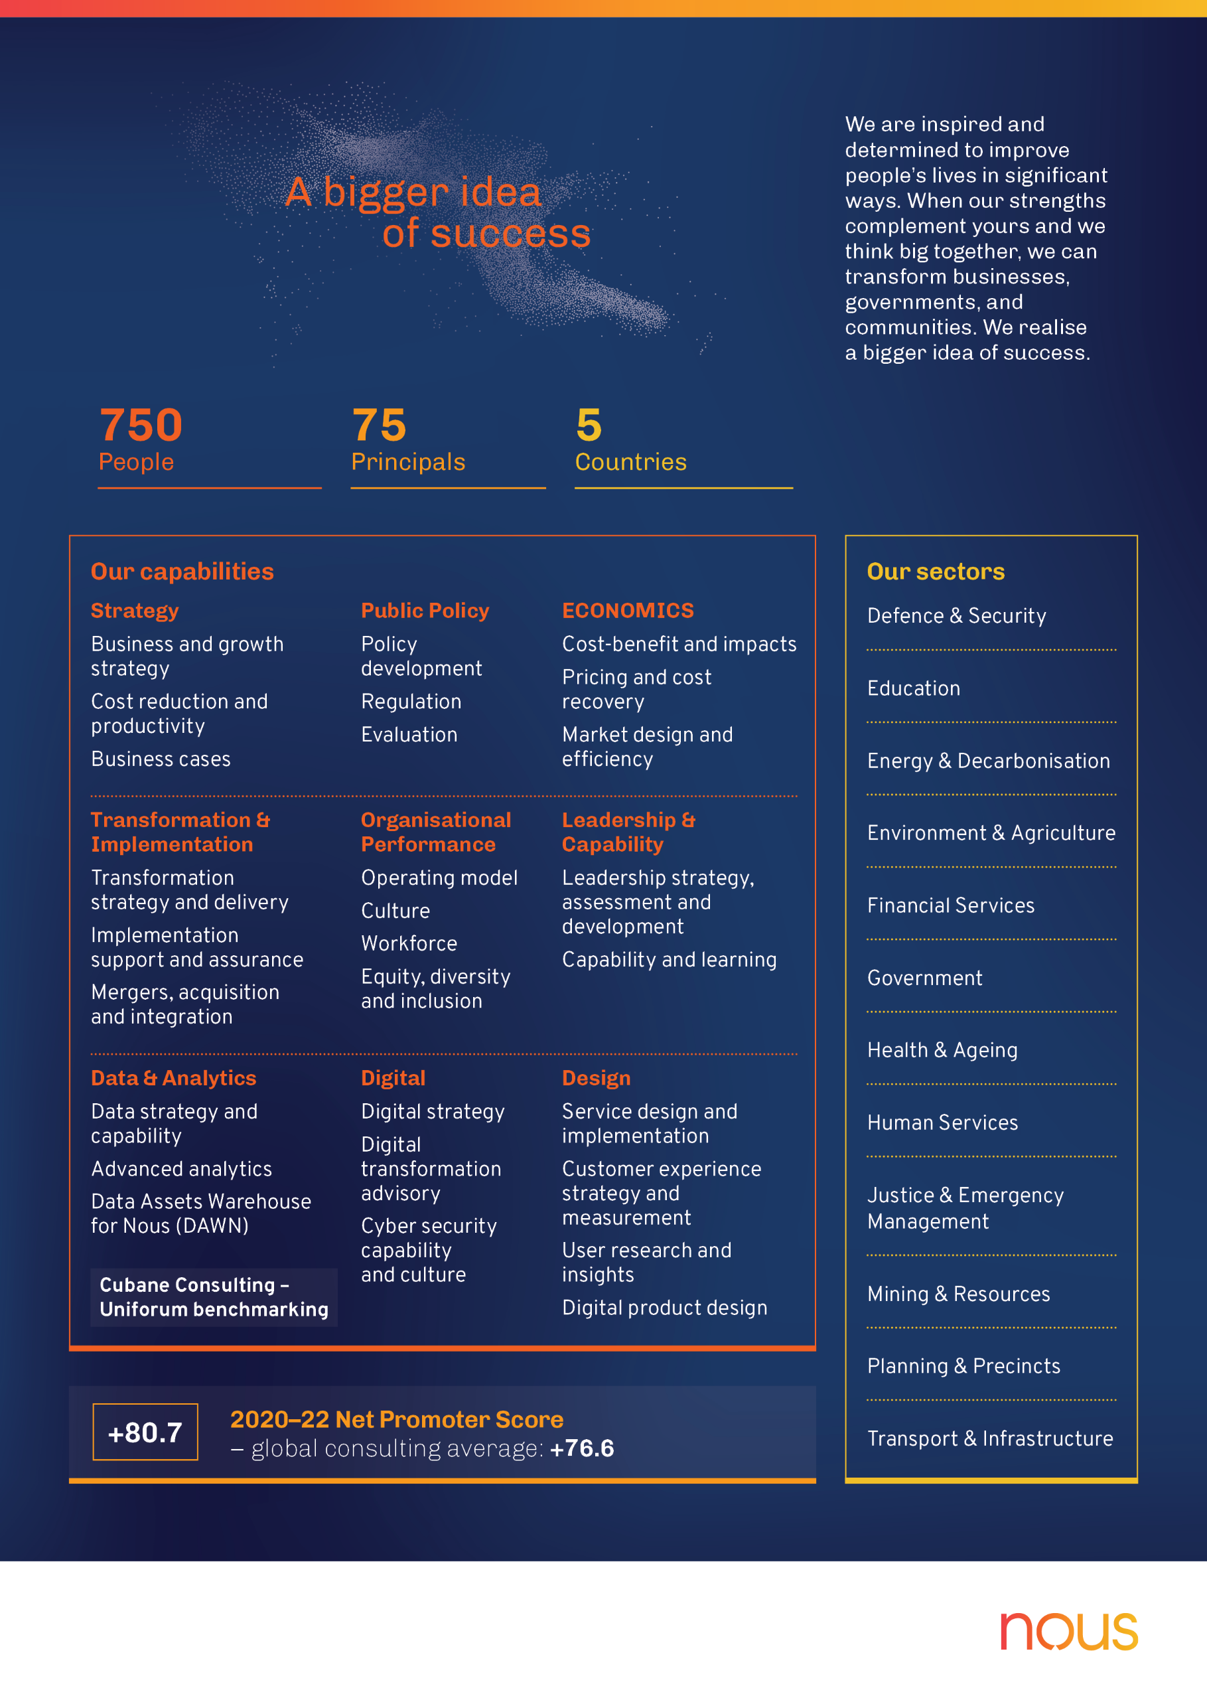

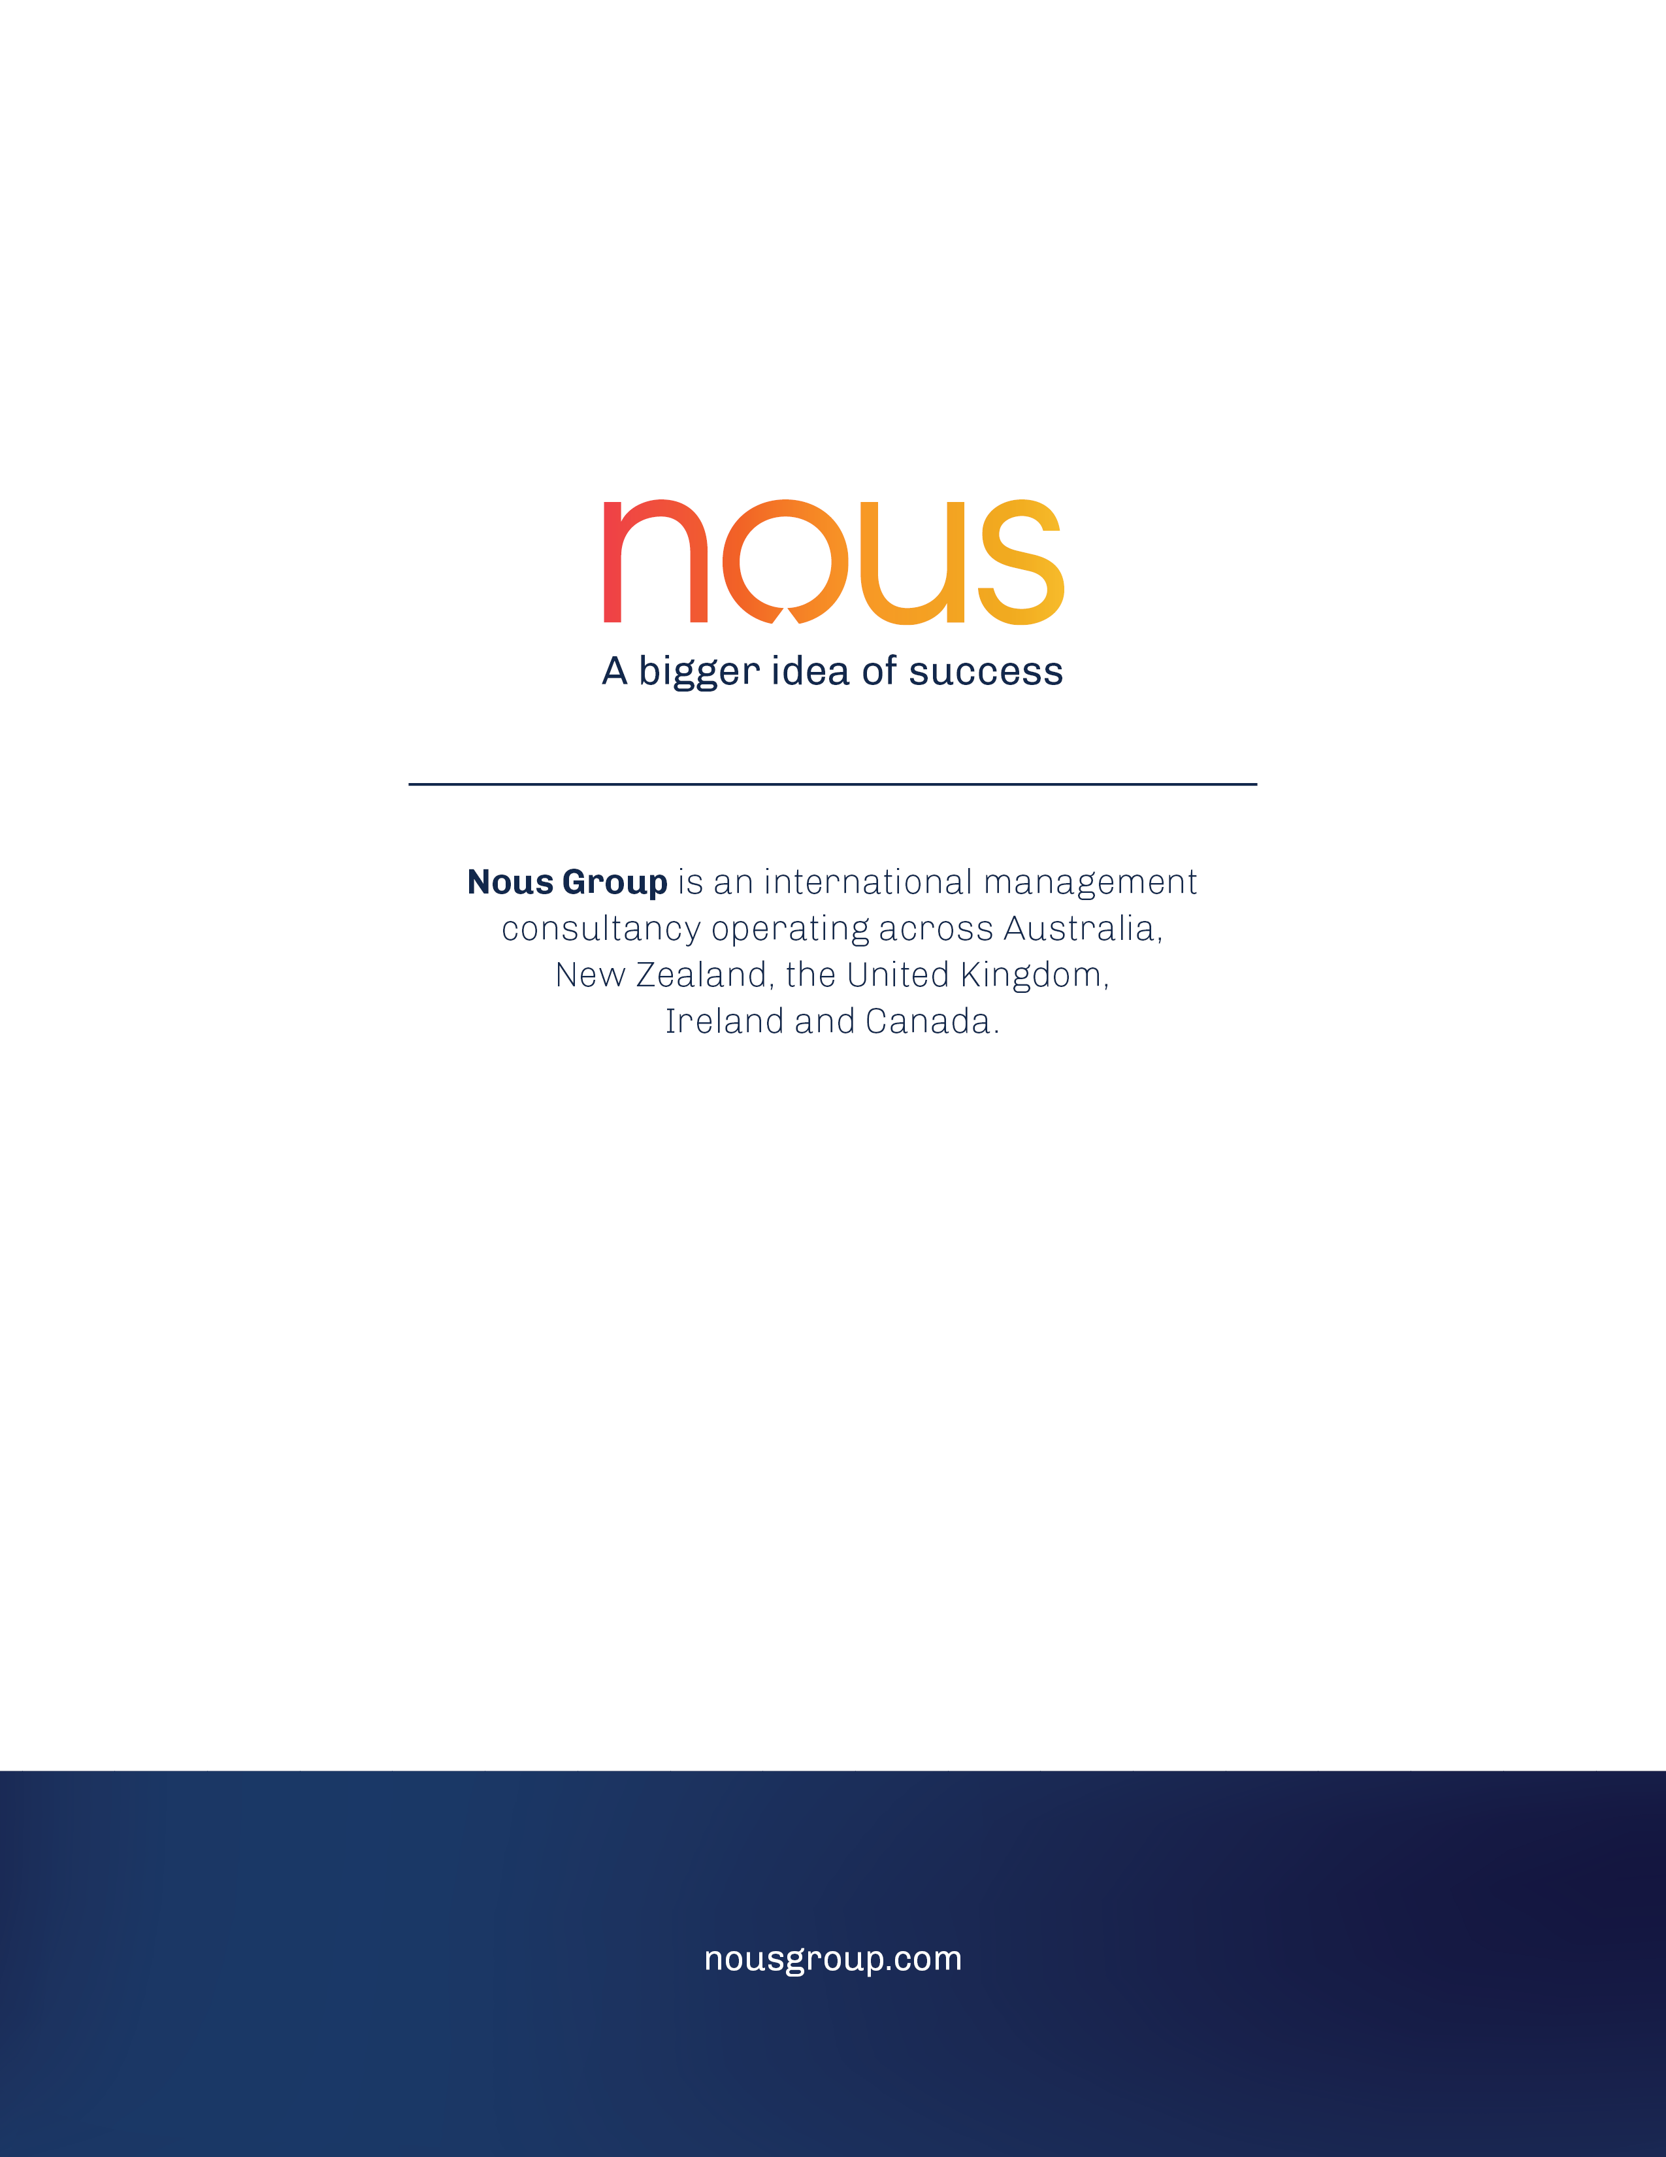

1. Productivity Commission, ‘Inquiry Report No. 84: Shifting the dial. 5 year productivity review: Commonwealth-State relations.’ 2017. Royal Commission into Aged Care Quality and Safety, “Interim report: Neglect, Volume 2”, 2019.
2. Needs rounds (outlined above) can also be considered a form of in-reach; however, they focus on proactive screening and assessment, rather than reactive support and service delivery once residents’ needs are identified.
3. Nous survey of RACFs, 2021.
4. Analysis of Aged Care Quality and Safety Commission (ACQSC) data on compliance with Aged Care Standards between July 2019 and March 2022.
5. Nous survey of RACFs, 2021.
6. Analysis of ELDAC data on Residential Aged Care (RAC) Analytics Toolkit Report April 2018 to June 2020.
7. Analysis of NIHSI-AA data from July 2014 to June 2019, provided by AIHW.
8. Ibid.
9. Analysis of PCOC data from January to December 2021, provided by PCOC at the Australian Health Services Research Institute (AHSRI), University of Wollongong.
10. Ibid.
11. Analysis of NIHSI-AA data from July 2014 to June 2019, provided by AIHW.
12. Ibid.
13. Nous survey of RACFs, 2021.
14. Analysis of NIHSI-AA data from July 2014 to June 2019, provided by AIHW.
15. Ibid.
16. Analysis of PCOC data from January to December 2021.
17. Analysis of ACQSC data on complaints between July 2019 and March 2022.
18. Nous survey of RACFs, 2021.
19. National Project Agreement for Comprehensive Palliative Care in Aged Care. 21 July 2020. Commonwealth of Australia.
20. NIHSI-AA is a linked data asset developed by the Australian Institute of Health and Welfare (AIHW). It is comprised of: RAC Episodes data, Admitted Patient Care (APC) data, ED data, Medicare Benefits Schedule (MBS) data, Pharmaceutical Benefits Scheme (PBS) data and National Death Index (NDI) data.
21. Chapter 3: The federal funding of palliative care in Australia, Palliative Care in Australia. (2012) Commonwealth of Australia <https://www.aph.gov.au/parliamentary_business/committees/senate/community_affairs/completed_inquiries/2010-13/palliativecare/report/c03>
22. Royal Commission into Aged Care Quality and Safety, Interim Report: Neglect”, Volume 1 (2019).
23. Voluntary Assisted Dying, Queensland University of Technology. Accessed at <https://end-of-life.qut.edu.au/assisteddying#:~:text=Voluntary%20assisted%20dying%20%28VAD%29%20is%20a%20major%20legal%2C,early%202023%2C%20and%20Queensland%20on%201%20January%202023>.
24. Maple, J and Smallwood, N (2022) A burnt out workforce impacts patient care. *RACGP*. Accessed at <https://www1.racgp.org.au/newsgp/professional/a-burnt-out-workforce-impacts-patient-care>
25. National Project Agreement for Comprehensive Palliative Care in Aged Care. 21 July 2020. Commonwealth of Australia.
26. Commonwealth of Australia. Responsibilities as outlined in the National Project Agreement for Comprehensive Palliative Care in Aged Care. 21 July 2020.
27. Mid-point assessment informed by 2021 and 2022 milestone reports provided by states and territories to the Commonwealth Department of Health.
28. Productivity Commission (2011) Caring for older Australians, Report No. 53, Final Inquiry Report.
29. Booth R et al, (2005) Workplace training practices in the residential aged care sector”, National Vocational Education and Training Research.
30. Finn, J, Flicker, L, Mackenzie, E, et al., (2006) Interface between residential aged care facilities and a teaching hospital emergency department in WA. Medical Journal of Australia.
31. ELDAC, Final report: ELDAC 2017-2020.
32.
33. Australian Department of Health. (2020) Aged Care Workforce Census Report. Nous Group (2020) Literature review summary report – National Evaluation of the CPCiAC.
34. Nous Group (2020) Literature review summary report – National Evaluation of the CPCiAC.
35. Nous Group (2020) Literature review summary report – National Evaluation of the CPCiAC.
36. Productivity Commission (2017) Introducing competition and informed user choice into human services: Reforms to human services. Chapter 3: End-of-life care in Australia.
37. Lane, H, Philip, J, (2015) Managing expectations: Providing palliative care in aged care facilities," Australasian Journal on Ageing.
38. National Project Agreement for Comprehensive Palliative Care in Aged Care. 21 July 2020. Commonwealth of Australia.
39. Nous survey of RACFs, 2021.
40. ACQSC data on compliance with Aged Care Standards between July 2019 and March 2022.
41. Nous survey of RACFs, 2021.
42. Analysis of ELDAC data on RAC Analytics Toolkit Report April 2018 to June 2020.
43. Analysis of NIHSI-AA data from July 2014 to June 2019, provided by AIHW.
44. Ibid.
45. Analysis of PCOC data from January to December 2021, provided by PCOC at the AHSRI, University of Wollongong.
46. Ibid.
47. Analysis of NIHSI-AA data from July 2014 to June 2019, provided by AIHW.
48. Ibid.
49. Nous survey of RACFs, 2021.
50. Analysis of NIHSI-AA data from July 2014 to June 2019, provided by AIHW.
51. Ibid.
52. Analysis of PCOC data from January to December 2021.
53. Analysis of ACQSC data on complaints between July 2019 and March 2022.
54. Nous survey of RACFs, 2021.
55. In 2021, Nous conducted a survey of all RACFs in Australia. A total of 472 responses were received out of the 2,719 RACFs that were invited to participate, representing a response rate of 17.3 per cent. Responses have been weighted based on state or territory, regionality and organisation type (e.g., not-for-profit or private) to produce estimates that are representative of all RACFs in Australia.
56. Nous survey of RACFs, 2021.
57. Of the RACFs that were assessed by the ACQSC between July 2019 and March 2022 for compliance with the Aged Care Standards 2(3)(b), 2(3)(c) and 3(3)(c)).
58. Commonwealth of Australia (2021) Royal Commission into Aged Care Quality and Safety Final Report: Care, Dignity and Respect, Volume 2 The current system. Canberra, ACT.
59. ELDAC Final Performance Report: ELDAC Workstream 4 (Working Together), 2021. The program involved 70 sites, 56 RACFs and 14 home services.
60. Standard 2(3)(c), Aged Care Quality Standards, My Aged Care, https://www.myagedcare.gov.au/aged-care-quality-standards#quality-standards
61. Standard 2. Ongoing assessment and planning with consumers, Aged Care Quality and Safety Commission, https://www.agedcarequality.gov.au/providers/standards/standard-2
62. Nous Group (2020) Literature Review Summary Report – National Evaluation of the Comprehensive Palliative Care in Aged Care Measure.
63. Survey of a sample of RACFs conducted as part of this evaluation. Responses have been weighted based on state or territory, regionality and organisation type (e.g., not-for-profit or private) to produce estimates that are representative of all RACFs in Australia.
64. ELDAC, RAC Analytics Toolkit Report April 2018 to June 2020.
65. Ibid.
66. Data provided by AHHA did not capture user workplace, so this is likely an over-estimate of the number of RACF staff accessing AHHA training.
67. Estimated numbers of direct care workers in RACFs in 2020 and net aged care sector workforce in 2021, sourced from the 2020 Aged Care Workforce Census Report and the Department of Health cited in the Aged Care Workforce Action Plan 2022-2025. The 2020 Aged Care Workforce Census reported that the 208,903 Residential Aged Care direct care workers in 2020 comprised of 70 per cent Personal Care Workers, 23 per cent nurses and seven per cent allied health professionals.
68. ELDAC Final Performance Report: ELDAC Workstream 4 (2021) Working Together.
69. There were 602 users of the portal surveyed by AHHA in 2020 and 2021.
70. AHHA training is voluntary and funded under the Measure.
71. Australian Department of Health (2022) Aged Care Workforce Action Plan: 2022–2025: Growing a skilled workforce to deliver high quality care for senior Australians.
72. Based on an estimated RACF resident population of 850,000 over 2014-19, derived from AIHW: GEN Aged Care Data from 2014 to 2019.
73. This includes residents aged 50 and over on 1 July 2018 who were permanently admitted to a government subsidised RACF and who accessed received palliative-care related medicines or received subsidised specialist services provided by a palliative medicine physician, specialist and/or hospital admission for palliative care. This does not include people who received palliative care from community-based specialists who do not bill to MBS, so it is likely to be an under-representation of the total number of RACF residents who accessed palliative care.   
    MBS-subsidised palliative medicine specialist services include services provided by a palliative medicine physician/specialist that are claimed under specialist palliative care MBS items on a fee-for-service basis that are partly or fully funded under the Australian Government’s Medicare program. These services cover patient attendances (or consultations) provided in different settings (hospital/consulting room or person’s place of residence), as well as services such as case conferencing. MBS-subsidised palliative medicine specialist services provided by a palliative medicine physician/specialist included MBS service for palliative medicine attendances (items in 3003, 3005, 3010, 3014, 3015, 3018, 3023, 3028) and services for palliative medicine case conferences (items in 3032, 3040, 3044, 3051, 3055, 3062, 3069, 3074, 3078, 3083, 3088 and 3093).
74. This will not capture specialist palliative care teams who do not use MBS billing (such as the ACT’s Specialist Palliative Aged Care (PEACE) team). It does capture medicines prescribed from the PBS.
75. This percentage is calculated as an average of the percentages across all jurisdictions.
76. This proportion does not capture palliative care services such as being seen by a specialist (and not receiving medicines), being seen by a GP, or services provided by community-based palliative care specialists and so may be higher than this. The fact that this 12.9 per cent of RACF residents received medicines related to palliative care in 2018-19 is higher than the estimated seven per cent of the RACF resident population receiving palliative care services, including medicines, from 2014-19, indicates that the number of residents accessing palliative care services and medicines in 2018-19 is much higher than in the years from 2014-17. AIHW advised Nous that this was the case but did not provide a specific breakdown of numbers for each year in that five-year period. This increase in 2018-19 could reflect a change in the method of data collection, as opposed to indicate increased service use. Nous will monitor this closely in subsequent analysis and for subsequent reports.
77. Australian Institute of Health and Welfare (2019) GEN Aged Care Data: People using aged care.
78. Morin L, Aubry R, Frova L, MacLeod R, Wilson DM, Loucka M, Csikos A, Ruiz-Ramos M, Cardenas-Turanzas M, Rhee Y, Teno J. (2017) Estimating the need for palliative care at the population level: a cross-national study in 12 countries. Palliative medicine 31(6):526-36.
79. The study is an international study across 12 countries and the population comprised 3175 patients aged >15 years who died in hospital in 2016 and 2017. The main outcome measures were the proportion of decedents potentially benefitting from end-of-life care and receiving end-of-life care. This figure represents the range of proportions of people across the 12 countries who required palliative care at the end-of-life.
80. ELDAC Final Performance Report: ELDAC Workstream 4 (Working Together), 2021.
81. Commission into Aged Care Quality and Safety (2019) Interim Report: Neglect, Volume 1.
82. Nous survey of RACFs, 2021. This is a national average, not an average across jurisdictions.
83. Analysis published by AIHW indicates that in 2020-21 people in permanent residential aged care (PRAC) with an ACFI appraisal indicating need for palliative care accounted for 1.9 per cent (4,500) of all residents (243,500). This is likely to under-estimate need for palliative care.
84. The other 470 episodes not included in the benchmark assessment were episodes that had started earlier, or a date for care was not reported to PCOC (missing data).
85. International Classifications for Diseases (ICD) codes are provided in Figure 12. ICD codes are available at https://icdlist.com/icd-10/index.
86. Presentations to ED are not recorded in the same way as APC – it is not possible to identify whether an ED presentation is ‘related to palliative care’ in the same way.
87. ELDAC Final Performance Report: ELDAC Workstream 4 (Working Together), (2021).
88. Ibid.
89. Commonwealth of Australia (2021) Royal Commission into Aged Care Quality and Safety Final Report: Care, Dignity and Respect, Volume 2 The current system. Canberra, ACT.
90. ICD codes have been provided against each reason. An index of ICD codes is available at https://icdlist.com/icd-10/index.
91. This is calculated based on the proportion of total residents that died in Australia in 2018-19, who died in a RACF.
92. If WA and NT are removed from the analysis, an average of 21.6 per cent of RACF resident deaths occurred in hospital (APC) and 1.8 per cent in the ED in that year.
93. Swerissen H & Duckett S 2014. Dying Well. Grattan Institute.
94. ACQSC, Aged Care Quality Standards.
95. Analysis of NIHSI-AA indicates that between July 2018 to June 2019, there were 241,642 residents of RACFs for all or part of the year. However public reports from AIHW suggest that the total number of people in permanent residential aged care in 2018-2019 was closer to 180,000.
96. Hospital stay and ED presentation data is derived from NIHSI-AA, using the APC, RAC Episodes, NDI and Patient Demography file. More detail is provided in Appendix C. NIHSI-AA does not contain hospital stay and ED data for WA or NT.
97. Hospital admissions and separations related to palliative care were identified using care type as palliative care and/or any principal or additional diagnosis as palliative care. The ED data does not capture reasons for presentation in a comparable way.
98. Commonwealth of Australia (2021) Royal Commission into Aged Care Quality and Safety Final Report: Care, Dignity and Respect, Volume 2 The current system. Canberra, ACT.
99. NIHSI-AA analysis on the number of RACF residents who received palliative care services was provided for the entire 2014-15 to 2018-19 period (see Figure 8, page 38). The number of RACF residents who received palliative care services for 2018-19 was not estimated from this, as AIHW advised that numbers were not evenly distributed across the five years so estimates would be inaccurate.
100. Morin L, Aubry R, Frova L, MacLeod R, Wilson DM, Loucka M, Csikos A, Ruiz-Ramos M, Cardenas-Turanzas M, Rhee Y, Teno J. (2017) Estimating the need for palliative care at the population level: a cross-national study in 12 countries. Palliative medicine. 31(6):526-36.
101. The study population comprised 3175 patients aged >15 years who died in hospital in 2016 and 2017. The main outcome measures were the proportion of decedents potentially benefitting from end-of-life care and receiving end-of-life care.
102. Survey of a sample of RACFs conducted as part of this evaluation. Responses have been weighted based on state or territory, regionality and organisation type (e.g., not-for-profit or private) to produce estimates that are representative of all RACFs in Australia. See Appendix C for further details.
103. Ibid.
104. This includes both inpatient and community-based specialist palliative care services.
105. Nous survey of RACFs in 2021.
106. Commonwealth of Australia. (2021) Royal Commission into Aged Care Quality and Safety Final Report: Care, Dignity and Respect, Volume 2 The current system. Canberra, ACT.
107. Australian Government Department of Health (2018) National Palliative Care Strategy.
108. Goal 5 (Investment) and Goal 7 (Accountability) of the National Palliative Care Strategy are not necessary to be included as national

     outcomes for this evaluation.
109. Nous Group (2020) Literature Review Summary Report – National Evaluation of the Comprehensive Palliative Care in Aged Care Measure.
110. Nous Group (2020) Literature Review Summary Report – National Evaluation of the Comprehensive Palliative Care in Aged Care Measure.
111. Needs rounds (outlined above) can also be considered a form of in-reach however they focus on proactive screening and assessment, rather than reactive support and service delivery once residents’ needs are identified.
112. This table does not provide information on the two remaining models of care (culturally safe care models of care and access to multidisciplinary resources) as no information is available at this stage. Evidence of emerging successes is drawn from a range of midpoint data sources including 2022 consultations with state and territory health departments and a sample of RACFs and clinicians in each jurisdiction implementing projects, as well as six-monthly reported provided to evaluators by states and territories on progress and benefits. Where available, emerging findings from jurisdictional evaluations have been included (ACT’s INSPIRED pilot evaluation and SA/Flinders’ evaluation of initiatives under the Measure).
113. Nous Group (2020) Literature Review Summary Report – National Evaluation of the Comprehensive Palliative Care in Aged Care Measure.
114. Royal Commission into Aged Care Quality and Safety (2019) Canberra Hearing - Interfaces between the aged care and the health care systems.
115. Ibid.
116. Arendts G, Howard K (2010) The interface between residential aged care and the emergency department: a systematic review, Age and Ageing 39:306-312.
117. Belfrage, M, Chiminello, C, Cooper, D, et al. (2009) Pushing the envelope: clinical handover from the aged-care home to the emergency department.
118. Swerissen, H, Duckett, S (2014) Dying well. Grattan Institute.
119. Testa, L, Seah, R, Ludlow, K, et al. (2020) Models of care that avoid or improve transitions to hospital services for residential aged care facility residents: An integrative review," Geriatric Nursing, 41:360-372.
120. Belfrage, M, Chiminello, C, Cooper, D, et al. (2009) Pushing the envelope: clinical handover from the aged-care home to the emergency department.
121. Swerissen, H, Duckett, S (2014) Dying well. Grattan Institute.
122. Northern Territory Government, Department of Treasury and Finance. (2018) Guidance document – Commonwealth funding agreements.
123. Productivity Commission (2017) Inquiry Report No. 84: Shifting the dial. 5 year productivity review: Commonwealth-State relations.
124. Productivity Commission (2017) Introducing competition and informed user choice into human services: Reforms to human services. Chapter 3: End-of-life care in Australia.
125. Nous Group (2020) Literature Review Summary Report – National Evaluation of the Comprehensive Palliative Care in Aged Care Measure.
126. Productivity Commission (2017) 5 year productivity review: Commonwealth-State relations.
127. Productivity Commission (2017) Inquiry Report No. 84: Shifting the dial. 5 year productivity review: Commonwealth-State relations.
128. Council of Australian Governments (2011) National Partnership Agreement supporting national mental health reform.
129. Productivity Commission *(2017) Inquiry Report No. 84: Shifting the dial. 5 year productivity review: Commonwealth-State relations.
130. Nous Group (2020) Literature Review Summary Report: National Evaluation of the Comprehensive Palliative Care in Aged Care Measure, Available at: https://www.health.gov.au/resources/publications/literature-review-summary-report-national-evaluation-of-the-comprehensive-palliative-care-in-aged-care-measure.
131. The assessment of where the measure sits across these dimensions is based on consultations from states and territories (2021-22) and six-monthly data collection templates submitted over those years. The assessment of ‘ideal arrangements’ was based on the Nous literature review (2020). The category on local implementation approach was based on evidence of good practice in the lit review. The Evaluation category was based on the purpose and contribution of the national and state and territory level evaluations, as described in the Comprehensive Palliative Care in Aged Care Measure – Evaluation Framework.
132. Goal 5 (Investment) and Goal 7 (Accountability) of the National Palliative Care Strategy are not necessary to be included as national

     outcomes for this evaluation.
133. Australian Government Department of Health, (2018) National Palliative Care Strategy.
134. Goal 5 (Investment) and Goal 7 (Accountability) of the National Palliative Care Strategy are not necessary to be included as national outcomes for this evaluation.
135. Standalone APC, MBS and PBS data may provide an alternative where NIHSI-AA is not available.
136. Note this was previously identified as relating to Outcome 1, however based on NIHSI-AA analysis it was assessed as more relevant to Outcome 2.
137. Nous also received NIHSI-AA data on the number of residents dispensed with subcutaneous medicine as an indicator for Outcome 3. Based on advice from Nous Expert Advisor Dr David Currow, this data has not been included. There is significant variation across states and territories in the proportion of RACF residents receiving subcutaneous medicines associated with palliative care. However, Dr. Currow advised that palliative care management does not require subcutaneous medicines and this variation across jurisdictions is not likely to be driven by patient or RACF resource factors.
138. Note this was previously identified as relating to Outcome 3, however based on NIHSI-AA analysis it was assessed as more relevant to Outcome 4.
139. AIHW, Palliative care services in Australia: Palliative care for people living in residential aged care, 2020.
140. Note this was previously identified as relating to Outcome 3, 4, 6 and 8, however based on NIHSI-AA analysis it was assessed as most relevant to Outcome 8.
141. Note this was previously identified as relating to Outcome 3 and 4, however based on NIHSI-AA analysis it was assessed as most relevant to Outcome 8.
142. Note this was previously identified as relating to Outcome 3 and 4, however based on NIHSI-AA analysis it was assessed as most relevant to Outcome 8.
143. Commonwealth of Australia, Project Agreement for Comprehensive Palliative Care in Aged Care. 21July 2020.