**National Evaluation of the Comprehensive Palliative Care in Aged Care Measure – Baseline Report and Progress Report 2**

Australian Department of Health

22 September 2021

Disclaimer:

Nous Group (**Nous**) has prepared this report for the benefit of the Australian Department of Health (the **Client**).

© Nous Group

The report should not be used or relied upon for any purpose other than as an expression of the conclusions and recommendations of Nous to the Client as to the matters within the scope of the report. Nous and its officers and employees expressly disclaim any liability to any person other than the Client who relies or purports to rely on the report for any other purpose.

Nous has prepared the report with care and diligence. The conclusions and recommendations given by Nous in the report are given in good faith and in the reasonable belief that they are correct and not misleading. The report has been prepared by Nous based on information provided by the Client and by other persons. Nous has relied on that information and has not independently verified or audited that information.

Contents

1 Executive summary 4

1.1 Background and context 4

1.2 Purpose of this report 6

1.3 Baseline for the national evaluation 6

1.4 Progress in implementation of the Measure 9

2 Introduction 13

2.1 Purpose of this report 13

2.2 Background and context to the Measure 13

2.3 Purpose of the national evaluation of the Measure 16

2.4 Evaluation methodology 16

3 Baseline for the national evaluation 19

3.1 What is important to understand about the baseline? 19

3.2 What are the limitations to the baseline? 19

3.3 What is the baseline for the national evaluation? 21

4 Progress in implementing the Measure 44

4.1 What was planned and implemented under the Measure? 44

4.2 What are the emerging insights from initial implementation? 51

Appendix A Implementation progress by jurisdiction 55

A.1 Australian Capital Territory 56

A.2 New South Wales 58

A.3 Northern Territory 60

A.4 Queensland 62

A.5 South Australia 65

A.6 Victoria 68

A.7 Tasmania 69

A.8 Western Australia 71

Appendix B Evaluation progress report 73

B.1 Key decisions 73

B.2 Evaluation activities undertaken to date 73

B.3 Upcoming evaluation activities 75

B.4 Challenges and risks 75

Appendix C List of Commonwealth palliative care-related projects 1

Appendix D Data collection plan 6

Appendix E Evaluation indicators 9

Appendix F Residential aged care facility survey methodology 14

# Executive summary

## Background and context

There is a need to improve palliative care in residential aged care settings

Hearings from the Royal Commission into Aged Care Quality and Safety (the Royal Commission) indicated that the availability and standard of palliative care provided in residential aged care is widely variable.[1]

Other evidence indicates that early identification of palliative care needs, communication about palliative care and goals of care are a challenge for many – including residents, families, carers and staff.[2],[3]

Palliative care in residential aged care facilities (RACFs) straddles health and aged care systems

Palliative care in RACFs can be generalist or specialist in nature and should aim to address physical, spiritual and psychosocial needs. It can be delivered in a variety of ways – through generalist and specialist staff within the RACF or by state/territory in-reach or outreach services. Primary care providers, such as General Practitioners (GPs), also often play a role in the delivery of palliative care in RACFs. In addition, palliative care in the residential aged care setting is increasingly being used for temporary and intermittent support for non-permanent residents, not just permanent residents.

Governments have overlapping responsibilities for palliative care in RACFs:

* The state/territory governments have responsibility for the health system (outside of GPs) and therefore are usually delivering in-reach or outreach palliative care services.
* The Australian Government has responsibility for the aged care system, including RACFs.

All RACFs must comply with the Aged Care Quality Standards and other compliance obligations, although for-profit and not-for-profit RACFs have relatively more control over the types and mode of service delivered within the facility. Each RACF, no matter what the ownership structure, can determine its service model.

The Comprehensive Palliative Care in Aged Care Measure aims to improve palliative care in RACFs

The Comprehensive Palliative Care in Aged Care Measure (the Measure) aims to strengthen national efforts to improve access to quality palliative care as a key component of an integrated health-aged care system. The Measure provides $57.2 million in federal funding over six years from 2018-2024 through a Project Agreement, with funding to states and territories commencing from 2019-20.

The Measure aims to help older Australians living in residential aged care who are nearing the end of their life. Its goals are to:

* improve palliative and end-of-life care for older people living in residential aged care
* further enable people to die where they want, supported by increased aged care services.

The Measure is provided through a cost-sharing model, meaning states and territories are required to match federal funding. States and territories implement initiatives suited to local needs. The Measure focuses jurisdictional activities on three types of activities, shown in Figure 1.

Figure 1 Project Agreement categories focus jurisdictional activities

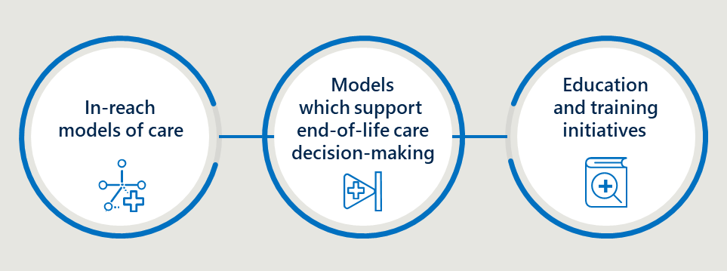

The national evaluation of the Measure will assess whether its aims are achieved

Nous Group (Nous) has been engaged by the Australian Government Department of Health and Aged Care (the Department) to undertake a national evaluation of the Measure between July 2020 and October 2023. The evaluation has process, outcome and economic components.

The national evaluation will determine the extent to which the aims and objectives of the Measure have been achieved. The outcomes of the evaluation will contribute to the national evidence base and inform policy decisions about palliative care in aged care, including on best practice models of care.

The evaluation is designed to address data and other limitations

The complexity of the palliative care landscape, and the fact that eight jurisdictions are implementing different activities, results in some challenges for the evaluation. These challenges include:

* Changes and pressures on the health and aged care systems will impact on the Measure and how it is evaluated. There is substantial work underway nationally and within each state and territory to improve palliative care (see Appendix A). COVID-19 and implementation of recommendations from the Royal Commission will continue to impact both the health and aged care systems.
* Implementation of the Measure varies across jurisdictions. Jurisdictions have different priorities and approaches to implementation of the Measure. Their maturity in the delivery of palliative care in RACFs also varies, including capability and capacity to build on existing initiatives.
* There are significant data limitations in residential aged care and palliative care. Jurisdictions collect different data, which in turn each have different limitations. Qualitative data collection will be used to fill any gaps in unavailable quantitative data where possible.
* Gaining direct input from families and carers on the Measure’s impact is not feasible. The views of families/carers of residents are critical, yet in the context of the Measure evaluation, it is challenging to draw insight from their direct input. It will often only relate to a specific facility and point in time. Instead, the evaluation will engage with clinicians, practitioners and Palliative Care Australia (PCA) consumer representative groups who may be better placed to observe changes in palliative care over time.

The national evaluation will not evaluate individual models the states and territories implement. It will explore the contribution of the Measure to palliative care outcomes from the Measure as a whole. Some jurisdictions are undertaking evaluations, which the national evaluation will draw on where relevant.

## Purpose of this report

This report provides the evaluation baseline and an update on implementation

This report, Baseline Report and Progress Report 2, serves two purposes:

* The evaluation baseline: to establish the baseline for the evaluation (section 2). The baseline provides a foundation from which to measure changes in the national outcomes over time.
* An implementation update: to provide a progress update on the activities states and territories have planned and implemented under the Measure to date (section 3).

It also provides a progress update on delivery of the national evaluation – Progress Report 2 (see Appendix B).

## Baseline for the national evaluation

National outcomes provide a consistent basis to measure the impact of the Measure

The Evaluation Framework identified ten national outcomes aligned to the Measure’s aims and to the National Palliative Care Strategy (see Table 1). The national outcomes cover aspects of palliative care in RACFs that are expected to be impacted by the Measure. These are:

* Understanding. People understand the benefits of palliative care, know where and how to access services, and are involved in decisions about their own care.
* Capability. Knowledge and practice of palliative care is embedded in all care settings.
* Access and choice. People affected by life-limiting illnesses receive care that matches their needs and preferences.
* Collaboration. Everyone works together to create a consistent experience across care settings.
* Data and evidence. A skilled workforce and systems are in place to deliver palliative care in any setting.[4]

The baseline provides insights on the performance against national outcomes at the time the Measure was beginning to be implemented, shown in Table 1. Nous will assess progress in the Final Report (2023).

Multiple data sources inform the baseline; more data sources will be added over time

The baseline draws on a survey of Australian RACFs conducted in April and May 2021 (see Appendix F) and stakeholder interviews conducted in July 2021. It draws on the Royal Commission and analysis from the Australian Institute of Health and Welfare (AIHW). Nous anticipates providing additional baseline analysis using backdated data from the AIHW’s linked data asset National Integrated Health Services Information Analytics Asset (NIHSI-AA) and other data (e.g., Palliative Care Outcomes Collaboration (PCOC), End of Life Directions for Aged Care (ELDAC), jurisdictional-level evaluations) in the Mid-Term Report in 2022. There are limitations to the baseline, detailed in section 2.2, including that some data sources provide conflicting information.

This report makes generalisations across RACFs. It is important to note that some RACFs have innovative approaches and good practice that provides residents with the appropriate care.

The baseline shows palliative care in RACFs is variable and difficult for many residents to access

The evaluation baseline shows that palliative care in RACFs is highly variable with many residents not being able to access quality palliative care. RACF staff typically do not have palliative care specific skills and training is often not mandatory. There are opportunities to improve the effectiveness of coordination between systems (health and aged care), services (e.g., specialist and generalist palliative care providers, RACFs) and staff (e.g., RACF staff, GPs).[5] There are also examples of intersections that are more effective than the norm. This variability impacts on the provision of palliative care in RACFs.

Table 1 provides the national outcomes with a high-level summary of the baseline for each outcome.

Table 1 Summary of the evaluation outcomes and baseline assessment

|  |  |  |  |
| --- | --- | --- | --- |
| Outcome number | Outcome theme | Outcome description | Baseline assessment |
| 1 | Understanding | More discussions focused on end-of-life care decision making between residents, families, carers, General Practitioners (GPs) and specialist palliative care services including use of Advance Care Plans (ACPs). | Many RACFs have processes in place to support end-of-life decision making, however, staff need more capability to use them as part of effective end-of-life discussions. |
| 2 | Understanding | Improved access to information that informs end-of-life care decisions for residents and families. | Information that informs end-of-life care decisions is often difficult for residents and families to access. |
| 3 | Capability | A higher proportion of clinical and non-clinical staff in RACFs have skills and confidence appropriate to their roles to recognise and respond to the holistic palliative care needs of residents, in a culturally safe way. | RACF staff typically do not have the skills and confidence appropriate to the requirements of their role to recognise and respond to the holistic palliative care needs of residents, in a culturally safe way. |
| 4 | Access and choice | Improved access to quality palliative care in RACFs including:   * increased use of assessments to establish residents’ palliative care needs * decreased health service use related to clinically futile or non-beneficial treatments and inpatient bed days * decreased healthcare expenditure arising from decreased service use. | Access to quality palliative care in RACFs is variable with many residents not accessing effective palliative care. |
| 5 | Access and choice | Improved quality of palliative care provided in RACFs including:   * reduced symptom burden * improved quality of life for residents during the period they access palliative care * better experience of death and dying for residents, families/carers and staff, including meeting physical, psychosocial, cultural and spiritual needs. | The quality of palliative care in RACFs is variable with some residents having low quality care that does not meet their physical, psychosocial, cultural and spiritual needs. |
| 6 | Access and choice | Greater resident choice in palliative care including:   * more people dying where they want * increased person-centred care informed by an individual’s choice. | Residents typically have limited choices in terms of palliative care. |
| 7 | Collaboration | Improved care coordination with GPs/primary care, acute care services and specialist palliative care services. | Palliative care for RACFs residents is provided by a range of services including the RACF, GPs, hospitals and specialist palliative care services. These services often have difficulty sharing information and providing coordinated care. |
| 8 | Collaboration | Improved integration between the health and aged care systems. | There is often limited integration between health and aged care systems to provide palliative care in RACFs. |
| 9 | Collaboration | More palliative care services and health planners are informed by performance information on appropriateness, effectiveness, efficiency and outcomes. | Few palliative care services and health planners are informed by performance information related to palliative care delivery in RACFs. There is mixed use of performance information on the appropriateness, effectiveness, efficiency and outcomes of palliative care. |
| 10 | Data and evidence | Improved clinical governance to identify and implement quality improvement initiatives and evaluation of outcomes within RACFs. | While quality improvement initiatives are in place there is limited evidence regarding clinical governance of palliative care in RACFs. Fragmented provision of palliative care in RACFs makes clinical governance of palliative care difficult. |

## Progress in implementation of the Measure

All jurisdictions have signed up to the Measure as of July 2021

The Measure was announced as part of the 2018-19 Budget and since then the Department has been negotiating specific agreements with each jurisdiction. There were more significant delays than anticipated in negotiating with jurisdictions to sign up to the Measure (as reported by the Department). All jurisdictions have signed up to the Measure, with most signing up in 2020, and Tasmania and Victoria the most recent. All jurisdictions, except Tasmania and Victoria, have begun implementation – with some being more progressed than others.

Jurisdictions are largely focused on in-reach or outreach models of care

Implementation in most jurisdictions started from mid-2020, using various approaches and these jurisdictions are now at varying levels of implementation. Each jurisdiction has identified a suite of initiatives in response to jurisdictional policy objectives, local health system contexts and local need.

Overall, for the eight jurisdictions:

* All jurisdictions are implementing an in-reach model of care (sometimes also referred to as outreach).
* Most jurisdictions have specific projects that aim to improve end-of-life care decision making; for many, this is one component of broader activities.
* All jurisdictions are planning education and training projects.
* Five of eight jurisdictions are planning an evaluation, as stipulated in the Project Agreement.
* Two of eight jurisdictions are planning projects to improve care for Aboriginal and Torres Strait Islander people.
* A summary of what has been planned and implemented in each jurisdiction is provided overleaf.

There are emerging successes and challenges

While there were delays with commencement of the Measure, challenges and successes are emerging. Successes and strengths include strong trusted relationships, flexibility and increased funding support. Key challenges in implementation to date have related to the nature, and some of the requirements, of the funding mechanism itself – a national Project Agreement.

Key challenges related to the Project Agreement include the:

* limited negotiation with jurisdictions prior to the announcement of the Measure
* need to navigate nine bureaucratic processes, which created long lead times for implementation
* nature of the funding mechanism, particularly the matched funding requirement.

Additional emerging challenges outside the Measure as a funding instrument related to the extent to which Measure activities are addressing interface issues and operational challenges in facilities.

* There has been mixed success to date in achieving the intention of a matched funding arrangement to address interface issues through a sense of shared responsibility.
* There are emerging signs that operational challenges at the facility level will affect the extent to which Measure activities will have an impact including: limited nurses or clinicians trained in palliative care in RACFs, significant turnover in the aged care workforce and the significant pressure on RACFs in part due to COVID-19 and the Royal Commission.

Table 2 Projects planned and implementation progress by jurisdiction

|  |  |  |
| --- | --- | --- |
| Jurisdiction | Projects planned | Implementation |
| Australian Capital Territory | The palliative care needs rounds (PCNR) model aims to help people to live better and die well in their preferred place of death. It has three core elements: PCNR, case conferences and clinical work. | ACT signed up to the Measure in May 2020. ACT has expanded the PCNR model to all RACFs in the territory.​ |
| New South Wales | Local Health Districts (LHDs) in NSW have developed initiatives that reflect local needs, such as an adapted decision assist linkages model using a Specialist Palliative Care Link-Nurse.​ | NSW signed up to the Measure in June 2020. Each LHD has received equal Commonwealth funding and provided plans to implement the Measure.​ |
| Northern Territory | The Measure is being used to establish in-reach Needs Rounds or screening rounds in Central Australia and Top End, including education and training components for the RACF workforce.​ | NT signed up to the Measure in March 2020. Needs Rounds have been trialed in four RACFs in Central Australia. Top End is formalising relationships with RACFs.​ |
| Queensland | QLD has enabled each Hospital and Health Service (HHS) to determine the most appropriate model of care, such as inter-professional education and case-based learning for healthcare staff.​ | QLD signed up to the Measure in July 2020. Each HHS has accepted funding and established project teams. Each HHS is engaging with local RACFs.​ |
| South Australia | SA have developed three major projects based on successful NGO Grants. Projects include Hospice in Aged Care, Hospice in the RACF and GP Shared Care.​ | SA signed up to the Measure in March 2020. NGO Grants have been administered. The three major projects are expected to commence in July 2021.​ |
| Tasmania | TAS has planned three major projects: Specialist Palliative Care in-reach into RACFs; training posts for GP registrars in palliative care; and RACF funding for allied health support.​ | TAS signed up to the Measure in May 2021. TAS is in the early stages of implementation of the Measure.​ |
| Victoria | VIC is planning five projects: building local capacity in RACFs, improving assessment tools, enhancing existing models of care, supporting goals of care and promoting culturally safe palliative care for Aboriginal people.​ | VIC signed up to the Measure in July 2021. VIC is in the early stages of implementation of the Measure.​ |
| Western Australia | WA has planned two major projects: expanding the MPaCCS; and the PaSCE Residential Aged Care Excellence in Palliative Care education program.​ | WA signed up to the Measure in May 2020. The two major projects commenced in early 2021. The third workstream is being scoped.​ |

# Introduction

|  |
| --- |
| This section describes the context for the evaluation including:   * background and aim of the Measure, including key contextual factors impacting the Measure * the purpose of the national evaluation * evaluation methodology (including a note on which data sources have informed this report) * the purpose of this report. |

## Purpose of this report

This report provides the evaluation baseline and an update on implementation

This report, Progress Report 2, marks the end of Stage 1 (April 2021 to August 2021) of the evaluation. It has two parts:

* The evaluation baseline which establishes the baseline for the evaluation (section 2). The baseline provides a foundation from which to measure changes in the national outcomes over time.
* An implementation update which provides a progress update on what states and territories have planned and implemented under the Measure to date (section 3).

It also provides an update on delivery of the national evaluation (see Appendix B).

## Background and context to the Measure

The Measure aims to improve palliative care in RACFs

The Measure provides $57.2 million in Commonwealth funding over six years from 2018 to 2024, with funding to states and territories commencing from 2019-20. The Measure aims to help older Australians living in residential aged care who are nearing the end of their life.

Its goals are to:

* improve palliative and end-of-life care for older people living in residential aged care
* further enable people to die where they want, supported by increased aged care services.

The Measure is provided through a cost-sharing model, meaning states and territories are required to match Commonwealth funding. States and territories then implement initiatives suited to local needs, with the only requirements being that the initiatives focus on:

* in-reach models of care, that include assessments to establish residents’ current and emerging palliative care needs
* models that support end-of-life care decision making that aim to deliver quality, person-centred care to dying residents through the development of agreed goals of care
* education and training initiatives, that aim to build the capacity of the RACF workforce and other clinicians involved in the delivery of care to residents of RACFs.

Palliative care in RACFs straddles health and aged care systems, with much reform underway

The Measure was introduced in a policy and operational context, with ongoing reforms of the health and aged care systems, summarised in Table 3 Policy and operating context of the Measure. The Measure activities are funded by a mix of funding from state and territory governments (for health systems) and federal governments (for aged care and primary care). The context is characterised by the following:

* There are overlapping responsibilities across the aged care and health systems. Residents may receive palliative care from multiple providers, funded by different levels of government and involving specialist palliative care clinicians or GPs. Recognising this, the evaluation baseline uses data from different sources including clinicians, RACFs and the Australian and state/territory governments to understand how the Measure addresses issues at the interface of these two systems.
* The Measure responds to findings from the Royal Commission. This includes that the availability and standard of palliative care provided in residential aged care is widely variable.[6] The Measure responds to these challenges and aims to strengthen national efforts to improve access to quality palliative care as a key component of an integrated health-aged care system. The baseline draws on evidence from the Royal Commission and recognises that recommendations will continue to impact implementation.
* There is substantial work underway to improve palliative care. The Australian and state and territory governments have much work underway related to palliative care in RACFs (see Appendix C). The evaluation seeks to contribute changes in national palliative care outcomes to the Measure where possible, however this will rarely be possible. The baseline helps to understand the trajectory of outcomes being achieved in the early stages of implementation of the Measure.

Table 3 Policy and operating context of the Measure

|  |  |
| --- | --- |
| Policy and strategy context | * Comprehensive Palliative Care in Aged Care Measure * National Palliative Care Strategy * End of Life Direction for Aged Care * Aged Care Quality Standards * Jurisdictional * strategies * and policy * frameworks * AHHA Palliative Care Online Training * Mandatory Quality Indicator Program * Program of Experience in the Palliative Approach * National Safety and Quality Health Standards * Palliative Care Standards * Palliative Care Outcomes Collaboration |
| Stakeholder environment | * Australian Government * State and territory governments * Residential aged care facilities * Generalist and specialist palliative care providers * Aged care and palliative care peak bodies |
| Operating environment | * Royal Commission into Aged Care Quality and Safety * COVID-19 * Shifting community expectations for person-centred and holistic care * Trends in the health and aged care sector including towards integrated care, values-based care and digital |

## Purpose of the national evaluation of the Measure

The national evaluation of the Measure will assess whether its aims are achieved

Nous has been engaged by the Department evaluate the Measure between July 2020 and October 2023. The national evaluation will determine the extent to which the aims and objectives of the Measure have been achieved. The outcomes of the evaluation will contribute to the national evidence base and inform policy decisions about palliative care in aged care, including on best practice models of care.

The evaluation objectives are to:

* assess the implementation, appropriateness, effectiveness and cost-effectiveness of the activities and approaches undertaken in each jurisdiction
* measure and analyse the impact of each of the state and territory activities in relation to the Measure’s program objectives
* identify the barriers and enablers to achieving the intended outcomes
* assess the effectiveness of the governance model of the Measure
* identify issues to be considered for future priorities for the Measure, taking into consideration demographics, and health and aged care reforms
* analyse the achievements of the program in relation to the National Palliative Care Strategy
* develop recommendations to inform palliative care policy development.

The national evaluation will not evaluate individual models implemented by the states and territories, rather palliative care outcomes as a whole. Some jurisdictions are undertaking evaluations, which the national evaluation will draw on where relevant.

## Evaluation methodology

The national evaluation has process, outcome and economic components

An Evaluation Framework, agreed by the Department and states and territories, outlines the evaluation approach and methodology. The evaluation has three components:

1. Process component. This refers to the process of implementation and delivery of the Measure, including the effectiveness of joint funding and delivery arrangements between the Australian Government and states and territories.
2. Outcome component. This refers to understanding the extent to which intended outcomes and overarching goals were achieved over the life of the Measure.
3. Economic component. This refers to understanding the cost-effectiveness of the Measure.

Table 4 summarises the information sources to be used in the evaluation and the expected insights that they will offer to the evaluation. This information will be synthesised via:

* Systemic analysis of each data source
* Triangulation of data from multiple sources
* Identify gaps, discrepancies or contradictions
* Test and confirm findings with states and territories and the Department

Progress reporting over the course of the evaluation includes:

* Regular progress reports
* Baseline report (this report)
* Midpoint report
* Interim and final evaluation reports

Eight questions structure the evaluation and will be answered by a range of data sources (see Appendix D).

Stage 1 of the evaluation is complete with delivery of the baseline

Nous is delivering the evaluation between April 2021 and November 2023, which includes:

* Stage 1 (April 2021 to August 2021) | The purpose is to establish a national baseline. Some data sources will not be available during Stage 1 (e.g., NIHSI-AA) and will be incorporated in Stage 2.
* Stage 2 (August 2021 to June 2023) | The purpose is to undertake regular data collection and reporting to monitor implementation progress and outputs at the national level.
* Stage 3 (July 2023 to November 2023) | The purpose is to measure outcomes from the Measure against the baseline, assess cost-effectiveness and develop final findings and recommendations.

Table 4 Overview of information sources to inform the evaluation

|  |  |  |  |
| --- | --- | --- | --- |
| Evaluation component | KEQ | Information/data source | Insights for evaluation |
| National outcomes | 4 | * Survey of sample RACFs * Consultations with a sample of RACFs and states/territories * State/territory provided info * National and other datasets | * Change in desired outcomes over time |
| Other national process | 1, 3, 7 | * Consultations states/territories, peak bodies, other experts and more * Desktop research | * National implementation * Effectiveness of joint funding and delivery mechanism * Alignment to National Palliative Care Strategy |
| Jurisdictional process and outcomes | 2, 6, 8 | * Jurisdictional data collection template * Other local monitoring/progress/evaluation reports | * Extent the Measure met needs * Whether a model of care was more successful than others * Extent models helped to address health system interface issues |
| Cost effectiveness analysis | 5 | * Use of NIHSI and selected model of care case studies. | * Cost-effectiveness of the Measure. |

The evaluation is designed to address data and other limitations

The complexity of the palliative care landscape, and the fact that eight jurisdictions are implementing different activities, results in some challenges for the evaluation. These challenges include:

* Changes and pressures on the health and aged care systems will impact on the Measure and how it is evaluated. There is substantial work underway nationally and within each state and territory to improve palliative care (see Appendix A). COVID-19 and implementation of recommendations from the Royal Commission will continue to impact both the health and aged care systems.
* Implementation of the Measure varies across jurisdictions. Jurisdictions have different priorities and approaches to implementation of the Measure. Their maturity in the delivery of palliative care in RACFs also varies, including capability and capacity to build on existing initiatives.
* There are significant data limitations in residential aged care and palliative care. Jurisdictions collect different data, which in turn each have different limitations. Qualitative data collection will be used to fill any gaps in unavailable quantitative data where possible.
* Gaining input from families and carers on the Measure’s impact is not possible. The views of families/carers of residents are critical, yet in the context of the Measure evaluation, it is challenging to draw insight from their direct input. It will often only relate to a specific facility and point in time. Instead, the evaluation will engage with clinicians, practitioners and PCA consumer representative groups who may be better placed to observe changes in palliative care over time.

# Baseline for the national evaluation

|  |
| --- |
| This section provides:   * an overview about the baseline for the evaluation * limitations to the baseline * the baseline assessment against the ten national outcomes. |

## What is important to understand about the baseline?

National outcomes provide a consistent basis to measure the impact of the Measure

The Evaluation Framework identified ten national outcomes aligned to the Measure’s aims and to the National Palliative Care Strategy (Table 2). The national outcomes cover different aspects of palliative care in RACFs that are expected to be impacted by the Measure including access, quality, coordination and capability. For each outcome, there are indicators and data sources (see Appendix E).

The baseline provides insights on the current performance against each outcome at the time states and territories started implementation. Nous will assess progress against the outcomes in the final reporting period (July 2023).

Nous will update the baseline in June 2022 and assess progress in 2023

At present, the baseline collates data and information from:

* a survey of Australian RACFs from April and May 2021 as part of the evaluation (see Appendix F)
* reports from the Royal Commission completed in March 2021, specific to palliative care in RACFs
* analysis from by AIHW on the interface between aged care and health systems, reported in 2020-21
* stakeholder interviews conducted by Nous in July 2021.

Nous anticipates providing additional baseline analysis using backdated data from NIHSI-AA and other data sources (e.g., Medicare Benefits Scheme (MBS), PCOC, ELDAC) at the time of the Mid-Term Report in 2022. Indicators that Nous cannot report on at this time, although will be able to provide backdated data for at the time of the Mid-Term Report, are highlighted in section 2.3.

Nous will assess progress against the baseline in the final reporting period in 2023.

## What are the limitations to the baseline?

Survey responses may not represent all RACFs and need to be validated with other evidence

Nous conducted a survey of Australian RACFs to collect relevant data for the baseline of the evaluation. A total of 472 facilities responded to the survey (17 per cent of all RACFs in Australia). Survey responses were broadly representative of Australia with all jurisdictions represented and a good mix of regionality (e.g., major cities, regional and remote) and organisation type (e.g., not-for-profit, government and for-profit).

Analysis of the survey used weighted responses to create estimates that represent all Australian RACFs, not just those who responded to the survey. For example, if a jurisdiction has a larger proportion of all RACFs than those who responded to the survey, responses from this jurisdiction will receive slightly more weight in the analysis. Similar weighting is done for regionality and organisation type.

Responses to the survey may be biased towards facilities who are more mature in their delivery of palliative care. Responses to some survey questions sit in contrast to other evidence collected as part of the evaluation. For example, analysis of the survey indicates that 96 per cent of RACFs can access specialist palliative care services (see Outcome 4). This is likely an over representation given other evidence that indicates RACF residents struggle to access specialist palliative care services.

It is not possible to use weighting to adjust for these types of biases. The baseline draws together data from multiple sources to validate results. Some survey responses align with other evidence.

Resident and carer views have been captured indirectly

The baseline does not include information from direct consultation with residents or carers. Nous has incorporated views from residents and carers from other data sources, such as submissions to the Royal Commission. Nous will conduct additional consultation with PCA consumer groups as part of the Mid-Term Progress Report that may provide additional information to inform the baseline.

The COVID-19 pandemic has impacted project implementation

RACFs are operating in a challenging policy environment, including the COVID-19 pandemic and related restrictions. Some jurisdictions reported that COVID-19 has delayed or impacted the ability of some RACFs to implement Measure projects/activities within expected timeframes.

External factors need to be considered when assessing change from the baseline

The Measure is being implemented alongside a range of other initiatives. These include:

* Commonwealth palliative care related projects (Appendix C)
* state or territory government initiatives (Appendix A)
* initiatives implemented by individual RACFs or RACF providers.
* Each of these initiatives may change the nature of palliative care in RACFs. This means the evaluation findings may be in part attributable to other changes occurring in parallel. Nous will seek to identify potential activities and implementation processes associated with changes in outcomes (e.g., comparing jurisdictional approaches to identify potential differences in outcomes).
* Other external factors including responses to the Royal Commission by governments and RACFs or RACF providers, and the COVID-19 pandemic will likely impact the delivery of palliative care in RACFs. The evaluation will consider these when assessing change from the baseline.

## What is the baseline for the national evaluation?

The baseline shows palliative care in RACFs is variable and difficult for many residents to access

Overall, the evaluation baseline shows that palliative care in RACFs is highly variable with many residents not being able to access quality palliative care. RACF staff, the majority of whom are Personal Care Attendants, typically do not have palliative care specific skills and training is often not mandatory. The coordination between systems (health and aged care), services (e.g., specialist or generalist palliative care providers, RACFs) and people (e.g., RACF staff, GPs) is not working effectively and this impacts on the provision of palliative care in RACFs.

The baseline incorporates data from a range of sources including quantitative and qualitative information, some of which is conflicting. The baseline combines evidence and makes generalisations across RACFs. Some RACFs have innovative or good practice approaches that provide appropriate care. Table 4 provides the national outcomes with a high-level summary of the baseline.

Table 5 National outcomes and baseline assessment

|  |  |  |  |
| --- | --- | --- | --- |
| Outcome number | Outcome theme | Outcome description | Baseline assessment |
| 1 | Understanding | More discussions focused on end-of-life care decision making between residents, families, carers, General Practitioners (GPs) and specialist palliative care services including use of Advance Care Plans (ACPs). | Many RACFs have processes in place to support end-of-life decision making, however, staff need more capability to use them as part of effective end-of-life discussions. |
| 2 | Understanding | Improved access to information that informs end-of-life care decisions for residents and families. | Information that informs end-of-life care decisions is often difficult for residents and families to access. |
| 3 | Capability | A higher proportion of clinical and non-clinical staff in RACFs have skills and confidence appropriate to their roles to recognise and respond to the holistic palliative care needs of residents, in a culturally safe way. | RACF staff typically do not have the skills and confidence appropriate to the requirements of their role to recognise and respond to the holistic palliative care needs of residents, in a culturally safe way. |
| 4 | Access and choice | Improved access to quality palliative care in RACFs including:   * increased use of assessments to establish residents’ palliative care needs * decreased health service use related to clinically futile or non-beneficial treatments and inpatient bed days * decreased healthcare expenditure arising from decreased service use. | Access to quality palliative care in RACFs is variable with many residents not accessing effective palliative care. |
| 5 | Access and choice | Improved quality of palliative care provided in RACFs including:   * reduced symptom burden * improved quality of life for residents during the period they access palliative care * better experience of death and dying for residents, families/carers and staff, including meeting physical, psychosocial, cultural and spiritual needs. | The quality of palliative care in RACFs is variable with some residents having low quality care that does not meet their physical, psychosocial, cultural and spiritual needs. |
| 6 | Access and choice | Greater resident choice in palliative care including:   * more people dying where they want * increased person-centred care informed by an individual’s choice. | Residents typically have limited choices in terms of palliative care. |
| 7 | Collaboration | Improved care coordination with GPs/primary care, acute care services and specialist palliative care services. | Palliative care for RACFs residents is provided by a range of services including the RACF, GPs, hospitals and specialist palliative care services. These services often have difficulty sharing information and providing coordinated care. |
| 8 | Collaboration | Improved integration between the health and aged care systems. | There is often limited integration between health and aged care systems to provide palliative care in RACFs. |
| 9 | Collaboration | More palliative care services and health planners are informed by performance information on appropriateness, effectiveness, efficiency and outcomes. | Few palliative care services and health planners are informed by performance information related to palliative care delivery in RACFs. There is mixed use of performance information on the appropriateness, effectiveness, efficiency and outcomes of palliative care. |
| 10 | Data and evidence | Improved clinical governance to identify and implement quality improvement initiatives and evaluation of outcomes within RACFs. | While quality improvement initiatives are in place there is limited evidence regarding clinical governance of palliative care in RACFs. Fragmented provision of palliative care in RACFs makes clinical governance of palliative care difficult. |

Subsequent pages provide detail on the baseline assessment against each outcome. This includes:

* the overall status of the outcome at the baseline of the evaluation
* supporting evidence and analysis used to determine the status of the outcome
* indicators that will be used to measure progress throughout the evaluation.

|  |
| --- |
| Nous has assigned evidence and indicators to the most relevant outcome and provided cross-references where there is overlap between evidence and outcomes. Some indicators contribute to multiple outcomes and are listed under each relevant outcome.  Outcome 1: More discussions focused on end-of-life care decision making between residents, families, carers, GPs and specialist palliative care services including the use of ACPs. |
| **Baseline assessment:** Many RACFs have processes in place to support end-of-life decision making; however, staff need more capability to use them as part of effective end-of-life discussions. |

RACFs reported using routine processes to discuss and record end-of-life care wishes; however, evidence suggests communication and decision making can still be problematic. Based on a survey of a sample of RACFs, facilities overwhelmingly reported (98 per cent) using routine processes to discuss and record the end-of-life care wishes of each resident.[7]

However, the Royal Commission noted instances of poor communication that impacted on the quality of palliative care.[8] Public submissions to the Royal Commission included accounts from relatives who were uninformed and unaware of what was happening. This may reflect the sample of RACFs that responded to the survey having more palliative care capability than RACFs more generally. It also suggests the nature or structure of these discussions is not necessarily meeting the needs of residents and their families.

Residents often have Advance Care Planning Documents (ACPDs) in place; however, the effectiveness and use of these plans varies. On average, RACFs reported that 81 per cent of all current residents have ACPDs in place.[9] This aligns with anecdotal evidence from specialist palliative care services who reported that approximately 80 per cent of residents have ACPDs in place. ACPDs are developed while residents are at the RACFs with only 32 per cent of residents having ACPDs when they enter the facility.

However, the Royal Commission noted that “one of the most common issues throughout their inquiry involved a failure by providers to implement palliative care plans for residents.”[10] Clinicians interviewed during baseline consultations also noted that some ACPDs did not have sufficient detail or relevant information to be legally sound.

There are some examples of good practice including Queensland using a “tracker” to support coordinated advance care planning. Queensland has developed an “ACP Tracker” (Advance Care Plan Tracker) that enables different parties including RACFs, hospitals and GPs to share and update their ACPDs. This facilitates decision making and makes it easier for ACPs to be followed. Western Australia (WA) is exploring options to develop a state-wide register of Advance Health Directives which will support their access and application in more settings, including RACFs.

Updating ACPDs more frequently may increase their usefulness. A sample of clinicians interviewed during baseline consultations noted that ACPDs should be reviewed regularly to ensure they are up to date and useful for end-of-life decision-making. Clinicians also noted that ACPDs should be used as a conversation, not simply a form to be completed, to ensure that residents and families understand their options.

Most RACFs reported updating ACPDs at least once a year, however, only one in four reported updating more than once every six months suggesting they may not be “living” documents with up-to-date information to support decision-making (see Figure 4).

Figure 2 Most RACFs reported updating ACPDs at least once a year[11]

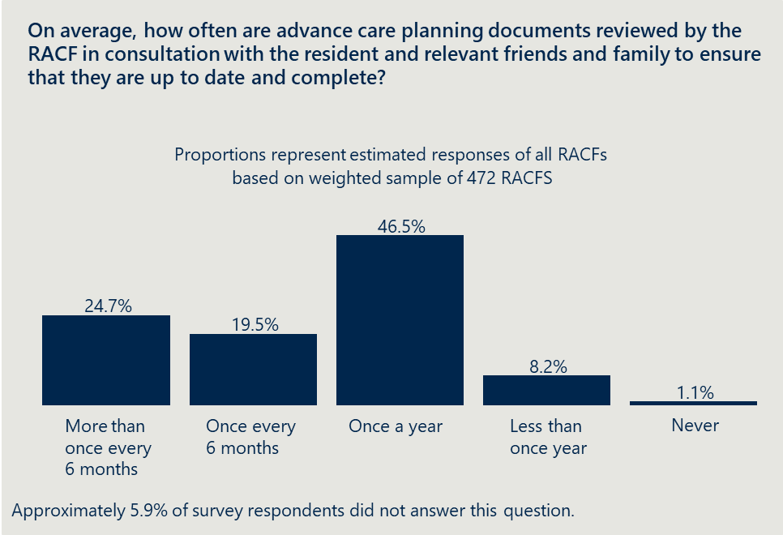

Additional data from NIHSI-AA and MBS will be in the updated baseline in June 2022.

|  |  |  |
| --- | --- | --- |
| Indicator | Baseline assessment | Data source |
| Increased proportion of RACF residents with ACPDs (e.g., ACPs or Advance Care Directives (ACDs)). | On average, RACFs reported that 81 per cent of all current residents have ACPDs in place. | RACF survey |
| Increased effectiveness and use of ACPDs (e.g., ACPs or ACDs) within RACFs. | ACPDs do not always have sufficient detail or relevant information for them to be effective when they need to be used to guide care. | Qualitative assessment |
| Increased number of Multidisciplinary Case Conferences by Medical Practitioners (Other Than Specialist or Consultant Physician) – (MBS items 735 to 758) in RACFs. | Baseline data for this indicator will be provided in the midpoint progress report in June 2022. | NIHSI-AA/MBS |

|  |
| --- |
| Outcome 2: Improved access to information that informs end-of-life care decisions for residents and families. |
| **Baseline assessment:** Information that informs end-of-life care decisions is often difficult for residents and families to access. |

Providing coherent and consistent information is difficult with multiple services and service providers responsible for palliative care. RACF residents can receive palliative care from multiple services including services within the RACF, GPs, specialist and generalist palliative care services and acute care services (e.g., hospitals).

Each of these services may provide some information regarding end-of-life care decisions, however, there is often not a coordinating service responsible for engaging with the resident and family to provide information and support end-of-life care decisions (see Outcome 7).

Community understanding of palliative care is limited and time needs to be taken to ensure residents, families and carers understand what is happening. Residents, family, friends and carers often do not understand what key terms like “palliative care”, “end-of-life care” or “advance care planning document” mean. The Royal Commission notes examples where these have not been explained leading to confusion and poorer quality care.[12]

Online information needs to be supported with local and personal knowledge. The Australian Government provides the My Aged Care website with information covering all aged care. The My Aged Care website has pages dedicated to end-of-life care that includes palliative care, however, key terms are not defined (e.g., “palliative care” or “specialist palliative care services”). The Royal Commission notes that My Aged Care should not be a substitute for local knowledge

“In an area that is so vitally important to peoples’ lives, there should always be the ability to talk to someone who has the relevant information and can help identify the best local options for service and care.”[13]

|  |  |  |
| --- | --- | --- |
| Indicator | Baseline assessment | Data source |
| Increased resident, family and carer access to information on end-of-life care. | Information to inform end-of-life care decisions is often difficult to access with multiple sources providing information that may not match community understanding. | Qualitative assessment |

|  |
| --- |
| “Three weeks before her father died, Mrs Nisi was told by a staff member over the phone that her father would be receiving palliative care, but care staff did not explain this term to her. Nor did care staff enact a palliative care plan. Mrs Nisi said she did not understand that her father was in the final stages of his life – no one took the time to explain this to her.”  Royal Commission into Aged Care Quality and Safety |

|  |
| --- |
| Outcome 3: A higher proportion of clinical and non-clinical staff in RACFs have skills and confidence appropriate to their roles to recognise and respond to the holistic palliative care needs of residents, in a culturally safe way. |
| **Baseline assessment:** RACF staff typically do not have the skills and confidence appropriate to the requirements of their role to recognise and respond to the holistic palliative care needs of residents, in a culturally safe way. |

There is a shortage of staff who have the qualification and skills to provide good palliative care. Stakeholders interviewed as part of the baseline including specialist palliative care services and clinicians noted, that staff do not have the appropriate knowledge and experience to provide palliative care. At the same time, these stakeholders emphasised that staff in RACFs are motivated and want to provide good quality care for residents, however, struggle to do so without the necessary expertise.

The Royal Commission also noted that there is “a shortage of staff who are qualified and experienced in providing good palliative care.”[14] Palliative care clinicians from multiple jurisdictions noted that there is limited coverage of Registered Nurses, particularly overnight.

RACF staff often lack the skills to assess when a resident is dying. Clinicians interviewed indicated that RACF staff are not confident making assessments about when a resident is dying and that this skill is crucial to providing quality anticipatory palliative care. RACFs overwhelmingly reported (97 per cent) that they have specific policies and procedures with clear steps to assist staff to recognise when a resident is close to end-of-life.[15] However, clinicians noted that these policies or procedures need to be accompanied by relevant training for them to be effective.

Education and training resources are available; however, training is often not mandatory. Clinicians noted that education and training resources are available including:

* Australian Healthcare and Hospitals Association (AHHA) Palliative Care Online Training
* ELDAC Residential Aged Care Toolkit
* Palliative and Supportive Care Education (PaSCE)
* Altura Learning Palliative care: End of life care
* The Palliative Care Bridge
* Ausmed Palliative Care Hub.

However, 37 per cent of RACFs indicated they did not have mandatory palliative care training for any staff group (Figure 5A). Less than one in ten RACFs have mandatory palliative care for all staff groups identified. Registered nurses were the only staff group where a majority of RACFs indicated mandatory training included palliative care (Figure 5B). Clinicians identified Personal Care Workers as a target cohort to upskill in identifying palliative care needs, however noted they were often least engaged in available training.

RACFs experience a high level of staff turnover including both care staff and managers leading to knowledge loss. Palliative care clinicians noted that RACFs have a high level of staff turnover including both managers and care staff. This likely leads to knowledge loss within RACFs as individuals who have participated in training, gained experience or understand the processes in the facility leave.

Figure 4 Close to 40 per cent of RACFs did not have palliative care as part of mandatory training for any staff groups[16]

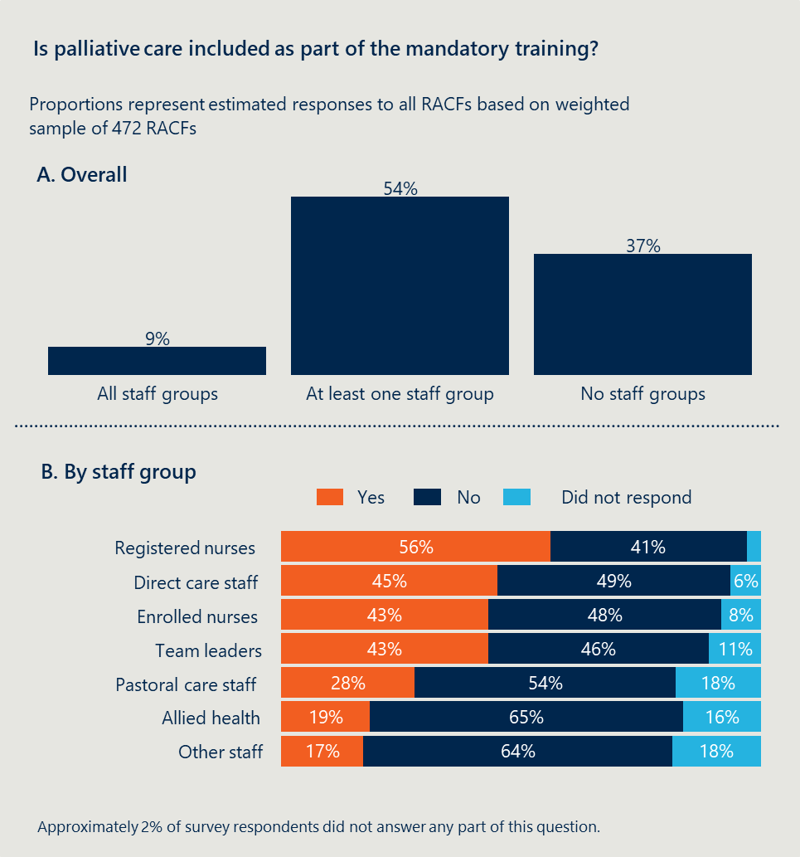

Additional data from NIHSI-AA, ambulance data pilot and training organisations will be incorporated into the baseline in the Mid-Term Progress Report in June 2022.

|  |  |  |
| --- | --- | --- |
| Indicator | Baseline assessment | Data source |
| Increased number of RACFs that have a policy in place and monitored to ensure that all staff (including casuals) uptake available training/education opportunities to improve their understanding about palliative care. | 37 per cent of RACFs do not have mandatory palliative care training for any staff group identified. | RACF survey |
| Increased number of residents who receive subcutaneous medicines associated with palliative care in RACFs. | Baseline data for this indicator will be provided in the midpoint progress report in June 2022. | NIHSI-AA |
| Decreased number of transfers from RACFs to acute care facilities. | Baseline data for this indicator will be provided in the midpoint progress report in June 2022. | NIHSI-AA/Ambulance data pilot |
| Decreased number of RACF residents admitted to an acute care facility for palliative care. | Baseline data for this indicator will be provided in the midpoint progress report in June 2022. | NIHSI-AA |
| Decreased number of inpatient bed days related to palliative care for residents of RACF. | Baseline data for this indicator will be provided in the midpoint progress report in June 2022. | NIHSI-AA |
| Increased completions of accredited courses related to palliative care. | Baseline data for this indicator will be provided in the midpoint progress report in June 2022. | AHHA/ELDAC |

|  |
| --- |
| Outcome 4: Improved access to quality palliative care in RACFs including:   * increased use of assessments to establish residents’ palliative care needs decreased health service use related to clinically futile or non-beneficial treatments and inpatient bed days * decreased healthcare expenditure arising from decreased service use. |
| **Baseline assessment:** Access to quality palliative care in RACFs is variable with many residents not accessing effective palliative care. |

Linked data analysed by AIHW suggests approximately one in five people in RACFs have accessed palliative care in the year before death. Analysis by AIHW published in 2021 found that only 18 per cent of older people who died in residential aged care received palliative care including being prescribed palliative care medications, had seen a palliative care specialist or had been admitted to hospital for palliative care during the preceding year. [17] Evidence suggests the general proportion of the population who need palliative care when dying ranges between 38 per cent and 74 per cent and that need for palliative care is higher in older patients.[18] This suggests there are some RACF residents who need specialist or generalist palliative care, though are not able to access it.

The AIHW analysis referenced above only includes data from Victoria and Queensland from 2016-17. There may be other palliative care services that are not identifiable in this data (e.g., specialist palliative care services provided by state or territory health services or palliative care physicians who do not charge the MBS). Analysis of NIHSI-AA included in the Mid-Term Progress Report will provide further insights that identify the use of palliative care services in RACFs with more comprehensive and recent data.

RACF residents are generally able to access GPs. Overall, 88 per cent of RACFs reported that residents can access palliative care services from a GP (see Figure 6). This aligns with recent analysis by AIHW which reported that most people (92 per cent) living in permanent residential aged care had at least one visit from a GP.[19]

AIHW also identified that GP visits in RACFs increased towards the end-of-life from approximately two visits per month for each resident to five visits per month for each resident.[20] While RACF residents can access GPs, the quality of palliative care is likely variable (see Outcome 5).

Figure 5 RACFs in remote Australia often do not have access to palliative care services from GPs[21]

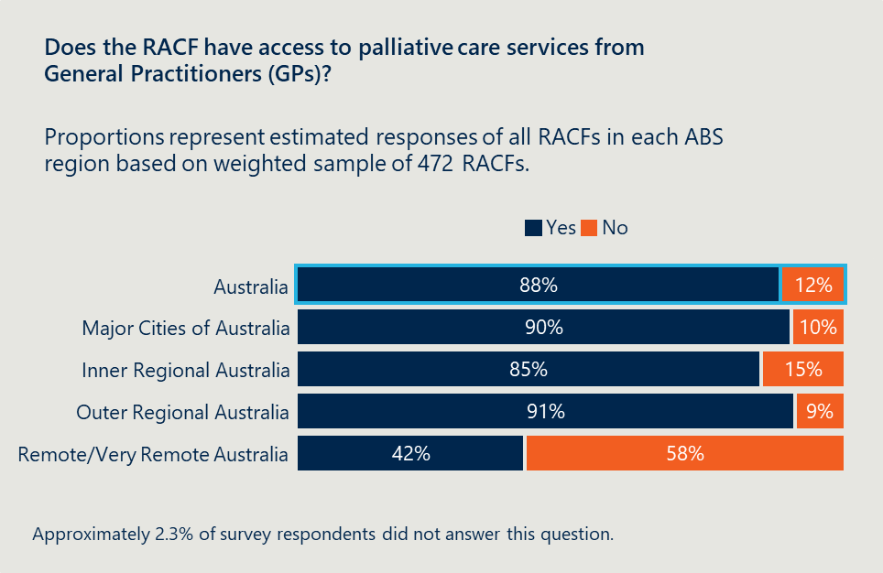

Evidence regarding access to specialist palliative care services is mixed. Across Australia, RACFs overwhelmingly reported being able to access specialist palliative care services (see Figure 7). This contrasts with evidence to the Royal Commission that “most residential aged care services do not have access to specialist palliative care teams”.

This may reflect that the sample of the survey is skewed toward facilities with access to specialist palliative care services. Also, RACFs may technically be able to access specialist palliative care services, however, the actual nature of this service is limited. Clinicians interviewed as part of the baseline noted that these services are only expected to provide specialist support to patients with complex needs and do not have capacity to provide palliative care for all residents who are dying.

Figure 6 Residents in remote Australia have less access to specialist palliative care provided by a state or territory health service

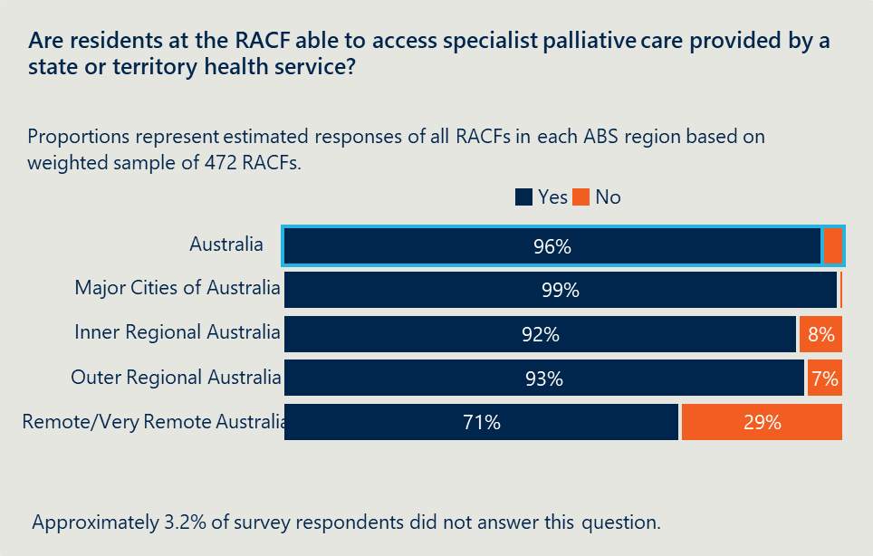

* Access to palliative care services is limited in remote parts of Australia. RACFs in remote Australia were much less likely to indicate access to GPs (42 per cent indicated access compared with 88 per cent overall) or specialist palliative care services (71 per cent compared with 96 per cent overall) (Figure 6 and Figure 7). AIHW also identified that residents in major cities had higher monthly rates of GP visits than those in more remote areas.[22]
* Palliative care clinicians noted that in regional areas there is often a stronger emphasis on good relationships between GPs and RACFs to provide palliative care. Taken together, this evidence suggests RACF residents in remote parts of Australia likely struggle to access quality palliative care.

Evidence indicates there is limited use of assessments to establish palliative care needs in RACFs. Many specialist palliative care services use assessments to establish palliative care needs, however, their use in RACFs is limited. Clinicians in specialist palliative care services noted during consultation that they see their role as providing support for complex cases that require additional support. These clinicians also noted they are not resourced to provide palliative care to all RACF residents who need more straightforward palliative care. In their view, this more routine provision of palliative care should be provided by the RACF staff. The PCOC has a model for RACF staff to conduct and monitor palliative care, however, this is still in the pilot stage with approximately ten facilities participating.

NIHSI-AA data is expected to provide detailed information regarding the level of health service used related to clinically futile or non-beneficial treatments and in patient bed days. Using linked data will enable the identification of services received by RACF residents in other settings including hospital.

Additional data from PCOC, NIHSI-AA and the ambulance data pilot will be incorporated into the baseline in the midpoint progress report in June 2022.

|  |  |  |
| --- | --- | --- |
| Indicator | Baseline assessment | Data source |
| Increased number of RACF residents who receive palliative care through a service participating in the PCOC. | Baseline data for this indicator will be provided in the midpoint progress report in June 2022. | PCOC |
| Increased number of RACFs that access palliative care provided by states/territory specialist services. | 93 per cent of Australian RACFs report that residents can access specialist palliative care provided by a state or territory health service. | RACF survey |
| Increased number of Multidisciplinary Case Conferences by Medical Practitioners (Other Than Specialist or Consultant Physician) – (MBS items 735 to 758) in RACFs. | Baseline data for this indicator will be provided in the midpoint progress report in June 2022. | NIHSI-AA/MBS |
| Increased number of residents who receive subcutaneous medicines associated with palliative care in RACFs. | Baseline data for this indicator will be provided in the midpoint progress report in June 2022. | NIHSI-AA |
| Increased number of residents who receive subcutaneous medicines associated with palliative care in RACFs. | Baseline data for this indicator will be provided in the midpoint progress report in June 2022. | NIHSI-AA |
| Decreased number of transfers from RACFs to acute care facilities. | Baseline data for this indicator will be provided in the midpoint progress report in June 2022. | NIHSI-AA/Ambulance data pilot |
| Decreased number of RACF residents admitted to an acute care facility for palliative care. | Baseline data for this indicator will be provided in the midpoint progress report in June 2022. | NIHSI-AA |
| Decreased number of inpatient bed days related to palliative care for residents of RACF. | Baseline data for this indicator will be provided in the midpoint progress report in June 2022. | NIHSI-AA |

|  |
| --- |
| Outcome 5: Improved quality of palliative care provided in RACFs including:   * reduced symptom burden * improved quality of life for residents during the period they access palliative care * better experience of death and dying for residents, families/carers and staff, including meeting physical, psychosocial, cultural and spiritual needs. |
| **Baseline assessment:** The quality of palliative care in RACFs is variable with some residents having low quality care that does not meet their physical, psychosocial, cultural and spiritual needs. |

The quality of palliative care in RACFs is variable. Many RACF residents do not access palliative care services meaning the quality of palliative care they receive is either low or non-existent (see Outcome 4 above). In contrast, other residents have access to quality palliative care through the RACF or in-reach services. One submission to the Royal Commission noted that the “lack of consistency results in a ‘postcode lottery’ of sorts for clients seeking palliative care support”. [23]

Some residents and families/carers and staff have a poor experience of death and dying that does not meet their physical, psychosocial, cultural and spiritual needs. The Royal Commission report includes examples where “the care provided to people in their last weeks and days of life was severely lacking and fell well short of community expectation”.[24] The Royal Commission report also identifies experiences of residents, families and carers who have a poor experience of death and dying.[25]

|  |
| --- |
| “So instead of [being] with my brother and comforting my mother, my father was in the corridor of the facility trying to find a staff member to help them and my brother. He ended up saying ‘can someone please help us, my son is dying’. It is sad that their last memories are of my brother struggling and looking in pain and them trying to get a staff member to assist. After he passed away, no one closed his eyes or did anything in the room other than open the doors. No staff member or manager came to the room to tell us what happens next. I had to go looking for staff to see what happened next.”  Submission to Royal Commission into Aged Care Quality and Safety |

Further information on the quality of palliative care in RACFs will be available in the midpoint update. Data from PCOC and consultation with representatives from PCA will provide further insight into the quality of palliative care in RACFs.

* Additional data from PCOC will be incorporated into the baseline in June 2022 (the Mid-Term Report).

|  |  |  |
| --- | --- | --- |
| Indicator | Baseline assessment | Data source |
| Increased number of providers/RACFs participating in the PCOC. | Baseline data for this indicator will be provided in the midpoint progress report in June 2022. | PCOC |
| Increased number of RACF residents who receive palliative care through a service participating in the PCOC. | Baseline data for this indicator will be provided in the midpoint progress report in June 2022. | PCOC |
| Improved resident experience of dying reported by family/carers. | Some residents and families/carers and staff have a poor experience of death and dying that does not meet their physical, psychosocial, cultural and spiritual needs. | PCA consumer representative group |

|  |
| --- |
| Outcome 6: Greater patient choice in palliative care including:   * more people dying where they want * increased person-centred care informed by an individual’s choice. |
| **Baseline assessment:** Baseline assessment: Residents typically have limited choices in terms of palliative care. |

A substantial proportion of RACF residents do not have their preferred place of death recorded by the RACF. A majority of RACFs record that they have preferred place of death recorded for more than half of residents (Figure 8). At the same time, approximately 23 per cent of RACFs reported that they have recorded a preferred place for less than half of all residents, including seven per cent that have preferred place of death recorded for no residents. Together this suggests there are many RACF residents who do not have their preference recorded.

Figure 7 A majority of RACFs have preferred place of death recorded for more than half of residents[26]

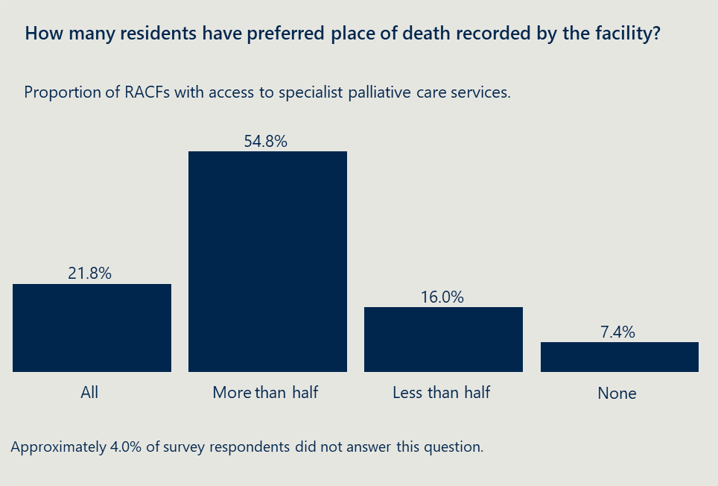

Most people living in residential aged care die in that facility. Studies of the general population show most Australians would prefer to die at home (60 to 70 per cent) rather than in a hospital or residential care.[27] However, when people enter residential aged care, this becomes their home and is assumed to be the preferred setting for most residents compared with hospital. AIHW recently reported that 79 per cent of people who had been living in residential aged care in the week before their death died in the RACF.[28] A total of 19 per cent of people who had been living in RACFs in the week before their death died in hospital and 1.7 per cent died in the Emergency Department (ED). This compares favourably to people who do not live in RACFs who more frequently die in hospital (71 per cent).[29]

Evidence indicates that many RACF residents have limited choices in terms of palliative care – including being able to die where they want. The lack of palliative care choices for RACF residents are driven by:

* access to palliative care services (see Outcome 4)
* access to information to make informed decisions (see Outcome 2)
* effectiveness of ACPDs (see Outcome 1)
* a workforce with limited experience and knowledge (see Outcome 3).

Additional data from NIHSI-AA will be incorporated into the baseline in June 2022 (Mid-Term Report).

|  |  |  |
| --- | --- | --- |
| Indicator | Baseline assessment | Data source |
| Increased proportion of RACF residents with ACPDs (e.g., ACPs or ACDs). | On average, RACFs reported that 81 per cent of all current residents have ACPDs in place. | RACF survey |
| Increased effectiveness and use of ACPDs (e.g., ACPs or ACDs) within RACFs. | ACPDs do not always have sufficient detail or relevant information for them to be effective when they need to be used to guide care. | Qualitative assessment through consultation |
| Increased number of RACFs that access palliative care provided by states/territory specialist services. | 93 per cent of Australian RACFs report that residents can access specialist palliative care provided by a state or territory health service. | RACF survey |
| Decreased number of RACF residents dying in an acute care setting (e.g., hospital). | Baseline data for this indicator will be provided in the midpoint progress report in June 2022. | NIHSI-AA |
| Decreased number of RACF residents admitted to an acute care facility for palliative care. | Baseline data for this indicator will be provided in the midpoint progress report in June 2022. | NIHSI-AA |

|  |
| --- |
| Outcome 7: Improved care coordination with GPs/primary care, acute care services and specialist palliative care services. |
| **Baseline assessment:** Palliative care for RACFs residents is provided by a range of services including the RACF, GPs, hospitals and specialist palliative care services. These services often have difficulty sharing information and providing coordinated care. |

Palliative care in RACFs is provided by a range of services. This includes palliative care provided by the RACF, GPs or other primary care, acute care services (e.g., hospitals) and specialist palliative care services. These services need to work in a coordinated way to provide effective and efficient palliative care to RACF residents.

Service providers typically struggle to share information with many using different systems to store information. Clinicians including specialist palliative care services reported that there is a lack of consistent systems across RACFs which makes communication difficult including using case notes to prescribe medication. There are examples of good practice, such as South Australia’s (SA) emerging network between GPs and specialist palliative care providers to support consultation and care coordination in RACFs. In Queensland, Western Moreton Primary Health Network (PHN) has an end-of-life collaborative with a history of integrated models of care.

Coordination between RACFs and acute care is a particular pain point. Clinicians noted that communication and coordination challenges arise when a RACF residents moves into acute care with a lack of clear communication between the hospital, RACF, resident and carers/family.

Similarly, clinicians noted that the clinical handover for residents who have been admitted to a hospital and transferred back to a RACF is often poor with little understanding of the different capabilities between hospital and RACF staff.

|  |
| --- |
| “It’s like sending them into and out of a vacuum.”  Clinician experience of a resident being transferred to a hospital and then back to RACF |

Additional data from NIHSI-AA/MBS will be incorporated into the baseline in the Mid-Term Progress Report in June 2022.

|  |  |  |
| --- | --- | --- |
| Indicator | Baseline assessment | Data source |
| Increased number of Multidisciplinary Case Conferences by Medical Practitioners (Other Than Specialist or Consultant Physician) – (MBS items 735 to 758) in RACFs. | Baseline data for this indicator will be provided in the midpoint progress report in June 2022. | NIHSI-AA/MBS |

|  |
| --- |
| Outcome 8: Improved integration between the health and aged care systems. |
| **Baseline assessment:** There is limited integration between health and aged care systems to provide palliative care in RACFs. |

Providing palliative care in RACFs requires integration between the health and aged care systems. RACF residents require access to health services as part of palliative care, including:

* health care in-reach and out-reach
* engagement with GPs, specialists and allied health professionals
* transfers to hospital.
* The aged care and health care systems are fragmented. Both health and aged care have their own distinct governance arrangements, funding mechanisms, eligibility criteria and entry processes. As a result, the service system is difficult for older people, families and carers to navigate.

RACF residents often struggle to access health services. RACFs are sometimes viewed by the broader health service as “standalone health services” that do not require access to wider health system.[30] For example, some community palliative care services that provide services to individuals in their home are prevented from providing palliative care inside RACFs.

Palliative care clinicians noted that some transfers from RACFs are inappropriate and could be reduced. These clinicians also noted other RACF residents would likely benefit from palliative care in a hospital and that these transfers do not always occur. AIHW analysis identified that people using permanent residential aged care were less likely to have had an ED presentation than those using home support or home care (32 per cent compared with 37 to 38 per cent) or a hospital separation (37 per cent, compared with 51 to 58 per cent). The Royal Commission also highlighted integration of care between RACF staff and other health practitioners as an issue in providing effective palliative care.[31]

* There is a lack of clarity regarding the roles and responsibilities for providing palliative care to RACF residents. The health and aged care systems need clearly defined roles to ensure that the palliative care needs of residents are met while also preventing duplication. Clinicians noted there is a lack of clarity regarding the role of specialist palliative care services funded by state and territory governments and aged care services funded by the Australian Government. This includes confusion around where “specialist” palliative care should be provided to residents with more complex needs and where more general palliative care is required (see Outcome 4 above for further discussion on roles and responsibilities for providing palliative care in RACFs).

Additional data from NIHSI-AA and ambulance data pilot will be incorporated into the baseline in the midpoint progress report in June 2022.

|  |  |  |
| --- | --- | --- |
| Indicator | Baseline assessment | Data source |
| Decreased number of transfers from RACFs to acute care facilities. | Baseline data for this indicator will be provided in the midpoint progress report in June 2022. | NIHSI-AA/Ambulance pilot |
| Decreased number of RACF residents admitted to an acute care facility for palliative care. | Baseline data for this indicator will be provided in the midpoint progress report in June 2022. | NIHSI-AA/Ambulance pilot |

|  |
| --- |
| Outcome 9: More palliative care services and health planners are informed by performance information on appropriateness, effectiveness, efficiency and outcomes. |
| **Baseline assessment:** Few palliative care services and health planners are informed by performance information related to palliative care in RACFs. |

There is mixed use of performance information on the appropriateness, effectiveness, efficiency and outcomes of palliative care. Approximately half of RACFs reported that they always or usually used an audit process to look at end-of-life care (e.g., an after death audit) (see Figure 9A).[32] This is likely an overrepresentation with clinicians noting during consultation there is limited use of audit processes beyond what are required for accreditation. Only 17 per cent of RACFs reported using a digital dashboard or other tool to monitor palliative care suggesting limited access to performance information (see Figure 9B).[33]

Figure 8 Limited use of audit processes and digital dashboard for palliative care[34]

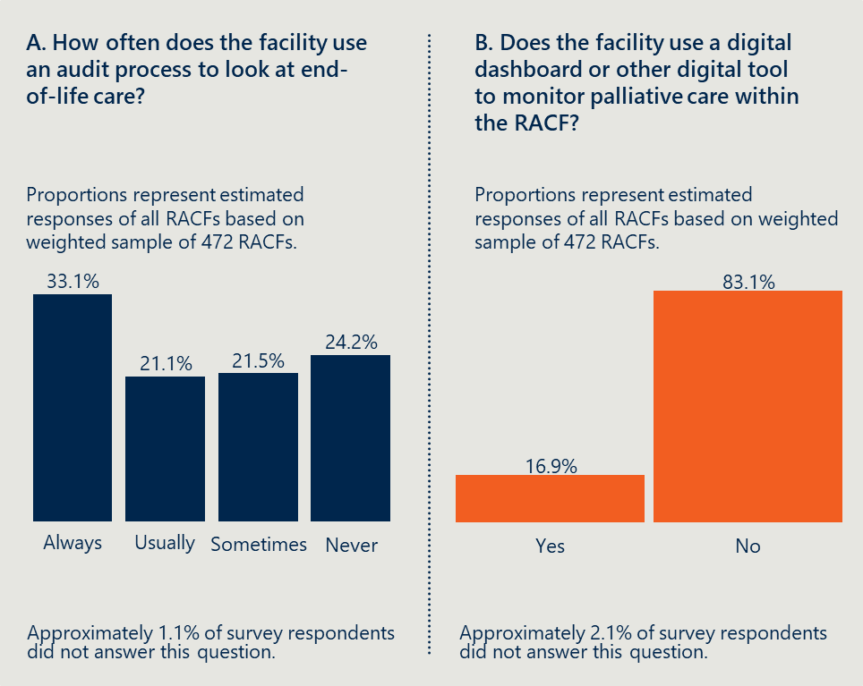

PCOC provides performance information to palliative care services and health planners; however, its use in RACFs is limited. PCOC collects information on palliative care outcomes alongside other information about the patient and support provided. The use of PCOC is well established in palliative care services, some of which provide services to residents in RACFs. PCOC has developed a new model that RACFs can implement to capture similar information. This was piloted in 2021 and is being rolled out further with additional funding in the 2021-22 Australian Government Budget. Further information on the use of PCOC and additional data from PCOC will be incorporated into the baseline in 2022 (Mid-Term Report).

|  |  |  |
| --- | --- | --- |
| Indicator | Baseline assessment | Data source |
| Increased number of providers/RACFs participating in the PCOC. | Baseline data for this indicator will be provided in the midpoint progress report in June 2022. | PCOC |

|  |
| --- |
| Outcome 10: Improved clinical governance to identify and implement quality improvement initiatives and evaluation of outcomes within RACFs. |
| **Baseline assessment:** While quality improvement initiatives are in place, there is limited evidence regarding clinical governance of palliative care in RACFs. |

Most RACFs are implementing palliative care quality improvement initiatives. A total of 65 per cent of RACFs have implemented quality improvement initiatives to improve palliative care outcomes over the past 12 months.[35] Many of these may have been in response to the Royal Commission.[36]

Figure 8 A majority of RACFs indicated they have implemented quality improvement initiatives[37]

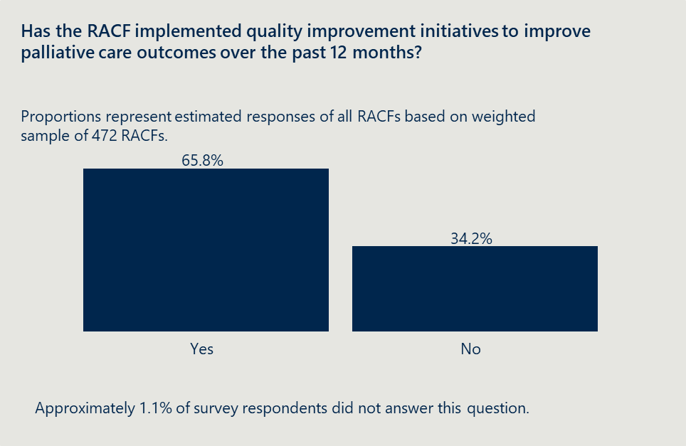

Fragmented provision of palliative care in RACFs makes clinical governance of palliative care difficult. The Aged Care Quality Standards require that RACFs have clinical governance and safety and quality systems to improve the reliability, safety and quality of clinical care.[38] This does not include requirements for palliative or end-of-life care in RACFs.[39] Palliative care in RACFs is provided by a range of services including the RACF, specialist and generalist palliative care services, GPs and other in-reach/out-reach health care. While some may have independent clinical governance, it is difficult to establish overarching clinical governance across these services – and the evaluation has not found evidence cross-service clinical governance.

Data from Aged Care Quality and Safety Commission will be incorporated in June 2022 (Mid-Term Report).

|  |  |  |
| --- | --- | --- |
| Indicator | Baseline assessment | Data source |
| Increased number of RACFs that implement quality improvement activities to improve palliative care. | 65 per cent of RACFs have implemented quality improvement initiatives to improve palliative care outcomes over the past 12 months. | RACF survey |
| Decreased number of complaints received by the Aged Care Quality and Safety Commission from residents and families related to palliative care. | Baseline data for this indicator will be provided in the midpoint progress report in June 2022. | Aged Care Quality and Safety Commission |

# Progress in implementing the Measure

|  |
| --- |
| This section summarises:   * what has been planned and implemented in each jurisdiction under the Measure * early learnings on implementation success and challenges |

## What was planned and implemented under the Measure?

Jurisdictional implementation started from mid-2020, using various approaches

The Project Agreement outlines three broad types of activities jurisdictions can fund under the Measure, as shown in Figure 11 and which include:

* In-reach models of care including services delivered by generalist and specialist palliative care providers within the RACF. In-reach services aim to better identify residents who are dying and provide good palliative care.
* Models that support end-of-life care decision making that aim to deliver quality, person-centred care to dying residents through the development of documentation around end-of-life care (e.g., ACPDs). These models typically involve an element that improves clinical governance and care coordination to enable effective end-of-life care decision making.
* Education and training initiatives that aim to build the capacity of the RACF workforce and other clinicians involved in the delivery of care to residents.

Jurisdictions can implement specific projects in response to local need and contexts.

Figure 10 Project Agreement categories to focus jurisdictional activities



All jurisdictions have signed up to the Measure as of July 2021

All jurisdictions have signed up to the Measure as of July 2021 (Figure 12). Six jurisdictions signed up to the Measure in 2020, two in 2021. Note: funding to jurisdictions commenced in the 2019-20 financial year.

All jurisdictions that signed up in 2020 have begun implementation. They are at different stages of implementation given their differing sign-up dates. Appendix A contains detail on the projects planned and implementation progress to date.

Figure 11 Timeline for Measure sign-up

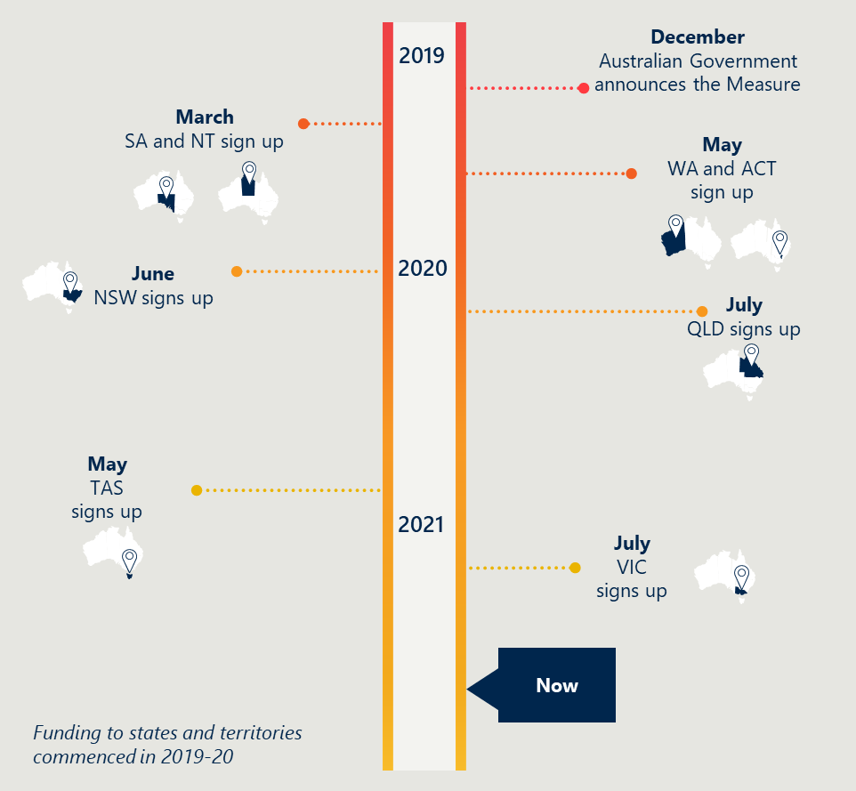

Jurisdictions have different approaches to implementation

Jurisdictions are using either a centralised or decentralised approach to design and implement the Measure, in part reflective of each health system structure. Some states have identified specific RACFs to implement projects (e.g., Northern Territory (NT)), whereas others are implementing projects state-wide (e.g., the Australian Capital Territory (ACT)). The approaches are summarised in Figure 13.

Table 6 Centralised and decentralised approach to implementation

|  |  |
| --- | --- |
| Centralised approach | Decentralised approach |
| One project team oversees one or more projects implemented across regions, with funding given directly to the organisation that will be delivering services.  For example, WA has a project team that coordinates two key projects currently underway. The WA project team is directly funding the organisation that will be delivering services, the Metropolitan Palliative Care Consultancy Service (MPaCCS). | Each local health authority, such as the Local Health District (LHD), Hospital and Health Service (HHS) or Local Health Networks (LHNs), establishes their own project team to oversee one project. Funding is provided to each project team, who then distribute it to the relevant organisations in their region to deliver services.  The local health authorities report back to a central project team on implementation progress and outcomes. For example, Queensland and NSW have opted to fund HHSs and LHDs (respectively) to identify and deliver projects that both meet local need and align to the aims of the Measure. |

All jurisdictions are implementing in-reach models of care and education and training

Each jurisdiction has identified initiatives in response to jurisdictional policy objectives, local health system contexts and local need.

Some jurisdictions, such as the ACT and WA, are expanding existing services, so are further progressed. This is largely because they build on existing structures (e.g., project model or design, project teams, clinical governance, partnerships with facilities) and workforces/relationships.

In most cases, jurisdictions have undertaken planning and design to ensure the projects reflect local needs and/or are based on extensive stakeholder engagement. In these instances, states and territories are typically still in the design phase or early implementation phase of these projects, since consultation and design are time-intensive processes (e.g., SA designing major projects based on successful non-government organisation (NGO) Grants).

Projects may touch on one or more of the Project Agreement categories. For example, under a model of care a specialist palliative care clinician may provide in-reach services that provide both direct palliative care service delivery (category 1) and also support to improve end-of-life decision making through the development of end-of-life care documentation (e.g., ACPDs) (category 2). This report groups activities under the category of best-fit, noting projects often contribute to numerous categories.

Overall, for all eight jurisdictions:

* all jurisdictions are implementing an in-reach model of care
* most jurisdictions have specific projects that aim to improve end-of-life care decision making; for many, this is one component of broader activities
* all jurisdictions are planning education and training projects
* five of eight jurisdictions are planning an evaluation, as stipulated in the Project Agreement
* two of eight jurisdictions are planning projects to improve care for Aboriginal and Torres Strait Islander people.

Each of these points is expanded further below.

|  |
| --- |
| **All jurisdictions are implementing an in-reach model of care.** |

All jurisdictions are implementing an in-reach model of care in some form, adapted to local needs and contexts. The most common form of in-reach model is a palliative care needs round (PCNR) or in-reach model for specialist palliative care delivery into RACFs.

For example, some individual HHSs in Queensland provide in-reach care via Specialist Palliative Care Clinical Nurse Consultants (CNC). These CNCs participate in monthly needs rounds with RACFs to identify and support residents’ palliative care needs. Similarly, an LHD in New South Wales (NSW) is also delivering la needs rounds model. The model takes a triage approach to identifying residents of RACFs most at risk of dying without an ACPD in place and providing direct care to dying residents.

Jurisdictions are implementing models of care through a range of modes. Some jurisdictions reported that different modes were being trialled to respond to fluctuating COVID-19 restrictions. These modes are:

* In-person – e.g., ACT is delivering PCNR in person.
* Telehealth – e.g., Queensland is supporting consultations and providing support via phone.
* Virtually – e.g., NSW is providing specialist input through a virtual care model.

|  |
| --- |
| **Some jurisdictions have specific projects that aim to improve end-of-life care decision making; for many, this is one component of broader activities** |

Most jurisdictions are focusing on improving end-of-life decision making as a component of other initiatives, rather than as a standalone project. All in-reach models of care planned have a component focused on improving end-of-life care decision making. For example, Tasmania plans to deliver specialist palliative care in-reach into RACFs led by CNCs. The CNCs will support care coordination and treatment delivered to residents, ensuring end-of-life care decision making and care delivered is in line with resident needs and wishes.

Other projects that support end-of-life care decision making focus on establishing or improving the delivery of shared care and/or integrated care. These approaches specifically aim to improve care coordination and transitions across care settings, which are significant challenges in the aged care setting.

* Shared care is where clinicians and staff involved in the delivery of services to a resident of a RACF jointly participate in the planned delivery of care. For example, SA has a project building networks between GPs and specialist palliative care providers to improve care coordination of palliative care in RACFs.
* Integrated care brings together staff involved in the delivery of care, as well as reviews other enablers, such as clinical governance and organisational design of services, to improve care. For example, WA, as part of the MPaCCS expansion, plans to embed a nurse liaison in hospitals to support transfers of residents from RACFs.

|  |
| --- |
| **All jurisdictions are planning education and training projects** |

The education and training projects planned to date leverage existing national initiatives (ELDAC, AHHA, PCOC) and some state-based activities (e.g., PaSCE in WA). A lack of minimum standardised training requirements for aged care creates a challenging context for quality education and training in Australia.[40] However, existing initiatives to improve the capability of the aged care workforce have provided a foundation for some jurisdictions to build from.

Education and training also comprise aspects of other projects, particularly in-reach models of care. For example, needs rounding includes a targeted or case-based educational component, which is being delivered in the ACT, NT, Queensland, and Tasmania. These are being focused on cohorts (e.g., Personal Care Workers, GPs) or are available to the wider RACF workforce.

|  |
| --- |
| **Five of eight jurisdictions are planning an evaluation, as stipulated in the Project Agreement**. |

Five jurisdictions (NSW, Queensland, SA, Tasmania and WA) are planning to undertake an evaluation. There is variability as to whether the evaluations are for Measure activities specifically or as part of larger, state-based evaluations of palliative care activities. Detail on the evaluation plans is limited as jurisdictions are in the early stages of planning.

As of July 2021, NT, Victoria and the ACT have not planned to conduct an evaluation of Measure activities. The ACT has already conducted an evaluation of the model it is expanding under the Measure. The NT will be collecting data from baseline onwards and this will be made available to the national evaluation.

|  |
| --- |
| **Two of eight jurisdictions are planning projects that intend to improve care for Aboriginal and Torres Strait Islander people.** |

Two jurisdictions (Victoria and NT) are planning projects that either directly or indirectly focus on improving care for Aboriginal and Torres Strait Islander people. In Victoria, the project is designed with Aboriginal and Torres Strait Islander people. Victoria is planning to work with Aboriginal and Torres Strait Islander organisations to develop and implement a model of care that supports Elders access to culturally safe and effective palliative and end-of-life care.

In the NT, the project is implemented in facilities that have a higher proportion of Aboriginal and Torres Strait Islander residents.

**Implementation is progressing as planned for most jurisdictions**

Jurisdictions are typically implementing what was originally planned.[41] Where changes have occurred, they have generally been to refine the scope (e.g., specify the RACFs that would be participating in projects) and to mitigate risks associated with delays. Commonly cited reasons for delay include COVID-19 and workforce constraints:

* COVID-19 delays were often due to third parties being unable to access RACFs in-person to implement a project (e.g., DiscoDTours implementing Moove and Groove Palliation in SA).
* More than half the states and territories noted that workforce constraints, particularly the limited pool of specialist palliative care clinicians, have delayed expansion of some projects.

Section 3.2 contains early implementation learnings to date. A snapshot of what has been planned and implemented to date is provided overleaf. Further detail is in Appendix A.

Table 7 Projects planned and implementation progress by jurisdiction

|  |  |  |
| --- | --- | --- |
| Jurisdiction | Projects | Implementation |
| Australian Capital Territory | The palliative care needs rounds (PCNR) model aims to help people to live better and die well in their preferred place of death. It has three core elements: PCNR, case conferences and clinical work. | ACT signed up to the Measure in May 2020. ACT has expanded the PCNR model to all RACFs in the territory.​ |
| New South Wales | Local Health Districts (LHDs) in NSW have developed initiatives that reflect local needs, such as an adapted decision assist linkages model using a Specialist Palliative Care Link-Nurse.​ | NSW signed up to the Measure in June 2020. Each LHD has received equal Commonwealth funding and provided plans to implement the Measure.​ |
| Northern Territory | The Measure is being used to establish in-reach Needs Rounds or screening rounds in Central Australia and Top End, including education and training components for the RACF workforce.​ | NT signed up to the Measure in March 2020. Needs Rounds have been trialed in four RACFs in Central Australia. Top End is formalising relationships with RACFs.​ |
| Queensland | QLD has enabled each Hospital and Health Service (HHS) to determine the most appropriate model of care, such as inter-professional education and case-based learning for healthcare staff.​ | QLD signed up to the Measure in July 2020. Each HHS has accepted funding and established project teams. Each HHS is engaging with local RACFs.​ |
| South Australia | SA have developed three major projects based on successful NGO Grants. Projects include Hospice in Aged Care, Hospice in the RACF and GP Shared Care.​ | SA signed up to the Measure in March 2020. NGO Grants have been administered. The three major projects are expected to commence in July 2021.​ |
| Tasmania | TAS has planned three major projects: Specialist Palliative Care in-reach into RACFs; training posts for GP registrars in palliative care; and RACF funding for allied health support.​ | TAS signed up to the Measure in May 2021. TAS is in the early stages of implementation of the Measure.​ |
| Victoria | VIC is planning five projects: building local capacity in RACFs, improving assessment tools, enhancing existing models of care, supporting goals of care and promoting culturally safe palliative care for Aboriginal people.​ | VIC signed up to the Measure in July 2021. VIC is in the early stages of implementation of the Measure.​ |
| Western Australia | WA has planned two major projects: expanding the MPaCCS; and the PaSCE Residential Aged Care Excellence in Palliative Care education program.​ | WA signed up to the Measure in May 2020. The two major projects commenced in early 2021. The third workstream is being scoped.​ |

## What are the emerging insights from initial implementation?

### There are emerging successes and challenges

Successes and challenges have included:

* relationships, flexibility and increased funding have supported implementation to date
* some challenges have arisen to date related to the funding mechanism
* other early implementation challenges relate to interface and operational issues.

Each of these points is expanded further below.

|  |  |  |
| --- | --- | --- |
| Early successes | Relationships, flexibility and increased funding have supported implementation to date.  Several factors have contributed to successful implementation of the Measure to date, including: |  |

* Collaborative relationships. The relationships the Department established with central agencies assisted in negotiating the Project Agreement. The collaboration the Department undertook with jurisdictions after the Measure was announced established strong working relationships.
* Flexible nature of the Project Agreement. Flexibility to design local approaches helped to support relevance and feasibility in jurisdictional approaches and expedite negotiations. This meant being able to match approaches to suit local health system contexts, localities and demographics.
* Shared funding arrangement, for some states. In some states there are early signs of a greater shared sense of responsibility at the health and aged care interface. For example, Queensland and WA indicated it is it easier for state-funded health services to engage with RACFs and to organise clinicians and aged care workers around a shared goal (as opposed to being distracted by revenue streams).
* Increased funding to enable innovative approaches. There are early indications from NSW, NT, Queensland and WA that the Measure is enabling innovation that otherwise would not have been funded.

|  |  |  |
| --- | --- | --- |
| Early challenges | Some challenges have arisen to date related to the funding mechanism.  The most significant challenges in implementation to date have related to the nature, and some of the requirements, of the funding mechanism itself – a national Project Agreement. Key challenges related to the Project Agreement include the: |  |

* Limited negotiation with jurisdictions prior to the announcement of the Measure. There was reportedly limited consultation with jurisdictions prior to the Measure being announced. This meant jurisdictions were not able to provide input on Measure priorities to ensure alignment to jurisdictional policy goals, nor discuss the matched funding requirement (and earmark jurisdictional budgets in advance).
* Need to navigate nine bureaucratic processes, which created long lead times for implementation. There was a long lead time from conception to implementation. The Department had to navigate eight different state and territory health department relationships and jurisdictional processes. This created delays, particularly for states with decentralised health systems (Queensland and NSW).
* Nature of the funding mechanism, particularly the matched funding requirement. Many states and territories noted that in principle ”pooled funding” arrangements can support major reforms or interface issues, yet “matched funding” can be problematic, particularly in the way it was announced for this Measure (with limited negotiation prior).
* Other concerns related to the funding mechanism reported by jurisdictions include:
* Time limited nature of the funding. Jurisdictions were hesitant to invest in some initiatives, given the potential risk to service continuity and sustainability. For example, NSW indicated they were prioritising models and positions which could be feasibly scaled back. Other states indicated that it raises expectations about ongoing service delivery and/or leaves states with the risk of industrial action at the end of the Measure funding. This aligns to evidence, which demonstrates that time-limitations in National Agreements such as the Measure can de-incentivise systemic improvements.
* Inability to fund existing initiatives or recognise in-kind contributions. For many jurisdictions, that meant they needed to find additional funding and identify new project priorities – potentially diverting funds away from already agreed state priorities.
* Unweighted funding allocations. The Project Agreement funding was not weighted by rurality or Aboriginality, rather based on a per-capita distribution. This would seem to be contrary to the way many funding allocations are made, given the known higher costs of servicing these populations.
* Lack of a mechanism to hold stakeholders to account. There is no clear point of authority to hold states and territories to account for implementation. This is in part evidenced in the requirement for state-level evaluations not being able to be enforced.

### Other early implementation challenges relate to interface and operational issues

Additional emerging challenges outside the Measure as a funding instrument related to the extent to which activities are addressing interface and operational challenges in facilities. These are detailed below.

**Challenges related to addressing interface issues**

The intention of a matched funding arrangement was in part to address the interface issues, by creating a shared sense of responsibility. It implies a reliance on collaboration to ensure success. There has been mixed success in achieving this intent to date.

Whilst some states have reported early signs of creating a shared sense of responsibility, others report viewing the funding as “two separate and distinct streams”. This demonstrates that more is needed above just the funding mechanism itself, such as trusting relationships, interface “champions” and other formal and ongoing mechanisms to drive collaboration.

In addition, while many Measure activities focus on the interface between health and aged care (as detailed in section 3.1), the evaluation has identified two emerging gaps in planned activities:

1. The aged care-hospital interface is critical, however, not a primary target of the Measure. Challenges, such as continuity of care and poor clinical handovers, exist at the interface between hospitals and RACFs, yet most Measure activities focus on the interface of palliative care specialist services or GPs in RACFs.[42],[43],[44] In consultations, jurisdictional health departments and clinicians reported limited information sharing between RACFs and hospitals, and ineffective handovers when residents return to RACFs post a hospital stay. WA is one example of where Measure funding is being used to invest in a nurse liaison role to work in hospitals to support residents from RACFs who come into acute care.
2. The extent to which the Measure impacts GPs varies. For many RACFs, GPs play a critical role in palliative care access. Timely access to GPs trained in palliative care allows for earlier identification of issues requiring intervention and avoidance of unnecessary hospitalisation.[45] There is variable engagement of GPs in Measure activities across jurisdictions. Some jurisdictions indicated their projects are supporting RACFs, GPs and specialist clinicians to work together to meet the palliative care needs of residents (including ACT, NSW, NT, Queensland, SA and WA) (see Appendix A).

**Operational challenges within facilities**

There are emerging signs that operational challenges at the facility level will affect the extent to which Measure activities will have an impact. Emerging challenges include:

* Limited clinical capacity in palliative care in RACFs. Palliative care specialists providing in-reach palliative care in RACFs is important. Yet one of the most consistently cited challenges is the limited number of Registered Nurses in RACFs and other medical palliative care specialists for in-reach/outreach. Given the typical qualifications and training of the aged care workforce, Registered Nurses trained in palliative care in facilities would play a critical role in needs assessments, medication provision and linkages to hospital and specialist care. Other flow on effects due to the small workforce pool, include:
* it is challenging to identify trained clinicians to provide clinical supervision
* succession planning is critical for ongoing delivery and management of many models of care.
* Significant turnover in the aged care workforce. There is significant turnover in facility managers, personal care workers and other aged care staff.[46] This makes upskilling in palliative care needs assessment and care challenging, in terms of getting lasting benefits from education and training initiatives (as reported in consultations and the literature review).[47]
* RACFs are under significant pressure in part due to COVID-19 and the Royal Commission. RACFs are operating in a challenging policy environment, along with the ongoing impact of COVID-19 and other workforce pressures. Some jurisdictions reported this delayed or impacted the ability of some RACFs to implement Measure projects/activities within expected timeframes.

1. Implementation progress by jurisdiction

This appendix contains detail on jurisdictions planned projects and the progress they have made towards implementation.

The first table for each jurisdiction contains outputs of the service mapping exercise Nous conducted in October 2020 and updated funding information for the Measure.

The second table captures information on projects planned and implementation progress as of July 2021. Jurisdictions were requested to return a template that captured projects and progress in April 2021. Nous undertook consultations in May and June with each state and territory representative(s) to explore the information provided in the templates.

* Australian Capital Territory
* Northern Territory
* New South Wales
* Queensland
* South Australia
* Tasmania
* Victoria
* Western Australia

The Measure is provided through a cost-sharing model, meaning states and territories match Commonwealth funding.

* 1. Australian Capital Territory

Table 8 Palliative care activities planned for implementation in the ACT under the Measure

|  |  |
| --- | --- |
| Type of activity | Brief description |
| In reach/outreach models of care​ | * Recruit 2.3 full time equivalent (FTE) palliative care nurse practitioners to support the delivery of specialist palliative care services to all ACT RACFs through a PCNR model of care. * Expand and build on existing in-reach models of specialist palliative care within RACFs across the ACT with care being delivered based on the risk stratification and clinical need of residents, identified through PCNR, case conferences and clinical work through referrals. |
| Education and training​ | * Delivery of education and training for RACFs to build capacity and capability to support the delivery of specialist palliative care in all RACFs. * Develop a workforce succession planning process that focuses on building a sustainable workforce to deliver specialist palliative care services to all ACT RACF residents. |
| End-of-life care decision making[48] | * Engage with hospitals to facilitate early assessment of palliative care needs for patients transitioning to RACFs. |
| Other commentary about Measure implementation | * Primarily the Measure will be used to expand the ‘integrating specialist palliative care into residential care for older people’ (INSPIRED) model to all RACFs across the ACT. * The ACT has used the Measure to expand the PCNR model to all RACFs in the territory. |

Table 9 Projects planned and implementation progress of the Measure implementation in the ACT

|  |  |
| --- | --- |
| Projects planned | The Palliative Care Needs Round model aims to help people to live better and die well in their preferred place of death. It comprises three core elements:​   1. PCNRs​  * Monthly 60 minute triage and risk stratification.​ * Up to ten residents with short prognosis and high symptom burden presented.​ * Incorporates case-based education to extend and reinforce staff knowledge.​  1. Case conferences​  * Case conferences between facility staff, resident, relatives and relevant health care providers (e.g. GP or geriatrician).​ * Agenda focuses on resident and/or family concerns, improving quality of life, care goals and completion of an ACP.​ * Medications and care plans may be changed as part of these discussions.​  1. Clinical work with relevant residents​  * PCNRs and case conferences may lead to referrals for direct specialist palliative care clinical work with residents. |
| Implementation progress | Recruitment   * The ACT began recruitment of the Nurse Practitioner positions in late 2019.​ * The position description of an advanced practice nurse has been developed and is currently being recruited. ​   Implementation ​   * The PCNR model is implemented across the whole of the ACT. The implementation resources for this model have been completed and are now publicly available. ​   Evaluation​   * The project team has previously evaluated the efficacy of the model across the ACT. The geographical zones of delivery have been updated and team members are rotated to provide support and to aid engagement of this work within RACFs. ​ * The project team has supported visits from several jurisdictions around implementation of the PCNR model. ​ |

* 1. New South Wales

Table 10 Palliative care activities planned for implementation in NSW under the Measure

|  |  |
| --- | --- |
| Type of activity | Brief description |
| In reach/outreach models of care​ | * Expand and build on existing models to improve palliative care for older Australians in RACFs in NSW including:   + Increase specialist palliative care workforce to provide palliative care for RACF residents with complex needs. Workforce enhancements will focus on palliative care nurses and may also include allied health workers.   + Develop, implement and enhance tailored and targeted models of specialist palliative care for RACF residents, including in-reach models and multidisciplinary approaches to assess, plan and provide care for people with complex palliative care needs.   + Develop and implement telehealth/virtual care to improve access to specialist palliative care for RACF residents.   + Develop, enhance and implement partnership arrangements to strengthen the interface between NSW health services; primary care and RACFs involved in providing palliative care. |
| Education and training​ | * Develop, implement and enhance education and training activities, including partnership initiatives, to build system capacity and RACF workforce capability to assess and recognise palliative needs and deterioration at the end-of-life, use appropriate tools for advance care planning and end-of-life conversations and manage appropriate referrals to specialist palliative care when needed. |
| End-of-life care decision making[49] | * Considering creating a Clinical Nurse Specialist (Grade 2) position with a community facing in-reach education component in aged care around decision making. * Implementing an Advance Care Planning Officer focused on RACFs. * Potentially partnering with ELDAC whose model has a strong focus on end-of-life decision making. |
| Other commentary about Measure implementation | * NSW funding is being distributed equally across participating LHDs. Each LHD will develop local initiatives to use the funding to support the aims of the Measure. * LHDs in NSW have each received equal Commonwealth funding and developed local plans to implement the measure. |

 Table 11 Projects planned and implementation progress of the Measure implementation in NSW

|  |  |
| --- | --- |
| Local implementation | * NSW Health interfaces with each LHD to support the development of local plans and monitor activities that are conducted under the Measure. * Each LHD has developed a local plan to implement the measure that reflects local needs, outlines appropriate models of care to address gaps and indicates where workforce will be enhanced. |
| Distinct models of care | * Needs rounds model using direct clinical support for residents and monthly hour-long triage meetings. * Adapted decision assist linkages model using a Specialist Palliative Care Link-Nurse. * Pop up model for Specialist Palliative Care in Multi-Purpose Services. * Working together ELDAC model including capacity building, technology solutions, increased information sharing and improved partnerships. * Compassionate hospitals project to facilitate early identification, management and planning for dying patients. * Improved pathways and virtual care model with education and training for RACF and primary care clinicians. * Nine more LHDs and St Vincent’s Health Network with local plans. |
| Implementation progress | * NSW Ministry of Health has allocated $2.4 million in Commonwealth funding across the 15 LHDs and St Vincent’s Health Network to support local initiatives and the process of further allocations of Commonwealth funding for the Measure. NSW Ministry of Health has allocated funding for additional palliative care nursing workforce, which will contribute in part to enhance specialist palliative care for people in RACFs. * All districts and St Vincent have provided detailed plans reflecting local needs, outlining appropriate models of care to address gaps and indicating where workforce will be enhanced. * 11 of the 16 participating districts/networks are using additional Commonwealth contribution funds to support an enhanced palliative care workforce. Planning for recruitment to the identified positions (e.g., clinical nurse specialists, nurse practitioners) has commenced. |

* 1. Northern Territory

Table 12 Palliative care activities planned for implementation in NT under the Measure

|  |  |
| --- | --- |
| Type of activity | Brief description |
| In reach/outreach models of care​ | * Establish a PCNR model and meet monthly with aged care facilities in Central Australia to identify which residents require ACPs and palliative care support. * Establish a PCNR model in select aged care facilities in Top End Australia. Support RACFs and attendant GPs to develop ACPs for residents that require palliative care support. |
| Education and training​ | * Education and training of palliative care needs, including evaluations of education activities. |
| End-of-life care decision making[50] | * Models in both Central Australia and Top End Australia aim to improve end-of-life care decision making, with the focus on developing ACPs for residents of RACFs. |
| Other commentary about Measure implementation | * NT is exploring implementation of a Geriatric Flying Squad, pending the arrival of a gerontologist in 2021. * NT will monitor ED admissions from Central and Top End RACFs to identify preventable admissions. * Activities were originally focused on Central Australia (in which there are four RACFs), however, have been expanded to the Top End. * NT has two projects underway in Central Australia and Top End. The Measure is being used to expand education and training initiatives, establish in-reach needs rounds and provide additional support to the RACF workforce. |

 Table 13 Projects planned and implementation progress of the Measure implementation in NT

|  |  |  |
| --- | --- | --- |
| Project | Project 1: Central Palliative Care Coordination | Project 2: Top End Palliative Care Coordination |
| Project description | * The project in Central NT embeds a PCNR and provides additional support for RACFs and attending GPs to develop a plan for end-of-life preferences. * Project 1 establishes a cycle of routine educational activities. Targeted case reviews with attendant GPs have occurred. Audit complete RACF transfers to the hospital in order to gain a better understanding of the specific needs and characteristics of RACF residents in Central Australia. | * This project aims to establish and formalise relationships with RACF GPs nursing staff and clinical leads of the four RACFs in Top End NT. * Project 2 provides regular palliative care screening rounds at four RACFs. This project includes the development of education schedules for RACF staff and Palmerston Regional Hospital staff. Telehealth methods are used by Palmerston Regional Hospital to avoid delays in seeing patients, hence preventing unnecessary admissions to Royal Darwin Hospital. |
| Implementation progress (as at April 2021) | * Screening of residents using PCNR model has been trialled in four RACFs. * Embedded support in place for RACFs and attendant GPs to develop a plan for end-of-life preferences. * Establish a cycle of routine educational activities. * Performed targeted case reviews with attendant GPs. * Completed audit of RACF transfers to the hospital in order to gain a better understanding of the specific needs and characteristics of RACF residents in Central Australia. | * Establishing and formalising relationships with RACF GPs, nursing staff and clinical leads of the four RACFs. * Introducing the project to the clinical leads of the four RACFs. * Embedded screening rounds at four RACFs and with attendant GPs. * Developing education initiatives and schedules for RACF staff and Palmerston Regional Hospital staff. * Introducing telehealth screening to Palmerston Regional Hospital to avoid delays in seeing patients, hence preventing unnecessary admissions to Royal Darwin Hospital. |

* 1. Queensland

Table 14 Palliative care activities planned for implementation in QLD under the Measure

|  |  |
| --- | --- |
| Type of activity | Brief description |
| In reach/outreach models of care​ | * Each HHS is developing a service model appropriate for their local context, aligning to a core set of service principles. |
| Education and training​ | * Delivery of specialist palliative care education and capacity-building activities in RACFs through the Specialist Palliative Care Residential Aged Care Facility Support Services. Each HHS is responsible for designing and delivering their own activities. * Specialist palliative care education and capacity-building activities will be delivered in RACFs through the Specialist Palliative Care in Aged Care (SPACE) model. Each HHS is responsible for designing and delivering their own activities. * The Central Project Team has established a working group to support the HHS teams. This working group will explore baseline palliative care learning needs for clinical staff working in residential aged care, develop a recommended education program based on building capacity of the RACF clinical staff through education, training and mentoring, promote the use of existing national resources and, where necessary, develop tools and resources. |
| End-of-life care decision making[51] | * Delivery of education and training activities as described above may contain a component in capability building in end-of-life care decision making. |
| Other commentary about Measure implementation | * Activities under the Measure will complement existing outreach services by focusing on education to raise awareness and build capability in palliative care in RACFs. Each HHS will be responsible for delivering their own activities. * All HHSs (n=15) have signed up to the Measure. Queensland is currently in the process of recruiting clinical leads to the Central Project Team and establishing implementation working groups. Further information on specific activities undertaken by each HHS will be available after this has been completed. * Queensland have focused on establishing both centralised and local governance structures, and collaborative working practices to enable devolved models of care in each HHS that meet local need. |

 Table 15 Projects planned and implementation progress of the Measure implementation in QLD

|  |  |
| --- | --- |
| Community of practice | * The Central SPACE Project Team facilitates a monthly community of practice meeting to link clinical leadership with operational experience. It is made up of representatives from each HHS and Clinical Nursing, Allied Health and Medical Leads. Each HHS has its own SPACE Project Team responsible for developing a service model appropriate to the local context based on engagement with local RACFs and defined service principles. |
| Devolved models of care | * Interprofessional education and case-based learning for healthcare workers * In-reach from Palliative Care Specialists to RACFs. * Telehealth consults and support lines, and virtual assessment clinics. * Reactive ‘pop-up’ models. * Example: In Gold Coast PHN, Specialist Palliative Care clinical nurse consultants (CNCs) participate in monthly needs rounds with RACFs to identify and support residents’ PC needs. To encourage a multidisciplinary approach, Gold Coast PHN has established a Steering Group consisting of local PHN, GPs, Hospital Network, RACF representatives, RACASS and GEDI to ensure guidance and collaboration from the right people. |
| Implementation progress | * Project governance has been established state-wide and at the HHS level. All 15 eligible HHSs accepted funding and established project teams (HHS SPACE Project Teams) and local reporting structures. * HHS Project Teams have been engaging with local RACFs to determine the most appropriate model of care and submitted service profiles outlining how they meet the principles. Strong relationships and proactive engagement have been key to gaining support for the project. Engaging RACFs as partners in care, communicating benefits and tailoring to the local context have helped to build trust. * The Central SPACE Project Team has developed an evaluation framework. * Developed a Guide to Palliative Care Education Resources for use by HHS SPACE teams to facilitate the delivery of palliative care education to RACFs. * Recruitment delays in many HHSs have been the biggest barrier to implementation and baseline data collection. There is concern that there are not enough palliative care practitioners to deliver promising in-reach models at scale across the state (currently at 50 per cent). |

* 1. South Australia

Table 16 Palliative care activities planned for implementation in SA under the Measure

|  |  |
| --- | --- |
| Type of activity | Brief description |
| In reach/outreach models of care​ | * Models of Care (Stream 6) will deliver quality outcomes in shared care delivery and specialist palliative care in-reach. |
| Education and training​ | * Education and Training (Stream 2) will build a collaborative approach to training the aged care workforce. This includes a training needs assessment with the aged care peak bodies and engaging with the RACF sector to promote PCOC. |
| End-of-life care decision making[52] | * Advance Care Planning (Stream 4) will develop a strategy for consistency and training. This includes implementing a pilot project to determine the role of protected time for RACF nurses to support advance care planning. |
| Other commentary about Measure implementation | * SA has seven streams of activities planned under the Measure, including the above streams:   + Research and Engagement (Stream 1) has gathered the evidence on palliative care in residential aged care via a literature review. The literature will be reviewed annually to ensure the evidence base is current.   + Grief and Bereavement (Stream 3) will develop a state-wide grief and bereavement agenda. This includes a Bereavement subgroup in the Palliative Care Clinical Network and a Bereavement Project Plan to address grief and bereavement within RACFs.   + Shared Care (Stream 5) will explore new models of care that foster collaboration. This includes stakeholder review of the existing GP palliative shared care program commencing September 2020 and seeking feedback from various stakeholders.   + Data (Stream 7) will measure efficacy of activities implemented under the Measure. * SA developed three major projects based on the success of NGO Grants. Projects aim to build internal capacity in RACFs and improve shared care between GPs and specialist palliative care services. |

 Table 17 Projects planned and implementation progress of the Measure implementation in SA

|  |  |
| --- | --- |
| NGO Grants | * SA Health awarded grants to nine NGOs in April 2020. As at April 2021, 20 individual RACFs in Adelaide and Regional SA have participated in programs to enhance palliative care skills and knowledge through the following grants and proof of concept programs. Grants include:   + GP Partners Australia: Integrated model of care tele-trial. Program includes after-hours GP and pharmacy services.   + DiscoDTours: Moove and Groove Palliation. Audio care program, customised and person-centred.   + Calvary Health Care Adelaide: Establishment of Specialist PCNR in RACFs. |
| Major projects | Project 1: Hospice in aged care   * This project aims to support rural and remote residents of state-funded RACFs and multi-purpose services (MPS) to internally manage end-of-life care within the facilities. The project includes:   + escalation of care pathways   + specialist palliative care support   + workforce education.   Project 2: Hospice in the RACF   * This project aims to build capacity of hospice care in the RACF, particularly so hospital or EDs are avoided at the end-of-life. The project includes:   + embedding telehealth consults and support lines   + virtual assessment clinics in metropolitan and regional SA   + internal escalation of care within RACF.   Project 3: GP Shared Care in Aged Care   * This project aims to establish links and networks between GPs and metropolitan specialist palliative care services, so that residents benefit from shared care under the case management of the GP. The project includes:   + GP skill development in palliative and end-of-life care   + shared care support through telehealth consultations, case conferences and Needs Rounds. |
| Implementation progress | * SA Health has completed administering the NGO Grants program, which were first advertised in February 2020. Some projects were funded for four to six months, others were funded for 12 months. NGO Grant holders reported delays to their projects due to COVID-19 and the SA lockdown in November 2020. Findings from the Grants program have informed the development of three major projects outlined above. * SA Health expects to have commenced all three major projects by July 2021. |

* 1. Victoria

Table 18 Palliative care activities planned for implementation in Victoria under the Measure

|  |  |
| --- | --- |
| Type of activity | Brief description |
| In reach/outreach models of care​ | * Explore models to strengthen integration across multiple service streams/providers, including exploring sustainability of ‘palliative care pop-up clinics’. * Partner with Aboriginal and Torres Strait Islander organisations to develop and implement a model of care that supports Elders to access culturally safe and effective palliative and end of life care. |
| Education and training​ | * Build capacity in RACF staff to recognise residents’ clinical deterioration and establish processes and pathways to initiate, manage and where relevant escalate care to specialist palliative care providers. |
| End-of-life care decision making[53] | * Review assessment processes in RACFs to enhance early recognition of decline, reduce unnecessary deterioration, functional decline and more. * Test, refine and implement resources to support families of residents without decision-making capacity to identify and record goals of care. |
| Other commentary about Measure implementation | * Victoria signed up to the Measure as of July 2021. |

* 1. Tasmania

Table 19 Palliative care activities planned for implementation in Tasmania under the Measure

|  |  |
| --- | --- |
| Type of activity | Brief description |
| In reach/outreach models of care​ | * Implementation of a specialist palliative care in-reach service into RACFs from 2021. The in-reach service is expected to cover all of Tasmania, including aged care beds in district hospitals. Specialist CNCs (Grade 6) in each region will perform assessments of residents approaching end-of-life. Education is not a focus, however, will be a part of this service. * Establishment of GP registrar training positions in palliative medicine within the Specialist Palliative Care Service and/or in the Tasmanian rural medical generalist pathway to expand the skilled workforce to provide quality palliative care to residents in RACFs. |
| Education and training​ | * There will be an element of education and training of the specialist palliative care in-reach service described above. |
| End-of-life care decision making[54] | * There will be improvements related to end-of-life care decision making through education and training surrounding advance care planning, completion of ACDs and decision making at end-of-life, supported by specialist CNCs. |
| Other commentary about Measure implementation | * Tasmania has only recently signed up to the Measure, however, has planned three major projects for implementation. These are centred around expanding in-reach models of care, and education and training initiatives. |

 Table 20 Projects planned and implementation progress of the Measure implementation in Tasmania

|  |  |
| --- | --- |
| Governance | * Tasmania is in the early stages of implementation of the Measure. A state-wide implementation group has been established including representatives from Aged Care Services Tasmania and Victoria, and RACF representatives (rather than other intradepartmental staff). |
| Major projects | Project 1: Specialist Palliative Care in-reach into RACFs   * This project aims to deliver dedicated and proactive specialist palliative care in-reach services in targeted RACFs, led by CNCs. This will include on-site clinical assessment, treatment and care coordination for residents. The CNCs will also deliver education and capacity building to RACFs to provide better care beyond the life of the Measure.   Project 2: Training posts for GP registrars in palliative care   * This project aims to support the establishment of GP registrar training positions in palliative medicine within the Specialist Palliative Care Service and/or the Tasmanian rural medical generalist pathway to expand the skilled workforce available to provide quality palliative care to residents in RACFs.   Project 3: RACF funding for allied health support   * This project will provide brokered allied health services to ensure the palliative care needs of residents in RACFs are met in a holistic way. |
| Implementation progress | * Tasmania has yet to being implementation of the Measure. |

* 1. Western Australia

Table 21 Palliative care activities planned for implementation in WA under the Measure

|  |  |
| --- | --- |
| Type of activity | Brief description |
| In reach/outreach models of care​ | * Expansion of MPaCCS will expand in-reach specialist palliative care services to additional metropolitan areas and includes additional clinical roles. The aim of this is to build capability and capacity with the workforce and improve activities at the interface between aged care and acute care. * Projects and grants to address care coordination in aged care as a result of an extensive consultation process, including:   + coordination of care within facilities and between care settings   + building capacity and capability of RACF staff to recognise and respond to decline in disease trajectories. |
| Education and training​ | * Additional education, training and support for aged care staff in RACFs provided through PaSCE. Training is aimed at building nursing and personal support staff capacity and capability, including managing carers and families on grief and bereavement. |
| End-of-life care decision making[55] | * Education and training in advance care planning, advance health directives and goals of patient care. |
| Other commentary about Measure implementation | * WA is in the process of conducting extensive stakeholder consultations to identify key issues and target priority areas for palliative care activities. The resulting activities accounts for approximately 50 per cent of the remaining budget under the Measure. * WA has developed two major projects centred around expanding in-reach models of care, and building education and training initiatives. |

 Table 22 Projects planned and implementation progress of the Measure implementation in WA

|  |  |
| --- | --- |
| Scoping | * WA has held ongoing consultations with aged and health sector stakeholders, including Health Service Providers, Departmental staff, the RACF workforce, GPs, key sector experts and peak aged care bodies. WA is planning a cross-sectoral Collaborative Forum to select priority needs-based models of care and approaches to palliative care, which will help inform Workstream 3. |
| Major projects | Project 1: MPaCCS Expansion   * This project aims to deliver dedicated and proactive specialist palliative care in-reach services in targeted RACFs, led by CNCs. This will include on-site clinical assessment, treatment and care coordination for residents. The CNCs will also deliver education and capacity building to RACFs to provide better care beyond the life of the Measure.   Project 2: PaSCE Residential Aged Care Excellence in Palliative Care   * This project aims to develop RACF workforce capability and capacity to provide quality end-of-life and palliative care services to residents and families. This project is a program of education, training and mentorship to upskill metropolitan and regional staff on the Residential Aged Care Excellence in Palliative Care (RACEPC) approach.   Project 3: Additional project in selection phase   * Key stakeholders have been identified for consultation to deliberate on and select additional projects. |
| Implementation progress | * Project 1 was executed on March 2021 to expand MPaCCS to facilitate sustained, coordinated and timely access to needs-based quality palliative care for RACF residents with a life-limiting illness in their home and other care settings (acute and sub-acute) as required. The expanded model will include a range of system-wide roles, such as a new Liaison Nurse, an additional Medical Consultant and an additional Clinical Nurse Specialist. * Project 2 was executed on April 2021 to develop RACF workforce capability and capacity to provide quality EOL&PC services to residents and families. Planning commenced for a program of education and training and mentorship to upskill metropolitan and regional staff on the palliative approach – the RACEPC approach. |

1. Evaluation progress report

This appendix provides an update against the Project Plan, approved by the Department in September 2020. It outlines the key decisions, and completed and upcoming evaluation activities.

* 1. Key decisions

Nous maintains a decision register of key evaluation decisions, an important tool and record for long-term, multi-year evaluations. The decision register records the date, decision makers, the decision and rationale.

There are no current decisions to note within the reporting period.

* 1. Evaluation activities undertaken to date

All evaluation activities are currently progressing as per agreed timeframes and have been completed as per agreed timeframes. Table 3 provides an overview of the activities currently underway or completed.

Table 23 | Summary of activities undertaken to date – as of July 2021

| Activity | Description | Due date | Status |
| --- | --- | --- | --- |
| Launch and analysis of the RACF survey | Nous distributed the RACF survey in April 2021 via the Australian Government facility contact list. The survey received 472 responses representing 17 per cent of facilities. Nous analysed the survey across June 2021 (see Appendix F). | July 2021 | Complete |
| Baseline report | The baseline report (this document) will establish the baseline for the national evaluation and describe what has been planned and implemented to date under the Measure nationally and within each jurisdiction. It includes key implementation learnings and a progress report on evaluation progress.  Nous will update the baseline with NIHSI-AA data once available. | 31 July 2021 (draft) | Complete |
| Jurisdictional data collection | Nous provided a standard data collection template for states and territories to complete in April 2021. It collects information about implementation of the Measure activities in each jurisdiction, challenges and progress, and any relevant jurisdiction-level documentation useful to inform the national evaluation.  Jurisdictions will complete the templates on a six-monthly basis. The next collection is scheduled for October 2021. | April 2021 to October 2023 | In progress |
| Consultation with states and territories | Nous undertook consultations with each state and territory following the receipt of the completed written data collection template. Consultations explored the information provided and collected other qualitative information to answer process and impact key evaluation questions (KEQs). | April 2021 to October 2023 | In progress |
| Consultation with other stakeholders (clinicians and intergovernmental representatives) | Nous undertook targeted consultations with clinicians in each jurisdiction to understand the impact of the Measure on service delivery.  Nous also sought to undertake targeted consultations with intergovernmental representatives from each jurisdiction to understand the effectiveness of the Measure as a funding mechanism and their experiences of negotiation and sign-up to the Agreement. These were conducted with Tasmania and Queensland; other jurisdictions are yet to engage. | July 2021 | In progress |
| Ongoing project management activities | Nous is continuing to hold regular meetings with the Department to discuss project progress, timeframes and update the ongoing risk and decision register. | July 2020 to November 2023 | In progress |

* 1. Upcoming evaluation activities

From July 2021, Nous will begin Stage 2 of the evaluation which focuses on regular data collection and reporting to monitor implementation progress and outputs at the national level. Stage 2 will culminate in the Mid-Point Report, due June 2022.

Nous will undertake two activities between Progress Report 2 and Progress Report 3 due November 2021. These will:

* Undertake jurisdictional data collection through the use of a written data collection template. Nous will continue to use the standard data collection template to gather information about implementation of the Measure activities in each jurisdiction, challenges and progress. It will also continue to gather any relevant jurisdiction-level evaluation or monitoring reports useful to inform the national evaluation.
* Undertake jurisdictional consultation. Nous will undertake consultations with each state and territory after the receipt of the completed written data collection template. They will explore the information provided and collect other qualitative information to answer process and impact KEQs.
  1. Challenges and risks

This section describes the potential challenges and risks of the evaluation, as outlined in the Evaluation Framework. Key challenges/risks relate to data collection challenges, delays to state/territory activities and the variance in state/territory palliative care delivery. Three key challenges are outlined below.

There are significant data limitations in residential aged care and palliative care

Access to high quality and comprehensive data in relation to RACFs – particularly relating to the provision of palliative care – presents many challenges. Jurisdictions collect different data, which in turn each have different limitations. Some of the challenges that may arise relating to data limitations include:

* Jurisdictions may not have specific data collections for state-based palliative care services or be able to identify when these services are provided in RACFs.
* Aged Care Funding Instrument (ACFI) data captures only permanent residents who have been appraised as requiring palliative care and may therefore underrepresent the number of residents receiving palliative care.
* Data for GP presentations at RACFs do not distinguish palliative care.
* Jurisdictions may not be able to identify when a patient is from a RACF in admitted or non-admitted patient data sets.

These challenges mean the evaluation approach will be flexible. Qualitative data collection will be used to fill any gaps in unavailable quantitative data – for example, using a RACF survey to identify a baseline.

Delays to state/territory activities under the Measure raises challenges to the timeline

There is variation in the timeline of jurisdictions implementing activities, as well as delays to implementation, which will influence the evaluation including:

* Tasmania and Victoria signed up much later than the other states and territories.
* Jurisdictions are implementing a range of different activities under the Measure and many will implement different activities over an extended timeframe.
* Each individual RACF may vary in their timeline of implementing activities under the Measure.

Nous will communicate with jurisdictions to remain aware of implementation timelines. We will discuss with the Department and relevant stakeholders in the event delays are seriously impacting the national evaluation.

Variance in state/territory palliative care delivery at the onset of the evaluation will impact findings at the national level

State and territory palliative care and aged care sectors (facilities, workforce, governance mechanisms, regulatory capacities) varied significantly before the Measure. Each jurisdiction is approaching the Measure from different stages of maturity, which will impact the kind of activities they implement, outcomes achieved and measurement of outcomes.

* Some jurisdictions are expanding on existing programs (e.g., WA’s metropolitan in-reach program), whereas other jurisdictions will be trialling new programs (e.g., NT’s PCNR).
* Within jurisdictions, RACFs will have varying levels of capabilities and capacities that will impact the activities they implement and outcomes they achieve.

It may be challenging to evaluate the national impact of activities across jurisdictions. Nous will refer to the service mapping exercise (November 2020) and consultations with jurisdictions to understand the baseline prior to the Measure. This will allow us to better evaluate the national impact of Measure activities.

Nous employs a risk matrix approach to determine overall risk rating and mitigation strategies. **Error! Reference source not found.**Appendix D of the Evaluation Framework provides a thorough risk assessment. It includes a risk rating, mitigation strategies and residual risk. Nous will continue to assess risks using a risk register.

2. List of Commonwealth palliative care-related projects

This appendix provides an overview of the existing palliative care related projects currently underway that are funded by the Australian Government. These are described in Table 4.

Table 24 List of palliative care projects

|  |  |  |
| --- | --- | --- |
| Project/initiative | Organisation | Description |
| Strengthening access to best evidence-based care for people with palliative care needs in Australian prisons: a national co-design and capacity building project | University of Technology Sydney | Design a new national framework for palliative care for Australian prisons; inclusive of national policies, workforce capacity building strategies, clinical service model of care and a toolkit of resources. |
| Education and assessment for psychosocial and existential wellbeing and palliative care | Notre Dame University Australia | Education and knowledge translation project focussed on education workshops to train and up-skill clinicians (nurses, physicians, psychosocial health providers) about how to explore and discuss psycho-existential symptoms, treat or refer to appropriate expertise. The project will also work to identify patients who may have unmet need using assessment tools. |
| The Advance Project: Initiating advance care planning and palliative care for people living with dementia through training and resources for care providers | HammondCare | Tailor existing Advance Project resources (comprehensive evidence-based toolkit and multi-modal training resource for team-based initiation of advance care planning and palliative care in primary care and general practice settings) to be used with people living with dementia. |
| Improving quality, access to and knowledge of palliative care for LGBTI communities across Australia | National LGBTI Health Alliance | This project will build the capacity of the palliative care sector to provide appropriate services to LGBTI people and increase knowledge and awareness of palliative care within LGBTI communities. |
| A tailored education and training suite to support palliative care service delivery for Aboriginal and/or Torres Strait Islander people | Australian General Practice Accreditation Limited | This project will provide a blended education and training suite to improve access to and the quality of palliative care service delivery for Aboriginal and/or Torres Strait Islander people. |
| End of Life Law for Clinicians | Queensland University of Technology | This project will build on the existing End of Life Law for Clinicians training program to continue to address the issue of significant legal knowledge gaps among clinicians about end-of-life law and the adverse effects this has on end-of-life and palliative care for patients. |
| Caring Safely for Aboriginal and Torres Strait Islander Australians at Home | Brisbane South Palliative Care Collaborative | This project targets the needs of Aboriginal and Torres Strait Islander people with a primary outcome of supporting individuals to be cared for, and die at home, if that is their choice. The project leverages off previous investment in caring@home resources and using expert stakeholders will adapt these to ensure culturally appropriate resources for carers.  caring@home is a practical resource kit that can be accessed by health professionals to train carers at home to assist with symptom management for the person they are caring for receiving palliative care. |
| Palliative Care Online Training Portal | Australian Healthcare and Hospitals Association | This project will expand current content on the Palliative Care Online Training Portal to include two new modules on specific population groups who have recognised limited access to palliative care.  This training specifically focusses on a palliative approach to care and can be accessed by any aged care and health care worker. |
| End of Life Essentials for Acute Hospital Clinicians | Flinders University | This project will extend the existing End-of-Life Essentials for Acute Hospital Clinicians project which provides online education, and a toolkit and web-based resources for clinicians working in acute settings. |
| Improving palliative care services for people with an intellectual disability | The University of New South Wales | The project is a mixed-method approach to examine access to and the impact of palliative care for people with intellectual disability. This project will develop and launch a toolkit, as well as establishing national data collection. |
| CarerHelp Diversity | St Vincent’s Hospital Melbourne | This project will translate relevant end-of-life resources from CarerHelp or develop new end-of-life resources to meet the needs of carers from underserved populations. It will also develop new end-of-life resources for support workers, volunteers or community leaders and an online directory of resources.  CarerHelp resources are focussed on supporting lay carers whilst they care for someone with a life-limiting illness, particularly at the end-of-life. |
| Palliative Care Australia | Palliative Care Australia | PCA will provide national leadership to the health and aged care sectors, and the wider Australian community by implementing projects designed to improve access to high quality palliative, end-of-life care and advance care planning. PCA provides infrastructure support to inform and contribute to the development of palliative care public policy in Australia; consultation and collaboration with the wider community on end-of-life care issues; and promote increased awareness. |
| CareSearch including PalliAGED | Flinders University of South Australia | CareSearch provides nationally available interactive websites connecting health practitioners and the wider community with trustworthy, evidence-based information and resources in palliative care, including synthesised guidance for practice. |
| Palliative Care Outcomes Collaboration | University of Wollongong | PCOC supports palliative care providers in all states and territories to identify and measure the impact of their service delivery on people with a life-limiting illness, their families and carers. The Collaboration seeks systematic improvement through embedding routine standardised assessment frameworks in clinical settings; the establishment of a set of outcome measures for palliative care in collaboration with the sector; national and service level benchmarking; and embedding a quality improvement framework where patient outcomes trigger a review of processes. |
| Palliative Care Education and Training Collaborative | Queensland University of Technology | Activities include:   * Program of Experience in the Palliative Approach (PEPA) – delivering clinical placements, workshops, knowledge translation and service improvement activities. * Palliative Care Curriculum for Undergraduates (PCC4U) – integrating palliative care in university and Vocational Education and Training (VET) sector courses across the country. * Aboriginal and Torres Strait Islander Palliative Care Workforce Development – tailored community engagement, capacity building, clinical placements, workshops, knowledge translation and service improvement activities. * National Palliative Care Workforce Development Action Plan to ensure a highly skilled and sustainable workforce. |
| Quality of Care Collaborative Australia (QuoCCA) | Children’s Health Queensland HHS | The QuoCCA will build the capacity of local health professionals to provide palliative care to children and their families and carers by improving access to palliative care service skill development; the quality of palliative care service delivery; and community awareness of palliative care. The project aims to build and enhance research and data collection capacity within the palliative care sector and improve collaboration between Commonwealth and all state/territory departments. |
| Advance Care Planning Australia (ACPA) | Austin Health | ACPA will develop a national program for advance care planning promotion and capacity building, implemented across Australia. The project provides assistance to individuals across Australia to choose their end-of-life care and to inform their families, carers and health professionals of the choices that they have made. The program will deliver on national advance care planning coordination, advisory services and resources; national advance care planning curriculum and learning; and national advance care planning prevalence data and research. |

1. Data collection plan

This appendix provides the data collection plan. The KEQs and research questions highlighted in grey are those that are the focus of the baseline report.

**Research questions:**

1. Has the Measure been implemented as planned and what are the implementation lessons from the Measure?
2. How appropriate is the Measure to meet the needs of residents, families and carers in the RACF setting?
3. How effective have the joint funding and delivery arrangements been for implementing and achieving the aims of the Measure? How could governance arrangements be more effective?
4. To what extent has the Measure achieved its intended outcomes?
5. How cost-effective is the Measure?
6. Is there a specific model of care that has been implemented that has proven to be more successful than others?
7. How well does the Measure align and contribute to the National Palliative Care Strategy? Are there opportunities for improvement?
8. Does the Measure and the models adopted in each jurisdiction help to address health system interface issues?

Table 25 Data collection plan

| KEQ | Research question | Process evaluation | Outcome evaluation | Economic evaluation |
| --- | --- | --- | --- | --- |
| 1 | What is important to understand about the policy and operating contexts in which the Measure is delivered? | **✓** |  |  |
| 1 | What is the aim of the Measure? |  | **✓** |  |
| 1 | Has the Measure been implemented as planned? | **✓** |  |  |
| 1 | How could the implementation process have been improved? | **✓** |  |  |
| 2 | What are the palliative care needs of residents, families/carers and staff in RACF settings? |  | **✓** |  |
| 2 | How well did the Measure meet those needs? |  | **✓** |  |
| 3 | What evidence exists on best practice approaches to funding and delivery arrangements? | **✓** |  |  |
| 3 | To what extent do the joint funding and delivery arrangements enable the Measure to achieve its aims? | **✓** |  |  |
| 3 | How could the funding and delivery arrangements be improved? | **✓** |  |  |
| 4 | What are the intended outcomes? |  | **✓** |  |
| 4 | How can outcomes be measured? |  | **✓** |  |
| 4 | What is the baseline for the evaluation? |  | **✓** |  |
| 4 | How have outcomes changed over the life of the Measure? |  | **✓** |  |
| 5 | What are the costs of the ‘do nothing scenario’ across the RACF, hospitals, transport, medication and elsewhere? |  |  | **✓** |
| 5 | What are the costs of the Measure across the RACF, hospital, transport, medication and elsewhere? |  |  | **✓** |
| 5 | What is the difference in costs between the ‘do nothing scenario’ and the Measure? |  |  | **✓** |
| 5 | What activities undertaken through the Measure are the most cost efficient? |  |  | **✓** |
| 5 | What processes for implementing the Measure were the most cost efficient? | **✓** |  | **✓** |
| 6 | Which models of care implemented under the Measure have been most successful? |  | **✓** |  |
| 6 | What models of care exist elsewhere that have proven successful? |  | **✓** |  |
| 7 | How do the Measure’s listed outcomes align with the goals and priorities of the National Palliative Care Strategy? | **✓** |  |  |
| 7 | How has the Measure contributed to the goals and priorities of the Strategy? |  | **✓** |  |
| 7 | How could the Measure be better aligned to the Strategy? |  | **✓** |  |
| 8 | What are the key interface issues? | **✓** |  |  |
| 8 | How have the models adopted within the Measure acted to address interface issues? |  | **✓** |  |
| 8 | How have other palliative care in RACF initiatives outside of the Measure sought to address health interface issues? |  | **✓** |  |

1. Evaluation indicators

Table 5 presents the potential indicators to measure national outcomes. It outlines the feasibility, limitations, data source and outcomes each indicator measures. The table is ordered by feasibility:

* “Good” indicates that data is expected to be available and will cover all jurisdictions.
* “Intermediate” indicates that data is expected to be available, however will only cover some jurisdictions or time periods.
* “Poor” indicates that it is unlikely that a substantial amount of data will be available.

Table 26 Potential indicators to assess progress against national outcomes

|  |  |  |  |  |
| --- | --- | --- | --- | --- |
| Potential indicator(s) | Data source(s) | Feasibility | Limitations | Outcome |
| Increased proportion of RACF residents with ACPDs (e.g., ACPs or ACDs). | * Survey of sample of RACFs | Good | Many RACFs facilitate residents having ACPs and so there may be little change in this indicator. Needs to be considered alongside qualitative assessment of ACPs. | 1, 6 |
| Increased effectiveness and use of ACPDs (e.g., ACPs or ACDs) within RACFs. | * Qualitative assessment through consultation with sample of RACFs | Good | Sample of RACFs will be relatively small. Care will be taken to ensure that it is representative of the RACFs across the country who receive support through the Measure. | 1, 6 |
| Increased number of RACFs that implement quality improvement activities to improve palliative care. | * Survey of sample of RACFs | Good | This measure will be self-reported by RACFs and will allow identification of the improvement activities. | 10 |
| Increased number of providers/RACFs participating in the PCOC. | * PCOC | Good |  | 5, 9 |
| Increased number of RACF residents who receive palliative care through a service participating in the PCOC. | * PCOC | Good | PCOC currently has limited collection of data related to RACFs. This is expected to expand as more services participate in PCOC and engage with RACFs to provide palliative care. | 4, 5 |
| Increased resident, family and carer access to information on end-of-life care. | * Qualitative assessment through consultation (PCA[56] and state/territory health departments) * Desktop research | Good | Will not involve direct measures of access from residents, families or carers. | 2 |
| Decreased number of complaints received by the Aged Care Quality and Safety Commission from residents and families related to palliative care. | * Aged Care Quality and Safety Commission through the Department | Good | Complaints data will need to be interpreted with caution due because of the potential for a skewed sample. | 10 |
| Increased number of RACFs that have a policy in place and monitored to ensure that all staff (including casuals) uptake available training/education opportunities to improve their understanding about palliative care. | * Survey of sample of RACFs | Good |  | 3 |
| Increased number of RACFs that access palliative care provided by states/territory specialist services. | * Survey of sample of RACFs * State/territory government data | Good/ Intermediate | The extent of state/territory data on the location of specialist palliative care services is still unclear. | 4, 6 |
| Improved resident experience of dying reported by family/carers. | * PCA consumer representative group | Intermediate | PCA consumer representative group may not contain all perspectives regarding resident experience of dying. | 5 |
| Increased number of Multidisciplinary Case Conferences by Medical Practitioners (Other Than Specialist or Consultant Physician) – (MBS items 735 to 758) in RACFs. | * NIHSI-AA[57] * MBS[58] | Intermediate | NIHSI-AA is not available in all jurisdictions and has a time-lag of approximate one year (i.e., 2018-19 will be released in 2020-21). Standalone MBS data may provide an alternative where NIHSI-AA is not available. | 1, 4, 7 |
| Decreased number of RACF residents dying in an acute care setting (e.g., hospital). | * NIHSI-AA | Intermediate | NIHSI-AA is not available in all jurisdictions and has a time-lag of approximate one year (i.e., 2018-19 will be released in 2020-21). | 6 |
| Increased number of residents who receive subcutaneous medicines associated with palliative care in RACFs. | * NIHSI-AA | Intermediate | NIHSI-AA is not available in all jurisdictions and has a time-lag of approximate one year (i.e., 2018-19 will be released in 2020-21).  Expert clinical advice will be needed to identify medicines associated with palliative care from the PBS. | 3, 4 |
| Increased number of individuals accessing palliative care in RACFs. | * NIHSI-AA | Intermediate | NIHSI-AA is not available in all jurisdictions and has a time-lag of approximate one year (i.e., 2018-19 will be released in 2020-21). Expert guidance will be needed to develop a marker of palliative care from the treatment information included in NIHSI-AA. ACFI assessments involving palliative care are inherently lower than the total number of residential aged care requiring palliative care.[59] | 4 |
| Decreased number of transfers from RACFs to acute care facilities. | * NIHSI-AA * Ambulance data pilot | Intermediate | NIHSI-AA is not available in all jurisdictions and has a time-lag of approximate one year (i.e., 2018-19 will be released in 2020-21).  Ambulance data will be a pilot of one jurisdiction (likely Tasmania). | 3, 4, 8 |
| Decreased number of RACF residents admitted to an acute care facility for palliative care. | * NIHSI-AA | Intermediate | NIHSI-AA is not available in all jurisdictions and has a time-lag of approximate one year (i.e., 2018-19 will be released in 2020-21).  Expert clinical advice will be needed to develop a marker of admissions related to palliative care within the NIHSI-AA data set. | 3, 4, 6, 8 |
| Decreased number of inpatient bed days related to palliative care for residents of RACF. | * NIHSI-AA | Intermediate | NIHSI-AA is not available in all jurisdictions and has a time-lag of approximate one year (i.e., 2018-19 will be released in 2020-21).  Expert clinical advice will be needed to develop a marker of inpatient bed days related to palliative care within the NIHSI-AA data set. | 3, 4 |
| Increased completions of accredited courses related to palliative care. | * AHHA[60] * ELDAC[61] | Intermediate/ Poor | There are limited VET courses focussed on palliative care. AHHA will have data on the number of participants on their Palliative Care Online Training Courses. ELDAC may also be able to provide relevant data. | 3 |

1. Residential aged care facility survey methodology

This appendix provides methodology for the RACF survey including:

* purpose and questions
* data collection
* data processing and analysis.

Purpose and questions

Nous conducted a survey to provide information on the palliative care in RACFs across Australia that was not available from existing data sources. The initial survey conducted in April and May 2021 provides baseline information. A follow-up survey will be conducted in 2023 to understand changes in the delivery and quality of palliative care in RACFs that have occurred during the evaluation period. Table 6 provides the questions included in the survey grouped by:

* facility information
* RACF palliative care processes
* access to palliative care
* ACPDs
* education and training
* focus group participation.

Table 27 RACF survey questions

|  |  |  |
| --- | --- | --- |
| # | Question about facility information | Response type |
| 1 | Please enter the postcode of the facility | Four-digit number |
| 2 | Please identify the service type of the facility | * Residential aged care facility * Multi-Purpose Service * Other (please specify) |
| 3 | Please select the type of organisation that best describes the organisation which provides residential aged care at your facility | * State or territory government * Local government * Religious * Charitable * Religious and charitable * Not-for-profit * Community based * Private Incorporated Body * Publicly Listed Company * Other (please specify) |
| # | Question about RACF palliative care processes | Response |
| 4 | Does the RACF use routine processes to discuss and record the end-of-life care wishes of each resident?  For example, running multidisciplinary case conferences, or discussions between a resident and their family/informal carer, RACF staff, specialist care services and General Practitioner (GP). |  |
| 5 | Does the RACF have palliative care specific policies or procedures?  If yes, do these have clear steps to:   * Assist staff to recognise when a resident is close to end-of-life? * Ensure residents’ emotional, spiritual and cultural needs are met at end-of-life? * Ensure residents can access appropriate medication if their condition changes suddenly at end-of-life? | Yes/No for overall question. If yes, then Yes/No for each item |
| 6 | How often does the facility use an audit process to look at end-of-life care? For example, the End of Life Directions for Aged Care (ELDAC) After Death Audit. | Never/Sometimes/Usually/Always |
| 7 | Does the facility use a digital dashboard or other digital tool to monitor palliative care within the RACF? For example, the ELDAC digital dashboard. | Yes/No |
| 8 | Has the RACF implemented quality improvement initiatives to improve palliative care outcomes over the past 12 months?  If yes, please provide a brief description of the activity. | Yes/No. If yes, free text. |
| # | Question about access to palliative care | Response |
| 9 | Are residents at the RACF able to access palliative care provided by a state or territory health service? This could be nurses, specialist doctors, allied health or private services.  If yes, please select all modes through which specialist palliative care (from any provider) can be accessed:   * In person * Telephone * Video call | Yes/No for overall and then checkbox for each item. |
| 10 | Does the RACF have access to palliative care services from General Practitioners (GPs)? If yes, please describe access from GPs to the RACF. | Yes/No. If yes, free text. |
| 11 | How many staff who have completed a recognised course in palliative care work at the RACF? Please provide an estimate of full-time equivalent staff. | Number |
| # | Question about advance care planning documents | Response |
| 12 | What proportion of current residents have advance care planning documents (ACPDs)?  For example, an Advance Care Plan, Advance Health Directive or Advanced Care Directive   * On entry to the RACF * Within the first three months of entry * All current residents. | Proportion for each group |
| 13 | Please describe any process used within the RACF for residents and their families and carers to update ACPDs. | Free text. |
| 14 | On average, how often are ACPDs reviewed by the RACF in consultation with the resident and relevant friends and family to ensure that they are up to date and complete? | Never/Less than once a year/ Once a year/Once every six months/More than once every six months. |
| 15 | Are ACPDs able to be accessed on request by staff in:   * The RACF * Specialist palliative care services * Hospitals * General practice. | Yes/No for each item. |
| 16 | How many residents have preferred place of death recorded by the RACF? | None/Less than half/More than half/All |
| # | Question about education and training | Response |
| 17 | Is palliative care included as part of the mandatory training for each of these staff groups (including casuals):   * Registered Nurses * Enrolled Nurses * Team Leaders * Allied Health practitioners * Direct care staff (e.g., Personal care worker) * Pastoral care staff * Other staff. | Yes/No for each staff group |
| 18 | Does the facility use a preferred training package or provider for palliative or end-of-life care? If yes, please identify the preferred package. For example, Palliative Care Online Training provided by the Australian Healthcare and Hospitals Association. | Yes/No. If Yes, free text. |
| 19 | On average, how regularly does each staff member who is responsible for end-of-life discussions and care provision participate in palliative or end-of-life training? | Never/Less than once a year/Once a year/Once every six months/More than once every six months. |
| # | Questions about focus groups | Response |
| 20 | Please provide any further comments or clarify any responses above. | Free text. |
| 21 | Is someone in your organisation willing to participate in a focus group conversation to discuss palliative care in RACFs (e.g., one-hour virtual focus group to further discuss palliative care delivery and access in your RACF)? If yes, you may be contacted by the Nous team to arrange participation at a time that works for you. | Yes/No |

Data collection

All RACFs in Australia were invited to participate in the survey through email using a list provided by the Department. The survey was administered through the Alchemer survey platform. Participants were able to respond to the survey from April 6th 2021 until May 28th 2021. A total of 472 responses were received out of the 2,719 RACFs that were invited to participate, representing a response rate of 17.3 per cent.

Data processing and analysis

Data analysis was conducted using the R statistical programming language. Weights for each response were developed using an iterative proportional fitting procedure[62] that included the following variables:

* State/territory
* Organisation type (e.g., not-for-profit, state or territory government, private etc.)
* ABS regionality (e.g., metropolitan, inner regional).

These weights were then used during analysis to create estimates that are representative of all Australian RACFs from the sample that responded.

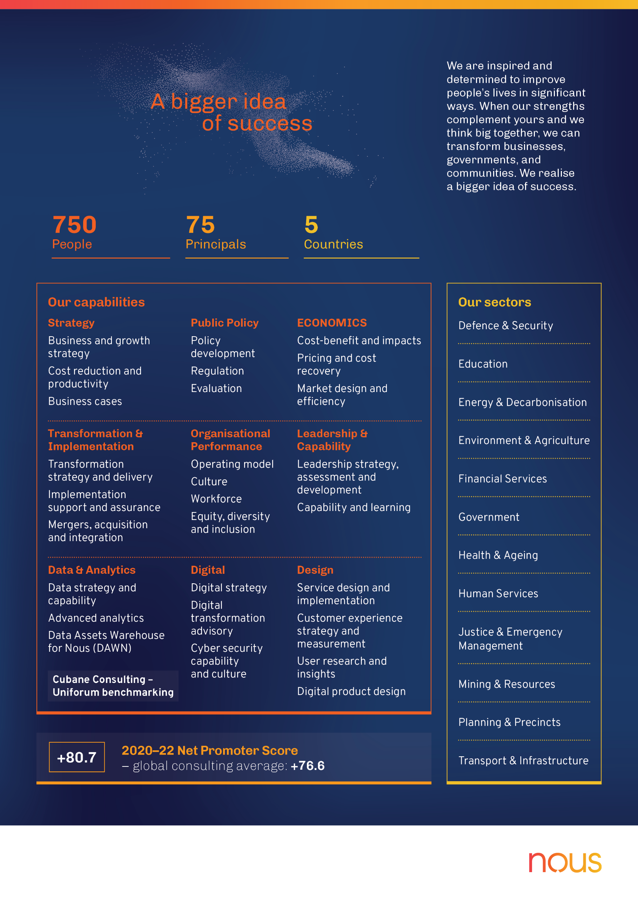

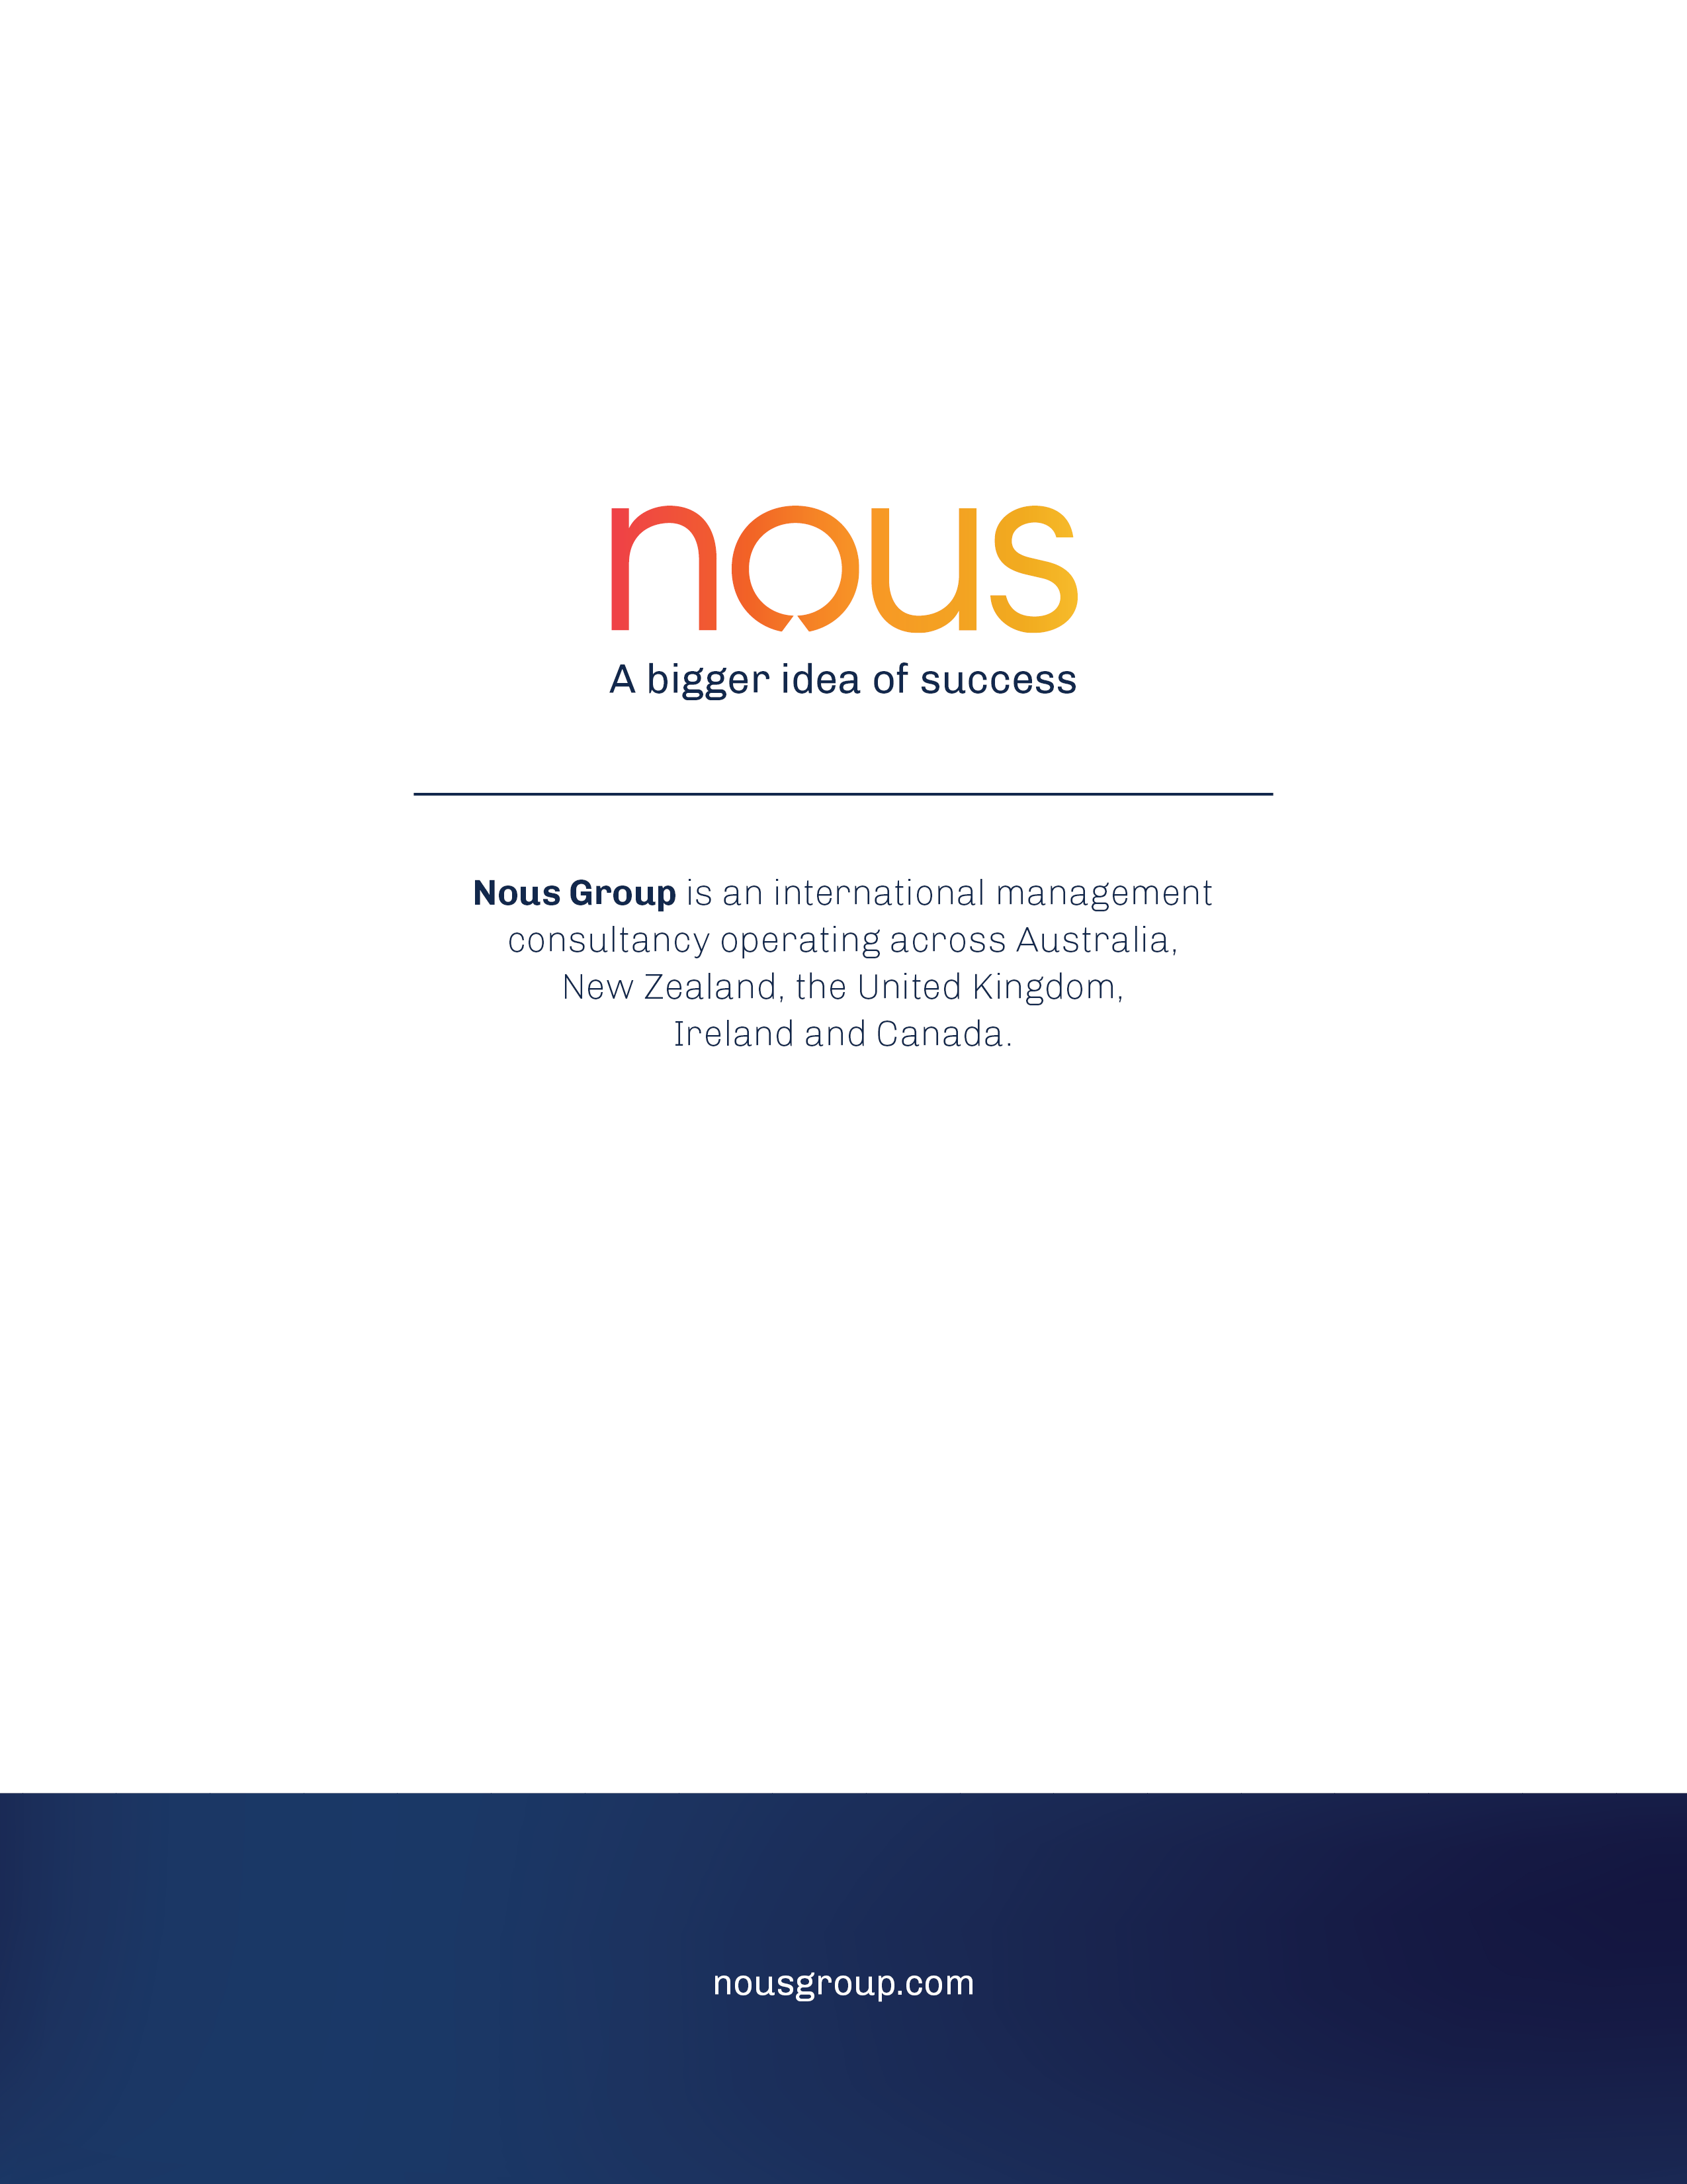

1. Royal Commission into Aged Care Quality and Safety, “Interim Report: Neglect”, Volume 1, 2019.
2. Lane, H, Philip, J, "Managing expectations: Providing palliative care in aged care RACFs," Australasian Journal on Ageing, 2015.
3. Productivity Commission, "Introducing competition and informed user choice into human services: Reforms to human services. Chapter 3: End-of-life care in Australia", 2017.
4. Australian Government Department of Health, 2018. National Palliative Care Strategy.
5. The National Palliative Care Standards differentiates between specialist palliative care and generalist palliative care services as follows: Specialist palliative care services comprise multidisciplinary teams with specialised skills, competencies, experience and training in palliative care, for people with more complex palliative care needs. Generalist palliative care services (also referred to as ‘palliative care services’) is care that is provided by other health professionals, including GPs, that have minimum core competencies in the provision of palliative care.
6. Royal Commission into Aged Care Quality and Safety, “Interim Report: Neglect”, Volume 1, 2019.
7. Survey of a sample of RACFs conducted as part of this evaluation. Responses have been weighted based on state or territory, regionality and organisation type (e.g., not-for-profit or private) to produce estimates that are representative of all RACFs in Australia. See Appendix F for further details.
8. Commonwealth of Australia, Royal Commission into Aged Care Quality and Safety Final Report: Care, Dignity and Respect, Volume 2 The current system. [Internet] Canberra, ACT. Available from: agedcare.royalcommission.gov.au
9. Survey of a sample of RACFs conducted as part of this evaluation. Responses have been weighted based on state or territory, regionality and organisation type (e.g., not-for-profit or private) to produce estimates that are representative of all RACFs in Australia. See Appendix F for further details.
10. Commonwealth of Australia, Royal Commission into Aged Care Quality and Safety Final Report: Care, Dignity and Respect, Volume 2 The current system. [Internet] Canberra, ACT. Available from: agedcare.royalcommission.gov.au
11. Survey of a sample of RACFs conducted as part of this evaluation. Responses have been weighted based on state or territory, regionality and organisation type (e.g., not-for-profit or private) to produce estimates that are representative of all RACFs in Australia. See Appendix E for further details.
12. Commonwealth of Australia, Royal Commission into Aged Care Quality and Safety Final Report: Care, Dignity and Respect, Volume 2 The current system. [Internet] Canberra, ACT. Available from: agedcare.royalcommission.gov.au
13. Ibid.
14. Commonwealth of Australia, Royal Commission into Aged Care Quality and Safety Final Report: Care, Dignity and Respect, Volume 2 The current system. [Internet] Canberra, ACT. Available from: agedcare.royalcommission.gov.au
15. Survey of a sample of RACFs conducted as part of this evaluation. Responses have been weighted based on state or territory, regionality and organisation type (e.g., not-for-profit or private) to produce estimates that are representative of all RACFs in Australia. See Appendix E for further details.
16. Survey of a sample of RACFs conducted as part of this evaluation. Responses have been weighted based on state or territory, regionality and organisation type (e.g., not-for-profit or private) to produce estimates that are representative of all RACFs in Australia. See Appendix E for further details.
17. Australian Institute of Health and Welfare 2021. Interfaces between the aged care and health systems in Australia – where do older Australians die? Cat. no. AGE 106. Canberra: AIHW. Data from 2016-17 from Victoria and Queensland.
18. Morin L, Aubry R, Frova L, MacLeod R, Wilson DM, Loucka M, Csikos A, Ruiz-Ramos M, Cardenas-Turanzas M, Rhee Y, Teno J. Estimating the need for palliative care at the population level: a cross-national study in 12 countries. Palliative medicine. 2017 Jun;31(6):526-36.
19. Australian Institute of Health and Welfare 2020. Interfaces between the aged care and health systems in Australia – GP use by people living in permanent residential aged care 2012–13 to 2016–17. Cat. no. AGE 103. Canberra: AIHW.
20. Ibid.
21. Survey of a sample of RACFs conducted as part of this evaluation. Responses have been weighted based on state or territory, regionality and organisation type (e.g., not-for-profit or private) to produce estimates that are representative of all RACFs in Australia. See Appendix E for further details.
22. Australian Institute of Health and Welfare 2020. Interfaces between the aged care and health systems in Australia – GP use by people living in permanent residential aged care 2012-13 to 2016-17. Cat. no. AGE 103. Canberra: AIHW.
23. Commonwealth of Australia, Royal Commission into Aged Care Quality and Safety Final Report: Care, Dignity and Respect, Volume 2 The current system. [Internet] Canberra, ACT. Available from: agedcare.royalcommission.gov.au
24. Ibid.
25. Ibid.
26. Survey of a sample of RACFs conducted as part of this evaluation. Responses have been weighted based on state or territory, regionality and organisation type (e.g., not-for-profit or private) to produce estimates that are representative of all RACFs in Australia. See Appendix E for further details.
27. Swerissen H & Duckett S 2014. Dying Well. Grattan Institute. Available from: https://grattan.edu.au/wp-content/uploads/2014/09/815-dying-well.pdf
28. Australian Institute of Health and Welfare 2021. Interfaces between the aged care and health systems in Australia – where do older Australians die? Cat. no. AGE 106. Canberra: AIHW. Data from 2016-17 from Victoria and Queensland.
29. Ibid.
30. National Evaluation of the Comprehensive Palliative Care in Aged Care Measure 2020. Literature review summary report.
31. Commonwealth of Australia, Royal Commission into Aged Care Quality and Safety Final Report: Care, Dignity and Respect, Volume 2 The current system. [Internet] Canberra, ACT. Available from: agedcare.royalcommission.gov.au
32. Survey of a sample of RACFs conducted as part of this evaluation. Responses have been weighted based on state or territory, regionality and organisation type (e.g., not-for-profit or private) to produce estimates that are representative of all RACFs in Australia. See Appendix E for further details.
33. Ibid.
34. Ibid.
35. Survey of a sample of RACFs conducted as part of this evaluation. Responses have been weighted based on state or territory, regionality and organisation type (e.g., not-for-profit or private) to produce estimates that are representative of all RACFs in Australia. See Appendix E for further details.
36. Commonwealth of Australia, Royal Commission into Aged Care Quality and Safety Final Report: Care, Dignity and Respect, Volume 2 The current system. [Internet] Canberra, ACT. Available from: agedcare.royalcommission.gov.au
37. Survey of a sample of RACFs conducted as part of this evaluation. Responses have been weighted based on state or territory, regionality and organisation type (e.g., not-for-profit or private) to produce estimates that are representative of all RACFs in Australia. See Appendix E for further details.
38. Australian Government Aged Care Quality and Safety Commission, Aged Care Quality Standards, Canberra, ACT. Available from: https://www.agedcarequality.gov.au/providers/standards
39. Ibid.
40. Parliament of Australia, “Future of Australia’s aged care sector workforce”, 2017.
41. As part of the national evaluation data collection, states and territories have agreed to provide Nous a standard reporting template every six months. It provides detail on what they are implementing, progress, challenges and the extent to which activities in their jurisdiction are contributing to Measure aims, including improving the health-aged care interface.
42. Belfrage, M, Chiminello, C, Cooper, D, et al., "Pushing the envelope: clinical handover from the aged-care home to the emergency department." 2009.
43. Ibid.
44. Nous Group, "Stocktake and analysis of activities at the interface between the aged care, health and disability systems." 2020.
45. Finn, J, Flicker, L, Mackenzie, E, et al., "Interface between residential aged care facilities and a teaching hospital emergency department in Western Australia," Medical Journal of Australia. 2006.
46. Productivity Commission, “Caring for older Australians, Report No. 53, Final Inquiry Report”, 2011.
47. Booth R et al, “Workplace training practices in the residential aged care sector”, National Vocational Education and Training Research. 2005.
48. These three types of activities are taken from the Project Agreement for the Measure, which describes that some projects may relate to ‘models that support end-of-life care decision making and development of agreed goals of care for individuals’ (i.e. it may include work related to advance care planning or related conversations). ​
49. These three types of activities are taken from the Project Agreement for the Measure, which describes that some projects may relate to ‘models that support end-of-life care decision making and development of agreed goals of care for individuals’ (i.e. it may include work related to advance care planning or related conversations). ​
50. These three types of activities are taken from the Project Agreement for the Measure, which describes that some projects may relate to ‘models that support end-of-life care decision making and development of agreed goals of care for individuals’ (i.e. it may include work related to advance care planning or related conversations). ​
51. These three types of activities are taken from the Project Agreement for the Measure, which describes that some projects may relate to ‘models that support end-of-life care decision making and development of agreed goals of care for individuals’ (i.e. it may include work related to advance care planning or related conversations). ​
52. These three types of activities are taken from the Project Agreement for the Measure, which describes that some projects may relate to ‘models that support end-of-life care decision making and development of agreed goals of care for individuals’ (i.e. it may include work related to advance care planning or related conversations). ​
53. These three types of activities are taken from the Project Agreement for the Measure, which describes that some projects may relate to ‘models that support end-of-life care decision making and development of agreed goals of care for individuals’ (i.e. it may include work related to advance care planning or related conversations). ​
54. These three types of activities are taken from the Project Agreement for the Measure, which describes that some projects may relate to ‘models that support end-of-life care decision making and development of agreed goals of care for individuals’ (i.e. it may include work related to advance care planning or related conversations). ​
55. These three types of activities are taken from the Project Agreement for the Measure, which describes that some projects may relate to ‘models that support end-of-life care decision making and development of agreed goals of care for individuals’ (i.e. it may include work related to advance care planning or related conversations). ​
56. PCA: Palliative Care Australia
57. NIHSI-AA: National Integrated Health Services Information Analysis Asset.
58. MBS: Medicare Benefits Schedules.
59. AIHW, Palliative care services in Australia: Palliative care for people living in residential aged care, 2020.
60. AHHA: Australian Healthcare and Hospitals Association.
61. ELDAC: End-of-life Directions for Aged Care.
62. Australian Bureau of Statistics, Population Estimates: Concepts, Sources and Methods, 2009: Appendix 5 The Iterative Proportional Fitting Procedure, 2009, Canberra, ACT. [Internet] Available from: https://www.abs.gov.au/ausstats/abs@.nsf/Products/3228.0.55.001~2009~Appendix~The+iterative+proportional+fitting+procedure+(Appendix)?OpenDocument