AGREEMENT TO IMPLEMENT THE SOCIAL AND EMOTIONAL WELLBEING POLICY PARTNERSHIP

PARTNERSHIP AGREEMENT TO IMPROVE OUTCOMES UNDER CLOSING THE GAP FOR SOCIAL AND EMOTIONAL WELLBEING

ESTABLISHED BY THE JOINT COUNCIL ON CLOSING THE GAP

UNDER THE AUTHORITY OF THE NATIONAL AGREEMENT ON CLOSING THE GAP

# Preamble

The National Agreement on Closing the Gap (the National Agreement) makes provision for the establishment of policy partnerships under Priority Reform One: Formal Partnerships and Shared Decision-Making. Policy partnerships are partnerships created for the purpose of working on discrete policy areas, such as education, health or housing (Clause 30, National Agreement).

The National Agreement states at Clause 38, that by 2022, the Joint Council will establish a joined-up approach to five policy priority areas, between the Commonwealth, states and territories and Aboriginal and Torres Strait Islander representatives. The five policy priority areas are:

1. justice (adult and youth incarceration)
2. social and emotional wellbeing
3. housing
4. early childhood care and development
5. Aboriginal and Torres Strait Islander languages.

## Social and Emotional Wellbeing

Social and emotional wellbeing (SEWB) includes a collective sense of self that is defined by connections to mind, body, family, community, culture, Country and spirituality. Furthermore, sense of self is significantly impacted by historical, political, social, and cultural determinants of health. The SEWB concept also recognises the significant diversity among Aboriginal and Torres Strait Islander peoples across Australia, how culture evolves and adapts over time, and how experiences and expressions of SEWB can change over an individual's lifespan. The SEWB concept and the diagram pictured (below) were first described by Aboriginal psychologist Graham Gee, Pat Dudgeon, Clinton Schultz, Amanda Hart and Kerrie Kelly in the [Working Together](https://www.telethonkids.org.au/our-research/early-environment/developmental-origins-of-child-health/expired-projects/working-together-second-edition/) book (2014).

The SEWB Policy Partnership is approaching SEWB from a comprehensive and holistic perspective looking at all factors including prevention, protective factors, mental health, mental health complexities, and suicide prevention/postvention.

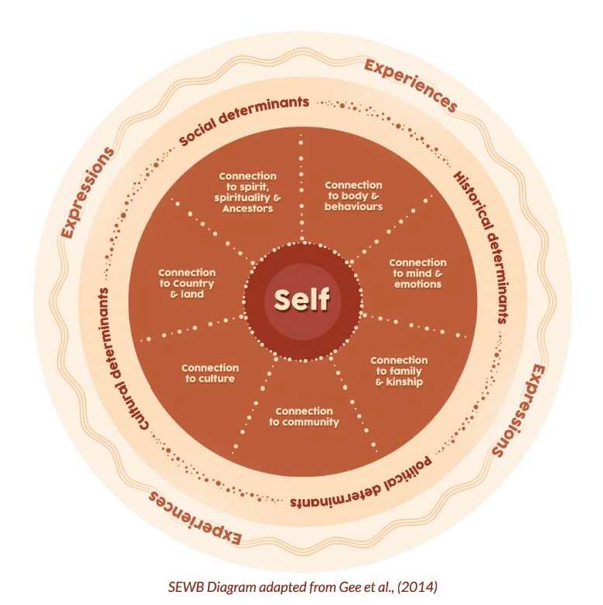

See Schedule C for additional SEWB resources.

## Strong Partnership Elements

The National Agreement states that policy partnerships should include the strong partnership elements articulated at Clause 32 unless Aboriginal and Torres Strait Islander people, communities and organisations choose not to pursue elements (Clause 35).

The SEWB Policy Partnership is consistent with the Partnership Agreement on Closing the Gap and the National Agreement. The strong partnership elements at Clauses 32 and 33 of the National Agreement apply to the SEWB Policy Partnership.

The SEWB Policy Partnership will be guided by the Principles of Partnership and Shared Decision Making at Schedule B.

# Purpose

1. The purpose of this Agreement is to establish a mechanism for the Parties (Schedule A) to develop a joined-up approach to drive Aboriginal and Torres Strait Islander led outcomes in social and emotional wellbeing, mental health and suicide prevention.
2. The primary function of the SEWB Policy Partnership is to make recommendations to Joint Council to ensure Aboriginal and Torres Strait Islander people achieve the highest attainable standard of social and emotional wellbeing, improve mental health outcomes and reduce suicide rates (Outcome 14 of the National Agreement).

# Objectives

1. The objectives of the SEWB Policy Partnership are to:
   1. Establish a joined-up approach between all governments and Aboriginal and Torres Strait Islander representatives to improve social and emotional wellbeing and mental health outcomes and reduce suicide rates
   2. Give a focus to the Priority Reforms in the National Agreement, and how they can be harnessed to make the changes needed to accelerate improved levels of social and emotional wellbeing in the lives of Aboriginal and Torres Strait Islander people
   3. Identify specific measures to accelerate improved levels of social and emotional wellbeing and mental health outcomes and reduce suicide rates
   4. Identify opportunities to work more effectively across governments, reduce service gaps and duplication and improve outcomes under the National Agreement
   5. Support efforts to implement the National Agreement including meeting targets for the Priority Reform areas and socioeconomic outcomes
   6. Enable Aboriginal and Torres Strait Islander community-led outcomes on Closing the Gap, and support community-led development initiatives
   7. Enable Aboriginal and Torres Strait Islander representatives, communities and organisations to negotiate and implement agreements with governments to address all Priority Reforms and policy strategies to support the National Agreement.

# Scope

1. The SEWB Policy Partnership will focus on issues and actions that will deliver progress towards Outcome 14 of the National Agreement
   1. Outcome: Aboriginal and Torres Strait Islander people enjoy high levels of social and emotional wellbeing
   2. Target: Significant and sustained reduction in suicide of Aboriginal and Torres Strait Islander people towards zero.
2. Topics in scope for consideration are:
   1. Issues and actions that progress the objectives of the SEWB Policy Partnership including establishing a joined-up approach to policy related to social and emotional wellbeing, mental health and suicide prevention
   2. Visibility of the implementation of policy and reform relating to social and emotional wellbeing, mental health and suicide prevention, including the implementation of the Gayaa Dhuwi Declaration, the National Aboriginal and Torres Strait Islander Suicide Prevention Strategy, and the refresh of the National Aboriginal and Torres Strait Islander Social and Emotional Wellbeing Framework 2013-23
   3. Issues and actions that can be directly linked to progressing the socioeconomic targets and indicators related to social and emotional wellbeing, mental health and suicide prevention in the National Agreement. This includes issues and actions related to intersecting socioeconomic targets, specifically relating to:
      1. early childhood health, development and education (National Agreement Targets 2-4)
      2. justice (National Agreement Targets 10-11)
      3. child protection (National AgreementTarget 12)
      4. family violence (National Agreement Target 13).
   4. Issues and actions that progress the Priority Reforms as they relate to social and emotional wellbeing, mental health and suicide prevention. This may include the following actions for consideration by the SEWB Policy Partnership members:
      1. *Priority Reform One (formal partnerships and shared decision making):* review existing partnerships to ensure Aboriginal and Torres Strait Islander organisations and communities inform policy and resources that are intended to support their social and emotional wellbeing
      2. *Priority Reform Two (Building the community-controlled sector):* review the community-controlled social and emotional wellbeing, mental health and suicide prevention sector, and consider actions to build a strong, sustainable sector that meets the needs of Aboriginal and Torres Strait Islander people across the country
      3. *Priority Reform Three (Transforming government organisations):* review government and other mainstream systems, structures, mindsets/attitudes/beliefs, behaviours, processes and tools to ensure they are culturally safe and responsive and are not disproportionately or unfairly impacting Aboriginal and Torres Strait Islander people
      4. *Priority Reform Four {Shared access to data and information at a regional level}:* Government partners to work with Aboriginal and Torres Strait Islander organisations and communities to access and use the data they need to design, deliver and advocate for social and emotional wellbeing outcomes for their communities.
   5. Issues and actions that relate to the drivers of mental ill-health, trauma and suicidality for Aboriginal and Torres Strait Islander people The socioeconomic, cultural and political drivers and targets that have a direct and tangible effect on social and emotional wellbeing and mental health outcomes and reducing suicide rates will be considered.
   6. Issues and actions related to prevention and early intervention.
3. The Parties to the SEWB Policy Partnership will have authority to determine by consensus whether a topic is in scope or not. If the Parties are unable to agree on whether a topic is in scope, the dispute resolution processes may be triggered.
4. Matters that are considered out of scope for the SEWB Policy Partnership may be referred to other bodies or mechanisms for consideration in line with powers of the SEWB Policy Partnership set out above.

# Chairing arrangements

1. The SEWB Policy Partnership is co-chaired by a representative of the Coalition of Peaks and a representative of the Commonwealth who are Parties to the Agreement. The co-chairs are indicated in Schedule A.
2. The co-chairs are responsible for agreeing meeting agendas, chairing meetings, and overseeing and monitoring the work of the SEWB Policy Partnership.

# Parties

1. The two Parties to the Agreement are the Government Party (Commonwealth, state and territory government representatives) and the Aboriginal and Torres Strait Islander Party (Coalition of Peaks representatives, and Independent Aboriginal and Torres Strait Islander representatives).
2. Continuity of membership and attendance at meetings is critical to the effective functioning of the SEWB Policy Partnership.
   1. Coalition of Peaks and Independent Aboriginal and Torres Strait Islander representatives will confirm their attendance with the Peaks' co-chair prior to meetings. If a Coalition of Peaks representative is unable to attend the Peaks' co-chair will nominate an alternative representative in consultation with the relevant Peak. Independent Aboriginal and Torres Strait Islander have been selected in their own right and it will not be appropriate for them to nominate someone else if they cannot attend. If the member misses three meetings the co-chair will ask them to reconsider their ongoing membership and advise the Coalition of Peaks. In such an event, the Coalition of Peaks may remove the member and call expressions of interest for a replacement.
   2. Government representatives are required to have decision making authority (in terms of decision making by the SEWB policy partnership) and will confirm their attendance with the Government co-chair prior to meetings. If a Government representative is unable to attend a meeting, then the jurisdiction will nominate an alternative representative. If the member misses three meetings the Government co-chair will ask them to reconsider their ongoing membership.
   3. Continuity of proxies is also crucial to the effective functioning of the SEWB Policy Partnership. Where possible, representatives should nominate a consistent proxy.
3. Co-chairs will endorse any changes to membership of the SEWB Policy Partnership for the relevant party.
4. The Parties to the Agreement are listed at Schedule A.
5. A meeting quorum will be six representatives of the Government Party and six representatives of the Aboriginal and Torres Strait Islander Party.

# Roles and responsibilities

1. All Parties are jointly responsible for:
   1. Developing a joined-up approach to social and emotional wellbeing, mental health and suicide prevention policy including:
      1. identifying opportunities to work more effectively across governments
      2. reducing gaps and duplication, and
      3. improving social and emotional wellbeing and mental health outcomes and reducing suicide rates.
   2. Agreeing the priorities and work plan for the SEWB Policy Partnership
   3. Conducting and commissioning research and studies, analysing data and information, preparing reports
      1. Developing recommendations for action through the implementation approaches of the National Agreement, and
   4. Tracking and reporting on progress.
2. The Government representatives will:
   1. Liaise with other agencies in their jurisdiction to develop cross-agency perspectives to inform the work of the SEWB Policy Partnership
3. Engage with other organisations to seek expert advice
   1. Engage with relevant Ministers and seek Ministerial clearance of key actions ahead of SEWB Policy Partnership agreement
   2. Consider how recommendations of the SEWB Policy Partnership can be implemented in their jurisdiction, including through the implementation planning process or more urgent action
   3. Communicate the work of the SEWB Policy Partnership to other agencies in their jurisdiction
   4. Share data with Aboriginal and Torres Strait Islander representatives, where government is the owner of that data and privacy or other requirements allow, to inform shared decision­ making.
4. The Coalition of Peaks representatives will:
   1. Liaise across the Coalition of Peaks and their membership and bring the perspectives of the Aboriginal and Torres Strait Islander people, communities and organisations, their expertise, and their lived experiences to the deliberations of the partnership
5. The Coalition of Peaks and the Independent Aboriginal and Torres Strait Islander representatives will:
   1. Provide opportunities for Aboriginal and Torres Strait Islander people, communities and organisations to inform them of their concerns and how they might be resolved.
6. The Agreement comes into effect on the date of signing and continues for an initial period of three years.
7. The SEWB Policy Partnership will be reviewed before the end of its initial three-year term with a view to being extended or renewed to drive ongoing progress. The process for this review will be established by the Drafting Group in consultation with SEWB Policy Partnership Parties, agreed by the Partnership Working Group and advice provided to Joint Council, which will endorse a decision on next steps.

# Amendment

1. The Agreement can be amended at any time by agreement of the Parties.
2. The SEWB Policy Partnership will consider whether any amendments are required to this Agreement, its membership and its forward work plan at least once each year.

# Decision-making

1. The SEWB Policy Partnership is guided by the principle that decision-making is shared between governments and Aboriginal and Torres Strait Islander people. Shared decision-making is:
   1. By consensus, where the voices of Aboriginal and Torres Strait Islander representatives hold as much weight as the governments
   2. Transparent, where matters for decision are in terms that are easily understood by all Parties and where there is enough information and time to understand the implications of the decision
   3. Where Aboriginal and Torres Strait Islander representatives can speak without fear of reprisals or repercussions
   4. Where a wide variety of groups of Aboriginal and Torres Strait Islander people, including women, young people, elders, LGBTQl+SB and Aboriginal and Torres Strait Islander people with a disability can have their voice heard
   5. Where self-determination is supported, and Aboriginal and Torres Strait Islander lived experience is understood and respected
   6. Where relevant funding for programs and services align with jointly agreed community priorities, noting governments retain responsibility for funding decisions
   7. Where partnership Parties have access to the same data and information, in an easily accessible format, on which any decisions are made.

# Recommendations

1. The SEWB Policy Partnership may make recommendations under this Agreement and will provide those recommendations to the Joint Council for its information, unless the recommendation is for an action to be taken to Joint Council for agreement.
   1. Recommendations of the SEWB Policy Partnership made to Joint Council will only be made public with the express agreement of Joint Council.
2. All recommendations made pursuant to this Agreement are made by consensus of the Parties. Recommendations are non-binding.
3. Recommendations may be made as national recommendations or may apply to a specific member or other party. Recommendations should not duplicate existing efforts in a particular jurisdiction and should be tailored to existing structures and jurisdictional drivers. It is not the intention that jurisdictions would have to report against all the recommendations of the SEWB Policy Partnership as some may not be applicable.
4. Actions to respond to relevant recommendations would be included in each Parties' annual implementation plan updates where publication of the recommendations is endorsed by Joint Council. Specific actions should be considered and taken forward through jurisdictional partnership arrangements for implementation plans, to enable actions to be tailored to the specific circumstances of each jurisdiction. Progress on actions against recommendations should be outlined in Parties' annual reports.
5. Beyond incorporating actions to respond to the recommendations in implementation plans, Parties may take more urgent action if appropriate.
6. The extent to which recommendations have been implemented by jurisdictions and

other organisations will be reported as part of the SEWB Policy Partnership reporting process (set out under the ‘Reporting' section of this Agreement).

# Referring matters

1. The SEWB Policy Partnership may refer matters which it deems out of scope to an appropriate mechanism for consideration.
2. By agreement, the Parties may establish sub-structures or working groups as required to progress recommendations or explore specific topics arising under the SEWB Policy Partnership. Where possible, Parties should rely on existing structures, including existing jurisdictional and regional arrangements to progress recommendations.

# Expert advice

1. Subject matter experts, including people with lived experience, may be invited to attend meetings of the SEWB Policy Partnership from time to time for the purpose of presenting on topics being considered by the SEWB Policy Partnership or to provide expert advice. Experts must be agreed by Parties before being invited to attend a meeting.

# Data sharing

1. Parties should endeavour to share available data with the SEWB Policy Partnership to assist the SEWB Policy Partnership to have clear understanding of context, to make evidence-based recommendations and to gauge progress toward the targets. The SEWB Policy Partnership may agree to ask Parties to collate and provide relevant data, and Parties will endeavour to do so as far as possible.

# Reporting

1. Policy partnerships will be a standing item at Joint Council. This standing item will include a verbal update on how the SEWB Policy Partnership is progressing, including jurisdictional updates on actions taken to support the objectives of the SEWB Policy Partnership.
2. In addition to verbal updates, the SEWB Policy Partnership will report annually in writing to the Joint Council on:
   1. Recommendations it has made
   2. Actions being taken to implement recommendations
   3. Progress against the objectives of the SEWB Policy Partnership
   4. Progress against any relevant Priority Reforms and socioeconomic targets in the National Agreement
   5. Any other updates.
3. The written report will, where possible, draw on existing reporting and not add additional reporting burdens. It will compile information from all the jurisdictional implementation plans on how recommendations of the SEWB Policy Partnership are being addressed. It will also include a short summary of how the SEWB Policy Partnership is progressing, and a list of any recommendations made by the SEWB Policy Partnership.
4. The SEWB Policy Partnership annual report to Joint Council will be tabled via the Partnership Working Group. The Partnership Working Group may prepare additional materials or responses to accompany the report.
5. Actions arising from recommendations of the SEWB Policy Partnership which are incorporated into Implementation Plans will also be reported on through the annual public reports (clause 118 and 119 of the National Agreement). These reports should also include a specific reference to the SEWB Policy Partnership and its progress.

# Measurement of partnership effectiveness

1. The SEWB Policy Partnership is committed to establishing an effective partnership in line with the features outlined in the table below. The success in meeting this commitment will be assessed and monitored throughout the life of the Partnership. The Secretariat will develop an assessment tool to enable both Parties to rate the effectiveness of the partnership against each of the features. These ratings will be used to create a heat map of the overall effectiveness of the Partnership.

|  |  |
| --- | --- |
| **Features of effective partnerships** | **Features of ineffective partnerships** |
| Parties assume positive intent and work in genuine partnership and a spirit of cooperation. [1] | Parties misunderstand each other’s perspective or fail to appreciate the emotional context of the issues at stake. [2] |
| Parties acknowledge existing power imbalances and intentionally implement governance arrangements and resource flows to overcome them. | Some parties have considerably more bargaining power than others, and this power imbalance is evident in negotiations. |
| All parties have sufficient authority to negotiate and to commit to undertakings as a result of negotiations. | Parties are not able to commit to undertakings, and negotiations are delayed because they must get approval from a higher-up. |
| Sufficient time is allowed for thorough discussion and consultation with members. All parties participate in all discussions. Decisions are made by consensus, meaning that all parties must agree before a decision is taken.[3] | One or more parties dominates discussions or uses their influence to rush decisions through. Parties are pressured to agree so that proposals can be passed. Meetings take place without all parties being present. |
| All parties share information and data to enable good decision making and transparent and open discussion. Data is provided with sufficient time and support to digest and understand. | Information is withheld or provided in a piecemeal fashion, and some parties lack all of the information when participating in discussions.[4] |
| Parties are open to feedback. Grievances or challenges can be communicated openly and respectfully. Parties commit to developing cultural competency and better understanding one another. | Parties become resentful over grievances, and struggle to communicate openly with one another. Cultural differences are misunderstood or misinterpreted, leading to offence. |

# Dispute resolution

1. The Parties to the SEWB Policy Partnership will endeavour in the spirit of co-operation, good faith, and mutual trust to resolve any difficulties or misunderstandings with respect to the SEWB Policy Partnership.
2. If the matter cannot be resolved by negotiation, the SEWB Policy Partnership will refer the matter to the Joint Council for resolution.

# Meetings

1. Regular meetings of the Parties will be held as required. The Parties will meet at least four times per calendar year.
2. The forward work plan for the SEWB Policy Partnership for its first 12 months will be determined at the first meeting of the Parties. The agenda for each meeting will be determined with input from the Parties and approved by the co-chairs.

# Secretariat support

1. A Secretariat will be established to support the SEWB Policy Partnership by:
   1. Preparing papers
   2. Organising meetings including travel
   3. Compiling the annual reports
   4. Maintaining and updating public material.
2. Secretariat responsibilities will be shared between Aboriginal and Torres Strait Islander and government leads to support shared decision-making in the development of Partnership documents and agendas.
3. Papers will be distributed one week ahead of each meeting. The SEWB Policy Partnership may agree to progress items out of session.

# Resourcing

1. In accordance with Clause 33 of the National Agreement, the Parties acknowledge that the Coalition of Peaks representatives need to be provided with adequate and ongoing financial support to enable them to engage and negotiate as equal partners. This financial support will be separate to their current funding as this is a new activity not covered by existing funding sources.
2. The Parties acknowledge that the independent Aboriginal and Torres Strait Islander representatives also need to be provided with adequate and ongoing financial support to enable them to engage and negotiate as equal partners.
3. The Commonwealth will provide funding for the establishment of the SEWB Policy Partnership, including resourcing for the SEWB Policy Partnership Secretariat and reasonable meeting costs such as travel for the SEWB Policy Partnership. The Commonwealth will also support the participation of the Independent Aboriginal and Torres Strait Islander representatives of the SEWB Policy Partnership, including through sitting fees. Representatives can choose not to accept fees where they may already be receiving a salary or payment from their employer.
4. Resourcing for additional activities of the SEWB Policy Partnership will be negotiated and agreed by the Parties as they arise during the life of the Agreement. This includes the commissioning of any reports or expert evidence.

# Schedule A: Parties to the Agreement to Implement the SEWB Policy Partnership

## Aboriginal and Torres Strait Islander Party

### Coalition of Peaks representatives

Professor Pat Dudgeon, Gayaa Dhuwi Proud Spirit Australia (co-Chair)

Dawn Casey, National Aboriginal Community Controlled Health Organisation

Scott Wilson, Aboriginal Drug and Alcohol Council

Zaccariah Cox, Kimberley Aboriginal Medical Service

Fiona Cornforth, The Healing Foundation

### Independent Aboriginal and Torres Strait Islander representatives

Dean Bayliss

Danielle Dyall

Donna Murray

Deborah Woods

Paul Gray

## Government Party

### Government representatives

**Commonwealth Government** – Ms Tania Rishniw, Deputy Secretary, Primary and Community Care Group, Department of Health and Aged Care (co-Chair)

**New South Wales Government** – Brendan Flynn, Acting Executive Director, Mental Health Branch, Health System Strategy and Planning Division, Department of Health

**Victorian Government** – Monica Kelly, Mental Health and Wellbeing Promotion Adviser, Executive Director, Mental Health and Wellbeing Division, Department of Health

**Queensland Government** – Dr Helen Brown, Deputy Director-General, Clinical Excellence Queensland, QLD Health

**Western Australian Government** – Ann-marie Cunniffe, Acting Deputy Commissioner, Mental Health Commission

**South Australian Government** – Ms Tanya McGregor, Director Aboriginal Health, Department for Health and Wellbeing

**Tasmanian Government** – Mr George Clarke, General Manager, Mental Health, Alcohol and Drug Directorate, Department of Health

**Australian Capital Territory Government** – Dr Elizabeth Moore, Coordinator-General, The Office for Mental Health and Wellbeing

**Northern Territory Government** – Ms Cecelia Gore, Executive Director, Mental Health, Alcohol and Other Drugs Branch, Department of Health

# Schedule B: Principles of Partnership and Shared Decision Making

## Overview

The Partnership model is a new way for Government to work alongside First Nations people, and set a higher standard in effective negotiation, consensus building and shared decision-making. Partnership is both advocacy and consultation because it involves shared decision-making and accountability. This means that First Nations peoples are equal partners with governments under the *National Agreement on Closing the Gap* (CTG Agreement).

## Closing the Gap partnership elements

Under the CTG Agreement (Clause 28), Parties committed to building and strengthening structures that empower First Nations people to share decision-making authority with governments to accelerate policy and place-based progress against Closing the Gap. Strong partnership comprises of key partnership elements (Clause 32).

## Partnership principles

The Social and Emotional Wellbeing Policy Partnership (Partnership) members recognise that First Nations peoples have great strengths, creativity and endurance and a deep understanding of the relationships between human beings and their environment. The Partnership acknowledges and celebrates First Nations leadership and cultures, and respects the holistic context that encompasses mental health and physical, cultural and spiritual health.

The Partnership is committed to providing a culturally safe and respectful environment for all members to engage in learning, understanding, consensus building and shared decision-making. This is with the ultimate aim of self-determination and driving outcomes. To achieve this, and in addition to member responsibilities in the Agreement to Implement, Partnership members agree to the following partnership principles (based on CTG Strong Partnership principles, and expanded on through conversations with Peak partners and First Nations members).

1. Partnerships are accountable and representative
   1. First Nations members are chosen by First Nations peoples; representation is equal (member numbers, intersectionality of members, capacity to contribute meaningfully)
   2. Government membership can include up to three levels of government, and others as agreed by members
   3. All members need to have appropriate negotiation and decision-making authority and be able coordinate and present a jurisdictional position.
   4. Strong partnerships are built on good relationships, trust and understanding
2. Partnerships have a formal agreement that all parties are signed up to
   1. Detailed documents are drafted together, and made publicly available for transparency
   2. Formal governance structures are in place
   3. Members commit to agreeing common language and expectations, building consensus, and working towards shared goals and outcomes
3. Decision-making within the Partnership is shared between governments and First Nations members
   1. All voices are equal and should be supported to be so – meeting spaces should be safe for all members to speak freely without concern to voice dissenting or contrary views
   2. Members prioritise listening and understanding – includes adequate time for listening and reflection
   3. Space for First Nations led (or First Nations only), and government conversations are important
4. Adequate resourcing is required to support First Nations members to be equal partners
   1. First Nations peoples have resources and support to participate as equal partners – funding, access to information, time to consider the information and caucus with other members or their Peak representative
   2. Allow time to engage with other experts and other stakeholders, as well as sharing community views
   3. Language used is clear, simple, consistent and meaningful to all members.

## Closing the Gap spectrum of engagement behaviours (developed by the closing the Gap Coaliton of Peak Organisations)

The spectrum of behaviours model highlights the ways in which the government can and should work with First Nations people, communities, and organisations.

As power shifts more prominently into the hands of First Nations people, the further along the spectrum one moves and this should coincide with an increase in trust of government. Ultimately, the spectrum shows decision-making should be shared, and both parties hold sufficient resources to engage equitability in the relationship.

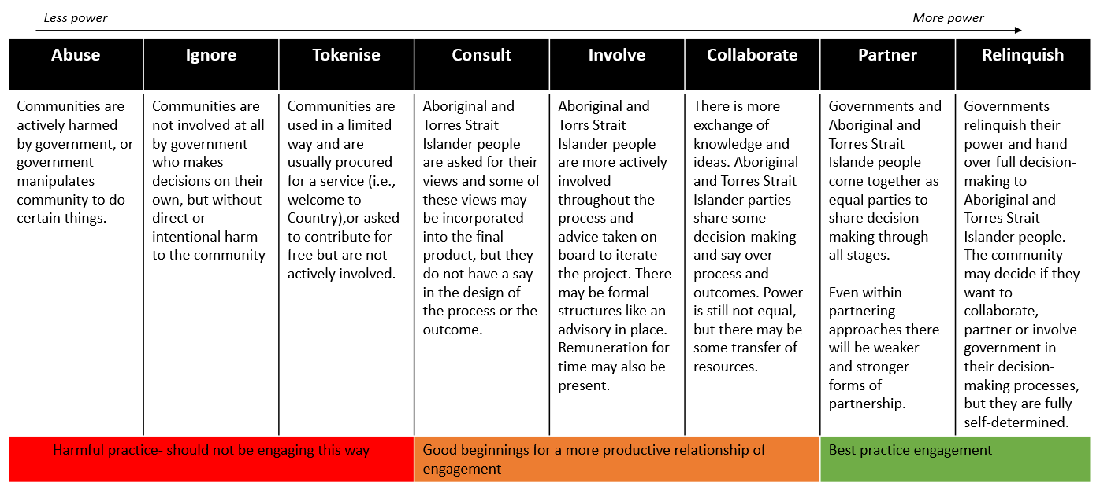

# Schedule C: Social and Emotional Wellbeing Resources

## National Strategic Framework for Aboriginal and Torres Strait Islander Peoples' Mental Health and Social and Emotional Wellbeing 2017-2023

Then nine guiding principles for the Framework are drawn from the *Ways Forward report and the 2004 Framework* to emphasise the holistic and whole-of-life definition of health held by Aboriginal and Torres Strait Islander peoples.

1. Aboriginal and Torres Strait Islander health is viewed in a holistic context, that encompasses mental health and physical, cultural and spiritual health. Land is central to wellbeing. Crucially, it must be understood that when the harmony of these interrelations is disrupted, Aboriginal and Torres Strait Islander ill health will persist.
2. Self-determination is central to the provision of Aboriginal and Torres Strait Islander health services.
3. Culturally valid understandings must shape the provision of services and must guide assessment, care and management of Aboriginal and Torres Strait Islander people's health problems generally, and mental health problems, in particular.
4. It must be recognised that the experiences of trauma and loss, present since European invasion, are a direct outcome of the disruption to cultural wellbeing. Trauma and loss of this magnitude continues to have inter-generational effects.
5. The human rights of Aboriginal and Torres Strait Islander people must be recognised and respected. Failure to respect these human rights constitutes continuous disruption to mental health. Human rights relevant to mental illness must be specifically addressed.
6. Racism, stigma, environmental adversity and social disadvantage constitute ongoing stressors and have negative impacts on Aboriginal and Torres Strait Islander peoples' mental health and wellbeing.
7. The centrality of Aboriginal and Torres Strait Islander family and kinship must be recognised as well as the broader concepts of family and the bonds of reciprocal affection, responsibility and sharing.
8. There is no single Aboriginal or Torres Strait Islander culture or group, but numerous groupings, languages, kinships, and tribes, as well as ways of living. Furthermore, Aboriginal and Torres Strait Islander people may currently live in urban, rural or remote settings, in traditional or other lifestyles, and frequently move between these ways of living.
9. It must be recognised that Aboriginal and Torres Strait Islander people have great strengths, creativity and endurance and a deep understanding of the relationships between human beings and their environment.

## Gayaa Dhuwi (Proud Spirit) Declaration

The Dhuwi Declaration has five pillars:

1. Improving Aboriginal and Torres Strait Islander peoples' access to affordable and culturally safe programs, services and professionals, free from racism or indirect discrimination. It advocates for improved access to cultural healers and healing methods across Aboriginal and Torres Strait Islander peoples' lifespans.
2. Combining the best of cultural SEWB, mental health and healing concepts with clinical practice in mental health care to achieve a best of both worlds approach in all service provision, curriculums of educational institutions, professional and standard setting bodies.
3. Supporting Aboriginal and Torres Strait Islander peoples' leadership in co-designing services and programs and evaluating the impact.
4. Training, employing, empowering, valuing and ensuring Aboriginal and Torres Strait Islander people are safe at work, in all areas of government activity that affect the mental health and SEWB of Aboriginal and Torres Strait Islander peoples.
5. Improving the visibility and influence of Aboriginal and Torres Strait Islander peoples' leadership across the mental health system to Aboriginal and Torres Strait Islander communities, as well as promoting Aboriginal and Torres Strait Islander leaders to engage in self-care, support and learn from each other in professional networks.

## National Agreements:

* National Agreement on Closing the Gap
* National Mental Health and Suicide Prevention Agreement

1. Partnership Agreement on Closing the Gap Health Check 2020, p. 16.
2. Partnership Agreement on Closing the Gap Health Check 2020, p. 16.
3. Partnership Agreement on Closing the Gap Health Check 2020, p. 12.
4. Partnership Agreement on Closing the Gap Health Check 2020, p. 12.