

Revised
Aged Care
Quality
Standards
  - Draft for Pilot
March 2023

Table of contents
Table of contents 2
Standard 1: The Person 5
Intent of Standard 1 5
Standard 1 expectation statement for older people: 6
Outcome 1.1: Person-centred care 6
Outcome 1.2: Dignity, respect and privacy 7
Outcome 1.3: Choice, independence and quality of life 7
Outcome 1.4: Transparency and agreements 8
Standard 2: The Organisation 10
Intent of Standard 2 10
Standard 2 expectation statement for older people: 10
Outcome 2.1: Partnering with older people 11
Outcome 2.2: Quality and safety culture 11
Outcome 2.3: Accountability and quality system 12
Outcome 2.4: Risk management 13
Outcome 2.5: Incident management 13
Outcome 2.6: Feedback and complaints management 14
Outcome 2.7: Information management 14
Outcome 2.8: Workforce planning 15
Outcome 2.9: Human resource management 16
Outcome 2.10: Emergency and disaster management 17
Standard 3: The Care and Services 18
Intent of Standard 3 18
Standard 3 expectation statement for older people: 18
Outcome 3.1: Assessment and planning 19
Outcome 3.2: Delivery of care and services 20
Outcome 3.3: Communicating for safety and quality 22
Outcome 3.4: Coordination of care and services 22
Standard 4: The Environment 24
Intent of Standard 4 24
Standard 4 expectation statement for older people: 24
Outcome 4.1a: Environment and equipment at home 25
Outcome 4.1b: Environment and equipment in a service environment 25
Outcome 4.2: Infection prevention and control 26
Standard 5: Clinical Care 28
Intent of Standard 5 28
Standard 5 expectation statement for older people: 29
Outcome 5.1: Clinical governance 29
Outcome 5.2: Preventing and controlling infections in clinical care 30
Outcome 5.3: Safe and quality use of medicines 30
Outcome 5.4: Comprehensive care 32
Outcome 5.5: Clinical safety 33
Outcome 5.6: Cognitive impairment 36
Outcome 5.7: Palliative care and end-of-life care 36
Standard 6: Food and Nutrition 38
Intent of Standard 6 38
Standard 6 expectation statement for older people: 39
Outcome 6.1: Partnering with older people on food and nutrition 39
Outcome 6.2: Assessment of nutritional needs and preferences 40
Outcome 6.3: Provision of food and drink 40
Outcome 6.4: Dining experience 41
Standard 7: The Residential Community 43
Intent of Standard 7 43
Standard 7 expectation statement for older people: 44
Outcome 7.1: Daily living 44
Outcome 7.2: Transitions 45
Terms and definitions 46

Below are the proposed strengthened Aged Care Quality Standards, including the expectation statements for older people, intent of each standard, enforceable outcomes and detailed actions to be demonstrated by a provider under each standard.
Further information about how these strengthened Quality Standards have been developed can be found through the detailed consultation paper and summary version.
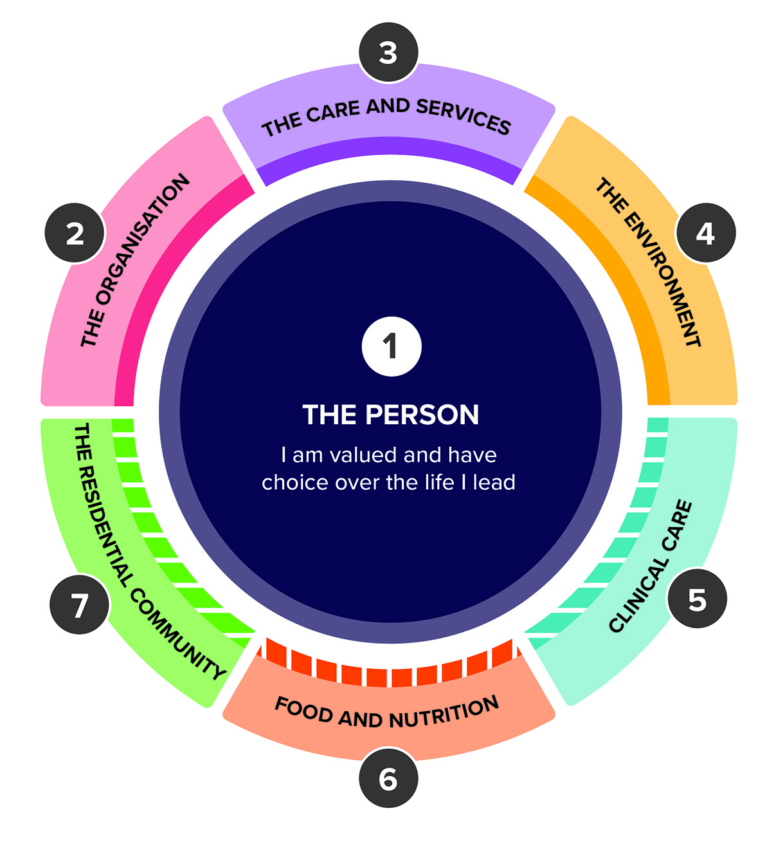
Please note the draft strengthened Quality Standards in this document are not yet in operation. The strengthened Quality Standards are being piloted from April 2023, with findings to inform any further changes prior to commencement. This draft is intended for test purposes only.

Standard 1: The Person

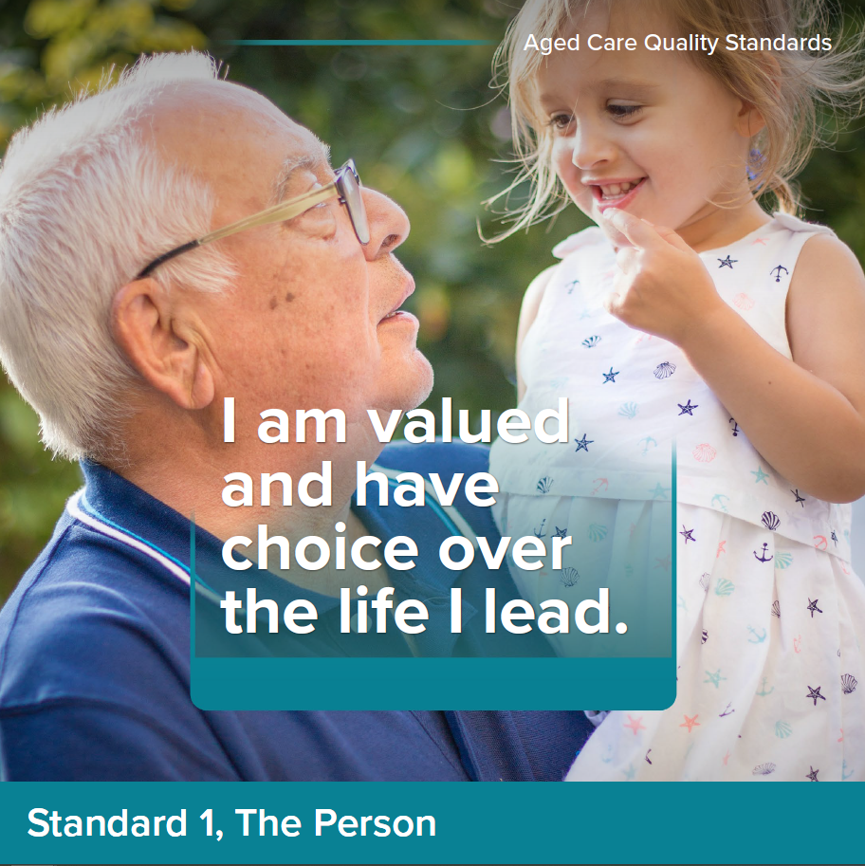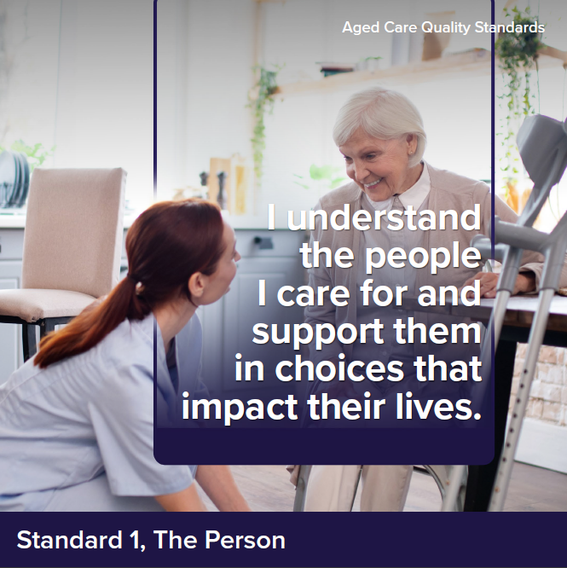

Intent of Standard 1
Standard 1 underpins the way that providers and workers are expected to treat older people and is relevant to all standards. Standard 1 reflects important concepts about dignity and respect, older person individuality and diversity, independence, choice and control, culturally safe care and dignity of risk. These are all important in fostering a sense of safety, autonomy, inclusion and quality of life for older people.
Older people are valuable members of society, with rich and varied histories, characteristics, identities, interests and life experiences.
Older people can come from a diverse range of backgrounds and groups, including, but not limited to, Aboriginal and Torres Strait Islander peoples, people from culturally and linguistically diverse backgrounds, people living in rural or remote areas, people who are financially or socially disadvantaged, people who are veterans, people experiencing homelessness or at risk of becoming homeless, people who are care leavers (i.e. a person who spent time in care as a child), parents separated from their children by forced adoption or removal, people who are lesbian, gay, bisexual, transgender or intersex, people of various religions, people experiencing mental health problems and mental illness, people living with cognitive impairment including dementia, people living with disability.
A person’s diversity does not define who they are, but it is critical that providers recognise and embrace each person’s diversity and who they are holistically as a person, and that this drives how providers and workers engage with older people and deliver their care and services.

Standard 1 expectation statement for older people:
I have the right to be treated with dignity and respect and to live free from any form of discrimination. I make decisions about my care and services, with support when I want it. My identity, culture and diversity are valued and supported, and I have the right to live the life I choose. My provider understands who I am and what is important to me, and this determines
the way my care and services are delivered.

Outcome 1.1: Person-centred care

Outcome statement:
The provider understands and values the older person, including their identity, culture, ability, diversity, beliefs and life experiences. Care and services are developed with, and tailored to, the older person. Care and services are provided in a way that upholds the rights of older people and cultivates their relationships and social connections.

Actions:
- The way the provider and workers engage with older people supports them to feel safe, welcome, included and understood.
- The provider implements strategies to:
  - identify the older person’s individual background, culture, diversity, beliefs and life experiences as part of assessment and planning and use this to direct the way their care and services are delivered
  - identify and understand the individual communication needs and preferences of the older person
  - ask and record if an older person identifies as an Aboriginal and Torres Strait Islander person
  - deliver care that meets the needs of older people with specific needs and diverse backgrounds, including Aboriginal and Torres Strait Islander peoples and people living with dementia
  - deliver care that is culturally safe, trauma aware and healing informed
  - continuously improve its approach to inclusion and diversity.
- The provider and workers recognise the rights, and respects the autonomy, of older people, including their right to intimacy and sexual and gender expression.
- Workers have professional and trusting relationships with older people and work in partnership with them to deliver care and services.
Notes:
- ‘Older people with specific needs and diverse backgrounds’ are identified more fully under the Intent of Standard 1. While we recognise the need to improve outcomes for all older people from diverse backgrounds and with specific needs, we have intentionally specified Aboriginal and Torres Strait Islander peoples and people living with dementia in response to findings from the Royal Commission regarding the need for additional efforts to improve outcomes for these groups.
- Workers can build trusting relationships with older people by listening to, and engaging with, the older person in a way that is right for them, free from judgement or assumptions.

Outcome 1.2: Dignity, respect and privacy

Outcome statement:
Older people are treated with dignity and respect, they receive care and services free from discrimination, and their personal privacy is respected.

Actions:
- Older people are treated with kindness, dignity and respect.
- The relationship between older people, their family and carers is recognised and respected.
- The provider implements a system to recognise, prevent and respond to violence, abuse, racism, neglect, exploitation and discrimination.
- The personal privacy of older people is respected, older people have choice about how and when they receive intimate physical care or treatment, and this is carried out sensitively and in private.
Notes:
- A ‘system to prevent violence, abuse, etc.’ includes incident management systems, worker training, encouraging reporting of incidents (by both workers and older people), etc.

Outcome 1.3: Choice, independence and quality
of life

Outcome statement:
Older people have independence and make decisions about their care and services, with support when they want or need it. Older people are provided timely, accurate, tailored and sufficient information, in a way they understand. Older people are supported to exercise dignity of risk to achieve their goals and maintain independence and quality of life.

Actions:
- The provider implements a system to ensure information given to
older people about their care and services:
  - is current, accurate and timely
  - is plainly expressed and presented in a way the older person understands
  - enables the older person to make informed decisions.
- The provider implements a system to ensure that older people give their informed consent where this is required for a treatment, procedure or other intervention.
- The provider implements a system:
  - to ensure older people who require support with decision-making are identified and provided access to the support necessary to make, communicate and participate in decisions that affect their lives
  - that involves family and carers in supporting decision-making where possible
  - that uses substitute decision-makers only after all options to support an older person to make decisions are exhausted.
- The provider supports older people to access advocates of their choosing.
- The provider supports older people to live the best life they can, including by understanding the older person’s goals and preferences and enabling positive risk-taking that promotes the person’s autonomy and quality of life.
- The provider records, monitors and responds to changes to the older person’s quality of life.
Notes:
- As part of Action 1.3.1, where the provider (and/or workers) require translating or interpreting services to communicate effectively with older people, it is expected that the provider would arrange this.

Outcome 1.4: Transparency and agreements

Outcome statement:
Older people have autonomy and can take time and seek advice before entering into any agreements about their care and services. Older people are supported to understand agreements, fees and invoices.

Actions:
- Prior to entering into any agreement or care commencing (whichever comes first), the provider gives older people information to enable them to make informed decisions about their care and services.
- The provider supports older people to understand information provided to them, including any agreement they will be required to enter into, the terms relating to their rights and responsibilities, the care and services to be provided and the fees and other charges to be paid.
- The provider allows older people sufficient time to consider and review their options and seek external advice.
- The provider informs the older person of any changes to previously agreed fees and charges and seeks their informed consent to implement these changes before they are made.
- The provider implements a system to ensure prices, fees and payments are accurate and transparent for older people.
- The provider ensures invoices are timely, accurate, clear and presented in a way the older person understands.
- The provider promptly addresses any overcharging and provides refunds to older people.
Notes:
- It is expected that (as per Outcome 1.3), all information relating to agreements is provided to older people in a way they understand, including where this may require the provider to engage a translator or interpreter to help communicate with older people.

Standard 2: The Organisation

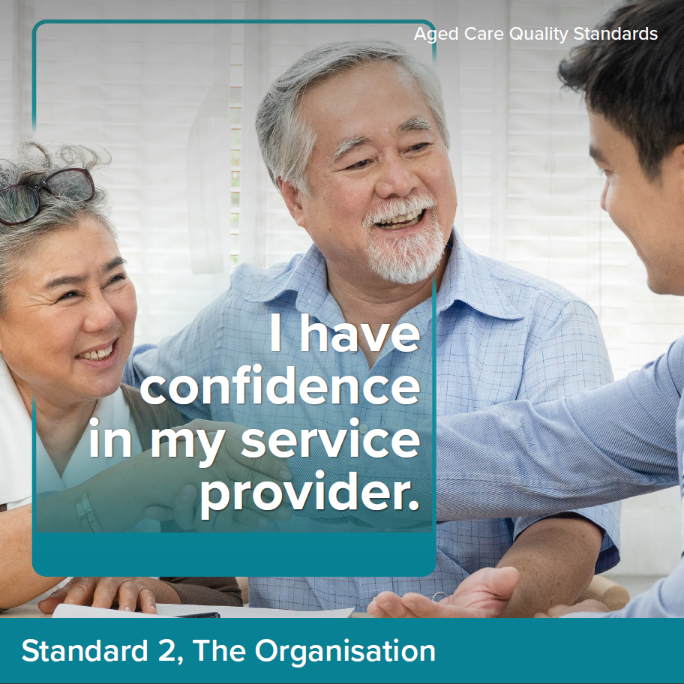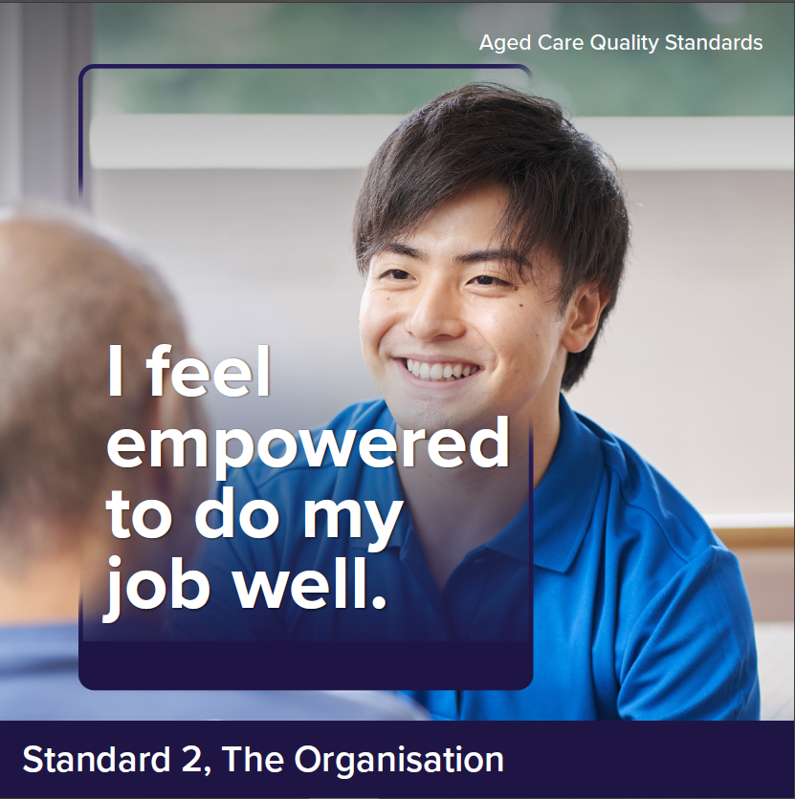

Intent of Standard 2
The intent of Standard 2 is to hold the governing body responsible for meeting the requirements of the Quality Standards and delivering quality care and services.
The governing body sets the strategic priorities for the organisation and promotes a culture of safety and quality. The governing body is also responsible for driving and monitoring improvements to care and services, informed by engagement with older people, family, carers and workers, and data and information on care quality.
A provider’s governance systems and workforce are critical to the delivery of safe, quality, effective and person-centred care for every older person, and continuous care and services improvement.

Standard 2 expectation statement for older people:
The organisation is well run. I can contribute to improvements to care and services. My provider and workers listen and respond to my feedback and concerns. I receive care and services from workers who are knowledgeable, competent, capable and caring.

Outcome 2.1: Partnering with older people

Outcome statement:
Meaningful and active partnerships with older people inform organisational priorities and improvements to quality care and services.

Actions:
- The governing body partners with older people to set priorities and strategic directions for the way care and services are provided.
- The provider supports older people to participate in partnerships.
- The provider partners with older people in the governance of the organisation and the design, evaluation and improvement of quality care and services.
- The provider understands the diversity of older people who use their services, including those at higher risk of harm, and tailors information, communication and services to meet their needs.
- The provider partners with older people that reflect the diversity of those who use their services.
- The provider partners with Aboriginal and Torres Strait Islander older people to ensure care and services are accessible to, and culturally safe for, Aboriginal and Torres Strait Islander peoples.

Outcome 2.2: Quality and safety culture

Outcome statement:
The governing body leads a culture of safety, inclusion and quality, with a focus on continuous improvement, which embraces diversity and prioritises the rights, safety, health and quality of life of older people and the workforce.

Actions:
- The governing body leads a positive culture of quality care and services and continuous improvement and demonstrates that this culture exists within the organisation.
- In strategic and business planning, the governing body:
  - prioritises the rights, safety, health and quality of life of older people
  - ensures that care and services are accessible to, and appropriate for, people with specific needs and diverse backgrounds, Aboriginal and Torres Strait Islander peoples and people living with dementia
  - considers legislative requirements, organisational and operational risks, workforce needs and the wider organisational environment.

Notes:
- In ensuring that care and services ‘are accessible to, and appropriate for, people with specific needs and diverse backgrounds, Aboriginal and Torres Strait Islander peoples and people living with dementia’, it is expected the provider would engage with older people from these backgrounds and with these needs to assess how care and services can be made more accessible and appropriate for them.

Outcome 2.3: Accountability and quality system

Outcome statement:
The governing body is accountable for the delivery of quality care and services and maintains oversight of all aspects of the organisation’s operations. The provider’s quality system enables the organisation’s performance and continuous improvement.

Actions:
- The provider implements a quality system that:
  - supports quality care and services for all older people
  - sets out accountabilities and responsibilities for supporting quality care and services, specific to different roles
  - sets strategic and operational expectations to support quality care and services
  - enables the governing body to monitor the organisation’s performance in delivering quality care and services, informed by:
    - feedback from family, carers and workers
    - analysis of risks, complaints and incidents (and their underlying causes)
    - Quality Indicator data
    - contemporary, evidence-based practice
  - supports the provider to meet strategic and operational expectations and identify opportunities for improvement.
- The governing body monitors investment in priority areas to deliver quality care and services.
- The provider regularly reviews and improves the effectiveness of the
quality system.
- The provider regularly reports on its quality system and performance to older people, family and carers.
- The provider practices open disclosure and communicates with older people, family and carers when things go wrong.

Outcome 2.4: Risk management

Outcome statement:
Risks to older people, workers and the organisation are identified, managed and continuously reviewed.

Actions:
- The provider implements a risk management system to identify, assess, document, manage and regularly review risks to older people, workers and the organisation.
- The provider puts strategies in place and undertakes actions to prevent, control, minimise or eliminate identified risks.
- The provider collects and analyses data and engages with older people and workers to inform risk assessment and management. This feeds into the provider’s quality system to improve care and services.
- The provider regularly reviews and improves the effectiveness of the risk management system.

Outcome 2.5: Incident management

Outcome statement:
The provider uses an incident management system to safeguard older people and acknowledge, respond to, effectively manage and learn from incidents.

Actions:
- The provider implements an incident management system to record, investigate, respond to and manage incidents and near misses that occur in connection with the delivery of care and services and reduces or prevents incidents from recurring.
- The provider takes timely action to respond to and manage incidents.
- The provider supports older people, family and carers to report incidents and encourages their involvement in identifying ways to reduce incidents from occurring.
- The provider supports the workforce to prevent, recognise, respond to and report incidents.
- The provider collects and analyses incident data. Outcomes are reported to older people and workers and feed into the provider’s quality system to improve the quality of care and services.
- The provider regularly reviews and improves the effectiveness of the incident management system.
Notes:
- In relation to 2.5.3, some older people may need particular support or encouragement to feel safe to voice a concern. It is expected that providers foster an environment where older people, carers and workers feel safe to raise concerns, report incidents and provide particular support for older people with diverse needs and from specific backgrounds to report incidents.

Outcome 2.6: Feedback and complaints management

Outcome statement:
Older people and others are encouraged and supported to provide feedback and make complaints about care and services. Feedback and complaints are acknowledged, managed transparently and contribute to the continuous improvement of care and services. Older people and others can complain without reprisal.

Actions:
- The provider implements a complaints management system to receive, record, respond to and report on complaints.
- The provider encourages and supports older people, family and carers, workers and others to provide feedback and make complaints.
- Older people are empowered to access advocates, language services and other ways of raising and resolving feedback and complaints.
- The provider takes timely action to resolve complaints and uses an open disclosure process when things go wrong.
- The provider collects and analyses feedback and complaints data. Outcomes are reported to the governing body, older people and workers and inform the provider’s quality system to improve the quality of care and services.
- The provider regularly reviews and improves the effectiveness of the complaints management system.

Outcome 2.7: Information management

Outcome statement:
Information is identifiable, accurately recorded, current and able to be accessed and understood by those who need it. The information of older people is confidential and managed appropriately, in line with their informed consent. Current policies and procedures guide the way workers undertake their roles.

Actions:
- The provider implements an information management system to securely manage records.
- The provider’s information management system ensures that:
  - workers and older people have access to the right information at the right time to deliver and receive quality care and services
  - the accuracy and completeness of information collected and stored is maintained
  - informed consent is sought to collect, use and store the information of older people or to disclose their information (including assessments) to other parties
  - older people understand their right to access or correct their information or withdraw their consent to share information
  - information from different sources is integrated.
- The provider regularly reviews and improves the effectiveness of the information management system.
- The provider maintains policies and procedures that are current, regularly reviewed, informed by contemporary, evidence-based practices, and are understood and accessible by workers and relevant parties.

Outcome 2.8: Workforce planning

Outcome statement:
The provider understands and manages its workforce needs and plans for the future.

Actions:
- The provider implements a workforce strategy to:
  - identify, record and monitor the number and mix of workers required and engaged to manage and deliver quality care and services
  - identify the skills, qualifications and competencies required for each role
  - engage suitably qualified and competent workers
  - use direct employment to engage workers whenever possible, and minimise the use of independent contractors
  - mitigate the risk and impact of workforce shortages and worker absences or vacancies.
- The provider implements strategies for supporting and maintaining a satisfied and psychologically safe workforce.

Outcome 2.9: Human resource management

Outcome statement:
The care and services needs of older people are met by workers who are skilled and competent in their role, hold relevant qualifications and who have relevant expertise and experience to provide quality care and services.

Actions:
- The provider maintains records of worker pre-employment checks, contact details, qualifications and experience.
- The provider deploys the number and mix of workers to enable the delivery and management of quality care and services.
- Workers have access to supervision, support and resources.
- The provider maintains and implements a training system that:
  - includes training strategies to ensure that workers have the necessary skills, qualifications and competencies to effectively perform their role
  - draws on the experience of older people to inform training strategies
  - is responsive to feedback, complaints, incidents, identified risks and the outcomes of regular worker performance reviews.
- The provider regularly reviews and improves the effectiveness of the
training system.
- All workers regularly receive competency-based training in relation to core matters, at a minimum:
  - the delivery of person-centred, rights-based care
  - culturally safe, trauma aware and healing informed care
  - caring for people living with dementia
  - responding to medical emergencies
  - the requirements of the Code of Conduct, the Serious Incident Response Scheme, the Quality Standards and other requirements relevant to the worker’s role.
- The provider undertakes regular assessment, monitoring and review of the performance of workers.

Outcome 2.10: Emergency and disaster management

Outcome statement:
Emergency and disaster management considers and manages the risks to the health, safety and wellbeing of older people and workers.

Actions:
- The provider develops emergency and disaster management plans that describe how the organisation and workers will respond to an emergency or disaster and manage risks to the health, safety and wellbeing of older people and workers.
- The provider implements strategies to prepare for, and respond to, an emergency or disaster.
- The provider engages with older people, family, carers and workers about the emergency and disaster management plans.
- The provider regularly tests and reviews the emergency and disaster management plans in partnership with older people, family, carers, workers and other response partners.
Notes:
- ‘Response partners’ may include government agencies, the State Emergency Service, other service providers, community organisations, etc.

Standard 3: The Care and Services
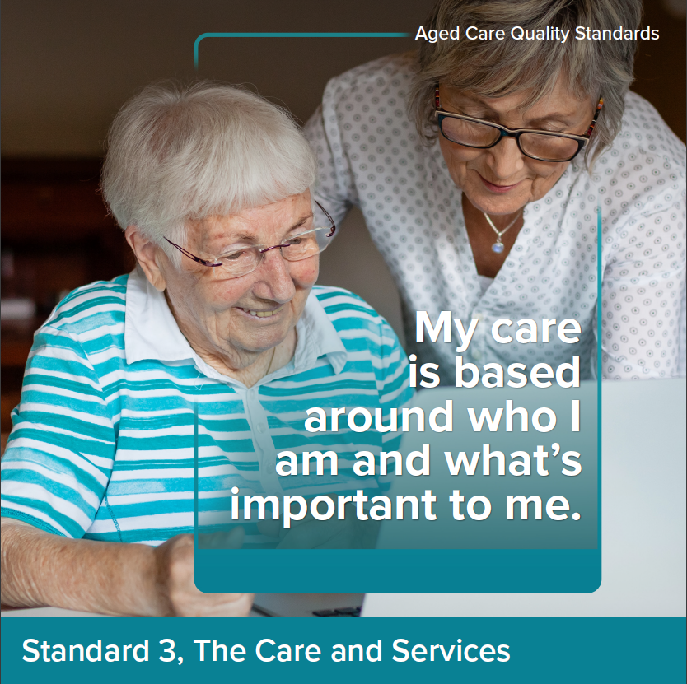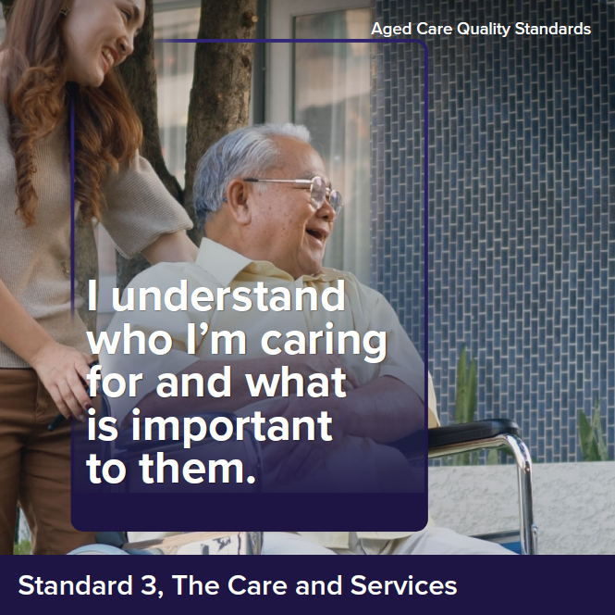

Intent of Standard 3
Standard 3 describes the way providers must deliver care and services for all types of services being delivered (noting that other standards describe requirements relevant to specific service types). Effective assessment and planning, communication and coordination relies on a strong and supported workforce as described in Standard 2 and is critical to the delivery of quality care and services that meet the older person’s needs, are tailored to their preferences and support them to live their best lives.
In delivering care and services, providers and workers must draw on all relevant standards, with particular reference to Standard 1, including to ensure care is tailored to the individual and what’s important to them. Family and carers are recognised as having an important role in assisting or providing care and services.

Standard 3 expectation statement for older people:
The care and services I receive:
- are safe and effective
- optimise my quality of life, including through maximising independence and reablement
- meet my current needs, goals and preferences
- are well planned and coordinated
- respect my right to take risks.

Outcome 3.1 Assessment and planning

Outcome statement:
Older people are actively engaged in developing and reviewing their care and services plans. Care and services plans describe the current needs, goals and preferences of older people, are regularly reviewed and are used by workers to guide the delivery of care and services.

Actions:
- The provider implements a system for assessment and planning that:
  - identifies and records the needs, goals and preferences of the older person
  - identifies risks to the older person’s health, safety and wellbeing and, with the older person, identifies strategies for managing these risks
  - supports preventative care and optimises quality of life, reablement and maintenance of function
  - involves relevant health professionals where required
  - directs the delivery of quality care and services.
- Assessment and planning are based on ongoing communication and partnership with the older person and others that the older person wishes to involve.
- The outcomes of assessment and planning are effectively communicated to:
  - the older person, in a way they understand
  - the older person’s family, carers and others involved in their care, with their informed consent.
- Care and services plans are individualised and:
  - describe the older person’s needs, goals and preferences
  - are current and reflect the outcomes of assessments
  - include information about the risks associated with care and services delivery and how workers can support older people to manage these risks
  - are offered to, and able to be accessed by, the older person
  - are used and understood by workers to guide the delivery of care and services.
- Care and services plans are reviewed regularly, including when:
  - the older person’s needs, goals or preferences change
  - the older person’s ability to perform activities of daily living, mental health, cognitive or physical function, capacity or condition deteriorates or changes
  - the care that can be provided by an older person’s family or carer changes
  - risks emerge or there are changes or an incident that impacts the older person
  - care responsibility changes between others involved in the older person’s care.
Notes:
- Where care and services plans are accessed by older people, the provider may develop a summary version, noting that care and services plans are often likely to includes significant volumes of information about a person’s care and services however the older person must have access to their full care and services plan if requested.

Outcome 3.2: Delivery of care and services

Outcome statement:
Older people receive quality care and services that meet their needs, goals
and preferences and optimise their quality of life, reablement and maintenance of function. Care and services are provided in a way that is culturally safe, appropriate for people with specific needs and diverse backgrounds.

Actions:
- Older people receive culturally safe, trauma aware and healing informed care and services that:
  - are provided in accordance with contemporary, evidence-based practices
  - meet their current needs, goals and preferences
  - optimise their quality of life.
- The provider delivers care and services in a way that optimises the older person’s quality of life, reablement and maintenance of function, where this is consistent with their preferences.
- Older people are supported to use equipment, aids, devices and products safely and effectively.
- The provider ensures older people receive timely and appropriate referrals
to support early identification and intervention, reablement, maintenance of function and quality of life, including to:
  - health professionals
  - My Aged Care for re-assessment as required.
- The provider implements strategies for supporting workers to:
  - recognise risks or concerns related to an older person’s health, safety and wellbeing
  - identify deterioration or changes to an older person’s ability to perform activities of daily living, mental health, cognitive or physical function, capacity or condition
  - respond to, and escalate, risks in a timely manner.
- The provider implements a system for caring for older people living with
dementia that:
  - incorporates contemporary, evidence-based strategies for the timely recognition of dementia and the delivery of care that best supports people living with dementia
  - enables the identification and regular review of the strengths and skills of people living with dementia and encourages use of these day-to-day
  - enables family, carers and health professionals involved in the older person’s care to act as partners in planning and delivering the older person’s care (in line with the older person’s wishes).
- The provider minimises the use of restrictive practices and, where restrictive practices are used, these are:
  - used as a last resort
  - used in the least restrictive form and for the shortest time needed
  - used with the informed consent of the older person
  - monitored and regularly reviewed.
- The provider makes reasonable efforts to involve the older person in selecting their workers (including the gender of, and language spoken by, workers providing care) and maximise worker continuity.
- The provider supports workers to:
  - understand the way different older people communicate, including people living with dementia or have difficulty communicating
  - communicate effectively with different older people, both verbally and non-verbally.
Notes:
- This outcome is intended to apply to all care and services, regardless of the service type or setting.
- It is intended that Action 3.2.5 align with any requirements regarding the use of restrictive practices in the legislation when this is settled.

Outcome 3.3: Communicating for safety and quality

Outcome statement:
Critical information relevant to the older person’s care and services is communicated effectively with the older person, between workers and with family, carers and health professionals involved in the older person’s care. Risks, changes and deterioration in an older person’s condition are escalated and communicated as appropriate.

Actions:
- The provider implements a system for communicating structured information about older people and their care and services that ensures critical information is effectively communicated in a timely way to workers family, carers and health professionals involved in the older person’s care.
- The provider’s communication system is used when:
  - the older person commences receiving care and services
  - the older person’s needs, goals or preferences change
  - risks emerge, there is a change, deterioration or an incident that impacts the older person
  - handover or transitions of care occurs between workers or others involved in the older person’s care.
- The provider implements processes for older people, family, carers and health professionals involved in the older person’s care to escalate concerns about the older person’s health, safety or wellbeing.
- The provider implements processes to:
  - correctly identify and match older people to their care and services
  - provide Monthly Care Statements to older people in residential aged care.

Outcome 3.4: Coordination of care and services

Outcome statement:
Older people receive planned and coordinated care and services, including where multiple health and aged care providers, family and carers are involved in the delivery of care and services.

Actions:
- The provider, in partnership with the older person, identifies others involved in the older person’s care and ensures coordination.
- Carers are recognised as partners in the older person’s care and involved in the coordination of care and services.
- The provider facilitates a planned and coordinated transition to or from the provider in collaboration with the older person and other providers of care and services, and this is documented, communicated and effectively managed.
Notes:
- Under the new In-Home Aged Care Program, it is expected there will be a care management service type. Where this service is being provided, care coordination would be the responsibility of this provider.

Standard 4: The Environment

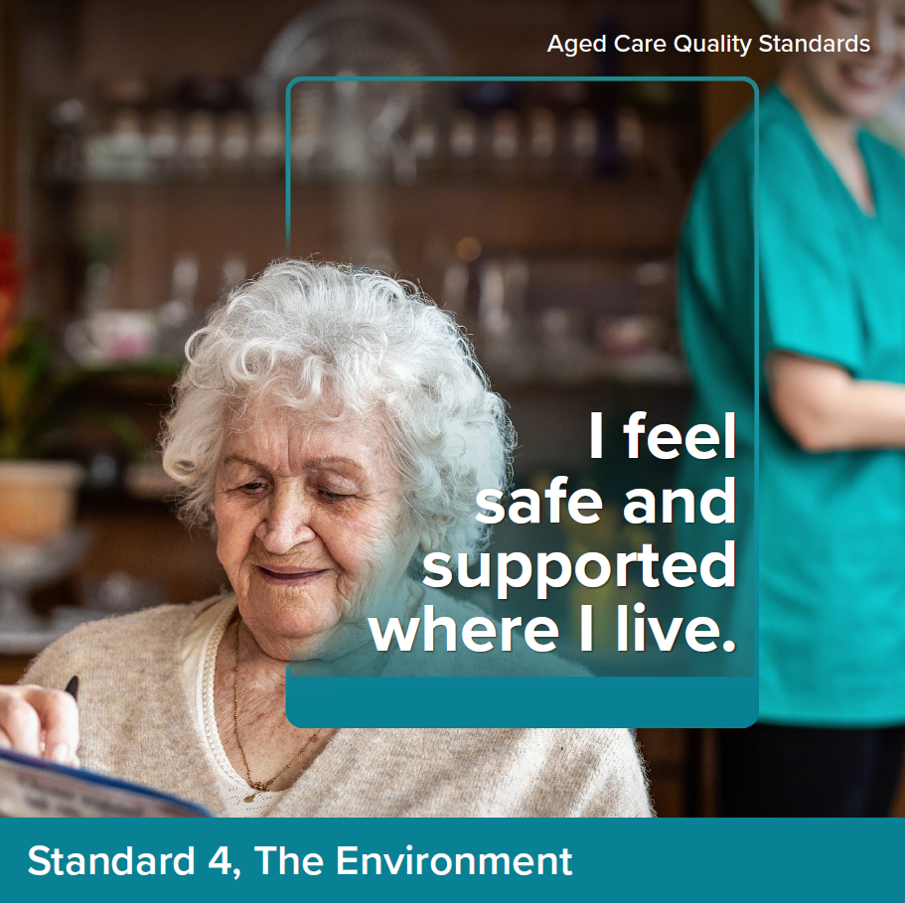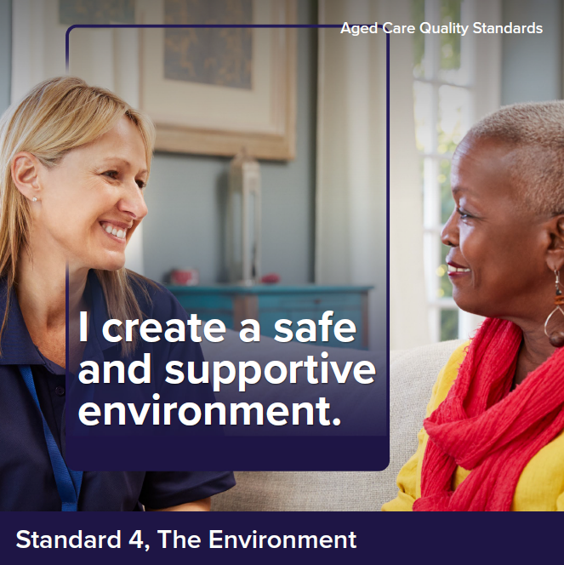

Intent of Standard 4
The intent of Standard 4 is to ensure that older people receive care and services in
a physical environment that is safe, supportive and meets their needs. Effective infection prevention and control measures are a core component of service delivery to protect older people, their family, carers and workers.

Standard 4 expectation statement for older people:
I feel safe when receiving care and services. Where I receive care and services through a service environment, the environment is clean, safe and comfortable and enables me to move around freely. Equipment is safe, appropriate and well-maintained and precautions are taken to prevent the spread of infections.

Outcome 4.1a: Environment and equipment at home

Outcome statement:
Providers support older people to mitigate environmental risks relevant to their care and services. Where equipment is used in the delivery of care and services or given to the older person by the provider, it is safe and meets the needs of older people.

Actions:
- Where care and services are delivered in the older person’s home, as relevant to the services being delivered, the provider:
  - identifies any environmental risks to the safety of the older person
  - discusses with the older person, any environmental risks and options to mitigate these.
- Equipment and aids provided by the provider are safe, clean, well-maintained and meets the needs of older people.
Notes:
- These requirements would apply to care and services delivered to older people in their own home.

Outcome 4.1b Environment and equipment in a service environment

Outcome statement:
Older people access care and services in a clean, safe and comfortable environment that optimises their sense of belonging, interaction and function. Equipment used in the delivery of care and services is safe and meets the needs of older people.

Actions:
- The provider ensures the service environment is:
  - routinely cleaned and well-maintained
  - safe, welcoming and comfortable
  - fit-for-purpose.
- The provider ensures the service environment:
  - is accessible, including for older people with disability
  - promotes movement, engagement and inclusion through design
  - enables older people to move freely both indoors and outdoors
  - unobtrusively reduces safety risks, optimises useful stimulation and is easy to navigate.
- Equipment used in the delivery of care and services is safe, clean, well-maintained and meets the needs of older people.
Notes:
- ‘Unobtrusively’ means that providers should aims to minimise safety risks in a way that is least restrictive on an older person’s freedom (e.g. fences and locked doors may inhibit movement) however, where it is in the interests of an older person’s safety, visible signage, handrails etc. would be appropriate.
- Action 4.1.2 draws on dementia enabling environment principles. Moving ‘freely indoors and outdoors’ means that people are able to go in and outside at their leisure, acknowledging that there may be some areas of a service that would be inaccessible to older people (such as commercial laundries, kitchens or storage areas).

Outcome 4.2: Infection prevention and control

Outcome statement:
The provider has an appropriate infection prevention and control system. Workers use hygienic practices and take appropriate infection prevention and control precautions when providing care and services.

Actions:
- The provider implements a system for infection prevention and control that is used where care and services are delivered:
  - identifies an appropriately qualified and trained infection prevention and control lead
  - describes standard and transmission-based precautions appropriate for the setting, including cleaning practices, hand hygiene practices, respiratory hygiene, cough etiquette and waste management and disposal
  - prioritises the rights, safety, health and wellbeing of older people
  - complies with contemporary, evidence-based practice
  - includes additional precautions to respond promptly to novel viruses and outbreaks of infectious diseases (suspected or confirmed)
  - communicates and manages infection risks to older people, family, carers and workers
  - is informed by worker and older person immunisation and infection rates
- The provider implements a system to ensure:
  - that personal protective equipment is available to workers, older people and others who may need it
  - workers, older people and others who need to use personal protective equipment are supported to correctly use personal protective equipment.
Notes:
- Some baseline requirements regarding infection prevention and control are included in other standards to ensure all providers adopt appropriate precautions, noting that Standard 5 sets out additional expectations relevant to the delivery of clinical care.

Standard 5: Clinical Care

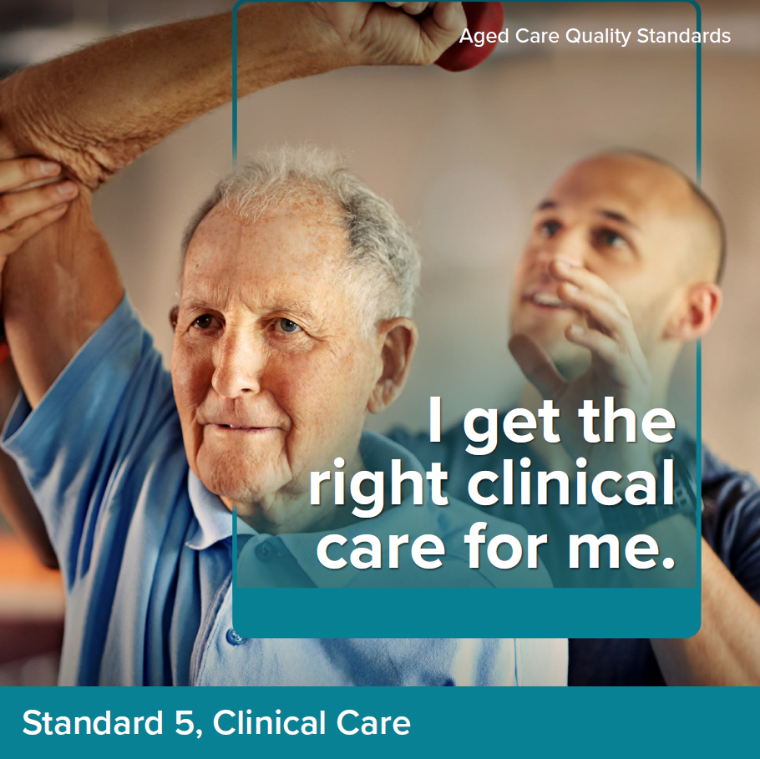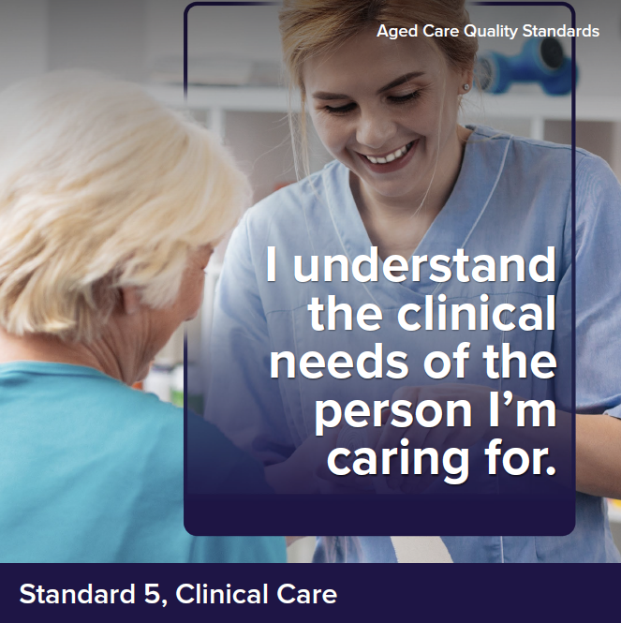

Intent of Standard 5
The Clinical Care Standard describes the responsibilities of providers to deliver safe and quality clinical care to older people. The governing body has overall responsibility to ensure a clinical governance framework is implemented and to monitor its effectiveness. Providers operationalise the clinical governance framework and report on its performance.
Many older people who require clinical care have multiple chronic co-morbidities and complex care needs. These people may be experiencing sickness, frailty, disability, cognitive impairment or be nearing the end of their life. Access to a range of health professionals is crucial to address these complex needs. Good clinical care can optimise an older person’s quality of life, reablement and maintenance of function. Improved health and wellbeing supports continued participation in activities that are enjoyable and give life meaning.
At all times, the clinical care provided should be person-centred. It should be planned and delivered in partnership with the older person, involving family, carers and others in line with the older person’s needs and preferences. Delivering safe, quality clinical care requires a multidisciplinary approach with a skilled workforce with clear accountabilities that are supported to deliver contemporary, evidence-based care. Allied health professionals have distinct roles in reablement and maintenance of an older person’s functional capabilities.
Effective implementation of Standard 5 is reliant on the systems and processes from Standards 1–7. Standard 5 does not seek to replicate the base expectation of understanding the person in Standard 1 or the base planning, assessment and delivery expectation of Standard 3 as an example. These systems and processes establish a baseline expectation which supports the delivery of person-centred and safe clinical care, ensuring that risks of harm to older people from clinical care are minimised and support continuous quality improvement.

Standard 5 expectation statement for older people:
I receive evidence based, safe, effective, and person-centred clinical care by qualified health professionals and competent workers that meets my changing clinical needs and is in line with my goals and preferences.

Outcome 5.1: Clinical governance

Outcome statement:
The governing body meets its duty of care to older people and continuously improves the safety and quality of the provider’s clinical care. The provider integrates clinical governance into corporate governance to actively manage and improve the safety and quality of clinical care for older people.

Actions:
- The governing body:
  - sets priorities and strategic directions for safe and quality clinical care and ensures that these are communicated to workers and older people
  - endorses the clinical governance framework
  - monitors the safety and quality of clinical systems and performance.
- The provider implements the clinical governance framework as part of corporate governance, to drive safety and quality using:
  - feedback and information on experiences of older people, family, carers and workers
  - analysis of clinical safety and quality indicator data, including data from the mandatory Quality Indicator Program
  - contemporary, evidence-based practice.
- The provider implements processes to ensure clinical care is culturally safe, trauma aware and healing informed.
- The provider implements processes to ensure workers providing clinical care are qualified, competent and work within their defined scope of practice or role.
- The provider and health professionals agree on their respective roles, responsibilities and protocols for providing clinical care.
- The provider works towards implementing a digital clinical information system that:
  - integrates clinical information into nationally agreed electronic health and aged care digital records
  - supports interoperability using national healthcare and aged care unique identifiers and standard national terminology
  - has processes for workers and others to access information in compliance with legislative requirements.

Outcome 5.2: Preventing and controlling infections in clinical care

Outcome statement:
Older people, workers and others are encouraged and supported to use antimicrobials appropriately to reduce risks of increasing resistance. Infection risks are minimised and, if they occur, are managed effectively.

Actions:
- The provider implements an antimicrobial stewardship system that complies with contemporary, evidence-based practice and is relevant to the service context.
- The provider implements processes to minimise and manage infection when providing clinical care that include but are not limited to:
  - performing clean procedures and aseptic techniques
  - using, managing and reviewing invasive devices including urinary catheters
  - minimising the transmission of infections and complications from infections.
- The provider implements a system for infection prevention and control that includes:
  - risk-based vaccine-preventable diseases screening and immunisation for older people and the workforce
  - disease screening and immunisation requirements for visitors.

Outcome 5.3: Safe and quality use of medicines
Outcome statement:
Older people, workers and health professionals are encouraged and supported to use medicines in a way that maximises benefits and minimises the risks of harm. Governance processes ensure medicines-related incidents are analysed and acted on to improve the safe and quality use of medicines.

Actions:
- The provider implements a system for the safe and quality use of medicines, including processes to:
  - ensure medicines-related information is available to workers and the older person
  - ensure workers and others caring for an older person have access to the older person’s up-to-date medicines list and other supporting information at transitions of care
  - ensure safe administration including assessing the older person’s swallowing ability, determining suitability of crushing medicines and providing alternative safe formulations when required
  - minimise interruptions to the administration of prescribed medicines including supporting access to medicines when an older person is prescribed a new medicine or an urgent change to their medicine
  - ensure a current, accurate and reliable record of all medicines is documented and the clinical reasons for the treatment are stated, including pro re nata (PRN) medicines
  - support remote access for prescribing.
- Health professionals review, plan and make changes to medicines for the older person when they are acutely unwell.
- The provider has processes to ensure medication reviews are conducted including:
  - at the commencement of care, at transitions of care and annually when care is ongoing
  - when there is a change in diagnosis or deterioration in behaviour, cognition or mental or physical condition
  - when there is polypharmacy and the potential to deprescribe
  - when a new medicine is commenced, or a change is made to an existing medicine or to the medication management plan
  - when there is an adverse event potentially related to medicines.
- The provider documents existing or known allergies or side effects to medicines, vaccines or other substances at the commencement of care and monitors and updates documentation when new allergies or side effects occur.
- The provider implements processes to identify, monitor and mitigate risks to older people associated with the use of high-risk medicines, including reducing the inappropriate use of psychotropic medicines.
- The provider reports adverse medicine and vaccine events to the Therapeutic Goods Administration.
- The provider regularly reviews and improves the effectiveness of the system for the safe and quality use of medicines.
Note:
These actions apply to providers responsible for medication management including prescribing, dispensing, providing information about medicines, storing, administering and monitoring medicines.

Outcome 5.4: Comprehensive care

Outcome statement:
Older people receive comprehensive clinical care that is safe, quality, evidence based and person-centred. Clinical care encompasses prevention, treatment and management, optimising quality of life, reablement and maintenance of function. Systems and processes support multidisciplinary care, in partnership with the older person, family and carers that minimises harm and supports early identification of changing clinical needs.

Actions:
- The provider implements an assessment and planning system that supports partnering with the older person, family, carers and others to set goals of care and support decision-making.
- On commencement of care, the provider conducts a comprehensive clinical assessment that includes:
  - a comprehensive medical assessment with a General Practitioner
  - collaboration with health professionals who know the older person
  - identifying, documenting and planning for clinical risks, acute conditions and exacerbations of chronic conditions
  - identifying an older person’s level of clinical frailty and communication barriers and planning clinical care to optimise the older person’s quality of life, reablement and maintenance of function.
  - referring and facilitating access to medical, rehabilitation, allied health, specialist nursing and advisory services to address the older person’s clinical needs
  - identifying and providing access to the equipment, aids, devices and products required by the older person.
- The provider uses the care and services plan required as part of Standard 3 to document the outcomes of clinical assessments, treatment and agreed goals of care.
- The provider implements processes to monitor clinical conditions and routinely review and evaluate the effectiveness of the older person’s care and services plan, updating the plan:
  - when the care and services plan is not effective
  - when the older person’s needs change
  - at transitions of care
  - when there is a change in diagnosis or deterioration in behaviour, cognition, mental, physical or oral health.
- The provider implements processes to:
- deliver coordinated, multidisciplinary and holistic comprehensive care in line with the care and services plan
- communicate and collaborate with others involved in the older person’s care, in line with the older person’s needs and preferences
- facilitate access to after-hours and urgent clinical care
- provide timely notification to the person’s General Practitioner, family, carers and health professionals involved in the older person’s care when clinical incidents or changes occur.
- The provider has processes for advance care planning that:
  - support the older person to discuss future medical treatment and care needs, in line with their needs, goals and preferences, including beliefs, cultural and religious practices and traditions
  - support the older person to complete and review advance care planning documents, if and when they choose
  - support the older person to nominate and involve a substitute decision maker for health and care decisions, if and when they choose
  - ensure that advance care planning documents are stored, managed, used and shared with relevant parties, including at transitions of care.
Notes:
- These actions apply to providers based on the service types being delivered.
- The provider is expected to understand the older person and establish the care and services plan in accordance with Standards 1 and 3. The requirements regarding comprehensive clinical care set out in Outcome 5.4 are in addition to those set out in Outcome 3.1.
- The provider is expected to apply the processes outlined in Outcome 5.4 to the provision of all clinical care.

Outcome 5.5 Clinical safety

Outcome statement:
Older people receive comprehensive care that identifies, monitors and addresses specific clinical care needs, aligned with their goals of care and minimises their risk of harm. Older people have access to relevant health professionals to address clinical safety.

Actions:

Choking and swallowing
    - The provider implements processes to support safe swallowing by:
  - identifying, monitoring and responding to swallowing and choking risks, including when the older person is eating, drinking, taking oral medicines and during oral care
  - facilitating access to relevant health professionals when required.

Continence
    - The provider implements processes for continence care by:
  - optimising the older person’s dignity, comfort, function and mobility
  - protecting the older person’s skin integrity
  - ensuring safe and responsive assistance with toileting that meets the older person’s needs
  - identifying, monitoring and responding to incontinence and incontinence associated dermatitis
  - facilitating access to relevant health professionals when required.

Falls and mobility
    - The provider implements processes to minimise falls and harm from falls by:
  - maximising mobility to prevent functional decline
  - delivering effective and timely post falls care when required
  - monitoring falls and injuries and review the reason for and consequences from falls
  - facilitating access to relevant health professionals when required.

Nutrition and hydration
    - The provider implements processes to maintain an older person’s nutrition and hydration by:
  - conducting regular malnutrition screening
  - minimising the impact of chronic conditions
  - responding to the risk of malnutrition and when an older person is malnourished or has unplanned weight loss or gain
  - facilitating access to relevant health professionals when required.

Mental health
    - The provider implements processes to optimise mental health by:
- identifying, monitoring and responding to changes in an older person’s mental health
- minimising distress, depressive symptoms, risk of self-harm, suicide or harming others
- facilitating access to mental health treatment when required.

Oral health
    - The provider implements processes to maintain oral health and prevent decline by:
  - facilitating access at the commencement of care to oral health assessments and regular review by a dentist or other oral health practitioner
  - monitoring and responding to deterioration in oral health and providing timely referral to specialist oral and medical care when required
  - assisting with daily oral hygiene needs
  - providing access to and use of required products, aids and equipment.

Pain
    - The provider implements processes to manage pain by:
  - assessing the older person’s pain including where the older person experiences challenges in communicating their pain
  - planning for, monitoring and responding to the older person’s need for pain relief
  - ensuring pain management is available 24-hours a day
  - facilitating access to specialist pain management care when required.

Pressure injury and wounds
    - The provider implements processes to prevent and manage pressure injuries and wounds by:
  - conducting routine comprehensive skin inspections
  - monitoring and responding to pressure injuries and wounds when they occur
  - facilitating access to specialist wound management care when required.

Sensory Impairment
    - The provider implements processes to minimise and manage sensory impairment by:
  - monitoring and responding to hearing loss, vision loss and balance disorders
  - providing access to and use assistive devices and aids to maximise the older person’s independence, function and quality of life
  - facilitating access to relevant health professionals when required.

Outcome 5.6 Cognitive impairment

Outcome statement:
Older people who experience cognitive impairment whether acute, chronic or transitory receive comprehensive care that optimises clinical outcomes and is aligned with their needs, goals and preferences. Situations and events that may lead to changes in behaviours are identified and understood.

Actions:

    - The provider identifies and responds to the complex clinical care needs of people with delirium, dementia and other forms of cognitive impairment that includes:
  - identifying and mitigating clinical risks
  - delivering increased care requirements
  - being alert to deterioration and underlying contributing clinical factors.
    - The provider collaborates with older people with cognitive impairment, family, carers and others to understand the person and to optimise clinical care outcomes.
    - The provider implements processes to:
  - identify and minimise situations that may precipitate changes in behaviour
  - identify and respond to clinical and other identified causes of changes in behaviour.

Outcome 5.7: Palliative care and end-of-life care

Outcome statement:
The older person’s needs, goals and preferences for palliative care are recognised and addressed. The older person’s pain and symptoms are actively managed, their dignity is preserved, and their family and carers are informed and supported, including during the last days of life.

Actions:
    - The provider has processes to recognise when the older person requires palliative care or is approaching the end of their life, supports them to prepare for the end of life and responds to their changing needs and preferences.
    - The provider supports the older person, their family, carers and substitute decision maker, to:
  - have advance care planning conversations
  - develop or review documents to align with their current needs, goals and preferences
  - discuss requesting or declining aspects of personal care, life-prolonging treatment and responding to reversible acute conditions.
    - The provider uses its processes from comprehensive care, to plan and deliver palliative care that:
- prioritises the comfort and dignity of the older person
- supports the older person’s spiritual, cultural, and psychosocial needs
- identifies and manages changes in pain and symptoms
- provides timely access to specialist equipment and medicines for pain and symptom management
- communicates information about the older person’s preferences for palliative care and the place where they wish to receive this care to workers, their carers, family and others
- facilitates access to specialist palliative care when required
- provides a suitable environment for palliative care
- provides information about the process when a person is dying and about loss and bereavement to family and carers.
    - The provider implements processes in the last days of life to:
  - recognise that the older person is in the last days of life and respond to rapidly changing needs
  - ensure medicines to manage pain and symptoms, including anticipatory medicines, are prescribed, administered, reviewed and available
24-hours a day
  - provide pressure care, oral care, eye care and bowel and bladder care
  - recognise and respond to delirium
  - minimise unnecessary transfer to hospital, where this is in line with the older person’s preferences.
Note: These actions apply to providers according to their service context and the services being delivered.

Standard 6: Food and Nutrition

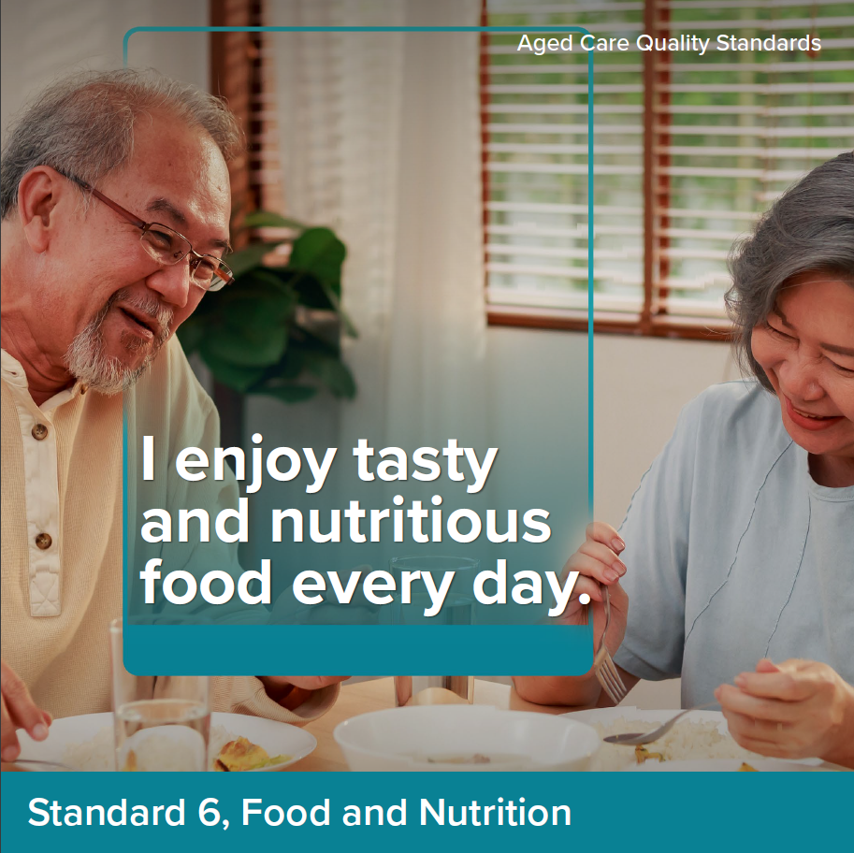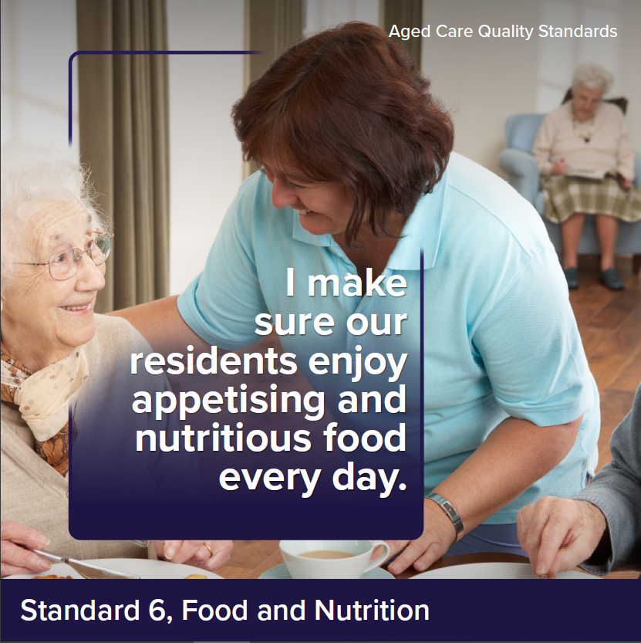

Intent of Standard 6
Access to nutritionally adequate food is a fundamental human right. Food, drink and the dining experience can have a huge impact on a person’s quality of life. As people age, they may lose their appetite or experience conditions that impact on their ability to eat and drink. As such, it is particularly important that providers engage with older people about what and how they like to eat and drink, deliver choice and meals that are full of flavour, appetising and nutritious (including for older people with texture modified diets), and support older people to consume as much as they want and exercise dignity of risk.
In many cultures, food also plays a large role in fostering feelings of inclusion and belonging. The experience of sharing food and drink with other older people, friends, family and carers is important for many older people.
Providers must draw on Standard 3 in delivering food services to ensure this is informed by robust assessment and planning, and services are delivered in line with the needs, goals and preferences of older people. It is also critical for providers to monitor older people for malnutrition and dehydration and respond appropriately where concerns are identified – this is addressed as part of Standard 5.
Standard 6 is intended to apply only to residential care services.

Standard 6 expectation statement for older people:
I receive plenty of food and drinks that I enjoy. Food and drinks are nutritious, appetising and safe, and meet my needs and preferences. The dining experience is enjoyable, includes variety and supports a sense of belonging.

Outcome 6.1: Partnering with older people on food and nutrition

Outcome statement:
The provider partners with older people to provide a quality food service, which includes appealing and varied food and drinks and an enjoyable dining experience.

Actions:
- The provider partners with older people on how to create enjoyable food, drinks and dining experience at the service.
- The provider implements a system to monitor and continuously improve the food service in response to:
  - the satisfaction of older people with the food, drink and the dining experience
  - older people’s intake of food and drink to ensure it meets their nutritional needs (including review of identified unplanned weight loss and malnutrition identified in Standard 5)
  - the impact of food and drink on the health outcomes of older people
  - contemporary, evidence-based practice regarding food and drink.
Notes:
- ‘Intake’ refers to however older people meet their nutritional and hydration needs, including through oral intake, enteral nutrition through a percutaneous endoscopic gastrostomy, etc.

Outcome 6.2: Assessment of nutritional needs
and preferences

Outcome statement:
The provider understands the specific nutritional needs of older people and assesses each older person’s current needs, abilities and preferences in relation to what and how they eat and drink.

Actions:
- As part of assessment and planning, the provider assesses and regularly reassesses each older person’s nutrition, hydration and dining needs and preferences. The assessment considers:
  - the specific nutritional needs of older people, including a focus on protein and calcium rich foods
  - the older person’s dining needs
  - what the older person likes to eat and drink
  - when the older person likes to eat and drink
  - what makes a positive dining experience for the older person
  - clinical and other physical issues identified that impact the older person’s ability to eat and drink.
Notes:
- ‘Clinical and other physical issues’ may include consideration of a person’s oral health, ability to chew and swallow, the impact of medications on appetite, seating and positioning requirements for eating and drinking, dexterity, physical assistance needed to eat and drink, etc.

Outcome 6.3: Provision of food and drink

Outcome statement:
Older people receive food and drinks that meet their nutritional needs, are appetising and flavoursome, have variation and choice about what they eat and drink and are able to eat and drink as much as they want.

Actions:
- Menus (including for texture modified diets):
  - are designed in partnership with older people
  - are developed with the input of chefs/cooks and an Accredited Practising Dietitian, including for older people with specialised dietary needs
  - are regularly changed, include variety and enable older people to make choices about what they eat and drink
  - enable older people to meet their nutritional needs
  - are reviewed at least annually through a menu and mealtime assessment by an Accredited Practising Dietitian.
- For each meal, older people can exercise choice about what, when, where and how they eat and drink.
- Meals, drinks and snacks provided to older people (including where older people have specialised dietary needs or need support to eat):
  - are appetising and flavourful
  - served at the correct temperature and in an appealing way, including the presentation of texture modified foods using tools such as moulds
  - are prepared and served safely
  - meet each older person’s assessed needs
  - are in accordance with each older person’s choice
  - reflect the menu.
- Older people are offered and able to access nutritious snacks and drinks (including water) at all times.
Notes:
- ‘Prepared and served safely’ refers to food and drink being prepared in line with the applicable food safety requirements and specialised dietary requirements, but also served to older people in a way that is safe for them (e.g. to prevent older people from burning themselves, etc.).
- It is intended that older people have opportunities to be safely involved in the preparation of food and drink. This is not explicitly drawn out here as it is expected to be covered by Action 7.1.1(e).

Outcome 6.4: Dining experience

Outcome statement:
Older people are supported to eat and drink. The dining experience meets the needs and preferences of older people to support social engagement, function and quality of life.

Actions:
- The provider supports older people to eat and drink, including by:
  - making sufficient workers available to support older people to eat and drink
  - prompting and encouraging older people to eat and drink
  - identifying older people who require support to safely eat or drink
  - physically supporting older people who require support to safely eat and drink as much as they want, at their preferred pace.
- The dining environment supports reablement, social engagement and a sense of belonging and enjoyment.
- There are opportunities for older people to share food and drinks with their visitors.

Standard 7: The Residential Community

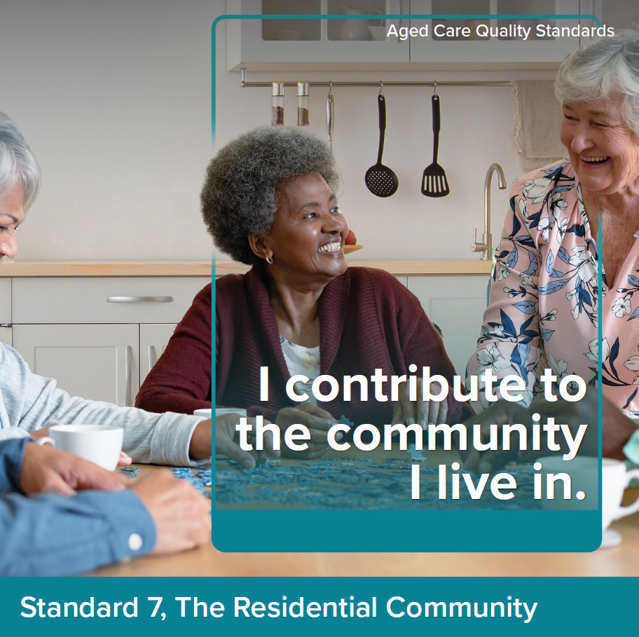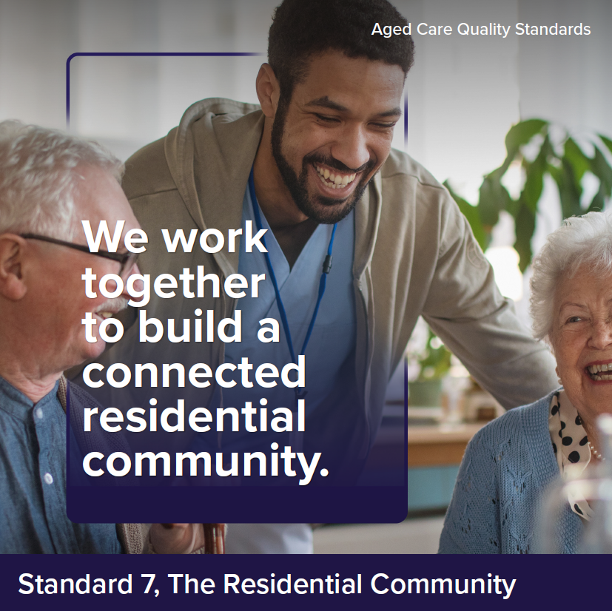

Intent of Standard 7
When people move into a residential service, the residential community becomes a central feature of their lives. It is critical that older people feel safe and at home in the residential community, have opportunities to do things that are meaningful to them and are supported to maintain connections with people important to them. Meaningful activities can include participating in hobbies or community groups, seeing friends and family or activities that contribute to the residential community such as gardening, cooking and setting tables.
A residential community can involve diverse members from different cultures and backgrounds. It is important that each older person's culture is respected, and their diversity valued so they feel included, safe and at home in the service.
Given the scope of responsibility in residential care, providers also have increased requirements to ensure that older people have access to other services and to coordinate a planned transition to or from the service to maximise continuity of care for older people.
Standard 7 is intended to apply only to residential care services.

Standard 7 expectation statement for older people:
I am supported to do the things I want and to maintain my relationships and connections with my community. I am confident in the continuity of my care and security of my accommodation.

Outcome 7.1: Daily living

Outcome statement:
Older people get services and supports for daily living that optimise their quality of life promote use of their skills and strengths and enable them to do the things they want to do. Older people feel safe in their service environment.

Actions:
- The provider supports and enables older people to do the things they want to do, including to:
  - participate in lifestyle activities that reflect the diverse nature of the residential community
  - promote their quality of life
  - minimise boredom and loneliness
  - maintain connections and participate in activities that occur outside the residential community
  - have social and personal relationships
  - contribute to their community through participating in meaningful activities that engage the older person in normal life.
- The provider has processes to identify, monitor and record older people’s function in relation to activities of daily living.
- The provider implements strategies to protect the physical and psychological safety of older people.
- Older people have control over who goes into their room and when this happens.
- Older people can entertain their visitors in private.
- Older people can maintain relationships of choice free from judgement, including intimate relationships, and engage in sexual activity.
Notes:
- Action 7.1.1(f) is intended to enable older people to participate in activities that would be a normal part of their life at home. For example, helping with food preparation, cooking and meal service, setting tables, doing laundry, arranging flowers, etc.

Outcome 7.2: Transitions

Outcome statement:
Older people experience a well-coordinated transition to or from the provider for planned and unplanned transitions. There is clear responsibility and accountability for an older person’s care and services between workers, health professionals and across organisations.

Actions:
- The provider has processes for transitioning older people to and from hospital, other care services and stays in the community, and ensures that:
  - use of hospitals or emergency departments are recorded and monitored
  - there is continuity of care for the older person
  - older people, their family and carers as appropriate, are engaged in decisions regarding transfers
  - receiving family, carers, health professionals or organisations are given timely, current and complete information about the older person as required
  - when the older person transitions back to the service, their care and services are reviewed and adjusted as needed.
- The provider facilitates access to services offered by health professionals, other individuals or organisations when it is unable to meet the older person’s needs.
- The provider maintains connections with specialist health services, including specialist dementia care services, and accesses these services as required.
Notes:
- While there are some actions relevant to ensuring continuity of care when coordinating with, and transferring older people between, others involved in the older person’s care as part of Outcome 3.4, this outcome describes additional/increased expectations about this applicable to residential services, where providers are entirely responsible for the older person’s care and services (noting that, under the proposed new In-Home Aged Care Program, older people are likely to have multiple providers involved in delivery of their care and services).

Terms and definitions
Wherever possible, definitions have been taken or adapted from existing glossaries in the Aged Care Quality and Safety Commission’s Guidance and resources for providers to support the Aged Care Quality Standards and the Australian Commission on Safety and Quality in Health Care’s glossary to accompany the strengthened Aged Care Quality Standards and the National Safety and Quality Health Service Standards. Where terms are not covered in these resources, they have been developed based on definitions used by prominent organisations, government publications and conversations / materials used in the development of the strengthened Quality Standards.

Term | Definition
Activities of daily living | Activities of daily living include the fundamental skills typically needed to manage basic physical needs in the following areas: grooming/personal hygiene including oral care, dressing, toileting/continence, transferring/ambulating, and eating.
Advance care planning | The voluntary process of planning for future health and personal care needs. It provides a way for an older person to make their beliefs, values and preferences for future medical care known to inform future medical decisions, if the older person cannot make or communicate these decisions themselves. Advance care planning is not a single event but an ongoing process and conversation that should be undertaken early and revisited regularly.
Advance care planning documents | A catch-all term to include documents that result from advance care planning. It includes Advance Care Directives and advance care plans.  An Advance Care Directive is a document completed and signed by a competent consumer who still has decision-making capacity regarding their future care and preferences for end-of-life care.  In Australia, advance care directives are recognised by specific legislation or common law. Advance care directives can record the person’s preferences for future care and/or appoint a substitute decision-maker to make decisions about the person’s health care.  An advance care plan captures what is known about a person’s beliefs, values and preferences in relation to future care decisions, but it does not meet the requirements for statutory or common law recognition as a result of the person’s insufficient capacity. The document may provide helpful information to guide substitute decision-makers and health professionals but is not legally binding. (Advance Care Planning Australia, 2021, Advance Care Planning: Aged care implementation guide).
Adverse Event | A response to a medicine that is noxious and unintended and occurs at doses normally used or tested in humans for the prophylaxis, diagnosis or therapy of disease, or for the modification of physiological function. An allergy is a type of adverse drug reaction.
Anticipatory Medicines | Medicines prescribed and dispensed in preparation for a time when a person needs them. They are used to manage symptoms in the home with the goals of rapid relief and avoiding unplanned or unwarranted admission to a healthcare facility.
Antimicrobials | A chemical substance that inhibits or destroys bacteria, viruses or fungi, and can be safely administered to humans and animals (National Safety and Quality Health Service (NSQHS) Standards, 2nd ed.).
Antimicrobial stewardship | Efforts to reduce the risks related to increasing antimicrobial resistance (i.e. failure of an antimicrobial to inhibit a microorganism at the antimicrobial concentrations usually achieved over time with standard dosing regimens) and to extend the effectiveness of antimicrobial treatments. It can include a broad range of strategies, such as monitoring and reviewing how antimicrobials are used.
Aseptic technique | A set of practices aimed at minimising contamination; particularly used to protect a person from infection during procedures (National Safety and Quality Primary and Community Healthcare (NSQPCH) Standards).
Care and services plan | A document (or set of documents) describing a person’s aged care and service needs, including clinical care they receive to meet those needs. Care plans include relevant information about a person’s needs, goals and preferences and describe how and when services are delivered in line with these.
Carer | A partner, family member or friend who provides unpaid care, support and help to an older person. A carer may also be an older person. This does not include employees of the provider, or people the provider contracts or pays to provide care and services, or people who help as a volunteer. This definition is in line with the Carer Recognition Act 2010.
Choking | Occurs when a foreign body – such as a mouthful of food – partly or completely blocks a person's airway, making breathing difficult. Choking is a medical emergency (Queensland Government, Choking)
Clinical care | Health care that encompasses the prevention, treatment and management of illness or injury, as well as the maintenance of psychosocial, mental and physical wellbeing. It includes care provided by doctors, nurses, pharmacists, allied health professionals and other regulated health professionals. Organisations providing clinical care are expected to make sure it is best practice, meets the older person’s needs, and optimises the older person’s health and wellbeing.
Clinical frailty | Clinical frailty is a syndrome of physiological decline that occurs in later life and is associated with vulnerability to adverse health outcomes. Older people who are frail are less resilient to stressors (e.g., acute illness, trauma) and at an increased risk of adverse outcomes, procedural complications, falls, institutionalisation, disability and death. Old age alone does not define frailty, and frailty is not an inevitable consequence of ageing (Royal Australian College of General Practitioners (RACGP) Aged Care Clinical Guide (Silver Book) 5th edition).
Clinical governance | An integrated set of leadership behaviours, policies, procedures, responsibilities, relationships, planning, monitoring and improvement mechanisms that are implemented to support safe, quality clinical care and good clinical outcomes for each older person.  The purpose of clinical governance in aged care is to support the workforce and visiting health professionals in a service to provide safe, quality clinical care as part of a holistic approach to aged care that is based on the needs, goals and preferences of the older person (Aged Care Quality and Safety Commission (ACQSC), Glossary).
Clinical Governance Framework | Describes the processes and structures that are needed to deliver quality clinical care, including in relation to:  - governance, leadership and culture  - quality improvement systems  - clinical performance and effectiveness  - safe environment for the delivery of clinical care  - partnering with older people (NSQPCH Standards).
Cognitive impairment | Deficits in one or more of the areas of memory, communication, attention, thinking and judgement. This can be temporary or permanent. It can affect a person’s understanding, their ability to carry out tasks or follow instructions, their recognition of people or objects, how they relate to others and how they interpret the environment.  As each individual’s experience is different, understanding each individual is important in order to communicate effectively and provide the right care. Although dementia and delirium are common causes of cognitive impairment, cognitive impairment can result from many other conditions and in people of any age.
Contemporary, evidence-based practice | Evidence-based practice is an approach to care that integrates the best available research evidence with clinical expertise and the values of the older person. It involves translating evidence into practice, also known as knowledge translation, and ensuring that ‘stakeholders (health professionals, older people, family and carers) are aware of and use research evidence to inform their health and healthcare decision-making’.  When the intervention, treatment or care provided is based on the best available evidence, which is used to achieve the best possible outcomes for older people.
Clinical Information System | A system that is used by a healthcare provider to manage older person and practice records. It may include a software component connected to the My Health Record or My Aged Care (Australian Digital Health Agency)
Comprehensive Care | Comprehensive care involves teams of health professionals working together and communicating effectively to plan, manage and coordinate care with the older person, their family and carers. It requires providers to have systems and processes in place to support this, and to foster a collaborative and person-centred culture. (NSQHS)
Communication barriers | A communication barrier is something that prevents an older person from understanding the information they receive or the ability for others to understand them. Language, cognitive impairment, and physical conditions can all create barriers to communication that can be addressed with appropriate supports (Vic Health).
Continence | The ability to control bladder or bowel movement (Continence Foundation of Australia).
Continuous improvement | A systematic, ongoing effort to raise an organisation’s performance in achieving outcomes for older people under the Quality Standards. Continuous improvement:  - responds to the needs and feedback of older people, their family and carers  - supports the workforce to improve and innovate in providing safe and quality care and services  - can address practices, process or outputs to achieve a desired outcome.
Culturally safe care | Culturally safe care and services are planned and delivered in a way that is spiritually, socially, emotionally and physically safe and respectful for older people. Culturally safe care and services ensure that an older person’s identity is respected so that who they are and what they need is not questioned or denied. Whether care and services are ‘culturally safe’ can only be determined by those receiving care.  For Aboriginal and Torres Strait Islander peoples, culturally safe practice is the ongoing critical reflection on provider knowledge, skills, attitudes, practicing behaviours and power differentials in delivering safe, accessible and responsive care and services free of racism.
Delirium | An acute disturbance of consciousness, attention, cognition and perception that tends to fluctuate during the day. It is a serious condition that can be prevented in 30–40% of cases and should be treated promptly and appropriately. Delirium can be hyperactive (the person has heightened arousal; or can be restless, agitated and aggressive) or hypoactive (the person is withdrawn, quiet and sleepy) (NSQHS Standards, 2nd ed.).
Dementia | A collection of symptoms that are caused by disorders affecting the brain. It is not one specific disease. Dementia affects thinking, behaviour and the ability to perform everyday tasks. Brain function is affected enough to interfere with the person’s normal social or working life (Dementia Australia, What is dementia?).
Deprescribing | The process of tapering or stopping medicines, which aims to discontinue potentially inappropriate medicines, minimise inappropriate polypharmacy and improve a person’s health outcomes. Also referred to as ‘de-escalation’. (Quality Use of Medicines: Guiding Principles)
Deterioration | Physiological, psychological or cognitive changes that may indicate a significant worsening of the older person’s health status (NSQPCH Standards).
Dignity of risk | The concept that all adults have the right to make decisions that affect their lives and to have those decisions respected, even if there is some risk to themselves.  Dignity of risk means respecting this right. Care and services need to strike a balance between respect for the older person’s autonomy and the protection of their other rights (such as safety, shelter), unless it is unlawful or unreasonably impinges on the rights of others.
Digital clinical information system | The software used by the provider to enter, store and retrieve an older person’s clinical information.
Dining experience | The complete dining experience, including environment, service, ambience, aromas, company, time provided to eat, serving size, temperature, presentation of food and drinks, etc.
Dining needs | An older person’s specific dining needs includes consideration any dietary needs, including allergies, intolerances, relevant health risks and conditions, religious or cultural preferences, etc.
Diversity | The varied needs, characteristics and life experiences, which may be social, cultural, linguistic, religious, spiritual, psychological, medical or care needs of consumers.  Also refers to diverse gender and sexuality identities, experiences and relationships, including (but not limited to) lesbian, gay, bisexual, transgender or intersex.
End-of-Life | The period when an older person is living with, and impaired by, a fatal condition, even if trajectory is ambiguous or unknown. This period may be years in the case of older people with chronic or malignant disease, or very brief in the case of older people who suffer acute and unexpected illnesses or events, such as sepsis, stroke or trauma (NSQHS Standards, ed 2).
Fall | An event that results in a person coming to rest inadvertently on the ground or floor, or another lower level (NSQHS Standards, 2nd ed.)
Goals of care | Clinical and other goals for an older person’s care that are determined in the context of a shared decision-making process (NSQHS Standards, 2nd ed.).
Governance | The set of relationships and responsibilities established by an organisation between its executive, workforce and stakeholders (including the older person). Governance incorporates the processes, customs, policy directives, laws and conventions affecting the way an organisation is directed, administered or controlled. Governance arrangements provide the structure for setting the corporate objectives (social, fiscal, legal, human resources) of the organisation and the means to achieve the objectives. They also specify the mechanisms for monitoring performance. Effective governance provides a clear statement of individual accountabilities within the organisation to help align the roles, interests and actions of different participants in the organisation to achieve the organisation’s objectives (NSQHS Standards, 2nd ed.).
Governing body | The individual or group of people (such as a Board) with overall responsibility and ultimate accountability for the organisation. This includes responsibility for the strategic and operational decisions that affect the safety and quality of care and services.
Health professionals | People who provide health care, treatment and advice based on formal training and experience. This includes nurses, doctors, dentists, specialists and allied health professionals.
High-risk medicines | Medicines that have an increased risk of causing significant harm or death if they are misused or used in error. High-risk medicines may vary between hospitals and other settings, depending on the types of medicines used and person being treated. Errors with these medicines are not necessarily more common than with other medicines. Because they have a low margin of safety, the consequences of errors with high-risk medicines can be more devastating. At a minimum, the following classes of high-risk medicines should be considered:  - Medicines with a narrow therapeutic index  - Medicines that present a high risk when other system errors occur, such as administration via the wrong route
Holistic | A holistic approach means to provide support that looks at the whole person. In the provision of clinical care, the provider should consider the older person’s physical, mental and emotional, social and spiritual wellbeing (adapted from NSW Health definition)
Incontinence associated dermatitis | Incontinence associated dermatitis (IAD) type of skin irritation or damage, due to prolonged contact with urine or faeces. It is often characterised by redness, inflammation and/or skin breakdown. (Quality Indicator program manual, Department of Health and Aged Care)
Incident | Any act, omission, event or circumstance that occurs in connection with the provision of care or services that:  - has (or could reasonably be expected to have) caused harm to an older person or another person (such as a worker or family member)  - is suspected or alleged to have (or could reasonably be expected to have) caused harm to an older person or another person, or  - the provider becomes aware of and has caused harm to an older person (NSQHS Standards, 2nd ed).
Infection | The invasion and reproduction of pathogenic (disease-causing) organisms inside the body. This may cause tissue injury and disease (NSQHS Standards, 2nd ed.).
Infection Prevention and Control | The system, plan and processes which an organisation uses to prevent and manage the spread of infection. The scope and complexity of a program will depend on the nature of the care the organisation provides, the context and risk. (ACQSC, Glossary)
Informed consent | An older person’s decision, given voluntarily, to agree to a clinical care treatment, procedure or other intervention that is made:  - following the provision of accurate and relevant information about the intervention and alternative options available  - with adequate knowledge and understanding of the benefits and material risks of the proposed intervention relevant to the older person
Injury | Damage to tissues caused by an agent or circumstance (NSQPCH Standards).
Interoperability | The ability of a system or product to transfer meaning of information within and between systems or products without special effort on the part of the user. Interoperability is made possible by the implementation of standards. (Australian Digital Health Agency)
Last days of life | The hours, days or, occasionally, weeks when a person’s death is imminent. This is sometimes referred to as the period when a person is actively dying. (National Consensus statement, Australian Commission on Safety and Quality in Health Care (ACSQHC))
Medication management | Practices used to manage the provision of medicines, including:  - How medicines are selected, ordered and supplied  - How older people take medicines or are assisted to take them  - How medicines use is recorded and reviewed  - How medicines are stored and disposed of safely  - How medicines use is supported, monitored and evaluated.  Medication management occurs at both individual and services levels. Medication management has also been described as a cycle, pathway or system, which is complex and involves a number of different health professionals. The older person is the central focus. The system includes manufacturing, compounding, procuring, dispensing, prescribing, storing, administering, supplying and monitoring the effects of medicines. It also includes decision-making, and rules, guidelines, support tools, policies and procedures that are in place to direct the use of medicines. (Quality use of Medicines Glossary for the Guiding Principles and User Guide 2022)
Medication reconciliation | A formal process of obtaining a ‘best possible medication history’ and verifying a complete and accurate list of each older person’s current medicines and determining if the medicines the older person is taking are the same as those that are prescribed and intended to be taken.
Medication review | A systematic, comprehensive and collaborative assessment of medicine use and management for an older person. Medication review aims to optimise their medicines and outcomes of therapy by providing a recommendation or making a change. It includes the objective of reaching an agreement with the older person about medicine use in the context of overall treatment, optimising the impact of medicines, minimising the number of medication-related problems and reducing waste.  Medication review is related to but distinct from medication reconciliation. (Quality use of Medicines Guiding Principles Glossary)
Medicine | A chemical substance given with the intention of preventing, diagnosing, curing, controlling or alleviating disease, or otherwise improving the physical or mental wellbeing of people. These include prescription, non-prescription, investigational, clinical trial and complementary medicines, irrespective of how they are administered (Quality use of Medicines Guiding Principles Glossary)
Medicines list | Prepared by a health professional, a medicines list contains, at a minimum:  - All medicines an older person is taking, including over-the-counter, complementary, prescription and non-prescription medicines; for each medicine, the medicine name, form, strength and directions for use must be included  - Any medicines that should not be taken by the older person, including those causing allergies and adverse drug reactions; for each allergy or adverse drug reaction, the medicine name, the reaction type and the date on which the reaction was experienced should be included.  Ideally, a medicines list also includes the intended use (indication) for each medicine. It is expected that the medicines list is updated and correct at the time of transfer (including clinical handover) or when services cease, and that it is tailored to the audience for whom it is intended (that is, individual or health professional) (Quality use of Medicines Guiding Principles Glossary).
Monthly Care Statements | Monthly Care Statements will be given to residents or their authorised representatives outlining the care and services they have received and any significant changes or events in the previous month.
Multidisciplinary care | Comprehensive care that is planned and delivered by a group of health professionals from a range of disciplines, working together to address as many of the older person’s needs as possible.
Near miss | An incident or potential incident that was averted and did not cause harm, but had the potential to do so (Quality use of Medicines Glossary Guiding Principles)
Needs, goals and preferences | An older person’s needs, goals and preferences refers to their individual:  - goals of care, including in relation to wellness, independence, reablement and social connections  - needs, including identified care needs including personal care, social engagement, clinical care, food, cultural, religious and spiritual needs  - preferences about the way care is delivered and the things they do and don’t like.
Nutritious | Refers to foods that make a substantial contribution towards providing a range of nutrients, have an appropriate nutrient density and contain substances a person needs and can use to stay healthy.
Open disclosure | Open discussions with older people, their family, carers and others of issues or incidents that have caused harm or had the potential to cause harm to the older person. It involves an expression of regret and a factual explanation of what happened, the potential consequences and what steps are being taken to manage this and prevent it happening again.
Older person / older people | A person (or people) receiving Commonwealth-funded aged care services.  The current Quality Standards use the term ‘consumer’, however, this term is not generally well accepted by older people and is being reviewed as part of the development of a new Aged Care Act. Reference to an older person includes reference to a representative of the older person, so far as the provision can apply to a representative
Others involved in the older person’s care | Any individuals or organisations that are involved in delivering care, services or supports to older people. It may involve other aged care providers, health professionals, health services, community organisations, family, carers, etc.
Outcome | The status of an individual, group of people or population that is wholly or partially attributable to an action, agent or circumstance (NSQPCH Standards).
Pain | An unpleasant sensory and emotional experience associated with, or resembling that associated with, actual or potential tissue damage. (International Association for the Study of Pain)
Palliative care | Person and family-centred care provided for a person with an active, progressive, advanced disease, who has little or no prospect of cure, who is expected to die, and for whom the primary goal is to optimise the quality of life.  Palliative care is care that helps people live their life as fully and as comfortably as possible when living with a life-limiting or terminal illness. Palliative care identifies and treats symptoms which may be physical, emotional, spiritual or social.  Palliative care is an approach that improves the quality of life of older people and their carers and families who are facing the problems associated with life-limiting illness, through the prevention and relief of suffering by means of early identification and correct assessment and treatment of pain and other problems, whether physical, psychosocial or spiritual (National Palliative Care Strategy, 2018)
Partnership | A working relationship between two or more people. Partnership refers to organisations finding ways to work with older people, their family and carers and listening to their needs, goals and preferences, to plan their care and services.
Person-centred care | An approach to the planning, delivery and evaluation of care that is founded on partnerships between providers and the older person. Person-centred care is respectful of, and responsive to, the preferences, needs and values of the older person.  To achieve person-centred care, providers and workers need to:  - work in partnership with older people  - recognise that every person is unique and value the person’s voice, including the knowledge they bring about their care needs  - enable the experiences and expertise of older people to help shape decisions about care at the level of the organisation, service and individual.
Polypharmacy | The use of multiple medicines to prevent or treat medical conditions. It is commonly defined as the concurrent use of five of more medicines by the same person. Medicines include prescription, complementary and non-prescription (or over-the-counter) medicines. See also inappropriate polypharmacy.(Quality use of Medicines: Guiding Principles Glossary)
Prescriber | A health professional who is authorised by legislation to issue a prescription for the supply of medicines. PBS prescribers include doctors, dentists, optometrists, midwives and nurse practitioners who are approved to prescribe PBS medicines under the National Health Act 1953. (Quality use of Medicines: Guiding Principles Glossary)
Pressure injuries | Injuries of the skin and/or underlying tissue, usually over a bony prominence, caused by unrelieved pressure, friction or shearing. They occur most commonly on the sacrum and heel but can develop anywhere on the body. Pressure injury is a synonymous term for pressure ulcer (NSQHS Standards).
Preventative care | Any action taken to keep older people healthy, and prevent or avoid risk of poor health, illness, injury and early death.
Process | A series of actions or steps taken to achieve a particular goal.
Pro re nata (PRN) | In relation to medications, taken as needed.
Provider | The organisation providing Commonwealth-funded aged care services.
Psychotropics | Psychotropic medications are ‘any drug capable of affecting the mind, emotions and behaviour'.  The three main classes of psychotropics prescribed are antidepressants, anxiolytic/hypnotics (mostly benzodiazepines to manage anxiety and insomnia) and antipsychotics. Other psychotropic classes include anticonvulsants and stimulants. (ACQSC)
Quality care | Care and services that:  - keep older people safe from preventable harm  - are person-centred, provided with kindness and compassion, responding to the holistic needs of the older person and aiming to improve their wellbeing  - are inclusive, culturally safe, trauma aware and healing informed  - are effective, providing the right care to meet the older person’s needs goals and preferences  - are smoothly coordinated when care is provided by the workforce, health professionals and external providers.
Quality and safety culture | A culture of quality and safety prioritises the safety of older people and quality of their care and services in all aspects of the decision-making.  Culture is led from the top. Commitment from leaders and managers is key, their actions and attitudes influence the perceptions, attitudes and behaviours of the workforce. Other important aspects include:  - shared perceptions of the importance of quality and safety  - constructive communication  - mutual trust  - a workforce that is engaged and always aware that things can go wrong  - acknowledgement at all levels that mistakes occur  - ability to recognise, respond to, give feedback about, and learn from, complaints and incidents.
Quality of life | An older person’s perception of their position in life taking into consideration their environment and their goals, expectations, standards, and concerns. It includes their emotional, physical, material, and social wellbeing.
Reablement | A process directed by the older person to support restoration of function or adapt to some loss of day-to-day function and regain confidence and capacity for daily activities. It may promote independence, capacity or social and community connections.  Reablement focuses on rebuilding or re-establishing the daily living skills and community connections of older people.  Reablement is often goal-oriented, aiming to build a person’s skills, strength or function to provide them greater independence, engagement and enable them to undertake activities and reducing reliance on their aged care services.  A reabling approach to care and service delivery means that providers actively work with older people to understand the things they like to do, things that may be inhibiting their independence and work with them to identify goals and strategies to help them achieve these goals. Strategies could include training in a new skill, modification to a consumer’s home environment or having access to equipment or assistive technology.
Regularly | Occurring at recurring intervals. The specific interval for regular review, evaluation, audit or monitoring needs to be determined for each case. In the Aged Care Quality Standards, the interval should be consistent with best practice, risk based, and determined by the subject and nature of the activity (NSQPCH Standards).
Restrictive practices | The use of interventions and practices that have the effect of restricting the rights or freedom of movement of a person with disability. These primarily include restraint and seclusion.
Scope of practice | The extent of a worker’s approved clinical practice, based on their skills, knowledge, professional registration (where applicable), performance and professional suitability, and the needs and service capability of the organisation (NSQPCH Standards).
Service environment | The physical environment where care and services are delivered. Includes the service or site where care and services are delivered to older people (such as in a day therapy centre, centre-based respite delivered in a community centre, residential care service and day and overnight respite service (cottage).  It would not include environments such as community centres, shopping centres, GP clinics, etc. where the provider may take older people for appointments, excursions, etc. but where the environment is not under the control of the provider.
Substitute decision-maker | A person appointed or identified by law to make health, medical, residential and other personal (but not financial or legal) decisions on behalf of an older person whose decision-making capacity is impaired. A substitute decision-maker may be appointed by the older person, appointed for (on behalf of) the person, or identified as the default decision-maker by legislation, which varies by state and territory (NSQPCH Standards).
Supported decision-making | Supported decision-making is a framework within which a person with impaired cognitive function or decision-making capacity can be assisted to make safe, informed decisions. It is based on the premise that everyone has the right to make their own decisions and to receive whatever support they require to do so.
System | The resources, policies, processes and procedures that are organised, integrated, regulated and administered to accomplish a stated goal.
Timely | What is considered reasonable in best practice, considering how important or time critical the action is to an older person’s ongoing care or wellbeing, the context in which the service is provided and the clinical acuity of the older person. Guiding Principles (Adapted)
Transitions of Care | Situations when all or part of an older person’s care is transferred between locations, organisations, providers, or levels of care within the same location, or as the older person’s condition and care needs change (NSQHS Standards, 2nd ed.).
Trauma aware and healing informed care | Trauma aware and healing informed care recognises that most older people have experienced trauma in their lives and considers how this may impact them when providing care. Trauma aware and healing informed approaches must be used to restore wellbeing and enable older people to self-manage and control their care decisions.  As part of trauma informed care, providers and workers should:  - understand the effects of trauma on the older person (including through assessment)  - promote safety and trust (create a safe environment, interact in a and respectful way, etc)  - empower older people (by providing transparency, informed consent, collaboration, choice and control)  - build connections, focus on strengths and promote quality of life.
Urinary catheter | A hollow tube that drains urine directly from the bladder. (Continence Foundation of Australia)
Wellbeing | Wellbeing is a positive state experienced by an older person to give a sense of meaning and purpose. It encompasses an older person’s physical, spiritual, emotional and mental health and is strongly linked to quality of life.
Worker | An individual who is employed, hired, retained or contracted by the provider (whether directly or through an employment or recruiting agency) to provide care or other services.
Workforce | People working in an organisation who are responsible for its maintenance or administration, or the care and services, support of, or involvement with, older people. A member of the workforce is anyone the organisation employs, hires, retains or contracts (directly or through an employment or recruitment agency) to provide maintenance or administration, or care and services under the control of the organisation. It also includes volunteers who provide care and services for the organisation. For clarity, people in an organisation’s workforce include:  - employees and contractors (this includes all staff employed, hired, retained or contracted to provide services under the control of the organisation)  - allied health professionals the organisation contracts  - kitchen, cleaning, laundry, garden and office staff the organisation employs either directly or under contract. (Aged Care Quality Standards Glossary)

https://www.enablingenvironments.com.au/dementia-enabling-environment-principles.html, https://www.dementia.org.au/sites/default/files/helpsheets/Helpsheet-Environment03_HowToDesign_english.pdf

