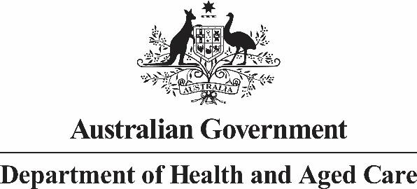

**Nurse Practitioner Steering Committee**

**Meeting Communique 3 April 2023**

The final Nurse Practitioner Steering Committee (NPSC) meeting was held on 3 April 2023. The focus of the meeting was to consider updates to the draft Nurse Practitioner Workforce Plan (Plan) following recent public consultation.

A summary of recent stakeholder engagement was presented to the NPSC, which included a stakeholder survey with 172 responses, 25 written submissions, a consumer focus group, two Yarning Circles, and several targeted stakeholder meetings. The results of this engagement and how the feedback contributed to updates to the Plan were also presented to the NPSC.

Steering Committee members reviewed the final draft of the Plan and provided valuable feedback on the actions under the four themes of the Plan and the overarching narrative of the Plan, including the value of using nurse practitioner stories to highlight their diverse roles. The feedback of the NPSC will be used to develop a final version of the Plan for approval by Government.

Steering Committee members were informed of the Monitoring and Evaluation Framework for the Plan that is under development, and members provided suggestions on potential areas of focus for future evaluation of the Plan.

The Chief Nursing and Midwifery Officer, Adjunct Professor (Practice) Alison McMillan PSM, thanked the Committee for its guidance and expertise in the development of the Nurse Practitioner Workforce Plan.