Opening slide: MRFF RAO Webinar 30 March 2023
Stephanie Lehoczky, A/g Director Policy and Support
Anne Raimondo, Director, Program Management Office
Ragini Singh, Director, Grants Management Office
Cindy Thamrin, Director, Performance and Evaluation

# Contents

1. **Acknowledgement of Country**
2. **Webinar overview**
3. **Consumers and the MRFF**
4. **Grant Assessment Criteria Refresh**
5. **Monitoring, Evaluation and Learning**
6. **Q&A**
7. **Keep Connected**

# MRFF Research Administration Officer Webinars

Aim to:

* provide practical information to the sector and Research Administration Officers (RAOs) in particular about MRFF administrative arrangements
* assist RAOs and potential grantees in better supporting MRFF funded research and researchers
* aid the implementation of any changes to MRFF grant administration
* seek feedback from RAOs, with a view toward continuous improvement of MRFF grant administration

# Consumers and the MRFF

**Stephanie Lehoczky, Acting Director,   
Policy and Support**

* MRFF Consumer Reference Panel
* Principles for Consumer Involvement in Research Funded by the Medical Research Future Fund
* Consumer involvement and grant assessment criteria
* Future work program

# MRFF Consumer Reference Panel (CRP)

Appointed from April 2022 *“to provide advice to the CEO of HMRO on strategies for strengthening consumer involvement in MRFF implementation”*

 John Stubbs (chair) (NSW)
 Dania Ahwang (deputy chair) (QLD)
 Anne McKenzie (ACT)
 Ben Horgan (WA)
 Karen Van Gorp (SA)
Kate Griggs (TAS)
Merryn Carter (VIC)
Mohammad Al-Khafaji (SA)
Nyree Gale (NSW)
Robina Yasmin (NSW)

https://www.health.gov.au/committees-and-groups/medical-research-future-fund-consumer-reference-panel 

# MRFF CRP – Initial Deliverables

Initial deliverables from the CRP Terms of Reference:

# Develop principles for consumer involvement in MRFF-funded research projects

# Endorsed by the Minister, released 24 March 2023

# Available at:

# <https://www.health.gov.au/resources/publications/principles-for-consumer-involvement-in-research-funded-by-the-medical-research-future-fund>

# Review and provide advice on MRFF processes, e.g. grant guidelines, assessment processes

# Light-touch review of assessment criteria descriptors completed

* CRP future work program

# Principles for Consumer Involvement in Research Funded by MRFF

*A* ***consumer*** *is a person with lived experience as a patient, client, potential patient, user of  
health services, and/or providing support as a carer, family or community member*

Research funded through MRFF will involve consumers:

* **In every type of research**, including basic science, public health, preventive health, translation and clinical research.
* **At all stages of research**, from defining the need/priority of a research question, refining the research question and research design through to conduct of the research and sharing and translation of results.
* **In partnership with researchers**, with consumers respected and recognised for the valuable and complementary knowledge, expertise and perspectives they bring to the research.
* **Effectively**, with sufficient time, resources and depth of relationships to enable consumers to understand and actively engage with and contribute to the research.
* **Sensitively and safely**, through research teams with strong and broad capacity and capabilities in consumer involvement, appropriate training and a supportive environment for consumers, and clearly defined and agreed roles.
* **With broad diversity and equity**, with the goal of increasing involvement of priority populations through culturally safe and appropriate engagement.

# Consumers - Future Work Program

**Areas of interest to the CRP:**

* **Research priority and question setting at the MRFF program level**
* E.g., improving the numbers and diversity of consumers involved in consultation processes
* **Application processes**
* E.g., strengthening consumer involvement requirements in Grant Opportunity Guidelines and application templates
* **Assessment processes**
* E.g., strengthening consumer involvement in the selection of research projects for funding
* **Post award processes**
* E.g., defining and requiring adherence to specific consumer engagement standards, requiring reporting on consumer involvement over the life of a research project
* **Supporting consumers and researchers**
* E.g., consumer capacity/capability/skill building, research team capacity/capability/skill building, promoting best practice examples of consumer involvement

# Grant Assessment Criteria Refresh

**Dr Anne Raimondo, Director, Program Management Office**

* MRFF assessment criteria
* *Why* they have been refreshed
* *How* they have been refreshed
* What this means for applicants, RAOs and assessors

# MRFF assessment criteria

**Applications to MRFF grant opportunities are assessed against four criteria:**

* **Project Impact**
* *Articulate the need for…*
* *Demonstrate how the project will…*
* **Project Methodology**
* *Specify arrangements for…*
* *Provide milestones that…*
* **Capacity, Capability and Resources**
* *Demonstrate that the research team includes…*
* *Provide an example of…*
* **Overall Value and Risk**
* Measures of Success Statement
* Budget
* Risk Management Plan

# MRFF assessment criteria refresh – *why* and *how* they are changing

**Part of a program of continuous improvement for the MRFF in response to:**

* Sector feedback from applicants, assessors and RAOs
* Outcomes of public consultation and roundtable discussions
* Advice from the MRFF Consumer Reference Panel, Mission Expert Advisory Panels, Australian Medical Research Advisory Board
* Lessons learned from previous grant opportunities

**Key changes:**

* **Simplification**
  + - reducing the overall number of dot points and using simpler language
* **Priority populations**
  + - specific requirements for research focusing on priority populations, including First Nations Australians
* **Consumer involvement**
  + - more explicit expectations re: lived experience, diversity, participation, consultation
* **Scoring materials have also been updated**

# MRFF assessment criteria refresh – what it means

**For applicants, RAOs and assessors:**

* MRFF applications continue to be assessed against the same four criteria
* The information you are required to provide for each criterion is unique to that grant opportunity
  + - Don’t assume all guidelines are the same
    - Check sections 5 and 6 every time
    - Contact the administering grant hub if you are unsure
* MRFF grant assessment committees will continue to be supported on how to interpret and use the assessment criteria and scoring materials to assess applications

**For the future…**

* Strengthening of consumer & priority population involvement
  + - Design of MRFF grant opportunities, including the assessment criteria & descriptors
    - Assessment and scoring of applications

# Monitoring, Evaluation and Learning

**A/ Prof. Cindy Thamrin   
Director, Performance and Evaluation**

* Monitoring, evaluation and learning strategy
* Evaluations to date and in progress
* Performance indicators towards the impact of the MRFF

MRFF Monitoring, evaluation and learning strategy

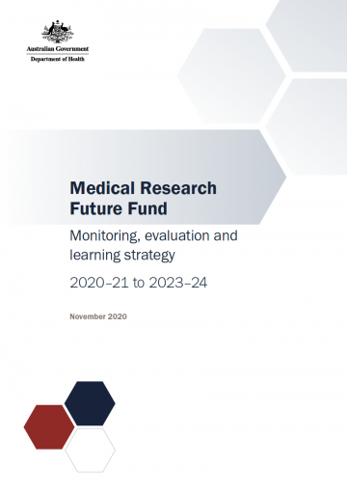The MRFF Monitoring, evaluation and learning strategy (Evaluation Strategy) provides an overarching framework for assessing the performance of the MRFF.

# Evaluations of MRFF initiatives

The Evaluation Strategy established a rolling series of reviews of MRFF initiatives to assess progress and guide future investments.

To date, three MRFF evaluations have been completed:

* + [Evaluation of the Rapid Applied Research Translation Initiative (2020)](https://www.health.gov.au/resources/publications/evaluation-of-the-rapid-applied-research-translation-initiative)
  + [Medical Research Commercialisation Landscape Report (2020)](https://www.health.gov.au/resources/publications/medical-research-commercialisation-landscape-report)
  + [Million Minds Mental Health Research Mission Review (2021-22)](https://www.health.gov.au/resources/publications/million-minds-mental-health-research-mission-review)

Two evaluations are currently in progress:

* + Australian Brain Cancer Mission Review
  + Clinical Trials Activity Initiative

**MRFF Measures of success and impact measures**

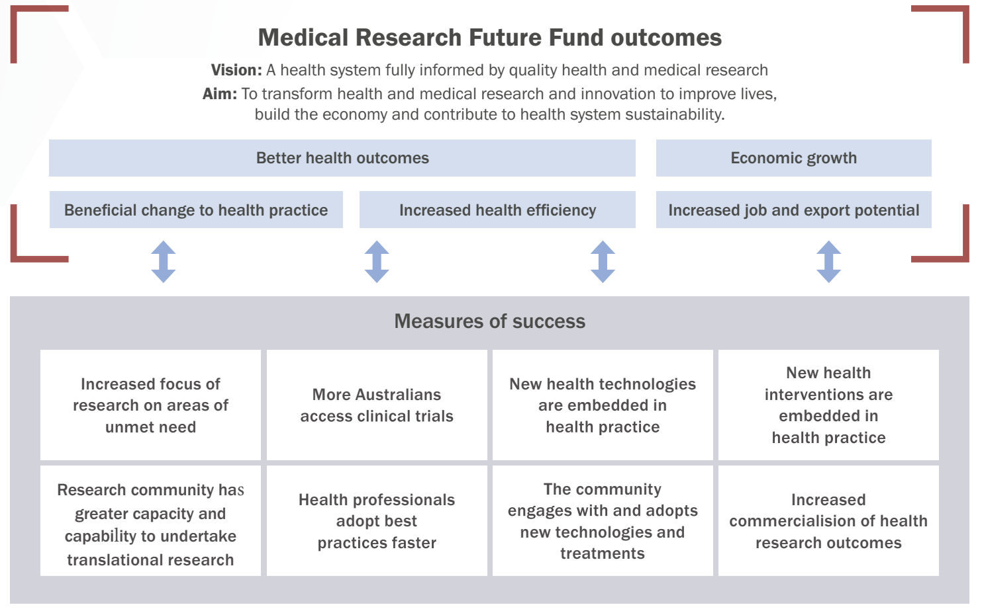

**Why is measuring the impact of the MRFF important?**

Measuring the impact of the MRFF benefits the public, researchers, consumers, Government and other stakeholders:

* + promotes **accountability** of the MRFF
  + provides policy and research benefit by **supporting translation** of research outcomes into practice
  + helps promote public engagement to support **community engagement in research**
  + provides **visibility** of MRFF research

Also directly benefits individual researchers by providing:

* + evidence to support future funding applications
  + evidence for career progression
  + opportunity to assess research achievement
  + opportunity to strategically prioritise research activities

We have developed a set of Performance Indicators to enable assessment of progress towards the MRFF Measures of Success and ultimately, the impact of the MRFF.

# Diagram illustrating the connections between MRFF inputs and activities, outputs, outcomes and impacts.Performance indicators: towards the impact of the MRFF

**Performance indicators underpinned by measurable outputs**

Performance indicator: Consumer involvement indicators

Rationale: To capture the level of involvement of relevant consumers throughout the research pipeline, from priority setting, co-design through to dissemination and translation  

Measurable outputs: Number, value and proportion of projects that: 
* include consumer organisations as project partners or advisory groups 
* involve consumers in priority and co-design of study 
* involve active consumer input in data gathering/analysis 
* involve active dissemination of results to consumers 
* deploy strategies to include traditionally underrepresented groups 
* involve consumers in project governance 

**Measuring research impact is not easy**

Known challenges include:

* Gathering evidence and linking research with impact
* Impact is a longer term indicator
* Challenges with attribution
* Links between the research and its impact is not always linear

These indicators represent a first step towards understanding the MRFF’s impact, and will be continually reviewed.

# How will the performance indicators be measured?

The Department will collect the information and data to report on performance against the indicators from a range of sources:

* **Program information** from administrative grant data
* **Progress/final reports** that capture wide ranging data on e.g., clinical trials, publications, workforce capacity and capability, impact case studies
* **Survey to grantees** which will capture data not available through existing collections
* **Other sources:** bibliometrics, clinical trial registries, submissions for regulatory approval and reimbursement, and patent registries.

A report on these performance indicators is due in 2023-24, which will support broader policy and program development.

# What do these performance indicators mean for researchers?

* The Department will continue to monitor progress and final reports to support assessment of impact
* A survey to collect additional data is planned for later this year and in future, taking care to minimise researcher burden
* Researchers can use the performance indicators as a guide to:
  + identify their project’s contribution to the MRFF’s measures of success, in grant applications and progress reports.
  + consider the impact of their own research at all stages along the research pipeline
* To facilitate accurate and broader data capture, please attribute the MRFF in your publications.
* Participation in MRFF evaluation activities contributes to improvements and helps shape the operation of the MRFF

# Other monitoring, evaluation and reporting activities

The Department is working on improving its reporting of grants data to the public

* List of grants currently available at <https://www.health.gov.au/summary-of-mrff-grant-recipients>
* Report on financial support for medical research and innovation (11 June 2021, updated every two years)

<https://www.health.gov.au/news/report-on-financial-support-for-medical-research-and-innovation>

* Gender data report (22 March 2022, to be updated annually)

<https://www.health.gov.au/resources/publications/medical-research-future-fund-grant-opportunity-gender-data-report-22-march-2022>

Expect future reporting to incorporate more detailed funding info/statistics

# Further information

* More information on the MRFF Monitoring, evaluation and learning strategy, including the Performance Indicators and ongoing evaluation activities, can be found at <https://www.health.gov.au/initiatives-and-programs/medical-research-future-fund/about-the-mrff/mrff-monitoring-evaluation-and-learning>.
* Should you have any questions regarding the performance indicators or evaluation of the MRFF, please contact [MRFF.Evaluations@health.gov.au](mailto:MRFF.Evaluations@health.gov.au)

# Q&A



Keep ConnectedSubscribe to MRFF News: www.health.gov.au/
initiatives-and-programs/medical-research-future-fund/mrff-news

Send any questions to MRFF@health.gov.au

Register for MRFF grant opportunities:
www. grants.gov.au

Follow Health Twitter for MRFF updates @healthgovau #MRFF