Medical Research Future Fund
Report on the Coronavirus Research Response
May 2023

Contents

Introduction 3

The Medical Research Future Fund Coronavirus Research Response 3

Report overview 4

Approach 6

Limitations 6

Funding insights 8

Summary 8

Application budgets 10

Gender of Chief Investigator(s) 11

Size of investigator team 15

Area of research 18

Institution sectors 22

Number of participating institutions 24

Location of administering institutions 25

Impact of COVID-19 grants 28

Australia’s first COVID-19 mRNA vaccine 29

Novel treatments and repurposing medicines 29

Up-to-date treatment guidelines 30

Knowledge gain leading to new research 31

Collaborative and innovative trial designs 33

Opportunities for learning and future funding 35

Conclusions 36

Appendices 37

# Introduction

The Australian Government is committed to health and medical research. It invests in Australian research and its translation into practice to ensure that Australia’s health system remains prepared for current and future health challenges.

The Australian Government provides direct support for health and medical research through the complementary Medical Research Future Fund (MRFF) and the National Health and Medical Research Council (NHMRC). The MRFF funds priority-driven research with a focus on research translation, whereas the NHMRC focuses on investigator-led research.

The MRFF aims to support Australian research and innovation to improve health outcomes, build the economy and contribute to health system sustainability.

## The Medical Research Future Fund Coronavirus Research Response

The MRFF Coronavirus Research Response (CRR) was announced 11 March 2020 as part of the COVID-19 National Health Plan. Priority areas for investment through the CRR were informed by infectious diseases experts as part of a February 2020 Coronavirus Research Roundtable discussion. The CRR has drawn on the expertise of Australia’s world-class health and medical researchers to ensure the preparedness and safety of all Australians and the global community for the COVID-19 pandemic.

Established mechanisms meant that the MRFF could quickly provide funding to the health and medical research sector early in the pandemic, and leverage the significant expertise of Australian researchers in responding to the pandemic. The CRR enabled Australian researchers to drive innovation and contribute to global efforts to control the COVID-19 outbreak and understand the longer-term impacts of COVID-19 on patients. As a result, Australian researchers have made important contributions to our response to the pandemic.

Growth over time

The nature of the MRFF as a priority-driven fund enabled rapid response to the pandemic by focusing on the changing priorities of the time: from vaccines to antivirals, clinical trials and diagnostics, and public health efforts. As a result, the types of research funded through the CRR evolved in response to the emerging epidemiology of COVID-19.

Topics are informed by international research findings, input from research and healthcare experts, and the emergent needs of health policy and health program responses. Currently, the areas of research covered by MRFF investments are:

a national linked data platform

antivirals

preparedness of the health system for future pandemics

clinical trials

communication strategies

diagnostics

digital health

genomics of the virus

immune response against the virus

long-term health impacts

mental health systems research

new medical devices and therapeutic approaches

public health

respiratory medicine research

treatment access

vaccine adverse events

vaccine development

vaccine schedules

virus airborne transmission

An investment of $30 million early in the pandemic has grown to $130 million (as of 31 December 2022). This highlights the Australian Government’s commitment to supporting health and medical research in Australia.

Grant opportunities

There were 24 grant opportunities available through the CRR between February 2020 and February 2022 (see Appendix A). These covered a variety of themes, including vaccine development, antiviral treatment, public health and disease prevention. A total of 80 projects had been awarded as of 31 December 2022.

## Report overview

Transparency about grant funded rates and outcomes is an important way of supporting continued improvements of the MRFF, such as improved design and implementation of MRFF grant opportunities.

This report provides insight into the research, researchers and institutions funded as part of the MRFF CRR. It also reports on the progress and impact of funded grants, for the purposes of monitoring, evaluation and transparency. Finally, this report reflects on potential learnings for future grant opportunities in response to rapidly emerging priorities.

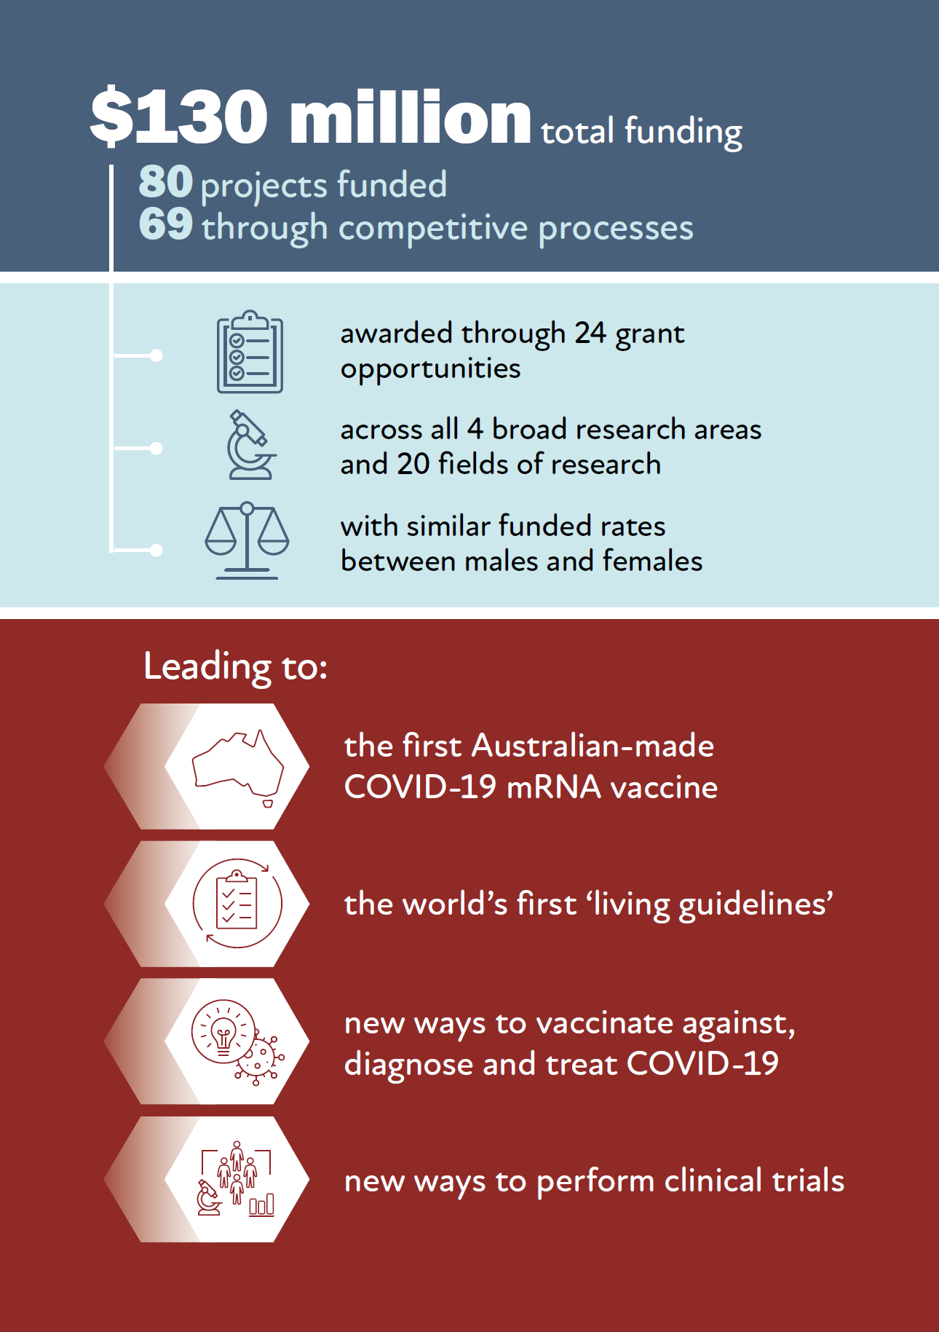

# Approach

Data provided by the grant administration hubs — that is, NHMRC and the Business Grants Hub (BGH) — show that 459 applications that were identified as being related to COVID-19 were received during the reporting period (November 2017 to November 2022).

Of these 459 applications:

434 were identified as applying for COVID-19-specific competitive grant opportunities; of these, 64 were funded, a funded rate of 14.7%

5 were funded through competitive subcontracts under MTPConnect, as part of the Biomedical Translation Bridge grant opportunity

11 were funded as part of COVID-19-specific non-competitive grant opportunities

9 were identified as applying for non-COVID-19-specific competitive grant opportunities; this identification used text matching of the search words ‘COVID19’, ‘COVID-19’ and ‘coronavirus’ against the title, abstract and media summary of the applications, followed by a manual assessment to remove false positives — of these, 3 were funded

A full list of funded grants is in Appendix B.

Unless otherwise stated, analyses involving applications and funded rates discussed in the rest of this report were calculated for the 434 applications within the COVID-19-specific competitive grant opportunities only. This is because there were not enough data for the other grant opportunities to allow for meaningful comparisons, or funded rates were not applicable. For some analyses, only NHMRC applications were included because data are not available for BGH-administered applications; this is stated in the relevant sections.

The analyses also do not include grants administered by research hubs other than NHMRC and BGH — that is, the Biomedical Translation Bridge grant opportunities administered by MTPConnect as part of the Medical Research Commercialisation initiative are omitted.

## Limitations

While the analysis presented in this report is comprehensive, the following limitations may affect the accuracy of the findings:

* Data constraints
* There were differences in how data were captured between NHMRC- and BGH-administered grants, and some data are only available for NHMRC-administered grants
* Limitations in data availability prevent more detailed analyses based on investigator characteristics – for example, stage of career

The analyses of funding and funded rates are based on data at the time of award and do not account for subsequent variations

* Inability to examine publications as an output
* Generally, publications are not reported or available by the end of the project
* It is difficult to find relevant data from literature searches because of inconsistent attribution to the MRFF. Researchers are encouraged to acknowledge the MRFF as their funding source in future publications

The Australian Government Department of Health and Aged Care (the department) intends to capture data more systematically as part of its [monitoring, evaluation and learning strategy](https://www.health.gov.au/resources/publications/mrff-monitoring-evaluation-and-learning-strategy-2020-21-to-2023-24)

* Inability to determine longer-term measures of success and impact at such an early stage

Based on the current status of funded projects, and given delays to projects, it is too early to analyse whether team size, budget size or other characteristics are associated with more favourable project outcomes and longer-term impacts

# Funding insights

## Summary

The MRFF received a broad variety of applications related to COVID-19 research, reflecting the range of grant opportunities that were on offer to Australian researchers. Note that the funding insights provided in this summary relate to competitive grant opportunities only, unless otherwise stated.

Size of COVID-19-related applications

The applications with the larger grant budgets tended to have higher funded rates (percentage of applications funded). These were often large randomised clinical trials, including platform trials, with large teams of investigators and/or involving several centres, but some were laboratory-based immunological studies on vaccines or treatments. However, these findings should be interpreted with the understanding that different grant opportunities may have different limits on grant size or funding available.

Investigator characteristics

There were no differences in funded rates between applications led by male or female investigators. This reflects MRFF funding as a whole, as seen in the [MRFF grant opportunity gender data report — 22 March 2022](https://www.health.gov.au/resources/publications/medical-research-future-fund-grant-opportunity-gender-data-report-22-march-2022). Hopefully, these findings and other efforts within the sector (including the [NHMRC Gender Equity Strategy 2022–2025](https://www.nhmrc.gov.au/research-policy/gender-equity/nhmrc-gender-equity-strategy-2022-2025)) encourage greater participation by female researchers, which will address the lack of balance in the number of applications and total funding amounts.

Applications from larger teams of investigators tended to have a high rate of funding, reflecting larger collaborative research networks. This is especially relevant for COVID-19 research, which has highlighted the importance of concerted efforts in responding to the threat of a global pandemic.

Institution characteristics

Applications with a higher number of participating institutions generally had a higher funded rate; however, there were some exceptions. The small numbers in some categories mean these results should be interpreted with caution.

Universities and medical research institutes were the primary recipients of funding related to COVID-19 research. This reflects MRFF funding as a whole.

Administering institutions from Victoria received the highest total amount of funding, although this is likely due to the high number of applications received from Victoria (associated with a large amount of research related to COVID-19).

Area of research

Most COVID-19-related applications were from clinical sciences, for both the broad research area (‘Clinical medicine and science’) and the field of research (‘Clinical sciences’). This is reflected in the funded rates and total funding amounts. These findings are likely due to the nature of the grant opportunities — at least 2 grant opportunities focused specifically on clinical trials and received more funding than was usual.

For broad research area, ‘Basic science’ had the second-lowest number of applications but had a similar funded rate to ‘Clinical medicine and science’. Within ‘Basic science’, funded rates were similar in ‘Medical microbiology’ and ‘Medicinal and biomolecular chemistry’.

‘Health services’ and ‘Public health’ had the lowest funded rates, both overall and in response to grant opportunities specifically aimed at those areas of research. This was despite these areas having numbers of applications comparable to or higher than other research areas.

Progress of COVID-19 grants

Of the 69 COVID-19 NHMRC-administered grants (as of 31 December 2022):

14 have been completed and 55 are in progress

35 have had a variation request (some several), including requests to extend the end date and change the research plan

6 have requested to defer the grant in progress

2 have been relinquished

Lockdowns and other restrictions resulting from the pandemic have impeded research. However, the variation request rate for COVID-19 grants (50.7%) is similar to that for all other MRFF grants administered by the NHMRC during the same period (54.1%).

## Application budgets

Most grant applications under competitive COVID-19-related grant opportunities requested a budget of between $0.5 million and $1.0 million (n = 162; Figure 1). The median requested budget was $1.5 million for funded applications and $0.8 million for those not funded. Applications requesting a budget greater than $5.0 million had the highest funded rate (75% of applications funded; Figure 2), although this should be interpreted with caution because of the low number of applications with budgets in this range.

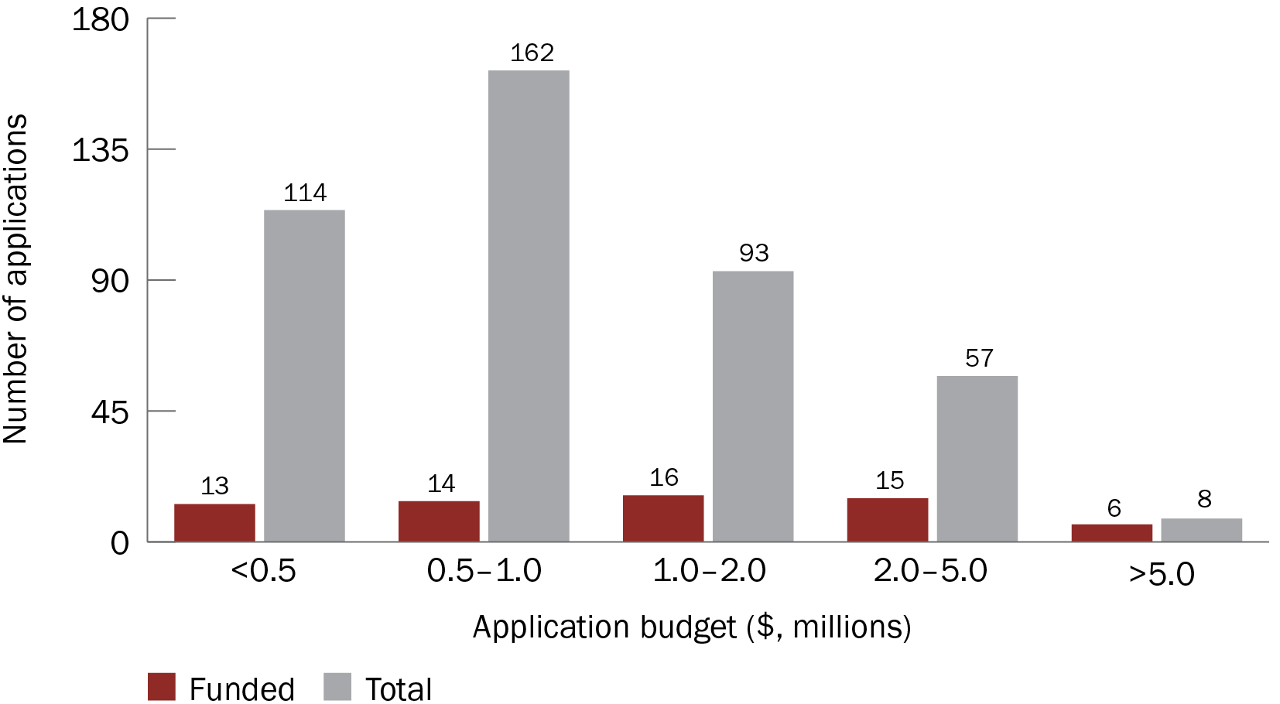

Figure 1 Application budgets and funding outcomes for competitive COVID-19 grant opportunities

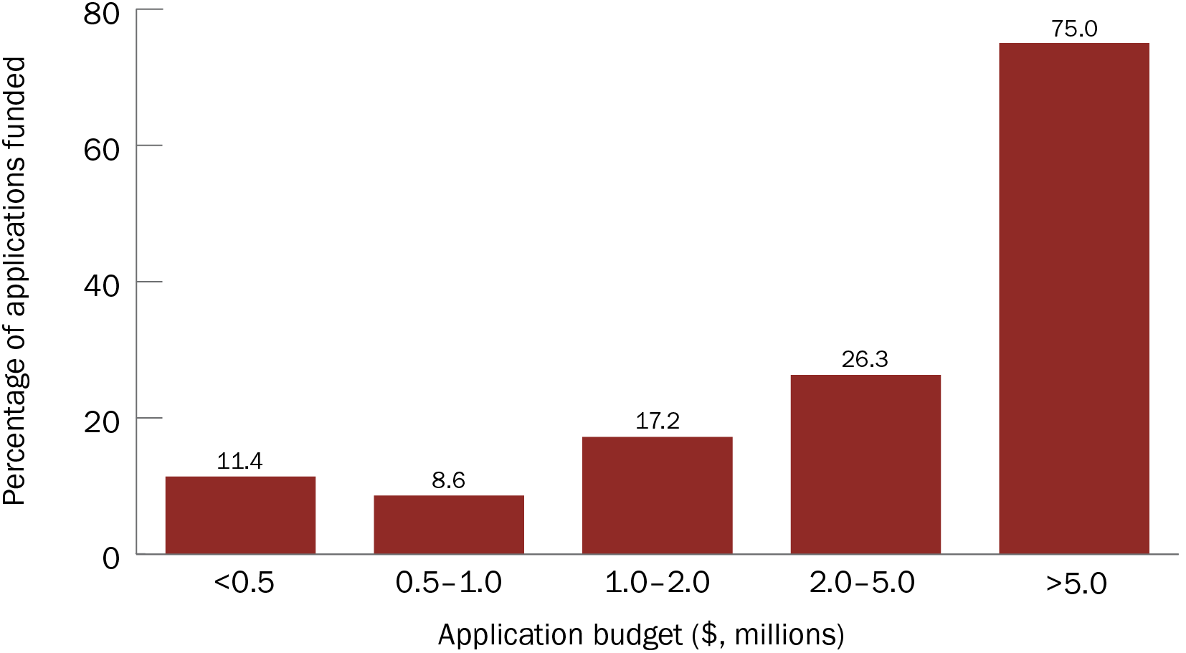

Figure 2 Funded rates, by application budget band

The grant opportunities with the smallest median requested budgets were:

2020 Communication Strategies and Approaches During Outbreaks (median application budget of $309,714)

2020 Antiviral Development for COVID-19 (median application budget of $368,578 for Stage 1)

2020 COVID-19 Mental Health Research (median application budget of $616,855)

These findings may reflect the amount of funding available and the maximum grant size for the first 2 grant opportunities. They may also reflect the typical direct research costs in social and mental health research, and/or pilot or pre-clinical research compared with clinical trials.

The grant opportunities with the largest median requested budgets were:

2020 COVID-19 Vaccine Candidate Research (median application budget of $3.0 million for all rounds and applications that passed the initial Expression of Interest rounds)

2021 COVID-19 Health Impacts and Vaccination Schedules (median application budget of $2.4 million)

2021 COVID-19 Treatment Access and Public Health Activities (median application budget of $2 million)

These applications have higher budgets because they are for large randomised clinical trials, including platform trials, with large teams of investigators and/or involving several centres.

Limitations of this analysis

There are limits on grant size or funding available, and these vary with each grant opportunity. The limits are provided in Appendix A.

## Gender of Chief Investigator(s)

Leading Chief Investigator

Most applications had a male listed as Chief Investigator A (*n* = 266, compared with *n* = 165 applications with a female Chief Investigator A) (Figure 3). However, funded rates (the percentage of applications funded) differed little between male and female leading Chief Investigators (15.0% and 14.5% applications funded, respectively) (Figure 4).

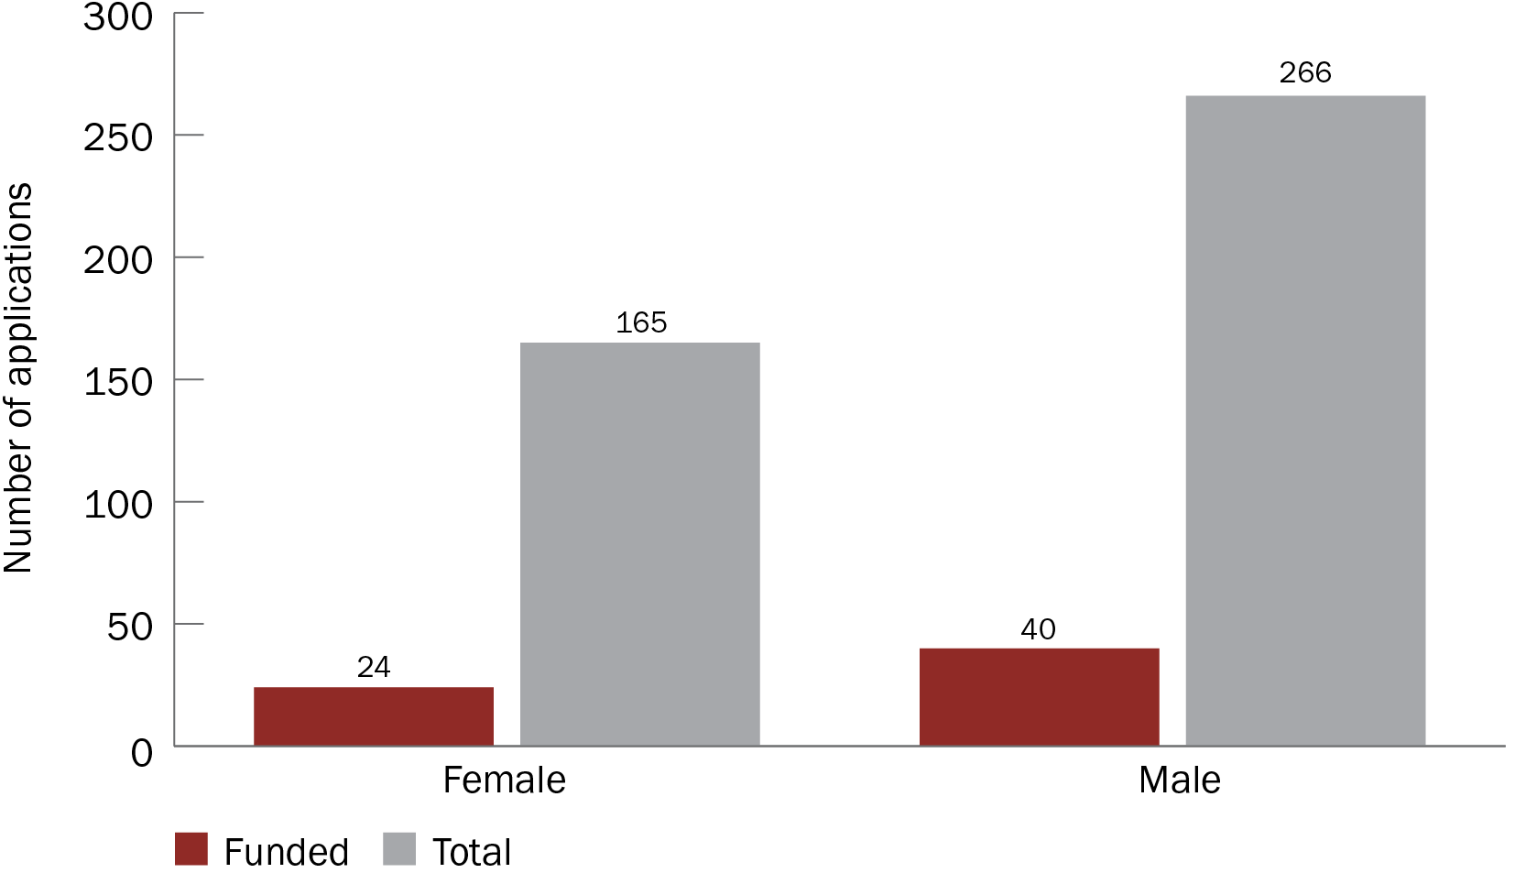

Figure 3 Number of applications received and funded, by gender of Chief Investigator A

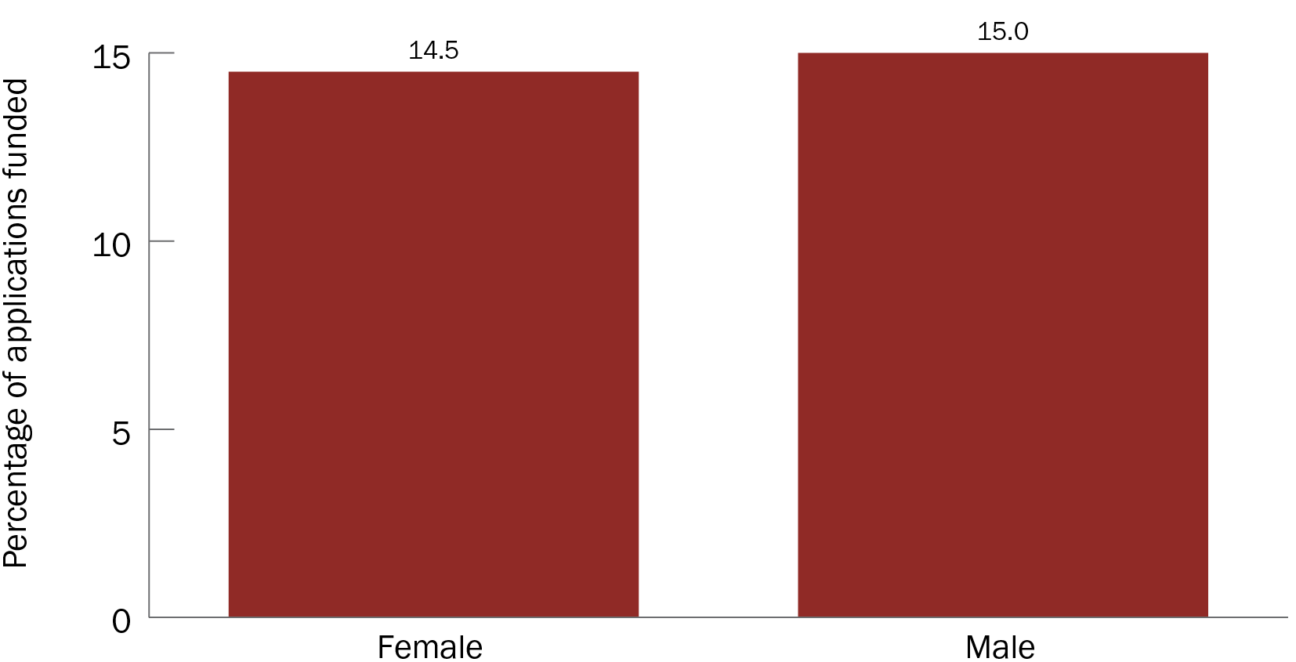

Figure 4 Funded rates, by gender of Chief Investigator A

Because of the higher number of applications, male-led projects received a higher amount of funding than female-led projects ($91.9 million compared with $42.2 million, respectively). The median funded amounts for projects with male and female leading Chief Investigators were $1.4 million and $1 million, respectively. This difference of around $0.4 million is not statistically significant (*P* = 0.160) (Figure 5).

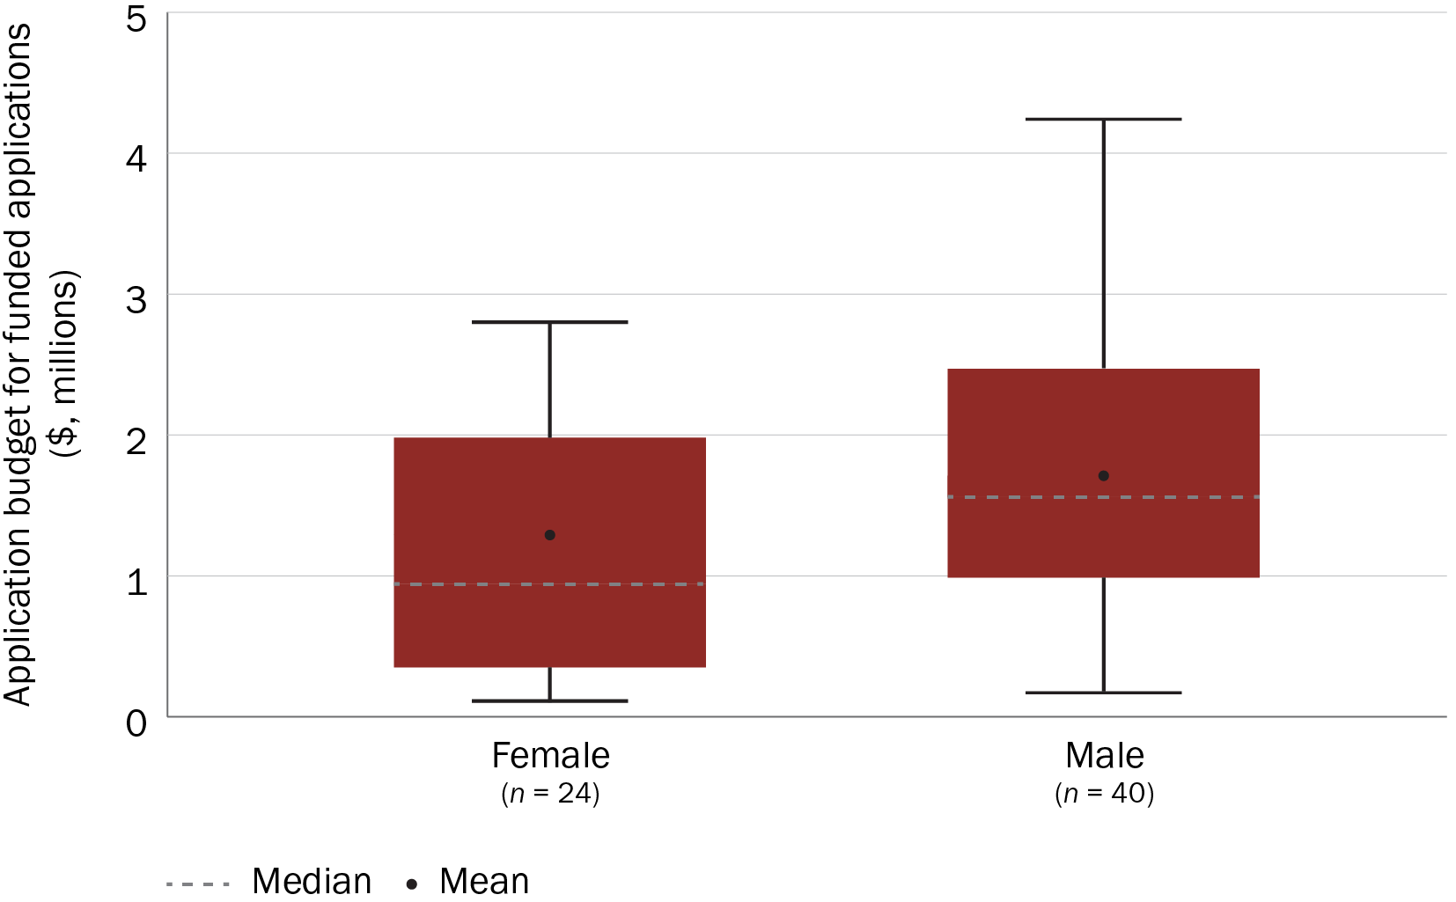

Figure 5 Application budgets for funded applications, by gender of Chief Investigator A

All Chief Investigators

The findings in this section are based on NHMRC data for applications for which gender data on all Chief Investigators were available (based on self-reported data, 311 out of the 3631 applicants included in this analysis were classified in this report as ‘not stated’, ‘not applicable’ or ‘non-binary or intersex’).

Only one grant opportunity, 2020 COVID-19 Mental Health Research, had more female than male Chief Investigator applicants. However, funded rates for male and female Chief Investigators were similar across all grant opportunities (22.6% and 20.3% applications funded, respectively; *P* = 0.104), and both rates were similar to the overall funded rate of applications (21.6% applications funded). A table with the number of female and male Chief Investigator applicants for each relevant grant opportunity is included in Appendix C.

There were more female than male Chief Investigator applicants in the broad research areas of ‘Health services’ (*n* = 371 and *n* = 285, respectively) and ‘Public health’ (*n* = 222 and *n* = 204, respectively) (Figure 6). However, the funded rates for female and male Chief Investigator applicants were similar for most broad research areas, with the exception being ‘Public health’ (Figure 7).

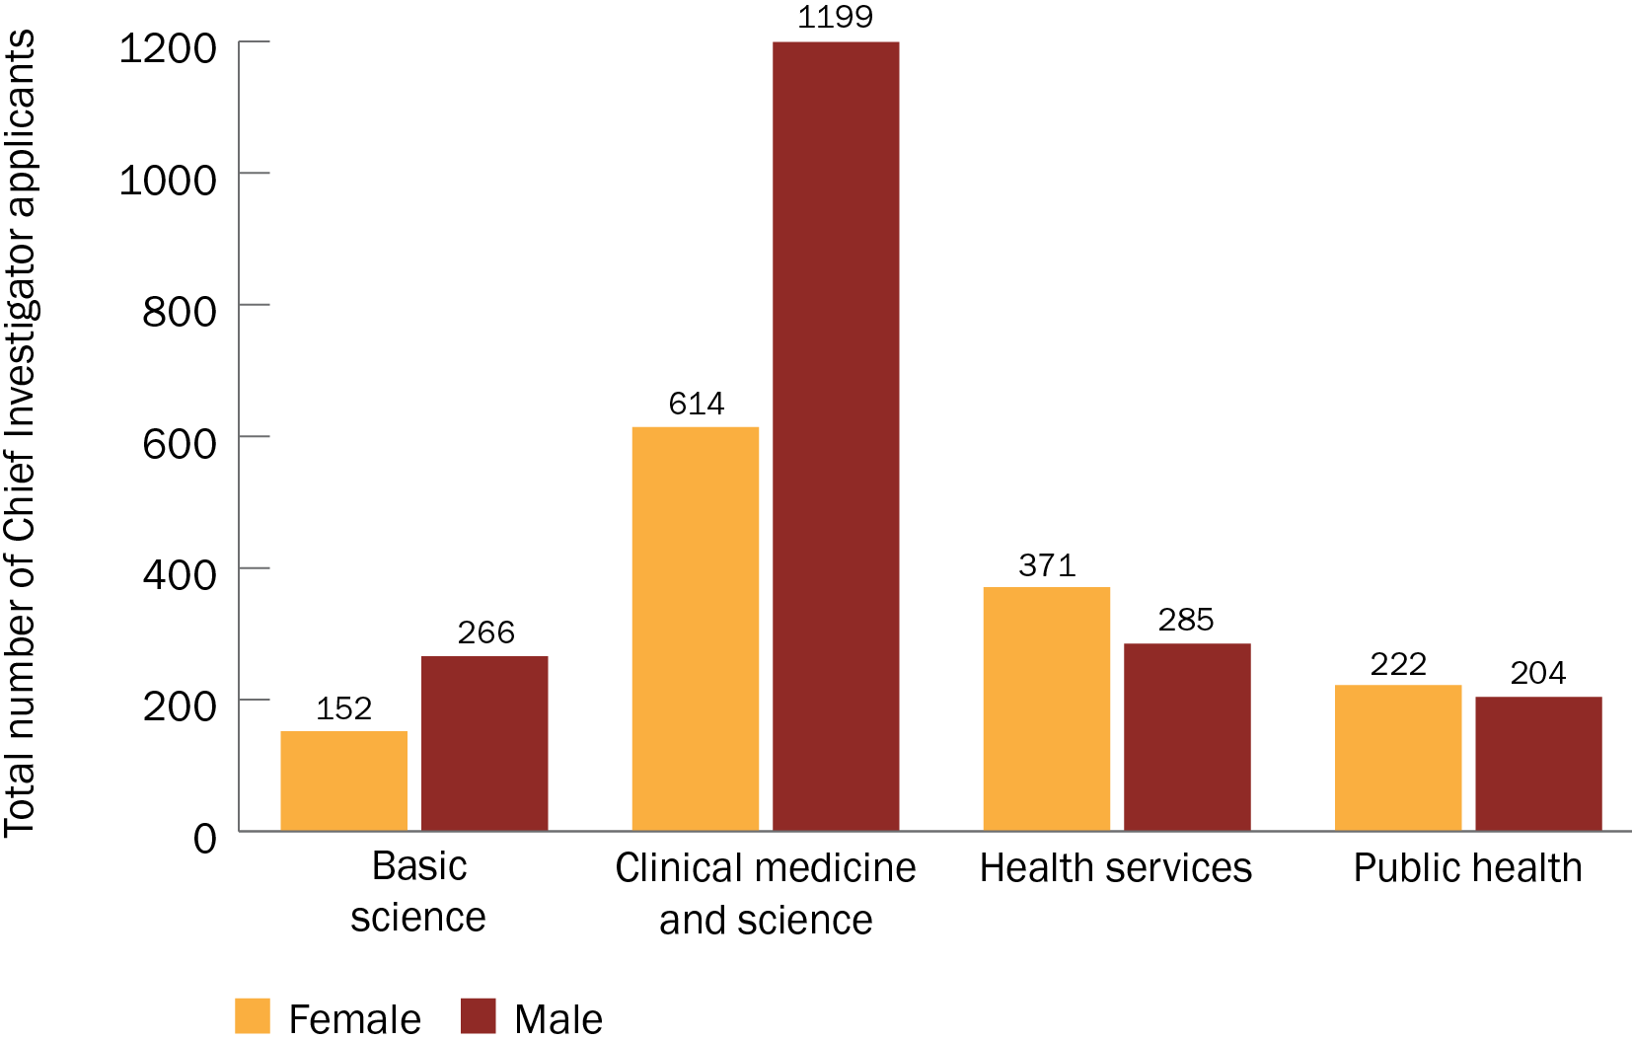

Figure 6 Gender of Chief Investigator applicants, by broad research area

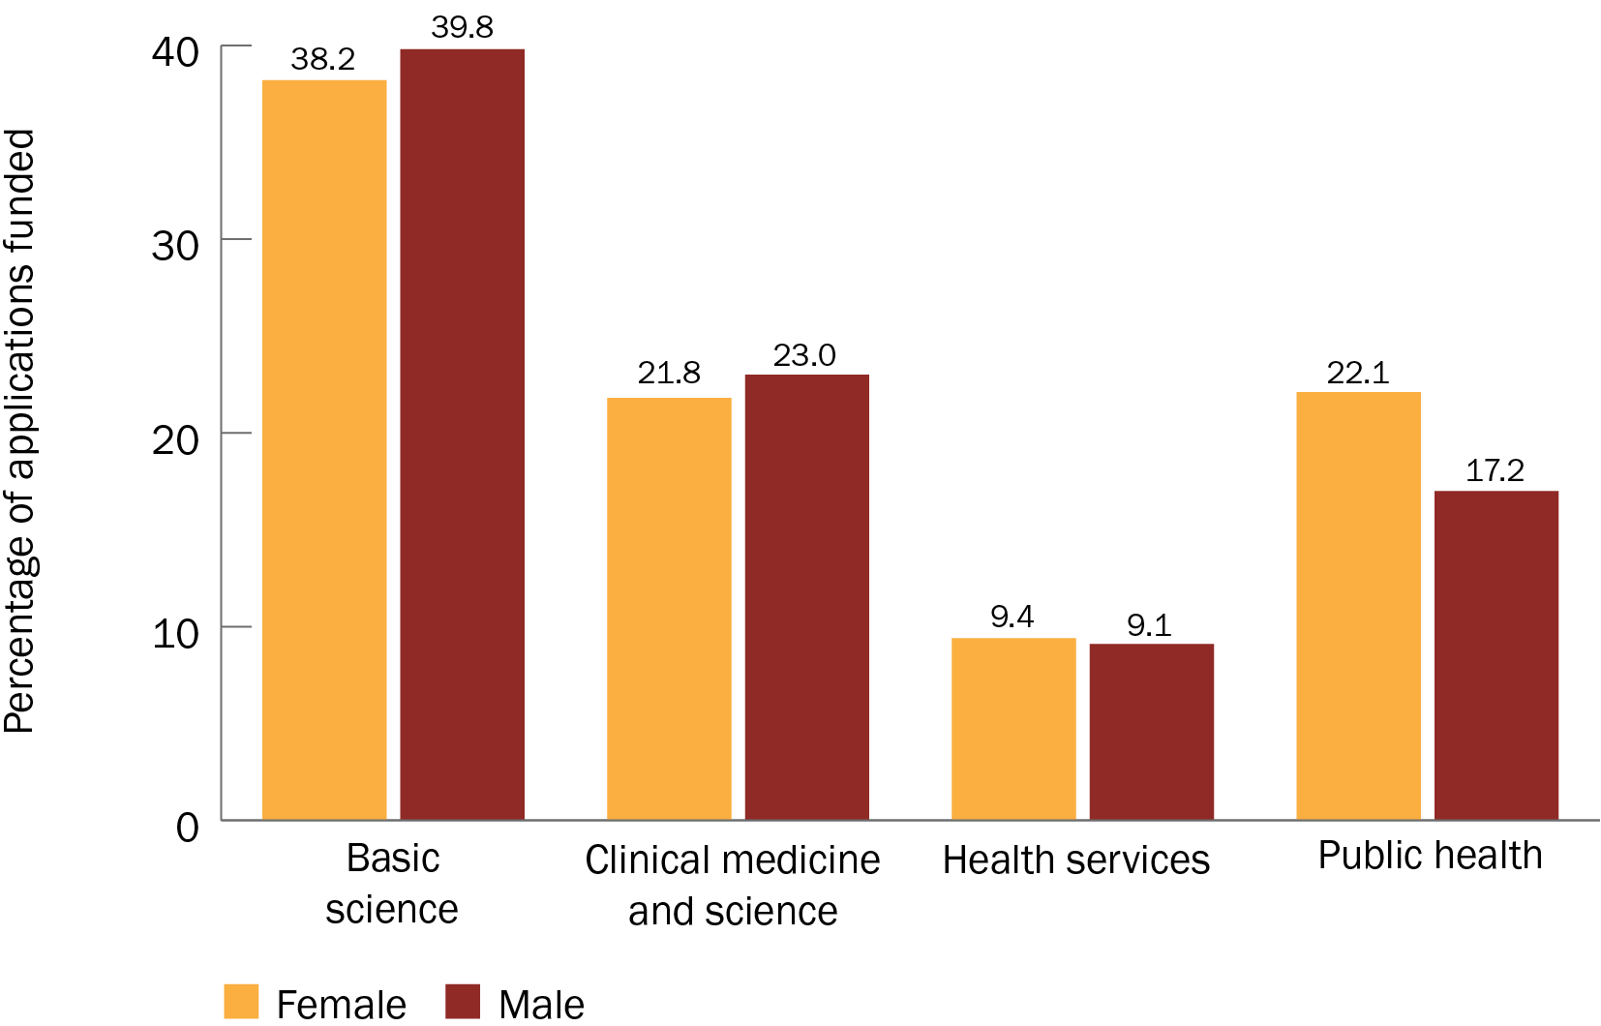

Figure 7 Funded rates for male and female Chief Investigators, by broad research area

Among the top 10 fields of research (for the applications received), males and females had similar funded rates in 6 fields. Female applicants had a higher funded rate than male applicants in the other 4 fields: ‘Cardiorespiratory medicine and haematology’, ‘Immunology’, ‘Medical biotechnology’ and ‘Medicinal and biomolecular chemistry’ (Figure 8). For the ‘Other’ category (all fields of research not included in the top 10), male applicants had a higher funded rate than female applicants (funded rates of 17% and 9%, respectively).

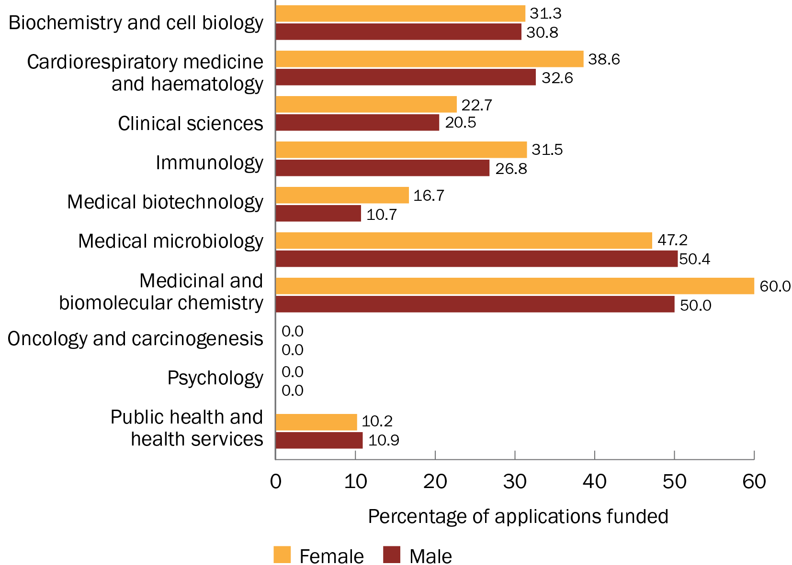

Figure 8 Funded rates for female and male Chief Investigators, by the top 10 fields of research (based on the total number of applications received)

Limitations of this analysis

Several categories had a small number of applications, especially when broken down by gender, so findings should be interpreted with caution. A list of fields of research and the total number of applications received can be found in Appendix D.

## Size of investigator team

All investigators

Each grant hub defines the investigator team differently, so this analysis includes Chief Investigators, Associate Investigators and Collaborators as part of the investigator team.

Most applications had a team size of between 1 and 10 investigators (Figure 9). Generally, as the team sizes increased, so did the funded rates of the applications (Figure 10).

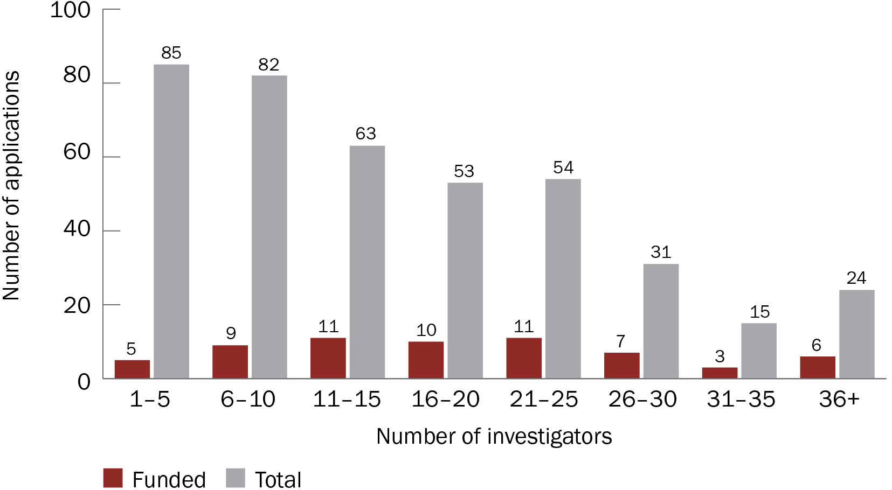

Figure 9 Number of applications received and funded, by investigator team size

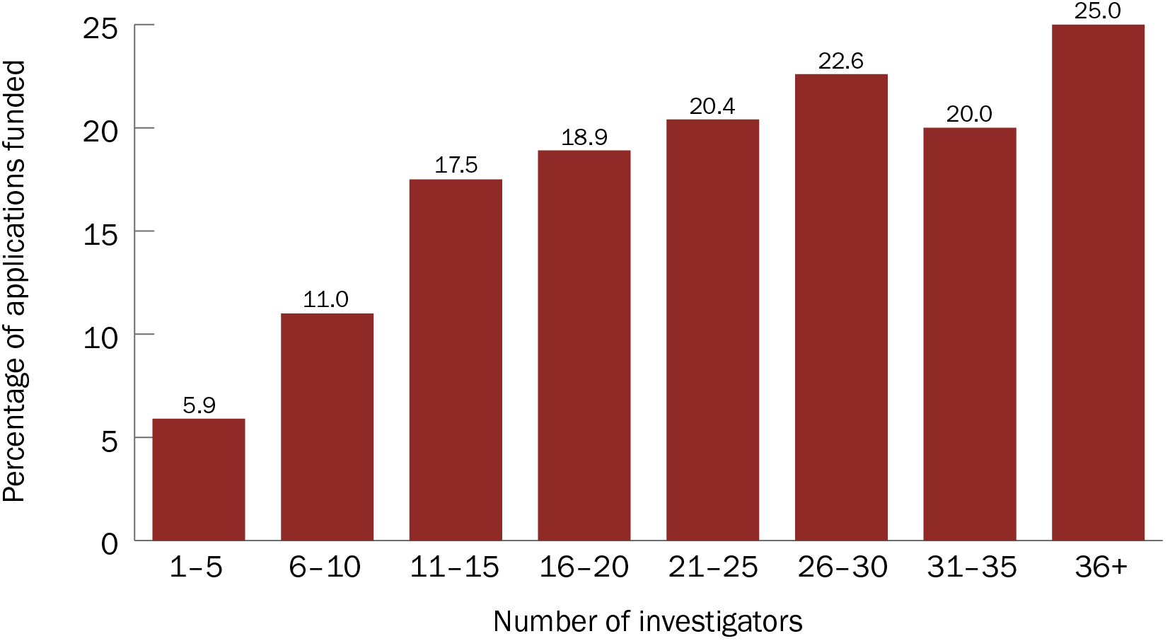

Figure 10 Funded rates, by investigator team size

Chief Investigators

The findings in this section are based on NHMRC data only.

Most applications had a team size of fewer than 10 Chief Investigators (Figure 11). Teams with more Chief Investigators tended to have higher funded rates (percentage of applications funded) (Figure 12).

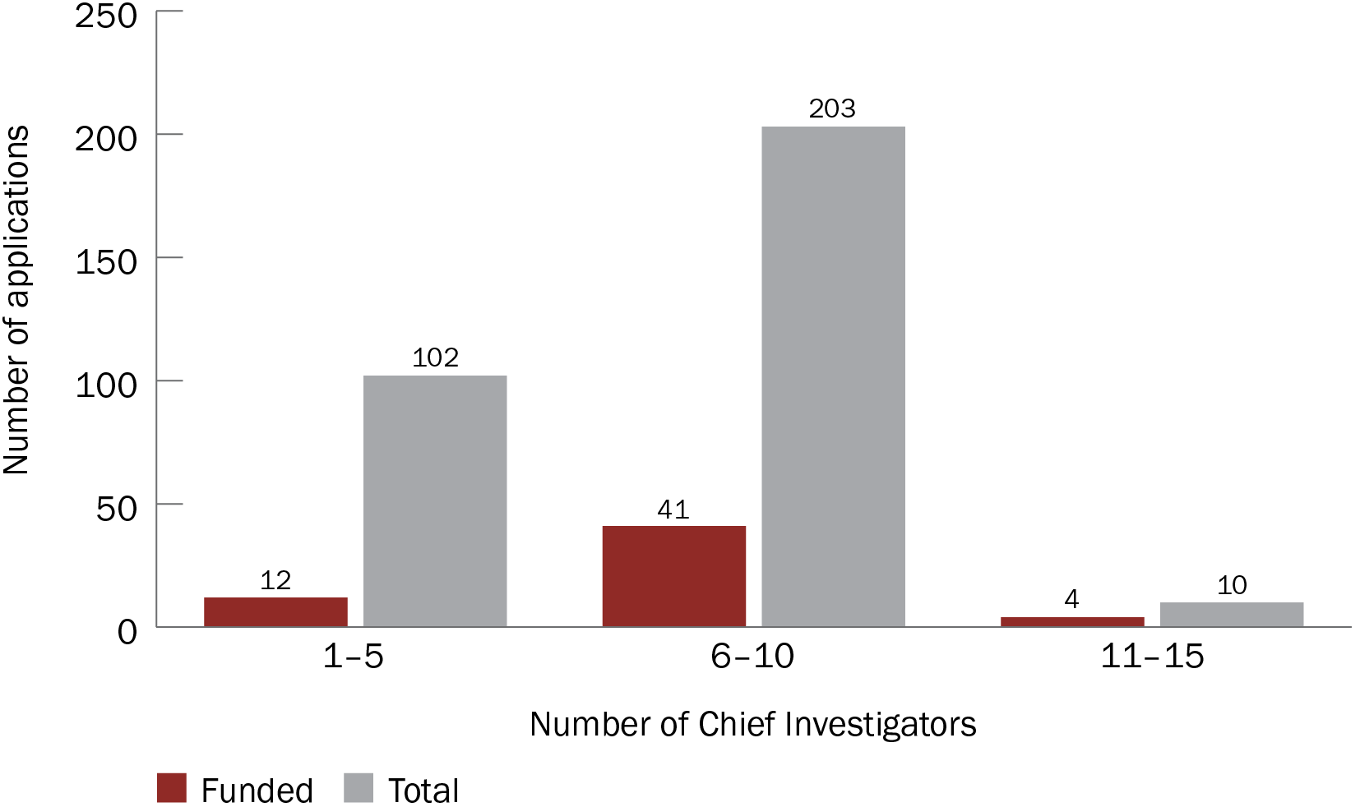

Figure 11 Number of applications received and funded, by Chief Investigator team size

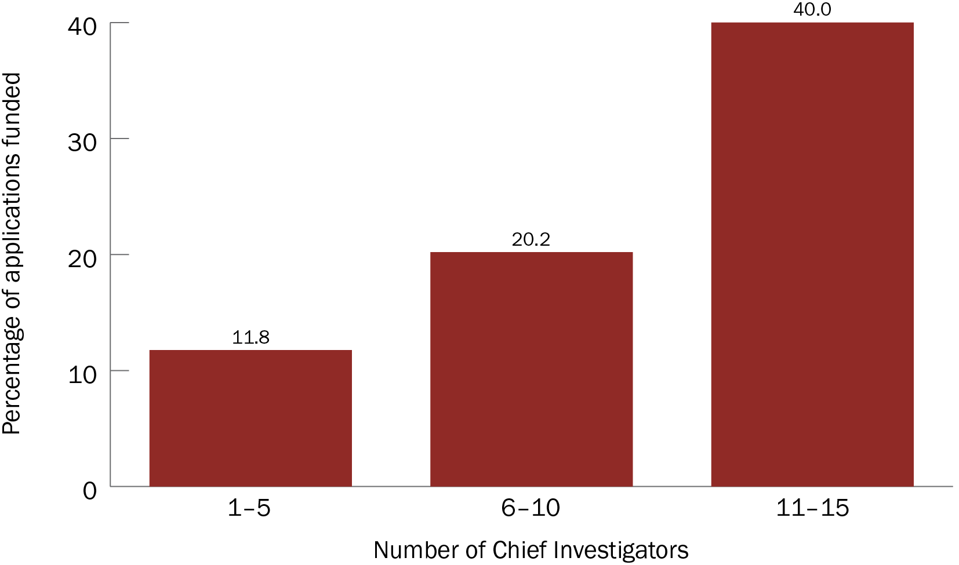

Figure 12 Funded rates, by Chief Investigator team size

#### Limitations of this analysis

All but one grant opportunity included in this analysis had a limit of 10 Chief Investigators, reflecting the funding rules at the time. This skews the results towards 10 or fewer Chief Investigators per application.

## Area of research

The findings in this section are based on self-nominated data from NHMRC applications only.

Broad research area

‘Clinical medicine and science’ had the highest number of applications (*n* = 167; 52.8% of all applications) and the highest number of funded grants (*n* = 32; 56.1% of all funded grants). All other broad research areas had similar numbers of applications (Figure 13). However, ‘Basic science’ applications had the highest funded rate (27.5%), demonstrating MRFF support for basic discovery research. ‘Health services’ had the lowest funded rate (8.9%) (Figure 14).

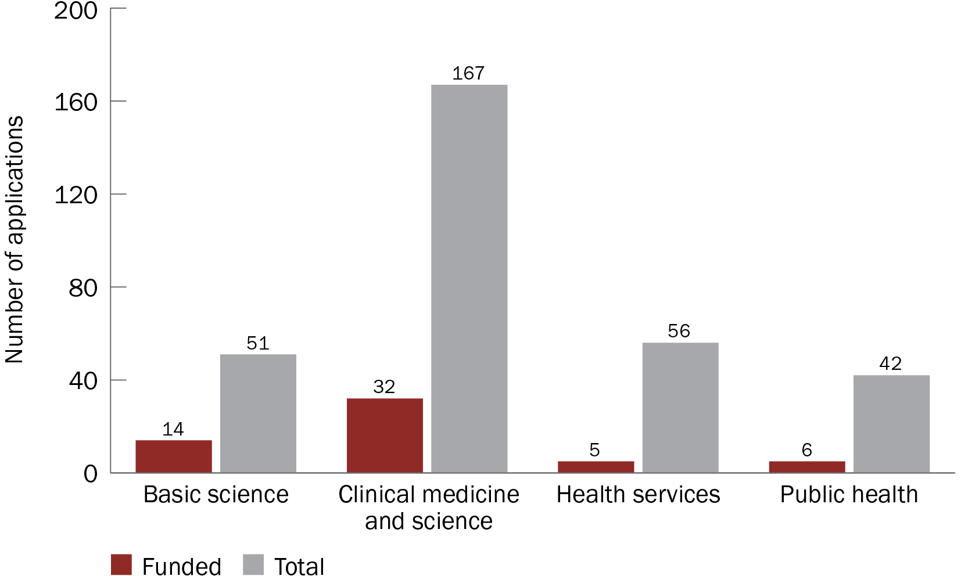

Figure 13 Number of applications received and funded, by broad research area

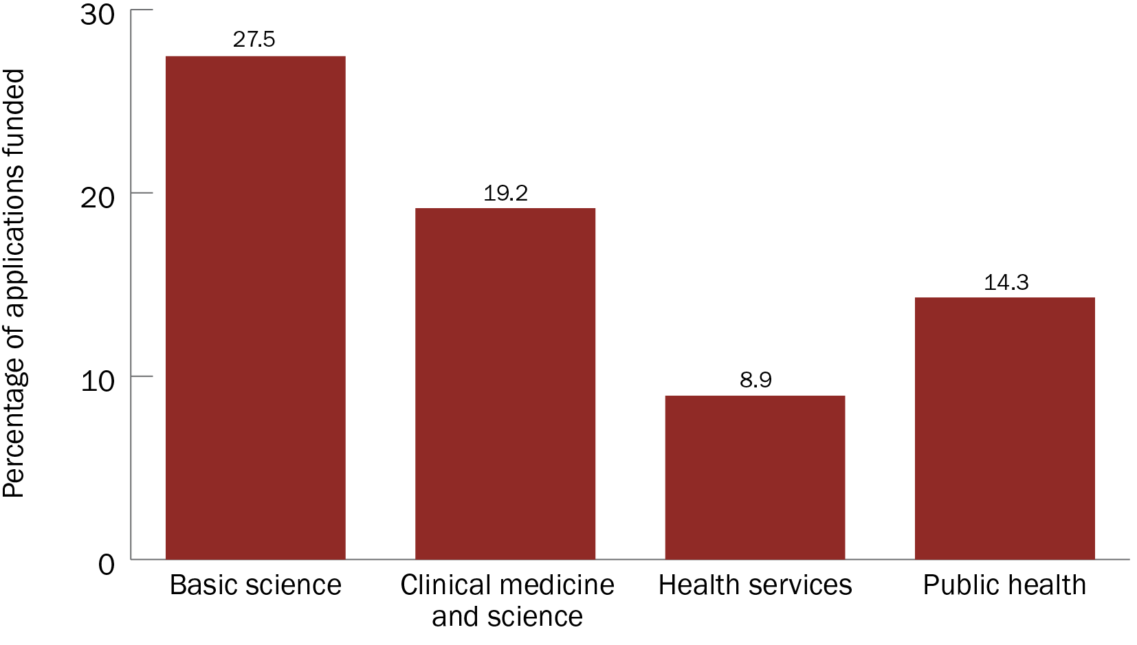

Figure 14 Funded rates, by broad research area

Because of the high number of applications, ‘Clinical medicine and science’ received the highest amount of funding ($78.3 million; 64.1% of the total funding). Although ‘Health services’ had the second-highest number of applications, the low funded rate meant that it received the lowest amount of funding ($4.3 million; 3.5% of the total funding) (Figure 15). These results reflect the type of COVID-19-related grant opportunities that were provided by the MRFF — a large proportion were focused on clinical trials and basic research.

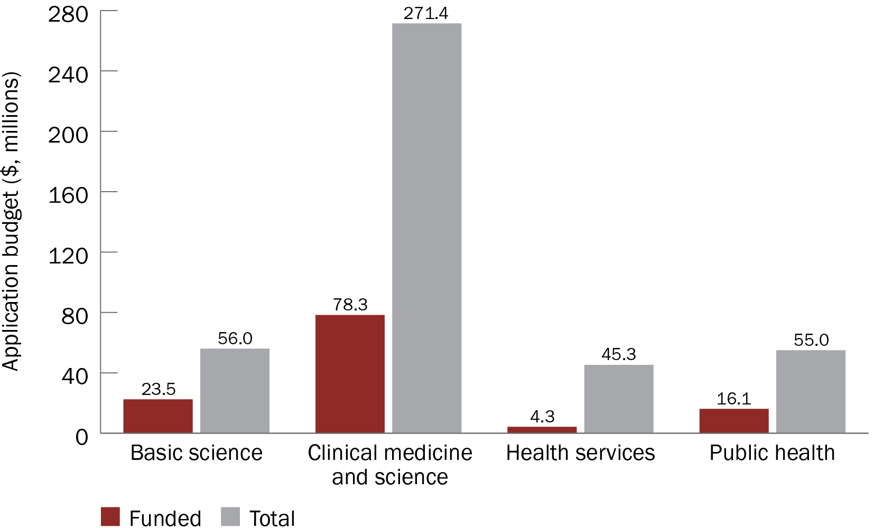

Figure 15 Funding amount applied for and received, by broad research area

Field of research

The analysis excluded fields of research specified as ‘null’ and those with 5 or fewer applications, and only considers fields that were nominated as primary field of research on the application. A full list of fields of research, and the number of applications received for each, is provided in Appendix D.

‘Clinical sciences’ was the primary field of research in the most applications (*n* = 98; 30.9% of all applications), and this field also had the highest number of funded grants (*n* = 18; 31.6% of all funded grants). The field with the second-highest number of applications was ‘Public health and health services’ (*n* = 70; 22.1% of all applications) (Figure 16).

However, the fields of research that had the highest funded rates (that also had more than 5 applications) were ‘Medicinal and biomolecular chemistry’ (40.0% of applications funded) and ‘Medical microbiology’ (32.0% of applications funded). ‘Public health and health services’ had a funded rate of 10%. ‘Psychology’ was the only field of research in which more than 5 applications were submitted and none were funded (Figure 17).

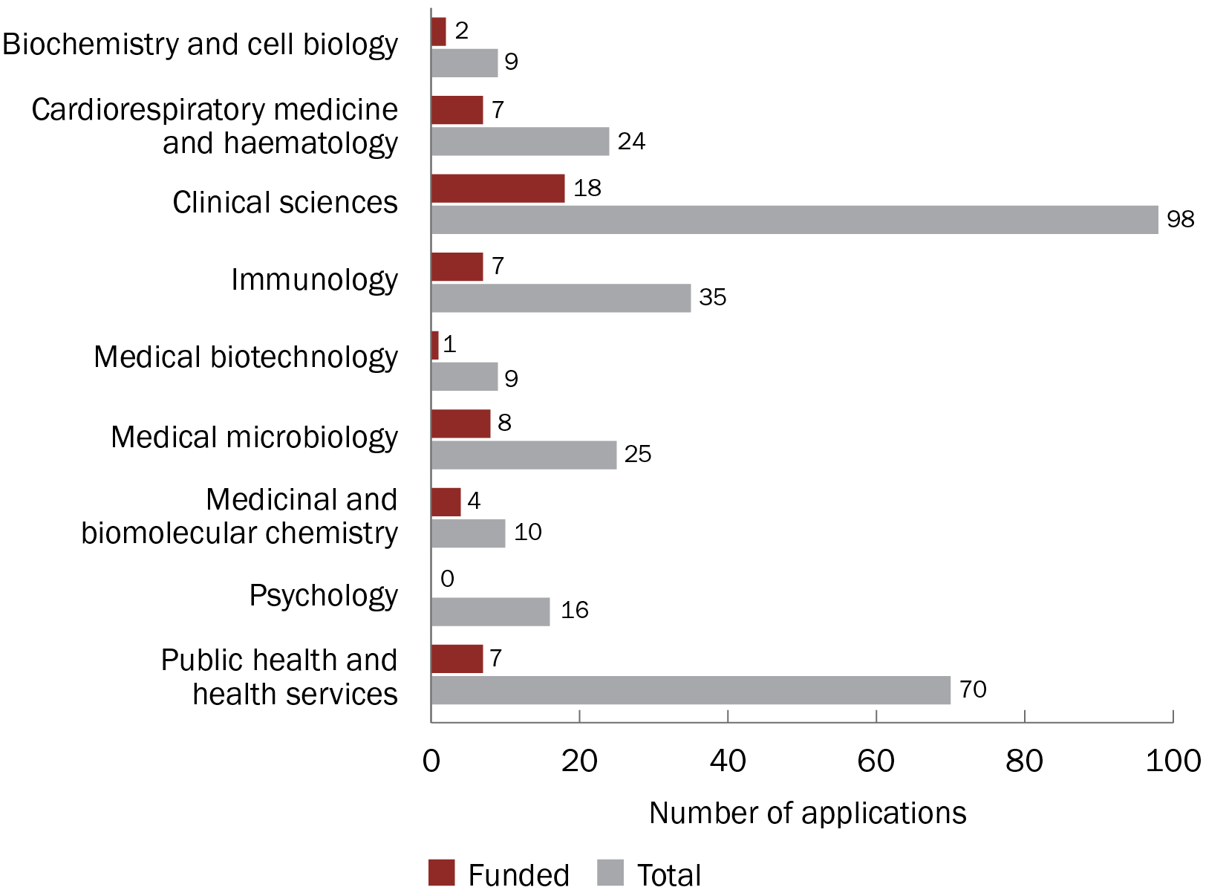

Figure 16 Number of applications received and funded, by field of research

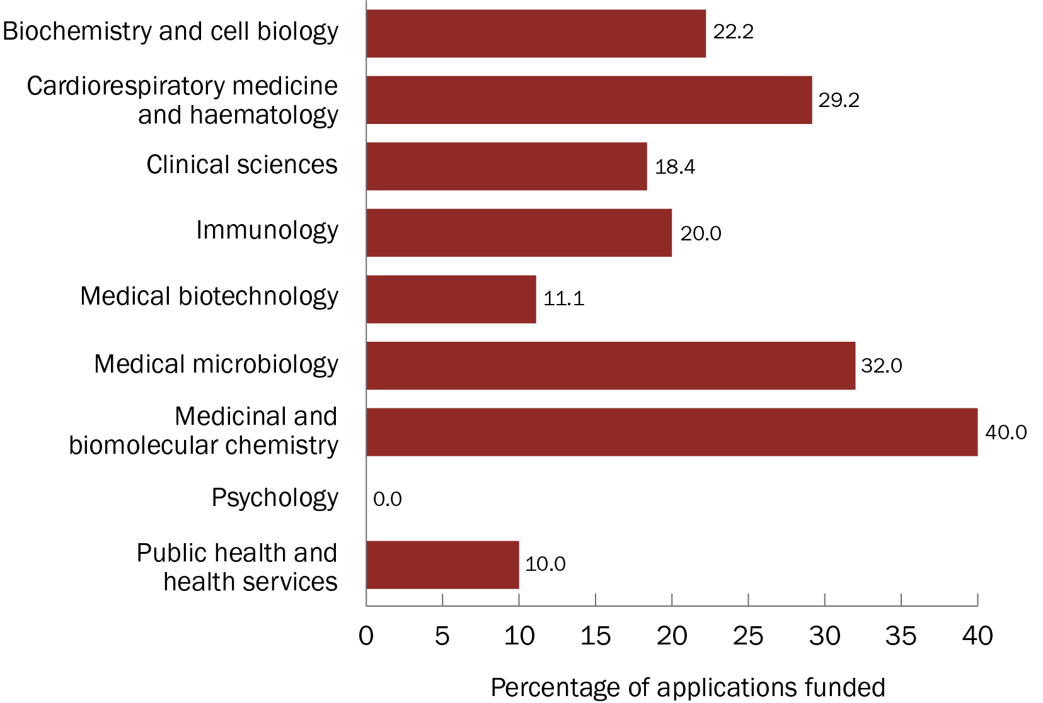

Figure 17. Funded rates, by field of research

Because of the high number of applications, ‘Clinical sciences’ received the highest amount of funding ($43.6 million; 35.7% of the total funding). Although ‘Public health and health services’ had the second-highest number of applications, it received $5.1 million in funding (4.2% of the total funding) (Figure 18).

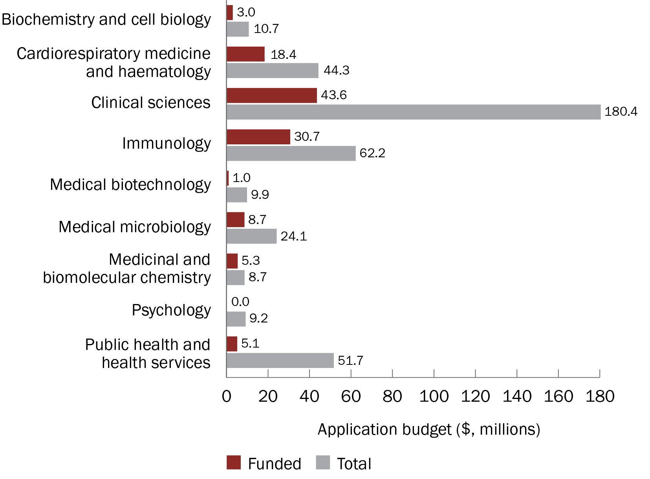

Figure 18 Funding amount applied for and received, by field of research

## Institution sectors

Each grant hub collects institution sector data differently, so the analysis in this section was from NHMRC data only.

The highest number of applications came from universities as administering institutions (*n* = 283; 89.6% of all applications) (Figure 19). However, applications from medical research institutes had a higher funded rate than those from universities (38.5% compared with 16.3% applications funded, respectively) (Figure 20).

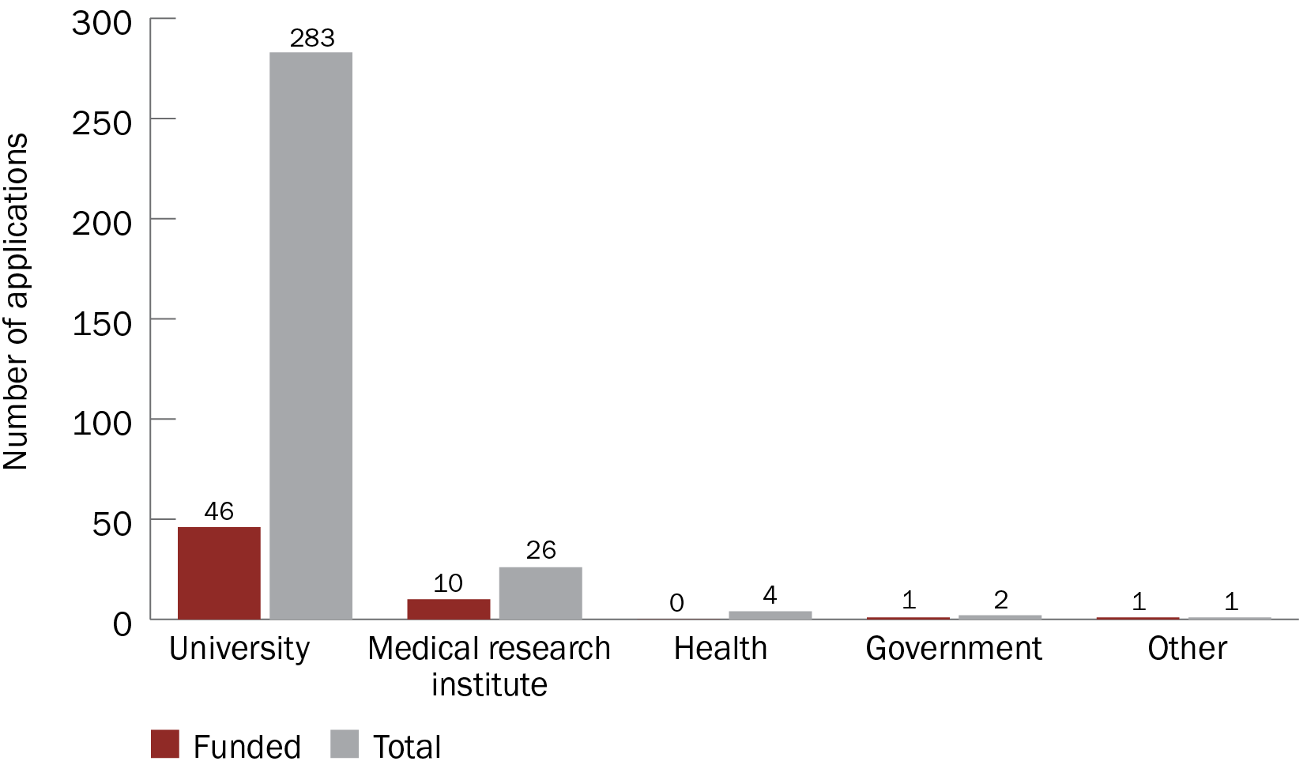

Figure 19 Number of applications received and funded, by institution sector

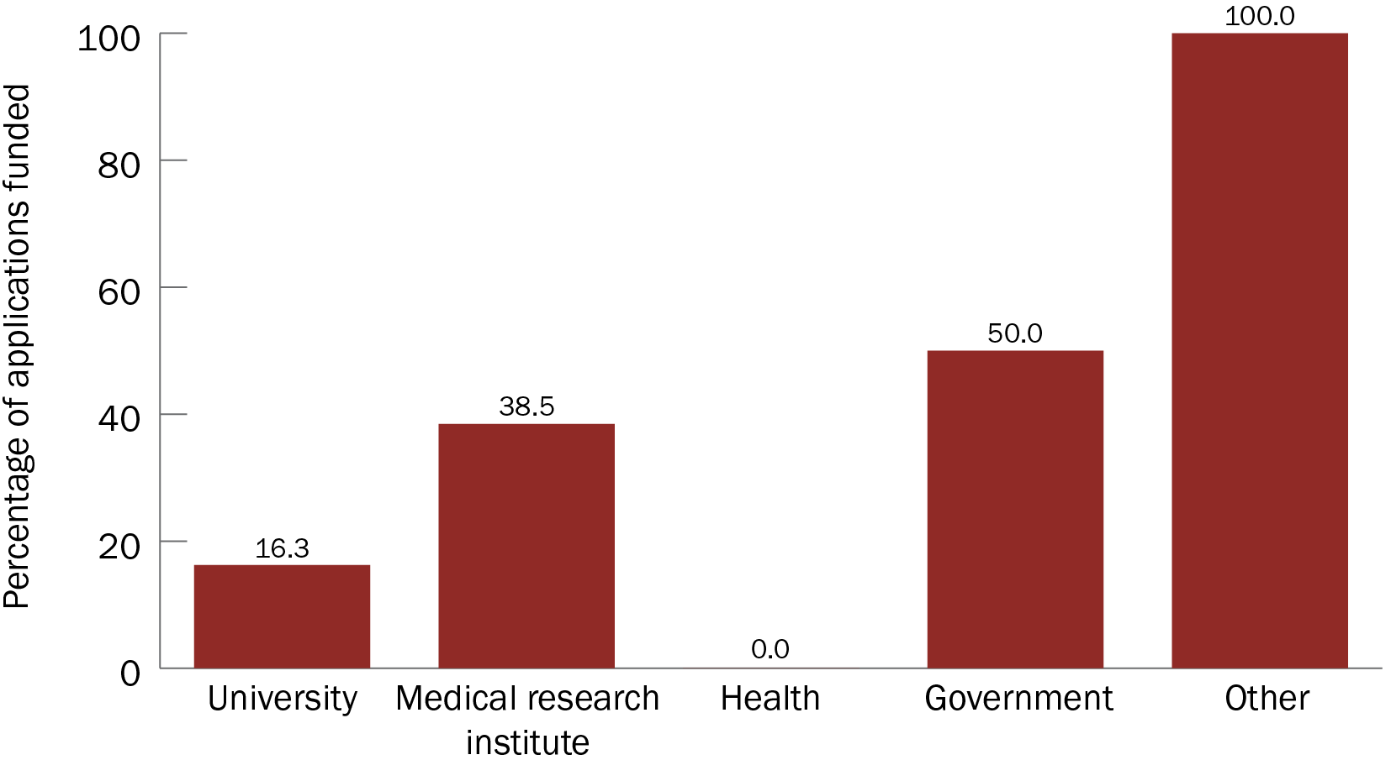

Figure 20 Funded rates, by institution sector

Because of the high number of applications, the university sector received the highest total amount of funding ($110.0 million). The medical research institute sector received $14.1 million in funding.

Limitations of this analysis

Not enough applications were submitted by the government (Australian Government, or state or territory agencies) or health (hospitals) sectors to draw any meaningful conclusions about these sectors.

## Number of participating institutions

Each grant hub defines institutions differently, and data were not available from all grant hubs. So, the analysis in this section was limited to NHMRC data only.

Applications involving 1 or 2 institutions were most common (*n* = 117 or 37.1% of all applications), though up to 5 institutions was not unusual (Figure 21).

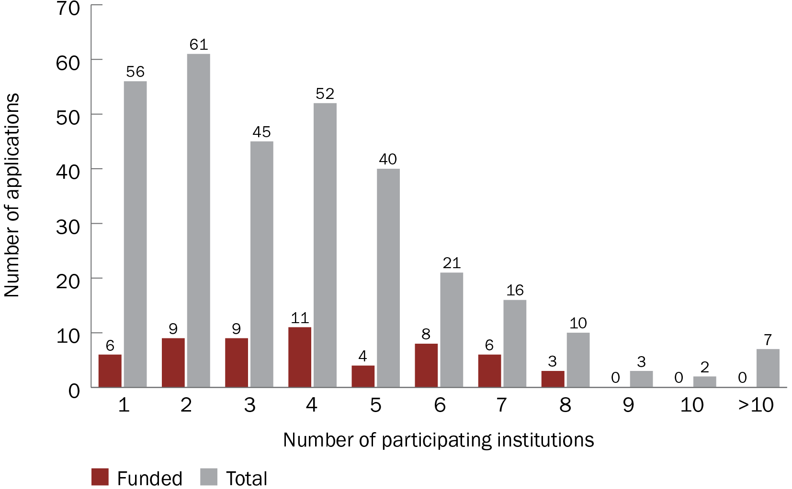

Figure 21 Number of applications received and funded, by numbers of participating institutions

Applications involving 6 institutions had the highest funded rate (38.1% of applications funded). Generally, the funded rate of the applications increased with the number of institutions involved, but no application involving 9 or more institutions was funded. The funded rate of applications that involved 5 institutions was low, but this is most likely an anomaly (Figure 22).

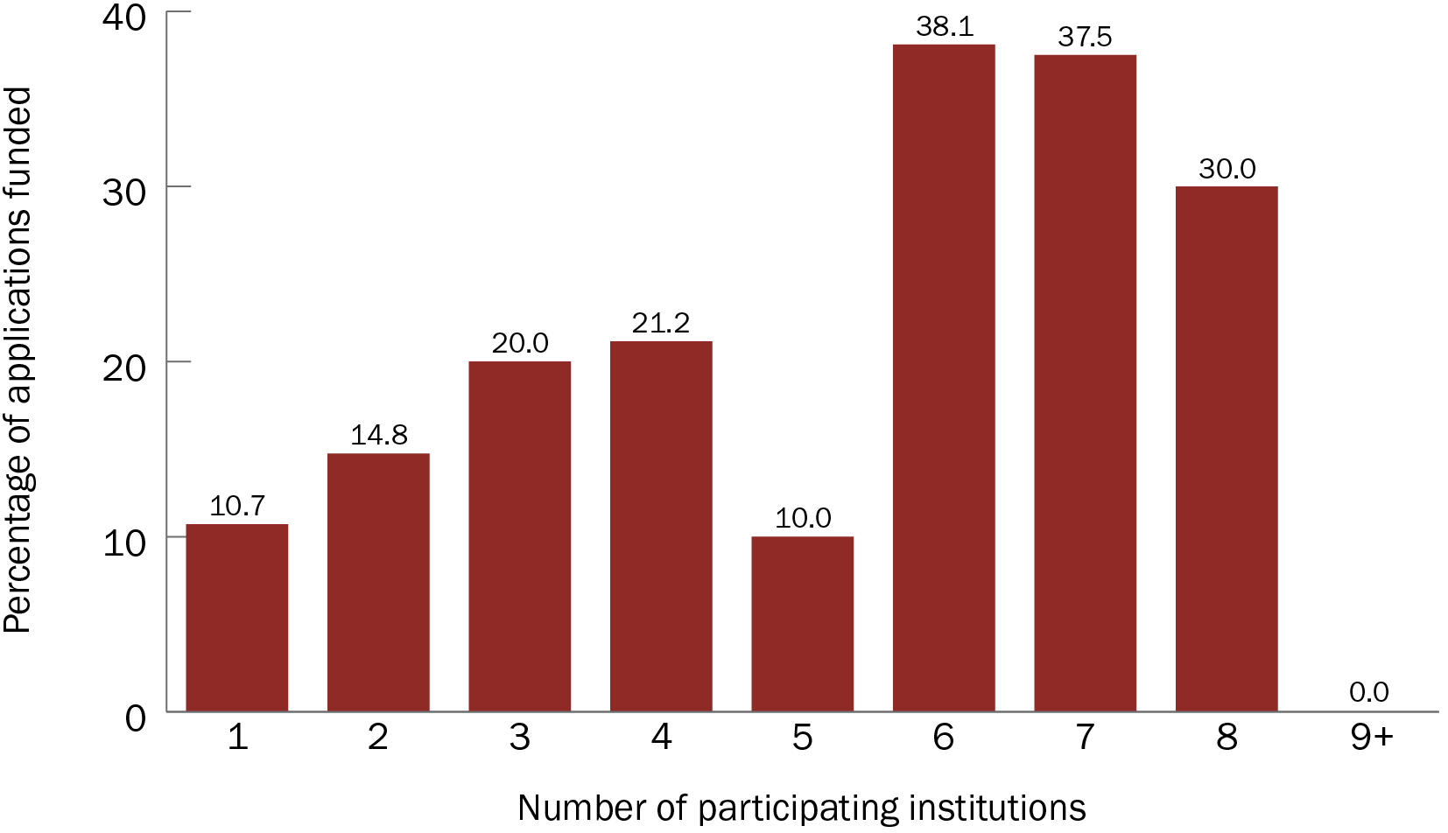

Figure 22 Funded rates, by numbers of participating institutions

Limitations of this analysis

Few applications involved high numbers of institutions, so these findings should be interpreted with caution.

## Location of administering institutions

Victorian administering institutions submitted the highest number of applications (*n* = 165; 38.0% of all applications) (Figure 23) and had the highest funded rate (19.4%) (Figure 24). The state with the second-highest funded rate was Western Australia (15.4%), despite submitting a total of 26 applications (the fourth lowest).

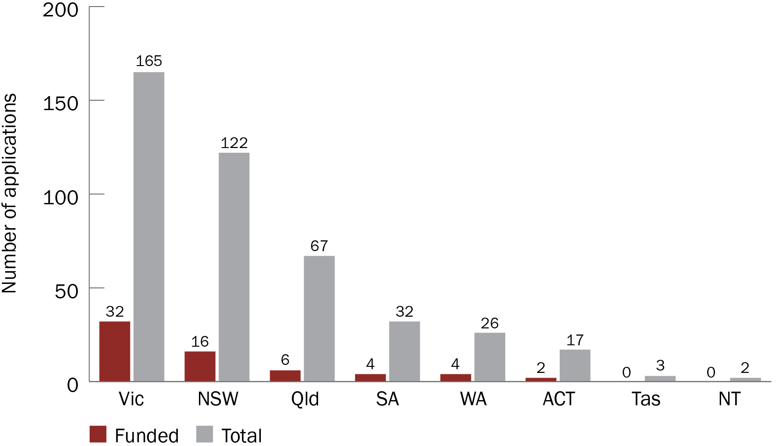

Figure 23 Number of applications received and funded, by state or territory of institution

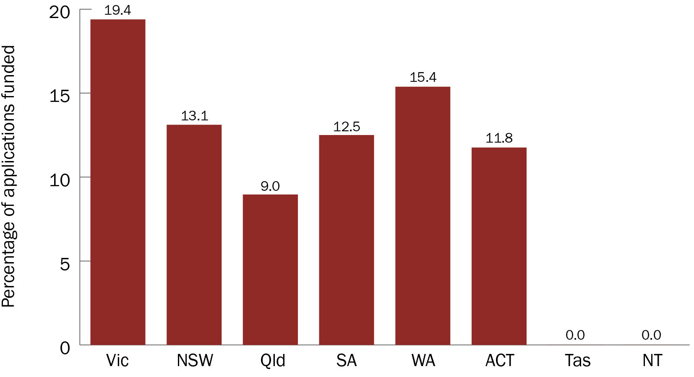

Figure 24 Funded rates, by state or territory of institution

Because of the many applications and high funded rate, Victorian administering institutions received the highest total amount of funding ($79.8 million). This was followed by New South Wales ($22.0 million) and Western Australia ($17.4 million) (Figure 25).

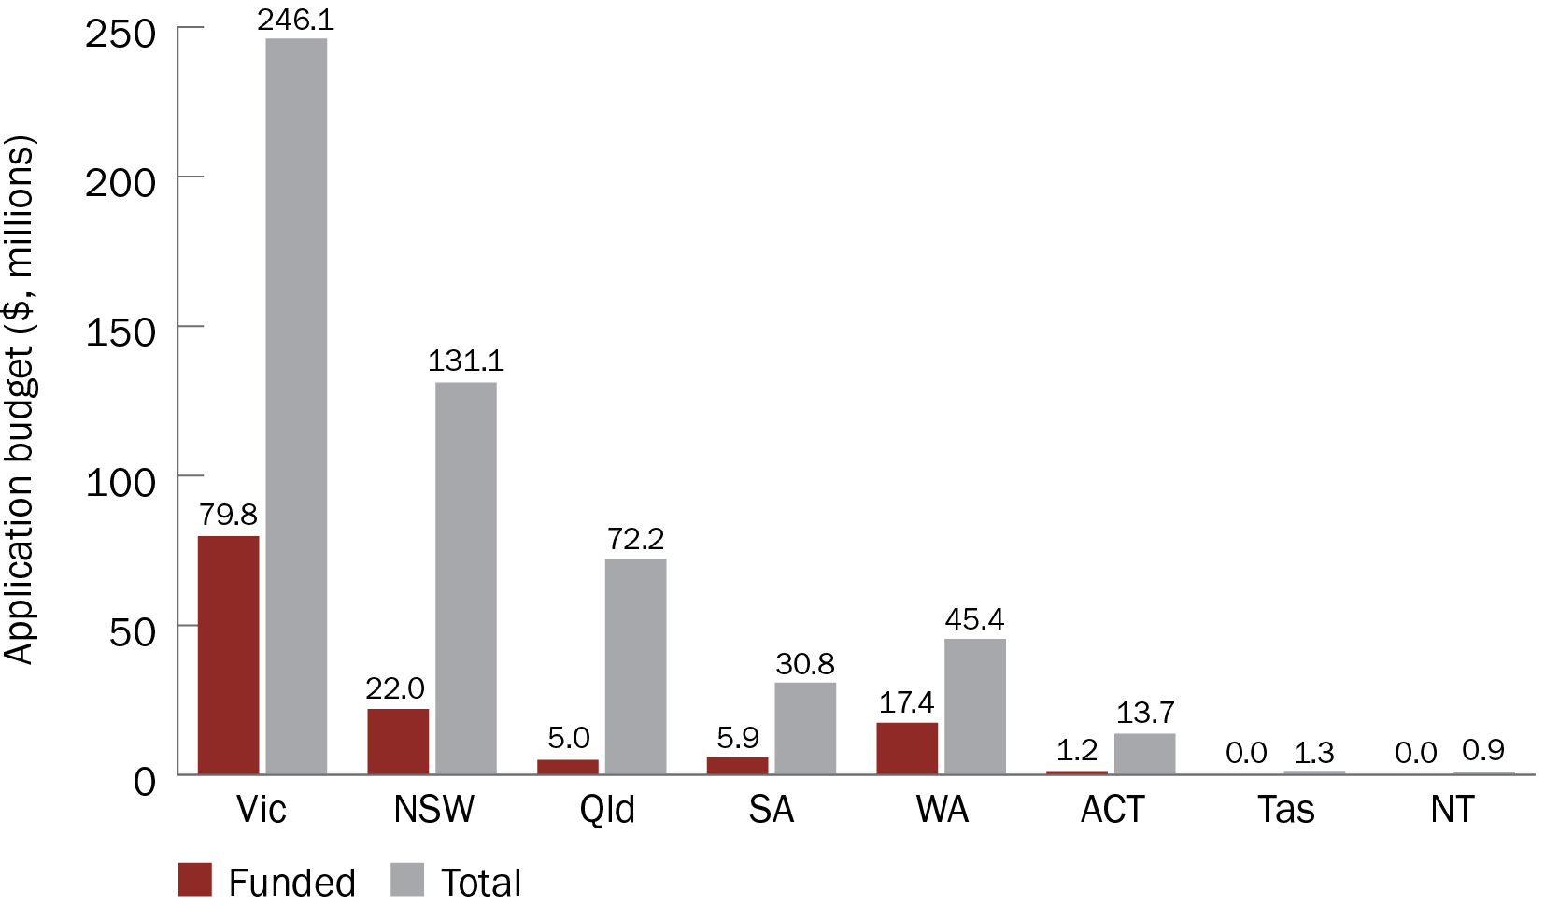

Figure 25 Funding amount applied for and received, by state or territory of institution

# Impact of COVID-19 grants

As part of the [MRFF Monitoring, Evaluation and Learning Strategy 2020–21 to 2023–24](https://www.health.gov.au/resources/publications/mrff-monitoring-evaluation-and-learning-strategy-2020-21-to-2023-24), the monitoring, evaluation and learning conceptual framework (Figure 26) sets out the MRFF’s measures of success. These measures support achieving MRFF outcomes and reflect MRFF’s vision, aims and objectives, which are articulated through 5 impact measures:

better health outcomes for patients

beneficial change to health practices

increased efficiency in the health system

increased job and export potential

economic growth from the commercialisation of health research outcomes

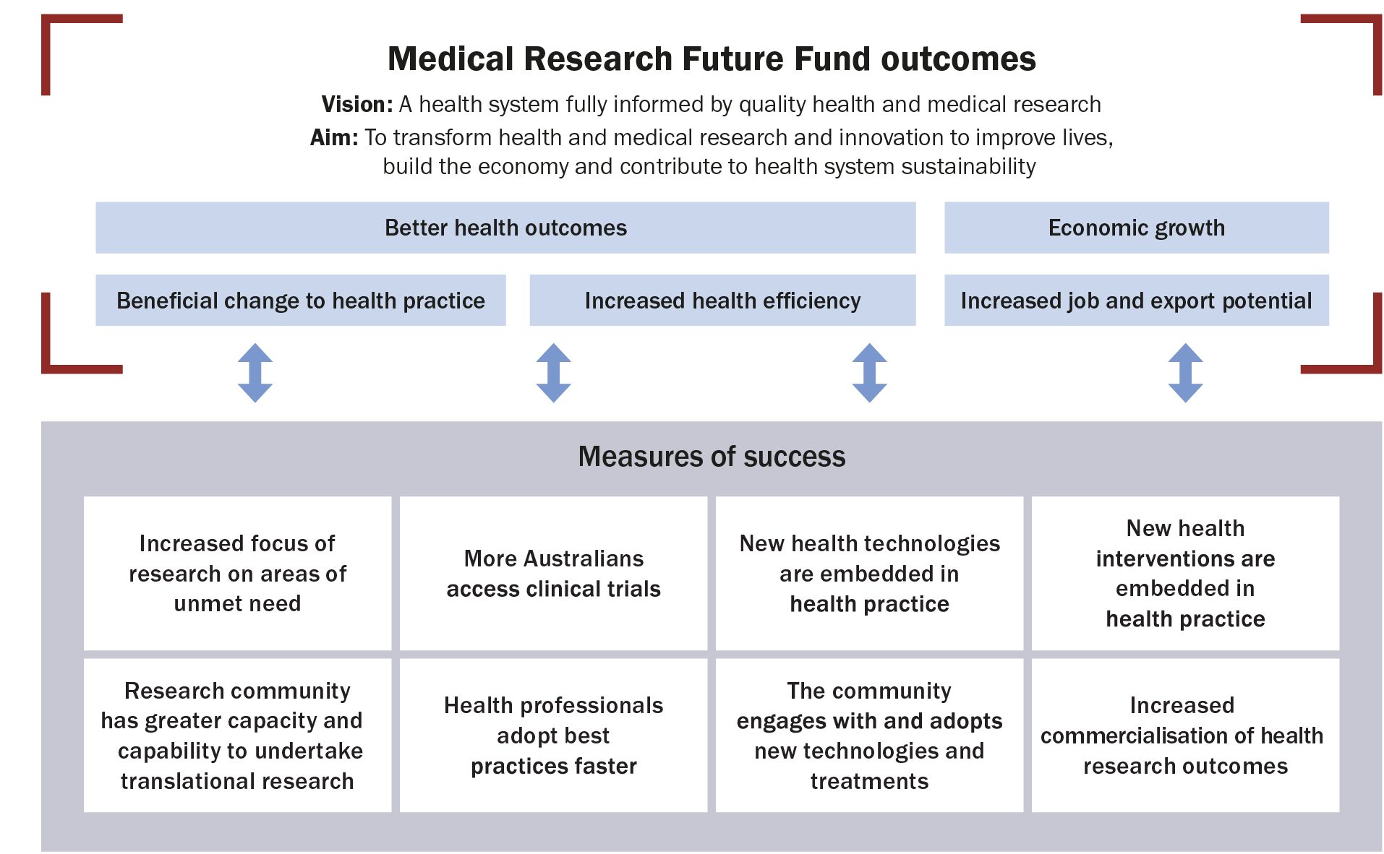

Figure 26 MRFF monitoring, evaluation and learning conceptual framework

The following sections highlight key outcomes of the grants awarded through the CRR and how the outcomes relate to the MRFF measures of success.

## Australia’s first COVID-19 mRNA vaccine

The COVID-19 vaccine rollout was one of Australia’s main strategies for overcoming the pandemic. However, Australia did not have the ability to develop and produce COVID-19 mRNA vaccines onshore.

On 12 May 2022, the first Australian-made COVID-19 mRNA vaccine dose was given to a clinical trial patient. This milestone was supported by 2 grants from the MRFF, both awarded to the University of Melbourne (partner institutions were the Peter Doherty Institute for Infection and Immunity and the Monash Institute of Pharmaceutical Sciences):

2020 COVID-19 Vaccine Candidate Research (Round 1), totalling $3.0 million

2020 Clinical Trials Rare Cancers, Rare Diseases and Unmet Need COVID-19, totalling $1.6 million

These research efforts supported by the MRFF have contributed to Australian mRNA vaccine research and development. Other contributing efforts within the sector include the upcoming establishment of an onshore mRNA vaccine manufacturing facility at Monash University. On 15 August 2022, the Australian Government [announced](https://www.pm.gov.au/media/homegrown-vaccines-way-australia) that the facility will be built as part of a 10-year partnership with Moderna and the Victorian Government. This manufacturing facility will reduce Australia’s dependence on imported mRNA vaccines and its vulnerability to supply disruptions or delays.

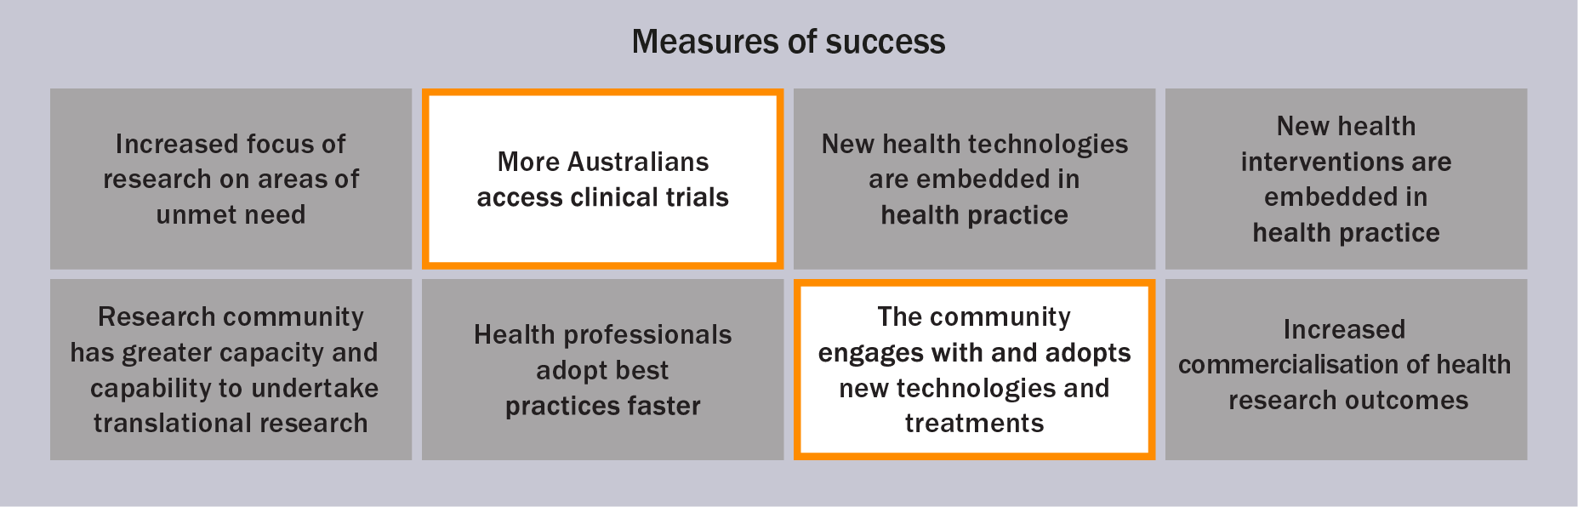

## Novel treatments and repurposing medicines

COVID-19 is a potentially deadly disease with few effective treatment options. The following research into novel antiviral treatments was supported through several rounds of MRFF funding:

The Walter and Eliza Hall Institute of Medical Research received funding for the discovery of an effective and safe antibody-based therapy to combat COVID-19. Funding was received through the 2020 Antiviral Development for COVID-19 (Stage 1) and 2020 Antiviral Development for COVID-19 (Stage 2) grant opportunities

Monash University received funding for novel inhaled RNA therapies to treat SARS-CoV-2. Funding was received through the 2020 Antiviral Development for COVID-19 (Stage 1) and 2021 COVID-19 Treatment Access and Public Health Activities grant opportunities

ENA Respiratory received funding for a nasal spray, INNA-051, that activates innate immunity to respiratory viral infections such as COVID-19. Funding was received from the Biomedical Translation Fund, which is also supported by the Australian Government. The University of Melbourne also received funding as part of the 2021 COVID-19 Treatment Access and Public Health Activities grant opportunity to test INNA-051 as a way of preventing COVID-19 in the elderly

It can take time to develop new treatments, especially for a novel disease, so it is also important to consider whether current treatments can be repurposed. The Queensland Institute of Medical Research received MRFF funding to investigate how COVID-19 can damage the heart, through the 2020 Rapid Screening of Approved Drugs in Stem Cell Models for COVID-19 grant opportunity. This research led to the discovery of 2 potential treatments for COVID-19, both of which are currently used for other diseases: baricitinib (for rheumatoid arthritis) and apabetalone (for cardiovascular disease).

Apabetalone is currently undergoing a Phase II clinical trial, while baricitinib has completed a Phase III clinical trial. Results showed that baricitinib is just as safe as standard of care and is associated with fewer deaths from COVID-19 for hospitalised adults.[1]

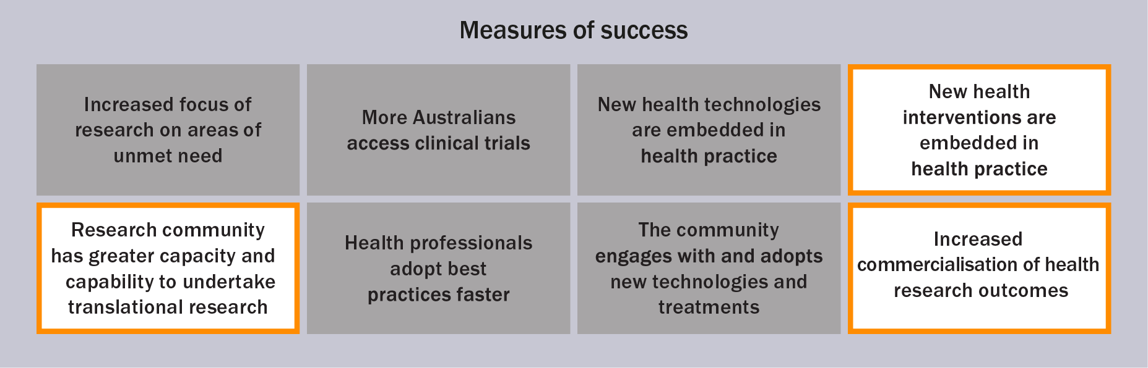

## Up-to-date treatment guidelines

The [Australian National COVID-19 Clinical Evidence Taskforce](https://clinicalevidence.net.au/) – a collaboration of 35 member organisations including Australia’s medical colleges and peak health organisations – supports clinicians to provide the best possible care to Australians.

During the COVID-19 pandemic, the taskforce continually updated evidence-based clinical guidelines to ensure that clinicians were receiving the latest advice. These ‘living guidelines’, the first in the world, received $1.5 million in funding from the MRFF.

The scope of the guidelines has expanded to include advice on the evolution of the pandemic and new options to treat patients. These include:

new antiviral treatments that are approved by the Therapeutic Goods Administration and listed on the Pharmaceutical Benefits Scheme

the management and care of people who have been infected with COVID-19 previously (eg those with long COVID)

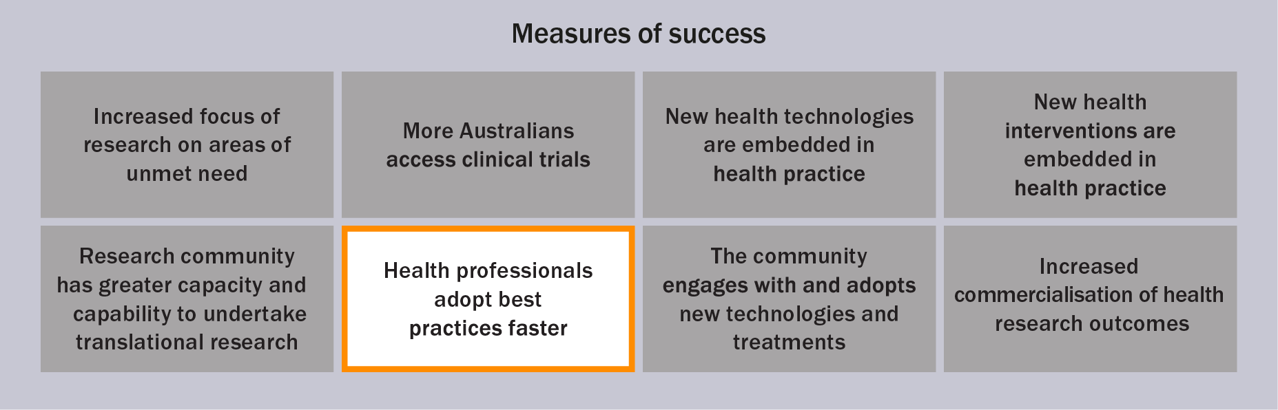

## Knowledge gain leading to new research

Early in the pandemic, the global community recognised that key pieces of information – specifically on vaccination, detection and treatment – were needed to try to control the new virus and illness. The MRFF provided support for research on these and other topics. Some projects provide outcomes that help the health system respond to COVID-19, and also other health issues and future pandemics.

Projects funded by the MRFF that have led, or may lead, to new research include disease detection and vaccine platforms, as described in the following sections.

Disease detection

Artificial intelligence is emerging as a valuable way of improving the diagnosis of diseases. A project from the University of Sydney uses lung computerised tomography screening and artificial intelligence to train clinicians to diagnose COVID-19 faster and more accurately.

Funding was received through the 2020 COVID-19 Diagnosis Platform (CovED) grant opportunity. The insights gained from using artificial intelligence for disease diagnosis has been further applied to a different disease, silicosis, which was also supported by the MRFF through the 2020 Silicosis Research grant opportunity. Projects such as these may lead to further research on the use of artificial intelligence for diagnosing diseases.

Vaccine platforms to prepare for the next pandemic

The COVID-19 pandemic has highlighted the rapid development of new vaccine platforms, from the bench to global rollout.

Building on many years of research, the mRNA vaccine against COVID-19 was the first authorised vaccine that used the mRNA technology. The challenge of finding vaccines against human immunodeficiency virus (HIV) and malaria shows that innovative approaches are required in immunisation.

The MRFF provided funding to 9 projects for the development of COVID-19 vaccines using different technologies (Table 1). These vaccine candidates may soon be included in Australia’s COVID-19 rollout, but could also allow the rapid development of vaccines against other infectious diseases, and so help fight the next pandemic.

Table 1 Potential new COVID-19 vaccines developed using different technologies

| Organisation | Vaccine name/target | Technology | MRFF funding received |
| --- | --- | --- | --- |
| University of Melbourne | AdaptiVax-CoV | Virus-like particles (protein) | $3.0 million |
| University of Melbourne | Chimeric next generation COVID vaccines | Chimeric trimeric receptor binding domain vaccine platform (protein) | $3.0 million |
| University of Melbourne | Receptor binding domain | mRNA | $3.0 million (plus $1.6 million from Clinical Trials Activity initiative) |
| University of Melbourne | Receptor binding domain | Protein | $3.0 million (plus $1.6 million from Clinical Trials Activity initiative) |
| University of Queensland | SARS-CoV-2 spike protein ectodomain | Molecular clamp technology (protein) | $5.0 million |
| University of South Australia | Sementis Copenhagen Vector system | Vaccinia viral-vector platform | $3.0 million |
| University of Sydney | COVIGEN vaccine | DNA vaccine, needle-free system | $3.0 million |
| University of Sydney | Mycobacteria vector | Innovative single-dose vaccine using the tuberculosis vaccine | $1.6 million |
| Vaxine (South Australia) | COVAX-19 (may also be called SpikoGen) | Proprietary spike protein antigen | $1.0 million |

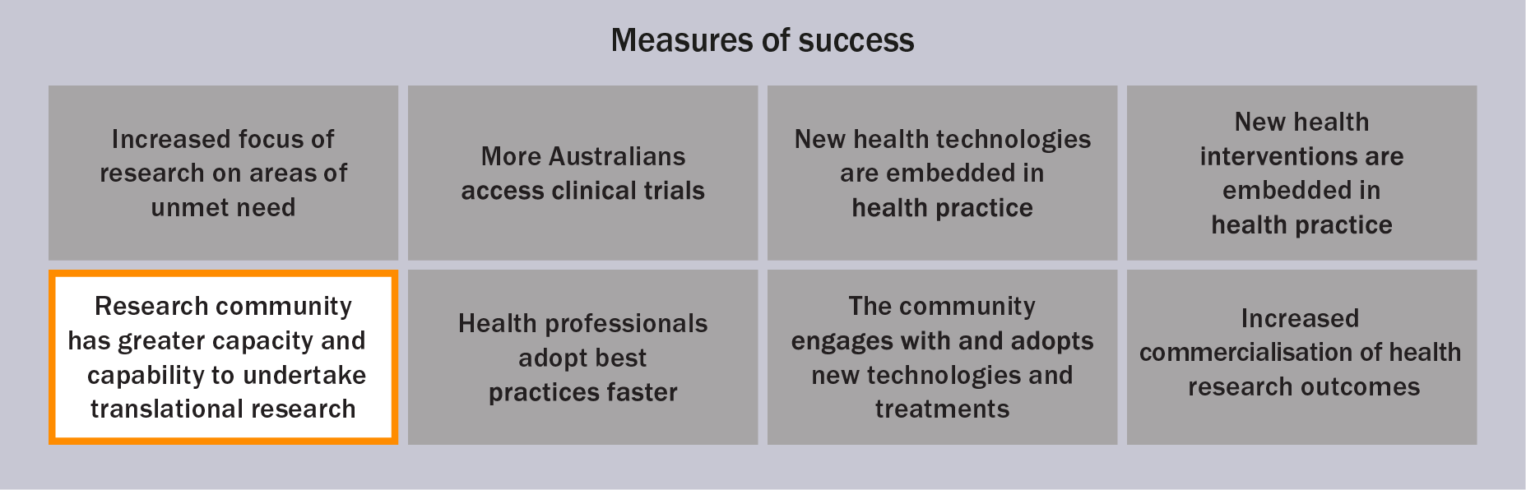

## Collaborative and innovative trial designs

Clinical trials test the effectiveness of therapies and treatments and create the evidence needed to improve clinical practice.

MRFF funded several projects, described in the following sections, that aim to refine the way clinical trials are performed. Finding new ways to carry out clinical trials or to include a broad representation of the community has several potential benefits that may lead to better patient outcomes. These benefits include improved treatment effectiveness and the ability to personalise treatment.

Using an adaptive clinical trial design

Traditional clinical trials have a linear design and make assumptions about participants and how they will respond to treatment. Results are considered only after the trial is over, and sometimes trials fail to reach an answer. Conversely, adaptive clinical trials have an end goal, but do not have a clear path to that goal. Instead, the design of the trial is flexible and depends on the data collected during the trial. This type of trial design enables researchers to learn which types of treatments are best for different types of patients, and is a more efficient way of performing research.

As part of the 2021 COVID-19 Treatment Access and Public Health Activities grant opportunity, Monash University was awarded $4 million to coordinate an Australia-wide project that joined together established adaptive platform trials – [ASCOT](https://www.ascot-trial.edu.au/) (Australasian COVID-19 Trial) and [REMAP-CAP](https://www.remapcap.org/) (Randomised, Embedded, Multi-factorial, Adaptive Platform Trial for Community-Acquired Pneumonia) – to identify effective treatments for COVID-19 as quickly as possible. This builds on previous MRFF support from the 2020 Australasian COVID-19 (ASCOT) Trial and 2021 International Clinical Trial Collaborations grant opportunities. Outcomes from these trials will quickly provide information to clinicians on effective treatments for COVID-19, as well as provide the global clinical trial community with insights on designing and implementing adaptive clinical trials.

Including under-represented groups in clinical trials

Booster doses of the COVID-19 vaccines are an important way to maintain protection against serious illness or death from COVID-19. To ensure all Australians benefit from booster doses, it is important to include a broad representation of the community in clinical trials.

As part of the 2021 COVID-19 Health Impacts and Vaccination Schedules grant opportunity, the University of Western Australia received $4.16 million to evaluate comparative booster vaccine strategies in adults to inform best practice in Australia. The trial, called PICOBOO (the Platform Trial in COVID-19 Vaccine Boosting), received a further $3.8 million through the 2021 COVID-10 Treatment Access and Public Health Activities grant opportunity to extend evaluation of vaccine strategies to children, adolescents and pregnant women. The outcomes from these participants, who are traditionally under-represented in clinical trials, will provide important and appropriate information that will help to most effectively vaccinate Australians against COVID-19.

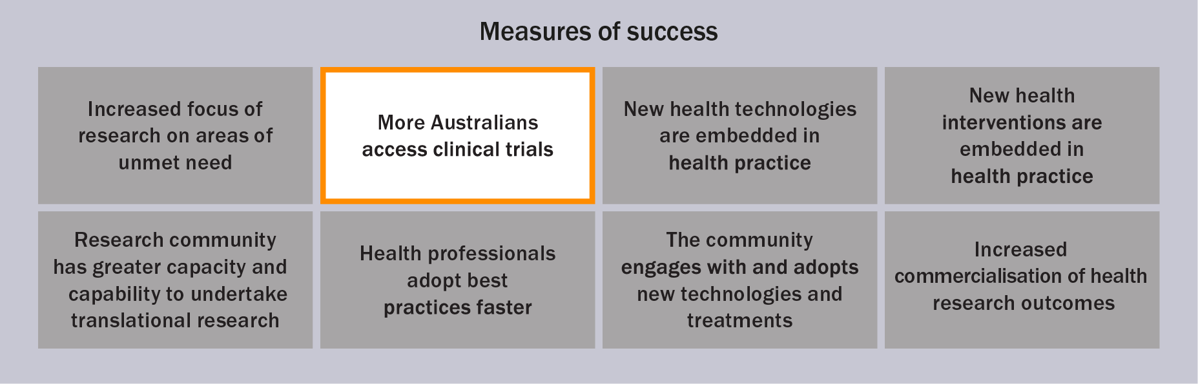

# Opportunities for learning and future funding

A review of COVID-19 clinical trials in Australia[2] identified that research response has been rapid, but there are several opportunities for improvement for funders and the research community. These include:

introducing procedures that enable fast-tracked funding

emphasising publicly available protocols to maintain scientific rigour

facilitating collaboration and data sharing

adopting innovative trial designs to counteract the challenge of relatively low case numbers

improving the national coordination of research priorities to minimise effort duplication (also raised in other reviews)[3]

The review also suggested that there were gaps in funding for public health communication, prevention of community transmission and symptoms of long COVID. However, this may reflect the state of science at the time of publication – in 2022, MRFF funding was awarded to 14 grants on access to treatment and public health activities.

Additionally, on 24 April 2023, the Australian Government [announced](https://www.health.gov.au/ministers/the-hon-mark-butler-mp/media/50-million-for-research-in-to-long-covid?language=en) that a further $50 million from the MRFF will be allocated to research on long COVID. The lessons learned from the CRR will help inform and shape future funding opportunities for the continuing effects of COVID-19.

The department will continue to monitor the science and epidemiology of COVID-19, and to adapt and respond to future priorities and needs for pandemic preparedness. This will take into account concurrent government efforts; for example, the department’s roundtable discussion in February 2022, the [NHMRC National COVID-19 Health and Medical Research Advisory Committee](https://www.nhmrc.gov.au/about-us/leadership-and-governance/committees/national-covid-19-health-and-research-advisory-committee), and the recent Commonwealth Scientific and Industrial Research Organisation (CSIRO) report on strengthening [Australia’s pandemic preparedness](https://www.csiro.au/pandemic).

# Conclusions

The COVID-19 outbreak has needed a rapid and adaptable response from both the Australian Government and the research sector, supported by a priority-led research funding mechanism.

The MRFF’s CRR was able to provide timely and responsive funding to the health and medical research sector for COVID-19 research, and leveraged the significant expertise of Australian researchers in responding to the pandemic. To date, $130 million has been invested on 80 projects across 24 grant opportunities/rounds. These grant opportunities cover a variety of themes, including vaccine development, antiviral treatments, public health and prevention.

Of the competitive grant opportunities, there was no difference in funded rates between genders. There was a mild trend towards higher funded rates for applications with larger grant budgets involving multiple investigators or institutions, but a range of budget and investigator team sizes were supported. Universities and research institutes received the most funding, and most grants were allocated to clinical research, although funded rates were highest for basic science.

It is too early to draw meaningful conclusions on longer-term impacts, but there are strong examples of MRFF-funded projects:

contributing to vaccine development in Australia

developing novel treatments

informing treatment guidelines

gaining knowledge that has led, or may lead, to new research

promoting collaborative and innovate trial designs

The department will continue to note opportunities for learning; monitor the science and epidemiology; and adapt and respond to emerging priorities (such as long COVID), future priorities and pandemic preparedness. This will ensure that Australians and the global community can benefit from improvements in the way we diagnose and treat COVID-19 and other diseases – including the source of the next pandemic.

# Appendices

Appendix A Grant opportunities through the Coronavirus Research Response

| Grant opportunity | Categorya | Total funding available | Maximum grant size allowableb | Opening date | Closing date | Number of applications | Number of funded grants |
| --- | --- | --- | --- | --- | --- | --- | --- |
| 2020 Novel Coronavirus Vaccine Development | Targeted competitive | $2,000,000 | $2,000,000 | 25/02/20 | 11/03/20 | 16 | 1 |
| 2020 Respiratory Medicine Clinical Trials Research on COVID-19 | Targeted competitive | $5,000,000 | $5,000,000 | 23/03/20 | 06/04/20 | 35 | 7 |
| 2020 Antiviral Development for COVID‑19 (Stage 1)c | Targeted competitive | $3,000,000 | $3,000,000 | 25/03/20 | 14/04/20 | 47 | 9 |
| 2020 Antiviral Development for COVID‑19 (Stage 2)c | Targeted competitive | $5,000,000 | $5,000,000 | N/A | N/A | 1 | 1 |
| 2020 COVID-19 Diagnostics | Closed non-competitive | $2,700,000 | $2,700,000 | 03/04/20 | 16/04/20 | 1 | 1 |
| 2020 COVID-19 Diagnosis Platform (CovED) | Closed non-competitive | $1,043,000 | $1,043,000 | 21/04/20 | 05/05/20 | 1 | 1 |
| 2020 National COVID-19 Clinical Evidence Taskforce | Closed non-competitive | $1,500,000 | $1,500,000 | 21/04/20 | 05/05/20 | 1 | 1 |
| 2020 COVID-19 PRO‑COVER Trial | Closed non-competitive | $3,000,000 | $3,000,000 | 22/04/20 | 06/05/20 | 1 | 1 |
| 2020 COVID-19 Vaccine Research | Closed non-competitive | $3,000,000 | $3,000,000 | 12/05/20 | 26/05/20 | 1 | 1 |
| 2020 Australasian COVID‑19 (ASCOT) Trial | Closed non-competitive | $350,000 | $350,000 | 12/05/20 | 26/05/20 | 1 | 1 |
| 2020 Tracking COVID-19 in Australia Using Genomics | Closed non-competitive | $3,270,000 | $3,270,000 | 29/05/20 | 09/06/20 | 1 | 1 |
| 2020 Rapid Screening of Approved Drugs in Stem Cell Models for COVID-19 | Closed non-competitive | $1,000,000 | $610,000 | 02/06/20 | 09/06/20 | 3 | 2 |
| 2020 COVID-19 Immunological Studies | Targeted competitive | $2,000,000 | $1,000,000 | 12/06/20 | 23/07/20 | 24 | 3 |
| 2020 COVID-19 Vaccine Candidate Research (Round 1) | Targeted competitive | $13,650,000 | $3,000,000 | 15/06/20 | 20/08/20 | 4d | 2 |
| 2020 COVID-19 Vaccine Candidate Research (Round 2) | Targeted competitive | $13,650,000 | $3,000,000 | 15/06/20 | 27/01/21 | 3d | 2 |
| 2020 COVID-19 Vaccine Candidate Research (Round 3) | Targeted competitive | $13,650,000 | $3,000,000 | 15/06/20 | 05/05/21 | 4d | 2 |
| 2020 COVID-19 Mental Health Research | Targeted competitive | $3,000,000 | $1,000,000 | 01/06/20 | 13/07/20 | 86 | 6 |
| 2020 Rapid Response Digital Health Infrastructure | Open competitive | $4,000,000 | $2,000,000 | 01/07/20 | 14/07/20 | 78 | 3 |
| 2020 Communication Strategies and Approaches During Outbreaks | Open competitive | $800,000 | $800,000 | 01/07/20 | 14/07/20 | 38 | 3 |
| Medical Research Commercialisation Initiative (Biomedical Translation Bridge) COVID‑19 Round 3 | Open competitive | Administered by MTPConnect | | | | | 5e |
| 2020 Rare Cancers, Rare Diseases and Unmet Need COVID-19 | Targeted competitive | $25,000,000 | $25,000,000 | 20/08/20 | 23/09/20 | 39 | 6 |
| 2020 Stem Cell Therapies Mission – Stream 5 | Targeted competitive | $1,000,000 | $1,000,000 | 16/12/20 | 03/03/21 | 4 | 1 |
| 2021 COVID-19 Vaccine-Associated Thrombosis With Thrombocytopenia Syndrome | Closed non-competitive | $3,000,000 | $3,000,000 | 30/07/21 | 18/08/21 | 1 | 1 |
| 2021 COVID-19 Health Impacts and Vaccination Schedules (3 streams) | Targeted competitive | $15,000,000 | $5,000,000 | 12/05/21 | 18/08/21 | 25 | 5 |
| 2021 COVID-19 Treatment Access and Public Health Activities (5 streams) | Streams 1–4: targeted competitive Stream 5: restricted competitive | $33,000,000 | Various | 03/12/21 | 23/02/22 | 30 | Streams 1–4: 13 Stream 5: 1 |

N/A = not applicable

a The [grant opportunity categories](https://www.health.gov.au/summary-of-mrff-grant-recipients) are defined as specified in the [Commonwealth Grants Rules and Guidelines 2017](https://www.finance.gov.au/government/commonwealth-grants/commonwealth-grants-rules-and-guidelines).

b Where the maximum grant size allowable was not specified in the grant opportunity guidelines, it was set to the total funding available, as specified in this table.

c Both stages of the 2020 Antiviral Development for COVID-19 grant opportunity are considered a single grant opportunity; the 9 successful grants from Stage 1 submitted a completion report, which determined further funding under Stage 2.

d Grant opportunities that included an Expression of Interest round – only full applications are considered in this table for the assessment of funded rates.

e For this grant opportunity funded by the Biomedical Translation Bridge, 5 projects were funded as subcontracts managed by the grantee MTPConnect.

Appendix B Funded grants

| Grant opportunity | Grant recipient | Project | Funding granted |
| --- | --- | --- | --- |
| 2020 Novel Coronavirus Vaccine Development (targeted competitive) | University of Queensland | The Molecular Clamp Stabilized Spike Vaccine for Rapid Response Program | $1.97 m |
| 2020 Respiratory Medicine Clinical Trials Research on COVID-19 (targeted competitive) | The Council of the Queensland Institute of Medical Research | Tocilizumab for treatment of COVID-19 in intensive care patients | $0.28 m |
| 2020 Respiratory Medicine Clinical Trials Research on COVID-19 (targeted competitive) | Queensland University of Technology | Use of therapeutic drug monitoring (TDM) to optimise oral/enteral hydroxychloroquine dosing in critically ill patients with COVID-19 | $0.17 m |
| 2020 Respiratory Medicine Clinical Trials Research on COVID-19 (targeted competitive) | South Australian Health and Medical Research Institute | Precision antibiotic strategies to reduce invasive mechanical ventilation and mortality in COVID-19 | $0.54 m |
| 2020 Respiratory Medicine Clinical Trials Research on COVID-19 (targeted competitive) | University of Melbourne | ProTreat: an adaptive and rapid implementation trial of novel therapies to prevent and treat COVID-19 infection in high risk cancer patients | $2.17 m |
| 2020 Respiratory Medicine Clinical Trials Research on COVID-19 (targeted competitive) | University of New South Wales | Repurposing existing medications to reduce severe acute respiratory distress in patients with COVID-19: the CLARITY trial | $1.41 m |
| 2020 Respiratory Medicine Clinical Trials Research on COVID-19 (targeted competitive) | University of Queensland | Reducing acute severe respiratory events in health care workers during the COVID-19 pandemic with OM85 (extract from the walls of bacteria) | $1.25 m |
| 2020 Respiratory Medicine Clinical Trials Research on COVID-19 (targeted competitive) | University of Sydney | IMPACT-ICO: Trials of immuno-modulatory particles and colchicine to improve COVID-19 outcomes | $0.98 m |
| 2020 Antiviral Development for COVID‑19 (targeted competitive) Stage 1a | Burnet Institute | Novel inhibitors of SARS coronaviruses targeting ACE2 | $0.30 m |
| 2020 Antiviral Development for COVID-19 (targeted competitive) Stage 1a | The Garvan Institute of Medical Research | Monoclonal antibody therapy of COVID-19 | $0.59 m |
| 2020 Antiviral Development for COVID‑19 (targeted competitive) Stage 1a | Griffith University | Targeting SARS-CoV-2 using stealth nanoparticles loaded with gene silencing siRNA | $0.32 m |
| 2020 Antiviral Development for COVID-19 (targeted competitive) Stage 1a | Monash University | Convalescent plasma for COVID-19 | $0.37 m |
| 2020 Antiviral Development for COVID-19 (targeted competitive) Stage 1a | Monash University | Inhaled oligonucleotides to generate a decoy receptor for the SARS-CoV-2 | $0.30 m |
| 2020 Antiviral Development for COVID-19 (targeted competitive) Stage 1a | Monash University | Ivermectin as an anti-viral against SARS-CoV-2 | $0.34 m |
| 2020 Antiviral Development for COVID-19 (targeted competitive) Stage 1a | University of New South Wales | Hyperimmune globulin: a rapid pathway to treatment of COVID-19 | $2.07 m |
| 2020 Antiviral Development for COVID-19 (targeted competitive) Stage 1a | The Walter and Eliza Hall Institute of Medical Research | Biologics for the prophylaxis and treatment of COVID‑19 | $1.99 m |
| 2020 Antiviral Development for COVID-19 (targeted competitive) Stage 1a | The Walter and Eliza Hall Institute of Medical Research | Targeting the deubiquitinase activity of coronaviruses: the VirDUB programme | $1.06 m |
| 2020 Antiviral Development for COVID‑19 (targeted competitive) Stage 2a | The Walter and Eliza Hall Institute of Medical Research | Biologics for the prophylaxis and treatment of COVID-19 | $5.00 m |
| **2020 COVID-19 Diagnostics** (closed non-competitive) | University of Melbourne | COVID-19 strategic planning and delivery of testing | $2.70 m |
| **2020 COVID-19 Diagnosis Platform (CovED)** (closed non-competitive) | University of Sydney | Transforming recognition and assessment of COVID-19 in Australia using lung CT (CovED Initiative) | $1.04 m |
| **2020 National COVID-19 Clinical Evidence Taskforce** (closed non-competitive) | Monash University | National COVID-19 Clinical Evidence Taskforce | $1.50 m |
| **2020 COVID-19 PRO-COVER Trial** (closed non-competitive) | The Walter and Eliza Hall Institute of Medical Research | COVID-19 prophylaxis with hydroxychloroquine in front-line health and allied-healthcare workers – the COVID-SHIELD Trial | $3.00 m |
| **2020 COVID-19 Vaccine Research** (closed non-competitive) | University of Queensland | Rapid acceleration of the UQ COVID-19 vaccine program | $3.00 m |
| **2020 Australasian COVID-19 (ASCOT) Trial** (closed non-competitive) | University of Queensland | The Australasian COVID-19 Trial (ASCOT) | $0.35 m |
| **2020 Tracking COVID-19 in Australia Using Genomics** (closed non-competitive) | University of New South Wales | Tracking COVID-19 in Australia using genomics | $3.27 m |
| **2020 Rapid Screening of Approved Drugs in Stem Cell Models for COVID-19** (closed non-competitive) | The Council of the Queensland Institute of Medical Research | Preventing cardiac injury in patients with COVID-19 | $0.39 m |
| **2020 Rapid Screening of Approved Drugs in Stem Cell Models for COVID-19** (closed non-competitive) | University of Melbourne | Stem cell-derived human tissue models for the identification of drugs to treat COVID-19 | $0.61 m |
| **2020 COVID-19 Immunological Studies** (targeted competitive) | University of Melbourne | Defining immune responses in COVID-19 to understand susceptibility and target treatments | $1.00 m |
| **2020 COVID-19 Immunological Studies** (targeted competitive) | University of New South Wales | Cellular and molecular correlates to SARS CoV2 immunity in convalescent patients | $0.99 m |
| **2020 COVID-19 Immunological Studies** (targeted competitive) | The Council of the Queensland Institute of Medical Research | Defining SARS-CoV-2 immune maintenance in the Australian population | $1.00 m |
| **2020 COVID-19 Vaccine Candidate Research** (targeted competitive) Round 1 | University of Melbourne | A safe, effective, and rapidly tuneable SARS-CoV-2 vaccine | $3.00 m |
| **2020 COVID-19 Vaccine Candidate Research** (targeted competitive) Round 1 | University of Sydney | Novel DNA based COVID-19 vaccine: A phase 1/1b trial for Australia | $2.95 m |
| **2020 COVID-19 Vaccine Candidate Research** (targeted competitive) Round 2 | University of Sydney | A single dose, globally accessible vaccine to combat emerging SARS-CoV-2 variants | $1.56 m |
| **2020 COVID-19 Vaccine Candidate Research** (targeted competitive) Round 2 | University of South Australia | Next generation COVID-19 vaccine using the established Sementis Copenhagen [viral] Vector platform system | $2.98 m |
| **2020 COVID-19 Vaccine Candidate Research** (targeted competitive) Round 3 | University of Melbourne | Chimeric next generation COVID vaccines | $3.00 m |
| **2020 COVID-19 Vaccine Candidate Research** (targeted competitive) Round 3 | University of Melbourne | AdaptiVax-CoV: A novel adaptable SARS-CoV2 VLPvaccine to produce broad humoral and T cell responses to S, E and M viral proteins | $3.00 m |
| **2020 COVID-19 Mental Health Research** (targeted competitive) | University of Wollongong | Narratives of recovery – practices supporting community mental health and well being post bush fires and COVID 19 | $0.43 m |
| **2020 COVID-19 Mental Health Research** (targeted competitive) | Monash University | Mobilising and empowering parents in the COVID-19 mental health response: a single-arm trial of an enhanced online parenting intervention to improve parent risk and protective factors for adolescent mental health | $0.61 m |
| **2020 COVID-19 Mental Health Research** (targeted competitive) | University of New South Wales | A novel text mining and data linkage approach to investigate the mental health needs of the population during the COVID-19 period | $0.23 m |
| **2020 COVID-19 Mental Health Research** (targeted competitive) | Deakin University | Evaluating the effectiveness of lifestyle therapy versus standard psychotherapy for reducing depression in adults with COVID-19 related distress: the CALM trial | $0.89 m |
| **2020 COVID-19 Mental Health Research** (targeted competitive) | University of Canberra | Implementing artificial intelligence (AI) to enhance Lifeline’s crisis support service capacity in response to COVID-19 and emerging crises | $0.22 m |
| **2020 COVID-19 Mental Health Research** (targeted competitive) | University of Technology Sydney | Identifying the mental health effects and support needs of people bereaved during and following COVID-19: a mixed methods project | $0.75 m |
| **2020 Rapid Response Digital Health Infrastructure** (open competitive) | Sydney Local Health District | Integrating remote monitoring technology into digital health infrastructure | $0.67 m |
| **2020 Rapid Response Digital Health Infrastructure** (open competitive) | Monash University | Towards a national data management platform and learning health system | $1.92 m |
| **2020 Rapid Response Digital Health Infrastructure** (open competitive) | Monash University | Real-time modelling of Australia’s COVID-19 response | $0.81 m |
| **2020 Communication Strategies and Approaches During Outbreaks** (open competitive) | Monash University | Effectiveness of tailored COVID-19 message for vulnerable Australians | $0.32 m |
| **2020 Communication Strategies and Approaches During Outbreaks** (open competitive) | Deakin University | Inclusive health communication in specialist disability accommodation | $0.11 m |
| **2020 Communication Strategies and Approaches During Outbreaks** (open competitive) | Macquarie University | Harnessing the health communication power of the early childhood sector | $0.17 m |
| **Medical Research Commercialisation Initiative (Biomedical Translation Bridge) COVID-19 (Round 3)** (open competitive) (Administered by MTPConnect)b | Dimerix Bioscience | Novel treatment for respiratory complications due to COVID-19 | $1.00 m |
| **Medical Research Commercialisation Initiative (Biomedical Translation Bridge) COVID-19 (Round 3)** (open competitive) (Administered by MTPConnect)b | Starpharma | Intranasal spray using a broad-spectrum antiviral dendrimer for COVID-19 (preventative treatment) | $1.00 m |
| **Medical Research Commercialisation Initiative (Biomedical Translation Bridge) COVID-19 (Round 3)** (open competitive) (Administered by MTPConnect)b | SpeeDx | Rapid response COVID-19 assay | $0.53 m |
| **Medical Research Commercialisation Initiative (Biomedical Translation Bridge) COVID-19 (Round 3)** (open competitive) (Administered by MTPConnect)b | University of Melbourne | Ventilated hood for patient isolation to provide better respiratory treatment and protect hospital staff from COVID-19 | $0.61 m |
| **Medical Research Commercialisation Initiative (Biomedical Translation Bridge) COVID-19 (Round 3)** (open competitive) (Administered by MTPConnect)b | Vaxine | The COVAX-19 vaccine | $1.00 m |
| **2020 Rare Cancers, Rare Diseases and Unmet Need COVID-19** (targeted competitive) | South Australian Health and Medical Research Institute | Prevention of SARS-CoV-2 transmission in aged care using ultraviolet light | $1.37 m |
| **2020 Rare Cancers, Rare Diseases and Unmet Need COVID-19** (targeted competitive) | Flinders University | 3D-printed facial guards to reduce P2/N95 respirator leak and protect health care workers from COVID-19 | $0.97 m |
| **2020 Rare Cancers, Rare Diseases and Unmet Need COVID-19** (targeted competitive) | University of New South Wales | Statin treatment to prevent brain complications as a result of COVID-19 | $2.38 m |
| **2020 Rare Cancers, Rare Diseases and Unmet Need COVID-19** (targeted competitive) | University of Melbourne | Use of cardioprotective therapy to manage persistent cardiovascular effects of COVID-19 | $2.57 m |
| **2020 Rare Cancers, Rare Diseases and Unmet Need COVID-19** (targeted competitive) | University of Melbourne | Protecting aged care residents from the pandemic via specialised nutritional supplementation | $1.19 m |
| **2020 Rare Cancers, Rare Diseases and Unmet Need COVID-19** (targeted competitive) | University of Melbourne | Clinical trial for mRNA and protein vaccines being developed at the University of Melbourne | $1.59 m |
| **2020 Stem Cell Therapies Mission** (targeted competitive) | Commonwealth Scientific and Industrial Research Organisation (CSIRO) | The sySTEMs initiative: systems biology-augmented, stem cell-derived, multi-tissue panel for rapid screening of approved drugs as potential COVID-19 treatments | $1.00 m |
| **2021 COVID-19 Vaccine-Associated Thrombosis With Thrombocytopenia Syndrome** (closed non-competitive) | Monash University | A national, multi-centre study evaluating Thrombotic Thrombocytopenia Syndrome (TTS) associated with ChAdOx1 (AZD1222) and other SARS-CoV-2 vaccines (viral vector and m-RNA) | $2.90 m |
| **2021 COVID-19 Health Impacts and Vaccination Schedules** (targeted competitive) | Murdoch University [Stream 1: Health Impacts] | Molecular phenomic approaches to improve understanding of Post-Acute COVID-19 Syndrome – a biomarker-augmented strategy for risk based stratification and targeted intervention to improve clinical outcomes | $3.40 m |
| **2021 COVID-19 Health Impacts and Vaccination Schedules** (targeted competitive) | University of Melbourne [Stream 1: Health Impacts] | Predicting the neurological impact of SARS-CoV-2 variants of concern - protecting Australians from long-COVID brain injury | $1.78 m |
| **2021 COVID-19 Health Impacts and Vaccination Schedules** (targeted competitive) | University of New South Wales [Stream 2: Vaccine Schedules, immunocompromising conditions] | Comparing immunisation-boosting regimens for COVID‑19 upon initiation of immunosuppressive therapies (CIRCUIT Study) | $2.75 m |
| **2021 COVID-19 Health Impacts and Vaccination Schedules** (targeted competitive) | Monash University [Stream 2: Vaccine Schedules, immunocompromising conditions] | Bringing optimised COVID-19 vaccine schedules to immunocompromised populations (BOOST-IC) | $2.91 m |
| **2021 COVID-19 Health Impacts and Vaccination Schedules** (targeted competitive) | University of Western Australia [Stream 3: Vaccine Schedules, combine different vaccines] | The platform trial in COVID-19 vaccine Boosting (PICOBOO) | $4.16 m |
| **2021 COVID-19 Treatment Access and Public Health Activities Streams 1–4 (targeted competitive)** | Monash University | A coordinated multiplatform randomised trial for hospitalised patients with COVID-19 | $4.00 m |
| **2021 COVID-19 Treatment Access and Public Health Activities Streams 1–4 (targeted competitive)** | University of Melbourne | mRNA-based antiviral therapeutics for SARS-CoV-2 using Cas13 | $1.00 m |
| **2021 COVID-19 Treatment Access and Public Health Activities Streams 1–4 (targeted competitive)** | University of New South Wales | Development of antiviral RNA therapeutics targeting SARS-CoV-2 infection | $1.00 m |
| **2021 COVID-19 Treatment Access and Public Health Activities Streams 1–4 (targeted competitive)** | Curtin University | Compound repurposing into novel therapeutics to treat SARS-COV2 infection | $1.00 m |
| **2021 COVID-19 Treatment Access and Public Health Activities Streams 1–4 (targeted competitive)** | Monash University | Pre-clinical testing of novel inhaled RNA therapies for stability, safety and effectiveness against SARS-CoV-2 to demonstrate proof of concept | $0.50 m |
| **2021 COVID-19 Treatment Access and Public Health Activities Streams 1–4 (targeted competitive)** | The Walter and Eliza Hall Institute of Medical Research | A lethal and irresistible combination: Simultaneous targeting of the SARS-CoV-2 proteases Mpro and PLpro | $1.00 m |
| **2021 COVID-19 Treatment Access and Public Health Activities Streams 1–4 (targeted competitive)** | Esfam Biotech Pty Ltd | **:** Experimental validation of the target of ESFAM289 – a molecule with in vivo efficacy against SARS-CoV-2 | $1.00 m |
| **2021 COVID-19 Treatment Access and Public Health Activities Streams 1–4 (targeted competitive)** | University of Melbourne | Intranasal TLR2/6 activation to prevent COVID infection in the elderly | $3.88 m |
| **2021 COVID-19 Treatment Access and Public Health Activities Streams 1–4 (targeted competitive)** | University of Western Australia | The platform trial in COVID-19 boosting: stage 2 (PICOBOO-2) | $3.83 m |
| **2021 COVID-19 Treatment Access and Public Health Activities Streams 1–4 (targeted competitive)** | University of Melbourne | Immune responses to SARS-CoV-2 variants across age groups and vulnerable populations | $3.00 m |
| **2021 COVID-19 Treatment Access and Public Health Activities Streams 1–4 (targeted competitive)** | Monash University | PROPHECY: Profiling immune response in paediatric and high-risk populations to SARS-CoV-2 | $6.33 m |
| **2021 COVID-19 Treatment Access and Public Health Activities Streams 1–4 (targeted competitive)** | University of New South Wales | Aerosol transmission of SARS-CoV-2 experimentally and in an intensive care setting | $0.99 m |
| **2021 COVID-19 Treatment Access and Public Health Activities Streams 1–4 (targeted competitive)** | University of Melbourne | Aerosol infection research: better models to reduce indoor exposure (AIRBORNE) | $1.00 m |
| **2021 COVID-19 Treatment Access and Public Health Activities Stream 5 (restricted competitive)** | Australian Institute of Health and Welfare | Towards an Australian COVID-19 register and linked data set | $2.99 m |

m = million

a Both stages of the 2020 Antiviral Development for COVID-19 grant opportunity are considered a single grant opportunity; the 9 successful grants from Stage 1 submitted a completion report, which determined further funding under Stage 2.

b For this grant opportunity funded by the Biomedical Translation Bridge, 5 projects were funded as subcontracts managed by the grantee MTPConnect.

Appendix C Gender of Chief Investigators for NHMRC-funded grant opportunities

| Grant opportunities | All applicants – Total | All applicants – Funded | All applicants – Funded rate (%) | Female applicants – Total | Female applicants – Funded | Female applicants – Funded rate (%) | Male applicants – Total | Male applicants – Funded | Male applicants – Funded rate (%) |
| --- | --- | --- | --- | --- | --- | --- | --- | --- | --- |
| 2020 Antiviral Development for COVID‑19 (Stage 1)a | 432 | 97 | 22.5 | 126 | 25 | 19.8 | 291 | 68 | 23.4 |
| 2020 COVID-19 Immunological Studies | 284 | 47 | 16.5 | 106 | 17 | 16.0 | 168 | 29 | 17.3 |
| 2020 COVID-19 Mental Health Research | 1048 | 88 | 8.4 | 524 | 44 | 8.4 | 405 | 33 | 8.2 |
| 2020 COVID-19 Vaccine Candidate Research (Round 1) | 51 | 27 | 52.9 | 13 | 6 | 46.2 | 32 | 17 | 53.1 |
| 2020 COVID-19 Vaccine Candidate Research (Round 2) | 28 | 24 | 85.7 | 6 | 6 | 100.0 | 20 | 17 | 85.0 |
| 2020 COVID-19 Vaccine Candidate Research (Round 3) | 52 | 34 | 65.4 | 13 | 9 | 69.2 | 31 | 23 | 74.2 |
| 2020 Novel Coronavirus Vaccine Development | 84 | 17 | 20.2 | 160 | 35 | 21.9 | 276 | 35 | 12.7 |
| 2020 Rare Cancers, Rare Diseases and Unmet Need COVID-19 | 470 | 77 | 16.4 | 86 | 24 | 27.9 | 247 | 65 | 26.3 |
| 2020 Respiratory Medicine Clinical Trials Research on COVID-19 | 356 | 92 | 25.8 | 22 | 5 | 22.7 | 39 | 11 | 28.2 |
| 2020 Stem Cell Therapies Mission – Stream 5 | 62 | 17 | 27.4 | 154 | 38 | 24.7 | 198 | 34 | 17.2 |
| 2021 COVID-19 Health Impacts and Vaccination Schedules | 415 | 84 | 20.2 | 135 | 63 | 46.7 | 198 | 99 | 50.0 |
| 2021 COVID-19 Treatment Access and Public Health Activities | 349 | 170 | 48.7 | 160 | 35 | 21.9 | 276 | 35 | 12.7 |
| **All applicationsb** | **3631** | **774** | **21.3** | **1362** | **276** | **20.3** | **1958** | **443** | **22.6** |

a Stage 2 of the 2020 Antiviral Development for COVID-19 grant opportunity is excluded from this calculation; the 9 successful grants from Stage 1 submitted a completion report, which determined further funding under Stage 2.

b Based on self-reported data, a total of 311 applicants (across all grant opportunities) were classified in this report as ‘not stated’, ‘not applicable’ or ‘non-binary or intersex.

Appendix D Field of research categories

| Field of research category | Number of applications |
| --- | --- |
| Clinical sciences | 98 |
| Public health and health services | 70 |
| Immunology | 35 |
| Medical microbiology | 25 |
| Cardiorespiratory medicine and haematology | 24 |
| Psychology | 16 |
| Medicinal and biomolecular chemistry | 10 |
| Biochemistry and cell biology | 9 |
| Medical biotechnology | 9 |
| Nursing | 3 |
| Oncology and carcinogenesis | 3 |
| Applied economics | 2 |
| Medical biochemistry and metabolomics | 2 |
| Nanotechnology | 2 |
| Neurosciences | 2 |
| Paediatrics and reproductive medicine | 2 |
| Pharmacology and pharmaceutical sciences | 2 |
| Basic science | 1 |
| Biomedical engineering | 1 |
| Library and information studies | 1 |
| Null (no field of research given) | 7 |

1. VC Marconi, AV Ramanan, S de Bono, CE Kartman, V Krishnan, R Liao et al (2021). ‘Efficacy and safety of baricitinib for the treatment of hospitalised adults with COVID-19 (COV-BARRIER): a randomised, double-blind, parallel-group, placebo-controlled phase 3 trial’, *The Lancet*, 9(12):1407–1418, doi:[10.1016/S2213-2600(21)00331-3](https://doi.org/10.1016/S2213-2600(21)00331-3).
2. AL Seidler, M Aberoumand, JG Williams, A Tan, KE Hunter and A Webster (2021). ‘The landscape of COVID-19 trials in Australia’, *Medical Journal of Australia*, 215(2):58–61.e1, doi:[10.5694/mja2.51148](https://doi.org/10.5694/mja2.51148).
3. AC Bowen, SYC Tong and JS Davis (2021). ‘Australia needs a prioritised national research strategy for clinical trials in a pandemic: lessons learned from COVID-19’, *Medical Journal of Australia*, 215(2):56–58.e1, doi:[10.5694/mja2.51143](https://doi.org/10.5694/mja2.51143).