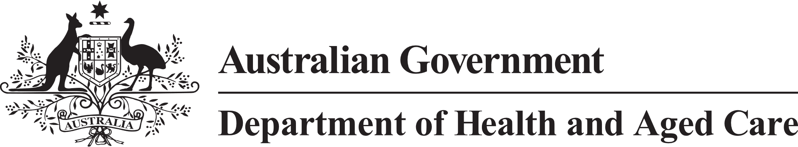

**Council of Elders**

# Communique – 19 and 20 April 2023

The Council of Elders welcomed our new Chair, Ms Anne Burgess AM, at the April meeting. Anne has more than 40 years’ experience leading areas of government focused on social justice and was announced as the [Chair of the Council](https://www.health.gov.au/ministers/the-hon-anika-wells-mp/media/anne-burgess-am-appointed-as-chair-of-the-aged-care-council-of-elders) by Minister Wells in April.

**Amplifying the voices of older people** – The Council talks to older people about changes being made to aged care and listens to their experiences. We use this information to give independent advice to Government about the aged care system and ageing well. Our advice is informed by the views of older people from across Australia.

Council took the opportunity of our first meeting with a new Chair to reflect on how we are working. We want to make sure we are focussed on the issues that will make the most difference to older people’s experiences of aged care.

Council could see how our advice has made an impact in policy development and implementation. Aged care reforms have been shaped by the voices, experiences, and needs of older people.

In coming months, we will prioritise meeting with more local groups to hear even more experiences so that the voices of older people in aged care reforms stays strong. We will share more information about this through our new Facebook page (see below).

The Council met with the Chair of the National Aged Care Advisory Council to discuss issues of mutual interest and opportunities to work better together so that we can get better outcomes for older people.

**Making it easier to share your experience with us** – On 1 May the new [Facebook group for the Aged Care Council of Elders](https://www.facebook.com/groups/agedcarecouncilofelders) was launched. The group will share information about the work of the Council, the aged care reforms and ageing well. Everyone is invited to join.

**Home care** – The department is reviewing how future changes to the Home Care Packages Program Manual will be communicated to the people impacted by reforms. Council will provide advice on the most effective ways to communicate with older people. We will also work with the department as it looks at how well the program meets disability related supports.

**The New Aged Care Act - Proposed disclosure (whistle-blower) protections** – Council discussed how volunteers can be best included in systems for making protected disclosures about aged care. Our advice focussed on making sure that the vital role of volunteers in supporting quality of life and safety of older people was maintained.

**Mid-term review of the National Health Reform Agreement Addendum 2020-25** – We discussed how the aged care and health systems are working together to support ageing well, and opportunities to make this better. Council members highlighted opportunities to provide better coordinated and joined up care in the community. Our discussion will contribute to the mid-term review of the National Health Reform Agreement Addendum 2020-2025.

The next meeting of the Council of Elders will be held on 15 May 2023.